**Power Plant Fuel Mix and Electricity Prices**

**Regulated Capacity Markets**

**Duke Energy and the North Carolina Power Plant Industry: Solar Farms, Nuclear Plants, and Capacity Payments**

<https://cleanview.co/solar-farms/north-carolina>

<https://www.gridinfo.com/plant/butler-warner-generation-plant/1016>

<https://www.eia.gov/state/?sid=NC>

<https://www.duke-energy.com/our-company/about-us>

<https://en.wikipedia.org/wiki/Duke_Energy>

<https://seia.org/state-solar-policy/north-carolina-solar/>

<https://www.eia.gov/state/analysis.php?sid=NC>

Power generation and distribution company

Yes, that Duke. James Buchanon Duke, the American tobacco magnate, who donated to Trinity College which was renamed Duke University. Catawba Power Company was renamed Duke Energy after a cash infusion from James Duke.

Duke Energy and Progress Energy merged in 2018, forming Duke Progress Energy, a power plant operator with a monopoly in North Carolina. The North Carolina power plant industry went from being an oligopoly, with two major players, to a monopoly, with one company. The three nuclear power plants in North Carolina are all owned by Duke Progress Energy. The name on the website is Duke Energy, it just helps to associate Duke Energy and Progress Energy together because their merger created the largest electric utility in America, and constituted a monopoly on all three nuclear power plants in North Carolina.

As of January 2025, North Carolina has the fifth highest solar generation capacity in the United States, 9,688 MW of total solar installed, 7,356 total state solar jobs, 9.33% percentage of NC's electricity from solar, and enough state solar installed to power 1,193,581 homes. As for capacity payments, Duke Energy is the energy monopoly in North Carolina, and some of the smaller municipal plants operate by selling capacity back to Duke Energy, for times when Duke Energy’s primary plants have generators down for maintenance or during peak pricing periods in the winter and summer.

**Nuclear Power Plants in North Carolina**

1. Duke Energy, Brunswick Nuclear Generating Station- Boiling water reactor (2 units)
2. Duke Energy, McGuire Nuclear Station- Pressurized water reactor (2 units)
3. Progress Energy, Shearon Harris Nuclear Power Plant- Pressurized water reactor (1 unit)

In 2000, Carolina Power & Light bought Florida Power Corporation and changed its name to Progress Energy. Progress Energy represents a family of companies, including CP&L, Florida Power, Progress Telecom, NCNG and SRS.[1] On January 10, 2011, Duke Energy announced plans to take over Progress Energy in a $26 billion deal resulting in the country's largest electric utility with 7.1 million customers. The merger was completed on July 3, 2012, and Duke Chairman James E. (Jim) Rogers became Chairman and CEO of the new combined company, while Progress CEO Bill Johnson resigned.

Duke Energy began in 1900 as the Catawba Power Company when Walker Gill Wylie and his brother financed the building of a hydroelectric power station at India Hook Shoals along the Catawba River near India Hook, South Carolina. The Southern Power Company was subsequently founded in 1905 with the addition of partners James B. Duke and James Blaney joining Wylie to construct additional hydroelectric power plants.

The Wateree Power Company was formed as a holding company in 1917 for several utilities that had been founded and/or owned by Duke, Blaney and associates, and in 1924 the name was changed to Duke Power. The subsidiary companies were merged into Duke Power in 1927, including Southern Power Company, Catawba Power Company, Great Falls Power Company, and Western Carolina Power Company. Southern Public Utilities, 100% owned by Duke Power, maintained a legally separate existence for the retail marketing of Duke-generated power to residential and commercial customers, and also operated transit systems, which Duke eventually converted from streetcars to buses.

**Regulated Capacity Markets**

Capacity markets are generally recognized as a deregulated or liberalized electricity industry market construct. The electricity market can be broken down into two markets: 1) energy market, present prices of electricity 2) capacity market, payments to supply future reserves of electricity. However, as we see in North Carolina, regulated markets factor capacity payments into their economic structure as well. In a regulated market, like North Carolina, the southeast and northwest are regulated markets in America, to go along with the seven RTOs or ISOs, in a regulated market the capacity payments are still made by the monopolist or oligopolist to the smaller power plant, however, it is not an auction.

In North Carolina, Duke Energy has a monopoly over both the nuclear power plants, owning all three, and the general power plant and electricity generation and distribution industry. The city of Fayetteville has a power plant, the Butler-Warner Generation Plant (BWGP), which was built in 1976. So clearly, this city had to have procured their electricity from other sources before that. And those other sources were the primary Duke Energy power plants, including the three nuclear power plants which serve North Carolina. When the Fayetteville power plant was built in 1976, it was built with an intent to provide capacity to Duke Energy, in that capacity means that the Fayetteville plant will provide power generation when the Duke Energy primary plants’ turbines are down for maintenance, or during peak periods in the winter and summer. Electricity prices generally rise in the winter and summer as demand for electricity rises, due to heating needs in the winter and air conditioning needs in the summer. In exchange for taxing the citizens of Fayetteville to build the Butler-Warner Generation Plant, a peaking plant, Duke Energy pays a capacity payment to the Fayetteville PWC, Public Works Commission.

“PWC negotiated a long-term full-requirements power supply contract with Progress Energy Corporation (now Duke Energy Progress) which began in 2012, and a companion lease agreement for BWGP was negotiated. Under the terms of this lease agreement, DEP was given the right to dispatch BWGP to meet the needs of the DEP system in exchange for a capacity payment based on how well BWGP performs. The revenue from the lease agreement is used to reduce the rates charged to PWC customers. The current lease term was scheduled to expire in 2023 and has been extended until 2024. A new agreement has been established to take effect in 2024 and will expire in 2032.”

North Carolina also has a few electric cooperative power plant utilities which serve local communities. North Carolina Electric Membership Corporation (NCEMC): NCEMC is the generation and transmission arm of North Carolina's electric cooperatives, with its own power generation assets and participation in joint ventures with Duke Energy.

Duke Energy (NYSE: DUK), a Fortune 150 company headquartered in Charlotte, N.C., is one of America’s largest energy holding companies. The company’s electric utilities serve 8.4 million customers in North Carolina, South Carolina, Florida, Indiana, Ohio and Kentucky, and collectively own approximately 54,800 megawatts of energy capacity. Its natural gas utilities serve 1.7 million customers in North Carolina, South Carolina, Tennessee, Ohio and Kentucky.8.4 million customers roughly translates to around 27 million people, considering households. It is important to note the difference between customers, or households, and total population, to grasp the full monopoly power Duke Energy has in North Carolina through Duke Energy Carolinas and Duke Progress Energy.

Duke Energy Carolinas is a regulated public utility primarily engaged in the generation, transmission, distribution and sale of electricity in portions of North Carolina and South Carolina.

Duke Energy Carolinas’ service area covers approximately 24,000 square miles and supplies electric service to 2.8 million residential, commercial and industrial customers.

Owned summer generation capacity: 19,500 MW

Duke Energy Progress is a regulated public utility primarily engaged in the generation, transmission, distribution and sale of electricity in portions of North Carolina and South Carolina.

Duke Energy Progress’ service area covers approximately 29,000 square miles and supplies electric service to approximately 1.7 million residential, commercial and industrial customers.

Owned summer generation capacity: 12,500 MW

***Coal in the United States***

The Trump administration announced plans in 2025 to increase coal production in the U.S. and to build new coal power plants. US coal producer Peabody, who will supply its significant land resources and land reclamation services, and renewable energy developer RWE, who will develop up to 5.5 GW of solar assets, or roughly the equivalent power demand of 850,000 homes, have entered into a partnership to repurpose land old coal mines into solar farms (Kennedy, 2024C). As more natural gas-fired and renewable energy resources came online, and with a coal shortage, the carbon intensity of electricity fell by 4% in the United States in 2022.[2] Per Chart 12, U.S. coal-related ${CO}_{2}$ emissions decreased by 7%, or 68 million metric tons (MMmt), in 2022 relative to 2021, largely due to an 8% decline in coal-fired power generation because of retiring coal-fired generating capacity.

**Chart 12. Carbon Dioxide Emissions from Energy Consumption by Source**

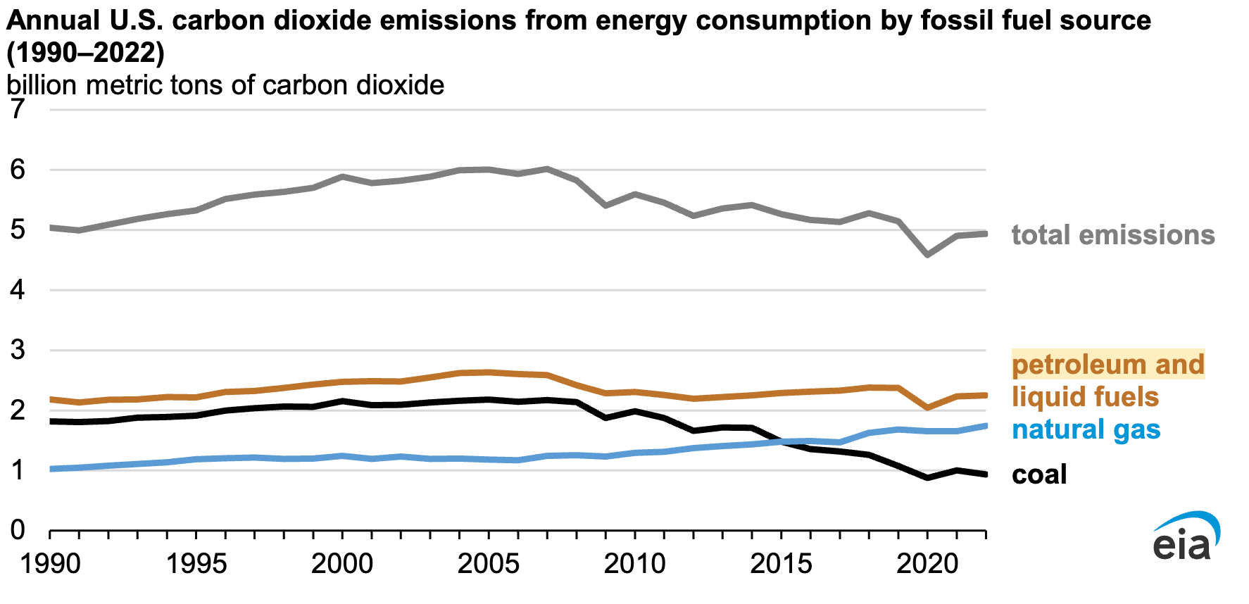

*Data source: U.S. Energy Information Administration, Monthly Energy Review, October 2023*

<https://cleantechnica.com/2023/12/01/us-coal-electricity-dropped-in-2022-down-to-20-of-us-electricity/>

Driven by a 2% increase in transportation sector emissions and a combined 1% increase in the residential and commercial sectors, with industrial sector emissions declining by 2% and industrial activity decreasing by 3%, U.S. energy-related CO2 emissions increased slightly in 2022 to 4,939 MMmt from 4,905 MMmt in 2021.[3] Coal emissions peaked at 2,180 MMmt in 2005, and have fallen 57% through 2024, mostly because of decreasing global coal demand and increasing competition from natural gas. From January 2021 and December 2022, U.S. coal-fired generation capacity declined by more than 25,000 megawatts, while natural gas-fired capacity increased by over 17,000 megawatts, while zero-carbon generation grew its share of the total generation mix from 39% in 2021 to 40% in 2022.[4]

**Chart 13. Electricity Net Generation Total (All Sectors)**

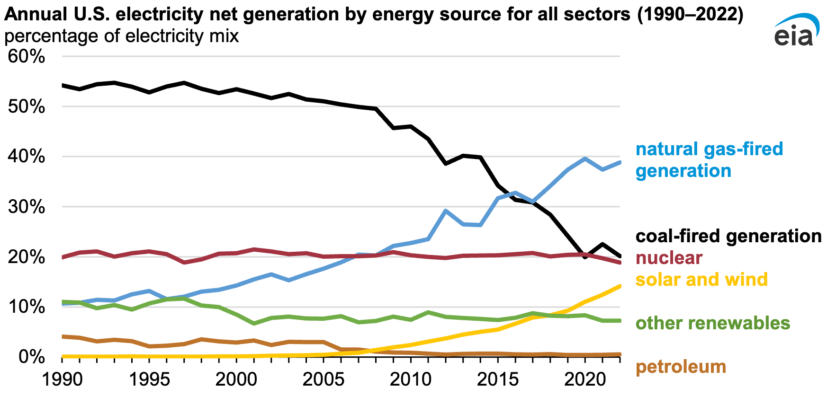

*Data source: U.S. Energy Information Administration, Monthly Energy Review, October 2023,*

[*https://cleantechnica.com/2023/12/01/us-coal-electricity-dropped-in-2022-down-to-20-of-us-electricity/*](https://cleantechnica.com/2023/12/01/us-coal-electricity-dropped-in-2022-down-to-20-of-us-electricity/)

*Note: Zero-carbon generation does not include generation from distributed energy sources or small-scale solar PV.*

A study estimates that U.S. coal ash contains 11 million tons of rare earth elements, which is nearly eight times the country’s known domestic reserves (Khollam, 2025). Also due to technological advancements, old coal mines have become prime targets to extract rare earth minerals. Specifically, old coal mines in Wyoming and West Virginia have received government funding and attention from private companies for the advancement of a new method to extract and separate rare earth elements and critical minerals from acid mine drainage and coal waste (Frangoul, 2023).

Carbon capture technology traps carbon dioxide from industrial operations before emissions enter the atmosphere and stores it underground, and can be a useful tool for achieving net zero emissions in some sectors. However, the IEA says that the global oil and gas industry needs to move in from the view that carbon capture technology is a solution to climate change, as just 1% of global investment in clean energy has come from oil and gas companies, with 2.5% of the industry’s capital spending went toward clean energy in 2022.[5] In order to meet the goal of limiting climate change to 1.5 degrees Celsius, and capture 32 billion tons of carbon, the oil and gas industry would need to invest 50% of capital expenditures in clean energy projects by 2030.

To collect this much carbon would require 26,000 terawatt hours of electricity to operate in 2050, more than total global demand in 2022, and would also require $3.5 trillion in annual investment from 2023 through 2050. U.S. oil major players such as Exxon Mobil and Chevron are investing billions in carbon capture technology, hydrogen, and buying oil companies such as Pioneer Natural Resources and Hess, while European majors Shell and BP have focused more on renewables such as solar and wind (Kimball, 2023).

**Solar Curtailment and Solar Bidding**

Solar curtailment, deliberately reducing output, is a process to control solar generation capacity and maintain the stability and reliability of the electric grid as solar penetration increases and more resources are brought online. PV curtailment can be used to integrate more renewable energy into the grid by connecting renewables projects that are struggling to obtain grid connections via taking fossil fuel generation offline. Curtailment is a natural process in the evolution of electricity systems with high penetrations of intermittent sources such as wind and solar, and serves a purpose in increasing the generation capacity of renewable energy sources. PV curtailment is important because the new renewable energy installations need to be integrated and utilized efficiently, and the investment returns of power companies for these new renewable energy projects need to be protected. When curtailment policy is strictly enforced, the scale of renewable energy projects in regions with high abandonment rates must be closely monitored, because there are fewer new projects in these regions. Even though installation costs have dropped and return on investment has increased for power projects due to advancements in solar technologies, curtailment regulations have bootstrapped energy companies in meeting installation targets, meaning many projects never are approved for construction. Solar power is said to be curtailed, or constrained-off, when the output of a renewable resource is reduced from what it could have otherwise produced. Solar curtailment can apply to either large PV power plants, solar farms, or smaller residential rooftop solar PV systems, where these systems are remotely shut down by the grid operator when there is a risk of grid overload. When curtailment is enacted, rooftop solar can soak up excess solar power by charging electric cars, home batteries, and hot water storage systems (Shaw, 2024A; Rüther and Blakers, 2025C).

Along with renewable curtailment schemes, negative electricity prices also contribute to more renewable energy sources being brought online, and consequently less use of coal fired plants during the daytime when the sun is shining. Solar curtailment might be necessitated by times of high solar irradiance and or moderate-low electricity demand (Rüther and Blakers, 2025C). One option for bypassing curtailment is to install an ultra-high voltage transmission network, as curtailment rises as solar generation exceeds available transmission capacity. Either advanced transmission infrastructure or battery energy storage capacity is needed to resolve temporary gluts of generation due to increased intermittent solar generation. There are two reasons curtailment occurs: 1) when there is congestion, when power lines don’t have enough capacity to deliver the power, or 2) during oversupply, when electricity generation exceeds customer demand (Kennedy, 2023). Solutions to curtailment include: 1) connecting to a larger electric grid whereby the ISO can buy and sell energy to balance supply and demand; for example, CAISO participates in the Western Energy Imbalance Market (WEIM) 2) expand transmission capacity buy building new lines to alleviate congestion, and 3) develop of flexible resources that can respond to demand, such as battery storage. For example, a 5% curtailment means that the utilization rates of solar and wind power projects can not fall below 95%. In 2018 China instituted a 5% curtailment cap on solar and wind (Shaw, 2024A).

The duck curve, or variations such as the canyon curve, represents the impact of solar generation on the electrical grid load curve, or the effect of intermittent renewables on traditional centralized transmission grid operation. In the electric grid with intermittent solar, there is a mismatch between peak solar generation (mid-day to afternoon) and peak electricity demand (late afternoon and evenings). The duck curve, shaped like an outline of a duck, shows the peaks and valleys of this mismatch throughout a typical day. For example, Chart 15 shows the duck curve in California, which is deepening as more solar generation is brought online, making it more difficult for the California Independent System Operator (CAISO) to balance the grid. To balance the duck curve and shorten the duck’s neck, either conventional fossil fuel power plants must be ramped up from midday to late evenings to satisfy demand, or large-scale battery energy storage systems must be installed (Kennedy, 2023).”

**Chart 15. California Duck Curve**

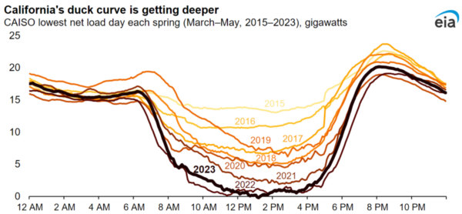

Image: EIA

<https://pv-magazine-usa.com/2023/10/31/california-is-curtailing-more-solar-power-than-ever-before/>

California is the leading U.S. state in installed solar cell capacity, and actively engages in solar power curtailment, primarily due to congestion. Out of the 2.4 million MWh of solar and wind generation California Independent System Operator (CAISO) curtailed in 2022, solar accounts for 95% of that total, according to Chart 16. In California, congestion-related curtailments have risen since 2019 as solar generation additions outpace transmission lines and battery storage additions, per Chart 17. Solar power is curtailed most by CAISO in the spring when electricity demand is generally low due to moderate temperatures and production is relatively high due to sunnier conditions, see Chart 18 (Kennedy, 2023).

**Chart 16. CAISO Monthly Wind and Solar Curtailments**

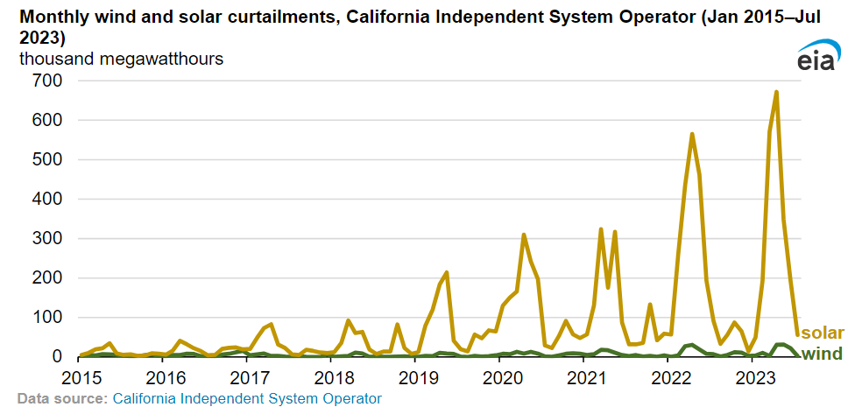

*Image: Energy Information Administration,* <https://pv-magazine-usa.com/2023/10/31/california-is-curtailing-more-solar-power-than-ever-before/>

**Chart 17. Curtailment by Cause, CAISO**

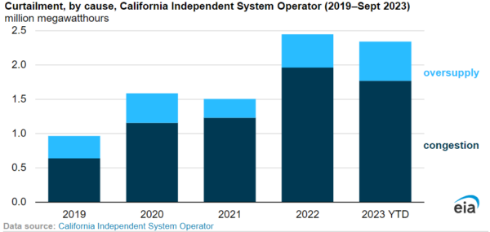

*Image: EIA,* <https://pv-magazine-usa.com/2023/10/31/california-is-curtailing-more-solar-power-than-ever-before/>

**Chart 18. Solar Production and Curtailments CAISO**

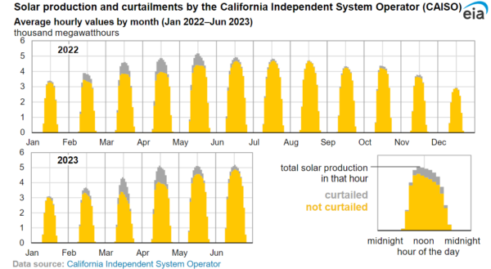

*Image: EIA,* <https://pv-magazine-usa.com/2023/10/31/california-is-curtailing-more-solar-power-than-ever-before/>

As of 2023, California possesses the largest energy storage market in the world, with a clean energy goal of 100% by 2045. California has increased its total energy storage capacity, primarily composed of lithium-ion batteries, to 6,600 MW in 2023 whereas from 100 MW in 2015, with targets of 19,500 MW of storage by 2035 and 52,000 MW by 2045 (Richardson, 2023). California has high electricity prices, not due to renewables, rather due to high fossil gas prices and the cost of upgrading aging transmission and distribution lines (Jacobson et al., 2025; Bellini, 2025C). In a developing trend in America, utilities in California and nationwide are fighting rooftop solar, which presents a major threat to their effective monopoly on the electricity market. California has moved to eliminate rooftop solar, as from 2022-2024, California has gutted net metering, or the payment for exporting solar from the home to the grid, by about 80%, and has created strict labor rules for commercial solar installations. In fact, California has instituted rules that require multimeter properties like schools and farms to sell their own solar energy production to the grid at a low price and buy it back at a significantly higher price (Kennedy, 2024D).

Researchers have analyzed Netherlands electricity markets to look for trends in and determinants of negative electricity prices. A clear correlation between the expected solar and wind energy for the following day and the negative hourly prices in the day-ahead market has been uncovered, with negative prices most common in the summer months during the day, especially on weekends, holidays, and during vacation periods when expected consumption is lower. Another contributor to negative electricity prices is stronger winds during the nights and colder months (Bellini, 2024A). PV asset owners can hedge default risk in the utility-scale PV business by transferring default risk to a protection seller using credit default swaps (CDS). A CDS is a financial contract which protects one party against the losses from the default of a borrower by buying protection from another party. The problem with PPAs, power purchase agreements, which have traditionally served as the cornerstone of revenue certainty for renewable energy projects, is that they lack protection against risks such as default scenarios, resource data inaccuracies, or changes in tax and market conditions (Jadidi et al., 2025; Bellini, 2025C). Visser et al. (2024) developed an operational stochastic bidding strategy for the day-after and the intraday markets using a technique that transforms results from probabilistic solar power forecasts models into actual interdependent scenarios (Visser et al., 2024; Kahana, 2024).

Khalili, S., Keiner, D., and Breyer, C. (2025A) PV Magazine, Flexibility options are a central concept for highly renewable energy systems research,

<https://www.pv-magazine.com/2025/05/13/flexibility-options-are-a-central-concept-for-highly-renewable-energy-systems-research/>

Khalili, S., Keiner, D., and Breyer, C. (2025B) Role and trends of flexibility options in 100% renewable energy system analyses towards the Power-to-X Economy, Renewable and Sustainable Energy Reviews, Volume 212, 115383, <https://doi.org/10.1016/j.rser.2025.115383>

To address the variability of renewable energy for a stable supply, 22 distinct types of flexibility options are found in 100% renewable energy systems research articles, categorized into power-to-X, energy storage, demand response, transmission and distribution grids, and curtailment. The groups with the most diverse flexibility options are PtX and energy storage. PtX processes serve as the technological solution for sector coupling as the central element of the Power-to-X Economy. The PtX concept includes processes that use electricity across various sectors, such as heating, electromobility, industry, and the production of electricity-based fuels (e-fuels), but also e-chemicals, and e-materials. PtX processes can use power from any electricity source, but using non-renewable energy goes against the main goal of cutting costs and moving away from fossil fuels. Europe significantly outperforms other regions in terms of flexibility options research, since a greater number of studies choose either Europe as a whole or specific European countries as case studies for their analyses. On a global scale, the PtX route for e-hydrogen has proven to be the most widely used technology. In Eurasia, e-methane is the most frequently applied. In the Middle East, seawater reverse osmosis (SWRO) desalination is a commonly employed technology, used in the same frequency as DACCU. The results show that batteries have the highest share of energy storage across all regions. Europe significantly outperforms other regions in terms of flexibility options research, since a greater number of studies choose either Europe as a whole or specific European countries as case studies for their analyses. On a global scale, the PtX route for e-hydrogen has proven to be the most widely used technology. In Eurasia, e-methane is the most frequently applied. In the Middle East, seawater reverse osmosis (SWRO) desalination is a commonly employed technology, used in the same frequency as DACCU. The results show that batteries have the highest share of energy storage across all regions. Europe significantly outperforms other regions in terms of flexibility options research, since a greater number of studies choose either Europe as a whole or specific European countries as case studies for their analyses. On a global scale, the PtX route for e-hydrogen has proven to be the most widely used technology. In Eurasia, e-methane is the most frequently applied. In the Middle East, seawater reverse osmosis (SWRO) desalination is a commonly employed technology, used in the same frequency as DACCU. The results show that batteries have the highest share of energy storage across all regions (Khalili et al., 2025A; Khalili et al., 2025B).

Molina, Pilar Sánchez (2025) PV Magazine, Nuclear has highest investment risk; solar shows lowest, say US researchers,

<https://www.pv-magazine.com/2025/05/21/nuclear-power-carries-highest-investment-risk-solar-shows-lowest-say-us-researchers/>

Sovacool, B.K. and Ryu, H. (2025) Beyond economies of scale: Learning from construction cost overrun risks and time delays in global energy infrastructure projects, Energy Research & Social Science, Volume 123, 104057, <https://doi.org/10.1016/j.erss.2025.104057>

Nuclear power plants exceed construction budgets by an average of 102.5%, costing $1.56 billion more than planned, according to a study by Boston University’s Institute for Global Sustainability. A new study by the Institute for Global Sustainability at Boston University found that energy infrastructure projects exceeded planned construction costs in more than 60% of cases. The study covered a wide range of project types. These included thermoelectric power plants fueled by coal, oil or natural gas, as well as nuclear reactors, hydroelectric facilities and wind farms. It also examined large-scale PV and concentrated solar installations, high-voltage transmission lines, bioenergy and geothermal plants, hydrogen production sites, and carbon capture and storage systems. Nuclear power plants had the highest cost overruns and delays, with average construction costs exceeding estimates by 102.5%, or $1.56 billion. Hydroelectric projects followed at 36.7%, then geothermal (20.7%), carbon capture (14.9%), and bioenergy (10.7%). Wind projects averaged a 5.2% cost increase, while hydrogen projects came in at 6.4%. By contrast, PV plants and transmission infrastructure recorded cost underruns of 2.2% and 3.6%, respectively. Construction delays also varied by technology. Nuclear, hydro, and geothermal projects experienced average delays of 35, 27, and 11 months, respectively. PV and transmission builds had the best performance, typically completing ahead of schedule or with only minimal delays – averaging one month if delayed at all (Sovacool and Ryu, 2025; Molina, 2025).

Kennedy, Ryan (2025) PV Magazine, Abandoned coalmines could host 10% of global solar capacity,

<https://www.pv-magazine-australia.com/2025/06/20/abandoned-coalmines-could-host-10-of-global-solar-capacity/?utm_source=Global+%7C+Newsletter&utm_campaign=e6feff3132-dailynl_gl&utm_medium=email&utm_term=0_6916ce32b6-e6feff3132-160603208>

A survey of mines closed since 2020 and those planned to close by 2030 present an opportunity for installing nearly 300 GW solar on already-developed lands, finds a report from Global Energy Monitor. Global Energy Monitor finds that abandoned coal mines could host nearly 300 GW of additional solar capacity, nearly 15% of the cumulative global total capacity. Global Energy Monitor surveyed global coal mine closures since 2020, finding that these sites of scarred land could host 103 GW of solar. It found that coal mines planned to be closed by 2030 could host another 185 GW. Together, this 288 GW solar potential is enough to power the annual needs of a large country like Germany, said the report. What’s more, all of the abandoned and upcoming closures are in relatively close proximity to existing transmission lines and substations, said the report. Most (96%) of recently abandoned mines are less than 10 km from the grid, and 91% are within 10 km of a grid connection point, such as a substation, it found (Kennedy, 2025).

## **Largest 24 Power Plants in North Carolina**

| **Plant** | **Utility** | **NC City** | **Annual Generation** |
| --- | --- | --- | --- |
| [Asheville](https://www.gridinfo.com/plant/asheville/2706) | [Duke Energy Progress - (NC)](https://www.gridinfo.com/duke-energy-progress-nc) | Arden | 3.9 TWh |
| [Belews Creek](https://www.gridinfo.com/plant/belews-creek/8042) | [Duke Energy Carolinas, LLC](https://www.gridinfo.com/duke-energy-carolinas-llc) | Belews Creek | 9.6 TWh |
| [Brunswick Nuclear](https://www.gridinfo.com/plant/brunswick-nuclear/6014) | [Duke Energy Progress - (NC)](https://www.gridinfo.com/duke-energy-progress-nc) | Southport | 15.6 TWh |
| [Buck](https://www.gridinfo.com/plant/buck/2720) | [Duke Energy Carolinas, LLC](https://www.gridinfo.com/duke-energy-carolinas-llc) | Salisbury | 4.3 TWh |
| [Cheoah](https://www.gridinfo.com/plant/cheoah/54899) | [Brookfield Smoky Mountain Hydropower LP](https://www.gridinfo.com/brookfield-smoky-mountain-hydropower-lp) | Tapoco | 447.8 GWh |
| [Cleveland Cnty Generating Facility](https://www.gridinfo.com/plant/cleveland-cnty-generating-facility/57029) | [Southern Power Co](https://www.gridinfo.com/southern-power-co) | Kings Mountain | 640.9 GWh |
| [Dan River](https://www.gridinfo.com/plant/dan-river/2723) | [Duke Energy Carolinas, LLC](https://www.gridinfo.com/duke-energy-carolinas-llc) | Eden | 4.7 TWh |
| [Desert Wind Farm, LLC](https://www.gridinfo.com/plant/desert-wind-farm-llc/59968) | [Avangrid Renewables LLC](https://www.gridinfo.com/avangrid-renewables-llc) | Hertford | 513.5 GWh |
| [Domtar Paper Co LLC Plymouth NC](https://www.gridinfo.com/plant/domtar-paper-co-llc-plymouth-nc/50189) | [Domtar Paper Company LLC](https://www.gridinfo.com/domtar-paper-company-llc) | Plymouth | 344.1 GWh |
| [Fontana Dam](https://www.gridinfo.com/plant/fontana-dam/2779) | [Tennessee Valley Authority](https://www.gridinfo.com/tennessee-valley-authority) | Fontana Dam | 813.6 GWh |
| [Harris](https://www.gridinfo.com/plant/harris/6015) | [Duke Energy Progress - (NC)](https://www.gridinfo.com/duke-energy-progress-nc) | New Hill | 7.7 TWh |
| [James E. Rogers Energy Complex](https://www.gridinfo.com/plant/james-e-rogers-energy-complex/2721) | [Duke Energy Carolinas, LLC](https://www.gridinfo.com/duke-energy-carolinas-llc) | Cliffside | 4.5 TWh |
| [Kings Mountain Energy Center](https://www.gridinfo.com/plant/kings-mountain-energy-center/59325) | [Carolina Power Partners, LLC](https://www.gridinfo.com/carolina-power-partners-llc) | Kings Mountain | 3.3 TWh |
| [L V Sutton Combined Cycle](https://www.gridinfo.com/plant/l-v-sutton-combined-cycle/58697) | [Duke Energy Progress - (NC)](https://www.gridinfo.com/duke-energy-progress-nc) | Wilmington | 4.0 TWh |
| [Lee Combined Cycle Plant](https://www.gridinfo.com/plant/lee-combined-cycle-plant/58215) | [Duke Energy Progress - (NC)](https://www.gridinfo.com/duke-energy-progress-nc) | Goldsboro | 6.6 TWh |
| [Marshall (NC)](https://www.gridinfo.com/plant/marshall-nc/2727) | [Duke Energy Carolinas, LLC](https://www.gridinfo.com/duke-energy-carolinas-llc) | Terrell | 7.8 TWh |
| [Mayo](https://www.gridinfo.com/plant/mayo/6250) | [Duke Energy Progress - (NC)](https://www.gridinfo.com/duke-energy-progress-nc) | Roxboro | 978.0 GWh |
| [McGuire](https://www.gridinfo.com/plant/mcguire/6038) | [Duke Energy Carolinas, LLC](https://www.gridinfo.com/duke-energy-carolinas-llc) | Huntersville | 20.0 TWh |
| [Narrows (NC)](https://www.gridinfo.com/plant/narrows-nc/54894) | [Eagle Creek Renewable Energy, LLC](https://www.gridinfo.com/eagle-creek-renewable-energy-llc) | Badin | 462.5 GWh |
| [Rockingham County CT Station](https://www.gridinfo.com/plant/rockingham-county-ct-station/55116) | [Duke Energy Carolinas, LLC](https://www.gridinfo.com/duke-energy-carolinas-llc) | Reidsville | 1.5 TWh |
| [Rowan](https://www.gridinfo.com/plant/rowan/7826) | [Southern Power Co](https://www.gridinfo.com/southern-power-co) | Salisbury | 4.2 TWh |
| [Roxboro](https://www.gridinfo.com/plant/roxboro/2712) | [Duke Energy Progress - (NC)](https://www.gridinfo.com/duke-energy-progress-nc) | Semora | 7.2 TWh |
| [Sherwood H Smith Jr Energy Complex](https://www.gridinfo.com/plant/sherwood-h-smith-jr-energy-complex/7805) | [Duke Energy Progress - (NC)](https://www.gridinfo.com/duke-energy-progress-nc) | Hamlet | 9.6 TWh |
| [Walters](https://www.gridinfo.com/plant/walters/2715) | [Duke Energy Progress - (NC)](https://www.gridinfo.com/duke-energy-progress-nc) | Waterville | 321.0 GWh |

Source: GridInfo.com

Table I. shows that Duke Energy, under either Duke Energy Progress (nine) or Duke Energy Carolinas (seven), owns 16 of the top 24 power plants in North Carolina, representing an annual generation of 55.899 TWh for Duke Progress Energy and 52.4 TWh for Duke Energy Carolinas, for a total of 108.299 TWh for Duke Energy from the top 24 power plants in North Carolina. Per Grid Info, North Carolina’s total annual generation for 2024 was 136.2 TWh. The 108.299 TWh represents capacity, not actual generation, but we can see that Duke Energy’s percentage of generation capacity for the top 24 power plants to actual generation output for 2024 is 108.299 / 136.2 = 79.5%. The number certainly qualifies as monopoly status for Duke Energy in North Carolina, even though since it is not 100%, the North Carolina power plant industry would technically still be an oligopoly, with the likes of Duke Energy, Southern Power Co, the Tennessee Valley Authority, and several smaller operators.

**Butler-Warner Generation Plant, Fayetteville, NC**

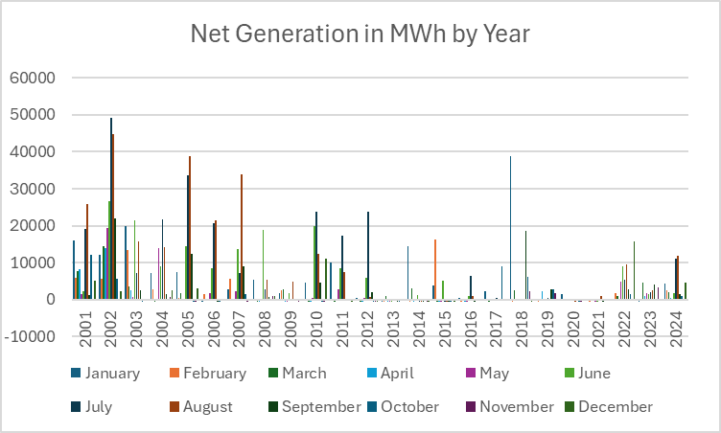

**Butler-Warner Plant, Net Generation MWh**

|  | 2001 | 2002 | 2003 | 2004 | 2005 | 2006 | 2007 | 2008 | 2009 | 2010 |
| --- | --- | --- | --- | --- | --- | --- | --- | --- | --- | --- |
| January | 15913 | 12084 | 19866 | 7153 | 7399 | -543 | 2780 | 5340 | 1816 | 4534 |
| February | 5878 | 5582 | 13297 | 2834 | 544 | 1378 | 5523 | -210 | 2557 | 146 |
| March | 7639 | 14590 | 3607 | -505 | 1678 | -406 | -395 | -515 | 2799 | -547 |
| April | 8233 | 13904 | 2527 | -312 | -164 | -193 | -431 | -479 | -462 | -484 |
| May | 1427 | 19402 | 681 | 14054 | 96 | 1675 | 2338 | 15 | -468 | 528 |
| June | 2356 | 26743 | 21438 | 9123 | 14467 | 8622 | 13741 | 18994 | 1770 | 19913 |
| July | 18998 | 49246 | 7255 | 21649 | 33583 | 20645 | 7118 | 2928 | -169 | 23891 |
| August | 25980 | 44861 | 15775 | 14154 | 38727 | 21571 | 33856 | 5482 | 4897 | 12485 |
| September | 1121 | 22027 | 2576 | 1429 | 12463 | -467 | 8913 | 766 | -107 | 4615 |
| October | 12026 | 5668 | -443 | -222 | -478 | -483 | 1547 | -349 | -395 | -481 |
| November | 39 | 118 | -188 | 757 | -496 | -346 | -517 | 905 | -485 | -507 |
| December | 5069 | 2201 | 2 | 2508 | 3016 | -274 | -55 | 997 | -364 | 11171 |

**Butler-Warner Plant, Net Generation MWh**

|  | 2011 | 2012 | 2013 | 2014 | 2015 | 2016 | 2017 | 2018 | 2019 | 2020 |
| --- | --- | --- | --- | --- | --- | --- | --- | --- | --- | --- |
| January | 10161 | 451 | -573 | 14440 | 3811 | 354 | 2387 | 38799 | -336 | 1409 |
| February | 72 | -261 | -530 | -548 | 16386 | -551 | -354 | -440 | -506 | -403 |
| March | -493 | -442 | 967 | 2994 | -550 | -265 | -551 | 2612 | -272 | -338 |
| April | -154 | -468 | -541 | -485 | -476 | -485 | -113 | -102 | 2332 | -85 |
| May | 2730 | 457 | -502 | -67 | -447 | -496 | -37 | -6 | -46 | 80 |
| June | 8530 | 5863 | -487 | 1165 | 5096 | 1004 | -29 | 12 | 164 | -60 |
| July | 17303 | 23684 | 39 | -499 | -477 | 6339 | 407 | -222 | 495 | -41 |
| August | 7352 | 748 | -200 | -506 | -496 | 928 | -75 | 157 | 322 | -461 |
| September | -257 | 2137 | -491 | -624 | -501 | -515 | 108 | 18640 | 2819 | -426 |
| October | -121 | -492 | -508 | -375 | -527 | -355 | 9043 | 6113 | 2762 | -511 |
| November | -77 | -444 | 259 | -552 | -429 | -212 | -102 | 2205 | 1782 | -506 |
| December | -542 | -539 | -86 | -567 | -523 | -202 | -388 | -505 | -424 | -416 |

**Butler-Warner Plant, Net Generation MWh**

|  | 2021 | 2022 | 2023 | 2024 |
| --- | --- | --- | --- | --- |
| January | -292 | 251 | -459 | 4366 |
| February | -509 | 1733 | -74 | 2466 |
| March | 258 | 1007 | 4546 | 2064 |
| April | -415 | -198 | 915 | 413 |
| May | -474 | 4811 | 1777 | 29 |
| June | -477 | 9135 | 1392 | 1641 |
| July | -102 | 5410 | 1971 | 11138 |
| August | 1000 | 9604 | 2623 | 11920 |
| September | -458 | 2736 | 4171 | 1621 |
| October | 191 | 1548 | -325 | 1090 |
| November | -286 | -392 | 3240 | -135 |
| December | -320 | 15809 | -360 | 4740 |

**Innovative Solar 46, Fayetteville, NC**

|  | 2017 | 2018 | 2019 | 2020 | 2021 | 2022 | 2023 | 2024 |
| --- | --- | --- | --- | --- | --- | --- | --- | --- |
| January | 6863 | 9621.81 | 7299 | 8448 | 8051 | 8583 | 7179 | 8355 |
| February | 11282 | 7889 | 6818 | 8807 | 7700 | 9873 | 8298 | 7179 |
| March | 12308 | 13402 | 12044 | 11080 | 11517 | 13330 | 12511 | 13167 |
| April | 14016 | 15334 | 15418 | 16501 | 17767 | 17839 | 13916 | 13787 |
| May | 17359 | 14255 | 18362 | 15829 | 17671 | 17030 | 14894 | 14641 |
| June | 16162 | 17158 | 16066 | 15254 | 15295 | 15739 | 15117 | 16745 |
| July | 18448 | 15831 | 17521 | 18595 | 15943 | 15171 | 14152 | 16358 |
| August | 14123 | 16435 | 14879 | 13595 | 14645 | 13930 | 14882 | 13553 |
| September | 15171 | 10334 | 14306 | 11445 | 14088 | 12876 | 12714 | 9866 |
| October | 12437 | 11892 | 10722 | 11782 | 11201 | 10791 | 12428 | 12243 |
| November | 10245 | 8029 | 8982 | 9044 | 10288 | 8098 | 9316 | 7902 |
| December | 7564 | 6103 | 7433 | 8267 | 7286 | 6186 | 5905 | 7160 |

**Innovative Solar 46, Fayetteville, NC**

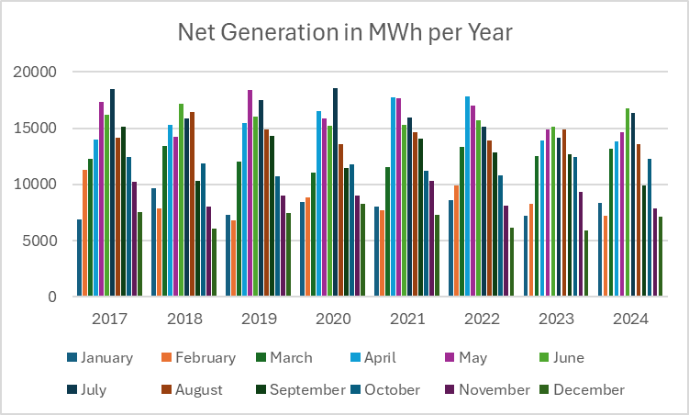

**Innovative Solar 42, Fayetteville, NC**

|  | 2018 | 2019 | 2020 | 2021 | 2022 | 2023 | 2024 |
| --- | --- | --- | --- | --- | --- | --- | --- |
| January | 8979 | 7917 | 7783 | 7130 | 8178 | 6753 | 8016 |
| February | 7496 | 6927 | 8360 | 6819 | 9568 | 7825 | 9828 |
| March | 12746 | 12432 | 10226 | 10250 | 12319 | 11964 | 12251 |
| April | 15026 | 13937 | 15531 | 16475 | 16726 | 13907 | 13860 |
| May | 14932 | 7619 | 14835 | 16355 | 15357 | 14248 | 14013 |
| June | 17087 | 15502 | 10982 | 14224 | 14870 | 14872 | 15178 |
| July | 15462 | 15566 | 16353 | 15134 | 14035 | 14850 | 12527 |
| August | 15727 | 13569 | 11760 | 13808 | 12868 | 14878 | 6470 |
| September | 7591 | 13324 | 10007 | 13224 | 12407 | 12610 | 8247 |
| October | 7382 | 9954 | 10265 | 10718 | 11258 | 11842 | 10602 |
| November | 5700 | 8202 | 7867 | 9474 | 8209 | 8766 | 6812 |
| December | 5224 | 6736 | 7107 | 6781 | 6188 | 7128 | 6637 |

**Innovative Solar 42, Fayetteville, NC**

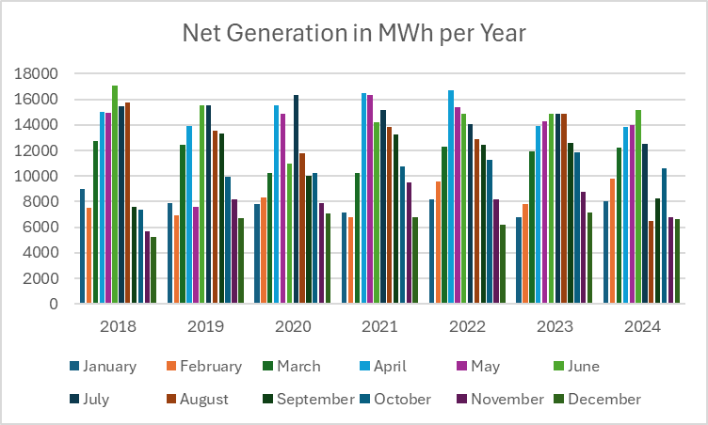

**DD Solar, Fayetteville, NC**

|  | 2016 | 2017 | 2018 | 2019 | 2020 | 2021 | 2022 | 2023 |
| --- | --- | --- | --- | --- | --- | --- | --- | --- |
| January | 1908.728 | 2121.601 | 1563.505 | 1842.542 | 2327.284 | 2061.739 | 2188.296 | 2495 |
| February | 1964.428 | 2590.011 | 1370.436 | 1775.801 | 2391.75 | 2014.042 | 2441.788 | 2660 |
| March | 3873.73 | 3188.569 | 1979.696 | 2942.331 | 3059.284 | 3304.008 | 3183.897 | 3469 |
| April | 3256.599 | 3473.082 | 2430.875 | 3023.649 | 4155.309 | 4439.679 | 4132.864 | 3877 |
| May | 2858.44 | 3796.799 | 2414.679 | 3435.078 | 4158.613 | 4474.101 | 3917.46 | 3984 |
| June | 3379.507 | 3247.395 | 2597.699 | 3328.96 | 4045.813 | 4121.56 | 4140.041 | 4030 |
| July | 3502.799 | 3623.957 | 2452.75 | 3700.845 | 4525.549 | 4453.373 | 3685.888 | 4146 |
| August | 4608.402 | 3271.695 | 2504.481 | 3295.65 | 3633.828 | 4058.905 | 3585.499 | 4200 |
| September | 3306.74 | 3141.853 | 1658.128 | 3005.386 | 3077.553 | 3796.836 | 3356.859 | 3256 |
| October | 2544.457 | 2735.854 | 1785.261 | 2383.055 | 3120.102 | 3117.429 | 2814.565 | 3588 |
| November | 1813.429 | 2416.506 | 1294.664 | 2052.276 | 2609.537 | 2931.645 | 2197.982 | 2980 |
| December | 2932.741 | 1975.678 | 1069.826 | 1820.427 | 2205.378 | 2141.683 | 1721.861 | 2565 |

**DD Solar, Fayetteville, NC**

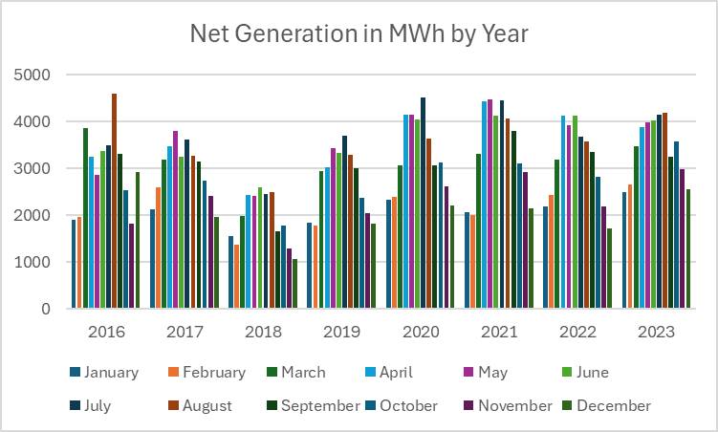

**Felt Map of North Carolina Power Plants**

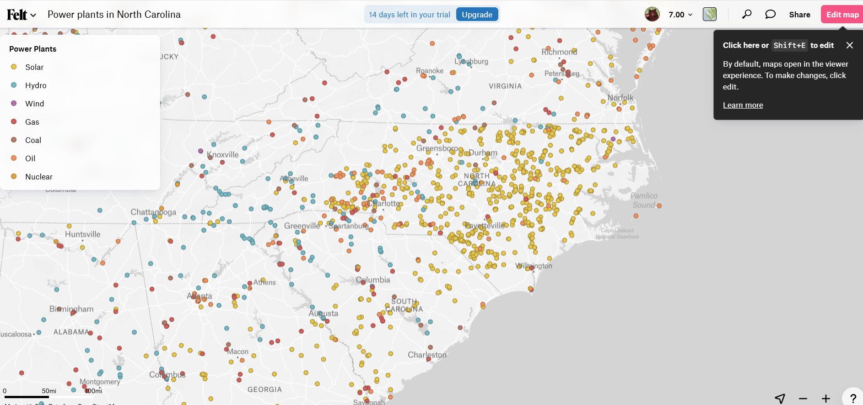

Source: Felt

As you can see from the map, the distribution of solar farms in North Carolina is more strongly dispersed on the plains, where land is flat. The mountain region has a small amount of solar farms, because you need flat agricultural land for solar farms.

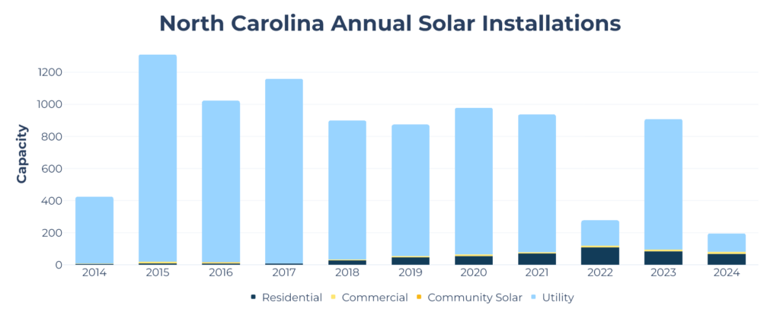

Source: SEIA

Renewable energy, North Carolina ranks fifth in the nation in solar power generation.

In 2023, renewable sources produced about 15% of the total electricity generated in North Carolina, with the sum of utility-scale (1 megawatt or larger) and small-scale (less than 1 megawatt) solar facilities providing the largest share, at about two-thirds of all renewables. The amount of electricity generated from solar energy increased rapidly in recent years. In 2017, solar energy became the largest source of the state's renewable electricity generation, surpassing conventional hydroelectric power for the first time. In 2023, solar power provided about 10% of the state's total generation.41 At the end of 2023, North Carolina ranked fourth in the nation in solar generating capacity, with nearly 6,600 megawatts, and fifth in total solar power generation.42,43

Hydroelectric power is the second-largest source of renewable electricity in North Carolina and accounted for 3% of the state's total generation in 2023.44 Most of North Carolina's 40 utility-scale hydroelectric dams with about 2,000 megawatts of generating capacity are found in the mountainous region in the western part of the state. The state has the first pumped-storage power facility with reversible turbines in the United States, with 86 megawatts of generating capacity, located at the Hiwassee Dam near the border with Tennessee.45,46,47

Biomass provided 1% of North Carolina's generation in 2023. Wood- and wood waste-fueled power plants account for about three-fourths of the generating capacity at the state's biomass-fueled power plants.48 Swine and poultry waste are additional resources for biomass-fueled electricity generation in the state.49,50,51 North Carolina's forest biomass resources also provide feedstock for five wood pellet manufacturing plants in the state that can produce 2.1 million tons of pellets each year.52 Wood pellets are used for heating and for electricity generation and 1 in 100 North Carolina households heat with wood.53,54

Wind energy has provided utility-scale power generation in North Carolina since 2016, when the state's first, and still only, wind farm came online in the northeastern part of the state with 208 megawatts of generating capacity from 104 turbines. It was the first coastal wind farm in the Southeast.55,56,57 In 2023, wind energy supplied 0.4% of North Carolina's electricity.58 The state has more undeveloped wind resources offshore and in its far western mountains.59 North Carolina's governor issued an executive order in 2021 that sets a goal for the state to have 2,800 megawatts of offshore wind power generating capacity by 2030 and 8,000 megawatts by 2040.60 In May 2022, the U.S. Department of the Interior leased two areas for wind power development in federal waters located about 25 miles off the North Carolina coastline near the border with South Carolina, known as the Carolina Long Bay lease.61 However, In January 2025, the federal government temporarily withdrew all federal offshore areas from leasing for wind energy development.62

North Carolina has one operating ethanol plant and one biodiesel plant. The ethanol plant has a production capacity of about 60 million gallons per year but is currently offline undergoing modifications and is scheduled to be operational by 2026. The biodiesel plant's production capacity is 2 million gallons.63,64,65 Although almost all the motor gasoline sold in the nation is E10 fuel, which is a blend of 10% ethanol and 90% gasoline, a motor fuel mixture containing up to 85% ethanol and 15% gasoline, known as E85, is sold at 94 public stations in North Carolina.66,67 Biodiesel is available at 108 private refueling stations across North Carolina that provide fuel to government and private fleets.68 North Carolina accounts for about 4% of U.S. ethanol consumption and about 1% of biodiesel consumption.69

In 2007, North Carolina became the first state in the Southeast to adopt a renewable portfolio standard, which required investor-owned electric utilities in the state to have 12.5% of their electricity retail sales come from renewable energy sources by 2021. That requirement was met. Rural electric cooperatives and municipal electric suppliers also met their target of obtaining 10% of their electricity sales from renewable sources by 2018. Additionally, the standard set statewide targets for increasing electricity generation from burning methane derived from swine and poultry waste for all power providers.70,71

North Carolina's governor signed clean energy legislation into law in October 2021 that will close some of the state's coal-fired power plants by 2030 and replace them with new generation from renewable sources. Under the law, the state's carbon emissions from electric generating facilities will be reduced 70% by 2030 and reach carbon neutrality by 2050.72,73

42 U.S. EIA, Electricity, Electric Power Annual (October 17, 2024), Table 4.7.B, Net Summer Capacity Using Primarily Renewable Energy Sources and by State, 2023 and 2022 (Megawatts).

43 U.S. EIA, Electricity, Electric Power Annual (October 17, 2024), Table 3.21, Net Generation from Solar Photovoltaic, Table 3.22, Utility Scale Facility Net Generation from Solar Thermal.

44 U.S. EIA, Electricity Data Browser, Net generation for all sectors (thousand megawatthours), North Carolina, 2001-23.

45 U.S. EIA, Electricity, Preliminary Monthly Electric Generator Inventory (based on Form EIA-860M as a supplement to Form EIA-860), Inventory of Operating Generators as of December 2024, Plant State: North Carolina, Technology: Conventional Hydroelectric, Hydroelectric Pumped Storage.

46 U.S. EIA, Renewable Electricity Infrastructure and Resources Dashboard, Filter by State: North Carolina, Filter by Primary Energy Source: Hydroelectric, Hydro - Pumped Storage, accessed January 13, 2025.

47 The American Society of Mechanical Engineers, Engineering History, Landmarks, #67 Hiwassee Dam Unit 2 Reversible Pump-Turbine, accessed January 13, 2025.

48 U.S. EIA, Electricity Data Browser, Net generation for all sectors (thousand megawatthours), North Carolina, 2001-23.

49 U.S. EIA, Electricity, Preliminary Monthly Electric Generator Inventory (based on Form EIA-860M as a supplement to Form EIA-860), Inventory of Operating Generators as of December 2024, Plant State: North Carolina, Technology: Landfill Gas, Wood/Wood Waste Biomass, Other Waste Biomass.

50 "The Carolina Poultry Power Project Fuels Our Electricity and Our Economy," NC Clean Energy Technology Center (September 23, 2021).

51 "North Carolina farms were properly approved to collect energy from hog waste, court says," Associated Press (December 5, 2023).

52 U.S. EIA, Monthly Densified Biomass Fuel Report, Table 1, Densified biomass fuel manufacturing facilities in the United States by state, region, and capacity, October 2024.

53 U.S. EIA, "New EIA survey collects data on production and sales of wood pellets," Today in Energy (December 14, 2016).

54 U.S. Census Bureau, Tables, Table B25040, House Heating Fuel, North Carolina, 2023 American Community Survey 1-Year Estimates.

55 U.S. EIA, Electricity Data Browser, Net generation for all sectors (thousand megawatthours), North Carolina, 2001-23.

56 U.S. EIA, Electricity, Preliminary Monthly Electric Generator Inventory (based on Form EIA-860M as a supplement to Form EIA-860), Inventory of Operating Generators as of December 2024, Plant State: North Carolina, Technology: Onshore Wind Turbine.

57 CleanEnergy.org, Amazon Wind Farm North Carolina - Desert Wind, accessed January 13, 2025.

58 U.S. EIA, Electricity Data Browser, Net generation for all sectors (thousand megawatthours), North Carolina, 2001-23.

59 U.S. Department of Energy, Energy Efficiency and Renewable Energy, WINDExchange, Wind Energy in North Carolina, accessed January 13, 2025.

60 Economic Development Partnership of North Carolina, North Carolina - Leading the Future of the Wind Energy Industry (March 2024), p. 2.

61 U.S. Department of the Interior, Bureau of Ocean Energy Management, Carolina Long Bay, accessed January 14, 2025.

62 The White House, "Temporary Withdrawal of All Areas on the Outer Continental Shelf From Offshore Wind Leasing and Review of the Federal Government's Leasing and Permitting Practices for Wind Projects," Press Release (January 20, 2025).

63 U.S. EIA, Petroleum & Other Liquids, U.S. Fuel Ethanol Plant Production Capacity Report (August 15, 2024), U.S. Fuel Ethanol Plant Production Capacity as of January 1, 2024 and Previous Issues: Year 2023, available in XLSX.

64 U.S. EIA, Petroleum & Other Liquids, U.S. Biodiesel Plant Production Capacity Report (August 15, 2024), Detailed annual production capacity by plant is available in XLSX format.

65 Benchmark Renewable Energy, "Benchmark Raeford North Carolina (Update)," Press Release (July 1, 2023).

66 U.S. EIA, "New EPA ruling expands sale of 15% ethanol blended motor gasoline," Today in Energy (July 16, 2019).

67 U.S. Department of Energy, Energy Efficiency and Renewable Energy, Alternative Fuels Data Center, Alternative Fueling Station Locator, North Carolina, Ethanol (E85), accessed January 14, 2025.

68 U.S. Department of Energy, Energy Efficiency and Renewable Energy, Alternative Fuels Data Center, Alternative Fueling Station Locator, North Carolina, Biodiesel (B20 and above), accessed January 14, 2025.

69 U.S. EIA, Table C2, Energy Consumption Estimates for Selected Energy Sources in Physical Units, 2022.

70 North Carolina Utilities Commission, Clean Energy and Energy Efficiency Portfolio Standards (CEPS), accessed January 30, 2025.

71 NC Clean Energy Technology Center, DSIRE, Clean Energy and Energy Efficiency Portfolio Standard, updated January 29, 2025.

72 General Assembly of North Carolina, House Bill 951, accessed January 14, 2025.

73 North Carolina Environmental Quality, Clean Energy Plan, accessed January 30, 2025.

U.S. Energy Information Administration (2023) Clean Technica. US Coal Electricity Dropped in 2022, Down to 20% of US Electricity. Retrieved December 4, 2023. <https://cleantechnica.com/2023/12/01/us-coal-electricity-dropped-in-2022-down-to-20-of-us-electricity/>

Frangoul, Anmar (2023) CNBC. Rare earth discoveries mean coal mines could have a key role to play in the energy transition. Retrieved November 24, 2023. <https://www.cnbc.com/amp/2023/11/24/rare-earth-discoveries-mean-coal-mines-could-have-a-future.html#amp_tf=From%20%251%24s&aoh=17008527536597&csi=0&referrer=https%3A%2F%2Fwww.google.com>

IEA (2023) Oil and gas industry faces moment of truth – and opportunity to adapt – as clean energy transitions advance, <https://www.iea.org/news/oil-and-gas-industry-faces-moment-of-truth-and-opportunity-to-adapt-as-clean-energy-transitions-advance>

Khollam, Aamir (2025) Interesting Engineering, Buried fortune: US finds $8.4 billion in rare earths sitting in coal ash landfills,

<https://interestingengineering.com/energy/rare-earth-worth-eight-billion-found>

Kimball, Spencer (2023) CNBC. Oil and gas industry needs to let go of carbon capture as solution to climate change, IEA says. Retrieved November 27, 2023. <https://www.cnbc.com/2023/11/23/oil-and-gas-industry-needs-to-let-go-of-carbon-capture-as-solution-to-climate-change-iea-says.html>

Shaw, Vincent (2024A) PV Magazine. China to increase PV curtailment. <https://www.pv-magazine.com/2024/04/04/china-to-increase-pv-curtailment/?utm_source=Global+%7C+Newsletter&utm_campaign=4320310547-dailynl_gl&utm_medium=email&utm_term=0_6916ce32b6-4320310547-160603208>

Rüther, Ricardo and Blakers, Andrew (2025C) PV Magazine, Curtailing solar photovoltaics is here to stay, overbuilding PV will become normal,

<https://www.pv-magazine.com/2025/01/02/curtailing-solar-photovoltaics-is-here-to-stay-overbuilding-pv-will-become-normal/>

Kennedy, Ryan (2023) PV Magazine. California is curtailing more solar power than ever before. Retrieved November 2, 2023. <https://pv-magazine-usa.com/2023/10/31/california-is-curtailing-more-solar-power-than-ever-before/>

Richardson, Jake (2023) Clean Technica. California Now Has A Little Over 6,600 MW Of Energy Storage. Retrieved November 5, 2023. <https://cleantechnica.com/2023/11/01/california-now-has-a-little-over-6600-mw-of-energy-storage/>

Jacobson, M.Z., Sambor, D.J., Fan, Y.F., Mühlbauer, A., and Delucchi, M.A. (2025) No blackouts or cost increases due to 100 % clean, renewable electricity powering California for parts of 98 days, Renewable Energy, Volume 240, 122262, <https://doi.org/10.1016/j.renene.2024.122262>.

Bellini, Emiliano (2025C) PV Magazine, ‘High electricity prices in California have nothing to do with renewables’,

<https://www.pv-magazine.com/2025/01/03/high-electricity-prices-in-california-have-nothing-to-do-with-renewables/?utm_source=Global+%7C+Newsletter&utm_campaign=15eb45e3e4-dailynl_gl&utm_medium=email&utm_term=0_6916ce32b6-15eb45e3e4-160603208>

Kennedy, Ryan (2024D) PV Magazine, California utilities scapegoat rooftop solar for high electricity rates,

<https://pv-magazine-usa.com/2024/11/15/california-utilities-scapegoat-rooftop-solar-for-high-electricity-rates/?utm_source=Global+%7C+Newsletter&utm_campaign=73370bd8c5-dailynl_gl&utm_medium=email&utm_term=0_6916ce32b6-73370bd8c5-160603208>

Bellini, Emiliano (2024A) PV Magazine, Netherlands posts more negative energy prices,

<https://www.pv-magazine.com/2024/08/16/netherlands-posts-more-negative-energy-prices/?utm_source=Global+%7C+Newsletter&utm_campaign=1a6ba955b3-dailynl_gl&utm_medium=email&utm_term=0_6916ce32b6-1a6ba955b3-160603208>

Jadidi, H., Firouzi, A., Rastegar, M.A., et al. (2025) Risk mitigation in project finance for utility-scale solar PV projects, Energy Economics, Volume 143, 108221, <https://doi.org/10.1016/j.eneco.2025.108221>

Bellini, Emiliano (2025C) PV Magazine, Mitigating default risk in large-scale PV projects through credit default swaps,

<https://www.pv-magazine.com/2025/01/30/mitigating-default-risk-in-large-scale-pv-projects-through-credit-default-swaps/?utm_source=Global+%7C+Newsletter&utm_campaign=f7d93fedad-dailynl_gl&utm_medium=email&utm_term=0_6916ce32b6-f7d93fedad-160603208>

Visser, L.R., AlSkaif, T.A., Khurram, A., Kleissl, J., van Sark, W. (2024) Probabilistic solar power forecasting: An economic and technical evaluation of an optimal market bidding strategy, Applied Energy, Volume 370, 123573, <https://doi.org/10.1016/j.apenergy.2024.123573>

Kahana, Lior (2024) PV Magazine, New bidding strategy for PV asset owners operating in spot market,

<https://www.pv-magazine.com/2024/08/08/new-bidding-strategy-for-pv-asset-owners-operating-in-spot-market/?utm_source=Global+%7C+Newsletter&utm_campaign=2a71bf6845-dailynl_gl&utm_medium=email&utm_term=0_6916ce32b6-2a71bf6845-160603208>

1. Murawski, John (2011-01-10). "Merger means uncertainty for Raleigh utility's workers". News & Observer. Archived from the original on 2011-01-11. Retrieved 2011-01-10.
2. U.S. Energy Information Administration (2023) Clean Technica. US Coal Electricity Dropped in 2022, Down to 20% of US Electricity. Retrieved December 4, 2023. <https://cleantechnica.com/2023/12/01/us-coal-electricity-dropped-in-2022-down-to-20-of-us-electricity/>
3. U.S. Energy Information Administration (2023) Clean Technica. US Coal Electricity Dropped in 2022, Down to 20% of US Electricity. Retrieved December 4, 2023.
4. U.S. Energy Information Administration (2023) Clean Technica. US Coal Electricity Dropped in 2022, Down to 20% of US Electricity. Retrieved December 4, 2023.
5. IEA (2023) Oil and gas industry faces moment of truth – and opportunity to adapt – as clean energy transitions advance, <https://www.iea.org/news/oil-and-gas-industry-faces-moment-of-truth-and-opportunity-to-adapt-as-clean-energy-transitions-advance>