Official U.S. Navy Discharge Protocol Manual
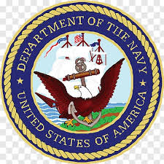

Kevin Sleem
In Collaboration with University of Cape Town Press
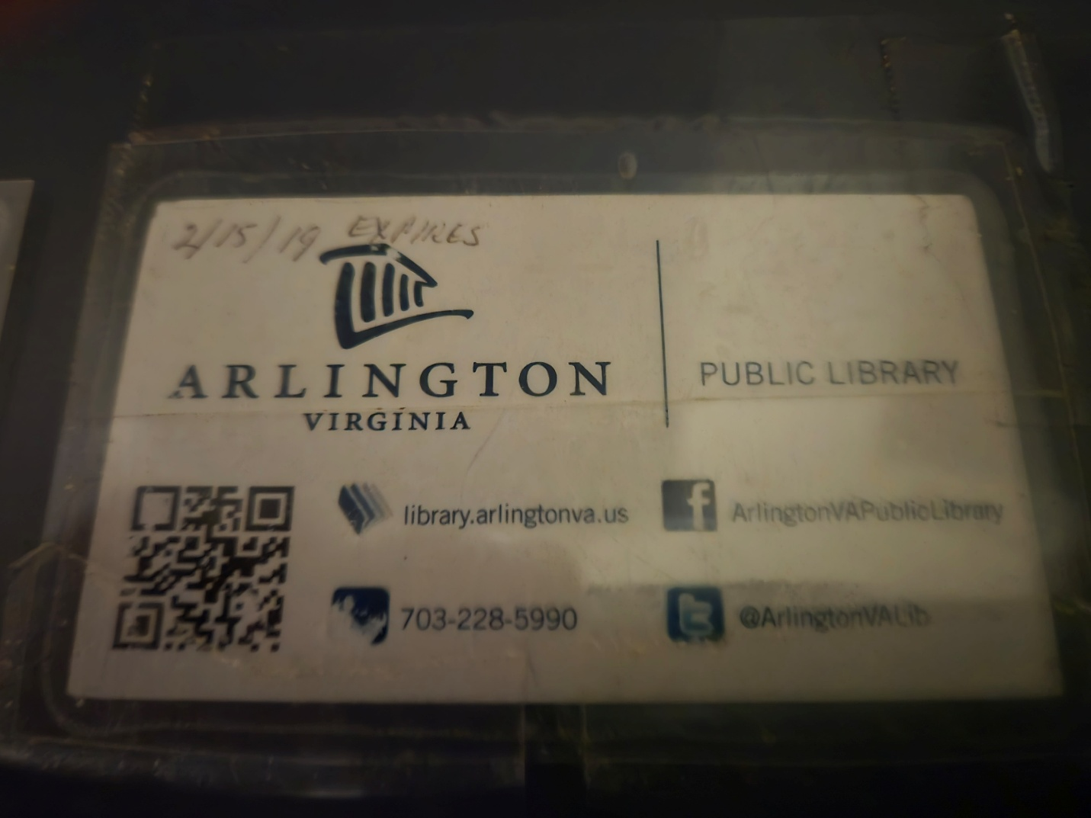

Court Martial Records for Kevin Sleem, U.S. Navy
Charleston, DUI, Nuke School, Barracks Housing
Mayport, Cocaine, Disrespect to a Superior Officer, Homeless on a Navy Ship

Submission to Fort Bragg Digital Library
University of Cape Town Press

Cumberland County and Arlington Libraries, Fayetteville State, Methodist, FTCC

I’ll be on base soon. I need to pick up my medal for the fireball at the Circle K in Afghanistan. Disks in your back don’t herniate on their own. But I fixed the broken back at the gym. I think I have been awarded 1 medal, National Defense, and purchased the pistol and rifle medals. But I volunteered for infantry, so I guess I was owed those shooting medals too.

Filing a lawsuit is a draconian filing process. And you should not sue your wife, you should commit her to the mental hospital. Just joking, my lawyer and counselor have signed papers on me before.

Issues Addressed in this Filing
- Homeless on a Navy Ship
- Honorable Discharge Rules
- Education Civil Rights

UCT Press Disclaimer
So, I owe FAU a couple papers, I published my FAU book with University of North Florida and Sleem Financial Services, but I did transfer my PhD in economics to Cape Town in 2009, so I owe Cape Town a book too. Fair is fair, Englishman. And, Tim CSAM Tebow, my contribution to South Africa is as a farm laborer, and documenting the South African electricity market deregulation.

Sincerely,

Kevin Sleem
E-1, U.S. Navy
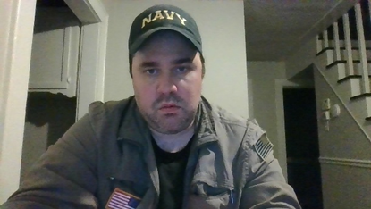
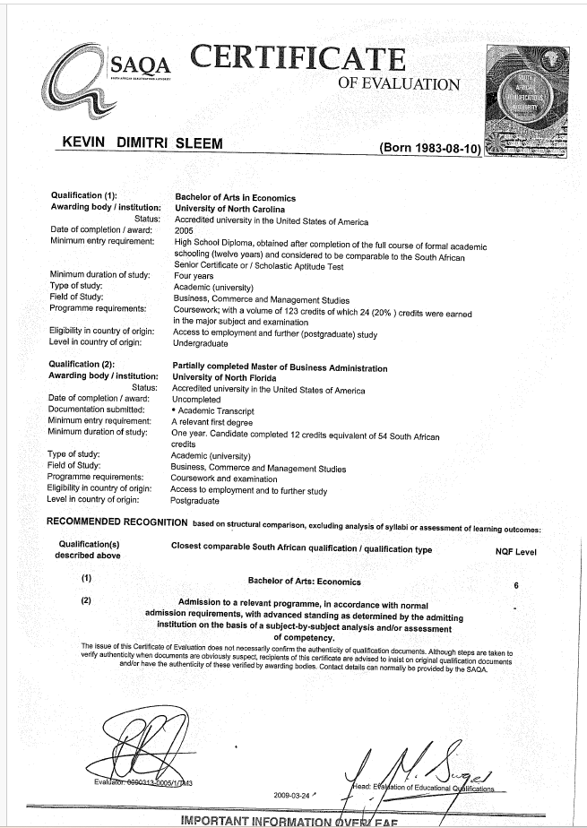
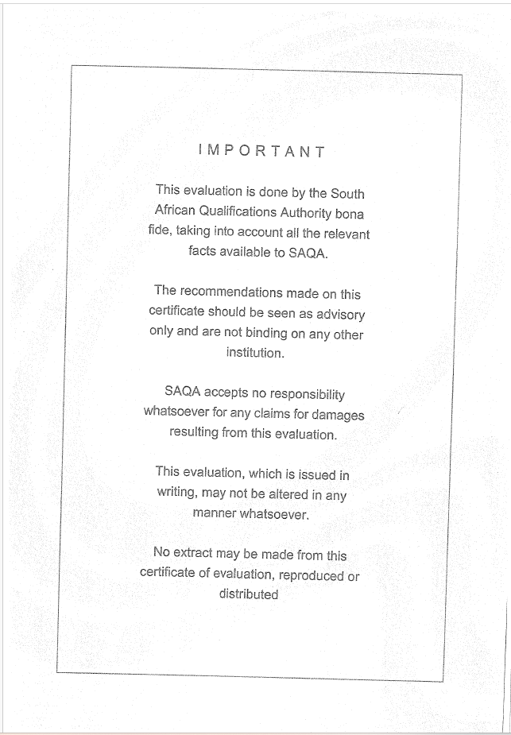
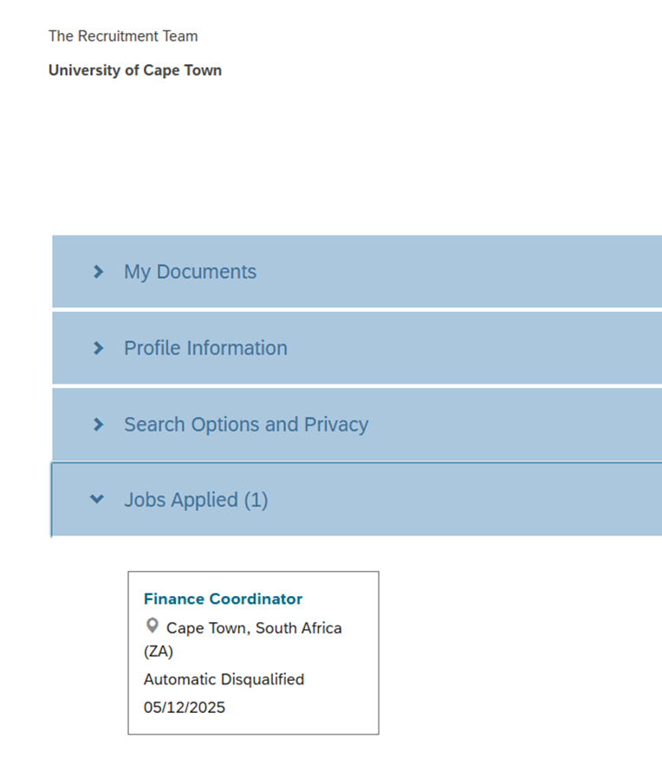

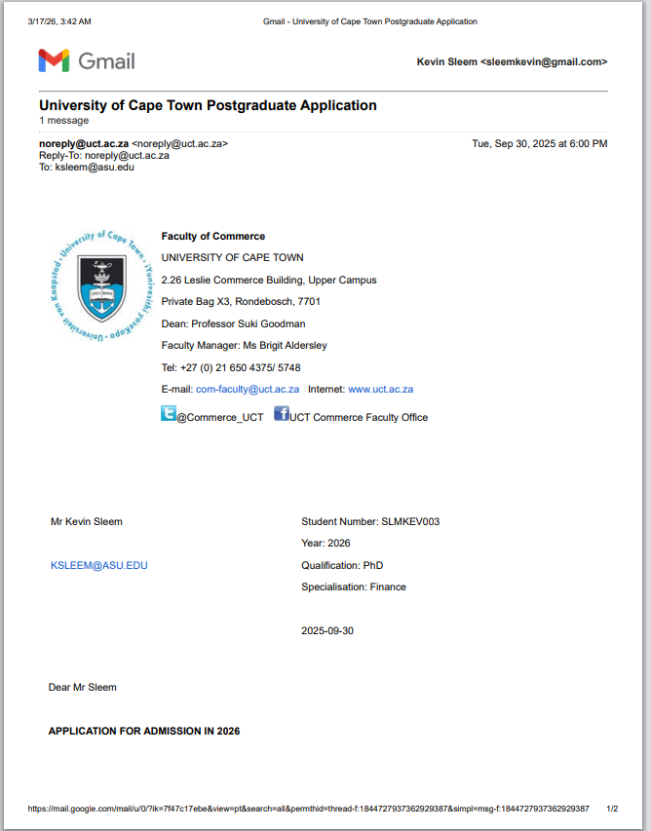

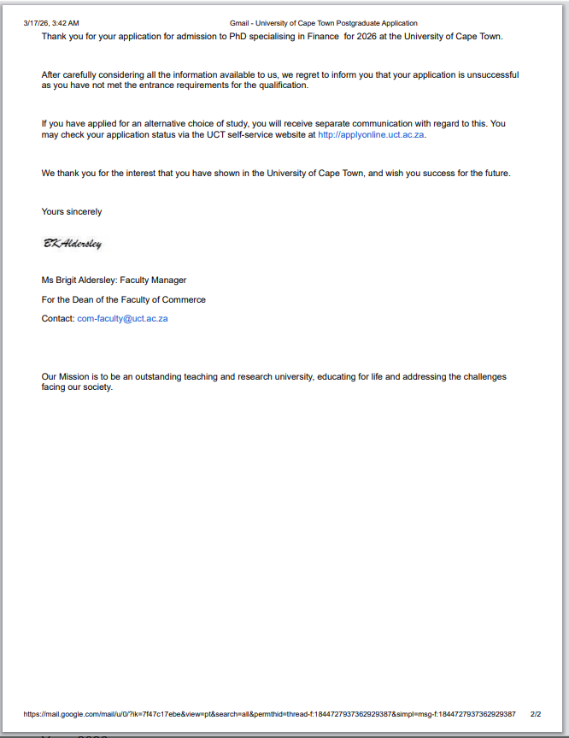

IN THE UNITED STATES DISTRICT COURT

FOR THE EASTERN DISTRICT OF NORTH CAROLINA

CIVIL DIVISION

Kevin Sleem, Plaintiff,
Case Number:
Vs. ____________

U.S. Navy, Defendant

Complaint

- To ask why my PTSD benefits were conditionally approved in 2020, upon submission of financial documents, though my benefits claim was flatly rejected in 2026? What changed, dearie?
- To ask why the Navy doctors said I was eligible for PTSD benefits at according to the prison records from Florida State Prison in 2017, but I was never made aware of the Navy doctor visits, and nobody ever told me. This led to me being homeless in London, LA, and DC in 2018, eventually to Duke Hospital in Durham, and to inquire what the policy for making tax paying citizens homeless in capitalism? This is a question for the judge’s views on capitalism and homelessness, and the Navy.
- The plaintiff agrees that benefits cannot be given to everyone with military service, there has to be red tape and qualifying service. However, he would like to petition the military for two things. 1) Universal healthcare, one argument for universal healthcare is that having preventative care reduces costs for chronic illness and hospital stays in the long-term. So if the military gave all veterans health insurance, they might save costs for society, and also provide a way for the CIA to monitor households, by checking in with the VA. 2) College is not for everyone, but college benefits the individual and society. So providing someone with a check for college is likely not detrimental to the person signing the check, since it has to be used on school.
- What is the amount for PTSD disability. I get 1500 dollars a month from social security for school, and that is a blessing, but what I am concerned with is that if I do not qualify for Navy benefits, when I got blown up by a bomb in Afghanistan, and yes, I fixed my back at the gym, then who are all these people getting Navy disability benefits. From my understanding, military benefits pay more than social security. So considering that I have an honorable discharge, and I can back that up in Boca Raton, should not I get more money for school? And I understand that some black and brown people are trying to shut down the Department of Education, and I am a vocal supporter of education civil rights.
- Judge Donald Middlebrooks of the federal court in Palm Beach dismissed my lawsuit against FAU, when I filed in prison, and then filed to withdraw when I was arguing with the warden over getting 15 pages of blank paper in the mail, and Judge Middlebrooks approved my request and dropped the lawsuit. And that worked out well, because peer pressure and peer review is better than suing in academia. Publishing is a long-term contract, so everyone wants to make sure they are publishing the right document. For that reason, I will not be appealing this decision to the U.S. Supreme Court, which has draconian filing requirements, but maybe one appeal.
- The purpose of this document is ‘Formal Submission to Fort Bragg Digital Library, regarding Education Civil Rights and Volunteer Service in the Community.’ So Judge Louise Flanagan dismissed a comprehensive lawsuit I filed when I was run out of Durham, and I guess my feelings were hurt, and as for education civil rights, community college should be accessible to all poor people in the communist community, but 4 year colleges have publishing decisions to make. So I am paying the filing fee this time, and I think this lawsuit is solid, with good formal exhibits, but I am not averse to the court finding this lawsuit frivolous as well, on the condition that the court notifies the Fort Bragg Digital Library of their decision, because I stand by my military record, and maintain that if the Navy had not made me homeless on a ship in port, I would have finished the 4 years.

Exhibits
- Exhibit 1. Submission to Fort Bragg Digital Library
- Exhibit 2. Greetings Navy Discharge Review Board
- Exhibit 3. Kevin Sleem, U.S. Navy GI Bill Application for UNLV
- Exhibit 4. Pictures
- Exhibit 5. Navy Discharge and Congressman Letter
- Exhibit 6. Buffalo VA Email Dismissals, GI Bill
- Exhibit 7. 2020 Benefits Conditional Approval 3528
- Exhibit 8. 2020 Education Benefits Denial 707
- Exhibit 9. Army Reserves Emails 2025
- Exhibit 10. Florida State Prison Communications 2017
- Exhibit 11. First Discharge Review 2022
- Exhibit 12. Second Discharge Review 2023
- Exhibit 13. Third Discharge Review 2025
- Exhibit 14. Benefits Denial 2026A
- Exhibit 15. Benefits Denial 2026B

Witnesses
- Karen Israel, Social Worker, North Florida/South Georgia VA
- Taylor Savage, North Florida/South Georgia VA
- Terrine Crooks, North Florida/South Georgia VA

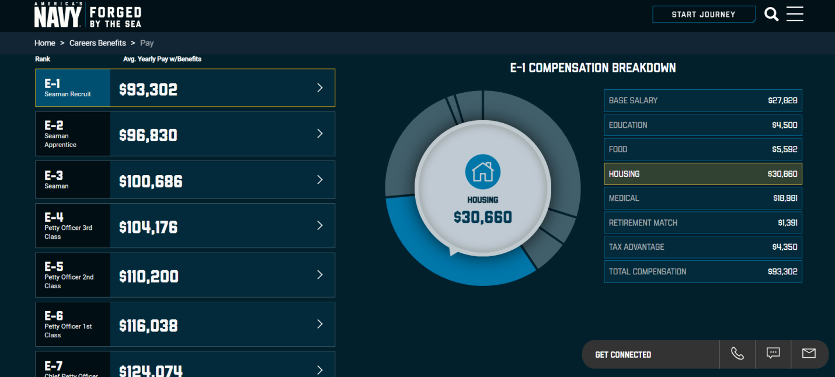Source: Navy.com; Note the payments for housing and education. A ship is not a house.

Exhibit 1. Submission to Fort Bragg Digital Library
Re: Education Civil Rights and Volunteer Service
internships@rosen.senate.gov, internship@tillis.senate.gov, bcnrcorrespondence@us.navy.mil
usarmy.bragg.usag.mbx.public-affairs-requests@army.mil

Kevin Sleem, Fayetteville, NC
sleemkevin@gmail.com, ksleem@asu.edu, sleem@unlv.nevada.edu

This is Kevin Sleem, Fayetteville, NC. So I don’t qualify for the GI Bill because of the characterization of my discharge, and the time that has elapsed since I left service. I make some points in this letter about both concerns, and hope that Senator Murkowski and Congressman Hudson, who I previously worked with in DC in 2019, consider my petition.

I want to schedule an in-person meeting with the government at some point in the future to discuss my GI Bill benefits eligibility. There are some discrepancies with the documents, such as wrong mailing addresses, I was in Durham at Hadrian House when I applied in 2020, so I want to make sure we are on the same page for the details. And I fully understand if you need an honorable discharge for GI Bill benefits, we need red lines and standards in society, but I would like to discuss. I might be in Las Vegas attending UNLV this fall, assuming I can sell them a paper. Since education for the individual benefits society at large, maybe this is an issue for the Congress to discuss.

As the letter from Congressman Richard Hudson shows, as well as the Lisa Murkowski and Joe Biden magazines, it could be argued that I was in the U.S. military from 2005-2019, not 2005-2008. And of course any service over 4 years is automatically either an honorable or dishonorable discharge, because you get credit for your good time. A dishonorable discharge would be for a felony, like a sex crime. So I am rather ambivalent on my Navy service, I can always apply to pull out the dueling pistols from Markwayne Mullin, just joking, Michael McAuliffe, but I do want to canvas for votes on this issue, which affects me, and society.

I am still waiting on the last discharge review request, I submitted it March 2025, and it can take up to 18 months, and am also waiting on PTSD benefits, which the Navy encouraged me to apply for, instead of a bad back, however you herniate a disk.

Kevin Sleem
707 Greenland Drive
Fayetteville, NC 28305

Exhibit 2. Greetings Navy Discharge Review Board

U.S. Navy Discharge Review Board
701 S. Courthouse Road, Suite 1001
Arlington, VA 22204-2490
bcnrcorrespondence@us.navy.mil
Docket No. NR20250002160
A fair question, if I originally signed up for the Navy SEALS, and Marines, then was assigned to Navy nuke school, after I quit nuke school, why was I not assigned to Marines infantry, instead of being made homeless on a ship? There are some suspicious orders here.

I am not updating my application, just inviting you to view my LinkedIn page, where I have posted views on the U.S. military.

The Marines is the infantry, there are no women in the infantry. Winsome Sears was never in the Marines. When a woman asks to join the marines, they are told to join the Navy, that's why we have Navy and Marines, Marines is for men, Navy is for men and women.
What might be more relevant is the phrase obeying a lawful order. People are talking about the military disobeying unlawful orders to attack drug smugglers.
1) Was it a lawful order when the marine recruiter told me that my Chinese tattoos were gang tattoos and disqualified me from an officer commission in ROTC at UNC, nor did he recommend I enlist instead?
2) Was it a lawful order when I went to the recruiting station in Durham in 2004, and said I wanted to join the marines, but was directed to the Navy? I'm keeping the Navy hat.
3) Was it a lawful order when I was not given the correct rules for college education while in the military? Could I have been placed on shore duty and attended UNF at nite for 15 months? What are the rules for college in the military, and does a history of DUI and crack use, not crack abuse with priests, just crack use when other party favors were not able to be obtained, because crack is cheap and available downtown, and not heroin, does that history change the equation? For example, it would not be fair to be enrolled in college on shore duty, and be smoking crack and get a DUI, but perhaps online school might be acceptable. The military should explain the virtues of online degrees to the soldiers.
Sincerely, Kevin Sleem, E-1

I went backwards in rank, laughable or cause for concern? I admit, I may not have been ready for officer, due to my substance abuse, but the recruiter should have still recommended I enlist in the marines, like a lot of non military school people do.

Exhibit 3. Kevin Sleem, U.S. Navy GI Bill Application for UNLV

Look, I take responsibility for my Navy discharge, I had substance abuse issues when I was young, though the DEA did sell me crack when I was 17. And yes, the physical fitness obstacle course in the infantry would have been good for my drinking problem. Conversely, I would go to bars to drink and drive when I was living on the ship, because I had no barracks. So, I have made it this far paying for school with gig jobs, student loans, and parents, so I can make it a few more years of STEM grad school, but I remain flexible on representing the U.S. Navy at UNLV in Las Vegas, or ASU in Tempe.

My question is, I had a Zoom meeting with the UNLV Veterans Center today, and they recommended I reach out to Ask VA, because I might qualify for military benefits, including the GI Bill.

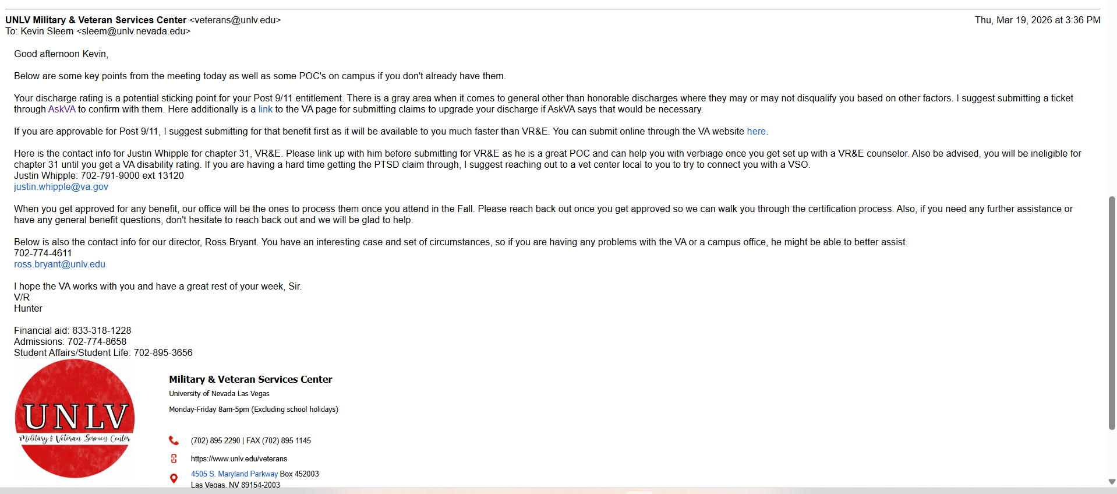

Exhibit 4. Pictures
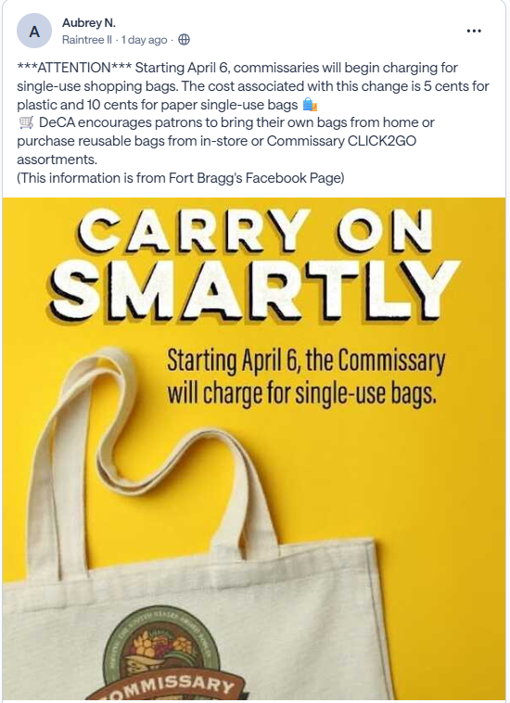

Exhibit 4. Pictures
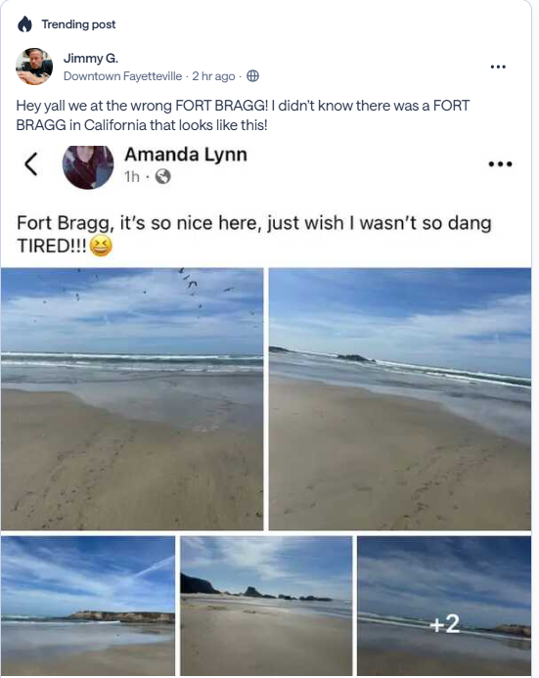

Exhibit 4. Pictures
I saw this picture on a construction site, I may be wrong, but I took it down. Could be a Spanish construction worker reference though. Probably wrong, hope the building didn't fall down, but when I get fired I go roaming. Circa 2021. Get that DC bling bling, How Bizarre.
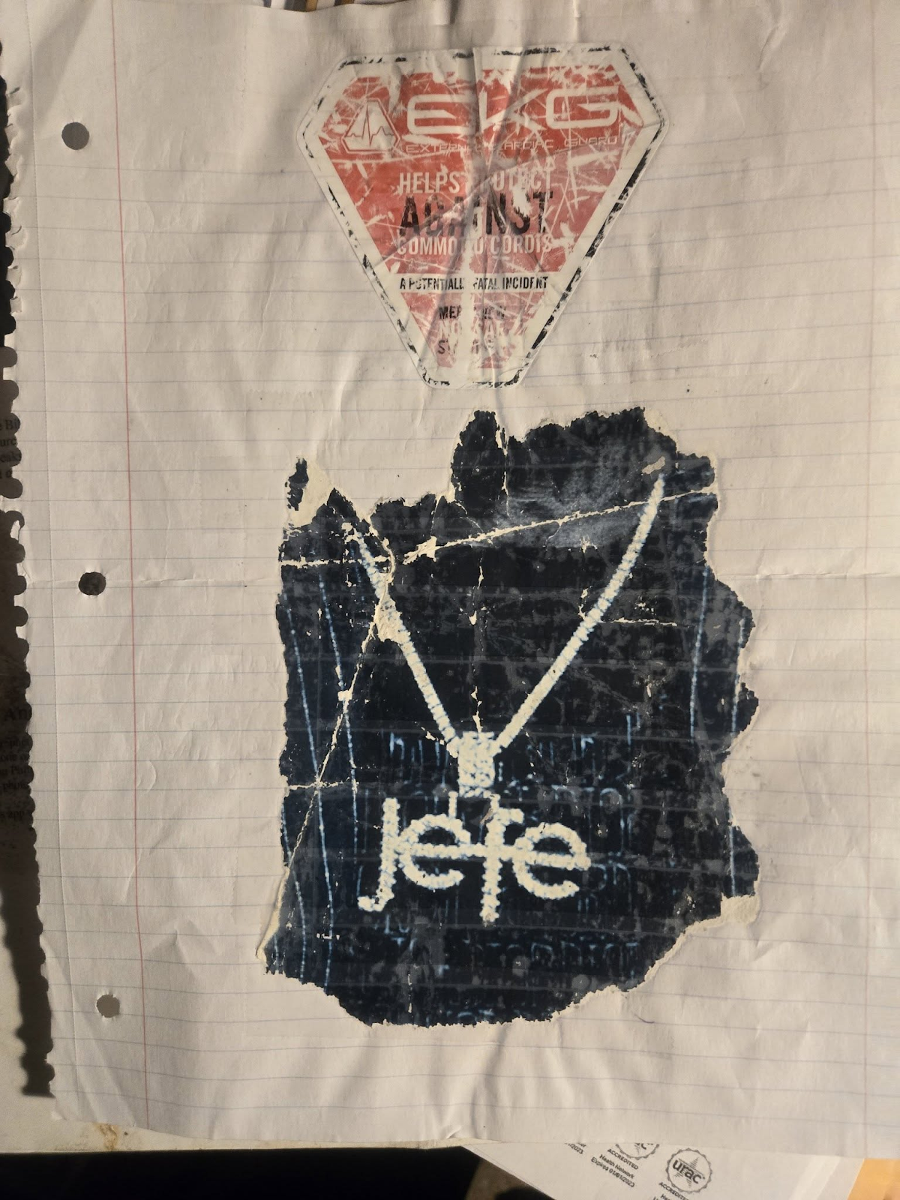

Exhibit 4. Pictures
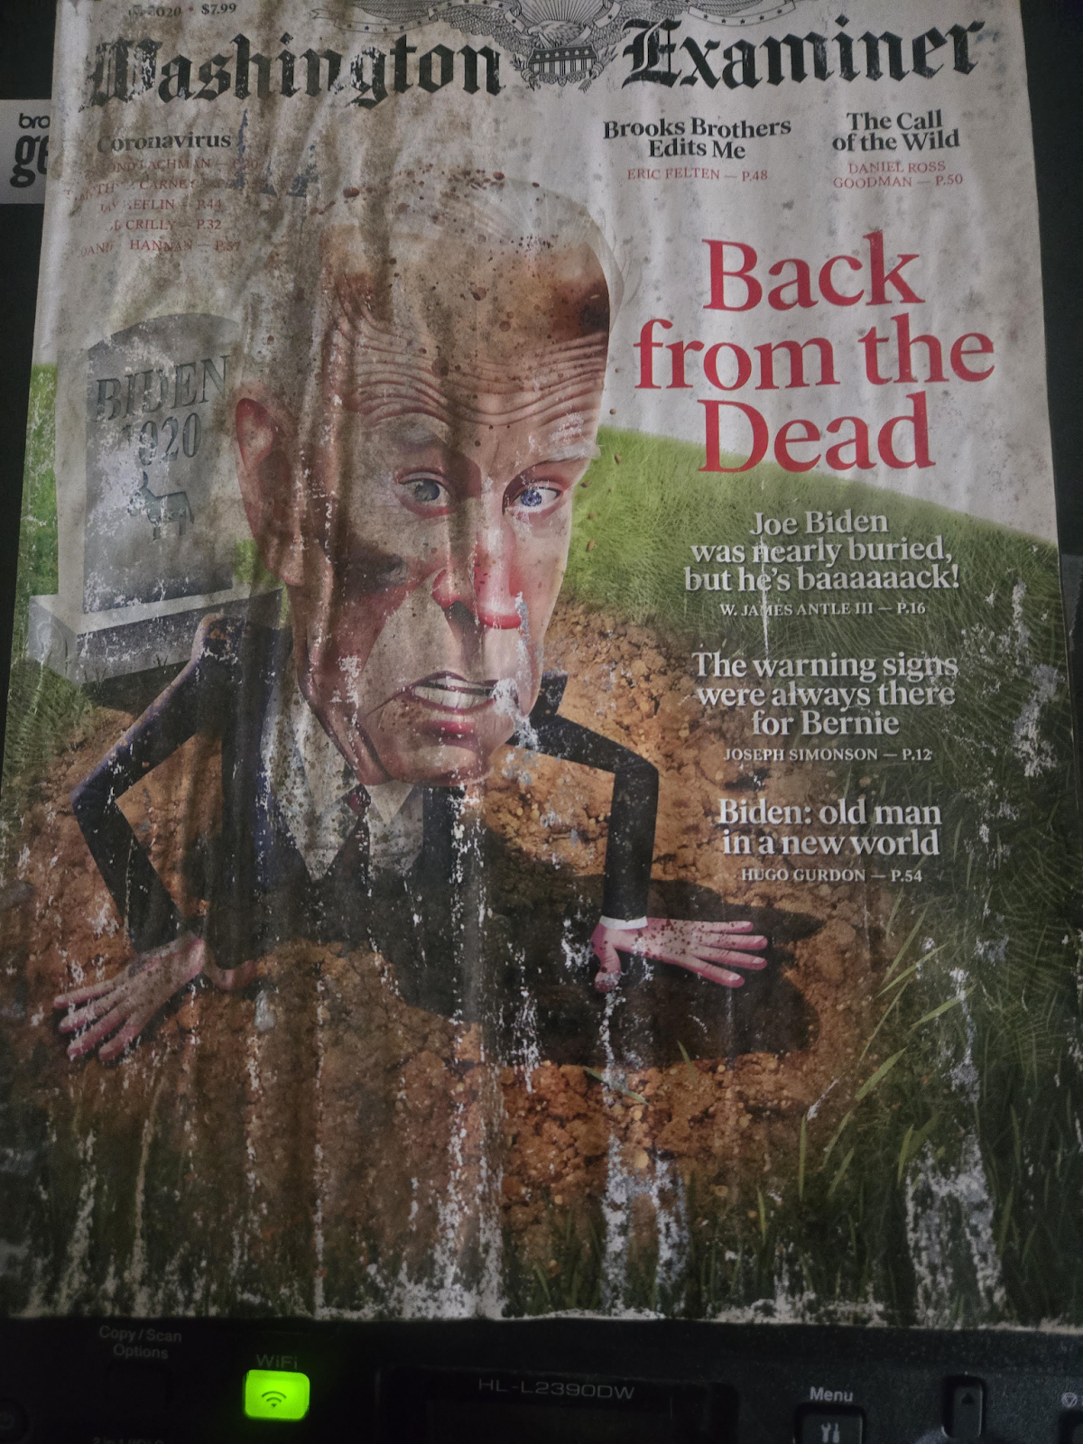

Exhibit 4. Pictures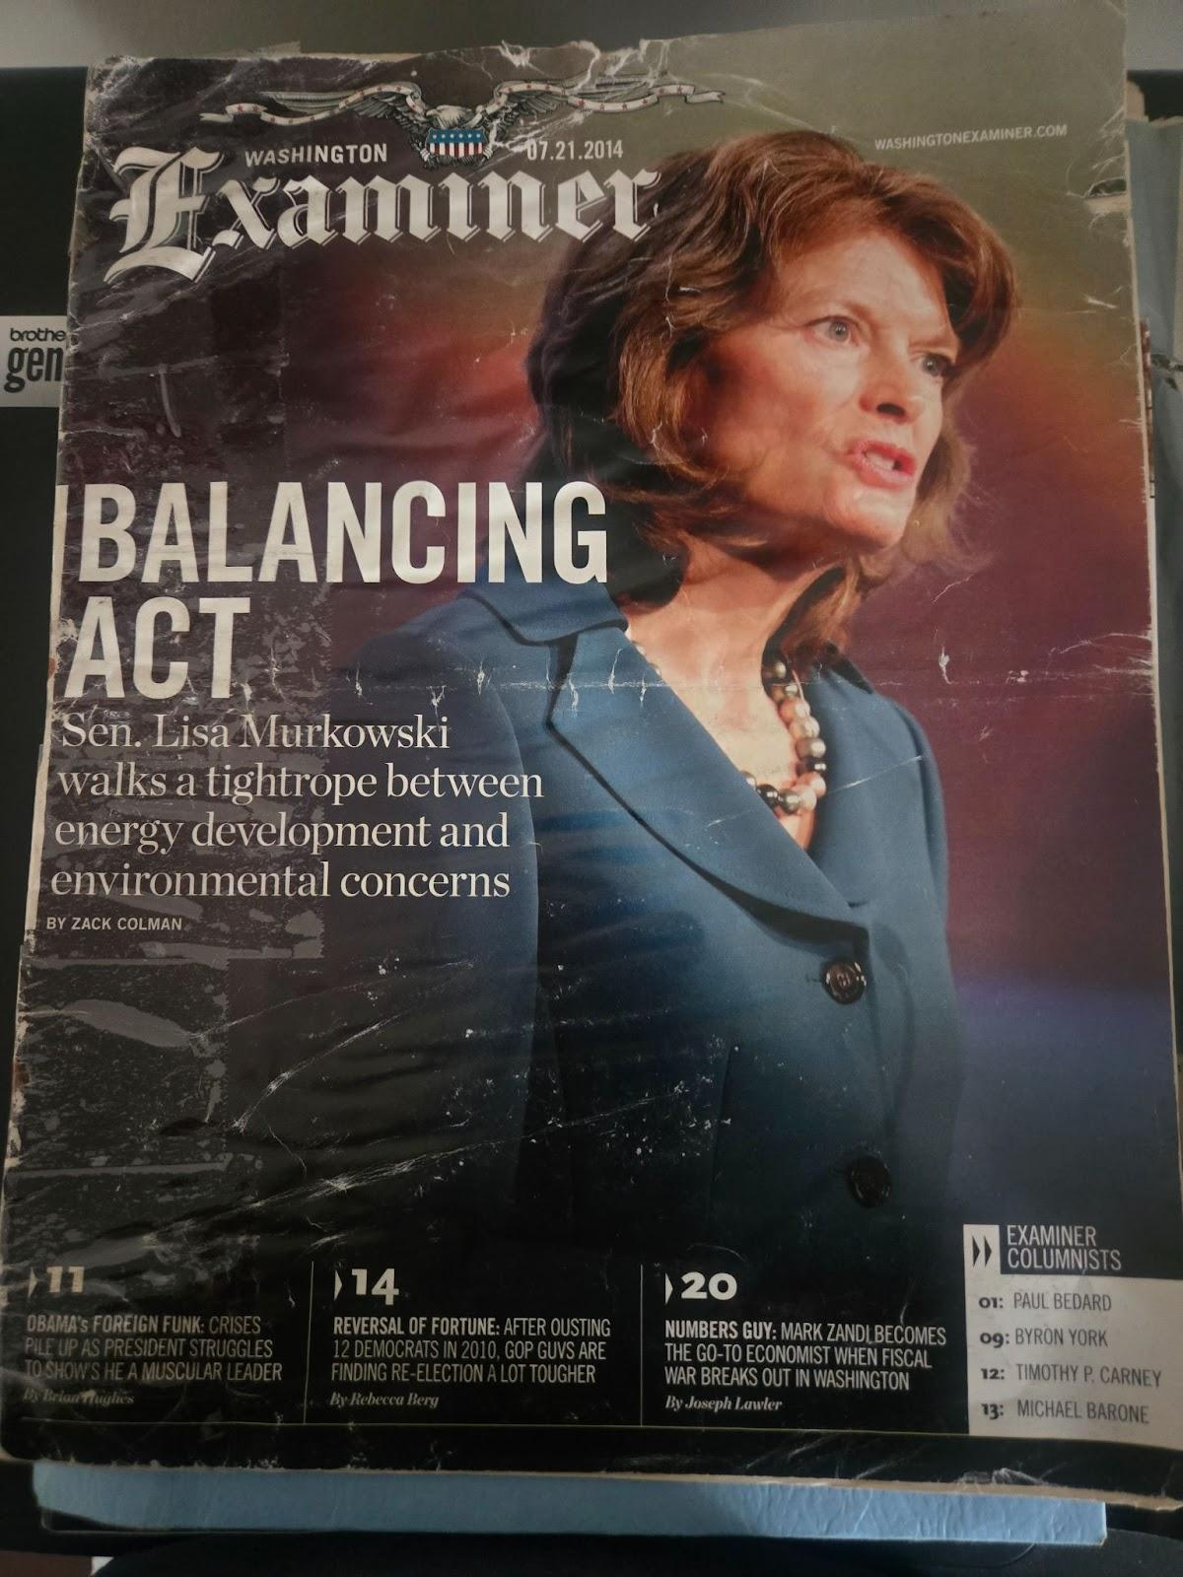
Exhibit 5. Navy Discharge and Congressman Letter
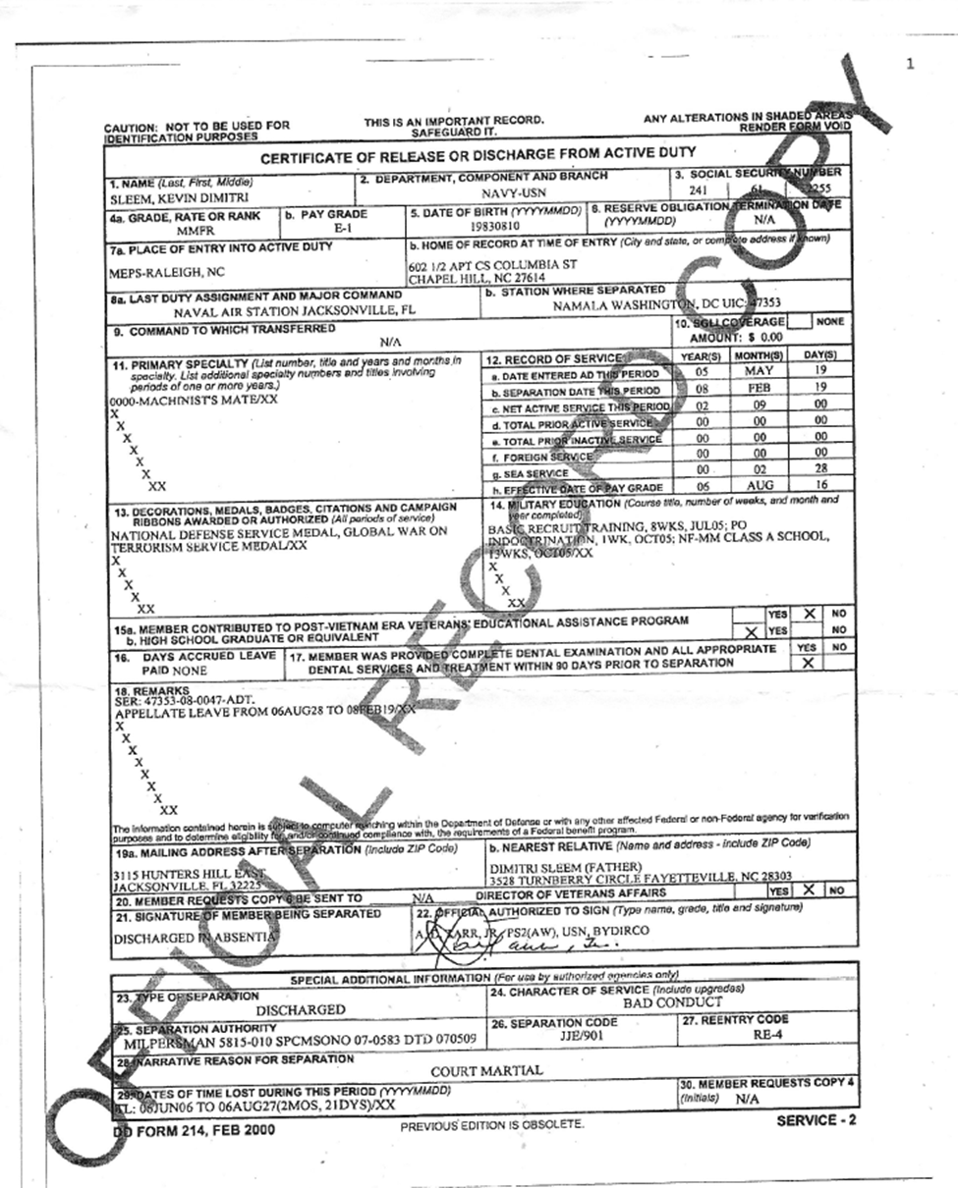

Exhibit 5. Navy Discharge and Congressman Letter
March 15, 2019

Mr. Kevin Sleem
3528 Turnberry Cir
Fayetteville, NC 28303-4664

Dear Mr. Sleem:

Thank you for contacting me regarding H.R. 227, the Multinational Species Conservation Funds Reauthorization Act . We completely agree on the need to protect and preserve our wildlife populations, particularly our endangered species. This is why I have supported numerous bills to protect our environment to ensure these species have thriving habitats.

As someone who loves and appreciates animals, I understand the importance of taking care of our most vulnerable wildlife. Additionally, as a lifelong outdoorsman who grew up right here in North Carolina, I know that caring for the environment is our duty and we must preserve our lands now and for future generations. I believe it is extremely important to be good stewards of the environment and I am committed to fighting for the responsible management of our wildlife.

As you may know, H.R. 227 was introduced in the 115 th Congress by Representative Don Young (R-AK) on January 3, 2017. While this legislation has not been reintroduced in the 116th Congress, please know I will keep your thoughts in mind should I have the opportunity to consider this or similar legislation this Congress.

Again, thank you for taking the time to share your views. Your opinions are important, so please continue to write, call, or email me with any concerns you may have in the future. For more information on issues impacting North Carolinians, please visit our website at http://hudson.house.gov and sign up for our weekly newsletter.

Sincerely,

Richard Hudson
Member of Congress

Exhibit 6. Buffalo VA Email Dismissals, GI Bill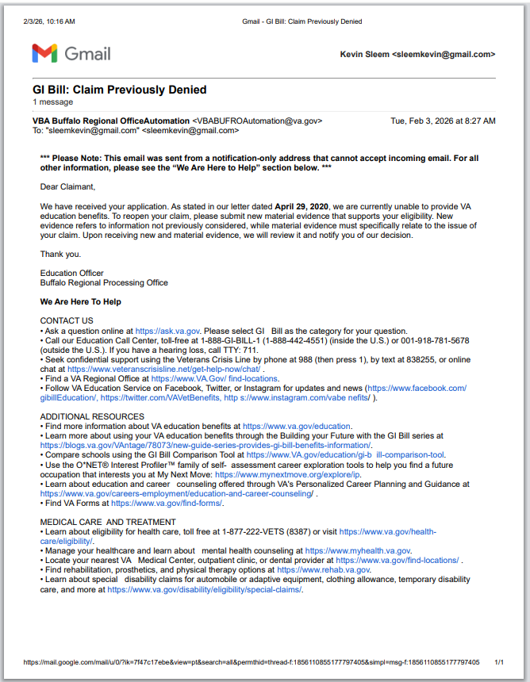

Exhibit 6. Buffalo VA Email Dismissals, GI Bill
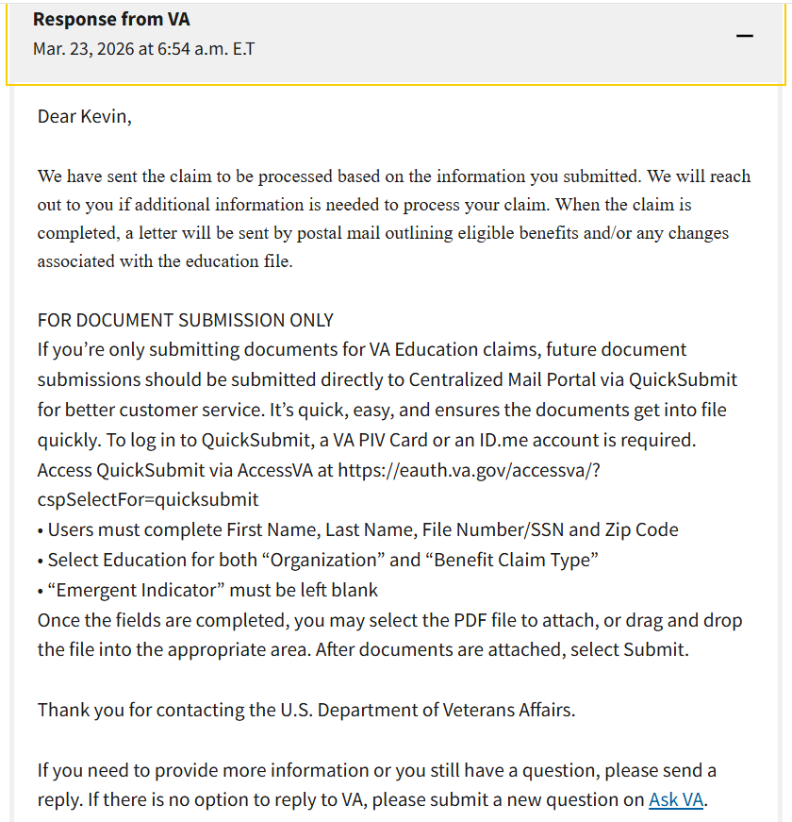

Exhibit 6. Buffalo VA Email Dismissals, GI Bill 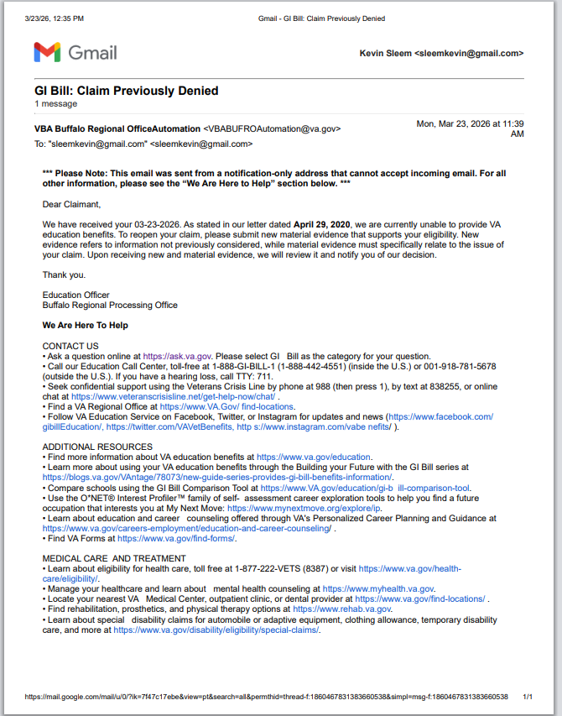

Exhibit 7. 2020 Benefits Conditional Approval 3528
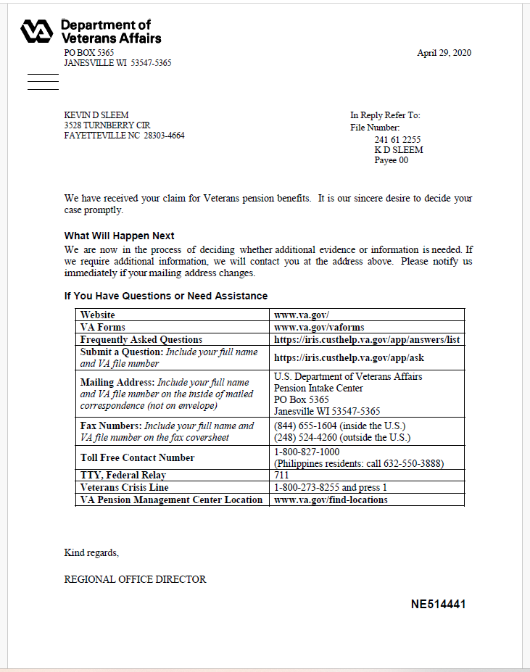

Exhibit 7. 2020 Benefits Conditional Approval 3528
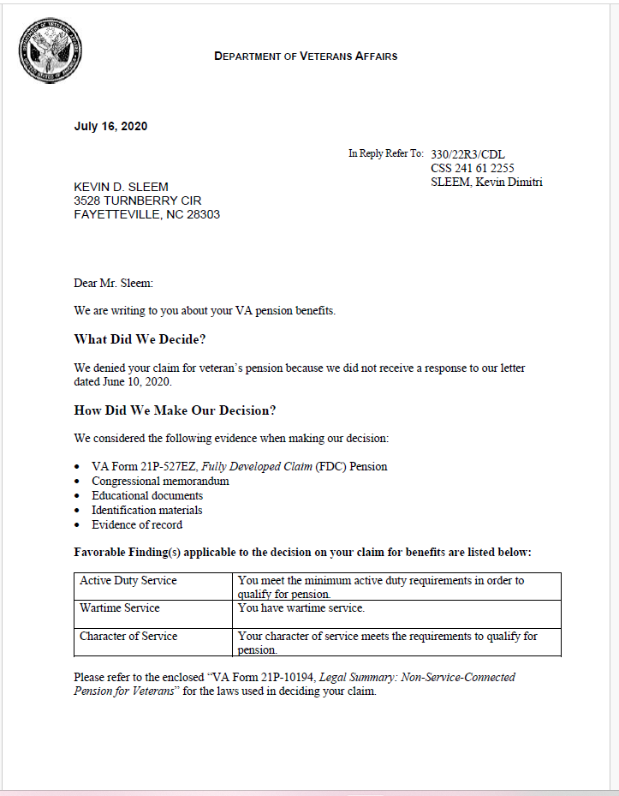

Exhibit 7. 2020 Benefits Conditional Approval 3528
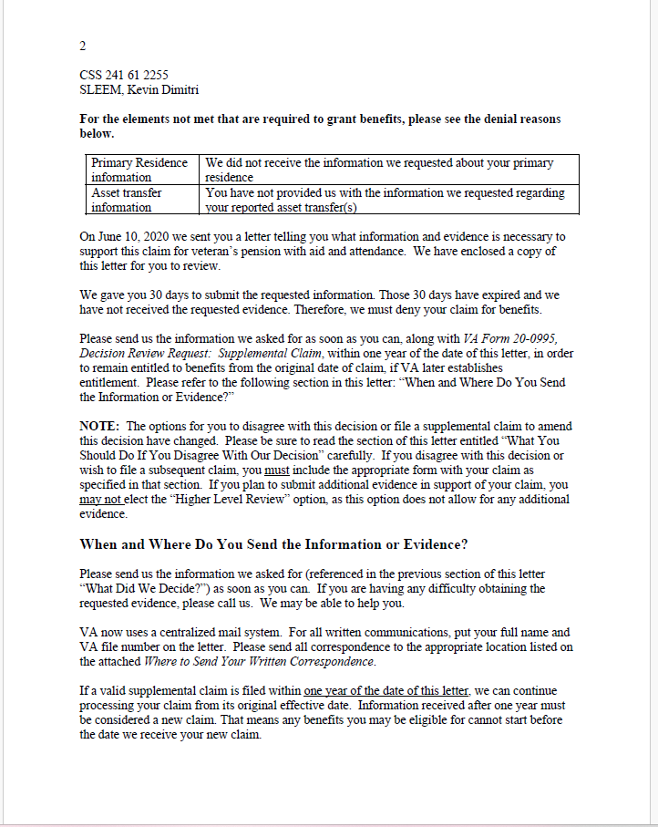

Exhibit 7. 2020 Benefits Conditional Approval 3528
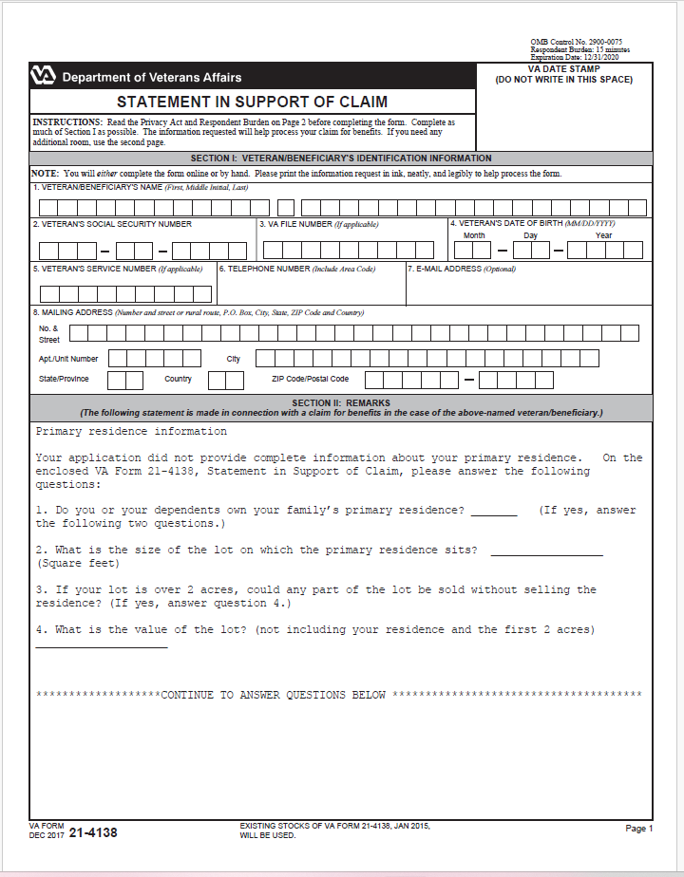

Exhibit 7. 2020 Benefits Conditional Approval 3528
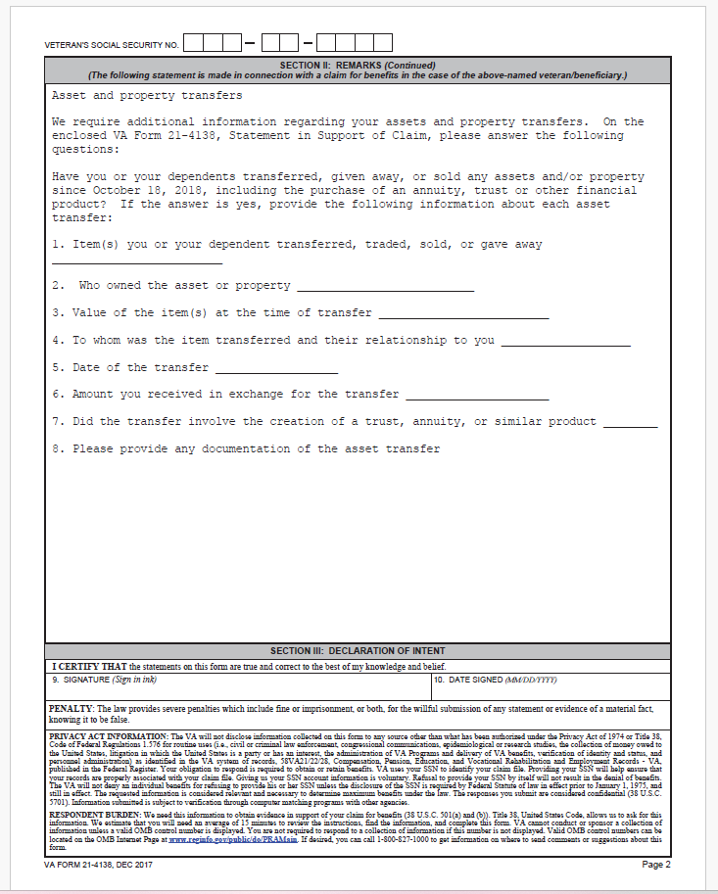

Exhibit 8. 2020 Education Benefits Denial 707
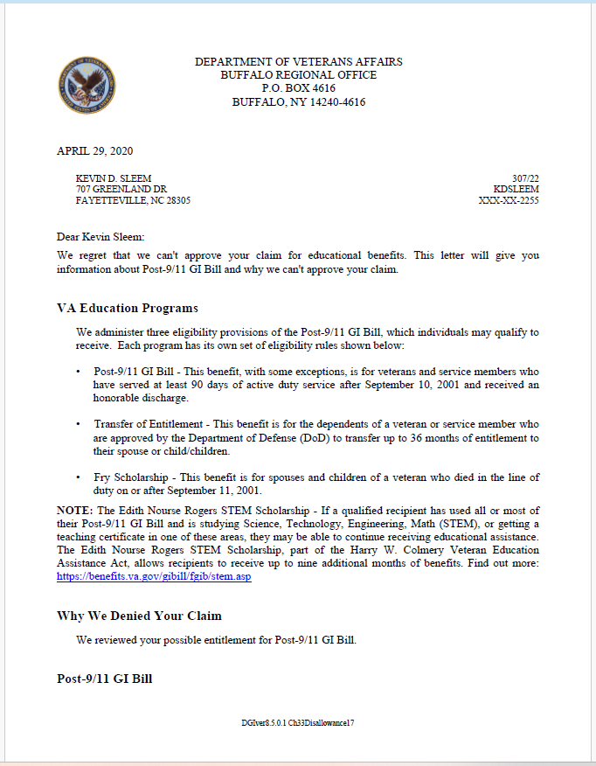

Exhibit 8. 2020 Education Benefits Denial 707
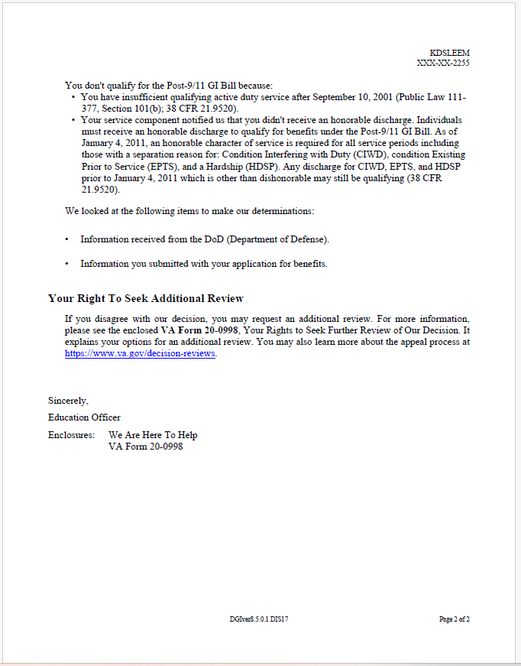

Exhibit 8. 2020 Education Benefits Denial 707
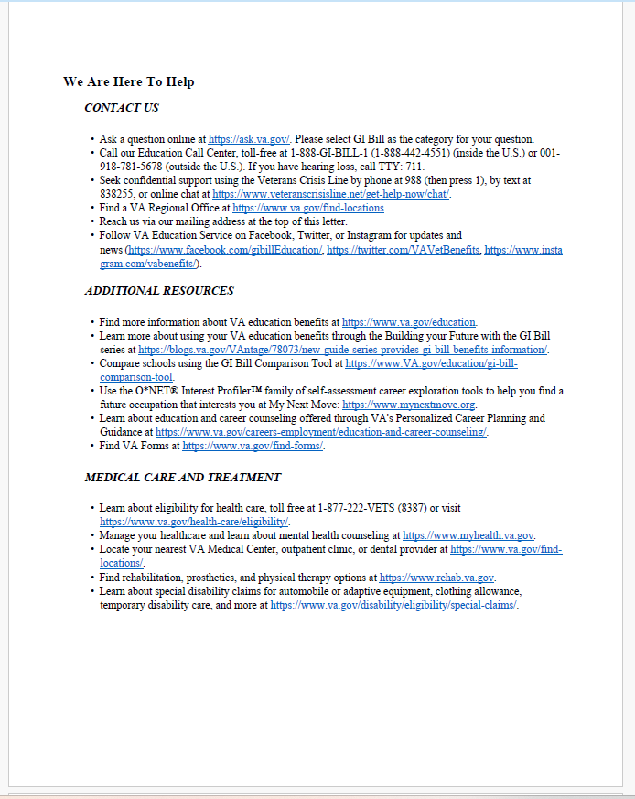

Exhibit 9. Army Reserves Emails 2025 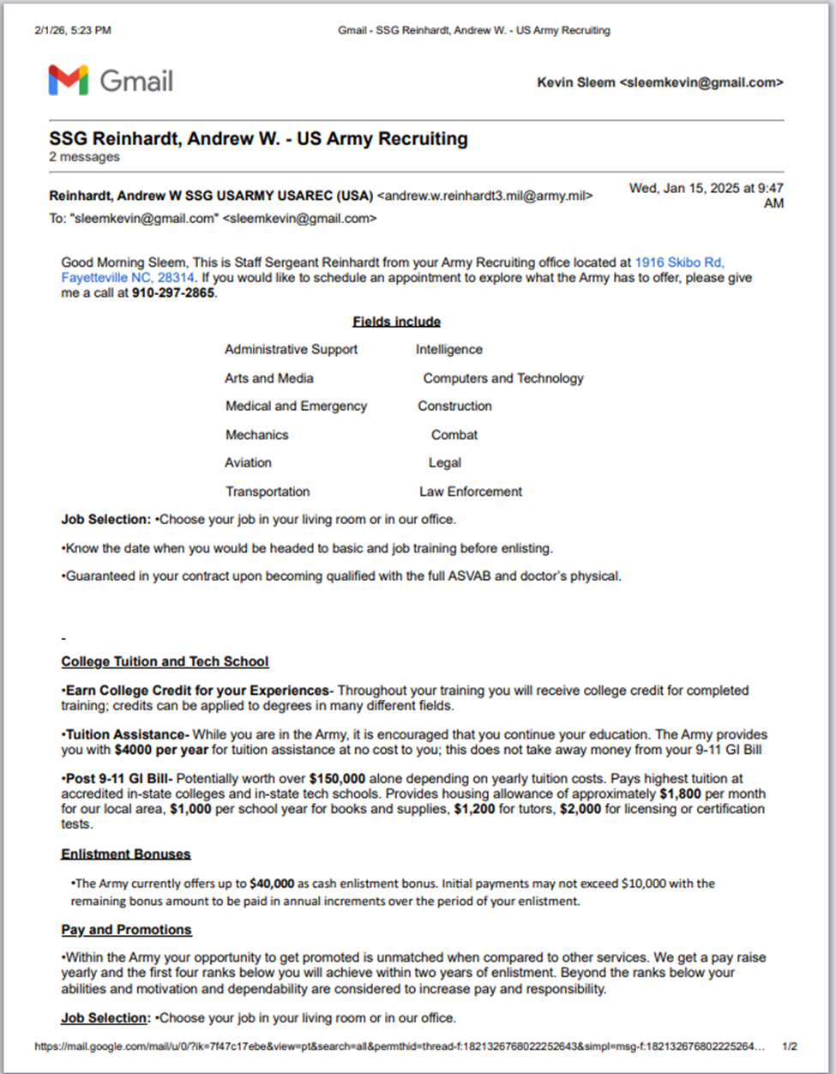
Exhibit 9. Army Reserves Emails 2025
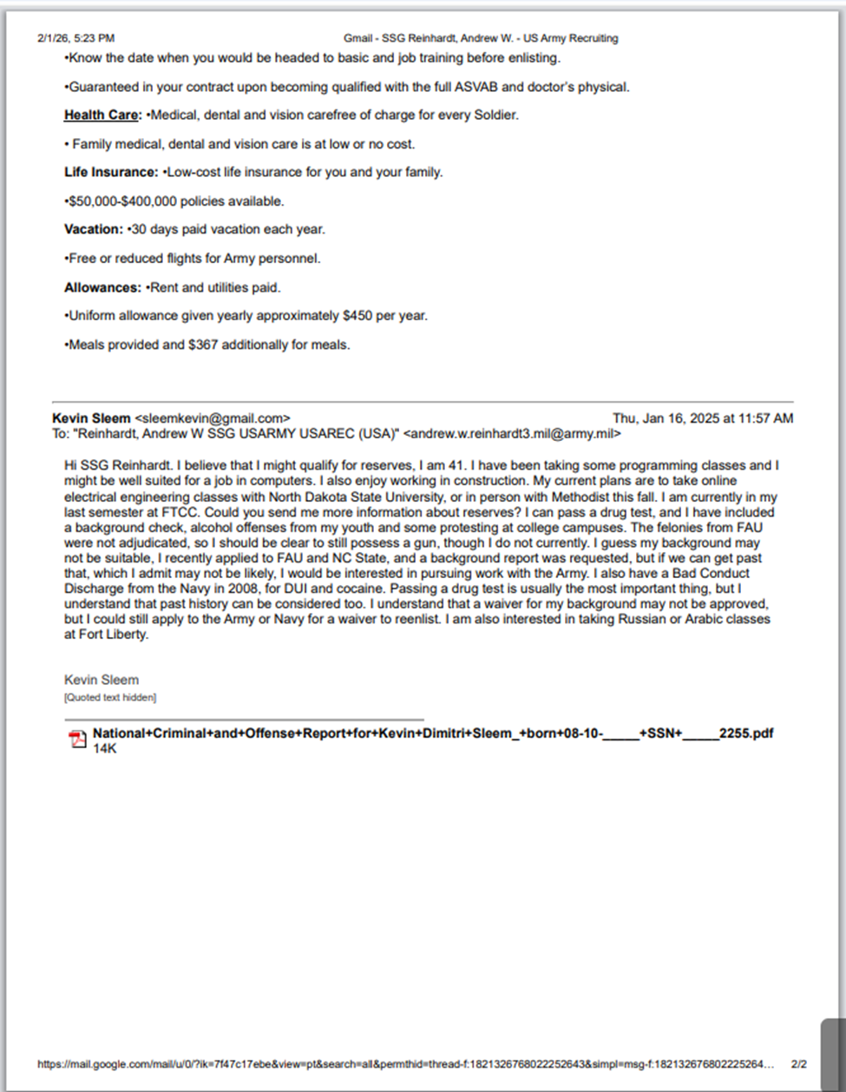

Exhibit 9. Army Reserves Emails 2025
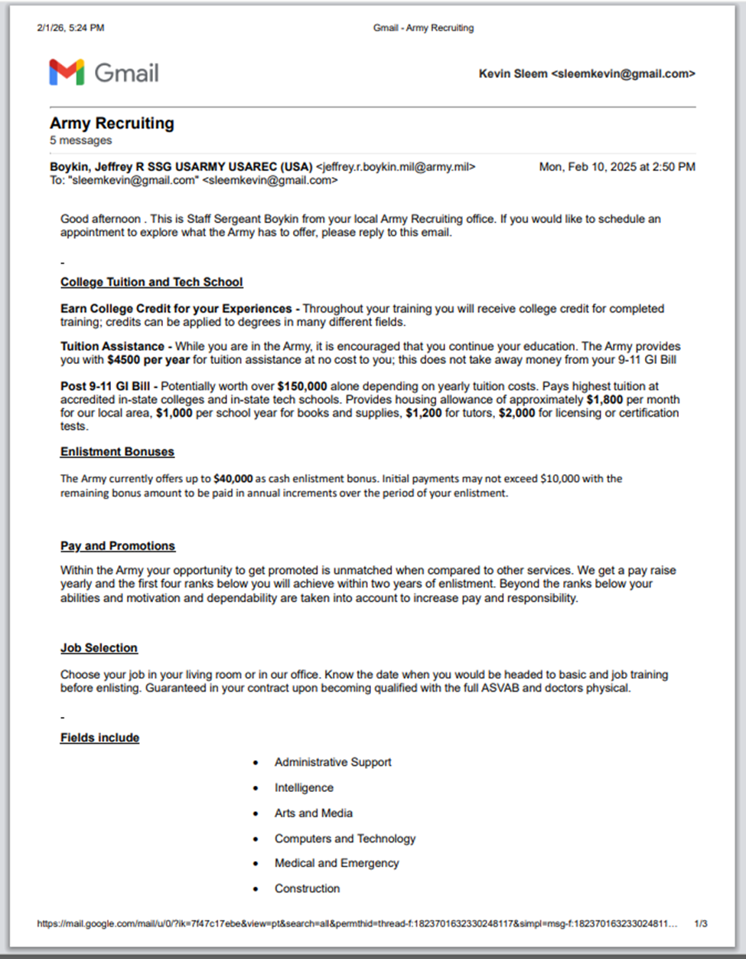

Exhibit 9. Army Reserves Emails 2025
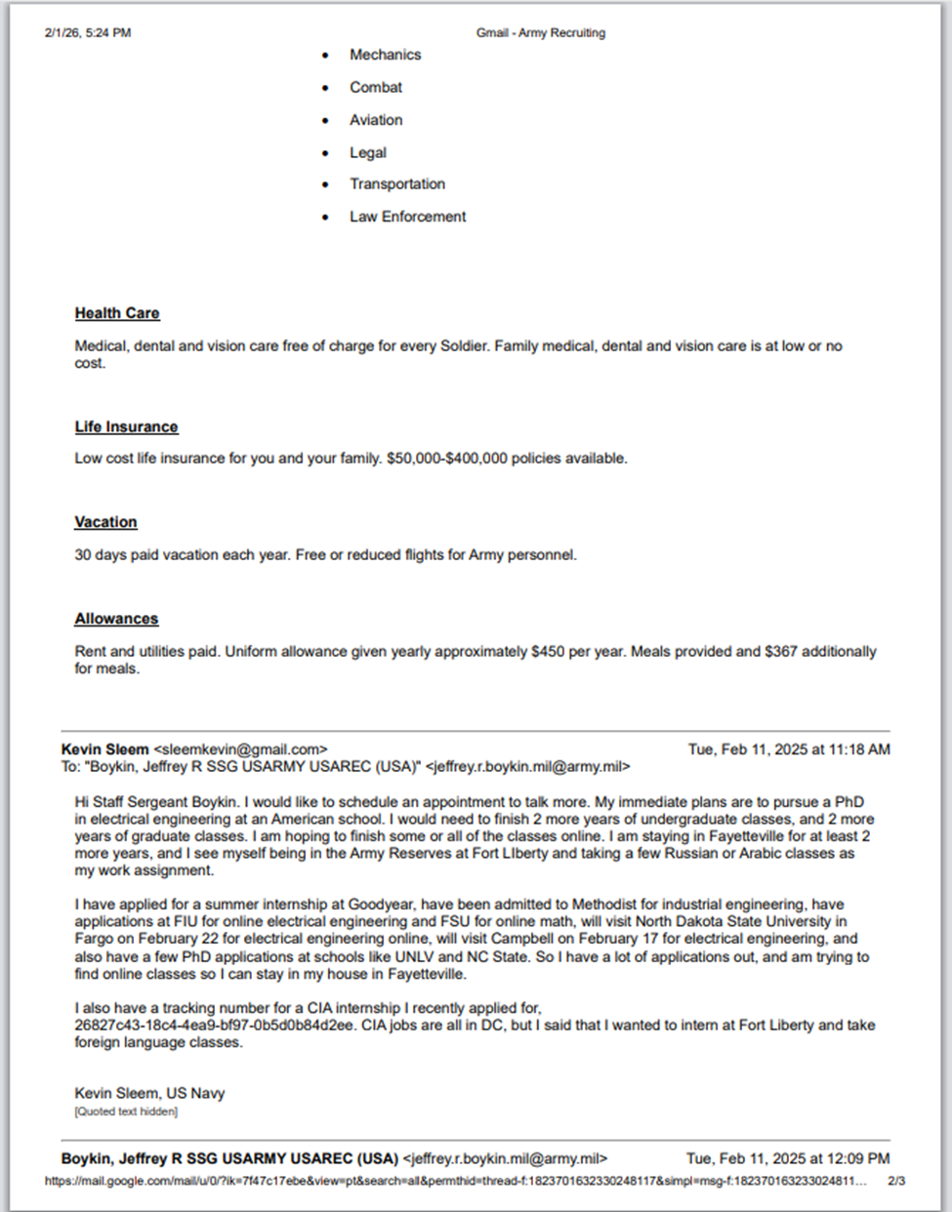

Exhibit 9. Army Reserves Emails 2025
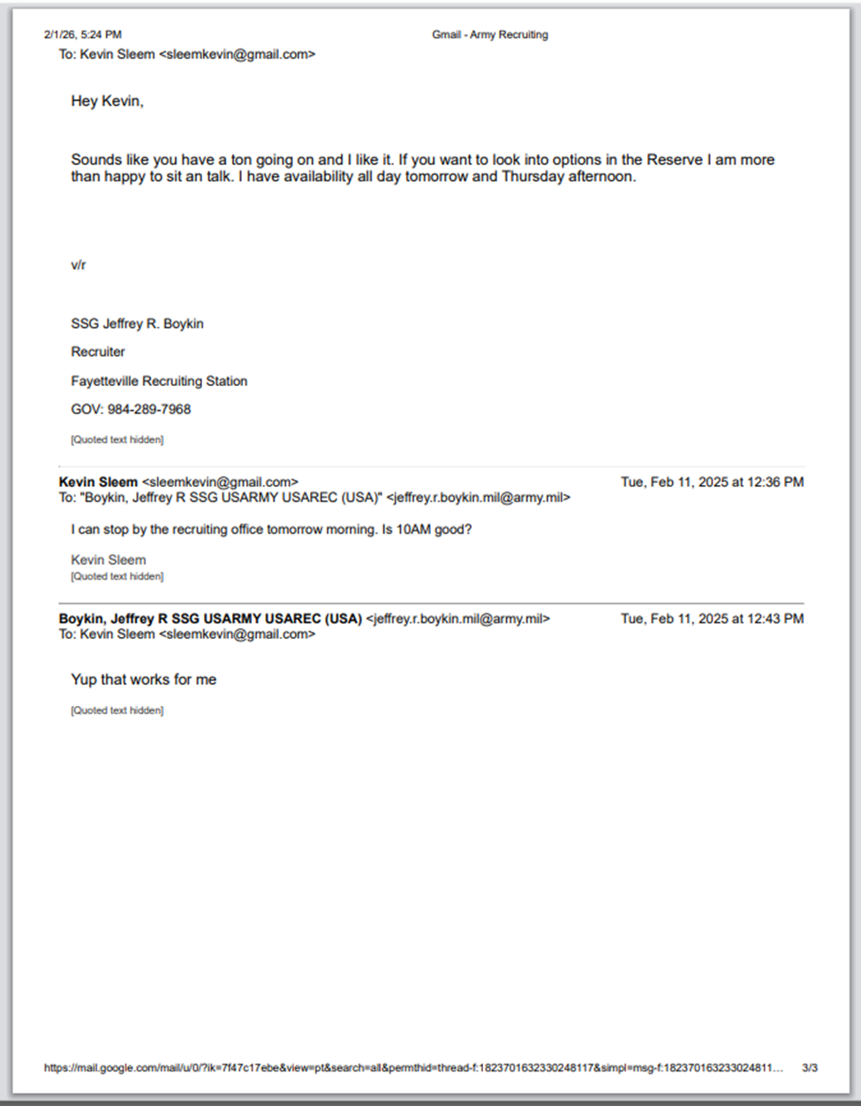

Exhibit 10. Florida State Prison Communications 2017
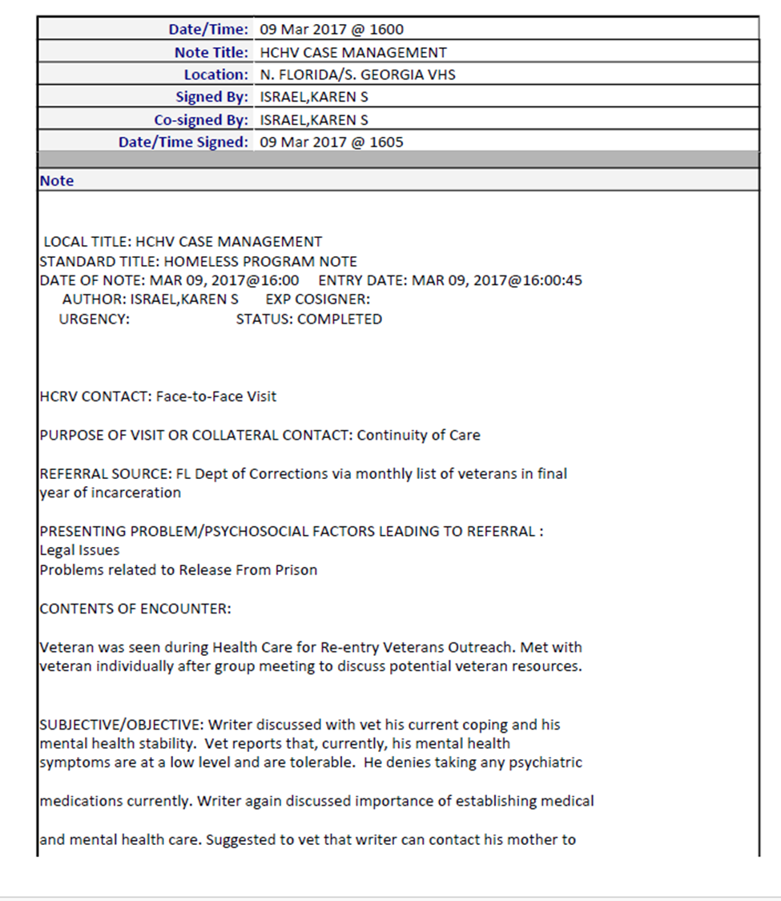

Exhibit 10. Florida State Prison Communications 2017
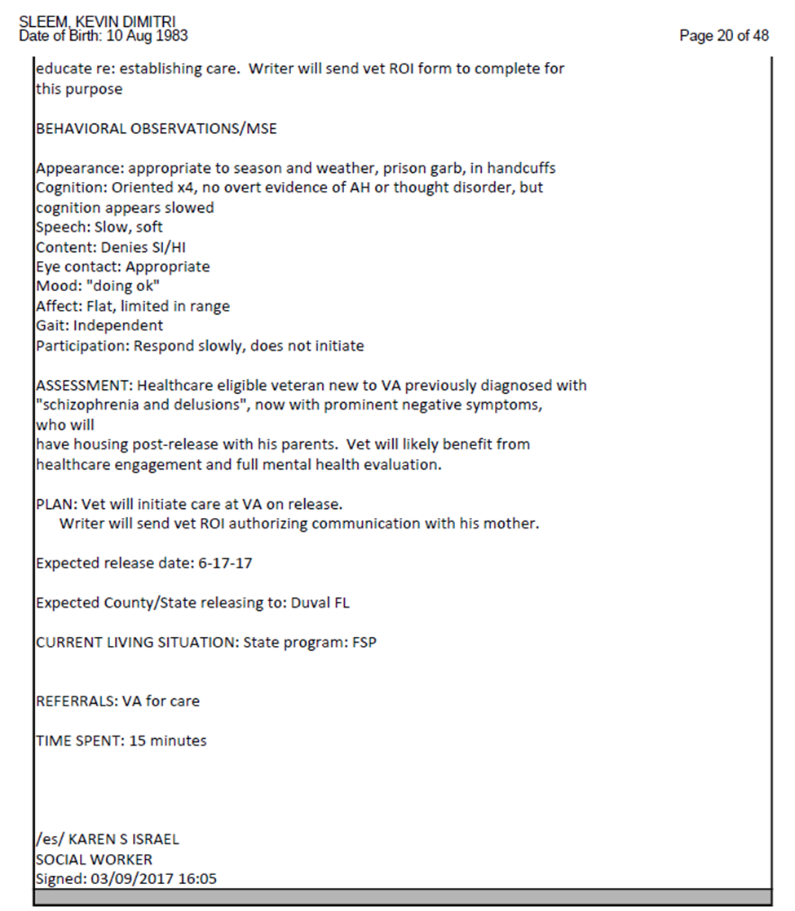

Exhibit 10. Florida State Prison Communications 2017
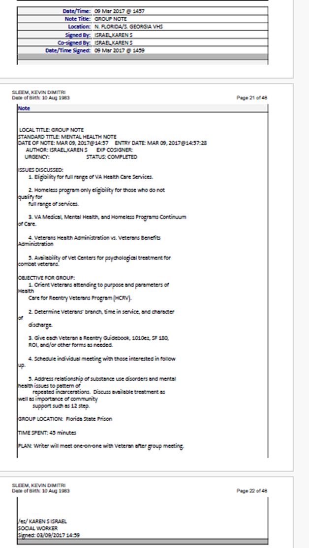

Exhibit 10. Florida State Prison Communications 2017
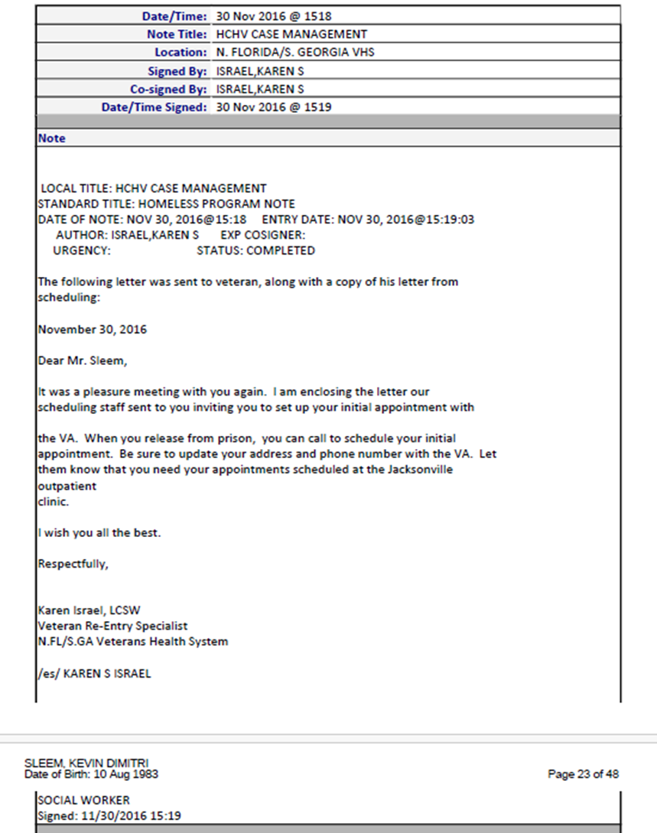

Exhibit 10. Florida State Prison Communications 2017
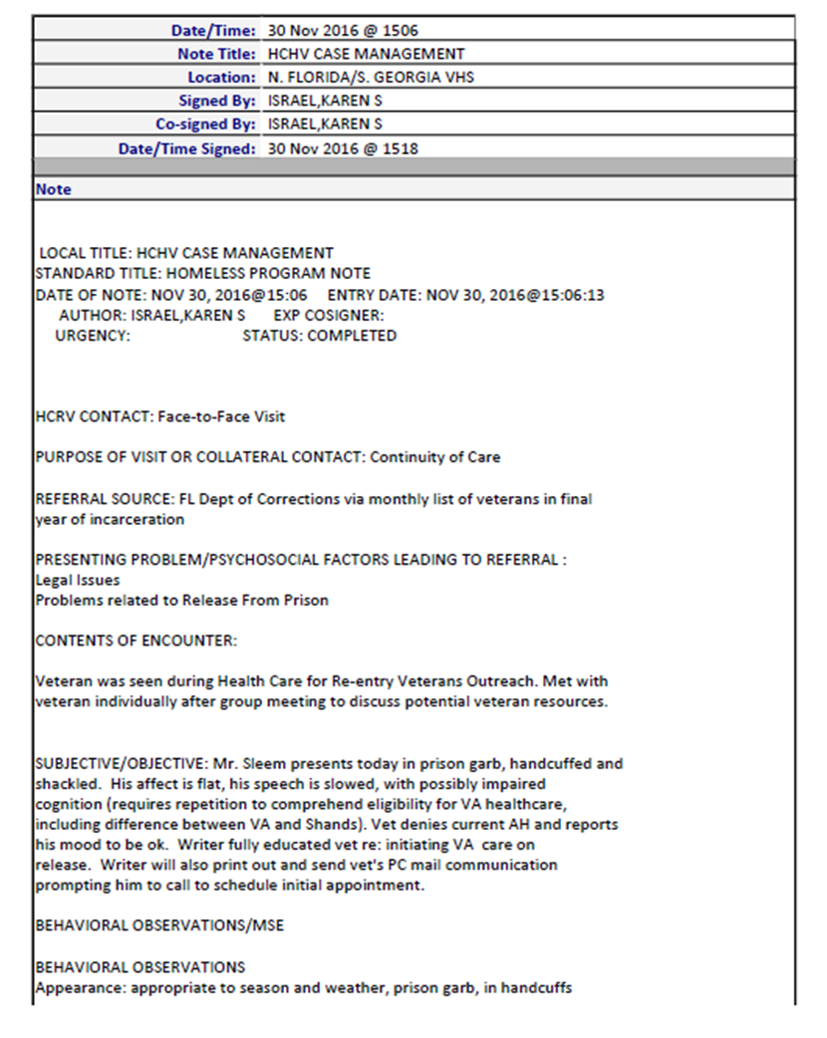

Exhibit 10. Florida State Prison Communications 2017
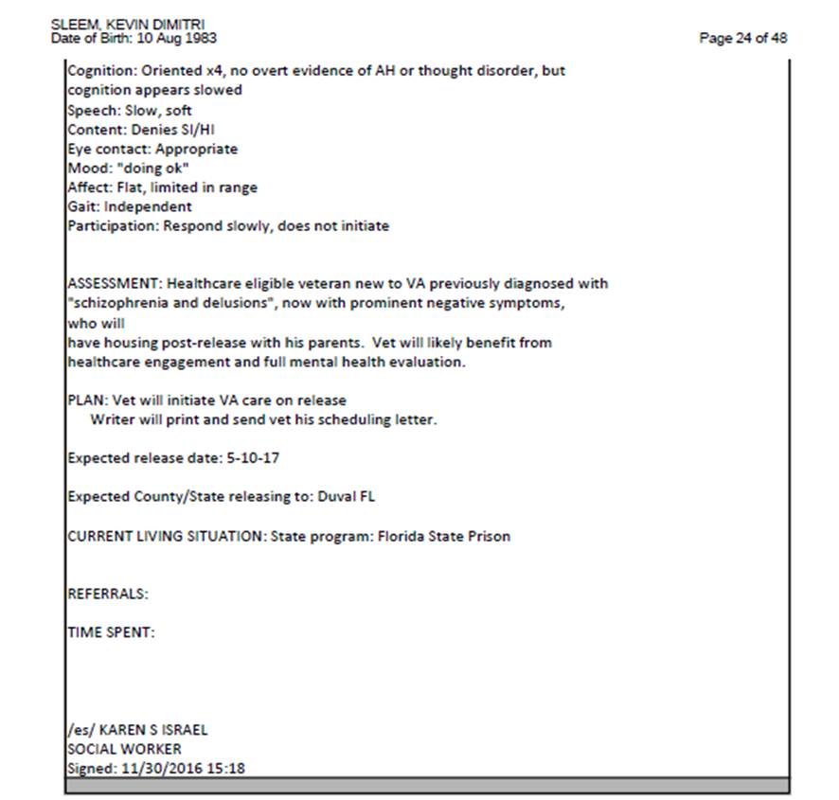

Exhibit 10. Florida State Prison Communications 2017

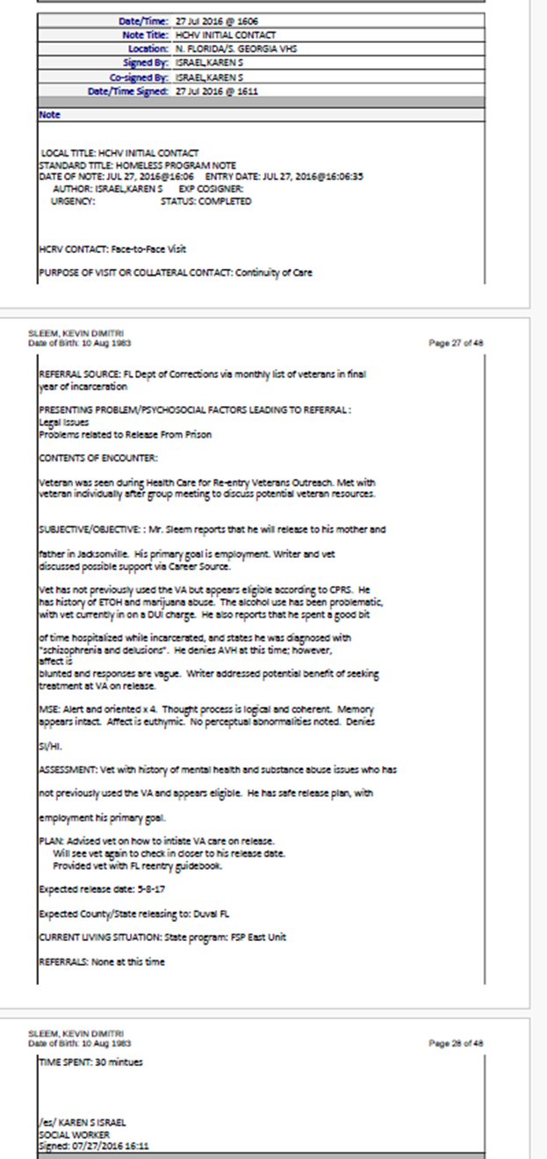

Exhibit 10. Florida State Prison Communications 2017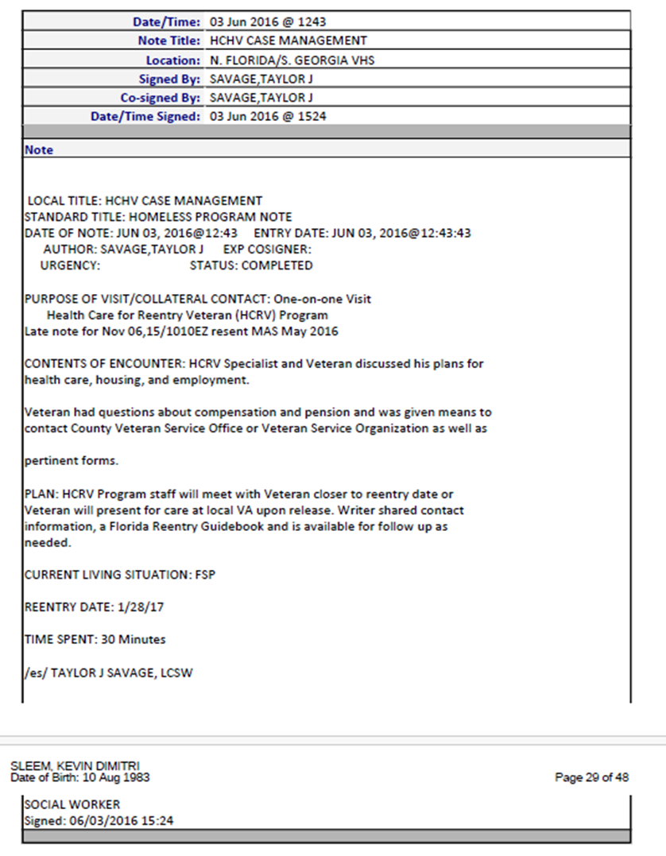

Exhibit 10. Florida State Prison Communications 2017
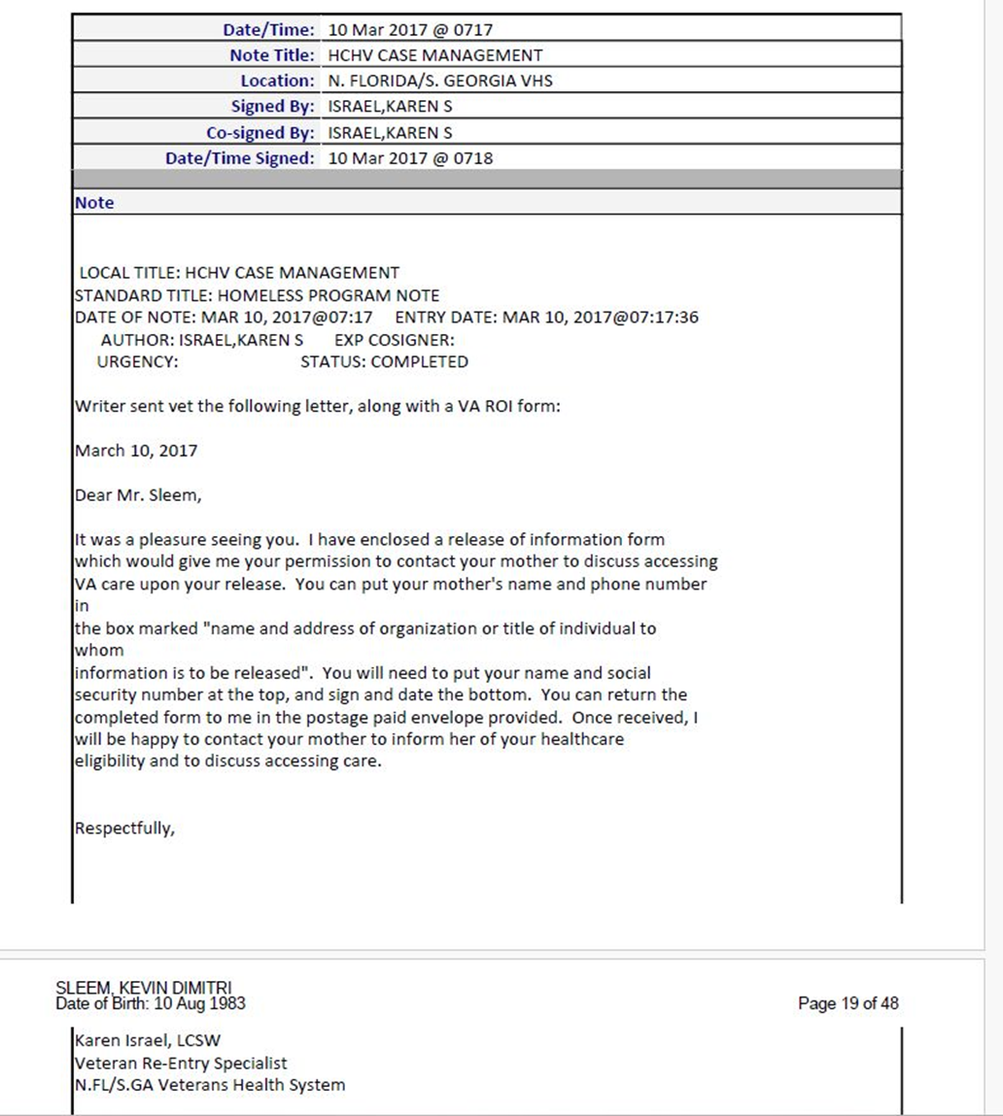

Exhibit 10. Florida State Prison Communications 2017
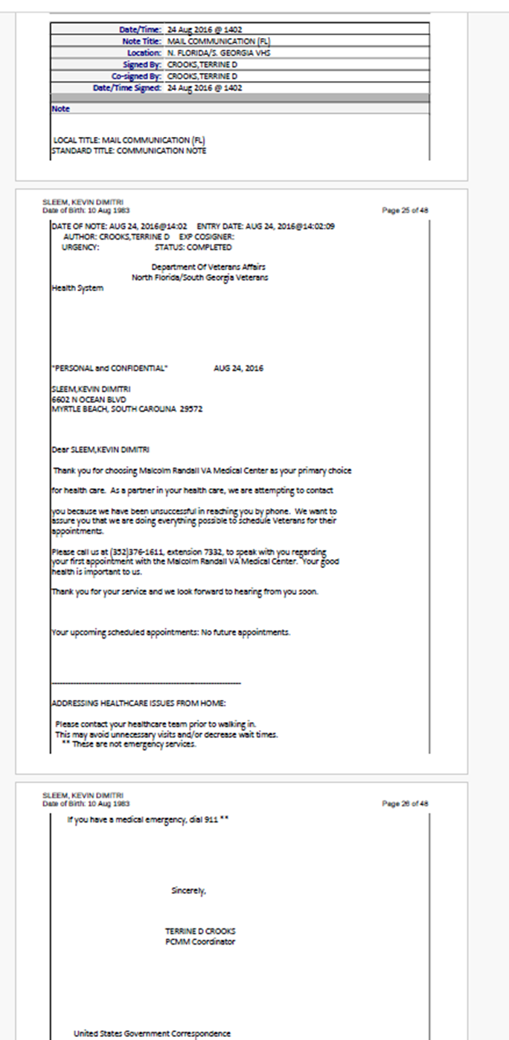

Exhibit 11. First Discharge Review 2022
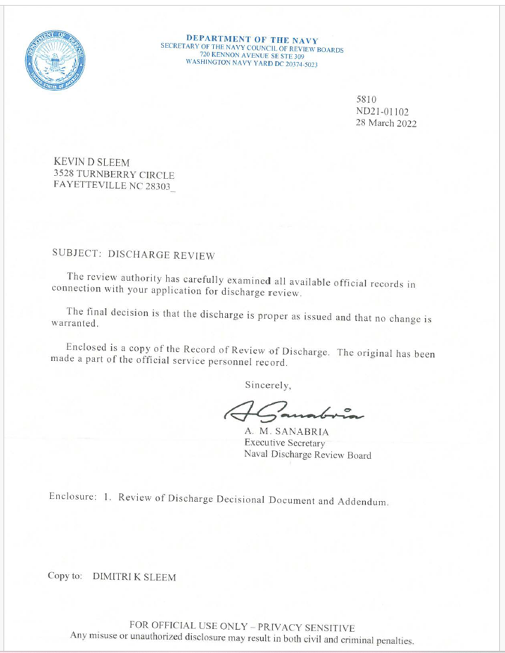
Exhibit 11. First Discharge Review 2022
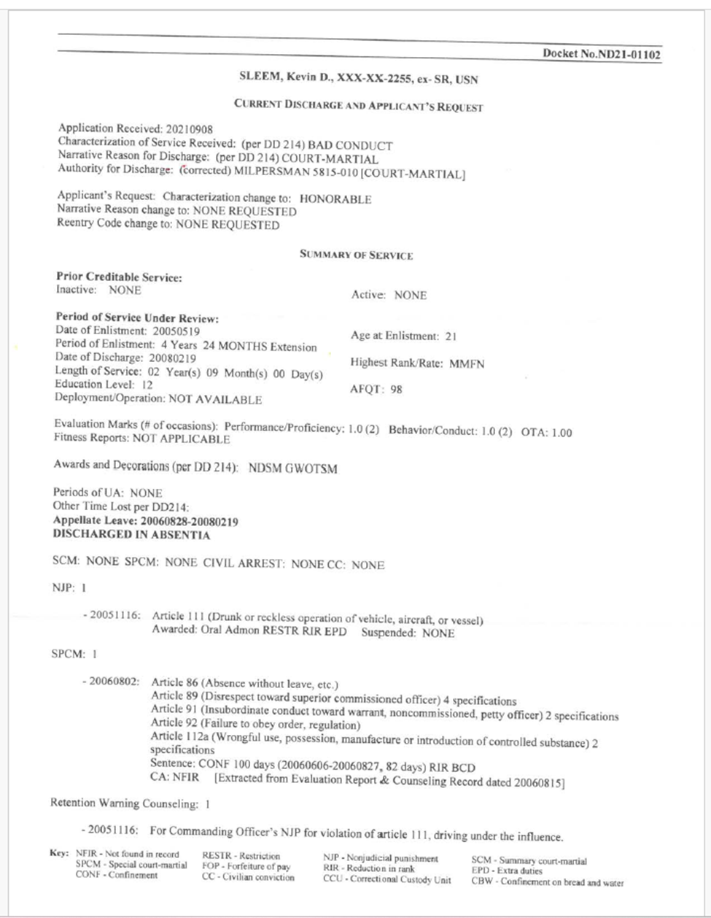

Exhibit 11. First Discharge Review 2022
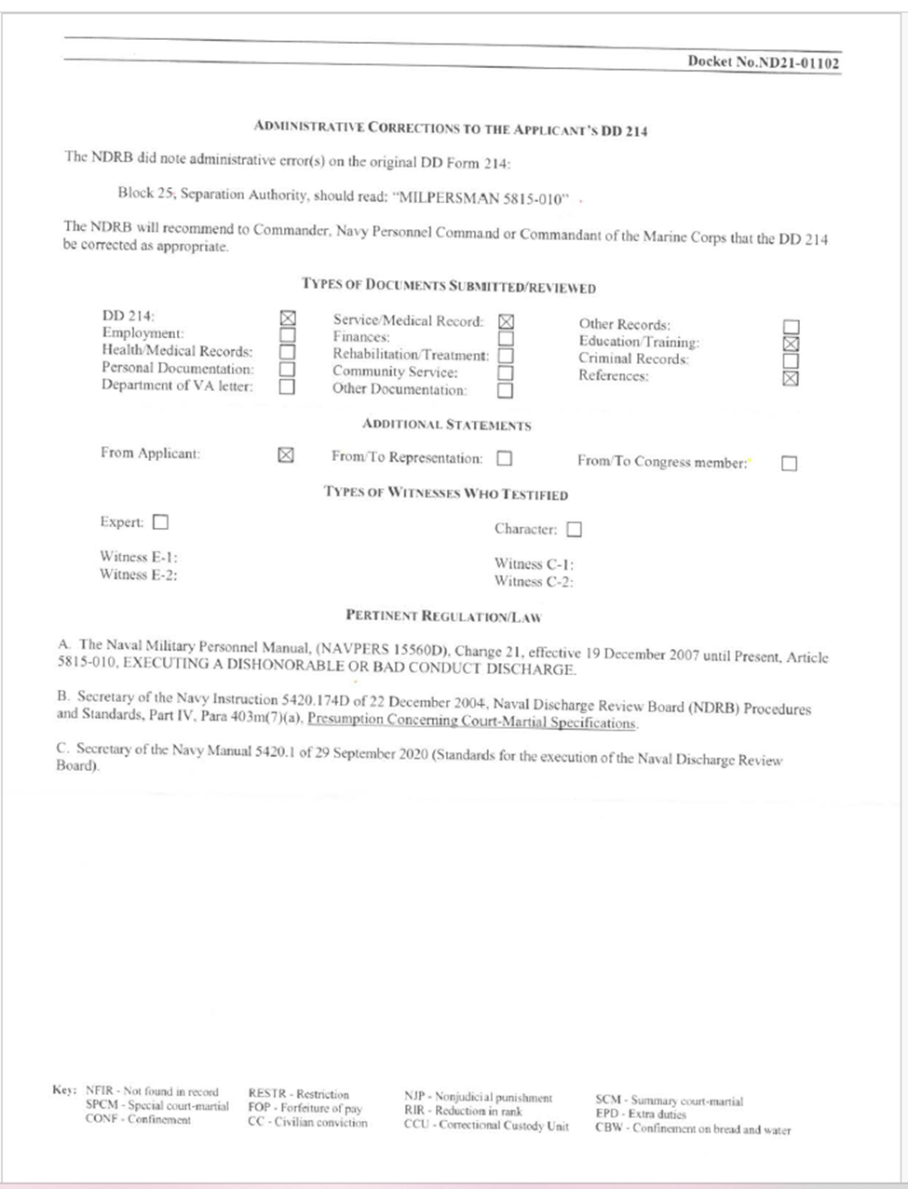

Exhibit 11. First Discharge Review 2022
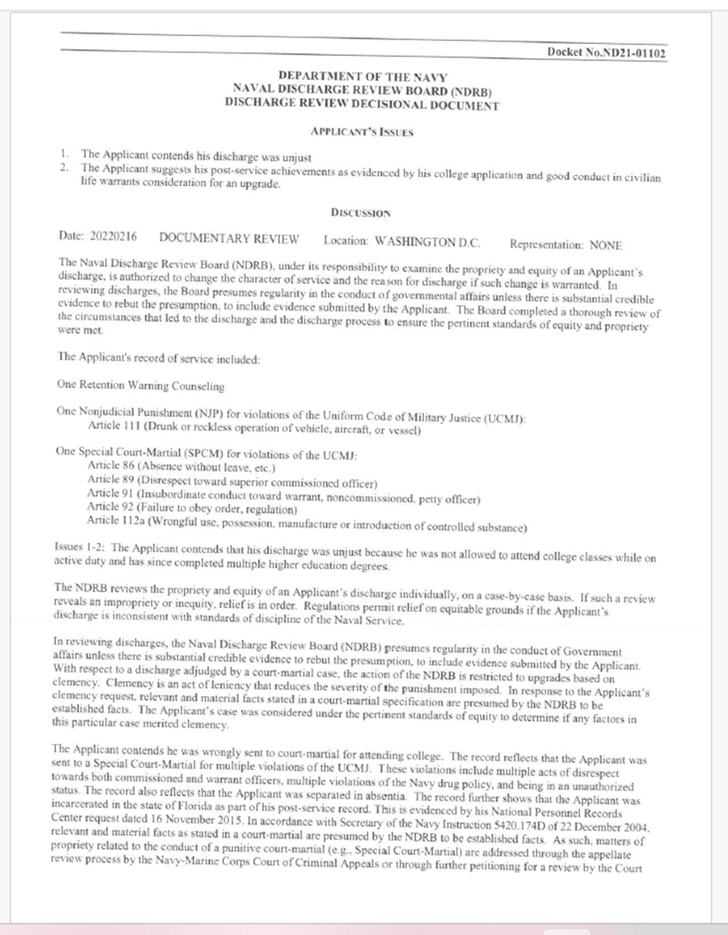

Exhibit 11. First Discharge Review 2022
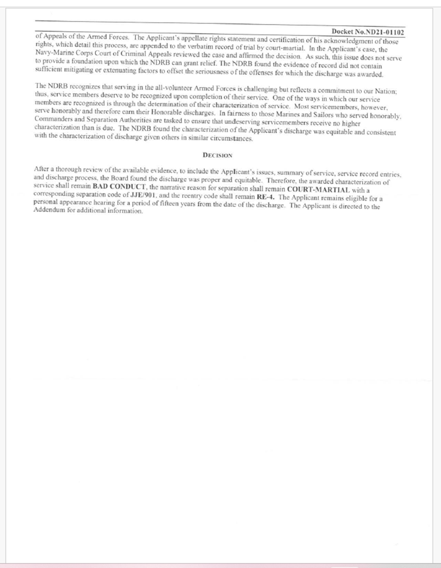

Exhibit 11. First Discharge Review 2022
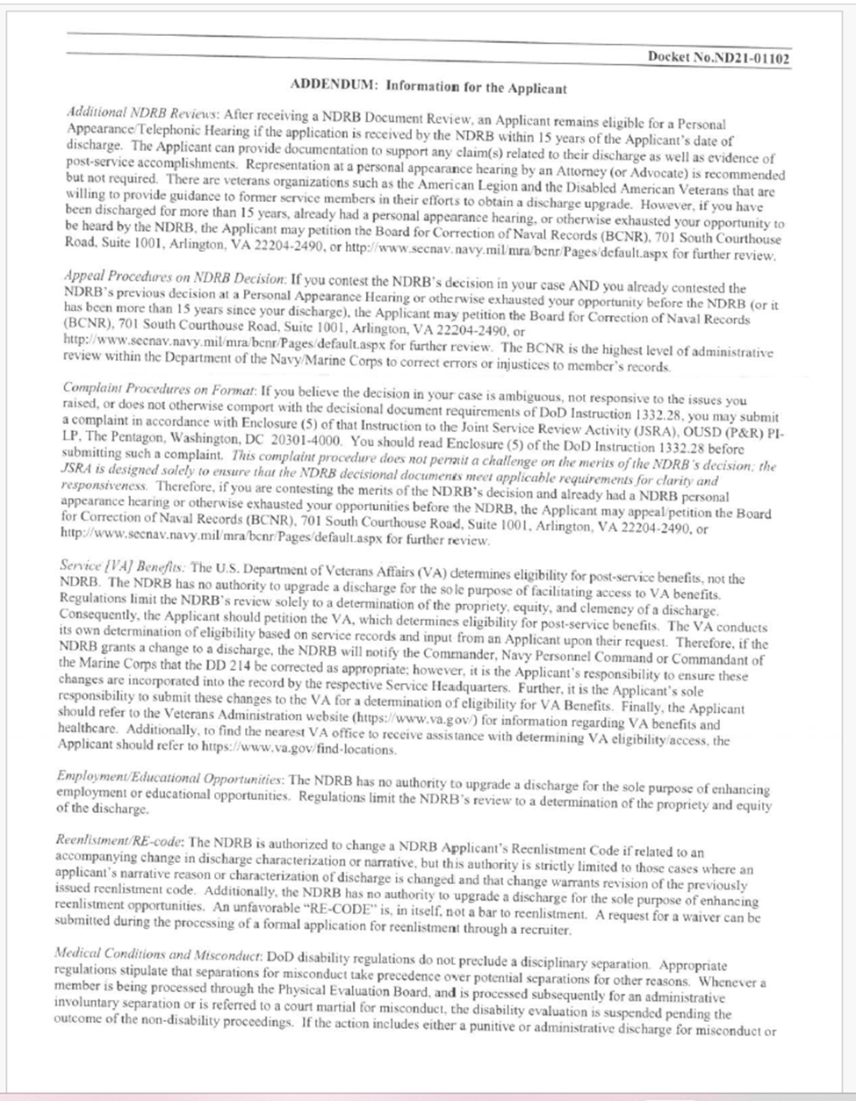

Exhibit 11. First Discharge Review 2022
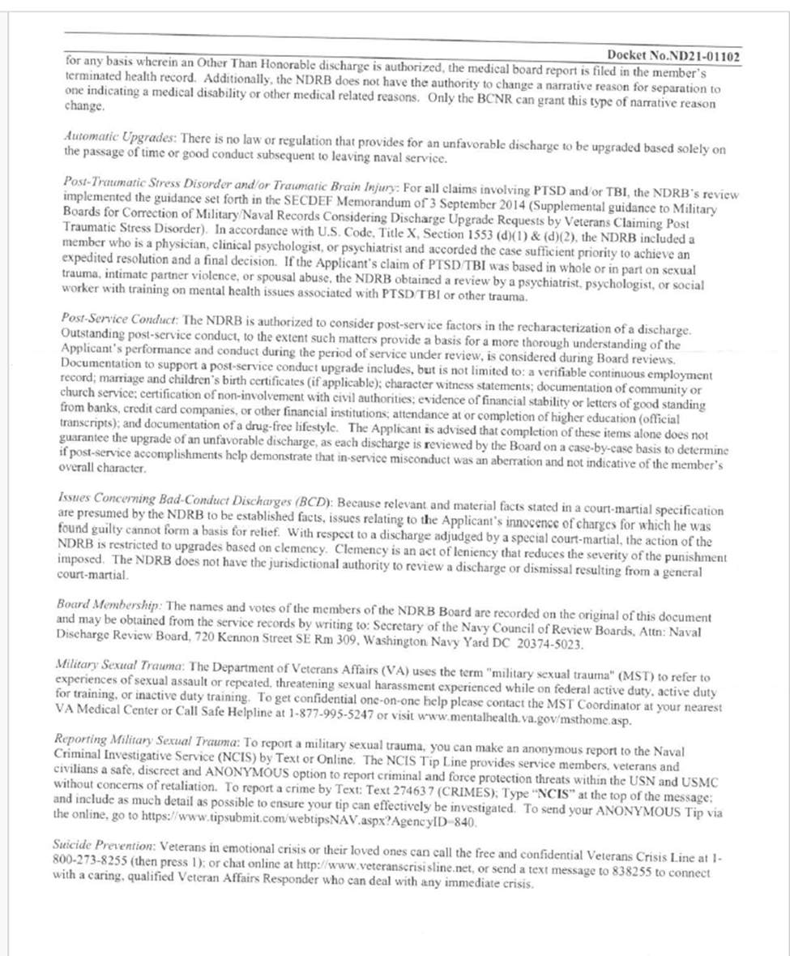

Exhibit 12. Second Discharge Review 2023
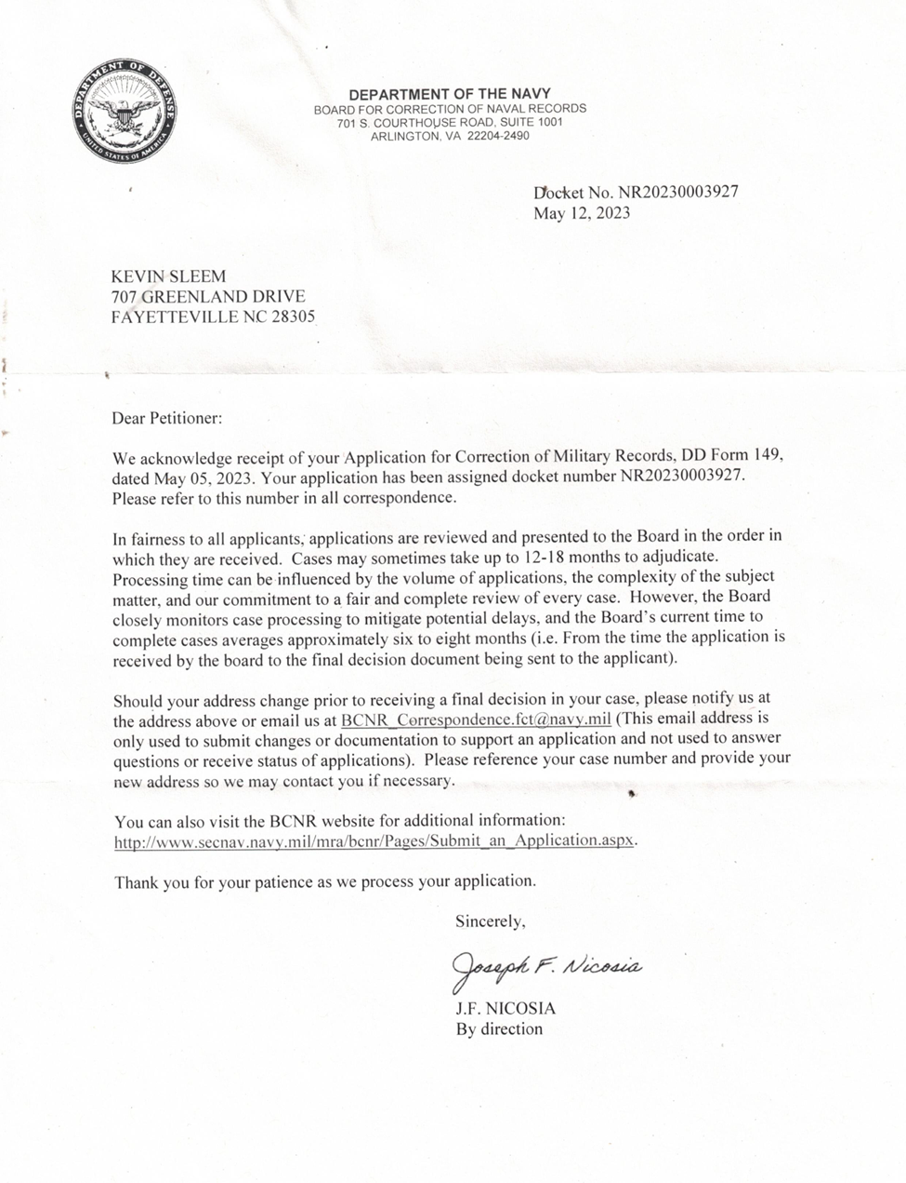

Exhibit 12. Second Discharge Review 2023
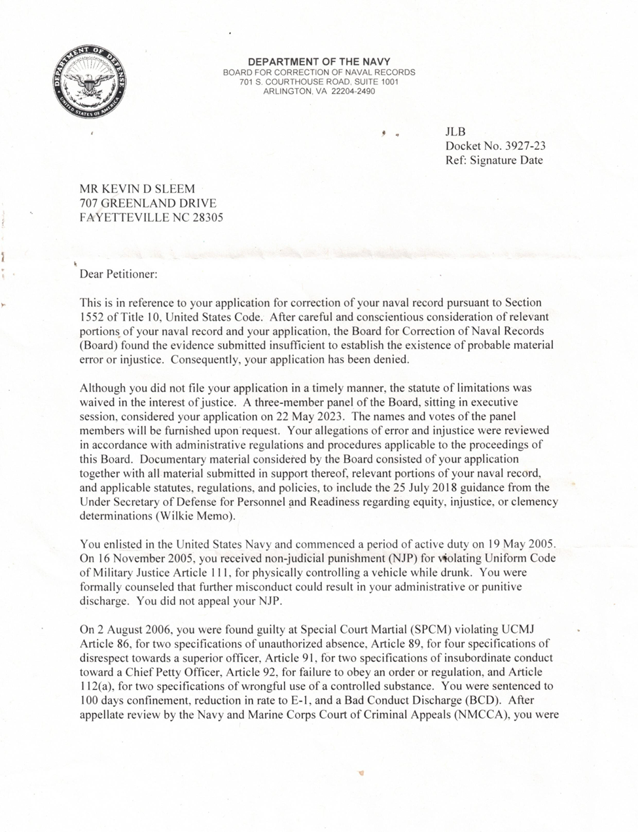

Exhibit 12. Second Discharge Review 2023
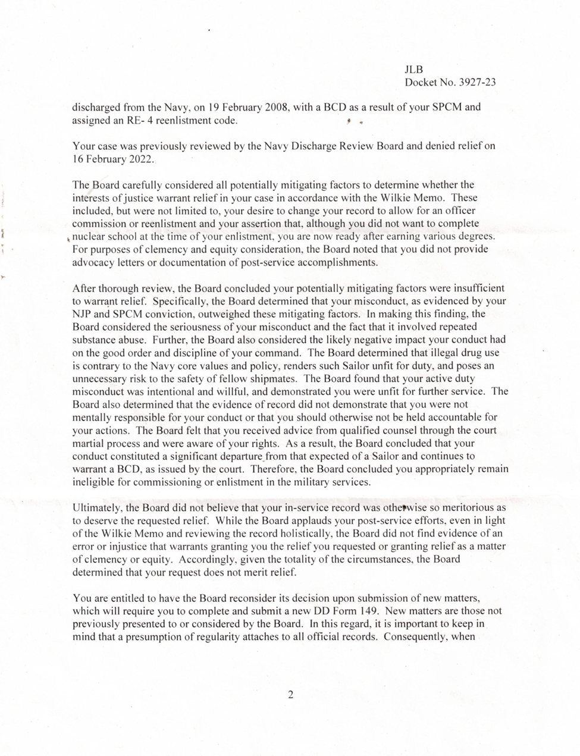

Exhibit 12. Second Discharge Review 2023
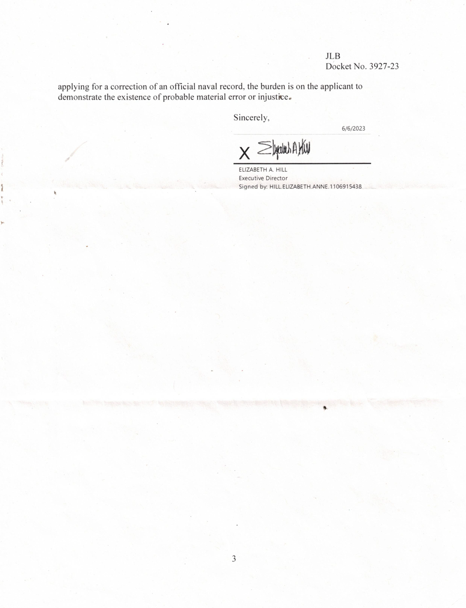

Exhibit 12. Second Discharge Review 2023
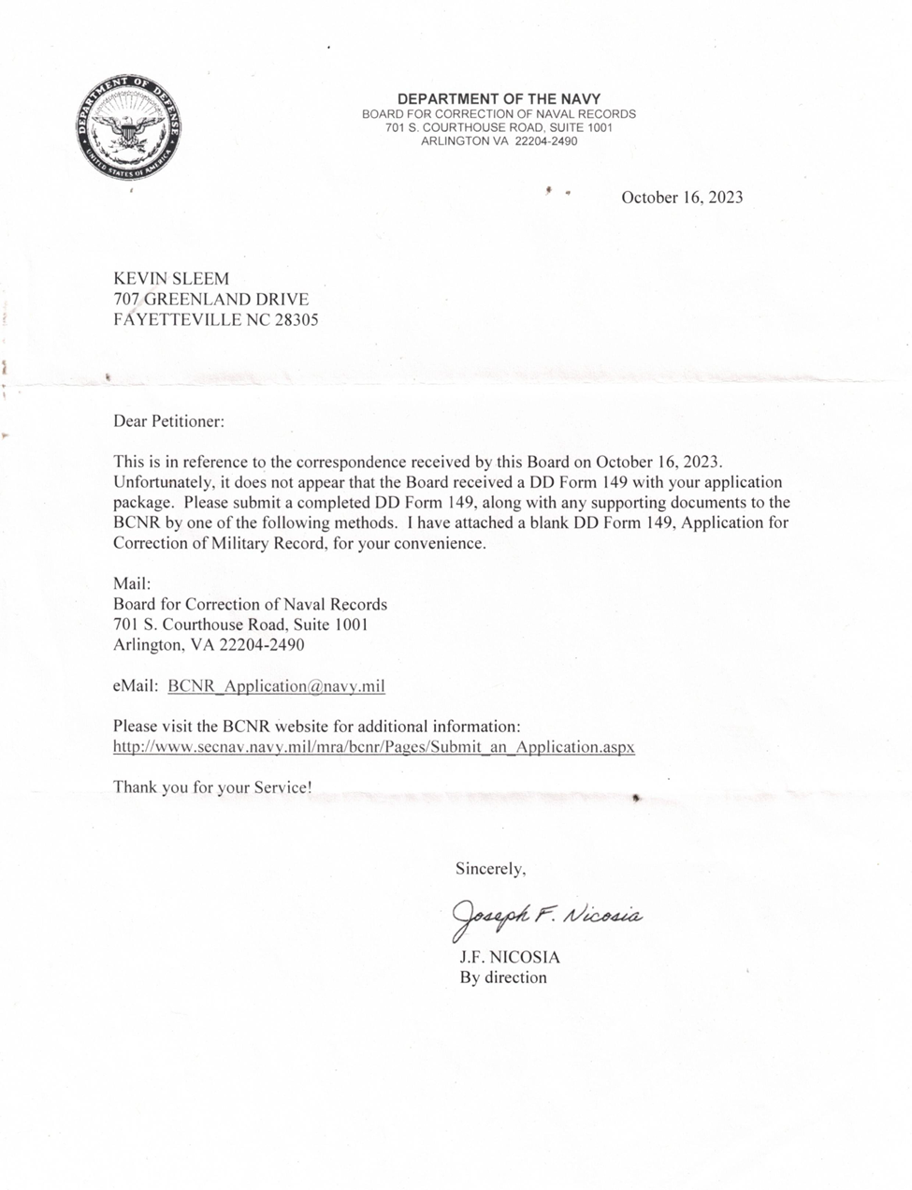

Exhibit 13. Third Discharge Review 2025
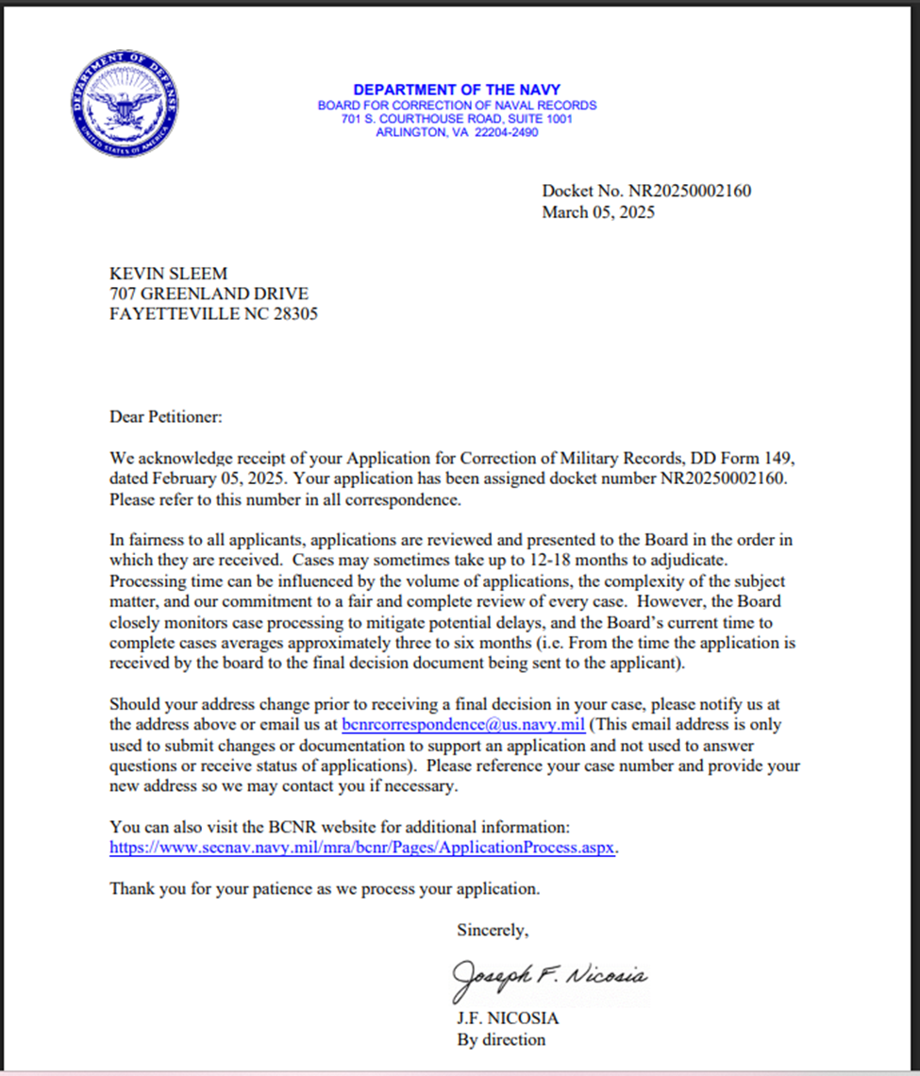

Exhibit 13. Third Discharge Review 2025
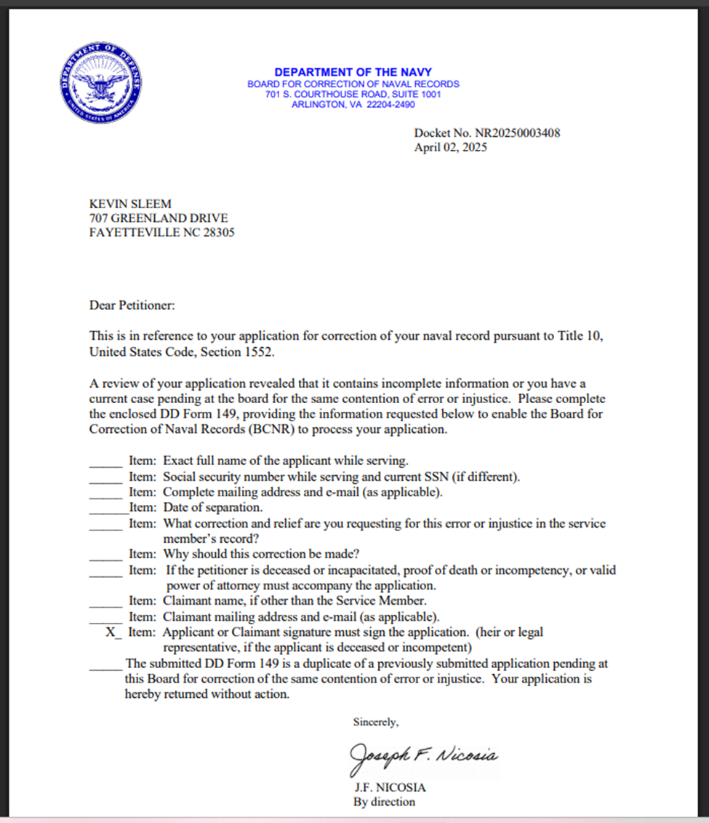

Exhibit 13. Third Discharge Review 2025
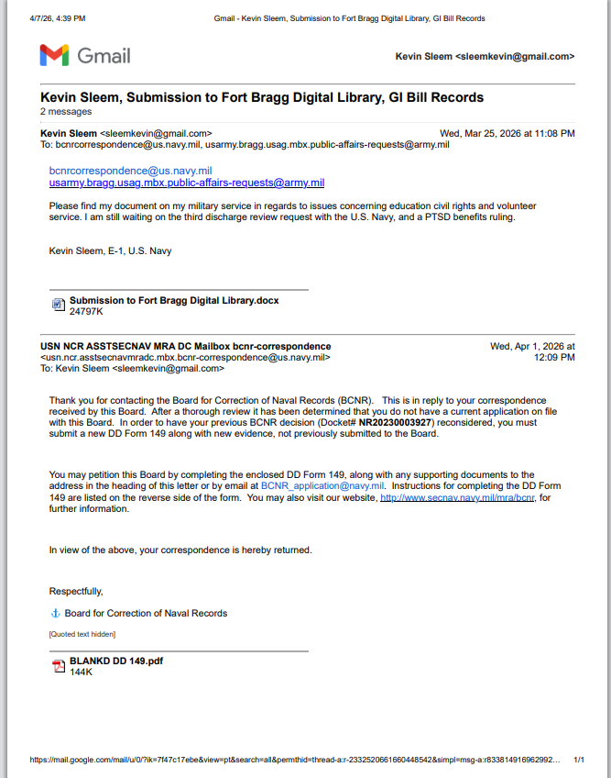

Exhibit 14. Benefits Denial 2026A
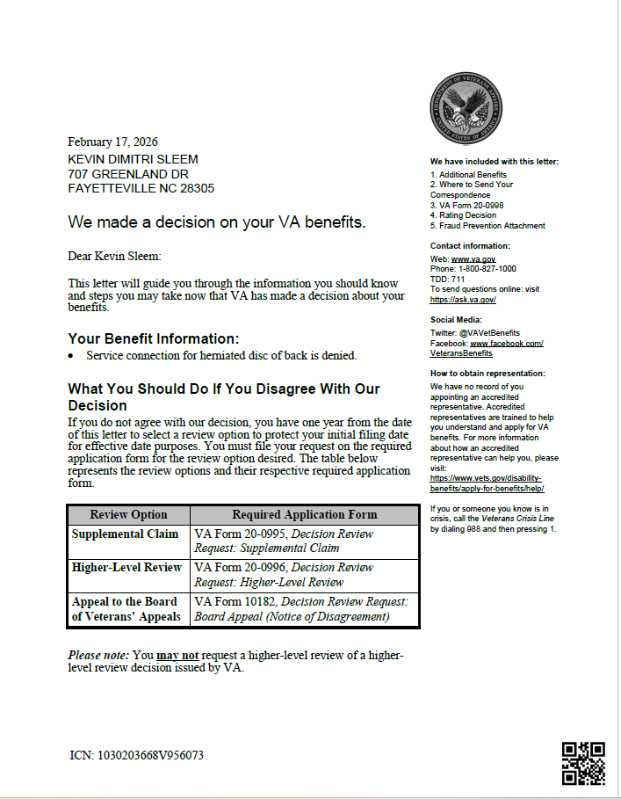

Exhibit 14. Benefits Denial 2026A
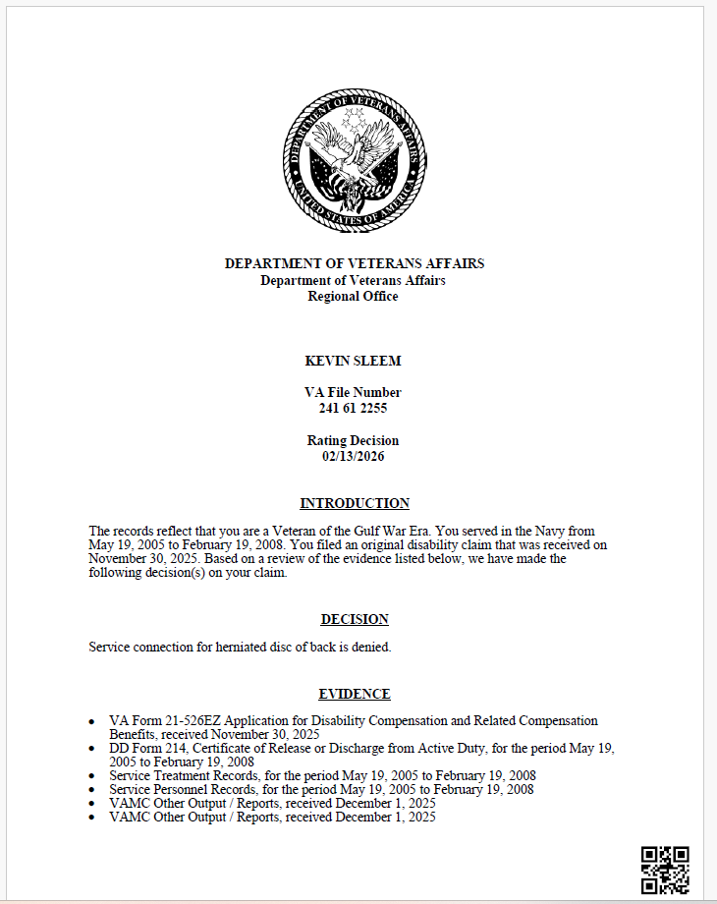

Exhibit 14. Benefits Denial 2026A
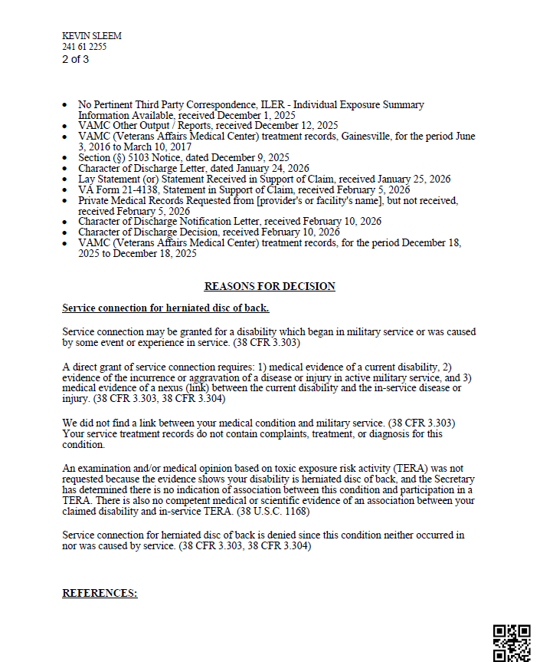

Exhibit 15. Benefits Denial 2026B
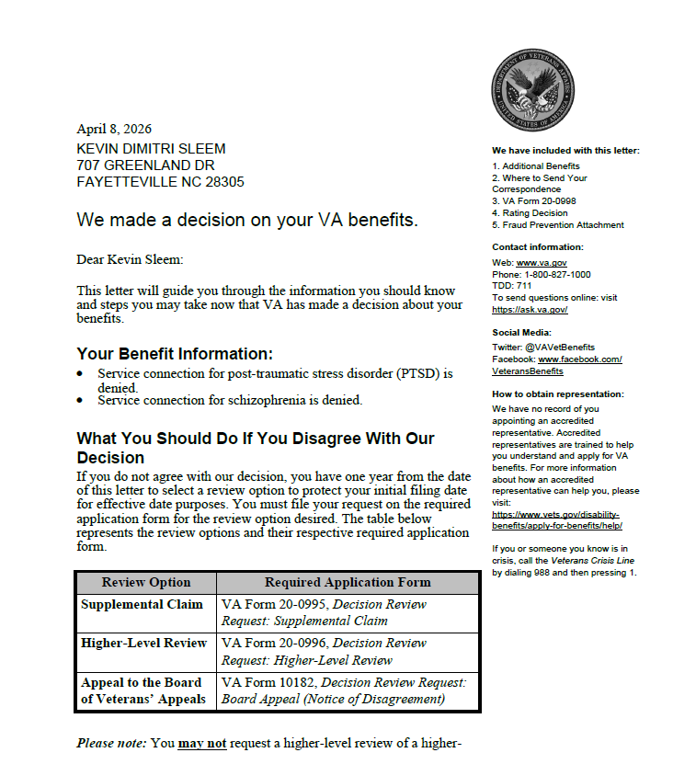

Exhibit 15. Benefits Denial 2026B
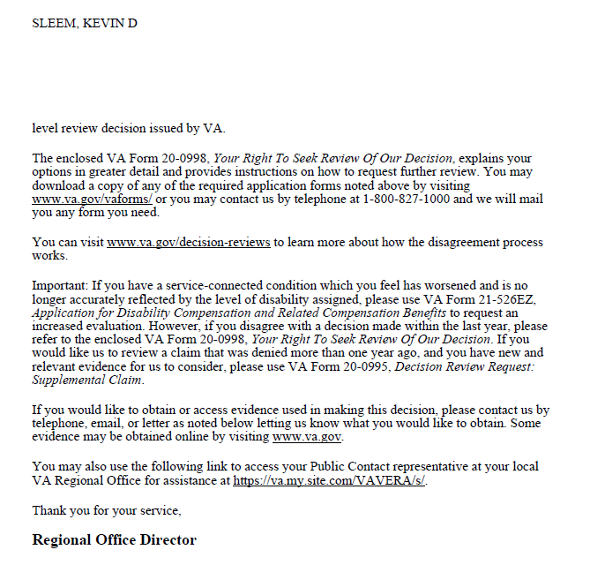

Exhibit 15. Benefits Denial 2026B
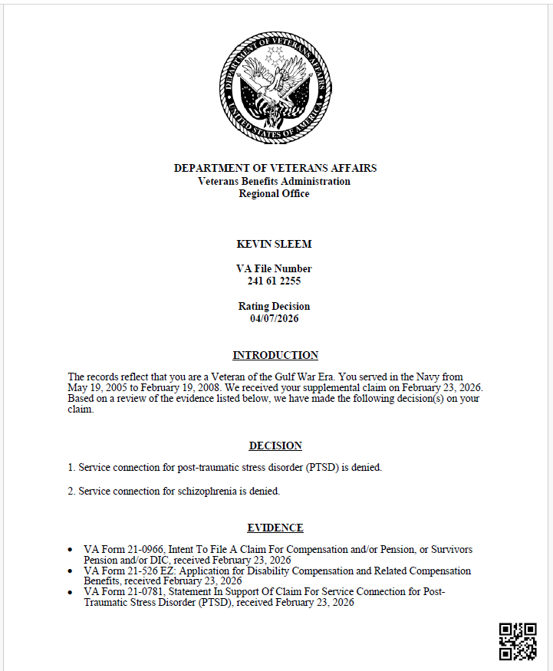

Exhibit 15. Benefits Denial 2026B
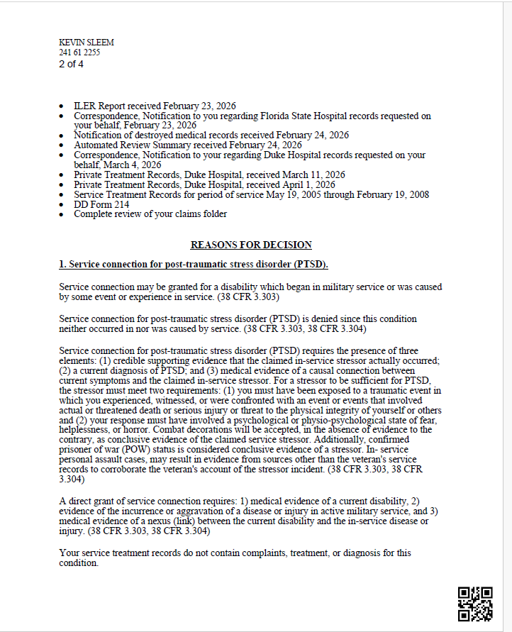

Exhibit 15. Benefits Denial 2026B
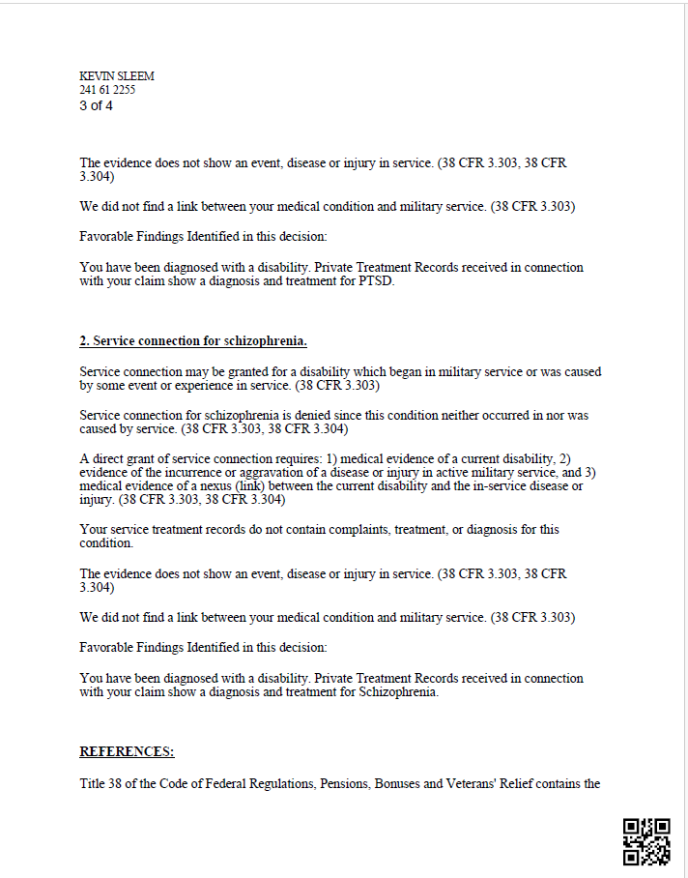

Exhibit 15. Benefits Denial 2026B
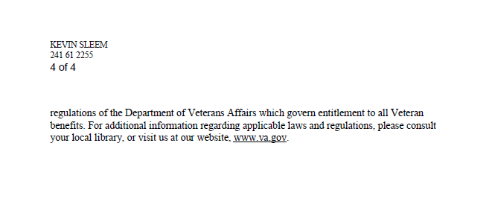

Exhibit 15. Benefits Denial 2026B
