**Capacity Markets in the U.S. Electric Industry, the Effects of Deregulation and the Push to Renewables**

Kevin Sleem, Sleem Financial Services

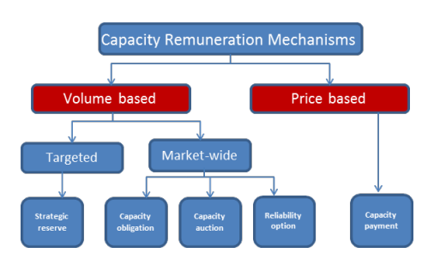

Image 1: Taxonomy of CRMs, Published in 2017, THE AGENCY FOR THE COOPERATION OF ENERGY REGULATORS reports on: CAPACITY REMUNERATION MECHANISMS AND THE INTERNAL MARKET FOR ELECTRICITY, <https://www.semanticscholar.org/paper/THE-AGENCY-FOR-THE-COOPERATION-OF-ENERGY-REGULATORS/1138781e16f1b5bc6df7829927f722705f31105f/figure/0>

Azhar, Aman (2024) Inside Climate News, Clean Energy Industry Questions a New PJM Proposal That Could Move Fossil Fuel Projects to the Front of the Interconnection Queue,

<https://insideclimatenews.org/news/08122024/grid-operator-pjm-proposal-could-prioritize-fossil-fuel-projects/?utm_source=InsideClimate+News&utm_campaign=50d2f4a9b7-EMAIL_CAMPAIGN_2024_12_14_02_12&utm_medium=email&utm_term=0_29c928ffb5-50d2f4a9b7-330709782>

PJM Interconnection has been prioritizing large nuclear and gas projects over renewable energy projects that have waited for years to connect to the region’s electric grid. The PJM has created he Reliability Resource Initiative (RRI) in order to expedite the construction of new electricity generation projects, up to 50 plants, in its service area to mitigate an impending reliability crisis the grid operator foresees toward the end of the decade as older, dirtier plants retire and demand soars due to data centers and rapid electrification (Azhar, 2024).

Lynas, Matthew (2024) PV Magazine, UK commits to hydrogen-to-power subsidy mechanism,

<https://www.pv-magazine.com/2024/12/10/uk-commits-to-hydrogen-to-power-subsidy-mechanism/?utm_source=Global+%7C+Newsletter&utm_campaign=0900ac023d-dailynl_gl&utm_medium=email&utm_term=0_6916ce32b6-0900ac023d-160603208>

In 2024, the UK government announced a new business model for hydrogen, based on dispatchable power agreements available to carbon capture technologies, with H2P plants also gaining access to the UK capacity market “as soon as practical.” Auctions for Great Britain’s capacity market are held by the National Electricity System Operator (NESO) with successful bidders securing contracts with the state-owned Low Carbon Contracts Company. Contracts in the capacity market can run for up to 15 years and provide greater revenue certainty for investors. The government has acknowledged that given higher “first-of-a-kind” costs, plus concerns about fuel availability, H2P projects may struggle to access capacity market support in the short term. It added, however, that allowing H2P to compete in the capacity market would provide greater long-term stability for the technology (Lynas, 2024).

Maisch, Marija (2024) PV Magazine, Polish capacity market auction for 2029 catalyzes gigawatts of battery storage,

<https://www.pv-magazine.com/2024/12/19/polish-capacity-market-auction-for-2029-catalyzes-gigawatts-of-battery-storage/?utm_source=Global+%7C+Newsletter&utm_campaign=7900a9ef7d-dailynl_gl&utm_medium=email&utm_term=0_6916ce32b6-7900a9ef7d-160603208>

In the Polish capacity market auction for 2029, clearing prices rendered gas projects uneconomical, while awarding more than 8 GW of capacity contracts for battery energy storage projects. While final results are yet to be released in January, industry insiders assess that the procurement exercise could have catalyzed around 4.2 GW of battery energy storage system (BESS) capacity pre-derating. A derating factor is a multiplier applied to the actual generation capacity of a unit to determine the maximum size of contract it can secure in the capacity market auction. It is based on the expected availability of the dispatchable capacity in hours when demand is highest. For the 2029 CM procurement, it stood at 61.3% (Maisch, 2024).

**Table of Contents**

1. Introduction- Page 3
2. Data Sources- Page 4
3. Regression Analysis and Results- Page 6
4. Other Graphs and Charts- Page 28
5. United States Electric Grid- Page 39
6. Capacity Markets in the U.S. Electric Industry, the Effects of Deregulation and the Push to Renewables- Page 48
7. Definitions of Capacity Markets- Page 52
8. Capacity Remuneration Mechanisms- Page 55
9. Economics of Electricity, Supply and Demand- Page 67
10. Merit Order Effect of Renewables- Page 76
11. Economics of Deregulated Markets- Page 79
12. Why do We Need Capacity Markets?- Page 80
13. How do Capacity Markets Support Reliability on the Energy Grid?- Page 85
14. Energy-Only Markets- Page 89
15. Ancillary Services Market- Page 92
16. Deregulation and Renewables, the Evolution of the Capacity Market- Page 93
17. Capacity Markets: Texas Undefined vs. New York Defined- Page 94
18. U.S. Capacity Markets: The Effects of the Push to Renewable Fuel Sources- Page 104
19. U.S. Market Structure and Available Renewable Energy Options- Page 107
20. Deregulation and Liberalization of The Electricity Industry- Page 112
21. Traditional Regulated Electricity Markets- Page 112
22. Deregulated Electricity Markets- Page 113
23. Retail Deregulation: Customer Choice- Page 113
24. Wholesale Deregulation: Creation of Competitive Wholesale Markets- Page 113
25. Variations Across Regions in the United States- Page 114
26. The Future of Electricity Markets- Page 114
27. Nuclear Industry Deregulation- Page 115
28. Electricity Industry: Generation, Transmission, Distribution- Page 121
29. Generation Units, Electric Power Generation
30. Transmission Units, Electric Power Transmission
31. Distribution Units, Electric Power Distribution
32. What is an Energy Utility- Page 122
33. Electricity and Power Plants- Page 125

**Introduction**

Capacity markets in the United States have been influenced in the recent past by deregulation beginning in the 1990s, and now are being characterized by the push to renewable sources or energy, such as wind, solar, and hydroelectric. The deregulation wave which swept the U.S. electric industry in the 1990s resulted in three basic models in the United States: traditionally regulated and vertically-integrated, that of no or limited capacity market like that in the California ISO and Texas ERCOT, and that of a pure capacity market, like the New York ISO and the other four regional transmission organizations (RTOs). Add in the new push to renewable fuel sources and we have a new element to analyze in light of the changes in the U.S. electric industry over the last 40 years.

This paper seeks to first analyze Texas ERCOT, New York NYISO, and PJM Interconnection to understand the initial effects of deregulation and how it shaped the capacity market structure in the United States. Then the role of renewable energy sources is analyzed and how this new $0 bid fuel source is affecting the capacity market structure in the United States going forward both as a whole, and in relation to the two different capacity market structures, in the case of this paper, Texas Undefined or New York Defined.

There are two underlying functions of the capacity market. One, it helps to secure generation reserves capacity to maintain system reliability, by all means a positive influence. Two, the capacity market serves to keep fossil fuel running generators in service, because they generate more sufficient rents to stay in operation to satisfy their fixed costs and depreciation expense.

**Data Sources**

1. **Federal Energy Regulatory Commission** <https://www.ferc.gov/industries-data/electric/electric-power-markets/rtoiso-performance-metrics>
2. World Energy Outlook Report, purchase**, 120 dollars, <https://www.iea.org/reports/world-energy-outlook-2020>
3. Texas ERCOT, Grid Information
4. NYISO, Reports, Gold Report
5. Public Power Magazine, Statistical Reports, 2018-2021
6. Annual Electric Power Industry Report, Form EIA-861 detailed data files, <https://www.eia.gov/electricity/data/eia861/>
7. Electric Power Research Institute, EPRI
8. Spot Market Prices, Europe, <https://www.energy-charts.info/charts/price_spot_market/chart.htm?l=en&c=DE>
9. Potomac Economics
10. Monitoring Analytics

**Numeric models are used to quantify**

1. Energy efficiency rates in the two different capacity market constructs, for all seven RTOs
2. Before and after, effects of $0 bid renewables on energy market prices and capacity market prices for all seven RTOs

-Approaches for defining wind and solar capacity contributions in existing capacity markets.

-to quantify wind and solar contributions during critical reliability hours, corresponding to the marginal contribution of a generator to reducing the expected unserved energy when adding another unit of capacity

-to calculate equilibria for combined energy-capacity-renewable credit markets, thus allowing us to quantify the distortions from incorrect renewable credits and their interactions with renewable subsidies

-wholesale transmission outages, distribution facility outages

-uncoordinated capacity markets and coordinated capacity markets

-peak load pricing approach, peak load pricing theory

-deregulation, restructuring, liberalization

**Gaps in the Capacity Market Literature and Models**

-Höschle et al. (2017)

1. Proposed game-theoretic equilibrium models fall short in representing the distinctive features of different types of CMs
2. Most models incorporating CMs found in the literature only focus on the interaction with the energy-based market. Valid assessments of CM need to consider the interaction of remuneration for available capacity and flexibility, and the indirect interaction with the remuneration for emission-neutral RES
3. Market-wide centralized capacity market
4. Targeted strategic reserves

**Regression Analysis and Results**

Tables 1 and 2 show the results of the regression analysis finding significance of different energy variables with world GDP and world population since 1965. Table 1 uses values for fuel sources since 1965, and Table 2 uses values for fossil fuels since 1998. Other renewables, biofuels, solar, oil, coal, and traditional biomass are significant with world GDP since 1965. Other renewables, hydropower, nuclear, oil, coal, and traditional biomass are significant with world population since 1965. Brent oil, China coal, Japan coking coal import, and Nigeria oil are significant with world GDP and world population since 1998. All data was taken from Our World in Data.

**Coal Indices**

1. Asian Marker Price Coal
2. China Qinhuangdao Spot Price Coal
3. Japan Coking Coal Import CIF Price
4. Japan Steam Coal Import CIF Price
5. Japan Steam Spot CIF Price Coal
6. Northwest Europe Coal
7. US Central Appalachian Coal Spot Price Index

**Oil Indices**

1. Brent Crude
2. Dubai Oil
3. Nigerian Forcados Oil
4. West Texas Intermediate Oil

**Natural Gas Indices**

1. German Import Natural Gas
2. Canada Alberta Natural Gas
3. LNG Japan CIF
4. UK NBP (ICIS NBP Index) Natural Gas
5. US Henry Hub Natural Gas

Graph 1 shows the worldwide fuel diversity consumption for 2022. Coal is the leading resource being used still, at 35.8%. This figure is contrasted with Table 3, which shows U.S. fuel diversity, where natural gas is the leading resource used. Natural gas is number two worldwide, whereas coal is number two in the United States. These results show how the United States has made a concerted effort to diversify from coal plants in recent years to more clean burning natural gas. Number three worldwide is hydro power, followed by nuclear at four and wind at five. In the United States, all three, hydro, nuclear, and wind, are about equal. Solar is still making inroads both worldwide and in the U.S.

Table 5 and Graph 3 show the fuel diversity and energy generation portfolio of Texas ERCOT from 2014 to 2022. Coal and natural gas were almost even in 2014, but natural gas is more than twice coal by 2022. Wind is second in Texas, followed by coal, nuclear, and solar. Tables 8, 9, and 10 show NYISO energy sources from 2014 to 2020. In the NYISO, natural gas is the biggest resource source, at 35%, followed by nuclear use at 29%. Hydro power is third in the NYISO at 22%, followed by wind at 3%, coal at 1%, and solar at 1%. The NYISO is ahead of the market in weaning itself off coal, though still has not embraced large-scale wind power.

Table 6 shows the output-weighted average price by generation type based on the generators’ specific locational prices in 2022 for Texas ERCOT. Gas peakers is the highest cost at $189.86 per MWh, followed by gas steam at $140.51 per MWh. Coal is relatively cheap, only costing $70 per MWh. Wind is the cheapest, at $34.09 per MWh, and solar is $73.09 per MWh. Nuclear is also relatively cheap, only costing $60.78 per MWh. Hydro costs $87.76 in 2022 per MWh. If coal is cheaper, then we could benefit from using more coal, even though coal produces more emissions for the environment.

Per Table 7, NYISO does not report prices per fuel source in either the Gold Book on the NYISO website or in their annual market reports in Potomac Economics. They do report natural gas prices per zone using indexes, which averaged to around $7.50. In 2022, average all-in prices rose to the highest levels observed in more than a decade, ranging from $58 per MWh in the North Zone to nearly $127 per MWh in Long Island. All-in prices rose 50 to 100 percent from 2021.

Tables 8, 9, and 10 show NYISO energy sources per GWh and percent from 2014 to 2020. Coal use decreases from 3% in 2014 to 1% in 2020. Nuclear use remains constant at around 30% use from 2014-2020. Solar is 1% and wind is 3% in all years, and natural gas use is around 35% in all years.

Table 11 and Graph 4 show PJM Interconnection wholesale costs from 2018 to 2022. For 2022, energy market cost is $54.16 per MWh, capacity market cost is $11.71 per MWh, and total cost is $79.37 per MWh. 2022 was the most expensive year since 2018.

Table 12 and Graph 5 show 2014 fuel diversity for capacity markets for the 6 RTOs, not including Texas ERCOT. These include ISO-NE, CAISO, MISO, NYISO, PJM and SPP. Table 13 and Graph 6 show 2014 fuel diversity for the energy-only market. This information is obtained from a singular 2015 ISO/RTO Metrics Report, which was only published for that year, and was published by the New England States Commission on Electricity. The fuel mix for capacity markets and energy-only markets mirror each other. For coal, MISO, PJM, and SPP each use coal for around 50% of their energy mix. CAISO used 0% coal, NYISO uses 3% coal, and ISO-NE uses 5% coal. These are major differences from our cheapest fossil fuel energy source, coal. Natural gas use is significant in all 6 markets. Nuclear use is around 30% in ISO-NE, NYISO, and PJM, and nuclear use is around 10% in CAISO, MISO, and SPP. Hydro and renewables use is significant in ISO-NE, CAISO, NYISO, and SPP.

Tables 14-17 display capacity auction results from the four U.S. capacity markets. Table 18 displays that PJM Interconnection is the largest capacity market in the U.S., followed by Midcontinent ISO, with NYISO and ISO-NE being about the same size. Per Table 19, energy costs were highest in CAISO and Lowest in SPP for 2018.

**VII. Conclusion**

China has said that regarding its use of coal fired power plants, it is important to embrace the future, but we cannot forget the past at the same time. In Texas ERCOT, coal is the cheapest form of fossil fuel energy, at $70 per MWh compared to natural gas at $140.51 per MWh. It is also relevant to note that wind energy has not caught on and advanced in all U.S. regions at the same pace. In 2020, wind usage nationwide was at 9.8% and solar usage was at 4%. In 2014, CAISO used 0% coal and 29% hydro and renewables. The 0% coal is significant, because it represents a clear denunciation at an early date from a major zone in use of our cheapest fossil fuel energy source. Capacity markets have emerged since deregulation as a means to secure system reliability and maintain operating reserves, but are needed in every market. In some markets, like Texas ERCOT, they utilize the energy-only market by itself to generate sufficient revenues for plant generation investments. Europe is a similar situation, with a few countries utilizing capacity remuneration mechanisms but some still only using energy-only markets. Thus we can say that having a capacity market or using CRMs at all is a political decision, and not needed in every situation.

**Table 1. Fuel Source Significance per GDP and Population**

|  | **GDP** |  | **Population** | |
| --- | --- | --- | --- | --- |
| **Variable** | **Estimate** | **Significance** | **Estimate** | **Significance** |
| **Other renewables (TWh, substituted energy)** | 5.77 | *** | 3.18 | *** |
| **Biofuels (TWh, substituted energy)** | -1.76 | * |  |  |
| **Solar (TWh, substituted energy)** | -2.64 | ** |  |  |
| **Hydropower (TWh, substituted energy)** |  |  | 6.74 | *** |
| **Nuclear (TWh, substituted energy)** |  |  | 3.22 | *** |
| **Oil (TWh, substituted energy)** | 3.86 | *** | 3.52 | *** |
| **Coal (TWh, substituted energy)** | 6.08 | *** | 4.5 | *** |
| **Traditional biomass (TWh, substituted energy)** | 3.08 | *** | 6.12 | *** |

**Table 2. Fossil Fuels Significance per GDP and Population**

|  | **GDP** |  | **Population** | |
| --- | --- | --- | --- | --- |
| **Variable** | **Estimate** | **Significance** | **Estimate** | **Significance** |
| **Brent Oil** | -2.09 | * | -1.99 | * |
| **China Coal** | 1.85 | * | 2.03 | * |
| **Japan Coking Coal Import** | -2.28 | * | -2.36 | ** |
| **Nigeria Oil** | 2.16 | * | 2.05 | * |

**Graph 1. Worldwide Fuel Diversity 2022**

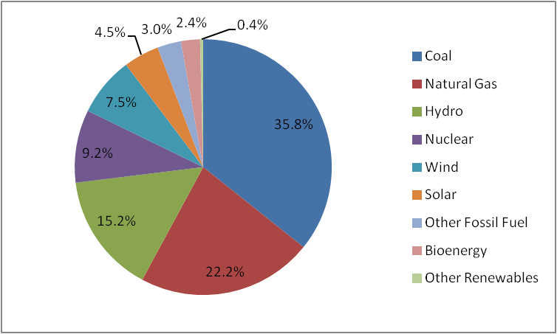

Source: Statista Research

**Table 3. U.S. Fuel Diversity in Megawatts**

|  | **2016** | **2017** | **2018** | **2019** | **2020** |
| --- | --- | --- | --- | --- | --- |
| **Coal** | 289,429 | 278,224 | 263,570 | 247,289 | 233,129 |
| **Gas** | 517,327 | 527,956 | 542,762 | 547,583 | 556,485 |
| **Nuclear** | 104,791 | 104,792 | 104,270 | 102,877 | 100,899 |
| **Oil** | 39,446 | 38,122 | 36,896 | 35,988 | 31,935 |
| **Wind** | 87,464 | 94,020 | 100,483 | 104,334 | 118,728 |
| **Hydro** | 101,020 | 101,238 | 101,786 | 101,661 | 101,865 |
| **Other** | 37,707 | 42,592 | 47,634 | 20,539 | 20,860 |
| **Solar** | - | - | - | 37,790 | 48,339 |

Source: Public Power Magazine

**Table 4. U.S. Fuel Diversity by %**

|  | **2016** | **2017** | **2018** | **2019** | **2020** |
| --- | --- | --- | --- | --- | --- |
| **Coal** | 24.6% | 23.4% | 22.0% | 20.6% | 19.2% |
| **Gas** | 43.9% | 44.5% | 45.3% | 45.7% | 45.9% |
| **Nuclear** | 8.9% | 8.8% | 8.7% | 8.6% | 8.3% |
| **Oil** | 3.4% | 3.2% | 3.1% | 3.0% | 2.6% |
| **Wind** | 7.4% | 7.9% | 8.4% | 8.7% | 9.8% |
| **Hydro** | 8.6% | 8.5% | 8.5% | 8.5% | 8.4% |
| **Other** | 3.2% | 3.6% | 4.0% | 1.7% | 1.7% |
| **Solar** | - | - | - | 3.2% | 4.0% |

Source: Public Power Magazine

**Graph 2. U.S. Fuel Diversity by %**

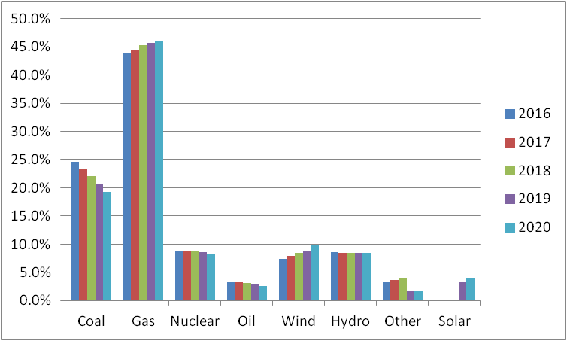

Source: Public Power Magazine

**Table 5. Texas ERCOT Energy Generation Portfolio**

|  | **2014** | **2015** | **2016** | **2017** | **2018** | **2019** | **2020** | **2021** | **2022** |
| --- | --- | --- | --- | --- | --- | --- | --- | --- | --- |
| **Nuclear** | 12% | 12% | 12% | 12% | 12% | 12% | 11% | 11% | 10% |
| **Coal** | 35% | 27% | 29% | 31% | 24% | 20% | 17% | 18% | 16% |
| **Natural Gas** | 41% | 48% | 43% | 39% | 44% | 46% | 46% | 43% | 43% |
| **Wind** | 11% | 12% | 15% | 16% | 18% | 19% | 22% | 23% | 25% |
| **Solar** | 0% | 0% | 1% | 2% | 1% | 2% | 3% | 4% | 5% |
| **Other** | 1% | 1% | 0% | 0% | 1% | 1% | 1% | 1% | 1% |

Source: Potomac Economics, 2022 State of the Market Report

**Graph 3. Texas ERCOT Energy Generation Portfolio**

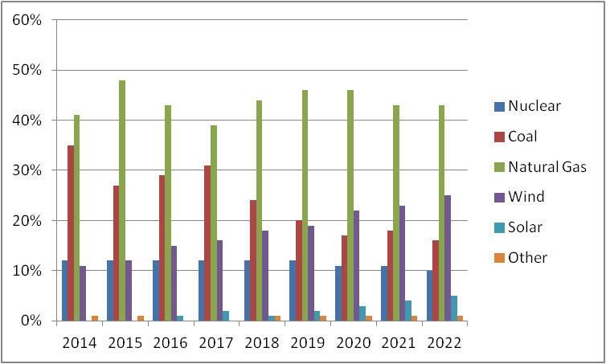

Source: Potomac Economics, 2022 State of the Market Report

**Table 6. Texas ERCOT Settlement Point Price by Fuel Type**

|  | **2020** | **2021** | **2022** |
| --- | --- | --- | --- |
| **Coal** | $24.84 | $148.06 | $70.00 |
| **Combined Cycle** | $24.60 | $207.84 | $80.71 |
| **Gas Peakers** | $60.26 | $1,023.09 | $189.86 |
| **Gas Steam** | $41.90 | $405.10 | $140.51 |
| **Hydro** | $23.88 | $305.15 | $87.76 |
| **Nuclear** | $20.31 | $137.71 | $60.78 |
| **Power Storage** | $80.50 | $109.29 | $92.64 |
| **Private Network** | $24.08 | $176.76 | $74.46 |
| **Renewable** | $35.23 | $43.54 | $83.00 |
| **Solar** | $25.49 | $75.97 | $73.09 |
| **Wind** | $11.45 | $60.53 | $34.09 |

Source: Potomac Economics, 2022 State of the Market Report

**Table 7. Natural Gas Prices, NYISO**

|  | **2019** | **2020** | **2021** | **2022** |
| --- | --- | --- | --- | --- |
| **Tennessee Zn6** | $3.26 | $2.13 | $4.68 | $9.20 |
| **Iroquois Zn2** | $3.04 | $2.09 | $4.36 | $8.82 |
| **Transco Zn6** | $2.59 | $1.64 | $3.49 | $7.04 |
| **Tenn Z4 200L** | $2.26 | $1.69 | $3.38 | $5.75 |

Source: Potomac Economics, 2022 State of the Market Report

**Table 8. NYISO Energy Sources GWh**

|  | **2020** | **2019** | **2018** | **2017** | **2016** |
| --- | --- | --- | --- | --- | --- |
| **RSolar** | 48.5 | 52.1 | 48.8 | 47.3 | 53.7 |
| **RWind** | 4,161.90 | 4,453.60 | 3,985.10 | 4,219.20 | 3,943.30 |
| **RSteam Turbine Refuse** | 1,619.70 | 1832.3 | 1,878.40 | 1,900.10 | 1,840.90 |
| **RSteam Turbine Wood** | 0 | 154.6 | 203.4 | 288.3 | 292.5 |
| **RInternal Combustion Methane** | 612.9 | 660.9 | 647.6 | 730.1 | 747.7 |
| **RConventional Hydro** | 29,521.30 | 30,140.90 | 29,045.10 | 29,554.20 | 26,314.10 |
| **NSteam BWR Nuclear** | 22,236.70 | 23,099.60 | 21,962.50 | 22,215 | 21,448.80 |
| **NSteam PWR Nuclear** | 16,200.30 | 21,688.30 | 21,040.60 | 19,959.60 | 20,188.70 |
| **PPumped Storage Hydro** | 635.5 | 583.1 | 810.8 | 795.3 | 835.6 |
| **FInternal Combustion Gas** | 26.1 | 28.5 | 1.7 | 1.4 | 1.1 |
| **FInternal Combustion Oil&Gas** | 0.9 | 0.9 | 2 | 1.8 | 1.8 |
| **FInternal Combustion Oil** | 2.8 | 2.5 | 2.2 | 1.3 | 2.1 |
| **FCombustion Turbine Gas** | 737.7 | 541.9 | 732.9 | 671.3 | 905.3 |
| **FCombustion Turbine Oil&Gas** | 396.8 | 325.9 | 432.1 | 408.8 | 854.8 |
| **FCombustion Turbine Oil** | 82.8 | 26.2 | 36 | 18 | 45.8 |
| **FJet Engine Gas** | 88.1 | 118.9 | 140.8 | 99.6 | 211.9 |
| **FJet Engine Oil&Gas** | 451.4 | 741 | 916 | 728.7 | 1,284.10 |
| **FJet Engine Oil** | 112 | 71.1 | 89 | 36.2 | 70.6 |
| **FCombined Cycle Gas** | 8,556.70 | 5,580.40 | 5,465.10 | 4,887.40 | 5,555.10 |
| **FCombined Cycle Oil&Gas** | 37,235.70 | 36,894 | 37,099.60 | 35,355.60 | 39,017.10 |
| **FSteam Turbine Coal** | 145.9 | 425.6 | 692 | 567.4 | 1,492.80 |
| **FSteam Turbine Gas** | 1,120.90 | 1003.2 | 1,253.30 | 1,037.70 | 1,114 |
| **FSteam Turbine Oil&Gas** | 7,455.40 | 6,106.70 | 9,075.80 | 7,640.60 | 11,292.60 |
| **FSteam Turbine Oil** | 11.6 | 4.2 | 24.4 | 18.1 | 17.1 |
| **Total** | 131,461.6 | 134,536.3 | 135,585.2 | 131,182.9 | 137,531.5 |

Source: NYISO Gold Book, Load and Capacity Data Report

**Table 9. NYISO Energy Sources GWh**

|  | **2020** | **2019** | **2018** | **2017** | **2016** | **2015** |
| --- | --- | --- | --- | --- | --- | --- |
| **Gas** | 10,530 | 7273 | 7594 | 6697 | 7787 | 9,737 |
| **Oil** | 209 | 104 | 152 | 74 | 136 | 146 |
| **Gas and Oil** | 45,540 | 44068 | 47526 | 44135 | 52450 | 52,028 |
| **Coal** | 146 | 425 | 692 | 567 | 1493 | 2,046 |
| **Nuclear** | 38,437 | 44788 | 43003 | 42175 | 41638 | 44,620 |
| **Pumped Storage** | 636 | 583 | 811 | 795 | 836 | 825 |
| **Hydro** | 29,521 | 30141 | 29045 | 29554 | 26314 | 25,879 |
| **Wind** | 4,162 | 4454 | 3985 | 4219 | 3943 | 3,984 |
| **Solar** | 49 | 52 | 49 | 47 | 54 | 52 |
| **Other** | 2,233 | 2648 | 2729 | 2919 | 2881 | 3,028 |
| **Total** | 131,462 | 134,536 | 135,585 | 131,183 | 137,532 | 142,345 |

Source: NYISO Gold Book, Load and Capacity Data Report

**Table 10. NYISO Energy Sources %**

|  | **2020** | **2019** | **2018** | **2017** | **2016** | **2015** | **2014** |
| --- | --- | --- | --- | --- | --- | --- | --- |
| **Gas** | 8% | 5% | 6% | 5% | 6% | 7% | 6% |
| **Oil** | 1% | 1% | 1% | 1% | 1% | 1% | 1% |
| **Gas and Oil** | 35% | 33% | 35% | 34% | 38% | 37% | 36% |
| **Coal** | 1% | 1% | 1% | 1% | 1% | 1% | 3% |
| **Nuclear** | 29% | 33% | 32% | 32% | 30% | 31% | 30% |
| **Pumped Storage** | 1% | 1% | 1% | 1% | 1% | 1% | 1% |
| **Hydro** | 22% | 22% | 21% | 23% | 19% | 18% | 18% |
| **Wind** | 3% | 3% | 3% | 3% | 3% | 3% | 3% |
| **Solar** | 1% | 1% | 1% | 1% | 1% | 1% | 1% |
| **Other** | 2% | 2% | 2% | 2% | 2% | 2% | 2% |

Source: NYISO Gold Book, Load and Capacity Data Report

**Table 11. PJM Interconnection Wholesale Cost**

|  | **2018** | **2019** | **2020** | **2021** | **2022** |
| --- | --- | --- | --- | --- | --- |
| **Energy** | $37.83 | $27.15 | $21.65 | $39.79 | $54.16 |
| **Reliability Capacity** | $11.89 | $11.05 | $9.45 | $11.04 | $11.71 |
| **Transmission** | $8.84 | $9.52 | $11.03 | $11.72 | $11.98 |
| **Other** | $1.44 | $1.26 | $1.28 | $1.52 | $1.52 |
| **Total** | $60.00 | $48.98 | $43.41 | $64.07 | $79.37 |

Source: PJM Interconnection 2022 Markets Report

**Graph 4. PJM Interconnection Wholesale Cost**

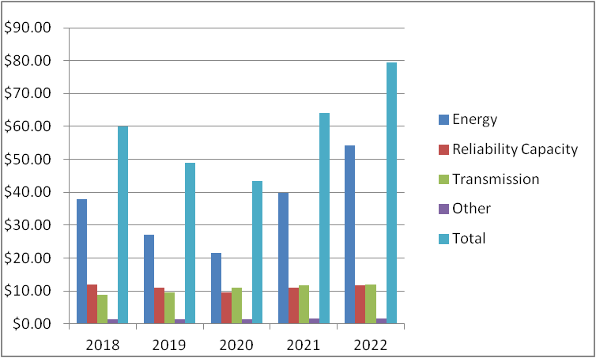

Source: PJM Interconnection 2022 Markets Report

**Table 12. 2014 Fuel Diversity, Capacity Markets**

|  | **ISO-NE** | **CAISO** | **MISO** | **NYISO** | **PJM** | **SPP** |
| --- | --- | --- | --- | --- | --- | --- |
| **Coal** | 6% | 0% | 38% | 4% | 39% | 35% |
| **Oil** | 9% | 1% | 0% | 7% | 7% | 2% |
| **Natural Gas** | 43% | 59% | 41% | 53% | 31% | 46% |
| **Nuclear** | 15% | 4% | 8% | 15% | 17% | 4% |
| **Hydro and Renewables** | 22% | 36% | 12% | 21% | 5% | 12% |
| **Other** | 5% | 0% | 1% | 0% | 1% | 1% |

Source: 2015 ISO/RTO Metrics Report

**Graph 5. Fuel Diversity, Capacity Markets**

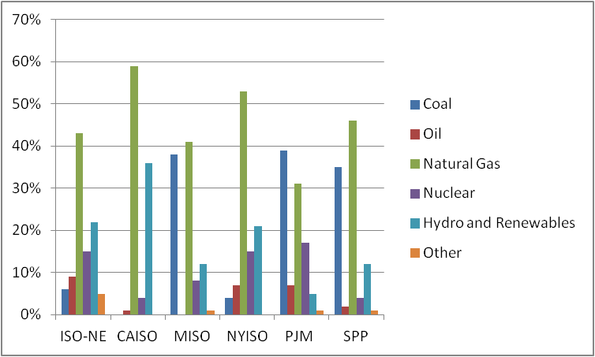

Source: 2015 ISO/RTO Metrics Report

**Table 13. 2014 Fuel Diversity, Energy-Only Markets**

|  | **ISO-NE** | **CAISO** | **MISO** | **NYISO** | **PJM** | **SPP** |
| --- | --- | --- | --- | --- | --- | --- |
| **Coal** | 5% | 0% | 54% | 3% | 43% | 60% |
| **Oil** | 2% | 0% | 0% | 0% | 1% | 0% |
| **Natural Gas** | 42% | 59% | 23% | 41% | 17% | 19% |
| **Nuclear** | 34% | 11% | 15% | 30% | 34% | 8% |
| **Hydro and Renewables** | 15% | 29% | 6% | 26% | 2% | 13% |
| **Other** | 2% | 1% | 2% | 0% | 3% | 0% |

Source: 2015 ISO/RTO Metrics Report

**Graph 6. Fuel Diversity, Energy-Only Markets**

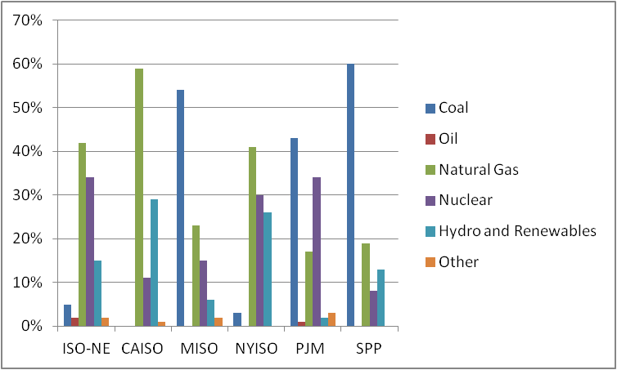

Source: 2015 ISO/RTO Metrics Report

**Table 14: ISO-NE Capacity Auction Results**

|  |  | Demand in Megawatts | |  | Supply (MW) |  | Reserve Margin | |
| --- | --- | --- | --- | --- | --- | --- | --- | --- |
|  |  |  | (MW) |  |  |  | (percentage) |  |
| Auction | Capacity | Expected | Region-wide | Capacity | Capacity | Total | Calculated | Calculated |
| Number | Delivery | Peak | Resource | Commitments | Commitments | Capacity | with | with Total |
|  | Year | Demand | Adequacy | Procured in | Procured | Commitments | Resource | Capacity |
|  |  |  | Requirement | Capacity | Outside the | Procured | Adequacy | Commitments |
|  |  |  |  | Auctions | Capacity |  | Requirement | Procured |
|  |  |  |  |  | Auction |  |  |  |
| **1** | 2010/2011 | 29,035 | 31,480 | 32,085 | 1,308 | 33,392 | 8 | 15 |
| **2** | 2011/2012 | 29,405 | 31,232 | 34,971 | 851 | 35,822 | 6 | 22 |
| **3** | 2012/2013 | 29,020 | 30,709 | 34,582 | 854 | 35,436 | 6 | 22 |
| **4** | 2013/2014 | 28,570 | 30,862 | 35,108 | 856 | 35,964 | 8 | 26 |
| **5** | 2014/2015 | 29,025 | 31,900 | 34,595 | 891 | 35,486 | 10 | 22 |
| **6** | 2015/2016 | 29,380 | 32,221 | 33,928 | 973 | 34,902 | 10 | 19 |
| **7** | 2016/2017 | 29,400 | 31,777 | 33,829 | 985 | 34,815 | 8 | 18 |
| **8** | 2017/2018 | 29,790 | 32,618 | 31,478 | 998 | 32,475 | 9 | 9 |
| **9** | 2018/2019 | 30,005 | 32,823 | 32,405 | 890 | 33,295 | 9 | 11 |
| **10** | 2019/2020 | 29,861 | 32,808 | 33,220 | 911 | 34,130 | 10 | 14 |
| **11** | 2020/2021 | 29,601 | 32,722 | 33,470 | 896 | 34,366 | 11 | 16 |

Source: GAO-18-131, Electricity Markets. Demand, supply, and reserve margins in ISO New England’s initial capacity auction for capacity delivery years 2010/2011 through 2020/2021.

**Table 15: MID ISO Capacity Auction Results**

|  |  | Demand in Megawatts | | |  | Supply (MW) | Reserve Margin | |
| --- | --- | --- | --- | --- | --- | --- | --- | --- |
|  |  |  | (MW) |  |  |  | (percent) |  |
| Auction | Capacity | Expected | Region-wide | Capacity | Capacity | Total | Calculated | Calculated |
| Number | Delivery | Peak | Resource | Commitments | Commitments | Capacity | with | with Total |
|  | Year | Demand | Adequacy | Procured in | Procured | Commitments | Resource | Capacity |
|  |  |  | Requirement | Capacity | Outside the | Procured | Adequacy | Commitments |
|  |  |  |  | Auctions | Capacity |  | Requirement | Procured |
|  |  |  |  |  | Auction |  |  |  |
| **1** | 2013/2014 | 91.539 | 97,214 | 62,255 | 34,959 | 97,214 | 6 | 6 |
| **2** | 2014/2015 | 127,597 | 136,912 | 89,890 | 47,022 | 136,912 | 7 | 7 |
| **3** | 2015/2016 | 127,319 | 136,359 | 88,130 | 48,229 | 136,359 | 7 | 7 |
| **4** | 2016/2017 | 125,913 | 135,483 | 99,488 | 35,995 | 135,483 | 8 | 8 |
| **5** | 2017/2018 | 125,003 | 134,753 | 85,290 | 49,463 | 134,753 | 8 | 8 |

Source: GAO-18-131, Electricity Markets. Demand, supply, and reserve margins in Midcontinent ISO’s initial capacity auction for capacity delivery years 2013/2014 through 2017/2018.

**Table 16: NYISO Capacity Auction Results**

|  | Demand in Megawatts | | Supply (MW) | Reserve Margins | |  |
| --- | --- | --- | --- | --- | --- | --- |
|  | (MW) |  |  | (percent) |  |  |
| Capacity | Expected Peak | Region-wide | Total Capacity | Calculated with | Calculated with Total | |
| Delivery | Demand | Resource | Commitments | Resource | Capacity |  |
| Month |  | Adequacy | Procured | Adequacy | Commitments | |
|  |  | Requirement | In and Outside the | Requirement | Procured |  |
|  |  |  | Auctions |  |  |  |
| **Aug-06** | 33,295 | 37,154 | 39,829 | 12 | 20 |  |
| **Aug-07** | 33,447 | 37,228 | 39,691 | 11 | 19 |  |
| **Aug-08** | 33,809 | 36,633 | 39,663 | 8 | 17 |  |
| **Aug-09** | 33,930 | 36,362 | 39,219 | 7 | 16 |  |
| **Aug-10** | 33,025 | 35,045 | 38,609 | 6 | 17 |  |
| **Aug-11** | 32,712 | 34,684 | 38,827 | 6 | 19 |  |
| **Aug-12** | 33,295 | 35,076 | 38,477 | 5 | 16 |  |
| **Aug-13** | 33,279 | 35,467 | 37,338 | 7 | 12 |  |
| **Aug-14** | 33,666 | 35,812 | 37,547 | 6 | 12 |  |
| **Aug-15** | 33,567 | 35,920 | 38,665 | 7 | 15 |  |
| **Aug-16** | 33,359 | 35,430 | 38,166 | 6 | 14 |  |

Source: GAO-18-131, Electricity Markets. Demand, supply, and reserve margins in NYISO’s initial capacity auction for the capacity delivery month of August for 2006 through 2016.

**Table 17: PJM Capacity Auction Results**

| Auction | Capacity | Expected | Region-wide | Capacity | Capacity | Total | Calculated | Calculated |
| --- | --- | --- | --- | --- | --- | --- | --- | --- |
| Number | Delivery | Peak | Resource | Commitments | Commitments | Capacity | with | with Total |
|  | Year | Demand | Adequacy | Procured in | Procured | Commitments | Resource | Capacity |
|  |  |  | Requirement | Capacity | Outside the | Procured | Adequacy | Commitments |
|  |  |  |  | Auctions | Capacity |  | Requirement | Procured |
|  |  |  |  |  | Auction |  |  |  |
| **1** | 2007/2008 | 137,421 | 148,277 | 129,409 | 24,133 | 153,542 | 8 | 12 |
| **2** | 2008/2009 | 139,806 | 150,935 | 129,598 | 24,404 | 154,001 | 8 | 10 |
| **3** | 2009/2010 | 142,177 | 153,480 | 132,232 | 24,694 | 156,926 | 8 | 10 |
| **4** | 2010/2011 | 144,592 | 156,637 | 132,190 | 25,596 | 157,786 | 8 | 9 |
| **5** | 2011/2012 | 142,390 | 154,251 | 132,222 | 25,186 | 157,408 | 8 | 11 |
| **6** | 2012/2013 | 144,857 | 157,489 | 136,144 | 23,756 | 159,900 | 9 | 10 |
| **7** | 2013/2014 | 160,634 | 173,549 | 152,743 | 23,560 | 176,304 | 8 | 10 |
| **8** | 2014/2015 | 164,758 | 178,087 | 149,975 | 29,763 | 179,738 | 8 | 9 |
| **9** | 2015/2016 | 163,168 | 177,184 | 164,561 | 14,407 | 178,968 | 9 | 10 |
| **10** | 2016/2017 | 165,412 | 180,332 | 169,160 | 14,205 | 183,364 | 9 | 11 |
| **11** | 2017/2018 | 164,479 | 179,545 | 167,004 | 14,538 | 181,542 | 9 | 10 |
| **12** | 2018/2019 | 161,418 | 174,897 | 166,837 | 14,289 | 181,126 | 8 | 12 |
| **13** | 2019/2020 | 157,189 | 171,037 | 167,306 | 13,944 | 181,250 | 9 | 15 |
| **14** | 2020/2021 | 153,915 | 167,644 | 165,109 | 13,289 | 178,398 | 9 | 16 |

Source: GAO-18-131, Electricity Markets. Demand, supply, and reserve margins in PJM Interconnection’s initial capacity auction for capacity delivery year 2007/2008 through 2020/2021.

**Table 18: 4 RTOs with Capacity Markets**

| **RTO** | **Year** | **Energy Market** | **Capacity** | **Ancillary** | **Total RTO Market** | **Total RTO Market** |
| --- | --- | --- | --- | --- | --- | --- |
|  |  | **Costs** | **Market** | **Services** | **Costs** | **Costs** |
|  |  |  | **Costs** | **Market Costs** |  | **(in dollars per** |
|  |  |  |  |  |  | **megawatt-hour)** |
|  | 2011 | 7,223 | 1,451 | 42 | 8,715 | 64 |
|  | 2012 | 5,500 | 1,252 | 60 | 6,812 | 51 |
| **ISO New England** | 2013 | 8,349 | 1,083 | 158 | 9,590 | 71 |
|  | 2014 | 9,297 | 1,081 | 339 | 10,717 | 82 |
|  | 2015 | 5,988 | 1,124 | 212 | 7,325 | 56 |
|  | 2016 | 4,130 | 1,160 | 146 | 5,437 | 42 |
|  |  |  |  |  |  |  |
|  | 2014 | 27,433 | 320 | 54 | 27,808 | 42 |
| **Midcontinent ISO** | 2015 | 18,086 | 536 | 42 | 18,664 | 29 |
|  | 2016 | 17,680 | 1,120 | 53 | 18,853 | 29 |
|  |  |  |  |  |  |  |
|  | 2009 | 7,916 | 1,463 | 173 | 9,551 | 60 |
|  | 2010 | 9,875 | 1,714 | 176 | 11,764 | 72 |
|  | 2011 | 8,937 | 848 | 147 | 9,932 | 61 |
| **New York ISO** | 2012 | 6,894 | 1,583 | 134 | 8,611 | 53 |
|  | 2013 | 8,941 | 2,965 | 152 | 12,057 | 74 |
|  | 2014 | 9,611 | 3,403 | 147 | 13,161 | 82 |
|  | 2015 | 6,298 | 2,595 | 139 | 9,033 | 56 |
|  | 2016 | 4,834 | 2,039 | 191 | 7,065 | 44 |
|  |  |  |  |  |  |  |
|  | 2008 | 60,658 | 7,638 | 921 | 69,218 | 91 |
|  | 2009 | 30,872 | 9,808 | 669 | 41,349 | 58 |
|  | 2010 | 39,637 | 10,680 | 705 | 51,021 | 68 |
|  | 2011 | 38,511 | 8,198 | 734 | 47,443 | 61 |
| **PJM Interconnection** | 2012 | 30,612 | 5,508 | 646 | 36,766 | 45 |
|  | 2013 | 33,670 | 6,463 | 1,147 | 41,280 | 49 |
|  | 2014 | 45,569 | 7,987 | 911 | 54,467 | 65 |
|  | 2015 | 30,194 | 9,727 | 648 | 40,569 | 49 |
|  | 2016 | 24,300 | 9,400 | 570 | 34,270 | 41 |

Source: GAO-18-131, Electricity Markets. Total annual costs in regional transmission organizations (RTO) with capacity markets, in millions of dollars, adjusted for inflation, for available years.

**Table 19: 6 RTOs, Wholesale Power Costs by Charge Type**

| **RTO/ISO** | **2014** | **2015** | **2016** | **2017** | **2018** |
| --- | --- | --- | --- | --- | --- |
| **CAISO** |  |  |  |  |  |
| **Energy** | $50.83 | $34.61 | $30.84 | $38.09 | $46.46 |
| **Transmission** | $8.03 | $9.87 | $10.82 | $9.85 | $11.91 |
| **Capacity** | - | - | - | - | - |
| **Operating Reserves** | $0.30 | $0.27 | $0.51 | $0.69 | $0.85 |
| **Ancillary** | $0.00 | $0.00 | $0.00 | - | - |
| **RTO and Regulatory Fee** | $0.40 | $0.42 | $0.42 | $0.42 | $0.43 |
| **Other** | $0.54 | $0.50 | $0.40 | $0.52 | $1.41 |
| **ISONE** |  |  |  |  |  |
| **Energy** | $51.87 | $30.94 | $35.43 | $45.76 | $42.23 |
| **Transmission** | $14.18 | $15.95 | $16.78 | $18.11 | $17.87 |
| **Capacity** | $8.56 | $9.17 | $9.40 | $25.07 | $32.49 |
| **Operating Reserves** | $1.87 | $0.75 | $0.80 | $0.86 | $0.82 |
| **Ancillary** | $0.32 | $0.32 | $0.30 | $0.29 | $0.31 |
| **RTO and Regulatory Fee** | $1.30 | $1.37 | $1.50 | $1.58 | $1.57 |
| **Other** | $0.43 | $0.45 | $0.45 | $0.34 | $0.12 |
| **MISO** |  |  |  |  |  |
| **Energy** | $36.91 | $25.02 | $24.34 | $26.70 | $29.15 |
| **Transmission** | $2.65 | $2.93 | $3.45 | $3.74 | $3.55 |
| **Capacity** | $0.00 | $0.00 | $0.01 | $0.00 | $0.00 |
| **Operating Reserves** | $0.08 | $0.06 | $0.08 | $0.10 | $0.11 |
| **Ancillary** | $0.30 | $0.33 | $0.35 | $0.34 | $0.35 |
| **RTO and Regulatory Fee** | $0.20 | $0.21 | $0.21 | $0.24 | $0.32 |
| **Other** | $0.56 | $0.26 | $0.25 | $0.32 | $0.32 |
| **NYISO** |  |  |  |  |  |
| **Energy** | $33.92 | $22.48 | $18.31 | $19.05 | $25.19 |
| **Transmission** | $0.66 | $0.64 | $0.83 | $0.79 | $0.85 |
| **Capacity** | - | - | - | - | - |
| **Operating Reserves** | $0.58 | $0.50 | $0.85 | $0.76 | $0.81 |
| **Ancillary** | $0.44 | $0.46 | $0.45 | $0.47 | $0.55 |
| **RTO and Regulatory Fee** | $0.71 | $0.72 | $0.91 | $0.98 | $0.96 |
| **Other** | $0.14 | $0.07 | $0.15 | $0.28 | $0.20 |
| **PJM** |  |  |  |  |  |
| **Energy** | $53.14 | $36.16 | $29.23 | $30.99 | $38.24 |
| **Transmission** | $5.72 | $6.90 | $7.12 | $8.62 | $8.57 |
| **Capacity** | $8.91 | $11.14 | $8.99 | $8.75 | $11.89 |
| **Operating Reserves** | $0.59 | $0.36 | $0.24 | $0.24 | $0.31 |
| **Ancillary** | $0.51 | $0.51 | $0.53 | $0.59 | $0.57 |
| **RTO and Regulatory Fee** | $0.26 | $0.27 | $0.21 | $0.32 | $0.32 |
| **Other** | $1.15 | $0.38 | $0.16 | $0.11 | $0.21 |
| **SPP** |  |  |  |  |  |
| **Energy** | $3.47 | $2.59 | $4.02 | $4.29 | $4.24 |
| **Transmission** | $5.68 | $6.34 | $7.49 | $8.16 | $8.05 |
| **Capacity** | - | - | - | - | - |
| **Operating Reserves** | $0.39 | $0.27 | $0.28 | $0.29 | $0.29 |
| **Ancillary** | $0.15 | $0.17 | $0.21 | $0.22 | $0.21 |
| **RTO and Regulatory Fee** | $0.63 | $0.69 | $0.61 | $0.69 | $0.67 |
| **Other** | $0.43 | $0.33 | $0.35 | $0.33 | $0.36 |

Source: GAO-18-131, Electricity Markets.

**Other Graphs and Charts**

**MIssing Money Problem**

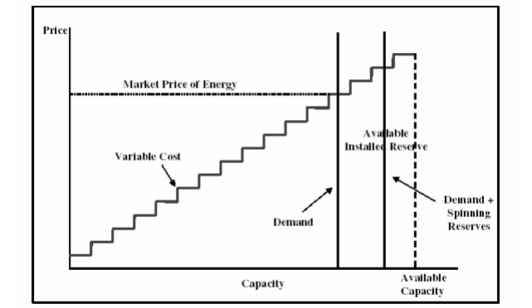

Source: Scott M. Harvey, ICAP Systems in the Northeast: Trends and Lessons, prepared for use by the California ISO, September 19, 2005, pg. 4. Bernstein Research White Paper.

In this exhibit, in competitive markets, prices reflect the marginal cost of supply and thus tend not to compensate reserve generating units ordinarily not required to supply power to the system. This exhibit displays the problem of recovering the cost of reserve capacity in a competitive power market, and presents an upward sloping supply curve for electricity, reflecting the variable operating cost of the various generating units on the system; a vertical demand curve for electricity, whose intersection with the supply curve sets the price of power; and a second vertical line, which represents the sum of demand and the 15- 18% reserve margin required to maintain system reliability. Under normal circumstances these reserves of generating capacity are not called upon to run, and they produce no revenue.

**Missing Money Problem**

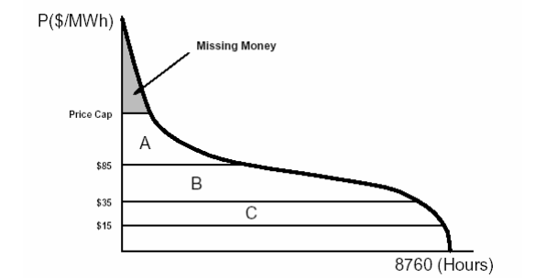

Source: William W. Hogan, On an “Energy Only” Electricity Market Design for Resource Adequacy, September 23, 2005. Bernstein Research White Paper.

In this exhibit, mitigation measures limit generators’ revenues during peak hours, creating a “missing money” problem that most adversely affects peaking plants. These mitigation measures most affect marginal generators, whose profits depend on peak-hour pricing. This exhibit shows a price duration curve, with the price of electricity on the y-axis and the hours of the year that the price is at or above that level on the x-axis. The lowest horizontal line, marked “C,” indicates the variable operating cost of a nuclear generator; the line marked “B” the cost of operating a coal-fired power plant; and the line marked “A” the cost of operating a simple cycle gas turbine. Thus a nuclear generator would earn a gross margin, revenues minus variable costs, equal to the area under the curve minus the area under line “C.” When the independent system operator imposes a price cap, the highest horizontal line, the loss of revenue that results (referred to as the “missing money”) has the greatest proportional impact on the gross margin of the gas turbine generator. While all generators’ gross margins are reduced by mitigation measures, it is these peaking plants that are most adversely affected.

**The First Generation of Capacity Markets Resulted in Highly Unstable Capacity Prices**

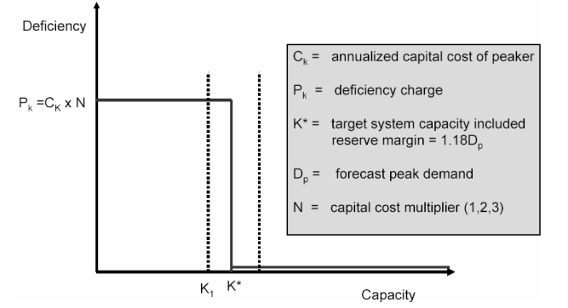

Source: P. L. Joskow, Why Capacity Obligations and Capacity Markets? June 2005. Bernstein Research White Paper.

The first generation of capacity markets results in capacity prices so unstable that they fail to reward the construction of new generating units or prevent the retirement of old ones. When capacity reserves exceed target levels, capacity prices in these markets tend to fall near zero. In markets with abundant capacity, competing owners of generating capacity bid its price down to its marginal cost, which is zero, as the capacity has already been built. But in markets with capacity deficits, a mandatory capacity requirement can send prices to levels that reflect the cost of procuring new generating plant or curtailing power demand. The binary nature of the resulting capacity prices renders investment in peaking capacity risky.

The x-axis of the chart measures the generation capacity available to the system, which the ISO desires to maintain at or above K*, equivalent to 118% of forecast peak demand. The y-axis measures the price of capacity in dollars per megawatt per year. If available capacity is below K*, the ISO imposes a deficiency charge on LSEs equivalent to some multiple (N) of the annual capital cost of a new peaker (Ck ). The ISO’s capacity requirement and deficiency charge give rise to an effective demand curve for capacity represented by the step-shaped line. The horizontal portion of the curve to the left of K* represents the price of capacity when available capacity is below the target stipulated by the ISO. Because capacity cannot be added to the system in the short term, the price of capacity under these circumstances rises immediately to the level of the deficiency charge. When capacity exceeds the target stipulated by the ISO, however, capacity in excess of this level has no value, and capacity prices fall to zero.

**A Downward-Sloping Demand Curve for Capacity Resources**

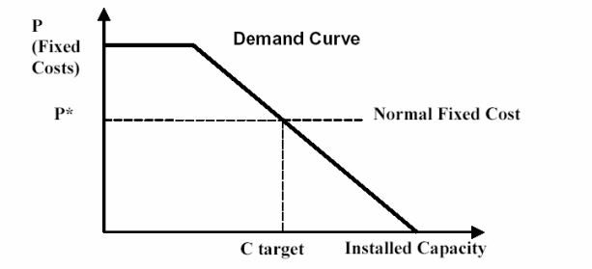

Source: California Public Utilities Commission, Capacity Markets White Paper, August 25, 2005. Bernstein Research White Paper.

In this exhibit, we see a downward-sloping demand curve such as PJM uses. PJM’s demand curve is designed so that if the capacity offered is equal to PJM’s target level (labeled “C target”), then the capacity price will equal the levelized annual cost of a new gas turbine generator (P* = Normal Fixed Cost). If the capacity offered implies a reserve margin of 12% or less, the capacity price will be twice this level. Finally, if the capacity offered implies a reserve margin of 20% or more, the capacity price will be zero. Such a demand curve implies that a slight excess of available capacity relative to target levels will result in a capacity price only slightly lower than the levelized annual capital cost of a new peaker (P*); conversely, a slight deficit of available capacity relative to target will result in prices slightly above this level. Capacity prices will fall to zero only when available capacity is well in excess of system requirements (i.e., a reserve margin of 20% or greater). As generators respond to these price signals by building generating units when capacity is below target and refraining from investing when it is above target, capacity prices should tend to gravitate back to the levelized annual capital cost of a new peaker. PJM thus hopes that introduction of its downward-sloping demand curve will eliminate the volatility in capacity prices that characterized the first generation of capacity markets and will provide a relatively consistent signal to generators of the value of new investment.

**Power Plant Generating Capacity by Fuel Type and Region of the Country, for 2006 and 2017**

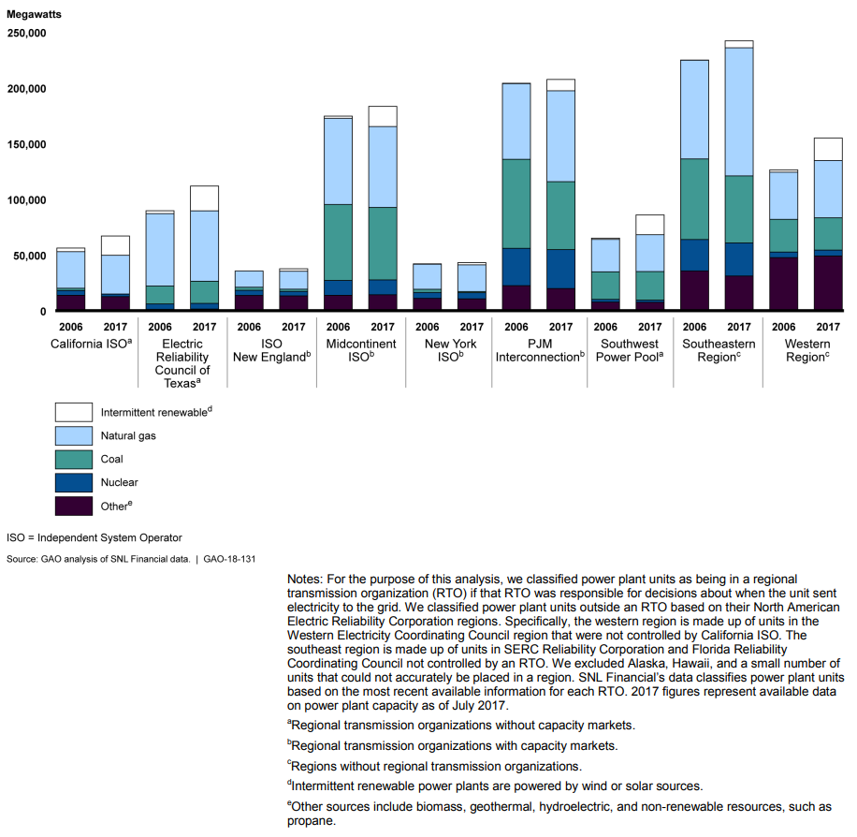

Source: US GAO 2017, Electricity Markets

**U.S. ISOs Share of Total Generation by Fuel Type**

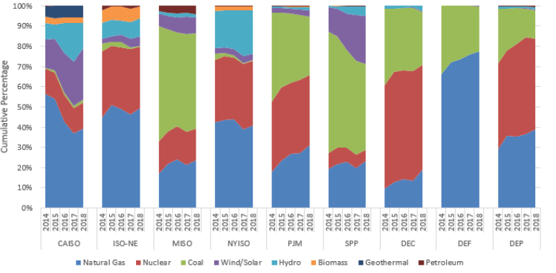

Common Metrics Staff Report 2021. Source: Based on Information Collection FERC-922. Notes: The natural gas-fired generation in NYISO includes all generation from dual-fuel (natural gas and oil) resources. Duke Energy Carolinas. Duke Energy Progress. Duke Energy Florida.

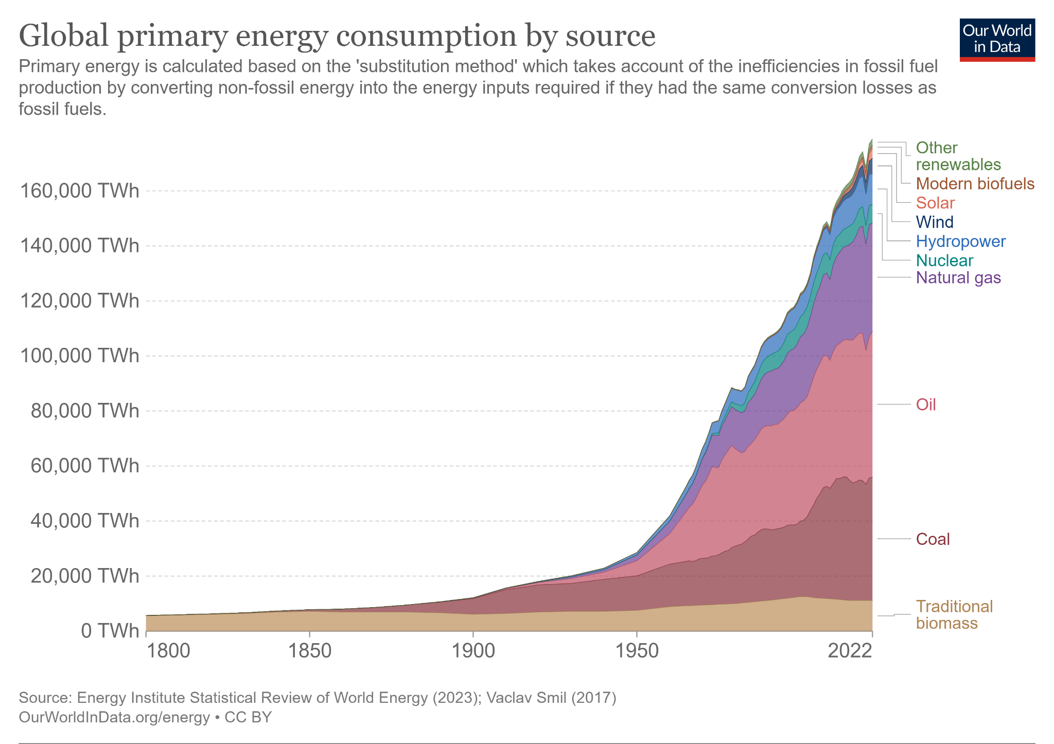

Source: Energy MIx, OurWorldinData.org

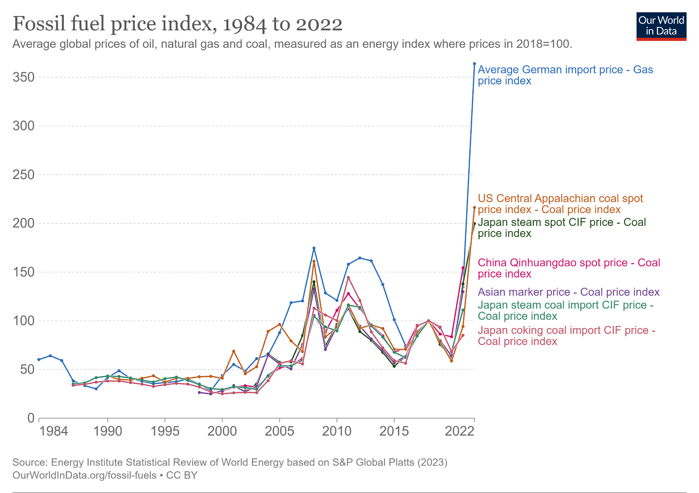

Source: Energy MIx, OurWorldinData.org

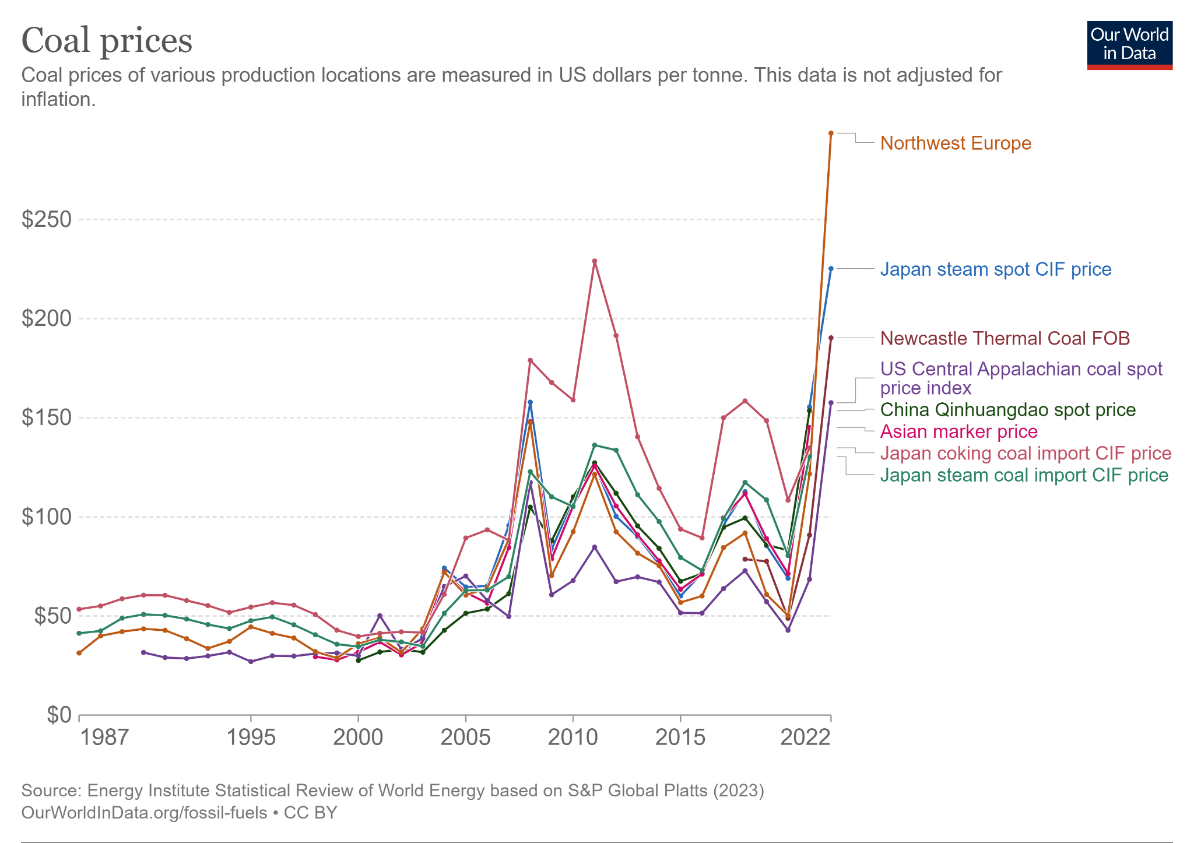

Source: Energy MIx, OurWorldinData.org

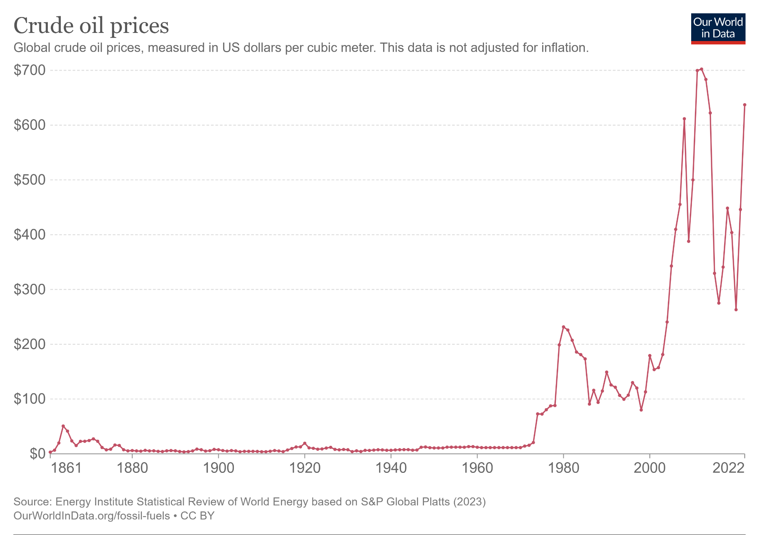

Source: Energy MIx, OurWorldinData.org

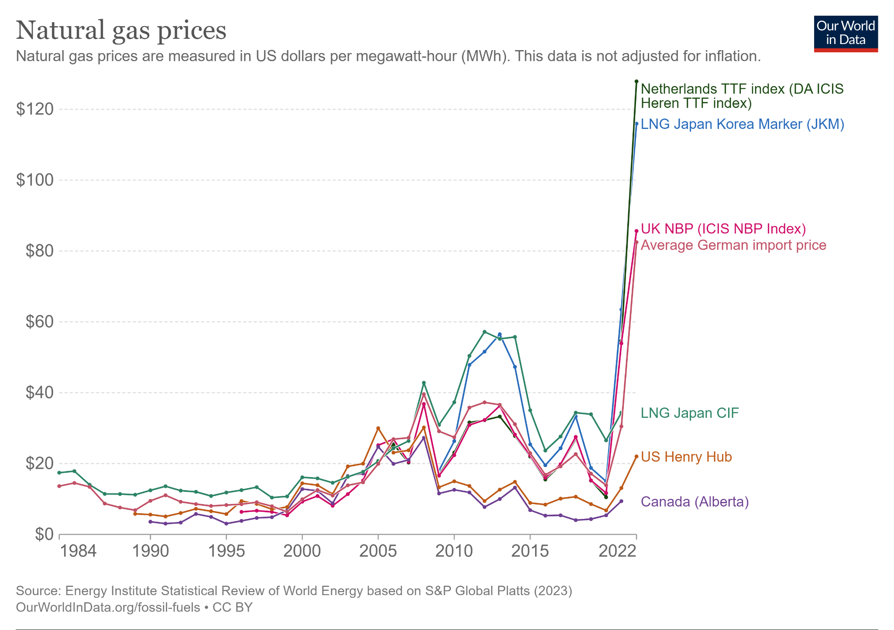

Source: Energy MIx, OurWorldinData.org

**United States Electric Grid**

The U.S. electric grid consists of 7,300 power plants, nearly 160,000 miles of high-voltage power lines, and millions of miles of low-voltage power lines and distribution transformers, connecting 145 million customers throughout the country (EIA, 2016). There are four major electric interconnections which connect the US 48 continental states and Canada, the: Western Interconnect, the Texas Interconnect, the Eastern Interconnect, and the Quebec Interconnect. The Eastern Interconnection comprises the area from the Great Plains states (excluding most of Texas) eastward to the Atlantic coast. The Western Interconnection comprises the area west of the Rocky Mountains and the Great Plains to the Pacific coast. The Electric Reliability Council of Texas (ERCOT) covers most of the state of Texas. The Quebec Interconnection covers the Canadian province of Quebec. An Interconnection is a zone in which utilities are electrically tied together during normal system conditions. Hawaii and Alaska do not have grid systems which are connected to the lower 48 states.

An ISO is an independent system operator, which uses competitive market mechanisms that allow independent power producers and non-utility generators to trade power. An RTO is a regional transmission organization, which is another term for ISO. There are seven ISOs, and two regions that are not served by ISOs, the Southeast and West. The seven ISOs are: California CAISO, Midcontinent MISO, ISO New England, New York NYISO, PJM Interconnection, Southwest Power Pool SPP, and Texas ERCOT. The traditionally regulated gray areas are where the wholesale electricity market are vertically-integrated utilities that are responsible for the entire flow of electricity to consumers. They own the generation, transmission and distribution systems used to serve electricity consumers. The two other ISOs in North America, the 2 Canadian ISOs, are the Alberta Electric System Operator (AESO) and the Ontario Independent Electricity System Operator (IESO).

Texas ERCOT is an ISO and reliability region, or regional reliability council. The Midcontinent Independent System Operator is an ISO and RTO. The Southwest Power Pool is an RTO and reliability region. ISO New England is an RTO and ISO. The four RTOs are PJM Interconnection, Midcontinent MISO, Southwest Power Pool (SPP), and ISO New England (ISONE). Texas ERCOT, the Electric Reliability Council of Texas, does not fall under the jurisdiction of FERC for interstate transmission and wholesale markets, though is still subject to

NERC oversight and FERC regulation for reliability.

**Image 2: 7 U.S. ISOs**

<https://www.epa.gov/green-power-markets/us-electricity-grid-markets>

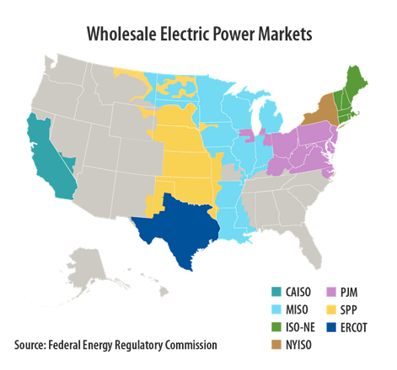

**Image 3: Retail Electric Power Markets**

<https://www.epa.gov/green-power-markets/us-electricity-grid-markets>

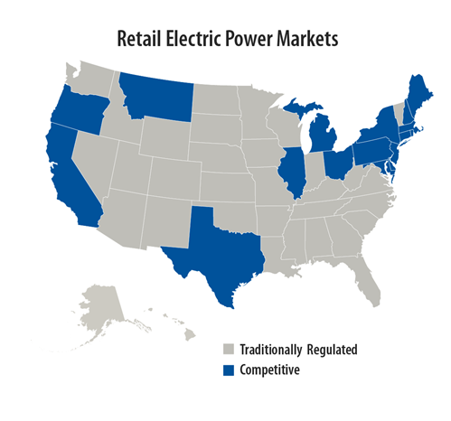

The first configuration of reliability regions had 10 regions, and the present day standard has six. First the old 10 are presented, then the new six. The Western Electricity Coordinating Council (WECC) comprises the entire Western Interconnection, including 11 western states, two Canadian provinces, and the northern portion of Baja California in Mexico. The Florida Reliability Coordinating Council (FRCC) covers most of the state of Florida. The SERC Reliability Corporation (SERC) covers 16 southern and central states. The Mid-Atlantic Coordinating Council (MAAC) covers New Jersey, the District of Columbia, and most of Pennsylvania and Maryland. Texas ERCOT covers most of the state of Texas. The Southwest Power Pool (SPP) covers 7 states. The Mid-Continent Area Power Pool (MAPP) covers 10 states and two Canadian provinces. The East Central Area Reliability Council (ECAR) covers nine east-central states. The Northeast Power Coordinating Council (NPCC) covers northeastern North America, including New York, New England, and three Canadian provinces. The Mid-American Interconnected Network (MAIN) covers 4 mid-central states.

The six current regional entities of NERC include: Midwest Reliability Organization (MRO), Northeast Power Coordinating Council (NPCC), ReliabilityFirst (RF), SERC Reliability Corporation (SERC), Texas Reliability Entity (Texas RE), and Western Electricity Coordinating Council (WECC).

**Image 4: NERC: 8 Regional Reliability Councils and 4 Interconnections**

https://en.wikipedia.org/wiki/North_American_power_transmission_grid#/media/File:NERC-map-en.svg

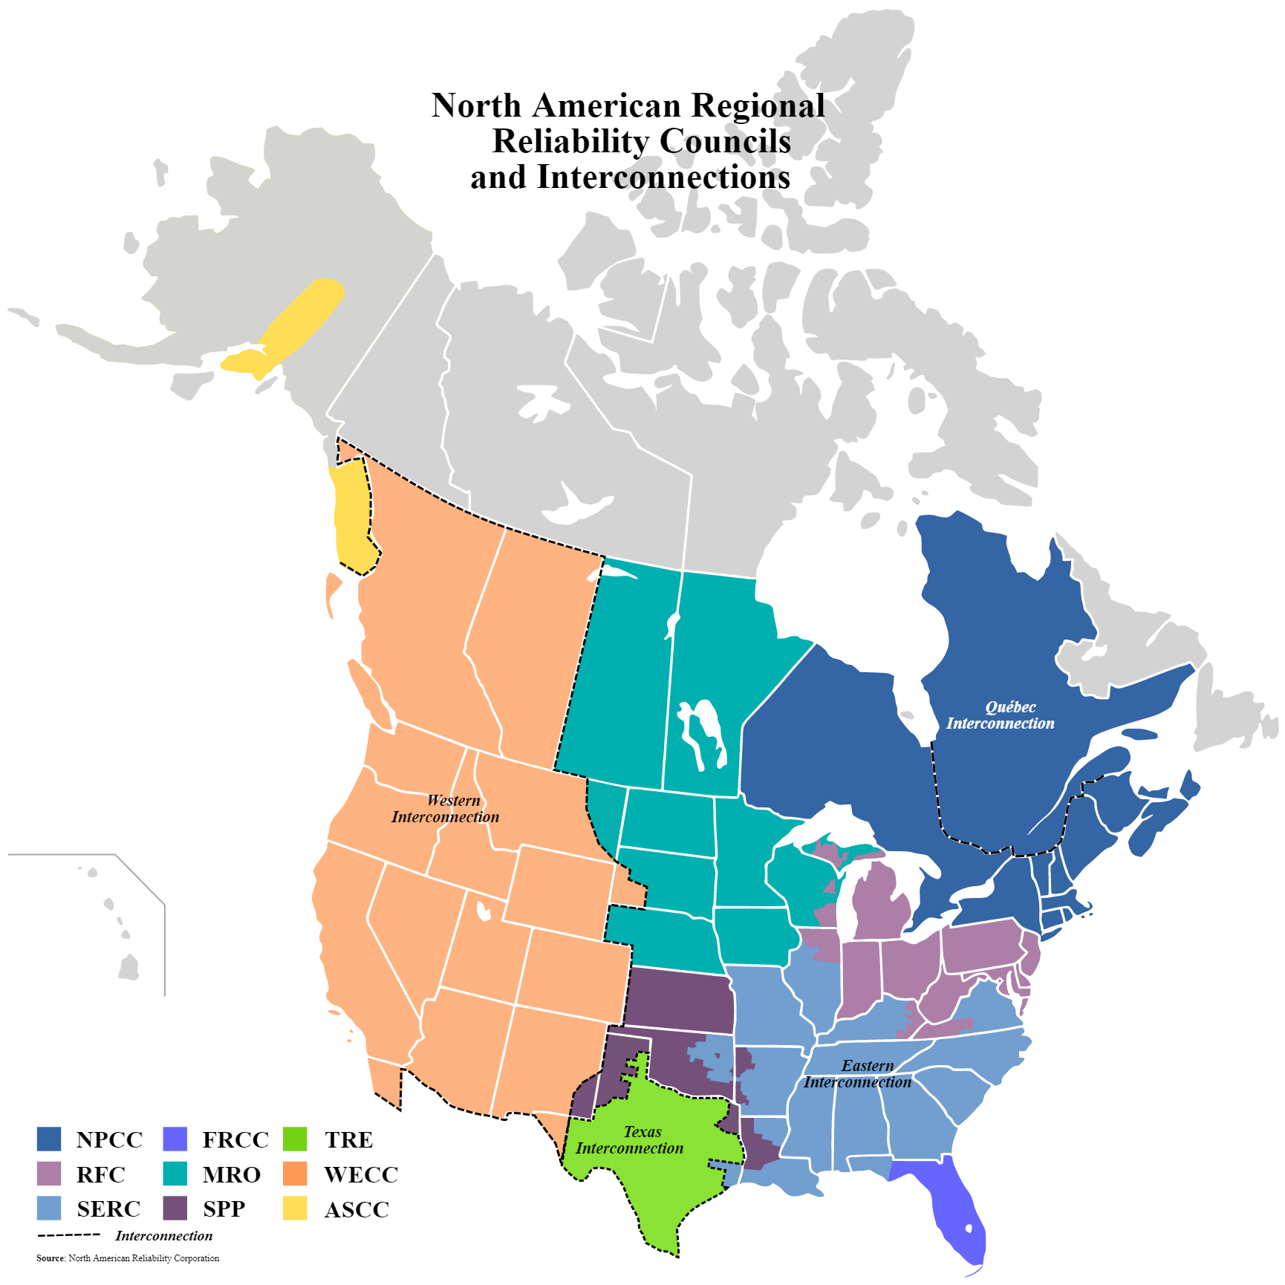

**Image 5: NERC Old 10 Reliability Regions**

https://www.eia.gov/electricity/data/eia411/

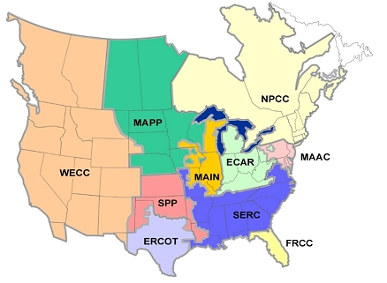

**Image 6: NERC Current 6 Reliability Regions**

https://www.nerc.com/AboutNERC/keyplayers/Pages/default.aspx

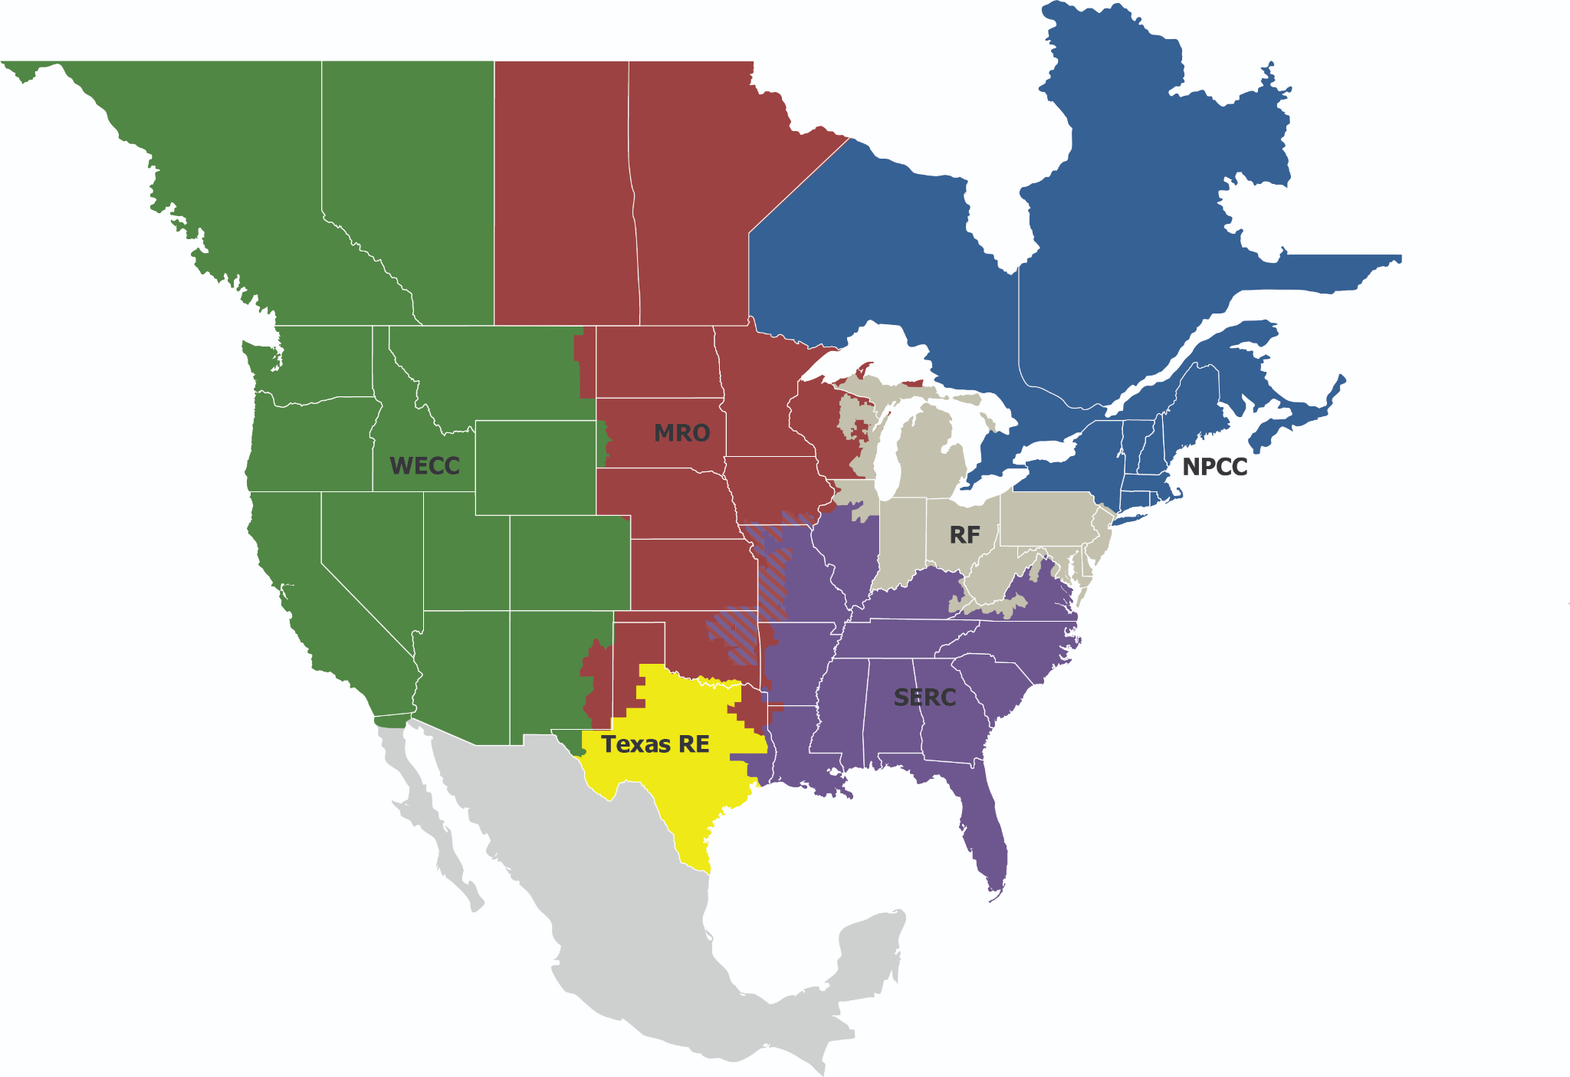

**Reliability Councils, ISOs, and RTOs**

The job of a reliability council is to promulgate system planning and operating criteria that are intended to ensure that each utility with generation or transmission assets builds and operates them in a way that allows system controllers to preserve bulk power reliability. The job of an ISO or RTO is to coordinate, control, and monitor the operation of the electrical power system, usually within a single US state, but sometimes encompassing multiple states. FERC issues recommendations to form ISOs and RTOs. The difference between an ISO and RTO is that an ISO either does not meet the minimum requirements specified by FERC to be designated as an RTO, or has not petitioned FERC for the status. RTOs perform the same basic functions as an ISO, though have a greater responsibility for the transmission network as established by the FERC, in that they monitor the operation of the region’s transmission network by providing fair transmission access. The basic functions of the ISO and RTO include: operate the region’s electricity grid, administer the region’s wholesale electricity markets, and provide reliability planning for the region’s bulk electricity system. TSO is the term used in the European Union to refer to an RTO, in this case, transmission system operator.

In regions where there is no ISO or RTO, the local utility still serves all these basic functions of the ISO and RTO, including ensuring fair transmission lines access, under the regulation of the state public utility commission (PUC). This includes the regions of the United States of the Southeast and West, who are still under FERC regulation.

The ISO is the heart of the competitive electric industry, the merger of competitive generation and transmission markets, although the markets function independently. An ISO includes representation on the management board from each segment of the market so no segment has veto power over the other. The ISO may adopt rules from the power pool it was created from, and is responsible for all transmission functions. An RTO is simply a larger ISO.

The ISO is tasked with facilitating commercial electricity transfers without compromising reliability, and to do this, the ISO has responsibility for scheduling transmission transactions and maintenance. An ISO may also have operational responsibility, dispatch generation, and operate the integrated transmission system. System reliability is maintained in the long-run through the provision of adequate transmission capability (an ISO planning function), and in the short-run through generation reserve margins. Reserves are either purchased by the ISO from a reserve market it operates or are a required component of transfers over the transmission system.

The ISO is also responsible for providing ancillary services in addition to reserves, provided through contracts with generation operators. Black-start capability is the ability to start-up in case of system collapse, and some generators may be required to even out voltage and frequency variations in real time too. Providing for transmission losses, which happens in transmission transfers 4 to 7 percent of the time, is a major ancillary service provided by the ISO. A market may be provided to make up for these losses, where participants can purchase sufficient power to clear, or they may be required to provide extra generation to make up for transmission transfer losses.

A black-start is the process of, without relying on external electric power from the transmission network, of restoring a power unit to operation. Nuclear and hydro units are typically used for black-starts because of their large capacity and backup power capabilities. The cranking path will be designated in a black-start, in which the system operator determines the order for units to start up in different parts of the system in order to gradually restore the grid to operation.

The ISO is also the tariff administrator for the region, responsible for managing financial transactions as well as electrical transactions. One financial impediment that FERC is attempting to mitigate with ISOs is rate pancaking, which is the end result of a power trade that crosses multiple transmission lines to stack a different rate for each of the utility’s transmission lines. The ISO has very few capital assets of its own, though it provides the bank for billions of dollars in market transactions. The ISO may have a provision in its charter to allow them to collect for any defaults by dunning solvent market participants. The ISO simply provides the administrative structure for the fiscal safety net to ensure market participants of their financial integrity, which is underwritten by the market participants.

When it comes to planning, ISOs and utility transmission systems must face the need to either increase capacity or find a better way to ration existing capacity. A transmission network in an RTO environment is like a freeway, once in place, they are quickly overwhelmed with traffic simply because they make transactions so much easier. In fact, FERC Order 888 requires transmission owning utilities to increase system capacity in the face of wholesale customer demand. Prior to deregulation, system expansion was solely a utility responsibility, and cost recovery from retail customers was virtually guaranteed. State regulators are also reluctant to approve utility transmission line expansion in an RTO environment where ratepayers may end up financing transmission lines that are used for interstate commerce.

ISOs are responsible for planning transmission line grids, though do not have the authority to initiate construction. Also, they plan the grid as a singular unity, which ignores the fact that the actual transmission grid is composed of multiple utility owning entities. This creates complications because transmission system additions change the ay power flows in the system, which may decrease revenues to one or more transmission owners.

Performance-based regulation (PBR) of utility companies characterizes utility review in the post-deregulation era. In PBR, a small number of criteria is used to evaluate utility performance.

As for marketing, deregulation rules prohibit the distribution utility from trying to compete for retail electricity sales. This also means that distribution utilities will not be able to collect ratepayer funds specifically for development of renewable generation for commercial power sales.

RTOs cover all or part of 38 states and the District of Columbia, and in addition to their grid operator transmission lines responsibilities, RTOs also manage wholesale electricity markets to buy and sell services need to maintain a reliable grid, such as energy, capacity, and ancillary services. Wholesale energy market prices refer to three markets, all three of which are regulated by FERC: energy, capacity, and ancillary services. Ancillary services may include resources, such as power plants and large consumers of electricity, being available on short notice to increase or decrease their generation or consumption.

**FERC, Federal Energy Regulatory Commission**

The FERC is an independent agency within the U.S. Department of Energy that regulates the interstate transmissions of electricity, and natural gas and oil and hydropower projects, within the United States. FERC decisions are only reviewable by the federal courts, not the President or Congress. Issues that FERC is not concerned with include: regulate retail electricity sales to retail customers, approve the construction of electric generation assets, regulate the activities of nuclear power plants (NRC, Nuclear Regulatory Commission), assess reliability problems related to distribution facilities, or monitor utility vegetation control in residential areas.

***FERC’s Responsibilities within the Electricity Industry Include:***

1. Regulates the transmission and wholesale sales of electricity in interstate commerce
2. Reviews certain mergers and acquisitions and corporate transactions by electricity companies
3. Reviews the siting application for electric transmission projects under limited circumstance
4. Licenses and inspects private, municipal, and state hydroelectric projects
5. Protects the reliability of the high-voltage interstate transmission system through mandatory reliability standards
6. Monitors and investigates energy markets
7. Enforces FERC regulatory requirements through imposition of civil penalties and other means
8. Oversees environmental matters related to hydroelectricity projects
9. Administers accounting and financial reporting regulations and conduct of regulated companies

Through the Energy Policy Act of 2005, procurement of reliable availability of energy resources, FERC is tasked with assisting consumers in obtaining reliable, efficient, and sustainable energy services at a reasonable cost through appropriate regulatory and market means by: 1) ensuring that rates, terms and conditions are just, reasonable and not unduly discriminatory or preferential 2) promoting the development of safe, reliable and efficient energy infrastructure that serves the public interest, and 3) achieving organizational excellence by utilizing resources effectively, adequately equipping FERC employees for success, and executing responsive and transparent processes that strengthen public trust.

**NERC, North American Electric Reliability Corporation**

The NERC is a non-profit international regulatory body whose objective is to ensure the reliability of the bulk power system in North America. NERC was granted the authority to oversee and regulate the electrical market according to certain reliability standards in 2006, when it was designated the government’s electrical reliability organization (ERO) by FERC. NERC is the actual entity that audits power companies and levies fines for non-compliance, though their authority is vested by the FERC. NERC has jurisdiction over electric users, owners, and operators of the bulk power system, and FERC oversees the operations of NERC as an ERO. NERC is composed of eight regional reliability councils and six reliability regions, spanning the continental U.S., Canada, and the northern portion of Baja California, Mexico.

***NERC’s Responsibilities Include:***

1. Developing and enforcing reliability standards
2. Annually assessing seasonal and long-term reliability
3. Monitoring the bulk power system through system awareness
4. Educating, training, and certifying industry personnel

**NRC, Nuclear Regulatory Commission**

The U.S. Nuclear Regulatory Commission (NRC) was created as an independent agency by Congress in 1974 to ensure the safe use of radioactive materials for beneficial civilian purposes while protecting people and the environment. The NRC regulates commercial nuclear power plants and other uses of nuclear materials, such as in nuclear medicine, through licensing, inspection and enforcement of its requirements.

**Capacity Markets in the U.S. Electric Industry, the Effects of Deregulation and the Push to Renewables**

Kevin Sleem, Sleem Financial Services

**Abstract**

In response to the effects of deregulation and the emergence of renewable energy sources, capacity markets have emerged as a construct to ensure system reliability and adequate generation capacity. The capacity market is a market-wide and price-based approach to capacity remuneration mechanisms, in which a central regulator sets the price at which to procure generation capacity through a capacity auction. Price caps in the energy-only market prevent the sufficiency of scarcity pricing during blackouts to generate sufficient revenues to provide for investment of plant assets. In analyzing worldwide fuel diversity, we see that coal is the predominant energy source used worldwide in 2022. The U.S. has already begun the process to move away from coal, and sees natural gas as the primary energy source of its energy zones. Wind power has made more progress than solar power in the United States, and worldwide. Maybe China is correct that utilizing coal as a cheaper fossil fuel energy source than natural gas is a smarter idea than transitioning so quickly to clean energy and cleaner burning gas.

Keywords: capacity markets, electricity markets, deregulation, renewable energy sources

**I. Introduction**

A major question to ask in the advent of electricity market deregulation is whether the restructured electricity markets sufficiently incentivize investments in new generating capacity, or if capacity remuneration mechanisms such as capacity markets are necessary to ensure adequate investment of plant generation, fixed assets, and sunk costs. Since deregulation, or liberalization, the US electric grid has seen the emergence of Independent System Operators (ISO) and Regional Transmission Operators (RTO). Some of the US has maintained a traditional regulated electric industry with generation, transmission, and distribution of electricity being controlled by one electric utility, while some areas have transitioned to ISOs and RTOs where a central authority regulates prices. Further, some of the ISOs have created capacity markets to ensure resource adequacy, while some have continued to rely just on the energy-only market. Thus, it can be stated that the capacity market construct is a creation of deregulation.

The push to renewables in the electric industry has created upheaval in the markets and for prices of electricity. Renewables such as wind and solar have zero marginal cost, or fuel cost, so they tend to bring down spot prices in the energy-only market. Electric utilities must therefore find a way to effectively price renewables into the spot market. The futures market is typically used for risk hedging. Voluntary Renewable Energy Certificates (REC) prices in the U.S. increased from $0.31/MWh in August 2017 to $0.70/MWh in August 2018.[1] Renewable energy purchases can either be voluntary or mandatory. Some states have mandatory requirements for percentage of energy used, and also impose penalties if the quotas are not met. In the energy only market, the merit order effect describes the lowering of power prices at the electricity exchange due to an increased supply of renewable energies. In capacity markets, renewables share contributes to the missing money problem of investment in fixed assets for power plants.

Liberalized electricity markets have been questioned due to reliability concerns resulting from increasing energy demands, the decommissioning of conventional power plants, and the steady growth of renewable energy sources (RES) (Gailani et al., 2020). It is thus a relevant question to ask whether capacity markets can help to distribute revenue in the face of the increased use of renewable energy sources. Two RES characteristics pose problems to traditional electricity market design: low marginal costs and intermittency. In an energy-only market with marginal cost bidding, renewables push into the merit order from the left and consequently price high marginal cost conventionals out of the market. This includes peak-load generation, such as gas-fired generation, which suffers from running fewer load hours leading to decreasing profitability. Considering the intermittent nature of RES, since there are neither grid-scale storage technologies nor large-scale demand response programs available, the same amount of conventional generation capacity is needed as without the RES feed-in to still ensure generation adequacy, even though RES provide a significant share of energy to the market (Hach and Spinler, 2018).

The emergence of renewable energy sources has been accelerated by the development of capacity markets. Many of the new generators providing capacity market services use lithium-ion batteries (LIBs) to store the energy due to their high energy density and long life cycle (Lee et al., 2019). In fact, batteries can enhance new generators by providing capacity services ranging from 40% to 100% of their nameplate capacity, thus reducing the number of shortage events in the capacity market (Sioshansi et al.,2014). Stafell and Rustomji (2016) find that the revenue from energy storage devices can be tripled if LIBs are utilized to provide energy reserve services in the electricity markets. Teng and Strbac (2016) find that batteries participating in the capacity market can secure substantial upfront revenue, while only marginally reducing profits from other markets.

In Europe, they have transmission system operators (TSO) and distribution system operators (DSO). In the United States, they have independent system operators (ISO) and regional transmission operators (RTO). The ISO and RTO are effectively the same thing in the United States. The TSO and DSO are different functions in Europe. TSOs utilize system-wide flexibility services in order to follow load and/or generation variations close to real-time to maintain the system frequency within a permissible level (Khajeh et al., 2019). DSOs, conversely, utilize local flexibility services to fulfill their responsibilities. DSOs can purchase flexible energy resources connected to these networks to regulate voltage and manage congestion (Khajeh et al., 2019).

**Failures of Current Electricity Market Design (Komorowska, 2021)**

1. Electricity supply and demand, can’t store electricity without batteries
2. Low short-run price elasticity of demand, consumers can’t respond to hourly fluctuations in price in real-time
3. Lower operating costs for renewable energy generators, resulting in lack of capacity payments to conventional generators for new investment
4. Price caps during periods of peak demand, which restricts market signals during these periods which could result in better capacity payments without price caps

In the United States, the Federal Energy Regulatory Commission (FERC) approves and regulates capacity markets by independent system operators and regional transmission operators in the restructured competitive markets that serve 70% of electricity customers in the U.S. California, Texas, and New York are restructured competitive markets. The ISO includes the RTO. About half of the United States is still traditional regulated markets, where the electric utility controls the generation, transmission, and distribution of electricity. In the United States, there are three interconnections for the electric grid. The Eastern Interconnection comprises the area from the Great Plains states eastward to the Atlantic coast. The Western Interconnection comprises the area west of the Great Plains to the Pacific coast. The Electric Reliability Council of Texas (ERCOT) covers most of the state of Texas. Seven RTOs operate across the United States: the California Independent System Operator (CAISO), Southwest Power Pool (SPP), Electric Reliability Council of Texas (ERCOT), Midcontinent ISO, PJM Interconnection, New York ISO (NYISO), and ISO New England (ISO-NE). These RTOs cover part or all of 38 states and the District of Columbia.

Capacity markets are a form of an economical construct known as a reserve market which are

used in the electricity industry to ensure resource adequacy of power plant generation. In the world of increasing electricity demand and increased use of renewable energy sources, ensuring adequate reserves of generation capacity is a critical need. An issue which rises to the forefront however is that of whether capacity markets and the capacity auctions which they entail are truly the best economic construct to achieve resource adequacy, as challenges arise with their complexity and high cost relative to benefit (Rusco, 2017). The four RTOs with capacity markets which FERC has approved to maintain resource adequacy are: ISO New England, Midcontinent ISO, New York ISO, and PJM. The three RTOs without capacity markets are: California ISO, Southwest Power Pool, and Texas ERCOT. The two regions that are still regulated markets for electricity are the West and the Southeast.

The evolution of these U.S. capacity markets includes the creation of separate markets for flexible capacity, geographical definition of market sub-regions, and modifications to market clearing mechanisms (such as use of demand curves). CAISO imposes a resource adequacy requirement on load serving entities, but has not created a centrally coordinated market to facilitate efficient trading of resources to meet that requirement (Bhagwat et al., 2016).

The Federal Energy Regulatory Commission (FERC) is responsible for overseeing Regional Transmission Organizations’ (RTOs) development and operation of capacity markets. Only an RTO has the organizational means to create a capacity market, which is a conglomeration of financial contracts from different regions and operators. Thus, a capacity market is wholly an RTO creation, as a regulated utility has neither the means nor the need to create a capacity market. It does not have the means because it is not a grid operator for several different regions and zones, and it does not have the need because its regulated rates already provide a return to ensure resource adequacy and generator capacity reserves.

Issues plaguing capacity market design in the United States include: the role of demand response, whether locational constraints should be imposed, how far forward such markets should be run, and whether separate markets should be created for flexible capacity to back up intermittent renewables (Bhagwat et al., 2016). Another issue that arises with capacity markets, as seen in the European Union, is seams issues (US) or cross-border effects (EU). Cross-border effects means that inefficiencies might arise when wholesale electricity markets with different capacity markets are interconnected or when regions with capacity markets are interconnected with energy-only markets, which could lead to sub-optimal performance of the capacity markets and spillover of benefits or costs to neighboring markets (Bhagwat et al., 2016).

**RTOs Facilitate Integration of New Technologies and Market Participants**

-Yoo and Blumsack (2018)

1. Renewable power generation
2. Energy storage
3. Demand response

**Definitions of Capacity Markets**

When discussing capacity markets, one of the first descriptions that comes to mind is the difference between the capacity auction and capacity generation. The capacity auction is one tool to serve the capacity generation requirements, and the most commonly accepted means of doing so in the United States, though the capacity auction is not necessary to serve the capacity generation requirements. Capacity auction refers to the presence of an established and defined capacity market, like the New York ISO, that takes bids at auction and writes contracts with suppliers to serve the capacity generation needs. Conversely, capacity generation is the generic term that all energy suppliers must provide to run an effective electric power generating plant. Capacity generation refers to the adequacy of capacity resources to meet the peak of demand plus a reserve margin capable of withstanding unanticipated loss of generation and transmission capacity (Creti and Fabra, 2004). So the capacity auction is the empirical construct used to solve the physical problem of capacity generation requirements.

These are a few more definitions related to capacity markets and the word capacity. Capacity charge is the fee paid to recover the capital invested in the generating plant, whether or not the plant was dispatched by the utility. Capacity payment is money paid at the capacity auction, for example, to compensate electric generators for loss of reserve capacity. Capacity deficiency fee is a punitive fee levied on electric generators for failing to maintain sufficient electric capacity reserves. Capacity reserves or reserve capacity is the excess of generation capacity maintained over that needed for normal working operations. Installed capacity is the maximum capacity that a system is designed to run at. Capacity factor is the measure of how often a power plant runs for a specific period of time. It's expressed as a percentage and calculated by dividing the actual unit electricity output by the maximum possible output. This ratio is important because it indicates how fully a unit's capacity is used. Capacity factor is the actual generation in a period divided by the maximum potential if the generator was producing at its installed capacity during the entire period.

Capacity mechanism is the capacity related term, such as strategic reserve, capacity payment, or reliability options, which enable power plants to be available for generating electricity when needed. A reliability option is a call option that is both physical and financial. It is financial in that a generator that sells an RO must pay the ISO the difference between the spot price and the strike price whenever the spot price exceeds the strike price. It is physical in that it delivers security of supply and creates a supplementary revenue stream to deliver missing money.

A capacity remuneration mechanism is an energy policy instrument designed to ensure long-term capacity adequacy, such as the capacity market and capacity payments. Capacity value is the contribution that a plant makes toward the planning reserve margin. Capacity credit is the level of conventional generation that can be replaced with wind generation. Value of lost load expresses a consumer’s willingness to pay for an uninterrupted supply of electricity.

The base load is the amount of energy supplied based on annually predictable levels. The intermediate or cycling capacity is the additional generation capacity needed during high activity hours, such as the morning. And peak capacity is the third level of generating capacity needed, generally needed on particularly hot or cold days. The system operator is charged with ensuring short-term supply/demand balance, and being able to react to critical events, such as brownouts and blackouts. A brownout is a minor drop in voltage, which can cause lights to dim and refrigerators and air conditioners to operate below capacity. A cascading blackout occurs if a major generator supplying the grid fails, and then the remaining generators on the system sense the demand/supply imbalance, and try to produce more power, in doing so overload, and then their automatic equipment takes over and shuts them down.

The spinning reserve is a generator that is already fired up, spinning and synchronized to the hertz cycle of the grid and thus immediately available for use. Cold reserves are capacity that can be scheduled to begin generation in three or four hours to supply the grid at the appropriate time, such as for morning times. The load serving entity, LSE, is the utility or electric company.

Loss of load refers to an outage, in that an outage means that some customer loads are not being served, or the system operator has intentionally shut off some customers to keep the rest of the system from overloading. The loss of load probability, the most common measure of electric systems reliability, is one day’s outage every 10 years. In seeking to meet this objective, system operators typically maintain an unutilized reserve of generation capacity equal to 15-18% of peak demand. The cost of this unutilized reserve must be recovered, which is the objective of capacity auctions and capacity markets. Missing money is the problem where inadequate gross margins are earned to cover the cost of investment in new resources.

Strategic reserves refers to a capacity mechanism orchestrated by the system operator where a certain volume of generation capacity is contracted to avoid a capacity shortage, and this reserve capacity is then made available to the electricity market at a price significantly higher than the marginal cost of generation during scarcity hours.

Capacity credit (CC, also capacity value or de-rating factor) is the fraction of the installed capacity of a power plant which can be relied upon at a given time (typically during system stress), frequently expressed as a percentage of the nameplate capacity. The most efficient capacity credit to award a resource is its marginal contribution even when combined with other subsidies.

**Blackout and Brownout**

A brownout is a temporary imbalance between supply and demand that causes the voltage on the grid to drop to levels at which electric devices cannot function efficiently. This minor drop in voltage, or brownout, can cause lights to dim; air conditioners and refrigerators to operate below capacity; and fire alarms, clocks and computers to malfunction. A blackout is a more serious mismatch between supply and demand, and might occur if a major generator supplying the grid were to fail. This occurs when the remaining generators on the system sense the mismatch between demand and supply and try to produce more power, and in doing so overload; their automatic equipment then takes over and shuts them down.

Spinning reserve is already fired up, spinning and synchronized to the hertz cycle of the grid and thus immediately available for use. Cold reserves are capacity that can be scheduled to begin generation in three or four hours to supply the grid at the appropriate time, such as predictable increases in load that occur at the beginning of each working day.

**Adequacy Assessment**

Adequacy assessments are performed by system operators or other organization, and can be performed for different time horizons (week-ahead, seasonal, mid-term, years-ahead), scenarios (normal conditions, rare extreme weather conditions, different forecasts of load growth, and political agendas), approaches (hourly, stochastic, probabilistic), using different metrics and criteria (Söder et al., 2020). Reliability standards used include Loss of Load Probability (LOLP), the probability of an outage, or the Loss of Load Expectation (LOLE), the expected number of outage hours per year. In the United States the measure adopted is “one day in 10 years,” which corresponds to a LOLP for the peak hour for all days of the year being equal to 0.1. Energy-related reliability metrics include the Expected Energy Not Served (EENS), which captures the severity of the outages in terms of the energy that is shed. Time-dependent reliability metrics include the Loss of Load Frequency (LOLF) and the Loss of Load Duration (LOLD), which capture the expected frequency and duration of outage events.

Value of Lost Load (VoLL) represents the customer damage from an outage event with a direct monetary value, though is difficult to estimate since the VoLL is likely to vary from customer to customer, and is highly dependent on the timing, the frequency and duration of an outage. When estimating LOLP, a “loss of load event” is defined as: “an event where the system requires import (if available) from outside the area/country in question to serve the demand.”

**Capacity Remuneration Mechanisms (CRMs)**

**Capacity Remuneration Mechanisms**

-Agency for the Cooperation of the Energy Regulators, 2013

1. Tender for new capacity; Financial support is granted to capacity providers in order to ensure the required additional capacity, such as financing the construction of new capacity or long-term power purchase agreements.
2. Strategic reserves; A certain volume of capacity is contracted and held in reserve outside the energy-only market, being different from, and in addition to, operating reserves. The reserve capacity is only deployed if specific conditions are met, such as: a shortage of supply in the spot market, or a price settlement above a certain electricity price.
3. Targeted capacity payments; A central body sets a fixed price paid only to eligible generation capacity, such as selected technology types or newly built capacity.
4. Market-wide capacity payments; Based on estimates of the level of capacity payments needed to bring forward the required capacity, a capacity price is determined centrally, which is then paid to all capacity providers in the market.
5. Capacity auctions
6. Capacity obligations
7. Forward capacity options
8. Volume- or price-based
9. Centralized or decentralized
10. Market-wide or technology-specific
11. Central buyer; The total volume of required capacity is set by a central body and procured through a central bidding process so that the market determines the price. Two common variants of the central buyer mechanism include the forward capacity market and reliability options.
12. Decentralized obligation; An obligation is placed on load-serving entities to individually secure the generation capacity needed to meet their consumers’ demand. In contrast to the central buyer model, there is no central bidding process, rather, individual contracts between load-serving entities and capacity providers are negotiated.

**Targeted mechanisms**

1. Volume-based; 1) tender for new capacity 2) strategic reserve
2. Price-based; targeted capacity payments

**Market-wide mechanisms**

1. Volume-based; 1) central buyer capacity market 2) decentralized capacity obligation
2. Price-based; market-wide capacity payments

Many governments intervene in the electricity markets in order to achieve generation adequacy through the use of capacity remuneration mechanisms. The goal of capacity remuneration mechanisms is to increase the level of security of supply in the system and to ensure that there is sufficient generation capacity to meet a certain reliability standard. In a CRM scheme, the operators of capacity resources receive financial compensations for keeping their generation units available. Certified capacity is the capacity to be available during crucial hours, and is determined by calculating the de-rating factors, which differ within different capacity mechanisms (Pugl-Pichler et al., 2020). CRMs provide an incentive for new entrants to locate in regions where there is a need for additional resources (Miller et al., 2012). CRMs help to maintain existing capacity or invest in new installations, and address generation capacity and flexibility adequacy concerns (Leiren et al., 2019).

The objective of a capacity remuneration mechanism is to propose a financially fair pricing mechanism that will guarantee enough new capacity and not present state aid (Ilak et al., 2021). Generation adequacy means ensuring that in the medium and long term the power system can supply the aggregate electricity demand at all times while accounting for scheduled and reasonably expected unscheduled outages of power system elements. Capacity mechanisms offer additional rewards to energy providers in return for maintaining existing capacity or investing in new installations (Leiren et al., 2019). The capacity market is the most comprehensive type of market-wide capacity mechanisms.

Lynch and Devine (2017) discuss how refurbishment of existing generators to increase their reliability is typically not considered in defining capacity market designs. They found that capacity payments increase reliability when refurbishment is not possible, and capacity payments and reliability options increase reliability when refurbishment is possible. Capacity remuneration mechanisms (CRMs) attempt to compensate generation firms for owning generation capacity, regardless of the extent to which it is utilized. The main reason for CRMs is ensuring sufficient revenue to render such low-load units as economically viable. In an energy-only market, generators are compensated on the basis of the energy they generate only.

Komorowska (2021) defines capacity remuneration mechanisms (CRMs) are energy policy instruments designed to ensure long-term capacity adequacy, such as the capacity market and capacity payments, which provide additional remuneration for power companies in compensation for electricity generation in peak demand, and also for transitions from conventional generators to cleaner burning generators, such as from coal to gas. CRMs both compensate generators and encourage consumers to reduce their electricity consumption during peak demand periods by raising rates. Capacity mechanisms compensate the power company for providing electricity generation during peak demand, though also extend the economic lifeline of sometimes obsolete plants, generally carbon-based thermal generation units.

**Image 1. Capacity Remuneration Mechanisms**



Source: Taxonomy of CRMs, Published in 2017, THE AGENCY FOR THE COOPERATION OF ENERGY REGULATORS reports on: CAPACITY REMUNERATION MECHANISMS AND THE INTERNAL MARKET FOR ELECTRICITY.

**Image 2. Classification of Capacity Remuneration Mechanisms**

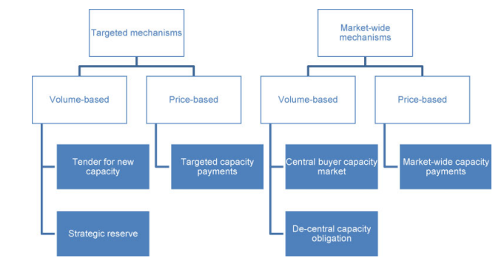

Source: Pugl-Pichler et al., (2020). European Commission, ‘Final Report on the Sector Inquiry on Capacity Mechanisms’ (European Commission 2016).

There are two essential categories of CRMs: (1) price-based capacity mechanisms: capacity payments and (2) volume-based capacity mechanisms: strategic reserve, reliability options, capacity obligations, and capacity auctions. Targeted capacity remuneration mechanisms address only a part of the market, whereas market-wide approaches target the entire market. Price-based capacity mechanisms utilize capacity payments set by the regulator, and set the price first before determining volume. The set capacity remuneration should not exceed the Value of Lost Load (VoLL) reduced by the revenues from the energy market. VoLL is the willingness of consumers to pay to avoid a supply disruption (Cramton et al., 2013). Volume-based capacity mechanisms involve the regulator stipulating the required capacity, or volume first, then setting the price of this capacity through auctions or contracts. The last bid accepted to cover the required capacity then becomes the capacity price paid to all generators.

**CRMs**

(1) tender for new capacity; (2) strategic reserve; (3) reliability options; (4) targeted capacity payment; (5) market-wide capacity payment; (6) central buyer; (7) de-central obligation.

A tender for new capacity is a targeted mechanism and volume-based approach. In a tender, financial support is granted to capacity providers in order to ensure the required additional capacity. The tender could be for either financing the construction of new capacity or long-term power purchase agreements.

Strategic reserves are targeted and quantity-based mechanisms. In a strategic reserve system, a capacity reserve is formed outside the energy markets and is only activated if the supply on the wholesale market is not able to meet the demand, or if no market clearing takes place (Pugl-Pichler et al., 2020). Strategic reserves is a construct consisting of generators with high operating costs and/or demand-side resources that are contracted by the TSO or RTO and are dispatched when the market does not provide sufficient generation capacity (Bhagwat et al., 2016). In a strategic reserve system, control of some power stations is transferred to the transmission system operator TSO or RTO, and the RTO dispatches the strategic reserve at a price above the variable costs of the generation units in the event there is not enough available generation capacity, which causes the average electricity price to increase and thus stimulate investment in generation capacity. Strategic reserves may be dispatched in case of shortage of supply in the spot market or a price settlement above a certain electricity price (Söder et al., 2020).

When discussing the value of strategic reserves versus capacity markets, Lambin and Léautier (2019) find that the direct, upfront cost of capacity support is greater when the security of supply (SoS) standards are met with capacity markets instead of a strategic reserve, although the energy prices are (weakly) higher with a strategic reserve. Therefore, the higher upfront cost of implementing support through a capacity market, relative to a strategic reserve, is offset through smaller electricity bills. Strategic reserve is similar to central capacity markets, because the procurement and compensation of capacities is done via a central body. However, strategic reserve only comes into play in emergency situations, and these installations are not entitled to participate in the energy-only market or the balancing energy market (Monjoie, 2021).

Reliability options are a market-wide and volume based approach to CRMs. In a reliability option scheme, physical capacity is bundled with a financial option to supply energy at spot prices above a strike price, with the market pricing capacity from the bids of competitive new entry in an auction. Two major advantages of reliability options are that the capacity payment (a) hedges load from high spot prices and (b) reduces supplier risk by replacing peak energy rents (the rents derived from selling energy at high spot prices during periods of scarcity) with a constant capacity payment (Cramton et al., 2013).

Administrative capacity payments for specific plants represent a targeted and price-based mechanism, where a central authority determines the price of the capacity. Usually, only a group of market participants, such as operators of a certain generation technology, such as flexible peak load power plants, receive capacity payments (Pugl-Pichler et al., 2020). Market-based capacity payments constitute a market-wide and price-based scheme, whereby all generators and demand response providers receive a predetermined price, which is set by a central regulator.

The centralized capacity market is a market-wide and volume based approach, where all market participants, except those already receiving state aid, are allowed to participate in the capacity market with their guaranteed capacity. The required volume is determined in advance by the operator (TSO or RTO) of the capacity market and the price is determined by the market (the clearing price in capacity auctions). Decentralized capacity obligations also represent a market-wide and volume-based approach. In contrast to the single buyer model, however, there is no centralized bidding process to determine the compensation for generators. Instead, suppliers are obliged to contract sufficient capacity to securely meet the consumption of their customers (Pugl-Pichler et al., 2020).

Capacity markets can be either centrally regulated by the government or demand-driven (decentralized). In centrally regulated models, there can be either comprehensive capacity markets where all electricity generators can participate, or targeted capacity markets where only those institutions that fulfill certain criteria can participate. In a demand-driven capacity market, balance group managers determine the pricing of capacity, which is wholly determined by the demand side. The demand-driven model must be both the creation of products such as the “provision of reliable capacity” and “backup capacity” and also of sufficient demand for capacity products. In a centralized design the fundamental question is how the cost is allocated to final consumers. In a decentralized design, the fundamental question is how retailers value a marginal capacity. In a decentralized demand model, retailers must buy the capacities directly in the capacity market to cover their sales, with the penalty system used to enforce the obligation (Monjoie, 2021).

A capacity market is a type of capacity remuneration mechanism. Capacity markets improve the resource adequacy of the system by maintaining sufficient reserve margins, which are calculated from the loss of load expectation (LOLE) requirement of the ISO. LOLE is the expected number of hours during which resources are insufficient to meet the demand needs in a given zone during a given time period. One argument for capacity markets is that because only the supply side and not the demand side actively participate in the electricity market, there will always be imperfections such as exercise of market power or regulatory interventions in an energy-only market (Cramton and Stoft, 2005). A second argument is that an increasing share of RES feed-in exacerbates the adequacy problem because RES provide price-inelastic supply due to the low marginal costs, thereby intensifying fluctuations in prices and demand for conventional generation. The attractiveness of conventional generation investments decreases with rising RES feed-in due to decreasing load factors (Cramton et al., 2013).

In a capacity market, the regulator determines the required capacity and the market establishes the price through an auction. Capacity markets have gained increased prominence over strategic reserves and capacity payments. All capacity markets include capacity payments as remuneration, though not all capacity payment mechanisms are capacity markets. The capacity payment construct can be defined as separate from the capacity market construct. One major difference in capacity markets is the timing of when they procure capacity. Some obtain commitments from plant owners 3 years before electricity is needed (ISO New England and PJM Interconnection), while some obtain commitments closer to when electricity is needed (NYISO and Midcontinent ISO). Level of resource adequacy refers to the availability of adequate power plants and other resources to meet customers’ electricity needs. Reasons for the need of a capacity market for electricity include: fixed costs, uncertainty, technical constraints, political intervention, and unpriced externalities.

The PJM and NYISO use a demand curve capacity auction, where an administratively set demand curve is established. The demand curve establishes the price that load serving entities (LSE) will pay for various quantities of capacity, with the price of capacity increasing as the demand for such capacity increases. The final price that LSEs pay in this type of auction, the clearing price, is based on the price of capacity on the demand curve line that is equal to the amount of capacity offered for sale in the auction (Miller et al., 2012). Buyer-side mitigation refers to offer floors that have been put in place by the FERC to deter large net buyers and local governments from subsidizing new entry and artificially depressing capacity market prices (Miller et al., 2012). There is little empirical evidence that capacity markets result in lower electricity costs for consumers, such as by expanding the number of available generators (Drom, 2014).

Buyer-side market power mitigation has been implemented by FERC to improve capacity markets’ long-term performance by meeting load-serving entities’ needs for diverse resource portfolios, enabling states’ efforts to pursue policy goals, satisfying generators’ need for stable revenues, and ensuring resource adequacy (Morrison, 2016). However, the author continues that buyer-side mitigation cannot serve the FERC’s goals because the centralized capacity constructs to which they have been appended are inherently incapable of doing all that the FERC asks of them. Thus, centralized capacity constructs must include bilateral capacity markets and LSEs’ self-build options.

In terms of improving capacity markets, RTOs have periodically changed the boundaries of capacity zones in their regions to better reflect transmission constraints. The auction’s underlying design can also be changed, for example, in 2014 and 2015, ISO New England and PJM separately received approval from FERC to modify their capacity markets to better ensure that power plants with capacity commitments were available to generate electricity when they agreed to be. Reasons for differences in capacity auction prices include: differences in the availability and type of resources across regions, differences in regional energy market and fuel prices, and differences in overall market design (US GAO, 2017).

**Interaction of Inaccurate Capacity Credits**

1. Energy Price Caps
2. Renewable Portfolio Standards
3. Renewable Energy Tax Credits
4. Generation Mixes
5. Efficiency Losses
6. Distortions among Competing Wind and Solar Developments

Energy price caps can create inaccurate capacity credits because price caps distort the true cost of electricity, and thus could result in lower capacity credits that divert resources away from the energy generation source and create a missing money in investment problem. Renewable Portfolio Standards (RPS) require that a specified percentage of the electricity utilities sell comes from renewable resources. Renewable energy tax credits are a variety of indirect federal subsidies to finance the investment and production of renewable energy. The generation mix is the combination of thermal and renewable generators, while efficiency losses result from using thermal over renewable sources. Efficiency losses in electricity generation result from burning fuel to generate electricity, which creates waste heat that siphons off most of the energy. In fact, for thermal generation like coal, natural gas, and nuclear, by the time electricity reaches your outlet, around two-thirds of the original energy has been lost in the process. Renewables like wind, solar, and hydroelectricity don’t need to convert heat into motion, so they don’t lose energy.

Defining capacity credits for resources that may be limited, such as renewables, can be difficult, though capacity factors for solar are typically 15-25% 25-35% for wind, and 100% for thermal generators. Too much capacity credit for a particular resource is an implicit subsidy that may lead to overinvestment, while too little credit could divert investment away from a resource. Inaccurate capacity credits can subsidize or penalize different resources, and consequently distort investment between renewables and non-renewables, and also among different types and locations of renewables (Bothwell and Hobbs, 2017). Capacity credit is only used when calculating endogenous capacity additions. The capacity value is defined as the fraction of the rated capacity considered firm for the purposes of calculating the module reserve margin. For thermal power plants the value is normally 100%. Lower values can be used for intermittent and hydro renewable power plants reflecting their lower average availability. Some plants assumed to have no firm capacity can even have zero values (for example imported electricity may sometimes have no firm capacity).[2]

**Affect Capacity Auctions**

1. Increasing share of renewable energy
2. Varying carbon emission costs
3. Existing capacity mix

The increasing share of renewable energy is affecting capacity auctions for capacity markets because they are $0 bids, which exacerbates the issue of long-term investment for generators. These $0 bids drive down prices, which results in less money available for investment, or missing money. Varying carbon emission costs are affected by carbon emissions caps set by the government, and result in higher prices at auction.

**Four Functions of Capacity Markets**

1. Provide capacity payments as reservation payments to ensure that a generator will be able to provide energy over a specified period of time, to meet peak load plus a reserve margin
2. Missing money from capacity market, capacity revenues can provide generators with the missing money when they do not receive enough money to cover fixed and variable costs from selling energy and ancillary services; aggravated by the introduction of renewable energy generators
3. Capacity payments provide an incentive for new entrants to locate in regions where there is a need for additional resources
4. Price signals to build new power plants or reduce demand

**Functions of Capacity Markets**

1. Maintain reliability
2. Encourage the economic development of new capacity resources
3. Moderate electricity price swings
4. Meet peak load demand
5. Provide adequate reserve margins

**Capacity Market Design Issues**

1. The role of demand response
2. Whether locational constraints should be imposed
3. How far forward such markets should be run
4. Whether separate markets should be created for flexible capacity to back up intermittent renewables

**Ways to Improve Capacity Reserves**

1. Energy storage
2. Improving market design
3. Enhancing system operation

There are three ways to improve capacity reserves: energy storage, improving market design, and enhancing system operation. Energy storage can be facilitated through the use of renewable resources and batteries to store their power, like wind and solar. Market design can be improved by focusing on demand side and supply side characteristics. The demand side in the PJM is characterized by energy efficiency resources and demand resources. Energy efficiency (EE) resources are load resources that are offered in an RPM auction as capacity and receive the relevant resource clearing price. EE resources are designed to achieve a continuous reduction in electric energy consumption during peak periods. Demand resources (DRs) are interruptible load resources that are offered in an RPM auction as capacity and receive the relevant clearing price.[3] The NYISO breaks down the supply side of capacity markets into three categories, installed capacity suppliers (ICAP Suppliers), capacity suppliers with duration limitations, and other capacity suppliers. Other capacity suppliers, which remain at a 4 hour duration requirement for participation in the Capacity Market, and performance-based generators (Wind, Solar, RoR Hydro), which will continue to be Installed Capacity Suppliers if qualified.[4] System operation can be enhanced with new and improved electrical capacity generating resources, often financed via capacity payments. Electric suppliers must upgrade the electric grid periodically, and more importantly must find the financial resources to fund these improvements over time.

**Goals of Capacity Markets**

1. Remunerate new electrical generators
2. Reduce investment risks
3. Avoid electricity blackouts

Capacity markets have three primary goals: remunerate new electrical generators, reduce investment risks, and avoid electricity blackouts. They remunerate new electrical generators by ensuring a capacity payment to ensure new investment in plant assets for the future. This serves to reduce investment risks, because the electric utility is getting an external payment for its investments, instead of having to rely on internally generated funds. Avoiding electricity blackouts is another function of capacity markets, in that the capacity market determines how much power is needed and where it should be located in order to prevent widespread power outages when demand for electricity is high. Formulas are developed to predict a region’s peak total energy usage for the year, plus a cushion. The cushion is usually provided by expensive, fossil-fueled power plants, and thus electric customers often end up paying too much for dirty power they don’t need when the cushion is inflated. A 2020 Sierra Club study found consumers are paying $4.4 billion in over-procurement costs to keep 77 gas and coal plants online in PJM territory.[5]

**Design Elements of a Capacity Remuneration Mechanism**

-Ilak et al. (2021)

1. Market orientation
2. Insurance of long-term power system adequacy
3. Optimal cross-border generation capacity utilization

The objective of a capacity remuneration mechanism is to propose a financially fair pricing mechanism that will guarantee enough new capacity and not present state aid (Ilak et al., 2021). Generation adequacy means ensuring that in the medium and long term the power system can supply the aggregate electricity demand at all times while accounting for scheduled and reasonably expected unscheduled outages of power system elements (Llak et al., 2021).

**Ilak et al. (2021) Design Elements**

1. Security of supply
2. Different amounts of newly installed firm capacity
3. Different short-run marginal costs of newly installed firm capacity
4. Different capacity factors of newly installed firm capacity
5. Electricity prices
6. Electricity load

Capacity factor is the measure of how often a power plant runs for a specific period of time. It's expressed as a percentage and calculated by dividing the actual unit electricity output by the maximum possible output. This ratio is important because it indicates how fully a unit's capacity is used. Capacity factor is the actual generation in a period divided by the maximum potential if the generator was producing at its installed capacity during the entire period.

**Regulatory Designs**

-Le Coq et al. (2017)

1. A baseline price cap system that restricts scarcity rents
2. A price spike regime that effectively lifts these restrictions
3. A capacity market that directly rewards the provision of capacity
4. Market design
5. Capacity provision
6. Pricing in electricity markets.

Le Coq et al. (2017) defines three available regulatory designs for an electricity market to price its electricity. One, a baseline price cap system that restricts scarcity rents. Scarcity rents represent the market mechanism needed to signal resource shortages and provide incentives for new investment in resources. Two, a price spike regime that effectively lifts these restrictions, which allows for higher prices to provide for investment funds. Three, a capacity market that directly rewards the provision of capacity.

**Calculations Taken into Account in Reserve Margins**

1. Normal maintenance problems
2. Extreme acts of nature (hurricanes and ice storms)
3. Unanticipated losses of fuel (delivery limitations)
4. Any variable that may prevent generation assets from being fully available during peak demand periods

The reserve margin is the amount of unused available capability of an electric power system, at peak load for a utility system, as a percentage of total capability. Normal maintenance problems affect reserve margins because when the system is down for maintenance, there has to be sufficient reserve capacity to meet demand until the generator is fixed.

Lambin and Léautier (2019) find that capacity markets may spread due to their negative cross-border effect on investment incentives. They find that a capacity market is ineffective unless transmission capacity is small, if TSOs and RTOs can’t reduce export capacity and neighbors stay energy-only. Further, If TSOs and RTOs can reduce export capacity, the capacity market attracts investments and security of supply (SoS) of non-domestic markets shrink. Thus, a neighboring energy-only or strategic reserve market will be influenced in the long-run and may have to implement a capacity market as well in order to meet its SoS standard. Capacity markets often aim at capacity levels of around 115% of peak load (Le Coq et al., 2017).

Komorowska (2021) considers capacity markets as remuneration mechanisms for long-term capacity adequacy, with adequacy linked to thermal power generation as it impacts decarbonization. The study considered the introduction of a capacity market on decarbonisation in power systems with a high penetration of fossil fuels. She found that the introduction of a capacity market delays the decarbonisation of the power system and has a negative impact on carbon neutrality, as even though coal-fired plants are phased out, they are replaced primarily with natural gas. The introduction of the capacity market resulted in the slowing down of the decarbonisation process in Poland, as coal-fired power units were maintained longer than without the capacity remuneration mechanism.

**Economics of Electricity, Supply and Demand**

There are two markets for electricity. The wholesale energy-only market where electricity is sold on the spot, intraday, and future markets; and the capacity market, where capacity auctions are the balancing market which ensures short-run security of supply. Investment decisions using the energy-only market are plagued by long lead times for generation investments and the absence of demand response prevents reaching a situation of market equilibrium. Electricity as a consumer good has high requirements for security of supply since power interruptions can be extremely costly. This need can be considered in the context of the value of lost load (VoLL) which expresses a consumer’s willingness to pay for an uninterrupted supply of electricity (Pugl-Pichler et al., 2020). Energy security and the security of electricity supply can be framed in different ways: fuel adequacy, generation capacity adequacy, balancing and flexibility, as well as network adequacy–all with the ultimate goal of uninterrupted, resilient supply at lowest possible cost (Cherp and Jewell, 2014). Resource adequacy in electricity markets can emphasize supply-side elements (generation infrastructure), transmission (interconnectors) as well as demand-side responses and energy efficiency (Leiren et al., 2019).

Market prices in the energy-only market must be high enough to finance the operational and fixed costs by stimulating adequate investment on the supply side. Bublitz et al. (2019) state several market-related and physical barriers to generation adequacy in the energy-only market. Market-related barriers in the energy-only market include: price caps, the inelasticity of demand for electricity, and supply side balancing of the electricity market. Physical barriers to generation adequacy include: balancing of consumption and generation, battery storage, the free-rider problem and reliability contracts, and spot market clearing process and fulfillment for short-term trading. Recent developments affecting generation adequacy in the energy-only market include the rise of renewables and the merit order effect and missing money problem, and the phase out of specific fuel types and technologies, like coal and nuclear.

The energy-only market is sufficient to meet generation adequacy demands if three economic conditions are met: (1) the market is perfectly competitive, (2) market participants have rational expectations and (3) follow a risk-neutral strategy (Cepeda and Finon, 2011). However, all three of these assumptions do not hold, as power markets are usually oligopolies (Schwenen, 2014). Further, investors may not have rational expectations, which leads to investment cycles of over- or under-investment (Ford, 2002). Also, investors are typically risk-averse, building less capacity than risk-neutral investors would (Neuhoff and de Vries, 2004).

The energy-only market neglects the energy adequacy problem, because it assumes that the energy demand and supply are always balanced. Thus, when the supply side becomes scarce, there must be a load reduction from the demand side to ensure market clearance. However, due to the inelastic nature of the demand side and rational customer responses, electricity markets do not guarantee a demand response or market clearance (Gailani et al., 2020). Additionally, despite the scarce capacity and the peak demand, generators do not earn money in blackout events. Pugl-Pichler et al., (2020) notes the energy policy objective triangle of affordability, sustainability and security of supply, which is espoused in the European Union, to provide customers with a secure, clean, and affordable supply of electricity.

The RTO may perform an adequacy assessment to evaluate capacity reserves and system reliability, and can be performed for different time horizons (week-ahead, seasonal, mid-term, years-ahead), scenarios (for example normal conditions, or rare extreme weather conditions, different forecasts of load growth, political agendas etc), approaches (hourly, stochastic, probabilistic) (Söder et al., 2020). Reliability standards include the Loss of Load Probability (LOLP) (0.1) or the Loss of Load Expectation (LOLE) (1 day in 10 years). Energy-related reliability metrics include the Expected Energy Not Served (EENS), which captures the severity of the outages in terms of the energy that is shed. Time-dependent reliability metrics include the Loss of Load Frequency (LOLF) and the Loss of Load Duration (LOLD) which capture the expected frequency and duration of outage events. A “loss of load event” is defined as: “an event where the system requires import (if available) from outside the area/country in question to serve the demand”.

A cost-benefit analysis, based on Value of Lost Load (VoLL), can be applied to derive some of the reliability standards based on observations of the decreasing marginal value of adding more capacity beyond a certain level of reliability. Value of Lost Load (VoLL) is a parameter that represents the customer damage from an outage event with a direct monetary value. VoLL, however, is hard to estimate, because it is likely to vary from customer to customer, and it is highly dependent on the timing, the frequency and duration of an outage (Söder et al., 2020). The implementation of the different reliability standards by the local practitioners in question often varies with subjective input assumptions, modeling methods, and choice of sensitivity analyses (Söder et al., 2020). Other sources of dIscrepancies between jurisdictions for reliability analysis are which units are included in the adequacy evaluation, whether the demand is considered to be price sensitive, and whether the reserves are included. Reliability standards in place in many regions are seen as a worst-case lower bound rather than a legally binding target.

**Characteristics of Electricity**

-Bernstein (n.d.)

1. Consumers require electric power on demand in volumes that fluctuate widely over the course of the day, week and year
2. Electricity, because it cannot be stored economically, must be generated simultaneously with its consumption; supply and demand must thus be maintained in instantaneous and continuous balance
3. The balance of supply and demand is maintained across a common power grid; generators of electricity supply the common grid, and consumers of electricity draw their power from it
4. An imbalance between supply and demand on the grid of even a few minutes’ duration can cause a system blackout. The actions of individual generators and consumers to supply or withdraw power from the grid can thus affect the reliability of supply to all consumers.

***Electricity Markets, Homogenous Good Auction Types***

-Vasin et al., (2013)

1. Uniform price auction; Producers submit their supply functions that determine the amount of supplied good depending on the market price. These bids are typically sealed, in that they are not revealed to the other agents until the auction closes. The cut-off price balances the total supply and demand, and each agent sells or buys at this price according to their bid.
2. Pay-as-bid auction; Differs in that each producer gets payment according to their bid while consumers pay the average price of the good.

**Wholesale Electricity Market Principles**

-Panfil and Zakaria (2020) discuss wholesale electricity market principles.

1. Wholesale market revenues should predominantly flow from well-designed energy and ancillary services markets.
2. When altering market design, FERC and ISOs should focus on only those services that are clearly needed and ensure that any market design change does not unduly discriminate between resources.
3. Minimize interventions that distort transparent and accurate pricing.
4. The just and reasonable standard strongly favors rate decreasing outcomes.
5. FERC and ISOs should facilitate and not undermine state public policy preferences.

Electricity is the only commodity delivered to customers with a separate capacity payment. Electricity is unlike other market goods, in that supply has to be stored to be released when demand arises. There has to be infrastructure to create and store electricity, as well as market mechanisms to regulate its price in the absence of national regulation. Electricity is like healthcare in that it has inelastic demand, which means that demand is not dependent on price, people will pay more money for electricity if they have to.

A reserve market is a market for essential goods where we need to have sufficient investment to produce them during peak demand, or when needed. In electricity markets, the energy-only market, which relies on private incentives, or wholesale prices, is sometimes not efficient enough to provide sufficient investment for generation reserves, for reasons such as: fixed costs, uncertainty, technical constraints, political intervention, and unpriced externalities. The answer is a reserve market, in which the producer sells the availability of its investment in return for additional funds, such as capacity markets in which electricity producers offer their power plant availability (Monjoie, 2021).

**Problems Facing Energy-Only Markets**

1. Asymmetric information resulting in price caps
2. High investment risk for generators

Schafer and Altvater (2019) note that energy-only markets face two problems: 1) asymmetric information resulting in price caps, and 2) high investment risk for generators. One, asymmetric information which results in price caps occurs when the regulator does not know if a power plant is not running because of unforeseen maintenance or because market power is used to provoke a scarcity event. This asymmetric information is why most spot markets have a price cap to limit the spot price, thereby preventing market power abuse in times of high demand. In the scenario of a too low price cap, the peak energy rent (PER) may be cut thereby resulting in missing money to cover capital costs. Asymmetric information prevents the regulator from introducing an optimal price cap, which depends on the spot market level and is thus not constant. A price cap which is optimal in one situation might result in missing money in a second or in market power abuse in a third situation. Two, there is also a high investment risk for generators, in that electricity producers must rely on a sufficient number and intensity of scarcity events to cover capital costs. Scarcity events are not predictable, are volatile and depend on actions of other generators, so this induces a high investment risk.

**Market Failures for which Capacity Markets Must Compensate**

CRMs assume that in electricity markets the spot markets for energy are characterized by two market failures for which capacity markets must compensate (Bhagwat et al., 2016).

1. Missing money problem- The missing money problem is a situation in an energy-only market where low power prices and few price spikes do not provide sufficient long-term investment incentives in new flexible generation capacity. Price caps result in an absence of shortage, or scarcity, pricing, and long averaging periods. This means that energy and ancillary service prices may fail to reflect the full value of energy generation, which in theory would result in underinvestment in capacity and inadequate remuneration for investors. Revenues from capacity markets enable generators with high variable costs that under normal circumstances would be dismantled to remain available.
2. Absence of a long run contract market- A long run contract market might be necessary to induce risk-averse investors to build new, long lived generation capacity. Stronger investment price signals are provided for new generation capacity additions from the additional revenues from capacity markets.

**Reasons for Capacity Mechanisms, the Missing Money Problem**

Lynch and Devine (2017) discuss reasons why low-load reserve units would not prove viable in the absence of a capacity remuneration mechanism. Power plants have long lead times and construction periods, so there may be several years between an indication of scarcity on the electricity market by price signals and the commissioning of new plants (Pugl-Pichler et al., 2020). Conventional power plants can encounter difficulties in recovering their fixed costs during periods of sustained low prices on energy-only markets. Pugl-Pichler et al. (202) describe the missing money problem as the situation on an energy-only market where low power prices and few price spikes do not provide sufficient long-term investment incentives in new flexible generation capacity.

1. The absence of an active demand-side in electricity generation markets, which means that consumers cannot signal their desired level of reliability of supply (Cramton and Stoft, 2005). There is therefore a weaker price signal for reliable supply, and consequently for electricity generation capacity. There is also opportunity and incentive to exercise market power, particularly the period close to real time.
2. The shared nature of the electricity network, which introduces a ‘free-rider’ problem, whereby it is not possible to differentiate between consumers who had entered into a contract for reliable supply.
3. Price caps
4. Electricity has public good characteristics (Abbott, 2001), and so policy-makers may be reluctant to leave the secure supply of generation capacity to market forces.

**Why Price Spikes have failed to provide the necessary incentives for generators to invest**

-Bernstein (n.d.)

1. First, power plants take years to develop and build, so price spikes during periods of scarcity occur too late to provide a timely signal to developers that capacity additions are required
2. Second, price spikes are triggered by capacity shortages; their very occurrence, in other words, signals an inadequate supply of capacity on the system and thus an increased probability of power cuts
3. Finally, price spikes are often subject to mitigation measures by independent system operators that limit the revenues available to recover capital invested. These measures include price caps designed to limit the exercise of market power by generators during periods of capacity scarcity; bidding rules that restrict bids too far in excess of cost; and the granting of special, out-of-market uplift payments to plants whose capacity is essential to system reliability (“reliability-must-run” units) that benefit these plants but create no revenues for other inframarginal generators.

In wholesale energy markets, the capacity market has been described as the missing money from the energy-only and ancillary services markets. Two of the functions of capacity markets is to prevent a black swan event, or loss of generation capacity, and the missing money problem, or lack of sufficient investment resources. The black swan event, the widespread loss of power to many customers that is caused by a lack of sufficient generating capacity, is unlikely, as loss of power to customers is rarely the result of generation-capacity deficiencies. This low probability of customer electricity loss is due to the extensive number, size, and diversity of generation resources (and significant reserve margins) across the nation. This means that the primary function of the capacity market is solving the missing money paradigm, where there are insufficient incentives to invest in new resources, or a failure to meet their long-term revenue requirements. The missing money problem is where the electricity market revenues are too low to cover the total costs of power generation units. Komorowska (2021) further defines the missing capacity dilemma, where the market signals do not provide a sufficient incentive for investors to build new power units, which can have implications for the entire economy and society. The missing money problem is created when spot market prices for electricity are depressed with price caps in times of scarcity, and is exacerbated by the increased use of renewable energy sources.

There are two ways to address the missing money problem in electricity markets. One, the price-based approach in the energy-only market, is to raise scarcity prices paid during blackouts. Two, the quantity-based approach in the capacity market, is to pay every supplier of capacity the same amount per MW of capacity.

**Measuring Security of Electricity Supply**

-Cherp and Jewell (2014); Goal of uninterrupted, resilient supply at the lowest possible cost

1. Fuel adequacy
2. Generation capacity adequacy
3. Balancing and flexibility
4. Network adequacy

**Ways to Measure Electric System Adequacy**

1. Loss of load probability, 1 day in 10 years for North American grid; an outage, some customer loads are not being served
2. Expected unserved energy
3. Spot market energy prices
4. Bilateral energy contracts

Loss of load describes the situation when in an electric grid the available generation capacity is less than the system load. Loss of Load Probability (LOLP) is a probabilistic reliability index that characterizes a probability of a loss of load occurring within a year. Loss of load events are calculated before the mitigating actions (purchasing electricity from other systems, load shedding) are taken, so a loss of load does not necessarily cause a blackout.[6] Expected unserved energy (EUE) is the expected amount of energy not supplied by the generation system during the period of observation, due to capacity deficiency.

The spot market for energy is a commodities market where the energy commodity is sold for cash and is delivered to a specific location for a specific time period that occurs on the day of the sale or on the day after the sale. Contracts bought and sold in a spot market are effective once agreed to. The spot price tells generators how much electricity the market needs at any moment in time to keep the physical power system in balance. When the spot price is increasing, generators ramp up their output or more expensive generators turn on to sell extra power to the market. When the spot price is decreasing, more expensive generators turn down or off. In electricity markets, spot markets may include day-ahead energy, intra-day energy, and/or real-time energy. Natural gas spot markets are typically for day-ahead transactions (or even multiple days ahead on weekends), although some intra-day spot trading does occur. Typical market participants in spot markets include wholesale marketers, brokers, suppliers such as gas producers and electric generators, utilities, large consumers, and retail marketers. Spot transactions are often performed using centralized exchanges or, in certain regions of the world with Independent System Operators (ISOs), using electric markets.[7]

A bilateral contract is a private trade between two parties. Bilateral transactions usually occur on the phone with two individuals negotiating and agreeing upon a price or via electronic trading exchanges. For shorter transactions, the use of electronic exchanges such as the Intercontinental Exchange (ICE) has become common. Longer-term transactions are typically negotiated face to face. A bilateral trade specifies key terms including delivery point, volume, time of delivery, price, and whether the transaction is firm. Trades are done for specified blocks of time.[8]

**Supply and Demand of Electricity**

It could be said that the central problem of grid management is balancing supply and demand on the electric grid. Creti and Fabra (2004) write that electricity has four key characteristics that distinguish it from other commodities. One, electricity is extremely costly, if not impossible, to store. Two, electricity markets require instantaneous and continuous balancing of supply and demand resources and maintain electrical equilibrium. Three, due to the fact that almost all end-consumers do not have the metering technology to observe nor the economic incentives to respond to real-time prices, little to none of the supply/demand balancing can be done through the demand side, or the electric utility, the supply side, has to balance the demand curve and supply curve. Four, electricity is needed to be supplied simultaneously with its consumption.

In electricity markets, supply and demand means that the supply of generation capacity must be adequate to meet peak demand even in the event of an unanticipated failure at a large generating plant or transmission line. Power systems must be equipped to handle equipment failures by pressing into service their generation reserves which are surplus to system requirements under normal circumstances. Generation and transmission systems must therefore be designed with excess capacity able to handle several simultaneous failures of generation plant and transmission lines without creating an outage. Capacity reserves, of generation capacity and transmission lines, is the additional generation capacity that can meet demand in the event of failures at large plants or transmission lines.

When designing an electricity sector, it is important to choose the market architecture that provides an efficient production of electricity (satisfies the demand with minimal costs), and gives correct signals for building new capacities (Vasin et al. 2013). The need for a capacity market in the electricity market structure is usually justified by the lack of fixed costs reimbursement for spike generators in a competitive market with inelastic demand (Vasin et al. 2013). Vasin et al. (2013) show that the market equilibrium corresponds to the optimal capacity structure under conditions of pure competition, full rationality, and completely informed agents in the market, although under more realistic conditions this assumption of the optimal structure is unlikely.

As for usage cycles, industrial facilities that are in continuous operation, three shifts per day, operate with a base level of power demand that is relatively constant, though service industries only use the grid for large amounts of electricity during the day for lighting and air conditioning. Creti and Fabra (2004) note that the power demand of a commercial building may be four times as high during working hours as it is at night. Residential loads are often only at maximum power use during meal times, which can be eight times as high as minimum power of use, which is registered at night.

**Price Spikes and Price Caps**

Economic theory suggests that price spikes during times of supply scarcity should compensate the electric utility to recover the costs of the generating plants, though this does not hold for two reasons. One, power plants are long-term fixed costs, and thus they cannot respond to price spikes in real time. Two, price spikes are subject to review and mitigation measures by independent agencies that limit the revenues available to recover capital invested, including price caps, bidding rules, and uplift payments. Price caps limit the exercise of market power by generators during periods of capacity scarcity. Bidding rules restrict bids too far in excess of cost. Uplift payments are out-of-market payments designed to compensate plants whose capacity is essential to system reliability (reliability-must-run units) that benefit these plants but create no revenues for other inframarginal generators.

Price caps, which are a market mitigation measure, can suppress high prices in times of shortage, and thus serve as intervention into the market forces of supply and demand. The intervention of these price caps into the competitive market results in lower than expected prices for energy during peak demand times, and thus results in the need for the capacity market. In the energy-only market, price spikes and price caps serve to guide new investment, though price caps can remove the ability of the power company to receive sufficient funds to incentivize new capacity, if the price caps are too low (Le Coq et al., 2017).

**Elasticity of Demand**

Electricity has a low short-run price elasticity of demand, as there is a lack of sufficient response of consumers to hourly price fluctuations. Price is inelastic when its coefficient is less than 1, as derived by the formula of the percentage change in quantity divided by the percentage change in price. In this case, of electricity, this would be the quantity of electricity supplied by the generators, and the price as driven either by the state commission’s regulated price or the demand-driven deregulated competitive markets.

Energy sources provide price-inelastic demand due to their need and lack of demand-side intervention for real-time prices. Price elasticity of demand is a measurement of the change in consumption of a product in relation to a change in its price. This means that energy prices do not change consumption, whether higher or lower, they are price-inelastic, consumption will occur regardless of the price. The price-inelasticity of demand for energy and electricity means that people will buy electricity no matter the price, within limits.

Electricity markets do not guarantee a demand response or market clearance due to the price inelastic nature of the demand side and rational customer responses (Cramton et al., 2013). Energy-only markets may neglect resource adequacy because it assumes that energy demand and energy supply are always balanced. This means that when there is a scarcity in the supply side, the demand side should shift a load reduction to ensure market clearance. This does not happen due to the price inelastic demand of electricity, as customers continue to buy electricity no matter the cost.

**Market Prices**

Lynch and Devine (2017) note that the reliability of generation units has an impact on market clearing prices, both directly, by seeing market prices increase when units are unavailable to generate, and indirectly, by inducing different levels of investment by generation firms. All prices dependent on the reliability of generation units include: the price paid by consumers, the total reliability of the system, the final levels of generation, and the profits of generators. A reliable electricity system requires the stimulation of adequate investments on the supply side by market prices, which are to be high enough to finance not only the operational but also the fixed costs (Bublitz et al., 2019).

**Merit Order Effect of Renewables**

A primary goal of modern electricity generation is to provide a cost-minimizing portfolio of resources that meet reliability and environmental standards. This means an electricity provider must manage the confluence of traditional thermal generators and new renewable generators which are increasing in volume and replacing conventional thermal power plants. Government agencies also must be cognizant of issuing mandates that push for more renewable generators and balance the needs of the modern electrical society between thermal and renewable sources. The generation mix thus becomes an important concept, as we must strive to include more renewable energy sources that don’t have the efficiency losses of converting fuel into heat that thermal generators produce. There is also the issue of distortions among competing wind and solar projects, as renewable sources compete against each other.

The contribution of renewable energy sources to cover the electricity demand is less certain than conventional power sources; therefore, the capacity value of renewables is smaller than that of conventional plants. Critical for intermittent renewable energy sources is capacity value, which more accurately captures a generator’s contribution to the generation capacity adequacy of a power system than by its installed capacity through considering factors such as forced or planned outages, seasonal ratings and temporally limited primary energy supply (Söder et al., 2020). The capacity value of a new generator is the maximum amount that the load in the system, including this generator, can be increased by while keeping the reliability of the system at the same level as before this generator was included (Garver, 1966).

The equilibrium generation mix should meet reliability and environmental standards. Three markets are the energy, capacity, and renewable credit markets. Traditionally the third market is known as the ancillary services market, though the emergence of the renewable credits market cannot be discounted. Renewable credit markets are here to stay and are a big part of the electricity market structure, and include diverse factors such as renewable generator capacity and the subsidies and tax schemes that promote their investment. The U.S. Energy Information Association projects that renewables share of the generation mix will double from its current 21 percent to 42 percent by 2050 (Wells, 2021).

The impact of renewables on the energy markets is evident through falling wholesale electricity prices and lower investment stability (Leiren et al., 2019). De Miera et al. (2008) notes the merit order effect of renewable energy in energy markets. This economic concept concerns the marginal costs of different forms of electricity, and their effect on the average spot price in the energy-only market. Marginal cost pricing is a consequence of spot markets with perfect competition, and renewable energy sources display lower marginal costs because they do not face fuel costs. Further, energy markets are characterized by relatively inelastic demand, and thus the more energy is secured from renewable sources the less is needed from traditional peaking fossil fuel sources. This means that fossil fuel peak-load plants which show higher marginal costs will be squeezed out of the market by renewables like solar, wind, and nuclear. Eventually the average spot price level will decrease in the energy-only market, which is called the merit order effect of renewable energy.

Base-load power plants run all the time, while peak-load power plants run only when needed. Intermittent renewable sources servicing base-load plants consequently need flexible plants for peak-load services. Flexible plants can ramp up and down quickly at a low cost, which means gas or coal. This means that the merit order effect of renewable energy creates a price signal at spot markets in the short run which counteracts the optimal capacity mix with more flexible power plants in the long run (Schäfer and Altvater, 2019). Wissen and Nicolosi (2008) suggest that the merit order effect will vanish in the long run because the power plant mix adjusts and at a certain point missing flexibility will lead to increasing spot prices. Mays et al. (2019) notes that CRMs favor peaking technologies like coal, oil and gas over wind, solar, or nuclear technologies.

Schäfer and Altvater (2019) note that In an ideal energy-only market, all generators bid prices corresponding to their marginal costs under perfect competition, which forms the merit order, with bids ordered from lowest to highest. In the energy-only market, spot market auctions follow uniform pricing so that the last power plant needed to satisfy demand sets the price for all successful generators. The infra-marginal rent (IR) is then gained when generating electricity by successful generators except for the price-setting generator. This rent is used to cover capital costs. Different power plants will be price-setting, since supply and demand vary over time. Peak-load power plants which face comparatively high marginal costs gain an IR less often than base-load power plants, although peak-load power plants display lower capital costs than base-load power plants. The peak-load power plant with highest marginal costs is never able to obtain an IR because it forms the right end of the merit order, and consequently covers its capital costs via a peak energy rent (PER) in times of scarcity. When demand is high, but supply is limited, the spot price rises above marginal costs of the last unit in the merit order so that all generating power plants gain a PER. An example why a power plant is not generating electricity, although the spot price exceeds its marginal costs, is unforeseen maintenance. Caramanis (1982) suggests that price signals in the context of IRs and PERs of an ideal energy-only market are sufficient to cover generators’ capital costs and incentivize necessary capacity investments.

***The Merit Order Effect of Renewable Energy***

The merit order effect of renewable energy refers to the consequence of renewable generators squeezing out fossil peak-load power plants which show highest marginal costs, and the average spot price level thus decreasing. Keeping in mind economic theory which suggests that spot markets with perfect competition are characterized by marginal cost pricing, this implies an energy-only market with spot prices and perfect competition in that a capacity market is not needed. As for marginal costs in the power plant, renewable generators display lowest marginal costs because they do not have fuel costs, and fossil-fuel based generators have highest marginal costs.

Schafer and Altvater (2019) note that the merit order effect creates a price signal at spot markets in the short run which counteracts the optimal capacity mix with more flexible power plants in the long run. Peak-load power plants are the most expensive in terms of marginal costs, as they must be able run quickly at comparatively low cost, and only run when needed, in contrast to base-load plants which run all the time. As flexibility is a necessary component of running renewable generators, an increasing share of renewable generators requires more flexible power plants in the long run. Wissen and Nicolosi (2008) write that economic theory suggests that the merit order effect will vanish in the long run because the power plant mix adjusts and at a certain point missing flexibility will lead to increasing spot prices.

**Renewable Energy Tax Credits**

Under the Consolidated Appropriations Act of 2021, the renewable energy tax credits for fuel cells, small wind turbines, and geothermal heat pumps now feature a gradual step down in the credit value, the same as those for solar energy systems.

***Tax Credit:***

1. 30% for systems placed in service by 12/31/2019
2. 26% for systems placed in service after 12/31/2019 and before 01/01/2023
3. 22% for systems placed in service after 12/31/2022 and before 01/01/2024

**Economics of Deregulated Markets**

Many countries have introduced wholesale electricity markets in favor of regulated monopolies in the energy sector. A deregulated electricity market system creates problems in recouping costs through rates, as the assurance that the cost of maintaining system reliability will be recovered in rates is eliminated, for two reasons. One, the cost of ensuring adequate levels of system reliability is primarily a fixed cost. Two, system reliability is a common good, from which all consumers benefit though no one can be held accountable. Consequently, a competitive electricity market is one in which the recovery of investments in reserve capacity or fixed or sunk costs, although necessary to ensure system reliability, is not assured. Liberalized markets have ambiguity regarding the responsibility for adequacy determination.

**Issues with Liberalized Electricity Markets**

1. Increasing energy demands, fast demand growth
2. Decommissioning of conventional power plants
3. Steady growth of renewable energy sources, RES

One, fixed or sunk costs for generation capacity means that much of the capital invested in a generation plant is expected to go unutilized in normal circumstances. In a regulated environment, rates are set to cover the average cost of supply, including both fixed and variable costs, and thus also provide for recovering the generation investment, or sunk costs. In a competitive deregulated market competing suppliers bid prices down to levels that reflect the unavoidable, variable costs of supply, with no allowance made for sunk costs. These sunk costs include the recovery of previous investments in generating capacity.

Two, system reliability is a common good, from which individual consumers are not held responsible but one in which all consumers benefit. In a competitive deregulated market, consumers have the ability to switch suppliers to whoever offers the best current price. This means that no electricity retailer has the incentive to ensure that his customers are paying their fair share for system reliability or fixed costs in the form of generating capacity. In periods of high demand, inadequate generation capacity may result in an outage, but all consumers will be affected, including competitors. When utilities were regulated monopolies this problem of securing fees for fixed costs did not arise, as customers had to pay rates that allowed the utility to recover its cost of ensuring reliable power supplies, or otherwise face a cutoff of service.

In the advent of deregulation, much new power plant capacity was built in the 1980s, though we have pretty much used up all that spare capacity along with the associated transmission. In the deregulated era, construction of new power plants falls mostly to non-utilities. Renewables will be the largest generation source supported by an upgraded grid, supported by natural gas and nuclear to keep electricity affordable and reliable. Liberalization of the electricity industry brought about the introduction of market-based mechanisms to replace national planning, including capacity remuneration mechanisms to directly remunerate installed capacity, and not only energy (Lambin and Léautier, 2019).

**Why do we Need Capacity Markets?**

We need capacity markets because power plants with high marginal costs cannot cover long-term costs in energy only markets. Capacity markets serve to guide investment and reserve margins, with reserve margin being the difference between available capacity and peak demand. Energy-only markets do not provide the incentives necessary to increase capacity and the reliability of the supply side, as new investment is driven by prices in scarcity periods, and regulators issue price caps to restrain these scarcity periods. Capacity payments serve to protect conventional generator sources with higher operating costs than renewables, as they help them to recoup costs for maintenance and new investment. Capacity payments also tend to compensate peaking plants online during peak demand times. Pre-qualifying criteria to participate in a capacity auction includes such factors as: type of installation, annual full load hours, and contribution to system stability (Held and Ole Voss, 2013). A starting point for any capacity market is the determination of the capacity amounts needed in the long-term.

A capacity market is an economical construct known as a reserve market, which is a market for essential goods where we need to have sufficient investment to produce them during peak demand, or when needed. In electricity markets, the energy-only market, which relies on private incentives, or wholesale prices, is sometimes not efficient enough to provide sufficient investment for generation reserves, for reasons such as: fixed costs, uncertainty, technical constraints, political intervention, and unpriced externalities. The answer is a reserve market, in which the producer sells the availability of its investment in return for additional funds, such as capacity markets in which electricity producers offer their power plant availability (Monjoie, 2021).

After deregulation of the electric industry, we developed a need for capacity markets, so you could say that we need capacity markets because of deregulation and the loss of collection of capacity charge in the ‘revenue requirement’ or ‘reliability standard’ set by state commission’s in regulated states. The ‘revenue requirement’ in the electric power industry is setting retail electricity prices based on recovering the utility’s A) operating costs and B) investment costs, plus C) a fair rate of return on those investments. The revenue requirement prevents utilities from overcharging customers for electricity, and must be approved by the state’s public utilities commission. The investment costs constitute the majority of the capacity charge, the total sum of all fixed costs of capital investments in the plant needed to power the plant.

We need capacity markets to balance the supply and demand of electricity, by ensuring an adequate supply generation and transmission reserves to meet customer demand and maintain system reliability in the event of a critical event, an unanticipated failure of equipment. We need capacity markets to remedy the shortfall in generators’ revenues due to the loss of income from rarely-utilized capacity reserves.

There are three ways for an electric utility, or load serving entity, to satisfy its obligation to maintain sufficient capacity reserves of a peak monthly load plus a reserve margin. They can own generation capacity, they can contract for it with third parties, or by purchasing it in periodic capacity auctions managed by ISOs. Capacity market refers to the fixed costs associated with electricity generation plants, and the possibility that a generator will be needed in service, and is regulated by the NERC, North American Electric Reliability Corporation. The NERC is an independent organization that ensures grid reliability, to support enough generating capacity to meet forecasted load plus a reserve margin to maintain grid reliability. A capacity auction may be run by an RTO to ensure that electricity retailers have a way to procure their capacity requirements while also ensuring that they can recover fixed costs. In this sense, fixed costs refers to those costs that do not vary with electricity production, and that may not be covered in the energy markets alone.

In a capacity auction market, electric generators set their bid price at an amount equal to the cost of keeping their plant available to operate if needed. As in the energy market, these bids are arranged from lowest to highest, and the market clears when supply meets demand, in this case, when the bids reach the required quantity that all the retailers collectively must acquire in order to adequately meet expected peak demand plus a reserve margin. Then the electric generator utilities that cleared the market, or where chosen to provide capacity, all receive the same clearing price, which is determined by the bid price of the last generator used to meet demand. There are two financial aspects to the capacity auction market. First, payments can be considered a reward for that electric generator utility being able to operate and provide electricity if needed. Two, the electric generator utility may face fees and fines under capacity performance requirements if they are unable to operate during a time in which they are called upon.

The periodic capacity auction works by offering revenue, a capacity commitment for a capacity payment, to owners of power plants. The capacity commitment is an agreement that power plants or other resources will be available to meet customers’ electricity needs during a specific future period, known as the delivery period. Participating power plant owners in the auction will offer to make a capacity commitment in MW at a specified price, and RTOs administer the capacity auctions by selecting offers on behalf of electricity suppliers and establishing a final auction price. Each electricity supplier pays a share of the total cost of the capacity commitments waged in the auction, in proportion to their customers’ share of the region’s total electricity needs, with the capacity commitments counting towards each electricity supplier’s resource adequacy requirement.

RTOs operate multiple markets related to reliably running the electricity grid, including the

capacity market, or installed capacity market. The capacity market refers to the function of the state commission in wholesale energy markets to incentivize generators to provide affordable electricity through their market designs, and the capacity market could be well defined or not. Well defined capacity markets include those which allocate payments for capacity, or the physical ability to generate or steel in the ground, and include all but the Texas ERCOT and California CAISO, both of which resort to other tactics to incentivize generators. In the capacity market, grid operators attempt to ensure the availability of electricity generation today, tomorrow and in the future, supplying both energy and critically needed balancing services. For example, the PJM, mid-Atlantic power pool, holds capacity auctions three years ahead of time to establish annual rates, and also caps wholesale energy prices at $2,000, per FERC Order 831.

Capacity market auctions determine, three years in advance, what price generators will receive to make their output available to grid operators. Generators get paid whether they produce power or not. The capacity market is payments made to operators to ensure power needs in coming years, to handle events like extreme weather.

A capacity market can be described as an auction where owners of power plants can be compensated for agreeing to make their power plants available to provide electricity at a specified time in the future. The owners are issued a capacity commitment, and are paid a capacity payment upon successful delivery of generator capacity at the specified date. In the absence of other remuneration mechanisms, such as regulated rates, these markets provide power plant owners an opportunity in free competitive electricity markets to build and retain enough power plants to meet customers’ future electricity needs.

Administrative decisions by RTO grid operators in capacity auctions include: amount of capacity to procure (based on estimates of how demand may change), limits on offers (to ensure auctions produce competitive results where the capacity auction price cannot be unduly influenced by power plant owners), and capacity auction prices (the upper limit on final auction price is equal to the regional cost of building a new power plant, typically gas-fired. RTOs identify geographic areas or zones where capacity of transmission lines into or out of the zone is limited to transmit electricity, and the auction price can be raised in these zones.

Capacity auctions take a resource-neutral approach, in that they focus only on costs, not environmental or operational characteristics. Capacity markets have changed over time, as RTOs have periodically changes the boundaries of capacity zones in their regions to better reflect transmission constraints.

Capacity prices can vary over time and vary by location. Capacity prices can vary from the availability of power plants and changes in energy market prices. Variation in prices from locations is due to differences in the availability and type of resources across regions, differences in regional energy market and fuel prices, differences in overall market design, transmission constraints within regions, and limited capacity as local power plants.

Three ways that FERC, RTOs, and independent market monitors can address problems with capacity markets are: modify auction offers with price caps to ensure market power mitigation, penalize misconduct, and change market rules. Market power mitigation is where offers are modified to approximate price levels that would be produced by a competitive market to ensure competitive offers even in the absence of competitive conditions.

A mandatory, centralized capacity program creates a forward capacity price that is charged to load-serving entities, and creates planning reserve margins that are based on physical reliability standards rather than economic objectives such as minimizing system costs. Capacity markets are a market instrument to allocate and provide the level of generation capacity that optimizes the duration of supply shortages in line with a specified reliability standard (Bucksteeg et al., 2019). Capacity markets seek to improve the resource adequacy of the system by maintaining sufficient reserve margins, with these margins being calculated from the LOLE requirement of the ISO (Bhagwat et al. 2015).

**Deregulation and Capacity Markets**

Creti and Fabra (2004) note that there are two primary reasons why deregulation eliminates the assurance that the cost of maintaining system reliability via capacity reserves will be recovered in rates. One, capacity charge is primarily a fixed cost, the investment cost, the capital invested in the generation plant, much of which is expected to go unused in normal circumstances. Two, system reliability is a common good, from which all consumers benefit but foe which individual consumers cannot be held accountable. Therefore, we need a capacity market to recoup the costs of capacity reserves, because a competitive power market is one in which the recovery of investments in reserve capacity cannot be assured, although necessary to ensure system reliability. Capacity reserves generally produce no revenue as they are not called upon to run in normal circumstances, so in a competitive power market no mechanism exists to recover their costs.

In a regulated market, the integrated utility is both the grid operator and electricity supplier. The grid operator is the entity that manages the physical transmission of electricity and determines which power plants supply the electricity to meet customers’ electricity needs. The electricity supplier coordinates the financial sale of electricity to customers. An ISO or RTO is a grid operator which manages regional networks of electrical transmission lines. Grid operators must have adequate resources to meet their electricity demand needs, including available power plants, demand-response agreements, ro energy efficiency improvements. A demand-response agreement is an agreement with commercial and residential customers to reduce their consumption when needed in exchange for a payment. Energy efficiency improvements provide permanent, continuous reductions in electricity consumption, such as more efficient lighting.

**Renewables and Capacity Markets**

One threat to traditional capacity markets is renewables. Renewable energy sources with low or even negative costs, or VRE, variable renewable energy, suppresses wholesale energy prices while providing relatively little capacity, and this effect becomes more pronounced the higher the VRE penetration in a market. Negative costs for renewable energy sources arises from federal tax credits, such as the Federal Production Tax Credit that pays wind generators $24 per MWh, which means that wind generators can sell below zero and still generate a positive cash flow. Fracking and cheap natural gas also threaten the higher rate structure per MWh in capacity markets in regions such as California and Texas, which utilize more independent methods to set capacity markets and incentivize generation. Dispatchable generation was long the standard for electric grids, meaning grid operators could dispatch the output from these resources in real-time to match changing load conditions. However, market rules have evolved to meet changing public policy objectives and the entry of new energy resources, including renewable resources and energy storage resources.

Because renewable energy generators can meet the real-time demand in favorable weather conditions, conventional generation units generate losses, and market conditions thus do not signal interest in starting new investment. Thus, increases in renewable capacity of wind and solar power generation units may lead to market failure of plants supplied by conventional generator sources.

**Resource Adequacy**

Maintaining resource adequacy includes two things by grid operators and other entities: 1) to make planning decisions to ensure electricity suppliers can meet their customers’ electricity needs, and 2) to develop financial incentives to ensure needed power plants and other resources are built. Planning decisions include ensuring that enough power plants and other resources are available in the case of an unexpected loss of a power plant or higher than expected electricity demand. The three planning methods are: 1) integrated resource planning 2) resource adequacy requirements, and 3) planning estimates. Integrated resource planning is used by integrated utilities and involves state regulators reviewing utility estimates of electricity demand and proposals of how they intend to meet those needs. Resource adequacy requirements are used by RTOs and involves meeting an annual resource adequacy requirement set by state regulators or grid operators by either participating in centralized markets, with power plants they own, or by agreeing to contracts with independent owners of power plants. Planning estimates are used by Texas ERCOT and involves the grid operator developing an estimate of needed resources but not requiring formal procedures for ensuring that these estimates are met, which can result in either higher or lower quantity of resources procured. The two financial incentives are either cost-based for regulated utilities or market-based for deregulated utilities (RTOs).

Approaches to maintaining resource adequacy and enough power plants can vary by region and include: contracts negotiated with electricity suppliers, wholesale electricity markets operated by the RTOs in deregulated markets, and cost-based incentives for traditional regulated markets. Capacity markets serve to assure that generators can meet peak load demands and provide adequate reserve margins of 15% beyond peak demand. Resource adequacy (system reliability) is the probabilistic determination that the transmission grid will reliably be able to meet peak electricity demands with an outage (lack of reliable electric generation capacity) occurring no more than once every ten years (1-in-10 Loss of Load Expectation, LOLE) (NERC, 2011). Leiren et al. (2019) note that overall resource adequacy can emphasize supply-side elements (generation infrastructure), transmission (interconnectors), as well as demand-side responses and energy efficiency.

**European Capacity Markets**

To consider how some other countries use capacity markets, we can look at Europe, the UK and France. The UK uses a capacity market based on centralized auctions, while in France they use a decentralized system based on a capacity obligation. In a report from the European Commission in 2016, concerns were raised that capacity markets may favor particular producers and technologies unduly and they create electricity trade obstacles across borders, distorting cross-border electricity trade and competition.

**How do Capacity Markets Support Reliability on the Energy Grid?**

In a capacity market, the regulator determines the required capacity needed and the market establishes the price through an auction. Having sufficient installed capacity is essential to promoting reliability on the grid, and to maintain this grid reliability, the energy system must have sufficient capacity to meet the highest levels of demand, no matter how briefly they occur, and no matter how much of their generation is based on intermittent renewable resources. Therefore, sufficient “fast-ramping” resources, like coal or gas, must be on hand to provide energy when the sun is not shining or the wind is not blowing.

The electric grid works by the amount of electricity being put onto the grid always being equal to the amount of electricity being consumed. The capacity market works by selling capacity at the capacity market auction, in order for electricity suppliers to commit themselves to being available to meet the energy needs of its residents. When energy demand is at its highest, capacity must be available to keep the grid in balance. So the capacity market supports reliability every day, though especially on high-demand days such as in the summer when increased air conditioning use pushes load to higher levels.

On a hot summer day, as the temperature climbs, electric demand grows, and grid-connected generators must have sufficient capacity to meet this peak demand. An increased reliance on intermittent resources, such as solar or wind, will fundamentally change the manner in which the balance between supply and demand is maintained, will require new flexible generation to maintain reliability, and will require changes in how the RTO manages the grid. In situations like cloud cover for solar panels or when the wind isn’t blowing, the installed capacity market helps to make sure there’s enough power to keep the United States energy grid flowing.

The capacity market facilitates the purchase and sale of generating capacity. Through this market, resources are essentially paid to be available when needed. Capacity is bought and sold through auctions (as well as individual contracts between generators and suppliers). The primary benefit of the capacity market is to make sure enough power is available to meet peak demand, to meet resource adequacy with the lowest possible cost of wholesale power.

The capacity market requires Load-Serving Entities (LSEs), such as utilities, to purchase sufficient capacity to meet their peak demand reliably. In a capacity auction, suppliers submit offers to reflect the cost of their available capacity, and LSEs submit bids to purchase it. Auctions are held in an open and competitive process administered by the RTO. Price signals created by these auctions encourage new capacity to enter the market if needed on the grid. These signals also encourage existing suppliers to exit the market if they are unable to beat the clearing price. In alignment with the reliability needs of the grid, the capacity market’s location-specific price signals inform decisions about investments in new and existing generation supply.

The capacity market is administered by the ISO, rather than the power exchange, because FERC requires generation and transmission markets to be independent. Some of the needs of generation capacity include for reserves and for voltage regulation.

**Buyer-Side Mitigation and Demand Curve Capacity Auctions**

Miller at al. (2012) consider the effects of buyer-side mitigation on capacity markets, with buyer-side mitigation referring to offer floors that have been put in place by the FERC to deter large net buyers and local governments from subsidizing new entry and artificially depressing capacity market prices. They find that FERC could modify its rules on buyer-side mitigation and create safe harbors for new entrants while also maintaining its ability to supervise competitive wholesale capacity markets.

A demand curve capacity auction is where an administratively set demand curve is established, in which the demand curve establishes the price that load serving entities will pay for various quantities of capacity, with the price of capacity increasing as the demand for such capacity increases. The clearing price, the ultimate price that LSEs pay in this type of auction, is based on the price of capacity on the demand curve line that is equal to the amount of capacity offered for sale in the auction. The PJM and NYISO use demand curve capacity auction (Miller et al. 2012).

**Central Capacity Markets v. Demand-Driven Capacity Markets**

Held and Ole Voss (2013) write that there are two models for evaluating capacity markets: centrally coordinated capacity markets or central capacity markets, and demand-driven or decentral capacity markets. Central capacity markets have capacity payments made by a state authority, and demand-driven capacity markets have capacity payments made by private institutions. Further, they claim that renewable energy generators compete with conventional energy generators and that in the demand-driven capacity market this leads to conflict between the two types, and thus we need transformation in the way that renewable energy is produced and sold.

In Germany final consumers for electricity can be differentiated from balance group managers, bilanzkreisverantwortliche, which are entities responsible for the management of energy accounts (balance groups) which are the basic means for every commercial transaction of electricity. Balance group managers must purchase capacity products that can be marketed by producers of conventional energy due to their forecasting and balancing responsibilities. The European Union also designates their RTOs as TSOs, transmission system operators. Strategic reserve is similar to the concept of central capacity market, because the procurement and compensation of capacity is done through a central body. There are two characteristics, however, of strategic reserves which differentiate it from conventional capacity markets: 1) the strategic reserve only comes into play in emergency situations, and 2) these installations are not eligible to participate in the energy-only market or the balancing energy market (Held and Ole Voss, 2013).

The balancing market is the last stage for trading electric energy, and are generally single-period markets, i.e., a separate session for each trading period (Mazzi and Pinson, 2017). The balancing market has been described as the real-time market. The three energy trading markets are the day-ahead market, the hour-ahead market, and the real-time market. The real-time or balancing market is used to correct for differences between the projected supply and demand and the actual supply and demand (Voss and Bryden, 2021).

The underlying objective of demand-driven capacity market models is to prevent further state intervention in the electricity generation market. A demand-driven capacity market model relies on the pricing of the capacity by the demand side itself, and does not rely on the power of a central authority to perform this function. The demand-driven model relies on concepts such as backup capacity and provision of reliable capacity, and requires all providers of renewable energy installations to participate in direct selling. Balance group managers must make available for use new capacity products in order to balance the intermittent feed-in from wind and solar energy.

In the European Union, capacity certificates are issued to providers of reliable capacity, to denote ability to meet capacity requirements for the years and to ensure access to a reliable supply of electricity. In order to abide by their capacity obligation, capacity suppliers are allowed to purchase or sell capacity guarantee on the capacity certificate market. The price of a traded capacity amounts to the value of curtailment and of the availability of production capacities during peak periods. Selling capacity certificates would create an additional source of revenue which would make it possible to fully recover the costs of generator operation to ensure reliable supply. A capacity surcharge is a financial transfer of costs that would bestow a non-state aid nature on the funds.

**Local Flexible Capacity Market**

-Khajeh et al., 2021

1. First stage, the offers of flexibility sellers are matched with the bids of flexibility buyers aiming to maximize the social welfare of all participants.
2. Second stage, the accepted flexible capacities are checked by the distribution system operator (DSO) not to violate the constraints of the local network.
3. Third stage, accepts the offers of the sellers based on the results of the previous stage.

Flexibility services are typically categorized into system-wide and local services based on the type of system operator (TSO or DSO) utilizing the service. TSOs procure system-wide flexibility services. System-wide flexibility services aim to follow load and/or generation variations close to real-time to maintain the system frequency within a permissible level. Local flexibility services help DSOs to do their jobs, as DSOs can purchase flexible energy resources connected to these networks to regulate voltage and manage congestion (Khajeh et al., 2021).

**Cross-Border Capacity Markets**

Lambin and Léautier (2019) discuss interconnected energy markets and the negative cross-border effects on investment incentives in capacity markets, and find that if transmission system operators (TSOs) cannot reduce export capacity and neighbors stay energy-only, a capacity market is ineffective unless transmission capacity is small. If TSOs can reduce export capacity, the capacity market attracts investments and Security of Supply (SoS) of non-domestic markets shrinks, which means that a neighboring energy-only market or strategic reserve market will thus be prejudiced in the long-run and may have to implement a capacity market as well in order to meet its SoS standard. This means that energy-only markets do not free-ride on the SoS provided by neighboring capacity markets.

Sub-optimal performance of the capacity markets and spillover of benefits or costs to neighboring markets could arise when wholesale electricity markets with different capacity markets are interconnected or when regions with capacity markets are interconnected with energy-only markets.

**Gains from interconnection with neighbors with TSO (RTO) intervention at times of scarcity and symmetric demand**

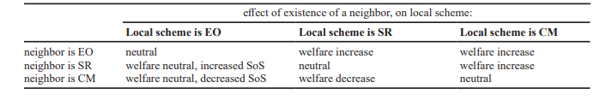Lambin and Léautier (2019).

**Energy-Only Markets**

To purchase electricity, energy markets are daily auctions that are used to coordinate electricity production, and RTOs run two types of energy markets: 1) day-ahead market 2) real-time market. In an energy market, we have supply side and demand side. The supply side is the electricity suppliers offer to sell their electricity that the power plants generate for a particular bid price, and the demand side is the load-serving entities that bid for that electricity in order to meet consumer demand. Prices are ordered in ascending order of offer price, and the market clears when the amount of electricity offered matches the amount demanded, and generators receive this market price per megawatt hour of power generated.

The day-ahead market represents 95% of all energy transactions and is based on forecasted load for the next day; this market occurs the prior morning to allow generators to prepare for operation the next day. The remaining 5% of energy transactions occurs in the real-time market, which is run once every hour and once every five minutes to account for real-time load changes that must be balanced at all times with supply.

The wholesale energy market allows RTOs to maximize use of clean energy sources which operate without fuel. They dispatch, or run, units in order of lowest cost to meet energy demand at the lowest possible price, which means that clean sources such as wind or solar, which have $0 costs per unit, are placed into the energy market and dispatched first. In the day-ahead market, RTOs decide which units to dispatch and in what order; they compile the list of generators available for next-day dispatch and order them from least expensive to most expensive to operate. Wholesale prices rise during periods of peak demand or high activity, because more high-cost units need to be dispatched to meet electric load.

Naturally, adding more clean generators to your repertoire will result in lower energy costs for consumers, not higher profits for the electric utility. However, adding more clean generators will not necessarily result in higher profits for electricity utility generating companies, as profit margin will remain the same. The base price changes, though the final price differential, the profit margin, the markup, remains the same; therefore, it is debatable the extent that electric companies have to utilize more clean burning sources over high-cost units, short of government mandate, or citizen revolt. If citizens boycott gas and coal facilities, then they may see lower costs from clean energy sources generators. Key to this debate about the costs of fuel and energy is nuclear power, which has high infrastructure costs, though low everyday fuel costs. Also key to this debate is that coal and gas require not only costs for the purchase and procurement of the materials, though also transport costs.

In general, base wholesale market prices reflect power prices free from transmission constraints across the RTOs territory, though sometimes RTOs account for congestion on transmission lines by allowing prices to differ across locations. Accordingly, areas with high demand and scarce electric resources may have higher prices than those with abundant generation relative to load. This means that geographic areas that have abundant natural resources will see lower energy prices than those with little energy resources. Also, areas with few electric generators will also see higher prices than those with plentiful electricity generators. So you need both, resources and capacity, natural resources for fuel supplies and capacity, electric generator capacity.

The energy-only market is also known as the wholesale market, as it deals exclusively with the physical and financial trade of electricity. The capacity market, or balancing market, is the natural complement to the energy-only market, which ensures the short-run supply of electricity. In the aftermath of liberalization, or deregulation, there are concerns whether the restructured electricity market system incentivizes sufficient investments in new generating capacity, though the lack of new investments will not be recognized for some time due to there being significant overcapacity at the time of deregulation due to regulatory and political intervention (Schafer and Altvater, 2019). We thus have an ongoing discussion about the need for more generation capacity in our power plants in light of deregulation to satisfy resource adequacy.

Regulatory challenges which led to overcapacity of generation assets is partly due to the promotion of variable renewable energy, and consensus is that one reason why renewable energy is promoted outside the market is because the internalization of emission costs is still incomplete. Cost internalization is the incorporation of negative external effects, notably environmental depletion and degradation, into the budgets of households and enterprises by means of economic instruments, including fiscal measures and other (dis) incentives. Thus, we still do not know how carbon based fossil fuels and their emissions affect the economy in full, and conversely how renewable energy sources such as solar and wind contribute to the total emissions forecast for a power plant.

Under perfect competition in energy-only markets all generators bid prices corresponding to their marginal costs, and then bids are ordered from lowest to highest forming the so-called merit order. Spot market auctions at the energy-only level follow uniform pricing so that the last power plant needed to satisfy demand sets the price for all successful generators. The infra-marginal rent is the rent gained by generating electricity for all successful generators except for the price-setting generator, and is used to cover capital costs. As supply and demand vary over time, different plants will be price setting, base-load plants or peak-load plants, with peak-load plants which face comparatively higher marginal costs gaining an infra-marginal rent less often than base-load plants. However, as peak-load plants display lower capital costs, this is generally not a problem.

The right end of the merit order is the plant which is never able to earn an infra-marginal rent, the peak-load plant with the highest marginal costs, with this plant covering its capital costs via a peak energy rent in times of scarcity. When demand is high and supply is at its limit, the spot price rises above marginal costs of the last unit in the merit order so that all generating plants earn a peak energy rent. Carmanis (1982) notes that even with unforeseen maintenance, a reason why a power plant is not generating electricity even though the spot price exceeds the marginal costs, infra-marginal rent and peak energy rent of an ideal energy-only market are sufficient to cover generators’ capital costs. Thus the argument is that an ideal energy-only market reflects adequate price signals to incentivize necessary capital investments.

In the energy-only market, since the supply side only and not the demand side actively participate in the market, there will always be imperfections such as exercise of market power or regulatory interventions (Hach and Spinler, 2018). It is incorrect to assume that customers pay no costs for acquiring capacity in an energy-only market, as costs are presumed to be included in the delivered cost of electricity. The capacity market only changes the proportion of revenues that on average would be earned from the energy market versus the capacity market.

If a power plant owner participates in both the energy-only market and capacity auction, they receive two payments, for their capacity commitment and for the energy they provide throughout the delivery period for the capacity auction. Different types of power plants earn their primary revenues in different markets. For example, nuclear power plants which operate frequently earn their primary revenues through the energy-only markets, while combustion turbines which operate less frequently earn a greater share of their revenues through the capacity markets.

The peak load pricing theory suggests that competitive energy-only markets incentivize optimal investments in new generation capacities by increasing prices when demand rises. Market equilibrium under the peak load pricing approach is staunched by two factors: long lead times for generation investments, and the absence of demand response (Bucksteeg et al., 2019).

***Energy-Only Markets Face Two Problems***

Schafer and Altvater (2019) write that energy-only markets face two problems in providing incentives for sufficient investment in generating capacity, asymmetric information and a high investment risk for generators. Asymmetric information due to unforeseen maintenance or the effect of price caps. Unforeseen maintenance comes into play because regulators do not know if a plant is running due to unforeseen maintenance, and price caps are important because without them market power could be used to provoke a scarcity event. Thus most electricity spot markets have price caps to limit the spot price, preventing market power abuse in times of high demand. A consequence of price caps is that a too low price cap may cut the peak energy rent, substantially resulting in missing money to cover capital costs. As for the high investment risk for generators, a generator relies on a sufficient number and intensity of scarcity to cover capital costs, and this induces a high risk since these scarcity events are not predictable, very volatile and depend on the actions of other generators.

**Ancillary Services Markets**

The ancillary services market includes other attributes not covered in the energy or capacity markets, such as: 1) help maintain grid frequency 2) provide short-term backup power if a generating unit stops. Some ancillary services include: regulation of voltage (120-, 240-, and 480- volt current at the power panel) and frequency (60 Hz cycle in North American power systems), reserves (back-up energy supplies), reactive control (the basis for reactive charges), and load following (exactly matching generation to consumption).

Without ancillary services the power system would be unreliable even with ample generating and transmission capacity. Ancillary services require fewer generators relative to those needed for power supply (less than 10% actually operating), and the control center provides for these services in the same way that it schedules and dispatches power plants.

There are two types of reserves required for system reliability, non-spinning reserve and spinning reserve. Non-spinning reserve is also known as installed capacity reserve (ICAP), and is supplied by power plants that are available for operation but sitting idle, able to provide reserves within 10 minutes. Spinning reserve is also known as operating capacity reserve (OCAP), is provided by power plants that are actually operating, just at less than full capacity, and also needs to be available within 10 minutes.

Reactive control, or imaginary power, is an ancillary service that results from AC systems. Utilities charge large customers a fee for reactive power in their rates. At the system level reactive control is provided through the operation of selected generators, and on the transmission and distribution system, reactive control is provided by capacitor banks.

Automatic generator control (AGC) is an ancillary service which assures industry standards for voltage and frequency through keeping voltage level when a large load is turned on, and keeps the power grid synchronized so all the generators are working together. When a large load is turned on, generators are forced to work harder, which can cause a temporary drop in voltage until the generators catch up.

Another ancillary service provides the necessary energy to match generation to loads within an hour, this is known as load following or imbalance energy, and can be done by controlling a specific generator or by redispatching several generators. An imbalance energy charge can result in a monetary fine. The imbalance energy charge may not be levied individually, and instead may be rolled into other charges or require power sellers to provide this service on their own. Imbalance energy charges can detract from wind or solar generation and distributed generators, or the construction and use of generation that is difficult to predict or schedule.

**Deregulation and Renewables, the Evolution of the Capacity Market**

The capacity auction did not always exist in its present form, a three year forward auction. Stage 1: before deregulation, the capacity charge was derived from the revenue requirement which constituted operating costs, investment costs, and a fair rate of return on those investments. Stage 2: with deregulation, the ISOs floundered at first with the notion of how to recoup capacity charges. In fact, the first generation of capacity markets resulted in capacity prices so unstable that they failed to reward the construction of new generating units or prevent the retirement of old ones, with capacity prices frequently falling to zero (Creti and Fabra, 2004). Stage 3: from there, the conventional forward capacity auction was introduced at U.S. ISOs, generally being three years in advance. Stage 4: where we currently stand, with the advancement of renewable energy sources technology and the effect that their $0 bids is having on the established capacity markets.

Some of the other characteristics of the modern capacity markets include: open to new entrants only, region-specific capacity requirements, and the level of capacity payments being directly tied to the availability of generating plants during periods of peak demand. As for open to new entrants only, this is not universal in all U.S. capacity markets, as the New England ISO is open to new entrants only, while the PJM allows existing as well as new generation capacity to participate in capacity auctions. The rationale behind the notion of ‘new entrants only’ is that unlike existing power plants, whose cost to bid capacity is zero, new entrants will seek to recover the capital cost of building a new power plant in their capacity payments. Region-specific capacity requirements refers to the conducting of separate auctions for capacity zones delineated on the basis of transmission limits that prevent capacity in one subregion from being made available to another. The PJM’s RPM, Reliability Pricing Model also allows for participation by demand response and transmission resources, so that transmission upgrades and interruptible supply contracts could be bid into auctions as substitutes for generation capacity.

Renewable portfolio standards are mandates for utilities to purchase power from renewable resources. They may be implemented through legislation or in regulatory orders, through an actual purchase requirement (the utility has to purchase power from renewable sources), or through a credit trading mechanism where the utility purchases a credit from a renewable developer rather than building the renewable generation on its own. Using credit trading mechanisms has the advantage of facilitating the development of renewable resources in regions with the best renewable resource potential, regardless of the location of the utility.

**Capacity Markets: Texas Undefined vs. New York Defined**

**Difference in design of various capacity markets in the US**

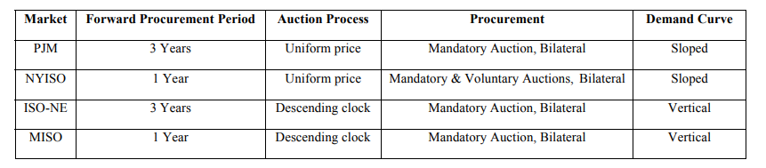

(Bhagwat et al., 2015) Based on (Spees et al., 2013).

**Supply and Demand Curve of a Capacity Auction**

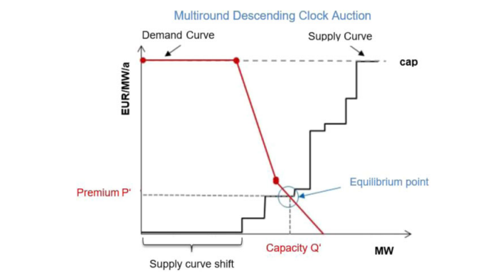

Pugl-Pichler et al., (2020).

**PJM Interconnection, Marginal Units by Fuel Type and Technology**

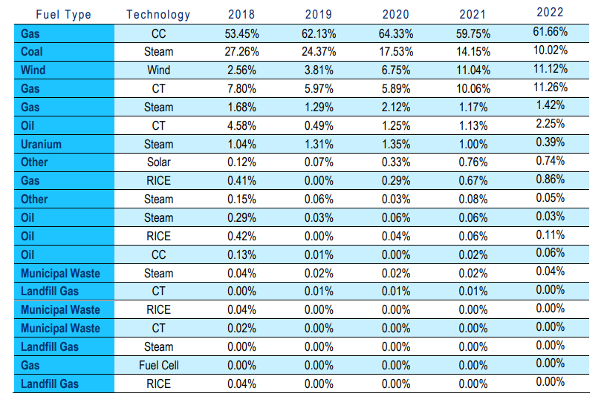

PJM Interconnection: 2018–2022 CO2, SO2 and NOX Emission Rates. The percentages by fuel type and technology provided in Table 1 are from the annual 2022 PJM State of the Market Report, Table 3-67 Type of fuel used and technology (By real-time marginal units): 2018 through 2022.

**California ISO, CAISO**

The CAISO does not operate a formal capacity market, but it does have a mandatory resource adequacy requirement, which is based on the California Public Utility Commission's Resource Adequacy framework. California has a limited competitive retail energy market and competitive wholesale energy market. They also do not have a capacity market, like Texas, though their method to address resource capacity in the near term is via the CAISO procuring capacity in specific instances, with one-year agreements that do not involve publicly visible trading.

In California in 2016, energy prices ranged from $23/MWh in March to $34 in June. There was a spike of up to $200 over a five hour period, and of $600 for a single one hour period. As for solar, a new peak of 9,914 MW was reported for mid-June. California has a problem called the duck curve, which means that as more solar power has come on line, the problem with so much solar is that it generates the most electricity mid-day when the sun is most intense. Therefore due to the duck curve, there is more solar energy surplus midday, resulting in some generators having two starts each day.

**Texas, ERCOT**

Kelly, S., McLaughlin, T., and Verma, S. (2021) Explainer: Texas's one-of-a-kind power system raises questions during price spike <https://www.reuters.com/article/us-usa-weather-power-prices-explainer-idUSKBN2AG2KD>

The Texas energy market and independent power grid is an electricity-only market; there is no capacity market paying generators to ensure there will be enough power to meet peak demand, which means that the generators only make money when they're delivering electricity into the grid. Texas regulators use scarcity pricing to ensure reliability, but that can cause real-time prices to soar due to shortages. Texas ERCOT has highly competitive retail and wholesale energy markets; instead of capacity payments, they have energy price caps at $9,000 instead of $2,000 per MWh, with the objective being to lure in new generation with higher potential prices (Kelly et al. 2021).

Texas produces and consumes more electricity than any other state, and is the only state in the continental United States that runs a stand-alone electricity grid. Naturally, a stand-alone electricity grid is designed to keep the state’s energy system independent and isolated from other markets. The Texas grid is not subject to federal oversight and is largely dependent on its own resources, according to the U.S. Energy Information Administration. Accordingly, they don’t have the infrastructure connected outside of Texas that might allow them to bring in imports of energy, in the case of an extreme weather event.

The problem with Texas’ energy independence means that during critical weather events like the February 2021 storm, most of Texas cannot connect to other grids, which are connected and draw from each other when needed. During this storm, around 4.4 million customers were without power. The February 2021 storm forced about 34,000 megawatts of generation off the system, or 40% of roughly 82,000 mw of expected capacity, as ERCOT instituted rolling blackouts. In terms of energy prices during this event, next-day power for the Tuesday after the Monday storm at the ERCOT North hub jumped to a record of $1,489.75 per megawatt hour (MWh), while some 5-minute power prices approached $11,000 per MWh over the past couple of days, ERCOT said. That annual average at the ERCOT North hub was $26 in 2020.

In Texas in 2016, according to ERCOT’s Potomac Economics Report, average energy prices were $24.62 per MWh, with loss-of-load and reliability adders contributing just another 40 cents. In 2016 in Texas, the spot market price never cleared $1,000, exceeded $300 for only 22 hours, and was negative for 133 hours, prices which are inadequate to bring in new generation. The Potomac Economics report further estimates that a new gas generator needs $80-95 per kW-year to satisfy annual fixed costs, though the net revenues for existing gas units are only $23-29 per kW-year.

***Effect of Extreme Weather Events on Electricity Generation***

Equipment can be winterized, as cold weather will force many kinds of generation offline, freezing wind turbines and shutting natural gas power generation operations as well. As cold weather can cause ice to build up on wind turbine blades, limiting their ability to produce electricity, turbines installed in colder climates are routinely equipped with warming systems that stop ice build-up.

***Texas Energy Profile***

Texas’ electricity is supplied through the following mediums: about half via natural gas, followed by coal, renewables and nuclear power.

***Issues with Texas ERCOT***

ERCOT’s market and system operations have been successful over the last several years even as demand has continued to rise in Texas, according to a long-term reliability study by North American Electric Reliability Corporation (NERC) in December 2020. ERCOT has been operating with a reduced buffer between electricity it can provide and its overall capacity. Since 2010, ERCOT’s reserve margin, the buffer between what it can produce vs. forecasted demand, has dropped to about 10% from about 20%. This has put pressure on generators during electricity demand spikes, making the grid less flexible, NERC said.

Texas can reduce the prices for day-ahead energy, day-ahead AS and real-time energy via wind generation development and demand-side-management. Further, Texas can improve its electricity trading efficiency by improving ERCOT's forecast accuracy to narrow the RTM energy price's divergence from the DAM energy price (Zarnikau et al., 2019).

**New York ISO, NYISO: Installed Capacity Market**

NYISO, The Capacity Market's Role in Grid Reliability: Frequently Asked Questions, October 7, 2020.

In New York, the New York ISO, the NYISO, runs an installed capacity (ICAP) market, where installed capacity refers to the maximum amount of electricity that a generator can generate under the expected peak design conditions. The NYISO website states that “the New York Installed Capacity (ICAP) market serves to maintain reliability of the bulk power system by procuring sufficient resource capability to meet expected maximum energy needs plus an Installed Reserve Margin (IRM). Unforced capacity (UCAP) is the installed capacity adjusted for availability, as provided by the Generating Availability Data System (GADS). UCAP is offered in a series of auctions by generators, and load-serving entities are obligated to purchase the minimum volume of unforced capacity that has been assigned to them. The unforced capacity requirement is calculated from the IRM and forecasted peak load, with the IRM defined as the required excess capacity presented as a percentage of expected peak demand, and is established with a LOLE of 1-in10 years (NYISO, 2020).

New York has state goals to achieve higher use of renewable energy sources in the near future, including mandates requiring 70% clean energy by 2030 and a zero-emission electric system by 2040. New York also has reliability rules which require an annual reserve margin to set the bar for how much capacity is procured in the NYISO's market to make sure the system can meet the highest peak demand. NYISO has two six-month capability periods during which it tests the maximum generation output of parties that have sold capacity credits: Summer capability period (May 1st - Oct 31st) and Winter capability period (Nov 1st - April 30th). Market parties are allowed to correct their positions in capability-period auctions and again in monthly spot auctions. NYISO uses a sloping demand curve.

*(The following is taken from Bhagwat et al., 2015)*

The New York Independent System Operator (NYISO) organizes an installed capacity (ICAP) market. Unforced capacity (UCAP) (NYISO, 2013a, 2013b) is offered in a series of auctions by generators. Load-serving entities are obligated to purchase the minimum volume of unforced capacity that has been assigned to them (Harvey, 2005; NYISO, 2013a, 2013b). UCAP is defined as the installed capacity adjusted for availability, as provided by the Generating Availability Data System (GADS) (NYISO, 2013b). Harvey (2005) describes how the UCAP is calculated. The unforced capacity requirement is calculated from the Installed Reserve Margin (IRM) and forecasted peak load (NYISO, 2013b). The IRM, defined as the required excess capacity (presented as percentage of expected peak demand), is established such that the loss-of-load expectation (LOLE) is once in every ten years, or 0.1 day/year. The LOLE represents the probability that the supply would be lower than demand, expressed in time units. In NYISO, ‘days/year’ are used (Čepin, 2011)).

Mandatory spot auctions for capacity are conducted once a year for the coming year. In these auctions, supply-side bids of capacity are cleared against a sloping demand curve. The parameters of the sloping demand curve are reviewed every three years. The ISO contracts the required capacity from the capacity market on behalf of load serving entities (LSEs), the cost of which is recovered from the customers as an additional charge. NYISO has defined two six-month capability periods during which it tests the maximum generation output of parties that have sold capacity credits: a Summer capability period (May 1st - Oct 31st) and a Winter capability period (Nov 1st – April 30th) (NYISO, 2014). Market parties are allowed to correct their positions in capability-period auctions and again in monthly spot auctions. Imports are allowed to bid into the capacity market, provided that they adhere strictly to rules regarding transmission capability, electricity market bidding, and availability (NYISO, 2013b). Market parties are also allowed to conclude bilateral 6 contracts. A detailed description of the market rules is available (NYISO, 2013b; Spees et al., 2013).

**PJM: Reliability Pricing Model**

*(The following is taken from Bhagwat et al., 2015)*

The Reliability Pricing Model (RPM) is the capacity auction for the PJM ISO. This is a three year forward market with a sloping demand curve. The PJM ISO administers an area covering parts of thirteen states and the District of Columbia. The capacity market in this region is called the Reliability Pricing Model (RPM). RPM divides the region into Locational Deliverability Areas (LDAs) that reflect the demand and supply conditions in different locations.

The RPM is a three-year forward capacity market (Cramton and Stoft, 2006). In the first step, mandatory three-year forward base residual auctions (BRA) are conducted. The suppliers’ bids are cleared against a sloping demand curve known as the variable resource requirement (VRR). The shape of the VRR depends upon the cost of new entry (CONE) and the administratively set reliability requirement value (Bowring, 2013a, 2013b; Hobbs et al., 2007; PJM, 2013). The BRA is followed by incremental auctions (IA) that are conducted to allow market parties to adjust their positions if required.

The load serving entities (LSE) are also allowed to meet their reliability requirement via selfsupply as well as bilateral contracts with generators. As in the NYISO-ICAP, imports are allowed to participate in capacity markets provided they comply with all PJM requirements (as approved by FERC). PJM has recently proposed capacity performance rules (PJM, 2014). Detailed description of the PJM-ICAP is available in (Bowring, 2013b; Hobbs et al., 2007; PJM, 2013; Spees et al., 2013).

**ISO-NE: Forward Capacity Market**

*(The following is taken from Bhagwat et al., 2015)*

ISO-NE initially implemented an ICAP market in 1998, though transitioned to a Forward Capacity Market in 2008 by conducting an auction for year 2010. This is a three year forward market with a vertical demand curve that has a price cap and floor. It is a descending clock auction. The New England ISO covers six states. The ISO-NE initially implemented an ICAP market in 1998. In 2002, deficiencies in the market design were identified by FERC. After much deliberation and negotiation, ISO-NE transitioned from ICAP to a Forward Capacity Market (FCM) in 2008 by conducting an auction for year 2010 (Benedettini, 2013; ISO New England Inc., 2015).

Similar to PJM-RPM, the ISO-NE FCM is a three-year forward market but with a vertical demand curve that has a price cap and floor. The resource adequacy requirement is calculated based on a LOLE of 0.1 day per year. The FCM employs a descending clock auction unlike other capacity market designs. Imports are allowed to participate in the FCM provided they comply with all FERC-approved requirements.

In the FCM, a three-year ahead forward capacity auction (FCA) is initially conducted followed by annual and monthly reconfiguration auctions in order to allow market parties to make 7 adjustments. The design of the FCM is described in detail in Benedettini, (2013); ISO New England Inc., (2015), 2014a, 2014b; Spees et al., (2013). The market is presently undergoing a redesign process based on findings of the Strategic Planning initiative (ISO New England Inc., 2014c).

**New England ISO Capacity Auction**

1. An annual auction to procure 100% of the system’s requirement for generation capacity three years in advance, thus providing an advance price signal to developers
2. A bidding process that will set the capacity price paid to all generators off the bids of new entrants only. Unlike existing power plants, whose cost to bid capacity is nil, new entrants will seek to recover the capital cost of building a new power plant in their capacity payments
3. (3) Region-specific capacity requirements — the New England ISO would conduct separate auctions for capacity zones delineated on the basis of transmission limits that prevent capacity in one subregion from being made available to another
4. (4) The level of capacity payments would be directly tied to the availability of generating plants during periods of peak demand.

**MISO: Planning Resource Auction**

*(The following is taken from Bhagwat et al., 2015)*

The Midcontinent ISO replaced its Voluntary Capacity Auction (VCA) with the Planning Resource Auction (PRA) in 2013. This is an annual auction with a vertical demand curve. The Midcontinent ISO introduced the Planning Resource Auction (PRA) in 2013 to replace its Voluntary Capacity Auction (VCA). Two types of auctions are conducted. Initially, the PRA is a sealed-bid auction for the upcoming year in order to provide a clearing price for each of the local resource zones. Subsequent transitional auctions allow market participants to adjust their positions (MISO, 2013). The PRA is held two months prior to the beginning of the planning year.

The planning reserve margin is set by MISO to achieve a LOLE of 0.1 day per year. The MISO region is divided into Local Resource Zones (LRZ) to ensure sufficient capacity in each geographic zone. The PRA utilizes a vertical demand curve. One of the recommendations of the 2013 State of the Market Report is to implement a sloped demand curve similar to the PJM RPM system (Potomac Economics, 2014).

External resources are allowed to participate in the PRA provided that they meet MISO’s FERC-approved requirements, including the must-offer obligation. Detailed description of the MISO PRA is available in MISO, (2015 and 2013); Potomac Economics, (2014); Spees et al., (2013).

**Different Regional Approaches by RTOs**

1. ***Ensuring Resource Adequacy-*** The California ISO and Southwest Power Pool both use resource adequacy requirements that electricity suppliers must meet. The Texas ERCOT using planning estimates instead, in that, according to ERCOT officials, the ERCOT market relies on incentives provided through energy-only and ancillary services markets as well as long-term contracts with electricity suppliers to encourage independent owners of power plants and other resources to build and retain adequate resources to meet customer electricity needs. Four RTOs use capacity markets as part of their resource adequacy approach: ISO New England, Midcontinent ISO, New York ISO, and PJM. Texas ERCOT does not collect data on the amount of capacity commitments procured, as they do not establish a resource adequacy requirement for electricity suppliers nor require electricity suppliers to procure capacity commitments.
2. ***Procuring Capacity Commitments through the Auction-*** PJM and ISO New England require electricity suppliers to meet their resource adequacy requirements using capacity markets administered by the RTOs, 93% and 97% in 2017. Midcontinent ISO and New York ISO do not require this, and allow them to procure resource adequacy outside the auctions, through contracts negotiated with power plant owners. Midcontinent ISO procured more than one-third of its capacity commitments outside its 2017 auction.
3. ***Auction Delivery Period and Timing-*** New York ISO has a series of capacity auctions, a seasonal auction, a monthly auction, and a final auction that takes place between 6 months and a few days before a 1-month delivery period. Midcontinent ISO has a single auction that is held 2 months in advance of a 1-year delivery period. When the auctions are held close to the delivery date the resources are needed, like New York ISO and Midcontinent ISO, only owners of existing power plants that are already built can participate in these auctions, whereas with an auction that is held 3 years in advance of a 1-year delivery period, like ISO New England and PJM, investors who plan to build but have not built power plants can still participate in the auction and potentially selected to make a capacity commitment to gauge demand for the new investment. Prices in these 3-year advance capacity auctions combined with expected revenue from other wholesale energy markets can act as a market signal to whether new investment is needed. ISO New England and PJM also conduct subsequent auctions to account for changes in the amount of resources that electricity suppliers are expected to need, and these subsequent auctions provide opportunities for owners of power plants who obtained capacity commitments to transfer these commitments to others. Since the New York ISO operates capacity auctions for each delivery month, and the other three procure commitments in a single auction for an entire delivery year, auction results are not directly comparable.
4. ***Auction Format-*** PJM, New York ISO, and Midcontinent ISO all use blind offers for capacity auctions which are then ranked from lowest to highest price, and selected in that order to meet demand. New England ISO uses a descending clock auction, in which the RTO administratively sets a starting auction price and then lowers the price, and when the price gets too low beyond the price they are willing to make a capacity commitment generator owners will drop out. In all four RTOs with capacity markets, the final price established in the auction is paid to all generator owners whose capacity commitments are selected, regardless of what offer price they submitted.
5. ***PJM, New York ISO, Midcontinent ISO, New England ISO-*** From 2013 to 2016 these four RTOs with capacity markets had combined energy market costs of $271 billion, capacity market costs of $51 billion, and ancillary services market costs of $5 billion. These costs, however, do not reflect the total cost of ensuring resource adequacy, as it does not include contracts for capacity commitments procured outside the auctions.
6. A mandatory, centralized capacity market results in higher reserve margins in comparison with a region that does not have a formalized capacity market. The ERCOT forecasted reserve margin for 2014 was 8.78 percent, whereas the PJM forecasted reserve margin for 2018 was 17.5 percent. Assuming a 15% reserve margin for 1-in-10 LOLE, these numbers thus suggest that PJM may be achieving more system reliability than 1-in-10 (Drom, 2014).
7. The PJM uses the Reliability Pricing Model program (RPM) to make capacity payments to generation assets (including demand-reduction providers). The RPM has several facets: 1) procurement of capacity three years before it is needed in a competitive auction 2) locational pricing for capacity that reflects limitations on the transmission system’s ability to deliver electricity into an area and to account for the differing need for capacity in various areas of PJM 3) a variable resource requirement to help set the price for capacity, and 4) a backstop mechanism to ensure that resources will be available to preserve system reliability (Drom, 2014).
8. The PJM Market Monitor reports that for the 2013-14 delivery year, RPM annual charges to load serving entities totaled $6.7 billion, with total billings of $33.9 billion in 2013, which means that $0.20 of every dollar was apportioned to the RPM capacity market from wholesale electricity costs from load serving entities, and $0.80 went to electricity costs (Drom, 2014).
9. ERCOT has a price cap of $5,000 per megawatt hour, whereas PJM has a price cap of $1,000 per megawatt hour. This speaks to the fact that ERCOT does not have a formal capacity market, so it allows for higher charges in the energy-only market for wholesale electricity prices (Drom, 2014).
10. In 2010, according to the Energy Information Administration, the lowest retail costs for electricity were found in Wyoming ($0.061 per kilowatt-hour) and the highest were found in Hawaii ($0.251 per kilowatt-hour). These costs are primarily based on the costs of producing electricity, which is influenced by the type of resource that is used to generate electricity (Drom, 2014). Neither Hawaii nor Wyoming has a capacity market.
11. It is also possible to change RTO jurisdictions, and the type of capacity market in each RTO may influence this transfer. In 2010 two utility companies transferred functional control of their transmission assets from the MISO to the PJM, Duke Energy Kentucky, Duke Energy Ohio and FirstEnergy Ohio. Their presumed reason for transferring RTOs was to achieve greater revenues through their generation assets’ participation in the centralized RPM construct relative to the MISO’s bilateral market. The RPM construct may provide greater access to capacity customers relative to MISO’s bilateral construct given the majority of MISO members are vertically integrated and rates to customers will be minimized when distribution utilities contract with their regulated generators. In this sense, bilateral construct means that in the MISO load serving entities negotiate for capacity resources the amount that is set by the MISO. MISO also has a centralized voluntary capacity auction, intended as a last resort for LSE’s short on their capacity obligations, conducted on a month-to-month basis (not 3 years forward like the PJM), and generally clears at a price essentially equal to zero (Bowden, 2010).

***Submarkets in the Electricity Market***

1. Spot market
2. Day ahead market
3. Forward market for electricity
4. Forward market for capacity

**Bilateral contract blocks:**

1. Peak: 5x16 (weekday blocks 5 days per week and 16 hours per day) or 6x16 (Mon-Sat 16 hours per day)
2. Off-peak: hours not defined as peak
3. Round-the-clock: 24 hours per day
4. Monthly (for a specified number of months)
5. Balance-of-month (the remaining days of the current month)
6. Daily (for a specific number of days)
7. Summer (July-Aug)
8. Winter (Jan-Feb)
9. Annual (a block for a year)

**Pricing options for bilateral contracts:**

1. Fixed: a specified $/MWh that does not change
2. Indexed: a specified formula for determining the price based on published indices
3. Strip: a specified fixed price for each month of a contract, which varies by month

**U.S. Capacity Markets: The Effects of the Push to Renewable Fuel Sources**

Bothwell and Hobbs (2017) write that there are three ways to evaluate variable renewable energy in capacity markets: through capacity credits, through renewable tax subsidies, and through portfolio standards. Due to declining energy prices as a result of subsidized renewable wind and solar generation, reliance on spot market energy prices or bilateral energy contracts alone will fail to attract needed new investment or prevent premature plant retirements (Cramton 2012). Capacity credit is the level of conventional generation that can be replaced with variable renewable generation.

The missing money problem is a natural issue in capacity markets, where generation capacity sits unused. This issue is that inadequate gross margins are earned to cover the cost of investment in new resources, as the capacity reserves do not generate any revenue in an electric power plant, and variable renewable energy exacerbates this issue. Renewables exacerbate this issue because they are $0 bids, so renewable generators offer little to no incentive for new investment, and is aggravated by the offer of production-based tax credits that decrease the price offers by renewables.

The missing money problem exists in both normal operating conditions and periods of scarcity. Peaking plants do not recover costs in normal operating conditions, and in scarcity periods regulators intervene to reduce prices below market conditions (Gailani et al. 2020). The missing money problem arises when administrative actions, such as price caps, put limits on market price increases due to increased demand.

Variable renewable generators offer increased uncertainty because their outputs, like load, depend on weather patterns and cannot be modeled as independent. According to Mazzi and Pinson (2017), renewable energy technologies such as wind face the problem of unreliable forecasts, with forecasts being needed to bid energy in the spot and futures market.

Variable renewable generation has made increases in their share of generators in power plants from the existence of subsidy programs. Direct subsidies include tax credits and feed-in tariffs, and are available at federal, state, and local level for renewable technologies. A Renewable Portfolio Standard, RPS, is an implicit subsidy that requires a prescribed amount of renewable energy whether or not it is economically efficient. As of 2017, 29 U.S. states have an RPS while eight others have non-mandatory goals, and a majority of the standards/goals are for 15-20% renewable energy by the early 2020s (DSIRE 2017). Some of the more aggressive RPS standards require 50% by 2030 in California, 75% by 2032 in Vermont, and 100% by 2045 in Hawaii. Capacity payments to renewable generators is another subsidy to renewable energy, in that they are made in a manner inconsistent with their actual contribution to system reliability (Bothwell and Hobbs 2017).

Renewable variable generators have capacity factors of around 15-25% for solar and 25-35% for wind, which although they have low availability, additions of such capacity can still contribute to system adequacy by enabling the system to accommodate more load while maintaining the same reliability (Bothwell and Hobbs 2017). Issues with measuring variable renewable energy sources for system adequacy requirements are: wind or solar variability that is correlated with load, limitations on total energy production from storage, limited hours of use or number of starts, or advance notification requirements for demand response.

Bothwell and Hobbs (2017) observe that inconsistent methods are used by system operators for calculating the capacity contributions of variable renewables. Problems are that too much capacity credit for a particular resource is an implicit subsidy that may lead to overinvestment, and that too little credit could divert investment away from a resource. Inaccurate credits can impact investment choices between renewables and thermal generation and can also affect relative profitability of different renewable types or locations.

Shafer and Altvater (2019) research that three variables can affect the outcome of a capacity auction: increasing share of renewable energy, varying carbon emission costs, and the existing capacity mix. They found that capacity auctions direct investments to more flexible power plants for an increasing share of renewable energy, which opposes the merit order effect of renewable energy which is found in energy-only markets (De Miera et al. 2008). Therefore a capacity market can prevent missing flexibility of energy generators mix seen in energy-only markets as a result of increasing share of variable renewable energy sources.

When electricity from renewable energy sources is fully integrated into the market, then this can serve only to promote competition and trade in the internal markets. Electricity from renewable sources must be sold directly, without an intermediate purchase from grid operators, to implement a fully demand-driven competitive market. A primary objective of demand-driven models is in the way that renewable energy is produced and sold, not in the modification of the energy-only market. Conventional plants will become profitable again when the variability of renewable electricity is reflected within the system, or when all electricity from renewables is allocated in balance groups of the respective traders (Held and Ole Voss, 2013).

Two characteristics of renewable energy sources contribute to instability in the electricity market, low marginal costs and intermittency. As renewable energy sources have marginal costs of close to zero in most cases due to no fuel costs, they push the merit order from the left and consequently push high marginal cost conventional sources out of the market. Due to their intermittency, the same amount of conventional generation capacity as without the RES feed-in is still needed to ensure generation adequacy (Hach and Spinler, 2018).

Due to their long life cycle and high energy density, many of the new generators providing capacity market services use lithium-ion batteries (Lee et al. 2019). Degradation cost of lithium-ion batteries is the main factor in determining operational cost. An experiment by Gailani et al. (2020) quantifies the degradation costs for three degradation mechanisms for LIB cells in the capacity market, which are solid-electrolyte interphase (SEI) layer growth, active material (AM) losses, and SEI layer fracture. By predicting degradation costs under different operating conditions, we can then simulate capacity market profits at those rates. For this experiment, they found that capacity market profits can be increased by 60% to 75% at 5°C and 25°C (Gailani et al. 2020).

For power plants, from 2016 to 2016, 53,000 MW of coal-fueled capacity was retired, equal to 18% of operating coal capacity in 2016; an additional 12,000 MW of coal capacity was scheduled for retirement from 2017 to 2021 (Rusco 2017). Trends that are influencing the selection of new power plants include low natural gas prices, higher coal prices, and state and federal policies. The composition of the panel of power plants available in a region also affects resource adequacy, such as if there is a large percentage of the generators that are intermittent renewable energy, such as wind and solar. This will require electricity suppliers to offer more flexible resources, such as gas fired plants which can run at any time. Similarly, regions that rely heavily one one natural resource such as gas or coal may also find resource adequacy problems. A program to promote reliability can help these gas or coal fired plants, such as making sure there are adequate inventories of oil, additional demand-response resources, and contracts for liquified natural gas (Rusco 2017).

Renewable energy sources exacerbate the traditional missing money problem of the electricity market (Cramton and Stoft, 2008). Renewable generation is semi-dispatchable, meaning that it can only be dispatched down, and has zero or near-zero marginal costs, which means that renewable units enter the market at the bottom of the supply curve and displace thermal generators, as well as depressing the prices earned by all generators in the spot market. To ensure sufficient supply at all hours during the year, excess thermal generation units are still needed due to the output of renewable units being variable and intermittent.

Lynch and Devine (2017) define reliability of generation units as the number of hours of the year where the unit can be expected to be available for generation. For thermal generators, reliability is thus measured as one minus the forced outage rate, while for renewable generators, the reliability is a function of the weather, and is linked to the capacity value of the unit in question.

González-Diaz (2015) argues that by maintaining a certain level of conventional capacity in the generation assets, a high share of renewables in the energy system is facilitated, by providing a stable baseload and flexible backup in times of peak demand. This leads to the missing money problem from no revenue being earned in the energy-only market due to dormant units generating no revenue, and the subsequent problem of the utilities having less money to finance new capacity and keep existing plants online, and therefore no new investment occurs.

Leiren et al. (2019) discusses two impacts of renewables on the energy markets, which are creating a shortage of energy project financing, and consequently power supply shortages: 1) falling wholesale electricity prices, and 2) lower investment stability. The impacts of renewable energy sources on energy markets is lower average wholesale prices and a squeezing out of conventional capacity.

The concern with sustainable energy transitions and low-carbon electricity generation such as nuclear power and renewables, is that a rise in variable renewables would increase the level and uncertainty of revenue for conventional generation capacity through lower and more volatile wholesale prices, and that this would deter the investment in such capacity that would be needed to provider flexibility in a future system with variable net demand (Lockwood et al., 2019).

Capacity value is the contribution that a plant makes toward the planning reserve margin. A generator’s contribution to the generation capacity adequacy of a power system is more accurately captured by its capacity value than by its installed capacity through considering factors such as forced or planned outages, seasonal ratings and temporarily limited primary energy supply. Since the contribution of intermittent renewable energy to cover electricity demand is less certain than conventional power sources, the capacity value of renewables is less than that of conventional plants (Söder et al., 2020). Capacity credit is the level of conventional generation that can be replaced with wind generation. Wind power contributes to system adequacy through its capacity credit, which then reduces the need for other types of capacity, while achieving the desired level of reliability (Söder et al., 2020).

***U.S. Market Structure and Available Renewable Energy Options***

Electricity market structure as well as state and utility policies can affect available renewable energy options. For example, participating customers in traditionally regulated and vertically-integrated regions usually pay more for renewable electricity in their electric utility bill. They will bundle their products to include renewable energy certificates (RECs) with electricity service. Services offered in traditionally regulated markets include green power products such as utility products or green pricing products, which are bundled. Green tariffs which are bundled green power products from specific renewable energy projects procured through special utility tariff rates. Customers in competitive or liberalized markets can purchase competitive products or green marketing products from several different suppliers. These are optional product offerings for customers in competitive or deregulated markets to procure bundled renewable electricity from their default utility supplier, or from an alternative competitive electricity supplier.

**Hydropower**

Hydropower plants have two classes of dam, storage projects and run-of-river projects. Run-of-river are more like wind or solar than thermal power plants, for several reasons, including that run-of-river projects are operated on a combination of water stored in reservoirs behind dams, water stored in the watershed as snow that will melt in warm weather, and projected rainfall. All hydropower dams are restricted by precipitation levels (snow and rain) and storage area behind dams. If rainfall is less than normal, then there will be less power available. Hydro system operators have to plan on having only as much power as can be produced from a minimum level of precipitation over an appropriate historical interval. Critical water planning means two things: 1) the region never runs out of power from lack of rainfall, even in drought years 2) whenever rainfall is greater than normal, there is a surplus of hydropower available. This means that in good years the plant can rely less on power from more expensive alternatives because it has abundant cheap power. When water power isn’t available, they have to pay market price for power generated by thermal power plants.

**Wind Power**

Wind turbines get taller every year, making them more efficient and capable of harnessing the wind. Some are even twice as tall as the Statue of Liberty, reaching heights of 599 feet with blades that reach 240 feet. Offshore wind turbines in the ocean can reach heights of 800 feet. Wind occurs when the sun heats the Earth and its air. As air is a mixture of gases, when the gas particles heat up, they rise. Cooler air comes in to take the warm air’s place creating movement that we can’t see but feel as wind (Wells, 2021).

As wind turbine utilities look for the windiest locations to build their turbines to capture as much of the movement as possible, factors such as mountains, water, and buildings can influence how windy a region is. A wind turbine works when gusts of wind spin the turbine’s blades, with blade tips traveling at more than 100 mph, to turn a generator that converts the wind’s mechanical energy into electricity.

As for the history of wind power, Egyptians were the first to use wind power when they used wind to propel boats down the Nile River in 5,000 B.C. Farmers in the Middle East and China were using windmills to pump water and grind grains by 200 B.C. Europe began using wind power by the 11th century, when the Dutch, who are well known for their windmills today, used wind for farming and engineering waterways. European immigrants brought their knowledge of wind power to the United States where it was and still is used extensively on farms and ranches for a variety of tasks.

The end of the 1800s is when people figured out how to use wind to generate electricity. Until the 1930s in the United States, wind was used sporadically to power homes and farms, when utility companies expanded the grid and built power lines in rural areas. Wind power started increasing again in the 1970s when gas prices skyrocketed, and renewable energy sources gained more traction. The first utility-scale wind projects were built in California in 1980, and from 1990 to 2020, wind grew from 1 percent of the United States’ electric generation to 8.4 percent.

In addition to providing a carbon-free source of electricity, wind turbines can also produce large amounts of electricity per unit. Landowners who lease their land to turbine owners can make money while still using their land to farm or ranch. Turbine owners paid $1.8 billion in taxes and land leases in 2020, and over the last decade, the industry has invested $145 billion to expand the technology. Wind energy employs more than 120,000 people, and wind technician is expected to be the nation’s fastest growing career as more turbines are built (Wells, 2021).

Wind energy is also a way for companies to offset their carbon emissions through virtual power purchase agreements. In a virtual power purchase agreement, companies can invest in new wind projects and help generate cleaner energy without the responsibility of operating them.

Duke Energy has installed and developed technologies to protect wildlife, like eagles and bats. cattle in wind turbine zones are unaffected, though flying species of animals face dangers. In Wyoming Duke Energy installed IdentiFlight, a system of cameras equipped with artificial intelligence to prevent golden eagles and bald eagles from colliding with a turbine’s blades. When the camera detects an eagle in a defined radius, the turbines at Top of the World Windpower Project stop spinning until the bird has left the area, and an independent study in 2020 showed an 82 percent reduction in eagle deaths. Duke Energy was also the first in the continental United States to deploy a Bat Deterrent System on a commercial scale to reduce bat fatalities at its Los Vientos Windpower Project in Texas, which reduced bat fatalities by 50 percent with reductions of nearly 80 percent in some species (Wells, 2021).

Challenges wind power faces are that it is an intermittent source and transmission obstacles from being located in remote areas. Wind is an intermittent energy source, and because the wind does not always blow, wind energy requires a way to store the energy, such as batteries, or a backup source of power to meet customers’ needs, such as natural gas or nuclear generators. Another key point of improving wind power efficiency is investments in grid improvements. This is because wind turbines are often located in remote areas, which can make it more expensive to deliver electricity long distances through the electric grid compared to other forms of generation.

**Solar Power**

The sun makes up 99.8 percent of the mass of all the system's planets and pieces combined as the largest object in our solar system. A star that big shines enough light on the Earth every hour to power the world’s annual electricity needs, and although solar panels can’t capture all of that, every year they are getting more efficient at capturing light. A solar panel works when light particles, called photons, reach the panel’s surface, which is a collection of cells, and converts them into electrical energy. Each panel at a solar installation is generally six feet long and three feet wide and weighs about 50 pounds. Photons are like tiny packets of energy, and when they fall on the panel’s glass top, they’re absorbed by the cells, and electrons break free from the packet. The photon cell has several layers, including a semiconductor, which is usually silicon, and metals that create an electric current and direct the loose electrons through wires into an inverter. The inverter converts the electricity from direct current to alternating current so it can be transmitted over transmission wires to your home (Wells, 2021).

Solar panels were recently developed in the 1950s, but the sun’s power has been harnessed for thousands of years. Egyptians and Mesopotamians concentrated sunlight with magnifying glasses made from polished crystals to start fires around 700 B.C., and around 300 B.C. Greeks and Romans used mirrors to light torches for ceremonies. The Romans later built their homes and gathering places with large, south-facing windows so the sun could warm their rooms. By the 1700s and 1800s, scientists around the world were developing methods in solar-generated electricity to use the sun to power machines and generate electricity, not just for fire and heating. In the 1800s French physicist Edmond Becquerel in 1839 discovered the photovoltaic effect, the ability to generate electricity from light, which paved the way for the first solar cells invented in the 1870s in Europe. In 1954 a team of scientists in the United States developed silicon-based solar panels like in use today, and since 1954, solar panels have improved from converting 2 percent of light to electricity to more than 20 percent. Some recent laboratory experiments surpass 40 percent efficiency with different types of panels. Materials such as cadmium telluride, copper, and perovskite are being researched to make panels more powerful, and experimental cells have been made so thin that they can rest on a soap bubble without it popping.

There has been substantial growth in solar generation in the 21st century, with the cost of solar panels falling 70 percent, along with tax credits by the government. As of 2021, the United States has more than 100 gigawatts of solar capacity compared to the 2.6 gigawatts available in 2010. Solar is projected to surpass wind as the largest source of renewable generation by 2040. In 2020, more than 230,000 Americans worked in the solar sector with solar technician as the nation’s third fastest growing job. In 2019, solar projects generated more than $25 billion of private investment (Wells, 2021).

Some other advances in the solar power industry, in addition to utilities building more solar to power the grid, include people are using solar to power their homes and electric vehicles while companies use solar to achieve their own sustainability goals. A virtual power purchase agreement can also be entered into like wind power in which they can generate cleaner energy without the responsibility of maintaining the system, and companies can invest in solar projects through rooftop or other on-site installations. Solar power’s limitations include the large amount of land required for utility-scale installations, the intermittency depending on weather and the cost and efficiency of panels. Solar trackers, a new technology, allow the panels to tilt along with the sun’s movement so they’re capturing as much light as possible.

**Battery Power**

Batteries can be used to collect and store energy from wind turbines and solar panels, and they also strengthen the grid by providing backup power for remote areas and controlling the flow of electricity in power lines. The United States has roughly 1.7 gigawatts of battery storage, which is enough to store the electricity generated from more than 5.4 million solar panels, and by 2050, predictions are that the country will have 10 times as much.

The way a battery works is by storing electrical energy as chemical energy so it can be converted back and released when needed. Batteries have two electrodes, an anode (positive) on one side and cathode (negative) on the other, with an electrolyte in between. The electrodes work together to initiate a chemical reaction that releases electrons, and the electrolyte, usually a liquid, makes it possible for the resulting electrical charge to flow between the two. From there, the electricity is directed from the battery’s terminals to the grid through a wire.

The modern battery was invented in 1800 by Italian scientist Alessandro Volta, which led to the field of electrochemistry, and the volt, a unit of electric potential, was named in his honor. It wasn’t until the 21st century that batteries were used for utility-scale projects. Before batteries were an option, energy companies used other methods to store energy and manage power quality including flywheels, compressed air, thermal energy and pumped-storage hydroelectric plants. Pumped storage is a type of hydroelectric station where the water can be reused and strategically moved between an upper and lower reservoir. When demand for electricity is low, the plant can take excess generation and use it to pump water to the upper reservoir that can be released later when demand for electricity rises. These hydro plants still make up the bulk of the nation’s energy storage, but most large-scale energy storage installations since 2003 have been batteries. As demand for electric vehicles and residential and utility-scale solar grows, the demand for batteries will grow, too (Wells, 2021).

The lithium ion battery is the most widely used battery for utility-scale projects today, with the cost of lithium ion batteries having fallen 89 percent since 2010. Hydrogen energy storage and microgrids are two other similar technologies to batteries. Microgrids are systems, usually a combination of renewables and batteries, that allow customers to disconnect from the energy grid and operate on their own. They can provide backup power in remote areas and improve power quality for critical infrastructure like hospitals, first responders or manufacturing facilities.

**Deregulation and Liberalization of The Electricity Industry**

There are three types of electric companies in the United States: 1) cities which have municipally owned utilities 2) rural areas with customer-owned rural cooperatives, and 3) investor owned. Investor-owned electric utilities can either be regulated or deregulated. Regulated electric utilities operate as vertically integrated monopolies with oversight from state public utility commissions. Deregulated electric utilities are markets where electric energy prices are set by market with some federal oversight of wholesale market operations. So regulated markets refer to state commissions, and deregulated markets refer to federal commissions, which makes sense, as the federal government must offer oversight to deregulated markets when the state does not regulate the market, in any economic marketplace, such as electricity. In turn, these four regulatory constructs, city, rural, state regulated and federal deregulated, determine how retail and wholesale electricity prices are set and how funding for power plants is procured and power plants are built. Retail prices refer to those paid by customers, and wholesale prices refer to those paid by the electric utilities for generation from larger electric generators (Cleary and Palmer 2020).

1. Different types of US electricity markets
2. How they are regulated
3. Implications for the future given ongoing changes in the electricity sector

**Traditional Regulated Electricity Markets**

As of 2021, although many states had abandoned traditional regulated electricity markets in favor of deregulation, still about one-third of US electricity demand operates under the regulated construct. Regulated markets typically are vertically integrated, which means that they own the electricity generators and power lines, with the power lines including both transmission and distribution lines. This change occurred in the 1990’s in America, in the midst of several industries deregulating, including natural gas, airlines, and telecommunications.

Regulated utilities operate as monopolies, which means that customers only have the option to buy from them, so state regulators must oversee the electricity prices set in order to keep electricity prices reasonable for customers. In the regulated utility construct customers bear the risk of investments because utilities can recover their costs through rates, regardless of the power plant’s economic performance. There are two costs for an electric utility which need state approval: 1) baseline electricity prices 2) power plants capital investments. Accordingly, electric utilities in these regulated regions use something collectively known as the revenue requirement to set retail electricity prices based on recovering the utility’s A) operating costs and B) investment costs, plus C) a fair rate of return on those investments. The revenue requirement prevents utilities from overcharging customers for electricity, and must be approved by the state’s public utilities commission. Two, vertically integrated regulated utilities use IRP, integrated resource planning, to demonstrate the necessity of future investments, to build power plants which contain generators for electricity generation.

The IRP long-term planning process helps utility companies to demonstrate how it plans to meet customer electricity demand going forward and thus the necessity of future investments. As regulated utilities determine which generators to build and then recover the costs of these investments through electricity rates, IRP helps them to set their revenue requirement and potential profit, which includes operating costs, investment costs, and fair rate.

Some vertically integrated utilities also still trade in the wholesale energy market via wholesale bilateral trading. The wholesale energy market and wholesale market transactions are regulated by the FERC, Federal Energy Regulatory Commission.

**Deregulated Electricity Markets**

Deregulation, or restructuring, of electricity systems creates competition and lowers costs. Under restructuring, the energy utility company sells its generation units, or generating assets, and leads to the creation of independent energy suppliers that own generators only. The electric utility then holds on to the natural monopoly assets of the transmission and distribution lines, and those power lines, which are natural monopoly functions, continue to be regulated by the state commissions. Deregulation leads to changes in retail and wholesale electricity sales, with the creation of retail customer choice and wholesale markets.

**Retail Deregulation: Customer Choice or Retail Choice**

Customer choice only applies to the generation portion of the consumer’s bill, as the natural monopoly functions of the transmission and distribution lines are still serviced by the local utility company, so only a portion of the rates are set competitively. Customer choice in retail deregulation means that electricity customers can choose an energy supplier other than their local electricity company. This offers competition for retail electricity prices from electricity suppliers or electric retailers. Contracts with generation suppliers typically offer customers a fixed charge, dollars per kilo-watt hour of power, over a certain period of time. While customer choice and retail competition can allow consumers to lower their electricity bills and choose clean energy suppliers, such as solar, wind, or hydroelectric, customers may also be required to sign long-term contracts. Fixed rates from independent companies are beneficial when local utility rates rise, and are detrimental when local utility rates drop. The local utility company is still obligated to provide customers with electricity generation supplies when they choose not to use an independent utility company. In every state, the electricity supply for end-users is procured from either the competitive wholesale market or from utility-owned rate-based generation, whether there is retail competition or not.

**Wholesale Deregulation: Creation of Competitive Wholesale Markets**

A key aspect of deregulated markets is that investment risk in power plants falls to the electric suppliers, and not to customers. A deregulated region uses markets to plan for investment in power plants for electricity generation, while a regulated region uses state sanctioned investment plans. Centralized wholesale markets is the term to describe how deregulated utility entities acquire power for their customers. In a centralized wholesale market, generators sell power and load-serving entities purchase it and sell it to consumers. In a deregulated market, what is known as a RTO, regional transmission organization, replaces the electric utility as the grid operator, and is the operator of the wholesale market for electricity.

With the exception of the Texas RTO, ERCOT, RTO’s are wholesale markets that encompass multiple states, and thus must be regulated by the FERC. The seven RTOs in the United States are: California ISO, Electric Reliability Council of Texas, Southwest Power Pool, Midcontinent ISO, New York ISO, PJM Interconnection, and the ISO New England. FERC has oversight of all wholesale power transactions on the two US large interconnected grids, the eastern and western interconnects. There are three types of RTO markets that determine wholesale prices for electricity generation services: 1) energy markets 2) capacity markets 3) ancillary services markets. Sales of wholesale power are regulated by FERC, with the exception of Texas ERCOT. ISOs and RTOs administer wholesale power markets, and both ISOs and RTOs provide open access to transmission and to ancillary services such as reserves and voltage support.

**Variation Across Regions in the United States**

States or regions may embrace aspects of both regulation and deregulation, as participation in RTOs and wholesale markets does not require retail customer choice or divestment of generation assets. For example, a regulated region with vertically integrated utilities may still join an RTO for grid services, such as West Virginia.

California has deregulated their wholesale markets though not their retail markets. The CAISO, California Independent System Operator, operates the grid and wholesale markets, though the state does not offer individual customer retail electricity choice. However, in California, communities can opt out of the local utility through what is known as community choice aggregation, under which a company hired by the community buys power in wholesale markets for all residents who do not opt out of this arrangement.

Two states do not run capacity markets, Texas ERCOT and California CAISO. When a region does not run a capacity market, it instead relies on price signals in the energy market alone to ensure reliability and meet NERC reliability requirements. For example, high prices in the energy market, typically caused by low supply and high demand, provide an economic signal for more electric generators utilities to enter the market, which can then lower energy prices and provide a signal that enough generating capacity is available to meet demand.

**The Future of Electricity Markets**

One issue that arises with the push to more clean sources of renewable energy and these $0 bids is that reducing wholesale prices for energy and capacity could discourage long-term investment for all resources. As these sources make up a larger portion of the electric grid over time, wholesale markets may need to adapt in the future to better accommodate different types of resources.

New York also is proposing a carbon pricing proposal for our energy market that would help grow renewable energy while encouraging less-efficient fossil fuel plants to close down or upgrade their equipment.As the United States increasingly relies on renewables like wind and solar power, additional installed capacity will be required to operate when the wind isn’t blowing or cloud cover rolls in.

**Nuclear Industry and Deregulation**

**Travers and Raughley, Effects of Electric Power Industry Deregulation on Electric Grid Reliability and Reactor Safety**

In the nuclear power industry, two concerns of electrical power industry deregulation are: 1) grid reliability and 2) reactor safety.

Industries that experience deregulation at some point in their lifespans include: electric power, airlines, telecommunications, and natural gas.

1. LOOP- Loss of Offsite Power
2. SBO- Station Blackout
3. NRC Licensees, Nuclear Utilities
4. LER- Licensee Event Reports
5. EDG- Emergency Diesel Generator
6. CDF- Core Damage Frequency
7. RES- Office of Nuclear Regulatory Research
8. National Energy Policy Act of 1992; allows for the sale of electricity on the open market and for customers to choose their supplier.
9. Federal Energy Regulatory Commission (FERC) Order 888; “Promoting Wholesale Competition Through Open Access Non-discriminatory Transmission Services by Public Utilities, Recovery of Stranded Costs by Public Utilities and Transmitting Utilities”; requires that utility and non-utility generators have open access to the electric power transmission system.
10. NRC Information Notice 98-07; “Offsite Power Reliability Challenges From Industry Deregulation”; to alert licensees to the potential adverse effect of electric power industry deregulation on the reliability of the offsite power source.
11. North American Electric Reliability Council (NERC), A) Reliability Assessment, 1997-2006, October 1997, B) Reliability Assessment 1998-2007, September 1998; assess future electric generation and transmission reliability on a regional basis and identify regional grid reliability concerns, opportunities for improvement, areas for increased attention, and the need to monitor performance.
12. SECY-97-246, October 23, 1997; “Information on Staff Actions to Address Electric Grid Reliability Issues”; status of staff activities with respect to grid reliability issues
13. SRM, May 27, 1997; listed 4 action items for the staff; A) make contacts with other agencies B) provide information regarding the Summer Nuclear Power Station July 11, 1989, grid disturbance C) make regional contacts with power pool and reliability councils D) review terms of the licensing basis and validate assumptions about grid reliability.
14. NUREG/CR-5496; “Evaluation of Loss of Offsite Power Events at Nuclear Power Plants: 1980-1996”; provides update of the LOOP data in NUREG-1032, shows the frequency per site-year has decreased for all three categories
15. NUREG-1032; “Evaluation of Station Blackout Accidents at Nuclear Power Plants”, JUne 1988; divides LOOP events into three categories: 1) plant-centered 2) weather-related 3) grid-related, and the median duration of a LOOP event is 30 minutes.
16. INEL-95-0035; “Emergency Diesel Generator Power System Reliability: 1987-1993”
17. RG-1.108, “Periodic Testing of Diesel Generator Units Used as Onsite Electric Power Systems at Nuclear Power Plants”; the overall reliability exceeds target goals, by 0.987 to .950, and by 0.985 to .0975, though the nature of the failures experienced during actual demands differed from those discovered during monthly inspection activities, suggesting that current testing may not be focusing on the dominant contributors to failures, and thus monthly testing may need to modified
18. Unresolved Safety Issue A-44, “Station Blackout”; contributed to NUREG-1032, to evaluate the risk associated with accident sequences initiated by LOOP
19. Information Notice 98-07, alerted licensees to the potential adverse effects of deregulation of the electric power industry on the reliability of the offsite power source

**Deregulation Issues; Notice 98-07**

1. Potential to challenge operating and reliability limits on the transmission system
2. Could affect the reliability of the electric power system including the reliability of offsite power to nuclear plants

**Rationale for Review, SRM Action Item Number 4**

1. Review terms of the licensing basis
2. Validate assumptions about grid reliability
3. Review the operating experience for offsite power, plant electrical protection systems, and the onsite emergency power systems
4. Perform sensitivity studies for potential changes to initiating frequency and event duration related to station blackout (SBO) risk
5. Review the NERC forecasts for future generation and transmission system reliability
6. Visit a number of electrical control centers to obtain information regarding system operation during deregulation

**Potential Concerns**

Two primary issues arise when discussing the principal design criteria of the licensing basis for the offsite electric power system: 1) deterministic considerations, General Design Criterion (GDC) 17, which requires that nuclear power plants be supplied by a reliable offsite power system, and 2) risk considerations, 10 CFR 50.63, Loss of All Alternating Current Power. This means the actual design of the system, and the risk contingency planning if AC Power is lost, or the backup generator system.

**Effects of Deregulation, Conversion to open grid access and deregulation**

1. Divestment of offsite electric power generating units from the electrical transmission and distribution systems
2. Transmission systems come the control of a new system control entity or an independent system operator
3. Power market emergence to sell electricity

***Since utilities no longer own generating and transmission units***

1. Decrease the reliability of the grid
2. Increase the time to restore electric power following a LOOP

***Key factors in determination of risk from SBO accidents***

1. Expected frequency of the LOOP
2. Probable time needed to restore offsite power
3. The redundancy and reliability of the emergency AC power sources

**NERC; Atlanta and Washington DC**

***Interconnections***

1. Eastern Interconnection covers most of eastern North America, extending from the Great Plains to the Atlantic seaboard, excluding most of Texas. The Eastern Interconnection is tied to the Western Interconnection via high voltage DC transmission facilities and also has ties to non-NERC systems in northern Canada.
2. Western Interconnection covers most of western North America, from the Rocky Mountains to the Pacific coast. It is tied to the Eastern Interconnection at six points, and also has ties to non-NERC systems in northern Canada and Northwestern Mexico.
3. Texas Interconnection covers most of the state of Texas. It is tied to the Eastern Interconnection at two points, and also has ties to non-NERC systems in Mexico.
4. Quebec Interconnection covers the province of Quebec and is tied to the Eastern Interconnection at two points. About one third of Canada's installed power (42 GW out of 130) and about one third of Canada's production (184 TWh out of 567) are in this interconnection. Despite being a functionally separate interconnection, the Quebec Interconnection is often[when?] considered[by whom?] to be part of the Eastern Interconnection.

***Regional entities***

1. Midwest Reliability Organization (MRO)
2. Northeast Power Coordinating Council (NPCC)
3. ReliabilityFirst (RF)
4. SERC Reliability Corporation (SERC)
5. Texas Reliability Entity (Texas RE)
6. Western Electricity Coordinating Council (WECC)

***Report Protocol, Request Information Regarding:***

1. Electric power grid performance
2. Impact on nuclear plant operations
3. Forecasting
4. Emergency conditions
5. Recovery from offsite power disturbances

-the interrelationship between nuclear power plants and the system control centers

-there is significant diversity among NERC regions and between utilities within regions

-grid reliability concerns consistent with grid reliability assessments performed by NERC

***LER, Licensee Event Reports***

Licensee event reports which present the operating experience, in conjunction with an engineering evaluation of the effects of deregulation constitute the basis for licensing utilities. The purpose of the LER review is to: 1) evaluate provisions to minimize the probability of a LOOP, and 2) previous protective scheme problems which could complicate offsite power systems availability and reliability.

***LERs Suggest***

1. Weaknesses in past voltage analysis, testing, and plant surveillance procedures that affect the adequacy of the degraded voltage design, particularly the degraded voltage protective schemes and surveillance procedures
2. Concerns in the scope of frequency protection
3. Potential unnecessary cascading during grid events

**Unresolved Safety Issue A-44, “Station Blackout”**

This report states that an objective that the expected core damage frequency (CDF) from a SBO accident could be maintained around 1E-5 (1 in 10,000) per reactor-year or lower for almost all plants, with the estimated range for the frequency of core damage as a result of SBO as given in NUREG-1032 as being 1E-4 to 1E-6 per reactor-year. RES studies to assess the potential effect of deregulation on nuclear power plant CDF considered grid-related events and plant-centered , grid-initiated events, such as transmission system load dispatch errors and nearby transmission line faults, and were based on the postulated frequency of LOOPs and recovery times developed from information obtained during the site visits, and on the data and models in NUREG/CR-5496. The findings from the RES studies indicate that potential grid unreliability due to deregulation as minimal, although individual plants might have an increase in CDF due to deregulation of as much as 1.5E-5 per reactor-year should grid performance substantially degrade.

The NRC analyzes LOOP events as part of the inspection program and the Accident Sequence Precursor (ASP) program, and events that meet or exceed a conditional core damage probability of 1E-6 receive further analysis. In order for the NRC to regulatory action as needed, they need to get prompt review of LOOP events as part of the inspection program to provide an early indication of an event’s significance and initiate additional investigation such as an Augmented Investigation Team.

Grid-related events generally have a broad public impact that creates pressure for extensive corrective action, such as the significant grid transients which occurred on the Western Connection in 1994 and 1996, which resulted in an effective response by electric utilities.

**Deregulation Conclusions**

Plants are expected to prepare for the effects of deregulation by ensuring that :

1. Plant features for coping with LOOP and SBO events are properly monitored and maintained.
2. Appropriate command, control and communication infrastructure with the grid controlling entity are in place.
3. Existing regulatory controls should ensure the reliability of emergency power generators and the adequacy of protective relays and alarms for the switchyard and emergency buses.
4. Assess LOOP events as part of the inspection program and the ASP program
5. For events exceeding the ASP threshold of 1E-6, further review for plant-specific and generic insights
6. ORNL Protocol for Site Visits, Oak Ridge National Laboratory will perform staff evaluation where necessary

The most practical means of assessing the potential impact of deregulation on the offsite power system is though the NERC grid reliability forecasts and required follow-up discussions.

1. NRC, Nuclear Regulatory Commission
2. NERC, North American Electric Reliability Corporation
3. FERC, Federal Energy Regulatory Commission
4. EPRI, Electric Power Research Institute

***To ensure that the licensing basis is maintained***

1. NERC and site visit concerns
2. Risk-based analyses
3. Operating experience
4. ASP (Accident Sequence Precursor) evaluations
5. The staff will evaluate the adequacy of (i) the existing technical guidance on offsite power and voltage issues, (ii) the degraded voltage protective relay setpoints, and (iii) the scope of the offsite power system frequency protection, including whether the existing reactor coolant pump under frequency protection could lead to unnecessary trips. These actions are intended to help assure that plant AC safety equipment remains protected from abnormal offsite system voltages and frequencies.
6. The staff will investigate causes of diesel generator unreliability identified from INEL-95/0035. The staff will continue to assess the reliability of the onsite diesel generators to ensure that the reliability is maintained consistent with the risk studies used to develop the SBO rule (10CFR50.63).
7. The staff will continue to assess significant LOOP events that are reported under 10 CFR Part 50.72 and 50.73, for prompt review as part of the inspection program. The 10 CFR 50.73 LOOP events will also continue to be reviewed as part of the ASP program. Follow-up action will be considered as indicated by the inspection program, for LOOP events that either meet or exceed the ASP conditional core damage probability of 1E-6, or have a duration in excess of the national median of approximately 30 minutes.
8. The staff will remain cognizant of the current status of grid issues, and assess future electric power grid reliability and its potential impact on nuclear power plants’ offsite power systems through its continued contacts with FERC, NERC, and EPRI.

**Electricity Industry: Generation, Transmission, Distribution**

**Common Phrases Used to Describe Power Systems**

1. Power engineering
2. Power systems engineering
3. Power systems technology
4. Electrical power supply systems
5. Electrical power systems
6. Electrical power engineering

**Electrical Power Supply Systems**

1. Generation Unit, Electricity Generation
2. Electrical substations to step voltage up or down
3. Transmission Unit
4. Distribution Units
5. Utilization of Power
6. Electrical Apparatus connected to such systems
7. Power plants which generate electric power
8. Transformers which raise or lower the voltages as needed
9. Transmission lines to carry power
10. Substations at which the voltage is stepped down for carrying power over the distribution lines
11. Distribution lines
12. Distribution transformers which lower the voltage to the level needed for the consumer equipment.

There are two primary ways to describe the composition of modern electrical power supply systems, either three-part or six-part. Three-part includes generation unit, transmission unit, and distribution units. And six-part includes: power plants, transformers, transmission lines, substations, distribution lines, and distribution transformers.

**What is an Energy Utility?**

A utility generally has three functions: 1) production (gas) or generation (electricity) 2) transmission, and 3) distribution. Utility service has been deemed by authorities, local, state, and federal, to be a vital need, so it is in the public interest to regulate its provision. Some monopoly rights have been conferred on individual utility companies to prevent price gouging and to encourage widespread access, which includes the right to regulate price and service terms and conditions. The service area or franchise area is the designated region where the energy utility has an exclusive right to sell energy to customers. Wholesale interstate transactions are under federal regulation, and consumer-level issues such as rates and service quality fall under state jurisdiction.

There are two types of utilities, public and private. Private utilities are known as investor-owned utilities, IOUs, issue stocks and sell bonds, and are under state jurisdiction by regulatory commissions. Public utilities are owned by the public, are either member-owned cooperatives, or government or municipally owned, and are not regulated by the state because they are assumed to have the customers’, who are also the owners or voters, best needs in mind when setting rates and service standards. Warwick (2002) writes that there are around 3,200 utilities operating in the United States, about 200 of them are private utilities, and the private utilities provide power to almost 70% of all U.S. consumers.

A third type of utility is called a holding company, a superset of IOUs, which are corporations that have subsidiary utility operations. Holding companies bypass state regulation and are instead regulated at the federal level by the SEC, Security and Exchange Commission, under provisions of the Public Utility Holding Company Act of 1935 (PUHCA). A holding company has restrictions on the number and kinds of businesses it can be involved in, and may notown subsidiaries or engage in business in more than two types of utilities, such as retail gas and electric sales.

Federal power marketing agencies represent involvement of the federal government in the utility business, with the states function to market wholesale power. PMAs do not own their own electricity generation plants, rather they market the electricity that is generated by plants and acts as balancing authority for supply and demand. Federal PMAs include the semi-autonomous Tennessee Valley Authority, TVA, and the four Department of Energy (DOE) power marketing administrations (PMAs): the Western Area Power Administration (WAPA), the Bonneville Power Administration (BPA), the Southeastern Power Administration (SEPA), and the Southwestern Power Administration (SWPA). Sales from federal PMAs are restricted to wholesale customers, usually publicly owned companies. These four PMAs operate electric systems and sell the electrical output of federally owned and operated hydroelectric dams in 33 states. They marketed 42% of the nation’s hydroelectricity in 2012, representing 7% of total electric power generation in the United States (Hoffman and Streit, 2015). Also owning and operating hydroelectric dams within these regions are the U.S. Army Corps of Engineers and the Department of Interior’s Bureau of Reclamation.

Universal service requires the utility to offer service to both wealthy and poor clients, and was started in the 1920s in the wave of municipal regulation of electric companies. After municipal regulation, the utilities and the public realized that state regulation was preferable, to prevent customer competition, duplication of service, and different regulations in myriad municipalities. A utility holding company owns utilities in industries such as power, gas, and water in many states. The holding company itself cannot be regulated at the state level if it is involved in interstate commerce, though its local utilities that it owns can be regulated at state level. Holding companies often provide services to local operating utilities, such as power supply and transmission that are interstate in nature.

**Power Outages and Restoration**

Risks that the power sector is exposed to include: weather-related (most disruptive, hurricanes, tornadoes, and winter weather), cyberterrorism, theft and physical attacks, man-made accidents, supply-demand, and other natural events (wildfires, earthquakes and animals). General preparedness includes: exercises, hardening, N-1 contingency planning, vegetation management, smart grid and microgrid, resiliency, and mutual assistance. Exercises are regularly timed to prepare for various scenarios. Hardening refers to the physical changes to a utility’s infrastructure to make it less susceptible to storm damage. N-1 contingency planning is where utilities ensure that they are able to maintain service if one or more system elements (transformers, generators, transmission lines, distribution lines) goes offline. Vegetation management refers to the removal of trees and other vegetation that may be too close to electric infrastructure as to potentially damage equipment during a storm. Smart grid and microgrid refers to a form of hardening of company infrastructure. Resiliency is the ability of a utility to recover quickly from severe damage to its assets. Mutual assistance is outside help to expedite power restoration in the event of large-scale outage events.

Prestorm preparation includes: appointing coordinators, identifying plans for response to Priority 1 calls (situations where there is an immediate threat to life or major property loss), reviewing critical facility list, communications plans, and identifying resources. The restoration order or process is: damage assessment of assets, eliminating hazardous situations, power plants, large transmission lines and substations, restoring power to critical infrastructure, distribution lines and substations, and individual homes.

**Government Legislation**

1. PUHCA, Public Utility Holding Company Act of 1935- Restricted the influence of holding companies, provided for regulation of holding companies at the federal level, limited the number and kind of utilities a holding company can own, and gave state regulatory commissions more control over affiliate utilities’ rates and services. The combination of rational regulation and technological progress allowed electric utilities to reduce rates from $.30 to $.50 per kilowatt-hour in the 1920s to $.07 per kilowatt-hour today.
2. Federal Power Act of 1935- Created the Federal Power Commission, FPC.
3. Natural Gas Act of 1938- Directed the FPC to regulate natural gas pipelines, but not wellhead prices.
4. 1954 Supreme Court Phillips Decision- Institutes price caps on both producer prices and transportation of natural gas. Resulted in a two-tiered market: price regulated market and market-based intrastate market.
5. PURPA, Public Utility Regulatory Policies Act of 1978, Section 201- Created a new legal category of power plants known as qualifying facilities, QFs, and new market entrants called independent power producers, IPPs. Contracts for power from QFs typically covered the life of the plant, because the only outlet for power from a QF was the local utility. Prompted by the Oil Embargo of the 1970s, and the usage of alternative fuels such as geothermal, wind, solar, and the burning of wood and municipal waste.
6. Natural Gas Policy Act of 1978- Removed federal price caps that had been in place since the 1950s. Created the FERC, Federal Energy Regulatory Commission. Directed FERC to reform natural gas pricing. Reversed Phillips Decision by deregulating wellhead prices.
7. Department of Energy Organization Act of 1977- Created the FERC, Federal Energy Regulatory Commission, out of the old Federal Power Commission.
8. FERC Open Access Rules 436 and 500, late 1980s- Attempted to reduce barriers to pipeline access by third parties by giving producers open access to pipelines. Allowed consumers to negotiate prices directly with producers and required pipelines to transport the gas resulting from these negotiations.
9. Mega-NOPR, 1991- Mega-Notice of Proposed Rulemaking. FERC requested comments from consumers and industry about new ways of structuring gas transportation.
10. FERC Order 636, 1992- Deregulated the natural gas industry and paved the way for restructuring of the electric utility industry. Opens pipeline access to all transporters and unbundles transportation services.
11. National Energy Policy Act of 1992- Authorized utilities to enter the IPP business as exempt wholesale generators, EW AGS.
12. FERC Orders 888 and 889- Consider restrictions on transmission access, in that transmission owning utilities are required to isolate the power trading and transmission operations from each other, and all requests for transmission access must be posted to a public bulletin board and satisfied on a first-come basis, even the utility’s own use. This job is done by a Tariff Administrator, or Independent System Operator (ISO) or Regional Transmission Operator (RTO).

**Electricity and Power Plants**

Hoffman and Streit (2015) give a good synopsis of the basics of electricity and how a power plant operates. They write, electrical energy, including electrical potential, or circuit voltage, is neither created nor destroyed, rather it is transformed from mechanical work at a power generating station, which occurs through electromagnetic induction. The process of electromagnetic induction was discovered by Michael Faraday in 1831, and states that current and voltage in a circuit are spontaneously induced in the presence of a changing magnetic field.

Modern electric generators use turbine engines to spin or rotate magnets around coils of conductive wiring to induce alternating currents and voltages capable of performing work over time, which is also known as power. Voltage (V), also known as the electromotive force, induces the flow of electrical current (I) in a closed circuit. Resistance (R) is the opposition to current flow through a load or electronic device. Watts (W) is the industry measures of electricity by units of power, and commonly seen related terms in the electric industry used in power plants include kilowatts (kW) and megawatts (MW), which are used to describe power units of larger scale such as a generator or a home.

Electrical power is the instantaneous flow of electrical charges, or currents, which serve as the means to perform work, and these currents are driven by an electromotive force, or voltage, which represents the driving force for performing work. Circuits are constructed to establish a path for power to flow, and flow can be controlled in a system using protective elements such as fuses, breakers, relays, and capacitors.

The way that a power plant works is that electricity is a secondary power source harvested from the mechanical work that is exerted from a turbine to a coupled, rotary magnet that spins around copper coils within a generator. A dynamic current is generated within each coil as the magnet rotates on a fixed axis within the generator, which is proportional to the direction and speed of the magnetic field’s rotation. Electrical currents and voltage are induced by the presence of the magnetic field that are directionally dependent due to the rotation of the magnetic field. The primary fuel source is used to create mechanical energy that can be transformed into electrical power. In a three-phase AC generator there are three windings that the magnets rotate around to include three separate AC currents. The induced currents drive an electromotive force, and together produce power from the power plant.

Thermal generators are driven by steam, in which fuel is combusted to produce steam from which mechanical work is extracted as it releases energy through high-pressure condensation in a turbine. Combustion turbines use thermal generation from fuel sources such as coal, gas, nuclear, and petroleum. A combined cycle facility is one which utilizes waste heat to drive an additional turbine to increase the plant’s thermal efficiency. The thermal efficiency factor compares the amount of energy produced to the amount that was consumed in the process, and this factor typically ranges from 0.45 - 0.60 (Hoffman and Streit 2015).

To see how nuclear plants are used more than coal or natural gas units due to cost and technical reasons, in 2014, 19 percent of national power output came from nuclear plants, though national nuclear generation was only 11 percent (Hoffman and Streit 2019). Nuclear plants have more complicated cycling procedures, start up and shut down, due to the large magnitudes of energy involved in a nuclear reaction as well as the precautionary measures associated with dealing with highly toxic resources of radiation. Nuclear power plants enter either a hot or cold shutdown depending on the location of the problem. A hot condition is more favorable for restarting the plant, and may be instituted if the issue has impacted downstream units independent of the reactor or generator. A cold shutdown may be executed if a problem has been detected within the reactor or to replace depleted fuel rods.

The evening is when priority peak typically occurs, when peak load demand is reached. The best peaking plants are natural gas-fired plants, which have faster start times though higher fuel costs. Base load plants have start times up to 12 hours, which includes coal and nuclear fired plants.

There are five different steps in the electricity consumption process, from generation, to step-up transformers, to transmission, to step-down transformers, to distribution. Step-up transformers help by changing energy, like pressure in a vacuum, from 5 to 34.5 kilovolts (kv) which it is produced at to 69 to 765 kv which it is transmitted at. Step-down transformers then bring it back down to 5 to 34.5 kv, which is the range electricity is distributed at. The theory behind a transformer is that at a constant power rate, as voltage and current are also proportional, an increase in voltage results in a reduction in current flow.

As of 2015, the U.S. bulk electric system consisted of 360,000 miles of transmission lines, including 180,000 miles of high-voltage lines, connecting to around 7,000 power plants (Hoffman and Streit, 2015). Transmission lines consist of structural frames, conductor lines, cables, transformers, circuit breakers, switches, and substations.

**Substations**

Substations are the facilities that house the equipment and conversion infrastructure, and are used to adjust voltage along the supply chain. There are seven types of substations: step-up substation, high voltage substation, step-down substation, distribution substation, distribution transformer, converter substation, and switching substation. A step-up substation links a generation plant to the transmission system. A high voltage substation connects the high-voltage transmission system. A step-down substation connects a high-voltage transmission system to a sub-transmission system. A distribution substation connects the transmission or subtransmission network to medium voltage distribution networks. A distribution transformer connects the medium voltage distribution system to end use customers. A converter substation connects non-synchronous AC transmission networks through high voltage direct current transmission (HVDC), or connects a HVDC transmission line to an AC transmission network. A switching substation acts as a circuit breaker in transmission and distribution networks.

Some of the devices that a substation usually contains include: transformers, protective equipment (relays and circuit breakers), switches for controlling high-voltage connections, electronic instrumentation to monitor system performance and record data, and fire-fighting equipment in the event of an emergency. Substations carry out several important functions including: voltage control, monitoring the flow of electricity, monitoring reactive power flow, reactive power compensation, and improving power factors.

**Transformers**

A transformer works by harnessing electromagnetic properties of electrical energy to convert voltage levels in the transmission system, thereby allowing the safe and efficient delivery of electricity. Transformers have limited interchangeability due to substations being highly specific to the systems they serve. Many transformers are located in isolated areas and are vulnerable to weather events, acts of terrorism, and sabotage. Transformers consist of two main components, the core and the windings, and come in two forms, core form and shell form. A transformer consists of two conductive coils arranged so that the magnetic field of one coil influences the other, and the voltage conversion factor is known as the “turns” ratio, which is the number of turns in the primary coil ($N^{1}$) to the number of turns in the secondary coil ($N^{2}$). The core is made of high-permeability, grain-oriented, silicon electrical steel, layered in pieces. The winding is made of copper conductors wound around the core, providing electrical input and output. In the shell-type power transformer, both primary and secondary windings are on one leg and are surrounded by the core. In the core-type power transformer, cylindrical windings cover the core legs. Shell form transformers are frequently used in industrial applications, as they have more electrical steel for the core and are more resilient to short-circuit in the transmission systems. A rectangular, mechanical frame known as the tank contains the core and windings. Parts of the transformer include the tank, bushings (which connect to the transmission lines), tap changers, power cable connectors, gas-operated relays, thermometers, relief devices, dehydrating breathers, and oil level indicators.

A large power transformer in the United States can cost from $2 million to $7.5 million for a megavolt-ampere MVA rating of between 75 MVA and 500 MVA, using 2010 data. The MVA represents the power rating, or range required to support voltage ratings of various transformers. These estimates are based on “Free on Board” calculations, which does not take into consideration such charges as transportation and installation, which can add 25 to 30 percent to the total cost. Some of the more expensive transformer models are also only manufactured abroad.

**Distributed Energy Resources and Microgrids**

Distributed energy resources include energy sources such as diesel generators, wind turbines, and solar panels which are positioned downstream from the transmission network and do not require an interconnection to the transmission network, and allow generation flexibility and supplemental power supplies closer to load centers. Microgrid is the term which refers to a group of localized distributed generation which can function independently of the power grid in the event of an outage. A microgrid can serve the purpose of utilizing and integrating renewable and clean distributed energy resources to accommodate local loads, in order to reduce the peak load of utility-supplied power.

**Reactive Power in Transmission**

The component of the apparent power that assists in maintaining voltage across transmission systems is known as reactive power, while the flow required to stabilize electricity transfer from generating stations to load centers is known as reactive power flow. The supply into the system of reactive power from generating stations and static capacitors built into the transmission lines serves to stabilize the transmission voltage. As reactive power flows are subject to significant resistance over transmission distance and are consumed at load centers and on highly-utilized transmission lines, sources for reactive power must be located in close proximity to demand centers.

An important concept in reactive power is the topic of voltage collapse. Voltage collapse occurs when transmission systems can no longer transfer electric power from distant generation to energy users in load centers. Reactive power must be supplied to the transmission lines to maintain voltage across the line, and if reactive power is not provided at the end of the line, then voltage could drop precipitously. The higher transmission line capacity utilization is, the more reactive power is consumed, and thus the more reactive power is required to maintain system voltage. If there are restrictions to the reactive power supply, then increased utilization of the transmission lines will result in a voltage drop along the lines.

Reactive elements are loads, electrical current, which are not transferred to the load as working current. The currents that reactive elements absorb are known as reactive power, and are not utilized for useful work. Reactive power, negative work transfer, is produced in a power system when voltage and current encounter elements that influence their directions out of synchrony, or out of phase, and it is during this occurrence in the cycle that some of the total current is not transferred to the load as useful work.

Apparent or complex power is the vector sum of the active and reactive powers, the two directionally dependent current components of electrical power. Reactive current performs no useful work at the load, though it dissipates heat into the load and wastes energy.

Reactive power is power that is temporarily being stored to be used at a later time, and is not actually doing any real work. Reactive power causes increased current, so more power is consumed by resistive transmission lines. Private customers are generally only charged for real power, while industrial customers are charged for both. Using capacitors is a common practice in heavy industry to limit reactive power.

**Generation Units, Electric Power Generation**

A generation unit can be defined as a device which generates electric power from sources of primary energy. These sources of primary energy include: fossil fuels, nuclear energy, and renewables. Electricity generation comprises the selection, design and construction of facilities that convert energy from primary forms, such as fossil fuels or renewables, to electric power. Electricity is produced by transforming other forms of energy to electricity, with production of electricity occurring in power stations or power plants. This generation is most often created at the power plant by electromechanical generators, primarily driven by heat engines fueled by either the combustion of fossil fuels such as coal or natural gas, or nuclear fission. Other energy sources include the kinetic energy of flowing water and rustling wind, or solar photovoltaics and geothermal power.

The creation of electric power begins at a generating station, where the potential difference can be as high as 33,000 volts, and at this stage, AC (alternating current) power is usually used.[9] Direct current is also used by some entities, and these users of large amounts of DC (direct current) power such as some railway electrification systems, telephone exchanges and industrial processes such as aluminium smelting will either use rectifiers to derive DC from the public AC supply, or may have their own generation systems. High-voltage DC, HVDC, can be advantageous for isolating alternating-current systems or controlling the quantity of electricity transmitted. From the generating station the electricity goes to the generating station's switchyard where a step-up transformer increases the voltage to a level suitable for transmission, from 44 kV to 765 kV.[10]

Electricity is generated through the rotation of a generator shaft, or rotor, through opposing magnetic fields, as the shaft rotation induces the flow of electricity in the generator. Power generated can be either direct current DC or alternating current AC, though when delivered by AC the shaft rotation turns on an alternator rather than a generator. The prime mover, or external energy source, is required to rotate a generator shaft. One of the more common types of generators is the thermal generator, which creates electricity by using heat from the burning of fuels or nuclear energy to create steam which turns a turbine, which rotates the generator shaft. Waste heat is released through a cooling tower or used in cogeneration applications in factories. The most common thermal power plant design uses a steam turbine. Thermal plants burn fuel or produce steam to turn the alternator.

In 2014 there were 19,023 individual, commercial generators at 6,997 operational power plants in the United States, and fossil fuels like coal, natural gas, and petroleum liquids accounted for 67 percent of U.S. electricity generation and 87 percent of installed capacity (Hoffman and Streit 2015).

Major power plant designs include: water turbines, reciprocating engines, steam turbines, and gas turbines. Hydropower plants direct water flow against turbine blades attached to one end of a generator rotor, and when water turns the turbine, it also turns the rotor and generates electricity. Due to siting challenges, as there are few options for hydro dams naturally in the environment, there are no plans for large-scale hydropower developments in the United States.

Reciprocating engines, like those in automobiles and trucks, are used as the prime mover to turn the alternator in engine generators, also known as motor-generator sets, or gen-sets, and are fueled with diesel oil or natural gas. These are commonly used for emergency power, including sensitive computer operations, and for co-generation, or combined heat and power (CHP) applications.

Steam turbines are the most common type of thermal power plant design, and in them steam for a steam generator can be produced from either nuclear reactions or the combustion of fossil fuels. In the United States, only a few new coal-fired generating stations have been built in the last twenty years, and no new nuclear reactors haven’t been commissioned since 1978.

Gas turbines use jet airplane designs, and in this design air is sucked into the gas turbine where it is compressed, which increases the density of the air and heats it, which increases combustion efficiency. The gaseous fuel is introduced in a combustion chamber and the resulting exhaust is used to drive a turbine attached to a generator rotor. The power plant design based on gas turbines is known as simple-cycle combustion turbines, or combustion turbines, CTs. If a steam generator is used in conjunction with a gas turbine the result is known as a combined-cycle combustion turbine, or CCCT. A gas turbine could range in size from 30kw for microturbines to several hundred megawatts for utility-scale plants (Warwick 2002). Most of the new power plants being built are gas turbines, as they are smaller, cleaner, half the cost, and thus easier to site than coal-fired plants. An added feature of gas turbines is that they can also burn oil in case of an emergency, or if natural gas prices rise. An IGCC is an integrated gasified combined cycle plant, and can liquify coal into natural gas for use.

The heat rate is used to measure the efficiency of a plant, and is expressed in terms of BTUs per kilowatt hour (kWh) of power, for example, 9,500 BTUs/kWh. A plant with a heat rate of 3,412 is perfectly efficient, a feat unlikely to be achieved, as one kWh of power produces 3,412 BTUs of energy. The average heat rate for all generators in service today is about 11,500 BTUs/kWh, and the best-of-class machines is around 6,500 BTUs/kWh. This means that new machines, many running off natural gas, burn roughly half fuel of the typical plant, with a similar reduction in carbon dioxide and other air emissions. Natural gas is processed before it is piped to customers, so it is both clean and uniform in terms of energy and moisture content.

New plants have high heat rates because they burn a lot of natural gas, as fuels with low heat contents like wood or coal are inexpensive, and fuels with high heat contents like gas, oil, and uranium are expensive. Coal fires 55% of U.S. electricity and is generally half as expensive as gas, per BTU.

Power plants have fixed or capital costs and variable or operating costs. Fixed costs, like a home mortgage, are the costs of the plant construction, and are also known as sunk costs, in that they cannot be recovered. Variable costs are dominated by fuel costs and labor. The merit order, or lowest production costs first, is how plants are dispatched, or started and run. So the least expensive plants are run the most, thereby minimizing production costs and minimizing total electricity costs.

The generation mix includes base-load plants, intermediate-load plants, and peak-load plants. Base-load plants run during normal operating hours, and run at full capacity year round, and are typically coal-fired, hydro, or nuclear plants. Peak-load plants are like a beachfront hotel, som seasons there is high demand and some months there is low demand, though it still has to be available to run year round, and are typically oil and gas-fired plants. Intermediate or midmerit plants are in between, and are typically combined-cycle combustion turbine plants. Nuclear and coal plants are expensive to start up and shut down, also known as cycling, and thus are best suited as base-load plants. Peak-load plants are only needed around 200 to 400 hours per year, and combustion engines are comparatively easy to cycle, so they make good peaking plants.

When adding to their generation mix, utility planners consider what is known as expansion planning, or what time of day and year electricity demand is growing the most. New baseload plants are commissioned from general growth from increasing customers or new industry. Smaller and older plants will oftentimes be used to provide operating reserves.

Utilities use industry standards, which are approved and reviewed by regulators, state and federal, to forecast customer growth, which can be uneven and unpredictable, and provide for all customer demand, even unexpected. Reserve margins are based on the power needed to be available if two of the utilities’ largest plants are out of service at the same time during the system’s peak, and is around 15-20%. The necessary capacity for generating reserves can be provided several ways, including: actual power plant capacity, through contracts for generating capacity owned by others, or through demand relief/interruptible loads. Reliance on reserves from sources outside the utility’s service area creates another contingency to be factored into the calculation of reserve margin, as it increases the reliance on the ability of the transmission system to deliver reserves when needed.

**Transmission Units, Electric Power Transmission**

A transmission unit can be defined as any device which contributes to the bulk movement of electrical energy from a generating site, such as a power plant, to an electrical substation. Electric power transmission requires the connection, or interfacing, between generation and distribution units, and it uses high voltage transmission lines and substation facilities to achieve this connection. The electric grid, or electricity delivery system, comprises the transmission network and the distribution network, with the transmission network being the interconnected lines between generation and distribution units, and the distribution network being the local wiring between high-voltage substations and consumers.

High voltages are required for efficient long-distance transmission of electric power in order to reduce the losses produced by heavy current. Transmission lines can use either AC or DC, with most using high-voltage AC, though some use HVDC, high voltage direct current. The voltage level is changed with transformers, stepping up the voltage for transmission from the generators, then stepping down or reducing voltage from transmission to local distribution and then use by consumers.

The transmission system moves wholesale power from generators to distributors. Transmission is regulated at the federal level by FERC. Transmission lines are usually located in remote areas with no trees so they can run for long distances in a straight line, which is cheaper to build. In transmission, power from remotely located generators travels to load centers along high-voltage transmission lines. A load center is a large concentration of customers, like a metropolitan area. Transmission lines also connect to each other to form a network, called the transmission grid. The power grid or power system is the combination of generation and the transmission network. A load island is an area that is not well integrated into the power grid, and a load pocket within the power grid is created by rapid urban growth or lagging construction of transmission.

Wheeling is a process whereby utilities rely on other utilities to provide for them the transmission of power, and requires the use of transmission lines that are owned by multiple utilities. Control centers are from where utilities manage the operation of generation, transmission, and transmission maintenance, and power that is wheeled through a system is coordinated between adjacent control towers. There are only 140 control centers in North America, and over 3,000 retail utilities. Control centers use computers on the operators’ desks to provide control, and these terminals provide schedules for the operation of generators and resulting transmission loadings. Real-time information allows the control operators to verify that all schedules are being followed and take corrective action when there are schedule deviations or if customer demand or weather is different than expected. Communication is maintained between system controllers and power plant operators and transmission crews.

Transmission and generation are substitutes for each other, in that power can be transmitted from a remote power plant to a consumer, or generated locally near the consumer. An extensive transmission system provides access to generation across a much broader area, which allows utilities to diversify their purchases, for power purchasers to look for lower cost power than might be available locally, and for distant generators to sell their low-cost power for a higher profit. There are also costs associated with an extensive transmission system, including construction expenses and maintenance costs. Also, when calculating generator reserve margins, reliance on power from distant power plants delivered over long transmission lines leaves a utility vulnerable to disruptions on the power lines, so the utility must plan to have backup available if procuring over long regions in the event of a disruption.

Reliability in the electric grid is composed of two elements, adequacy and reliability; adequacy of generation and transmission capacity, and reliability of transmission and distribution system performance. As for power outages, less than 10% of consumer outages are the result of the main power grid (the generation and bulk power transmission system), 10% is from substation failures, and the other 80% is from the local distribution system, such as falling tree limbs and other vegetation, animals getting into the power lines, car accidents, and lightning strikes or other severe weather. Transmission lines are built to be above or away from trees that can interfere with them, while distribution lines tend to be built in areas with trees lining the streets.

Electric outages are measured in terms of duration and number of customers affected, or customer hours, with 3 nines power, 99.9%, being the amount of time the power system works. However, regulators are normally concerned with customer service outages, though utilities don’t normally separately report outages on the transmission system v. the distribution system.

Transmission systems have a similar caveat as generation systems, in that demand growth is uneven and unexpected things can happen, though transmission lines unlike generators are both static and fixed, and long-lived. Transmission lines are also lumpy, in that they come in only a handful of sizes, so if one is too small, the next step up represents a significant increase in cost and transmission capacity. Transmission lines also do not wear out fast, so once they are built they tend to last for decades.

Power injected into a transmission line flows through the entire network, not just from point a to point b. An outage on a transmission line acts like a dam on an irrigation canal, forcing the water, or electricity, around the blockage. There will be adequate transmission as long as there are plenty of lines and spares in reserve. Electricity flows at the speed of light, so generation, transmission, and use are interdependent, and have to be in balance; therefore, all elements of the electric grid must be synchronized, and the responsibility for this synchronization falls on generators and the transmission system operators that control them.

Generators are used to respond to changes in electricity demand and to changes in schedules for generation or transmission. This is because generation capacity is dynamic, whereas transmission and consumption are passive elements of the electric grid. The location of the generator on the transmission lines contributes to system reliability, as a generator may be located at the midpoint of a transmission line instead of at a remote location, which effectively protects against transmission lines failures upstream of its location. Transmission planning and expansion typically involves the addition of new power plants.

**Distribution Units, Electric Power Distribution**

Distribution is the final stage in the delivery of electric power, and a distribution unit can be defined as one which carries electricity from the transmission system to individual consumers, or from the substation to the end customer. Distribution substations connect to the transmission system and lower the transmission voltage to medium voltage ranging between 2 kV and 35 kV with the use of transformers.[11] This medium voltage power is then carried by primary distribution lines to distribution transformers located near the consumers’ premises, and distribution transformers again lower the voltage to the utilization voltage used by lighting, industrial equipment and household appliances. Secondary distribution lines may supply several consumers from one single transformer, and commercial and residential customers are connected to the secondary distribution lines through service drops, with customers demanding a much larger amount of power being connected directly to the primary distribution level or the subtransmission level.

The transition from transmission to distribution happens in a power substation, which has the following functions:[12]

1. Circuit breakers and switches enable the substation to be disconnected from the transmission grid or for distribution lines to be disconnected.
2. Transformers step down transmission voltages, 35 kV or more, down to primary distribution voltages. These are medium voltage circuits, usually 600–35000 V.
3. From the transformer, power goes to the busbar that can split the distribution power off in multiple directions. The bus distributes power to distribution lines, which fan out to customers.

Power distribution in urban settings is mainly underground, and sometimes in common utility ducts, while rural power distribution is mostly above ground with utility poles, and suburban power distribution is a mix of both. As the electricity gets closer to the consumer, a distribution transformer steps down the primary distribution power to a low-voltage secondary circuit, usually 120/240 V in the US for residential customers. The power comes to the consumer via a service drop and an electricity meter, and the final circuit in an urban system may be less than 15 metres (50 ft), but may be over 91 metres (300 ft) for a rural customer.[13]

The distribution system moves retail power from distributors to consumers. DIstribution is regulated at the state level by state commissions. Distribution lines have to be close to the customer, and are built radial, or run away from transmission lines at a dead end. Distribution lines use voltage reduction to step power down, which means they can use smaller wires and shorter poles. Power from distribution lines gets stepped down again as it comes off the distribution lines, and goes into consumers’ homes and buildings, using large, round, black transformers mounted on the top of power poles. If there are underground distribution lines, the transformer is mounted on the ground in a housing.

Distribution lines have lower voltage ratings than transmission lines, from 69, 34, and 13 kva (kilovolt amperes). Transmission lines have higher voltage ratings, from 750, 500, 345, 230, and 115 kva. Transmission lines are generally anything above 115 kva, though in some rural areas where power transfer requirements are less lower voltages may be used for transmission. Transmission lines typically serve the bulk power system while distribution lines serve retail customers, though some industrial customers often receive retail service through high-voltage transmission lines. Higher voltage lines naturally require larger support structures and span lengths. Each single-circuit transmission line has three line connections, one for each phase in three-phase AC circuits.

Oftentimes in rural areas the same low-voltage wires will serve retail and wholesale power needs, and here both FERC and state commissions may have regulatory jurisdiction, often in conflict with each other. For example, state regulations prohibit access to transmission lines prior to deregulation, though FERC’s access terms require open access. And even though both transactions are using the same lines, FERC may assign different rates for transmission lines than state commission’s for distribution lines.

The large cylindrical devices mounted on power lines or on a concrete pad in a neighborhood are the distribution transformers. In order to attract power surges from lightning strikes safely to the ground and away from the voltage reduction equipment, lightning arresters are employed. Devices which assist in controlling and routing the high voltage connections through the transformer to the distribution bus where the outgoing distribution lines connect to the substation are switches, circuit breakers, and voltage regulators. Express feeders or distribution main feeders, are primary distribution circuits which carry medium-range voltage to additional distribution transformers that are located in closer proximity to load areas.

**Customer Service**

As for the electricity bill, the transmission component of retail rates is usually lower than 10% of the total cost of power, while the energy component varies from two-thirds for large customers to one-third for small customers. Charges associated with local utility operations compose one-half to two-thirds of most retail customer’s bills. The balance of the energy bill is for customer services, including maintenance and repair of power lines and customer service offices.

Times that customers have to pay for services include: 1) customers that are not close to distribution lines may have to pay for costs that exceed typical connection costs 2) for customer-owned or on-site generation services, including distributed energy resources (DER) 3) if customers wish to have service drops (connections to the distribution network) from two or more different substations to ensure a reliable power supply 4) customers that want to be connected to the high-voltage transmission grid, which requires a substation at the customer site.

The power meter is the utility’s cash register, and some utilities use traditional meters in place of newer high performance meters in order to keep rates low. Some of the things that utility ratepayer funds are used to finance include: 1) renewable energy projects, such as installation of wind turbines or solar panels, or a fuel cell in the utility system 2) public benefits programs, to subsidize electricity rates for elderly or low-income people. Electricity has been deemed to be an essential public service, so everyone is expected to have access to power to meet minimal health and safety needs.

There is a bundled tariff included in wholesale customer services, who are wholesale customers that large utilities serve with power and transmission services, and are typically other smaller utilities that sell the power to retail customers. The tariff consists of: 1) generation at prices agreed to between the customer and public utilities commission (PUC) 2) selected ancillary services, especially load following and load shaping services that match power demands in real-time 3) transmission and associated ancillary services. Additional services available outside of the standard tariff include: 1) substation services (transformation) 2) multiple delivery points (service from more than one substation with additional meters for each 3) maintenance of transmission facilities.

**Regulated Utilities**

In the United States state PUCs regulate retail electricity rates while FERC regulates wholesale prices. Cost of service pricing characterizes regulated markets, in which regulators set prices based solely on production costs, as benchmark prices from competitive firms are not readily available in regulated markets. Regulation of utilities is based on the premise that due to the lack of competition and high demand, there is a risk that a single monopoly supplier will overcharge consumers. Historically, the standard for wholesale power exchanges is that the price of electricity be cost-based, not market-based, and that savings associated with the exchange be shared between the utilities and passed on to consumers in the form of lower rates. FERC adopted the cost-based regulatory approach to stimulate economy exchanges and to protect buyers, small utilities, from the inherent advantage the sellers, large utilities, had in the transaction. The larger seller had the advantage of market power in not only having lower costs than the smaller buyer, though also in controlling the transmission lines between the seller and buyer. Value of service pricing characterizes deregulated markets, in which the final price of energy reflects market value, due to competitive pricing.

***Power Pools and Regional Power Markets***

Adjacent utilities can provide reliability reserve, alternative sources of generation to meet routine loads and partner to jointly build new generation. These alliances allow adjacent utilities to form power pools to collaborate on their collective generation portfolio to minimize operating costs. This union creates two challenges: 1) pricing of power in the exchange 2) how to create and manage an exchange, or market, that ensures cost minimization while maintaining overall system reliability.

In power pools, pricing of power exchanges is an issue because the wholesale transactions are regulated. Because the wholesale transactions are regulated, the seller is not supposed to earn extra profits from the sale, and the consumers need to both be protected from unfair prices and benefit from the exchange through lower rates. In a power pool, each transaction is subject to review by FERC for price and term, and by state PUCs for application of profits and savings to rates.

Power pools formed in order to facilitate economy exchanges and collaborative generation development. Each transaction does not have to be submitted to FERC for review because power pools have standard procedures for conducting power exchanges among members including arranging for wheeling. Pools will have routine mechanisms for negotiating exchanges, including a set time each day for buyers and sellers to join a conference call to conduct trades.

There are tight power pools and loose power pools. A loose power pool is a voluntary association of utilities that negotiates generation sales primarily on a bi-lateral basis, whereas a tight power pool requires true pooling of generating and transmission assets. In a loose power pool the bilateral transactions are private, so other participants are unaware of the terms of the exchange, the price and transmission access. Conversely, in a tight power pool the cost of each resource in the pool is known and each is operated on the basis of those costs, with lower cost resources being used first over high cost resources; also in a tight power pool the operation of pooled generation also requires cooperative operation of transmission in the pool, so tight power pools have forms of centralized transmission dispatch.

**Regulated Utility Rates and Costs**

Regulation of utility rates is based on the regulation of utility costs, and there are two components to utility costs, capital investments and operating expenses. Capital investments include generating plants, transmission and distribution systems, and other infrastructure such as office buildings, and is financed through borrowing from lenders or issuing stock to investors. Operating expenses include generating-plant fuel costs, purchased power and transmission services, and labor.

The rate base is the rate of return on invested capital that regulators allow utilities to earn, which is set in a range that allows the utility to earn a profit on its investment and attract capital at favorable rates, in other words, to recover its investment through rates. The revenue requirement is the combination of debt service and operating expenses that the utility needs to operate, so rates from revenues need to equal that rate. The rate level is the revenue requirement plus the allowed rate of return. Rate design is the process of ratemaking, and adheres to the principle of cost follows cause, which means that the rate-making ideal is for the cost of service to be perfectly allocated to each customer.

**Customer Classes, Residential, Commercial, Industrial**

The different customer classes will have varying cost structures, with the customer classes being: residential, small commercial, large commercial, industrial, and street lighting. Residential customers will pay more for distribution infrastructure, such as substations, distribution wires and transformers; and industrial customers will pay more for reactive power, which is also called imaginary power. Reactive power is created from alternating current, or getting more straight from transmission lines, and results from interactions between electric motors and generators. The real costs for imaginary or reactive power result from the fact that power generators have to work harder and burn more fuel, since electric motors rotate like generators but act as if they were working against the power system. Reactive control is an ancillary service to control these reactive power costs, and is provided at the system level through the operation of selected generators, dedicated to this purpose. Reactive control is provided by capacitor banks out on the transmission and distribution system.

**Fixed Costs, Kilowatt-Hour Charge**

Fixed costs are recouped through three mechanisms: 1) customer charge 2) usage or kilowatt-hour charge, and 3) demand charge. The customer charge varies for each customer class and is generally a flat monthly fee regardless of consumption, and includes things such as: metering, billing, and marketing and customer service functions. Recovering energy costs, or kilowatt-hour charge, is the largest part of power bills, and can be done in either flat, declining block or inverted block designs. The declining or inverted block rate designs can both have multiple blocks, and the flat fee is just where the kWh charge remains the same regardless of time or quantity of use.

In a declining block rate design, the cost per kWh is reduced as total use increases, thereby giving consumers a reason to consume more power. In contrast, inverted block designs are designed to discourage power consumption, in that they raise rates for more energy use. Inverted rate blocks require regulation and oversight, as the electric utility earns more money as the consumer uses more power. An inverted block rate would be difficult if not impossible to implement on the open and competitive market, where consumers have the ability to choose suppliers based on price.

There are also utility rate designs known as time-of-use or real-time rate designs, which have rates that change based on the season or monthly basis, or even daily use. Time-of-use (TOU) designs are used because power production costs vary by time of day and season due to the differences inherent in the power plants that are on line during each period. Real-time metering is when the kWh charge varies each hour based on real-time production costs or market-based power rates. You need to have a real-time meter installed to utilise this rate service, and they cost about $1,000. The customer may even receive a forecast of prices ahead of time so they can adjust usage. Important to note that this real-time service is characteristic of deregulated markets where prices are based in real-time markets.

**Fixed Costs, Demand Charges**

Demand charges reflect the amount of fixed costs generating capacity that is necessary to serve the customer, reflecting peak demand, and is the maximum amount of demand used by the consumer during the billing month. Peak demand is measured in kilowatts, corresponding to power plant capacity in megawatts, over a one-hour or shorter period.

Peak demand is billed as a separate line on the power bill, and is measured by a demand meter, a kilowatt-hour meter with a separate demand register, and are often built into TOU and real-time meters.

The costs of power delivery and generation are recouped by utilities using demand charges. The peak demand charge is used to recover the fixed costs of power delivery systems, transmission and distribution networks, because they are designed to meet peak demand and so the cost associated with maintaining these networks does not vary with the amount of power used. The demand charge has been eliminated for generation capacity, which has real-time prices from a competitive power exchange, though the demand charge for delivery of electricity will not be eliminated in deregulation. However, the demand charge for delivery will be lower than the demand charge for generation, most utilities may choose to only levy this fee during peak demand periods, and there will be no delivery fee during all other hours and seasons.

The load factor is used for measuring the ratio of peak demand to average energy use, and is the reason why customers with similar electricity usage may have significantly different electricity bills based on demand charges, based on usage during peak demand periods. A load factor of 1 means that electricity use is constant throughout the day, week, and month, and homes have a load factor of .45, businesses about .6, and industries between .85 and .95. When the load factor exceeds 1, the lowest average kWh cost and total electricity bill is obtained, and this indicates a shift in consumption to lower cost, off-peak periods.

**Rate Cases and Rate Setting**

A rate case is the procedure through which utility rates are established, and are complex and lengthy undertakings. Regulators and intervenors which the utility company has to open its financial records for review for include: residential consumer advocates, environmental organizations, large industrial customers, and competitors such as vendors of other fuels and adjacent utilities. Rate cases focus primarily on examination of historic and projected utility costs, as rates are regulated on the basis of cost of service, not value of service.

Rate cases deal with two issues, both of which cannot be changed outside the confines of a rate case: 1) the rate level, or amount of money the utility is allowed to collect, and 2) the rate design, or how rates are structured to match the utility’s revenue requirements. Rate cases may occur at the behest of either the utility company or the public utilities commission, and even rate decreases warrant a rate case. Utilities initiate rate cases to raise revenues or to attract investment capital through a higher rate of return, and commissions will initiate rate cases if they believe that the utility’s rates are in excess of their cost of service or cost of capital.

Rate cases may be submitted on a periodic basis, such as every three years, or ordered independently of the utility. Utilities typically only initiate rate cases when they have lower than expected earnings, or the addition of a new capital investment, such as a new generating plant. Fuel cost adjustment clauses, which allow utilities to adjust rates periodically without a rate hearing, prevent frequent rate cases due to fluctuating fuel prices, There is also a purchased power adjustment mechanism to account for more utilities buying power from neighboring utilities.

Public benefits fees can be used to cover programs and costs such as: covering unpaid bills for low-income customers, weatherizing homes of low-income and elderly customers and subsidizing their bills, research and development investments, investments in alternative energy resources, and investments in demand-side management. Public purpose or public benefits fees are attached as a percentage rider on the kilowatt-hour charge or as a flat fee. Often the fees are capped at a level, such as the first 500 kWh used each month, and these fees are now being turned over to independent organizations in the era of deregulation.

**Deregulated Utilities**

Value of service pricing characterizes deregulated markets, in which the final price of energy reflects market value, due to competitive pricing. Integrated resource planning (IRP) characterizes the response taken by regulators in the 1980s to power plant planning, in which conservation and other alternatives are evaluated instead of automatically building new power plants. Deregulation of the electric industry was prefaced by deregulation in the natural gas industry in the 1970s and 1980s, in which energy-efficient efforts resulted from the oil price shocks, such as the use of jet turbine engines, like those used in the airline industry, in peaking power plants. As a result of deregulation of the natural gas industry, the natural gas commodity market is the most active commodity market on the New York Mercantile Exchange.

By the early 1990s, IRP was working well in keeping electricity prices stable and stimulating consumer choice, though it was a highly adversarial process, time consuming and expensive. Deregulating, the substituting of market prices for government regulation of the energy portion of the rates, means removing the financial risk of power plant development from consumer rates and places the risk instead in the context of a competitive market. In deregulation, generation and distribution are unbundled and customers may purchase power from any supplier on the grid (they are lo longer captive customers), with the purchase of power done via market mechanisms like the power exchange, and transmission scheduling being done by the Independent System Operator (ISO).

Two details that deregulation needs to be successful are open markets and transparent pricing. For example, power trading and transmission operations have to be separated, in order to prevent collusion between the two utilities or insider trading based on non-public information about plant or transmission line outages. Prices that can be readily determined by market participants are transparent prices, and transparent pricing includes the use of bid-offer auctions. Wholesale power markets may use both single and multiple buyer/seller auctions. Market entry rules need to invite competition, address the issues of market power and market manipulation, and ensure open access for all qualified traders.

**Market Power**

Deregulation rules will require the local utility to mitigate potential market power. A local utility has several inherent advantages going into a deregulated market, including: it owns sufficient generation to meet the needs of the local market, utility owned generators are part of the company that owns and operates the transmission system which all traders use to access the market, and it has brand awareness in the retail market. Ways to mitigate potential market power include enlarging the market so the power of any one incumbent provider is diluted, to require the utility to divest of some or all of its generation capability, to restrict sales to the local market, or to require utility power sales through a third-party power exchange. A problem with enlarging the market is that oftentimes states have one or two large utilities that generate most of the power for the state. Divestiture increases competition by reducing the amount of generation the incumbent utilities have to sell and inviting new competitors into the state through the sale of power plants. Requiring third-party power exchanges prevents the utility from making preferred deals with favored retail customers in bi-lateral contracts and from withholding capacity from the market to manipulate prices.

**Market Manipulation**

Market manipulation can occur in electricity markets through restricting power generation, restricting transmission access, and manipulating power exchanges. Restricting power supplies, or generation, can occur through limiting access to transmission lines by the utility that owns them, generation owners can collude to limit bids into the market, and a generator can withhold capacity from the market by declaring that power plants are out-of-service.

FERC Orders 888 and 889 consider restrictions on transmission access, in that transmission owning utilities are required to isolate the power trading and transmission operations from each other, and all requests for transmission access must be posted to a public bulletin board and satisfied on a first-come basis, even the utility’s own use. This job is done by a Tariff Administrator, or Independent System Operator (ISO) or Regional Transmission Operator (RTO). Because they engage in interstate commerce, power pools and ISOs/RTOs are both FERC regulated. Power exchanges must have a market monitoring and market surveillance function, to review power trades after the fact to determine if one or more participants are attempting to manipulate the market. Competitive markets will relieve the regulating bodies, FERC, of having to review so many market-based wholesale trades, and thus allows it to turn its attention to ways to better monitor emerging markets and discipline illegal and unethical behavior.

**Plant Selection and Dispatch in a Power Exchange**

Power exchanges use bid prices to establish the plant dispatch order, whereas historically in vertically integrated regulated environments the local utility will dispatch power plants based on utility operating costs, without comparison to alternative, non-utility-owned plant costs. There are three different bid markets used: day-ahead market, hour-ahead market, and real-time market. A power exchange is a single buyer and multiple sellers, and it is a competitive market that settles at the marginal price or market-clearing price.

Reasons for zero bid include that if the plant is operating in the previous hour and is expected to operate in future hours, then it may cost more to shut it down than to continue to operate it for another hour for free; they may be bid into the market at zero at night when power demand is low so they will be available to bid into higher price daytime markets later. Plants that may make zero bids include large thermal plants, such as base load plants, that are likely to operate nearly all the time, and hydropower plants or nuclear plants, that are difficult if not impossible to cycle down.

Winning bids from the energy-only and capacity auctions are forwarded by the power exchange to the ISO control center to ensure operation of the plants is compatible with the transmission system during the operating hour (OH).

Both the market and ISO control activities in a deregulated market. The power exchange or pool, not individual utilities, determines which plants operate and what they are paid for power, and the ISO operates the regional transmission grid as an integrated unit, not as independent elements managed by each transmission-owning utility.

**Transmission Under Deregulation**

Available transmission capacity (ATC) is spare capacity on transmission lines that transmission owning utilities must make available to other utilities. ATC is calculated by subtracting transmission needed by the utility to serve its native load obligation from total transmission capacity (TTC). Transmission capacity varies based on physical factors and the way it is used. Limits on TTC result in fewer trading opportunities or higher transmission prices, and fewer retail power supply options, such as fewer green power options.

As for physical factors, transmission lines sag when they are heated, and there is a limit to how much power lines are allowed to sag. This is due to the fact that when electricity flowers through a wire, it has to overcome resistance, which generates heat, which creates power line sagging, and if it is cold, then that affects how much the lines sag and thus how much power can be transmitted through them. This is referred to as the dynamic line rating, and because weather conditions in the future are not known, calculations of TTC tend to be conservative. As for the way it is used, transmission takes one of two forms, either point-to-point or network. Point-to-point is easier to calculate, and means getting power between two points, whereas network means that it is non-specific about where power will enter and exit the transmission network.

Native load refers to the setting aside of a portion of a portion of transmission capacity to serve customers that remain dependent on the utility for retail electricity service. In still regulated states, the native load is virtually all retail customers. Default service customers are those which do not choose new suppliers or that are unable to get service from competitive suppliers, and the provider is the default service provider, or provider of last resort (POLR). The amount of capacity the utility sets aside is a function of both how many customers the utility has to serve and their expected consumption. However, it is important for the default service provider to keep in mind when making their service calculations that default service customers can choose alternative suppliers at any time, and customers can return to default service at any time.

Available transmission capacity has to be reserved out of the ATC pool, and transmission users compete with each other to reserve this capacity. Payment is made with a small reservation free, with the balance due at usage, and if it is clever that the transmission capacity won’t be used, it has to be released back to the transmission owner before the reservation passes. Transmission can even be reserved by anyone, including speculators, though this is a risky business venture, as transmission capacity is not scarce, about 95% of the time. Constrained power means that higher prices may be paid for those that hold power, and ways of eliminating transmission constraints include nodal and zonal pricing of transmission, whose goal is to force price-sensitive power sales off the grid until the constraint is removed.

**References**

Abbott, M. (2001) Is the security of electricity supply a public good? *The Electricity Journal*, *14* (7), 31-33.

Agency for the Cooperation of the Energy Regulators (2013). Capacity remuneration mechanisms and the internal market for electricity. <https://documents.acer.europa.eu/official_documents/acts_of_the_agency/publication/crms%20and%20the%20iem%20report%20130730.pdf>

Benedettini, S., 2013. PJM and ISO-NE forward capacity markets: a critical assessment. Milan

Bernstein Global Wealth Management, (n.d.) Do We Need Capacity Markets? US Utilities: Cashing in on Capacity Markets.

Bhagwat, P.C., de Vries, L.J, and Hobbs, B. (2015) Expert Survey on Capacity Markets in the US: Lessons for the EU. *Utilities Policy* *38*: 11-17.

Bhagwat, P.C., Richstein, J., Chappin, E., and de Vries, L. (2016) The effectiveness of a strategic reserve in the presence of a high portfolio share of renewable energy sources. *Utilities Policy 39:* 13-28.

Bothwell, C. and Hobbs, B. (2017) Crediting Wind and Solar Renewables in Electricity Capacity Markets: The Effects of Alternative Definitions upon Market Efficiency. *The Energy Journal* *38* (1).

Bowden, N. (2010) Do Capacity Markets Affect Voluntary Regional Transmission Organization Membership. *Natural Gas and Electricity.*

Bowring, J. (2013a) Capacity Markets in PJM. *Economics of Energy and Environmental Policy 2*.

Bowring, J. (2013b) The evolution of the PJM capacity market: Does it address the revenue sufficiency problem?, in: Sioshansi, F. (Ed.), Evolution of Global Electricity Markets. Elsevier.

Bublitz, A., Keles, D., Zimmerman, F., Fraunholz, C., and Fichtner, W. (2019) A survey on electricity market design: Insights from theory and real-world implementations of capacity remuneration mechanisms, *Energy Economics 80*, 1059-1078.

Bucksteeg, M., Spiecker, S., and Weber, C. (2019) Impact of Coordinated Capacity Mechanisms on the European Power Market. *The Energy Journal* 40 (2).

Carmanis, M. (1982) Investment decisions and long-term planning under electricity spot pricing. *IEEE Transactions on Power Apparatus and Systems*, *101* (12), 4640-4648.

Cramton P. and Stoft S. (2005) A capacity market that makes sense. *The Electricity Journal, 18*, 43–54.

Cepeda, M., Finon, D. (2011) Generation capacity adequacy in interdependent electricity markets. *Energy Policy 39*, 3128–3143.

Čepin, M. (2011) Assessment of Power System Reliability: Methods and Applications. Springer Science & Business Media.

Cherp, A. and Jewell, J. (2014) The concept of energy security: Beyond the four As. *Energy Policy* *75*, 415-421.

Cleary, K. and Palmer K. (2020) US Electricity Markets 101. Resources for the Future. <https://www.rff.org/publications/explainers/us-electricity-markets-101/>

Cramton, P. and Stoft, S. (2005) A capacity market that makes sense. *The Electricity Journal* *18* (7), 43-54.

Cramton, P., Stoft, S. (2006) The convergence of market designs for adequate generating capacity with special attention to the CAISO’s resource adequacy problem. Berkeley, California, White Paper Electricity Oversight Board.

Cramton, P. and Stoft, S. (2008) Forward reliability markets: Less risk, less market power, more efficiency. *Utilities Policy 16* (3), 194-201.

Cramton, P. (2012) Economics and design of capacity markets for the power sector. *Zeitschrift fur Energiewirtschaft* *6* (2): 113-134.

Cramton, P., Ockenfels, A., Stoft, S. (2013) Capacity Market Fundamentals. Economics of Energy and Environmental Policy *2*.

De Miera, G.S., del Rio Gonzalez, P., and Vizcaino, I. (2008) Analysing the impact of renewable electricity support schemes on power prices: The case of wind electricity in Spain, Energy Policy *36* (9), 3345-3359.

Drom, R. (2014) Electricity Capacity Markets: A Primer. *Natural Gas and Electricity 30* (10).

European Commission (2016) *Report from the Commission. Interim report of the sector inquiry on capacity mechanisms* (C(2016)2107 final). Brussels: European Commission.

Ford, A., 2002. Boom and bust in power plant construction: lessons from the California electricity crisis. *Journal of Industry Competition and Trade 2*, 59–74.

Fabra, N. and Creti, A. (2004) Do We Need Capacity Markets? White Book- U.S. Utilities: Cashing in on Capacity Markets, Bernstein Research.

Gailani, A., Al-Greer, M., Short, M., Crosbie, T., and Dawood, N. (2020) “Lifetime Degradation Cost Analysis for Li-Ion Batteries in Capacity Markets using Accurate Physics-Based Models.” *Energies* 13, 2816.

Garver LL. (1966) Effective load carrying capability of generating units. *IEEE Transactions on Power Apparatus and Systems (8)*, 10–919.

González-Diaz, F.E. (2015) EU Policy on capacity mechanisms. In L. Hancher, A. de Hauteclocque, & M. Sadowska (Eds.), Capacity mechanisms in the EU energy market (3-31). Oxford: Oxford University Press.

Hach, D. and Spinler S. (2018) Robustness of capacity markets: a stochastic dynamic capacity investment model. *OR Spectrum: Quantitative Approaches in Management 40* (2) 517-540.

Harvey, S. (2005) ICAP Systems in the Northeast: Trends and Lessons.

Hobbs, B.F., Hu, M.C,, Iñón, J.G., Stoft, S.E., and Bhavaraju, M.P. (2007) A dynamic analysis of a demand curve-based capacity market proposal: the PJM reliability pricing model. *IEEE Transactions on Power Systems*, *22* (1), 3-14.

Hoffman, P. and Streit, D. (2015) United States Electric Industry Primer, Office of Electricity Delivery and Energy Reliability, US Department of Energy, DOE/OE-0017.

Höschle, H., De Jonghe, C., Six, D., and Belmans, R. (2015) Capacity remuneration mechanisms and the transition to low-carbon power systems. *In European Energy Market (EEM), 2015 12th International Conference*, 1-5.

Höschle, H., De Jonghe, C., Le Cadre, H., and Belmans, R. (2017) Electricity markets for energy, flexibility and availability– Impact of capacity mechanisms on the remuneration of generation technologies. *Energy Economics 66*, 372-383.

Ilak, P., Herenčić, L., Rajšl, I., Raos, S., and Tomšić, Z. (2021) Equilibrium Pricing with Duality-Based Method: Approach for Market-Oriented Capacity Remuneration Mechanism, *Energies 14* (567).

ISO New England Inc. (2014a) ISO New England Manual for the Forward Capacity Market (FCM) Manual M-20.

ISO New England Inc. (2014b) Overview of New England’s Wholesale Electricity Markets and Market Oversight.

ISO New England Inc. (2014c) 2014 Regional Electricity Outlook.

ISO New England Inc. (2015) ISO-NE Website [WWW Document]. URL http://www.iso-ne.com/ (accessed 2.2.15).

Keles, D., Bublitz, A., ZImmerman, F., Genoese, M., and Fichtner, W. (2016) Analysis of design options for the electricity market: The German case. *Applied Energy 168*, 884-901.

Kelly-Detwiler, P. (2018) A Tale of Two ISOs: Energy Market Design in Texas and California. <https://www.ge.com/power/transform/article.transform.articles.2018.feb.a-tale-of-two-isos-energy-mark>

Kelly, S., McLaughlin, T., and Verma, S. (2021) Explainer: Texas's one-of-a-kind power system raises questions during price spike. <https://www.reuters.com/article/us-usa-weather-power-prices-explainer-idUSKBN2AG2KD>

Khajeh, H., Firoozi, H., Hesamzadeh, M., Laaksonen, H., and Shafie-Khah, M. (2021) A Local Capacity Market Providing Local and System-Wide Flexibility Services, *IEEE Access 9*.

Khajeh, H., Laaksonen, H., Gazafroud, A.S.,and Shafie-Khah, M. (2019) Towards flexibility trading at TSO-DSO-customer levels: A review. *Energies 13* (1), 165.

Khalfallah, H. (2011) A game theoretic model for generation capacity adequacy: Comparison between investment incentive mechanisms in electricity markets. *The Energy Journal*, 32 (4), 117-157.

Komorowska, A. (2021) Can Decarbonisation and Capacity Market go Together? The Case Study of Poland. *Energies, 14,* 5151.

Lambin, X. and Léautier,T.O. (2019) Cross-border Effects of Capacity Remuneration Schemes in Interconnected Markets: Who is Free-riding? *The Energy Journal 40* (6).

Le Coq, C., Orzen, H., and Schwenen, S. (2017) Pricing and capacity provision in electricity markets: an experimental study, *Journal of Regulatory Economics 51*, 123-158.

Lee, A., Vörös, M., Dose, W.M., Niklas, J., Poluektov, O., Schaller, R.D., Iddir, H., and Maroni, V.A. et al. (2019) Photo-accelerated fast charging of lithium-ion batteries. *Nature Communications 10* (4946).

Leiren, M.D., Szulecki, K., Rayner, T., and Banet, C. (2019) Energy Security Concerns versus Market Harmony: The Europeanisation of Capacity Mechanisms. *Politics and Governance 7* (1), 92-104.

Lockwood, M., Mitchell, C., and Hoggett, R. (2019) Unpacking ‘regime resistance’ in low-carbon transitions: The case of the British Capacity Market, *Energy Research and Social Science 58.*

Lynch, M. and Devine, M. (2017) Investment vs. Refurbishment: Examining Capacity Payment Mechanisms Using Stochastic Mixed Complementary Problems. *The Energy Journal, 38* (2), 27-51.

Mays, J.; Morton, D.P.; O’Neill, R.P. (2019) Decarbonizing electricity requires re-evaluating capacity mechanisms. *Natural Energy, 4,* 912–913.

Mazzi, N. and Pinson, P. (2017) Wind power in electricity markets and the value of forecasting. *Renewable Energy Forecasting.*

Meyer, R. and Gore, O. (2014) Cross-border effects of capacity mechanisms: Do uncoordinated market design policies countervail the goals of European market integration? *Technical report, Bremen Energy Working Papers*.

Miller, R., Butterklee, N., and Comes, M. (2012) Buyer-Side Mitigation in Organized Capacity Markets: Time for a Change? *Energy Law Journal 33*, 449.

MISO (2013) Business Practice Manual Resource Adequacy Planning Years 2013 and beyond.

MISO (2015) MISO Website [WWW Document]. URL https://www.misoenergy.org/ (accessed 2.2.15).

Monjoie, L. (2021) “How to design reserves markets? The case of the demand function in capacity markets.” Paris Dauphine University. *IAEE Conference Proceedings. International Association for Energy Economics*.

Morrison, J. (2016) Capacity Markets: A Path Back to Resource Adequacy *Energy Law Journal*, *37*.

NERC (2011) Planning resource adequacy analysis, assessment and documentation. Standard BAL-502-RFC-02. <https://www.nerc.com/files/BAL-502-RFC-02.pdf>

Neuhoff, K., de Vries, L.J. (2004) Insufficient incentives for investment in electricity generations. *Utilities Policy 12*, 253–267.

NYISO (2013a) About NYISO [WWW Document]. URL http://www.nyiso.com/public/about nyiso/ understanding the markets/capacity market/index.jsp

NYISO (2013b) NYISO Installed Capacity Manual. Rensselaer, NY.

NYISO (2014) NYISO - Frequently Asked Questions [WWW Document]. URL http://www.nyiso.com/public/markets_operations-services-customer_support-faq-index.jsp (accessed 8.17.23).

NYISO, The Capacity Market's Role in Grid Reliability: Frequently Asked Questions, October 7, 2020.

Panfil, M. and Zakaria, R. (2020) *Michigan Journal of Environmental & Administrative Law 9* (1), 145-187.

PJM (2014) PJM Capacity Performance Updated Proposal.

Potomac Economics (2014) 2013 State of the market report for the MISO electricity markets.

Potomac Economics (2023) 2022 State of the market report for the ERCOT electricity markets.

Pugl-Pichler, C., Tyma, F., Süßenbacher, W., Blume-Werry, E., and Todem, C. (2020) Capacity remuneration mechanisms on European electricity markets– legal basis and actual implementation status, *Journal of World Energy Law and Business 13*, 498-517.

Rusco, F. (2017) “Four Regions Use Capacity Markets to Help Ensure Adequate Resources, but FERC has not Fully Assessed their Performance.” U.S. GAO, United States Government Accountability Office, Report to Congressional Committees.

Schwenen, S. (2014) Market design and supply security in imperfect power markets. *Energy Economics 43*, 256–263.

Schäfer, S. and Altvater, L. (2019) On the functioning of a capacity market with an increasing share of renewable energy. *Journal of Regulatory Economics 56*:59-84.

Sioshansi, R.; Madaeni, S.H.; Denholm, P. (2014) A Dynamic Programming Approach to Estimate the Capacity Value of Energy Storage. *IEEE Transactions on Power Systems, 29*, 395–403.

Söder, L., Tómasson, E., Estanqueiro, A., Flynn, D., Hodge, B.M. et al. (2020) Review of wind generation within adequacy calculations and capacity markets for different power systems, *Renewable and Sustainable* *Energy Reviews 119*.

Spees, K., Newell, S.A., Pfeifenberger, J.P. (2013) Capacity Markets - Lessons Learned from the First Decade. *Economics of Energy and Environmental Policy, 2*.

Staffell, I.; Rustomji, M. (2016) Maximising the value of electricity storage. *Journal of Energy Storage, 8*, 212–225.

Teng, F.; Strbac, G. (2016) Business cases for energy storage with multiple service provision. *Journal of Modern Power System and Clean Energy, 4*, 615–625.

Travers, W. and Raughley W. (1999) Effects of Electric Power Industry Deregulation on Electric Grid Reliability and Reactor Safety. SECY-99-129.

U.S. Electricity Grid & Markets <https://www.epa.gov/greenpower/us-electricity-grid-markets>

U.S. GAO, (2017) Electricity Markets

Vasin, A., Kartunova, P., and Weber, G.W. (2013) Models for capacity and electricity market design, *Central European Journal of Operations Research, 21*, 651-661.

Voss, D. and Bryden K. (2021) Chapter 9, Path to commercialization. *Thermal, Mechanical, and Hybrid Chemical Energy Storage Systems.*

Walls, J. (2021) All about battery storage. Duke Energy. <https://illumination.duke-energy.com/articles/all-about-battery-storage?utm_source=SilverpopMailing&utm_medium=email&utm_campaign=grid-inv_renewable-net-zero_2021-sep_3021_decnc%20(1)&utm_content=&utm_id=1339000754>

Walls, J. (2021) All about solar energy. Duke Energy. <https://illumination.duke-energy.com/articles/all-about-solar-energy?utm_source=SilverpopMailing&utm_medium=email&utm_campaign=grid-inv_renewable-net-zero_2021-sep_3021_decnc%20(1)&utm_content=&utm_id=1339000754>

Walls, J. (2021) All about wind energy. Duke Energy. <https://illumination.duke-energy.com/articles/all-about-wind-energy?utm_source=SilverpopMailing&utm_medium=email&utm_campaign=grid-inv_renewable-net-zero_2021-sep_3021_decnc%20(1)&utm_content=&utm_id=1339000754>

Wissen, R. and Nicolosi, M. (2008) Anmerkungen zur aktuellen Diskussion zum Merit-Order-Effekt der erneuerbaren Energien. *Energiewirtschaftliche Tagesfragen*, 58, 110-115.

Yoo, K. and Blumsack, S. (2018) Can capacity markets be designed by democracy? *Journal of Regulatory Economics, 53*:127–151.

Zarnikau, J., Woo, C., Zhu, S., and Tsai, C. (2019) Market price behavior of wholesale electricity products: Texas. *Energy Policy* 125, 418-428.

1. US EPA, U.S. Renewable Electricity Market, Retrieved July 19, 2023. https://www.epa.gov/green-power-markets/us-renewable-electricity-market
2. Leap Help, retrieved May 7, 2023, <https://leap.sei.org/help/Transformation/Capacity_Value.htm>
3. Bowring, J. (2013) The Evolution of the PJM Capacity Market, *Evolution of Global Electricity Markets*
4. Lavillotti, M. and Smith, Z. (2019). DER Energy & Capacity Market Design, <https://www.nyiso.com/documents/20142/6128534/04%20DER%20Market%20Design%20Presentation.pdf/f457a835-9a6c-5281-fa1f-35683282f5df>
5. Citizens Utility Board. (2022). CUB explainer: What are Capacity Markets? <https://www.citizensutilityboard.org/blog/2022/07/22/cub-explainer-what-are-capacity-markets/>
6. Wikipedia, retrieved September 29, 2022, <https://en.wikipedia.org/wiki/Loss_of_load>
7. Energy Knowledge Base, retrieved May 5, 2023, <https://energyknowledgebase.com/topics/spot-market.asp>
8. Energy Knowledge Base, retrieved May 5, 2023, <https://energyknowledgebase.com/topics/bilateral-electric-contract.asp#:~:text=A%20bilateral%20contract%20is%20a,or%20via%20electronic%20trading%20exchanges>.
9. ["Extra-High-Voltage Transmission | 735 kV | Hydro-Québec"](http://www.hydroquebec.com/learning/transport/grandes-distances.html). *hydroquebec.com*
10. ["Extra-High-Voltage Transmission | 735 kV | Hydro-Québec"](http://www.hydroquebec.com/learning/transport/grandes-distances.html). *hydroquebec.com*. Retrieved 2016-03-08.
11. Short, T.A. (2014). *Electric Power Distribution Handbook*. Boca Raton, Florida, USA: CRC Press. pp. 1–33. [ISBN](https://en.wikipedia.org/wiki/ISBN_(identifier)) [978-1-4665-9865-2](https://en.wikipedia.org/wiki/Special:BookSources/978-1-4665-9865-2).
12. ["How Power Grids Work"](http://science.howstuffworks.com/environmental/energy/power5.htm). *HowStuffWorks*. April 2000. Retrieved 2016-03-18.
13. Short, T.A. (2014). *Electric Power Distribution Handbook*. Boca Raton, Florida, USA: CRC Press. pp. 1–33. [ISBN](https://en.wikipedia.org/wiki/ISBN_(identifier)) [978-1-4665-9865-2](https://en.wikipedia.org/wiki/Special:BookSources/978-1-4665-9865-2).