**Solar Cells, The Case for Perovskite Tandem Cells**

<https://www.energy.gov/eere/solar/perovskite-solar-cells>

<https://www.sciencedirect.com/topics/engineering/substrate-configuration#:~:text=16.4.&text=CIGSSe%20devices%20are%20usually%20grown,with%20efficiencies%20of%20about%2014%25>.

Advanced Solar Cell Concepts, <https://www.sciencedirect.com/science/article/abs/pii/S0973082608605736>

Overview on Different Types of Solar Cells: An Update,

<https://www.mdpi.com/2076-3417/13/4/2051>

Parashar, M., Singh, R., and Shukla, V.K. (2021) Fabrication of perovskite solar cells in ambient conditions, Materials Today: Proceedings, Volume 34, Part 3, Pages 654-657, <https://doi.org/10.1016/j.matpr.2020.03.182>

Bellini, Emiliano (2024C) PV Magazine, All solar cell efficiencies at a glance – updated,

<https://www.pv-magazine.com/2024/11/21/all-solar-cell-efficiencies-at-a-glance-updated-4/?utm_source=Global+%7C+Newsletter&utm_campaign=02571dcd32-dailynl_gl&utm_medium=email&utm_term=0_6916ce32b6-02571dcd32-160603208>

Jordan, D.C., et al., (2013) Photovoltaic Degradation Rates - an Analytical Review, Progress in Photovoltaics, vol. 21, no. 1, pp. 12-29, <https://onlinelibrary.wiley.com/doi/10.1002/pip.1182>

U.S. Department of Energy, (2022) Solar Energy Technologies Office Photovoltaics End-of-Life Action Plan

<https://www.energy.gov/sites/default/files/2022-03/Solar-Energy-Technologies-Office-PV-End-of-Life-Action-Plan_0.pdf>

U.S. Department of Energy Solar Energy Technologies Office, "Request for Information Summary: PV Module Recycling," <https://www.energy.gov/eere/solar/downloads/request-information-summary-pvmodule-recycling>

better utilization of the sun’s spectrum, hence better cell efficiency

Photovoltaic solar cells offer humanity the opportunity to harvest energy from the sun, the giant power plant millions of miles away, and convert that energy into electricity to power our buildings and vehicles. And the types of solar cells are great in number. New developments are being made every day to increase efficiency and stability of solar cells, utilizing precursors, or substances, such as silicon, perovskite, and kesterite. Silicon is currently the workhorse of solar cells, available in monocrystalline cells, polycrystalline cells, heterojunction (HJT) cells, TOPCON, or PERC cells. These advanced solar cell structures for silicon cells such as HJT, TOPCON, and PERC will be briefly discussed later. However, the focus of this paper is on the potential for perovskite solar cells, as perovskite is a mineral with superior absorption properties, albeit stability issues, which can be combined in tandem perovskite-silicon tandem cells to achieve high operating efficiencies.

A tandem cell is a multi-junction cell where multiple solar cells are stacked on each

other in with decreasing energy band-gap, which allows them to capture more energy from the sun. The first material, or top cell, absorbs the high energy photons (light), but transmits photons with lower energies, which then get absorbed in the cells below, bottom cell. There are triple junction tandem cells, but the focus of this research is on tandem cells with two junctions, often a perovskite top layer, and a silicon bottom layer. Tandem solar cells can be more efficient than single-junction solar cells, with the top efficiency rating for tandem perovskite-silicon cells pegged at 34.5%. Tandem cells can convert a wider range of solar spectra into electricity, and can be more cost-effective than other solar technologies. The materials used in the cells must be compatible with each other over a wide range of temperatures. The thermal expansion coefficients of the materials must be similar. The bandgaps of the materials must be a good match to the spectrum.

Solar photovoltaics, along with large-scale onshore wind, is the most sustainable and lowest-cost energy conversion technology we have, and is our best bet to combat climate change and decarbonize the globe. The solar cell and battery energy storage industry will be a critical player in developing innovative energy solutions to help combat climate change. By the end of 2024, global solar capacity is two terawatts, 2TW. To fully decarbonize the world, and keep global temperatures rise to 1.5 C, means installing 8 TW by 2030, and 75 TW by 2050. Reaching these goals will require more financing, investment, and deployment of both solar and storage and grid infrastructure. For global solar deployment to grow 40 times larger than today, to fully decarbonize the world, we need an annual growth rate of 20%, and will achieve this target in 2042.

As with any industry, solar needs DEI too, including more innovation and leadership from women. Carmen Madrid, founder of the WiSEu Network, says in an article for pv magazine, the renewable energy industry should embrace equity, diversity, and inclusion (DEI), as “At a micro level, networks like Women in Solar Europe are critical to creating the environments of belonging, psychological safety, and support that individuals need to thrive and contribute to the energy transition” (WISEU, 2024).

We need to ensure that global standards for solar cells, which are sustainable and ethical, are implemented and adhered to by all member nations in the solar supply chain. This means that information is clearly recorded and available, and accurate and relevant. At the 2024 Sustainable Solar Europe event, Belgian MEP Sara Mathieu said, in an effort to get more intervention from the policy side, “Carbon markets cannot solve this alone, and we need to ensure that national governments are not caught in a subsidy race.” Necessary policy interventions include environmental, social and governance (ESG), traceability, and recycling. ESG can be beneficial in quality assurance, warranty claims responsibility, and for recycling information. There needs to be conformity among standards between regions and regulating bodies, so differences in policy do not create audit fatigue among suppliers. As for traceability, the Solar Stewardship Initiative (SSI) has published the Supply Chain Traceability Standard, in which they tested audits of 14 sites covering the supply chain from polysilicon to modules, in order to create an “unbroken chain of custody” to ensure that “certified materials remain distinct from non-certified ones, reinforcing the integrity of solar products. Recycling of solar modules is an important area to consider, in that we must automate and upscaling initial module dismantling processes, and extract materials pure enough to go back into the solar supply chain. Automation, upscaling, and extraction need to become more cost effective, while limiting use of toxic chemicals. Another challenge for recyclers as well is determining exact contents of solar modules, which could be aided by policy and traceability standards. For example, in recycling, it must be determined whether glass contains antimony, and what material was used as a dopant in cell manufacturing. A ‘digital product pass’ detailing a module’s exact contents would be helpful in recycling solar modules (Hutchins, 2024).

In the transition to solar and wind energy, we must not turn our back on carbon fuels, such as oil and natural gas. During the COVID-19 pandemic there was an increased interest in renewable energy sources, at the expense of oil, which delighted conservationists, as the global demand for oil sunk to a record low. Exxon invested in hydrogen projects and lithium extraction, while U.K.-based BP and Shell invested in solar and wind. According to the Global Carbon Project, global carbon dioxide emissions from fossil fuels will reach a record 37.4 billion metric tonnes in 2024, a 0.8 percent increase on 2023 levels. Emissions are expected to fall in 2024 in the United States and Europe, with China contributing 32 percent of global emissions, while the U.S. accounts for 13 percent, India 8 percent, and the European Union 6 percent (Bradstock, 2024).

With energy consumption rising due to more data centers, EVs and AI, we need a more resilient and responsive energy infrastructure to meet modern technological and environmental ambitions, achieved through utilization of energy strategies like distributed energy resources and microgrids. Distributed energy resources are small-scale technologies that generate and store energy, and can be used to improve reliability, reduce costs, reduce emissions, increase renewable resources, and support electrification. DERs can be connected to the local electric power grid or operated independently, and include infrastructure such as: solar photovoltaic panels, wind turbines, fuel cells, microturbines, reciprocating engines, combined heat and power systems, and battery storage. A microgrid is a local electrical network that can operate independently or connected to the main power grid, and can be used remotely, in a network, or for neighborhoods.

While solar PV avoids the emission of carbon dioxide, it also contributes to landfill waste from the decommissioning of old solar modules, some of which cannot be recycled. Rüther and Blakers (2024) estimate that each kg of solar panel generates about 0.9 MWh over its lifetime, which allows avoidance of about 900 kg of carbon dioxide from coal burning – a ratio of 900:1, assuming future PV module mass of 25 W/kg (excluding frame), a capacity factor of 16%, and module lifetime of 25 years.

Burgeoning solar and wind projects must be supported through the development cycle, including integration and deployment into the electric network. According to a new report by the IEA, strategic government action, enhanced infrastructure, and regulatory action are required to ensure the successful integration of newly deployed solar and wind. A failure to integrate wind and solar into power systems at the point of deployment could result in solar and wind generation being 15% lower than projected in 2030, shaving 5% off their share of the global electricity mix and resulting in an up to 20% smaller reduction of carbon dioxide emissions in the power sector (Jowett, 2024A).

Solar cells, silicon and perovskite, can be tested for stability by exposing them to different outdoor stressors conditions such as humidity, light and heat and under low temperatures. These individual factors act simultaneously in the real-world conditions to affect solar cell performance. When combined, for example, light and heat significantly accelerate performance degradation or cause new problems that were otherwise absent or occurring at slower rates when testing separately. High temperature and illumination is the most important combination of stressors for determining the performance of a solar cell outdoors.

Advancements in efficiency, lifetime, and resistance have been achieved with solar panels, including both monocrystalline silicon and perovskite.

The efficiency loss in a photovoltaic module can range from 0.4% to 5% per year, depending on the climate and materials used. Manufacturing technology, aimed at increasing PV module power, is advancing rapidly. Panels are increasing in size and cell efficiency is also increasing. Between 1980 and 2020, a 76% reduction in the weight-to-power ratio of PV modules was achieved. This means that new panels can be mounted on existing support structures or trackers to produce much more power. Currently, the predominant technology in the global market is single crystalline silicon with an approximate module power ranging from 550 W to 750 W, compared with 350 W in 2019, less than 200 W in 2010, and below 100 W before 2000 (Rüther and Blakers, 2024B).

Digitalization and emerging technologies such as artificial intelligence (AI) are helping to solve issues such as aging infrastructures, unpredictable weather patterns, and ever-changing regulatory requirements, through the automation of functions, gathering and analyzing valuable data and enabling optimal scheduling of power production and maintenance. Solar AI can enable users to make better decisions by generating accurate forecasts for solar and wind generation, market pricing, and load projections. The software helps optimize energy investments, refine trading strategies, and maximize revenue opportunities while improving operational efficiency, resource planning, and regulatory transparency (Gupta, 2024). Inadequate electricity grids are a barrier to economic activity and energy access. According to global patent data, analyzed by the European Patent Office, there has been innovation in both physical and smart grid technologies from 2001 to 2022. A major focus of these new patent applications is artificial intelligence and smart grid solutions, with growth particularly notable among supply-demand forecasting tools and electric vehicle charging infrastructure (O’Dea, 2024).

**Solar Cell Precursors**

Conventional silicon solar panel manufacturing begins with the mining and refinement of raw polysilicon. The polysilicon is then made into polysilicon ingots, which are then sliced into thin photovoltaic wafers. These wafers are then manufactured as cells and integrated into a frame as a final solar panel (known as a module).

common solar cell precursor materials include: silicon (most prevalent), cadmium telluride (CdTe), copper indium gallium selenide (CIGS), gallium arsenide (GaAs), perovskite materials (like methylammonium lead halide), and organic materials; each offering different advantages in terms of efficiency, cost, and application depending on the specific design of the solar cell.

Key points about each material:

Silicon:

The most widely used material due to its established technology and relatively low cost, but can be less efficient than newer options.

Cadmium Telluride (CdTe):

A popular thin-film technology known for its high efficiency and potential for low production costs.

Copper Indium Gallium Selenide (CIGS):

Another thin-film material with good efficiency and potential for flexible applications.

Gallium Arsenide (GaAs):

Offers very high efficiency, but is typically more expensive due to its complex manufacturing process.

Perovskite Materials:

Emerging technology with rapid efficiency gains, but concerns about stability and potential toxicity of certain compounds.

Organic Materials:

Can be lightweight and flexible, but generally have lower efficiency compared to inorganic materials.

**Advanced Solar Cell Technologies**

1. PERC Solar Cells Technology
2. PERT Solar Cells Technology
3. TOPCON Solar Cells Technology
4. HJT Solar Cells Technology
5. Back-Contact Micrometric Photovoltaic Cells

**Photovoltaic Precursors**

1. Crystalline Silicon
2. Cadmium Telluride
3. Copper Indium Gallium Diselenide
4. Gallium-Arsenide-Nitrogen-Bismuth
5. Multijunction III-IV
6. Organic
7. Kesterite Solar Panels
8. Perovskite

<https://www.energy.gov/eere/solar/photovoltaics>

Monocrystalline

The most efficient and popular type of solar cell

Made from a single crystal of silicon, which gives it a uniform dark appearance and rounded edges

The original photovoltaic technology, invented in 1955

Polycrystalline

Made from many silicon crystals melted together, giving it a grainy texture and bluish hue

Less efficient than monocrystalline, but more affordable

Entered the market in 1981

Thin film

Can be made from a variety of materials, including amorphous silicon, cadmium telluride, and copper indium gallium selenide

Originally developed for space applications because of their power-to-weight ratio

More versatile than other types of solar cells because of their flexibility

Amorphous silicon

Requires less silicon than conventional solar panels and doesn't require as many toxic materials to build

<https://solarquarter.com/2023/10/13/explained-topcon-vs-hjt-what-are-the-fundamental-differences-in-the-solar-technologies/>

A tunnel oxide layer that offers passivation on the cell’s backside distinguishes TOPCon solar cells from other solar cells. This structure efficiently lowers recombination losses, enhancing cell functionality as a whole. HJT cells, on the other hand, have thin amorphous silicon (a-Si) layers on the front and back of the cell. Higher cell efficiency is a result of the better passivation and decreased contact resistance made possible by this design. TOPCon cells typically use conventional silicon wafers as its primary building block. The inclusion of a tunnel oxide layer for passivation is the crucial component, though. Thin-film technology is used in HJT cells. They are made up of layers of amorphous silicon on top of crystalline silicon wafers, which improve passivation and lower recombination losses.

***Accelerated Aging Tests Check that Silicon Modules are Robust***

1. Sealing modules inside humid, sauna-like conditions for about four months
2. Exposing them to bright simulated sunlight
3. Bombarding them with artificial hailstones

"No matter how hard you try, with whatever method you choose to make them, solar cells will always contain some defects thanks to entropy. By using a heterojunction structure, with carefully designed emitter properties, you can minimize the adverse impact of these defects on efficiency, even though you haven't done anything to reduce their concentration," said Kevin Schulte, a scientist in NREL's High-Efficiency Crystalline Photovoltaics group and lead author of the paper on III-IV solar cells published in the journal *Cell Reports Physical Science* (Hicks, 2023). Perovskite is the most abundant mineral on the planet, making up 38 per cent of the mass of the Earth. The biggest challenge to commercial perovskite production is improving reliability, as efficiency gains over silicone cells have already been achieved. Perovskite panels could be 50 per cent cheaper and 50 per cent more efficient than traditional silicon cells. The theoretical efficiency limit of silicon-perovskite tandem solar cells is 43 per cent, however this level is unlikely to ever be realized on a commercial scale (Cuthbertson, 2023B).

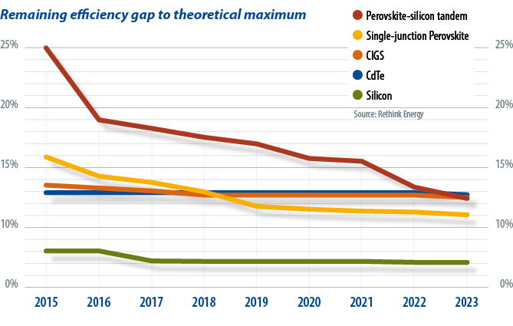

*Image: PV Magazine,* [*https://www.pv-magazine.com/2023/10/31/commercial-perovskites-imminent/*](https://www.pv-magazine.com/2023/10/31/commercial-perovskites-imminent/)

**PERC Solar Cells Technology**

PERC stands for passivated rear emitter contact solar cell, and was Invented by a group headed by Prof. Martin Green in UNSW in the 80s & 90s. In a PERC solar cell as shown in Figure 2, both the front and rear surfaces of the device are passivated by dielectrics. Small pockets of the rear dielectric layer are opened (etched away) with laser so that metal can be contacted to the rear surface of the device. Figure 1 shows a traditional Si solar cell architecture that has accounted for most of the solar PV cells manufactured in the world in the early and mid 2010s. The solar cell is based on p-type Si wafer. The front surface (emitter) is passivated by dielectrics such as SiNx, which also act as an antireflection layer. The rear surface of the Si wafer, however, is not passivated by any dielectric. Aluminium (Al) is being doped into Si to form a back surface field (BSF) during metal co-firing process to act as a high-low junction that prevent minority carriers from recombining at the rear surface.

Compared to a conventional Si solar cell, PERC is able to improve the efficiency of Si solar cells mainly due to the additional passivating dielectric layer on the rear side, through:

1. Rear side passivation that prevent minority carriers (current generated from light absorption) from recombining (eliminated) at the rear surface.
2. The extra rear dielectric layer reflects long wavelength photons from the rear surface back to the device for more light absorption and current generation.

**Figure 1: A conventional Si solar cell**

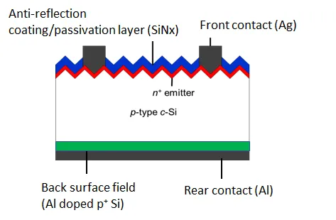

*Image: Keng Siew Chan (2019)* [*https://medium.com/@kengsiewchan/perc-solar-cells-3eb275804ded*](https://medium.com/@kengsiewchan/perc-solar-cells-3eb275804ded)

**Figure 2: A typical PERC solar cell**

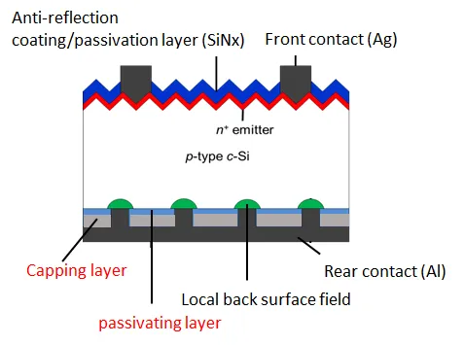

*Image: Keng Siew Chan (2019)* [*https://medium.com/@kengsiewchan/perc-solar-cells-3eb275804ded*](https://medium.com/@kengsiewchan/perc-solar-cells-3eb275804ded)

**PERT Solar Cells Technology**

The PERT solar cell, like the PERC solar cell, is also based on crystalline Si wafers. PERT stands for passivated emitter rear totally diffused. PERC (passivated emitter restructure has a localised back surface field(BSF). The BSF is created from the doping of Al into Si during metal co-firing processes. BSF helps to improve the solar cell efficiency by forming a high-low junction with the p-type Si base wafer. This junction repels minority carriers and prevent them from recombining at the rear surface of the Si wafer. On the other hand, for PERT structure, the rear surface is “totally diffused” with either boron (p-type) or phosphorus (n-type). Usually PERT technology is implemented on n-type Si solar cells. This is to take full advantage of n-type Si wafers’ higher tolerance to metallic impurities, lower temperature coefficient and lower light induced degradation than p-type Si wafers. The light induced degradation is lower in n-type Si, possibly due to lower boron-oxygen pairs, as the bulk in n-type wafer is doped with phosphorus. Nevertheless, the “totally diffused” BSF requires additional novel processes, such as high temperature POCL and BBr3 diffusion. As a result, PERT is more expensive to manufacture than PERC. Nonetheless, the full area BSF in PERT solar cells may provide more effective high-low junction passivation effect, than the localised, coarser Al based BSF in PERC. In addition, n-type PERT also allows the integration of the so-called tunnel oxide passivated contact (TOPCON) structure.

**Figure 1 shows the difference between a p-type PERC and a n-type PERT structure**

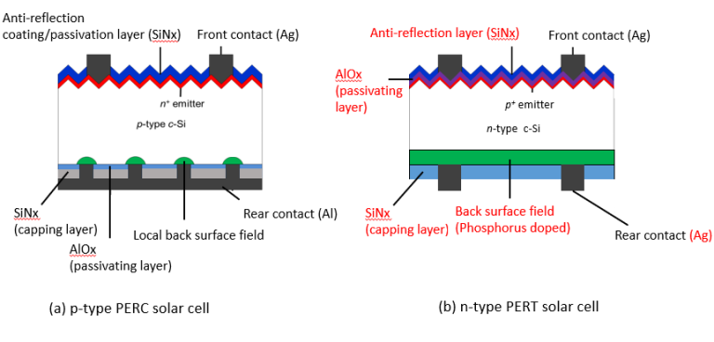

*Image: Keng Siew Chan (2019)* [*https://www.kschan.com/what-is-a-pert-solar-cell/*](https://www.kschan.com/what-is-a-pert-solar-cell/)

**TOPCON Solar Cells Technology**

TOPCON is the acronym for “Tunnel Oxide Passivated Contact”. TOPCON (also known as passivated contact) solar cell, is the next generation of solar cell technology after PERC, and was introduced by researchers at Fraunhofer Institute for Solar Energy Systems in Germany in 2013. Compared to the other potential new technologies, such as HJT and IBC, TOPCON can be upgraded from the current PERC or PERT line. As a result, lower capital investment is needed for existing PERC or PERT manufacturers who are looking to upgrade their existing production lines. Moreover, a good gain in solar cell efficiency can also be achieved, around a ~1% in absolute value.

As shown in the figure, n-PERT and n-TOPCON are quite similar. Typically, to upgrade an n-PERT solar cell to a n-TOPCON solar cell, only an additional ultra thin SiO2 layer and a doped poly-Si layer are required. The ultrathin SiO2 acts as surface passivation layer between the rear Si surface and the rear “contact” – the poly-Si layer. In addition, it also needs to be thin enough so that current can tunnel through it quantum mechanically. The poly-Si layer is highly doped to produce a high conductivity layer. This high conductivity layer will then acts as a contact for current collection. Additionally, in a n-type TOPCON, the poly-Si layer is typically doped with phosphorus to provide field passivation (back surface field). This is similar to the phosphorus doped rear surface of n-PERT as shown in figure 1(a). With the addition of the tunnel oxide layer, the original authors at Fraunhofer Institute for Solar Energy Systems reported an increase of ~1% in absolute solar cell efficiency.

**Figure 1. n-PERT compared to n-TOPCON solar cell architectures**

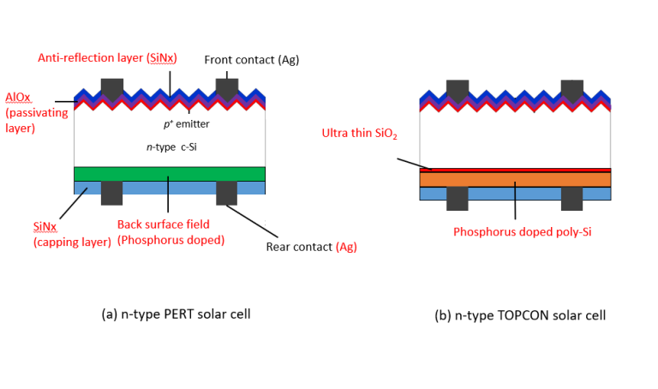

*Image: Keng Siew Chan (2019)* [*https://www.kschan.com/what-is-a-topcon-solar-cell/*](https://www.kschan.com/what-is-a-topcon-solar-cell/)

**HJT Solar Cells Technology**

HJT is the acronym for hetero-junction solar cells, and was introduced by the Japanese company Sanyo in the 1980s, then acquired by Panasonic in 2010s. Due to HJT’s fewer number of cell processing steps, and a much lower cell processing temperatures, this architecture has the potential to simplify the current solar cell manufacturing lines that are currently heavily based on PERC technology. As shown figure 1, HJT is very different to the popular PERC structure. As a result, manufacturing processes between these two architectures are very different. Compared to n-PERT or TOPCON, which can be upgraded from the current PERC lines, HJT requires significant capital investment in new equipment to start mass productions.

Additionally, as with a lot of new technologies, long-term operation/manufacturing stability of HJT is still under reviewed. This is due to processing challenges such as amorphous Si’s susceptibility to high temperature processes. HJT demonstrates high solar cell efficiency thanks to the high quality hydrogenated intrinsic amorphous Si (a-Si:H in Figure 1) that can provide impressive defect passivation to both the front and rear surface of Si wafers (both n-type and p-type polarity). The use of ITO as transparent contacts also improves current flows, while also acting the anti-reflection layer to provide optimal light capturing. Moreover, ITO can also be deposited via sputtering at low temperature, thus avoiding the re-crystallisation of the amorphous layer that will impact the passivation quality of the materials on the bulk Si surface. In spite of its processing challenges and high capital investments, HJT is still an attractive technology. This technology demonstrates the ability to achieve >23% solar cell efficiency, compared to ~22% shown by TOPCON, PERT and PERC technologies.

**Figure 1: p-type PERC vs n-type HJT solar cell**

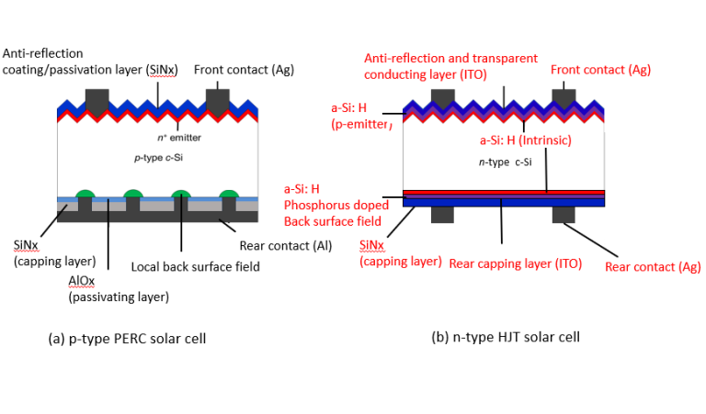

*Image: Keng Siew Chan (2019)* [*https://www.kschan.com/what-is-a-hjt-solar-cell/*](https://www.kschan.com/what-is-a-hjt-solar-cell/)

s, tandem solar cells can be heterojunction (HJT) cells. HJT cells are a type of silicon solar cell that are often used in tandem solar cells with perovskite cells.

How do HJT cells work in tandem solar cells?

In a tandem solar cell, two or more different photovoltaic materials are combined in a single device.

The wide bandgap perovskite top cell absorbs high energy photons, while the SHJ bottom cell absorbs lower energy photons.

This allows tandem cells to capture a wider range of the solar spectrum and generate more electricity than single-junction cells.

Benefits of HJT cells

HJT cells have a high efficiency and a relatively long lifetime.

Tandem solar cells using a SHJ bottom cell and Group III–V semiconductor top cells have been fabricated with power conversion efficiencies of over 32.8%.

Challenges

However, fabricating monolithic silicon/perovskite tandem solar cells is challenging due to material properties and processing requirements.

(HJT) solar cell is a photovoltaic cell that combines thin-film and traditional solar cell technologies. HJT cells are considered one of the most efficient solar technologies available.

How HJT cells work

HJT cells are made of three layers of photovoltaic material.

The top layer is amorphous silicon, which catches sunlight before it hits the crystalline layer.

The middle layer is monocrystalline silicon, which turns most of the sunlight into electricity.

The bottom layer is another amorphous silicon layer, which captures any remaining photons.

Benefits of HJT cells

High efficiency: HJT cells can have a conversion efficiency of over 30%.

Temperature coefficient: HJT cells are less affected by changes in temperature.

Bifacial rate: HJT cells can absorb sunlight from both the front and back sides.

Resilience: HJT cells can perform well in extreme weather conditions.

Other names for HJT cells

HJT cells are also known as Silicon heterojunctions (SHJ) or Heterojunction with Intrinsic Thin Layer (HIT).

**Heterojunction v. Multijunction**

Ji, R., Zhang, Z., Hofstetter, Y.J. et al. Perovskite phase heterojunction solar cells. Nat Energy 7, 1170–1179 (2022). <https://doi.org/10.1038/s41560-022-01154-y>

heterojunction refers to a junction formed between two different semiconductor materials with different bandgaps, while a multijunction describes a solar cell made up of multiple junctions, often stacked on top of each other, and "tandem" is essentially another term for a multijunction cell, particularly when referring to a two-junction configuration where different layers absorb different wavelengths of light to maximize efficiency; essentially, a heterojunction is about the interface between two different semiconductors, while multijunction/tandem is about the overall structure of a solar cell with multiple junctions made from different materials.

Key points to remember:

Heterojunction:

Focuses on the contact point between two different semiconductor materials, creating a unique electrical behavior due to their different bandgaps.

Multijunction:

Describes a solar cell with multiple p-n junctions, meaning multiple layers of different semiconductor materials stacked together to absorb a broader range of light wavelengths.

Tandem:

Often used interchangeably with "multijunction," but specifically refers to a two-junction configuration where the stacked layers are designed to absorb different light energies, maximizing efficiency.

Example: A solar cell could utilize a heterojunction between a wide bandgap material like gallium arsenide and a narrower bandgap material like indium phosphide to create a multijunction/tandem cell, where the different layers absorb different portions of the light spectrum.

Heterojunction perovskite solar cells (PSCs) are photovoltaic devices that use a combination of semiconductor layers to generate, separate, and transport photocarriers. The heterojunction structure is crucial to the cell's performance.

Benefits

Low cost: PSCs are a promising low-cost alternative to silicon solar cells

High efficiency: Some PSCs have achieved power conversion efficiencies (PCEs) comparable to silicon solar cells

Versatile: PSCs can be fabricated on flexible substrates and can be made into multijunction cells

Challenges

Open-circuit voltage: Inverted PSCs have lower open-circuit voltages than regular PSCs

Recombination losses: Nonradiative recombination losses can occur at the charge-extraction layers and inside the perovskite

Design

Graded heterojunction

The electron-accepting material is distributed in the perovskite layer to improve photoelectron collection

Facet heterojunction

Two films with distinct crystal facets are integrated to create junctions that enhance device performance

Phase heterojunction

The introduction of phase heterojunctions can improve the stability and efficiency of PSCs

Future directions

Advanced heterojunction design is crucial to further improving the performance of PSCs.

, perovskite solar cells (PSCs) can be made using heterojunction technology. Heterojunctions are a common feature of traditional photovoltaic devices.

How heterojunctions improve PSCs

Reduce defects: Heterojunctions can reduce the formation of crystal interface defects.

Improve energy levels: Heterojunctions can tune energy levels into perovskites.

Enhance performance: Heterojunctions can improve the power conversion efficiency (PCE) of PSCs.

Examples of heterojunction PSCs

Perovskite-silicon tandem solar cells: These cells use a bottom cell based on a heterojunction design.

Facet heterojunction solar cells: These cells combine the advantages of (001) and (111) facet orientations of perovskite.

Bilayer heterojunction (BLH) cells: These cells reconstruct the perovskite surface into a BLH structure to minimize voltage losses.

Bulk heterojunction PSCs: These cells are made with thin films that combine 2D and 3D perovskites.

Other ways to improve PSCs

Doping semiconductors to form heterojunctions

Using charge transport layers (CTLs) to separate and collect photo-generated charge carriers

Developing an electron transport layer (ETL)

**Back-Contact Micrometric Photovoltaic Cells**

Back-contact micrometric photovoltaic cells have a size twice the thickness of a strand of hair, have significant advantages over conventional solar technologies, reducing electrode-induced shadowing by 95% and potentially lowering energy production costs by up to three times (de Lafontaine et al., 2023; Rizk, 2023).

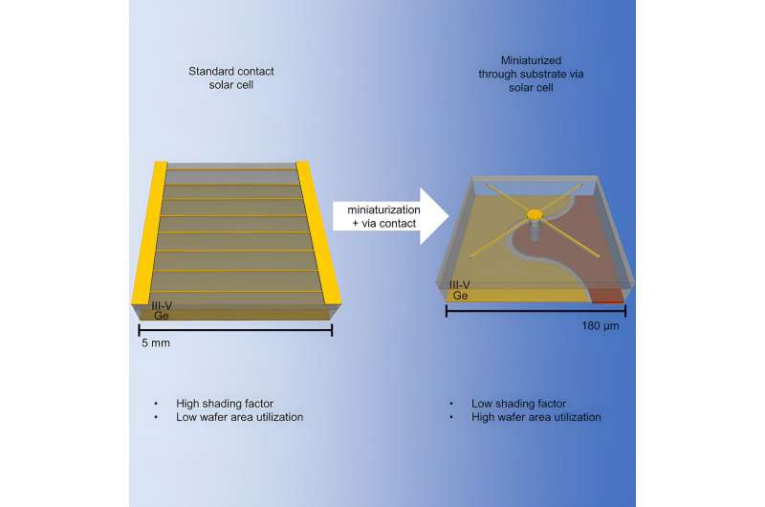

*Image: Cell Reports Physical Science (2023). DOI: 10.1016/j.xcrp.2023.101701*

<https://techxplore.com/news/2023-11-back-contact-micrometric-photovoltaic-cells.html>

**Crystalline Silicon Solar Cells**

The bigger the size of a solar cell, the lower the rate of efficiency it can achieve. For mainstream solar power generation, technologies that cannot operate for more than two decades are unlikely to succeed, regardless of other benefits. For commercial, grid-level electricity production, SETO is targeting an operational lifetime of at least 20 years, and preferably more than 30 years. Crystalline silicon PV cells are the most common solar cells used in commercially available solar panels, representing more than 85% of world PV cell market sales in 2011. Crystalline silicon PV cells have laboratory energy conversion efficiencies over 25% for single-crystal cells and over 20% for multicrystalline cells. However, industrially produced solar modules currently achieve efficiencies ranging from 18%–22% under standard test conditions. Current research efforts focus on innovative ways to reduce costs. Research and development is being done to reduce raw material requirements, including pioneering ultra-thin crystalline silicon absorber layers, developing kerf-free wafer production techniques (kerf is silicon dust that is wasted when silicon ingots are cut into thin wafers), and optimizing growth processes.

Commercial silicon cells are typically larger than an A5 sheet of paper, and these are assembled into 2-meter-long modules, the building blocks of larger panels and arrays, that have an efficiency of around 22–24%. The modules typically come with a warranty that guarantees at least 80% of their original performance after 25 years — that is, a loss of less than 1% efficiency per year (Peplow, 2023).

**Cadmium Telluride Solar Cells**

Cadmium telluride solar cells are the second-most common type of solar cell deployed in the world behind crystalline silicon photovoltaic cells, though with just 5 percent of the market share. Commercial CdTe solar cells, which are largely used in large commercial solar farms, have comparable efficiencies to silicon cells, and CdTe is the preferred material for most ultra-thin solar film products. CdTe thin-film solar cells can be manufactured quickly and inexpensively, providing an alternative to conventional silicon-based technologies. The record efficiency for a laboratory CdTe solar cell is 22.1% by First Solar. First Solar also reported its average commercial module efficiency to be approximately 18% at the end of 2020. Current projects seek higher cell efficiencies by increasing crystal quality, improving doping control, and increasing the minority carrier lifetime. Manufacturers are also working to improve materials reuse and recycling as a way to mitigate concerns on toxicity and materials scarcity.

***Benefits of Cadmium Telluride Solar Cells***

1. High absorption: Cadmium telluride is a direct-bandgap material with bandgap energy that can be tuned from 1.4 to 1.5 (eV), which is nearly optimal for converting sunlight into electricity using a single junction.
2. Low-cost manufacturing: Cadmium telluride solar cells use high throughput manufacturing methods to produce completed modules from input materials in a matter of hours.

***Production of Cadmium Telluride Solar Cells***

The most common CdTe solar cells consist of a p-n heterojunction structure containing a p-doped CdTe layer matched with an n-doped cadmium sulfide (CdS) or magnesium zinc oxide (MZO) window layer. Typical CdTe thin-film deposition techniques include vapor-transport deposition and close-spaced sublimation. CdTe absorber layers are generally grown on top of a high-quality transparent conductive oxide (TCO) layer—usually fluorine-doped tin oxide (SnO2:F). Cells are completed using a back electrical contact—typically a layer of zinc telluride (ZnTe) followed by a metal layer or a carbon paste that also introduces copper (Cu) into the rear of the cell.

**Copper Indium Gallium Diselenide**

Copper indium diselenide (CuInSe2) thin-film technology has been considered promising for solar cells because of its favorable electronic and optical properties. It was later found that by substituting gallium (Ga) for indium (In), the bandgap can be increased from about 1.04 electron-volts (eV) for copper indium diselenide (CIS) films to about 1.68 eV for copper gallium diselenide (CGS) films. Optimal devices have been fabricated with only a partial substitution of Ga for In, leading to a substantial increase in overall efficiency and more optimal bandgap. These solar cells are commonly known as a copper indium gallium diselenide [Cu(InxGa1-x)Se2], or CIGS, cells. Although laboratory-scale cell efficiencies have exceeded 20%, commercial CIGS modules typically have efficiencies between 12% and 14%.

***Benefits of Copper Indium Gallium Diselenide Cells***

1. High absorption: This direct-bandgap material can absorb a significant portion of the solar spectrum, enabling it to achieve the highest efficiency of any thin-film technology.
2. Tandem design: A tunable bandgap allows the possibility of tandem CIGS devices.
3. Protective buffer layer: The grain boundaries form an inherent buffer layer, preventing surface recombination and allowing for films with grain sizes of less than 1 micrometer to be used in device fabrication.

***Production of Copper Indium Gallium Diselenide Cells***

1. Co-evaporation, in which precursor elements are allowed to sublimate in a high-vacuum environment and then re-deposit on a heated substrate.
2. Precursor Reaction Processes, in which a precursor containing Cu and In/Ga is deposited at a low temperature by any of several processes, such as sputtering or electroplating. This is followed by a reactive annealing step in a Se compound, such as hydrogen selenide (H2Se) or gaseous selenium (Se), to form CIGS films. This is also commonly known as two-stage deposition; a variant of this technique, three-stage deposition, is also commonly used. After the CIGS deposition, the junction is formed by chemical-bath deposition of the n-type CdS layer. To finish the solar cell, a high-resistance zinc oxide (ZnO) layer and a high-conductivity n+-type ZnO layer are deposited by either sputtering or chemical-vapor deposition. Laser-scribing processes at different steps in the production process create the individual solar cells connected in series.
3. Alternative manufacturing techniques have been explored, such as reactive sputtering, magnetron sputtering (Cu, In, and Ga are sputtered while Se is evaporated), and electrodeposition. However, co-evaporation and precursor reaction processes still remain the most popular.

A major increase in device performance was achieved when the ceramic or borosilicate glass substrate was replaced by soda-lime glass. Although soda-lime glass was chosen because it has closer thermal expansion properties to CIGS, it was ultimately determined that the primary advantage of using soda-lime glass results from the diffusion of sodium (Na) ions from the glass into the CIGS absorber layer. Work is currently being done to identify the role of Na in improving CIGS performance and what tolerances CIGS has to the inclusion of Na. Current manufacturing techniques incorporate Na either from soda-lime glass or a separate Na source. Soda-lime glass has an added advantage of being less expensive than previous glass substrates.

All high‐efficiency CIS and CIGS devices use molybdenum (Mo) as the back contact primarily because of its work function and the high reflectivity of the Mo film. These films are typically deposited through direct-current (DC) sputtering. The sputtering deposition process requires precise pressure to control the stress in the film. Because of some inherent problems with the Mo back-contact, such as the possibility of a hole-blocking Schottky diode effect at the interface, other metals have been investigated to replace Mo, but have had limited success.

**Gallium-Arsenide-Nitrogen-Bismuth Solar Cells**

A low bandgap solar cell based on a gallium-arsenide-nitrogen-bismuth (GaAsNBi) absorber has been developed by a Finnish-German research group, which has a 6 × 6 mm low bandgap GaAsNBi solar cell with an active area of 0.25 cm2. These findings will encourage the viability of GaAsNBi PV devices for use in multi-junction solar cells, and was published in *Solar Energy Materials and Solar Cells*. The device has an energy bandgap of 0.86 eV and is reportedly suitable for applications in multi-junction solar cells, and is intended to be used as a bottom device in a multi-junction PV cell. Their attempt to build a GaAsNBi solar cell follows scientists at Osaka University in Japan unveiling a 2.01%-efficient device with a 1.15 eV bandgap in 2021. The performance of the device was assessed through external quantum efficiency (EQE) and light-current-voltage (LIV) measurements under standard solar illumination conditions. EQE is the ratio of the number of energy carriers harvested by the solar cell to the number of photons of a given energy incident on the cell itself (Puustinen et al., 2024; Bellini, 2023A).

***Challenges***

1. Unconventional growth conditions required for Bi and N incorporation, which may lead to a large number of defects. Incorporating Bi in GaAs needs low growth temperatures and carefully controlled V/III flux ratios. To solve this, they grew the GaAs layers using molecular beam epitaxy (MBE), which is an evaporation technique implemented in an ultra-high vacuum for decomposing compounds with extreme regularity of layer thickness and composition.

A new porosification technique was developed in 2023 to build gallium arsenide (GaAs) solar cells that allow the recovery of germanium films, with the new cell achieving an efficiency that is reportedly in line with that of other GaAs PV devices, but can be produced at a lower cost thanks to the reuse of germanium. They grew the cell on detachable germanium (Ge) films, which allows the reuse of Ge in other applications, thus reducing production costs. “By ingeniously creating a weak layer between epitaxial layers and a germanium substrate, we unlock the potential for reusing germanium, leading to a significant reduction in both environmental impact and production costs for optoelectronic devices,” said Sherbrooke Professor, Maxime Darnon, as published in *RR Solar*. To create this weak layer, it used the so-called PEELER technique, a novel electrochemical porosification technique originally used for silicon wafers. Utilizing metal-organic chemical vapor deposition (MOCVD), the researchers fabricated a 1 mm2 front-contacted GaAs PV device based on a Ge substrate, the weak Ge layer, an epitaxial Ge layer, the GaAs absorber, a top contact made of nickel (Ni), Ge, and gold (Au), and a contact layer. The champion device built with this architecture achieved a power conversion efficiency of 23.1%, an open-circuit voltage of 1.012 V, a short-circuit current density of 26.28 mA/cm2, and a fill factor of 81.98% (Daniel et al., 2024; Bellini, 2023F).

**Gallium Arsenide Solar Cell**

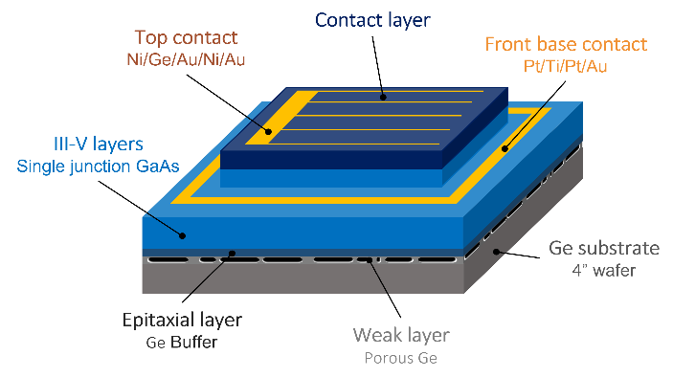

*Image: Université de Sherbrooke,* [*https://www.pv-magazine.com/2023/11/21/gallium-arsenide-solar-cell-achieves-23-1-efficiency-via-electrochemical-porosification/*](https://www.pv-magazine.com/2023/11/21/gallium-arsenide-solar-cell-achieves-23-1-efficiency-via-electrochemical-porosification/)

**III-IV Solar Cells**

The III-V cells derive their name from where the materials used to make them are positioned on the periodic table of elements and are widely used to power space-faring technologies. D-HVPE offers the potential to be a lower-cost method of synthesizing these cells compared to incumbent techniques. Solar cells manufactured from GaAs and gallium indium phosphide (GaInP) have long yielded some of the highest conversion efficiencies of any technology. The challenge with these cells is bringing down production costs to make them viable for mainstream solar applications (Schulte et al., 2023; Bellini, 2023B; Hicks, 2023).

Scientists at the U.S. Department of Energy's National Renewable Energy Laboratory (NREL) grew a gallium arsenide (GaAs) heterojunction solar cell using dynamic hydride vapor phase epitaxy (D-HVPE) with a certified efficiency of 27%, the highest efficiency ever reported for a single-junction GaAs cell grown using this technique, published in *Cell Reports Physical Science*. To synthesize the solar cell, they used dynamic hydride vapor phase epitaxy (D-HVPE) as an alternative lower-cost solution to metal organic vapor phase epitaxy (MOVPE). HVPE uses low-cost elemental group III precursors with high utilization efficiency and very high growth rates. The study aims to improve the performance of solar cells via optimization of the doping and bandgap of a device layer called the "emitter" to minimize the impact of defects on device efficiency. The results are theoretically applicable to materials beyond III-Vs that use heterojunctions such as silicon, cadmium telluride, or perovskites (Schulte et al., 2023; Bellini, 2023B; Hicks, 2023).

Along with the GaAs base layer, the solar cell relied on an emitter layer of gallium indium arsenide phosphide (GaInAsP). Together the two different layers make up the heterojunction. Researchers modeled the effect of varying the zinc doping density and bandgap of the emitter layer, which is realized by varying the relative concentrations of gallium, indium, arsenic, and phosphorus during layer growth, on cell efficiency. The modeling identified optimal choices for these two parameters that maximize device efficiency. The rear heterojunction solar cell that served as a baseline used an emitter comprised of GaInP and had a reported efficiency of 26%. By reducing the doping in the emitter and changing its composition from GaInP to the lower bandgap GaInAsP, the efficiency increased to 27% even though the rest of the device was exactly the same (Hicks, 2023). For processing, a reflective Au metal contact was electroplated onto the AlGaAs contact layer, and then samples were inverted onto a Si handle, and the substrate was etched away followed by the etch stop (Schulte et al., 2023; Bellini, 2023B; Hicks, 2023).

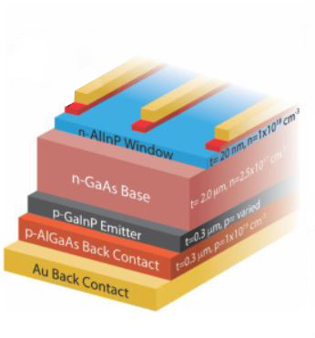

*Image: PV Magazine,* [*https://www.pv-magazine.com/2023/11/10/nrel-presents-new-gaas-solar-cell-concept-with-27-efficiency/*](https://www.pv-magazine.com/2023/11/10/nrel-presents-new-gaas-solar-cell-concept-with-27-efficiency/)

**Kesterite Solar Cells**

Kesterite is currently the most promising emerging fully inorganic thin film photovoltaic technology based on critical raw-material-free and sustainable solutions. Kesterite is one of the most promising light absorber material candidates for potential use in lower-cost thin-film solar cells. Kesterites include common elements such as copper, tin, zinc, and selenium. Unlike CIGS compounds, there are no supply bottlenecks expected in the future. However, kesterite is still less efficient than CIGS in mass production. The world record for such cells is 12.6%, achieved for large-area devices by Japanese thin-film producer Solar Frontier in 2013. The scientists introduced the new cell design in the study “Controlling Selenization Equilibrium Enables High-Quality Kesterite Absorbers for Efficient Solar Cells,” published in *Nature Communications* (Xu et al., 2023; Bellini, 2023D)

The Chinese Academy of Sciences (CAS) has used a new selenization approach that facilitates the direct and rapid formation of the Kesterite phase, thus improving charge transport in the absorber film, to build a kesterite solar cell with better charge transport and power conversion efficiency. They implemented a dual-temperature zone selenization approach to realize a solid-liquid/solid-gas synergistic selenization reaction strategy. “The introduction of a large amount of liquid selenium (Se) has facilitated a solid-liquid reaction pathway, while the high Se chemical potential has promoted the direct and rapid formation of the Kesterite phase,” they explained. “In the subsequent stage, a synergistic regulation of Se condensation and volatilization has led to improved crystal growth and enhanced removal of organic residues.” They also explained that the strategy requires pre-depositing a sufficient amount of liquid selenium onto the precursor film to facilitate liquid-phase-assisted phase evolution and crystal growth. The following synergistic control of selenium volatilization is intended to balance the film crystallization and organics removals. The research team built the cell with an absorber based on Kesterite films with reduced bulk and interface defects, a cadmium sulfide (CdS) buffer layer, a window layer of zinc oxide (i-ZnO), an indium tin oxide (ITO) layer, and anti-reflection coating (ARC) based on magnesium fluoride (MgF2). The device has an aperture area of 0.2627 ${cm}^{2}$  and a designated illuminated area of 1.066 ${cm}^{2}$  (Xu et al., 2023; Bellini, 2023D).

**Perovskite Solar Cells**

Current research areas for perovskite solar cells primarily focus on improving their efficiency, stability under various environmental conditions, and scalability for large-scale production, with key areas including: material engineering, charge transport layer optimization, stability enhancement, device fabrication techniques, and tandem solar cell development.

**Perovskite**

By analyzing and altering the interfaces where the perovskite material meets other components within the cell, new strategies for enhancing stability and performance can be developed. As perovskite is still in the testing stage, protocols must be established so that improvements from different groups can be easily validated and compared.

Perovskite solar cells are manufactured from a three-dimensional material called perovskite, with the name originated from the structural form of the original substance, calcium-titanium-oxide, found in the Ural Mountains and commemorated to Russian mineralogist–Lev Perovski. Perovskite solar cells are thin films made of inexpensive and simple perovskite materials, commonly using lead-containing perovskite materials. The light-absorbing layer functions just like the transparent silicon layer, which operates exactly the same way as traditional solar cells. Perovskite solar cells also have a special optoelectronic manner which is favorable for the efficient conversion of sunlight into electricity (Garcia, 2024).

**Perovskite Cells Characteristics**

1. High efficiency
2. Low manufacturing costs
3. Flexibility of application- ability to be applied to a variety of substrates, from rigid glass to flexible materials.

Bulky “defect pacifying” molecules can increase perovskite solar cells’ stability and lifespan, According to U.S. researchers. Perovskite crystals contain lead atoms, or undercoordinated sites, that aren’t fully bound to the other components within the perovskite, and these lead defects hinder the movement of electrons and speed up the decay of the perovskite material. These undercoordinated sites are defects often found on the crystal surfaces and at grain boundaries where there’s a break in the crystal lattice. Mixing defect pacifying molecules into the perovskites can help lock up the undercoordinated lead, in turn preventing other imperfections from forming at high temperatures. However, the researchers were not able to determine exactly how a given molecule affected the hardiness of perovskite cells, or what features on the molecules specifically improve the perovskite’s stability (Kim et al., 2024).

Perovskite degradation can be analyzed through the intricate engineering of the nanoscale structure of perovskite solar cells to optimize their efficiency and extend their operational lifespan. To accomplish this, U.S. researchers used passivation, which is aimed at stabilizing the material’s surface and interfaces. Passivation reduces the degradation of the cells, ensuring that they maintain their efficiency for a longer period (deQuilettes et al., 2024; Lewis, 2024).

To improve the stability of perovskites, researchers primarily focus on modifying the perovskite composition by mixing different cations and halides, incorporating additives to strengthen the crystal structure, utilizing hydrophobic coatings, and implementing protective encapsulation techniques to shield the perovskite from environmental factors like moisture, oxygen, and UV light; this can involve adjusting the interface layers and using appropriate electrode materials.

Key strategies to enhance perovskite stability:

Compositional engineering:

Mixed cations: Replacing a single organic cation (like methylammonium) with a mixture of cations (like formamidinium and cesium) can improve stability.

Mixed halides: Incorporating different halide ions (like bromine with iodine) can enhance the crystal lattice stability.

Surface modification:

Hydrophobic coatings: Applying hydrophobic materials on the perovskite surface can prevent water penetration.

Passivation layers: Using additives or interfacial layers to passivate surface defects and improve stability.

Device architecture:

Interface engineering: Optimizing the properties of the electron and hole transport layers to minimize charge carrier recombination at the interfaces.

Buffer layers: Adding a stable buffer layer between the perovskite and charge transport layers can protect the perovskite from degradation.

Encapsulation techniques:

Hermetic sealing: Protecting the perovskite device with a tightly sealed package to prevent exposure to environmental factors.

Factors affecting perovskite stability:

Moisture: Water molecules can penetrate the perovskite structure, causing degradation.

Oxygen: Exposure to oxygen can also lead to perovskite degradation.

Temperature: High temperatures can accelerate perovskite decomposition.

Light exposure: UV radiation can induce degradation in some perovskite materials.

various types of perovskite solar cells, including thin-film, tandem, and inverted cells.

Thin-film perovskite solar cells

Perovskite solar cells are a type of thin-film solar cell that use perovskite-structured compounds to harvest light

The perovskite layer needs to be several hundred nanometers thick to harvest light effectively

The quality of the film and its thickness are important for the practical fabrication of perovskite solar cells

Tandem perovskite solar cells

Tandem solar cells are made by stacking multiple solar devices on top of each other to increase the amount of electrical energy

Perovskites can use smaller wavelengths of the sun's spectrum more efficiently

Inverted perovskite solar cells

Inverted perovskite solar cells use a hole-transport layer, such as PEDOT:PSS, PTAA, or P3CT-X

Metal oxides, such as MoO x, GeO 2, and NiO x, can be added to the PEDOT:PSS thin films to improve photovoltaic performance

Other types of solar cells: Dye-sensitized solar cells, Concentration photovoltaics, and Quantum dot solar cells.

**Halide Perovskite and Silicon Tandem Solar Cells (PSC)**

Halide perovskites are a family of materials that have shown potential for high performance and low production costs in solar cells. The name “perovskite” comes from the nickname for their crystal structure, although other types of non-halide perovskites (such as oxides and nitrides) are utilized in other energy technologies, such as fuel cells and catalysts. Perovskite solar cells have shown remarkable progress in recent years with rapid increases in efficiency, from reports of about 3% in 2009 to over 25% today. The theoretical efficiency of perovskite-silicon tandem cells is 43%, which makes them the most feasible alternative to current mono-junction silicon cells. The term perovskite refers to a family of compounds, and when used in solar cells, the materials are called perovskite because of their structural similarity to a mineral called perovskite discovered in Russia in 1839 (Boyd, 2023).

***Advantages of Perovskite***

1. Simpler fabrication methods
2. Lower production costs
3. Flexible design capability
4. The potential for higher energy conversion efficiencies
5. No need for rare earth metals.

***Disadvantages of Perovskite***

1. The material will break down when exposed to heat, moisture, or snow

Rethink Energy projects several gigawatts of perovskite PV generation capacity to be built in 2026, led by companies such as Microquanta, UtmoLight, GCL System Integration, Caelux, and Oxford PV, who have already commissioned 100 MW pilot production lines. They think that by 2026, every mainstream silicon manufacturer will have committed to perovskite products. Second-generation perovskites will be superior to current mainstream options and will outcompete silicon PV on rooftops, with consequences for building-integrated photovoltaics (BIPV). Outcompeting thin-film solar, perovskites will make BIPV a relevant business. Rethink Energy expects perovskites will completely take over solar during the 2030s, regardless of whether the industry reaches 1 TW or 2 TW in scale. Qcells, in South Korea, has invested in a $100 million perovskite pilot line. In the United States, First Solar has acquired Swedish perovskite startup Evolar AB for $32 million, with an additional $42 million contingent on the business hitting R&D targets. The world’s biggest silicon solar manufacturer, Longi, is continually reporting ever-higher perovskite-heterojunction tandem cell efficiency results (Wantenaar, 2023).

These thin-film products which work well with BIPV will initially be perovskite single-junction devices but, over time, more and more will switch to tandem technology in combination with potentially every other thin film. The tunability of perovskite absorption spectra is a major advantage of the technology over other thin films, with tunability meaning that perovskites can be combined with every other PV semiconductor, including other perovskites. Where single-junction silicon has a theoretical efficiency limit of 29.4%, a perovskite-perovskite tandem could reach 43% – there is already one Chinese startup pursuing this route. As more junctions are added, the technical potential grows: the theoretical limit for a triple-junction perovskite is 50%. As for perovskite tandem devices, First Solar in the U.S. is researching perovskite-cadmium telluride, while others will find entry through silicon heterojunction-perovskite. Rethink Energy expects that these tandems will first dominate the rooftop segment by the mid-2030s, then the entire solar industry by 2040 (Wantenaar, 2023).

Rethink Energy’s forecast is a minimum case on two levels. Firstly, perovskites will be so disproportionately cost-effective that once the tipping point is reached, they will be adopted at least as swiftly as we have forecast, and possibly much more rapidly. Secondly, perovskites’ superior performance and price have the potential to enable immense additional solar demand, including futuristic green hydrogen complexes, among other things, on a scale that silicon alone cannot enable. Perovskites will play a part in European and United States efforts to reclaim a share of global solar manufacturing while India, which is still switching from multicrystalline to monocrystalline passivated-emitter rear contact solar, will be slower to adapt (Wantenaar, 2023).

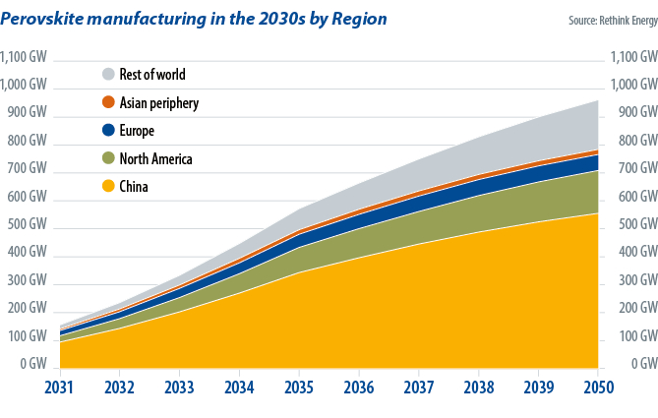

*Image: PV Magazine,* [*https://www.pv-magazine.com/2023/10/31/commercial-perovskites-imminent/*](https://www.pv-magazine.com/2023/10/31/commercial-perovskites-imminent/)

Perovskites can decompose when they react with moisture and oxygen or when they spend extended time exposed to light, heat, or applied voltage. To increase stability, degradation in both the perovskite material itself and the surrounding device layers must be studied, and improved cell durability is critical for the development of commercial perovskite solar products. Research areas for perovskite cells include operational lifetime and understanding and improving stability and degradation. Efforts include improved treatments to decrease the reactivity of the perovskite surface, alternative materials and formulations for perovskite materials, alternative surrounding device layers and electrical contacts, advanced encapsulation materials, and approaches that mitigate degradation sources during fabrication and operation. One issue with assessing degradation in perovskites is developing consistent testing and validation methods. Research groups report performance results based on highly varied test conditions, including different encapsulation approaches, atmospheric compositions, illumination, electrical bias, and other parameters.

Perovskite solar cells are thin-film devices built with layers of materials, either printed or coated from liquid inks or vacuum-deposited. Producing uniform, high-performance perovskite material in a large-scale manufacturing environment is difficult, and there is a substantial difference in small-area cell efficiency and large-area module efficiency. Additional barriers to commercialization are the potential environmental impacts of perovskite materials, which are primarily lead-based. As such, alternative materials are being studied to evaluate, reduce, mitigate, and potentially eliminate toxicity and environmental concerns. For widespread deployment of perovskites, maintaining these high efficiencies while achieving stability in large-area modules will be necessary. Continued improvement in efficiency in medium-area modules could be valuable for mobile, disaster response, or operational energy markets where lightweight, high-power devices are critical.

***Research Areas for Halide Perovskite Cells***

1. Stability and durability
2. Power conversion efficiency at scale
3. Manufacturability
4. Technology validation and bankability, ensuring the willingness of financial institutions to finance a project or proposal at reasonable interest rates

***2 Major Production Types for Halide Perovskite Cells***

1. Sheet-to-Sheet: Device layers are deposited on a rigid base, which typically acts as the front surface of the completed solar module. This approach is commonly used in the cadmium telluride (CdTe) thin-film industry.
2. Roll-to-Roll: Device layers are deposited on a flexible base, which can then be used as either an interior or exterior portion of the completed module. Researchers have tried this approach for other PV technologies, but roll-to-roll processing did not gain commercial traction because of the performance limitations of these technologies. However, it is widely used to produce photographic and chemical film and paper products such as newspapers.

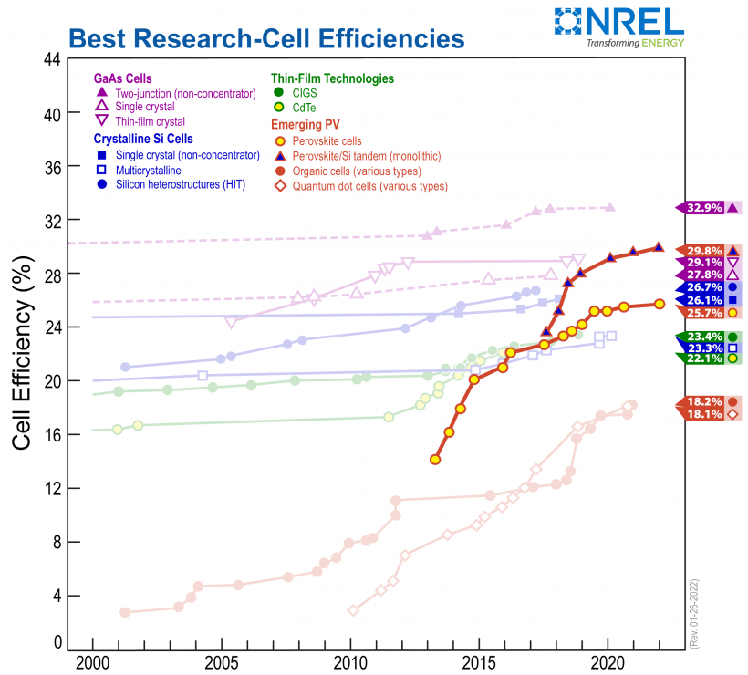

*Chart showing record efficiencies over time of perovskite PV devices compared to other PV technologies. Efficiency records for perovskite PV cells compared to other PV technologies, with current records of 25.7% for single junction perovskite devices and 29.8% for tandem perovskite-silicon devices (as of January 26, 2022).*

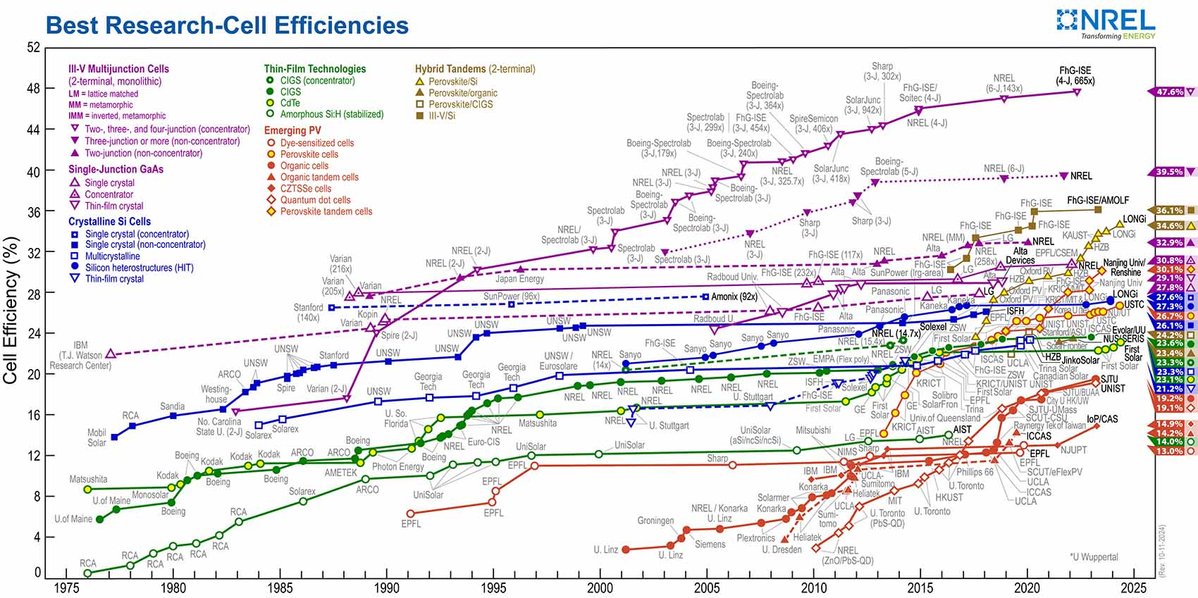

<https://www.nrel.gov/pv/cell-efficiency.html>

Perovskites can be tuned to respond to different colors in the solar spectrum by changing the material composition, and a variety of formulations have demonstrated high performance. This flexibility allows perovskites to be combined with another, differently tuned absorber material to deliver more power from the same device. This is known as a tandem device architecture. Using multiple PV materials enables tandem devices to have potential power conversion efficiencies over 33%, the theoretical limit of a single junction PV cell. Perovskite materials can be tuned to take advantage of the parts of the solar spectrum that silicon PV materials can’t use very efficiently, meaning they make excellent hybrid-tandem partners. It is also possible to combine two perovskite solar cells of different composition to produce a perovskite-perovskite tandem. Perovskite-perovskite tandems could be particularly competitive in the mobile, disaster response, and defense operations sectors, as they can be made into flexible, lightweight devices with high power-to-weight ratios.

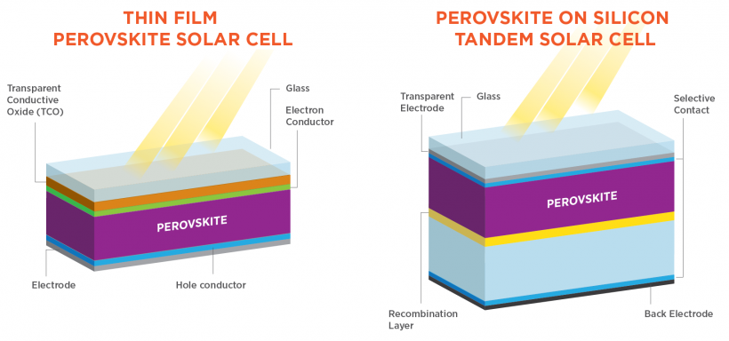

A team in China, led by Tan Hairen, in Nature in June 2023, has achieved an efficiency of 28%, which means 28 out of 100 units of incoming sunlight can be converted into electricity, on a research-sized PSC of 0.49 square centimeters. In January 2022, it achieved 26.4%. At that time, it also recorded an efficiency of 24.2% on a larger PSC (1.04 square cms) and 21.7% on a mini-module-sized one (20.25 square cms). The bigger the size of a solar cell, the lower the rate of efficiency it can achieve (Lin et al., 2023; Pao, 2023). This third-generation solar cell is said to be able to convert 50-75% more sunlight into electricity than the traditional silicon photovoltaic (PV) cell. The product is also 95% cheaper than the silicon solar cell as its key raw material is methylammonium lead iodide, making it a potential great option for countries that want to switch to solar power to meet their carbon neutrality targets (Lin et al., 2023; Pao, 2023). PSC cells are easier to produce and can be made in a single factory, so even with other items added, the overall cost of production is only half of that of traditional silicon cells. Perovskite solar cells (PSCs) are capable of retaining over 90 per cent of their initial performance after 600 hours of continuous operation, making them suitable for commercial use. PSCs have lower fabrication cost, low-temperature solution processability, roll-to-roll manufacturing, and wide-bandgap tunability, and thus have the potential to become the candidate of choice for high-efficiency tandem solar cells (Cuthbertson, 2023A).

***Halide Perovskite, Kinetically Controlled Space Confinement, Higher Quantum Well 2D Perovskites Synthesis***

Atoms or molecules arrange themselves into highly organized, regular lattices, as they form into crystals. For example, ice has 18 possible atomic arrangements, or phases, and like the hydrogen and oxygen atoms in ice, the particles that make up halide perovskites can also form multiple lattice arrangements. The goal with 2D halide perovskite layers is to synthesize layers that exhibit only a single phase throughout, as materials are phase-dependent. Traditional synthesis methods for higher n value 2D perovskites generate uneven crystal growth, which impacts the material's performance reliability, where you get crystals with mixed phases due to the lack of control over crystallization kinetics, which is the dynamic interplay between temperature and time (Hou et al., 2024; Clark, 2023).

Aditya Mohite of Rice University has developed a process that yields 2D perovskite-based semiconductor layers of ideal thickness and purity by controlling the temperature and duration of the crystallization process. “Producing 2D perovskite crystals with layer thicknesses—or quantum well thickness, also known as 'n value'—greater than two is a major bottleneck,” said JIn Hou of Rice University in the journal *Nature Synthesis*. An n value higher than four means materials have a narrower band gap and higher electrical conductivity, which is a crucial factor for application in electronic devices. Mohite and Hou designed a way to slow down the crystallization and tune each kinetics parameter gradually to hit the sweet spot for phase-pure

synthesis, and also created a map (phase diagram) of the process through characterization, optical spectroscopy and machine learning. The goal is to improve the purity of the crystals and approach a high n value, phase-pure crystal synthesis. This research will lead to commercially relevant stability for solar cells and for many other optoelectronic device applications and fundamental light matter interactions (Hou et al., 2024; Clark, 2023).

**2 Barriers to Perovskite Adoption**

1. ***Stability***- Perovskites’ performance declines much more quickly than silicon when they are exposed to moisture, heat and even light.
2. ***Cost of Silicon Cells***- Silicon modules have become incredibly cheap and efficient over the past decade, and companies in China continue to expand manufacturing capacity at a startling rate.

**Issues with Perovskite Cells**

1. ***Size and Stability***- The best perovskite cells made in labs are typically smaller than a postage stamp, the current leader is closer to the size of a sesame seed, and they might operate for only a few days or weeks before their performance degrades
2. ***Manufacturing Process***- They’re often made by dropping solutions of materials onto a spinning plate in a process called spin coating, which is impractical for large-scale manufacturing
3. ***Decomposition and Encapsulation***- Although perovskites have a nasty habit of decomposing on contact with air or water, this can be prevented by encapsulating tandem cells in an impermeable coating, a common tactic in the solar industry
4. ***In-built degradation mechanisms that encapsulation cannot solve***- Some of the perovskite’s ions can move around during operation, for example, or escape into adjacent layers. This can create defects that enable electrons and holes to recombine before they can be turned into electricity, wasting the energy that created them. Light and heat tend to exacerbate these degradation mechanisms. To keep the perovskites’ ions in the right places, researchers have fine-tuned their composition and added nanometre-thick protective layers to the cells

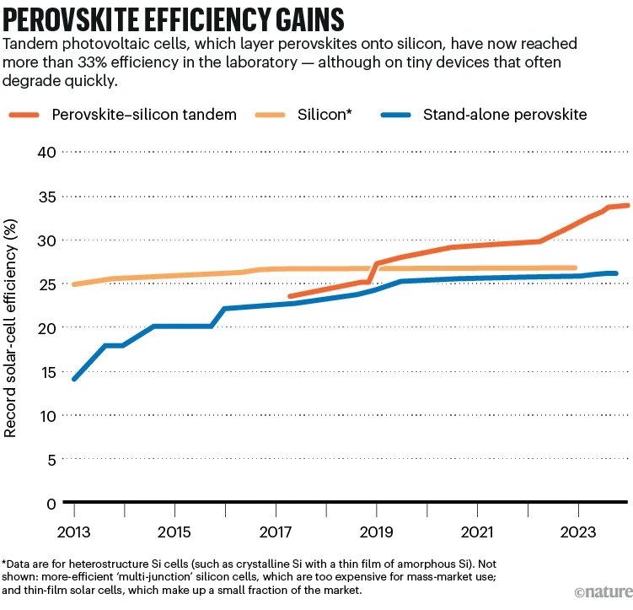

*Image: US National Renewable Energy Lab,* <https://www.nature.com/articles/d41586-023-03714-y>

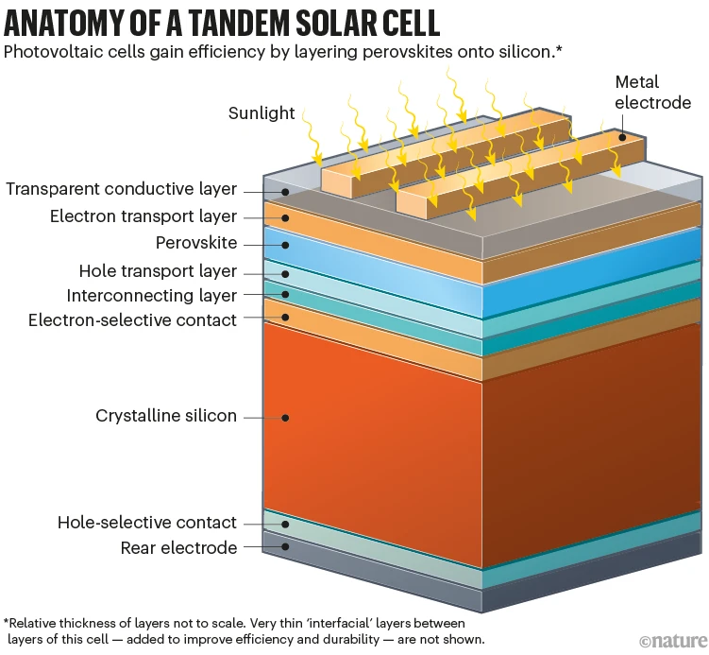

*Image: Nature,* <https://www.nature.com/articles/d41586-023-03714-y>

**Black Perovskite, Inorganic Cesium Lead Triiodide (${CsPbl}_{3}^{}$) Perovskite**

Cesium-lead iodide (CsPbI3) perovskite is also known as black perovskite. In 2023, the Chinese Academy of Sciences developed a black perovskite solar cell with a dopant-free hole transport layer based on the P3HT polymer which was able to retain around 93% of its original efficiency after continuous illumination for 570 h. Their device offers superior moisture and illumination stability. This perovskite material has an energy bandgap of approximately 1.7 eV and, according to several scientists, is an ideal solution for single-junction and wide-band-gap sub-cells in tandem PV devices (Li et al., 2023; Bellini, 2023C, Jia, 2023).

As published in Joule, Professor Jinsong of China developed a universal hydrogen-bonding-facilitated DMA extraction strategy for fabricating efficient and stable inorganic CsPbI3 solar cells. They introduced polyacrylic acid (PAA) into the inorganic CsPbI3 precursors consisting of CsI, PbI2 and DMAI. During the formation of CsPbI3 the PAA could form the hydrogen bonds with DMA, which accelerates the decomposition of DMAPbI3 and DMA extraction. The PAA-added sample exhibited relatively faster phase transformation and achieved the high-quality CsPbI3 film with no DMA residue. Systematic experimental and theoretical investigations revealed that the hydrogen bonding facilitated the DMA extraction by lowering the escaping energy barrier. DMAPbI3 (dimethylammonium [DMA]) or "HPbI3"-assisted crystallization is effective for the preparation of high-quality β- or γ-phase CsPbI3 films, but it unfortunately causes DMAPbI3 residue and the degradation of photovoltaic performance and stability. Combining with stable poly(3-hexylthiophene) (P3HT) hole transport layers, the CsPbI3 perovskite solar cells (PSCs) with PAA treatment achieved a power conversion efficiency (PCE) of 20.25%, the highest efficiency reported on CsPbI3 PSCs with a dopant-free P3HT hole transport layer (HTL). The devices demonstrated superior moisture and operational stability in terms of maintaining 94% of their initial PCE after aging at low relative humidity (RH) conditions (<15%) for 10,224 h and more than 93% PCE after continuous illumination for 570 h (Li et al., 2023; Bellini, 2023C, Jia, 2023).

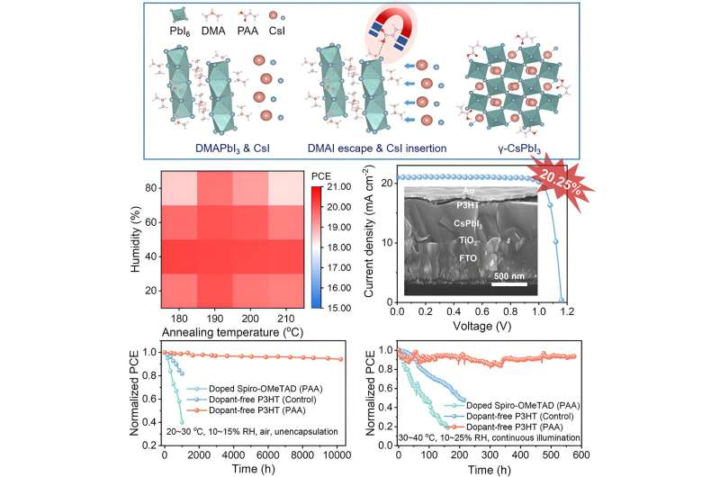

*Image: Credit: Joule (2023). DOI: 10.1016/j.joule.2023.09.009*

[*https://www.cell.com/joule/pdfExtended/S2542-4351(23)00399-9*](https://www.cell.com/joule/pdfExtended/S2542-4351(23)00399-9)

<https://phys.org/news/2023-11-stable-efficient-inorganic-cspbi3-solar.html>

Zhang, C., Park, NG. (2024) Materials and methods for cost-effective fabrication of perovskite photovoltaic devices. Communications Materials 5, 194, <https://doi.org/10.1038/s43246-024-00636-8>

Manuel Vásquez-Montoya, Juan F. Montoya, Rafael Betancur, Daniel Ramirez, Franklin Jaramillo, Chapter 14 - Perovskite solar cells: New precursors and challenges for scaling-up, Editor(s): Soumen Das, Sandip Dhara, Chemical Solution Synthesis for Materials Design and Thin Film Device Applications, Elsevier, 2021, Pages 477-508, <https://doi.org/10.1016/B978-0-12-819718-9.00009-1>

Areas of perovskite cell manufacturing which need to improve to bring perovskite to commercialization include: precursor synthesis, selection criteria for precursors based on chemistry, additive engineering, and deposition techniques. PSCs have superior optoelectronic properties, including high absorption coefficients, tunable bandgaps, and long carrier diffusion lengths (Kim et al., 2012; Li et al., 2023; Zhao et al., 2018; Long et al., 2020; Chen et al., 2020; Yang et al., 2019; Chen et al., 2017). The perovskite fabrication process remains a challenge, and advancements need to be made in materials and methods to simplify and reduce the fabrication costs of PSCs, including the preparation and deposition methods of the perovskite layer, and selection of precursors, additives and solvents (Park et al., 2016; Niu et al., 2021; Kim et al., 2020; Park, 2020; Seok et al., 2018; Lee et al., 2019; Rong et al., 2018).

The selection of precursors, for instance, directly affects the crystallization kinetics, film morphology and quality, and ultimately the photovoltaic performance of the PSCs (Lee et al., 2023; Halder et al., 2023; Chen et al., 2019; Liu et al., 2020; Ma et al., 2022A; Ma et al., 2023A). Additive engineering, on the other hand, can stabilize the perovskite phase, inhibition migration, and passivate defects, minimize recombination losses, and improve the overall stability and efficiency of the PSCs (Chen et al., 2020; Zhou et al., 2014; Graetzel et al., 2012; Cho and Park, 2017; Ma et al., 2023B).

the commercialization of PSCs faces several challenges in formulation, deposition, post-processing, performance, and cost-effectiveness.

Perovskite film quality, high quality films

Efficiency, stability, and reproducibility

To achieve low-cost fabrication

**Perovskite Precursors**

Precursor selection (Park, 2020; Lee et al., 2019; Yuan et al., 2024; Zhao et al., 2023)

Additive engineering (Ma et al., 2023B; McKeekin et al., 2023; Tan et al., 2023; Ding et al., 2024; Zhang and Park, 2023)

Crystallization kinetics (Lu et al., 2020; Wu et al., 2024)

Film morphology ()

Film quality (Ma et al., 2023A; Ma et al., 2022B)

Photovoltaic performance of perovskite devices (Ding et al., 2024; Jiang et al., 2023; LI et al., 2023)

Precursors for PSCs can be either organic or inorganic halide salts, or metal halides, and purity is important. Inorganic salts include lead iodide (PbI2) and cesium iodide (CsI), and organic salts include methylammonium iodide (MAI) and formamidinium iodide (FAI), which are dissolved in a solvent to create a "precursor solution" before being deposited onto the solar cell substrate to form the perovskite film (Kim et al., 2012; Shin et al., 2020).

The properties of the precursor solution, including its concentration, solvent choice, and purity, significantly influence the final quality of the perovskite film and the performance of the solar cell. When the precursor solution is deposited and heated, the chemical components react and rearrange to form the desired perovskite crystal structure. In the context of a solar cell, a "precursor" refers to a chemical compound that is used as a starting material to create the active material within the cell, usually a perovskite material, which then undergoes a reaction to form the final crystalline structure needed for efficient light absorption and charge generation; essentially, it's the initial chemical compound that is transformed into the desired material within the solar cell through a chemical process.

The stoichiometric ratio of the precursors must also be controlled. The ratio of PbI₂ to MAI, FAI, or CsI determines the composition and crystallinity of the perovskite film, and an imbalance in this ratio can lead to the formation of undesired phases or defects, affecting the optical and electrical properties of the film (Kang et al., 2022). Excess PbI₂ in the precursor solution can promote the formation of a PbI₂-rich phase within the perovskite film which can act as a passivation layer, potentially improving the film’s electronic properties by reducing surface recombination. However, too excessive PbI₂ can lead to incomplete conversion to the perovskite phase, resulting in poor film quality and lower device performance. Conversely, an excess of MAI or FAI can lead to the formation of perovskite films with better coverage and reduced pinhole density. However, too much organic iodide can result in the formation of non-perovskite phases, which are detrimental to the film’s stability and performance.

To address the purity of the precursor materials and the balance of the stoichiometric ratio, Zhang and Park (2024) experimented with the purification of pre-synthesized perovskite microcrystal powders via crystallization, to serve as the precursors for perovskite film, using ambient-temperature stable δ-phase ${FAPbI}_{3}$ powder synthesized from low-grade ${PbI}_{2}$ (purity <99%) and FAI. Since α-phase ${FAPbI}_{3}$ needs a high temperature of over 150 °C, aqueous synthesis of δ-phase ${FAPbI}_{3}$ at room temperature is a cost-effective way for mass production of precursor material. The significant reduction of ${Ca}^{2+}$ ions, the major impurity, decreased carrier trap states and greatly improved device performance and stability.

**Perovskite Substrates**

Wang, Y., Lin, R., Wang, X. et al. Oxidation-resistant all-perovskite tandem solar cells in substrate configuration. Nat Commun 14, 1819 (2023). <https://doi.org/10.1038/s41467-023-37492-y>

In a solar cell, the "substrate" refers to the base layer or supporting material on which the active layers of the cell are deposited, essentially acting as the foundation for the entire solar cell structure; commonly made from materials like glass, metal, or plastic, depending on the application and desired flexibility of the solar cell.

Key points about the substrate in a solar cell:

Function:

It provides a stable surface to build the various layers of the solar cell upon, including the light-absorbing layer (absorber) and the electrodes.

Material options:

Glass: Widely used due to its transparency and stability, particularly for conventional solar panels.

Metal foils: Can be used for flexible solar cells, offering durability and potential for lightweight applications.

Plastics (like PET): Also used for flexible solar cells, providing lightweight and conformability.

Importance of choice:

The substrate material selection depends on factors like cost, desired flexibility, thermal expansion coefficient, and compatibility with the fabrication proces

**Tandem Cells Front and Back Subcells**

In a solar cell, "front" and "back" refer to the sides of the cell where the electrical contacts are placed, not necessarily separate "subcells," although in advanced tandem solar cell designs, the front and back surfaces can indeed house separate subcells with different bandgaps to capture a wider spectrum of light.

Key points about front and back in solar cells:

Basic function:

The front side typically receives sunlight and is where the light-absorbing semiconductor material is exposed, while the back side is where the electrical contact is made to collect the generated electrons.

Contact placement:

In most conventional solar cells, the positive contact is on the front and the negative contact is on the back.

Tandem cells:

In more complex "tandem" solar cells, the front and back can each contain a separate subcell with different bandgaps, allowing for better light absorption across the spectrum

This is possible due to perovskite’s ability to absorb certain colors of light very effectively. Perovskite absorber layers can also be stacked on top of another absorber layer, such as silicon, to use the colors of light not absorbed in the perovskite, resulting in a cell that can be theoretically more efficient than cells made of either material on their own. When two layers are stacked in such a manner, this is known as a tandem solar cell.

In a solar cell, the perovskite absorber is attached to other materials, which “force” electric current to flow in a single direction through the absorber layer and into the metal contacts to be collected as electric current. Learn more about how solar cells work.

**Additive Engineering**

Additive engineering for solar cells encompasses solvents, functional additives, dopants, and interface engineering. Solvent selection influences the wettability of the substrate, precursor dissolution, and evaporation rate during the process (Chao et al., 2021; Cao et al., 2019). Functional additives can be used to modify the properties of the perovskite crystals (Bai et al., 2022), including the orientation and homogeneity of the perovskite films (Ma et al., 2022A; Ma et al., 2022B). Dopants are a type of additive that can be used to modify the electronic properties of perovskite films (Lee et al., 2022).

Interface engineering (Chen and Park, 2020)

Additive engineering (Zhang and Zhu, 2020)

***Solvents***

Among the various polar solvents commonly used, such as dimethyl sulfoxide (DMSO), dimethylformamide (DMF), γ-butyrolactone, N-methyl-2-pyrrolidone, tetrahydrofuran, dimethylacetamide, only DMSO was evaluated as a non-toxic green solvent by measuring disability-adjusted life years (Vidal et al., 2021; Park, 2021). A method was reported for synthesizing stable α-FAPbI3 that is insensitive to temperature and humidity variations and compatible with large-scale fabrication. This method involves utilizing a vertically aligned PbI2 thin film grown from an ionic liquid green solvent, methylammonium formate. This kind of PbI2 film facilitates the rapid infiltration and full reaction of FAI through its nanoscale ionic channels to form α-FAPbI3. Environmentally benign biomass-derived green solvents, specifically γ-valerolactone (GVL) and n-butyl acetate, were reported98. Compared to traditional reagents (DMF and DMSO) that might cause instability of FA+ in the precursor, GVL not only exhibits a strong interaction with FA+, stabilizing it and promoting the formation of high-valence [PbIx]2–x complexes (Hui et al., 2021).

The annual production of DMSO is ~100,000 tons. Industrial-grade DMSO costs approximately 1 USD per kilogram. For 3500 L (3.85 tons), the cost would be ~3850 USD. When scaled to the overall cost of producing 1 GW of solar capacity, this represents a minor fraction of the total production costs. Therefore, eco-friendly and low-cost fabrication of PSCs should primarily focus on DMSO as the main solvent, or alternatively, efforts should be made to develop more green solvents for the preparation of high-quality perovskite thin films (Yun et al., 2022; Chen et al., 2022; Hui et al., 2021; Miao et al., 2023).

***Functional Additives***

Additives are used in small quantities to improve the efficiency and stability of the perovskite solar cell. Zhang and Park (2024) showed that additives being capable of hydrogen bonding with iodide species in precursor solution lead to the creation of polyhedral single crystals with distinct facets (Ma et al., 2022B), and that facets with different atomic densities exert a significant influence on the chemical and electronic environments of the perovskite surface, consequently affecting the performance of the final device. For instance, the (100) and (111) facets exhibited comparable carrier mobility and photocurrent, both of which were notably superior to the (110) facet. By increasing the proportion of both (100) and (111) facets among all facets, the corresponding PSC demonstrated a quasi-steady-state PCE as high as 24.6%. Furthermore, the moisture stability of perovskite crystals was discovered to strongly depend on the perovskite facets (Ma et al., 2023A).

In terms of the homogeneity of perovskite composition across the layer, FA-rich composition was formed on the perovskite film surface, while Cs-rich composition was dominant at the bottom of the film (Liang et al., 2023). This inhomogeneity is one of the origins of instability and lower efficiency in PSCs. 1-(phenylsulfonyl)pyrrole was developed as an additive to homogenize cation distribution within the perovskite films, where the difference in crystallization kinetics and phase transition kinetics between FA cation and Cs cation was overcome.

During thermal annealing of 3D perovskites, the encapsulated DMSO leaves the bulk film, causing dissolution and recrystallization. This process, balanced by DMSO evaporation, leads to crystal volume collapse and voids at grain boundaries. The use of amidino-based Dion-Jacobson 2-dimensional (2D) perovskite assists in the nucleation and growth of 3D perovskite, reducing voids and bulk defects in the film. This results in efficient charge transport and significantly improved stability.

Furthermore, additive engineering can be extended to the Sn-Pb alloyed perovskite, where the utilization of the narrow bandgap Sn-Pb perovskite can replace crystalline Si to make a perovskite-perovskite tandem solar cell. However, unlike the single lead ion, nonuniform nucleation and rapid crystallization are often observed in this binary system, which impedes film quality and overall device performance. By introducing aminoacetamide hydrochloride (AAH) into the precursor, the processing window was significantly increased from 10 s to 100 s, thereby facilitating the easier fabrication of high-quality perovskite films without pinholes (Gao et al., 2024). AAH was found to be primarily distributed at the bottom interface of the final perovskite film, serving the additional function of passivating the buried interface.

It should be emphasized that the additive engineering discussed above can be extended not only to the preparation of Sn-Pb perovskites but also to other types of perovskites in general, such as Pb-free, wide-bandgap, and 2-dimensional (2D) perovskites.

***Facets Engineering***

In the context of solar cells, "facets" refer to the different flat surfaces or crystal planes that make up the crystal structure of a semiconductor material, like perovskite, within the cell, and the specific arrangement of these facets can significantly impact the solar cell's efficiency and stability due to their varying electronic and physical properties depending on their atomic arrangement; essentially, different facets interact with light and charge carriers differently, allowing for targeted manipulation to optimize solar cell performance through "facet engineering.”

Different crystal facets have distinct atomic arrangements, leading to varied electronic properties like carrier mobility and defect density. By selectively passivating specific facets through facet-dependent passivation, with appropriate materials, researchers can improve the performance of solar cells by addressing potential recombination sites. Facet engineering is particularly important in perovskite solar cells due to their complex crystal structure and the potential for tuning the facet distribution to enhance efficiency and stability. Some frequently studied facets in perovskite solar cells include (100), (111), and (110), each with unique characteristics regarding charge carrier transport and stability. By controlling crystal growth, researchers can promote the formation of desired facets on the perovskite film, maximizing desirable properties. In interface engineering, heterojunctions are created between different facets with tailored electronic properties, which can improve charge carrier separation and collection. Passivation strategies include applying specific materials to selectively passivate certain facets, which can mitigate charge recombination at the surface.

***Dopants***

By incorporating dopants into the perovskite, α-phase perovskite can be stabilized (Lu et al., 2020), strain can be regulated (Kim et al., 2020), ion migration is able to be mitigated (Zhao et al., 2022; Chen et al., 2022), defects can be passivated (Chen et al., 2022; Jeong et al., 2021), and thereby the overall stability of the materials and PSCs can be enhanced (Lee et al., 2022; Zhao et al., 2022; Jeong et al., 2021). For instance, the black α-phase of $FAP{bI}_{3}$ often suffers from its intrinsic instability at room temperature due to transition into the inactive non-perovskite yellow δ-phase. Consequently, stabilization of the α-phase at ambient conditions is critical and can be possible by doping. A method utilizing vapour-assisted doping with formamidinium thiocyanate or methylammonium thiocyanate containing ${SCN}^{-}$ ions has been reported to effectively facilitate the conversion of the yellow phase to the black phase (Lu et al., 2020). The presence of ${SCN}^{-}$ ions in the perovskite is helpful to maintain the long-term stability of the generated black phase perovskite.

To further maximize the performance of PSCs, anion engineering was proposed. Formate (${HCOO}^{-}$) as a pseudo-halide anion was investigated (Jeong et al., 2021), where it was found that the presence of formate suppresses common anion vacancy defects at the grain boundaries and surfaces of the perovskite films.

***Interface Regulation***

The design of the interface is complex, such as the choice between organic and inorganic charge transport layers (CTLs), as well as the overall interface design, heavily depends on the specific device architecture and intended application. Research areas include efficient CTLs tailored to various device structures, perovskite compositions, and deposition methods. Considering the general and effective interface modification layers directly related to the perovskite layer, it has been reported that these interface layers formed between the perovskite film and the charge transport layers improved substantially photovoltaic performance and were found to play an important role in protecting the PSCs from degradation (Yu et al., 2023; Azmi et al., 2022; Jiang et al., 2022; Park et al., 2023; Sidhik et al., 2022).

Precisely adjusting the number of inorganic layer (n) at the interlayer is one method, whereby the temperature effect of the interlayer formed by post-treatment with oleylammonium iodide is considered (Azmi et al., 2022). Specifically, high-temperature (100 °C) post-treatment mainly leads to the formation of a 2D perovskite passivation layer with n = 1, while a quasi 2D perovskite passivation layer with n = 2 was dominant after overnight storage at room temperature. It was shown that the energy level of the quasi 2D with n = 2 was more compatible with that of C60, which is beneficial for charge transfer and reduces charge accumulation.

Understanding the interaction between the passivation molecules and the different perovskite crystal facets is important to achieve uniform passivation layer on the whole perovskite surface. We studied systematically dependence of crystal facets on passivating materials and verifed a facet-dependent passivation principle.

Thickness control of the interlayer is hard to control with the traditional precursor solution and spin-coating technique. A method of growing uniform 2D layers on the 3D perovskite layer was reported by adjusting donor number and dielectric constant of solvents for the 2D layer deposition.

For the preparation of multicomponent mixed perovskite films, out-of-plane phase separation and/or uneven cation distribution are often observed, which could result in a weak adhesion interface of the perovskite layer with charge transport layers (Liang et al., 2023; Zhang et al., 2024).

**Deposition techniques for large-area fabrication**

Mass production of perovskites (Lee et al., 2019; Chao et al., 2021; Zhang et al., 2024A; Kim et al., 2020)

Cost-effective and high-speed roll-to-roll (R2R) fabrication methods are regarded as the key deposition technique. These methods require accurate control over the formation of the intermediate phase and their conversion into the perovskite structure (Li et al., 2021; Park and Zhu, 2020; Kim et al., 2021).

R2R gravure printing is highly scalable and flexible but struggles with uniformity and solvent control, limiting PCE due to film defects and crystallization issues. Blade coating is simple and cost-effective, yet maintaining uniform film quality and environmental sensitivity can hinder performance. Slot-die coating offers high throughput and precision but requires costly equipment and precise solution viscosity management, with defect formation and drying dynamics as key PCE limits. Spray coating is versatile and scalable but faces challenges in achieving uniform coverage and environmental sensitivity, affecting PCE through particle size and film defects. Additionally, the choice of solvents presents a certain level of complexity, as different large-area deposition methods typically require distinct solvent combinations. Therefore, the introduction of various deposition techniques is usually accompanied by the optimization of solvent selection.

To overcome the challenges encountered, a short processing window and uneven crystallization, a green antisolvent combination consisting of tert-butyl alcohol and ethyl acetate (EA) was introduced into R2R-compatible gravure printing with specific printing patterns. This solvent blend was found to improve the perovskite processing window, facilitating the deposition of uniform and high-crystalline films without PbI2 traces (Kim et al., 2020).

It was reported that highly crystalline, highly oriented, and scalable smooth thin films were fabricated under ambient conditions at room temperature by utilizing a high-concentration precursor solution and low-boiling point solvents such as a 10% w/w mixture solvent of methylamine in ACN (Dou et al., 2018). This mixture allows the high-concentration solution to rapidly transition into a supersaturated state, enabling the rapid preparation of a high-quality ${MAPbI}_{3}$. High-speed in situ XRD monitoring demonstrates that the precursor film can rapidly crystallize within one second at room temperature, achieving a relative crystallinity of over 98%. The method is compatible with various deposition techniques, including blade coating (PCE of 19.6%) (Fig. 6d) and slot-die coating (PCE of 17.3%) (Fig. 6e). Spray-coating is also regarded as an alternative deposition technology, which can be applied to various substrate materials with micro-scale roughness. For instance, CsPbI2Br was prepared by ultrasonic-assisted spray coating (Fig. 6f) (Lee et al., 2022) where other components or layers were also tried to deposit via spray coating. Recently, a detachable, reassemblable tandem perovskite/silicon solar cell has been reported. This modular cell incorporates a spray-coated single-walled carbon nanotube film between the top perovskite cell and the bottom silicon cell. This advancement not only simplifies the assembly, disassembly, and maintenance of the tandem solar cell but also effectively addresses the issue of resource wastage caused by mismatched lifetimes of the top and bottom cells (Zhang et al., 2024B)

mass production of perovskite solar cells, the most promising methods include solution-based deposition techniques like spin coating, blade coating, slot-die coating, spray coating, and particularly roll-to-roll processing which allows for continuous production on flexible substrates, alongside other methods like screen printing and inkjet printing, depending on the desired level of precision and throughput needed for large-scale manufacturing; all aiming to achieve high-quality perovskite films while maintaining cost-effectiveness.

Key aspects of perovskite solar cell mass production methods:

Solution-based deposition:

This is preferred due to its potential for low cost and scalability, where a liquid precursor solution containing the perovskite materials is deposited onto a substrate using various techniques.

Roll-to-roll processing:

Considered a leading method for large-scale production as it enables continuous deposition of the perovskite layer on a flexible substrate, significantly increasing production speed and lowering costs.

Spin coating: A common method for laboratory-scale production, where the precursor solution is spun on a substrate to create a thin film, but may not be as suitable for large-area manufacturing.

Blade coating: A more scalable method where a blade is used to spread the perovskite precursor solution across the substrate, offering better control over film thickness compared to spin coating.

Slot-die coating: A precise method for depositing uniform films by dispensing the precursor solution through a narrow slit.

Spray coating: A method where the precursor solution is sprayed onto the substrate, allowing for large-area deposition and potential for flexible substrate applications.

Screen printing: A relatively low-cost method for depositing thick perovskite films by using a screen with a desired pattern to transfer the ink onto the substrate.

Inkjet printing: Offers high precision and potential for complex patterns by precisely depositing small droplets of the perovskite precursor solution onto the substrate.

Challenges in perovskite solar cell mass production:

Stability concerns:

Perovskite materials can degrade over time, especially under environmental stresses, requiring further research on stabilization strategies.

Film uniformity:

Achieving consistent film quality across large areas is crucial for high efficiency and scalability.

Material compatibility:

Selecting suitable materials for charge transport layers and electrodes that are compatible with the perovskite layer is important.

Zhang, C., Choi, Y. J., Kim, J. Y. & Park, N.-G. Detachable, reassemblable two-terminal perovskite/silicon tandem solar cells. ACS Energy Lett. 9, 4280–4282 (2024B)

Kim, H.-J., Kim, H.-S. & Park, N.-G. Progress of perovskite solar modules. Adv. Energy Sustain. Res. 2, 2000051 (2021)

Li, D. et al. A review on scaling up perovskite solar cells. Adv. Funct. Mater. 31, 2008621 (2021)

Park, N.-G. & Zhu, K. Scalable fabrication and coating methods for perovskite solar cells and solar modules. Nat. Rev. Mater. 5, 333–350 (2020)

Lee, D. S. et al. Fully scalable and stable CsPbI2Br solar cells realized by an all-spray-coating process. ACS Appl. Mater. Interfaces 14, 7926–7935 (2022).

Dou, B. et al. Roll-to-roll printing of perovskite solar cells. ACS Energy Lett. 3, 2558–2565 (2018)

Kim, Y. Y. et al. Roll-to-roll gravure-printed flexible perovskite solar cells using eco-friendly antisolvent bathing with wide processing window. Nat. Commun. 11, 5146 (2020)

Kim, Y. Y. et al. Roll-to-roll gravure-printed flexible perovskite solar cells using eco-friendly antisolvent bathing with wide processing window. Nat. Commun. 11, 5146 (2020)

Zhang, C. et al. Work function tuning of a weak adhesion homojunction for stable perovskite solar cells. Joule 8, p1394-1411 (2024A)

Yu, S. et al. Homogenized NiOx nanoparticles for improved hole transport in inverted perovskite solar cells. Science 382, 1399–1404 (2023)

Azmi, R. et al. Damp heat-stable perovskite solar cells with tailored-dimensionality 2D/3D heterojunctions. Science 376, 73–77 (2022)

Jiang, Q. et al. Surface reaction for efficient and stable inverted perovskite solar cells. Nature 611, 278–283 (2022)

Park, S. M. et al. Engineering ligand reactivity enables high-temperature operation of stable perovskite solar cells. Science 381, 209–215 (2023)

Sidhik, S. et al. Deterministic fabrication of 3D/2D perovskite bilayer stacks for durable and efficient solar cells. Science 377, 1425–1430 (2022)

Jeong, J. et al. Pseudo-halide anion engineering for α-FAPbI3 perovskite solar cells. Nature 592, 381–385 (2021)

Zhao, Y. et al. Suppressing ion migration in metal halide perovskite via interstitial doping with a trace amount of multivalent cations. Nat. Mater. 21, 1396–1402 (2022)

Chen, C. et al. Polyacrylonitrile‐coordinated perovskite solar cell with open‐circuit voltage exceeding 1.23 V. Angew. Chem. Int. Ed. 61, e202113932 (2022)

Kim, G. et al. Impact of strain relaxation on performance of α-formamidinium lead iodide perovskite solar cells. Science 370, 108–112 (2020)

Lu, H. et al. Vapor-assisted deposition of highly efficient, stable black-phase FAPbI3 perovskite solar cells. Science 370, eabb8985 (2020)

Lee, J.-W., Tan, S., Seok, S. I., Yang, Y. & Park, N.-G. Rethinking the A cation in halide perovskites. Science 375, eabj1186 (2022)

Liang, Z. et al. Homogenizing out-of-plane cation composition in perovskite solar cells. Nature 624, 557–563 (2023)

Gao, H. et al. Homogeneous crystallization and buried interface passivation for perovskite tandem solar modules. Science 383, 855–859 (2024)

Bai, Y., Hao, M., Ding, S., Chen, P. & Wang, L. Surface chemistry engineering of perovskite quantum dots: strategies, applications, and perspectives. Adv. Mater. 34, 2105958 (2022)

Chao, L. et al. Solvent engineering of the precursor solution toward large‐area production of perovskite solar cells. Adv. Mater. 33, 2005410 (2021)

Cao, X. et al. A review of the role of solvents in formation of high-quality solution-processed perovskite films. ACS Appl. Mater. Interfaces 11, 7639–7654 (2019)

Vidal, R. et al. Assessing health and environmental impacts of solvents for producing perovskite solar cells. Nat. Sustain. 4, 277–285 (2021)

Park, N.-G. Green solvent for perovskite solar cell production. Nat. Sustain. 4, 192–193 (2021)

Yun, H.-S. et al. Ethanol-based green-solution processing of α-formamidinium lead triiodide perovskite layers. Nat. Energy 7, 828–834 (2022)

Chen, C. et al. Perovskite solar cells based on screen-printed thin films. Nature 612, 266–271 (2022)

Hui, W. et al. Stabilizing black-phase formamidinium perovskite formation at room temperature and high humidity. Science 371, 1359–1364 (2021)

Miao, Y. et al. Green solvent enabled scalable processing of perovskite solar cells with high efficiency. Nat. Sustain. 6, 1465–1473 (2023)

Chen, J. & Park, N.-G. Materials and methods for interface engineering toward stable and efficient perovskite solar cells. ACS Energy Lett. 5, 2742–2786 (2020)

Zhang, F. & Zhu, K. Additive engineering for efficient and stable perovskite solar cells. Adv. Energy Mater. 10, 1902579 (2020)

Kim, H.-S. et al. Lead iodide perovskite sensitized all-solid-state submicron thin film mesoscopic solar cell with efficiency exceeding 9%. Sci. Rep. 2, 591 (2012).

Shin, G. S., Zhang, Y. & Park, N.-G. Stability of precursor solution for perovskite solar cell: mixture (FAI+ PbI2) versus synthetic FAPbI3 Crystal. ACS Appl. Mater. Interfaces 12, 15167–15174 (2020)

Kang, D.-H., Park, Y.-J., Jeon, Y.-S. & Park, N.-G. Extended X-ray absorption fine structure (EXAFS) of FAPbI3 for understanding local structure-stability relation in perovskite solar cells. J. Energy Chem. 67, 549–554 (2022).

Jiang, X. et al. Molecular dipole engineering of carbonyl additives for efficient and stable perovskite solar cells. Angew. Chem. Int. Ed. 62, e202302462 (2023).

Li, G. et al. Highly efficient pin perovskite solar cells that endure temperature variations. Science 379, 399–403 (2023).

Ma, C. et al. Photovoltaically top-performing perovskite crystal facets. Joule 6, 2626–2643 (2022B).

Lu, H. et al. Vapor-assisted deposition of highly efficient, stable black-phase FAPbI3 perovskite solar cells. Science 370, eabb8985 (2020).

Wu, Z. et al. Crystallization kinetics of hybrid perovskite solar cells. Angew. Chem. Int. Ed. 63, e202319170 (2024).

McMeekin, D. P. et al. Intermediate-phase engineering via dimethylammonium cation additive for stable perovskite solar cells. Nat. Mater. 22, 73–83 (2023).

Tan, Q. et al. Inverted perovskite solar cells using dimethylacridine-based dopants. Nature 620, 545–551 (2023).

Ding, B. et al. Dopant-additive synergism enhances perovskite solar modules. Nature 628, 299–305 (2024).

Zhang, Y. & Park, N. G. Tailoring the functionality of additives for enhancing the stability of perovskite solar cells. Adv. Funct. Mater. 33, 2308577 (2023).

Lee, D.-K., Jeong, D.-N., Ahn, T. K. & Park, N.-G. Precursor engineering for a large-area perovskite solar cell with>19% efficiency. ACS. Energy Lett. 4, 2393–2401 (2019).

Yuan, L. et al. Volatile perovskite precursor ink enables window printing of phase-pure FAPbI3 perovskite solar cells and modules in ambient atmosphere. Angew. Chem. Int. Ed. 63, e202316954 (2024).

Zhao, J. et al. Efficient and stable formamidinium-caesium perovskite solar cells and modules from lead acetate-based precursors. Energy Environ. Sci. 16, 138–147 (2023).

Zhou, H. et al. Interface engineering of highly efficient perovskite solar cells. Science 345, 542–546 (2014).

Graetzel, M., Janssen, R. A., Mitzi, D. B. & Sargent, E. H. Materials interface engineering for solution-processed photovoltaics. Nature 488, 304–312 (2012).

Cho, A. N. & Park, N. G. Impact of interfacial layers in perovskite solar cells. ChemSusChem 10, 3687–3704 (2017).

Ma, C. et al. Facet-dependent passivation for efficient perovskite solar cells. J. Am. Chem. Soc. 145, 24349–24357 (2023B).

.

Lee, D.-K. & Park, N.-G. Additive engineering for highly efficient and stable perovskite solar cells. Appl. Phys. Rev. 10, 011308 (2023).

Halder, A., Yeom, K.-W. & Park, N.-G. Strategies toward suppression of Sn (II) oxidation for stable Sn-Pb perovskite solar cells. ACS Energy Lett. 8, 4267–4277 (2023).

Chen, J., Zhao, X., Kim, S. G. & Park, N. G. Multifunctional chemical linker imidazoleacetic acid hydrochloride for 21% efficient and stable planar perovskite solar cells. Adv. Mater. 31, 1902902 (2019).

Liu, C., Cheng, Y.-B. & Ge, Z. Understanding of perovskite crystal growth and film formation in scalable deposition processes. Chem. Soc. Rev. 49, 1653–1687 (2020).

Ma, C., Grätzel, M. & Park, N.-G. Facet engineering for stable, efficient perovskite solar cells. ACS Energy Lett. 7, 3120–3128 (2022A).

Ma, C. et al. Unveiling facet-dependent degradation and facet engineering for stable perovskite solar cells. Science 379, 173–178 (2023A).

Park, N.-G., Grätzel, M., Miyasaka, T., Zhu, K. & Emery, K. Towards stable and commercially available perovskite solar cells. Nat. Energy 1, 1–8 (2016).

Niu, B. et al. Mitigating the lead leakage of high-performance perovskite solar cells via in situ polymerized networks. ACS Energy Lett. 6, 3443–3449 (2021).

Kim, J. Y., Lee, J.-W., Jung, H. S., Shin, H. & Park, N.-G. High-efficiency perovskite solar cells. Chem. Rev. 120, 7867–7918 (2020).

Park, N. G. Research direction toward scalable, stable, and high efficiency perovskite solar cells. Adv. Energy Mater. 10, 1903106 (2020).

Seok, S. I., Grätzel, M. & Park, N. G. Methodologies toward highly efficient perovskite solar cells. Small 14, 1704177 (2018).

Lee, J. W., Lee, D. K., Jeong, D. N. & Park, N. G. Control of crystal growth toward scalable fabrication of perovskite solar cells. Adv. Funct. Mater. 29, 1807047 (2019).

Rong, Y. et al. Challenges for commercializing perovskite solar cells. Science 361, eaat8235 (2018).

Kim, H.-S. et al. Lead iodide perovskite sensitized all-solid-state submicron thin film mesoscopic solar cell with efficiency exceeding 9%. Sci. Rep. 2, 591 (2012).

Li, H., Shen, N., Chen, S., Guo, F. & Xu, B. Recent progress on synthesis, intrinsic properties and optoelectronic applications of perovskite single crystals. Adv. Funct. Mater. 33, 2214339 (2023).

Zhao, B. et al. High-efficiency perovskite-polymer bulk heterostructure light-emitting diodes. Nat. Photonics 12, 783–789 (2018).

Long, G. et al. Chiral-perovskite optoelectronics. Nat. Rev. Mater. 5, 423–439 (2020).

Chen, B. et al. Enhanced optical path and electron diffusion length enable high-efficiency perovskite tandems. Nat. Commun. 11, 1257 (2020).

Yang, Z. et al. Enhancing electron diffusion length in narrow-bandgap perovskites for efficient monolithic perovskite tandem solar cells. Nat. Commun. 10, 4498 (2019).

Chen, Z. et al. Thin single crystal perovskite solar cells to harvest below-bandgap light absorption. Nat. Commun. 8, 1890 (2017).

**Perovskite Bandgap Tuning**

* **Material engineering:**
  + Developing new perovskite compositions with tailored bandgaps to optimize light absorption.

Miah, H., Khandaker, M.U., Rahman, B. (2024) Band gap tuning of perovskite solar cells for enhancing the efficiency and stability: issues and prospects, RSC Adv., 14, 15876-15906, <https://pubs.rsc.org/en/content/articlehtml/2024/ra/d4ra01640h>

the significance of band gap tuning in achieving both high-performance and high-stability PSCs in the presence of various degradation factors. By investigating the mechanisms of band gap engineering,

First-generation cells based on monocrystalline and polycrystalline silicon wafers offer high power conversion efficiency (PCE) and stability; however, the drawback is their high manufacturing cost. Second-generation cells based on thin-film technologies, including CdTe and CIGS, have low manufacturing costs, can use flexible substrates, and broaden the possible application sectors, but they usually have lower efficiency and stability. Third-generation and/or emerging PV technologies, such as CZTS, DSSCs, PSCs, organic photovoltaics, and quantum dot solar cells, are cost-effective and hold promise for higher PCEs with novel applications but face challenges regarding stability and scalability.

PSCs stand as a leading-edge innovation considering their higher PCE, low cost, and easy manufacturing process (Miah et al., 2023A). In addition, perovskite materials retain distinctive characteristics such as tunable band gaps, low exciton binding energy, high absorption coefficients, ambipolar charge transportation, and long charge carrier diffusion lengths (Guerrero et al. 2014; Salhi et al., 2018; Rahman et al., 2023; Miah et al., 2023B).

stability, which determines their capability to sustain performance over time under various environmental conditions. Stability in PSCs is a multidimensional challenge. These PSCs are naturally vulnerable to moisture, oxygen, heat, and light, which can cause deterioration and loss of performance over time (Miah et al., 2023C; Min et al., 2021; Kojima et al., 2009; Green et al., 2024; Chowdhury et al., 2023) Their performance and stability are also affected by crystal defects, ion migration, hysteresis and hydrophobicity (Snaith et al., 2014; Azpiroz et al., 2015; Elumalai and Uddin, 2016; Pazos-Outon et al., 2018; Chen et al., 2019).

Band gap tuning through structural modification is a critical aspect of overcoming some of the aforementioned limitations and the optimization of PSCs for high performance and better stability. The band gap governs the range of energy of light that the perovskite materials can absorb efficiently. In an ideal world, the band gap should be modified to match the wavelength of solar energy to maximize light absorption and thus enhance the performance of the PSCs. The common techniques for band gap tuning in perovskite materials are compositional engineering, doping, interface engineering, dimensional modification, and pressure or strain (Noh et al., 2013; Eperon et al., 2014; Liu et al., 2019; Ou et al., 2019). By modulating the composition and structure of perovskite materials, researchers aim to modify their optical and electronic properties to achieve optimal performance from PSCs. In addition, by modifying the band gap, along with photovoltaic performance, stability against extrinsic and intrinsic degradation factors can be obtained (Xia et al., 2023; Xu et al., 2024).

Analyze the structural changes and compositional variations of cations, anion replacement in the perovskite structure, dimensional reduction and mixing of the dimensions, and pressure-induced bandgap modulation on material properties.

**2. Photon absorption management**

When photons interact with a semiconducting material, they can have three possible outcomes: (a) they may be reflected from the surface depending on the difference in refractive index between the material and surroundings, (b) they may be absorbed within the material depending on its extinction coefficient, or (c) it may be transmitted through the material. In the context of photovoltaic devices, both reflection and transmission are typically considered losses since photons are not absorbed and do not contribute to power generation. However, when a photon is absorbed, it can raise one electron from the valence band to the conduction band. The energy level of photons that will be absorbed can be estimated by using eqn (1):

$E_{in}=\frac{1240}{λ(nm)}eV$

where $E_{in}$ represents the incident photon's energy and λ is the wavelength of the corresponding photon. Here, 1240 nm is the wavelength of a photon that contains 1 eV of energy. This incident photon will be absorbed if $E_{in}$ ≥ $E_{g}$, where $E_{g}$ represents the band gap of the material. Generally, at the edge of the band gap of semiconducting materials, the highest absorption or emission occurs.

This band gap plays a crucial role in dictating which portion of the solar spectrum can be absorbed by a photovoltaic cell (Goetzberger et al., 1998). A semiconductor will not absorb photons of lower energy than its band gap; a lower energy photon than the band gap energy will not be able to create enough excitation of the valence band electron to reach the conduction band. On the other hand, photons of higher energy than the band gap mostly generate heat by making a transition to the conduction band edge, offering no contribution to the solar cell's performance. For clearer comprehension, the incident photons can be fragmented into three categories based on their energy relative to the semiconductor band gap, and the absorption process.

(a) If the incident photon energy $E_{in}$ is smaller than the band gap energy $E_{g}$, only minimal interactions with the semiconductor will occur (and such an interaction will not contribute to the photovoltaic process) and will pass through the material as if it is transparent.

(b) For $E_{in}$ = $E_{g}$, the incident photons have just enough energy to produce an electron–hole pair and consequently, the valence band electron can just reach the conduction band.

(c) If the incident photon energy $E_{in}$ is larger than the band gap energy $E_{g}$, strong photon absorption occurs and the electron now stays on the conduction band with some excess energy. However, in photovoltaic applications, additional photon energy with respect to the band gap is lost by the quick non-radiative transition of electrons to the conduction band edge. This non-radiative transition leads to heat generation.

As an example, it is well known that the AM 1.5G sunlight has a wide range of useable energy from ∼0.5 eV to 4.4 eV (wavelengths from 280 nm to 2500 nm) (Lei et al., 2022). The active perovskite materials used in PSCs typically have energy band gaps between 1.48 eV and 1.62 eV, where the optimum bandgap of the best-performing PSCs is almost pinpointed in the range from 1.53 eV to 1.56 eV (Jung et al., 2023; Hossain et al., 2021; Fujiwara et al., 2018A; Miao et al., 2021; Son et al., 2016; Yang et al., 2015; Saliba et al., 2016; Fujiwara et al., 2018B). It has been reported that the PSCs with a bandgap of ∼1.5 eV can utilize incident photons in the 300–800 nm region and photon absorption over 800 nm has been reported to be less (Eperon et al., 2014; Lei et al., 2022). This suggests that a significant portion of the solar energy over the near-infrared region cannot be utilized by the most recognized perovskites. The underutilization of high-energy photons is mainly related to hot carriers.

To address these issues, according to eqn (1), the photon management concept can be employed (Zanatta, 2022). This approach involves modifying the band gap to align with the solar visible spectrum (shown in Fig. 4), which can tune the absorption profile of the solar-sensitive material, thereby optimizing its performance. In addition, the band-gap fine-tuning optimizes semiconductors for use as bottom or top cell absorbers in PBTSCs for harnessing whole solar spectrum energy (Jiang et al., 2024; Aydin et al., 2024; Priyanka and Muchahary, 2024). Various research groups have implemented diverse approaches including compositional engineering, dimensionality reduction, mixing of dimensions, and pressurized tactics to modulate the band gap in materials to align them with the solar spectrum (Noh et al., 2013; Eperon et al., 2014; Haq et al., 2021; Xing et al., 2018). These efforts have resulted in improved absorption, offering enhanced performance and heightened structural stability in solar energy conversion technologies (Xu et al., 2024).

Depending on the electronic band structure, there are two types of solar materials, namely, direct and indirect band-gap materials (Welte et al., 2008; Monllor-Satoca et al., 2007; Malyi and Acosta, 2020). The indirect band gap materials showcase weighty challenges when applied in solar cell applications. In contrast to direct band gap materials, where electron transitions occur without momentum modification, indirect band gap materials necessitate the participation of a phonon to conserve momentum during electronic transitions, as shown in Fig. 5 (Kangsabanik et al., 2022; Liang and Bowers, 2010). This additional requirement may meaningfully decrease the efficiency of photon absorption and the rate of electron–hole pair production, thereby controlling the performance of solar cells based on that material (Hutter et al., 2016). Moreover, the phonon-assisted transitions launch additional non-radiative recombination corridors for the generated electron–hole pairs (Haug, 1979; Pilkuhin, 1979). These non-radiative routes can significantly degrade the overall performance of solar cells based on indirect band gap materials (Green et al., 2014). Several research groups have undertaken initiatives to transform indirect band gaps into direct band gaps and adjust band structures to better match the solar spectrum (Kuc et al., 2011). The goal of these efforts is to enhance the performance of solar energy conversion technologies by improving the absorption of sunlight and facilitating more efficient charge carrier generation.

Perovskite is the term used to describe any ${ABX}_{3}$ stoichiometric structure. This name originated from the discovery of ${CaTiO}_{3}$ in 1839 by a German mineralogist Gustav Rose, who named it in honor of a Russian mineralogist Count Lev Alekseyevich von Perovski (Miah et al., 2023D). In the ABX3 stoichiometric structure, A stands for a monovalent inorganic–organic cation, B represents a divalent metal cation and X denotes a halide anion (Rahman et al., 2023). Furthermore, halogens can be replaced by oxygen, nitrogen, and carbon, etc. For example, A and B are often represented as divalent and tetravalent ions, respectively, when oxygen is utilized instead of halogen for charge neutrality (Park, 2015). The cubic perovskite structure is comprised of corner-sharing BX6 octahedra, which form a 3D network with A-site cations in the 12-fold coordinated (cuboctahedral) vacancies to ensure charge neutrality (shown in Fig. 6) (Aftab and Ahmad, 2021; Kumar and Naidu, 2021). Conversely, the perovskite material may be viewed as a cubic close-packed AX3 sublattice with divalent B-site cations inside six-fold coordinated (octahedral) cavities.

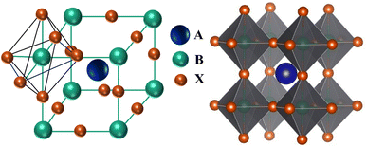

The Goldschmidt tolerance factor is a dimensionless parameter and is used to predict the geometrical distortion and stability of perovskite structures based on the sizes of the cations and anions in ${ABX}_{3}$. The Goldschmidt tolerance factor is defined by $t = (R_{A}+R_{B})/\sqrt{2}(R_{X}+R_{B})$, where $R_{A}$, $R_{B}$ and $R_{X}$ are the effective ionic radii for A, B, and X atoms respectively. It should be within the range of 0.80 < t < 1.0 to sustain the 3D structure (Valipour et al., 2020). The tolerance factor of a given ${ABX}_{3}$ not only serves as an indicator for evaluating its probability to adopt a 3D structure but also serves as a predictive tool for determining whether it will demonstrate a cubic phase (t ≈ 1) or deviate towards tetragonal (0.9 < t < 1.0), or tilted towards orthorhombic (0.8 < t < 0.9) phases (Gao et al., 2020). Additionally, non-perovskite structures form when the tolerance factor is larger than one or less than 0.8 (Stoumpos and Kanatzidis, 2015). Another crucial parameter known as the octahedral factor, μ, is used to forecast the formation of the ${BX}_{6}$ octahedral and the stability of the perovskite structure. This factor is defined as the ratio of the ionic radius of the divalent cation $R_{B}$ to the ionic radius of the anion $R_{X}$. This octahedral factor needs to be within the range of 0.414 < μ < 0.732 to facilitate the formation of the ${BX}_{6}$ octahedral (Bartel et al., 2019). Sustaining this 3D crystal structure is vital for easing the charge transport within the system, ensuring the efficient accumulation of photo-generated charges (Etgar, 2018).

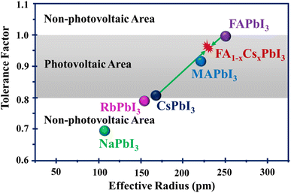

Crystal-structure changes can impact the stability of perovskite materials. A central measure for assessing the phase stability of perovskite structures is the Goldschmidt tolerance factor (t), which is based on the effective ionic radii of the elements in the ${ABX}_{3}$ or mixed perovskite formula. In addition, tolerance factor values greater than 1 or less than 0.8 tend to result in non-photovoltaic perovskite structures.

Depending on the tolerance factors, perovskite crystal phases can be categorized into cubic (t ≈ 1), tetragonal (0.9 < t < 1.0) and orthorhombic (0.8 < t < 0.9) structures. The α-phase of the perovskite structure is more stable than others. This phase has a cubic or tetragonal crystal structure, which is highly symmetrical and allows for effective charge transport. In comparison to the α-phase, the δ-phase exhibits less stability and symmetry. It does not have the desired perovskite structure and is frequently seen at lower temperatures. Its structure can drastically degrade the material's performance in devices such as solar cells since it doesn't allow charge movement as effectively. For example, there are two phases of ${FAPbI}_{3}$, namely the photoactive α-phase with a large tolerance factor and the non-photoactive δ-phase. The δ-phase of FAPbI3 is converted to the stable perovskite α-phase at temperatures higher than room temperature (Pool et al., 2017). The impressive optical properties and record performance of ${MAPbI}_{3}$ are overshadowed due to its phase instability (Kogo et al., 2018). This material undergoes a structural shift from the tetragonal to cubic phase at 54–57 °C, which leads to various issues (Onoda-Yamamuro et al., 1990; Baikie et al., 2013). These include the formation of defects, reduced mobility of charge carriers, shorter diffusion lengths, alterations in the band structure, and increased recombination losses within the absorbing material (Roghabadi et al., 2019; Ball and Petrozza, 2016).

**Band-gap Tuning, Compositional Engineering**

-approaches for achieving high performance and stability of PSCs by band gap alteration

1. Substituting A-site Cations
2. Substituting B-site Cations
3. Substituting X-site Anions
4. Pressure
5. Reducing Dimension

The band gap is the energy difference between the valence band maximum and the conduction band minimum of a material. Because of its direct influence on optoelectronic characteristics, band-gap adjustment in perovskite materials is crucial. It specifies the range of light wavelengths that a substance may absorb and convert into an electrical signal. The ability to modify the band-gap from low to high range has made perovskites appealing for a diversity of applications including photovoltaics, lasing, light-emitting devices, photodetectors, high energy, and particle detection (Miah et al., 2024). Metal halide perovskites are an encouraging family of materials for highly efficient PSCs for their tunable band-gap aligning with solar energy. In this section, compositional engineering, pressure-induced band gap modulation, and dimensional reduction and mixing approaches have been discussed.

Compositional engineering involves replacing elements in different sites in ${ABX}_{3}$, where B and X-site modifications have more pronounced effects on the electronic band gap structure as compared to A-site replacement. While A-site replacements mainly influence the spatial arrangement of octahedral structures, B and X-site replacements directly impact the conduction and valence bands of the perovskite materials, respectively. Consequently, strategies focusing on B and X-site modifications are more effective for attaining desired band gap adjustments.

However, although pressure-induced bandgap tailoring effectively modifies the bandgap of perovskite materials, there are issues connected with maintaining a consistent pressure during the device's application to attain optimal performance levels. This drawback raises concerns about the practical viability and long-term stability of devices relying solely on pressure-induced modulation.

perovskite-based tandem solar cells (PBTSCs)

***Compositional Engineering***

One of the most appealing aspects of perovskites for photovoltaics is the capability to adjust their energy band gap by simple compositional exchange. The perovskite semiconducting materials utilized in high-performing PSCs typically have energy band gaps between 1.48 eV and 1.62 eV (Eperon et al., 2014; Son et al., 2016; Saliba et al., 2016; Yang et al., 2015). The semiconducting materials with lower band gaps are essential for capturing more of the visible solar spectrum. Utilizing different perovskite materials with varying band gaps enables the formation of PBTSCs, permitting the absorption of a wider spectrum of light. This approach has the potential to exceed the Shockley–Queisser PCE limit observed in single-junction PSCs (Shockley and Queisser, 1961). As an extensively used and high PCE-possessing material, the energy band-gap of methylammonium lead iodide (${MAPbI}_{3}$) may be adjusted from 1.6 eV to 2.3 eV by replacing iodine with bromine at different ratios (Noh et al., 2013). A similar technique may adjust the band gap of formamidinium lead tri-halide (${FAPbX}_{3}$) from 1.48 eV to 2.23 eV.21 The compositional band-gap fine-tuning optimizes metal halide perovskites for usage as bottom or top cell absorbers in tandem or single junction solar cells. A-site substitution has a relatively less direct impact on the edge of the band structure, i.e., Eg in comparison with B and X-site substitutions in the ${ABX}_{3}$ phases (Lehner et al., 2015). However, A-site cations can influence the lattice constant, which might indirectly influence the band structure. These A-site cations can also affect the dielectric characteristics, hydrogen bonding interactions (with halide anions), and/or alter the ${BX}_{6}$ octahedral framework. We have outlined the following three factors involved with the compositional changes, which may facilitate the readers' understanding of the band gap engineering of the perovskite materials.

(i) The first aspect is related to electronegativity, where $E_{g}$ is increased when the electronegativity difference between the B-site metal and the X-site halide increases, but the A-site atoms have an indirect effect on $E_{g}$. (Kim et al., 2015; KIm et al., 2016).

(ii) The second factor linked to the $E_{g}$ is the B–X–B angle. Particularly, $E_{g}$ increases with the B–X–B angle decreases (Filip et al., 2014; Amat et al., 2014).

(iii) The third factor is the distance between X and B atoms, where $E_{g}$ is reduced as the distance between the X and B atoms decreases (Kim et al., 2015; Grote and Berger, 2015; Kong et al., 2016).

It is essential to emphasize that when replacing atoms at various sites within the ${ABX}_{3}$ structure, careful attention must be given to maintaining the Goldschmidt tolerance factor and octahedral factor in order to achieve and preserve the 3D crystal structure. It is generally well-known that the characteristics of a semiconducting material are substantially governed by its crystal structure; hence, geometric distortion considerably contributes to the modifications in the features of perovskite semiconducting materials.

The stability and high performance of PSCs are intricately dependent on multifaceted factors ranging from material engineering to fabrication techniques, post-treatment processes, and device design (Roy et al., 2020; Li et al., 2018). Material engineering plays a fundamental role in tailoring the composition, structure, and properties of perovskite materials to accomplish desired optoelectronic features; this has been explained in detail in this study (Prakash et al., 2018). Precise control over fabrication procedures, including solution processing, vapor deposition, and printing methods, affects film morphology, crystallinity, and defect density, which are crucial aspects that determine device performance (Bhattarai et al., 2022; Jamal et al., 2018; Krishna et al., 2021; Dubey et al., 2018). Moreover, post-treatment techniques, including thermal annealing and solvent engineering, further polish film quality and optimize the perovskite layer for enhancing charge transportation and light harvesting (Liu et al., 2015; Kim et al., 2017; Dualeh et al., 2014; van Franeker et al., 2017). Device architectures, which include the selection of charge transport layers, interfacial engineering, and passivation strategies, are essential for reducing the losses due to recombination and increasing the charge extraction efficiency (Krishna et al., 2021; Miah et al., 2023). Effective encapsulation strategies shield PSCs from environmental degradation factors like moisture, oxygen, and light exposure, which preserve their stability and prolong their operational lifetime (Miah et al., 2023; Singh et al., 2020). The interplay of these factors, spanning from film morphology to encapsulation, ultimately determines PSC stability and long-term high performance, which make them attractive contenders for widespread utilization in renewable energy applications.

M. H. Miah, et al., Understanding the Degradation Factors, Mechanism and Initiatives for Highly Efficient Perovskite Solar Cells, ChemNanoMat, 2023, 9(3), e202200471, DOI:10.1002/CNMA.202200471.

R. Singh, S. Ghosh, A. S. Subbiah, N. Mahuli and S. K. Sarkar, ALD Al2O3 on hybrid perovskite solar cells: Unveiling the growth mechanism and long-term stability, Sol. Energy Mater. Sol. Cells, 2020, 205, 110289, DOI:10.1016/J.SOLMAT.2019.110289.

J. Liu, et al., Improved Crystallization of Perovskite Films by Optimized Solvent Annealing for High Efficiency Solar Cell, ACS Appl. Mater. Interfaces, 2015, 7(43), 24008–24015, DOI:10.1021/ACSAMI.5B06780/SUPPL_FILE/AM5B06780_SI_001.PDF.

M. Kim, et al., High-Temperature-Short-Time Annealing Process for High-Performance Large-Area Perovskite Solar Cells, ACS Nano, 2017, 11(6), 6057–6064, DOI:10.1021/ACSNANO.7B02015/SUPPL_FILE/NN7B02015_SI_001.PDF.

A. Dualeh, N. Tétreault, T. Moehl, P. Gao, M. K. Nazeeruddin and M. Grätzel, Effect of Annealing Temperature on Film Morphology of Organic–Inorganic Hybrid Pervoskite Solid-State Solar Cells, Adv. Funct. Mater., 2014, 24(21), 3250–3258, DOI:10.1002/ADFM.201304022.

J. J. van Franeker, K. H. Hendriks, B. J. Bruijnaers, M. W. G. M. Verhoeven, M. M. Wienk and R. A. J. Janssen, Monitoring Thermal Annealing of Perovskite Solar Cells with In Situ Photoluminescence, Adv. Energy Mater., 2017, 7(7), 1601822, DOI:10.1002/AENM.201601822.

S. Bhattarai, et al., A detailed review of perovskite solar cells: Introduction, working principle, modelling, fabrication techniques, future challenges, Micro Nanostruct., 2022, 172, 207450, DOI:10.1016/J.MICRNA.2022.207450.

M. S. Jamal, et al., Fabrication techniques and morphological analysis of perovskite absorber layer for high-efficiency perovskite solar cell: A review, Renewable Sustainable Energy Rev., 2018, 98, 469–488, DOI:10.1016/J.RSER.2018.09.016.

B. G. Krishna, G. S. Rathore, N. Shukla and S. Tiwari, Perovskite solar cells: A review of architecture, processing methods, and future prospects, Hybrid Perovskite Compos. Mater., 2021, 375–412, DOI:10.1016/B978-0-12-819977-0.00018-4.

A. Dubey, et al., A strategic review on processing routes towards highly efficient perovskite solar cells, J. Mater. Chem. A, 2018, 6(6), 2406–2431, 10.1039/C7TA08277K.

J. Prakash, et al., Progress in tailoring perovskite based solar cells through compositional engineering: Materials properties, photovoltaic performance and critical issues, Mater. Today Energy, 2018, 9, 440–486, DOI:10.1016/J.MTENER.2018.07.003.

P. Roy, N. Kumar Sinha, S. Tiwari and A. Khare, A review on perovskite solar cells: Evolution of architecture, fabrication techniques, commercialization issues and status, Sol. Energy, 2020, 198, 665–688, DOI:10.1016/J.SOLENER.2020.01.080.

Z. Li, et al., Scalable fabrication of perovskite solar cells, Nat. Rev. Mater., 2018, 3(4), 1–20, DOI:10.1038/natrevmats.2018.17.

C. Grote and R. F. Berger, Strain Tuning of Tin-Halide and Lead-Halide Perovskites: A First-Principles Atomic and Electronic Structure Study, J. Phys. Chem. C, 2015, 119(40), 22832–22837, DOI:10.1021/ACS.JPCC.5B07446/SUPPL_FILE/JP5B07446_SI_001.PDF.

L. Kong, et al., Simultaneous band-gap narrowing and carrier-lifetime prolongation of organic-inorganic trihalide perovskites, Proc. Natl. Acad. Sci. U. S. A., 2016, 113(32), 8910–8915, DOI:10.1073/PNAS.1609030113/SUPPL_FILE/PNAS.1609030113.SAPP.PDF.

M. R. Filip, G. E. Eperon, H. J. Snaith and F. Giustino, Steric engineering of metal-halide perovskites with tunable optical band gaps, Nat. Commun., 2014, 5(1), 1–9, DOI:10.1038/ncomms6757.

A. Amat, et al., Cation-induced band-gap tuning in organohalide perovskites: Interplay of spin-orbit coupling and octahedra tilting, Nano Lett., 2014, 14(6), 3608–3616, DOI:10.1021/NL5012992/SUPPL_FILE/NL5012992_SI_001.PDF.

J. Kim, S. C. Lee, S. H. Lee and K. H. Hong, Importance of orbital interactions in determining electronic band structures of organo-lead iodide, J. Phys. Chem. C, 2015, 119(9), 4627–4634, DOI:10.1021/JP5126365/SUPPL_FILE/JP5126365_SI_001.PDF.

J. Kim, S. H. Lee, C. H. Chung and K. H. Hong, Systematic analysis of the unique band gap modulation of mixed halide perovskites, Phys. Chem. Chem. Phys., 2016, 18(6), 4423–4428, 10.1039/C5CP05982H.

A. J. Lehner, et al., Crystal and Electronic Structures of Complex Bismuth Iodides A3Bi2I9 (A = K, Rb, Cs) Related to Perovskite: Aiding the Rational Design of Photovoltaics, Chem. Mater., 2015, 27(20), 7137–7148, DOI:10.1021/ACS.CHEMMATER.5B03147/SUPPL_FILE/CM5B03147_SI_001.PDF.

W. Shockley and H. J. Queisser, Detailed Balance Limit of Efficiency of p-n Junction Solar Cells, J. Appl. Phys., 1961, 32(3), 510–519, DOI:10.1063/1.1736034.

M. H. Miah, M. U. Khandaker, M. A. Islam, M. Nur-E-Alam, H. Osman and M. H. Ullah, Perovskite materials in X-ray detection and imaging: recent progress, challenges, and future prospects, RSC Adv., 2024, 14(10), 6656–6698, 10.1039/D4RA00433G.

F. Arabpour Roghabadi, et al., Stability progress of perovskite solar cells dependent on the crystalline structure: From 3D ABX3 to 2D Ruddlesden–Popper perovskite absorbers, J. Mater. Chem. A, 2019, 7(11), 5898–5933, 10.1039/C8TA10444A.

J. M. Ball and A. Petrozza, Defects in perovskite-halides and their effects in solar cells, Nat. Energy, 2016, 1(11), 1–13, DOI:10.1038/nenergy.2016.149.

N. Onoda-Yamamuro, T. Matsuo and H. Suga, Calorimetric and IR spectroscopic studies of phase transitions in methylammonium trihalogenoplumbates (II), J. Phys. Chem. Solids, 1990, 51(12), 1383–1395, DOI:10.1016/0022-3697(90)90021-7.

T. Baikie, et al., Synthesis and crystal chemistry of the hybrid perovskite (CH3NH3)PbI3 for solid-state sensitised solar cell applications, J. Mater. Chem. A, 2013, 1(18), 5628–5641, 10.1039/C3TA10518K.

A. Kogo, Y. Sanehira, Y. Numata, M. Ikegami and T. Miyasaka, Amorphous Metal Oxide Blocking Layers for Highly Efficient Low-Temperature Brookite TiO2-Based Perovskite Solar Cells, ACS Appl. Mater. Interfaces, 2018, 10(3), 2224–2229, DOI:10.1021/ACSAMI.7B16662/SUPPL_FILE/AM7B16662_SI_001.PDF.

V. L. Pool, et al., Thermal engineering of FAPbI3 perovskite material via radiative thermal annealing and in situ XRD, Nat. Commun., 2017, 8(1), 1–8, DOI:10.1038/ncomms14075.

L. Etgar, The merit of perovskite's dimensionality; can this replace the 3D halide perovskite?, Energy Environ. Sci., 2018, 11(2), 234–242, 10.1039/C7EE03397D.

C. J. Bartel, et al., New tolerance factor to predict the stability of perovskite oxides and halides, Sci. Adv., 2019, 5(2), 1–9, DOI:10.1126/SCIADV.AAV0693/SUPPL_FILE/AAV0693_TABLE_S4.CSV.

C. C. Stoumpos and M. G. Kanatzidis, The Renaissance of Halide Perovskites and Their Evolution as Emerging Semiconductors, Acc. Chem. Res., 2015, 48(10), 2791–2802, DOI:10.1021/ACS.ACCOUNTS.5B00229/ASSET/IMAGES/MEDIUM/AR-2015-002292_0014.GIF.

W. Gao, et al., A-Site Cation Engineering of Metal Halide Perovskites: Version 3.0 of Efficient Tin-Based Lead-Free Perovskite Solar Cells, Adv. Funct. Mater., 2020, 30(34), 2000794, DOI:10.1002/ADFM.202000794.

F. Valipour, E. Yazdi, N. Torabi, B. F. Mirjalili and A. Behjat, Improvement of the stability of perovskite solar cells in terms of humidity/heat via compositional engineering, J. Phys. D Appl. Phys., 2020, 53(28), 285501, DOI:10.1088/1361-6463/AB8511.

A. Aftab and M. I. Ahmad, A review of stability and progress in tin halide perovskite solar cell, Sol. Energy, 2021, 216, 26–47, DOI:10.1016/J.SOLENER.2020.12.065.

N. Suresh Kumar and K. Chandra Babu Naidu, A review on perovskite solar cells (PSCs), materials and applications, J. Mater., 2021, 7(5), 940–956, DOI:10.1016/J.JMAT.2021.04.002.

N. G. Park, Perovskite solar cells: an emerging photovoltaic technology, Mater. Today, 2015, 18(2), 65–72, DOI:10.1016/J.MATTOD.2014.07.007.

M. B. Rahman, N.-E. Ashrafi, M. H. Miah, M. U. Khandaker and M. A. Islam, Selection of a compatible electron transport layer and hole transport layer for the mixed perovskite FA0.85Cs0.15Pb (I0.85Br0.15)3, towards achieving novel structure and high-efficiency perovskite solar cells: a detailed numerical study by SCAPS-1D, RSC Adv., 2023, 13(25), 17130–17142, 10.1039/D3RA02170J

M. H. Miah, et al., Understanding the Degradation Factors, Mechanism and Initiatives for Highly Efficient Perovskite Solar Cells, ChemNanoMat, 2023D, 9(3), e202200471, DOI:10.1002/CNMA.202200471.

A. Kuc, N. Zibouche and T. Heine, Influence of quantum confinement on the electronic structure of the transition metal sulfide TS2, Phys. Rev. B: Condens. Matter Mater. Phys., 2011, 83(24), 245213, DOI:10.1103/PHYSREVB.83.245213/FIGURES/6/MEDIUM.

M. A. Green, A. Ho-Baillie and H. J. Snaith, The emergence of perovskite solar cells, Nat. Photonics, 2014, 8(7), 506–514, DOI:10.1038/nphoton.2014.134.

A. Haug, Non-radiative recombination of electron-hole drops by means of phonon-assisted Auger recombination, J. Lumin., 1979, 20(2), 173–177, DOI:10.1016/0022-2313(79)90048-6.

M. H. Pilkuhin, Non-radiative recombination and luminescence in silicon, J. Lumin., 1979, 18–19(PART 1), 81–87, DOI:10.1016/0022-2313(79)90078-4.

E. M. Hutter, et al., Direct–indirect character of the bandgap in methylammonium lead iodide perovskite, Nat. Mater., 2016, 16(1), 115–120, DOI:10.1038/nmat4765.

J. Kangsabanik, M. K. Svendsen, A. Taghizadeh, A. Crovetto and K. S. Thygesen, Indirect Band Gap Semiconductors for Thin-Film Photovoltaics: High-Throughput Calculation of Phonon-Assisted Absorption, J. Am. Chem. Soc., 2022, 144(43), 19872–19883, DOI:10.1021/JACS.2C07567/SUPPL_FILE/JA2C07567_SI_001.PDF.

D. Liang and J. E. Bowers, Recent progress in lasers on silicon, Nat. Photonics, 2010, 4(8), 511–517, DOI:10.1038/nphoton.2010.167.

A. Welte, C. Waldauf, C. Brabec and P. J. Wellmann, Application of optical absorbance for the investigation of electronic and structural properties of sol–gel processed TiO2 films, Thin Solid Films, 2008, 516(20), 7256–7259, DOI:10.1016/J.TSF.2007.12.025.

D. Monllor-Satoca, R. Gómez, M. González-Hidalgo and P. Salvador, The ‘Direct–Indirect’ model: An alternative kinetic approach in heterogeneous photocatalysis based on the degree of interaction of dissolved pollutant species with the semiconductor surface, Catal. Today, 2007, 129(1–2), 247–255, DOI:10.1016/J.CATTOD.2007.08.002.

O. I. Malyi and C. M. Acosta, Amorphization of Indirect Band Gap Semiconductors to Tune Their Optoelectronic Properties, J. Phys. Chem. C, 2020, 124(27), 14432–14438, DOI:10.1021/ACS.JPCC.0C02332/SUPPL_FILE/JP0C02332_SI_001.PDF.

M. A. Haq, M. Saiduzzaman, T. I. Asif, I. K. Shuvo and K. M. Hossain, Ultra-violet to visible band gap engineering of cubic halide KCaCl3 perovskite under pressure for optoelectronic applications: insights from DFT, RSC Adv., 2021, 11(58), 36367–36378, 10.1039/D1RA06430D.

J. Xing, et al., Color-stable highly luminescent sky-blue perovskite light-emitting diodes, Nat. Commun., 2018, 9(1), 1–8, DOI:10.1038/s41467-018-05909-8.

S. Jiang, R. Wang, M. Li, R. Yu, F. Wang and Z. Tan, Synergistic electrical and light management enables efficient monolithic inorganic perovskite/organic tandem solar cells with over 24% efficiency, Energy Environ. Sci., 2024, 17(1), 219–226, 10.1039/D3EE02940A.

E. Aydin, et al., Pathways toward commercial perovskite/silicon tandem photovoltaics, Science, 2024, 383(6679) DOI:10.1126/science.adh3849.

E. Priyanka and D. Muchahary, Performance improvement of perovskite/CIGS tandem solar cell using barium stannate charge transport layer and achieving PCE of 39 % numerically, Sol. Energy, 2024, 267, 112218, DOI:10.1016/J.SOLENER.2023.112218.

A. R. Zanatta, The Shockley–Queisser limit and the conversion efficiency of silicon-based solar cells, Results Opt., 2022, 9, 100320, DOI:10.1016/J.RIO.2022.100320.

S. K. Jung, N. G. Park and J. W. Lee, Light management in perovskite solar cells, Mater. Today Energy, 2023, 37, 101401, DOI:10.1016/J.MTENER.2023.101401.

M. I. Hossain, et al., Near field control for enhanced photovoltaic performance and photostability in perovskite solar cells, Nano Energy, 2021, 89, 106388, DOI:10.1016/J.NANOEN.2021.106388.

H. Fujiwara, M. Kato, M. Tamakoshi, T. Miyadera and M. Chikamatsu, Optical Characteristics and Operational Principles of Hybrid Perovskite Solar Cells, Phys. Status Solidi, 2018A, 215(12), 1700730, DOI:10.1002/PSSA.201700730.

Y. Miao, et al., Construction of efficient perovskite solar cell through small-molecule synergistically assisted surface defect passivation and fluorescence resonance energy transfer, Chem. Eng. J., 2021, 426, 131358, DOI:10.1016/J.CEJ.2021.131358.

D. Y. Son, et al., Self-formed grain boundary healing layer for highly efficient CH3NH3PbI3 perovskite solar cells, Nat. Energy, 2016, 1(7), 1–8, DOI:10.1038/nenergy.2016.81.

W. S. Yang, et al., High-performance photovoltaic perovskite layers fabricated through intramolecular exchange, Science, 2015, 348(6240), 1234–1237, DOI:10.1126/SCIENCE.AAA9272/SUPPL_FILE/YANG-SM.PDF.

M. Saliba, et al., Cesium-containing triple cation perovskite solar cells: Improved stability, reproducibility and high efficiency, Energy Environ. Sci., 2016, 9(6), 1989–1997, 10.1039/C5EE03874J.

H. Fujiwara, M. Kato, M. Tamakoshi, T. Miyadera and M. Chikamatsu, Optical Characteristics and Operational Principles of Hybrid Perovskite Solar Cells, Phys. Status Solidi, 2018B, 215(12), 1700730, DOI:10.1002/PSSA.201700730.

Y. Lei, Y. Li and Z. Jin, Photon energy loss and management in perovskite solar cells, Energy Rev., 2022, 1(1), 100003, DOI:10.1016/J.ENREV.2022.100003.

A. (Adolf) Goetzberger, J. Knobloch, and B. Voss, Crystalline Silicon Solar Cells, Wiley, 1998, p. , p. 237, accessed: Feb. 21, 2024, [Online], available, <https://www.wiley.com/en-us/Crystalline+Silicon+Solar+Cells-p-9780471971443>

Y. Xia, et al. (2023) Organic-Inorganic Hybrid Quasi-2d Perovskites Incorporated with Fluorinated Additive for Efficient and Stable Four-Terminal Tandem Solar Cells, Energy Mater., 3(1), 300004, DOI:10.20517/energymater.2022.55.

J. Xu, L. A. Castriotta, A. Di Carlo and T. M. Brown (2024) Air-Stable Lead-Free Antimony-Based Perovskite Inspired Solar Cells and Modules, ACS Energy Lett., 9(2), 671–678, DOI:10.1021/ACSENERGYLETT.3C02409.

J. H. Noh, S. H. Im, J. H. Heo, T. N. Mandal and S. Il Seok (2013) Chemical management for colorful, efficient, and stable inorganic-organic hybrid nanostructured solar cells, Nano Lett., 13(4), 1764–1769, DOI:10.1021/NL400349B/SUPPL_FILE/NL400349B_SI_001.PDF.

G. E. Eperon, S. D. Stranks, C. Menelaou, M. B. Johnston, L. M. Herz and H. J. Snaith (2014) Formamidinium lead trihalide: a broadly tunable perovskite for efficient planar heterojunction solar cells, Energy Environ. Sci., 7(3), 982–988, 10.1039/C3EE43822H.

G. Liu, L. Kong, W. Yang and H. Kwang Mao (2019) Pressure engineering of photovoltaic perovskites, Mater. Today, 27, 91–106, DOI:10.1016/J.MATTOD.2019.02.016.

Q. Ou, et al. (2019) Band structure engineering in metal halide perovskite nanostructures for optoelectronic applications, Nano Mater. Sci., 1(4), 268–287, DOI:10.1016/J.NANOMS.2019.10.004.

H. J. Snaith, et al., (2014) Anomalous hysteresis in perovskite solar cells, J. Phys. Chem. Lett., 5(9), 1511–1515, DOI:10.1021/JZ500113X/SUPPL_FILE/JZ500113X_SI_001.PDF.

J. M. Azpiroz, E. Mosconi, J. Bisquert and F. De Angelis (2015) Defect migration in methylammonium lead iodide and its role in perovskite solar cell operation, Energy Environ. Sci., 8(7), 2118–2127, 10.1039/C5EE01265A.

N. K. Elumalai and A. Uddin (2016) Hysteresis in organic-inorganic hybrid perovskite solar cells, Sol. Energy Mater. Sol. Cells, 157, 476–509, DOI:10.1016/J.SOLMAT.2016.06.025.

L. M. Pazos-Outón, T. P. Xiao and E. Yablonovitch (2018) Fundamental Efficiency Limit of Lead Iodide Perovskite Solar Cells, J. Phys. Chem. Lett., 9(7), 1703–1711, DOI:10.1021/ACS.JPCLETT.7B03054/ASSET/IMAGES/LARGE/JZ-2017-030546_0008.JPEG.

B. Chen, P. N. Rudd, S. Yang, Y. Yuan and J. Huang (2019) Imperfections and their passivation in halide perovskite solar cells, Chem. Soc. Rev., 48(14), 3842–3867, 10.1039/C8CS00853A.

M. H. Miah, et al., (2023C) Understanding the Degradation Factors, Mechanism and Initiatives for Highly Efficient Perovskite Solar Cells, ChemNanoMat, 9(3), e202200471, DOI:10.1002/CNMA.202200471.

H. Min, et al., (2021) Perovskite solar cells with atomically coherent interlayers on SnO2 electrodes, Nature, 598(7881), 444–450, DOI:10.1038/s41586-021-03964-8.

A. Kojima, K. Teshima, Y. Shirai and T. Miyasaka, (2009) Organometal halide perovskites as visible-light sensitizers for photovoltaic cells, J. Am. Chem. Soc., 131(17), 6050–6051, DOI:10.1021/JA809598R/SUPPL_FILE/JA809598R_SI_001.PDF.

M. A. Green, et al., (2024) Solar cell efficiency tables (Version 63), Prog. Photovolt.: Res. Appl., 32(1), 3–13, DOI:10.1002/PIP.3750.

T. A. Chowdhury, M. A. Bin Zafar, M. Sajjad-Ul Islam, M. Shahinuzzaman, M. A. Islam and M. U. Khandaker, (2023) Stability of perovskite solar cells: issues and prospects, RSC Adv., 13(3), 1787–1810, 10.1039/D2RA05903G.

Miah, M.H. et al., (2023A) Optimization and detail analysis of novel structure Pb-free CsGeI3-based all-inorganic perovskite solar cells by SCAPS-1D, Optik, 2023, 281, 170819, DOI:10.1016/J.IJLEO.2023.170819

A. Guerrero, E. J. Juarez-Perez, J. Bisquert, I. Mora-Sero and G. Garcia-Belmonte, (2014) Electrical field profile and doping in planar lead halide perovskite solar cells, Appl. Phys. Lett., 105(13), 133902, DOI:10.1063/1.4896779.

B. Salhi, Y. S. Wudil, M. K. Hossain, A. Al-Ahmed and F. A. Al-Sulaiman, (2018) Review of recent developments and persistent challenges in stability of perovskite solar cells, Renewable Sustainable Energy Rev., 90, 210–222, DOI:10.1016/J.RSER.2018.03.058.

M. B. Rahman, N. Noor-E-Ashrafi, M. H. Miah, M. U. Khandaker and M. A. Islam (2023) Selection of a compatible electron transport layer and hole transport layer for the mixed perovskite FA0.85Cs0.15Pb (I0.85Br0.15)3, towards achieving novel structure and high-efficiency perovskite solar cells: a detailed numerical study by SCAPS-1D, RSC Adv., 13(25), 17130–17142, 10.1039/D3RA02170J.

M. H. Miah, et al., (2023B) Understanding the Degradation Factors, Mechanism and Initiatives for Highly Efficient Perovskite Solar Cells, ChemNanoMat, 9(3), e202200471, DOI:10.1002/CNMA.202200471.

* + Investigating the effects of different cations and anions on perovskite properties.

When investigating the effects of different cations and anions on perovskite properties, the key point to understand is that substituting different ions at the A and B sites of the perovskite structure (AX2B) can significantly impact the material's crystal structure, band gap, stability, charge carrier mobility, and overall optoelectronic properties, making it crucial for tailoring perovskite materials for specific applications like solar cells, light-emitting diodes, and electronic devices.

1. Cation size and charge:
2. A-site cation: Changing the size and charge of the A-site cation (e.g., substituting smaller cations like Cs+ for larger ones like MA+) can influence the lattice distortion, impacting the stability and optical properties of the perovskite.
3. B-site cation: Modifying the B-site cation (e.g., Pb2+ with Sn2+) can significantly alter the band gap, affecting the absorption spectrum and charge carrier mobility.

2) Anion size and electronegativity:

1. Halide anions: Substituting different halide anions (I-, Br-, Cl-) at the X-site can significantly adjust the band gap due to their varying electronegativity, allowing for fine-tuning of the perovskite's optical properties.

Specific effects of different cations and anions:

1. Improved stability:
2. Larger cations: Incorporating larger cations like Cs+ can enhance the structural stability of the perovskite by reducing lattice distortions.
3. Mixed cations: Using a mixture of cations with different sizes (e.g., MA+ and FA+) can sometimes lead to better stability by creating a more evenly distributed strain within the lattice.

2) Band gap tuning:

1. Halide substitution: Replacing I- with smaller Br- or Cl- anions usually leads to a wider bandgap, shifting the absorption spectrum towards shorter wavelengths.

3) Charge carrier mobility:

1. Cation selection: The choice of A-site cation can affect the charge carrier mobility due to the interaction with the lattice vibrations.

4) Defect engineering:

1. Doping with cations: Intentionally introducing small amounts of dopant cations can help passivate defects, improving the perovskite's electrical properties.

Investigative methods:

1. X-ray diffraction: To analyze the crystal structure and lattice parameters of the perovskite.
2. Optical spectroscopy (UV-Vis, PL): To study the band gap, absorption coefficient, and emission properties.
3. Electrical characterization (conductivity, carrier mobility): To assess the charge transport behavior.
4. Density Functional Theory (DFT) calculations: To predict and understand the electronic structure and properties based on different cation and anion combination
   * Exploring 2D layered perovskites for enhanced stability.

Hsinhan Tsai, The challenges and promises of layered 2D perovskites, Chem, Volume 8, Issue 4, 2022, Pages 890-891, <https://doi.org/10.1016/j.chempr.2022.03.021>

2D perovskite structure is composed of alternating layers of inorganic metal halide octahedra (like PbI6) "sandwiched" between layers of large organic cations, acting as spacers, which effectively create a two-dimensional sheet-like structure within the crystal lattice; the general chemical formula for a 2D perovskite is (RNH3)2(A)n-1MX3n+1, where R is the organic spacer cation, A is a smaller cation, M is the metal cation (like Pb), X is the halide ion, and n represents the number of inorganic perovskite layers between spacer layers.

Key points about 2D perovskite structure:

Spacer cations:

Large organic cations like butylammonium (BA) or phenylethylamine (PEA) are crucial for creating the 2D structure by separating the inorganic octahedral layers.

Inorganic layer:

The inorganic layer consists of metal halide octahedra where the metal is typically lead (Pb) and the halide is iodine (I).

Quantum well effect:

Due to the confinement of charge carriers within the inorganic layers, 2D perovskites exhibit quantum well effects, leading to unique optoelectronic properties.

Tunable thickness:

By adjusting the number of inorganic layers (n value), the thickness of the 2D perovskite can be controlled, influencing its properties.

2D perovskite solar cells are made from perovskite materials with a layered crystal structure, while 2D/3D perovskite solar cells are a combination of 2D and 3D perovskites. The main difference between the two is their crystal structure.

2D perovskites

Have a layered structure of metal-halide sheets separated by organic cations

Have improved stability compared to 3D perovskites

Have a large bandgap and limited charge transport

Have greater synthetic versatility

2D/3D perovskites

Combine the advantages of 2D and 3D perovskites

Can maintain long-term stability and high performance

Can have improved film quality and charge extraction

Can have decreased defect density

2D perovskites are promising for a wide range of applications, including solar cells, light emitting diodes, and radiation detectors. 2D/3D perovskites are an attractive research direction for obtaining high-performance perovskite devices

2D perovskite materials have a layered crystal structure, while 2D/3D perovskite materials are a combination of 2D and 3D perovskites. Both types of perovskite materials have different optical and electronic properties. 2D perovskite Made of metal-halide sheets separated by organic cations Has a layered structure that changes its optical and electronic properties Has high exciton binding energies Has poor charge transport in the out-of-plane direction 2D/3D perovskite Has higher charge mobility and power conversion efficiency than 2D perovskite Has less non-radiative charge recombination than 2D perovskite Has a smaller bandgap than 2D perovskite Has long-term stability Has tunable properties Has improved interface level 2D/3D perovskite materials are used in perovskite solar cells (PSCs). The 2D layers in 2D/3D perovskite materials improve stability, prevent ion migration, and increase the effectiveness of charge collection. 2D/3D perovskite materials can be synthesized using...

* **Charge transport layer optimization:**
  + Designing efficient hole and electron transport materials to facilitate charge collection.
  + Studying interfacial properties between the perovskite layer and charge transport layers.
* **Stability enhancement:**
  + Understanding degradation mechanisms under environmental stresses like heat, humidity, and UV light.
  + Developing encapsulation strategies to protect perovskite cells from degradation.
  + Exploring methods to improve ion migration within the perovskite layer.
* **Device fabrication techniques:**
  + Optimizing solution-based deposition methods like spin coating, spray coating, and blade coating for large-scale production.
  + Investigating novel fabrication techniques like roll-to-roll processing for flexible perovskite modules.
* **Tandem solar cell development:**
  + Combining perovskite cells with other photovoltaic technologies like silicon to achieve higher efficiencies.
  + Designing efficient charge transfer mechanisms between different layers in a tandem device.
* **Characterization and analysis:**
  + Utilizing advanced microscopy techniques (TEM, SEM) to study the morphology and microstructure of perovskite films.
  + Employing spectroscopy methods (XPS, PL) to evaluate the optoelectronic properties of perovskite materials.
* **Cost-effective manufacturing:**
  + Developing low-cost materials and processing techniques for large-scale perovskite solar cell production.

To develop low-cost perovskite solar cells for large-scale production, researchers are focusing on utilizing readily available, inexpensive materials, and implementing scalable processing techniques like spin coating, blade coating, screen printing, or inkjet printing, while optimizing the perovskite precursor chemistry to achieve high efficiency with minimal processing steps and reduced waste.

Key aspects of low-cost perovskite solar cell development:

* **Material selection:**
  + **Affordable precursors:** Using readily available and inexpensive metal halides like lead iodide (PbI2) and organic cations like methylammonium (MA+) or formamidinium (FA+) as the primary building blocks of the perovskite material.
  + **Additive engineering:** Incorporating small amounts of additives to the precursor solution to control crystal growth, improve film morphology, and enhance device performance.
  + **Alternative materials:** Exploring lead-free perovskite compositions to address environmental concerns while maintaining high efficiency.
* **Processing techniques:**
  + **Solution-based deposition:** Utilizing techniques like spin coating, blade coating, or slot-die coating to deposit the perovskite film on substrates, enabling large-area coverage and uniform thickness.
  + **Printing methods:** Exploring inkjet printing or screen printing for precise pattern deposition and potential for high-throughput manufacturing.
  + **Optimized annealing process:** Developing thermal annealing profiles to achieve high-quality perovskite crystallization with minimal energy consumption.
* **Device architecture optimization:**
  + **Inverted device structure:** Using an inverted device design with a charge transport layer on top of the perovskite layer to improve stability and facilitate large-area fabrication.
  + **Interface engineering:** Optimizing the interfaces between the perovskite layer and charge transport layers to minimize carrier recombination and enhance charge collection.

Specific research areas:

* **Developing new low-cost perovskite materials with high stability:**Exploring new organic cations, inorganic halide combinations, and incorporating functional additives to improve the stability of the perovskite material under environmental stress.
* **Scalable precursor synthesis:**Optimizing the synthesis process to produce high-quality perovskite precursors in large quantities with consistent chemical properties.
* **In-situ monitoring of film formation:**Utilizing advanced characterization techniques to monitor the perovskite film formation process in real-time, allowing for fine-tuning of deposition parameters.
* **Developing cost-effective substrates:**Investigating alternative substrate materials that are compatible with large-scale manufacturing and can be readily recycled.

Challenges:

* **Stability concerns:**Addressing the degradation of perovskite materials under environmental conditions like moisture and temperature fluctuations.
* **Large-area uniformity:**Ensuring consistent film quality and device performance across large areas during large-scale production.
* **Toxicity issues:**Finding lead-free perovskite materials with comparable performance to lead-based perovskites.

Overall, developing low-cost materials and optimizing processing techniques through research in solution-based deposition methods like spin coating, blade coating, and printing holds significant potential for large-scale, cost-effective production of high-efficiency perovskite solar cells.

* + Exploring recycling and reuse strategies for perovskite materials

**Tandem (Multijunction) Cells**

Monolithic perovskite-PERC tandem solar cell with 23.7% efficiency – pv magazine International <https://www.pv-magazine.com/2023/08/24/monolithic-perovskite-perc-tandem-solar-cell-with-23-7-efficiency/>

Tandem Cell - an overview | ScienceDirect Topics <https://www.sciencedirect.com/topics/engineering/tandem-cell>

Ding, Z., Kan, C., Jiang, S. et al. Highly passivated TOPCon bottom cells for perovskite/silicon tandem solar cells. Nat Commun 15, 8453 (2024). <https://doi.org/10.1038/s41467-024-52309-2>

Tandem solar cells: HJT + perovskite - the future of solar power - [hjtpv.com](http://hjtpv.com/) <https://hjtpv.com/tandem-solar-cells-hjt-perovskite-the-future-of-solar-power/>

1. Perovskite-Silicon Tandem Cells
2. Perovskite-Perovskite Tandem Cells

***Tandem Silicon-Perovskite Cells***

Perovskite PV should be seen as an augmentation to silicon PV, as perovskite adds light-absorbing properties to the stability of silicon. In terms of stability, silicon PV can reliably function for over two decades, whereas perovskite PVs degrade after just a few months to a few years of operation. To make high-purity silicon, temperatures over 1,000 degrees Celsius are needed, and the high temperature comes with higher economic and environmental costs. Perovskites can be produced at lower temperatures, around 200 degrees Celsius, but they degrade when exposed to heat, moisture and air and thus their lifespan is shorter (Kim et al., 2024).

Perovskite solar cells can be combined with silicon cells in a two-layered configuration where they complement each other perfectly to produce electricity. The tandem cell has better performance with greater efficiency than the efficiency produced by either cell independently.

One advantage of tandem silicon perovskite solar cells is higher power conversion efficiency compared to single-junction cells, because the combination of minerals allows the cell to absorb a wider range of the solar spectrum, as perovskite is known for its light-absorbing properties, and silicon is known for its stability. Tandem cells also have lower manufacturing costs thanks to the low-cost perovskite material. High energy yields can be achieved in tandem cells by optimizing the bandgaps of the silicon and perovskite layers, leading to broader spectral absorption, as the perovskite layer absorbs high-energy visible light, while the silicon layer absorbs lower-energy infrared light, allowing the cell to utilize a larger portion of the solar spectrum. Tandem cells have flexibility in design, as the bandgap of perovskite can be tuned to optimize the absorption of light in the tandem cell, allowing for customization depending on the application. Tandem cells can be lighter and thinner, because perovskite layers are very thin, which can lead to lighter and more flexible solar panels. Integrating perovskite with a stable silicon substrate can help mitigate the stability concerns associated with perovskite materials alone. Concerns with tandem silicon perovskite cells include manufacturing complexity, as creating efficient tandem cells requires precise control over the interface between the perovskite and silicon layers, and perovskite stability issues, as perovskite materials can still degrade over time.

***Tandem perovskite-silicon solar cells have several key advantages:***

1. The proliferation of tandem cells would far surpass efficiencies from existing silicon or perovskite cells which are nearly 30%.
2. With only a thinning perovskite film in a tandem perovskite cell, less lead and other materials are needed compared to in thicker standalone perovskite cells.
3. Tandem cell technology can be used as part of an N-type PV cell manufacturing process that is compatible with the prevailing industry trends.
4. Lower sensitivity to temperature variations can appear – the perovskite top cell also builds efficiency stability in high temperatures.
5. Durability or longevity
6. Efficiency retention when scaled to larger sizes or larger module areas— issues that have hindered their leap from laboratory to commercial viability.

**4-Junction Perovskite-CSI Tandem Solar Cell**

In 2023, an international research team fabricated a four-junction (4T) tandem solar cell based on perovskite and copper/indium/selenium (CIS) thin-film with a power conversion efficiency of up to 29.9%. The researchers used methyldiammonium diiodide (MDADI) to reduce open-circuit voltage losses in the top perovskite cell. The scientists said they used halide salt methyldiammonium diiodide (MDADI) for surface defect passivation, which they said reduced the open-circuit voltage loss in the device's top cell based on perovskite while improving the overall tandem cell efficiency and near-infrared (NIR) transmittance (Liang et al., 2023; Bellini, 2023E).

The scientists grew the top cell through a multi-stage co-evaporation process. The device was based on a substrate made of glass and indium tin oxide (ITO), a hole transport layer (HTL) made of nickel(II) oxide (NiOx), a perovskite absorber, a buckminsterfullerene ($C_{60}$) electron transport layer (ETL), a tin oxide (SnOx) layer, an ITO layer, and an ultrathin lithium fluoride (LiF) interlayer. “We then vary the optical pathways within the semi-transparent front cell to realize the control of the interference spectrum,” the team explained. “By matching the optical interference with the AM 1.5 G irradiance spectrum, the perovskite front cell achieves high average NIR transmittance (ANT) of 81.5% and an efficiency of 21.8%.” The academics also explained that the MDADI-treated film can reach a much higher quasi-Fermi level splitting (QFLS) compared with the one without the treatment. “The pseudo current-voltage (J-V) plot shows that the MDADI-treated film reaches an implied open-circuit voltage of 1.29 V, whereas the untreated film reaches only 1.24 V, and this marks a difference of around 50 mV.” his top cell was then combined in a tandem device with a bottom cell made with a glass substrate coated with molybdenum (Mo), a CIS absorber, a cadmium sulfide (CdS) buffer layer, and a window layer of zinc oxide (i-ZnO). This device has an efficiency of 17.3%, an open-circuit voltage of 0.60 V, a short-circuit current density of 39.7 mA/cm2, and a fill factor of 72.9% (Liang et al., 2023; Bellini, 2023E).

**Perovskite-Silicon Tandem Cells**

Perovskites are cheap, abundant photovoltaic (PV) materials that some have hailed as the future of green energy. Silicon is the primary material inside 95% of solar panels. Rather than replace it, you can layer perovskite on silicon to create tandem cells. Because each material absorbs energy from different wavelengths of sunlight, tandems could potentially deliver at least 20% more power than a silicon cell alone. Perovskite supporters say that this extra electricity could more than offset the additional costs of tandem cells, particularly in crowded urban areas or industrial sites where space is at a premium. There have been improvements in perovskite performance, achieved by tweaking the composition of both the crystals and the solar cells made from them. The term ‘perovskite’ describes the crystal structure of a naturally occurring mineral; the perovskites used in solar cells are synthetic crystals that mimic this structure, but can be made of many materials. A standard silicon panel can have ten times more lead in its soldered contacts than an entire perovskite panel does (Peplow, 2023).

Perovskite cells require very thin light-absorbing layers, and the materials involved are typically low cost and abundant. Thus, if perovskite cells were produced on the scale of silicon cells, they would have a lower energy and material footprint. In a typical tandem device, the perovskite cell is positioned above the silicon cell; each cell is made of multiple layers that all play a part in turning light into electricity. Sunlight hits the perovskite first and releases electrons from the material, leaving behind positively charged ‘holes’. The electrons travel into an adjacent charge-collection layer, and onwards to an electrode; holes migrate in the opposite direction. A similar process happens in the silicon cell, which is better at absorbing the lower-energy photons missed by the perovskite cell. As for the manufacturing process for tandem cells, it starts with silicon wafers, and the wafers pass through a series of chambers resembling conjoined refrigerators. Inside, clouds of ions build up layers of the cell in a process called physical vapor deposition. It’s slower than solution-based methods, but produces extremely high-quality films. A similar process creates the perovskite cell (Peplow, 2023).

**Recycling**

using advanced recycling processes, it is possible to create a circular economy for photovoltaic systems with lead perovskites.

The three primary options for PV module End-of-Life (EOL) disposal are: landfilling, recycling, and secondary use, with landfilling being the lowest cost handling option. As for module recycling, the process starts with mechanically removing the aluminum frames and then shearing off the junction box. For silicon recycling, the modules are then shred into small pieces, grinded into fine particles, and then the glass, polymers, interconnect ribbons, and cells are separated using eddy currents and sifting. Another silicon module recycling technique uses heat to remove the polymers from the glass, and then chemical treatments to separate the metals from the silicon. For Cadmium Telluride, CdTe, modules, after mechanical removal of the frame and junction box the commercial recycling process then proceeds to shred the laminate, grind it into small pieces in a hammermill, mechanical separate the glass and laminate pieces, and then immerse it in a series of chemical baths to recover the Cd and Te. In 2030, cumulative end-of-life PV waste in the United States is projected to be between 0.17 and 1 million tons, according to the International Renewable Energy Agency. This is compared to around 200 million tons of solid waste, excluding recycled and composted materials, generated in the United States each year. Estimates of annual PV module EOL volumes by 2050 is 12% of annual municipal electronic waste volumes in the United States. PV module materials are 99% non-hazardous and 95% of the materials are recyclable with current technologies. When recycling solar panels we want to research and develop safe and low impact EOL material handling tools, and to handle PV EOL volumes safely, responsibly, and economically, allowing for greater deployment and safe and socially responsible supply chains. The lifespan of PV systems is currently at 25-35 years, but some consumers and plant operators may choose to upgrade their panels before the warranty period expires or to take advantage of technological improvements. Early end-of-life issues for solar panels are caused by weather damage, installation errors, and manufacturing serial defects.[1]

To recycle silicon from end-of-life photovoltaic panels, Netherlands scientists have created a methodology to help create different wafer categories for recycling silicon for new ingot production, However, most of recycled silicon in the near future will come from p-type products, which will hardly be reutilized in a market now dominated by n-type modules. They investigated how cleaned wafers or wafer fragments recovered from end-of-life (EoL) PV modules could be reused for new crystalline silicon ingot production, and found that gallium-doped wafers could be particularly suitable for this purpose. Silicon from the discarded wafers should be recycled by eliminating any contamination on its surfaces, which would re-include it in the high-purity material category. According to the researchers, the main contaminants are dopant, oxygen, carbon, and nitrogen, analyzed from the perspective of dopant and resistivity control, and to a limited extent also from the perspective of other remaining contaminants (Geerlings et al., 2024; Bellini, 2024A).

One way to recycle solar panels is to reuse discarded solar modules, give a second life, from revamped plants for social solar projects to support communities, hospitals, families, and schools, using panels that are still in good condition and fully functional. According to Italian company ERG, these panels still deliver a significant percentage of their expected power yield and can be redeployed at a relatively low cost (Tripodo, 2024).

PV CYCLE is a not-for-profit, member-based organization founded in 2007 by the PV industry to manage a broad range of electrical and electronic equipment including PV modules, batteries, packaging and industrial waste. It offers waste management and legal compliance services for companies and waste holders and has representatives around the world. At a solar plant in Brazil, a case study determined that 10% efficient polycrystalline silicon PV modules operated continuously until 2022, when it was decided to replace them with new modules more than twice as efficient to double the installed capacity in the same area at that space-constrained location. After more than 20 years of operating in this offshore environment, most of the 76 PV modules still have an output of about 80% of the original nameplate rating and, instead of being discarded/recycled, they were reinstalled at the UFSC solar energy research laboratory and are being monitored in a second-life, PV module reuse project. Social housing programs in Brazil and elsewhere can benefit from very low-cost, second-life PV modules, provided their performance and safety can be guaranteed after manufacturer warranties are no longer valid (Rüther and Blakers, 2024A).

If we assume that 10 billion people require 100 TW of solar PV (10 kW each) for global decarbonization, then 400 W/person of solar modules will retire each year. This amounts to 16 kg of solar module waste per person per year, most of which is glass with a small amount of plastic, silicon and metals. The current glass waste stream in the USA is about 11 million tonnes or 32 kg per person. Thus, solar PV adds 50% to the existing waste stream while avoiding the emission of 900 times greater mass of carbon dioxide. The future solar module waste of 16 kg per person per year is only 2% of the 800 kg per person per year of annual solid waste in the USA. In summary, solar module waste is a minor issue. However, is there an alternative to sending solar panels to landfill? After retirement, do PV modules still have useful power generation capabilities? There are studies underway that propose a circular life cycle for solar modules. Large amounts of PV modules are being discarded, and there is a lack of clarity regarding the technical, economic, and social feasibility of reusing them in a second life instead of directing them straight to recycling. Additionally, there is a lack of policies, standards, and methodologies guiding whether the equipment can be reused (second life) or should be recycled. Legislation, such as the WEEE Directive in Europe, presents a challenge for the reuse market (Rüther and Blakers, 2024B).

Australian researchers have developed a process to synthesize freestanding graphene from non-toxic and renewable tangerine peel oil, which they then used to recover silver from waste and end-of-life organic PV material. To demonstrate the quality of the recovered silver and the synthesized graphene, they made a dopamine sensor that reportedly outperformed reference devices. The recycling process resulted in high-quality graphene, and also demonstrated a remarkable ability to selectively recover silver from photovoltaic waste, as one of the most surprising findings was how exceptionally selective the graphene was in targeting silver. The quality of both the recovered and synthesized materials was then demonstrated in a silver-enhanced SPE dopamine sensor device, which outperformed two reference dopamine sensors made without the silver graphene composite (Zafar et al., 2024; Thompson, 2024A).

**Waste Disposal of Solar Panels**

In terms of solar cell recycling, data on bill of materials, quantity, age, location, cause of EOL, and EOL handling for modules is useful. Establishing quality data on PV EOL would help communities, the solar industry, and EOL industries better understand the current state of EOL and make decisions based on informed analysis. EOL considerations should span the life cycle of a component rather than only at EOL. These valuable materials must be reused to balance the supply chain from mining to finished products. As of 2023, only 10% of solar panels were being recycled (Lewis, 2023)

Solar panels current lifespans are from 25-35 years; however, some components have shorter lifespans and some components have longer lifespans. New materials, designs, and practices can help to reduce PV manufacturing’s environmental impact by minimizing waste, energy use, negative effects on human health, and pollution. End-of-life management is the phrase used by the U.S. Department of Energy to describe the process to dispose of solar panels and their components when they are retired from operation. Presently, recycling solar panels is too expensive, so one research area with solar panels is to find ways to make recycling economically viable and planet friendly.

Cumulative end-of-life PV waste in the United States in 2030 is projected to be between 0.17 and 1 million tons, according to the International Renewable Energy Agency. Put in perspective this is compared to the 200 million tons of solid waste, excluding recycled and composted materials, generated in the United States each year. Annual PV module EOL volumes may reach up to 12% of annual municipal electronic waste volumes in the United States by 2050. PV module materials are 99% non-hazardous and 95% of the materials is recyclable with current technologies. The research goal for recycling is to develop safe and low impact EOL material handling tools, and to handle PV EOL volumes safely, responsibly, and economically, allowing for greater deployment and safe and socially responsible supply chains.

Early end-of-life issues are caused by weather damage, installation errors, and manufacturing serial defects, but some consumers and plant operators may choose to upgrade their panels before the warranty period expires or to take advantage of technological improvements. The lifespan of PV systems is currently at 25-35 years. The economics of EOL handling are presently unfavorable to recycling. The cost to waste generators to recycle PV modules is around $15-$45 per module, which is significantly higher than the landfill fee, which is $1-$5 per module. This price differential means that federal and state policy will have a large impact on how waste is processed in the absence of recycling price improvements. SETO is developing a database to better understand the state of EOL that tracks the materials, quantity, age, location, cause of EOL, and EOL handling for modules.

Efforts in end-of-life management for solar panels include to design reusable modules and other equipment, recycling research and analysis, improving environmental safety and health in PV manufacturing, life-cycle analysis of PV modules and cost models for module recycling. We also want to develop new materials and designs that can make PV products longer-lasting, less energy-intensive to produce, easier to recycle, and even less polluting at the end of life. New practices can improve understanding of environmental impacts to prevent unintended pollution or human health effects.

A PV system is comprised of modules, racking structures, and inverters that connect it to the grid. Modules, which are composed of approximately 90% glass and aluminum (Al) by mass, contribute about half of the materials by mass of a system. The remainder of the system materials include steel for racking, piles, and trackers; copper (Cu) and Al for wiring; and plastics for electronics and wire housing. Steel, Al, and Cu can be sold into scrap metal markets. Solar glass, which is clearer than the majority of glass, can be recycled or used for secondary products, such as reflective paints. However, the glass still needs to be separated from the rest of the module laminate.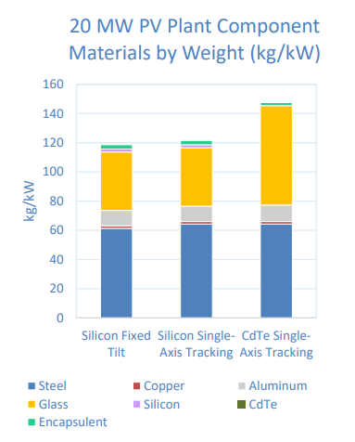

*System-level materials breakdown by weight for fixed tilt and single-axis tracking configurations for a Si PV plant, and a single-axis tracking CdTe plant.*

The majority of non-module system component materials can be sold to the scrap metal market, like steel, copper, and aluminum. However, the module and inverter are the components that are considered electronic waste (e-waste) and do not have as robust recycling and secondary materials markets as steel, Al, and Cu. Module EOL handling will be the main priority, as module EOL volumes will be far larger than inverter EOL volumes due to their respective mass proportions in a system and module recycling will be different from other e-waste recycling due to differences between consumer electronics and module designs.

A silicon module is made of silicon solar cells, which are electrically connected with silver (Ag), sandwiched between glass and plastic sheets, and framed in Al.

Silver is difficult to recover from screen-printed contacts as the silver is embedded in a composite with dielectric materials and engineered to strongly adhere to the silicon wafer. Silicon is also difficult to recover with sufficient purity for reuse. While silver accounts for only 0.3-0.4% of a module by weight, the PV industry has consumed between 8.8% and 9.9% of the global silver supply annually since 2016.[2] While the silicon embodied in a PV cell could be valuable, other materials are intentionally added to the silicon to make it into a solar cell. This makes the recovered silicon lower quality than is needed for electronic applications, although it may be useful for metallurgical applications.

CdTe thin film modules are made by depositing CdTeSe absorber materials directly on the glass of the module, using plastic encapsulant and edge seals, and Al and molybdenum (Mo) contacts, and an Al frame. Tellurium (Te) is a rare element in the earth’s crust, with an abundance on par with platinum. The amount of CdTeSe absorber in the module is below 0.1% by mass but an estimated 40% of global Te consumption was used for thin film solar module production in 2020.[3]

The three main options for PV module EOL are landfilling, recycling, and secondary use. Landfilling is currently the lowest cost handling option for PV module EOL generators. Landfilling fees range from $30/ton to $70/ton depending on the geographical location of the landfill. Currently, the cost to recycle PV modules is around $15-$45 per module, which is higher than the landfill fee, which is $1-$5 per module, not including transportation costs (Curtis et al., 2021).

The module recycling process starts with mechanically removing the aluminum frames, if applicable, and shearing off the junction box. The commercial process for silicon then shreds the module into small pieces, grinds them into fine particles, and then uses eddy currents and sifting to separate the glass, polymers, interconnect ribbons, and cells. Other silicon module recycling techniques use heat to remove the polymers from the glass and chemical treatments to separate the metals from the silicon. For CdTe modules, after mechanical removal of the frame and junction box the commercial recycling process then proceeds to shred the laminate, grind it into small pieces in a hammermill, mechanical separate the glass and laminate pieces, and then immerse in a series of chemical baths to recover the Cd and Te.

In the 2014 SETO PV Recycling Request for Information (RFI), respondents defined module EOL to be the time when a module is operating at 80% (T80) to 50% (T50) of the nameplate power.[4] Assuming a module power degradation rate is constant at around 0.7% per year then a module T80 EOL would be 30 years and a module T50 EOL would be roughly 70 years (Jordan, 2013).

In terms of Federal policies that apply to PV EOL, the Resource Conservation and Recovery Act managed by the EPA lays out regulations regarding toxicity characteristics of solid waste. A leaching test determines if a solid waste is hazardous. Internationally, European Union member states have been required since 2004 to set targets to recover 85% of e-waste and recycle 80% of the recovered materials under the Waste Electrical and Electronic Equipment Directive.

Research areas for recycling solar panels includes better materials separation and recovery techniques, and design for recycling. Acknowledging that EOL handling costs will depend on both policy decisions and technology development, SETO aims to decrease the cost of module recycling by a module by more than half by 2030, which would make it $3/module (or < $150/ton) by 2030. Degradation rates are helpful to estimating module life spans and may have changed with the new Si and CdTe module designs that came into the market in recent years so they will need to be continuously updated for new technologies.

Material Usage Efficiency – While this document focuses on EOL, material usage efficiency is the first step to waste management. Research to reduce the amount materials, especially critical materials, and energy needed to produce system components will reduce the resources needed to process EOL materials as well. Extending the life span of modules and system components means that the material usage rate will decrease which also alleviate material usage.

Reuse – Reuse extends the life of system components when they no longer perform at the levels required for primary use. PV plant components have not been designed with reuse in mind but with growing demand and markets, designs that consider secondary use for components may be helpful. For example, developing standards for components such as module size, racking dimensions, and connectors could allow for easier intergenerational compatibility and longer useful life spans.

Recycling – At the system level, the steel, aluminum frames, and glass are easily recovered and recyclable. These materials can be saved from the landfill but are not hazardous if they were landfilled. The areas where materials recovery may be challenging include recovering silver from the metallization, recycling and separation challenges for polymers and composites such as backsheets, and the semiconductor materials which are difficult to purify for use in solar or electronics applications

Landfilling – Safety will be the priority for research in this area. One area of concern is solder used to join cells in a Si module contains lead. This may pose a health and environmental risk depending on the stresses a module experiences in a landfill. Preliminary studies have shown that the amount of lead from modules are below the limits that EPA sets for determining if waste is hazardous. Further studies are needed to establish the environmental impacts of a larger population of PV modules. Another possible area to investigate is the backsheet material that contains fluoropolymers which can release fluorine gases under thermal treatment. Understanding issues in the chemistries needed for CdTe materials recovery and handling of recovered Cd material in CdTe module recycling would be useful to ensure safe handling of these recycled materials.

**Misinformation and Decarbonization**

Heather Mirleterz, in her paper, "Unfounded concerns about photovoltaic module toxicity and waste are slowing decarbonization," which in the journal *Nature Physics*, claims that "Transitioning away from fossil fuels, a substantial reduction in waste mass and toxicity is possible and the remaining waste is well within our capabilities to manage responsibly." "Communities, government agencies and policymakers may be operating under outdated or false assumptions about PV module waste and toxicity hazards resulting in delay or unnecessary impediments to the rapid deployment of PV needed to meet decarbonization goals," Mirletz said (Grad, 2023).

Health sites in several states list PV toxins such as arsenic, gallium, germanium and hexavalent chromium. But the majority of PV units are composed of crystalline silicon or cadmium telluride, Mirletz said. Those are toxic substances, but comprise less than 0.1% of the modules, which consist mainly of glass, aluminum and polymers. The International Energy Agency (IEA) claims that the "only potential human health and environmental concern" about PV models are "trace amounts of lead in solder" used in the manufacture of modules. The IEA also states that the more recently used cadmium telluride is "extremely stable" and does not pose the same toxicological risk as cadmium (Grad, 2023).

Opponents of solar energy often cite the 2016 IRENA end-of-life report that calculated that if solar energy is embraced globally, 60 million tons of waste will be generated through PV disposal by the year 2050. Mirletz notes that her group's study determined the number may be closer to 54 million tons, though in a worst-case scenario, she said, the number could go as high as 160 million tons (Grad, 2023).

**Solar Cell Structures**

Dutch and German researchers have developed a tunnel oxide passivated contact (TOPCon) solar cell that utilizes silver nanowire (Ag NW) grids, as opposed to indium tin oxide, as transparent electrodes, being the first time that metallic nanostructure offers photonic gain in a solar cell. Ag NW networks have superior optoelectronic and mechanical properties compared to indium tin oxide (ITO) for cell electrodes, and these Ag NW wires will be particularly useful in thin film-based solar cells, where light trapping is more challenging and carrier diffusion lengths are smaller. TOPCon cells can be used to provide inference into the grid’s transparency, as due to the long minority carrier diffusion length of the emitter, TOPCon cells are ideally suited as an electrically active detector. The Ag NW grids on the solar cell were grown by using two scalable and low-cost techniques – nanoimprint lithography, generally used in the industrial manufacturing of photonic devices and large area displays, and room-temperature light-driven electrochemical deposition, commonly utilized to fabricate rear electrodes for solar cells (Bleiji et al., 2025; Bellini, 2024B).

HJT technology has long-term reliability challenges, despite its high efficiency, as it is very susceptible to degradation under high-temperature and high-humidity conditions. Cell-level testing is approximately two orders of magnitude faster than module-level evaluations, allowing for detailed characterization of failure modes.

The impact of sodium-induced moisture degradation in heterojunction solar cells under accelerated damp-heat testing was investigated by Australian researchers, and found that most degradation modes predominantly affect the cells themselves, making cell-level testing the preferred approach. They used an accelerated and granular approach to understand the underlying mechanisms of Na-induced degradation and its interactions with environmental anions and material compositions, such as transparent conductive oxide (TCO) layers and metal contacts, so as to guide the field in effectively addressing the recombination issues and other degradation pathways and support the development of improved bills of materials, solar cells, and testing protocols. They considered three different types of sodium salts, sodium bicarbonate (NaHCO₃), sodium chloride (NaCl), and sodium nitrate (NaNO₃), and identified the degradation mechanisms attributed to each contaminant to simulate contamination in HJT cells under damp-heat. The results suggest that sodium ions require specific conditions to initiate degradation in SHJ cells, selectively impacting vulnerable regions. The researchers found that NaHCO₃, due to its alkaline nature, induces significant degradation in silicon heterojunction solar cells (SHJ) cells by chemically interacting with transparent conductive oxide (TCO) layers, leading to marked alterations in elemental composition and ultimately compromising both open-circuit voltage stability and contact integrity. NaCl, driven by its chloride ions, primarily triggers severe contact failures associated with morphological transformations in nano-silver particles. NaNO₃ exhibited negligible impact on SHJ cell performance, which could be attributed to its neutral anionic structure and lower chemical reactivity (Wu et al., 2025; Bellini, 2025).

Australian researchers investigated failure modes in heterojunction (HJT) solar modules with glass-backsheet configurations, and identified four failure modes in the silicon heterojunction glass-backsheet module which has the potential to result in a power loss of up to 50% following damp heat testing. The experiment was conducted on bifacial half-cut n-type silicon HJT solar cells sourced from industrial production lines of unidentified manufacturers. The first failure type consisted of cell darkening in localized points, and the second was represented by darkening around the interconnection of busbars and ribbon wires. The third failure mode involved intense darkening between the interconnected regions of busbars and ribbon wires, while the fourth showed darkening on the interconnected region of busbars and ribbon wires (Sen et al., 2023; Bellini, 2023G).

German wafer manufacturer NexWafe GmbH achieved a power conversion efficiency of 24.4% for a heterojunction (HJT) solar cell built with its ultrathin wafers, achieved with an unspecified M6 HJT commercial production line. NexWafe's direct gas-to-wafer process could be a full replacement for conventional Czochralski (CZ) wafers, while offering the potential for significant cost savings by reducing material losses, energy consumption by 40%, and eliminating the saw damage etching process step in cell production. The oxygen content of EpiNex wafers is also 20 times lower than conventional CZ wafers, which enables thermal stability and helps improve cell performance (Bellini, 2024D).

Chinese solar company Trinasolar achieved efficiency of 27.08% for large-area high efficiency n-type fully passivated HJT solar cells, using 210 x 105 mm squared large-area 210 half-cell industrial grade phosphorous-doped CZ-type silicon wafer substrate and thin-film passivation technology to achieve the outcome. Backside fully passivated heterojunction technology, multi-frequency radio frequency process was used to optimize the doped microcrystal system, and ultra-fine line printing technology (Foley, 2024A).

JA Solar’s patented anti-dust frame technology enhances drainage and decontamination performance, thus reducing dust accumulation and avoiding hotspot issues, specifically designed for roof-top PV, as the module is lightweight, highly reliable, and easy to maintain. The main feature of the new single-glass product is a special encapsulation n-type paste, which prevents water vapor ingress and corrosion (Bellini, 2024E).

Solar panels can be constructed that utilize a backsheet made of a natural fiber composite zeolite-polyester resin as an alternative to conventional polyethylene terephthalate (PET) backsheets, in an effort to reduce the environmental impact of PET backsheets and to improve the solar module's thermal and mechanical properties. The natural fiber backsheet was produced via Vacuum-assisted resin transfer moulding (VARTM), which ensures optimal thermal management and insulation, was used to produce the fibers, which utilizes a vacuum to facilitate resin flow into a fiber layup contained within a mold tool covered by a vacuum bag. After the impregnation occurs, the composite part can be “cured” at room temperature with an optional post-cure sometimes being executed. Using a natural fiber coated with zeolite-polyester resin enhances performance and reduces heat accumulation in the panels, and ensures excellent structural integrity, uniformity, and reliability. Initial cost is higher for zeolite-polyester resin, though the long-term benefits include lower maintenance costs and better performance, especially in harsh conditions (Sathyanarayanan et al., 2024; Bellini, 2024F).

“Dye-sensitized solar cells (DSSC) are the thin-film solar cells also known as Grätzel cells, which convert light into electricity through photosensitizers. The DSSC dye compounds absorb light and inject electrons into an array of oxide nanocrystals, which are then collected as electric current. The photosensitizers are attached to the surface of nanocrystalline mesoporous titanium dioxide films, which are saturated with redox-active electrolytes or a solid charge-transport material. The entire design aims to generate electric current by moving electrons from the photosensitizer to an electrical output such as a device or storage unit (Brągoszewska et al., 2024; Bellini, 2024G).”

Dye concentrators can improve PV cell field, with one such device utilizing a tinted and luminescent acrylic glass known as polymethyl methacrylate, which reportedly increases power generation by 1.21%. Yellow and red dye concentrators are used by the Polish scientists in the place of dye-sensitized solar cells, tested for cell temperature and the intensity of illuminance, either luminescent or pigmented, based on a tinted and luminescent acrylic glass known as polymethyl methacrylate (PMMA). Dye concentrators do not have as stringent requirements as those for dyes used in DSSC cells, but must have three main properties: high stability, the ability to focus sunlight, and long-term usability. As the concentrator dyes do not generate electricity and are simply utilized as elements that concentrate solar radiation onto a silicon cell, they do not need to undergo a series of chemical reactions, exhibit properties enabling connection to the conductor surface, or possess redox properties (Brągoszewska et al., 2024; Bellini, 2024G).

**Tandem Cells**

Thompson, Valerie (2024B) PV Magazine, Fraunhofer ISE developing copper metallization for tandem perovskite-silicon solar cells,

<https://www.pv-magazine.com/2024/12/13/fraunhofer-ise-developing-copper-metallization-for-tandem-perovskite-silicon-solar-cells/?utm_source=Global+%7C+Newsletter&utm_campaign=d23cbc3cc1-dailynl_gl&utm_medium=email&utm_term=0_6916ce32b6-d23cbc3cc1-160603208>

Three printed copper metallization methods to avoid using silver for tandem silicon-perovskite cells compatible with either TOPCon or heterojunction bottom cells include: screen printing, FlexTrail printing and rotary printing (flexographic printing and indirect gravure printing) (Thompson, 2024B).

Jowett, Patrick (2024B) PV Magazine, Fraunhofer ISE concludes perovskite-silicon tandem solar cell project,

<https://www.pv-magazine.com/2024/12/12/fraunhofer-ise-concludes-perovskite-silicon-tandem-solar-cell-project/?utm_source=Global+%7C+Newsletter&utm_campaign=896946d5b0-dailynl_gl&utm_medium=email&utm_term=0_6916ce32b6-896946d5b0-160603208>

German researchers concluded that high efficiencies can only be achieved with lead perovskites in an experiment, as non-toxic, lead-free alternatives in perovskites were unable to produce tandem solar cells of sufficient efficiency from any of the lead-free materials. They then fabricated highly efficient demonstrators, such as a perovskite silicon tandem solar cell of more than 100 sq cm with screen-printed metallization, using a combination of vapor deposition and wet-chemical deposition to ensure an even depositing of the perovskite layer on the textured silicon surface. To evaluate the efficiency and stability of tandem solar cells, they used characterization data and an opto-electrical simulation model to carry out a comprehensive loss analysis on the tandem solar cell and determined a practical upper limit of 39.5% efficiency (Jowett, 2024B).

To evaluate low-energy focused ion beam techniques for the preparation of industrial tandem solar cells, the cells are analyzed using high resolution using a transmission electron microscope (TEM). A special sample holder was constructed to allow the direct deposition of absorber and contact layers on TEM substrates, while methods were developed to investigate the thickness, degree of coverage and chemical bonding of self-organized molecular monolayers. Calculation models can be used to describe the structural and photovoltaic properties of relevant absorber materials and their interfaces with optically transparent and electrically conductive contact materials (Jowett, 2024B).

Bellini, Emiliano (2024H) PV Magazine, Scientists design 30.22%-efficient perovskite-silicon tandem solar cell with heterojunction bottom tech,

<https://www.pv-magazine.com/2024/11/22/scientists-design-30-22-efficient-perovskite-silicon-tandem-solar-cell-with-heterojunction-bottom-tech/?utm_source=Global+%7C+Newsletter&utm_campaign=74f4b85441-dailynl_gl&utm_medium=email&utm_term=0_6916ce32b6-74f4b85441-160603208>

Harter, A., Artuk, K., Mathies, F. et al. (2024) Perovskite/Silicon Tandem Solar Cells Above 30% Conversion Efficiency on Submicron-Sized Textured Czochralski-Silicon Bottom Cells with Improved Hole-Transport Layers, ACS Applied Materials & Interfaces, Volume 16, Issue 45, 1944-8244, 10.1021/acsami.4c09264

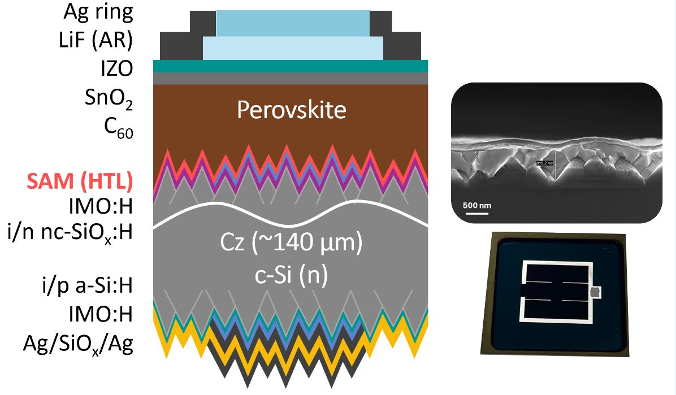

Perovskite-silicon tandem solar cells can be manufactured with a hole transport layer based on methyl-substituted carbazole and submicron-sized textured silicon bottom heterojunction cells, using commercially available Czochralski silicon wafers and with efficiencies over 30%. This HTL cell Enhances the wettability of the perovskite layer and reduces shunting issues, which are common with conventional HTLs based on a phosphonic acid called methyl-substituted carbazole (Me-4PACz), leading to better film formation while maintaining the very good HTL characteristics of Me-4PACz. By using submicron-sized textured silicon bottom cells, the new cell overcomes the challenges associated with traditional micrometer-sized textures, enabling better integration of solution-processed perovskite films, reducing reflection losses and enhancing light in-coupling, while maintaining compatibility with industrial production methods. Optimizing the perovskite layer’s thickness and spin-coating parameters allows for efficient film formation on the submicron-textured surface and demonstrates the viability of using cost-effective and scalable solution-based methods for producing high-efficiency tandem cells (Harter et al., 2024; Bellini, 2024H).

Bellini, Emiliano (2024I) PV Magazine, Perovskite-silicon tandem solar cell based on indium oxide buffer layer achieves 30.04% efficiency,

<https://www.pv-magazine.com/2024/11/20/perovskite-silicon-tandem-solar-cell-based-on-indium-oxide-buffer-layer-achieves-30-04-efficiency/?utm_source=Global+%7C+Newsletter&utm_campaign=d093898816-dailynl_gl&utm_medium=email&utm_term=0_6916ce32b6-d093898816-160603208>

Du, L., Li, C., Jiang, Y. et al. (2025) Indium oxide buffer layer for perovskite/Si 4-terminal tandem solar cells with efficiency exceeding 30%, Journal of Energy Chemistry, Volume 102, Pages 189-196, <https://doi.org/10.1016/j.jechem.2024.10.037>

Four-terminal (4T) semi-transparent perovskite-silicon tandem solar cells can be manufactured with an indium oxide (${In}_{2}O_{3}$) sputtering buffer layer (SBL) to protect the top layer perovskite absorber and the electron transport layer (ETL) from bombardment arising from the indium tin oxide (ITO) transparent electrode deposition process. The e-beam evaporation technique was used to fabricate the ${In}_{2}O_{3}$ SBL, whereby the optical and electrical properties of the ${In}_{2}O_{3}$ film exhibited a strong dependence on the deposition rate, as a higher deposition rate resulted in In-rich ${In}_{2}O_{3}$ films with poor transmittance and increased parasitic absorption (Du et al., 2025; Bellini, 2024I).

Bellini, Emiliano (2024J) PV Magazine, Perovskite-silicon tandem solar cell based on copper(I) thiocyanate achieves 31.46% efficiency,

<https://www.pv-magazine.com/2024/11/07/perovskite-silicon-tandem-solar-cell-based-on-copperi-thiocyanate-achieves-31-46-efficiency/?utm_source=Global+%7C+Newsletter&utm_campaign=21c7ddc8fd-dailynl_gl&utm_medium=email&utm_term=0_6916ce32b6-21c7ddc8fd-160603208>

Kan, C., Hang, P., Wang, S. et al. (2024) Efficient and stable perovskite-silicon tandem solar cells with copper thiocyanate-embedded perovskite on textured silicon. Nature Photonics, 19, pages 63–70, <https://doi.org/10.1038/s41566-024-01561-5>

To solve issues of the hole transport layer (HTL) in tandem devices, perovskite top cell and silicon bottom cell, including the HTL in the perovskite top cell, Chinese and Saudi researchers developed a process for co-deposition of inorganic CuSCN, copper(I) thiocyanate, and perovskite in the top cell absorber, which demonstrated extraordinary light and damp-heat stabilities. HTLs used in top cells for tandem devices usually suffer from defects caused by non-conformal deposition or de-wetting. To manufacture the cell, the researchers deposited the perovskite precursor ink with CuSCN directly on the recombination layer made of indium tin oxide (ITO) of a 24.42%-efficient silicon heterojunction (SHJ) bottom cell, which formed local hole-collecting contacts by embedded CuSCN in device, resulting in a different device structure from that of a common and classic p-i-n configuration based on a thin self-assembly monolayer (SAM) on recombination layers like ITO (Kan et al., 2024; Bellini, 2024J).

Bellini, Emiliano (2024K) PV Magazine, KAUST, Helmholtz-Zentrum Berlin present 31.2%-efficient blade-coated perovskite-silicon tandem solar cell,

<https://www.pv-magazine-india.com/2024/10/31/kaust-helmholtz-zentrum-berlin-present-31-2-efficient-blade-coated-perovskite-silicon-tandem-solar-cell/?utm_source=Global+%7C+Newsletter&utm_campaign=3649b5e8b7-dailynl_gl&utm_medium=email&utm_term=0_6916ce32b6-3649b5e8b7-160603208>

Subbiah, A.S., Mannar, S., Hnapovskyi, V. et al. (2024) Efficient blade-coated perovskite/silicon tandems via interface engineering, Joule, 101767, <https://doi.org/10.1016/j.joule.2024.09.014>.

Perovskite-silicon tandems have convincingly proven their high-performance potential with many groups now achieving efficiencies higher than 30%, however, translating these results from a lab-scale environment towards techniques that are relevant to the industry requires attention, especially for solution processing techniques.

Saudi and German researchers developed a perovskite-silicon tandem solar cell that has a two terminal configuration and a 2D perovskite layer at the bottom interface, and achieves efficient charge extraction and interface passivation. The researchers used blade-coated perovskites and contact passivation using 2D perovskites, as spin coating faces scalability issues due to limited throughput. Blade coating was used to deposit the 3D perovskite onto a 2D perovskite layer in the perovskite top device, which had a p-i-n inverted device configuration. To minimize the energy level mismatch at the bottom interface, achieve efficient hole extraction, and reduce performance losses in our blade-coated p-i-n devices, the team tuned the targeted dimensionality (n) of the 2D perovskite film, which is made prior to the 3D perovskite (Subbiah, 2024; Bellini, 2024K).

Bellini, Emiliano (2024L) PV Magazine, Perovskite-silicon tandem solar cell based on hybrid interconnecting layers achieves 28.47% efficiency,

<https://www.pv-magazine.com/2024/08/09/perovskite-silicon-tandem-solar-cell-based-on-hybrid-interconnecting-layers-achieves-28-47-efficiency/?utm_source=Global+%7C+Newsletter&utm_campaign=410eab76aa-dailynl_gl&utm_medium=email&utm_term=0_6916ce32b6-410eab76aa-160603208>

Zheng, J., Ning, D., Li, Y. et al. (2024) Hybrid interconnecting layers reduce current leakage losses in perovskite/silicon tandems with 81.8% fill factor, Cell Reports Physical Science, Volume 5, Issue 8, 102114, <https://doi.org/10.1016/j.xcrp.2024.102114>

Chinese researchers designed a two-terminal (2T) perovskite-silicon tandem solar cell that utilizes new hybrid interconnecting layers (ICLs) to reduce recombination losses in the top perovskite device by preventing direct contact between the perovskite absorber and transparent conductive oxide (TCO). To address the issues of poor uniformity and compactness when a self–assembled monolayers (SAMs) is placed directly on a transparent-conductive-oxide (TCO) recombination layer, thus resulting in significant current leakage losses and poor reproducibility of tandem solar cells, a sputtered nickel oxide (NiOx) can be used as the seed layer of SAMs to build the hybrid interconnecting layers, as the sputtered treatment technique allows for an easy coating on a complex substrate with high reproducibility. NiOx materials can further increase the coupling of SAM molecules with the substrate. Thus, the hybrid ICLs could improve the uniformity of the interface between the TCO and the SAM based on MeO-2PACz, which is also known as [2-(3,6-Dimethoxy-9H-carbazol-9-yl)ethyl]phosphonic acid, by decreasing the interface defects and bulk defects, and reduce the leakage current. A good energy level alignment between perovskite and hybrid ICLs was built, which is beneficial to carrier extraction and transportation. Using a bottom silicon heterojunction device and a top inverted perovskite solar cell integrating the ICLs, the perovskite layer was designed with a substrate made of indium tin oxide (ITO), a hole transport layer (HTL) made of nickel(II) oxide (NiOx), the MeO-2PACz SAM, a perovskite absorber doped with 2-phenylethylammonium iodide (PEAI), an electron transport layer (ETL) based on a buckminsterfullerene (C60), a transparent back contact made of indium zinc oxide (IZO), and a silver (Ag) metal contact (Zheng et al., 2024; Bellini, 2024L).

Thompson, Valerie (2024C) PV Magazine, U.S. startup develops 28%-efficient perovskite-silicon tandem solar module,

<https://www.pv-magazine.com/2024/08/05/u-s-startup-develops-28-efficient-perovskite-silicon-tandem-solar-module/>

Metal halide four-terminal (4T) perovskite-silicon tandem solar cells can be made with a stability-enhancing interfacial treatment, enhancing the stability and reliability of perovskite films in tests, and in fabrication conditions (Thompson, 2024C).

Jowett, Patrick (2024C) PV Magazine, Qcells hits 28.6% efficiency with scalable perovskite-silicon solar cell,

<https://www.pv-magazine.com/2024/12/19/qcells-hits-28-6-efficiency-with-scalable-perovskite-silicon-solar-cell/?utm_source=Global+%7C+Newsletter&utm_campaign=7900a9ef7d-dailynl_gl&utm_medium=email&utm_term=0_6916ce32b6-7900a9ef7d-160603208>

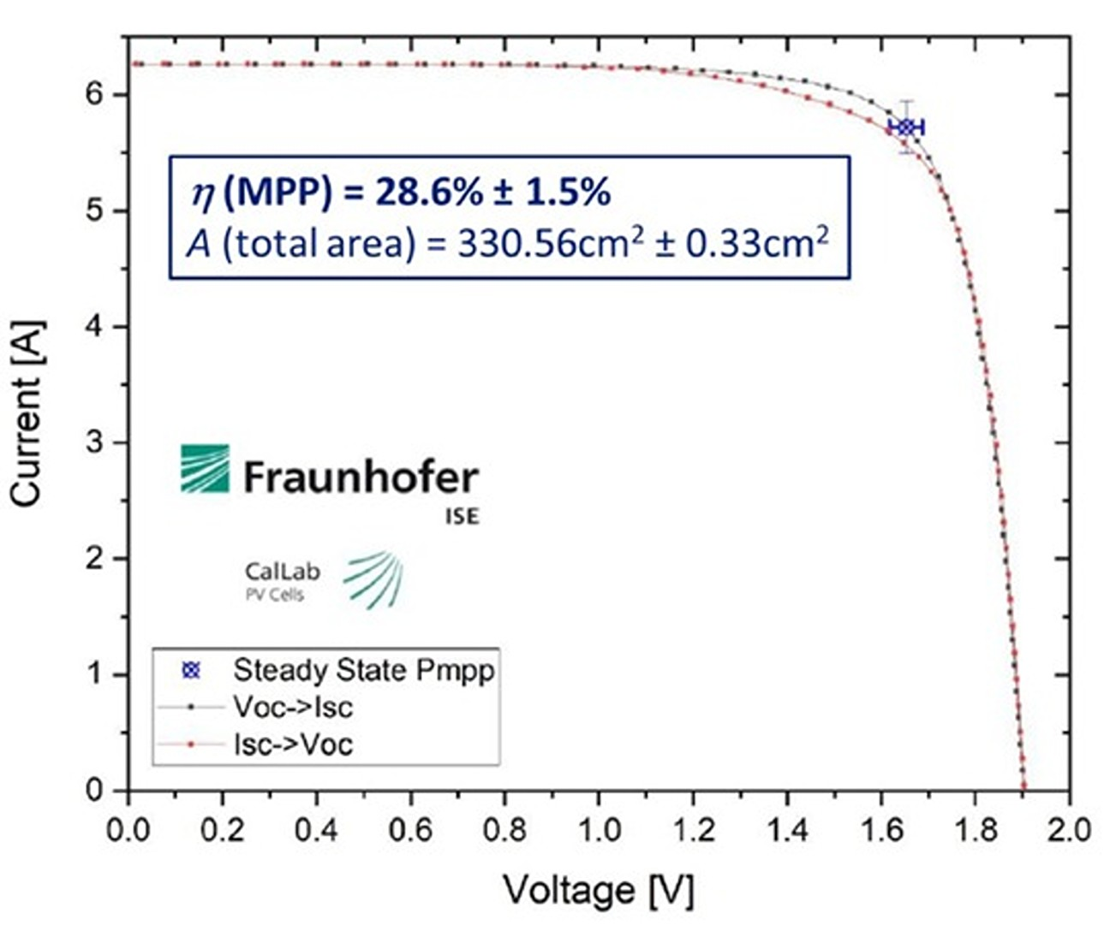

South Korean company Qcells has developed a solar cell that uses perovskite technology for the top cell and proprietary Q.ANTUM technology for the bottom cell, which boosts performance by letting the top cell capture high-energy light more efficiently while the bottom cell captures transmitted low-energy light (Jowett, 2024C).

Bellini, Emiliano (2024M) PV Magazine, Perovskite-HJT tandem solar cell based on phosphonic acid, self-assembled monolayer achieves 30.22% efficiency,

<https://www.pv-magazine.com/2024/12/24/perovskite-hjt-tandem-solar-cell-based-on-phosphonic-acid-self-assembled-monolayer-achieves-30-22-efficiency/?utm_source=Global+%7C+Newsletter&utm_campaign=dc4657fc55-dailynl_gl&utm_medium=email&utm_term=0_6916ce32b6-dc4657fc55-160603208>

Harter, A., Artuk, K., Mathies, F. et al. (2024) Perovskite/Silicon Tandem Solar Cells Above 30% Conversion Efficiency on Submicron-Sized Textured Czochralski-Silicon Bottom Cells with Improved Hole-Transport Layers, ACS Applied Materials & Interfaces, Volume 16, Issue 45, <https://doi.org/10.1021/acsami.4c09264>

Swiss researchers have fabricated a tandem solar cell based on a perovskite top cell and a heterojunction (HJT) bottom device, z-silicon (Cz-Si) bottom cell, with a thickness of 100–150 μm and double-sided micro-textured surfaces, which is a double-sided textured bottom cell, and circumvents the film formation issue associated with the use of phosphonic acid. The HJT cell was fabricated by wet-etching random pyramids, with their height being adjusted by alkaline texturing with no current loss in the cell. “To achieve high-performance shunt-free perovskite/silicon tandem solar cells with solution-processed with high yield top cells, the perovskite absorber thickness must be thicker than the pyramid texture height,” it stressed. “Since high-quality wide band gap perovskite absorbers are typically 600–800 nm thick and do not usually conformally cover the surface when processed from solution, the pyramid height must be adjusted accordingly.” The perovskite top cell was built with a hole transport layer (HTL) with a self-assembled monolayer (SAM) based on [2-(3,6-Dimethoxy-9H-carbazol-9-yl)ethyl]phosphonic acid (MeO-2PACz), a perovskite absorber, an electron transport layer (ETL) made of tin oxide (SnO2) and buckminsterfullerene (C60), a transparent back contact made of indium zinc oxide (IZO), and a silver (Ag) metal contact. The silicon bottom cell was fabricated with an a-Si:H(i)/nc-SiOx:H(n) layer stack on the front side and an a-Si:H(i)/a-Si:H(p) layer stack on the rear side deposited using plasma-enhanced chemical vapor deposition (PECVD) (Harter et al., 2024, Bellini, 2024M).

Bellini, Emiliano (2024N) PV Magazine, All-perovskite tandem solar cell based on tin-lead perovskite achieves 28.8% efficiency,

<https://www.pv-magazine.com/2024/08/16/all-perovskite-tandem-solar-cell-based-on-tin-lead-perovskite-achieves-28-8-efficiency/?utm_source=Global+%7C+Newsletter&utm_campaign=1a6ba955b3-dailynl_gl&utm_medium=email&utm_term=0_6916ce32b6-1a6ba955b3-160603208>

Li, C., Chen, L., Jiang, F. et al. (2024) Diamine chelates for increased stability in mixed Sn–Pb and all-perovskite tandem solar cells. Nature Energy 9, 1388–1396, <https://doi.org/10.1038/s41560-024-01613-8>

Canadian researchers have fabricated an all-perovskite tandem solar cell with a wide-band-gap bottom cell based on tin-lead (Pb-Sn) perovskite with a limited amount of passivating defects and reduced interface recombination, by using diamine chelation chemistry targeting tin-containing perovskite, where a metal ion forms a stable bond with a molecule that has two nitrogen atoms holding the metal in place. To improve the perovskite solar cell’s surface, the scientists created partially non-conductive and non-functional areas that protect the perovskite area underneath from becoming defective. The addition of diamine to the surface allowed extra tin to be removed and the tin-to-lead ratio to be more balanced, and also created a stable barrier layer that helps protect the surface from atmospheric oxygen and heat. The research team built the tandem device with a substrate made of glass and indium tin oxide (ITO), a hole transport layer (HTL) made of nickel(II) oxide (NiOx) and phosphonic acid called methyl-substituted carbazole (Me-4PACz), a wide-bandgap perovskite absorber treated with 1,2-diaminopropane (DAP), an electron transport layer (ETL) based on buckminsterfullerene (C60), a gold (AU) metal contact, a PEDOT-PSS layer, a low bandgap perovskite absorber, another ETL made of C60, a tin oxide (SnO2) buffer layer, and a metal electrode (Li et al., 2024; Bellini, 2024N).

Thompson, Valerie (2024D) PV Magazine, Japanese startup developing flexible chalcopyrite solar modules,

<https://www.pv-magazine.com/2024/12/16/japanese-startup-developing-flexible-chalcopyrite-solar-modules/?utm_source=Global+%7C+Newsletter&utm_campaign=b06ab08016-dailynl_gl&utm_medium=email&utm_term=0_6916ce32b6-b06ab08016-160603208>

Chalcopyrite (CuGaSe2) has an energy bandgap of 1.7 eV and has been used in solar cells with limited fill factor and open-circuit voltage to date. Japanese researchers are developing flexible chalcopyrite modules with a tandem perovskite-chalcopyrite solar cell technology, with a focus on durability improvement, for use in a range of vehicle-integrated PV (VIPV) applications, such as solar-powered portable refrigerated containers, a solar-integrated passenger car, and an electric tricycle, with future plans to power data centers with clean energy, supply power to portable base stations to be deployed in disaster-affected areas during emergencies, and on ultra-lightweight high altitude platform station (HAPS), the solar-powered aircraft meant to operate at an altitude of 20 km above the earth’s surface carrying telecommunications base stations as the payload (Thompson, 2024D).

Bellini, Emiliano (2024O) PV Magazine, Researchers claim record-breaking 25.7% efficency for perovskite-organic tandem solar cell,

<https://www.pv-magazine.com/2024/12/06/scientists-claims-record-breaking-25-7-efficency-for-perovskite-organic-tandem-solar-cell/?utm_source=Global+%7C+Newsletter&utm_campaign=1ca09a0ec5-dailynl_gl&utm_medium=email&utm_term=0_6916ce32b6-1ca09a0ec5-160603208>

Jiang, X., Qin, S., Meng, L. et al. (2024) Isomeric diammonium passivation for perovskite–organic tandem solar cells. Nature 635, 860–866, <https://doi.org/10.1038/s41586-024-08160-y>

German and Chinese researchers have developed a perovskite-organic tandem cell based on a wide-bandgap perovskite bottom cell and a narrow-bandgap organic top device, using a compound known as cyclohexane 1,4-diammonium diiodide for surface passivation. Using an organic cell as a bottom device offers the advantage in terms of low carbon footprint compared to cell technologies based on crystalline silicon or copper, indium, gallium and selenium (CIGS) thin-film, which require high processing temperatures, whereas perovskite and organic solar cells are both processed at low temperatures. To address the fact that tandem solar cells are limited by the perovskite layer, which shows strong efficiency losses if adjusted to absorb only blue/green parts of the sun spectrum, Jiang et al. (2024) used a passivation layer applied to the perovskite that reduces material defects and improves the performance of the whole cell, a red/infrared absorbing organic solar cell that reportedly extends its absorption even further into the infrared (Jiang et al., 2024; Bellini, 2024O).

Thompson, Valerie (2024E) PV Magazine, Inkjet printed formamidinium tin-lead perovskite cell with 10.26% efficiency,

<https://www.pv-magazine.com/2024/11/21/inkjet-printed-formamidinium-tin-lead-perovskite-cell-with-10-26-efficiency/?utm_source=Global+%7C+Newsletter&utm_campaign=02571dcd32-dailynl_gl&utm_medium=email&utm_term=0_6916ce32b6-02571dcd32-160603208>

Tara, A., Schröder, V., Paul, A. et al. (2024) Inkjet-Printed FASn1–xPbxI3-Based Perovskite Solar Cells, ACS Applied Materials & Interfaces, Volume 16, Issue 46, <https://doi.org/10.1021/acsami.4c12477>

German and Indian researchers have developed an inkjet printing method to fabricate formamidinium tin-lead (SN-Pb) perovskite solar cells, achieving 10.26% power conversion efficiency and a 1.25 eV energy bandgap, meaning it can narrow the bandgap subcell of all-perovskite tandem solar cells. Inkjet-printing was chosen for the combinatorial mixed formamidinium tin-lead (Sn-Pb) film due to its “flexibility in design” and ability to “precisely adjust the crystallization properties of organohalogen perovskite layers,” in addition to a high degree of control. Inkjet-printing is also considered to be a high-throughput manufacturing methodology as opposed to spin coating, which has enabled high-performing lab-sized devices but lacks the scaling potential. Further research is to develop large-area inkjet printed tin-lead perovskite solar cells and finally to integrate them as bottom cells in all-perovskite tandem solar cells (Tara et al., 2024; Thompson, 2024E).

Bellini, Emiliano (2024P) Solar cell based on silver bismuth sulfide exceeds 10% efficiency threshold for first time,

<https://www.pv-magazine.com/2024/11/27/solar-cell-based-on-silver-bismuth-sulfide-exceeds-10-efficiency-threshold-for-first-time/?utm_source=Global+%7C+Newsletter&utm_campaign=fc1e287759-dailynl_gl&utm_medium=email&utm_term=0_6916ce32b6-fc1e287759-160603208>

Oh, J.T., Wang, Y., Rodà, C. et al. (2024) Post-deposition in situ passivation of AgBiS2 nanocrystal inks for high-efficiency ultra-thin solar cells, Energy & Environmental Science, Volume 17, Issue 22, pages 8885-8892, <http://dx.doi.org/10.1039/D4EE03266G>

Spanish researchers have developed a post-deposition in situ passivation strategy to reduce surface defects in silver bismuth sulfide cells, using a layer-by-layer solid-state ligand exchange process that, however, is not suitable for large-area high-volume manufacturing needed for PV deployment. Silver bismuth sulfide (AgBiS2) nanocrystals (NCs), a promising ternary semiconductor that is free of toxic heavy metals and has been shown to possess extraordinary optical properties including the highest optical absorption amongst any other photovoltaic absorber, are an earth-abundant material that has been used in recent years as a promising PV material, often in combination with cadmium sulfide in the development of several kinds of ultra-thin solar cells. AgBiS2 NCs can be fabricated in air at low temperatures using low-cost solution processing techniques and inexpensive production equipment, and have very low toxicity compared to other materials used for thin-film solar cells, such as cadmium telluride and cadmium sulfide (Oh et al., 2024; Bellini, 2024P).

Thompson, Valerie (2024F) PV Magazine, Coatema launches roll-to-roll production lines for organic, perovskite, dye-sensitized solar cells,

<https://www.pv-magazine.com/2024/11/22/coatema-launches-roll-to-roll-production-lines-for-organic-perovskite-dye-sensitized-solar-cells/?utm_source=Global+%7C+Newsletter&utm_campaign=74f4b85441-dailynl_gl&utm_medium=email&utm_term=0_6916ce32b6-74f4b85441-160603208>

A German company has created roll-to-roll product lines for flexible organic, perovskite, and dye-sensitized solar cells (DSSC) technologies, with working web widths of up to 1,000 mm, as well as a smaller tool for sheet-to-sheet setups used. There are 20 modules available for coating,including gravure, doctor blade, slot die coating, rotary screen, curtain coating, and screenprinting. Drying choices include hot air, infrared, UV crosslinking, and jet drying. They also want to integrate inline laser scribing and quality control systems within the roll-to-roll process, for use in an automated module assembly line (Thompson, 2024F).

Kahana, Lior (2024A) PV Magazine, Onsemi launches silicon carbide power integrated modules for utility-scale PV,

<https://www.pv-magazine.com/2024/12/09/onsemi-launches-silicon-carbide-power-integrated-modules-for-utility-scale-pv/?utm_source=Global+%7C+Newsletter&utm_campaign=6e98937acf-dailynl_gl&utm_medium=email&utm_term=0_6916ce32b6-6e98937acf-160603208>

A U.S. company has developed silicon carbide hybrid power-integrated modules (PIMs) in an F5BP package that can be integrated with solar string inverters or energy storage system (ESS) applications. The PIMs feature an I-type neutral point clamp (INPC) design for the inverter module and a flying capacitor topology for the boost module. They also have an optimized electrical layout and advanced direct-bonded copper (DBC) substrates, reducing stray inductance and thermal resistance for improved performance (Kahana, 2024A).

**Perovskite**

MacPherson, Colleen (2024) TechXplore, Making solar cells more weatherproof: Researchers discover why humidity causes perovskite cells to fail,

<https://techxplore.com/news/2024-12-solar-cells-weatherproof-humidity-perovskite.html>

D’Souza, R.M., Onuonu, O.I., Lehtonen, B.N. and Kelly, T.L. (2024) Humidity Resistance of Inverted Perovskite Solar Cells as Measured by Operando X-ray Scattering, ACS Applied Energy Materials, Volume 7 Issue 21, doi: 10.1021/acsaem.4c02470

Perovskite is a semiconductor material that requires much less energy to produce than silicon, giving it an environmental advantage. Inverted perovskite cells have a device structure known as “p-i-n”, in which hole-selective contact (p) is at the bottom of intrinsic perovskite layer (i) with electron transport layer (n) at the top. Conventional halide perovskite cells have the same structure but reversed – a “n-i-p” layout. In n-i-p architecture, the solar cell is illuminated through the electron-transport layer (ETL) side; in the p-i-n structure, it is illuminated through the HTL surface (D’Souza et al., 2024; MacPherson, 2024).

D’Souza et al. (2024) designed an experiment to determine why solar cells made with lead halide perovskite, rather than silicon, were failing prematurely, and found that cell performance started to decline with the introduction of humidity. The perovskite formulation was investigated using a synchrotron technique called X-ray diffraction to visualize the 3D structure of the atoms in the material in real time. Possible solutions to address the issue of premature cell failure, including using corrosion-resistant materials for the electrodes, buffer layers to prevent the mobile ions from reaching the electrodes, or fully encapsulating the cell to keep out any moisture (D’Souza et al., 2024; MacPherson, 2024).

Thompson, Valerie (2024G) PV Magazine, Inverted perovskite solar cell based on co-absorbed self-assembled monolayer achieves 24.68% efficiency,

<https://www.pv-magazine.com/2024/11/26/inverted-perovskite-solar-cell-based-on-co-absorbed-self-assembled-monolayer-achieves-24-68-efficiency/?utm_source=Global+%7C+Newsletter&utm_campaign=3eb8d82d52-dailynl_gl&utm_medium=email&utm_term=0_6916ce32b6-3eb8d82d52-160603208>

Li, D., Lian, Q., Du, T. et al. (2024) Co-adsorbed self-assembled monolayer enables high-performance perovskite and organic solar cells. Nature Communications 15, 7605, <https://doi.org/10.1038/s41467-024-51760-5>

Chinese researchers improved the efficiency and stability of an inverted perovskite cell using a co-adsorbed approach to incorporate self-assembled monolayers (SAM) at the hole transport layer (HTL), aimed at reducing passivating defects and increasing efficiency. They used SAMs made of 2-chloro-5-(trifluoromethyl)isonicotinic acid, referred to as PyCA-3F, while the HTL was made with [2-(9H-Carbazol-9-yl)ethyl]phosphonic acid (2PACz). The co-adsorbed approach (CA) for the SAM application consists of growing the perovskite films on 2PACz substrates with and without PyCA-3F. The cell was built with a substrate made of indium tin oxide (ITO), the 2PACz HTL, a perovskite absorber, an electron transport layer (ETL) relying on buckminsterfullerene (C60), a bathocuproine (BCP) buffer layer, and a copper metal contact (Li et al., 2024; Thompson, 2024G).

Bellini, Emiliano (2024Q) PV Magazine, Ultrathin perovskite solar cell based on Gires-Tournois resonator,

<https://www.pv-magazine.com/2024/11/25/ultrathin-perovskite-solar-cell-based-on-gires-tournois-resonator/?utm_source=Global+%7C+Newsletter&utm_campaign=7e380cd323-dailynl_gl&utm_medium=email&utm_term=0_6916ce32b6-7e380cd323-160603208>

Dou, W., Zhang, Z., and Dai, N. (2024) Ultrathin perovskite solar cell based on Gires-Tournois resonator configuration with 27% theoretical efficiency, Solar Energy, Volume 284, 112997, <https://doi.org/10.1016/j.solener.2024.112997>

An ultrathin perovskite solar cell was developed by Chinese researchers that uses a back mirror based on silver, a Gires-Tournois resonator, to improve light harvesting and absorption, by optimizing light capture and utilization while improving light absorption capacity. Gires-Tournois resonators are optical standing-wave resonators designed for generating chromatic dispersion, and are based on a reflective metal mirror and are primarily used in chirping applications such as pulse compression. Ultrathin perovskite cells, which reduce manufacturing costs and lead content, require the use of vacuum deposition techniques to achieve the desired efficiency levels in commercial production. The cell achieves an average absorptivity of approximately 85%, due to an increase in light absorption in the wavelength range of 400-800 nm, which would result in a significant enhancement in the incident photon current efficiency (IPCE) attributable to pronounced light-matter interference effects between the perovskite absorber and the metal mirror, with a conversion efficiency of ultra-thin perovskite solar cells can even reach about 27% (Dou et al., 2024; Bellini, 2024Q)

Thompson, Valerie (2024H) PV Magazine, New encapsulation method boosts perovskite solar cell efficiency by 8%,

<https://www.pv-magazine.com/2024/11/18/new-encapsulation-method-boosts-perovskite-solar-cell-efficiency-by-8/?utm_source=Global+%7C+Newsletter&utm_campaign=73370bd8c5-dailynl_gl&utm_medium=email&utm_term=0_6916ce32b6-73370bd8c5-160603208>

Mousavi, S.M., Shirazi, H.D., Ranta, R. et al. (2024) Addressing the efficiency loss and degradation of triple cation perovskite solar cells via integrated light managing encapsulation, Materials Today Energy, Volume 46, 101707, <https://doi.org/10.1016/j.mtener.2024.101707>

Finnish researchers have created a one-step method for polydimethylsiloxane encapsulated perovskite solar cells that simultaneously provide anti-reflective light management and shielding from oxygen and moisture-induced degradation. Given that perovskite solar cells often encounter optical losses and suffer from instability, our study showed simultaneous encapsulation and patterning of the front surface of the solar cells could address both issues (Mousavi et al. 2024; Thompson, 2024H).

Foley, EV (2024B) PV Magazine, Flexible printed solar film research tacks closer to commercial viability,

<https://www.pv-magazine.com/2024/10/30/flexible-printed-solar-film-research-tacks-closer-to-commercial-viability/?utm_source=Global+%7C+Newsletter&utm_campaign=cafea62a75-dailynl_gl&utm_medium=email&utm_term=0_6916ce32b6-cafea62a75-160603208>

Flexible perovskite cells can be printed on long continuous rolls of flexible plastic film, where the solar films are thin, lightweight, portable and semi-transparent, making them suitable for various applications including construction, space, defence, mining, emergency management, disaster relief, and wearables. For example, printed PV films can be laminated onto windows or other glazing or incorporated into tents or sails for recreational or emergency purposes (Foley, 2024B).

Thompson, Valerie (2024I) PV Magazine, Perovskite solar cell built with slot die coating achieves 19.17% efficiency,

<https://www.pv-magazine.com/2024/10/30/perovskite-solar-cell-built-with-slot-die-coating-achieves-19-17-efficiency/?utm_source=Global+%7C+Newsletter&utm_campaign=cafea62a75-dailynl_gl&utm_medium=email&utm_term=0_6916ce32b6-cafea62a75-160603208>

Sangale, S.S., Mann, D.S., Lee, H.J. et al. (2024) Influence of interfacial roughness on slot-die coatings for scaling-up high-performance perovskite solar cells. Communications Materials 5, 201, <https://doi.org/10.1038/s43246-024-00645-7>

South Korean researchers have proposed slot die coating (SDC) to make uniform high-quality perovskite films as a step towards large-area perovskite device manufacturing, as SDC increased the roughness of the hole transport layer (HTL) interface, which improved the wettability of the surface, enabling a high-quality perovskite film without bubbles or pinholes. Self-assembled monolayer (SAM), such as Me-4PACz are excellent materials for the HTL in perovskite solar cells, but they have poor wettability, which has slowed progress so far. Using a nickel oxide (NiOx) and Me-4PACz combination, the researchers found that the use of SDC improved the roughness of the HTL interface, resulting in improved wettability. The SDC-based NiOx/Me-4PACz hole transport layer suppressed energy losses at the HTL/perovskite interface (Sangale et al., 2024; Thompson, 2024I).

Bellini, Emiliano (2024R) PV Magazine, Perovskite solar cell based on lead iodide treated with 4-fluorobenzylamine achieves 23.62% efficiency,

<https://www.pv-magazine.com/2024/11/01/perovskite-solar-cell-based-on-lead-iodide-treated-with-4-fluorobenzylamine-achieves-23-62-efficiency/?utm_source=Global+%7C+Newsletter&utm_campaign=2c91113505-dailynl_gl&utm_medium=email&utm_term=0_6916ce32b6-2c91113505-160603208>

Huang, Z., Du, Z., Ma, Z. et al. (2024) Lead iodide secondary growth and π-π stack regulation for sequential perovskite solar cells with 23.62% efficiency, Chemical Engineering Journal, Volume 499, 156684, <https://doi.org/10.1016/j.cej.2024.156684>

A perovskite solar cell has been built with low non-radiative recombination and defect state density by regulating the secondary growth of lead iodide, that shows lower non-radiative recombination and defect state density, using lead iodide (PbI2) secondary growth and π-π stack regulation strategy that enhances the photovoltaic efficiency and stability of perovskite solar cells. The research team controlled PbI2 nucleation and crystallization using 4-fluorobenylamide (FBA), we achieved high-quality perovskite films with large grains and minimized defect states, raising cell efficiency from 22.06% to 23.62%. π–π stacking interactions consists of a nondestructive noncovalent interaction used in modern chemistry and molecular biology, and offers advantages such as strong binding force, nondestructive fabrication process, and simple operation. To address iodine loss in perovskite solar cells degradation, the researchers utilized π-π stacking and hydrogen bonding interactions between FBA and the lead iodide (Pb-I) framework, to stabilize the PbI6 skeleton, which enhances the resilience of the Pb-I structure under heat and light stress. The group used a porous PbI2 film with low Gibbs free energy and high crystallinity to build a large-grain, low-defect perovskite absorber. The Gibbs free energy is the available energy of a substance that can be used in a chemical transformation or reaction. The cell was built with a substrate made of indium tin oxide (ITO), an electron transport layer (ETL) made of tin oxide (SnO2), the perovksite absorber, a hole transport layer (HTL) relying on spiro-OMeTAD, a spacer based phenyl-C61-butyric acid methyl ester (PCBM), and a silver (Ag) metal contact (Huang et al., 2024; Bellini, 2024R).

Thompson, Valerie (2024J) PV Magazine, Terpyridine-passivated perovskite solar cells achieve 25.24% efficiency,

<https://www.pv-magazine.com/2024/09/09/terpyridine-passivated-perovskite-solar-cells-achieve-25-24-efficiency/?utm_source=Global+%7C+Newsletter&utm_campaign=1ec4c7a7da-dailynl_gl&utm_medium=email&utm_term=0_6916ce32b6-1ec4c7a7da-160603208>

Wang, S., Yao, C., and Li, L. et al. (2024) Enhanced passivation durability in perovskite solar cells via concentration-independent passivators, Joule, Volume 8, Issue 4, 1105 - 1119, DOI: 10.1016/j.joule.2024.01.020.

Perovskite solar cells were treated with a molecular passivator based on π-conjugated terpyridine Lewis-base molecules, with the treatment working at high concentrations, which is typically needed to passivate surface defects over time, while improving passivation durability without damaging the perovskite film or diminishing cell performance (Wang et al., 2024; Thompson, 2024J).

Bellini, Emiliano (2025) PV Magazine, Perovskite solar cell based on hole-selective interlayer achieves 26.39% efficiency,

<https://www.pv-magazine.com/2025/01/02/perovskite-solar-cell-based-on-hole-selective-interlayer-achieves-26-39-efficiency/?utm_source=Global+%7C+Newsletter&utm_campaign=222dd31803-dailynl_gl&utm_medium=email&utm_term=0_6916ce32b6-222dd31803-160603208>

Shen, L., Song, P., Jiang, K. et al. (2024) Ultrathin polymer membrane for improved hole extraction and ion blocking in perovskite solar cells. Nature Communications 15, 10908, <https://doi.org/10.1038/s41467-024-55329-0>

Ion migration is considered the key cause of instability for perovskite solar cells, and occurs when the soft crystal lattice and relatively weak bonds in the perovskite film lead to low formation energies of defects, so heat and light could easily activate ionic defects within the perovskite lattice. The accumulation of ions deforms the local crystal structure and degrades the perovskite film, both the electron transport layer (ETL) and hole transport layer (HTL), as well as the electrodes (Shen et al., 2024; Bellini, 2024). Hole-selective interlayer incorporation in perovskite solar cells is inspired by proton exchange membrane (PEM) fuel cells, where the PEM serves as a proton conductor while blocking the diffusion of other chemical species, as designing internal barriers that block the layer-to-layer ion diffusion is critically important to improve the operation lifetime of perovskite solar cells.

A perovskite solar cell has been built that can effectively reduce ion migration through a hole-selective interlayer inhibiting ion diffusion to offer better stability, and utilizes an ultrathin membrane made of a polymeric material known as PDTBT2T-FTBDT (D18), which reportedly offers conformal coverage on the surface of perovskite film due to its high fluidity (Shen et al., 2024; Bellini, 2024).

Bellini, Emiliano (2024S) PV Magazine, Improving perovskite solar cell performance with cadmium telluride buffer layer,

<https://www.pv-magazine.com/2024/08/08/improving-perovskite-solar-cell-performance-with-cadmium-telluride-buffer-layer/?utm_source=Global+%7C+Newsletter&utm_campaign=2a71bf6845-dailynl_gl&utm_medium=email&utm_term=0_6916ce32b6-2a71bf6845-160603208>

Islam, A., Haider, S.Z., Wang, M., Ismail, A.G., and Anwar, H. (2024) Interface engineering for improved performance of perovskite solar cells using CdTe buffer layer, Results in Engineering, Volume 23, 102618, <https://doi.org/10.1016/j.rineng.2024.102618>

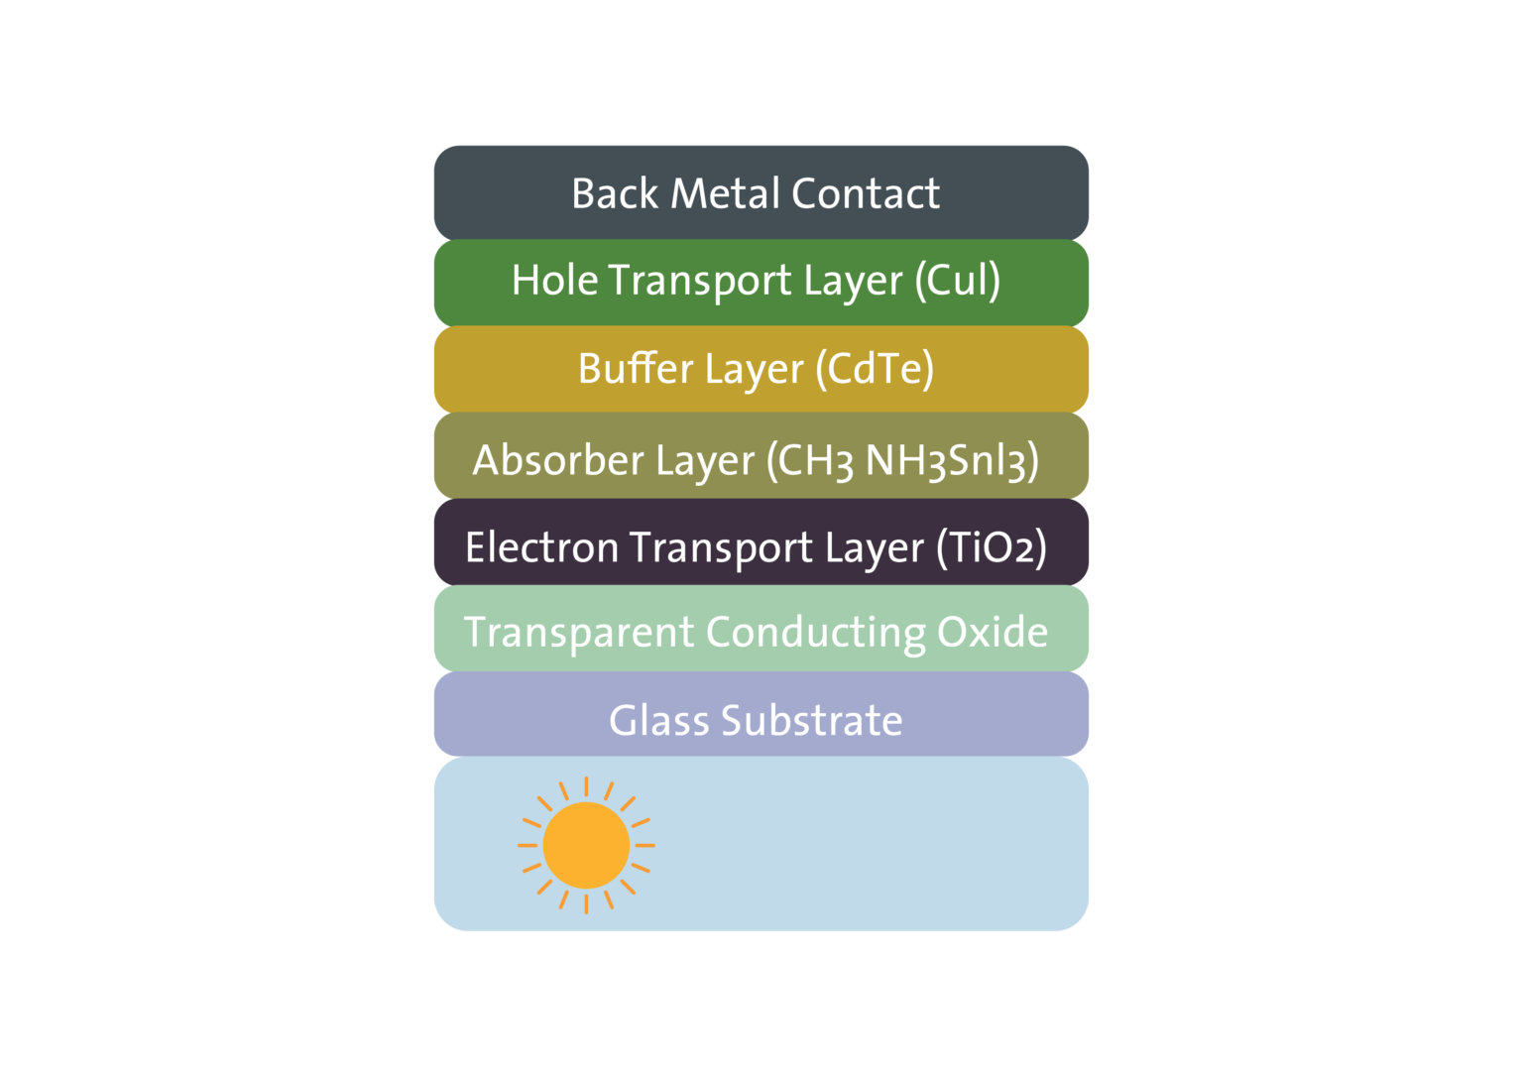Pakistani researchers have developed perovskite solar cells by adding a buffer layer (BL) made of cadmium telluride (CdTe), which reportedly enhances extraction of charge carriers while reducing device defects, thereby improving efficiency and stability. The presence of a BL in a perovskite cell offers a porous structure that aids in forming the upper hole-transporting layer (HTL), while also preventing the leakage of corrosive additives from the HTL material, to promote efficient hole transfer and conduction and also restrict charge recombination. CdTe was chosen since the hydrophobic nature of CdTe could protect the absorber from moisture and corrosion, and that its high UV resistance could minimize UV-induced degradation, enhancing cell stability. The SCAPS-1D solar cell capacitance software, developed by the University of Ghent, was used to simulate the cell configuration. The device was based on a substrate made of glass, a transparent conductive oxide (TCO), an electron transport layer (ETL) made of titanium oxide (TiO2), an absorber made of a perovskite material known as CH3NH3SnI3, the CdTe buffer layer, an HTL made of Copper(I) iodide (Cul), and a back metal contacts (Islam et al., 2024; Bellini, 2024S).

Bellini, Emiliano (2024T) PV Magazine, Inverted perovskite solar cell based on self-assembled monolayer achieves 23.31% efficiency,

<https://www.pv-magazine.com/2024/12/20/inverted-perovskite-solar-cell-based-on-self-assembled-monolayer-achieves-23-31-efficiency/?utm_source=Global+%7C+Newsletter&utm_campaign=73b4cb8bc3-dailynl_gl&utm_medium=email&utm_term=0_6916ce32b6-73b4cb8bc3-160603208>

Liu, W., Zang, Y., Tu, Y., et al. (2024) Reconstruction of Hole Transport Layer via Co-Self-Assembled Molecules for High-Performance Inverted Perovskite Solar Cells. Small, 2408314. <https://doi.org/10.1002/smll.202408314>

Inverted perovskite cells have a device structure known as “p-i-n”, in which hole-selective contact p is at the bottom of intrinsic perovskite layer i with electron transport layer n at the top. Conventional halide perovskite cells have the same structure but reversed – a “n-i-p” layout. In n-i-p architecture, the solar cell is illuminated through the electron-transport layer (ETL) side; in the p-i-n structure, it is illuminated through the HTL surface. SAM increases the photoelectric conversion efficiency of inverted perovskite solar cells as an HTL material, but clusters will be formed when SAM exceeds a certain concentration in solution. These cluster phenomena lead to weak binding between the phosphate anchoring group at the bottom of SAM and indium tin oxide (ITO), which greatly affects the coverage of SAM on ITO substrate, resulting in loss of carrier extraction efficiency (Liu et al., 2024; Bellini, 2024T).

Chinese researchers developed an inverted perovskite solar cell based on a hole transport layer (HTL) with a self-assembled monolayer (SAM) aimed at passivating defects and increasing efficiency. A “co-assembled SAM (Co-SAM) strategy” was utilized, consisting of selecting additive material to be mixed with a common SAM based on a layer of MeO-2PACz, which is also known as [2-(3,6-Dimethoxy-9H-carbazol-9-yl)ethyl]phosphonic acid. This strategy was chosen to achieve optimal SAM coverage. The cell was produced with a substrate made of glass and indium tin oxide (ITO), the MeO-2PACz layer, the perovskite absorber, a layer based on phenethylammonium iodide (PEAI), an ETL based on phenyl-C61-butyric acid methyl ester (PCBM), a bathocuproine (BCP) buffer layer, and a silver (Ag) metal contact (Liu et al., 2024; Bellini, 2024T).

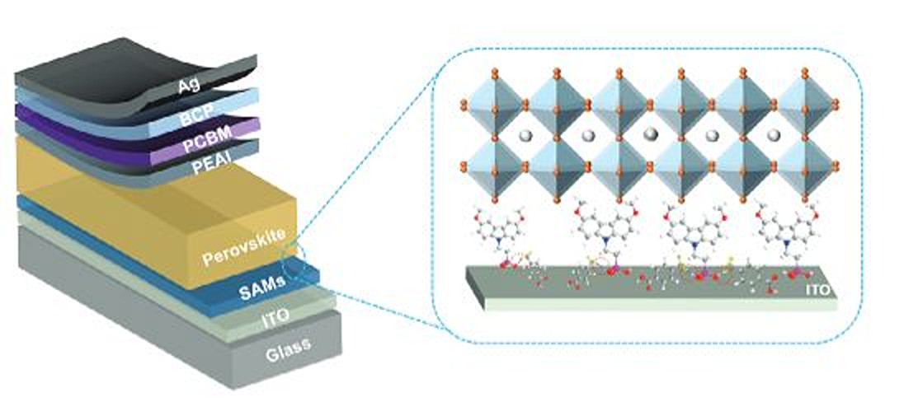

Bellini, Emiliano (2024U) PV Magazine, Bifacial perovskite solar can achieve bifaciality of 90% when tilted at 20 degrees,

<https://www.pv-magazine.com/2024/12/23/bifacial-perovskite-solar-can-achieve-bifaciality-of-90-when-tilted-at-20-degrees/?utm_source=Global+%7C+Newsletter&utm_campaign=fc1d9f2811-dailynl_gl&utm_medium=email&utm_term=0_6916ce32b6-fc1d9f2811-160603208>

Paul, A., Singha, A., Koul, S. et al. (2024) Quantitative Estimation of Albedo and Tilt Angle Variation in Bifacial Perovskite Solar Cells, ACS Applied Materials & Interfaces, Volume 18, Issue 44, <https://doi.org/10.1021/acsami.4c13114>

According to Indian researchers, bifacial perovskite solar cells, for applications in either tandem or single-junction PV devices, can achieve a 2% higher power conversion efficiency with a tilt angle of 20 degrees. They conducted a quantitative analysis of optimal values for albedo and tilt angle in bifacial perovskite solar cells and have found that enhancing the rear-side albedo to 0.5 and using a tilt angle of 20 degrees results in the highest efficiency levels, using Lambertian reflection effects through tilt angle arrangements and bottom albedo illuminations. The core component of their bifacial solar cells is the transparent back contact made of indium zinc oxide (IZO), which they claim has excellent conductivity, high mobility, and optimum transparency. The cell was designed to have a transparent fluorine-doped tin oxide (FTO) substrate, an electron transport layer (ETL) made of tin oxide (SnO2), a perovskite absorber, a hole transport layer (HTL) relying on spiro-OMeTAD and molybdenum oxide (MoOx), the IZO layer, a molybdenum oxide (MoOx) (Paul et al., 2024; Bellini, 2024U).

**Silicon**

Kahana, Lior (2024B) PV Magazine, Improving solar cell efficiency with upconversion nanoparticles,

<https://www.pv-magazine.com/2024/12/10/improving-solar-cell-efficiency-with-upconversion-nanoparticles/?utm_source=Global+%7C+Newsletter&utm_campaign=0900ac023d-dailynl_gl&utm_medium=email&utm_term=0_6916ce32b6-0900ac023d-160603208>

Wang, Y., Xu, W., Liu, H. et al. (2024) A multiband NIR upconversion core-shell design for enhanced light harvesting of silicon solar cells. Light: Science and Applications 13, 312 (2024). <https://doi.org/10.1038/s41377-024-01661-5>

A light upconversion system, consisting of a multiband near-infrared (NIR) upconversion (UC) system to enhance light harvesting in silicon solar cells (SSCs), has been developed that can reportedly improve crystalline silicon solar cell efficiency by up to 0.87%, which consists of multilayer lanthanide (Lb) and ytterbium (Yb) doped upconversion nanoparticles (UCNPs), which can capture NIR energy in a broad range of 1,100 to 2,200 nm, that act as near-infrared absorbers across different spectral ranges by converting low-energy photons in the infrared range into higher-energy photons in visible light. This device collects more of the NIR energy in sunlight by SSCs by integrating multiband NIR responsive core-shell UCNPs. The system also contains holmium ion (Ho³⁺), erbium ion (Er³⁺), and thulium ion (Tm³⁺), which are all Ln activator ions. Using a solvothermal method, they were all synthesized to create core-shell-shell-shell (CSSS) nanocrystals. Yb³ was introduced to all layers of the CSSS, and the team found it to “serve as a highly efficient electron pump, in synergistic action with the long-wavelength excitation NIR light, and simultaneously acts as a two-photon UC emitter (Wang et al., 2024; Kahana, 2024B).

Thompson, Valerie (2024K) PV Magazine, New tech to reduce oxygen defects in Czochralski wafers,

<https://www.pv-magazine.com/2024/12/30/new-tech-to-reduce-oxygen-defects-in-czochralski-wafers/?utm_source=Global+%7C+Newsletter&utm_campaign=e8c7177124-dailynl_gl&utm_medium=email&utm_term=0_6916ce32b6-e8c7177124-160603208>

Dezfoli, Amir Reza Ansari (2025) Engineering insights into heater design for oxygen reduction in CZ silicon growth, Case Studies in Thermal Engineering, Volume 65, 105596, <https://doi.org/10.1016/j.csite.2024.105596>

For both multicrystalline and monocrystalline silicon photovoltaic applications, oxygen is a key impurity issue. For example, it can cause silicon oxide formation, which increases the hardness of crystals, which can complicate downstream processing (Dezfoli, 2025; Thompson, 2024K).

Taiwanese researchers have developed a heater design in the Czochralski silicon crystal growth process that can control and decrease oxygen concentration without incurring the costs associated with other methods, such as installing magnets or using alternative crucible materials. As certain oxygen defects reduce the bulk lifetime and enhance recombination activity at dislocations, the team focused on controlling, mainly reducing, the oxygen impurity by modifying the heater design in the Czochralski (CZ) puller, as an oxygen reduction of 6 Ppm atoms could be achieved by “simply altering” the heater design configuration (Dezfoli, 2025; Thompson, 2024K).

**Organic**

Jowett, Patrick (2024D) PV Magazine, Scientists reveal factors for morphology control in organic solar cells,

<https://www.pv-magazine.com/2024/12/06/scientists-reveal-factors-for-morphology-control-in-organic-solar-cells/?utm_source=Global+%7C+Newsletter&utm_campaign=1ca09a0ec5-dailynl_gl&utm_medium=email&utm_term=0_6916ce32b6-1ca09a0ec5-160603208>

Zhang, R., Chen, H., Wang, T. et al. (2024A) Equally high efficiencies of organic solar cells processed from different solvents reveal key factors for morphology control. Nature Energy, <https://doi.org/10.1038/s41560-024-01678-5>

It is important to understand the entire solar cell manufacturing process in order to choose the right solvent, including knowing the initial structures of the solution, observing the dynamic processes during evaporation and checking the final structure of the solar cell film (Zhang et al., 2024A; Jowett, 2024D).

To fabricate organic solar cells using non-toxic solvents, researchers identified interactions between the acceptor material side chains and the solvent, along with interactions between donor and acceptor materials, as key factors for controlling morphology in organic solar cells. Morphology optimization has been crucial in achieving power conversion efficiencies (PCE) exceeding 20% in organic solar cells. The scientists developed the acceptor material, BTP-TO2, by incorporating an oligo (ethylene glycol) side chain attached to the central nitrogen atom of its benzotriazole unit, as BTP-TO2 leads to similar active layer morphology when processed from a wide range of solvents, both halogenated and non-halogenated (Zhang et al., 2024A; Jowett, 2024D).

Jowett, Patrick (2024E) PV Magazine, Ternary organic solar cell based on dimerized small molecule achieves 18.12% efficiency,

<https://www.pv-magazine.com/2024/08/19/ternary-organic-solar-cell-based-on-dimerized-small-molecule-achieves-18-12-efficiency/?utm_source=Global+%7C+Newsletter&utm_campaign=1a6ba955b3-dailynl_gl&utm_medium=email&utm_term=0_6916ce32b6-1a6ba955b3-160603208>

Pu, M., Ke, C., Lang, Y. et al. (2024) Dimerized small molecule donor enables efficient ternary organic solar cells, Giant, Volume 19, 100325, <https://doi.org/10.1016/j.giant.2024.100325>

Chinese scientists have designed and synthesized a dimerized small molecule donor for ternary organic solar cells. Ternary organic solar cells are the best strategy to achieve high-performance organic cells, but a third component needs to be added to maximize efficiency, with the dimerized small molecule donor, ternary component, DSMD-βV, fabricated by connecting two asymmetric small molecule donors with the vinyl group. DSMD-βV, an oligomeric molecule, is considered a suitable third component in the ternary cell due to its absorption, as it displays a wide absorption range from 350 to 800 nm, and energy level matching when compared with PM6 and BTP-eC9, and DSMD-βV can also improve phase separation of PM6:BTP-eC9 based film morphology. In the experiment, the scientists obtained an asymmetric small donor with bromine substituted end group through a series of synthesis strategies, and the compound was then coupled with vinyl to synthesize the target product DSMD-βV via a Stille-coupling reaction, employing Pd2(dba)3 as the catalyst and P(o-tol)3 as the ligand. To test the dimerized small molecule donor, the scientists fabricated a solar cell consisting of DSMD-βV and a PM6:BTP-eC9 system as the binary matrix, and found that the PM6:DSMD-βV:BTP-eC9 ternary organic cell device recorded a power conversion efficiency of 18.26%, compared to a result of 17.63% in a PM6:BTP-eC9-based binary cell. The ternary device featuring DSMD-βVf achieved more effective exciton dissociation, suppressed trap-assisted recombination, promoted charge transfer, inhibited charge recombination and improved carrier lifetime and extraction time when compared to the reference binary device (Pu et al., 2024; Jowett, 2024E).

Jowett, Patrick (2024F) PV Magazine, Organic solar cell with bilayer hole transport layer achieves 17% efficiency,

[https://www.pv-magazine.com/2024/07/04/organic-solar-cell-with-bilayer-hole-transport-layer-achieves-17-efficiency/?utm_source=Global+%7C+Newsletter&utm_campaign=df2cb836f5-dailynl _gl&utm_medium=email&utm_term=0_6916ce32b6-df2cb836f5-160603208](https://www.pv-magazine.com/2024/07/04/organic-solar-cell-with-bilayer-hole-transport-layer-achieves-17-efficiency/?utm_source=Global+%7C+Newsletter&utm_campaign=df2cb836f5-dailynl_gl&utm_medium=email&utm_term=0_6916ce32b6-df2cb836f5-160603208)

Zhang, D., Ji, Y., Cheng, Y. et al. (2024B) High-efficiency ultrathin flexible organic solar cells with a bilayer hole transport layer, Journal of Materials Chemistry A, 12, 15099-15105, <https://doi.org/10.1039/D4TA01679C>

Chinese researchers have developed an ultra-thin organic solar cell with a bilayer hole transport layer (HTL) and a power-per-weight ratio of 39 W/g, as the bilayer HTL incorporates a molybdenum trioxide (MoO3) interlayer between PEDOT:PSS, a blend of polymers poly(3,4-ethylenedioxythiophene) and polystyrene sulfonate, and indium tin oxide (ITO), and said the introduction of this interlayer was the key factor allowing the cell to achieve a remarkable power conversion efficiency of 17%, as well as good storage stability and mechanical stability (Zhang et al., 2024B; Jowett, 2024F).

**Cadmium Telluride**

Bellini, Emiliano (2024V) PV Magazine, Increasing voltage in cadmium telluride solar cells through nickel oxide back buffer layer,

<https://www.pv-magazine.com/2024/08/05/increasing-voltage-in-cadmium-telluride-solar-cells-through-nickel-oxide-back-buffer-layer/?utm_source=Global+%7C+Newsletter&utm_campaign=441c448a28-dailynl_gl&utm_medium=email&utm_term=0_6916ce32b6-441c448a28-160603208>

Hunwick, N., Liu, X., Togay, M. et al. (2024) The effect of oxygen on NiO as a back buffer layer in CdTe solar cells, Energy Advances, Volume 3, Issue 7, Pages 1746-1753, <https://doi.org/10.1039/d4ya00125g>

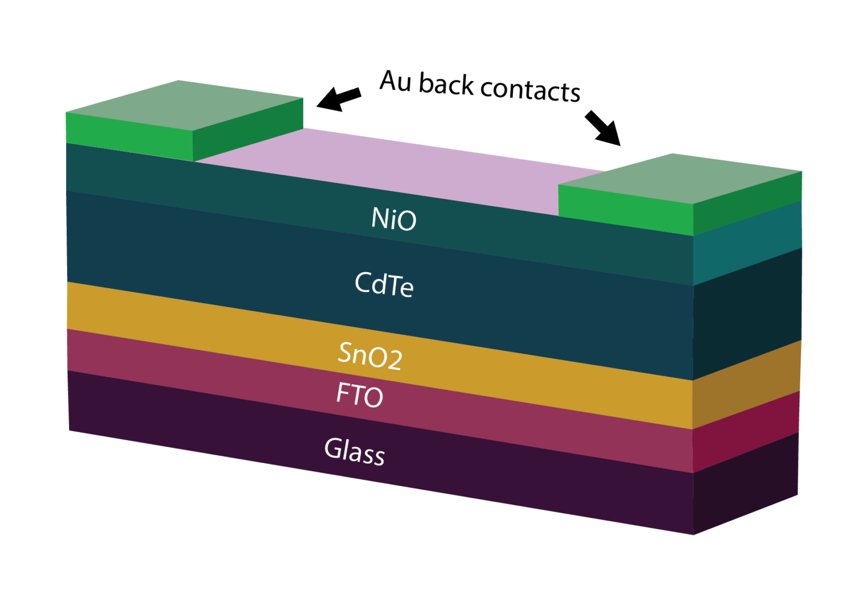

Cadmium telluride solar cells are commonly based on non-ohmic back contacts that affect the device open-circuit voltage, as these devices rely on low minority carrier lifetime, low carrier density and non-ohmic back contacts, and one solution to this problem is to add a nickel oxide back buffer layer, which forms an ohmic back contact and increases open-circuit voltage levels. British researchers have designed a cadmium telluride (CdTe) solar cell with a buffer layer made of nickel oxide (NiO) deposited without oxygen, which improves the device's open-circuit voltage. NiO, which is an efficient electron reflector due to the large conduction band offset, can be used as a back buffer layer to form an ohmic back contact. As optical transmission and band gaps are affected by oxygen input, typically reducing in both aspects with increasing oxygen, NiO begins to exhibit structural changes when introducing oxygen, forming nickel vacancies. The SCAPS-1D solar cell capacitance software, developed by the University of Ghent, was used to simulate the CdTe cell configuration, with the 0.25 cm2 device based on a substrate made of glass and fluorine-doped tin oxide (FTO), a tin oxide (SnO2) electron transport layer (ETL), a CdTe absorber, the Nio buffer layer with a thickness of 100 nm, and gold (Au) metal contacts. In the proposed cell architecture, the NiO back buffer layer increases device efficiency by reducing the barrier height at the Au back contact and improving the valence band offset at the CdTe/NiO interface (Hunwick et al., 2024; Bellini, 2024V).

Thompson, Valerie (2025A) PV Magazine, Perovskite-CIGS tandem solar cells powering electrodynamic tethers used in satellites,

<https://www.pv-magazine.com/2025/01/09/perovskite-cigs-tandem-solar-cells-for-electrodynamic-tethers-used-in-satellites/?utm_source=Global+%7C+Newsletter&utm_campaign=c53d954c15-dailynl_gl&utm_medium=email&utm_term=0_6916ce32b6-c53d954c15-160603208>

Propellant-free miniaturized space propulsion technology based on electrodynamic tethers integrating perovskite-copper indium gallium diselenide (CIGS) tandem solar cells has been developed by European researchers. This technology could be used to maneuver satellites in space or in de-orbiting without relying on heavy propellants on board. The main challenge of the project is to reach technology readiness level four (TRL 4) for an ultra-compact propellant-less, in-space green-propulsion mobility module (GMM) fed with solar energy and based on electrodynamic tether technology (Thompson, 2025A).

Bellini, Emiliano (2025A) PV Magazine, JinkoSolar claims 33.84% efficiency for perovskite-silicon tandem solar cell,

<https://www.pv-magazine-australia.com/2025/01/07/jinkosolar-claims-33-84-efficiency-for-perovskite-silicon-tandem-solar-cell/?utm_source=Global+%7C+Newsletter&utm_campaign=d15cfe302f-dailynl_gl&utm_medium=email&utm_term=0_6916ce32b6-d15cfe302f-160603208>

JinkoSolar’s N-type high-efficiency monocrystalline TOPCon solar cell as the bottom cell uses n-type wafers, and contributes innovations such as full-area passivated contact technology, perovskite interfacial defect passivation technology, and bulk defect passivation technology (Bellini, 2025A).

Exceeding the 39.5% efficiency threshold for perovskite-silicon tandem cells requires a change in cell architecture, replacing buckminsterfullerene (C60) with a more transparent electron transport layer, and finding more transparent alternatives to indium tin oxide (ITO) layers. The efficiency of perovskite-silicon tandem solar cells could reach up to 39.5%, though exceeding this efficiency threshold requires a change in cell architecture, replacing buckminsterfullerene (C60) with a more transparent electron transport layer, and finding more transparent alternatives to indium tin oxide (ITO) layers.

Mishra, Prabhat Ranjan (2025) Interesting Engineering, China develops perovskite cells with 26.39% efficiency, 95% retention after 1,100 hours,

<https://www.yahoo.com/news/china-develops-perovskite-cells-26-132810592.html>

Shen, L., Song, P., Jiang, K. et al. (2024) Ultrathin polymer membrane for improved hole extraction and ion blocking in perovskite solar cells, Nature Communications 15, 10908, <https://doi.org/10.1038/s41467-024-55329-0>

As the major cause of instability of perovskite solar cells is believed to be ion migration, perovskite solar cells have demonstrated limited operational lifetimes, primarily due to the layer-to-layer ion diffusion in the perovskite/doped hole-transport layer (HTL) heterojunction, leading to conductivity drop in HTL and component loss in the perovskite (Shen, 2024).

Chinese scientists have developed perovskite cells that utilize a hole-selective interlayer inhibiting ion diffusion to increase the device's stability, including an ultra-thin (~7 nm) p-type polymeric interlayer (D18) with excellent ion-blocking ability between perovskite and HTL to address these issues. The ultra-thin D18 interlayer effectively inhibits the layer-to-layer diffusion of lithium, methylammonium, formamidium, and iodide ions. Additionally, D18 improves the energy-level alignment at the perovskite/HTL interface and facilitates efficient hole extraction (Shen et al., 2024; Mishra, 2025).

Bellini, Emiliano (2025B) PV Magazine, Inverted perovskite solar cell based on self-assembled bilayer achieves 26.08% efficiency,

<https://www.pv-magazine.com/2025/01/14/inverted-perovskite-solar-cell-based-on-self-assembled-bilayer-achieves-26-08-efficiency/?utm_source=Global+%7C+Newsletter&utm_campaign=541936f3d6-dailynl_gl&utm_medium=email&utm_term=0_6916ce32b6-541936f3d6-160603208>

Dong, B., Wei, M., Li, Y. et al. (2025) Self-assembled bilayer for perovskite solar cells with improved tolerance against thermal stresses. Nature Energy, <https://doi.org/10.1038/s41560-024-01689-2>

Inverted perovskite cells have a device structure known as “p-i-n”, in which hole-selective contact p is at the bottom of intrinsic perovskite layer “i” with electron transport layer n at the top. Conventional halide perovskite cells have the same structure but reversed – an “n-i-p” layout. In an n-i-p architecture, the solar cell is illuminated through the electron-transport layer (ETL) side; in the p-i-n structure, it is illuminated through the hole transport (HTL) surface (Dong et al., 2025).

Chinese researchers have developed a self-assembled bilayer (SAB) used as a hole-selective molecular contact that ensures an improved adhesive contact with the perovskite film, and consists of a phosphonic acid self-assembled monolayer (SAM) with an upper layer made of an organic compound known as triphenylamine, which is intended to improve the adhesive contact with the perovskite film compared with a conventional SAM-perovskite interface. Triphenylamine also enhances the interface's thermal and mechanical robustness. SABs represent a basic form of self-assembled multilayers, consisting of distinct monolayers with varying constituents—interconnected via covalent or ionic bonds, as this layer-by-layer assembly stabilizes the labile monolayer by introducing rigid components and enables control over film termination (Dong et al., 2025; Bellini, 2025B).

Kennedy, Ryan (2025) PV Magazine, Organic solar cells for space demonstrate radiation resistance, self-healing,

<https://www.pv-magazine.com/2025/01/13/organic-solar-cells-for-space-demonstrate-radiation-resistance-self-healing/?utm_source=Global+%7C+Newsletter&utm_campaign=ae14186bc2-dailynl_gl&utm_medium=email&utm_term=0_6916ce32b6-ae14186bc2-160603208>

Li, Y., Kamaraj, K., Silori, Y., et al. (2025) Radiation hardness of organic photovoltaics, Joule, 101800, <https://doi.org/10.1016/j.joule.2024.12.001>

Silicon solar cells used on Earth rapidly degrade when exposed to the harsh radiation of space. Alternatively, gallium-arsenide solar cells are used today on satellites and spacecraft for the material’s ability to withstand the conditions of space. However, gallium-arsenide cells are expensive, rigid and heavy, making them difficult to integrate with an efficient craft (Li et al., 2025) .

While conventional silicon solar cells degrade rapidly in space, and gallium arsenide cells are heavy and inflexible, U.S. researchers have suggested that carbon-based solar cells, referred to as organic solar cells, may outperform conventional silicon solar cells and gallium-arsenide solar cells in space applications. They investigated the effects of radiation on organic solar cells at a molecular level, with the cells tested with proton radiation, which is considered the most damaging particles in space for electronic materials. They tested various organic solar cell configurations, and found that cells made with small molecules demonstrated strong resistance to protons, showing no damage after three years of radiation testing. Conversely, cells made with complex polymers lost about half of their efficiency under testing (Li et al., 2025; Kennedy, 2025).

Yirka, Bob (2025) TechXplore, Ultrathin polymer layer boosts perovskite solar cell efficiency to 26.39% <https://techxplore.com/news/2025-01-ultrathin-polymer-layer-boosts-perovskite.html>

Shen, L., Song, P., Jiang, K. et al. (2024) Ultrathin polymer membrane for improved hole extraction and ion blocking in perovskite solar cells, Nature Communications 15, 10908, <https://doi.org/10.1038/s41467-024-55329-0>

Over the past several years, scientists have been looking for ways to replace silicon as the basis for solar cell production due to its complex and expensive manufacturing process. The most promising replacement is the mineral perovskite, which is made up mostly of calcium titanate. But it has some hurdles to overcome, such as durability, scalability, its environmental impact and, of course, its cost (Shen et al., 2024).

a hole-selective interlayer that inhibits ion diffusion to improve the device's stability. The researchers created a super-thin p-type polymeric layer using a spin coating of PDTBT2T-FTBDT, which they call D18. In testing, it exhibited strong ion-blocking abilities between a layer of perovskite and the hole transport layer. Holes in solar cells refer to positively charged particles that are generated by light absorption—they serve as guides toward the anode. Further testing showed that the D18 layer installed in a functioning solar cell inhibited ion diffusion between layers as intended—and worked better than other polymers they tried. They also showed that it improved the alignment of energy at the interface of the hole transport layer and the perovskite and successfully carried out efficient hole extraction (Shen et al., 2024; Yirka, 2025).

Thompson, Valerie (2025B) PV Magazine, Recycled silicon powder from end-of-life solar panels can be reused in anti-corrosion coating,

<https://www.pv-magazine.com/2025/01/20/recycled-silicon-powder-from-end-of-life-solar-panels-can-be-reused-in-anti-corrosion-coating/?utm_source=Global+%7C+Newsletter&utm_campaign=3b5fed05bb-dailynl_gl&utm_medium=email&utm_term=0_6916ce32b6-3b5fed05bb-160603208>

Saha, R., Neha, Thukral, A., Pal, A., and Saini, P. (2025) A facile waste-to-wealth approach for synthesis of functionalized silica nanoparticles from end-of-life solar panel waste for technological applications, Resources, Conservation and Recycling, Volume 215, 108059, <https://doi.org/10.1016/j.resconrec.2024.108059>

Indian researchers have developed a wet chemical process to recover silicon with high purity from end-of-life (EoL) solar panels, which they used to make functionalized silica nanoparticles. Tests of the processed nanoparticles in anti-corrosion coatings showed a corrosion protection efficiency of 99.5 %, which they said was 200 times lower corrosion rate compared to uncoated silica nanoparticles. Their facile wet chemical process for recycling EoL panels focuses on aluminum back surface field (Al-BSF) type panels because most of the current and future EoL panels will be of this type. It is challenging to recover silicon-solar cells that are encapsulated between top and bottom ethyl-vinyl acetate (EVA) polymer sheets, without incinerating the EVA. The team used solvents for the EVA removal step, which presented yet another challenge that had to be overcome: preventing the loss of used medium or solvents and subsequent regeneration for reuse. Recovered cells were exposed to successive chemical treatments to selectively etch out various layers, such as the top silver finger contacts, top anti-reflection coatings, and bottom aluminum contact layer, according to the research. The component materials, such as silicon cells, cover glass, connecting wires, and layers of polymeric were separated to expose the bare silicon wafer. It had a purity of over 99.9%. As the recovered silicon could not be re-used to manufacture solar silicon, the team decided to use it to make silica nanoparticles, optical grade hydrophilic silica nanoparticles with optimized functionalization. The team took crushed silicon powder to use as a precursor for the synthesis of the silica nanoparticles, which was processed through chemical functionalization into silica (SNP) and hydrophobic silica (HSNP) nanoparticles in a three-step process. The SNPs and HSNPs were then characterized based on structural, morphological, optical, and spectroscopic techniques. The HSNPs were used as anti-corrosion coatings and they “significantly” outperformed conventional coatings based on both plain polymeric matrix and uncoated nanoparticles-filled polymer composites. The corrosion inhibition efficiency was 99.5 %, and the corrosion rate was about 200 times lower compared to the uncoated silica nanoparticles-filled polymer coating, according to the team. The performance was attributed to the ability of the nanoparticles to minimize water absorption and effectively prevent corrosive agents from reaching the substrate (Saha et al., 2025; Thompson, 2025B).

Bellini, Emiliano (2025C) PV Magazine, Reducing silver use in heterojunction solar cells via low-cost copper wires,

<https://www.pv-magazine.com/2025/01/21/reducing-silver-use-in-heterojunction-solar-cells-via-low-cost-copper-wires/?utm_source=Global+%7C+Newsletter&utm_campaign=34a15409ba-dailynl_gl&utm_medium=email&utm_term=0_6916ce32b6-34a15409ba-160603208>

Liu, Y., Peters, I.M., Ding, K., et al. (2025) Silver reduction through direct wire bonding for Silicon Heterojunction solar cells, Solar Energy Materials and Solar Cells, Volume 282, 113412, <https://doi.org/10.1016/j.solmat.2025.113412>

German researchers have proposed to use direct wire bonding (DWB) to reduce silver consumption in heterojunction solar cells, direct wire bonding (DWB) as a low-temperature method for interconnecting finger-free heterojunction (HJT) solar cells on the front side using low-cost, highly conductive copper (Cu) wires, whereby low-cost copper wires on HJT solar cells are utilized as electrodes with conductive paste applied in discrete pads to replace the traditional metallization and interconnection process. The paste used in this structure is cured at low temperatures during the lamination process, making it suitable for heterojunction and perovskite-silicon tandem solar cells. Despite the slightly lower efficiency, the proposed cell configuration offers considerable advantages in terms of paste consumption, with the scientists affirming it is comparable to that of modules with the lowest usage 0BB solution. The DWB offers superior cost savings by eliminating the need for interconnect material (Liu et al., 2025; Bellini, 2025C).

Bellini, Emiliano (2025D) PV Magazine, Taiwanese researchers unveil 31.5%-efficient perovskite-silicon tandem solar cell,

<https://www.pv-magazine.com/2025/01/22/taiwanese-researchers-unveil-31-5-efficient-perovskite-silicon-tandem-solar-cell/?utm_source=Global+%7C+Newsletter&utm_campaign=c2df1123d6-dailynl_gl&utm_medium=email&utm_term=0_6916ce32b6-c2df1123d6-160603208>

Taiwan's Academia Sinica created a two-terminal (2T) perovskite-silicon tandem solar cell that utilizes a heterojunction crystalline device as the bottom cell and a perovskite top cell made of indium tin oxide (ITO) integrating a hole transport layer (HTL) made of nickel(II) oxide (NIOx) and phosphonic acid called methyl-substituted carbazole (Me-4PACz), a perovskite absorber, a buckminsterfullerene (C60) electron transport layer (ETL), a tin oxide (SnOx) buffer layer, a transparent back contact made of indium zinc oxide (IZO), a silver (Ag) metal contact, and an anti-reflective coating based on magnesium fluoride (MgF2) (Bellini, 2025D).

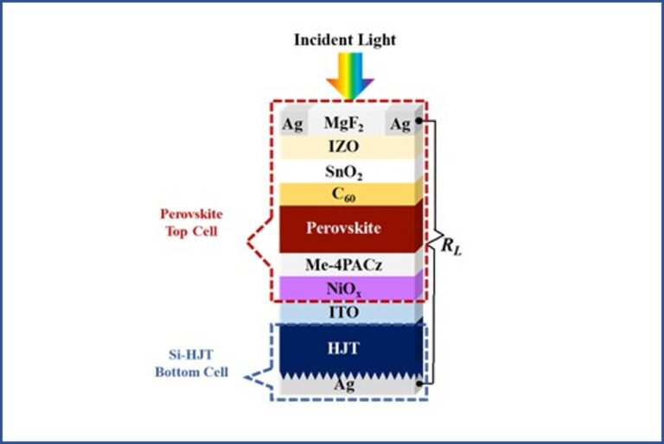

Thompson, Valerie (2025C) PV Magazine, All-perovskite tandem solar cell based on wide bandgap perovskite achieves 29.1% efficiency,

<https://www.pv-magazine.com/2025/01/23/all-perovskite-tandem-solar-cell-based-on-wide-bandgap-perovskite-achieves-29-1-efficiency/?utm_source=Global+%7C+Newsletter&utm_campaign=6e72185966-dailynl_gl&utm_medium=email&utm_term=0_6916ce32b6-6e72185966-160603208>

Liu, Z., Lin, R., Wei, M., et al. (2025) All-perovskite tandem solar cells achieving >29% efficiency with improved (100) orientation in wide-bandgap perovskites. Nature Materials 24, 252–259, <https://doi.org/10.1038/s41563-024-02073-x>

Chinese researchers have developed an effective technique to control the crystal orientation without compromising charge transport, with a 0.049 ${cm}^{2}$ all-perovskite tandem solar cell with reduced open-circuit voltage losses in the wide-bandgap (WBG) perovskite subcell and improved overall efficiency. They achieved this by suppressing non-radiative recombination using a two-dimensional perovskite as an intermediate phase on the film surface. The preferred orientations in wide-bandgap perovskites can be realized by augmenting the quantity of two-dimensional phases through surface composition engineering, without the need for excessive two-dimensional ligands that otherwise impede carrier transport. They incorporated phenylethylamine iodide (PEAI) and methylammonium iodide (MAI) into the anti-solvent during fabrication, forming a 2D perovskite layer on the surface of the wide-bandgap perovskite subcell. This 2D perovskite layer served as heterogeneous nucleation sites, facilitating the vertical growth of (100)-oriented 3D perovskite crystals due to the reduced interfacial energy associated with the 2D/3D heterostructures. Consequently, the anti-solvent treatment not only altered the perovskite surface but also significantly influenced the crystallographic orientation of the perovskite crystals, promoting a more advantageous crystal alignment. The approach resulted in high-quality WBG perovskite films with a (100) orientation, which suppressed non-radiative recombination in the wide-bandgap perovskite subcells, achieving an open-circuit voltage of 1.373 V for a bandgap of 1.78 eV with 21.1% efficiency. This was combined with a high-efficiency narrow-bandgap subcell in a tandem configuration, “incorporating a well-optimized optical-electrical matching design” to achieve the high-performance all-perovskite tandem solar cell. For the WBG films, common approaches were investigated, noted the researchers. One approach added the PEAI into the precursor solution as a direct additive (DA) and the other introduced PEAI into the anti-solvent as a solution-process additive (SPA). Another SPA had a mixture of MAI and PEAI with a weight ratio of 1:2 as the mixed solution-process additive (M-SPA) to create a local MA-rich environment. future efforts should focus on non-MA additives that enhance the formation of 2D templates (Liu et al., 2025; Thompson, 2025C).

Bellini, Emiliano (2025E) PV Magazine, Improving solar cell performance with narrower contact fingers,

<https://www.pv-magazine.com/2025/01/24/improving-solar-cell-performance-with-narrower-contact-fingers/?utm_source=Global+%7C+Newsletter&utm_campaign=ad886cc5b9-dailynl_gl&utm_medium=email&utm_term=0_6916ce32b6-ad886cc5b9-160603208>

Schweigstill, T., Mielich, N., Vogt, A., Schulz-Ruhtenberg, M., Clement, F., Huyeng, J. . and Lorenz, A. (2024), Advanced Fine Line Printing With Glass Stencils: Achieving Metal Contact Fingers Below 10 μm. Prog Photovolt Res Appl. <https://doi.org/10.1002/pip.3885>

German researchers have developed a low temperature new metallization process that can produce ultra-fine line metal contact fingers for solar cells. The proposed technique is based on the so-called LIDE technology and can reportedly help increase overall PV device efficiency. Narrower ultra-fine line contacts may reduce front-side shading in solar cells, thus enhancing their overall efficiency and performance. The solar industry has been able to reduce finger width from 120 μm in 2005 to less than 20 μm in 2024. The proposed metallization process is based on glass stencils provided by LPKF Laser & Electronics SE. These stencils rely on the so-called LIDE technology, which is a two-step process that creates deep structures in thin glass with a high aspect ratio in the range of over 1:10 at a high processing speed. “This process is not only rapid but also cost-efficient, allowing for the production of dot- or line-shaped structures down to 5 μm and less,” the academics stressed. They also explained that they used the LIDE technique to initially modify a 400 μm thick sheet of 10 cm x 10 cm AF 32 eco glass. They then used wet chemical etching to remove the laser-modified glass at a faster rate than the unmodified areas, which they said resulted in highly precise microstructures. Moreover, they used a lasering process to structure the glass for the opening of the final aperture channel at the opposite side of the glass foil (Schweigstill et al., 2024; Bellini, 2025E).

Bellini, Emiliano (2025F) PV Magazine, TU Delft research outlines optimization path for two-terminal perovskite-silicon tandem solar modules,

<https://www.pv-magazine.com/2025/01/31/tu-delft-research-outlines-optimization-path-for-two-terminal-perovskite-silicon-tandem-solar-modules/?utm_source=Global+%7C+Newsletter&utm_campaign=eac8dda627-dailynl_gl&utm_medium=email&utm_term=0_6916ce32b6-eac8dda627-160603208>

Blom, Y., Vogt, M.R., Isabella, O., and Santbergen, R. (2025) Optimization of the perovskite cell in a bifacial two-terminal perovskite/silicon tandem module, Solar Energy Materials and Solar Cells, Volume 282, 113431, <https://doi.org/10.1016/j.solmat.2025.113431>

Dutch researchers the effect rear irradiance has on the optimal bandgap energy and thickness of the perovskite cell in a bifacial two-terminal perovskite-silicon tandem module. Their findings show that bifacial tandems have over a 25% gain in energy yield compared to bifacial single junction modules and up to 5% gain compared to monofacial tandem modules. The research group used a reference 32.5%-efficient perovskite-silicon tandem cell developed by German research center Helmholtz-Zentrum Berlin (HZB) to optimize the design of a perovskite cell in a bifacial monolithic 2T tandem module under various conditions. “The reference cell is adjusted by reducing the wafer thickness and adding glass and encapsulation,” the group said. “The bifacial modules are created by removing the silver layer and adding a second encapsulant layer.” The simulations were conducted via the PVMD Toolbox, which is a comprehensive modeling software to simulate building-integrated and tandem PV systems. The Advanced Semiconductor Analysis (ASA) was used to calculate the electrical properties of the cells and the calibrated lumped element method (CLEM) was utilized for energy yield simulations (Blom et al., 2025; Bellini, 2025F).

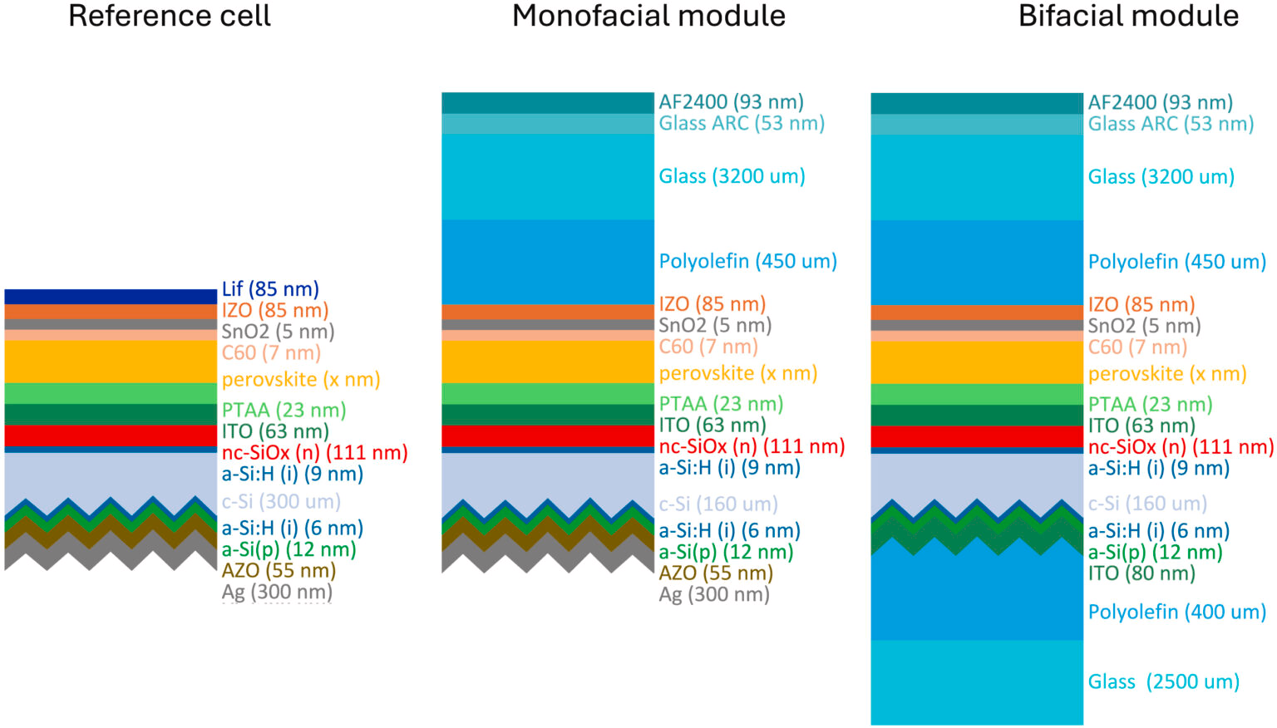

The bifacial perovskite/silicon cell structure used in the simulations

*Image: TU Delft, Solar Energy Materials and Solar Cells, CC BY 4.0*

<https://www.pv-magazine.com/2025/01/31/tu-delft-research-outlines-optimization-path-for-two-terminal-perovskite-silicon-tandem-solar-modules/?utm_source=Global+%7C+Newsletter&utm_campaign=eac8dda627-dailynl_gl&utm_medium=email&utm_term=0_6916ce32b6-eac8dda627-160603208>

Bellini, Emiliano (2025) PV Magazine, Perovskite solar cell based on 3D/2D heterostructures achieves 26.05% efficiency,

<https://www.pv-magazine.com/2025/01/29/perovskite-solar-cell-based-on-3d-2d-heterostructures-achieves-26-05-efficiency/?utm_source=Global+%7C+Newsletter&utm_campaign=7f5382b038-dailynl_gl&utm_medium=email&utm_term=0_6916ce32b6-7f5382b038-160603208>

Chang, X., Azmi, R., Yang, T. et al. (2025) Solvent-dripping modulated 3D/2D heterostructures for high-performance perovskite solar cells, Nat Commun 16, 1042, <https://doi.org/10.1038/s41467-025-56409-5>

Saudi researchers have developed a 3D/2D perovskite solar cell based on a meta-amidinopyridine (MAP) ligand that can reportedly improve ferroelectric properties and passivation effects at the cell's 3D/2D interface without deteriorating charge transport. Perovskite cells built with 2D hybrid materials are known for their stability and exhibit large exciton binding energy compared to conventional 3D devices. Different organic ammonium salts have been tested to develop 3D/2D solar cells, with halogenated analogs of phenethylammonium iodide (PEAI) salts being the preferred choice due to their potential to enhance hole extraction. The researchers explained that currently 3D/2D perovskite heterostructures are formed by dissolving suitable ligands in polar solvents, which affects charge transport and cell stability. To address this issue, they used MAP ligands and the solvent post-dripping, which resulted in a “highly ordered” 2D perovskite phase on the surface of a 3D perovskite film, without significantly compromising the quality of the whole 3D/2D-MAP film. “2D-MAP without post-dripping treatment exhibits a disordered orientation of the 2D phase atop the 3D perovskite,” they further explained. “In contrast, after solvent post-dripping, the 2D-MAP sample shows a more ordered 2D phase parallel to the 3D perovskite layer with a more infiltrated structure.” The research team built the solar cell with a substrate made of glass and indium tin oxide (ITO), a hole transport layer (HTL) based on 2PACz, a 3D perovskite absorber, a 2D perovskite layer, an electron transport layer (ETL) based on buckminsterfullerene (C60), a bathocuproine (BCP) buffer layer, and a silver (Ag) metal contact (Chang et al., 2025; Bellini, 2025).

The cell consists of a top cell based on a perovskite absorber and a bottom cell with a heterojunction (HJT) structure.

Kahana, Lior (2025) PV Magazine, Aluminum foils can reduce temperature in double-glass PV modules by 6 C,

<https://www.pv-magazine.com/2025/01/30/aluminum-foils-can-reduce-temperature-in-double-glass-pv-modules-by-6-c/?utm_source=Global+%7C+Newsletter&utm_campaign=f7d93fedad-dailynl_gl&utm_medium=email&utm_term=0_6916ce32b6-f7d93fedad-160603208>

Sun, X., Tan, Y., Cui, X., et al. (2025) Reducing the temperature of monofacial double-glass photovoltaic module by enhancing in-plane thermal conductivity, Next Energy, Volume 7, 100236, <https://doi.org/10.1016/j.nxener.2024.100236>

Scientists in China placed a 0.5 mm thick aluminum (Al) foil inside PV modules to enhance its in-plane thermal conductivity and cool it from within, between the solar cell and the EVA, and between the EVA and the glass layer, to dissipate heat from the transversal direction and simultaneously increase the in-plane temperature uniformity of the PV module. The two experimental modules were compared to a reference module and were found to dissipate heat and increase the in-plane temperature uniformity. Passive cooling methods such as phase change cooling and radiation cooling dissipate heat from the surface of the PV module, and less consideration focuses on the in-plane heat conduction close to the solar cell (Sun et al., 2025; Kahana, 2025).

Carroll, David (2025) PV Magazine, Australian researchers set world record with kesterite solar cell,

<https://www.pv-magazine.com/2025/01/28/unsw-team-achieves-13-2-world-record-efficiency-for-kesterite-solar-cell/?utm_source=Global+%7C+Newsletter&utm_campaign=80e4babb6e-dailynl_gl&utm_medium=email&utm_term=0_6916ce32b6-80e4babb6e-160603208>

Wang, A., Cong, J., Zhou, S. et al. (2025) Hydrogen-enhanced carrier collection enabling wide-bandgap Cd-free Cu2ZnSnS4 solar cells with 11.4% certified efficiency, Nat Energy, <https://doi.org/10.1038/s41560-024-01694-5>

High bandgap kesterite (CZTS) solar cells, a compound of copper, zinc, tin and sulfur, is a high-bandgap thin film, flexible material suitable that offers a promising alternative to the more widely studied perovskite as a tandem top-cell candidate because it is environmentally friendly, cost-effective to manufacture, and is known to maintain its performance over a long period. Its energy conversion efficiency has however been hindered by relatively low energy conversion efficiencies, largely attributed to defects created within CZTS during production. Prof. Xiaojing Hao and her team from UNSW’s School of Photovoltaic and Renewable Energy Engineering say they have helped to solve this problem by annealing, or heat-treating, the CZTS solar cell device in a hydrogen-containing atmosphere. “In basic terms, to create CZTS you take copper, tin, zinc and sulphur and ‘cook’ them all together at a certain temperature which turns it into a material you can use as a semiconductor,” Hao said. “The tricky part is controlling the defects that are introduced during that process. What we have shown in this work is that introducing hydrogen can ensure those defects have less of an impact, which is known as passivation. Because hydrogen is modulating the defects within CZTS, that’s what helps increase its efficiency in terms of converting sunlight into electricity (Wang et al., 2025; Carroll, 2025).

Thompson, Valerie (2025) PV Magazine, Scientists build 23.2%-efficient lead tin perovskite solar cell with improved lifetime,

<https://www.pv-magazine.com/2025/01/28/scientists-build-23-2-efficient-lead-tin-perovskite-solar-cell-with-improved-lifetime/?utm_source=Global+%7C+Newsletter&utm_campaign=80e4babb6e-dailynl_gl&utm_medium=email&utm_term=0_6916ce32b6-80e4babb6e-160603208>

Perera, W.H.K., Webb, T., Xu, Y., et al. (2025) 23.2% efficient low band gap perovskite solar cells with cyanogen management, Energy Environ. Sci., 2025,18, 439-453, <http://dx.doi.org/10.1039/D4EE03001J>

The researchers built the lead-tin perovskite solar cell with a hole transport layer (HTL) based on PEDOT:PSS and were reportedly able to reduce the losses caused by this compound with the utilization of a thiocyanate additive. The researchers built the cell with a hole transport layer (HTL) based on PEDOT:PSS, a polymer known for its low cost and easy preparation properties and said this material is widely used for lead-tin mixed narrow bandgap perovskites used in all perovskite tandem solar cells and also multijunction solar cells. “This particular sub-cell is anticipated to replace the role of silicon in current perovskite-based tandem and multijunction cells. The team investigated performance loss and lower stability mechanisms of PEDOT:PSS-based perovskite optoelectronics. They noted that amine-containing organic cations de-dope PEDOT:PSS. It can be “partially recovered with thiocyanate additives,” but improvement comes at the expense of device stability due to cyanogen formation from thiocyanate-iodine interaction, which the team noted is accelerated in the presence of moisture. “Our work shows that the organic cations can diffuse into PEDOT:PSS that leads to efficiency loss,” explained Jayawardena. “We also show that this diffusion process can be alleviated with a thiocyanate additive. However, the thiocyanate can also accelerate the degradation of the perovskite solar cell in the process of any moisture to which we have demonstrated a solution.” The biggest challenge was to isolate factors that could mask the actual diffusion and degradation mechanism, according to Jayawardena. The team noted that, in the presence of moisture, thiocyanates form cyanogens, which accelerate the perovskite degradation, irrespective of the hole transport layer used. It also explained that device efficiency as well as stability for lead-tin perovskites under ambient conditions could be improved with iodine reduction within the bulk as a key strategy. “To mitigate this degradation pathway, we incorporate an iodine reductant in lead-tin PSCs. The resulting devices show an improved power conversion efficiency of 23.2% which is among the highest reported for lead-tin PSCs,” stated the team, adding that it resulted in a 66% enhancement in the TS80 lifetime under maximum power point tracking and ambient conditions (Perera et al., 2025; Thompson, 2025).

Bellini, Emilano (2025) PV Magazine, Reducing TOPCon solar cell degradation via copper plating,

<https://www.pv-magazine.com/2025/01/27/reducing-topcon-solar-cell-degradation-via-copper-plating/?utm_source=Global+%7C+Newsletter&utm_campaign=45ea69cbdd-dailynl_gl&utm_medium=email&utm_term=0_6916ce32b6-45ea69cbdd-160603208>

Wang, X., Sen, C., Wu, X., et al. (2025) Alleviating contaminant-induced degradation of TOPCon solar cells with copper plating, Solar Energy Materials and Solar Cells, Volume 282, 113444, <https://doi.org/10.1016/j.solmat.2025.113444>

Australian researchers a 1 µm copper plating layer on the front silver grid of a TOPCon solar cell to create a protective barrier that reportedly reduces corrosion susceptibility. The cell showed significantly lower contaminant-induced degradation that unprotected reference devices. to reduce contaminant-induced degradation in solar cells based on tunnel oxide passivated contact (TOPCon) technology by using copper (Cu) plating on screen-printed devices. According to the research group, their work not only enhances the reliability and durability of TOPCon cells under damp heat (DH) and field-like conditions but also highlights the potential for reducing silver consumption and lowering the levelized cost of electricity (LCOE). The researchers explained that plated-Cu contacts capped with silver (Ag) or tin (Sn) are used to prevent contaminants from infiltrating the contacts themselves and causing oxidation, as well as to improve the soldering process in TOPCon cells. Furthermore, scanning electron microscopy (SEM) and energy-dispersive X-ray spectroscopy (EDS) analysis confirmed that Cu plating filled voids in the silver contact, creating a denser, more robust interface that prevents contaminant penetration and reduced parasitic recombination (Wang et al., 2025; Bellini, 2025).

**References**

Bellini, Emiliano (2023A) PV Magazine. New attempt to build solar cells based on gallium-arsenide-nitrogen-bismuth. Retrieved November 5, 2023. <https://www.pv-magazine.com/2023/11/02/new-attempt-to-build-solar-cells-based-on-gallium-arsenide-nitrogen-bismuth/>

Bellini, Emiliano (2023B) PV Magazine. NREL presents new GaAs solar cell concept with 27% efficiency. Retrieved November 13, 2023. <https://www.pv-magazine.com/2023/11/10/nrel-presents-new-gaas-solar-cell-concept-with-27-efficiency/>

Bellini, Emiliano (2023C) PV Magazine. Black perovksite solar cell achieves 20.25% efficiency. Retrieved November 13, 2023. <https://www.pv-magazine.com/2023/11/08/black-perovksite-solar-cell-achieves-20-25-efficiency/>

Bellini, Emiliano (2023D) PV Magazine. Kesterite solar cell achieves 12.01% efficiency via selenization approach. Retrieved November 20, 2023. <https://www.pv-magazine.com/2023/11/17/kesterite-solar-cell-achieves-12-01-efficiency-via-new-selenization-approach/>

Bellini, Emiliano (2023E) PV Magazine. Scientists achieve 29.9% efficiency for four-junction perovskite-CSI tandem solar cell. <https://www.pv-magazine.com/2023/11/20/scientists-achieve-29-9-efficiency-for-four-junction-perovskite-csi-tandem-solar-cell/>

Bellini, Emiliano (2023F) PV Magazine. Gallium arsenide solar cell achieves 23.1% efficiency via electrochemical porosification. Retrieved November 22, 2023. <https://www.pv-magazine.com/2023/11/21/gallium-arsenide-solar-cell-achieves-23-1-efficiency-via-electrochemical-porosification/>

Bellini, Emiliano (2023G) PV Magazine, Scientists warn of heat-induced failure risks in HJT glass-backsheet PV modules, <https://www.pv-magazine.com/2023/05/09/scientists-warn-of-heat-induced-failure-risks-in-hjt-glass-backsheet-pv-modules/>

Bellini, Emiliano (2023G) PV Magazine, Scientists warn of heat-induced failure risks in HJT glass-backsheet PV modules, <https://www.pv-magazine.com/2023/05/09/scientists-warn-of-heat-induced-failure-risks-in-hjt-glass-backsheet-pv-modules/>

Bellini, Emiliano (2024A) PV Magazine, Prospects for reusing silicon from end-of-life solar modules in new ingot production,

<https://www.pv-magazine.com/2024/12/27/prospects-for-reusing-silicon-from-end-of-life-solar-modules-in-new-ingot-production/?utm_source=Global+%7C+Newsletter&utm_campaign=3c5e3c9128-dailynl_gl&utm_medium=email&utm_term=0_6916ce32b6-3c5e3c9128-160603208>

Bellini, Emiliano (2024B) PV Magazine, Fraunhofer ISE, AMOLF unveil TOPCon solar cell based on metal nanowire grid front electrodes,

<https://www.pv-magazine.com/2024/12/04/fraunhofer-ise-amolf-unveil-topcon-solar-cell-based-on-metal-nanowire-grid-front-electrodes/?utm_source=Global+%7C+Newsletter&utm_campaign=84fee40efa-dailynl_gl&utm_medium=email&utm_term=0_6916ce32b6-84fee40efa-160603208>

Bellini, Emiliano (2024D) PV Magazine, Nexwafe claims 24.4% efficiency for heterojunction solar cell built with its ultrathin wafers,

<https://www.pv-magazine.com/2024/12/18/nexwafe-claims-24-4-efficiency-for-heterojunction-solar-cell-built-with-its-ultrathin-wafers/?utm_source=Global+%7C+Newsletter&utm_campaign=fe3c6f8aee-dailynl_gl&utm_medium=email&utm_term=0_6916ce32b6-fe3c6f8aee-160603208>

Bellini, Emiliano (2024E) PV Magazine, JA Solar debuts 23.3%-efficient single-glass, anti-dust solar panel at SNEC,

<https://www.pv-magazine.com/2024/06/17/ja-solar-debuts-23-3-efficient-single-glass-anti-dust-solar-panel-at-snec/?utm_source=Global+%7C+Newsletter&utm_campaign=6bb29a7611-dailynl_gl&utm_medium=email&utm_term=0_6916ce32b6-6bb29a7611-160603208>

Bellini, Emiliano (2024F) PV Magazine, Scientists build solar panels based on natural fiber backsheet,

<https://www.pv-magazine.com/2024/09/03/scientists-build-solar-panels-based-on-natural-fiber-backsheet/?utm_source=Global+%7C+Newsletter&utm_campaign=c814edb6a0-dailynl_gl&utm_medium=email&utm_term=0_6916ce32b6-c814edb6a0-160603208>

Bellini, Emiliano (2024G) PV Magazine, Improving solar cell performance with dye concentrators,

<https://www.pv-magazine.com/2024/08/07/improving-solar-cell-performance-with-dye-concentrators/?utm_source=Global+%7C+Newsletter&utm_campaign=2a71bf6845-dailynl_gl&utm_medium=email&utm_term=0_6916ce32b6-2a71bf6845-160603208>

Bellini, Emiliano (2025A) PV Magazine, New research sheds light on impact of sodium-induced degradation in heterojunction solar cells,

<https://www.pv-magazine.com/2025/01/03/new-research-sheds-light-on-impact-of-sodium-induced-degradation-in-heterojunction-solar-cells/?utm_source=Global+%7C+Newsletter&utm_campaign=15eb45e3e4-dailynl_gl&utm_medium=email&utm_term=0_6916ce32b6-15eb45e3e4-160603208>

Bleiji, Y., Müller, R., Micali, M. et al. (2025) Enhanced near infrared light trapping in Si solar cells with metal nanowire grid front electrodes, Solar Energy Materials and Solar Cells, Volume 281, 113289, <https://doi.org/10.1016/j.solmat.2024.113289>

Boyd, John (2023) IEEE Spectrum. Perovskite Solar Cells Double as Windows and Walls. Retrieved November 13, 2023. <https://spectrum.ieee.org/amp/perovskite-2666168147-2666168147#amp_tf=From%20%251%24s&aoh=16996414453112&csi=0&referrer=https%3A%2F%2Fwww.google.com>

Bradstock, Felicity (2024) Oil Price, Why Energy Giants Won't Turn Their Backs on Oil,

<https://oilprice.com/Energy/Energy-General/Why-Energy-Giants-Wont-Turn-Their-Backs-on-Oil.html>

Brągoszewska, E., Bogacka, M., and Wajda, A. (2024) Enhancing the efficiency of photovoltaic cells through the usage of dye concentrators, Frontiers in Energy Research, Volume 12, <https://doi.org/10.3389/fenrg.2024.1399020>

Clark, Silvia (2023) Tech Explore. Breakthrough synthesis method improves solar cell stability. Retrieved October 21, 2023. <https://techxplore.com/news/2023-10-breakthrough-synthesis-method-solar-cell.html>

Curtis, T. L., et al., "Solar Photovoltaic Module Recycling: A Survey of U.S. Policies and Initiatives," NREL, 2021.

Cuthbertson, Anthony (2023A) The Independent. ‘Miracle material’ solar panels to finally enter production in China. Retrieved October 30, 2023. <https://www.independent.co.uk/tech/perovskite-solar-panels-cells-china-b2361555.html>

Cuthbertson, Anthony (2023B) The Independent. Solar panel world record smashed with ‘miracle material’. Retrieved November 13, 2023. <https://www.independent.co.uk/tech/perovskite-solar-panels-uk-b2446225.html>

Daniel, V., Bidaud, T., Chretien, J., et al. (2024), High-Efficiency GaAs Solar Cells Grown on Porous Germanium Substrate with PEELER Technology. Solar RRL, 8: 2300643. <https://doi.org/10.1002/solr.202300643>

de Lafontaine, M., Bidaud, T., Gay, G., et al. (2023) 3D interconnects for III-V semiconductor heterostructures for miniaturized power devices, Cell Reports Physical Science, Volume 4, Issue 12, 101701, <https://doi.org/10.1016/j.xcrp.2023.101701>

deQuilettes, D.W., Yoo, J.J., Brenes, R. et al. (2024) Reduced recombination via tunable surface fields in perovskite thin films. Nature Energy 9, 457–466, <https://doi.org/10.1038/s41560-024-01470-5>

Foley, EV (2024A) PV Magazine, Trinasolar hits record efficiency high 27.08% for HJT solar cells,

<https://www.pv-magazine-australia.com/2024/12/20/trinasolar-hits-record-efficiency-high-27-08-for-hjt-solar-cells/?utm_source=Global+%7C+Newsletter&utm_campaign=73b4cb8bc3-dailynl_gl&utm_medium=email&utm_term=0_6916ce32b6-73b4cb8bc3-160603208>

Garcia, D. (2024) Eco News. The new material that will multiply the power of solar panels: we use it every day and did not know its potential. <https://www.ecoticias.com/en/perovskite-silicon-solar-panels/397/>

Geerligs, L. ., Kuypers, A. and Theelen, M. (2024), Potential for Recycled Silicon Solar Cells as Feedstock for New Ingot Growth. Progress in Photovoltaics Res Appl. <https://doi.org/10.1002/pip.3872>

Grad, Peter (2023) Tech Explore. Research team counters solar energy misinformation. Retrieved November 6, 2023. <https://techxplore.com/news/2023-10-team-counters-solar-energy-misinformation.html>

Gupta, Uma (2024) PV Magazine, Hitachi Energy unveils AI-based solar forecasting solution,

<https://www.pv-magazine.com/2024/12/10/hitachi-energy-unveils-ai-based-solar-forecasting-solution/?utm_source=Global+%7C+Newsletter&utm_campaign=0900ac023d-dailynl_gl&utm_medium=email&utm_term=0_6916ce32b6-0900ac023d-160603208>

Hicks, Wayne (2023) Tech Explore. Design improvements boost efficiency of III-V solar cells. Retrieved November 6, 2023. <https://techxplore.com/news/2023-10-boost-efficiency-iii-v-solar-cells.html>

Hou, J., Li, W., Zhang, H. et al. (2024) Synthesis of 2D perovskite crystals via progressive transformation of quantum well thickness. Nature Synthesis 3, 265–275, <https://doi.org/10.1038/s44160-023-00422-3>

Hutchins, Mark (2024) PV Magazine, Standards and transparency key to solar sustainability,

<https://www.pv-magazine.com/2024/12/13/standards-and-transparency-key-to-solar-sustainability/?utm_source=Global+%7C+Newsletter&utm_campaign=d23cbc3cc1-dailynl_gl&utm_medium=email&utm_term=0_6916ce32b6-d23cbc3cc1-160603208>

Jia, Liu (2023) Phys.org. Researchers develop stable and efficient inorganic CsPbI3 solar cells. Retrieved November 13, 2023. <https://phys.org/news/2023-11-stable-efficient-inorganic-cspbi3-solar.html>

Jowett, Patrick (2024A) PV Magazine, IEA calls for stronger solar, wind integration measures,

<https://www.pv-magazine.com/2024/09/20/iea-calls-for-stronger-solar-wind-integration-measures/?utm_source=Global+%7C+Newsletter&utm_campaign=2e36662961-dailynl_gl&utm_medium=email&utm_term=0_6916ce32b6-2e36662961-160603208>

Kim, H., Figueroa Morales, C., and Seong, S. et al. (2024) Molecular design of defect passivators for thermally stable metal-halide perovskite films, Matter, DOI: 10.1016/j.matt.2023.12.003.

Lewis, Michelle (2023) Electrek. A huge US solar developer just committed to recycling its solar panels. Retrieved November 8, 2023. <https://electrek.co/2023/11/06/us-solar-panel-recycling/>

Lewis, Michelle (2024) Electrek. MIT just released directions for commercializing perovskite solar cells. <https://electrek.co/2024/02/28/mit-just-released-directions-for-commercializing-perovskite-solar-cells/>

Liang, H., Feng, J., Rodríguez-Gallegos, C.D. et al. (2023) 29.9%-efficient, commercially viable perovskite/CuInSe2 thin-film tandem solar cells, Joule, Volume 7, Issue 12, Pages 2859-2872, <https://doi.org/10.1016/j.joule.2023.10.007>

Li, M.H., Wang, S., Ma, X., et al., (2023) Hydrogen-bonding-facilitated dimethylammonium extraction for stable and efficient CsPbI3 solar cells with environmentally benign processing, Joule, 7,2595–2608, <https://doi.org/10.1016/j.joule.2023.09.009>

Lin, R., Wang, Y., Lu, Q. et al. (2023) All-perovskite tandem solar cells with 3D/3D bilayer perovskite heterojunction. Nature 620, 994–1000, <https://doi.org/10.1038/s41586-023-06278-z>

O’Dea, Blathnaid (2024) PV Magazine, Patents to add AI to power grids are surging, says IEA,

<https://www.pv-magazine.com/2024/12/13/patents-to-add-ai-to-power-grids-are-surging-says-iea-epo-report/?utm_source=Global+%7C+Newsletter&utm_campaign=d23cbc3cc1-dailynl_gl&utm_medium=email&utm_term=0_6916ce32b6-d23cbc3cc1-160603208>

Pao, Jeff (2023) Asia Times. China rushes to market with next-gen solar cell. Retrieved October 30, 2023. <https://asiatimes.com/2023/06/china-rushes-to-market-with-next-gen-solar-cell/>

Peplow, Mark (2023) Nature, A new kind of solar cell is coming: is it the future of green energy? <https://www.nature.com/articles/d41586-023-03714-y>

Puustinen, J., Hilska, J., Aho, A. et al. (2024) Low bandgap GaAsNBi solar cells, Solar Energy Materials and Solar Cells, Volume 264, 112598, <https://doi.org/10.1016/j.solmat.2023.112598>

Rizk, Bernard (2023) Tech Xplore. Researchers manufacture the first back-contact micrometric photovoltaic cells. Retrieved November 29, 2023. <https://techxplore.com/news/2023-11-back-contact-micrometric-photovoltaic-cells.html>

Rüther, Ricardo and Blakers, Andrew, International Solar Energy Society (ISES) (2024A) PV Magazine, Circular economy and solar photovoltaics: is there a case for second-life PV modules?,

<https://www.pv-magazine.com/2024/09/20/circular-economy-and-solar-photovoltaics-is-there-a-case-for-second-life-pv-modules/?utm_source=Global+%7C+Newsletter&utm_campaign=2e36662961-dailynl_gl&utm_medium=email&utm_term=0_6916ce32b6-2e36662961-160603208>

Rüther, Ricardo and Blakers, Andrew, International Solar Energy Society (ISES) (2024B) PV Magazine, Circular economy and solar photovoltaics: is there a case for second-life PV modules?,

<https://www.pv-magazine.com/2024/09/20/circular-economy-and-solar-photovoltaics-is-there-a-case-for-second-life-pv-modules/?utm_source=Global+%7C+Newsletter&utm_campaign=2e36662961-dailynl_gl&utm_medium=email&utm_term=0_6916ce32b6-2e36662961-160603208>

Sathyanarayanan, A., Murugesan, B., Rajamanickam, N. et al. (2024) Comprehensive study on zeolitepolyester composite coated sheet for eco-friendly solar panels for enhanced panel performance and reduced panel temperature. Scientific Reports 14, 20072, <https://doi.org/10.1038/s41598-024-71108-9>

Schulte, K.L., Simon, J., Steiner, M.A., and Ptak, A.J. et al. (2023) Modeling and design of III-V heterojunction solar cells for enhanced performance, Cell Reports Physical Science, Volume 4, Issue 9, 101541, <https://www.cell.com/cell-reports-physical-science/fulltext/S2666-3864(23)00338-7>

Sen, C., Wang, H., Wu, X. et al. (2023) Four failure modes in silicon heterojunction glass-backsheet modules, Solar Energy Materials and Solar Cells, Volume 257, 112358, <https://doi.org/10.1016/j.solmat.2023.112358>

Thompson, Valerie (2024A) PV Magazine, Recovering silver from PV waste via green graphene,

<https://www.pv-magazine.com/2024/08/05/recovering-silver-from-pv-waste-via-green-graphene/?utm_source=Global+%7C+Newsletter&utm_campaign=441c448a28-dailynl_gl&utm_medium=email&utm_term=0_6916ce32b6-441c448a28-160603208>

Tripodo, Massimiliano (2024) PV Magazine, Italian energy supplier to reuse discarded PV modules for social projects,

<https://www.pv-magazine.com/2024/09/20/italian-utility-to-reuse-discarded-pv-modules-for-social-projects/?utm_source=Global+%7C+Newsletter&utm_campaign=2e36662961-dailynl_gl&utm_medium=email&utm_term=0_6916ce32b6-2e36662961-160603208>

U Michigan (2024) Sci Tech Daily. New Advancement Could Make Solar Panels 2 to 4 Times Cheaper. <https://scitechdaily.com/new-advancement-could-make-solar-panels-2-to-4-times-cheaper/>

U.S. Department of Energy, (2022) Solar Energy Technologies Office Photovoltaics End-of-Life Action Plan, chrome-extension://efaidnbmnnnibpcajpcglclefindmkaj/<https://www.energy.gov/sites/default/files/2022-03/Solar-Energy-Technologies-Office-PV-End-of-Life-Action-Plan_0.pdf>

Wantenaar, Andries (2023) PV Magazine. Commercial perovskites imminent. Retrieved November 4, 2023. <https://www.pv-magazine.com/2023/10/31/commercial-perovskites-imminent/>

WISEU, Women in Solar Europe (2024) PV Magazine, From policy to practice: aligning governments, industry, professional networks to champion DEI,

<https://www.pv-magazine.com/2024/12/06/from-policy-to-practice-aligning-governments-industry-professional-networks-to-champion-dei/>

Wu, X., Wang, X., Lv, R. et al. (2025) Unveiling the degradation mechanisms in silicon heterojunction solar cells under accelerated damp-heat testing, Solar Energy Materials and Solar Cells, Volume 282, 113325, <https://doi.org/10.1016/j.solmat.2024.113325>

Xu, X., Zhou, J., Yin, K. et al. (2023) Controlling Selenization Equilibrium Enables High-Quality Kesterite Absorbers for Efficient Solar Cells. Nature Communications 14, 6650, <https://doi.org/10.1038/s41467-023-42460-7>

Zafar, M.A., Liu, Y., and Jacob, M.V. (2024) Green synthesis of graphene for targeted recovery of silver from photovoltaic waste,

Chemosphere, Volume 362, 142512, <https://doi.org/10.1016/j.chemosphere.2024.142512>.

1. U.S. Department of Energy, (2022) Solar Energy Technologies Office Photovoltaics End-of-Life Action Plan
2. Newman, P., "World Silver Survey," The Silver Institute, Washington DC, 2020
3. U.S. Geological Survey, "Tellurium Data Sheet - Mineral Commodity Summaries," 2020
4. U.S. Dept. of Energy Solar Energy Technologies Office, "Request for Information Summary: PV Module Recycling," [Online]. Available: <https://www.energy.gov/eere/solar/downloads/request-information-summary-pvmodule-recycling>