**Renewable Energy Applications: Sodium-ion Batteries, Perovskite Solar Cells, and Hydrogen Fuel Cells**

1. The Dominance of Solar Energy
2. Secondary Batteries, Accelerating Advancement of Sodium Batteries
3. Solar Cells, The Case for Perovskite Tandem Cells
4. Hydrogen Energy, Vehicle Fuel Cells and Industrial Furnaces

Kevin Sleem

**Sodium Battery Labs**

1. University of Houston, Capella Lab
2. University of San Diego
3. University of Colorado
4. Sandia
5. Argonne

**Hydrogen Labs**

1. Los Alamos National Laboratory (LANL), Hydrogen and Fuel Cell Technologies Office
2. DOE, Lab Innovator 2.0 Cooperative Research and Development Agreement (L'Innovator 2.0)
3. DOE, ARPA-E

**Solar Panels Labs**

<https://scaps.elis.ugent.be/>

SCAPS-1D, University of Ghent

Detailed Cost Analysis Model (DCAM), NREL and DOE

<https://dcam.openei.org/>

ELPV benchmark dataset, which includes 2,624 electroluminescence (EL) images of PV cells

Kowsar, A., Debnath, S.C., Shafayet-Ul-Islam M.D., et al. (2025) An overview of solar cell simulation tools, Solar Energy Advances, Volume 5, 100077, <https://doi.org/10.1016/j.seja.2024.100077>

1. International Renewable Energy Agency
2. National Renewable Energy Laboratory (NREL) on life-cycle analysis of PV modules and cost models for module recycling
3. International Energy Agency Photovoltaic Power Systems (IEA-PVPS) program.
4. SETO's Photovoltaics End-of-Life Action Plan outlines a five-year strategy to establish safe, responsible, and economic end-of-life practices
5. US Department of Energy’s National Renewable Energy Laboratory (NREL)

Engineering equation solver (EES) software

<https://fchartsoftware.com/ees/>

Solargis has launched a new cloud-based solution for PV project design and evaluation. Evaluate 2.0 is the next generation of the PV data company’s Evaluate solution.

The simulations were conducted via the PVMD Toolbox, which is a comprehensive modeling software to simulate building-integrated and tandem PV systems. The Advanced Semiconductor Analysis (ASA) was used to calculate the electrical properties of the cells and the calibrated lumped element method (CLEM) was utilized for energy yield simulations.

Bellini, Emiliano (2025) PV Magazine, U.S.-made perovskite-silicon tandem solar modules could be produced at around $0.35/W,

<https://www.pv-magazine.com/2025/01/09/u-s-made-perovskite-silicon-tandem-solar-modules-could-be-produced-at-around-0-35-w/?utm_source=Global+%7C+Newsletter&utm_campaign=c53d954c15-dailynl_gl&utm_medium=email&utm_term=0_6916ce32b6-c53d954c15-160603208>

Cordell, J.J., Woodhouse, M., Warren, E.L. (2024) Technoeconomic analysis of perovskite/silicon tandem solar modules, Joule, 101781, <https://doi.org/10.1016/j.joule.2024.10.013>

Production costs for U.S.-made tandem perovskite-silicon products were found to range between $0.29/W and $0.42/W, with module efficiencies ranging from 25% to 30%, at a minimum sustainable price of $0.35/W. The data were processed through the detailed cost analysis model DCAM, which is an open-access tool developed by NREL itself for building cost models for PV components and systems, with the analysis being made assuming tandem efficiencies of up to 35%, lifetimes ranging from 10 to 30 years, and GW-sized factories (Cordell et al., 2024; Bellini, 2025).

Landivar, Ignacio and Lindig, Sascha (2025) PV Magazine, Optimizing photovoltaic systems: Best practices for economic, technical key performance indicators,

<https://www.pv-magazine.com/2025/01/15/optimizing-photovoltaic-systems-best-practices-for-economic-technical-key-performance-indicators/>

IEA PVPS programme, Task 13 report, Best practices guidelines for the use of economic and technical KPIs, <https://iea-pvps.org/wp-content/uploads/2024/12/IEA-PVPS-T13-28-2024-REPORT-Technical-and-Economic-KPIs.pdf>

**Technical KPIs**

1. Pxx Energy Yield estimates the probability of achieving specific energy outputs over a given time. This KPI is critical for financial modeling, as it aligns performance expectations with realistic variability in weather and operational conditions.
2. Performance Ratio (PR) measures the system’s energy efficiency by comparing actual output to the potential output under ideal conditions. It's simple to use and can be adjusted to different temperatures or bifacial modules, but it can be influenced by environmental factors like high DC-to-AC ratios or curtailment.
3. Availability tracks the operational uptime of a PV system (whether it’s time-based availability or energy-based availability), ensuring it generates electricity during periods of suitable irradiance. It is a staple in O&M contracts and directly influences system reliability assessments.
4. The Soiling Ratio (SR) quantifies performance losses due to dirt or debris on PV panels, comparing actual output to what would be expected if panels were clean. It supports data-driven cleaning schedules to optimize efficiency, and it’s particularly important when it comes to desert and polluted regions.
5. The Degradation Rate (Rd) evaluates the irreversible loss of performance due to material aging and wear, and is often fed into financial models to predict future maintenance needs. It is a critical parameter for long-term reliability, but it requires several years of high-resolution data for accurate assessments.
6. The Performance Loss Rate (PLR) includes all reversible and irreversible performance losses in a PV system, such as soiling or degradation. It offers a broader view of system health compared to Rd, and is a key parameter for O&M planning and lifecycle cost assessments.
7. The Energy Performance Index (EPI) measures the ratio of actual to expected energy yield based on modeled performance. It also has higher seasonal stability compared to PR, and its use has shown particular growth in regions where high-efficiency modules with non-standard configurations are becoming the norm.
8. The Capacity Tests verify system performance by comparing measured output against expected output under standardized reference conditions. They are used primarily during system commissioning and periodic audits, and help ensure compliance with contractual obligations and validate system performance under real-world operating conditions.

**Economic KPIs**

1. The Levelized Cost of Electricity (LCOE) measures the cost of generating one unit of electricity, accounting for all expenditures over the system’s lifetime. It balances CAPEX, OPEX and performance metrics, and is used to compare the cost-effectiveness of different PV projects. As innovations like bifacial modules and tracking systems improve efficiency, LCOE continues to drop, making solar more competitive against other energy sources.
2. The Internal Rate of Return (IRR) reflects the profitability of a PV project by identifying the discount rate at which the project breaks even, thus providing insights into long-term financial feasibility. It is a highly valuable metric for attracting investors, especially in projects with high upfront costs but long-term gains.
3. The Net Present Value (NPV) calculates the present value of cash flows against the initial investment, providing insights into project profitability. The NPV enables stakeholders to assess competing project proposals, prioritizing those with the best financial returns.
4. Capital Expenditure (CAPEX) represents the upfront costs associated with deploying a PV system, including equipment, installation, and infrastructure. Minimizing CAPEX without compromising quality is crucial for project feasibility, and innovations in manufacturing and localizing supply chains are helping to reduce it significantly.
5. Operational Expenditure (OPEX) covers ongoing costs such as maintenance, repairs, and monitoring systems. OPEX can be optimized by strategies such as real-time monitoring systems and condition-based maintenance approaches.

**Data quality: a crucial need for reliable KPIs**

High-quality data is indispensable for accurate KPI calculations. The report emphasizes the importance of rigorous data cleaning and validation, from initial collection to processing. Factors like missing values, inconsistent measurements, and inadequate data storage practices can compromise KPI reliability.

Advanced Supervisory Control and Data Acquisition (SCADA) systems and robust data imputation techniques are recommended to address these challenges.

The report also highlights the IEC 61724 standard as a critical guideline for ensuring data consistency. Following this standard enhances transparency and comparability of KPIs, fostering better collaboration across stakeholders.

Challenges and best practices

Despite their usefulness, the implementation of KPIs is not without challenges.

1. Standardization gaps: While KPIs are widely accepted, variations in calculation methods can lead to inconsistencies. For instance, the report notes differences in how temperature-corrected PR and bifacial adjustments are applied, underscoring the need for standardized definitions and methodologies.
2. Complexity of advanced KPIs: Emerging metrics such as the Energy Performance Index (EPI) require sophisticated calculations, making them harder to understand and adopt. The development of user-friendly tools and clear guidelines is essential for broader acceptance.
3. Uncertainty in long-term metrics: KPIs like Rd and PLR depend on extended data periods, introducing uncertainty. The report suggests best practices for minimizing these uncertainties, including the use of advanced statistical methods and cross-validation techniques.

Future directions

The evolution of KPIs will likely focus on greater integration with advanced technologies and improved standardization. Some paths include:

1. Machine learning for performance prediction: AI-driven models can enhance the accuracy of KPI forecasts, enabling more precise planning and optimization.
2. Geospatial mapping: Using satellite data and drones to map KPIs like PR and Rd across regions offers new opportunities for performance benchmarking and site selection.
3. Sustainability metrics expansion: As the industry prioritizes environmental goals, KPIs related to lifecycle impacts, such as carbon footprint and material recycling rates, will gain prominence.

Rüther, Ricardo and Blakers, Andrew (2025) PV Magazine, The fastest energy change in history continues,

<https://www.pv-magazine.com/2025/01/13/the-fastest-energy-change-in-history-continues/>

Electrification of transport, heat and industry will double or triple electricity demand in developed countries. In developing countries, rising affluence and “electrification of everything” could cause electricity production to grow fivefold by mid-century. New solar and wind capacity is being deployed about five times faster than everything else combined (hydro, coal, gas, nuclear and others). Almost all growth in electricity demand is being met by solar and wind.

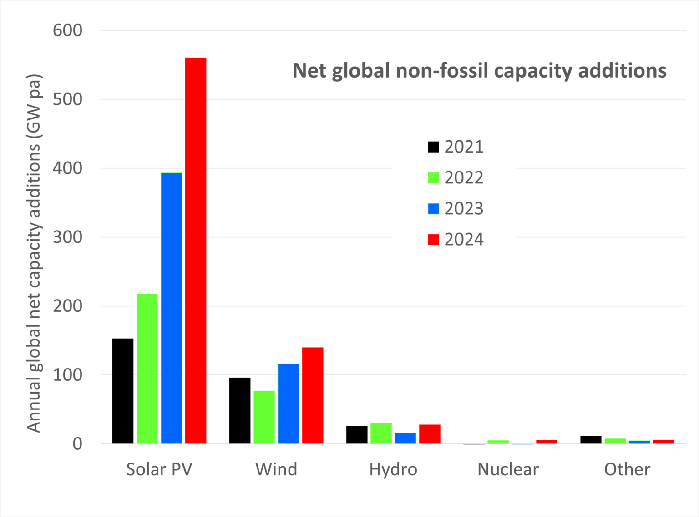

<https://www.pv-magazine.com/2025/01/13/the-fastest-energy-change-in-history-continues/>

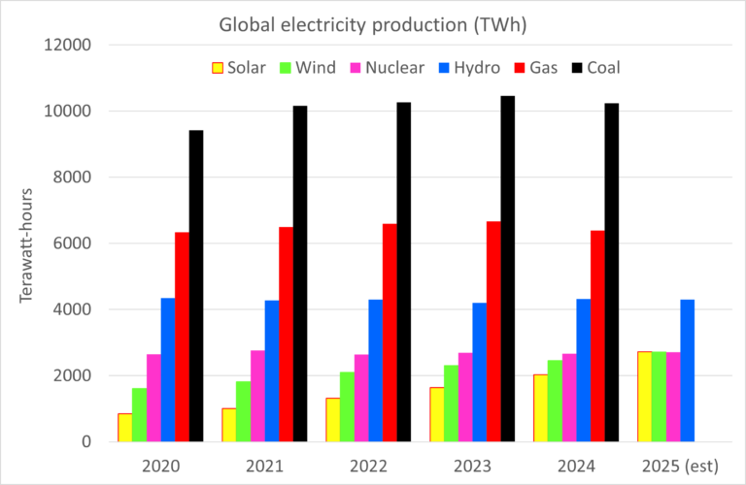

Kennedy, Ryan (2025) PV Magazine, US bans five Chinese PV firms under Uyghur Forced Labor Prevention Act,

<https://www.pv-magazine.com/2025/01/16/us-bans-five-chinese-pv-firms-under-uyghur-forced-labor-prevention-act/?utm_source=Global+%7C+Newsletter&utm_campaign=8a1d825858-dailynl_gl&utm_medium=email&utm_term=0_6916ce32b6-8a1d825858-160603208>

The US Department of Homeland Security announced the addition of 37 more businesses to the Uyghur Forced Labor Prevention Act (UFLPA), including five solar supply chain providers. Signed into law by US President Joe Biden in December 2021, the UFLPA places a ban on all solar product imports from China's Xinjiang region, unless products are demonstrated to not be connected to forced labor. Beijing has denied any use of forced labor practices in Xinjiang. As much as 50% of the global supply of polysilicon, the essential material in manufacturing conventional solar panels, was produced in the Xinjiang region at the time President Biden signed the UFLPA into law. Suppliers have since made efforts to de-tether their supply chains from the region, but this has proved complex (Kennedy, 2025).

Donghai JA Solar Technology – From Jiangsu Province, China, a company that focuses on research and development of silicon rods, wafers, ingots, and solar cell modules.

Hongyuan Green Energy Co. – A vertically integrated manufacturer in power stations, industrial and crystalline silicon, wafers, battery and modules. Its subsidiary Hongyuan New Materials was also added to the list.

Jiangsu Meike Solar Co. – A silicon rod and wafer manufacturer and its subsidiary Baotou Meike were added to the UFLPA list.

Shuangliang Silicon Materials – A manufacturer of crystal silicon rods and wafers in Batou City.

Xinjiang Energy Group – A state-owned power developer in coal, wind, PV, oil and gas.

Bellini, Emiliano (2025) PV Magazine, China reviewing anti-dumping duties on solar-grade silicon from US, South Korea,

<https://www.pv-magazine.com/2025/01/13/china-reviewing-anti-dumping-duties-on-solar-grade-silicon-from-us-south-korea/?utm_source=Global+%7C+Newsletter&utm_campaign=ae14186bc2-dailynl_gl&utm_medium=email&utm_term=0_6916ce32b6-ae14186bc2-160603208>

The Chinese government says it will review 2014 anti-dumping duties on US and South Korean polysilicon imports, and will maintain them during its investigation, which was requested by 13 Chinese manufacturers. China first extended the duties in 2020 for five years. MOFCOM said the review request and evidence provided meet requirements for a final review. Initially set in 2014, duties on US companies ranged from 53.3% to 57%, and for South Korean manufacturers from 2.4% to 48.7% (Bellini, 2025).

Bellini, Emiliano (2025) PV Magazine, Mitigating default risk in large-scale PV projects through credit default swaps,

<https://www.pv-magazine.com/2025/01/30/mitigating-default-risk-in-large-scale-pv-projects-through-credit-default-swaps/?utm_source=Global+%7C+Newsletter&utm_campaign=f7d93fedad-dailynl_gl&utm_medium=email&utm_term=0_6916ce32b6-f7d93fedad-160603208>

Jadidi, H., Firouzi, A., Rastegar, M.A., et al. (2025) Risk mitigation in project finance for utility-scale solar PV projects, Energy Economics, Volume 143, 108221, <https://doi.org/10.1016/j.eneco.2025.108221>

Canadian researchers have proposed to hedge default risk in the utility-scale PV business by adopting credit default swaps. The new methodology was tested through a series of Montecarlo simulations and reportedly showed how PV asset owners can transfer default risk to a protection seller at an affordable cost. The novel approach utilizes credit default swaps (CDS) to provide an extra layer of financial security for PV project developers. A CDS is a contract between two parties in which one party buys protection from another party against losses from the default of a borrower. “While PPAs, power purchase agreements, have traditionally served as the cornerstone of revenue certainty for renewable energy projects, they do not fully protect against risks such as default scenarios, resource data inaccuracies, or changes in tax and market conditions,” the researchers said. “A CDS offers a mechanism to transfer default risk from lenders to third parties, functioning similarly to an insurance contract.” Under the terms of this agreement, the SPV is obligated to make periodic premium payments to the protection seller until either the CDS deal expires or default materializes. The new risk mitigation strategy also includes the utilization of a closed-form formula for the evaluation of the default probability (DP) over a specified period, which the scientist said is key for pricing the CDS (Jadidi et al., 2025; Bellini, 2025).

Kennedy, Ryan (2025) PV Magazine, Trump’s $500 billion AI datacenter project expected to be powered by solar,

<https://pv-magazine-usa.com/2025/01/24/trumps-500-billion-ai-datacenter-project-expected-to-be-powered-by-solar/?utm_source=Global+%7C+Newsletter&utm_campaign=45ea69cbdd-dailynl_gl&utm_medium=email&utm_term=0_6916ce32b6-45ea69cbdd-160603208>

Solar and batteries constructed by Softbank’s SB Energy are expected to power at least part of the Stargate project, according to a Bloomberg report. The Trump administration unveiled this week a plan to develop a $100 billion artificial intelligence datacenter with Softbank, OpenAI and Oracle, with plans to expand to “at least” $500 billion in investment. The rapid advancement of AI-powered data centers alone is expected to account for 8% of the U.S.’s total energy consumption by 2030, up from 3% in 2022, according to Goldman Sachs (Kennedy, 2025).

**Introduction**

There are four main types of low-carbon energy: solar, wind, hydro, and nuclear. These are our four options for producing electricity and power in the near future, when we run out of fossil fuels. Like China, I don’t believe that global warming and climate change is a big deal, and believe that the world temperature is rising and the arctic ice melting because of normal changes in the Earth’s climate as has happened over millions of years. That said, maybe we should not be pursuing the U.S. Democratic Green New Deal so much, but we still need to be spending money researching new power technologies for the time when fossil fuels run out. Plus, it is healthier for the environment to use renewable energy sources or nuclear, it is just not healthy for the economy to rush to change so quickly before the technology is sound. In the U.S., government taxpayer subsidies constitute a portion of the costs of wind and solar technologies. This is not sustainable, using taxpayer subsidies to pay for electricity. However, nascent industries often benefit from and even need government aid to survive and prosper, which could come in the form of subsidies or tariffs.

Two primary issues arise when discussing renewable or intermittent power sources. One, their construction and design, or how do we create renewable energy sources that can produce enough electricity to power our society. Related to this issue, is that of battery storage, and how do we create more powerful batteries to store the renewable energy from the sun and the wind to power our society at nite and on cloudy days? Two, is the pricing of renewable energy sources in the electricity market, as they have low marginal cost. This low marginal cost leads to what is known as the merit order effect of renewable energy sources, whereby conventional fossil fuel energy sources are priced lower. Renewable energy sources have low marginal costs because they have zero fuel costs and only price operations and maintenance into their marginal cost.

One area of research for solar panels is how do we increase the amount of diffuse solar radiation which is utilized by solar panels. Diffuse solar radiation is the solar radiation that is absorbed, scattered, and reflected by: air molecules, water vapor, clouds, dust, pollutants, forest fires, and volcanoes. The solar radiation that reaches the Earth's surface without being diffused is called direct beam solar radiation. The sum of the diffuse and direct solar radiation is called global solar radiation. Atmospheric conditions can reduce direct beam radiation by 10% on clear, dry days and by 100% during thick, cloudy days.[1]

Another area of research for low-carbon systems is the battery design that stores the intermittent energy sources before they are dispatched by power plants for energy to households and businesses. Related to battery design is how do we increase the life of the solar panels. A third area of research is in waste disposal of solar panels and dealing with the dangerous chemicals and minerals that are used to construct solar panels.

In order to move away from nuclear energy in the future, which still relies on rare earth elements to service energy demands, we have to figure out ways to still draw solar energy when the clouds are out, and ways to still harness wind energy when the wind is not blowing. Of these two options, becoming more efficient at utilizing diffuse solar radiation is more feasible than procuring wind when the wind is not blowing. Diffuse radiation is still there, unlike wind power, and we only need to figure out how to harness diffuse solar radiation.

This thesis concerns three applications of renewable energy: sodium-ion batteries, perovskite solar cells, and hydrogen fuel cells. Sodium-ion batteries have low risk of thermal runaway, and low energy density. Lithium-ion batteries have high risk of thermal runaway, and high energy density. We want to use sodium, which is cheaper than lithium, and less costly to the environment to mine, and raise its energy density while keeping its risk of thermal runaway low, through modifications to the cathode, anode, and electrolytes. As for perovskite solar cells, perovskite is a good light absorbing mineral, though it does not perform well in terms of stability. By creating tandem silicon perovskite cells, we combine silicon’s stability, as silicon cells last for decades, and perovskite’s light absorbing properties to create higher solar conversion ratios for converting solar energy into electricity in our solar cells. Perovskite lasts from a few months to a few years before it degrades, so we need to increase that through mixing different cations and halides, incorporating additives to strengthen the crystal structure, utilizing hydrophobic coatings, and implementing protective encapsulation techniques. Hydrogen fuel cells may not ever catch up to electric vehicles, as hydrogen has to be stored at subzero temperatures, making it difficult and costly to transport, however, hydrogen could be used in some applications, including heavy machinery, long-distance trucking, shipping, and to power industrial furnaces such as steel making.

**The Dominance of Solar Energy**

Kevin Sleem, LOrange Institute

**Abstract**

Cheap solar energy can serve to free people from poverty around the globe. Solar energy looks to be the dominant form of energy in the future, over wind, nuclear, and fossil fuels. An achievable goal is that solar panels and batteries should be able to store enough energy in two days to last the entire week. The future of solar cells lies in making solar cells more efficient and lowering their cost for mass-scale installation and in developing countries, which might entail using different types of cells than traditional crystalline silicon cells. One issue that arises with solar energy, and wind energy, however, is how power plants plan for natural disasters in disaster prone areas, like Florida or California. Are renewable energy sources more prone to damage than fossil fuel generating plants, which do not need the solar farms and wind farms? Is this additional infrastructure prone to damage from natural disasters? Bloomberg reports that fossil fuels are expected to produce 21% of electricity in 2050, down from 62% in 2020, while solar energy will account for 56% of electricity production in 2050. Sector-wide cost pressures, such as supply chain problems and higher interest rates due to inflation, in the wind and solar industries could threaten government renewable energy targets. Solar panel efficiency has improved to the point that efficiency is not the primary constraint on the global acceptance of solar power, rather, the bottlenecks for the solar industry are the lack of electrical grid infrastructure for solar, and the high cost of batteries to store excess power.

**Introduction**

The sun is the largest power plant in the universe, generating power 93 million miles away from Earth. Even though solar energy is the most abundant and proximate renewable energy source, not every country relies primarily on solar energy for renewable energy sources. For example, Portugal, which derives all of its electricity needs from renewable energy sources on some weekends in 2023, uses wind power primarily, followed by hydro power, and then in third place solar power. In South Australia, they also can derive nearly all their electricity needs from renewable energy sources on some weekends in 2023, and most of their renewable energy comes from rooftop solar panels. So solar is dominant in some areas, and wind dominant in others, even though the cost of a solar panel is cheaper than the cost of a wind turbine. Frankenstein solar systems combine different panels, inverters, battery storage systems and electric trucks, made by different companies in the supply chain. It is better to use integrated energy solutions for solar systems, which uses products from the same supplier. A report in Nature Communication by professors at the University of Exeter in England notes that solar panel costs dropped by 15% a year from 2010-20. The installed capacity (the amount of energy the system can produce) increased by 25% per year as well (Kazmer, 2023).

According to the International Energy Agency, photovoltaic solar power generated about 4.5% of global electricity in 2022, behind hydropower and wind, with solar's growth up 26%, with China creating about 38% of the new capacity, in 2022, and the European Union and the United States developed 17% and 15% of the increase, respectively (Kazmer, 2024).

Solar power is leading the United States and the rest of the world in energy deployments. The rapid expansion of solar technology has driven down costs, making solar the cheapest form of energy in many countries.

The solar panel supply chain begins with mining and refining raw polysilicon, forming it into ingots, slicing it into wafers, manufacturing it into cells, and then assembling the cells into a frame, making a solar module.

In 2024, according to data from the Global Solar Council, global installed photovoltaic capacity surpassed 2 TW, with 7 billion solar panels and 25 million “solar homes” are now installed, and an additional 4 TW of solar capacity likely to be deployed by 2030. It took 68 years to reach 1 TW of installed capacity (1954-2022), only two years were needed to add the next TW, from 2022 to 2024, according to the Global Solar Council (Molina, 2024A). The combined global market for PV, wind turbines, electric cars, batteries, electrolyzers, and heat pumps will rise from $700 billion in 2023 to more than $2 trillion by 2035, according to the International Energy Agency (IEA), “Energy Technology Perspectives 2024,” with global solar module manufacturing capacity set to exceed 1.5 TW by 2035 (Jowett, 2024B). Due to gains from green economy applications, especially the PV sector, global silver demand grew in 2024, according to the Silver Institute and Metals Focus, with the global silver market showing a physical deficit of around 182 million ounces in 2024, the fourth consecutive year of shortfall. Across industrial applications, demand for silver is expected to increase 7% year on year in 2024, reaching 700 million ounces (Moz) (Jowett, 2024A).

According to the latest Energy Technology Perspectives 2024 (ETP-2024) report, published in 2024 by the International Energy Agency (IEA), the value of the global market for six key mass-produced clean energy technologies, solar PV, wind, electric vehicles (EVs), batteries, electrolysers and heat pumps, increased almost fourfold between 2015 and 2023, exceeding $700 billion, or roughly half the value of all natural gas produced in the world that year, and under current policies, the market for these clean technologies will almost triple by 2035 and exceed $2 trillion. China is currently the country with the lowest costs to manufacture clean energy technologies, while producing solar PV modules, wind turbines and battery technologies costs on average up to 40% more in the United States, up to 45% more in the European Union and up to 25% more in India (Molina, 2024B).

California could easily rely on a wind-water-solar-dominated large grid, and California’s current electricity prices are high because of several reasons that have nothing to do with renewables, including high fossil gas prices and the cost of upgrading aging transmission and distribution lines (Jacobson et al., 2025; Bellini, 2025C). The California Solar and Storage Association (CALSSA) has described a troubling trend in America, whereby utilities in California and nationwide are fighting rooftop solar, a major threat to their effective monopoly on the electricity market. In a series of rulemaking decisions backed by the three California utilities, PG&E, SCE, and SDG&E, the California Public Utilities Commission (CPUC) has moved in congruence to eliminate rooftop solar. In the past two years, California has gutted net metering, or the payment for exporting solar from the home to the grid, by about 80%, and has created stringent labor rules for commercial solar installations with AB2143. Also in California, multi-meter properties like schools and farms cannot use their own solar energy production and must sell it to the grid at a low price and buy it back at a significantly higher price (Kennedy, 2024D). In the Netherlands, there is a clear correlation between the expected solar and wind energy for the following day and the negative hourly prices in the day-ahead market, with negative prices most common during the day in the summer months, especially on weekends, holidays, and during vacation periods when expected consumption is lower. Also, slightly stronger winds during the nights and colder months directly contribute to negative hourly prices (Bellini, 2024D).

As the solar industry prepares for possible consolidation, second tier manufacturers will not be spared and there will also be shifts among the very large photovoltaic manufacturers from China. As the industry is competing for sales markets around the globe, module prices in some segments are falling below manufacturing costs. As of 2024, JinkoSolar is the last major Chinese photovoltaic manufacturer still listed on the Nasdaq stock exchange (Enkhardt, 2024). In the U.S., clean energy sources wait for an average of five years before connecting to the grid, meaning that thousands of gigawatts of clean energy are languishing in interconnection queues. To address growing power demand from data centers, AI, and EV charging, these interconnection queues must be bypassed, and one option is to provide off-grid energy solutions using direct current power instead of alternating current power (Skok, 2024). Paces, a renewable-energy project-planning software developer, found decreases in the number of sites suitable for renewables, the average acreage of sites available and the average feeder capacity, a key metric for determining energy output, from January 2024 to October 2024 in the U.S. (Metea, 2024).

One argument against renewable energy sources is that they might fail in times of stress, when conventional fossil fuels would more easily supply the electric grid. In February 2021, the electric grid in Texas failed, and some people said it was because of Texas’s reliance on renewable energy sources. However, it could also be argued that the outage was primarily caused by the failure of natural gas infrastructure and supply chains. What the truth may be is that there is no intrinsic reason why a renewables-based grid would be more prone to blackouts, but it does require planners to account for the characteristics of those renewables when they do their planning. Wind, solar, hydropower and geothermal energy produced about 20% of U.S. power in 2022. Issues affecting how fast a 100% renewable electrical grid can be developed include technological innovation, political will, economics, supply chain strength, policy decisions and planning decisions. To maintain reliability, replacement technologies that can help grid operators respond to problems must be widely incorporated into wind and solar plants or elsewhere on the grid before too many coal and gas plants go offline (Petersen, 2023).

***Strategies to Deal with the Intermittent Nature of Renewables***

1. **Storing power to be used later-** This means transforming “intermittent” renewable power into "dispatchable power" − meaning the power is guaranteed to be available for a given time, even if the weather is bad.
2. **Transmitting power over distance-** This means importing power from a different region where the sun is still shining or the wind is blowing. The U.S. has three electric grid interconnections: Eastern, Western, and Texas.
3. **Creating resource diversity with different types of renewables-** Wind and solar are often complementary, in that when one is down, the other is up. Resources can be managed across the U.S., within a region, or even at a power plant.
4. **Using “demand response” initiatives to encourage consumers to use power when it is plentiful-** How do we shape the demand curve to take advantage of what the system naturally wants to produce?

Substantial new transmission infrastructure will be necessary to build out a reliable renewables-driven grid, however, permitting for new transmission lines is difficult, and some proposed transmission projects (as well as some solar and wind projects) have met resistance due to social, cultural, ecological and wildlife impacts. Additional storage could make up for less-than-ideal transmission infrastructure. Smart transmission technologies and advanced conducting materials can also help reduce the amount of new transmission needed by allowing planners to use existing transmission infrastructure more efficiently. For example, the amount of power that can be sent through a given transmission line is determined by weather and temperature, but planners currently limit the amount of transmitted power based on conservative worst-case weather conditions. Smart dynamic line rating technology can be used to quickly adjust the amount of power flowing through wires based on real-time weather data − allowing more power flow when conditions are ideal (Petersen, 2023).

**Map of U.S. Resources and Electric Interconnections**

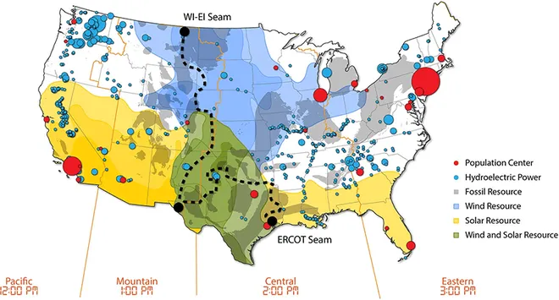

*2021 National Renewable Energy Laboratory SEAM Study*

**Constraints on Solar Energy Acceptance**

In 2020, fossil fuels produce 62% of electricity, and this percentage reduces to 21% in 2050, with solar responsible for 56% of production, according to some projections. Solar is poised to become the dominant source of energy by 2050, but four constraints could hamper this progress: 1) creation of stable power grids 2) financing solar in developing economies 3) capacity of supply chains, and 4) political resistance from regions that lose jobs. Resolving these barriers may be more effective than price instruments such as carbon taxes in accelerating the clean energy transition, said researchers at the University of Exeter and University College London, as part of the Economics of Energy Innovation and System Transition (EEIST) project.[2]

1. **Grid resilience:** Solar power is an intermittent energy source, so grids must be designed to account for the fact that time of day, season, and weather affects power generation. There are several accepted methods for building resilience, including: investing in other renewables such as wind, transmission cables linking different regions, extensive electricity storage, and policy to manage demand (such as incentives to charge electric cars at non-peak times). Government subsidies and funding for R&D will help to create a resilient grid, especially in the early stages.
2. **Access to finance:** the availability of finance will impact the trajectory of solar growth. Currently, low-carbon finance is highly concentrated in high-income countries. Middle-income countries even see benefits from international finance, but low-income and developing countries are often left out of the renewable energy global financing scheme.
3. **Supply chains:** Manufacturing solar technology is intensive in metals and minerals, with future demand due to electrification and batteries for these critical minerals such as lithium and copper increasing. As countries accelerate their decarbonization efforts, renewable technologies are projected to make up 40% of total mineral demand for copper and rare earth elements, between 60 and 70% for nickel and cobalt, and almost 90% for lithium by 2040.
4. **Political opposition:** Resistance from declining fossil fuel related industries may impact the transition to renewable energy sources. The pace of the transition depends both on economic decisions by entrepreneurs and also on how beneficial policy makers consider it. 13 million people worldwide currently are working in fossil fuel industries and dependent industries, and a rapid transition to renewables may put their jobs at risk. Regional economic and industrial development policies can resolve inequity and can mitigate risks posed by resistance from declining industries.

**Worldwide Share in Electricity Production of Various Technologies**

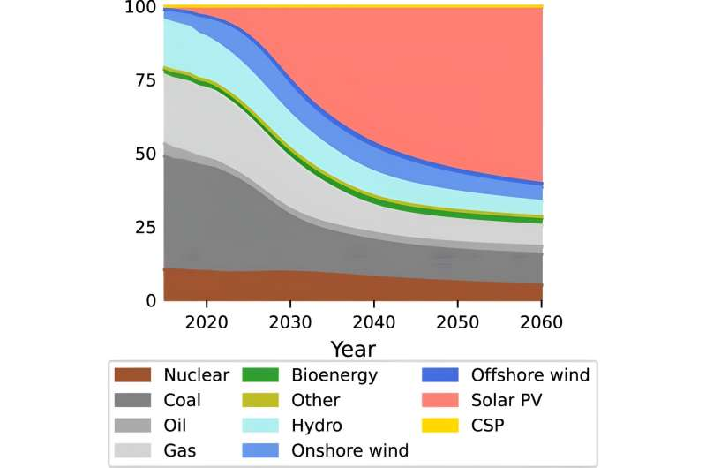

*Credit: Nature Communications (2023). DOI: 10.1038/s41467-023-41971-7*

One issue with the emergence of renewable energy sources is increasing transmission line capacity to bring the new capacity online. According to a Berkeley study, large-scale reconductoring of existing transmission lines could cost-effectively double transmission capacity within existing rights-of-way, as renewable energy projects near reconductored transmission lines could more easily interconnect (Driscoll, 2023).

**Advanced conductor and ACSR conductor**

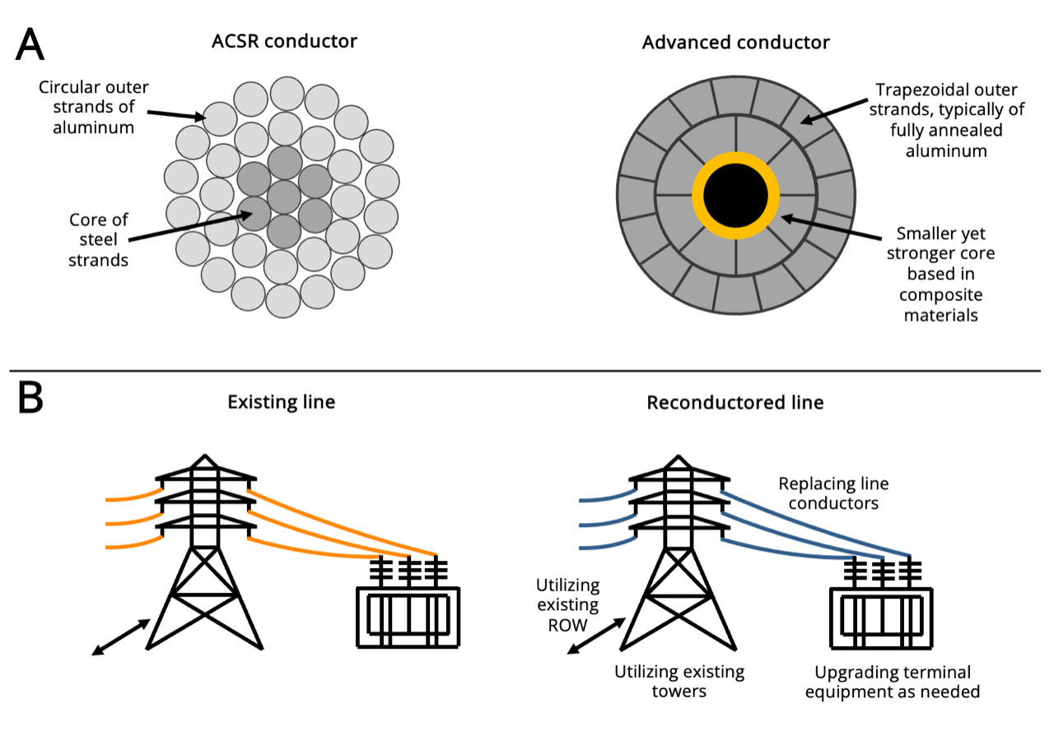

*Image: Energy Institute at the UC Berkeley Haas School of Business*

In 2022, the world had about 1.2 terawatts (TW) of generating capacity from solar power, which in turn provided around 5% of global electricity generation. Energy strategists suggest that the world will need 75 TW by 2050 to meet climate goals. This requires installations to rise above 3 TW per year by the mid-20301, but the silicon PV industry is projected to achieve that, making it one of the rare green-technology areas that is on track (Peplow, 2023).

**Solar’s Expansion Plans**

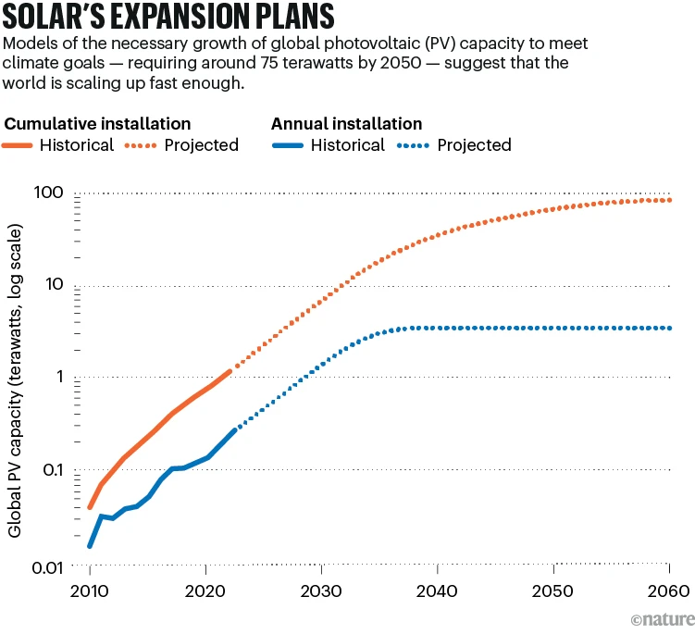

*Image: Nature*

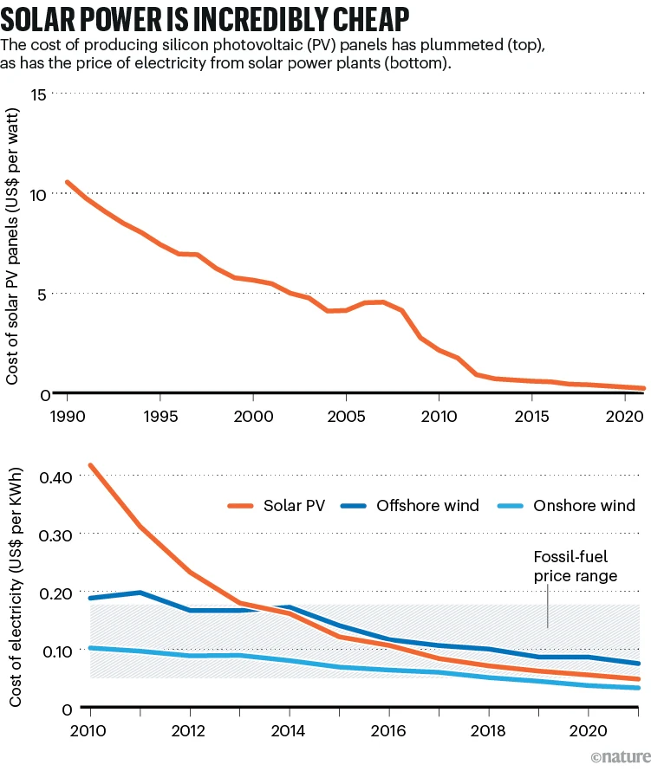

*Image: Nature, Our World in Data*

**History of Solar Energy**

French physicist Edmond Becquerel, in 1839, invented the photovoltaic effect, which is a process that generates an electric current or voltage when exposed to light or other light radiation. By the early 1900s there were already solar panels being invented, and one of those inventions came from Canadian inventor George Cove. He invented a solar panel in 1905, but mass production never resulted for two reasons. One, the industrial revolution prioritized fossil fuels, and the machinery of the period ran off coal, steam, and oil. Two, George Cove was kidnapped, allegedly by fossil fuel enthusiasts, and he later disbanded his solar panel company when he was released. Cove's company, Sun Electric Generator Corporation, based in New York, was capitalized at US$5 million, which is around US$160 million in today's money. Some say Cove staged his own kidnapping for publicity, while others say that a former investor was behind it. Other energy players from this time include John Rockefeller and Standard Oil, which cornered the market for oil, and Thomas Edison and his light bulb, who advocated for the use of coal energy to power his electric substations and power plants. The next iteration of solar panels after George Cove in 1905 was Bell Labs 40 years later.[3]

Global investments in the solar energy sector reached the $308 billion mark in 2022, an increase of 36% over 2021 levels, though solar still only accounted for 11.5% of the overall energy investment in 2022 ($2.6 trillion), according to a 2023 report by the International Solar Alliance (Gupta, 2023). Private finance was a major contributor to solar energy projects, accounting for more than 80% of total investments between 2015 and 2022. The majority of solar panel research and development is in Asia, Europe, and North America. Developing countries need more investments to stimulate their solar panel industries. In 2003, the U.S. installed 1 MW of solar, but by 2023 they installed 30 MW (Montague, 2023).

Since 2010, solar energy prices have decreased by 85% due to economies of scale and government subsidies (Mamchii, 2023). This is a good sign for installing more solar farms to power power plants, for industrial processes, and for developing nations. The bigger the size of a solar cell, the lower the rate of efficiency it can achieve. We need to extract more efficiency from solar cells, and at a lower cost. Hydrogen produces only water when burned, making it very attractive as a potential clean energy source for industries like aviation, shipping and steel-making that need so much energy it’s almost impossible to meet through renewables such as solar and wind. Perhaps concentrated solar power with solar collectors and receivers can serve industrial processes like steel-making, though what do we use for aviation and shipping? Solar kerosene? Light-harvesting materials, like halide perovskites, has increased solar cell efficiency, but the ability to produce them reliably at scale continues to be a challenge.

The two primary methods of harnessing solar energy are through photovoltaic cells, or solar panels, and concentrated solar power. A photovoltaic (PV) cell is anon-mechanical device, sometimes known as a solar cell, which converts sunlight directly into energy. Concentrated solar power is a method of producing electricity by using mirrors, or solar collectors, to reflect sunlight. Large mirrors or lenses focus sunlight onto a narrow region known as the receiver. Natural sunlight is reflected, focused, and concentrated by the mirrors into a certain area, where it is eventually turned to heat. The steam is then produced using the heat, and the steam powers a turbine to produce electricity. The mirror, or solar collectors, have distinct designs and focusing techniques, such as dish systems, solar power towers, and parabolic troughs. The receiver is situated at the solar collector's focal point, and is in charge of absorbing and turning the concentrated sunlight into heat. The receiver's contents include heat-transfer fluids such as molten salt or high-temperature oil. Drawbacks of CST include it requires a favorable climate with constant sunshine in order to function at its best, and it is expensive. CST doesn't compete with PV solar energy, as PV gives you power when the sun is shining, and CST takes energy from the sun, stores it and then allows the user to use that energy when the sun isn't shining, such as overnight or on cloudy days.

New technological developments have made old coal mines prime targets to extract rare earth minerals. In the U.S., old mines in Wyoming and West Virginia have received government funding and attention from private companies for the advancement of a "pioneering method to extract and separate rare earth elements and critical minerals from acid mine drainage and coal waste." In Scotland, researchers have been looking at how the water that's flooded old, disused mines can be used to provide decarbonized heating to buildings. In England, Geothermal Engineering Limited recently said lithium would be produced as a by-product of its projects focused on geothermal power generation. According to the firm, it will be enough lithium to supply roughly 250,000 electric car batteries per year. "GEL's primary geothermal business of providing baseload geothermal electricity and heat produces a naturally hot geothermal brine from which lithium can be sustainably extracted onshore in the UK as a by-product," it said (Frangoul, 2023).

**China’s Dominance in Solar Panels**

China presently has dominance in solar panel production, even though the U.S. invented solar panels. China and the U.S. consistently attract the most annual solar investments, and together, they have received about 50% of all solar investments since 2015, according to a new report by the International Solar Alliance (Gupta, 2023). Since 2000, China has become the leader in both production and deployment of solar panels through significant investments in research, development, and manufacturing. China’s rise to dominance in the solar industry is the result of strategic planning and relentless investment, with the commitment evident in the form of government policies, financial incentives, and aggressive expansion strategies. China launched initiatives like the Golden Sun Program and Top Runner Program to encourage technological advancements and market expansion. Areas where China has achieved dominance include: solar power production, solar panel manufacturing, and battery technology.

China has impeccable manufacturing skills, and the country’s massive scale and efficient production capabilities have enabled it to produce solar panels and components at a lower cost than most competitors. China’s supply chain expertise and infrastructure development have further solidified its position as the world’s leading solar manufacturer, contributing substantially to its rise in the solar industry. China has exported not only solar products but also comprehensive solar solutions, including technology, expertise, and financing. China’s efforts towards renewable energy have removed barriers to entry and simplified the transition to renewable power sources globally for all nations. By 2030, China will have 1.37 TW of wind and solar capacity, exceeding the government’s objective of 1.2 TW. As of April 2023, China has 430 GW of solar capacity, and installed more than 30.88 GW of solar PV systems in the first half of 2022 (Mamchii, 2023).

The manufacturing of solar panels involves the use of hazardous chemicals, such as lead (${Pbl}_{2}$), tin (${Snl}_{2}$), cadmium, silicon, and copper. China has faced criticism for careless environmental regulations in some regions where solar manufacturing is concentrated. Global competition can drive innovation and quality improvements, but it also exerts downward pressure on prices in China. Also, trade disputes and regulatory changes in export markets can disrupt China’s solar dominance. Compared to China, which focuses on massive manufacturing capabilities and economies of scale for slate panels and components, the United States has focused on technological innovation and research, consistently contributing to advancements in solar technology, energy storage, and grid integration. American companies have excelled in producing high-efficiency solar panels and cutting-edge solar technologies. To combat China’s dominance, the United States has introduced tariffs on Chinese solar imports, has increased investment in domestic solar manufacturing, and has shown support for research and development (Mamchii, 2023).

Fischer (2023A) reports that A Wood Mackenzie report, “How will China’s expansion affect global solar module supply chains?,” forecasts that China will hold more than 80% of poly, wafer, cell and module manufacturing capacity through 2026. China invested an estimated $130 billion into its solar industry in 2023, according to the Wood Mackenzie report, and with more than 1 TW of wafer, cell and module forecast to come online in the next year, China will have enough capacity to meet global demand through 2032. Not only will China dominate in capacity, its product will come at a lower cost, for example, a module made in China is half the price of that made in Europe and 65% less than that made in the U.S. China has estimated 17 times more cell capacity than the rest of the world, though is terminating more than 70 GW in capacity due to oversupply and competition, which mainly concerns old production lines that produce lower efficiency p-type and M6 cells. Wood Mac analysts expect p-type cells to decline to just 17% of supply by 2026.

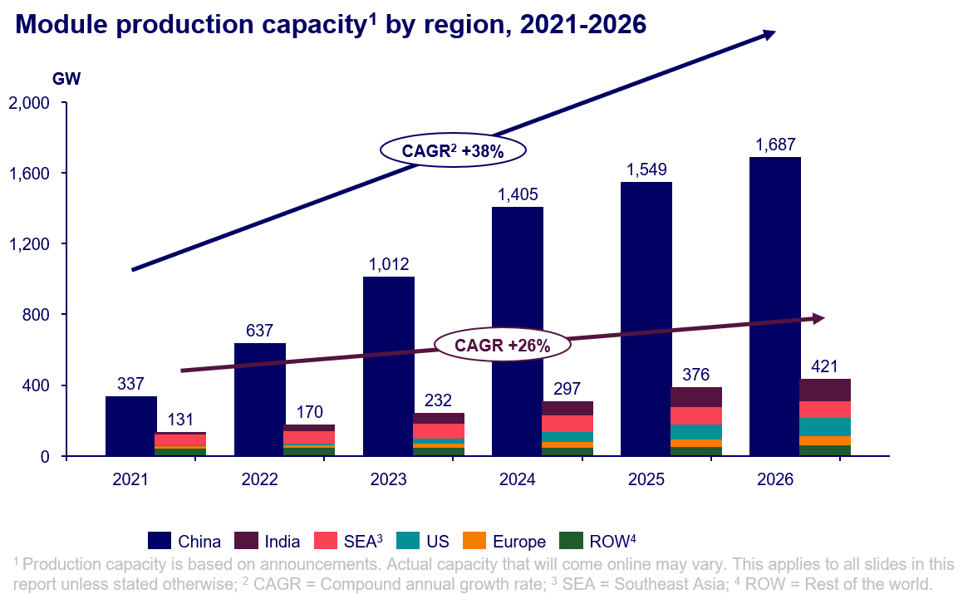

*Image: Wood Mackenzie*

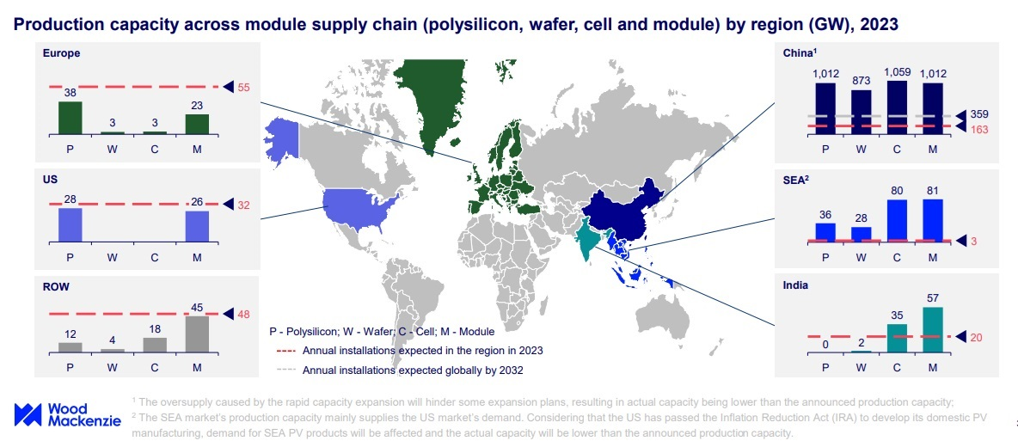

*Image: Wood Mackenzie*

As of 2023, China has reached its goal to have more non-fossil fuel installed electricity capacity than fossil fuels earlier than planned, with 50.9% of its power capacity now coming from non-fossil fuel sources. In 2021, the Chinese authorities said they would target renewables to outpace fossil fuel-installed capacity by 2025. China is consolidating its leading position in renewable energy and is set to account for nearly 55% of global additions of renewable power capacity in both 2023 and 2024, the International Energy Agency (IEA) said in 2023. By 2024, China is expected to deliver nearly 70% of all new offshore wind projects globally, as well as over 60% of onshore wind and 50% of solar PV projects, the IEA said in its Renewable Energy Market Update in June 2023 (Paraskova, 2023).

In the 2023 Wood Mackenzie Report, they say that China could install 230 GW of PV and wind capacity, surpassing Europe's 75 GW and 40 GW in the United States, and will export more than 200 GW of solar panels in 2023. Also, unlike Europe and the United States, China is proving adept at avoiding the high curtailment of PV and wind. China’s solar industry is benefited by deflation due to communist price controls, falling interest rates, low energy costs, and intense price competition. China’s end-user power prices are less than half those in Europe or Australia and this supports a strong competitive edge in global trade, and the China power market is now larger than that of Europe and the US combined. PV and wind curtailment in China reached 4% in 2022, down from over 10% before 2020. China is also projected to achieve a cumulative grid-connected energy storage capacity of 67 GW in 2023, with plans to expand to 300 GW by 2030. As far as China’s reliance on coal power, China’s investment in renewables and support infrastructure in recent years has outstripped what was going into coal power by a factor of 5 to 1. The share of coal in power generation has been continuously falling, down 10 percentage points in the last five years to about 55% today. About 80% of the reduction was replaced by renewables and the rest mostly by nuclear power (Bellini, 2023A).

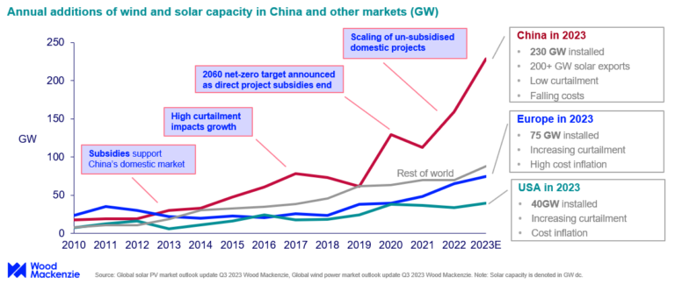

*Image: Wood Mackenize*

On May 11, 2024, in the first phase of a 100-MWh project, a 10-MWh sodium-ion battery storage station was put into operation on in Nanning, Guangxi in southwestern China, according to China Southern Power Grid Energy Storage, the energy storage arm of Chinese grid operator China Southern Power Grid. This 100-MWh project will be able to provide 73 million kWh of clean power annually, meeting the electricity needs of 35,000 residential customers and reducing carbon dioxide emissions by 50,000 tons. In the Chinese 10-MWh sodium-ion battery energy storage station, 210 Ah sodium-ion battery cells are used that can be charged to 90 percent in 12 minutes. There is also a thermal management system that keeps the temperature difference between more than 22,000 sodium battery cells within 3 degrees Celsius, and extends the time it takes for the cells to spread thermal runaway from 30 minutes to 2 hours. In China, electrochemical storage, including lithium-ion and sodium-ion batteries, accounted for more than 95 percent of the cumulative installed capacity of China's new energy storage projects of 35.3 million kWh, by March 2024 (Zhang, 2024).

China emits the most greenhouse gasses (GHG) in the world (33%), followed by the U.S. (15%). However, China’s argument is that their emissions result from industrial growth, and is only catching up to the United States and the industrial revolution. China’s electrical power will grow from 30% renewables in 2024 to 55% by 2035, and 88% by 2050. In 2022 about 40% of global solar and wind capacity, separately, were installed by China. As for China’s primary energy supply, from 2030 to 2050, solar and wind will increase from 7% to 41%, a multiple of 7 times. At the same time, fossil fuels will fall by half, from 83% to 44%. Renewable electricity, which by 2030 will be around 51%, will increase to 78% by 2050. In the same time frame, from 2030 to 2050, fossil-burning power plants will fall by half from 46% to 24%. Carbon emissions in China are projected to peak by 2026, according to DNV, with a 30% reduction by 2040. In 2023, China emitted a third of global emissions but this will be reduced by 70% by 2050, to only a fifth of global emissions. The keys to this reduction of emissions are displacing coal in power plants and other primary energy end use (Palmer, 2024).

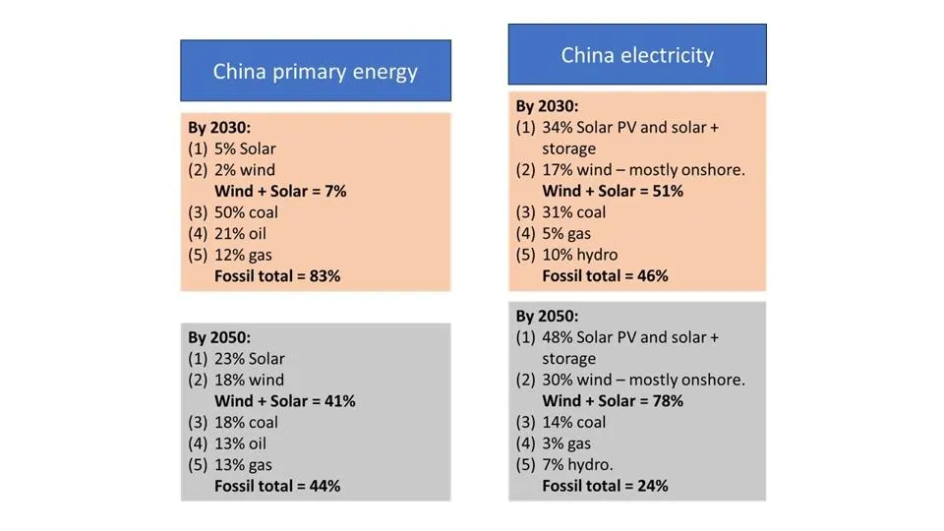

Table 1. Progress in China’s energy transition, as predicted by DNV. DNV/PALMER

PV curtailment clears up space for new renewables projects that are struggling to obtain grid connections by taking a greater percentage of generation offline. A 5% curtailment means that the utilization rates of solar and wind power projects can not fall below 95%. A 5% curtailment cap in 2018 was introduced in China by the China’s National Development and Reform Commission (NDRC) and the China’s National Energy Administration (NEA). In 2024, China's NEA and State Grid Corp. of China (SGCC) are contemplating whether to increase the 5% of output that can currently be curtailed from wind and solar projects. PV curtailment ensures the efficient utilization of renewable energy installations and protects the investment returns of power companies. Strict enforcement of curtailment policy imposes limitations on the scale of renewable energy projects, particularly in regions with high abandonment rates, where the approval and development of new projects is limited. As advancements in solar technologies have led to a reduction in installation costs and better returns on investment for power projects, energy companies are constrained by curtailment regulations in setting installation targets, which means that many projects struggle to secure approval for construction. China is also creating an ultra-high voltage transmission network to address the curtailment issue, which requires substantial investment (Shaw, 2024A).

China is trying to pivot from its economic reliance on the real estate industry to new energy industries like solar, electric vehicles, and lithium-ion batteries. 80% of solar panels are made in China, and the solar-panel market is in a state of oversupply, which means manufacturers in the US and Europe mus reduce prices. Solar-panel supply globally is forecast to reach 1,100 gigawatts by the end of 2024, three times more than demand, according to a 2024 International Energy Agency report. Prices on the spot market fell by half in 2023 and are likely to extend decline by another 40% by 2028. In fact, solar panels are so cheap that they're now being used to line garden fences in Germany and the Netherlands, the Financial Times reported in 2024. Putting solar panels on fences saves on pricey labor and scaffolding costs required for roof installations, as solar panels are typically installed on rooftops, where they can capture the most sunlight (Tan, 2024).

In 2024, the Biden Administration raised the tariff rates on solar cells imported from China from 25% to 50%. They also raised tariff rates on aluminum and steel imported from China, from 0% to 7.5% up to 25%, as well as those applied to semiconductors, from 25% to 50%. Tariffs on electric vehicles were raised from 25% to 100% and those on lithium-ion EV batteries from 7.5%% to 25%. The U.S. government has also increased the tariffs on ship-to-shore cranes and medical products (Bellini, 2024B).

China and Vietnam have had antidumping duties placed on solar glass imports into India, in the range of $673 to $677 per metric ton for China and for imports from Vietnam at $565 per metric ton. The antidumping duties are on textured toughened (tempered) glass in solar panels and solar thermal products from China and Vietnam for a period of six months, starting Dec. 4, 2024 (Gupta, 2024).

China Green Development Investment Group has turned on the Xinjiang Midong solar project, a 3.5-gigawatt operation, which has more than 5.26 million panels on 32,947-acres, and will generate about 6.09 billion kilowatt-hours of electricity each year. A gigawatt can power 100 million LED light bulbs (Kazmer, 2024).

In 2024, the China Securities Regulatory Commission (CSRC) approved polysilicon derivatives to address rising price volatility and structural imbalances between supply and demand in the solar-grade polysilicon market, marking a key step in developing risk management tools for the solar supply chain, to help companies hedge against volatility, manage risks, and strengthen market confidence (Shaw, 2024B).

China Huadian and PowerChina have completed the world’s highest solar plant by altitude, a 100 MW facility in Tibet, paired with 20 MW/80 MWh of battery storage. The project, at an altitude of 5,228 meters, is the world’s highest-elevation solar installation, surpassing the first phase, which was built at 5,100 meters. Previously, the highest utility-scale solar-plus-storage project in the world was another installation at 4,700 meters in Tibet, completed in 2020 (Shaw, 2024C).

In 2024, China raised the minimum capital ratio for starting PV projects from 20% to 30%, thereby tightening investment rules for PV manufacturing, due to challenges such as intensified disorderly competition, market fluctuations and adjustments, as well as accelerated technological progress. New efficiency standards include for p-type monocrystalline cells and modules, which must exceed efficiencies of 23.7% and 21.8%, respectively, while n-type cells and panels must achieve over 26% and 23.1%, respectively (Shaw, 2024D).

In a move that might force some Chinese companies to increase export prices to mitigate potential financial losses, in 2024 China reduced the export tax rebate for solar products, lowering refunded taxes for Chinese PV exporters, with the rebate for unassembled solar cells (HS Code 85414200) and assembled PV modules (HS Code 85414300) dropping from 13% to 9% (Shaw, 2024E).

**U.S. Energy Goals and the Biden Administration**

The U.S. Department of Energy states in the Solar Energy Technologies Office Photovoltaics End-of-Life Action Plan, from March 2022, that the Biden Administration’s goal is to decarbonize the electricity grid by 2035. Whether this is feasible or not, this objective shows an inefficiency in the American political system. Now, this is a good goal, and we should want to decarbonise as quickly as possible, but this should be a goal of the United States, not just the Biden Administration. Maybe this is a perk of being president, you get to attach your name to projects and initiatives, though considering the dissenting views on issues such as decarbonization and electric vehicles, attaching this goal to a particular presidential administration rather than the country itself and its people, takes away from its value. This is similar to the space program, or the military. We don’t need a new president every 4 or 8 years changing space policy, military policy, or energy policy. We don’t need a new president stopping oil drilling, in the vain hopes of one day achieving renewable energy sufficiency. This erratic energy policy does not help the American people. Maybe the police and the energy department should be a permanent administration and installation.

To achieve the Biden Administration’s goals to decarbonize the electric grid by 2035, the United States must install 30 gigawatts AC (GW) of solar each year between 2022 and 2025 and ramp up to 60 GW per year from 2025 to 2030. The United States installed 19 GW of solar capacity in 2021. In 2022, the installed capacity of photovoltaic (PV) systems in the United States exceeded 100 GW and approximately 75% of this capacity has been deployed since 2017. In the U.S., solar’s share of total installed US generating capacity trails wind at 11.6%, and is closing in on that of hydropower at 7.9%. Taken together, the installed capacity of all renewable sources, including biomass (1.2%) and geothermal (0.3%), was 28.3% of the US’s total at the end of the first nine months of 2023 – up from 27% in 2022 (Lewis, 2023).

Estimates of solar production in the United States due to increased manufacturing from the Biden Inflation Reduction Act are 90 GW of module capacity by 2026, 20 GW of cells and potentially 20 GW of wafer. This will leave U.S. solar manufacturers beholden to importing cells and wafers, which presents a challenge for developers to claim the 40% domestic content adder. There is also a transformer shortage and the challenge of hiring skilled workers in the United States, with estimates of needing 4,000 to 5,000 people to run 100 GW of plants. In terms of what module technology will be used from 2023-2030, TOPCON will be the main technology for a few years, but heterojunction (HJT) will play a role in the future (Fischer, 2023B).

Another area where the U.S. is leading energy resources changes is in the electric vehicle industry. The Biden Administration has proposed ambitious targets, along with some states like California, to transition from gas vehicles to electric vehicles (EVs). However, some people, like Toyota’s chairman, think that we have been too aggressive in the transition to electric vehicles. What is true, is that American car manufacturers are losing money on electric vehicles, and Americans are not buying them. There is not the charging infrastructure in place for long distance trips for EVs to be economically feasible, and hybrids seem like a smarter choice for manufacturers than pure EVs. There is some hope for the transition to EVs though, as conditions from the UAW strike against Ford, GM, and Stellantis mandated the production of a certain number of electric vehicles annually from the Big 3.

Building a supply chain takes time, even with the passage of the Inflation Reduction Act (IRA) in the U.S., which includes $370 billion to support renewable energy build out. Forecasts expect the U.S. to be heavy with downstream solar manufacturing, and will have to continue to rely on imports from foreign partners for polysilicon, ingots and wafers to the U.S. MJ Shiao, vice president of supply chain and manufacturing for the American Clean Power Association, estimated that it can take from three to five years to build new polysilicon manufacturing. The buildout of U.S. solar manufacturing will begin with modules, which is the smart way to go to ensure that we meet the downstream demand, then start to look for more of the upstream part of the supply chain to meet domestic demand, but upstream manufacturing takes time (Fischer, 2023A).

The Biden IRA also resulted in a disproportionate amount of wind, solar, battery, and manufacturing investment going to areas that used to host fossil fuel plants. The share of clean energy investment occurring in areas that the White House classifies as "energy communities" is almost double their share of the national population. While communities that once hosted coal, oil, or gas infrastructure make up only 18.6% of the population, they received 36.8% of the clean energy investment in the year after the Inflation Reduction Act's passage. The White House has repeatedly emphasized that clean energy can be a pathway to jobs and the rejuvenation of rural economies - rather than a path to job losses for coal, oil, and gas workers (Osaka, 2023).

The IRA includes incentives for developers to place wind and solar in regions that have historically relied on fossil fuels. Developers that build clean energy in sites contaminated by pollution; cities or towns that have historically depended on coal, oil, and gas for tax revenue; or areas where coal-fired power plants or mines were recently closed receive an additional 10 percent tax credit. significant amounts of clean investment were also going to disadvantaged communities, defined as communities with environmental or climate burdens, and low-income communities. Some experts say that the Biden administration's definition of "energy communities" is too broad. "Large portions of Nevada, Michigan, and Arkansas are considered 'energy communities' despite the fact that very little fossil fuel extraction happens there," Daniel Raimi, a fellow at the environmental nonprofit Resources for the Future, said in an email. "Many of these so-called 'energy communities' are not the ones that depend most heavily on fossil fuels for their economic well-being (Osaka, 2023)."

One thing that the United States is going to have to do to prepare the electric grid for electric vehicles and renewables is to install more or bigger wooden utility poles. There are around 120 million wooden utility poles holding up wires in the U.S., and they have to be replaced sometimes due to issues such as damage by fires, car crashes, or natural forces — wind, woodpeckers, beavers, and rot. Biden’s infrastructure bill, which aims to upgrade the electric grid, will also kickstart this process of replacing wooden utility poles. Demand is rising for taller and larger-diameter power poles, which means massive old-growth conifers are needed to satisfy this demand. The old standard 40-foot Class 4 pole is falling out of favor, as power companies jump to install new 45-foot Class 2 poles for a thicker and stronger foundation to their lines. This new pole will give the utility companies room to add things in the future. The Class 4 pole is much easier to find in the wild, and is the typical dimensions of mature trees. It is harder to find Class 2 poles. A solution is that utility companies consider more poles, not bigger poles. concrete, steel, and composite poles could also be used (Brownell, 2023).

Around 2023, there was a transformer shortage in the United States. Supply chain problems tightened supply of high-voltage transformers necessary to connect wind and solar farms and batteries to the grid. The long lead-time for delivery of the transformers, which can be the size of a large truck and need to be custom built, has forced some project developers to order equipment before commercial agreements to sell power from the projects are in place. The long lead-times and the higher prices they are paying for the equipment means developers are having to take a big bet on getting all the deals and approvals they need to make a project viable. The delivery time for transformers and other associated equipment grew from 50 weeks in 2022 to 150 weeks in 2023. Large-scale battery projects to store energy on grids and to smooth out the variance of wind and solar power are also seeing longer lead times. They are taking around 12 to 18 months to complete, around six months longer than they would take without the supply issues. For the full year 2023, developers and power plant owners plan to add 9,400 MW of battery storage capacity to the existing total of 8,800 MW, according to the U.S. Energy Information Administration. The capacity is expected to nearly double again to reach 30,000 MW by 2025 (Jao, 2023).

The Biden Administration implemented a 50% tariff on the early parts of the solar supply chain, polysilicon and wafers, according to the Office of the US Trade Representative, which doubles the previous tariff rate on polysilicon, and places wafers on the Section 301 tariff list for the first time. In May 2024 President Joe Biden doubled solar cell tariffs from China from 25% to 50%. Section 301 tariffs were first introduced by the Trump administration in 2018 and have been increased under the Biden administration (Kennedy, 2024A).

Under the Biden Administration, the US Inflation Reduction Act (IRA) has reshored solar manufacturing in the United States, and along with the Bipartisan Infrastructure Law and the Creating Helpful Incentives to Produce Semiconductors (CHIPS) and Science Act, the United States has a strong industrial policy for the first time in about 50 years. Under President Biden, more than $265 billion of clean energy investments have been made, with 330,000-plus new jobs anticipated, since the IRA was enacted (Fischer, 2024A).

The United States deployed nearly 50 GW of solar modules in 2024, which is a 25% increase from 2023 (Weaver, 2024). According to the “US Solar Market Insight Q4 2024” report by SEIA and Wood Mackenzie, the U.S. has balanced capacities of domestically made modules, cells, wafers and ingots, and at full capacity, the United States can now produce enough solar modules to meet nearly all domestic demand (Fischer, 2024B).

Under the Biden Administration and the CHIPS Act of 2022, upstream solar manufacturing like ingot and wafer production will be supported by the Investment Tax Credit, based on final rules released by the Department of the Treasury, designating that solar ingot and wafer production qualifies for the 48D investment tax credit (ITC) of 25%, for facilities that begin construction before 2027. Now downstream stages like module manufacturing and the earlier and more expensive upstream processes like ingot and wafer production will both receive incentives. According to the Solar Energy Industries Association (SEIA), since the Inflation Reduction Act passed in America, there have been 21 gigawatts of wafer announcements and 10 gigawatts of ingot announcements, but only 3.3 GW of ingot and wafer capacity is under construction at the end of 2024 (Kennedy, 2024F). Because of suspected noncompliance with the Uyghur Forced Labor Prevention Act (UFLPA), in 2024 U.S. Customs and Border Protection blocked Mexican Maxeon products from its module factories in Ensenada and Mexicali, Mexico (Kennedy, 2024E).

**U.S. Energy Goals and the Trump Administration**

**Top 10 Solar Priorities Under Trump**

1. Support American energy dominance, including strong solar and battery energy storage industries, with the United States as of 2024 at No. 2 in solar power deployment and No. 3 in solar manufacturing globally. 2. Eliminate dependence on China, as according to SEIA, the United States needs to continue to grow solar, steel and electronics manufacturing in the United States to lessen reliance on China. 3. Improve American solar manufacturing capabilities, with strong policies to support manufacturing and domestic demand. 4. Data centers, AI and cryptocurrency; the US power grid is faced with rapidly-rising electricity needs to power innovations in artificial intelligence and cryptocurrency mining. 5. Cut red tape in energy sector through implementation of common-sense policies to make it easier for new power to join the grid. 6. Regulatory reform; eliminate restrictions on infrastructure investments on federal lands, stifle competition, and impose undue EPA rules and regulations on used solar panels. 7. Keep taxes low to support local jobs, factories and economies. 8. Support energy freedom through rooftop solar and home batteries, which represent consumer choice and freedom from monopolized electricity markets. 9. Bring more solar jobs to the US heartland. 10. Private property rights, and remove policies that prevent private landowners from leasing their land for the development of solar facilities (Kennedy, 2024B).

Due to threatened tariffs by President-elect Trump on Chinese and European solar products, freight costs rose at the end of 2024 as businesses rushed to import goods. Trump has proposed blanket tariffs of up to 20% on all imports into the US and additional tariffs of 60% to 100% on goods from China. According to Xeneta, a shipping company, the last time Trump ramped up tariffs on Chinese imports during the trade war in 2018, ocean container shipping freight rates spiked more than 70%. Xeneta suggested that a repeat of 2018 is unlikely, with frontloading of imports expected to play a larger role this time (Bellini, 2024E).

**European Solar Initiatives**

The European Solar Manufacturing Council (ESMC) in 2024 called for a differentiated European Central Bank rate for renewable energy projects using resilient hardware, a differentiation of Value Added Tax to favor European products, and for EU member states to be required to include reindustrialization objectives in their National Energy and Climate Plan. The ESMC also called for a prolongation of the Temporary Crisis and Transition Framework (TCTF), currently due to expire in 2025, which could be used to allow member states to bring specific operational support when needed, such as low electricity prices in strategic industries to ensure European manufacturing capacity. A Climate Tech Sovereignty Fund should be established to support capital expenditures for PV, as a joint venture that draws on public investors, private equity and pension funds “would make it possible to meet the financing needs of net zero industrial projects.” Industrial startups often encounter major financing difficulties, which slows down the completion of projects, and suggests the implementation of a dedicated pre-seed fund for such start-ups that meets the objectives of the Green Deal Industrial Plan. The Carbon Border Adjustment Mechanism (CBAM) should be expanded to cover entire PV modules, because European solar manufacturers face carbon tariffs when importing components, like aluminum or glass, to assemble solar modules, while Chinese companies exporting complete modules from China pay no such fee (Jowett, 2024C).

Rystad Energy suggests that the proposed North Africa-to-Europe interconnectors could transfer energy from 24 GW of generation capacity, from the North African solar belt, which offers solar irradiance in abundance. There are currently two high-voltage cables linking Morocco with Spain, each with 700 MW of transmission capacity. A third cable linking the two nations is in development and there are much longer planned connections attracting financial backing. Xlinks, connecting the United Kingdom and Morocco; the GREGY initiative between Greece and Egypt; and Elmed joining Tunisia and Italy (Lynas, 2024).

***Coal in the United States***

U.S. coal-related CO2 emissions decreased by 7%, or 68 million metric tons (MMmt), in 2022 relative to 2021. This decrease was largely due to an 8% decline in coal-fired power generation because of retiring coal-fired generating capacity. Changes in electricity generation sources decreased the carbon intensity of electricity by 4% in the United States in 2022 as growing natural gas-fired and renewable energy resources and a coal supply shortage contributed to the lower coal-related emissions (US EIA, 2023).

A new partnership has been created in the U.S. to repurpose reclaimed land previously used for coal mines into solar facilities, by US coal producer Peabody, who will supply its significant land resources and land reclamation services, and renewable energy developer RWE, who will develop up to 5.5 GW of solar assets, or roughly the equivalent power demand of 850,000 homes. The plan calls for 10 potential projects across Illinois and Indiana, and RWE said the projects will advance development of renewables in the Midcontinent Independent System Operator (MISO) region, while promoting jobs and producing tax revenues for local communities, and maintaining existing agricultural lands (Kennedy, 2024C).

**Carnot Batteries and Repurposed Coal Plants**

Danish researchers investigated how solar-powered Carnot batteries could be integrated into decommissioned coal power plants to produce clean energy. They found that a 300 MW retrofitted plant coal plant with 1.37 GWh of thermal storage capacity has the potential for annual net power production of up to 1,150 GWh for 12 h storage at a levelized cost of energy of €88.09 ($95.97)/MWh. Decommissioned coal power plants are ideal sites to combine electric heaters and thermal storage as they enable the reuse of existing equipment, such as steam turbines, heat recovery boilers and heat exchangers. Furthermore, conventional generators, rather than inverter-based resources, are able to retain a significant amount of inertia for grid frequency stabilization (Roldán Serrano et al., 2024; Bellini, 2023F).

Carnot batteries are systems that store electricity in the form of heat through storage media, such as water or molten salt, and transform the heat back to electricity when needed.

1. Liquid air energy storage (LAES) systems
2. Brayton or Rankine based pumped thermal energy storages (PTES) systems
3. Lamm-Honigmann storage, which is a sorption-based technique that can be charged and discharged with both heat and electrical power, and systems based on integrated resistive heating with power cycles

**India**

India has a goal to be coal-free by 2070. Contrast this to California, which wants to be fossil fuel-free by 2045. India’s reliance on coal and fossil fuels will last into 2050, as they continue to make up 75% of the country’s power supply in 2023. That said, India has made progress in renewables, while claiming that 50% of its power generation will come from renewables by 2030, and 100% by 2070. India in 2023 has around 180 gigawatts of installed renewable energy, and hydropower makes up half of that mix, however, more advanced infrastructure is needed to ensure it serves as a reliable alternative to coal in the future. India in 2023 has around 180 gigawatts of installed renewable energy and aims to reach 500 gigawatts by 2030 (Jacob, 2023).

"India is presently witnessing a rapid surge in electricity demand, driven by the electrification of numerous households, the burgeoning economy, and the increasing adoption of electric vehicles, infrastructure development, and cooling systems," said Sooraj Narayan, Wood Mackenzie's senior research analyst of power and renewables in Asia Pacific. The country's coal production rose to 893 million tons in 2022 to 2023, a 14% growth from 778 million tons in 2021 to 2022, according to data from the Ministry of Coal, with estimated coal production could reach 1,335 million tons in 2031 to 2032. Countries like India will need to rely on foreign capital flows to finance their development of domestic renewable energy power sources (Jacob, 2023).

**Carbon Dioxide Emissions from Energy Consumption by Source**

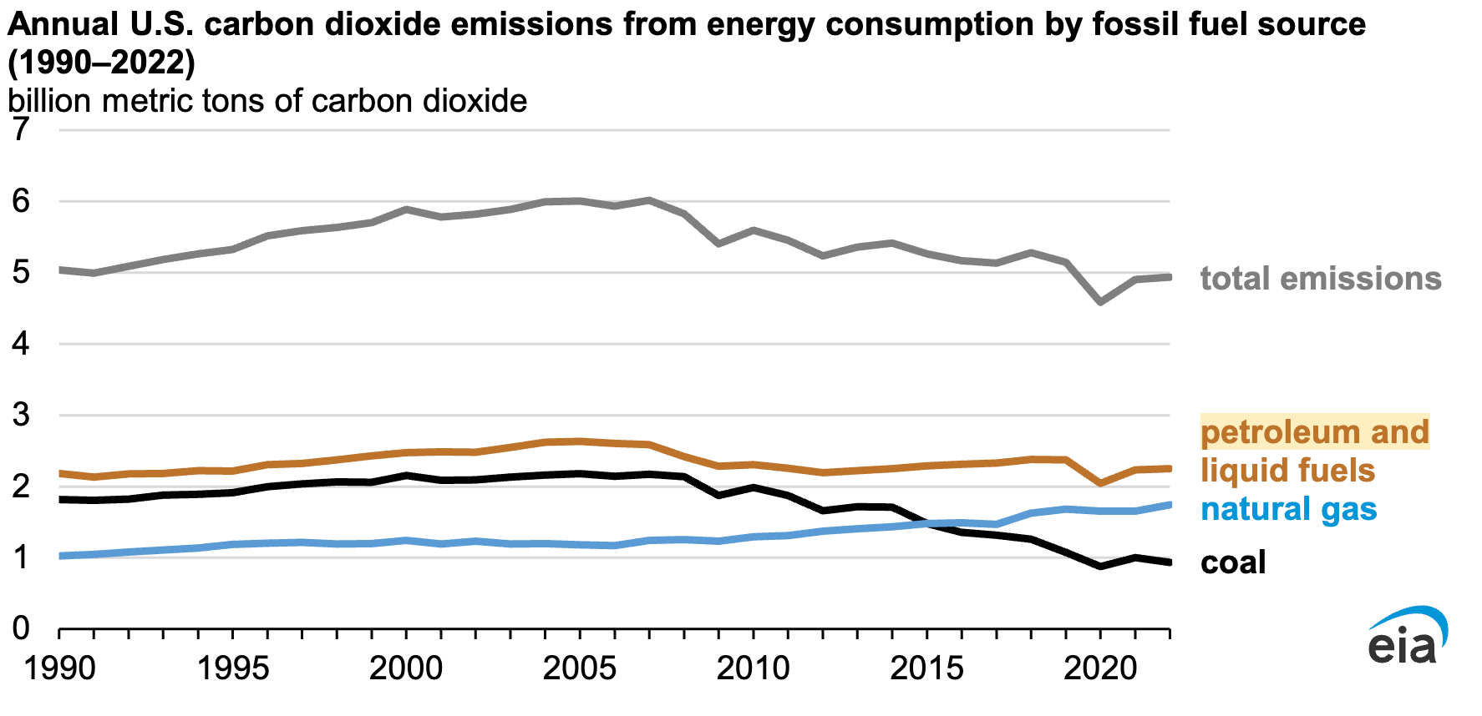

*Data source: U.S. Energy Information Administration, Monthly Energy Review, October 2023*

Overall, U.S. energy-related CO2 emissions increased slightly in 2022 to 4,939 MMmt from 4,905 MMmt in 2021, driven by a 2% increase in transportation sector emissions and a combined 1% increase in the residential and commercial sectors, as industrial sector emissions declined by 2% and industrial activity decreased by 3% over the period (US EIA, 2023).

**Electricity Net Generation Total (All Sectors)**

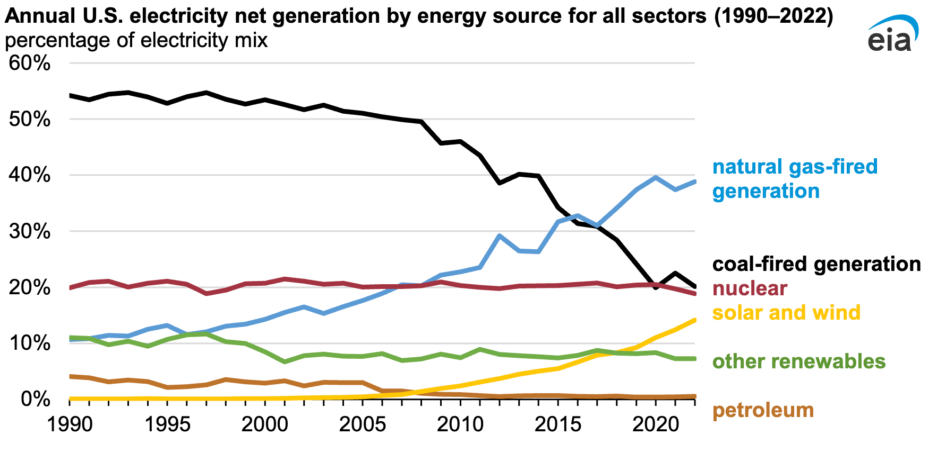

*Data source: U.S. Energy Information Administration, Monthly Energy Review, October 2023, Note: Zero-carbon generation does not include generation from distributed energy sources or small-scale solar PV.*

Coal emissions have fallen 57% from their peak of 2,180 MMmt in 2005. Between 2017 to 2019, coal production declined by 9%, mostly because of decreasing global coal demand and increasing competition from natural gas. U.S. coal production decreased by an additional 24% in 2020 because of a coal surplus in 2019 coupled with lower electricity demand due to pandemic-related economic impacts. Between January 2021 and December 2022, U.S. coal-fired generation capacity declined by more than 25,000 megawatts, while natural gas-fired capacity increased by over 17,000 megawatts. Zero-carbon generation also grew in 2022, and its share of the total generation mix increased from 39% in 2021 to 40% in 2022 (US EIA, 2023).

***Solar Energy Industries Association (SEIA) Report, Energizing American Battery Storage Manufacturing***

Globally, total demand for batteries in all applications, including solar and electric vehicles, will grow from roughly 670 GWh in 2022 to over 4,000 GWh by 2030 while U.S. demand for battery energy storage systems (BESS) is likely to increase over six-fold from 18 GWh to 119 GWh by 2030, according to the report. U.S. manufacturing capacity for all lithium-ion battery applications is currently at 60 GWh. “America’s ability to lead the global clean energy transition and boost grid reliability depends on how quickly we scale domestic production and deploy battery storage technology,” said SEIA president and CEO Abigail Ross Hopper (Clean Technica, 2023B).

The barriers to building a robust energy storage manufacturing sector in the United States include cost competitiveness, access to raw materials, technical expertise, and the need for a large, diverse workforce. The biggest barrier to energy storage manufacturing is the cost and availability of raw materials. While phosphorus and lithium from the United States and its trading partners are available in sufficient quantities, the availability of graphite and other processed materials, like cathode and anode active materials, could create a shortfall. Production elements including siting, permitting, constructing, and commissioning new factories influence how quickly domestic manufacturing can scale. These builders must work to recruit, train, and retain a high-quality workforce, focusing on roles for machine operators, production technicians, and mining, chemical, and electrical engineers (Clean Technica, 2023B).

The Biden Administration Inflation Reduction Act resulted in a demand surge for energy storage, but estimates calculate that domestic supply will fall short as early as 2025 without strategic action. The U.S. broadened its federal incentive program to include domestic manufacturing through new tax credits, grants, low-cost loans, government procurement, research and development support, and public-private partnerships. For energy storage, the IRA offers incentives to produce electrode-active materials, battery cells, and battery modules. These production incentives could reduce energy storage costs by 40% or more, helping to improve U.S. competitiveness. If factories can access raw materials at reasonable costs and improve their production yields to 90%, the IRA incentives could make U.S. batteries cost competitive with products produced in China (Clean Technica, 2023B).

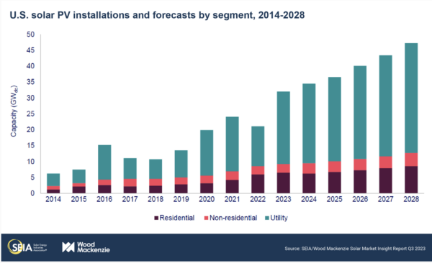

*Image: Wood Mackenize*

**Carbon Capture**

According to an International Energy Agency report, just 1% of global investment in clean energy has come from oil and gas companies. The oil and gas industry needs to let go of the “illusion” that carbon capture technology is a solution to climate change, according to the IEA. The technology captures carbon dioxide from industrial operations before emissions enter the atmosphere and stores it underground. The industry would need to invest 50% of capital expenditures in clean energy projects by 2030 to meet the goal of limiting climate change to 1.5 degrees Celsius, according to the IEA report. About 2.5% of the industry’s capital spending went toward clean energy in 2022. Carbon capture is essential for achieving net zero emissions in some sectors, but it should not be used as a way to retain the status quo, according to the IEA (Kimball, 2023).

An “inconceivable” 32 billion tons of carbon would need to be captured for utilization or storage by 2050 to limit climate change to 1.5 degrees Celsius under current projections for oil and gas consumption, according to the IEA. The necessary technology would require 26,000 terawatt hours of electricity to operate in 2050, more than total global demand in 2022, according to the IEA. It would also require $3.5 trillion in annual investment from today through mid-century, which equivalent to the entire oil and gas industry’s annual revenue in recent years, according to the report. U.S. oil major players such as Exxon Mobil and Chevron are investing billions in carbon capture technology and hydrogen, while European majors Shell and BP have focused more on renewables such as solar and wind. Exxon and Chevron are also doubling down on fossil fuels through mega deals. Exxon is buying Pioneer Resources for nearly $60 billion, while Chevron is purchasing Hess for $53 billion (Kimball, 2023).

***Solar Curtailment and Solar Bidding***

As solar penetration increases and more resources are brought online, solar generation must be controlled to maintain the stability and reliability of the electrical system. One of the challenges that the integration of solar energy into the electrical grid faces is the phenomenon known as the “duck curve” or variations such as the “canyon curve”, which represents the impact of solar generation on the electrical grid load curve. Persistent curtailment and negative electricity prices can result in more renewable energy sources being brought online, and less use of coal fired plants during the daytime. Curtailment is a valuable tool for integrating more renewable energy into the grid, and plays a role in the evolution of electricity systems with high penetrations of intermittent sources such as wind and solar. Times of high solar irradiance and moderate-low electricity demand may necessitate curtailment of solar. When solar power is curtailed, or constrained-off, the output of a renewable resource is reduced from what it could have otherwise produced, and can apply to large-scale centralized PV power plants, and to distributed and dispersed generation residential rooftop solar PV systems, where the electrical system operator can remotely shut down large-scale or rooftop solar PV when there is a risk of grid overload. To soak up excess solar electricity, rooftop solar can be used to charge electric cars, home batteries and hot water storage systems (Rüther and Blakers, 2025).

A new bidding strategy by U.S.-Dutch scientists for the day-after and the intraday markets uses a technique that transforms results from probabilistic solar power forecasts models into actual interdependent scenarios, and has the ability to yield increased revenues and reduced imbalance, and is designed to optimize bidding results, considering the uncertainty of PV power generation. Operational stochastic bidding strategies for electricity markets must be developed that consider PV systems and rely on probabilistic solar power forecasting models. It is important to have accurate forecasts, which can assist in the timely scheduling of the dispatch of power generators and batteries, and therewith ensuring grid stability, while reducing the need for balancing reserves. The U.S.-Dutch method seeks to maximize revenues from the day-ahead market (DAM) by considering a set of scenarios, which are a range of possible power outputs. The Pinson method is used, a statistical technique that can transform probabilistic forecasts to scenarios that consider the interdependence structure of the prediction errors, and originally developed for the purpose of wind power forecasting and was later also successfully used for net load forecasting, i.e. demand subtracted with solar generation (Visser et al., 2024; Kahana, 2024).

**Portugal**

Portugal has proven that it is possible to power your electricity industry off of just renewable power sources, such as wind, hydro, and solar. The last weekend of October, 2023, Portugal supplied all of its energy needs with renewable power sources. Between Friday and Saturday, Portugal generated 172.5 GWh of renewable electricity, with Its output including 97.6 GWh of wind, 68.3 GWh of hydro, and 6.6 GWh of PV; it exported surplus power to Spain, while consuming 131.1 GWh. Wind contributed 97.6 GWh, hydroelectric 68.3 GWh, and photovoltaics 6.6 GWh. According to the International Renewable Energy Agency (IRENA), Portugal boasts an installed renewable energy capacity of 16,329 MW, with over 7,500 MW from hydroelectric, approximately 5,500 MW from wind, and around 2,536 MW from PV (Molina, 2023).

**California**

California has more installed solar cell capacity than any other U.S. state, though has been forced to curtail solar power. Curtailment, or deliberately reducing output, rises as solar generation exceeds available transmission capacity. As intermittent solar generation increases, a lack of available transmission infrastructure or energy storage capacity causes temporary gluts of generation. Curtailment occurs either when there is congestion, when power lines don’t have enough capacity to deliver the power, or during oversupply, when electricity generation exceeds customer demand. In 2022, the California Independent System Operator (CAISO) curtailed 2.4 million MWh of solar and wind generation. Solar accounts for 95% of that total. In California, curtailment is largely a result of congestion, said EIA. Congestion-related curtailments have been steadily on the rise since 2019 as solar generation additions outpace transmission and storage additions. CAISO tends to curtail solar the most in the spring when electricity demand is generally low due to moderate temperatures and production is relatively high due to sunnier conditions (Kennedy, 2023).

***Solutions to Curtailment***

1. Participate in the Western Energy Imbalance Market (WEIM). This is a real-time market that allows participants outside CAISO to buy and sell energy to balance supply and demand. In 2022, more than 10% of total possible curtailments were avoided by trading in this market, said EIA. A day-ahead market is expected to be added to WEIM in Spring 2025.
2. Expanding transmission capacity to alleviate congestion. CAISO’s 2022-2023 transmission planning report outlines 45 projects to accommodate a growing share of renewables. The look-ahead plan is adding significant capacity to meet the 40 GW of generation capacity expected to be added to the system over the next ten years.
3. Development of flexible resources that can respond to demand. In 2023 California has 4.6 GW of battery energy storage, and developers plan to add 7.6 GW by the end of 2024, based on EIA data.

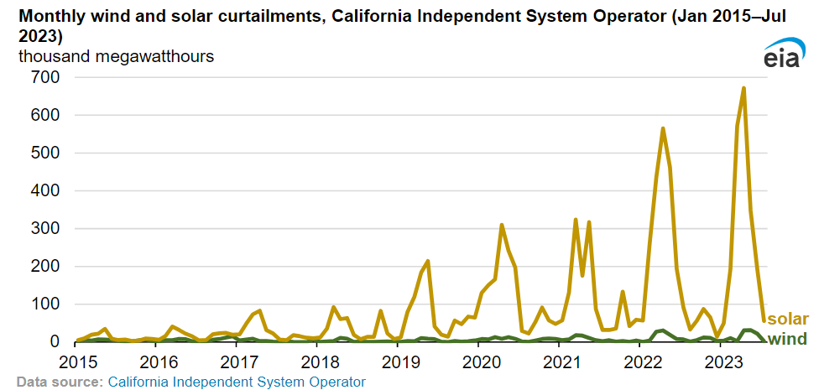

*Image: Energy Information Administration*

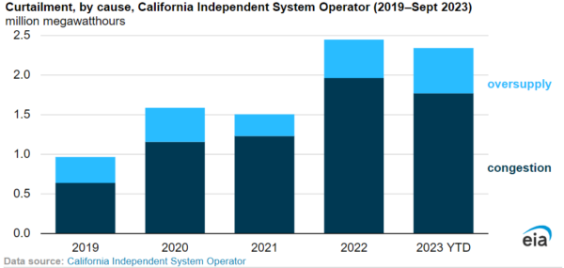

*Image: EIA*

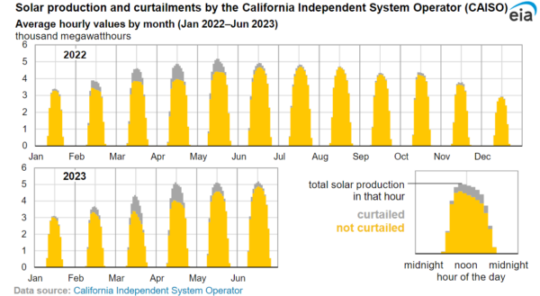

*Image: EIA*

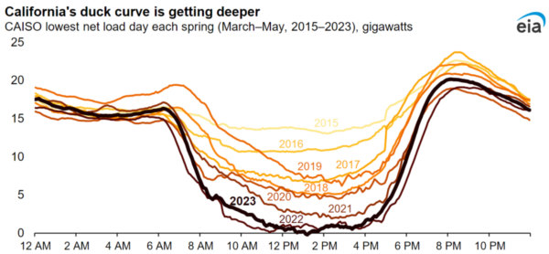

Image: EIA

***Duck Curve, Energy Storage***

The duck curve represents the effect of intermittent renewables on traditional centralized transmission grid operation, which is an electric grid operation concept that signifies the mismatch between peak solar generation (mid-day to afternoon) and peak electricity demand (late afternoon and evenings). Shaped like the outline of a duck, the curve shows the peaks and valleys of this mismatch throughout a typical day. As solar adoption grows in California, the duck curve is deepening, with the midday dip in net load getting lower, making it more difficult for the California Independent System Operator (CAISO) to balance the grid. In the duck curve, conventional fossil fuel power plants must be ramped up from midday to late evenings to satisfy demand. “The large-scale deployment of energy storage systems, such as batteries, allow some solar energy generated during the day to be stored and saved for later, after the sun sets,” said EIA. “Storing some midday solar generation flattens the duck’s curve, and dispatching the stored solar generation in the evening shortens the duck’s neck (Kennedy, 2023).”

Solar-plus-storage has an advantage in capture price, despite higher total project costs. Plants with storage can charge their batteries when sunlight is plentiful during the day and sell the stored electricity when the price is high. DNV, a global risk assurance firm, said that by 2038, the capture price advantage of solar and storage co-located projects will surpass the cost disadvantage, making these projects even more attractive. “PV and storage systems are designed as a ‘package’ that can produce energy on demand, just like hydropower, nuclear, or combustion power plants,” said DNV. In 10 years, DNV said roughly 20% of solar projects worldwide will be built with dedicated storage, and by mid-century such projects will reach about 50% (Kennedy, 2023).

**California Battery Storage Capacity**

California has increased its total energy storage capacity today to just over 6,600 MW, whereas In 2015, the total was less than 100 MW. 6,600 MW is enough to supply electricity to about 6.6 million homes in California for 4 hours. Battery storage is a major solution to the intermittency problem of renewable energy sources like wind and solar. California has targets of 19,500 MW of storage by 2035 and a goal of 52,000 MW by 2045. California is the largest energy storage market in the world in 2023, and their clean energy goal is 100% by 2045. The bulk of the state’s energy storage systems are lithium-ion batteries (Richardson, 2023).

***California Battery Storage in 2023***

1. Residential: 843 MW, 119,483 installations
2. Commercial: 540 MW, 2,492 installations
3. Utility-scale: 5,234 MW, 106 installations

**Australia**

Over several weekends in the spring of 2023, the state of South Australia produced enough electricity from solar panels installed on rooftops to meet its electricity demands. Solar photovoltaic cells started to be installed at a rapid pace across Australia in the early 2010s. Roughly one in three Australian households, more than 3.6m homes, now generate electricity domestically. In South Australia, the most advanced state for rooftop solar, the proportion is nearly 50%. An easy-to-access, upfront national rebate available to everyone has helped make panels cost-effective and easy to install. Rooftops provided 11% of the country’s electricity in 2022, part of a 38% total renewable energy share. The Australian government has set a challenging national goal of 82% of all electricity coming from renewables by 2030. The sums vary depending on geography, but the Solar Quotes comparison site suggests many Australians can get a 6kW solar system for about A$6,000 (£3,100). The panels are likely to have paid for themselves within five years (Morton, 2023).

**References**

Bellini, Emiliano (2023A) PV Magazine. Renewables helping China to halve power prices compared to US, Europe. Retrieved November 28, 2023. <https://www.pv-magazine.com/2023/11/28/renewables-helping-china-to-halve-power-prices-compared-to-us-europe/>

Bellini, Emiliano (2024B) PV Magazine US government doubles tariff rates on PV cell imports from China to 50%. <https://www.pv-magazine.com/2024/05/15/us-government-doubles-tariff-rates-on-pv-cell-imports-from-china-to-50/?utm_source=Global+%7C+Newsletter&utm_campaign=d9c62a7ed9-dailynl_gl&utm_medium=email&utm_term=0_6916ce32b6-d9c62a7ed9-160603208>

Bellini, Emiliano (2025C) PV Magazine, ‘High electricity prices in California have nothing to do with renewables’,

<https://www.pv-magazine.com/2025/01/03/high-electricity-prices-in-california-have-nothing-to-do-with-renewables/?utm_source=Global+%7C+Newsletter&utm_campaign=15eb45e3e4-dailynl_gl&utm_medium=email&utm_term=0_6916ce32b6-15eb45e3e4-160603208>

Bellini, Emiliano (2024D) PV Magazine, Netherlands posts more negative energy prices,

<https://www.pv-magazine.com/2024/08/16/netherlands-posts-more-negative-energy-prices/?utm_source=Global+%7C+Newsletter&utm_campaign=1a6ba955b3-dailynl_gl&utm_medium=email&utm_term=0_6916ce32b6-1a6ba955b3-160603208>

Bellini, Emiliano (2024E) PV Magazine, Looming Trump tariffs drive rush on imports, push shipping costs higher,

<https://www.pv-magazine.com/2024/11/19/looming-trump-tariffs-drive-rush-on-imports-push-shipping-costs-higher/>

Bellini, Emiliano (2023F) PV Magazine. PV-driven Carnot batteries may help convert coal power plants into renewable energy facilities. Retrieved November 24, 2023. <https://www.pv-magazine.com/2023/11/22/pv-driven-carnot-batteries-may-help-convert-coal-power-plants-into-renewable-energy-facilities/>

Brownell, Bradley (2023) Jalopnik. We're Going To Have To Cut Down A Lot Of Big Trees To Upgrade The Electric Grid For EVs. Retrieved November 15, 2023. <https://jalopnik.com/were-going-to-have-to-cut-down-a-lot-of-big-trees-to-up-1851007188>

Clean Technica (2023B) New Report Charts the Path to an American-Made Energy Storage Future. Retrieved November 20, 2023. <https://cleantechnica.com/2023/11/16/new-report-charts-the-path-to-an-american-made-energy-storage-future/>

DNV: ENERGY TRANSITION OUTLOOK CHINA 2024. <https://www.dnv.com/news/china-energy-transition-outlook/>

Driscoll, William (2023) PV Magazine. Reconductor existing transmission to ‘unlock’ renewables, says UC Berkeley study. Retrieved November 29, 2023. <https://www.pv-magazine.com/2023/11/24/reconductor-existing-transmission-to-unlock-renewables-says-uc-berkeley-study/>

Enkhardt, Sandra (2024) PV Magazine, PV industry faces consolidation, says JinkoSolar,

<https://www.pv-magazine.com/2024/08/08/pv-industry-faces-consolidation-says-jinkosolar/?utm_source=Global+%7C+Newsletter&utm_campaign=2a71bf6845-dailynl_gl&utm_medium=email&utm_term=0_6916ce32b6-2a71bf6845-160603208>

Fischer, Anne (2023A) PV Magazine. China expected to dominate solar manufacturing through 2026. Retrieved November 13, 2023. <https://www.pv-magazine.com/2023/11/07/china-expected-to-dominate-solar-manufacturing-through-2026/>

Fischer, Anne (2023B) PV Magazine. New US solar manufacturers likely to choose TOPCon. Retrieved November 15, 2023. <https://www.pv-magazine.com/2023/11/02/new-us-solar-manufacturers-likely-to-choose-topcon/>

Fischer, Anne (2024A) PV Magazine, Trump touts solar trade tariffs,

<https://www.pv-magazine.com/2024/12/16/trump-touts-solar-trade-tariffs/?utm_source=Global+%7C+Newsletter&utm_campaign=b06ab08016-dailynl_gl&utm_medium=email&utm_term=0_6916ce32b6-b06ab08016-160603208>

Fischer, Anne (2024B) PV Magazine, US starts solar cell manufacturing to close supply chain gap,

<https://www.pv-magazine.com/2024/12/05/us-starts-solar-cell-manufacturing-to-close-supply-chain-gap/?utm_source=Global+%7C+Newsletter&utm_campaign=f1f040ae5a-dailynl_gl&utm_medium=email&utm_term=0_6916ce32b6-f1f040ae5a-160603208>

Frangoul, Anmar (2023) CNBC. Rare earth discoveries mean coal mines could have a key role to play in the energy transition. Retrieved November 24, 2023. <https://www.cnbc.com/amp/2023/11/24/rare-earth-discoveries-mean-coal-mines-could-have-a-future.html#amp_tf=From%20%251%24s&aoh=17008527536597&csi=0&referrer=https%3A%2F%2Fwww.google.com>

Gupta, Uma (2023) PV Magazine. US, China dominate solar investment, Retrieved November 5, 2023. <https://www.pv-magazine.com/2023/11/02/us-china-dominate-solar-investment/>

Gupta, Uma (2024) PV Magazine, India imposes antidumping duties on solar glass from China, Vietnam

<https://www.pv-magazine.com/2024/12/06/india-imposes-antidumping-duties-on-solar-glass-from-china-vietnam/>

Jacob, Charmaine (2023) CNBC. Coal free by 2070? India’s push toward renewables won't stop coal reliance for the next two decades. Retrieved November 5, 2023. <https://www.cnbc.com/amp/2023/11/03/india-push-toward-renewables-will-not-stop-coal-reliance-for-20-years.html#amp_tf=From%20%251%24s&aoh=16991155096255&csi=0&referrer=https%3A%2F%2Fwww.google.com>

Jacobson, M.Z., Sambor, D.J., Fan, Y.F., Mühlbauer, A., and Delucchi, M.A. (2025) No blackouts or cost increases due to 100 % clean, renewable electricity powering California for parts of 98 days, Renewable Energy, Volume 240, 122262, <https://doi.org/10.1016/j.renene.2024.122262>.

Jao, Nicole (2023) AOL. U.S. renewable, grid battery projects battle transformer shortage. Retrieved November 29, 2023. <https://www.aol.com/u-renewable-grid-battery-projects-153245773.html?guccounter=1>

Jowett, Patrick (2024A) PV Magazine, Solar underpins record high industrial demand for silver,

<https://www.pv-magazine.com/2024/11/13/solar-underpins-record-high-industrial-demand-for-silver/?utm_source=Global+%7C+Newsletter&utm_campaign=36445cefe8-dailynl_gl&utm_medium=email&utm_term=0_6916ce32b6-36445cefe8-160603208>

Jowett, Patrick (2024B) PV Magazine, Solar module manufacturing capacity could exceed 1.5 TW by 2035, says IEA,

<https://www.pv-magazine.com/2024/10/30/solar-module-manufacturing-capacity-could-exceed-1-5-tw-by-2035-says-iea/?utm_source=Global+%7C+Newsletter&utm_campaign=cafea62a75-dailynl_gl&utm_medium=email&utm_term=0_6916ce32b6-cafea62a75-160603208>

Jowett, Patrick (2024C) PV Magazine, ESMC publishes recommendations for restoring Europe’s solar industry,

<https://www.pv-magazine.com/2024/12/16/esmc-publishes-recommendations-for-restoring-europes-solar-industry/?utm_source=Global+%7C+Newsletter&utm_campaign=b06ab08016-dailynl_gl&utm_medium=email&utm_term=0_6916ce32b6-b06ab08016-160603208>

Kahana, Lior (2024) PV Magazine, New bidding strategy for PV asset owners operating in spot market,

<https://www.pv-magazine.com/2024/08/08/new-bidding-strategy-for-pv-asset-owners-operating-in-spot-market/?utm_source=Global+%7C+Newsletter&utm_campaign=2a71bf6845-dailynl_gl&utm_medium=email&utm_term=0_6916ce32b6-2a71bf6845-160603208>

Kazmer, Rick (2023) Yahoo Finance. Experts predict one source of energy will dominate the power grid by 2050: ‘We are still seeing very rapid innovation’. Retrieved November 29, 2023. <https://finance.yahoo.com/news/experts-predict-one-source-energy-190000317.html>

Kazmer, Rick (2024) The Cool Down, World's largest solar plant featuring over 5 million panels gets switched on in China: 'It looks really cool',

<https://www.thecooldown.com/green-tech/worlds-largest-solar-plant-china-activated/>

Kennedy, Ryan (2023) PV Magazine. California is curtailing more solar power than ever before. Retrieved November 2, 2023. <https://pv-magazine-usa.com/2023/10/31/california-is-curtailing-more-solar-power-than-ever-before/>

Kennedy, Ryan (2024A) PV Magazine, US doubles solar polysilicon and wafer tariffs on China,

<https://www.pv-magazine.com/2024/12/12/us-doubles-solar-polysilicon-and-wafer-tariffs-on-china/?utm_source=Global+%7C+Newsletter&utm_campaign=896946d5b0-dailynl_gl&utm_medium=email&utm_term=0_6916ce32b6-896946d5b0-160603208>

Kennedy, Ryan (2024B) PV Magazine, Top 10 priorities for US solar under Trump,

<https://www.pv-magazine.com/2024/12/13/top-10-priorities-for-us-solar-under-trump/?utm_source=Global+%7C+Newsletter&utm_campaign=d23cbc3cc1-dailynl_gl&utm_medium=email&utm_term=0_6916ce32b6-d23cbc3cc1-160603208>

Kennedy, Ryan (2024C) PV Magazine, US Midwest coal mines to host solar arrays under new partnership,

<https://www.pv-magazine.com/2024/11/27/us-midwest-coal-mines-to-become-solar-arrays-under-new-partnership/?utm_source=Global+%7C+Newsletter&utm_campaign=fc1e287759-dailynl_gl&utm_medium=email&utm_term=0_6916ce32b6-fc1e287759-160603208>

Kennedy, Ryan (2024D) PV Magazine, California utilities scapegoat rooftop solar for high electricity rates,

<https://pv-magazine-usa.com/2024/11/15/california-utilities-scapegoat-rooftop-solar-for-high-electricity-rates/?utm_source=Global+%7C+Newsletter&utm_campaign=73370bd8c5-dailynl_gl&utm_medium=email&utm_term=0_6916ce32b6-73370bd8c5-160603208>

Kennedy, Ryan (2024E) PV Magazine, Maxeon solar panels shipped from Mexico denied entry to U.S.,

<https://www.pv-magazine.com/2024/11/15/maxeon-solar-panels-shipped-from-mexico-denied-entry-to-u-s/?utm_source=Global+%7C+Newsletter&utm_campaign=a23595961a-dailynl_gl&utm_medium=email&utm_term=0_6916ce32b6-a23595961a-160603208>

Kennedy, Ryan (2024F) PV Magazine, U.S. CHIPS Act makes solar manufacturing eligible for significant tax credits,

<https://pv-magazine-usa.com/2024/10/29/u-s-chips-act-makes-solar-manufacturing-eligible-for-significant-tax-credits/?utm_source=Global+%7C+Newsletter&utm_campaign=cafea62a75-dailynl_gl&utm_medium=email&utm_term=0_6916ce32b6-cafea62a75-160603208>

Kimball, Spencer (2023) CNBC. Oil and gas industry needs to let go of carbon capture as solution to climate change, IEA says. Retrieved November 27, 2023. <https://www.cnbc.com/2023/11/23/oil-and-gas-industry-needs-to-let-go-of-carbon-capture-as-solution-to-climate-change-iea-says.html>

Lewis, Michelle (2023) Electrek. New US solar capacity additions have edged past natural gas in 2023. Retrieved November 28, 2023. <https://electrek.co/2023/11/28/us-solar-capacity-additions-2023/>

Lynas, Matthew (2024) PV Magazine, Bringing clean African electrons to Europe,

<https://www.pv-magazine.com/2024/12/07/bringing-clean-african-electrons-to-europe/?utm_source=Global+%7C+Newsletter&utm_campaign=6e98937acf-dailynl_gl&utm_medium=email&utm_term=0_6916ce32b6-6e98937acf-160603208>

Mamchii, Oleksandra (2023) Best Diplomats. The Rise of China in the Solar Industry: A Global Revolution. Retrieved October 23, 2023. <https://bestdiplomats.org/why-china-is-dominating-the-solar-industry/>

Metea, Rachel (2024) PV Magazine, Land availability for US solar continues to slide, says Paces,

<https://www.pv-magazine.com/2024/12/11/land-availability-for-us-solar-continues-to-slide-says-paces/?utm_source=Global+%7C+Newsletter&utm_campaign=7d6b2035d1-dailynl_gl&utm_medium=email&utm_term=0_6916ce32b6-7d6b2035d1-160603208>

Molina, Pilar Sánchez (2023) PV Magazine. Portugal powered solely by renewables last weekend. Retrieved November 2, 2023. <https://www.pv-magazine.com/2023/11/01/portugal-powered-solely-by-renewables-last-weekend/>

Molina, Pilar Sánchez (2024A) PV Magazine, Global installed PV capacity tops 2 TW,

<https://www.pv-magazine-australia.com/2024/11/15/global-installed-pv-capacity-tops-2-tw/?utm_source=Global+%7C+Newsletter&utm_campaign=a23595961a-dailynl_gl&utm_medium=email&utm_term=0_6916ce32b6-a23595961a-160603208>

Molina, Pilar Sánchez (2024B) PV Magazine, PV panel, battery production up to 45% more expensive in EU than in China, IEA finds,

<https://www.pv-magazine.com/2024/10/31/producing-pv-panels-batteries-costs-up-to-45-more-in-eu-than-in-china-iea-finds/?utm_source=Global+%7C+Newsletter&utm_campaign=3649b5e8b7-dailynl_gl&utm_medium=email&utm_term=0_6916ce32b6-3649b5e8b7-160603208>

Montague, Tim (2023) PV Magazine. Quiet shift from central to string inverters in utility-scale solar. Retrieved November 5, 2023. <https://www.pv-magazine.com/2023/11/02/quiet-shift-from-central-to-string-inverters-in-utility-scale-solar/>

Morton, Adam (2023) The Guardian. ‘Go hard and go big’: How South Australia got solar panels onto one in every three houses. Retrieved November 2, 2023. <https://www.theguardian.com/environment/2023/nov/01/how-generous-subsidies-helped-australia-to-become-a-leader-in-solar-power>

Osaka, Shannon (2023) The Washington Post. Wind and solar energy are booming in surprising places. Retrieved November 20, 2023. <https://news.yahoo.com/wind-solar-energy-booming-surprising-135317507.html#amp_tf=From%20%251%24s&aoh=17003335575944&csi=0&referrer=https%3A%2F%2Fwww.google.com>

Palmer, Ian (2024) Forbes. Oil Going Down While China’s Energy Mix And Emissions Doing A Backflip. <https://www.forbes.com/sites/ianpalmer/2024/04/28/oil-going-down-while-chinas-energy-mix-and-emissions-doing-a-backflip/?sh=7bac27401eee>

Paraskova, Tsvetana (2023) Oil Price. Chinese Energy Firms Plan One of the World’s Biggest Renewables Projects. Retrieved November 20, 2023. <https://oilprice.com/Latest-Energy-News/World-News/Chinese-Energy-Firms-Plan-One-of-the-Worlds-Biggest-Renewables-Projects.html>

Peplow, Mark (2023) Nature. A new kind of solar cell is coming: is it the future of green energy? Retrieved December 4,2023. <https://www.nature.com/articles/d41586-023-03714-y>

Petersen, Kate (2023) USA Today. Can we count on renewable energy? Four ways wind, solar and water can power the US. Retrieved November 8, 2023. <https://www.usatoday.com/story/news/factcheck/2023/11/07/renewable-energy-power-reliability-explained/70748158007/>

Richardson, Jake (2023) Clean Technica. California Now Has A Little Over 6,600 MW Of Energy Storage. Retrieved November 5, 2023. <https://cleantechnica.com/2023/11/01/california-now-has-a-little-over-6600-mw-of-energy-storage/>

Roldán Serrano, M.I., Knobloch, K., Giuliano, S., et al. (2024) Retrofit of a coal-fired power plant with a rock bed thermal energy storage, Journal of Energy Storage, Volume 75, 109238, <https://doi.org/10.1016/j.est.2023.109238>

Rüther, Ricardo and Blakers, Andrew (2025) PV Magazine, Curtailing solar photovoltaics is here to stay, overbuilding PV will become normal,

<https://www.pv-magazine.com/2025/01/02/curtailing-solar-photovoltaics-is-here-to-stay-overbuilding-pv-will-become-normal/>

Shaw, Vincent (2024A) PV Magazine. China to increase PV curtailment. <https://www.pv-magazine.com/2024/04/04/china-to-increase-pv-curtailment/?utm_source=Global+%7C+Newsletter&utm_campaign=4320310547-dailynl_gl&utm_medium=email&utm_term=0_6916ce32b6-4320310547-160603208>

Shaw, Vincent (2024B) PV Magazine, China approves polysilicon futures,

<https://www.pv-magazine.com/2024/12/16/china-approves-polysilicon-futures/?utm_source=Global+%7C+Newsletter&utm_campaign=b06ab08016-dailynl_gl&utm_medium=email&utm_term=0_6916ce32b6-b06ab08016-160603208>

Shaw, Vincent (2024C) PV Magazine, World’s highest solar plant by elevation goes online in China,

<https://www.pv-magazine.com/2024/12/17/worlds-highest-solar-plant-by-elevation-goes-online-in-china/?utm_source=Global+%7C+Newsletter&utm_campaign=7e54715aef-dailynl_gl&utm_medium=email&utm_term=0_6916ce32b6-7e54715aef-160603208>

Shaw, Vincent (2024D) PV Magazine, China issues stricter investments rules for PV manufacturing,

<https://www.pv-magazine.com/2024/11/21/china-issues-stricter-investments-rules-for-pv-manufacturing/>

Shaw, Vincent (2024E) PV Magazine, China cuts export tax rebate for solar products,

<https://www.pv-magazine.com/2024/11/18/china-cuts-export-tax-rebate-for-solar-products/>

Skok, Phoebe (2024) PV Magazine, US startup launches off-grid DC solutions to bypass US grid delays,

<https://www.pv-magazine.com/2024/12/23/us-startup-launches-off-grid-dc-solutions-to-bypass-us-grid-delays/?utm_source=Global+%7C+Newsletter&utm_campaign=fc1d9f2811-dailynl_gl&utm_medium=email&utm_term=0_6916ce32b6-fc1d9f2811-160603208>

Srivastav, Sugandha (2023) If the first solar entrepreneur hadn't been kidnapped, would fossil fuels have dominated the 20th century? Retrieved October 25, 2023. <https://techxplore.com/news/2023-10-solar-entrepreneur-hadnt-kidnapped-fossil.html>

Tan, Huileng (2024) Business Insider. China has flooded the market with so many solar panels that people are using them as garden fencing. <https://www.businessinsider.com/china-flood-solar-panel-cell-market-garden-fence-overcapacity-yellen-2024-4>

University of Exeter (2023) Tech Explore. World may have crossed solar power 'tipping point,' study suggests. Retrieved November 8, 2023. <https://techxplore.com/news/2023-10-world-solar-power.html>

U.S. Energy Information Administration (2023) Clean Technica. US Coal Electricity Dropped in 2022, Down to 20% of US Electricity. Retrieved December 4, 2023. <https://cleantechnica.com/2023/12/01/us-coal-electricity-dropped-in-2022-down-to-20-of-us-electricity/>

Visser, L.R., AlSkaif, T.A., Khurram, A., Kleissl, J., van Sark, W. (2024) Probabilistic solar power forecasting: An economic and technical evaluation of an optimal market bidding strategy, Applied Energy, Volume 370, 123573, <https://doi.org/10.1016/j.apenergy.2024.123573>

Weaver, John Fitzgerald (2024) PV Magazine, US targets 50 GW of solar in 2024,

<https://www.pv-magazine.com/2024/12/06/us-targets-50-gw-of-solar-in-2024/>

Zhang, Phate (2024) CNEV Post. China's 1st large-scale sodium battery energy storage station put into operation. <https://cnevpost.com/2024/05/13/china-1st-large-sodium-battery-energy-storage-station-operation/>

1. Solar Radiation Basics, Department of Energy. Retrieved October 6, 2023. <https://www.energy.gov/eere/solar/solar-radiation-basics>
2. University of Exeter (2023) Tech Explore. World may have crossed solar power 'tipping point,' study suggests. Retrieved November 8, 2023. <https://techxplore.com/news/2023-10-world-solar-power.html>
3. Srivastav, Sugandha (2023) If the first solar entrepreneur hadn't been kidnapped, would fossil fuels have dominated the 20th century? Retrieved October 25, 2023. <https://techxplore.com/news/2023-10-solar-entrepreneur-hadnt-kidnapped-fossil.html>