**Global Financial Markets**

**Stock Markets and Currency Unions**

**American, Asian-Pacific, and European and Currency Union Convergence and Capital Market Integration**

***With Review of Foreign Corporate Involvement in the Americas***

by Kevin Sleem

*submitted in accordance with the requirements for the degree of Doctor of Philosophy*

*in the subject of Economics*

*for: International Financial Markets and Currency Unions*

Date Submitted: April, 2010

**Table of Contents**

1. Introduction
2. Financial Market Theory in the 21st Century
3. Transition to InterEconomy Trade
4. Government's Role in the Financial Markets
5. Americas
6. Asia-Pacific
7. Europe
8. Appendices
9. References
10. Index

**I. Introduction**

This doctoral thesis developed in several stages. The author began by reviewing papers discussing both monetary economics and the impact of the Sarbanes-Oxley Act on corporations utilising the financial markets. Due to the University of North Florida not having a research programme in economics, the author then continued his studies with the financial support of Florida Atlantic University. In addition to thanking his parents, the author would also like to thank the universities which provided much appreciated technical guidance on the structure of the academic community. The academic journal *Review of Finance* performed the technical review of the dissertation. The author would again like to thank everyone who helped him complete this PhD in the subject of: *International Financial Markets and Currency Unions.* The official copies are archived with *Sleem Financial Services*.

Sarbanes-Oxley appealed to the author because of his interests in both accounting and stock markets, and monetary economics because of its importance as a foundation subject. The author then read an interesting paper, "Regulation and Bonding: The Sarbanes-Oxley Act and the Flow of International Listings," by Joseph Piotroski and Suraj Srinivasan, which provided the impetus for this thesis. In their paper, the behaviour of cross-listed corporations onto U.S. and U.K. exchanges is analysed in regard to the effect of the Sarbanes-Oxley Act. This meant that the foreign corporations listing onto U.S. and U.K. exchanges before and after SOX were collected and examined for analysis. As such, this author then hypothesised that a thorough analysis of the same type focusing on just the American markets could be a legitimate contribution to the economics literature.

A thorough and intense data collection then ensued of the same foreign corporations listed on the NYSE and Nasdaq as those used in Piotroski and Srinivasan's study. Next, the data collection was extended to the other American markets, namely: Bermuda, Brazil, Canada, and Mexico. The current listings were easy to obtain directly from the stock exchange websites, though for the delisted foreign corporations the SEC website proved helpful, as did proprietary data obtained from the Toronto and Bermuda Stock Exchanges. Delisted foreign corporations from the Mexican or Brazilian Stock Exchanges were not able to be obtained, though there have been only three total foreign delistings from the Brazilian Stock Exchange, and 57 from the Mexican Stock Exchange. This includes all foreign corporations from inception on these markets, though there perhaps may be a few prior to 1990 that were not obtained. Nevertheless, as discussed in the proceeding chapters, analysis of the data suggests that cross-listing activity did not begin in earnest until the late 1980s, and so, this data set can be considered rather complete for an analysis of foreign corporations listing onto American exchanges since their inception, or since cross-listing began in earnest.

As discussed in the next chapters, two of the primary ways to analyse financial integration is through (i) cross sectional analysis of foreign influences and (ii) time series analysis of segment specific characteristics to identify unit roots and significant variables. The primary data collection satisfied the first issue, and the second issue then was addressed. In an effort to include a time series aspect to the analysis, the stock market specific data was collected for each stock exchange in order to identify trends. Then, it was determined that a more thorough analysis would include economy specific characteristics, which can be used to proxy for currency union possibilities. Thus, the dissertation now took on the character of a thorough analysis of *International Financial Markets and Currency Unions*.

After completing the Americas study, the analysis then turned to that of general financial market theory, and on that of the role of the Offshore Market and the Forex market in the international financial markets, in conjunction with analysis of general monetary economics. As the author continued to read and analyse the data, however, it was determined that complete analyses could also be obtained on that of the influence of European and Asian-Pacific corporations in the Americas. Thus, it was determined that an appropriate dissertation could be completed which combined analyses of the finance market and currency union integration prospects of the three primary world regions, in special regard to the effect of foreign corporate involvement in the Americas.

As the author was reviewing the international stock exchanges, several thoughts arose. One, was that analysis of foreign corporations operating on these exchanges could be productive. Two, was that analysis of the foreign governments on all the international stock exchanges could be productive. As such, both of these collections have an important caveat. That is, the government collections and the analysis of foreign corporations on the European and Asian-Pacific stock exchanges are only representative of the corporations currently listed at the time. Four important qualifications are relevant in regard to these two issues: (i) the government listings are typically for debt, which usually are listed longer, and thus the government activity is likely quite representative of a sustained pattern of activity (ii) the German stock exchange was simply difficult to understand, and there may be more foreign companies on the Frankfurt stock exchange than is reported herein, although, according to the data on the World Federation of Exchanges, the data herein should be quite close to accurate (iii) the Japanese exchange provides a copy of all foreign participants from inception, which made it quite easy to quickly identify foreign corporations on the Tokyo Stock Exchange, as well as to see a trend from one of the major international stock exchanges with regard to cross-listing behaviour over time (iv) the list of foreign corporations on the European and Asian-Pacific exchanges only represent currently listed firms, and the purpose is to offer guidance as to what the typical composition of foreign corporations on those exchanges may be (v) the Luxembourg, Swiss, German, and British markets together serve the vast majority of the entire world's government financing needs. As such, the final section to be determined was that of a theoretical for government in the financial markets.

***Outline***

This thesis is prepared to offer an analysis of the three primary world regions in primary regard to the concentration of foreign corporations cross-listed on American exchanges since their inception. Several theoretical chapters precede the three primary empirical and theoretical analyses of the major world regions, being: the Americas, Asia-Pacific, and Europe. There are two primary differences in the regional studies, (i) the discussion of the theoretical rationales that define the respective regions' distinguishing financial markets and economic characteristics, and (ii) the empirical methods utilised. The region specific theoretical constructs are distinct to each region, and are intended to specify the specific financial characteristics of the respective region which may contribute to the state of their currency union integration and capital market convergence. The relevance of foreign cross-listed corporations in the Americas to these region's currency union integration and capital market convergence is then empirically analysed, in conjunction with data regarding their economy and stock exchange specific characteristics.

**Section II.**, Financial Market Theory in the 21st Century, offers a theoretical expose on issues and aspects of financial markets in the 21st century. The theoretical constructs presented in this section are incorporated as appropriate into the three regional studies. In today's markets, there are issues regarding regulation and supervision, welfare benefits, and contagion consequences from integrated financial markets.

**Section III.**, Transition to InterEconomy Trade, suggests how the economy evolves to the point of integrated intereconomy trade. The impact of computers is also touched on in this section.

**Section IV.**, Government's Role in the Financial Markets, discusses matters relating to the ideal role of the government in the financial markets. As such, interest rate caps and a profit allocation scheme are options which may help stabilise the financial markets. An empirical analysis on the foreign activity of the governments in the financial markets is also presented.

Each empirical study begins with an introduction discussing the outline and goals of the specific paper, which is followed with the offering of the theoretical assumptions relevant to that region's economic nature and reputation, which is the first major difference amongst the studies. Four theoretical sections are presented within the three regional studies which analyse (i) cross-listing rationale, (ii) stock market solitariness theory, (iii) currency union integration rationale, and (iv) capital market convergence theory. The hallmark of the Americas region is their reputation as the favoured corporate cross-listing market in the world, and so the theoretical assumptions of the cross-listing rationale are presented in the Americas section. The Asian-Pacific region is known for their traditionally closed-door economic policies, and as such the premises for stock market solitariness is explored in the Asia-Pacific segment. Europe has customarily advocated integration in their markets and cultures more so than other regions, and thus the theories of currency union integration and capital market convergence are examined in the Europe chapter. The Americas section also presents a short expose on the relationship between debt and equity in the finance markets.

After the different theoretical assumptions are presented which pertain to each region's financial markets, then a brief synopsis of the current state of each region's capital markets is offered. Next, the relevant hypothetical assumptions and empirical analyses for each region are presented, and then a concise summary and introspection for future possibilities is discussed with consideration of the political pressures which invariably dominate the economic integration processes. The second difference between the studies is the treatment of the variables used for the empirical analyses. The Americas region has more variables for both the cross-sectional and time series tests, with 28 for the cross-sectional and 42 for the time series, with the economy-specific and stock exchange-specific portions each having 21 indicators. For the Asia-Pacific and Europe regions, nine of the region-specific variables are dropped from the cross-sectional analysis for a total of 19, and five variables are dropped from the economy-specific time series analysis, bringing the total time series factors for these two regions to 37.

Detailed analyses of the descriptive statistics and of the ARCH results included in the appendices was not performed for all regions, though was so for the Americas. This is for three reasons: (i) due to the amount of data used, extensive analysis of each individual data term might cloud the primary results and intent of the study; (ii) there is little original contribution to be obtained from these results; (iii) for the purposes of this study, intent analysis of the descriptive statistics and ARCH results would not be economical, as there is a generous amount of original data and results already presented; (iv) for example, there are many more countries analysed in the Europe and Asia-Pacific sections, which would make for an exhausting addition to the papers, which are already thorough enough as it is.

The American region is arguably one of the three primary regions in the world, the other two being Europe and Asia-Pacific. As such, the first part of the thesis focused completely on the American markets. As the analysis proceeded, it was identified that the vast majority of the foreign corporations listing onto the American markets could be separated into these three distinct groups as well, again being: Americas, Asia-Pacific, and Europe.

***The Regions***

**Section V.** The Americas region study provides a contribution to the analysis of foreign cross-listing behaviour in general, and on the state of the integration of the American region's capital markets and economies in specific; while also examining the market preferences of U.S. firms in the Americas and around the world in the context of their integration within the Americas; as well as analysing the role of the growth and integration of the Mexican stock exchange into the American financial markets in regard to the 2008 credit crisis and in general. A logistic regression model is developed which takes into consideration exchange, firm, geographic, and industrial regressors in order to determine whether firms prefer listing on the New York Stock Exchange as compared to the Toronto Stock Exchange. Logistic regressions are also run on foreign corporations operating in Bermuda, Mexico and Brazil. Unit-root causality tests are run on the economic specific characteristics of the American economies to analyse monetary union possibilities.

**Section VI.** The Asia-Pacific region analysis considers three primary hypotheses. Do certain Asian-Pacific countries exhibit more preference for the Americas than others, and if so, which American markets do their corporations prefer? How do these countries' preferences differ according to region and cultural heritage? Has there been a change in Asian-Pacific involvement in the Americas since the SOX act? If so, what is the behaviour of the different regions and cultures, and what of the countries that could be integrated into common stock markets or a common currency? Is there a discernible time series trend, in terms of unit roots and significant variables, in the stock markets and economies of the Asian-Pacific countries? If so, do these trends correlate to region, and do they mirror the affiliations we see today in their political and cultural heritages?

**Section VII.** The Europe region discussion analyses three primary hypotheses. Do certain European countries exhibit more preference for the Americas than others, and if so, which American markets do their corporations prefer? How do these countries’ preferences differ according to region, and according to whether or not they are in the Euro-Zone, Euro-Next, or Nordic, and what of the other countries that could join one of these three groups? Has there been a change in European involvement in the Americas since the introduction of the Euro? If so, what is the behaviour of the Euro-Zone countries, and what of the other countries that are either integrated into common stock markets, or could be integrated into common stock markets or a common currency? Is there a discernible time series trend, in terms of unit roots and significant variables, in the stock markets and economies of the European countries? If so, do these trends correlate to region, and do they mirror the affiliations we see today in the Euro-Zone, Euro-Next, and Nordic exchanges.

The purpose of this thesis is to contribute to the literature on cross-listing in general, and on currency union and finance market integration in relation to the cross-listing activity in the Americas. As far as general integration thoughts, it is likely that Europe is the most integrated world region, followed by the Americas and then Asia-Pacific. The empirical results are also similar across regions in terms of listing preferences in the Americas. For example, since SOX firms have preferred other American exchanges over the USA, and within the USA the NYSE over the Nasdaq. Corporations with high levels of assets, sales, and income prefer the USA exchanges, and the NYSE in particular. Within the Americas, the USA and Canada have the most similar economies, while Mexico has similarities with both North and South America, though is becoming more integrated with the North American economies. Canada, however, is not as integrated with the USA as it may seem. As far as American stock markets go, the USA, Canadian, and Brazilian stock markets are the most integrated, while the Mexican and Bermudian have less in common with the major American markets.

**Use of Artificial Intelligence**

Gemini AI notes have been saved and posted to [www.sarlington.com](http://www.sarlington.com). A few sections in the first chapter, Financial Markets in the 21st Century, were edited with the use of AI. Page 17, Financial Equality, interest rates and prices in financial integration. Page 17, Higher Savings and Investment Rates, The globalisation of financial markets has led to changes in patterns of saving and investment across the world. Page 18, Individual Investors, opportunities for individual investors in economic integration. Page 18, Corporate Financing, corporate financing and market integration. Page 21, Regulation and Supervision and Massive Intervention, intervention to control financial contagion.

**II. Financial Market Theory in the 21st Century**

I. Today's Financial Markets

II. Evolution of Financial Markets

III. Regulation and Supervision

IV. Welfare Benefits

V. Contagion Issues

**I. Today's Financial Markets**

Financial markets naturally evolve toward becoming increasingly integrated globally. Through the course of history, international market integration has ebbed and flowed, starting at high levels in the late 1800s, collapsing between World War I and II, stabilising after 1945, and reaching levels comparable to pre-1914 in the 1990's. Today’s financial markets are equaled in integration only by pre-1914 levels, however, the impact of computers in today’s global economy cannot be understated. Bordo et al. (1998) writes that new information-generating and processing technologies have reduced the market-segmenting effects of asymmetric information, resulting in a wider web of financial claims that are traded internationally. In the early days of international trade, claims for international financial transactions were settled by entities with tangible and transparent assets, and included governments, railroads, and mining companies. In the present day, to conduct international business, investors can now buy and sell a broad range of securities, from debt to equity listings on stock exchanges, to foreign currencies on the FOREX market. From the first ATM being introduced in the 1960s in London, to computerised stock trading in the 1971 with the Nasdaq, we have made strides in our global computerised economy and continue to refine regulations to make trading fair for everyone.

As discussed in this chapter, global financial markets naturally evolve towards regulation, welfare benefits, and contagion. There must be rules and regulation to settle disputes and standardize norms between countries, there must be benefits in terms of increased welfare for all the trading partners, and there will also naturally be some contagion in the markets where negative welfare can be transferred from country to country, just like positive welfare is transferred in the course of trade. In order to analyze how interconnectedness is influencing our lives, we must first answer the subjective question of what exactly it means to be integrated. We all may agree that being integrated is networking with each other, but where differences arise is in how integrated and connected we should be. This question of integration could be as simple as joining a neighborhood watch or local PTA, or as complicated as petitioning for the rights of migrants, or deciding whether a Chinese firm should list on a U.S. stock exchange. Kali and Reyes (2005) describe the global trading system as an interdependent complex network of trade linkages, and by analysing these trade linkages one can determine how well connected a country is into the global trading system. This makes sense, many trade linkages make up the global interconnected economy, and this suggests that individuals have more power than they might think to impact one of the many trade linkages. So, we are all part of the interconnected world economy, and through these many trade linkages, for example, a small business foreign exporter is a trade linkage, we all contribute to the integrated nature of the global economy which we all share.

After defining the integrated market, we must ask ourselves what is the purpose of the connected global economy, and if it is necessary. Well, global trade is necessary to have all the possessions one desires, at a cheaper cost. We would still produce textiles and toys in America, but it is cheaper to buy them from China, so we shift to more service jobs, which pay higher salaries, and still have all the goods we desire from cheaper labor in countries where the applied labor rate is still a decent standard of living. We can see the similar levels in standard of living by comparing nations based on purchasing power parity, instead of per capita GDP. In terms of purpose, financial markets perform a primary function, facilitating the transfer of securities into cash, or cash into securities (Weber, 1993). Trade functions by exchanging currency for products or services, and on the national level, this means that the country’s balance of payments has been adjusted, and goods have been paid for using securities. Securities is the best way to transact international trade, which could be in foreign currency, or even the national debt of the trading country. Petro dollars in Saudi Arabia are denominated in U.S. dollars, and China owns a significant amount of U.S. national debt. So we see that we need these international securities to facilitate the flow of global trade. Sabri (2002) notes that we can continue to evolve as a society and global economy and still have the primary purpose of obtaining wanted products at cheaper prices, because some countries have comparative advantages over others. As world financial markets and institutions gain new information processing features to increase transactional efficiency, and improve our standard of living through the lower prices of global trade. We must also learn to operate in different environments and conditions to keep the global economic ship afloat, such as depressions and recessions; we must manage the business cycle on a global level to achieve these gains in standard of living that all citizens of the world deserve the opportunity to see in their countries, developed and developing countries. Tripathy (2006) remarks that international financial market integration is a very sensitive segment of the world economy, as it is through this tool that the country's exposure to the outer world is most readily felt. Therefore, one purpose of the global integrated economy is that we develop experiences as individuals and governments to the personalities of others, and not only do we learn from others in the globe what regulation works and what does not work in terms of positive welfare and negative contagion, we also learn new people skills, such as second languages.

The question could also be asked, as to whether integrated markets really make trade more efficient. Mirman and Schenk-Hoppé (2003) studied the effect of financial markets on the investment-consumption decisions of closed countries, as opposed to the open global economy, where trade between consumers of both countries takes place on competitive spot or financial markets, and found that the investment decisions in both individual cases are inefficient compared with the efficient, or integrated world economy. This study implies that integrated financial markets result in a more efficient allocation of goods and money, and that individuals and governments can prosper from the economies of scale of integrated markets and the resulting efficiency gains they provide. Essential to operating efficiency is a well-functioning and resilient operating environment with a stable financial market infrastructure (Jenkinson, 2007). Stability and functionality are essential to efficiency gains, as the market must be stable to reduce fluctuations in rates, and functional to be effective at facilitating trade. Tripathy (2006) verifies that there has been increased global operating efficiency as integration of the international capital market has facilitated cross-country financial flows, which contribute to a more efficient allocation of resources. For example, when Chinese firms list onto the NYSE, there is money going to both U.S. operations of the Chinese company, and cross-border back to China where the firm is headquartered. For New York to be the financial capital of the world, we need cross-country financial flows, which allocate money in an equitable fashion throughout the world. The argument thus goes that the more money that crosses borders, the more efficient allocation of resources there is.

Today’s financial markets see a mix of capitalism and communism. Sikka (2003) suggests that globalisation can be considered the most advanced phase of capitalism. Capitalism is not a perfect science, and there have been recessions and depressions in capitalist economies, like communist economies, though capitalism continues to evolve into new forms of financial market efficiency, all while generating adequate returns on capital for investors. A key aspect of today’s financial markets is the emergence of offshore financial centres, which facilitate the mobility of capital by providing low tax and low regulation operating schemes, allowing countries to engage in international trade. Offshore financial centres are essential to offshore trade, as they offer a third party intermediary to reduce taxes on international transactions by allowing the company to domicile in their jurisdiction, at a low tax rate, and also are seen in the shipping and aviation industry with their role in registering ships and planes for international commerce and travel. Furstenberg (2006) notes the policy trilemma that governments cannot simultaneously maintain an open capital account, a fixed exchange rate, and a domestically-oriented monetary policy. An open capital account, or liberalized capital market, is one where individuals and businesses can freely access international financial markets. All countries must first cater to domestic-oriented monetary policy, but there needs to be a balance with foreign trade policy. And as we see, the U.S. has a floating exchange rate, which allows the U.S. dollar to be the world reserve currency and currency of choice for petro dollars. China has a fixed exchange rate, and many countries peg their exchange rates to the U.S. dollar, and this decision on how to manage the country’s exchange rate becomes a factor in their balance of payments balance for international trade. Monetary policy, exchange-rate policy, and tax policies are all impacted by this policy trilemma.

***Impact of Computers***

Computers in specific and technology in general are the norm not the exception in all facets of society today. This topic is touched on again in the next section which summarises the transition to intereconomy trade. Without computers, our system of international trade would have to revert to late 1800 and early 1900 trade schemes. Computers allow for on demand processing and settlement of cross border financial transactions, including in areas such as currency conversion through the FOREX market, and tax payments to countries.

**II. Evolution of Financial Markets**

*Two primary questions arise in the discussion of the processes inherent in the evolution of financial markets:*

**(1)** How to define the creation of or being of the integrated financial market; or necessary conditions?

**(2)** Are there certain indicators, requirements, or tools that can be used to quantify the degree of financial market integration; or sufficient conditions?

Financial markets have evolved from physical commodity markets and exchange fairs, to the computerised system that we use today to settle payments. In the early days of our global economy, transactions were processed using coins as currency, which has evolved to the use of fiat currency and credit cards in our markets today. Clearly, credit cards use computers to check the availability of funds in real time. One advancement we have made in the growth of our capital markets are laws against usury. From a historical standpoint, Pezzolo and Tattara (2006) suggest that success of the Bisenzone fairs of exchange directly challenges the theory which suggests that the laws against usury restrained the development of capital markets in early modern Italy. For a non-European example, we also see that stability in the economies of Islamic nations observing Shariah which bans interest. Is there still usury in our modern world? Some would say that credit card companies sometimes charge usurious rates, but it is also true that credit cards should only be used in emergencies, and paid off in full every financial statement period. Another form of usury in our modern society could be student loans, but as we have seen recently in America, the Biden Administration canceled student loans debt for many borrowers. Credit cards and student loans are necessary evils, evil being the usurious loan. People need credit cards for emergencies, and this author feels that student loans should be repaid in full, and college should not be free. College should be cheap, not free. Someone has to pay the bill, and better it be the person who is going to college, rather than a person who has succeeded in life without college. College is one way to get ahead in life, not the only way. Many construction jobs do not require college degrees, only a high school diploma.

***Being of***

So what is an integrated financial network? The global financial network is not one single network, rather it is a collection of financial networks that are in turn integrated together, sort of like roots from different plants growing into each other, yet in a seemingly organised fashion. Seemingly is important here, because, as those roots become more intertwined, and even though they may look like a pretty picture, it becomes increasingly difficult to maintain where each of those roots originated from. This is what happens when financial products are lent out to a bank in another country, and then out to yet another and another. The initial root or loan keeps growing and meeting other avenues, and they make sense on paper, yet it becomes more difficult to unwind that root in the event there is an issue with original loan or root, as that one is contaminating other roots around it, and thus it must be unwound to remove it from all the other intertwined roots to prevent disease from spreading to the healthy roots.

For developing countries, an integrated financial market integration should accelerate the development of burgeoning financial markets, and allow companies and governments from developing nations to access credit and security markets in more stable countries. To be integrated, you have to be coordinated. Governments and financial institutions must work together and coordinate their activities to achieve maximal operating efficiency in an integrated global economy. Weber (1993) notes how fragmented markets may arise when parties are not coordinating actions and working together, leading to overall regression in the development of the global financial market. Fragmented markets lead to efficiency loss, and can even result in higher rates and less capital movement across borders. Financial globalisation from the integration of markets is also known as financial liberalisation, with Arestis and Basu (2003) defining financial globalisation as a process whereby financial markets internationally are integrated so closely that they can be considered as a single market.

Fecht et al. (2007) suggests different classes of financial markets. The integration process market, or the markets where goods and services are exchanged, includes the: segmented markets, secured interbank market, unsecured interbank market, and the retail markets. The process of integration in these four markets ultimately leads to equilibrium financial integration in the global economy. The financial instrument market, or the payment mechanisms, consists of: FOREX, credit, debt, derivative, and equity markets. These different financial markets interact with each other in order to grow the global market in the process of financial market globalisation, whereby product prices reach an international equilibrium through the evolution and movement of financial flows (Nagurney et al., 2004).

If integration is considered a form of risk sharing, then segmentation is the most basic form where no integration or sharing takes place, and then the markets evolve to integration and risk sharing in the secured bank market, unsecured bank market, and retail markets. The secured interbank market, where banks report liquidity needs, becomes an optimal risk-sharing apparatus while contributing little risk of cross-regional financial contagion to the global financial markets. As the number of integrated regions increases, the secured interbank market loses impact on risk sharing and integration through overuse of the liquidity provision, and consequently this moral hazard problem appears in regions with large exposure to the global economy, and thus either unsecured interbank lending or the utilisation of retail markets is preferable. Fecht suggests that contagion issues now become more prevalent when the unsecured interbank market or retail market become integrated over larger regions, though for large economic areas integration from these markets can still be beneficial, because it can implement an efficient sharing of idiosyncratic regional shocks. Further, these idiosyncratic shocks to the banking sector can be minimised by increasing the diversification options of banks across borders through the cross-border integration of interbank markets. According to the logic of the second method, seven key markets which form the basis for financial market integration are the: FOREX, corporate bond, government bond, equity, credit, money, and derivative markets. The corporate and government bond markets comprise the debt market, while the credit and money markets comprise the credit market, so these 7 essentially can be seen as 5 markets. These markets are discussed in greater detail in later sections. After determining what exactly is an integrated financial network, we can analyse the necessary conditions for the growth of the financial network.

***Indicators of***

Although there are many factors which contribute to the development of integrated financial markets, and not all can realistically be identified or quantified due to unknown market forces, we can identify some of the major factors. The 5 most widely cited indicators of financial market integration are: (1) general information technology advances (2) more efficient clearing and settlement processes (3) interest rate convergence (4) extent of home bias (5) the use of a common currency. It is more difficult to measure home bias or the level of technological advancement, as compared to use of a common currency, and so it must ultimately be an individual opinion as to how integrated the financial markets are. What we can say for sure when identifying indicators of financial market integration is that when prices are low, and we can purchase all the goods and services that we desire, that means the global markets are functioning correctly.

Some additional authors' opinions on what which factors contribute to the creation of connected financial markets, include: who the decision-makers are and what sources of funds they control, behaviour of the financial intermediaries, and the demand markets for the various financial products, derived from the maximisation of net return and the minimisation of risk for the decision makers (Nagurney et al., 2004). Sabri (2002) suggests additional influences as well, noting: an increased role of the financial sector in the world economy, higher activity between the financial markets and institutions, liberalisation of the related laws and regulations, increased linkages between sub-segments of financial markets, computerising of financial markets and institutions, and introduction of new instruments and innovative derivatives. Gkoutzinius (2004) notes that financial integration can include the internationalisation of securities markets, banking markets, cross-border bank mergers and other types of direct investment in the financial sector.

*In No Order:*

**1. Information Technology**

Without information technology and the instantaneous transaction time of computers, we would not have seen the exponential increase in integration since 1990. Today, we continue to see new automation technologies being used in the international financial markets, including from banks, securities firms, and the markets themselves. Weber (1993) suggests that due to proliferation of information technology in financial markets, and the need for more international regulation to monitor the new IT, some markets may see some fragmentation in the future as markets struggle to keep up with IT advances.

**2. Clearing and Settlement**

Related to the impact of information technology and computers, the effectiveness and efficiency of the clearing and settlement system is of great importance. An efficient securities clearing and settlement system seeks to ensure the safe transfer of ownership of assets when payment is presented. The risks involved with securities transactions, such as fraud and nonpayment, must be minimised so as to not hinder the acquisition or disposal of securities, while still offering low costs. Carvalho (2004) notes that a smoothly functioning integrated infrastructure for clearing and settlement within the regional market is a precondition to further developments of the single financial market.

**3. Interest Rate Convergence**

One may rightfully wonder why convergence of interest rates would be more important than that of other important economic indicators such as exchange or inflation rates; this is because interest rates are direct measures of business investment opportunities, such as with loan or credit rates. In the ideally integrated open economy, domestic interest rates will be influenced by international rates, and will converge to the global rates. It is true that global financial conditions affect domestic rates, as a recession in one country can spread to other countries through financial contagion. As such, analysing the convergence of interest rates is one tool to gauge the degree of integration for various financial markets, as domestic rates will naturally converge to international rates. Speculative opportunities in developed or emerging countries suggests a lower degree of international integration because rates should converge. Interest rates fluctuate over time, though they must stabilise and be equal across asset classes at all times to prevent excessive speculative profits. Even at full integration in our financial networks, or interest rate convergence, there will still be interest rate swings from time to time. In efficiently integrated markets, expected risk-free rates can vary freely over time, however, they must be equal across assets (Flood and Rose, 2004). In order to study the shocks which are transmitted across international financial markets, we can look at the comovement in rates, such as the bond market, between developed and emerging economies.

**4. Home Bias**

Equity home bias can be defined as investing more in domestic stocks than international stocks, thereby not reaping the rewards of international diversification. If low home bias is considered a condition for integration, that means that home bias can set the degree of international diversification, and thus indicate the preference for embracing a globally integrated financial network. Pungulescu (2008) writes that countries with lower home bias experience higher economic growth rates and better consumption variability, due to them being more connected with the global economy, a precursor better for more trade and growth. A low home bias may also lead to more international risk sharing and a better income equality for citizens in the home market. Consequently, in terms of regional financial market integration, a higher home bias for market preference signals a lower degree of integration.

**5. Currency**

As we see in the EuroZone, the introduction of a common currency is another way to facilitate the integration of financial markets. Although adoption of a common currency is one way to measure financial network integration, developing and implementing a common currency is not a speedy process. A precursor for developing a common currency for a trading zone is the implementation of information technology and computer systems as well as a clearing and settlement system; there also must be as well as effective coordination among the participant countries. Fecht and Gruner (2005) notes that regions should first pursue the optimal regional and/or sectoral integration of financial systems, or the creation of regional currency systems and effective regulation and supervision among countries.

**III. Regulation and Supervision**

Financial markets must have effective laws, regulation and supervision, in order to have a healthy functioning national economy. Regulation and supervision help to maintain the financial markets' efficient operations, while also performing another integral function, protecting the interests of the individual participants. To ensure fair business, financial markets must be both regulated and supervised, and differences in regulatory regimes between countries and regions must be effectively managed. Jenkinson (2007) writes that in the complex and globally integrated financial system we have, vigilance, flexibility and international coordination among policymakers becomes important. Across the globe, we see that the creation of the EuroZone has led to increased financial integration between some European countries, while the United States, as the engine of the world economy, must remain vigilant in their regulation and supervision of their banks, to reduce contagion consequences around the globe. Banking policies must be coordinated among international countries to support the globally integrated system, and this regulation and supervision must take place before transactions are consummated.

**Regulation**

As noted previously, different definitions can define integration. This continues to hold true when we attempt to define what exactly effective regulation and supervision entail, as differing countries and regions advocate contrary levels of involvement in the society from the government. To solve this identification issue, Gkoutzinius (2004) notes that there must be legal convergence in facilitating linkages between national financial systems for more integration in the financial markets. Another issue with regard to the creation of global financial markets is that of how the legal process affects the flow of capital, with one of the causes of incomplete financial globalisation being the legal obstacles and barriers that may inhibit the flow of capital across national borders. There must be coordination between domestic legal and regulatory institutions and international financial operations. The global financial network has many components, and thus there are a multitude of factors likely to affect the effectiveness of integrated regulation and supervision. Holopainen (2007) notes that the continued emergence of financial conglomerates and multinational financial institutions, as well as the development of new financial products, will continuously raise concerns as to the ability of separate sectoral supervisors and different national authorities to effectively oversee financial markets. Stolz (2002) writes that banking supervision must be considered with reference to the presence of cross-border lending, which refers to the contagion effects that an individual bank failure in one country could trigger in another country.

**Supervision**

To effectively monitor the current state of financial markets, it is essential to periodically review and adjust regulation and supervision mechanisms, just as it is with any other system (Gugler, 2005). Financial market integration is positively correlated with a higher quality of supervision in financial services and greater consistency of supervision across sectors. Cihák and Podpiera (2007) note the trend in many countries toward integrating effective regulation and supervision of banks, nonbank financial institutions, and securities markets in a single national agency lately. Also, the primary government body for enacting and overseeing regulation and supervision, becomes of concern with cross-border financial markets, which can be located inside or outside the central bank.

**Fair Play**

There must be fair play in an integrated global economy. The tradeoffs between developed and emerging countries must be fairly distributed, or evenly dispersed, with developed countries as well as emerging countries profiting from the integration. There is a dynamic relationship between the developed markets and the world market, as when the world stock market is efficient and co-integrated with the developed market, there will be an equilibrium long-run relationship (Tripathy, 2006). Emerging economies have increased their standards of living and have seen greater influence in the international banking and capital markets due to global integration. The Bank for International Settlements writes in a 2008 paper that more liquid emerging economy markets have developed from the growth of local money and capital markets, due in part to demographic trends. For example, in emerging market economies, growth in pension fund assets helps to deepen financial markets, and the development of derivatives markets has been helped by strong growth in the spot foreign exchange market for emerging market economy currencies and the increase in local currency domestic bonds outstanding.

**Legal Convergence**

There must be legal convergence to have integrated markets, in that legal diversity and legal harmonisation must intersect. Therefore, even though each country may have different legal rules, there must be legal harmony between the countries in order for there to be efficient cross-border financial flows where people in both countries benefit. Gkoutzinius (2004) notes that there has been a proliferation of common international standards and codes of best practice in prudential regulation, securities regulation, accounting and other areas relating to international finance, which aim to introduce a minimum level of consistency among national systems and practices. Gkoutzinius (2004) argues that the exemplar global financial system will have democratic and capitalist features, and that the national architectures of each member country, communist and capitalist, will all influence the global financial architecture.

**IV. Welfare Benefits**

Welfare benefits of integrated financial markets can be divided into general economy effects and individual entity effects. Some of the positive general effects from integration include: higher economy-wide growth rates, more efficient economic policies, better innovations, lower transaction costs, higher saving and investment rates, and more financial equality. Some of the positive individual entity effects from integration include: more opportunities for individuals and corporations and better financing and returns for corporations.

***General Effects***

There are many benefits of integrated financial markets for the entire world, as increased financial openness expands private credit, bank assets, and stock market and private bond market development, as well as it generates efficiency gains in the banking system.

**1. Economy-Wide Growth**

Investors seek to reap growth and profits from their investments, and as such a purpose of integration is economic growth for all entities. Financial integration can lead to economic growth in the regional market, for both individuals and corporations. Through integration, and the resulting higher liquidity and competition in the capital markets, investors will see higher returns on savings while maintaining a diversified portfolio to insure against international financial shocks (Carvalho, 2004). In the integrated market, corporations will enjoy better access to capital financing, and financial intermediates will offer a wider range of financial products at lower prices due to competitive forces. Calderon and Kubota (2009) write that increased financial openness will enlarge the size and activity of financial intermediaries, improve efficiency in the banking system, and contribute to deepening the private bond markets in countries with moderate to high levels of institutional quality, investor protection, and high trade openness. However, Dumas and Uppal (1999) warn that growth or welfare gain is not guaranteed from increased risk taking or technological innovation, even with economies of scale, as welfare gain from financial market openness is not monotonic with respect to investors' risk aversion and the aggregate volatility of output growth.

**2. Improved Economic and Legal Policies**

More efficient and effective economic and legal policies are another welfare benefit from financial market integration; these often go hand in hand as well, as the economic monetary stabilisation policy and the legal regulation and intervention methods are both indicators of the political regime. Further, both of these types of policies are influenced by multiple factors, including: the government, businesses, the nature of the financial markets and institutions being used, the physical infrastructure such as payment systems, and the success of the policies being used currently. Integration implies connection among different entities, and as such, one of the most primary, and arguably the most important, is effective coordination and regulation among the entities in their policy making. Legal regulation and supervision policies have already been covered, and although similar to economic policies in theory, economic policies usually represent the wishes of the large businesses of the society, while the legal policies should serve to protect the smaller entities more. The large businesses drive economic growth, while legal policies strive to ensure fair play. In regard to economic policies, White (1999) suggests that central bankers and other regulators must increasingly recognise the international dimension of the nature and processes of the policies adopted in their efforts to promote the health of financial institutions, financial markets and the financial infrastructure such as legal and payment systems which supports them. Effective economic policies help both large corporations and individual investors through lower interest rates and inflation rates, and consequently we need stability in both domestic monetary policy and the international financial markets.

**3. Innovations**

International financial Integration leads to productivity increases through developments in technology and workplace innovation. In the global economy, we see increased competition leading to better products due to more international competitors and learning from different systems and cultures. Acharya and Bisin (2005) note that capitalist theory suggests that welfare gains from innovations are maximal when the endowments of affected agents are negatively correlated,which means that improvements in technology can lead to temporary welfare decreases for some directly involved in the innovating industry. Computers allow for real time transaction processing, and when social networks and financial networks become intertwined, electronic processing issues arise as to potential criminal activity such as fraud and identity theft (Nagurney et al., 2004).

**4. Lower Transaction Costs**

Transaction costs refer to the economic cost of the performance of the trade of the goods. The lower the transaction costs between competing financial markets, the better the trade efficiency. Nagurney et al. (2004) writes that low transaction costs can lead to higher demand for assets issued on the markets, more efficient asset prices, and greater diversification. Increasing relationship levels or degrees of integration can reduce transaction costs and lower risk for consumers. Transaction costs for the process of transferring goods will persist no matter how integrated the global economy becomes, however, the welfare gain from integration is not drastically reduced by the presence of goods' market imperfections, which seen as a cost of transferring goods from one country to the other (Dumas and Uppal, 1999). However, Martin and Rey (1999) write that as financial integration typically benefits the largest economy of the integrated area, only when transaction costs become very small does financial integration lead to relocation of markets in the smallest economy

**5. Increased Goods' Mobility**

Closely related to the concern of transaction costs is goods’ mobility. Goods have imperfect mobility, and integration of economies seeks to improve mobility and raise welfare. Increased goods’ mobility is correlated with lower risk, which collectively lead to welfare gain. Dumas and Uppal (1999) note that the imperfect mobility of goods has an effect on international risk sharing, which can impact investment in risky projects, welfare, and growth. The mobility issue can be reduced or eliminated through economic integration, and even though full goods' mobility takes time to achieve, financial market integration can improve mobility and thus welfare.

**6. Risk Diversification**

Risk diversification in the economy is when assets are spread out into several markets, so shocks in a smaller group of markets do not create a situation whereby losses in one region lead to significant losses for the overall portfolio. International integration of financial markets allows better access to other markets, including emerging markets where there is higher risk and higher return potential,

and then diversification of assets into other markets becomes possible which leads to lower risk and higher returns. When markets are integrated and assets diversified, losses in one region do not lead to losses on the overall portfolio. However, there is an ambiguous welfare impact of global trade for countries outside the integrated area, as they enjoy better risk diversification, though face an adverse movement in their financial terms of trade (Martin and Rey, 1999).

**7. Higher Savings and Investment Rates**

The globalisation of financial markets has led to changes in patterns of saving and investment across the world. As for savings patterns, we see increased capital flows, which can influence interest rates and investment returns in both the source and destination countries, and competition for savings, in that savers have access to a broader range of financial products and institutions globally, leading to greater competition for savings and potentially better returns for savers. As for investment strategies, when investors pursue global investment strategies, they must consider macroeconomic factors, currency movements, and political risks in different countries. Global integration has also seen the rise of institutional investors, as the growth of institutional investors like pension funds and sovereign wealth funds has further fueled cross-border investments and influenced global financial markets. Calderon and Kubota (2009) suggest that cross-border asset trade can lead to improvements in the intermediation of the savings afforded by integration, in that domestic financial markets will be developed through higher investment. When financial markets integrate, we see more financial opportunities and lower prices for products. More financial opportunities result in better savings rates, and lower prices result in more money to invest or save. Thus, savings increase because more money is kept in financial products when prices for perishable or durable goods are lower. Higher savings rates consequently mean higher investment rates to stimulate the economy, and in the fiat monetary economy the financial intermediaries now have more money to lend to businesses for investment and economic growth purposes.

**8. Financial Equality~Interest Rates and Prices**

Financial equality means that people in different regions or countries can now access similar prices for the same asset class. Integration of financial markets means it is easier to both become knowledgeable about better prices in other regions, as well as easier to take advantage of those deals. Further, as the markets are connected, the better deal in one area will cause the worst deal in another region to make itself more presentable to market participants. Thus, interest rates and other financial products should have a more equal dispersion, thus making it easier for all entities to achieve the same prices on products. In terms of financial equality, financial integration offers more access to capital, and increased standards of living for poorer people. However, richer people stand to benefit as well, and income inequality can become an issue if the profit allocation scheme of the government is not properly implemented. Some people even advocate for interest rate caps, and we do have those, but perhaps, for example, credit card companies could charge lower rates. Financial integration can also lead to a convergence of interest rates across countries, because capital flows seek higher returns, putting downward pressure on interest rates in high-interest countries and upward pressure in low-interest countries.

***Individual Effects***

As there are general effects from integration, there are also individual and corporate specific benefits as well.

**1. Individual Investors**

Due to the investment potential inherent in global diversification, individual investors can reap profits from the investing opportunities created by integration, as more opportunities arise due to the increased competition from new markets. Investors now have access to international stocks and bonds, foreign real estate, and emerging markets with high returns. This means new industries and currencies to invest in, as well as navigating the different market cycles and rental yields. Opportunities for arbitrage and information asymmetry may also arise, where the investor may have knowledge about a specific country, or prices in different countries vary. Pungulescu (2008) notes that although standards of living invariably increase for residents of emerging economies and developed economies alike, and everyone benefits from lower transaction costs and increased goods’ mobility, astute rich investors may benefit as well, creating income inequality.

**2. Corporate Financing**

One clear advantage for corporations is just like that for the individual investors, the access to the new markets gives businesses new financing options, as well as potentially a lower cost of capital from global debt and equity markets. Additionally, the increase in savings from individuals means that more funds are now available in the financial markets, meaning that the corporations who are the primary borrowers now have more money to borrow. There is certainly quite a domino effect in financial globalisation, just as in other facets in life; the new markets encourage individuals to save more by offering more products at better rates, the new markets offer more opportunities for corporate financing as well, and they then additionally create more funds for the corporations to borrow due to the increase in individual savings. The new markets not only offer new financing options for corporations, they also likewise offer new markets to sell their products. Titman (2002) warns, however, that as many businesses use economic models based on perfect integration, a lack of financial market integration can have effects on corporate financing strategies such as risk management and capital structure, where analysis commonly assumes the markets for different securities (debt, equity, credit, and derivative markets) are perfectly integrated. You may also see corporations engaging in currency hedging to balance payments from their foreign subsidiaries, which could be subsidiaries or joint-ventures.

**3. Companies’ Stock Returns and Profits**

Stock returns and corporate profits will typically rise on the heels of global integration and branching out business into new economies, including high risk opportunities in emerging economies. Koedijk (1999) notes that asset pricing models may price an individual firm's stock differently in an internationally integrated world. His study found that the single factor ICAPM induces mispricing for more than 60% of all firms, while the domestic CAPM leads to a substantial and statistically significant pricing error for approximately 7% of all firms. A reason why more firms are mispriced internationally is that there are more variables which become significant when the entire world is factored into the equation, with more unknowns not only from the increase in markets to analyse, though also from the lack of familiarity with the foreign market variables.

**V. Contagion Issues**

Financial contagion refers to the issue of shocks in one region spreading quickly to another region. Global financial integration can lead to welfare gains, but also increased market volatility and contagion. Going back to the roots of the plant example, if one root becomes diseased, and if that disease is contagious, then unless that root can be quickly separated from the rest then all of the roots could become infected and the whole system could collapse. The problem is that sometimes it is difficult to identify that original diseased root once it has infected others, and even if one can, it may be difficult to separate that root and all the others it has infected in a timely and orderly manner. Disease happens, however, and so it must be expected that financial contagion will occur. The goal is to create a regulatory system that can prevent that disease from initially taking hold in the root, and supervisory services to monitor if disease does take hold, and then to quickly isolate and eliminate the diseased root.

Before financial contagion can be diagnosed and treated, we must understand how it occurs and what its life cycle is. In a globally integrated financial market system, there are several reasons contagion arises. People will have to make trade-offs based on their personal preferences as the markets grow, as well as there will naturally be micro and macro economical effects of the end result of the contagion crisis. The primary question is how to diagnose contagion, and then how to treat it. Several issues go into diagnosis of contagion. Finding the centre is first, which will depend on the diversity of the system. The treatment of contagion requires analysing the process which creates the issue, as prevention is the best method of cleansing. Once contagion has occurred, only hard work and a strong resolve and ingenuity to outsmart the problem can fend off the disease which has been created.

***Contagion Life-Cycle***

**1. Beginning Trade-Off Decision**

So, there is a trade-off to globalisation, as there is with many things in life, as the risk of contagion across borders increases as integration increases. This risk of contagion is due to the aggregate asymmetric shocks, or default of banks transmitted across borders, where a regional shock is transmitted over an integrated interbank market to banks across borders and might ultimately destabilise banks that were initially not affected by the regional shock (Fecht et al., 2007). In this contagion scenario, financial integration increases the exposure to other regions and raises the systemic risk.

**2. Personal Preferences**

We commonly show greater care and concern for ourselves as opposed to others, a basic physiological survival need, and thus when financial markets becomes more connected we will disregard the foreign influences working with our markets in order to benefit our own in the short term, as we believe the other is doing the same and thus long-term cooperation becomes difficult as both sides become incapable of maturely working with each other. Cross-border contagion effects are often not taken into account by domestic jurisdiction oriented supervisors, with the optimal regulation and supervision not implemented from a supranational perspective from supervisors with such a national mandate. In this situation where national supervisors do not take into account global preferences, the probability of a bank failure will be inefficiently high (Stolz, 2002). Stolez recommends that to solve the issue of cross-border accountability is to institutionalise an regional "Supervisory Coordination Authority," to which national supervisors are accountable.

**3. Ending Micro and Macro Results**

Another issue with regard to contagion is its specific effects on general economy welfare, such as macro and micro results. There can be a drop in economic productivity after contagion and collapse, however, and administrators must determine where and how this loss is located and dispersed. Christoffersen and Errunza (2000) suggest that there is a significant loss of national welfare from economic crises resulting from weakness and contagion of the global financial system. As increasing financial openness is associated with rising relative volatility of consumption, there are benefits of financial integration in terms of improved risk-sharing and consumption smoothing possibilities (Kose et al., 2003). Kose writes that although international financial integration has an impact on macroeconomic volatility, Keynesian economic theory does not provide a clear guide to the effects of financial integration on volatility. His study found that in terms of macroeconomic volatility, the volatility of consumption growth relative to that of income growth has increased for more financially integrated developing economies in the 1990s, even though the volatility of output growth has, on average, declined in the 1990s relative to the three earlier decades.

***Diagnosis***

The diagnosis of contagion can be very difficult, and is the first step to curing the problem. It involves locating the centre of the episode first, and then identifying the reach of the disease.

**1. Centre**

When diagnosing financial contagion, it is critical to understand the diversity of the network at the centre of the crisis. Even though the effects of a financial crisis are increased the more integrated into the trade network the epicentre country is, it is also true that affected target countries are better able to dissipate the impact if they are well integrated into the network. This makes sense, as the impact can be dissipated throughout several countries’ borders when they are integrated with each other, or neighbouring countries can absorb some of the impact of the contagion and reduce the singular impact on any one target country. Kali and Reyes (2005) suggest using a network approach to explain stock market returns during episodes of financial crisis, and to explain the causes of contagion whereby the undulation and diffusion of interdependent ripples when a shock hits a specific part of the global trade network are analysed. Network-based measures of connectedness can explain why the Mexican, Asian and Russian financial crises were highly contagious, while the crises that originated in Venezuela and Argentina did not have such a virulent effect.

One example of financial contagion which can be analysed is the Russian 1998 financial crisis. In examining the linkage of the Russian equity market to the world market, there is a direct linkage between the Russian equity market and the world markets with regards to returns and volatility (Saleem, 2008). Dodd and Mills (2008) discuss the contagion issues surrounding the U.S. subprime mortgage crisis in 2008, and find that the spread of the problems to emerging market economies was limited, with the majority of the contagion spreading to developed countries who had big banks with shoddy loans. Also, the willingness of sovereign wealth funds to supply capital to stressed commercial and investment banks has been a sign of the positive role that such long-horizon investment institutions could play in contributing to global financial stability.

**2. Diversity**

The more diverse and far-reaching any system is, the more people it reaches; this can mean it reaches these people to hurt them or to help them. With an increasingly integrated global financial system, shocks to individual asset markets have more potent effects on financial markets worldwide as well (Felices et al., 2007). The more complicated any system becomes, the more difficult it becomes to effectively monitor said system. Fecht et al. (2007) writes that as bank investment decisions are affected by Improved diversification options of idiosyncratic risks, more specialisation in lending accrues, leading to more risk sharing, and thus regional financial institutions are more reliant on the integrated financial market. Christoffersen and Errunza (2000) suggests identifying fault lines when analysing contagion effects. Two major fault lines that have characterised most financial crises are: 1) how much regulation in general is needed, and 2) that of the continued changes in risk management practices, which deal with the new sources of risk inherent in an increasingly integrated and complex global economy.

***Treatment***

Once the contagion has been diagnosed, it can be treated. The best treatment, however, is outright prevention. After contagion has caught hold, the only way to eliminate it is through hard work, massive intervention, and the development of innovative new ideas to fix the disease. After fixing the current outbreak, the best way to ensure the system keeps working contagion free is to prevent it from occurring through adequate regulation and supervision.

**1. Regulation and Supervision**

The best way to combat contagion is through outright prevention via regulation and supervision. Jenkinson (2007) writes that structural change in financial intermediation and the global financial system has exposed new vulnerabilities, as market participants and policymakers alike need to evaluate their approach to risk assessment and take appropriate steps to identify and contain emerging threats. As we continue to evolve, along with our financial systems, the development of our financial markets will continue to depend heavily on how we contain episodes of contagion, and consequently the further development of an integrated financial market system. Central banks can strengthen regulations by implementing stricter capital requirements, liquidity standards, and risk management practices. Through enhanced supervision, the market can benefit from increased monitoring and oversight of financial institutions to help identify and address potential risks early on. As for macroprudential policies, implementing policies that address systemic risks in the financial system, such as limits on leverage or loan-to-value ratios, can help prevent the buildup of excessive risk.

**2. Massive Intervention**

If contagion has spread, then mass scale intervention is the only thing that can cure it. This is not only costly and time consuming, it is also very difficult to implement. Therefore, whatever measures can be introduced to combat contagion before it starts are preferable. Measures central banks can take to intervene in financial markets when contagion strikes include implementing liquidity provisions, providing capital injections, asset purchase programs, and utilising international coordination.

Central banks can provide liquidity to financial institutions facing funding shortages through various mechanisms, such as: lowering interest rates, open market operations, and emergency lending facilities. Lowering interest rates makes borrowing cheaper for banks, while open market operations include actions such as buying government securities to inject liquidity into the market, and emergency lending facilities provide short-term loans to banks facing liquidity crises. As for capital injections, governments can provide bailouts by injecting capital into struggling financial institutions to prevent their collapse and restore confidence in the financial system, and can implement capitalisation programs, where governments can establish programs to recapitalize banks, providing them with additional capital to absorb losses and resume lending. Asset purchase programs include quantitative easing (QE), whereby central banks can purchase assets, such as government bonds or mortgage-backed securities, to increase the money supply and lower long-term interest rates. QE can help stimulate economic activity and support asset prices.

International coordination to curtail financial contagion includes actions such as: information sharing, policy coordination, actions by international financial institutions, and international cooperation by central banks. Information sharing is where countries can share information about potential risks and vulnerabilities in their financial systems to facilitate early detection and coordinated action. Policy coordination is the process whereby countries can coordinate their macroeconomic and financial policies to prevent the spread of contagion and mitigate its impact. International financial institutions, such as the International Monetary Fund (IMF), can provide financial assistance and policy advice to countries facing financial crises. International cooperation from central banks is also critical to cure financial contagion, whereby central banks coordinate their actions and provide liquidity support to each other through swap lines or other agreements.

**III. Transition to InterEconomy Trade**

With intereconomy trade, we see how commodity prices in one part of the world can affect prices for other goods in other parts of the world, such as energy prices and oil. The impetus for this chapter was Chapter 1 of Monetary Policy and Theory by Milton Marquis, Currency in an Island Economy.

***Community Needs Hierarchy***

1. procreation

2. defence

3. barter~~economics

4. attack

5. equilibrium

When procreation begins to happen on an increasing scale, the community then finds itself better able to defend itself through more people and resources (this is a very close second to the primary reason of community creation of procreation, but procreation is more innately programmed in all humans). Defence is invariably needed to protect against other communities and nature at large. Other communities may want to attack in order to secure more natural resources for themselves in order to better defend their community, as well as to obtain more goods for trade within the home economy in order to increase the attackers' standard of living. In order to defend itself, the community must fairly supply itself, which requires donations from all community members. Those members who do not donate to the public works projects that make community life desirable are not allowed to stay; this is what we know today as taxation. The community is preferable because it offers protection, and allows for a higher standard of living through the trade of goods.

After the goods have been donated by the households, the community is well defended, and relevant community works projects are instituted, stronger psychological desires begin to present themselves. People see others having things they want, maybe someone is better at hunting and someone else better at growing; or a TV commercial. So, the economy now moves from autarkic to barter. There is now a functioning economy. We say autarkic economy when there is only 1 household, though in reality there is no economy since there is no need to price property for trade or to analyse financial markets performance for the best deal. The economy appears when people begin trading with each other, at barter, and then progresses on to the use of commodities for money before settling on fiat money for transactions. There is now the need for asset pricing and financial market analysis, or accounting and auditing. As such, the development of the economy gives reason to attack other communities as well, as the home community can now increase their standard of living through the procurement of other communities' goods, as well as ensure that available natural resources are secured for their community and not for another's. It is hoped that once this process has repeated itself a few times over, the communities that are left, as well as the members within each community, should find an equilibrium with each other.

It must be noted the incredible impact of psychology on community development, even more so than economics because psychology drives economic growth. Psychology is responsible for many of the hardships that organised society creates, as we now can’t help but to measure ourselves against all others we know, which today is everyone in the known world. The emergence of the television and computers has surely better connected the world, yet has done so at a price, which has been the loss of our innate human nature to some degree. As we progress from need 1 to need 5, the primate human nature begins to evolve to that of a more civilised state.

As such, when the economy presents itself, we then need to find a way to monitor the economy, which is a creation of humanity. What effectively has developed is accounting to monitor property pricing and auditing to monitor financial performance. And from the economics that must define the society which passes from barter to fiat money, monetary economics is created and must be understood to ensure the community maintains the same standard of living as it did in its nascence, while using the intrinsically worthless money. Eventually the community yearns to consume the commodity being used as money, and to do so they create a fiat currency at an agreed upon value. At this point the societies have become quite developed, and distinctive competencies begin to emerge amongst the communities at equilibrium. From the fiat money and the monetary economics needed to implement it, monetary economies emerge, as does an international transaction system to utilise each community's distinctive competencies. The monetary economies first utilise offshore centres to facilitate trade and to lessen the political bickering between the two communities by having a third party, then the Forex market develops to further the trade quicker as the countries need ways to trade their currency, and at around the same time cross-listing of businesses will begin to appear.

When two economies want to trade with each other, they must price their products and then evaluate the outcome to measure their financial performance. Not surprisingly, financial performance (auditing), along with property pricing (accounting) constitute two of the major areas of economics research.

***This brings us to 4 Issues with the trade:***

1. initial transaction

2. payment

3. taxation

4. next transaction

Economics is the study of how we interact with others to obtain goods for consumption. The goods could be needed or just wanted, but they must then be valued and then traded. In an autarkic society, there is no need to value or trade wares~~although intrinsic value may still be applied selectively within the household for unforeseen circumstances. In order to obtain the value the asset must be priced, and in order to trade the good financial market performance must be evaluated. Those who can most effectively perform these two tasks will most prosper in an any trade economy, whether it be a barter or fiat economy. So, there really is little difference between the different types of economies, except for the method of transaction. In order to perform steps 1 and 4, the accounting of the property prices and the auditing of the financial markets is needed. To fill in steps 2 and 3, the third part offshore centre is needed to ensure payment and fair taxation, as well as the Forex market for quicker payment and thus a faster 'next' transaction.

Of course there exists the traditional methods of payment such as bills of lading and such, though in a fully integrated financial transaction system these purely physical methods of payment and interaction become impediments to efficiency and accuracy. They are still necessary for cargo inspection and the sort, however, the final procurement is typically handled via a computerised network.

Businesses will often times even choose to list their company in one of the foreign markets they conduct business in order to primarily increase presence and ensure efficient operations, and secondarily to be able to utilise the foreign capital markets in order to expand their business in that foreign market, thus improving that foreign society. This is one deficiency in the global financial system today, as many corporations cross-list for the second reason first, and their desire to actually contribute to the market in which they enter is non-existent. These two reasons are very closely related however, as there is no reason to list onto the market and accept the additional fees and reporting requirements unless there will be a financial incentive. There must be a mutually beneficial arrangement, however, as if someone will not gain themselves from the transaction, they will have no reason to pursue it. Another issue is that sometimes the mutually beneficial arrangement benefits the foreign company and the domestic bankers arranging the deal, at the expense of the home citizenry.

Any listing onto a stock exchange will be to in some capacity to utilise the capital markets, otherwise there would be no reason to accept the increased fees and reporting requirements. Financial markets become integrated by nature when the national stock exchange is created by bringing together different domestic regional markets. Market listing factors can be analysed from two perspectives: domestic and foreign companies, both of which have implications for international trade. In fact, a domestic listing of a company commonly signals their appearance to be more visible and have a far reaching trade, which may be international in nature. A primary difference is that the domestic company will normally have a much greater connection to the market than the foreign company, which means that the foreign company will not necessarily contribute as much of their financial proceeds back into the market; rather, they will take the newly acquired funds back to their country, unless they have a distinct presence in the foreign country. This further signals that the market itself has a responsibility to monitor the foreign firms which attempt to utilise their markets to ensure that only firms with genuine interests in their economy are allowed to employ their financial markets.

The impact of computers has been incredible on world trade and society.

**Impact of Computers**

The importance of technology is incredible. Workplace innovation in general is beneficial. When it is health benefits or better working standards, wealth increases slightly due to the redistribution of idle money to productive uses~~the poorer create immediate value from the money, which increases productivity and consequently innovation and wealth creation. Wealth is created by better quality and lower prices the workplace innovation creates (definition of workplace innovation, which is one of several wealth creators).

When technology, or more specifically computers and integrated financial markets, becomes the impetus of workplace innovation, and thus lower prices or better quality, the innovation that is produced is lower prices on borrowing funds and less constraints to the acquiring of capital for investment and thus wealth creation, which also leads to lower prices and best quality from wider variety of suppliers. Technology in the form of more efficient production processes via robotics, though technology or innovation always has the ability to become more efficient and effective, if not by advances in the current state, than in being able to adapt easier and better to a changing society and economy.

Intereconomy trade thus develops when computers allow foreign financial markets to trade fully with each other. Intereconomy trade still occurs without computers, such as a sailing expedition to collect spices from the Far East, though far larger volumes can be traded when the payment systems are automised. The payment system is the key in intereconomy trade, because each economy must beware of the other defaulting. The taxation system is also important, as that is how the governments maintain the ability to offer protection to their citizens so they are able to engage in business activity. As such, computers effectively solve many taxation and payment issues, as the amount of oversight drops dramatically due to computers being able to handle many of the chores, as well as the amount of energy that need be extended drops significantly due to the computers' ability to more efficiently maintain records; this means that more time, energy and money is available to devote to the original business needs, thus allowing the economy to keep growing.

Computers really allow international trade and offshore centres as we know them today to exist. Transactions can be initiated between two major economies, and instead of having to travel to the third party to discuss financial and political issues, the offshore centre can perform the actions and all parties can simultaneously be aware with the press of a button. This leads us to the twin issues of offshore centres and the Forex market, concerns relevant to financial market theory, though outside the scope of this thesis. Nevertheless, by considering these preceding theoretical treatises, comprehension of the next three regional studies can be enhanced. By understanding financial market theory in the 21st Century, in conjunction with what a theoretical role for government in the financial markets may be, and then considering the transition to InterEconomy trade which sees the development of the offshore and Forex markets, how these three regional markets are truly interacting can be understood better.

**IV. Government's Role in the Financial Markets**

**1. Introduction**

In a world of ever tenuous financial markets, it is inevitable for there not to be consistent and persistent change in the structure of economic decision making. Interest rate caps and a profit allocation scheme, two instruments we already see in place today, could become more important, or at least better utilised, as our financial markets continue to grow. Laws are passed all the time which cap interest rates, and we see profit allocation schemes from the central bank to the Treasury in most fiat nations. What there is not, however, is more profit redirection from the financial institutions to the Treasury, nor is there interest rate caps on a majority of products, and when they are present, they usually are not too low. As such, absolute interest caps and a 100% profit allocation scheme are not likely to ever occur; there are simply too many other influences on the economy for any pure theoretical construct to usually work correctly in the economics discipline. What is certain, however, is that the governments of today seem to cater too much to the financial institutions, which is odd, as the government is the one that prints the money that the financial institutions need to function. To this author, it seems that given the intrinsically worthless nature of fiat money, there should be zero excessive profit allowed to financial institutions by the government, which makes the money. Further, from a pure theoretical standpoint, charging more interest than is worth the time value of money with relevant risks hedged in, seems unfair to the economy at large, and is something the government should ostensibly strive to prevent. In this study the theoretical role for the government is analysed, and the results of a study on government activity in the international financial are presented.

A theoretical framework of the government's involvement in the financial markets suggests that the actions of a government in the financial markets consists of three aspects: regulation, intervention, and personal business needs *(equation 1).* Implementing proper regulation consists of aligning the political interests directing the economy with the fundamental role of the financial intermediary in a fiat monetary economy *(equation 2).* Empirics can also be utilised to analyse regulation through a study of interest rate caps, and to determine what a profit allocation scheme to the central bank would look like in this scenario *(equation 3).* Intervention, both standard and exceptional, can be analysed through the standard active monetary stabilisation policy tools used to influence the specific macroeconomic indicators such as the inflation, exchange, and interest rates, and through the exceptional entity-specific interventionary actions *(equation 4).* The government's personal financing needs can be statistically monitored with a review of the international stock exchanges, and is done so herein in conjunction with the theoretical framework presented *(equation 5).* To further analyse, the impact of the island economy pursuing these policies in an integrated global economy with similar and dissimilar foreign economies can be measured empirically pursuant to the relevant theoretical constructs.

The financial system is in many ways just like any other industry, yet is more important in many ways as well, as money forms the foundation for any industry's operations. Simply put, the financial markets must function for any other industry to operate, and thus the government must ensure that the financial markets are operating in order for the economy and thus the country to function. Two main issues emerge when the role of a government in the financial markets is discussed: (1) How much regulation and then intervention, or total oversight, does the government need to perform to ensure efficient operations of the economy at large? (2) How involved should the government itself be in utilising the financial markets to maintain their business operations? This study analyses the first primary undertaking, namely the government’s role in regulation and intervention, from a theoretical perspective. The second primary undertaking, that of the government's personal business needs in the financial markets, is both theoretically analysed and empirically investigated in this study.

*Government Financial Market Action = (Regulation + Intervention)[1] + Personal Needs[2] (1)*

The theoretical framework of the government's action in the financial markets involves three primary aspects: regulation, intervention, and the government's personal financing needs. Continuing with the theoretical assumptions of the regulatory component, the fundamental role of the financial intermediary in a fiat monetary economy can be simplified as having three distinct purposes: holding savings, lending those savings, and performing risk hedging procedures for genuine business needs. These fundamental roles for the financial intermediary can be further aided in effective regulation with the implementation of interest rate caps and a profit allocation scheme, from which the need for government intervention via active discretion and extraordinary measures will be reduced. The personal financing needs should theoretically be satisfied within the domestic markets before looking to foreign markets.

*Financial Intermediary Action (FI ACTN) = Saving + Borrowing + Risk Hedging (2)*

*Regulation = FI ACTN + Interest Caps + Profit Scheme (Passive Rules) (3)*

*Intervention = Standard + Exceptional (Active Rules) (4)*

*Personal Needs = Domestic + Foreign (5)*

The nature of economics suggests that these questions are as much political as theoretical in nature. Oftentimes the theory of economics is just that; it is what the desires of the current political regime are. For example, if the government wants to help its corporations sell more product in the international market, the government will inflate its currency to make its products cheaper to other countries. If the government wants to increase the value of its currency through deflation, they will empower the citizens of the country to purchase more foreign products via a stronger domestic currency, thereby raising imports and lowering exports. These are changes which can occur overnight, in line with the changes in political doctrine. Thus, there really is no prescribed economic dictate that works for every country; rather each nation tailors their economic policies to a mix of ideologies in order to appease the major interests in that country.

Any modern 21st century nation utilises a fiat monetary system, including those in Africa, Asia, the Americas, and Europe. As such, the theoretical assumptions suggested in this treatise will hold firm for any fiat monetary nation, and would be preferable for the greater good of the citizens, although admittedly at the expense of some of the wealthy in the financial sector. No industry wants regulation; they want to be able to do whatever they want, and the financial services industry is no different. What separates the financial services industry from any other, and urges that ironclad regulation be applied to the financial intermediaries, is that they, like the intrinsically worthless fiat money we use, are illusions and creations of a fiat monetary society. Consequently, they must be treated as such, and that nation which identifies the financial intermediary as an obsolete mechanism at the will of the government to solely satisfy the citizens' borrowing, saving, and risk hedging needs may see a reduction in crime resulting from income inequality.

There are simply many things we cannot absolutely control, including the economy, as well as anything else which can be influenced by nature. As such, many interventionary active monetary stabilisation policy techniques are moves of vanity which can be mitigated with effective passive monetarist rules demanding prudent regulation. Human nature can lead to a desire to want to be in absolute control or have absolute power; however, that kind of attitude is destructive and is reminiscent of the regimes of old world monarchs that many 21st century nations ostensibly dismiss. It is simply more intelligent to acknowledge that the 'invisible hand' in the economy is just that; it is something that we cannot measure or understand, and thus an effective fiat monetary society must use a responsible blend of passive and active monetary stabilisation policy.

***Foreign Influence***

After making these theoretical assumptions for the island economy, the influence of foreign economies on the home economy's regulation, intervention, and personal financing needs must be addressed. The main way to insulate the domestic economy from negative effects by the foreign economy is with prudent policies. Zaman (2008) suggests that two prudent policies for reducing negative foreign influence are implementing proper strategies for attracting foreign direct investment and maintaining a responsible budget deficit. By applying the theoretical constructs for the regulated island economy to a plot connecting them to foreign economies which pursue passive rules, active discretion, or a blend of both, possible scenarios can be deduced as to likely effects resulting from interactions with each. The most effective way to mitigate negative influence or contagion, once again, is with recognition of the proper domestic foreign policies, while keeping the foreign government's intent in mind.

***Four Issues in a Computerised Fiat Monetary Economy***

There are many issues which arise when dealing with the nature of a computerised fiat monetary economy, all of which testify to the need for stringent government oversight (first primary undertaking) as well as for limited utilisation (second primary undertaking) of the financial markets by the government entity.

*(1) How and to whom to assign liability in a globally integrated financial system, where buyers and sellers do not have to know anything about each other.* The nature of a globally integrated financial system suggests that there are multiple conduits through which the initial funds may be transferred and/or allocated. Then, when processes such as securitisation happen and those funds are combined into new financially engineered products, neither the individuals nor the financial intermediaries know who owns what when they keep selling them to other financial intermediaries and investors. Thus, it is difficult at times to know both where funds originated from as well as whose possession they may currently be in.

*(2) Partly due to this ambiguous nature of the transactions, it is difficult to end relationships with financial intermediaries.* Forward contracts, currency swaps, and similar products make withdrawal from financial product contracts primarily difficult, and withdrawal becomes additionally difficult when one factors in the other much more complicated financial instruments that make it much harder to end a financial relationship. This means that anyone that needs limited liability, such as a government, should refrain from utilising the financial markets as much as possible. The above statement 'partly due' considers the fact that all transactions in any industry have an element of contractual professionalism to them, and thus any agreement or dealing will have some sort of delicacy required in ending the relationship.

*(3) Following in theory, due to the configuration of the intertwined financial markets in a global society, it is difficult to know at all times how much liability one has, and thus how much more risk would be acceptable to take on.* To understand how much more risk is acceptable, one must know both how much liability they currently have, and how much total liability they can safely take on. This holds true for individuals, businesses, and the government, yet is more relevant to the government's actions. The government must be more careful about over-extending itself than the other members of society, and thus must make much more conservative estimates of their liabilities, leading to less financial market activity that they can safely accept.

*(4) Perhaps most importantly, due to the intrinsically worthless nature of money, there is no physical harm that can accrue from financial products, which makes the abuse of money centred products that much harder to vilify. Oftentimes money manipulation is chalked up to 'superior business acumen.'* There is zero physical harm that accrues from banking policies. This is a fundamental difference between money and any other industry. Both in the manufacturing process and in the consumption process for goods, there is always inherent danger similar to that of everyday life. For the finance industry, there is none of this, which makes it seem okay to pursue these policies to their fullest extent. Thus, danger in the financial industry is much more understated, as financial crises show, as the problem may not become apparent until it is too late, and only moral fortitude or more restrictive government regulation would have prevented it.

These four issues are important to recognise; however, the two central undertakings of (i) regulation and intervention, and (ii) personal use by the government in the financial markets are hard to quantify. All societies value different ideals, and have differing economic and political interests that they need to pursue.

**2. Views on Financial Market Oversight**

Perspectives on government oversight (regulation and intervention) of the financial markets, the first primary undertaking, can essentially be separated into 'for' or 'against.' Usually one feels either that a pure free market works, or that extensive oversight is needed, or that a medium ground should be instituted. From an empirical perspective, typically when market prices rise, government regulation relaxes, and when prices fall, regulation becomes stricter. As such, Frankel (2009) suggests that regulation may be less meaningful to investors during rising markets, and more meaningful after a crash, because investors use prices as a surrogate for market integrity. In terms of trends, since the mid 1980s stabilisation of economic activity has focused on the effect on regulation by economic shocks, inventory management, monetary stabilisation policy, and primarily financial engineering (Dynan et. al., 2005). As such, different countries may have varying political goals to achieve, and thus divergent world regions will typically see varying levels of progression in and approach to the arena of financial market oversight.

In Africa, aggregate measures of financial intermediation show that credit supply has either stagnated or declined in most of the sub-Saharan African countries in the past two decades. Recent structural and institutional indicators of financial market development, however, show that a number of countries have made significant progress in promoting an environment that is conducive to financial intermediation (Ndikumana, 2001). In the Americas, investors do not appear to have fled the markets in the last 30 years as they did in the 1930s, possibly because some have been locked into investments for tax benefits, and because sometimes a simple change to a corporate culture of honesty may restore lost investor confidence (Frankel, 2002). Europe has traditionally been perhaps the most regulatory world region, as much European financial regulation is based on the disclosure paradigm to remedy market failure, discipline market actors, improve investor/consumer choice, and prevent abuse (Avgouleas, 2009). In Asia, since the financial crisis in the late 1990s, the markets have learned from their mistakes and have become more integrated and efficient than before the crisis (Yang et. al., 2003).

To summarise, Africa has seen some stagnation in their financial markets, all the while with their infrastructure getting more advanced. The Americas has seen greater stability as evidenced by the reluctance of many investors to flee their markets immediately following signs of weakness, as they did during the Great Depression in the 1930s. In Europe, which has traditionally been quite strict in terms of their oversight and government involvement, better disclosure has been a key area of improvement. Asian markets have experienced rapid growth over the last 20 years, and after their crisis in the 1990s, regulation seems to have been restored to higher levels than before.

Financial derivatives have played a vital role in integrating the global financial system over the last 20 years, and have been very responsible both for the growth of the markets as well as the collapses in the markets we have seen. Thus, when considering regulation of the financial markets, the issue of regulation takes on very opposing sides when discussing the use of financial derivatives. The intrinsic nature of financially engineered products means that they will not work when heavily regulated, though if they are allowed to be used freely they have the potential to cause serious harm; therefore, the nature of financially engineered products lends to arguments both for and against strict regulation.

***For***

Three of the arguments for regulation of the financial markets are that: (i) regulation actually improves business because it raises investor trust, (ii) disclosure is needed by companies so people can be confident that they are being treated fairly by the businesses, and (iii) because of the nature of financial derivatives, they must be restrained to function in their proper fundamental role. As there is a relationship between investors' trust and financial market regulation, regulated financial institutions benefit from oversight by offering issuers and investors government support in their efforts to gain investors' trust (Frankel, 2002). Further, progress in regulation will not only promote financial market development, yet it will also foster economic growth by: strengthening the institutional framework for banking regulation, promoting monetary stabilisation policy autonomy, establishing government and central bank credibility, and developing banking supervision, all of which will create an environment that is conducive to investment and saving (Ndikumana, 2001).

Another reason strict regulation is needed is that most companies will only disclose what they have to, and even when they do they may do so in an ambiguous manner, as many risks are often fully disclosed yet the markets fail to understand them (Avgouleas, 2009). The nature of financial products also suggests tight regulation. Financial derivatives are complex tools that banks and corporations can use to better manage risk exposures; however, they can also be used recklessly for speculative behaviour (Siems, 1994). Thus, regulation may be beneficial in limiting the speculative use of said instruments.

***Against***

Three of the arguments against regulation of the financial markets are that: (i) regulation will restrain economic growth, (ii) it will increase costs, and (iii) because of the nature of financial derivatives, they cannot be restrained to function correctly. Perhaps the most vocal argument against regulation is that is will usually restrain economic growth (this may actually be a good thing, however, because if the economy grows too fast it will just crash hard in the future; some people that are expecting the crash will profit wildly, though most people will suffer). Vass (2008) concurs that increased regulation and intervention occurring at the same time will throttle the innovative economic forces that unleash economic growth. Frankel (2009) also agrees, as he suggests that prior substantive regulation has an undesirable effect on innovations and the freedom of the markets, as well as regulating after a crash is undesirable and ineffective, and can be compared to reacting after the damage has been done.

Increased regulation naturally raises overall costs, and accordingly, these costs may be a barrier to issuers. In terms of arguments against regulation of financial derivatives, Siems (1994) comments that laws that restrict derivatives' usage could undermine market efficiency in transferring financial risks and destroy the economic benefits provided by derivatives. In fact, some may propose that any regulation of the financial derivatives markets should emphasise the use of market-oriented incentives to manage risk, as opposed to government-mandated rules designed to eliminate the use of derivatives because of their potential riskiness. There has been little literature written on the personal use of the financial markets by governments, the second primary undertaking, and as such this matter is explored empirically in this paper.

**3. Policy Implications and Empirical Tests**

The theoretical framework for the role of the government in the financial markets includes three forms of action: regulation, intervention, and then personal financing needs (*equation 1*). It is the government's responsibility to clearly define through regulation what the fundamental role of the financial intermediary should be and what activities they theoretically should be involved in based on the prevailing political preferences in the society (*equation 2*). The implementation of interest caps for further regulation and the use of active monetary policy stabilisation tools for intervention needs can be empirically analysed, though a complete analysis of these aspects is best suited for a complementary study, as are the profit allocation procedures for a simplified financial intermediary system (*equations 3 and 4*). The third action of the government in the financial markets (and the second primary undertaking), that of their personal financing needs, is empirically analysed in this paper and is explained in the following paragraphs (*equation 5*). To analyse appropriate use of the financial markets for government personal financing needs, we can analyse the involvement of governments in the foreign stock markets, at a cross-sectional point in time, 2010, to determine if there is a distinguishable method of operation among major world governments for their business needs in the global financial markets. Further, considering the time it takes to delist from an equity listing and especially a debt listing, and that most government listings are for debt, this data can possibly even be considered representative for a rather significant time period.

For the methodology of the empirical analysis, first the major stock exchanges of the world are gleaned for foreign governmental entities listed on those exchanges. Then the gathered data is analysed for descriptive statistics, as well as for the evaluation of the hypotheses. Simple charts and observational comparisons best explain this empirical analysis. This may seem simplistic in terms of econometric methodology; however, for a qualitative categorical situation such as this a more straightforward analysis suffices. The international supranational agencies are included, as are the government-sponsored financial services institutions, central banks, and stock exchanges, in addition to the local, regional, and national entities. The sample includes the majority of these types of entities; however, there may be a slight level of misstatement due to the language and cultural differences between countries, as well as the personal perceptions as to what type of entity constitutes a government institution.

There are four research hypotheses presented in this study. The first hypothetical assumption suggests that an empirical analysis of this sort can shed light on whether there are governments which are overstepping their boundaries in regards to equitable utilisation of the global financial markets. As connected as today's markets are, it is highly important that the governments of the world play by the same rules, so as to ensure that a level playing field exists for all countries, and that the contagion effects are not disproportionately spread from irresponsible regimes to more restrained countries. This is a slightly ambiguous question to answer, as are many things regarding the effect of financial relationships in a global computerised fiat monetary society, though analysis of the data from this study suggests that there may be a disproportionate balance of governments on the foreign stock exchanges, in relation to both the world regions and to the individual countries.

The second hypothetical assumption suggests that by determining which countries' governments do use foreign stock exchanges for financing needs, those results can be compared to those countries which do not and to each other for types of listings in light of the 2008 credit crisis. This most recent financial event is a legitimate event for analysis because it has made clear which countries had relevant issues with their financial markets. This would show if there is a connection between countries that experienced upheaval in their financial markets in 2008, and those whose governments list onto foreign stock exchanges. Data from the study shows that there are in fact similarities between countries which experienced upheaval in their financial markets during the 2008 credit crisis, and those whose governments make extensive use of the foreign financial markets.

Hypothesis three conjectures three theoretical control assumptions. First it is expected that governments will look to their domestic debt markets foremost for financing needs, and second that those domestic markets are efficient enough so as to render it unnecessary for the government to feel as if they would be safer utilising foreign markets. Third, it is assumed that in some extreme cases, there will be governmental entities listed onto their domestic stock exchanges for equity purposes; this may not be ideal, yet is preferred to listing onto foreign exchanges for equity purposes. The reasons the government should not be listing for equity purposes is that the citizens already own the country, and it would essentially amount to a double incident of ownership, whereas the debt bonding is not a transfer of ownership, rather a promise of interest calculated at the time value of money for relevant risk assumption. The results suggest that governments do not always look to their domestic debt markets first for their financing needs, and that there may be many countries whose markets are not efficient enough so as to allow their governments to safely satisfy their financing needs from within. In regard to the third assumption of hypothesis three, there are in fact governmental entities that utilise their domestic equity markets, yet there are also instances of governments utilising foreign equity markets.

The fourth hypothesis investigated theorises that governments will look to foreign stock exchanges: when they have exhausted their financial markets (i.e., for better prices), when their financial markets are not stable, when there are legitimate cultural, political, or geographical similarities, or for stealth reasons. The findings show that governments do look to foreign stock exchanges for all these reasons; however, each region sees different levels of usage for each of the motives. The overall results from this study lead to a situation where the best analysis is done by the individual, as there is no prescribed doctrine as to how governments should be utilising the financial markets. One author's perspectives on the role of the government in the financial markets will likely be different from another's. As such, what this study attempts to do is to simply gather the data, offer a personal opinion, and then present the data and let the rest of the community decide for themselves what the proper course of action should be for government in the financial markets, based on the current level of activity.

**4. Regulation and Intervention**

Referring to *equation (1),* the first primary undertaking regarding the role of the government in the financial markets concerns the degree of oversight. The government must both regulate the financial markets initially, as well as intervene in the markets when need be. The goal is perfect regulation, resulting in the need for little or no intervention. One must assume, however, that human nature will suggest that there will never be perfect regulation, and thus some intervention will likely always be necessary in order to respond to emotional actions. By recognising this failing of human emotion, strict regulatory controls over money can be instituted with some ease, resulting in scant need to unduly intervene in the financial markets with knee-jerk pastiche reactions.

The nature of money almost guarantees that the government must be highly involved in the financial markets. Money is unlike any other good, in that there is a nearly limitless consumption function for money. There is no diminishing return of value for money--most people always want more. Once you eat two hamburgers, there is a limited satisfaction that accrues from consuming the next one; once you have four cars, there is limited value or worth from spending more money to buy another car. There are always exceptions, as some people will eat 10 hamburgers, and some people would buy 10 cars just because; however, there are far fewer people that would turn down 100,000 more dollars just because they already have enough. The financial services industry needs to be much more regulated than any other industry, with strict mandates banning financial engineering, absolute interest caps, and an effective profit allocation scheme in order to achieve the delicate balance it serves in fuelling the economy. In fact, banking is perhaps the most straightforward industry, yet it has limitless options for innovation and profit creation when not regulated. Of course there are thousands of great financial products which can be defined and offered, though that does not suggest that it is healthy to indulge oneself in them.

Left unchecked, the money business will grow into a monster just as any large monopoly or oligopoly does. Heavy regulation is never favoured by the industry being targeted, which is to be expected, as rarely would anyone want to change his ways when he is being very profitable from them. Theoretically speaking, regulation and intervention in economics is a political process, and as the banking industry would obviously prefer less oversight so as to increase their profits, if bankers have open access to politicians, then the level of regulation and intervention may not be adequate. Considering the highly political and closed-door nature of the oversight process in a fiat monetary society, it is difficult to qualitatively assess levels of regulation and intervention within and among countries, short of an indicator variable for 'more' or 'less'; this is because unless all procedures are followed, the economy will essentially remain at a 'less' stage. For this reason, it is beneficial to identify the distinct qualitative attributes of an efficient financial system, defend their merit from a theoretical standpoint, apply quantitative experimentation where possible, and then hope that the financial services industry does not have too much sway over the government so as to ensure that we see the proper financial methods implemented for the society at large. That said, even though it is difficult to gauge where each country may be in the regulation and intervention evolutionary path, the theoretical assumptions presented herein can still be applied to each nation and to the world economy at large, by utilising the theoretical constructs and any supplied quantitative data.

The primary debate then emerges as to what explicitly could be done to introduce more passive monetary rules (regulation) into the active monetary stabilisation policy (intervention), which would maintain sufficient discretion for policymakers to intervene in extreme circumstances. This would suggest that policymakers could still intervene in the economy with open market operations, reserve ratios, and discount rates, while ensuring with prudential regulation that the financial institutions stay honest to their fundamental purposes of simply (i) facilitating transfers of money (saving and lending) and (ii) hedging risk for legitimate business needs, by capping interest rates and reducing the types of services they are allowed to offer coupled with the implementation of a profit allocation scheme.

***Regulation***

Passive monetarist stabilisation rules can be considered regulation, per *equations (2) and (3).* As such, what might regulation entail? If a system is not working properly, it is okay to acknowledge a mistake and change your ways, even if it means that some people will make less money, all while the society at large becomes better stabilised, to which the greater stabilisation will consequently lead to lower crime. So actually, it is greatly to the wealthy class's benefit to ensure equitable distribution of funds, so as to ensure that their children can be safe when they go out in public. Perhaps all that is needed are explicit interest rate controls for borrowing and lending purposes, implementation of a profit allocation scheme, and an acknowledged mission of the financial intermediaries by the government of simply serving to distribute funds between savers and borrowers. The facilitation of saving and lending to promote economic growth is the innate purpose of the financial intermediary, and as such, the ideal government seeks to advertise these objectives as so.

There are many different opinions as to what regulation of financial intermediaries should encompass. Frankel (2009) suggests both following prices more intently to recognise potential problem areas where bubbles or crashes could occur, and examining closely certain entities, such as: those that are too large to fail, those that are highly leveraged, those whose share price fluctuates excessively, and those that have obtained exemptions from regulation. Further, the creation of government deposit guarantees can mitigate bank runs and preserve stability throughout the financial system, as can examinations of the existing conditions in the banking sector and in non-bank intermediation (Zaman, 2008). Devoting attention to the different types of deposits, such as retirement savings accounts and pensions, and integrating regulation across various types of investment accounts, can help reformers recognise the fragmentation of regulatory authority, and as such there usually must be some sort of division of regulatory authority (Muir, 2009).

Disclosure may also be considered as a means of regulation, though Avgouleas (2009) suggests that insertion of default options in a variety of financial contracts for retail investors, as well as the creation of an independent financial products committee, may be a better regulatory protection strategy than just enhanced disclosure. Avgouleas further warns that disclosure-based market discipline in the banking sector often fails because of the implicit government guarantee, and in the case of capital markets, disclosure may fail because of product complexity and the impact of socio-psychological factors. Nevertheless, three of the most important regulatory actions are: clear understanding of the fundamental role of the financial intermediary, use of interest rate caps, and implementation of an effective profit allocation scheme.

***1. Role Definition***

As the financial intermediary grows within the economy, it often will want to offer other financial products in order to hedge legitimate business disruptions in both the domestic and international economy *(equation 2).* Goods which are hedged would be those needed for pertinent business needs, such as raw materials in the domestic economy, and currencies and possibly raw materials in the international economy. Relevant government regulation of the financial markets could therefore entail limiting hedges to necessary goods and currencies for business purposes; or, to put it another way, regulation would simply not allow speculative trading by bankers with more information than the society. This speculative trading is actually comparative to insider trading or abuse of government authority. This does not mean that financial products comprised of legitimate concrete securities cannot be bought and sold for investment purposes amongst the wealthy, or that the individual securities could not be bought and sold. What this does suggest is that the use of purely speculative financial products serves to primarily enrich those with the most information, and thus often causes severe disruptions in other sectors of the economy. Yes, there are examples of speculative hedge-happy entities profiting, though there are also instances of them failing and causing horrible harm to the society, such as Long Term Capital Management (LTCM) in 1998 or the 2008 Banking Crisis. Bona fide explanation of the fundamental role of the financial intermediary prevents institutions from being able to use financial or economic rationalisations to get around the actual law when the time lag for new laws has not quite caught up to society's progress.

***2. Interest Rate Caps***

Interest rate caps could prove very stabilising for a fiat monetary society. They ensure that the financial institutions remain honest to their primary mission of facilitating the transfer of funds between savers and borrowers and hedging risk for legitimate business needs, by allowing no incentive to take advantage of the savers and borrowers. Interest caps is actually a quite primitive concept, going back throughout mankind. Even today, interest is banned and is a punishable offence in Islamic nations observing Shariah, for example. Yes, interest allows for greater risks to be taken and thus quicker growth, yet at what long-term cost? Consequently, a beneficial insertion into the passive monetary stabilisation rules which regulate the economy is the implementation of stringent interest caps (active discretionary policy provides the intervention).

There are a few references to interest caps in the Old Testament and the Qur'an, which form the basis for Christianity, Judaism, and Islam, which are the three primary religions in the Western countries of the world.Deuteronomy (23:19) states that 'Thou shalt not lend upon usury to thy brother; usury of money, usury of victuals, usury of any thing that is lent upon usury.' Deuteronomy (23:20) states that 'unto a stranger thou mayest lend upon usury; though unto thy brother thou shalt not lend upon usury: that the LORD thy God may bless thee in all that thou settest thine hand to in the land whither thou goest to possess it.' There are other passages in the Old Testament as well; however, what one must ask oneself is, in a day of incredible technology, where we all know everything about each other, are we all strangers or brothers? The Qur'an (30:39)states 'And what you give in interest (riba) that it may increase on other people's wealth, increases not with Allah.' In (2:275) the Qur'an states 'Those who consume interest shall not rise, except as he rises whom Satan by his touch prostrates (he who is misled); that is because they say: "trade is like interest"; whereas, Allah has permitted trading but forbidden (haraam) interest. Whosoever receives a warning from their Lord, he shall have his past gains and his affair is committed to Allah; though whosoever reverts to devouring interest, those, they are the inhabitants of the fire, therein dwelling forever.'

The Old Testament allows interest from strangers, though the Qur'an forbids all interest. In reality, it may be seen as we are all brothers, and the Old Testament is simply allowing weak individuals to condemn themselves, whereas the Qur'an is very explicit in denouncing all interest. Religion of course needs not be the centrepiece of industry, though religion is the centrepiece of society, and thus its clear denunciation of a topic as serious as interest rates likely should not be ignored in order to maintain a functioning society. What this does not suggest, as the Qur'an discusses, is that trading should not be pursued, and this includes financial instrument trading among the wealthy. What this does suggest is that excessive interest rates on basic financial products that exceed the time value of money, with relevant risk hedges included, is unhealthy to the society. It is one thing to engage in business with someone of your own size, such as trading complicated financial instruments between equally wealthy people (the banks should not trade, just mediate the trades, thereby allowing a free market economy to function, where businesses that deserve to fail actually fail), yet entirely another to pick on someone less fortunate, such as with usurious interest rates on basic financial products.

***3. Profit Allocation Schemes***

The argument may be made that the financial institutions must make money to survive if they are independent, or even if they are government controlled, and that is true. Yet, the optimal profit structure would involve the central bank retaining all profits of the intrinsically worthless mechanism it created beyond a certain acceptable ceiling. Simply put, the bank which prints the make-believe money should be the one retaining all excessive profits made purely on the fake money itself. This is similar to what some central banks do today when they remit money to the Treasury, only they do not retain all excessive profits from all banking activities in their economy. Profit redirection and allocation between the financial intermediaries and the central bank is an empirical analysis beyond the scope of this review. On another note, the financial intermediaries may be either independent or government owned, in which case the profit redirection scheme must be modified accordingly.

Overcompensation in any one industry creates a double strain on the progress of the society, as now creative people feel a need to gravitate towards a specific industry where compensation is much more disproportionate, as is the case with the financial services industry today. Bankers are no smarter or more important than other members of society, yet they get compensated much higher in many instances due to the ambiguous nature of the impacts of financial manipulation. Elimination of excessive profits would reduce the abilities of creative individuals to manipulate the system. The majority of people will always take an advantage if it is offered to them, and the financial services industry is no different. Just because something is an option, doesn't mean you are supposed to do it. Asbestos is an option to use for insulation, though would that really be a good idea? Financially engineered innovations are just the same, and due to the theoretical basis of capitalism in a computerised fiat monetary economy, they seem to make sense to pursue.

***Intervention***

Active discretionary monetary stabilisation tools can be considered intervention per *equation (4).* Intervention can be either standard or exceptional, and accordingly, the level of initial regulation should determine the amount of both routine and extraordinary intervention needed. When standard, intervention will usually be in the form of the traditional active monetary stabilisation policy techniques of: open market operations, reserve ratios, and the discount rate; and when exceptional, intervention will usually be in the form of extreme intervention towards specific entities. Zaman (2008) suggests that the government needs to be prepared for quick reactions to any new situation, which means that in addition to the implementation of the correct regulatory rules, what is equally as important is the speed of discretionary intervention by the government. The intervention dilemma is less theoretical in nature than is the regulation question, and thus empirical analysis can be utilised to measure the effects of different interventionary measures possibly on a purer basis, albeit still through a theoretical construct. What this means is that the most commonly used active monetary stabilisation policy tools are more universally accepted than are the theoretically plausible passive rules. This is another argument for stringent regulation, as oftentimes it is difficult to realise or appreciate the dangers of reckless financial policies until mass intervention is needed to maintain the primary function of the financial intermediaries of facilitating funds transfers to businesses to grow the economy.

**5. Business of Government**

Referring to *equation* *(1),* the second primary undertaking (and third action) regarding the role of the government in the financial markets concerns the business of government. The government will need to utilise the capital markets from time to time in order to ensure infrastructure is properly maintained, when emergencies arise, and possibly for special programmes. Further, this involvement can be directly measured in both the domestic and foreign stock exchanges--*equation (5).* Domestic exchanges can be analysed for their government's activity in them; however, this is neither uncommon nor improper. What raises more questions about the government's proper utilisation of the financial markets for its business needs, though, is when foreign stock exchanges are being used. There are several reasons why foreign stock exchanges may be used, though there are also two fundamental reasons why the government must use extreme caution in their business uses of both the domestic and foreign financial markets.

As suggested in hypothesis four, some countries may need to use foreign stock exchanges because their country's financial markets are unstable, though those with strong financial markets theoretically should not need to. Other reasons to utilise foreign capital markets include: better prices, cultural and political similarities, geographical proximity, and for stealth. What this means is that, theoretically speaking, government entities from the strong American markets should not need to utilise stock markets in Europe, European governments should not need to use each other as they all are strong, and some poorer governments around the world might be best suited to utilise the historically stronger North American and European financial markets. Cultural, political, and geographical similarities are important as well, as it is theoretically more legitimate to list onto a foreign exchange which is more culturally and politically similar and is closer in proximity to the home regime. This suggests that it is more legitimate for European countries to be cross-listing on each other's exchanges, and less so for a government to be utilising overseas exchanges for their financing needs. That said, when the overseas market has cultural and political similarities, there may still be positive benefits that may accrue from the foreign listing.

There are also two fundamental reasons why the financial markets should be used with discretion. Firstly, in terms of the fundamental nature of the financial markets, they are the backbone of a society, and thus the government must be more careful in their dealings with the financial industry than with any other industry. As the government directly regulates the financial markets, they must be very discretionary as to the amount and timing of their involvement in the financial markets. The issue of government involvement really goes for any industry, as the government must not mix political motives with business practises. Specifically in terms of the financial markets, how the government utilises the financial markets not only affects particular relationships with individual financial intermediaries, yet it also can affect the general stability of the society more so than government involvement in other industries does. For example, using one buyer for automobile needs could lead to preferential treatment with that buyer; however, that would likely not bring down the government and the country. Conversely, misbehaviour in the financial markets can mortgage the future of the government much easier due to the contagion issue arising from a computerised fiat monetary economy.

From a second fundamental standpoint, involvement in the financial markets is also much harder to distance oneself from. Business contracts for most industries can be cancelled rather easily, or bought out; however, it is more difficult to just buy out debt contracts or stock market involvement. Even more so as the financial products become progressively complicated, it becomes increasingly difficult to wind down someone's involvement. For example, to cancel a purchase contract for a specific good, the process is rather straightforward. There may be minor legal differences between regions and industries, though the basic process is the same. With a product such as a credit-swap or a securitised loan, it can become nearly impossible to correctly unwind the contracts and liability when one needs to distance oneself from that financial intermediary. Especially as financial markets become more globally integrated and as much of the financial innovation is completely computerised in nature, it becomes increasingly difficult to identify where liability really lies and to know what exactly is at stake. Thus, for a government, which must always be able to identify a clean division from any part of society in order to avoid preferential treatment and to avoid serious contagion consequences resulting from being too leveraged in any one area, overuse of the financial markets in an increasingly computerised fiat monetary society is undesirable.

**6. Results**

The sample includes the foreign government entities listed on the major international stock exchanges, as suggested by the World Federation of Exchanges. This includes all national governments, states, provinces, regions, municipalities, and cities. Cross-listed central banks, stock exchanges, and supranational organisations have also been included, though utilities and airports have not. Government-sponsored financial institutions have also been included, though this is the area where there may be some debate, as oftentimes it is disputable as to what constitutes a government-sponsored entity. The author is also not European, and as such, he may have missed some of the institutions in Europe that a European would have more readily identified. The data was collected via careful analysis of the international stock exchanges, e-mail correspondence with the exchanges and supranational organisations, proprietary data listings, and Google searches. An analysis of the American governments' financial market activity is presented in accordance with the author's perspectives on the theoretical role of the government in the financial markets. As such, other researchers may have different opinions regarding the American markets, as well as researchers native to the other regions in the world may be better suited to comment on the state of their countries' actions in the financial markets.

The preferred financial markets for foreign governments are: Frankfurt, Luxembourg, London, and Switzerland. Italy, Australia, Mexico, the EuroNext, and the NYSE all see activity as well, though not on nearly the same level as the primary four government exchanges. No other international stock exchanges have foreign government activity, though some of them trade over-the-counter for debt. As such, due to the lower transparency related with OTC trading, it is unlikely that there are a significant amount of foreign government entities traded OTC.

Hypothesis one and hypothesis two are best analysed from a general perspective, while hypothesis three and hypothesis four can be best explored through a regional perspective. Hypothesis one considers whether there are certain countries that are overstepping their financial boundaries with respect to the global economic system. Once again, considering the obscure nature of a computerised fiat monetary system, this question is best considered in terms of proportionate presence. In terms of the stock markets, there appear to be a disproportionate concentration of countries whose stock exchanges are utilised by foreign governments, all of which are in Europe, as described in the preceding paragraph. In terms of the dispersion of individual governments utilising these four primary exchanges, there are 627 total listings of governments onto foreign stock exchanges, and 5,943 individual issuances. Europe has around 50% of both listings and issuances, which seems appropriate considering the four primary exchanges are in Europe. The USA has the most issuances, while France has the most listings. For comparison, the USA has 18% of the total issuances, and 6% of the listings; France has 9% of the total issuances, and 9% of the listings. North America is the region where there is the greatest discrepancy between listings and total issuances, though this does not necessarily mean that North America is using a disproportionate share of the financial markets for their government financing needs.

The two primary international financial organisations are the World Bank and the International Monetary Fund, both departments of the United Nations, all three of which are headquartered in the USA. Possibly, all three of these organisations being in the same country creates a situation where there will be an imbalance in the global economy by default, and then that imbalance will be exacerbated if those two financial organisations are overly active in the financial markets. The International Bank for Reconstruction and Development and the International Finance Corporation are both departments of the World Bank, and both have extensive activity in the foreign financial markets, being listed on five different exchanges with over 400 issuances. Though separate from the UN, the Inter-American Development Bank, with a mission to build the Caribbean and Latin America, is also headquartered in the USA and is very active in the international financial markets, as they are listed on six different markets with over 150 issuances. This activity is not as debatable as the UN agencies in the USA, though still represents a scenario where the USA is directly controlling major financial interests of the rest of the American region through an institution which ostensibly has no mission to directly contribute to the USA's welfare.

Hypothesis two considers if there is a connection between the countries whose financial markets experienced the greatest shocks during the 2008 credit crisis, and those whose governments list onto foreign stock exchanges. The Bank of Greece and the Bank of England are both listed onto foreign stock exchanges, as is the USA Treasury, in some capacity. The USA Treasury's listings are more vague than Greece or England, though they all represent the primary financial institution of a major country listed onto a foreign stock exchange, in some form. In light of the recent financial issues experienced by these three countries, and many others, this is therefore an area that could suggest impending financial issues for the country listing onto foreign stock exchanges. There is not necessarily an issue in pursuing a specific listing, rather this could be an indication of a possible issue with the financial stabilisation philosophy of that country, as theoretically it can be argued that the home country's primary bank should not be listing onto foreign stock exchanges. The stock exchanges cross-listed onto foreign markets are the NYSE-EuroNext and London Stock Exchange, both of which are listed on the Deutchse Borse in Frankfurt. It is not uncommon for stock exchanges to be publicly traded, however, they still represent a major conduit through which foreign corporations enter the home country, and as such, the financing activities of stock exchanges arguably should be confined to the home economy.

Hypothesis three and hypothesis four are best evaluated through a regional viewpoint. Hypothesis three makes three assumptions: that governments will look to their domestic debt markets first for financing needs, that those domestic markets are efficient enough so as to render it unnecessary for the government to feel as if they would be safer utilising foreign markets, and that a domestic equity listing is preferred to a foreign equity listing, when need be. Hypothesis four, which is also a primary theoretical assumption of the business of government, proposes that the reasons why governments utilise foreign stock markets are for: better prices, more stability in the foreign market, cultural and political similarities, geographical proximity, and for stealth.

***Africa***

The preferred foreign stock exchanges for African governments in order are: Frankfurt, Luxembourg, London, the EuroNext, and Switzerland. African countries do not have any foreign governments listed on their stock exchanges. The African countries seem to prefer using foreign stock exchanges for their debt needs because their markets may not be as stable, though they do not have government entities listed onto foreign stock exchanges for equity purposes. The most likely reasons African countries utilise the foreign stock markets for their government financing needs is for better prices and to appreciate the increased stability of the foreign markets. Stealth is likely not as reasonable an explanation due to the great difference in stability between the African and European financial markets. Some people may assume that Africa is not as developed as other regions, yet the results uncovered in this study suggest otherwise, and that Africa actually has characteristics of a developed financial policy system. Clearly the African governments have done an excellent job of not over-extending themselves into other nations, and of maintaining a safe distance from the contagion effects sometimes resulting from financial market integration. There are positive welfare effects that can accrue from financial market integration as well, though the contagion consequences are usually more powerful than the welfare gains, and thus the welfare gains should be carefully weighed. In a fiat monetary economy where the currency mechanism is intrinsically worthless, it is always most wise to monitor your own financial markets with a domestic intent first and foremost, which Africa has traditionally done better than most other regions.

***Europe***

The preferred foreign stock exchanges for European governments in order are: Frankfurt, Luxembourg, London, Switzerland, EuroNext, Italy, and Australia. Europe is by far the preferred destination for foreign governments listing onto stock exchanges, with Frankfurt, Luxembourg, London, Switzerland, Italy, and the EuroNext all catering to foreign governments' financing needs. European countries have very stable financial markets able to sustain their governments' financing requirements, though they also make extensive use of the other international stock exchanges for their government debt needs; European governments do not have any foreign government equity listings. Plausible reasons why the European governments utilise other world stock exchanges, even though their domestic markets are well developed, is that they have cultural, political, and geographical similarities, as the primary four markets for foreign government debt are in Europe. The European governments could also be using foreign markets for better prices, though stealth does not seem to be a reason considering the intimacy of the European continent. Although the reasons may not be completely clear as to why, the facts remain that the European countries are very active in utilising foreign stock exchanges to procure government financing needs, and that the European stock exchanges are the most preferred for foreign governments' financing needs around the world. An in-depth analysis of the European entities and capital markets may be best performed by someone more familiar with this region, as this author is more familiar with the American region.

***Asia***

The preferred foreign stock exchanges for Asian governments in order are: Frankfurt, Luxembourg, London, Switzerland, the EuroNext, Australia, and the NYSE. Asian countries do not have any foreign governments listed on their stock exchanges. Asia's governmental capital market activity is very similar to Africa's, as they are neither very extended nor do they allow foreign governments to utilise their stock exchanges, though their domestic governments do make extensive use of their quite stable home financial markets for debt needs; there are not any Asian government entities listed on foreign stock exchanges for equity purposes. In attempting to explain the business rationale for the Asian governments utilising international stock exchanges for government debt needs, there are little cultural or geographical similarities, and fewer political parallels. Stealth is likely not a reason, as there are few total Asian government foreign stock exchange listings. A more likely explanation for the Asian governments' activity on the international stock exchanges is because they are offered better prices at the time, and possibly for political bonding purposes.

***Oceania***

The preferred foreign stock exchanges for Oceania governments in order are: Frankfurt, London, Luxembourg, Switzerland, and the NYSE. The Australian Stock Exchange has the most foreign government listings of any country in Oceania, at seven. Due primarily to the strong Australian presence, Oceania seems to be where governments in Asia could look towards as a financing possibility in the future. The Oceanic financial markets are developed enough to be able to cater to their governments' debt needs, and they do so; Oceania also does not have any government entities listed for equity purposes on foreign stock exchanges. The most likely reasons why the governments from Oceania might utilise foreign stock exchanges are because of cultural and political similarities, and possibly because of better prices. Geographically, Oceania is quite distant from Europe, and stealth does not seem to be a relevant reason because there are so few overall listings.

***Americas***

The two regions where the most analysis can be extracted are the Americas and Europe. As this author is most familiar with the Americas, there is a greater confidence that the government institutions from the Americas have been fully collected, and that they can be analysed most effectively in this paper. As such, an in-depth analysis of the European entities may be best performed by someone more familiar with that region. The preferred foreign stock exchanges for North American governments in order are: Luxembourg, Frankfurt, Switzerland, London, Mexico, Australia, and Italy. The preferred foreign stock exchanges for South American governments in order are: Frankfurt, Luxembourg, London, Switzerland, and the EuroNext. The preferred foreign stock exchanges for Caribbean governments in order are: Luxembourg, Frankfurt, London, and Switzerland. There are only five total foreign government listings on the American exchanges: two on the USA NYSE and three on the Mexican BMV.

Canada and the USA would be assumed to have the most developed financial markets in the Americas, and thus their governments' would not need to utilise foreign countries' capital markets. The rest of the countries in the Americas can be assumed to be not as developed as Canada or the USA, and consequently their governments may need to utilise foreign stock exchanges in order to find the best prices and stability for their funding needs. Mexico, the Caribbean, and South America do have some cultural and political similarities with Europe, though no American country has any geographical parallels with Europe; stealth likely is not a factor in these countries' use of foreign stock exchanges for government financing needs, due to their low amount of total listings. Canada and the USA pursue many more foreign government listings than the other American countries, which could be because of better prices offered at the time, or for cultural, political, or stealth reasons. The USA, however, is the only country in the Americas that has a government entity listed for equity purposes on a foreign stock exchange.

Freddie Mac listed for equity on the Mexican BMV in 2008, at the height of the credit crisis (Freddie Mac, Fannie Mae, and several other USA government mortgage institutions are also listed on the Frankfurt and Luxembourg stock exchanges for debt). As discussed in hypothesis three, when governments list onto stock exchanges for equity purposes, a double incident of ownership is created, which is like making money for selling the same thing twice, as the citizens already own the government. A likely explanation, however, is that this was a way to raise money when they were in a dire financial situation, considering their financial needs at the time. By going to the Mexican exchange they were able to keep quiet where they were getting the funds to perhaps cover some of their other issues, all at the same time they were getting money from the USA taxpayers to bail them out. Perhaps this sort of activity acts as a band-aid for the current, while creating more issues for the future. The USA's Treasury listings in Mexico are perhaps more puzzling. The USA Treasury listed onto the Mexican Stock Exchange in 2006, which was right before some USA financial institutions began failing at the start of the 2008 credit crisis. Perhaps this was not the best route to take in order to ensure stable financial markets in the USA by the USA Treasury, which is their primary job in conjunction with the Federal Reserve of the USA, or at least the pure theoretics of the government's activity in the financial markets suggests so. It is possible, however, that the USA Treasury's listings in Mexico are little more than the Mexican government's way of keeping track of their supply of USA government debt. To put this central bank listing in perspective, the USA Treasury is also listed on the Frankfurt stock exchange, the Bank of Greece is listed on the London and Frankfurt stock exchanges, the Bank of England is listed on the Frankfurt and Swixx stock exchanges, and the Central Bank of Tunisia is listed on the Frankfurt stock exchange.

Now, it is not uncommon for governments to conduct business on stock exchanges, such as issuing debt, or municipal bonds. For example, the provinces of Quebec and Ontario are both listed on the Australian Stock Exchange for debt purposes, as well as many others. One must assume, however, that a government province, territory, or state, is quite different from a government agency. The provincial governments must maintain infrastructure and basic community services, which have limited if any financial repayment possibilities. Some government agencies behave in this manner as well, however, Freddie Mac does not. Freddie Mac is a government agent with a stated purpose of helping USA citizens buy homes through administering loans. This means they manage a loan portfolio, which consequently means that they both receive money and pay out money, thereby indicating that there should be a reasonable, moderate balance between the two payment mechanisms. Further, because of their existence as a government entity, they must be more restrained than a corporate financial intermediary and simply cannot take on as many risks, which could put them in a needy financial position. A corporation could issue debt if they were in a precarious financial position, as could a government entity; however, an agent of the government ideally should not be doing so. On a separate note for a different forum, financial intermediaries and government entities should be independent to a degree.

As such, the presence of Freddie Mac on the Mexican Stock Exchange indicates that their focus could possibly be on some sort of profits, and the resulting bonuses that accrue to management, or that they found themselves in a very precarious financial situation. Freddie Mac was founded by the USA Congress as a Government Sponsored Enterprise (GSE), and operates with a CEO. Freddie Mac's common stock is registered on the NYSE as well, and perhaps this is an issue for an entirely separate paper; however, to this author, this sort of capitalism raises serious domestic and foreign stability concerns. As it is, Freddie Mac has currently created a triple incident of ownership for USA citizens; by listing for equity on the NYSE they created a double incident of ownership, and when Freddie Mac listed on the BMV they created a triple incident of ownership. Even governments need to make money and to be somewhat business like in nature in order to provide for their citizens, though, there is simply a lower amount of risk the government can acceptably take without putting their citizens and globally integrated trading partners in danger. And to that end, Freddie Mac was a USA federal bailout recipient in 2008.

Canada has a relatively high amount of foreign listings by their provinces onto foreign stock exchanges, more so than any other American country and as much as some of the European countries. Canada also has mortgage-type governmental financial institutions listed onto foreign stock exchanges, though again, the author is not Canadian and so he cannot vouch for the Canadian government's responsibilities to their citizens. Again, there is no prescribed dictate for how a governmental entity should utilise the financial markets, just personal opinions which can be related to historical performance trends. As such, as a U.S. citizen, this author personally does not feel that Freddie Mac listing onto foreign stock exchanges helps USA citizens buy homes, and believes that government agencies such as Freddie Mac should only use domestic debt programmes in the financial markets, and only in extreme circumstances.

Financial shenanigans can be defined as: 'branching out into markets one has no legitimate business in'; when this happens immediate profits are made for a select few at the expense of the long-term stability of the majority when the economic forces demanding proper motive for economic transactions appear to balance out the distortion. This is what is hoped to be avoided, especially by the governments which are supposed to be setting the example. As such, perhaps there currently are instances of financial shenanigans by governments in their use of the financial markets.

**7. Closing Thoughts**

To sum up, the primary purpose of this paper is to outline a theoretical framework of a prescribed role for the government in the financial markets, which is comprised of three distinct functions: regulation, intervention, and personal use *(equation 1).* Regulation in economics is a political process, whereby the government aligns its political interests with its economic needs; for a fiat monetary economy this first involves delineating the role of the financial intermediary as a simple transferor of funds between savers and borrowers, and also as an entity which can provide risk hedging activities for business needs *(equation 2).* After the government has ensured the proper role of the financial intermediary in the society, the effect of interest rate caps for a fiat monetary economy can be empirically analysed, as can the profit allocation scheme for such a simplified financial intermediary system *(equation 3).* Intervention, both normal and extreme, can be best empirically analysed through the use of the active monetary stabilisation policy tools via the economic indicators on which they are based, such as the inflation, exchange, and interest rates; extreme intervention is a complicated process and is quite often as unpredictable as the events which precede its need, though it often involves direct action towards specific institutions *(equation 4).* Further, the impact on the island economy pursuing the theoretical financial intermediary function in the global economy can be analysed in the vacuum of foreign economies pursuing both similar and dissimilar policies. Personal utilisation of the financial markets by the government can be empirically analysed through inspection of the international stock markets *(equation 5),* which is the secondary purpose of this paper after the explanation of the theoretical framework for the role of the government in the financial markets.

A complementary study could look at the activity of governmental entities on the domestic exchanges for both debt and equity purposes, as well as analyse the movement of governments between foreign exchanges. Further, due to the nature of government interactions and disclosure by less transparent countries around the world, there could possibly be more current examples of governments on foreign exchanges, although this could truly be compared to finding the proverbial 'needle in the haystack.' In an ever increasingly technology driven society, it is becoming less intelligent for governments to be aggressive towards each other, either economically or militarily. The presence of rich countries and poor countries, however, creates a conundrum whereby a poor country will want to grab whenever they can to rise, and the rich country will want to grab to maintain; we even see this type of activity by governments in the financial markets.

It would be idyllic to think that everyone can act appropriately when offered large sums of money, though monetary history just suggests otherwise. As such, political interests and youthful enthusiasm from the new generations in their abilities and restraint will suggest that the financial markets will continue to be characterised by speculative behaviour, interest rate spreads, and government misuse at times. Nonetheless, recognition of the need for compromise on these financial issues can still be helpful in attempting to minimise corruption and inequality resulting from financial market inefficiency from an attempt to be more effective at 'making' money. Money can be 'made' quite quickly and effectively in a computerised fiat monetary economy. Nevertheless, more effective does not necessarily mean more efficient, and efficiency is what is most important for stability in economic growth and minimisation of social dissent.

The government can best suit its citizens by remaining as neutral as possible in their personal dealings with the financial markets, yet very strong in their regulation and supervision so as to constrain the inherent greed of money. As anyone can be influenced by greed, the government is no different, and is just as vulnerable to falling into that trap as other members of society. Even so, the government can maintain a better society by regulating the financial markets very strictly, and keeping a safe distance themselves in their personal use of the capital markets.

**V. Americas**

**1. Introduction**

A fiat monetary economy will by nature grow into a state of limited integration with other fiat monetary societies in their capital markets and currencies. Two primary issues for an economy are obtaining money and managing the money; the capital markets are where new money is obtained, and the currency, via the country's monetary policy, is how it is managed. Due to contagion issues, however, full integration in either aspect is not desired. For example, Switzerland has abstained from Euro adoption, which in turn insulates and balances the European community from shocks to the Euro in conjunction with other independent currencies. Two ways to measure the integration of economies are: through a cross-sectional approach to determine foreign dispersion of companies in the domestic capital markets, and through a time-series approach to develop estimations of capital market and currency convergence. This paper utilises both approaches yet focuses on the cross-sectional method, which analyses the foreign corporations listed on the American capital markets, to explore integration of the American region's finance markets. The analysis is then extended to the preferences of USA firms in the American economy in specific and around the world in general, to Mexico's integration within the Americas and changes in listing trends since Sarbanes-Oxley, and concludes with a supplementary time-series commentary on capital market and currency union possibilities in the Americas.

Integration of economies entails many different issues, including: regulation, capital markets convergence, foreign corporations operating in the home economies, and currency convergence, among other unforeseen issues. As such, the market characteristics of the countries in the region will be instrumental in determining the degree of and future prospects for integration within the area. The focus of this analysis is on the theory of integration in general, yet centres on convergence in the Americas in specific. The Americas is different from the other two large economic regions of Europe and the Pacific[3] for several reasons. There are only four discernable major economies significantly influencing trade in the area, and of these four the USA, the world leader, is heads above the other three. This has created a situation in the Americas where there are few cross-border economical similarities, thus compromising integration prospects for the Americas region. This does not means that there is not substantial financial integration in the Americas, it just means that the process of merging capital markets and adopting the same currency between neighbours, which helps partners of equals and the smaller economies in the region, is not likely to occur within the Americas any time soon. This is different to Europe and the Pacific, where the countries are relatively equal in many aspects; yet, what the Americas does do, is it provides the central capital markets for the world. Therefore, there is much foreign involvement in the American stock exchanges, and thus analysis into which of these markets foreign firms prefer will facilitate understanding of the American capital markets, and consequently the global capital markets.

Corporations have many options available and many factors to consider when cross-listing their stock in a foreign market. Similarly, the market must carefully evaluate potential participants, as well as the facets of the cross-listing process. This study primarily examines the options available and factors applicable to the major stock markets of North and South America for cross-listing firms, as well as provides a secondary analysis of currency unions in the Americas. When one normally considers stock exchanges in the Americas, they will likely review the *New York Stock Exchange* (NYSE); the *Toronto Stock Exchange* (TSX); and *Nasdaq*. The other two largest exchanges in North and South America in terms of market capitalisation are the Brazilian *BOVESPA* and the Mexican *Bolsa Mexicana de Valores* (BMV) exchanges, while the largest stock exchanges in the Caribbean are the *Bermuda Stock Exchange* (BSX) and the *Cayman Islands Stock Exchange* (CSX).[4]

This report is organised as follows. First, the logic of the cross-listing rationale within the integration process is discussed, and then the current state of the American markets today is presented within the framework of the cross-listing rationale and integration. Next, the hypotheses to be analysed are presented building on the framework of the cross-listing rationale and the state of the American markets today, and then the sampling distribution and empirical results are introduced. To conclude, an introspection of the future of the American markets is presented in conjunction with the results and observations provided.

**1.1 Cross-Listing Rationale**

The most distinguishing aspect of the American markets is their corporate cross-listing activity. Cross-listing is a primary aspect of integration amongst economies and financial markets, and is one of the best ways to measure integration of economies, along with matching up economy-specific and stock exchange-specific characteristics, as they all are directly empirically measurable. There are reasons a corporations will attempt to pursue a cross-listing, as well as motives for markets wanting to attract new corporations. That said, corporations must consider exchange, firm, geography, and market factors when determining the market to use for their ancillary capital needs; and the home market’s government and officials must understand the characteristics of their market in order to ensure the proper distribution of firms are being accepted. Entrance into the wrong capital market by a firm or acceptance of the wrong types of firms by a market can have negative long-term effects on economic output for the entity.

The data collected in this study suggests that corporations did not begin looking to foreign countries for external financing needs until the mid 1980s, and that considerable steam in this area did not appear until the 1990s. Unilever listed on the NYSE in 1961, and several Japanese corporations began listing onto the NYSE in the 1970s; however, these two instances represent the vast majority of foreign equity activity on the NYSE until the mid 1980s, and consequently, considering the dominant role the NYSE has and does occupy in the global financial markets, it can be deduced that cross-listings in the international capital markets did not begin in earnest until the mid 1980s, which coincidently was also a time of deregulation of the financial markets in many countries. In general, cross-listing is characterised by partial-day availability of close substitutes, as shares of the same companies are traded in their home markets that are not fully fungible with the cross-listed shares. Cross-listed stocks also may see narrower spreads and more competitive liquidity provision during overlapping trading hours resulting from a significant impact from the availability of more substitutes in addition to the enhanced information environment and liquidity externalities when home markets are open (Moutlon and Wei, 2009). Different regulatory environments also have a significant impact on information spillovers in cross-listed firms, as volatility transmissions from foreign cross-listing in lax regulatory environments appear to be important for spillovers to home equity cross-listings (Athanasios, 2004).

A corporation's decision to list onto an exchange is a step towards higher profits, a larger market presence, and increased liquidity (Huberman, 1984). Kadlec and McConnell's 1994 study found that during the 1990s, newly listed NYSE stocks earned abnormal returns of 5% in response to the listing announcement, and that listing is associated with an increase in the number of shareholders and a reduction in bid-ask spreads. Further, Coffee (2002) notes that companies that list onto an exchange usually have higher growth prospects, and are willing to sacrifice some of the benefits of private control to obtain more domestic or foreign equity financing. Due to the ever ostensibly increasing globalisation of capital markets and propensity of free trade agreements, however, many companies are now finding that they must go overseas to find sufficient capital, and in turn, countries' capital markets are competing for this business. The most likely reason for a cross-listing is that when a corporation cross-lists their stock in a foreign market, they gain new sources of funding. They also gain more exposure, which can help to establish their brand in an ever globalising world market, as well as a cross-listing may also help to maximise international portfolio diversification gains (Sarkissian, 2004). Another possibility for a cross-listing is bonding, whereby listing onto an exchange with higher governance subjects the company to higher disclosure standards and greater threat of enforcement (both by public and private enforcers); this is because when the company 'bonds,' they partially compensate for weak protection of minority investors under their own jurisdictions' laws and thereby achieve a higher market valuation (Coffee, 2002).

The market, in turn, purportedly receives a new player into their capital markets. As a market’s depth and liquidity depend on the entry decisions of all potential participants, the trader must assess the impact of the entrance by a new corporation on existing corporations (Pagano et al., 1989). The market, however, has a distinct social responsibility in the home market, while the corporation has no such culpabilities. The corporation does have a social responsibility to uphold, though usually only in their home market. Traditional market forces research dictates that the corporation must fulfil their role in stabilising the economy in which they operate; if they do not, then the economy suffers and the corporation will likely loss customers. If the customers are taken for granted, then they lose faith and the desire to continue to support the corporation. Therefore, the corporation must cater to its customers and ensure they are happy, and thus is to the corporation’s financial advantage to maintain social welfare. As such, if the corporation is in a foreign market, they will not have as much of an incentive to ensure a healthy foreign economy, as they will likely have a more profitable customer base in their home market.

Nonetheless, when a foreign corporation enters the home market, they have no such social responsibility; this changes the game for one side. The market must still be cognizant of protecting their domestic customers and firms, though the foreign corporations need only cater to their home market. This is not always the case, as when the firm has a large presence in the foreign market. Close examinations of the types of foreign firms listing in major markets such as London and New York, however, indicates that a vast majority of these foreign cross-listed firms do not have a significant presence in the new market. Further, we see an increase in developing countries’ firms onto the more established markets, with no such trend indicating firms from developed countries migrating to un-established markets. In the ideal free market, participants could rely on the individual world markets to provide incentives that would bring about optimal information quality and participation, and thus the government would not have to provide regulatory oversight. The market would fulfil a disciplinary role and recognise and price this attribute, which would lead to free and fair trade for all participants (Dunnea et al., 2008). As recent scandals have shown, however, this has not occurred and some world markets are now misappropriated and unlikely to change in the near future.

This unbalance consequently presents a major issue for cross-listing practices, as many world markets now are infiltrated by foreign corporations which has decidedly hurt the home customers in these markets for the foreseeable future. Therefore, it is to the corporation’s advantage to enter as many new markets as possible, and to collect as much funds as practical. The market must only accept corporations with significant presences in their home; therefore, both sides have conflicting goals, and so great scrutiny must be exercised by the market to ensure proper participants with aligned goals. Leon (2006) discusses how foreign companies seeking to raise capital should be aware of the shift in the global capital markets, yet also note the advantages of offering securities on foreign exchanges despite the regulatory hurdles. He uses the example of how the growth of the Chinese economy has created a wave of large cap Chinese firms seeking to issue foreign IPOs. In an ideal free market, this influx of new corporations seeking capital would increase the competitiveness of the foreign IPO market and raise the stakes in regulation of exchanges. In fact, foreign governments such as Korea freely admit that they many times initiate new policies that push for corporate sector and capital markets reforms through cross-listing of their corporations onto foreign exchanges (Kim and Kang, 2003).

The alignment of economic interests that geography commonly facilitates is an important aspect of cross-listing behaviour. We see this occur on a daily basis, with the creation of economic markets between neighbouring countries and even to a greater extent through the adoption of the same currency. Coordination between corporations and their intracontinental neighbours, or with whomever has similar financial goals, can in many cases lead to positive economic outcomes for both parties. The market with the most similar economic prerogatives to the prospective corporation happens to many times be the closest as well. As the case of Canada and the USA clearly shows, however, just being a large company in a neighbouring country does not suffice as being good enough explanation for cross-listing. Canada does not have a surplus of large USA corporations on the TSX, although many USA energy firms are allowed to list onto the energy-firm dominated Canadian exchanges.

**2. The American Markets Today**

It could be argued that the European markets cater to the government financing needs of the world, the American markets to the corporate financing needs, and the Pacific markets utilise both. As such, the most distinguishing aspect of the American markets today is the amount of corporate cross-listing activity that takes place, including between and within the American markets themselves. In general, the American markets are characterised by high regulatory standards and significant cross-listing in North America, growth potential in Latin America and the Caribbean, and an equal spread of debt and equity by their corporations and governments' activity on the financial markets.

It is important to remember that the USA is already perhaps the most efficient currency union in the world, as all countries are effectively currency unions comprised of their different regions. The USA has had a uniform currency since 1788, though in the 1800s, when there was a shock in the USA, typically in financial or agricultural markets, one region would be hit particularly hard, and the banking system in that region would lose reserves producing a monetary contraction that would aggravate the effects of the initial disturbance. During these time the USA may have been better off if each region had had its own currency, as changes in exchange rates could have secured equilibrium in interregional payments while monetary policy was directed toward internal stability. This pattern held in the USA until the 1930s when institutional changes, such as increased federal fiscal transfers which pumped high-powered money into regions that were losing reserves and bank deposit insurance, addressed the problem of regional banking shocks (Rockoff, 2000). In fact, Eichengreen noted that in 1991 North America already exhibited characteristics of a currency union, with high labour mobility and stable exchange rates and securities prices across Canada and the USA.

Integration between economies will commonly see regulatory agreements between the countries arise, and a few of these in the Americas include NAFTA and the Multi-Jurisdiction Disclosure System (MJDS). On this note, USA stock prices have been more integrated with both Canadian and Mexican stock prices since the passage of NAFTA (Aggarwal and Kyaw, 2004), and cost savings have been noted for Canadian listers since passage of the MJDS, which is an agreement that allows Canadian and USA firms to bypass some disclosure requirements in each other's markets. In fact, based on individual interviews, it appears that many Canadian nonlisters simply perceive it as unnecessary to list in the USA markets today.[5] A distinguishing trademark of the USA is their higher regulatory standards than many other nations, as evidenced by regulations such as Sarbanes-Oxley (SOX), which are applied even to their neighbours in Mexico and Canada. Analysis of listing Canadian companies shows that they are more concerned with USA GAAP reconciliations and disclosure requirements, while non-listing Canadian companies are more concerned with the overall difficulty of listing, the costs of listing, and USA litigation. Thus, contrary to expectations, USA accounting disclosure and reporting requirements are not perceived to be barriers to USA market entry for Canadian firms, rather they instead appear to be post-entry irritants (Houston and Jones, 2002).

Another characteristic of integration is spill over into each other's financial markets, creating both negative and positive effects. On the negative side, prices in one country can be dropped by events in another. Canarella et. al., (2009) note that in the last few years, the Mexican stock market has exhibited a tendency toward increased integration with the USA market, as the Peso crises and the stock-market crash in the USA seem to have been reflected in each other's stock markets to a high degree. To further highlight the negative spillovers in the American markets, the USA's contribution to price discovery in the North American markets is directly related to the USA's share of trading and to the proportions of trades on the NYSE and the TSE, and is inversely related to the ratio of bid-ask spreads on the NYSE and the TSE. For example, in response to a positive shock to the C$/US$ exchange rate, stock prices on the TSE rise, whereas those on the NYSE decline, and thus the NYSE may bear a greater burden of adjusting to exchange rate changes (Sabherwal and Eun, 2003).

On the positive side of integration, regional preferences may become more influential on the global stage due to the collaboration from the individuals in the region. For example, the pricing of Canadian stocks occurs primarily in a regionally integrated North American stock market rather than in a global market (Faff and Mittoo, 2000), this allows for a more accurate price and thus more efficient investment for traders. Following, part of the reason for the increased efficiency in asset pricing in the North American markets for USA and Canadian securities, is that they cross-list in high number on the other's exchanges. Jordan (2006) notes how Canadian-based interlisted corporations (CBIs) form the largest single group of interlisted foreign corporations in the United States, by a huge margin, representing over 25% all interlistings on the NYSE and Nasdaq in 2004. Canadian issuers also represent the largest single group of foreign private issuers (FPIs) in the United States, as in 2004, there were nearly five times as many Canadian FPIs as the next largest national group, United Kingdom issuers. Beck and Weber (2005) found empirical results that suggest that the USA and Canadian markets exhibit a pattern of integration that is comparable to that found for regions within the European Monetary Union (EMU), thus suggesting that that frictions across North American markets are at least as large as they are across European markets. Oran (1999) also identified significant effects of cross listing of non-USA firms onto the NYSE in terms of changes in the overall risk/return characteristics of stocks and abnormal returns around the initial cross listings.

This study analyses the characteristics of the American financial markets, and some of the results from testing of the hypotheses are presented in short form in this section. Within the Americas, the USA prefers Mexico, Brazil prefers the NYSE over the Nasdaq, and over Mexico. Bermuda prefers the USA, and Mexico and Canada prefer the USA. Around the world, the American corporations have a rather normal distribution, though the USA does have a significant amount of corporations listed in England, except that Bermuda and the Cayman Islands have a larger presence overseas than in the Americas. Since SOX, foreign corporations have preferred Canada and Mexico to the USA, except for those from China. Regarding integration prospects in the Americas, the Mexican BMV has been steadily growing quite close with the USA markets in terms of the amount of USA corporations listed on the BMV, though the Mexican and Brazilian economies are statistically different from the USA and Canadian. Regarding the stock markets, all the American stock markets show statistical similarities in their variables, thus suggesting that stock market integration could be closer than currency union convergence in the Americas. A few traits immediately stand out when analysing the American financial markets. Brazil is a massive economy yet only has 12 foreign entrants on their exchange since 1995, and Canada, the USA’s biggest trading partner, has 0 fortune 500 USA companies listed on the TSX. Further, Mexico has many large foreign participants, including many fortune 500 USA companies and other major international companies. These countries from the western hemisphere are not represented on any major American stock exchange: Barbados, Bolivia, Costa Rica, Cuba, El Salvador, French Guiana, Guatemala, Guyana, Haiti, Honduras, Jamaica, Nicaragua, Paraguay, Suriname, Uruguay; as well as several other small Caribbean island nations.

The TSX has only one corporation listed before 1995, and that is BP, which is an energy company with a legitimate physical presence in Canada. It should be noted, however, that none of the major USA Fortune 500 companies were identified as either delisted or listed companies. What this suggests, possibly, is that the MJDS has created an atmosphere of mutuality between the Canadian and USA markets, and thus . There is also a possibility that the proprietary data obtained from the TSX was not 100% complete; this creates another question, as the data that was collected on first observation yields a positive response that it is complete, as it provides corporations that have legitimate presences in Canada. Thus, although the question of listing preferences in Canada seems answered due to the concentration of energy corporations in Canada, and effect that the MJDS likely has on corporate listing preferences between Canada and the USA, there is a slight possibility that this question is still unanswered due to the ambiguous historical activity of major USA, and even European, corporations on the TSX, especially considering Canada's integrated role in the mainstream Western societies. South Africa, Australia, and the UK are the three most represented foreign countries on the TSX after the USA. Bermuda and Switzerland are the most represented on the Bovespa, and the USA, the UK, and Brazil are the most represented in Mexico. Israel is the most represented on the Nasdaq, and China, Brazil, and the UK are the most represented on the NYSE. Mexico has no companies in Canada, Brazil, or Bermuda, and only lists in the USA in the Americas. Bermuda has a quite diverse presence in the Americas, as they have listings on more American stock exchanges than any other country, including the USA.

***Latin America***

The Latin American countries have been moving to more openness in their financial markets for the last few years, though still lag behind the North American markets in terms of operating efficiencies. Gozzi et. al. (2007) notes, however, that despite the intense reform effort in recent years, capital markets in Latin America remain underdeveloped relative to markets in other regions, and their stock markets are actually below what should be expected given Latin America's economic and institutional fundamentals. Latin American countries are quite integrated with each other though, as there is evidence of high volumes of bilateral trade and correlated economic cycles in Latin America (Gonçalves, 2003). Gonçalves continues and suggests that in terms of the trend towards regionalism in Latin America, analysing average correlations with other countries in the region and with the world suggest that the Latin American stock markets have become more regionally integrated between Latin American countries since liberalisation in the early 1990s. Additionally, Lothian and McCarthy (2001) identified the existence of purchasing power parity across the Americas when examining behaviour of the real exchange rate of the Canadian dollar, Mexican peso, and Panamanian balboa relative to the USA dollar. They also identify that the equity markets of Argentina, Chile, and Mexico have become internationally integrated in the post-liberalisation period, though, no exhibit few secular trend towards greater integration.

In terms of Latin America's integration with the USA and North American markets, there seem to be strong short-term co-movements between larger Latin America markets and the USA market. Also, a number of Latin American countries have begun to form a currency union by unilaterally adopting the USA dollar. Miles (2006) warns, however, that very high real exchange rate variability between the USA and the Latin American nations, much higher than that between Germany and the countries which would later adopt the Euro, may lead to painful adjustment in Latin America in adopting the dollar. Prior to liberalisation, Latin American stock market returns showed greater association with the more developed markets, particularly the USA, than with their closest neighbours, which may have been due to the high dependence upon debt from these developed countries (Heaney, 2002). Lucey and Zhang (2007) find that the Latin America equity markets have not become integrated either within the region or the United States, which suggests long-run diversification benefits to USA and other international investors. Thus, Latin America is integrated within the Americas, though the degree of is debatable, and as such this paper attempts to clarify this question some with regards to Brazil and Mexico.

Mexico and Brazil are the two largest Latin American markets. Even though Mexico and Brazil are both large economies, they are both still developing their infrastructure and institutions. Adler and Qi (2003) note that in these developing markets, sometimes devaluations in their currency can affect the banking system more so than in a more advanced market, and these devaluations are more likely than appreciations to increase the volatilities of both the currency's and the equity market's returns. Hunter (XXXX) also discusses how that during the Brazilian and Mexican currency crises in 1994, their level of segmentation with Argentina and Chile temporarily increased, and appears to have had a more persistent effect on the level of integration of Mexico, as this market has become increasingly segmented within Latin America in the since 1994. As for Mexican integration, from 1991 to 2002, the Mexican markets became more integrated with the North American equity markets and the USA currency, though the market exhibited wide swings that were related to both global as well as local events. Thus, it seems that Mexico has perhaps been growing more integrated with the North American markets rather than the South American markets, an issue that is discussed in hypothesis **(D).**

***Caribbean***The Caribbean is an area of its own within the Americas, and caters to the two primary international offshore centres of Bermuda and the Cayman Islands. In terms of integration between their developing countries, however, Moreira and Mendoza (2006) advise that economic and political integration in the Caribbean, has been limited due to the countries' high openness, the limited size of the common market, and the countries' relatively similar factor endowments. Thus trade related gains in the area may be minimal from a currency union, though gains in the area of non-tradables, due to economies of scale which cannot be mitigated by trade and openness, can be substantial. One aspect of the Caribbean is that the Eastern Caribbean Central Bank (ECCB) helps to manage turbulence in global and Caribbean regional financial markets with its holdings of international reserves. In terms of the ECCB's capabilities, Dehesa et. al. (2009) conclude that the international reserves held by the ECCB are generally adequate for a variety of external current account and capital account shocks, though the ECCB may be challenged in the event of moderate to severe deposit outflows.

***Debt v. Equity on the Finance Markets***

There is a direct relationship between debt and equity on the finance markets, as the amount of debt a corporation has, both domestic and foreign, will affect their equity listings, both domestic and foreign, and vice versa. Government activity, however, is usually confined to the debt markets. Therefore, an understanding of the debt characteristics of the American capital markets, foreign corporations cross-listed in the Americas, and American corporations around the globe is critical to interpreting the aspects of finance market and monetary union integration in the Americas. An extensive analysis of these entities' debt preferences, however, is outside the scope of the study, and the equity characteristics are discussed in depth in section three.

The seven primary American capital markets utilise different types of administrative practises in regards to both debt and equity. The NYSE, Nasdaq, and TSX all have easy access stock exchanges, in that anyone can buy an equity through an online trader. The BMV, the BOVESPA, the BSX, and the CSX all require a licensed broker to execute a trade. The NYSE, the BMV, the BSX, and the CSX all trade debt on their exchanges, yet the TSX, Nasdaq, and the BOVESPA all trade debt OTC. Analysis of debt on the NYSE, the BMV, the BSX, and the CSX indicates a few interesting details about the foreign corporations listed on them. The majority of the debt issuances on the BMV, the BSX, and the CSX are foreign financial institutions, while the NYSE sees a rather normal distribution of foreign debt. The BMV sees perhaps the most intriguing trend, and thus is further explored in section three hypothesis **(D).** Globally, the USA has a much higher and more significant amount of foreign equity and debt listings than do the other American countries, which is discussed in section three hypotheses **(B)**, **(C)**, and **(D).**

***Government Listings in the Americas and of American Firms***

There is a delicate relationship between government and the financial markets. As discussed in 'Cross-listing Rationale,' the financial markets should ideally be heavily regulated by the national government, so as to ensure foreign institutions are not infiltrating the domestic economy. The governments, however, also must utilise the financial markets from time to time for their own business needs. It is preferable for a government to use their domestic equity and debt markets for their financing needs, however, when those are not sufficient, they may feel the need to utilise other countries' capital markets as well. Therefore, when discussing the capital market integration in the Americas, understanding if the region's governments do utilise foreign exchanges is important, as is knowing the markets in the region that the other countries prefer for their government financing needs. The activity of American governments on other world stock exchanges can shed light on what creates their government cross-listing needs within the Americas region, as theory suggests that the government will first utilise their domestic capital markets, then their region's capital markets, and then the world's capital markets. Table XVI. shows that the American governments prefer the four primary European exchanges that all countries prefer for their foreign financing needs: Frankfurt, Luxembourg, London, and Switzerland. Table XVII. describes how the American governments are interacting in the global financial markets, and according, it seems as if the American governments utilise the global financial markets quite efficiently, and even more so than Europe or Asia-Pacific.

The American governments do look to their home exchanges first for their financing needs, though the American governments then look to the world capital markets before the regional capital markets, which demonstrates an operating inefficiency by the American governments in the capital markets. In the Americas, however, the Mexican BMV is the only capital market used by other American governments. The USA markets cater primarily to USA domestic governmental entities, with the NYSE hosting a couple European governments as well. The Canadian and BOVESPA trade OTC, which does not mean that there are not foreign governments traded in Brazil or Canada, it just suggests that considering the transparency a government needs for its financing decisions, it is unlikely that there are many foreign government debt issuances traded OTC; the BSX and the CSX also do not have any foreign governments listed on their stock exchanges. As Table I. describes, the province of Quebec is listed on the BMV for municipal debt needs, Freddie Mac is listed on the BMV for equity, and the USA Treasury is listed on the BMV for 'diversified financials.' There are also a couple foreign supranational organisations listed on the BMV: the Inter-American Development Bank from the USA, and the Central American Bank for Economic Development from Honduras.

**Table I. Government Entities Cross-Listed in the Americas**

This table shows the distribution of foreign governments listed on American exchanges. 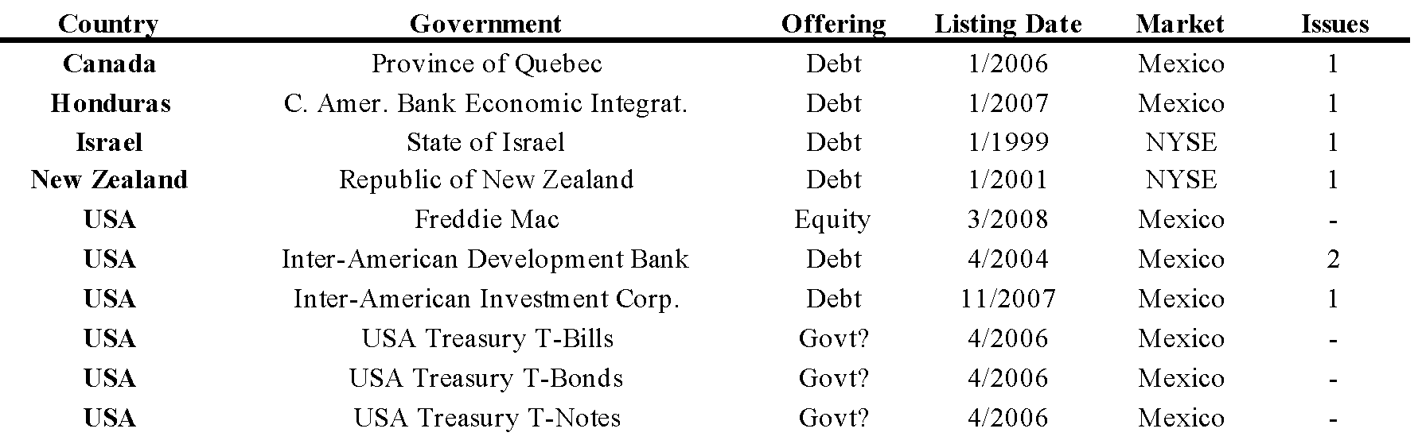

**3. Empirical Analysis**

Two ways to analyse economy integration are with time series analyses looking at trends in the economic indicators and stock market factors between economies, and with cross-sectional analysis of specific foreign involvement in the economies. Due to the relatively small similarities between the American economies and capital markets, analysis of the specific foreign corporate activity in the American markets is arguably more insightful for this region, and for exploring this region's financial integration within the world's three primary regions of Asia-Australia, Europe, and the Americas.

The first primary hypothesis of this study analyses corporate, country, industry, and market specific variables via logistic regression to attempt to quantify the most likely influences on cross-listing decisions for a corporation in the American markets. There has been significant research completed on this topic, though this paper adds to the current literature in seven significant ways: (1) brings together seven of the major American stock exchanges, covering North and South America, in a logit analysis of foreign firms focusing on the USA and Canadian exchanges (2) analyses the listing movements of major USA firms onto other American stock exchanges (3) offers insight on the listing activities of USA firms around the globe (4) examines the Mexican BMV's integration within the Americas and consequently its role in the 2008 credit crisis (5) looks at the changes in the American markets since Sarbanes-Oxley (6-7) and the second section utilises a three-step time series procedure to analyse capital market convergence and monetary union possibilities in the Americas.

Before proceeding, it is important to note that more dates could have been added for the time snapshots, such as a date for NAFTA passage, however, due to scope issues and the greater propensity of corporate activity surrounding SOX passage, inclusion of this time period in this study is not necessary. For the purposes of this paper, the full sample of all delisted and listed cross-listed corporations in the Americas is focused on; however, the most informative information from the other samples has been added herein with the comprehensive full study of all listed and delisted foreign corporations on American exchanges since cross-listing began in earnest in the Americas. As well, each individual country can be analysed as to which American exchanges they prefer, though in this paper the preferences of the primary American countries are focused on, i.e., that of the USA, Canada, Brazil, Bermuda, and Mexico. Further, due to the statistically low amount of listings by the other American counties, empirical analyses focusing on them would not be feasible.

There are two primary hypotheses investigated in this study. The first concerns capital market integration in the Americas, and the second pertains to monetary and currency union assimilation in the Americas. Currently in the Americas, stock market convergence is a more visible analysis, as there has been less currency union steam anywhere in the Americas. The capital markets in the Americas, however, have already begun to merge, and thus there is a wealth of experimentation possible in this area. As such, the first hypothesis, that of the state of finance market integration in the Americas, has several clearly delineated main points.

**3.1 Capital Market Cross-Section (First Primary Hypothesis)**

Empirical analyses are performed on a cross-section of the current and delisted foreign firms of the TSX, TVSX, NYSE, Nasdaq, BOVESPA, BMV, and BSX since 1990. Three sets of logistic regressions are run, and two sets of collected data are presented for trend analysis. The three logistic regressions include hypothesis **(A),** that of the NYSE and the TSX; hypothesis **(B)**, that of USA corporations within the Americas; and hypothesis **(E)**, that of the Sarbanes-Oxley time effect. The two qualitative comparisons include hypothesis **(C)**, that of the USA corporations around the globe; and hypothesis **(D)**, which is the Mexican BMV analysis.

***3.1.1 NYSE or TSX*** *~* ***Hypothesis (A)***

The first hypothesis analysed regarding stock market integration in the Americas assumes that foreign firms will prefer the NYSE over the TSX, which are the two largest stock exchanges of the two largest economies in the Americas. The assumption is also made that foreign corporations will prefer the Nasdaq over the TVSX. The other major countries' stock exchanges in the Americas, the Brazilian BOVESPA, the Mexican BMV, and the Bermudian BSX, are not included in this theory for differing reasons. The BOVESPA has only nine total foreign firms listed since 1995, so it is unlikely that they are a major factor in a foreign firm's cross-listing decision in the Americas. The BMV has many major international corporations, yet they are all listed on the Canadian and USA exchanges as well, and so the BMV thus represents an ancillary listing option to the primary Canadian and USA markets. The BSX is much smaller than the other four major American stock exchanges, and caters to primarily offshore oriented corporations, and therefore, the BSX does not represent a primary option for cross-listing choice of the typical international corporation.

The descriptive statistics show that market value of equity on the USA exchanges is higher than that of companies of comparable size on Canadian exchanges. One explanation is that either the USA markets are overvalued or the Canadian markets are undervalued; however, a more plausible rationale, as suggested by King and Segal (2003), is that Canadian firms may trade at a discount due to weaker corporate governance in Canada relative to the United States. They further suggest that Canadian firms may mitigate this discount by cross listing on a USA stock exchange, as Canadian firms cross listed on a USA exchange achieve a higher valuation than firms listed exclusively in Canada. Additionally, Canadian firms that are predominantly traded in the USA receive similar valuations to other USA listed firms, while cross listed Canadian firms with little USA turnover continue to trade at a discount. The logistic regression also supports this observation, as the MVE variable is dropped from most regressions because it predicts success perfectly for listing onto the USA exchanges. The empirical results also suggest that USA firms listed on the TSX are smaller than the other foreign firms listed on the TSX, confirming that the USA firms listing in Canada are not Fortune 500 corporations, rather they are mainly energy firms with legitimate interests in Canada. The Canadian firms listed on the USA exchanges are also smaller than the other foreign firms listed on those exchanges. Israeli firms prefer the Nasdaq to any other markets, as well as English speaking firms prefer the Canadian exchanges, which may be expected considering the wide global reach the USA exchanges have.[6]

***3.1.2 American Corporations within the Americas ~ Hypothesis (B)***

Secondly, it is assumed that corporations from the USA will prefer the Canadian over the Mexican stock exchange for their cross-listing needs, USA corporations will prefer the Canadian over the Bermudian exchanges, and USA corporations will prefer the Mexican over the Bermudian exchanges. Mexican, Canadian, Brazilian, and Bermudian corporations are not as important for this analysis as there are fewer of their companies in total, and there are fewer of them cross-listed within the Americas. There are a greater amount of and larger USA companies both in the Americas and around the world, and thus the USA corporations have a greater impact on the American economy and the world economy. USA corporations actually prefer the BMV to the TSX, though prefer both the BMV and the TSX to the BSX. There are a few interesting observations and results about the other major American countries as well, though all the other American countries prefer the USA financial markets.

In order to fully appreciate the state of finance market integration in the Americas, however, it is important to understand their listing preferences around the globe as well. It is well known that the USA has a large global presence, though as Table XXIV. shows, the American countries as a group are well represented on the world stage.

***3.1.3 American Corporations Around the World ~ Hypothesis (C)***

The third hypothesis from the stock market integration topic conjectures that the presence of the American firms around the globe will influence their listing needs within the American region, and vice versa. Put another way, hypothesis (B) and hypothesis (C) are mutually dependent. It is important to understand the presence of the domestic firm around the world, as their other listings will commonly influence their next listing, including their debt and equity. As the USA economy is so large and dominant within the Americas, a thorough understanding of their corporate presence around the world will provide a backdrop for understanding listing needs within the Americas region, although it is equally important to understand the global presence of all the American countries. Even though knowing both debt and equity preferences is important, due to the amount of debt listings of USA corporations around the world, extensive analysis of their debt issuances on all the international stock exchanges is outside the scope of this study.

Continuing, the focus is on the USA financial institutions, as they are the infrastructure of the USA and thus the American financial system, and they are also quite represented on the capital markets around the world. Financial institutions can offer greater insight into listing preferences because there is more obscurity to a financial institution's listing rationales. Due to the nature of fiat money, financial institutions enjoy a greater operating margin, and thus often are able to pursue business in many differing markets. As such, Wojcik (2002) notes that the level of foreign ownership in the major European countries is significant, though spread unevenly, with USA financial institutions controlling the majority of foreign stakes. The USA financial institutions are represented on many more international stock exchanges for both debt and equity than are financial institutions from other American countries. Also, the non-financial American companies have a normal distribution of cross-listings around the globe, as is usually the case. Consequently, considering that there are few abnormal listings by non-financial institutions in the Americas, it can be assumed that the global listings of non-financial American corporations do not significantly influence their American region cross-listings. Regarding the USA financial institutions, however, it seems as if many of these corporations are utilising the global markets more than the American markets. It is difficult to say exactly why, though one plausible explanation is that the American markets cater mostly to corporations that have a legitimate presence in their country, such as with the TSX, the BOVESPA, and the BSX. An emerging trend, however, and which is examined in hypothesis (D), is that the BMV is emerging as an international exchange similar to the USA markets and those in Europe, as they are accepting all types of corporations. As such, in recent years there has been a surge in listing activity of USA financial corporations on the BMV.

***3.1.4 Mexico's Integration within the Americas and the Globe ~ Hypothesis (D)***

Hypothesis four regarding stock market unions in the Americas supposes that the Mexican BMV has become an integral part of the American capital markets, and consequently within the world capital markets. This suggests that there will be a clear effect of the BMV's role in any major financial events, including the 2008 credit crisis. For a backdrop of the BMV, much of the foreign equity on the BMV is traded on an American Depository Receipt (ADR) sort of premise, in that for most of the foreign stocks there are no initial public offerings, rather the stock is bought in the USA or other major international exchange in the specified currency (Mexico allows the ten or so major international exchanges to participate in this, such as London, Germany, Tokyo, etc.), and then held in a trust via banks such as Deutsche Bank in Mexico in Mexican pesos. This allows Mexicans to buy the foreign stocks through their own banks in their own currency, yet mitigates direct foreign involvement in the Mexican economy. This amounts to essentially an offering in Mexico, as those shares now trade exclusively in Mexico, although they follow closely in price to the domestic exchange prices, similar to a private placement for the Mexican Stock Exchange. Mexico domiciles many large American companies' equity, including financial institutions, as well as a large amount of debt issuances for corporations, including many USA financial institutions. Mexico also represents the only stock exchange in the Americas that accepts foreign governments' debt financing needs. Thus, it could be said that the Mexican stock exchange is very much integrated into the USA and to a lesser extent the Canadian financial markets, and thus influences the state of the capital markets in the Americas to a significant degree. A more detailed empirical analysis of the BMV debt listings, however, is outside the scope of this study.

***3.1.5 Time Trends, 2002 & 2008 ~ Hypothesis (E)***

The fifth hypothesis regarding the stock market integration in the Americas concerns whether there has been a discernable shift in cross-listing preferences since a specific period of time. A good way to analyse market characteristics is by looking at a cross-sectional point in time. There has been a shift in listing preferences by foreign corporations onto the American markets since 2002, which was the year SOX was passed. Chinese firms have listed more since SOX, though there have fewer listings from corporations of most other countries. Also, foreign corporations have preferred Canadian exchanges to the USA exchanges since SOX, and further that market characteristics were more important in a corporation's cross-listing decision in the Americas before 2002.

A second time study considers the results from a cross-section of the corporations currently listed in 2008, and the entire sample of all the corporations listed and delisted on American exchanges. Interesting to note, all the USA and Canadian samples see a drop in the major corporation specific variables, except for the USA corporations cross-listed on the TSX when the delisted corporations are included. In this case, the cross-listed corporations actually have a significantly higher MVE, assets, and sales in the year of listing, which suggests that several large USA corporations delisted from the TSX in recent years. This trend could be considered similar to the overall occurrences on the Canadian exchanges of the large USA corporations suspending their listings, possibly due to the MJDS.

**3.2 Capital Market and Monetary Time-Series (Second Primary Hypothesis)**

The second hypothesis tested in this treatise considers that of the monetary union congruence in the Americas. To analyse the monetary union integration in the Americas, a unit-root causality test is employed which compares 42 macroeconomic and stock exchange variables from the USA, Canada, Mexico, and Brazil, and Bermuda since 1980 to determine currency union and stock market merger possibilities in the Americas. To test this test research hypothesis, a two-step time series analysis is employed that involves (i) eliminating non-stationary variables via unit root tests (ii) performing forecasts using an ARCH model of the stationary variables from the data set.

**3.2.1 Currency Unions**

It is hypothesised that monetary and currency union assimilation in the Americas is feasible, yet is a relatively long away from happening, due to the economic, cultural, political, and geographical differences within the Americas. Of the three primary macroeconomic indicators, inflation, interest rates, and exchange rates, Mexico and Brazil have shown little or no stability since 1980, whereas Canada and the USA have been rather consistent. Brazil has had extreme bouts of inflation since 1980, even more so than Mexico, who has itself been much more unstable than the very stable economies of the USA and Canada. The reality is that as big as Mexico and Brazil are, they have not really been that economically stable over the last thirty years, thus making them unlikely partners for either the USA or Canada to consider entering into a significant monetary union with. For the Americas region, due to there being only four major economies, and due to the USA being so big and thus they having so many corporations across the globe, a cross-sectional analysis of foreign firms in the region is greatly informative for analysing their integration prospects. Not withstanding the benefits of cross-sectional analysis in this study, time series analyses targeting their primary economic indicators and stock market trends can still yield pertinent information concerning the presence of any unit roots within these areas, thus providing more estimations of current integration levels.

An analysis of the American markets’ stock exchanges and economy specific characteristics is put through time series analysis. Miles (2006) suggests that currency unions have been promoted as a means to increase trade, investment and growth, though as joining a currency union involves the loss of a policy mechanism, high real exchange volatility between countries considering such a policy would suggest that a currency union could be quite costly in terms of large, persistent misalignment and thus balance of payments imbalances. Therefore, intensive analysis of countries' economic characteristics can be informative in ascertaining currency union possibilities.

**3.2.2 Stock Markets**

As far as the American stock markets are concerned, considerable integration has already occurred, all at a regional, national, and international level. The NYSE and Nasdaq are internationally merged stock exchanges, and perhaps there could be a merger in the works within the Americas as well. Wojcik (2002) advises that countries' borders, rather than company size ranges, are the main lines of discrimination between high and low levels of foreign corporate ownership and stock market integration, and that major factors influencing the intensity of cross-border links include the proximity of investors to the destination of capital and corporate governance. Thus, the makeup of the individual stock exchanges may help to explain which markets investors are preferring and why.

The stock market characteristics suggest that the NYSE, TSX, and Nasdaq have the most in common, They have the most stable trends of the stock exchanges, although all the American stock exchanges are more stochastic in nature than the economy-specific data. In terms of foreign corporations, Brazil has much fewer than any of the other American markets, though the NYSE supports more foreign trading and investing than any of the other American markets. The Nasdaq has a much higher turnover than the other markets, the BOVESPA a higher index return, and the NYSE the highest equity cap and bond cap levels. There simply are more differences between the stock exchanges and similarities based on their descriptive statistics, though time analysis of their stochastic elements can still shed light on the underlying processes working which may be similar.

**4. Sampling Distribution**

The sampling distribution details both the variables collected and the data sources used. The variables to be used were determined based on analysis of prior studies and after consideration of the current financial climate. Data sources utilised include both free-access databases and proprietary data obtained via correspondence.

**4.1 Variables**

Variables used include both the logistic cross-sectional, and the unit-root time series. There are 28 cross-sectional variables and 42 time series variables utilised. For the logistic cross-sectional study, there are: seven company specific variables, fourteen country specific variables, three industry specific variables, four market specific variables, and one time specific variable included. For the economy-specific series analysis there are 21 variables, which include: six income and productivity indicators, eight investment, savings, and government purchases variables, six monetary stabilisation policy variables, and one general indicator. The stock market-specific time series analysis utilises 21 variables: seven performance indicators, seven liquidity variables, and seven general identification factors.

**4.1.1 Logistic Cross-Sectional**

The firm specific variables account for size (assets), liquidity (sales), profitability (net income), growth prospects or book-to-market ratio (BTM), market cap or market value of equity (MVE), and efficiency of operations or return on assets (ROA). There is also one firm-level indicator variables included, Big5 auditor used in year of listing, and one time period indicator variable included, the year 2002 and SOX. Firms consistently face decisions when it comes to dealing with their market presence. It is commonly accepted that market conditions and firm characteristics are the strongest factor in influencing firms’ listing decisions (Hansen et al., 2008). Further, Dhaliwal (1983) uncovered a 'size effect' in regards to firms cross-listing behaviour, as very small firms on the exchanges display substantially higher risk-adjusted rates of return than do their larger counterparts, thereby suggesting a higher cost of equity capital. And so, the firm’s total assets, total sales, net income, market value of common equity, and book-to-market ratios in year of listing are used to control for firm specific features. Market value of equity is defined as the corporation’s stock price multiplied by the number of basic common shares outstanding for the year of listing. Book-to-market ratio is calculated as the ratio of total shareholders’ equity to MVE in the year of listing. If shareholders’ equity is negative, BTM is assigned a value of zero. Return on assets is calculated as net income scaled by total assets in the year of listing.

Another issue that will arise when a firm decides to cross-list on a new exchange is that modifications must be made to the firm’s accounting system; managers always have the opportunity to smooth income by selecting among accepted accounting methods or by applying given accounting methods in particular ways. Accordingly, when firms list their stock on foreign stock exchanges with more stringent accounting requirements than their home exchange, they may be forced to make even more modifications to their accounting systems (Sheikholeslami, 1994). For this reason, an indicator variable equal to 1 if the firm employed a Big5 auditor in the year of listing is included. This study looks at listing preferences on the major American finance markets, with most of the data being since 1980. As such, the midpoint date would be arguably be 1995 for a time analysis; however, this study uses 2002 for a time break due to the passage of the Sarbanes-Oxley Act and the perceived greater impact that law has had on listing preferences in the Americas than any other recent regulations, such as NAFTA. Sarbanes-Oxley is included as a variable to account for the effect of the act on companies listing in North America; SOX is also equal to 1 if the firm listed after SOX implementation. If this act is in fact pushing firms to list in markets with cheaper governance costs than those in the USA, then other American markets should see an increase in listing activity after the fact. The effect of this act is still debatable even 5 years after its issuance, as Lang (2008) notes that there are actually fewer of the less profitable firms with weaker governance that are not listing; the bigger, financially stable firms are still listing with the same propensity since SOX.

The country specific variables tested are: English speaking, Africa, UK territory, South or Central America, Asia-Australia, Europe, Caribbean, Israel, China, UK, emerging, common law, tax haven, and difference in trade to test for foreign dependence. The industry specific variables of energy, tech, or non/tech are added to control for preferences in industrial relocation. Studies have investigated the effects of geography and company type on cross-listing preferences; for example, the cross-listings of European companies appear to have sharply different motivations and consequences depending on whether they cross-list in the United States or within Europe (Pagano et al., 1999). Saudagaran (1988) further advises that the two of the primary influences on a corporation's decision to list their stock onto foreign exchanges are the company's main line of business and the nationality of the company. Moreover, the relative size of a corporation within its domestic capital market also influences its decision to list abroad, with corporations in smaller domestic capital markets being more likely to participate in foreign exchanges, with an additional influence being the extent of a company's dependence on foreign consumer and product markets. For these reasons, the indicator variables relating to the different geographic areas and industries are included.

Type of home government can also affect the cross-listing decision of a foreign firm. Georgieva and Lee (2007) agrees, as she writes that countries with common law systems will gravitate to countries with similar cultural and regulatory regimes. For this reason a country-specific indicator variable of home government, equal to 1 for common law is included; indicator variables for tax English speaking and tax haven also flow from this same reasoning. The reason for including emerging country as an indicator is that emerging countries typically experience higher degrees of corruption and have less developed regulatory regimes; as such, firms from these countries should prefer markets with similar regulatory structures. As well, the country specific variable diff_trade is included to control for foreign market dependence, which is calculated by the difference in home and foreign government trade balance in the year of listing scaled by home country GDP. Indicator variables are included for industry type, as studies have shown that in matching companies from Australia, Canada, and the USA by size and industry, the degree of capital market integration varies across industries. Global industry stocks such as oil and mining stocks are priced in a relatively integrated capital market while regional industry stocks such as consumer and capital goods stocks are priced in segmented markets (Faff and Mittoo, 2000).

As market conditions have also been shown to impact a corporation’s listing decision, several explanatory exchange-specific variables are used: the difference in the turnover of domestic shares, the difference in index returns, the difference in share value, and the percentage change in total companies per exchange in year of listing. Domestic as opposed to total values are used for these values to provide a more consistent sample of corporations that typically list on the respective exchanges. Saudagaran (1988) similarly notes that index price, share volatility, and share volume have shown to be three of the best exchange-level indicators for cross-listing preference. Velocity, turnover, or liquidity is the ratio between the turnover of domestic shares and their market capitalisation for the year. Index return is measured as the percentage of the exchange’s index return for the year. Value of share trading refers to the total number of shares traded multiplied by their respective matching prices for the year of listing, and the percentage change of companies is measured as the change in total companies listed on the exchange for the 12 calendar months preceding the listing event.

**4.1.2 Two-Step Time Series**

As the primary focus of the paper is to add to the cross-listing literature by focusing on the stock-market attributes of foreign corporations in the Americas at their listing dates, there is less attention devoted to the time series variables used for the unit root and ARCH tests. They are, however, the traditional variables used for such analyses, and thus this type of analysis provides additional explanation of integration attitudes in the Americas. Both the economy-specific and stock market-specific tests employ 21 variables for a total of 42. As income, monetary stabilisation policy, and stock market indicators can commonly indicate signs of congruence among regions and nations, these types of indicators are included in the time series tests (Aggarwal and Kyaw, 2004).

In the economy analysis, 21 variables are examined. There are six income and productivity indicators: gross domestic product (GDP) in USA dollars, % change in GDP, gross national income (GNI), output gap, GDP in terms of purchasing power parity (GDP-PPP), and GDP-PPP as a % of the world GDP. Investment, savings, and government purchases are represented with eight indicators: investment, foreign direct investment, foreign direct investment % of GDP, gross savings, gross external debt, gross government debt % of GDP, current account balance (CAB), and CAB % of GDP. There are six indicators commonly used for monetary stabilisation policy analysis: short-term interest rates, long-term interest rates, exchange rates, inflation rate, unemployment rate, and poverty rate. The overall population level is also included as a general variable. Output gap is calculated as the difference between potential GDP and actual GDP, with potential GDP being calculated from a detailed calculation entailing an estimated production function and the adding of an estimated total factor productivity to the amount contributed by the potential capital and labour. Since the USA is included in this analysis, the exchange rate is based on third party, that of the Swiss Franc. As poverty rate calculations can differ by country, it is calculated as the percentage of the people living under the poverty line for that country, as per the IMF website.

For the stock market study, 21 variables are used. These include seven performance indicators: index levels, equity market cap, bond market cap, PE ratio, gross dividend yield, total performance, index performance. Seven liquidity variables are regressed: value of share trading, value of bond trading, equity turnover, value of domestic equity trading, value of foreign equity trading, value of domestic bond trading, and value of foreign bond trading. Seven general identification factors are utilised, number of companies, stock market's importance in the national economy, gross capital formation, domestic equity capital raised, foreign equity capital raised, domestic bond capital raised, foreign bond capital raised. PE ratio is calculated by dividing the market capitalisation by the total market earnings of the stocks included in the main index of the stock exchange. Gross dividend yield is determined by dividing the total dividends distributed by the domestic companies composing the main index by their market capitalisation. Total performance is calculated by adding the annual stock price index performance and the gross dividend yield paid during a given year. Index performance is calculated as the percentage change in index level from the previous year. Turnover is calculated as value of share trading divided by equity market cap. Stock market's importance in the national economy is calculated as equity market cap divided by GDP. Capital raised is the exchange’s investment flows-capital raised divided by the national gross fixed capital formation (GFCF). Gross fixed capital formation is obtained from the IMF website, and is measured as the total value of a country's acquisitions less disposals of fixed assets for a given year.

**4.2 Data Sources**

Multiple data sources are used for both the cross-sectional and the time series collections. The cross-sectional data collection took substantially more time to complete, as many of the variables had to be cross-referenced and hand-collected from old listing prospectuses and annual financial information forms. The time series data collection was more straight-forward.

**4.2.1 Logistic Cross-Sectional**

A total of 28 variables are applied in hypothesis one, sections: **(A)**, **(B)**, and **(E)**. Seventeen are indicator variables and 11 are numerical values. Of the 11 numerical values, four are exchange-specific variables, and six are firm-specific variables, with three being logs of the numerical values for better standardisation. Thirteen indicator variables are used for geographic region or country, and two indicator variables are included for industry. Two more indicator variables are included for company specific characteristics, and diff_trade is the one country-specific quantitative variable. All variables are measured in terms of USA dollars.

As shown in Table XXV., a total of 694 (NYSE) + 632 (Nasdaq) + 189 (TSX) + 106 (TVSX) + 310 (BMV) + 10 (BOVESPA) + 58 (BSX) corporations from each exchange for a sample total of 1,994 foreign firms listed on American exchanges. Due to incomplete information: 25 firms are dropped from the NYSE, 28 from the Nasdaq, 1 from the TSX and 3 from the TVSX, 6 firms are eliminated from the BMV sample, and 22 from the BSX. This drops the total sample to 1,909 foreign firms listed on American exchanges for statistical regression analysis purposes. For the Bermudian, Brazilian and Mexican exchanges small amount of foreign firms which have delisted from these exchanges since 1996, with 23 from Bermuda, 1 from Brazil, and 57 from Mexico. Of the 23 plus delisted BSX group firms 22 are obtained, of the 108 delisted TSX Group firms 102 delisted firms are obtained, of the 163 plus delisted Nasdaq firms 314 are obtained, and of the 331 delisted NYSE firms 172 are obtained. Table XXI. shows these delistings and listings of foreign corporations by year onto the American exchanges. As such, based on the data obtained from the individual exchanges and other sources on delistings of foreign corporations in the Americas, and the subsequent sample that was able to be obtained, the author is confident that the sample collected provides a thorough and comprehensive population from which to analyse the cross-listings of foreign corporations onto American exchanges since their inception. The sample size with current listings only totals 1131, though when the delistings are added the sample size grows to 1994.

The first items to be collected were the listings of the current foreign firms from the respective exchanges. The NYSE and NASDAQ provide this data directly on their websites. TSX responded to email inquiries and provided listings, and BMV, BOVESPA, and BSX provided the information on their websites as well. Second, the delisted firms were collected. For the USA exchanges, a Google search was used, as well as the SEC website. The BSX provides that data on their website, and the TSX provided a proprietary listing. Brazil has not had much turnover through the years, so no delisted firms are obtained for Brazil, even though if they were needed it is questionable whether they would have been able to be located. No delisted Mexican firms were able to be located after an exhaustive search online and multiple requests to the Mexican stock exchange, providing the only missing link in the study. ADR data from the Bank of New York and Citibank provided supplementary data for CUSIP, year of listing, and industry data for cross-checking purposes. After the lists of foreign companies were collected for each exchange, firm specific data was needed. The Compustat database was used to extract data on total assets, net income, sales, BTM, and MVE in the year of listing. For companies not available, such as many TSX, BMV, BOVESPA, and BSX firms, the SEDAR database, company websites, and Yahoo Finance provided the necessary data. Next all the corporations’ annual reports were searched through to identify which firms had employed a big 5 auditor in the year of listing. Some of this data had already been retrieved in an earlier step with SEDAR, though the remaining is collected via EDGAR, SEDAR again, and company websites. The logs of MVE, Assets, and Sales are used for better standardisation in the logistic model. If sales are zero or btm, then logsales is assigned a value of 0, and if shareholder's equity is negative, then BTM is assigned a value of 0.

Indicator variables were then assigned. Companies are assigned indicator variables equal to 1 if they are from an emerging country, as reported by the World Bank. Tax haven is an indicator variable included to control for how authoritative and strict the home tax regime is; firms will gravitate towards similar exchanges, with the USA being the most strict as a result of legislation such as SOX. Asia/Australia, Europe, Caribbean, South/Central America, Israel, China, UK, UK Territory, and Africa are indicator variables equal to one if the firm is domiciled in a country that belongs to the respective region at the time of the listing. A common law home government, English speaking country, and having a Big5 auditor in year of listing also result in a one for the indicator variable. Industry indicators are included for energy, tech, and non/tech[7]. The final country specific variable needed was diff_trade, which is defined as the difference between home and foreign government trade balance in the year of listing scaled by home country GDP.[8] The trade balances are obtained from the International Monetary Fund (IMF) website, with GDP data obtained from there as well. Similar to the exchange-specific indicators, the Canadian values are then subtracted from the USA values to arrive at the final value for difference in trade.[9] These could be different for each exchange, though there are infinite possibilities what vales can be assigned; as such, and due tot he time required to locate all the data, one set was finalised on with the USA acting as the primary, Canada acting as the primary when the USA was not part of the calculation, and England being used as a proxy in the Canadian and USA corporations cross-listed onto each other exchanges. Perhaps Mexico or Brazil could have been used here, however, the use of England offers a new distinguishing aspect to the study, and also represents a legitimate choice of cross-listing market, as London is one of the most desired foreign stock exchanges around the world.

The exchange specific variables presented the greatest challenge in collection. The preference would be to use the value in the month of listing, however, it is difficult to obtain month of listing values for some of the less transparent exchanges and more obscure variables for all years and months. For this reason, year of listing is used for all variables in order to standardise the data sets and tests. All exchange specific factors are calculated using the USA exchange data as the primary, where applicable, as with the diff_trade variable. For example, when calculating TSX’s index return differential, TSX data is subtracted from NYSE data. This creates diff_liquidity, diff_index return, diff_share differential, and diff_percentage of company turnover. Exchange specific variables were retrieved from the World Federation of Exchanges website, DataStream, and through direct correspondence with the individual exchanges. Additionally, the London Stock Exchange’s main index FTSE is used for the calculation of exchange level variables of Canadian firms on USA exchanges and USA firms on Canadian exchanges, in order to provide the next most realistic option for exchange level and difference in trade variable comparisons.

To analyse the activity of USA firms in the Americas and around the world in hypothesis **(C),** the international stock exchanges are examined. This involves separating the foreign firms from the domestic firms for the 52 international stock exchanges that report to the World Federation of Exchanges, and examining the presence and type of USA and American corporations on each. For hypothesis **(D),** that of the Mexican BMV's integration status, the BMV website was consulted to determine the foreign corporations listed in Mexico for both debt and equity. From there, the debt listings were analysed, and as many of the debt listings in Mexico are from financial institutions, the decision was made to gather the information of the foreign financial institutions listed in Mexico, for both debt and equity, and to then analyse their listing characteristics in regard to integration and contagion events recently and currently occurring both in the Americas and around the globe to provide perspective on the activity on the BMV.

**4.2.2 Two-Step Times Series**

A total of 42 variables are applied in hypothesis two, and all are numerical values. For the economy study there are six income and productivity indicators; eight investment, savings, and government purchases variables; six monetary stabilisation policy variables; and one general indicator. For the stock market study there are seven performance indicators, seven liquidity variables, and seven general identification factors. The majority of the variables for the economy time series analysis were obtained from the International Monetary Fund website. There were a few variables that were incomplete, such as: output gap, savings rates, investment rates, foreign direct investment rates, interest rates, poverty rates, unemployment rates, and exchange rates. Output gap had to be calculated for Mexico and Brazil. This was accomplished by using a methodology supplied by the International Monetary Fund that they used themselves to calculate the variables.[10] Savings, investment, and foreign direct investment data was partially supplied by the IMF, and was supplemented by the *Earthtrends* searchable database. Short and long term interest rates for all four countries were obtained from their central bank websites. Poverty and unemployment rates for Brazil and Mexico were obtained from their central banks as well and were confirmed with a Google search based on historical trends. The exchange rates are based on conversion to the Swiss Franc and were obtained from a Google search; even though the US dollar is the most widely used exchange rate indicator, since the USA is part of this study it made sense to use a neutral country for the exchange rate comparisons. For the stock market data, the World Federation of Exchanges provided all of the information. Their website provides a wide array of stock market indicators for the major international stock exchanges, and this process was quite simple and straightforward.

**4.3 Limitations**

Several limitations presented themselves that made the data collection process more difficult. The primary issue was that delistings were not able to obtained for the Mexican exchange, though they were obtained for all other American exchanges going back to the mid 1990s. As much of the exchange information was obtained from the World Federation of Exchanges database, any data limitations from that database could be debilitating; as such, exchange info only goes back to 1996 on the World Federation of Exchanges database and is why two samples are used~~one for post 1995 and one with the full sample minus two the exchange variables of diff_sharevalue and diff_percentage of company turnover. In terms of classical assumptions fulfilment, several issues did present themselves. Of the three primary assumption issues; heteroscedasticty, autocorrelation, and model specification, the latter, model specification is the most pressing issue. Due to the large amount of variables used, it is difficult to say if all variables are truly needed in the final regression, or if all necessary explanatory variables have been culled from the error term. Another issue may be the standardisation of all variables. The size and scale variables were standardised using their logs, and the index variables were calculated using the same primary variables with the USA info serving as the model. The use of many dummy variables makes model creation more difficult as well, as dummy variable transformation can get rather mathematically involved.[11] One can conclude, however, that this sample reasonably represents the actual population of foreign corporations listing on American exchanges, as there are very few companies left out. Although this is not a representative sample of all firms listing on all American markets from market inception, it does provide a fair sample for use in today’s economy.

**5. Logistic Empirical Model**

The principle aims of the logistic regressions of the first hypothesis are to determine: **(A)** whether firms prefer listing on the NYSE as compared to the TSX **(B)** which market USA firms prefer for cross-listing within the American region **(E)** what changes in listing preferences have occurred since SOX. In order to test this research hypothesis, a probabilistic multi-factor random effects maximum likelihood logistic (logit) regression model is employed to run several different regressions: **(A)** NYSE (0) v. TSX(1); NYSE(0) v. Canada(1); Nasdaq(0) v. TVSX(1); Nasdaq(0) v. Canada(1); USA(0) v. Canada(1); **(B)** USACanada (1) v. USAMexico (0); USACanada (1) v. USABermuda (0); CanadaUSA (0) v. CanadaMexico; BrazilUSA (0) v. BrazilMexico (1); BermudaUSA (0) v. BermudaOther (1)

USATSX (0) v. USATVSX(1); CanadaNYSE (0) v. CanadaNasdaq (1); **(E)** SOXNYSE (0) v. SOXNasdaq (1); SOXUSA (0) v. SOXOther (1); SOXUSA (0) v. SOXCanada (1); SOXUSA (0) v. SOXMexico (1); SOXCanada (0) v. SOXMexico (1). Hypotheses **(C)** and **(D)**, that of American corporations around the world and the BMV's role in the American markets respectively, are also explored briefly in this section.

Cross-sectional confirmation can often yield more relevant results than can a time series estimation, though the more precise cross-sectional sample can be tested in ways that can yield time series results as well. There are two specific cross-sections culled from this data in order to offer a time perspective on the cross-section of primary data. One is the state of the listed corporations on the American stock exchanges in 2008, and the other is a full sample of all listed and delisted corporations in the Americas. Additional samples could have been separated, though in the spirit of conciseness and relevance these two primary samples are tested. These two primary samples are dual tested for the five NYSE-TSX studies, and are also compared for the two primary SOX analyses. The other three SOX analyses and the nine country specific studies use only the full sample of all listed and delisted corporations. In all equations and charts, the control variable (0) is represented by the first word and the test variable (1) is represented by the second word, In a logistic regression, negative coefficients suggest an inclination towards the control variable (0), and positive coefficients suggest an inclination towards the test variable (1).

Prob (NYSE =0) (1)

= α + β1*logMVE* + β2*logAst* + β3*logSales* + β4*ROA* + β5*NI*+ β6*BTM* + β7*Big5* + β8*SOX* + β9*English* + β10*Energy* + β11*Tech* + β12*Africa* + β13*UKTerr* + β14*South/CentralAmerica* + β15*Asia/Australia* + β16*Europe* + β17*Caribbean* + β18*Israel* + β19*China +* β20*UK* + β21*Emerging* + β22*Diff_Trade* + β23*CommonLaw* + β24*TaxHaven* + β25*Diff_Liquidity* + β26*Diff_IndexReturn* + β27*Diff_NCompanies* + β28*Diff_ShareValue* + ε

**5.1 NYSE (0) v. TSX (1)**

This sample includes foreign companies listed on the NYSE, TSX, Nasdaq, and TVSX that are from Europe, Asia-Australia, Africa, South America, Central America, Mexico and the Caribbean (no USA or Canadian corporations are included). Mexico, Brazil, and Bermuda are not included in this primary analysis for three reasons: (1) most of the firms on the BMV are USA firms, and the others are all major international companies listed in the USA as well (2) Brazil has less than ten foreign firms total all have specific interests in the Brazilian economy (3) the number of firms in Bermuda are few and particular to the services of the BSX, i.e., financial services and holding companies. Therefore none of these three exchanges is as relevant as the NYSE, Nasdaq, or the TSX for mass-scale foreign cross-listing purposes in the Americas. Canadian firms cross-listed on the USA exchanges and USA firms cross-listed on the Canadian exchanges are also not included because those firms are not deciding between Canada or the USA, they are just taking advantage of a geographical and political opportunity, though they are analysed in section 5.2 in the context of individual American countries' corporate listing preferences in the American region.

**5.1.1 NYSE and TSX**

The initial model regresses the foreign listings of the NYSE against those of the TSX both pre and post 1995.[12] In the Current Listings sample, energy firms prefer the TSX over the NYSE, as well as firms have preferred the TSX over the NYSE since SOX. Firms with a high market value of equity and a Big5 auditor in the year of listing prefer the NYSE to TSX, while firms from English speaking countries, Europe, and from UK territories, energy firms and technology firms prefer the TSX. In the Delistings and Listings sample a high ROA suggests a preference for the NYSE, listing after SOX is more common on the TSX, energy firms prefer the TSX, firms from emerging countries prefer the NYSE, and liquidity seems to be more important on the NYSE. For all samples, a high MVE predicts success perfectly for listing on the NYSE, while Israel is dropped because Israeli firms are only listed on USA exchanges.

**Table II. Prob(NYSE=0; TSX=1)**

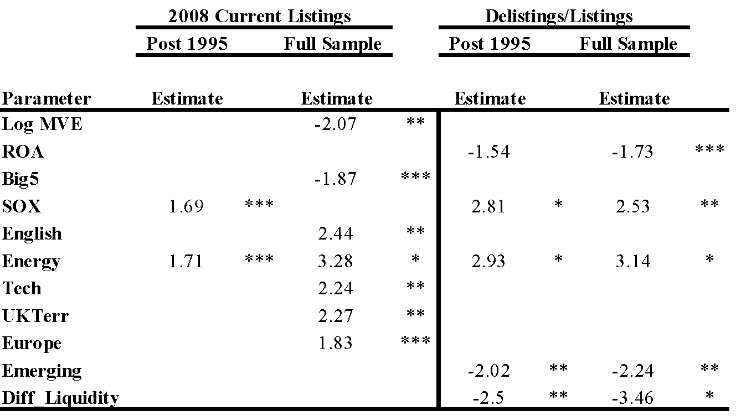

*The 2008 Current Listings sample includes 300 firms in the post-1995 sample (92% concordant with a chi-square of 259.08), and 372 firms in the full sample (87% concordant with a chi-square of 269.85). The Delistings/Listings sample includes 546 firms in the post-1995 sample (95% concordant with a chi-square of 444.73), and 618 firms in the full sample (93% concordant with a chi-square of 457.84).*

**5.1.2 NYSE and Canada**

Duly noted, more variables are significant when the entire sample of Canadian firms is used. In the Current Listings post 1995 sample, firms employing a Big5 auditor in the year if listing and firms from countries identified as tax havens prefer the NYSE, while firms from English speaking countries and Europe, from UK and USA territories, and energy firms prefer Canadian exchanges. Post SOX firms have preferred Canadian exchanges to the NYSE. For the full sample, a high MVE again supports a NYSE listing, as does employing a Big5 auditor in the year of listing. Firms from English speaking countries and UK territories, European firms, and energy and technology firms again prefer Canadian exchanges to the NYSE. A major difference in the full sample is that difference in trading velocity, or liquidity, in the month of listing suggests that this factor is more relevant to Canadian exchanges over the NYSE. For the Delistings and Listings sample, high sales and ROA identifies firms preferring the NYSE, and companies from Africa, South and Central America, Asia, Australia, and Europe prefer the NYSE. Energy firms and those listing since SOX prefer Canadian exchanges, and liquidity and share value may be more important on the NYSE, while number of companies may be a factor influencing listings on Canadian exchanges. For all samples, MVE predicts success, while Israel is also again dropped from both sample because Israeli firms are only listed on USA exchanges.

**Table III. Prob(NYSE=0; Canada=1)**

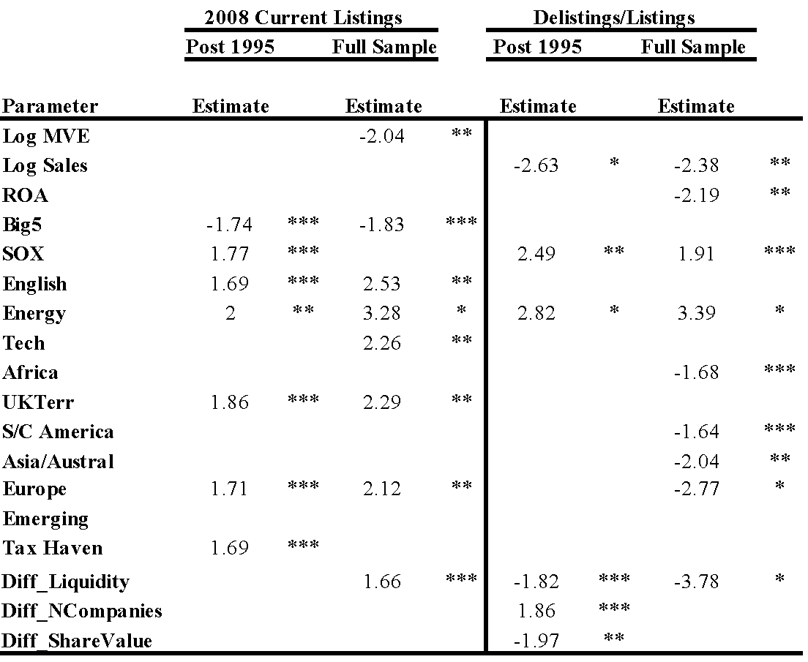

*The 2008 Current Listings sample includes 320 firms in the post-1995 sample (93% concordant with a chi-square of 320.3), and 392 firms in the full sample (89% concordant with a chi-square of 339.74). The Delistings/Listings sample includes 586 firms in the post-1995 sample (93% concordant with a chi-square of 559.89), and 658 firms in the full sample (91% concordant with a chi-square of 577.01).*

**5.1.3 Nasdaq and Canada**

In all tests, MVE is again dropped as is Israel, as they both predict complete success for listing on the Nasdaq over Canadian exchanges. In the Current Listings sample, greater amount of assets in the year of listing predicts the firm listing on the Nasdaq over the Canadian exchanges. Energy firms prefer the Canadian exchanges over Nasdaq, as do firms from South and Central America, Asia and Australia, and firms from countries with common law governments. Post SOX firms have preferred Canadian exchanges over Nasdaq. Here a major difference from the NYSE-Canada regression is difference in trading velocity, or liquidity, in the month of listing, is now correlated with Nasdaq over the Canadian exchanges, contrasted to this variable being correlated with the Canadian exchanges over the NYSE. A possible explanation is that the NYSE has the lowest average share turnover of the all the exchanges, while Nasdaq has the highest. Nasdaq and the TVSX were also regressed though there were no significant observations. The absence of many significant observations for the Nasdaq and Canada regressions suggests that the Nasdaq is not as integrated with the TSX as is the NYSE.

**Table IV. Prob(Nasdaq =1; Canada=0)**

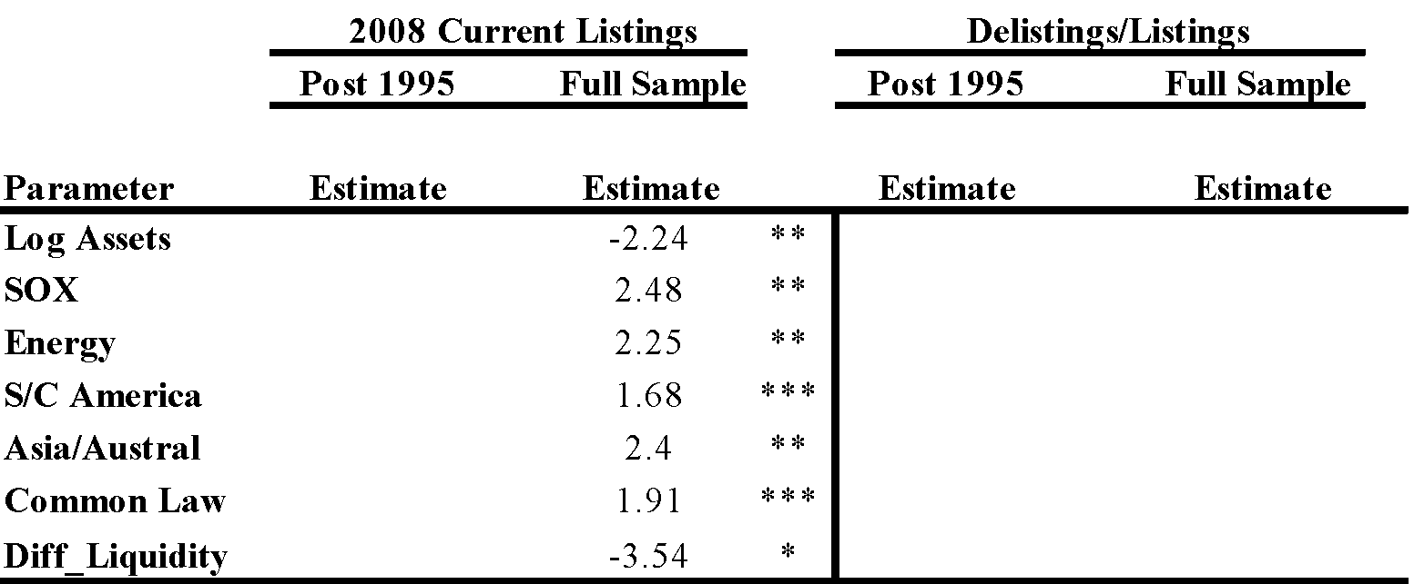

*The 2008 Current Listings sample includes 229 firms in the post-1995 sample (no significant results), and 257 firms in the full sample (85% concordant with a chi-square of 219.54). The Delistings/Listings sample includes 550 firms in the post-1995 sample (no significant results), and 581 firms in the full sample (no significant results).*

**5.1.4 USA and Canada**

For the Current Listings sample, one difference noted in the USA v. Canada regression is that market value equity is now correlated with Canadian exchanges opposed to USA, a change from the NYSE regressions; though the rest of the variables agree. This result produces more questions, as the summary statistics show that market value of equity is definitely higher in the USA exchanges. Firms with large amounts of assets and sales, employment of Big5 auditors in the year of listing, and those from the Caribbean, the UK, and tax havens prefer USA exchanges. Firms from USA and UK territories, energy firms, those from English speaking and common law countries, and those from South and Central America and emerging countries prefer Canadian exchanges. Post SOX firms have preferred Canadian exchanges to USA exchanges. In the Delistings and Listings sample, similar variables are significant, though market liquidity is suggested to be influential in USA listings.

**Table V. Prob(USA =0; Canada=1)**

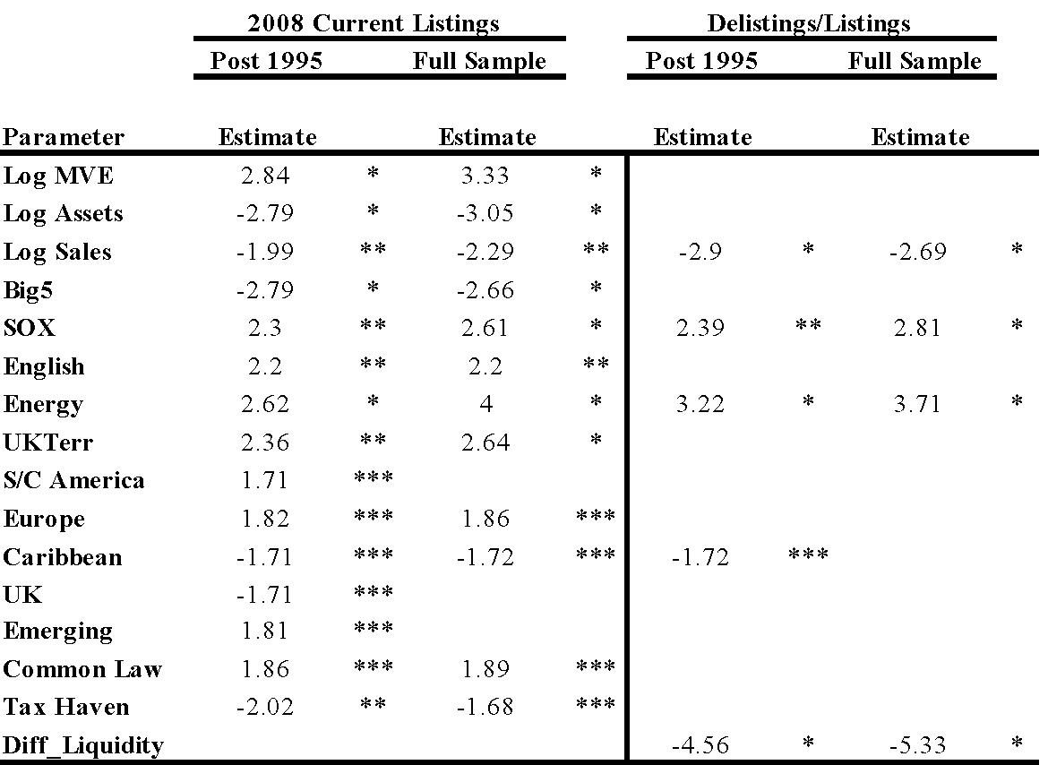

*The 2008 Current Listings sample includes 475 firms in the post-1995 sample (91% concordant with a chi-square of 354.66), and 574 firms in the full sample (85% concordant with a chi-square of 361.74). The Delistings/Listings sample includes 1012 firms in the post-1995 sample (92% concordant with a chi-square of 671.69), and 1114 firms in the full sample (90% concordant with a chi-square of 683.43).*

**5.2 American Corporations Cross-Listed in the Americas**

USA firms have listings all over the world, though they primarily list in Mexico and Canada. USA firms are also well-represented overseas in locations such as London and Tokyo; all of the major USA firms have cross-listings in either Canada, Mexico, or Bermuda, however, and as such analysis of these three markets within the Americas should provide insight into the listing preferences of USA corporations. As it is, there are many more USA corporations listed in other world regions than the other countries in the Americas, including Canada, Mexico, and Brazil. Canada and Mexico, their two direct neighbours, see the majority of USA corporate listings worldwide. The purpose of this test is to determine which American markets USA firms prefer to cross-list in, and if there are any discernible trends about USA corporate cross-listing behaviour that can be deduced both in the world at large, and specifically within the Americas region. The statistical test focuses on Canada and Mexico, the two largest markets of USA cross-listed firms, yet observations are also made based on USA corporate listings in Bermuda. In terms of the listing activities of the other major American countries, Canada, Brazil, and Bermuda have statistically observable trends within the American region as well, though Mexico only has listings on the USA exchanges within the Americas.

There are no USA firms in Brazil, and the ones in Bermuda are of a different type than those in Canada and Mexico. Bermuda simply occupies a distinct niche in the region, and in the world for that matter, serving primarily as a zone of incorporation for companies doing business all over the globe. Therefore, within the Americas region, Canada and Mexico represent the two countries that USA companies typically look to for cross-listings, although there are several USA firms in Bermuda. Canada serves USA companies that have business interests in Canada, especially mining and energy firms, and has 0 fortune 500 USA firms listed on the TSX. Mexico, contrastingly, has the typical array of USA fortune 500 firms, and even USA government agencies, more typical of the USA firm distributions seen on the major exchanges of Tokyo and London, while Bermuda has a few financial services firms from the USA. Country specific variables are dropped from this regression.

Prob (USACanada =0) (2)

= α + β1*logMVE* + β2*logAst* + β3*Sales* + β4*ROA* + β5*BTM* + β6*Big5* + β7*SOX* + β9*Energy* + β10*Tech* + β19Diff_Trade + β22Diff_Trade + β26Diff_Liquidity + β27Diff_IndexReturn + β28Diff_NCompanies + β29Diff_ShareValue + ε

**5.2.1 USA Canada v. USA Mexico v. USA Bermuda**

Although Canada and Mexico are both primary trading partners of the USA, one may reasonably expect for Canada to cater more to USA corporate interests because of their more established regulatory systems and financial markets and cultural similarities including a common language. A logistic regression is run on the assumption that USA firms would prefer Canada (0) to Mexico (1), Canada (0) to Bermuda (1), and Bermuda (0) to Mexico (1). SOX predicts failure perfectly for all three regressions, and diff_trade predicts failure perfectly for the two Canada regressions. This means that Bermuda has seen more activity since SOX than Canada by USA corporations, Mexico has seen more activity by USA corporations since SOX than either Bermuda or Canada, and that the USA's trade balance with Mexico and Bermuda may be directly increasing USA corporate activity in those countries. USA corporations with higher sales prefer Mexico over Canada and Bermuda, those with a higher ROA prefer Bermuda to Mexico, and those utilising a Big5 auditor in the year of listing prefer the BMV to the BSX. USA energy corporations prefer the TSX to the BSX, and technology companies prefer the BMV to the BSX. In terms of exchange characteristics, the liquidity of the BSX may attract USA listings to Bermuda, and the value of share trading on the BMV and TSX may attract USA corporations to Mexico and Canada.

**Table VI. USA Canada v. USA Mexico v. USA Bermuda**

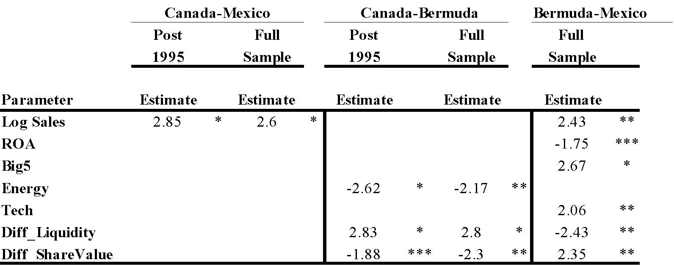

*The Canada-Mexico sample includes 339 firms in the post-1995 sample (77% concordant with a chi-square of 380.3), and 343 firms in the full sample (80% concordant with a chi-square of 380.6). The Canada-Bermuda sample includes 179 firms in the post-1995 sample (38% concordant with a chi-square of 37.84), and 183 firms in the full sample (68% concordant with a chi-square of 68.62). As all firms in the Bermuda-Mexico sample have listed since 1995, the full sample includes 194 firms (55% concordant with a chi-square of 62.8).*

**5.2.2 Bermudian, Brazilian, Canadian, and Mexican Companies in the Americas**

There are two regressions run on the Bermudian companies, one each for Brazil and Canada, and none for Mexico. Within the Americas, Bermuda has foreign corporations on exchanges in the USA, Canada, and Brazil, Canada has foreign corporations in Mexico and the USA, Brazil has foreign corporations in the Mexico and the USA, and Mexico only has foreign corporations in the USA. Bermudian corporations have preferred non-USA exchanges since SOX, while there were no significant observations found from the Bermudian corporations on the Brazilian v. Canadian exchanges analysis. Canadian companies with a high MVE prefer Mexico over the USA, while Canadian corporations employing a big5 auditor in the year of listing prefer the USA over Mexico. Brazilian corporations high in sales and net income prefer Mexican exchanges to USA exchanges.

**Table VII. Bermudian, Brazilian, Canadian, and Mexican Companies in the Americas**

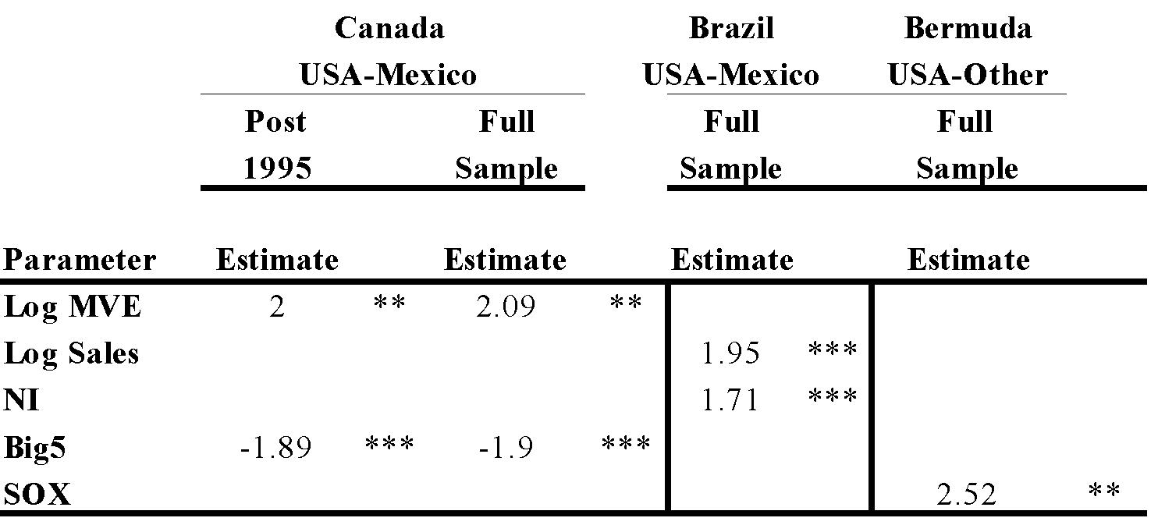

*The Canada-USA/Mexico sample includes 272 firms in the post-1995 sample (63% concordant with a chi-square of 40.04), and 288 firms in the full sample (67% concordant with a chi-square of 42.42). As all firms in the Brazil-USA/Mexico sample have listed since 1995, the full sample includes 83 firms (42% concordant with a chi-square of 16.8). As all firms in the Bermuda-USA/Other sample have listed since 1995, the full sample includes 51 firms (49% concordant with a chi-square of 23.27).*

**5.2.3 USA-TSX/TVSX and Canada-NYSE/Nasdaq**Two regressions are run to test whether Canadian corporations prefer the NYSE (0) over the Nasdaq (1), and whether USA corporations prefer the TSX (0) over the TVSX (1). USA corporations with a high MVE prefer the TSX over the TVSX, while a higher liquidity and number of companies in the year of listing may draw USA companies to the TVSX. When the Nasdaq has a high amount of share trading, Canadian companies may look to the Nasdaq over the NYSE. Canadian companies that have large amounts of assets and sales prefer the NYSE, while those with high net income prefer the Nasdaq. The NYSE has been more attractive to Canadian corporations since SOX, and companies with big5 auditors prefer the NYSE to the Nasdaq. Energy corporations from Canada prefer the NYSE, while technology corporations from Canada prefer the Nasdaq. A high trade differential in the year of listing suggests that USA corporations may choose the TVSX, while Canadian corporations may choose the NYSE for their cross-listing needs.

**Table VIII. USA-TSX and Canada-NYSE**

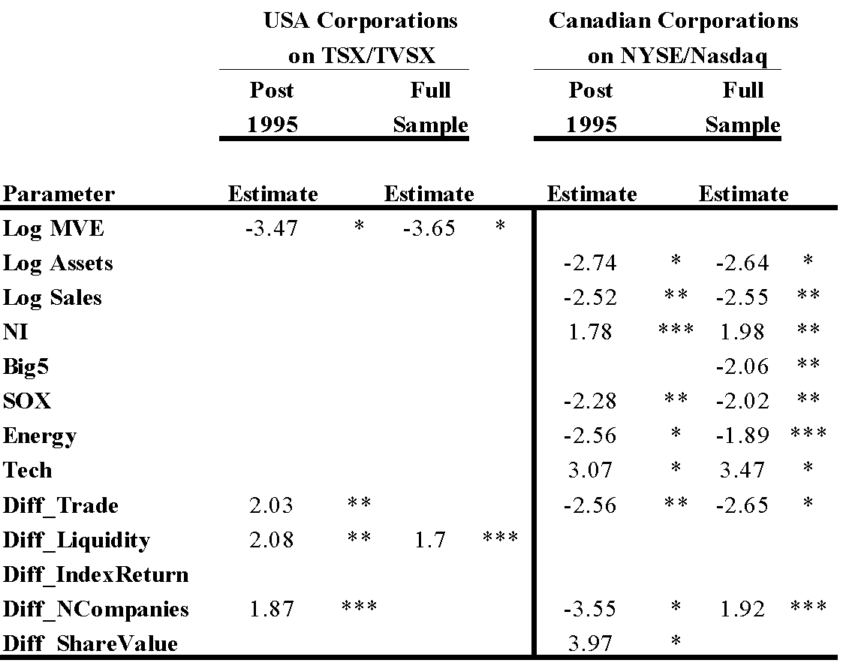

*The USA-TSX/TVSX sample includes 162 firms in the post-1995 sample (60% concordant with a chi-square of 129.3), and 166 firms in the full sample (57% concordant with a chi-square of 126.35). The Canada-NYSE/Nasdaq sample includes 261 firms in the post-1995 sample (66% concordant with a chi-square of 238.78), and 277 firms in the full sample (67% concordant with a chi-square of 255.09).*

**5.3 American Corporations Around the Globe**

Again, this analysis is mutually dependent on hypothesis **(B).** Additionally, the USA corporations are targeted because of the USA's dominance, and their financial corporations are focused on because of their conspicuousness, and due to scope limitations, the USA financial corporations on the BMV are the primary analysis. For a current sample snapshot of USA corporate foreign presence: (1) there are five USA firms listed on the Tokyo Stock Exchange, and all are major USA banks; (2) there are no major USA firms in Canada or Brazil, and everyone of the big USA firms is listed on the Mexican exchange; (3) the London stock exchange sees a rather normal distribution of USA firms; (4) there are also a few normal distributions across the rest of Europe. The USA generally stays within the Americas, as the majority of their listings are in Mexico, Canada, Bermuda, with of course a few using the Cayman Islands for processing needs. London has as wide a distribution as does New York of all countries' firms, and so it should also be expected for many USA firms to be registered in London. That said, nowhere else besides London and Mexico does the USA really have a substantial wide-ranging corporate presence on the stock markets. What this means is that even though Canada and Bermuda have a generous amount of USA listings as well, the listings they cater to are more specific to the economies of Canada and Bermuda, while London and Mexico have many different types of companies. Even from Australia to Germany and in other countries, the few USA firms listed have legitimate business in the country.[13] Japan is perhaps the most interesting, as the only USA corporations listed in Japan are all major USA banks. Of course listing onto the stock exchange is not the only way to engage in business in a country, though stock market presence is one observation that can be made.

**5.4. Mexican BMV's Role in the 2008 Credit Crisis**

As such, and the reason why Tables XXII. and XXIII. are included to clarify the proceeding observation, is that many USA and European financial institutions have recently issued significant amounts of debt in Mexico, while only two total non-financial institutions have done so. The Mexican stock exchange works like a private placement for foreign companies, whereby Mexican citizens can buy foreign stocks through their own exchange, with the Mexican stock exchange mainly just acting as a middle man. This allows foreign corporations to secure less-transparent private placements to the Mexican people, and the Mexican exchange to gain visibility and influence in the global financial markets. The problem with financial institutions pursuing many listings, is that they have no legitimate business in any area sans the domestic market whose citizens they cater to. It really is a quite primitive business model, as how could one realistically expect to stay in business if they have no concrete business base. Financial institutions have no concrete business base, because what they deal in is an imaginary, intrinsically worthless mechanism, fiat currency. Sooner or later, if financial institutions are allowed to pursue business in different markets based on new models they develop, there will likely be disasters in a computerised fiat monetary economy.

Equally interesting is that these debt issuances came around the same time as some of these financial institutions were failing, and thus this suggests that the Mexican stock exchange has become much more integrated with the USA, Canada, and thus the world since the 2008 credit crisis as a result of the USA and European financial institutions which raised significant amounts of debt in the Mexican financial markets from 2006-2009. Further, the listing of the USA Treasury (2006) into some sort of arrangement with the Mexican stock exchange, as well as the continued push by USA governmental agencies such as Freddie Mac (2008) onto stock exchanges such as the BMV, must be acknowledged in regard to the fiscal policies pursued by the USA government, as well as their financial institutions, which possibly led to the undermining of the USA financial system during the 2006-2009 time period. The Province of Quebec from Canada is also listed on the BMV for municipal project debt needs. Mexico has occupied both the role of the market for other governments' listing needs in the Americas, as well as has become the defacto exchange in the Americas that large corporations prefer for their on-demand financing needs, much like the London, New York, or Frankfurt exchanges do. Mexico has also seen extraordinary action in their stock exchange from USA and European financial institutions since 2006. It can thus be said that, in the American markets, the financial institutions from the USA in specific and all American corporations in general, do in fact base much of their activity in the American financial markets on their level of action in global markets, and vice versa.

**5.5 Time Trends 2002, 2008**

To test further, a date is then used as a cut-off point to determine how American policy is affecting listing behaviour by foreign firms onto American exchanges. A recent highly publicised event is the passage of the Sarbanes-Oxley Act, which aims to tighten controls over publicly traded firms on USA exchanges. A similar test which could also be run would use the year of implementation of NAFTA of 1994, or any other significant event. The influence of the SOX act on American listing behaviour by foreign firms is tested using a logistical procedure similar to that introduced for the comparison of the NYSE and TSX, in that pre-SOX, or 8/2002, is represented by a 0 and post-SOX, or post 8/2002, is represented by a 1, as it is expected that firms have listed less on USA exchanges and more on Canadian exchanges since this date, as well as we can analyse if firm characteristics have changed since passage of this law.

Prob (Pre-8/2002 =0; Post-8/2002=1) (3)

= α + β1*logMVE* + β2*logAst* + β3*Sales* + β4*ROA* + β5*BTM* + β6*Big5* + β7*SOX* + β8*English* + β9*Energy* + β10*Tech* + β11*USATerr* + β12*UKTerr* + β13*South/CentralAmerica* + β14*Asia/Australia* + β15*Europe* + β16Caribbean + β17Israel + β18China + β19Diff_Trade + β20Emerging + β21China + β22Diff_Trade + β23Emerging + β24CommonLaw + β25TaxHaven + β26Diff_Liquidity + β27Diff_IndexReturn + β28Diff_NCompanies + β29Diff_ShareValue + ε

**5.5.1 SOX-USA Exchange Listings Only**

Israeli firms have listed less since SOX and Chinese firms have listed more onto USA exchanges post SOX. Exchange index return has become less important on USA exchanges since SOX, suggesting that foreign firms do not value obtaining the greater market value for themselves that USA exchanges can provide. Difference in number of companies and of share value in month of listing have become less important since SOX; this result suggests that, as with the index return observation previously noted, that exchange specific advantages are less important as a listing incentive onto USA exchanges to prospective foreign firms since passage of SOX. High net income has remained an important forecasting tool for identifying foreign firms which may migrate to USA exchanges, while firms from UK territories have also listed more onto USA exchanges since SOX passage. The odds ratios indicate that: return on assets in year of prospective listing and being from a UK territory are possible factors influencing a firm's decision to list on American stock exchanges since SOX. In the Delistings and Listings sample, firms with high ROA, BTM, and technology firms listed more before SOX, while firms from South and Central America, Asia and Australia, Europe, the Caribbean, and China have listed more since SOX, while Israeli firms and those from tax havens listed more before SOX. Trade balances have become less important in cross-listing in the Americas since SOX, though market liquidity has become more important since SOX. The NYSE has been preferred over the Nasdaq since SOX.

**Table IX. SOX~~USA listings Only**

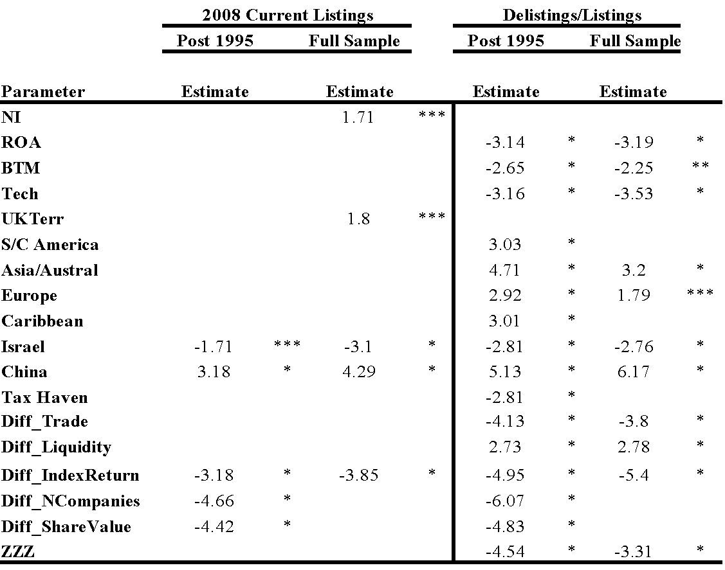

*The 2008 Current Listings sample includes 508 firms in the post-1995 sample (23% concordant with a chi-square of 154.06), and 621 firms in the full sample (16% concordant with a chi-square of 126.52). The Delistings/Listings sample includes 1148 firms in the post-1995 sample (28% concordant with a chi-square of 389.13), and 1266 firms in the full sample (22% concordant with a chi-square of 326.48).*

**5.5.2 SOX-All American Listings**

The indicator variable ZZZ representing country is added for the entire SOX sample to determine whether firms prefer the other American or USA exchanges more since SOX; this variable is significantly positive for both samples, thus indicating that foreign firms prefer other American exchanges since SOX passage. Chinese firms have again listed more since SOX, and all four exchange level factors were more important prior to SOX, indicating that firms do not care about exchange level factors as much when making listing decisions. Net income has again become an important indicator for identifying firms that may list onto North American exchanges post SOX, as well as Israeli firms have listed less since SOX. In the Delistings and Listings sample, more variables are significant, though the same factors are influential. Firms with higher sales, those from Asia and Australia, and from the Caribbean have listed more, though those with a high ROA, technology firms, Israeli firms and those from tax havens have listed less since SOX. One difference in the samples is that market liquidity is more important post-2002 in the full sample, though less important in the Current Listings sample.

**Table X. SOX-All American Listings**

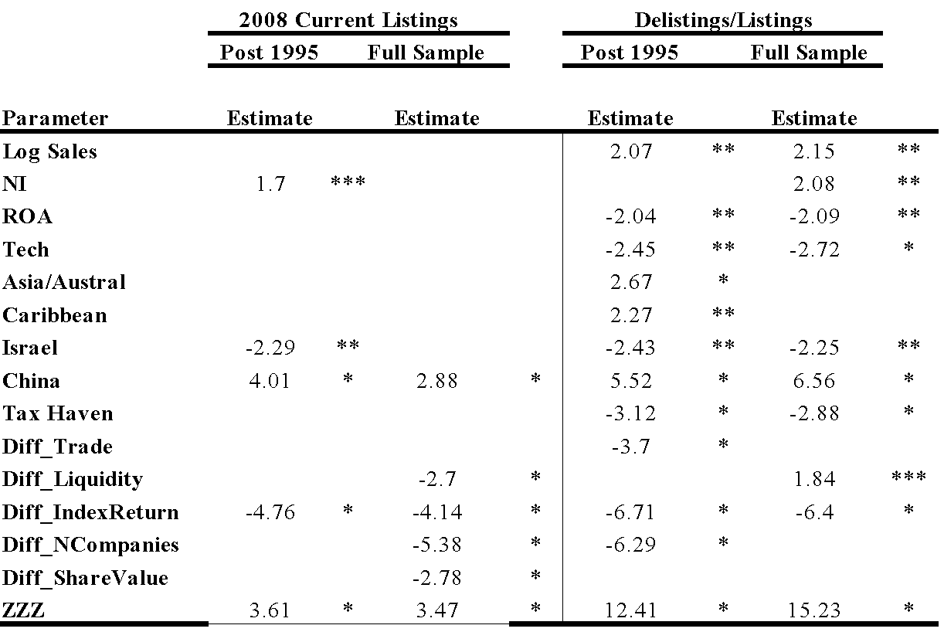

*The 2008 Current Listings sample includes 674 firms in the post-1995 sample (23% concordant with a chi-square of 209.76), and 791 firms in the full sample (20% concordant with a chi-square of 210.19). The Delistings/Listings sample includes 1739 firms in the post-1995 sample (37% concordant with a chi-square of 952.06), and 1861 firms in the full sample (39% concordant with a chi-square of 937.34).*

**5.5.3 SOX-Canada, Mexico, and the USA**

Since SOX, firms from Asia/Australia, the Caribbean, South/Central America, Europe, and emerging countries have listed more, while tech firms, those from tax havens, African firms, and Israeli firms have listed less. Firms with high return on assets have listed less since SOX, while those with a high net income have listed more. Chinese firms have listed more onto USA exchanges since SOX, though less onto Canadian and Mexican exchanges since 2002. Trade, liquidity, index return, and number of companies appear to have been more important for cross-listing decisions in the Americas before SOX, while share value was more important before when deciding between the USA and Mexico, though share value has been more important when deciding between Canada and Mexico since SOX. Mexico has been preferred over both Canada and the USA since SOX, and Canada has been preferred over the USA.

**Table XI. SOX-Canada, Mexico, and the USA**

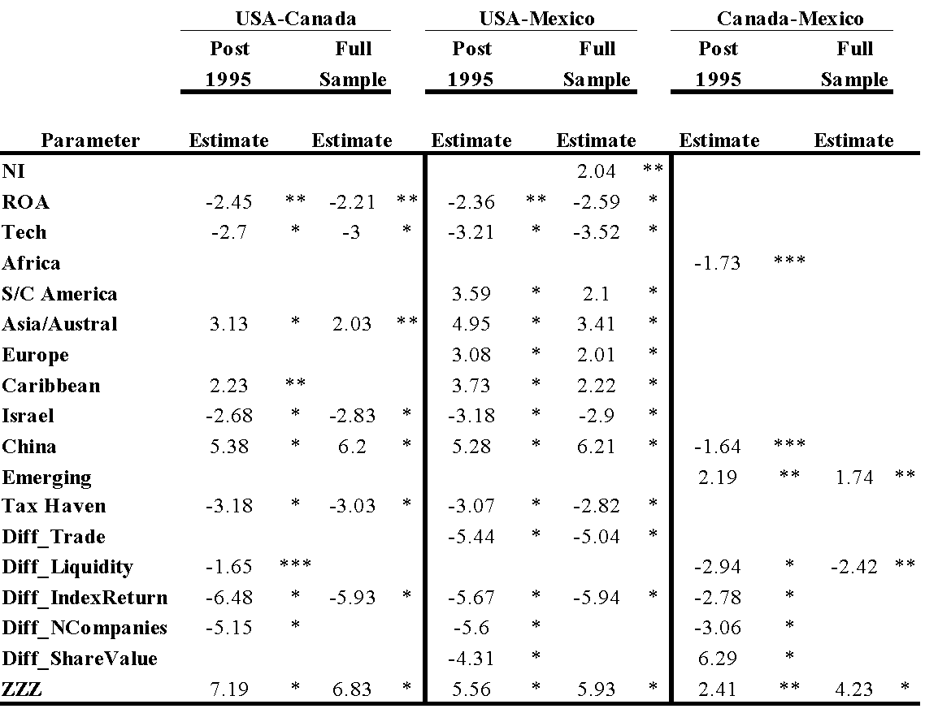

*The 2008 USA-Canada sample includes 1435 firms in the post-1995 sample (24% concordant with a chi-square of 462.52), and 1557 firms in the full sample (23% concordant with a chi-square of 460.21). The USA-Mexico sample includes 1453 firms in the post-1995 sample (48% concordant with a chi-square of 953.15), and 1570 firms in the full sample (45% concordant with a chi-square of 953.18). The Canada-Mexico sample includes 590 firms in the post-1995 sample (50% concordant with a chi-square of 240.45), and 595 firms in the full sample (33% concordant with a chi-square of 162.27).*

**6. Two-Step Time Series Analysis**

First the data is analysed for unit roots, then those unit roots which are significant are regressed against each other via an ARCH analysis to determine which variables are most dependent on each other, and thus which variables are most important for each stock exchange or economy. Then the most important variables from each stock market and economy can be compared against those from the other stock markets and economies to determine which stock markets and economies have both the most variables in common, and which variables seem to be most important for all the stock exchanges and economies, and within and between each of the stock exchanges and economies. Regarding the time series economy wide currency union analysis, it is presumed that the USA and Canada will again show the most similarities, and that Mexico will show similarities with both the USA and Brazil. As for the stock market time series analysis, it is hypothesised that the NYSE, Nasdaq, and TSX will be the most common. To test this theory a stochastic two-step time analysis procedure is implemented which analyses unit roots for stationarity, and then tests the stationary time series elements via an ARCH analysis. All the variables in this time series analysis exhibit stochastic properties, though in the economy data some of the variables do exhibit trends.

**6.1 Currency Unions**

Regarding the unit roots, Canada, Mexico, and the USA all have 18 variables with stationary trends, while Brazil only has 15, which is still a close number to 18. The USA is the only country where output gap and inflation are stationary, while Brazil is the only country where investment, gross savings, and exchange rates are not stationary. The USA and Canada both are not stationary in their external debt, while Brazil and Mexico are both not stationary in regards to their current account balance as a percentage of GDP. As such, Mexico seems to be straddling the line between Latin America and North Americas, by being close to all Brazil, Canada, and the USA, though all these countries show significant similarities to each other in their economies. Political and intangible effects must be considered as well, though, suggesting that a currency union in the Americas needs more to happen than just looking good on paper.

As for the ARCH results of the variables determined to be stationary from the unit root tests, the USA has the most significant variables, followed by Mexico, Brazil, and Canada. The ARCH results on the American economies significant unit roots show that the GDP measures are all relatively significant for each economy. The USA's most significant variables are GDP-USA, GNI, GDP-PPP, and poverty rates; Mexico's are population, GNI, and CAB; Canada's are exchange rates, population, FDI, and GDP-PPP; and Brazil's are GDP-USA, GDP-PPP, and population. As such, the GDP and population variables may forecast best when currency union convergence may occur in the Americas.

In terms of specific partners, the USA has the most significant variables, and Canada the least, thus these two countries may in actuality be the furthest away from joining a currency group. Mexico has similarities with both the USA and Brazil, and so Mexico may be the first major member from the Americas to pursue a currency union.

**Table XII. Unit Roots Economies**

This table contains unit root tests of stationarity for the four major American economies for 21 variables. 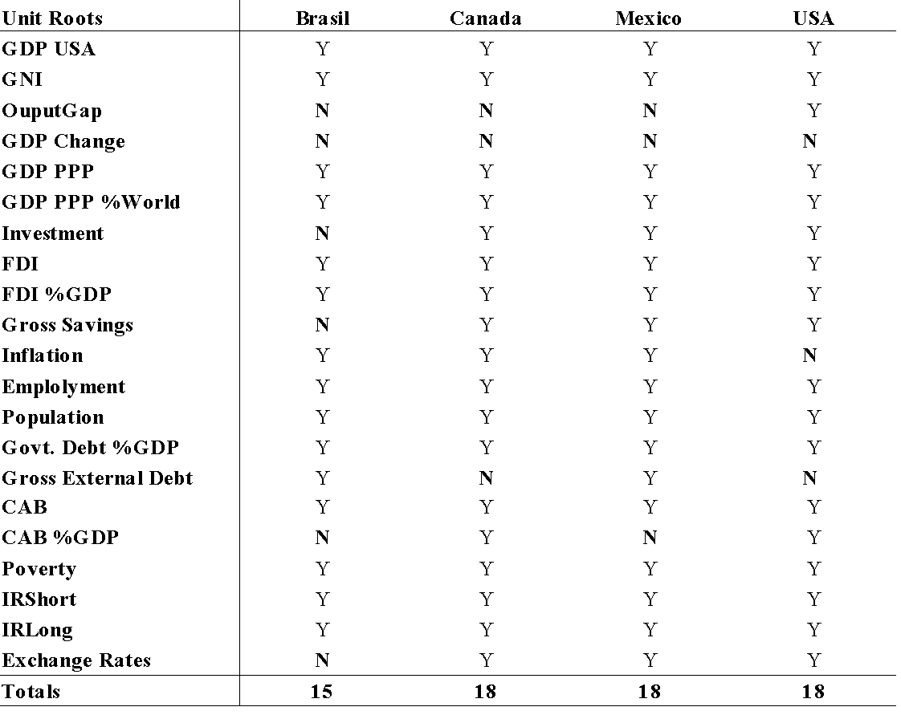

**Table XIII. ARCH Results Economies**

This table contains ARCH tests of the stationary times series elements for the four major American economies for 21 variables. 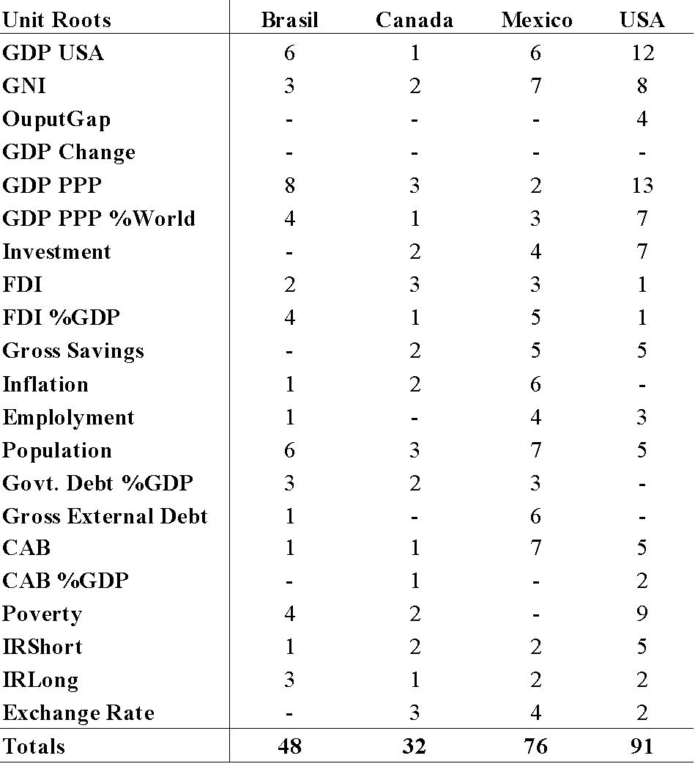

**6.2 Finance Markets**

The unit roots tests for the American finance markets show that the NYSE and the TSX have the most variables in common, followed by Nasdaq, the BOVESPA, and the BMV and BSX. None of the exchanges have any stationary elements in their amount of foreign bond capital raised, amount of foreign equity capital raised, total return, or index performance. The BOVESPA and Nasdaq are the only exchanges not stationary in their value of bond trading, while the BSX is not stationary in its number of companies and the BMV is not in its stock market's importance in the economy or the amount of capital raised. Turnover is not relevant on the BMV or BSX, while the PE Ratio is not on the BMV, BOVESPA, or BSX, though the gross dividend yield is relevant on the NYSE and TSX. Foreign bond trading is only significant on the NYSE, while foreign equity trading is only not relevant on the NYSE and domestic bond trading is only not relevant on the BOVESPA. Domestic equity capital raised is not relevant on either the BMV or BSX, while domestic bond capital is not significant on the BOVESPA, BSX, or Nasdaq. Index levels, value of share trading, equity market cap, bond market cap, and amount of domestic equity trading are all stationary for all six major American stock exchanges.

For the ARCH results, the NYSE has the most significant variables, followed by the Nasdaq, the Brazilian BOVESPA, the Canadian TSX, the Mexican BMV, and the Bermudian BSX. These results are possibly similar to what one may have expected, expect for Canada maybe to be more significant than the BOVESPA. One reason the BOVESPA may be more significant, is that they are a relatively closed-exchange to foreigners, which may allow them to operate more efficiently due to fewer obligations to outside interests. The most significant variables for the NYSE are equity market cap, bond market cap, and PE ratio; the most relevant on the Nasdaq are equity market cap, turnover, and stock market in the economy; for Brazil they are equity market cap, turnover, and number of companies; Canada emphasises stock market in the economy and turnover; in Mexico amount of domestic bond capital raised is most important; and in Bermuda index levels, stock market in the economy, capital raised, and foreign equity trading are all significant. As such, equity market cap seems to be the most important indicator between the NYSE, Nasdaq, and BOVESPA, while Canada and the Nasdaq both emphasise turnover, and Canada and Bermuda both place significance on the stock market's role in the economy. Mexico's stock exchange seems to have little in common with the other Americas stock exchanges, nor does Bermuda's.

**Table XIV. Unit Roots Finance Markets**

This table contains unit root tests of stationarity for the six major American stock markets for 21 variables. 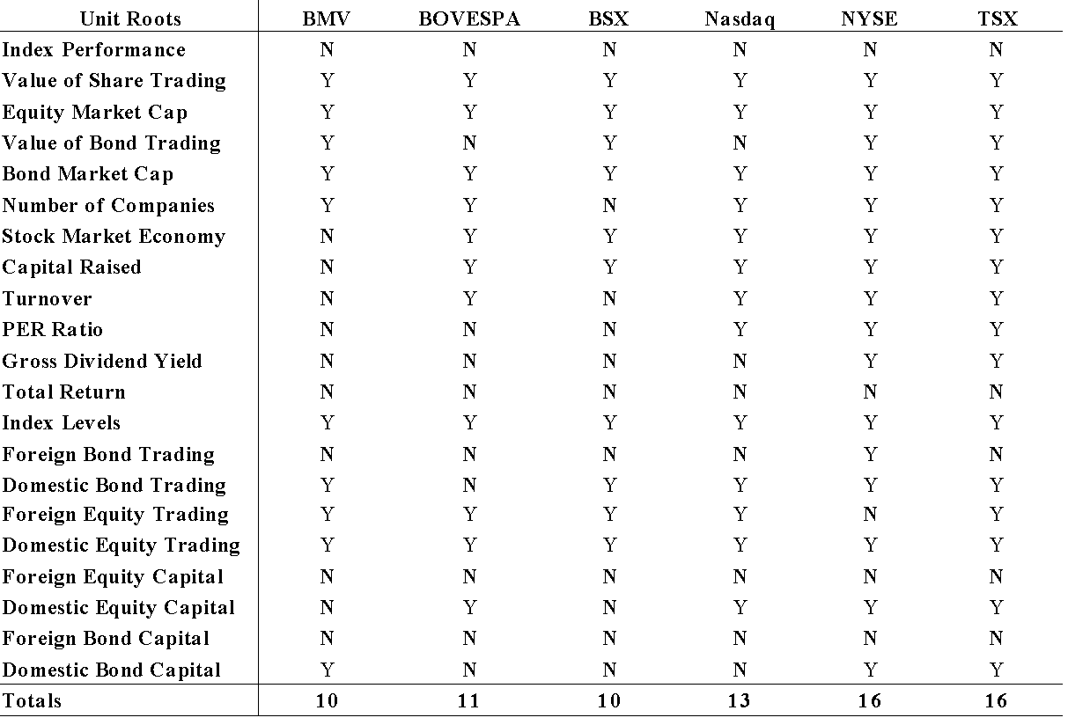

**Table XV. ARCH Results Finance Markets** 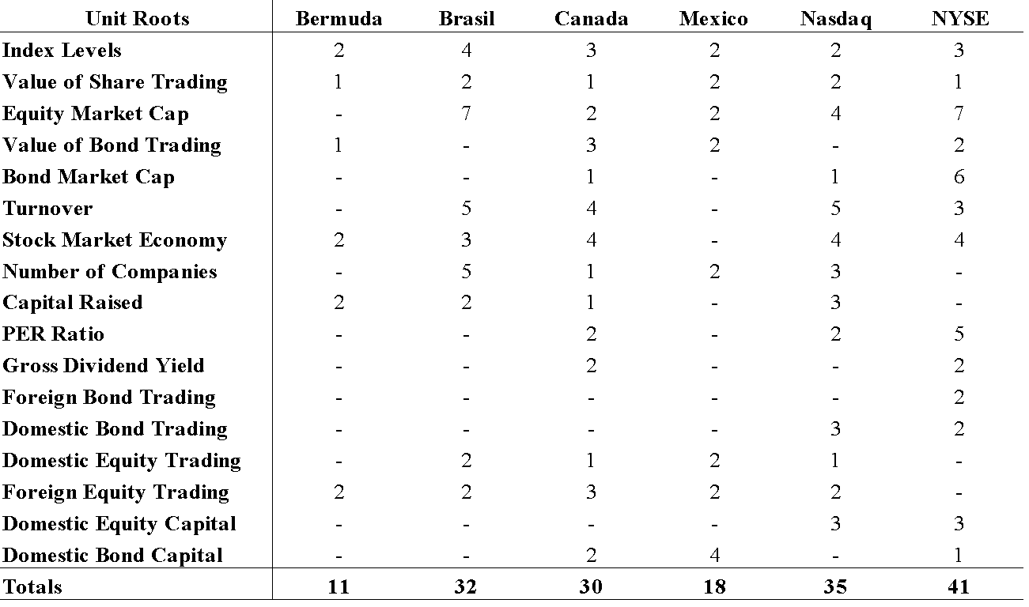

*This table contains ARCH tests of the stationary times series elements for the six major American stock markets for 21 variables.*

**7. Summary**

From the market’s perspective, acceptance of any type of firm is not an efficient policy; even if they are large corporations that will generate massive cash offerings with large commissions due to home market bankers. To achieve optimal operating efficiency, the market must choose corporations that align with its political and geographic interests. Cross-listing activity in the world did not begin until the 1980s and 1990s, though once it did it moved quickly, and since then we have seen stock markets merge, and even currency unions begin to form around the world. The Americas is already a highly integrated region, though the results suggest that further integration and congruence is possible with their economies and finance markets. Political and intangible effects are more influential in currency unions, as stock market mergers are oftentimes no more than a corporate business transaction. As such, it is likely that the finance markets in the Americas will merge before there is an outright currency union.

The results show that the assumptions most would commonly have about American exchanges and their companies are correct, although there are minor discrepancies between regression samples. For example, larger companies prefer USA exchanges and energy companies prefer Canadian exchanges, and there has been a decrease of foreign companies listing on USA exchanges since the passage of the Sarbanes-Oxley Act in 2002. The economies of the USA, Canada, and Mexico are highly integrated with each other, and Brazil shows similarities as well. As for finance markets, there is less integration, though the NYSE, Nasdaq, TSX, and BOVESPA show the most similarities. There are several questions, however. Brazil is the largest stock exchange and economy south of Mexico in the western hemisphere. That said, they have only nine total foreign companies listed from all regions of the world; which is rather surprising considering the large amount of foreign enterprises that conduct business in Brazil. Canada, similarly, has 0 fortune 500 USA companies listed. The question then arises ‘Why would this be?’ This is a rather ambiguous question, because only the Brazilian or Canadian exchanges could answer this question truthfully, however, there is a reasonable hypothesis that can be suggested. That is, that the unrestrained influx of private companies onto the home exchange is not helpful to the home country. Some persons in the home country prosper, such as the investment banks who procure the transaction, though the overall welfare of the home country is decidedly hurt, and thus Brazil and Canada may be protecting their economies better than others.

The argument then proceeds that in today’s economy with highly integrated markets, the funds being traded are actually of even distribution from all corners of the world, and so it doesn’t matter in which market a firm actually lists, as the domestic market will be no more subjected to potential loss of capital than the foreign participants. In a perfectly integrated global economy this would be the case, yet such is not reality; in actuality, the domestic market is much more represented than the foreign market. In some cases, such as London and New York, there is much more equal dispersion of funds to domestic and foreign participants; however, these are the exception and not the norm. In most markets, allowing foreign entrants in with little restraint leads to a nearly wholly transfer of funds from the home market to the foreign market. The foreign market is now richer and the home market is now poorer. Therefore, Canada has little incentive to allow USA firms to list onto their exchanges, unless their economic motives are closely aligned of course, and Brazilian firms have little reason to allow a lot of foreign firms into their market. Canada and Brazil, though, will attempt to list onto the NYSE and Nasdaq.

**7.1 Introspection**

In terms of the future integration prospects in the Americas, impetus will of course begin with the USA, although several issues are relevant. The USA is by far the most dominant economy in the world, and therefore within the region as well. The other four major international economies, Canada, Mexico, and Brazil, could be acceptable initial integration partners. Canada is the only other country as transparent as the USA, on par with the more established European economies. Mexico and Brazil are just as large as Canada, yet much less transparent. This transparency issue presents an issue for integration, as in the European system all the economies have relatively similar transparency. Further, the physical distance of Brazil from the North American countries makes effective integration of their stock markets or currency that much more difficult, with the other Central and South American economies between them being quite far away from the necessary transparency and stability needed to efficiently integrate with North America in any capacity.

Going forward, what may we expect from the American financial markets? The USA will continue to be the economic engine, although their autonomy is clearly diminishing as other economies catch up, and as their economic policies return to equilibrium after their free reign due to the collapse of the Soviet Union. The Canadian exchanges seem very stable, while the Mexican exchange seems to have questionable steam, although they are the unquestionable leader of Central America. Brazil may have the greatest opportunity to continue to grow, as they expand and grow as the leader in South America, in part due to their stronger relationship with Europe as compared with other South American countries. In terms of the Caribbean, the offshore centres of the Cayman Islands and Bermuda seem likely to continue in their dominant roles, as the other Caribbean nations are too small to have any impact. It is traditionally hard to enter the offshore market, and with world GDP not growing as rapidly currently, the Cayman Islands and Bermuda are likely to attract the most business attention, as legitimate companies typically prefer the more established offshore centres for their international business.

The USA and Canada are as much if not more highly integrated with Europe than they are with Mexico. Yes, there are trade arrangements, as would naturally be expected between neighbours, however, the NYSE and Nasdaq have branches in Europe, and seem uninterested, even if the Mexican government were to allow it (probably not likely), to merge stock markets with the Mexican stock exchange. The other two major players in the region, the international offshore leaders of Bermuda and the Cayman Islands, are both British territories, and therefore highly unlikely to part of any American stock market or currency integration process any time soon. Due to the size of the economies, the low transparency, and the negligible effect in the international economy, the rest of the countries in the Americas would not be integral in any integration scenario in the near future. Therefore, any integration scenario in the Americas would likely start in the North American countries, as would be expected. There has already been significant process in recent years to better integrate the region, as evidenced by NAFTA and the stock market unions of the NYSE-EuroNext and the Nasdaq-Nordiq (although these are obviously with Europe). Mexico, however, still has significant transparency issues and there is a cultural divide present between Mexico and its North American neighbours not seen in the European Union. This has less to due with Mexico speaking Spanish, and more about the political instability in South and Central America permeating up into Mexico and continuing into the USA, to some degree. In terms of Canada and the USA, here is the most likely possibility for where integration within the Americas might continue, both in stock markets and in currency. It must be noted, however, that although theoretically the USA and Canada would provide the most logical currency union presently, the economic might and traditional independent spirit of the USA by itself may suggest that currencies in South America, Central America, or the Caribbean may see convergence first. The USA has already shown with their European stock exchange mergers that that is something their government will accept, and so a stock market merger with Canada is likely the most probable integration scenario in the Americas at this time.

The Cayman Islands, Dominican Republic, and Jamaican exchanges all are major within the Caribbean, yet the Bermudian is the primary international exchange in the Caribbean. The Dominican and Jamaican exchanges cater primarily to their national companies, and are long established and form a sound basis for growth in the Caribbean, while the Caymans and Bermudian exchanges are among the world leaders in the offshore industry. The Cayman and Bermudian exchanges both serve as jurisdictions for incorporation for foreign firms all over the world, from Hong Kong to London. These four countries are the foundation of the Caribbean economy, and can be separated into two distinct categories, as even though their economies are comprised primarily of tourism and the offshore industry, the purpose and make up of their stock exchanges are different. Jamaica and the Dominican Republic are more national exchanges pushing the interests of their local citizens, similar to the Brazilian and Canadian exchanges. Bermuda and Cayman Islands are international market makers similar to the USA and Mexican exchanges, yet the Caymans offer primarily debt services, while Bermuda has a well-established international equity market.[14] Further, as discussed in section two, the American governments are operating at an inefficiency by looking to world capital markets before they look to their regional capital markets. As far as the amount of American government listings abroad, this is puzzling, as sometimes the regional markets are not developed enough to be able to handle the regional governments' financing needs, though the American markets are the strongest in the world. The American governments do not even look to foreign markets in their region, rather they go to Europe. It just raises concerns as to why individual USA states and government agencies would need to procure financing so far away, when the largest capital market in the world is in their backyard. Yes, sometimes there are better rates that can be obtained by going to different markets, though a government should ideally be much more restrained in their financing needs than a corporation.

If there were a currency union in the Americas, it may proceed similarly to the European system, whereby Canada and the USA would put a national depiction on one side of the coins, while using the same bank notes. This might suggest that the USA could have to accept the Queen of England back into their economy to some degree, even if on a ceremonial level, if the Americas region is to continue to integrate and maintain their position as a powerhouse region on par with Europe and the Asia~Australia regions as they integrate with more ease due to their cultural similarities. For example, the Bank of New York would then be re-distributing coins depicting the Queen of England, something a concept thought preposterous just a few years ago. In the European Union, Ireland voted no to the Lisbon Treaty in 2008, which would expand powers of the European Union. A country of four million thus was able to influence the lives of 500 million Europeans because of institutional arrangements. This is an extreme example, as Canada could of course choose a different figure and probably would, yet this would be a relevant issue considering the history between the USA and England, as Canada is a Commonwealth member. In an effort to see both side of the coin, the UK may see themselves in a similar situation if they joined the Euro-Zone. In an advanced society these are of course very trivial matters, though is still something that would have to be considered.

At the very least, a combination between the NYSE, Nasdaq, and the TSX could be achieved on a scale similar that of the EuroNext and Nordic exchanges, into some sort of North American exchange. TSX would actually fit in rather nice, as they occupy an energy and mineral specific niche in the international listing market. In the North American region, this is likely a more plausible and more likely to occur scenario than that of a currency union. The USA capital markets are interesting in their nature, as they are divided at home, yet successful at uniting capital markets in Europe, as the NYSE and Nasdaq compete for listings within the USA. Within Europe, the stock markets of France, Portugal, Netherlands, and Belgium have been united under the auspices of the NYSE, while the stock markets of Iceland, Finland, Sweden, and Denmark are united by Nasdaq. There is by no means complete unity in stock exchanges in Europe, though there are no situations where two major international exchanges within the same country compete for the same listings, as all other major exchanges in Europe are one to a country.

This has led to an interesting situation where the NYSE and Nasdaq have actually helped to integrate Europe, while creating a further divide between themselves and more efficient integration within the USA. As they have grown and become bigger through their exploits in Europe, it simply makes a combination of business more unlikely, although this is something that they have likely not considered as of yet anyways. They would now have to configure a domestic and international merger, instead of just worrying about their domestic issues, like the countries they united were able to. So, the question may arise as to what would happen if the NYSE and Nasdaq were to pull out of Europe? Since Western stock markets are both highly business driven and political in nature, it is difficult to suggest what may happen, though due to the progress of the European Union, one may suppose that they may continue under similar arrangements as the EuroNext and Nordic exchanges. The question also becomes that because of the sheer size of the USA economy, maybe two distinct exchanges are needed within the USA, which is a very plausible scenario, as Japan, China, Australia, and India have similar arrangements, though countries like England and Germany have successfully managed situations where they have a singular stock exchange entity.

**7.2 Future Research Areas**

As discussed in section three, one primary way this study can be extended is with additional point in time tests, and with in-depth analysis of each individual country's preferences regarding the American exchanges. Additional variables, calculated using the month of listing, and Canada Mexico difference, rolling averages, Canada as the primary instead of the USA, delisted corporations per month. A nested logit model could be developed that tests: after listing in a desired exchange, is there a specific type of capital that the firm on that exchange prefers. For example, is there a preference for equity over debt once the firm has chosen between the Canadian or USA exchanges. Thus, the many different types of offerings available and which markets cater to which type more could be an interesting area of future research. Further, the legal condition of the company as compared to deciding which market to list in could shed light on why a company would choose a particular market. Obtainment of the full compliment of delisted corporations would be beneficial, though marginally so considering the percentage of delisted corporations that was able to be procured, and likely would only possible by someone with intimate knowledge of the respective stock exchanges, especially the Mexican stock exchange. Also, forecasts could be created based on which variables are significant, though this would be empirically detailed to appropriately analyse all relevant variables, and also considering the highly political nature of currency unions and finance market integration, may not be extremely productive.

The overall trend of cross-listing in foreign markets has seen change over time. Through the mid 1990’s the majority of firms that were listing abroad on USA exchanges were European (Pagano et al., 1999). Now what we are seeing is a shift in regulation and increased cooperation between Canada and the USA, the emergence of Mexico and Brazil as legitimate financing options for foreign firms, and consequently a more equitable distribution of corporations onto exchanges both in the Americas and around the world to that which best suits their needs. The USA financial markets have long been a destination where firms could expect to reap large equity offerings with access to a large export market. The firms that typically prefer the USA are large in size, have high foreign sales before cross-listing, and high R&D spending after cross-listing (Posen, 2004). Notwithstanding the money that can be made with cross-listings, acceptance of all these types of firms by the USA, or by any market, is not an efficient business model.

**Table XVI. American Governments' Listings Preferences**

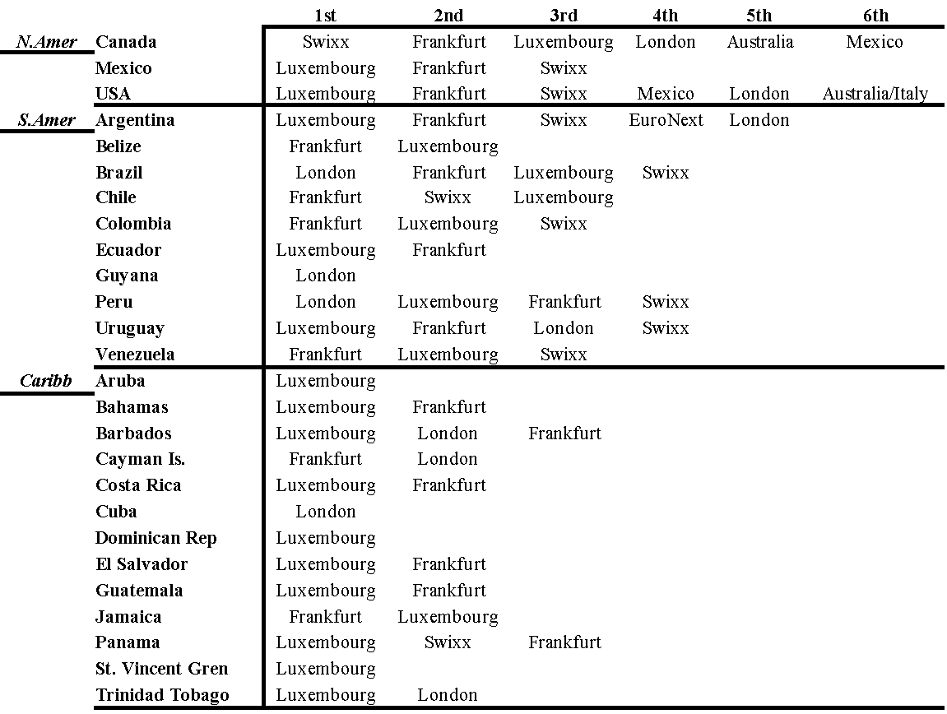

**Table XVII. American Governments' Proportional Utilisation of the Global Markets**

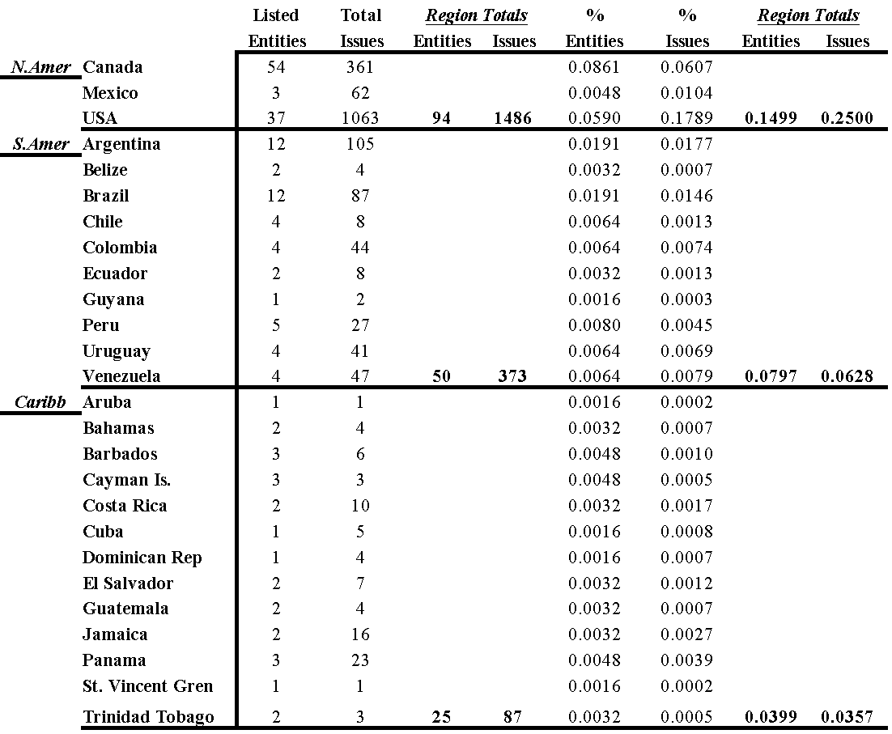

**Table XVIII. Summary Statistics Foreign Corporations on American Stock Exchanges**

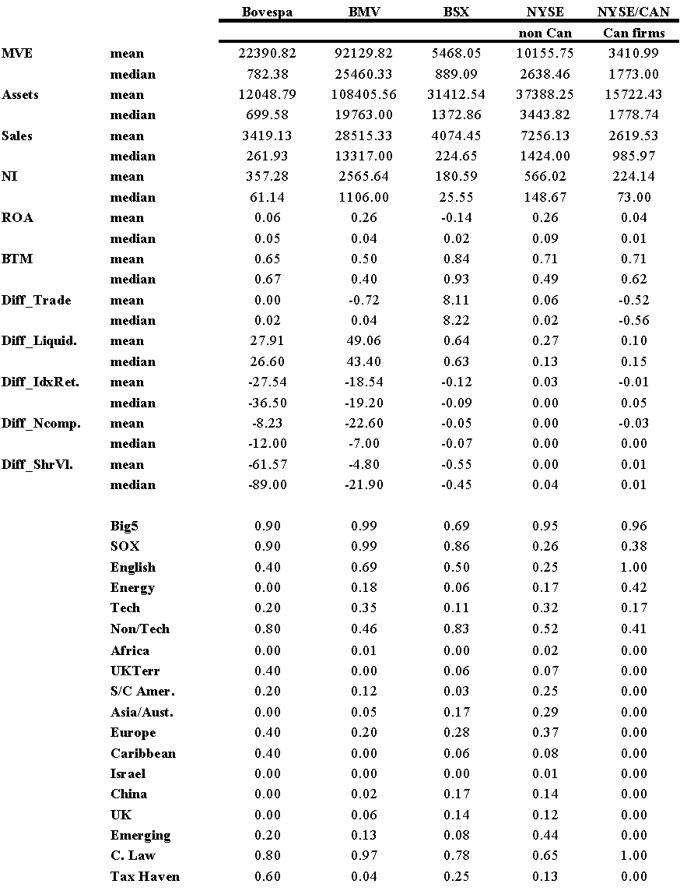

*These descriptive statistics indicate relative relationships between the firms. This table presents descriptive statistics for the sample of 1,994 foreign listings on American stock exchanges as of January 2010.*

**Table XVIII. Summary Statistics Foreign Corporations on American Stock Exchanges**

This table is a continuation of the summary statistics.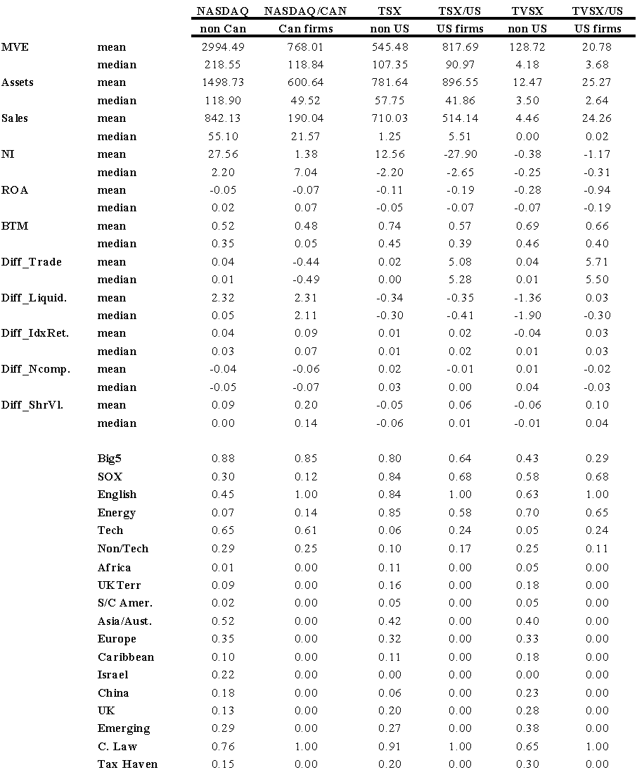

**Table XIX. Summary Statistics American Stock Markets**

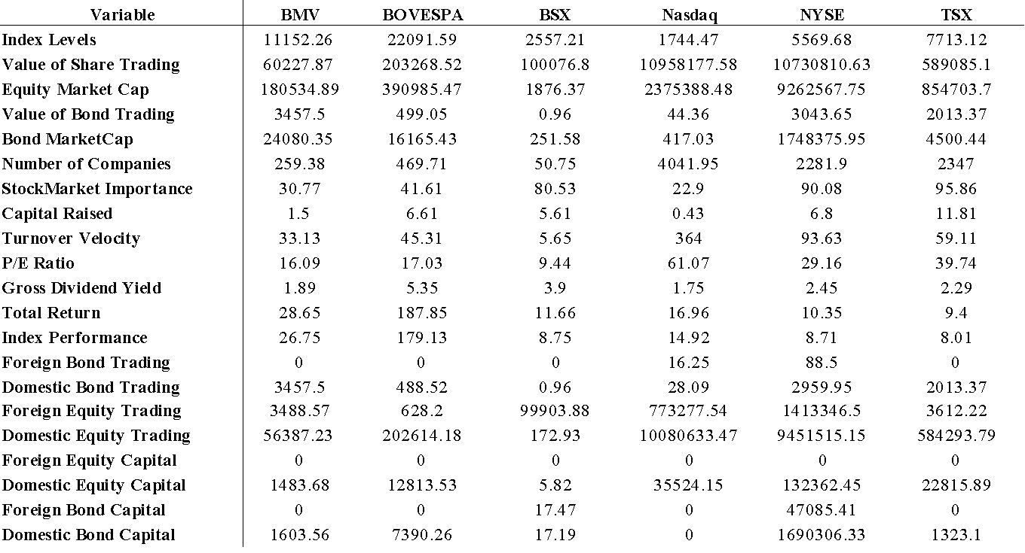

**Table XX. Summary Statistics American Economies**

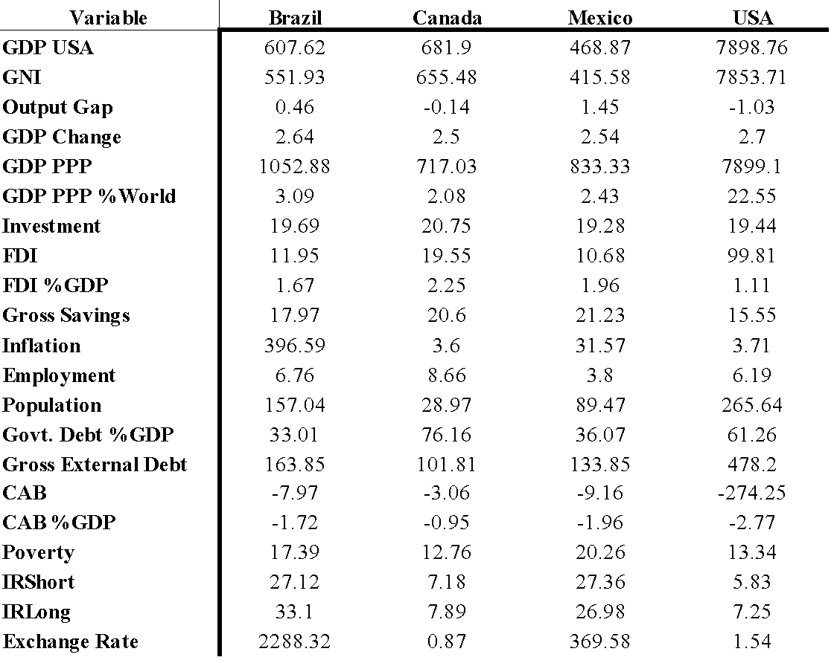

**Table XXI. Annual Listings and Delistings of Foreign Corporations in the Americas**

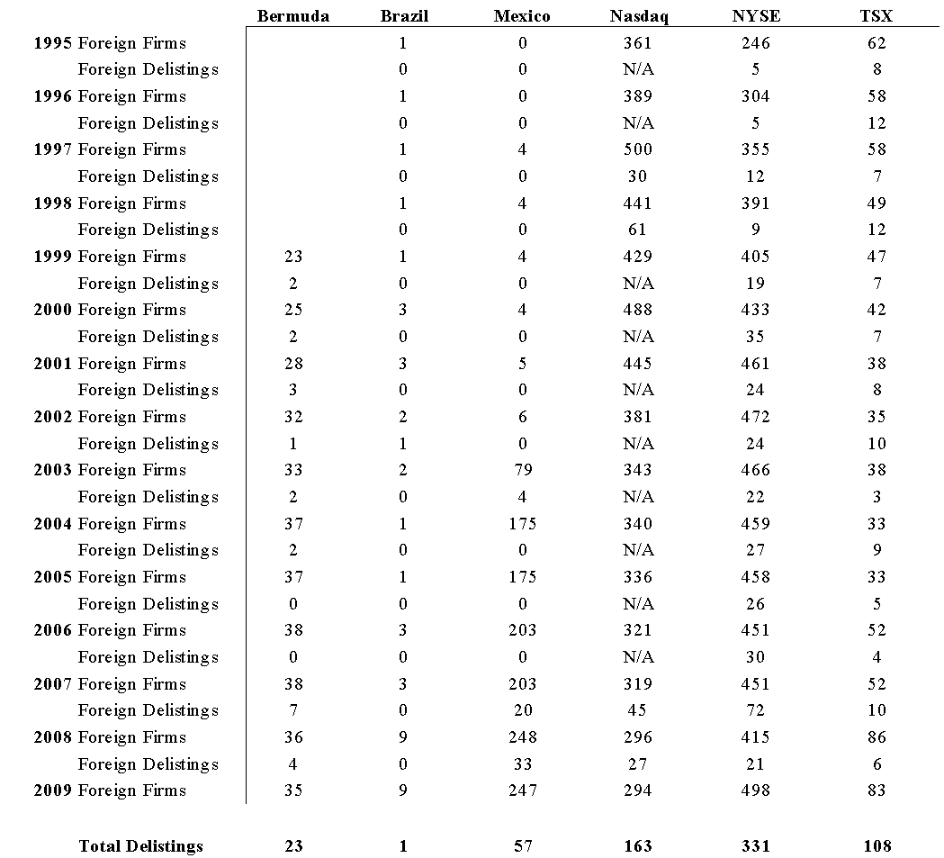

**Table XXII. Financial Corporations Listing Debt on the Mexican BMV since 2006**

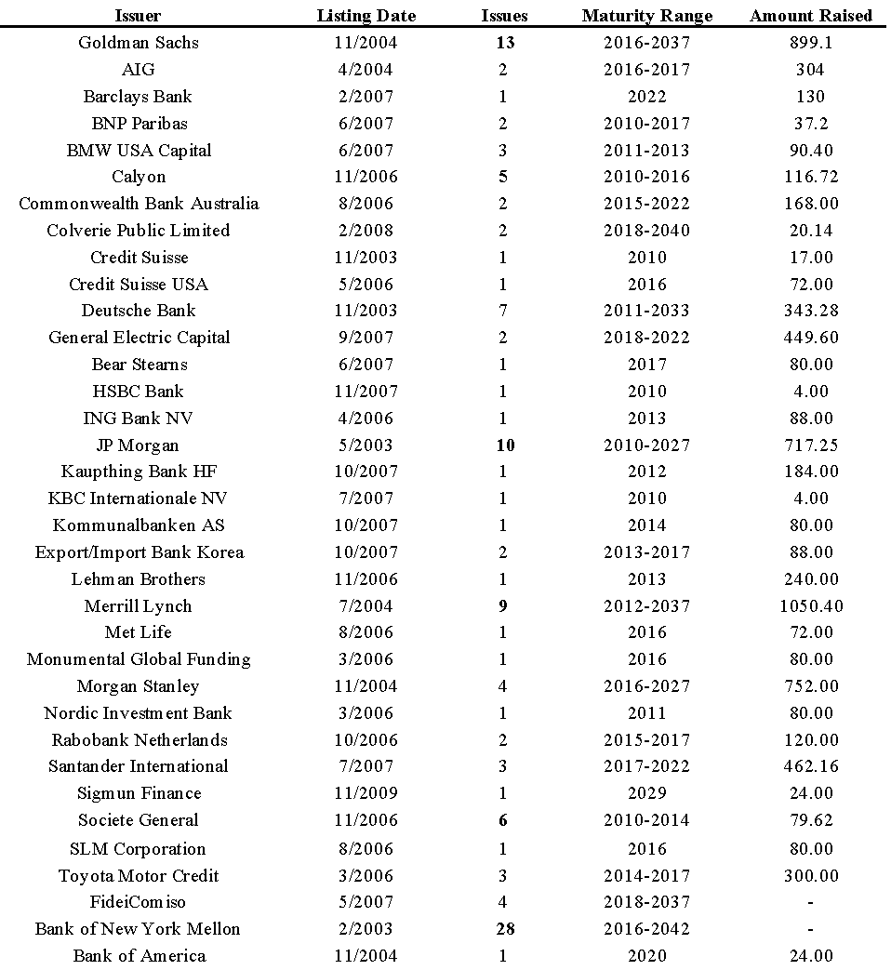

**Table XXIII. Financial Corporations Listing Equity on the Mexican BMV since 2006**

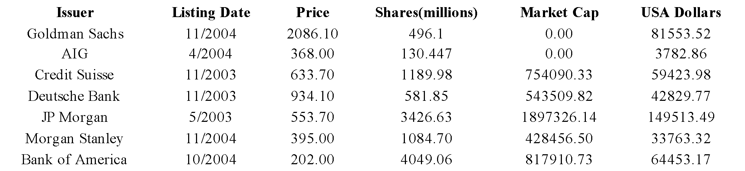

**Table XXIV. American Corporations' Listings Around the Globe**

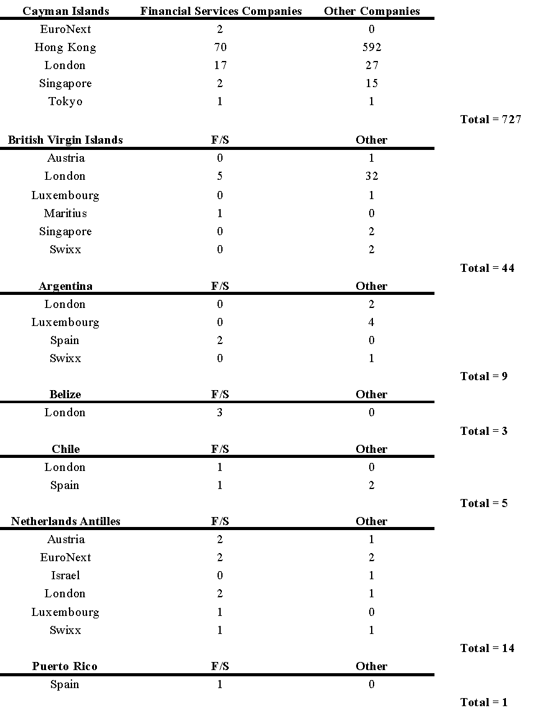

**Table XXIV.** **American Corporations' Listings Around the Globe**

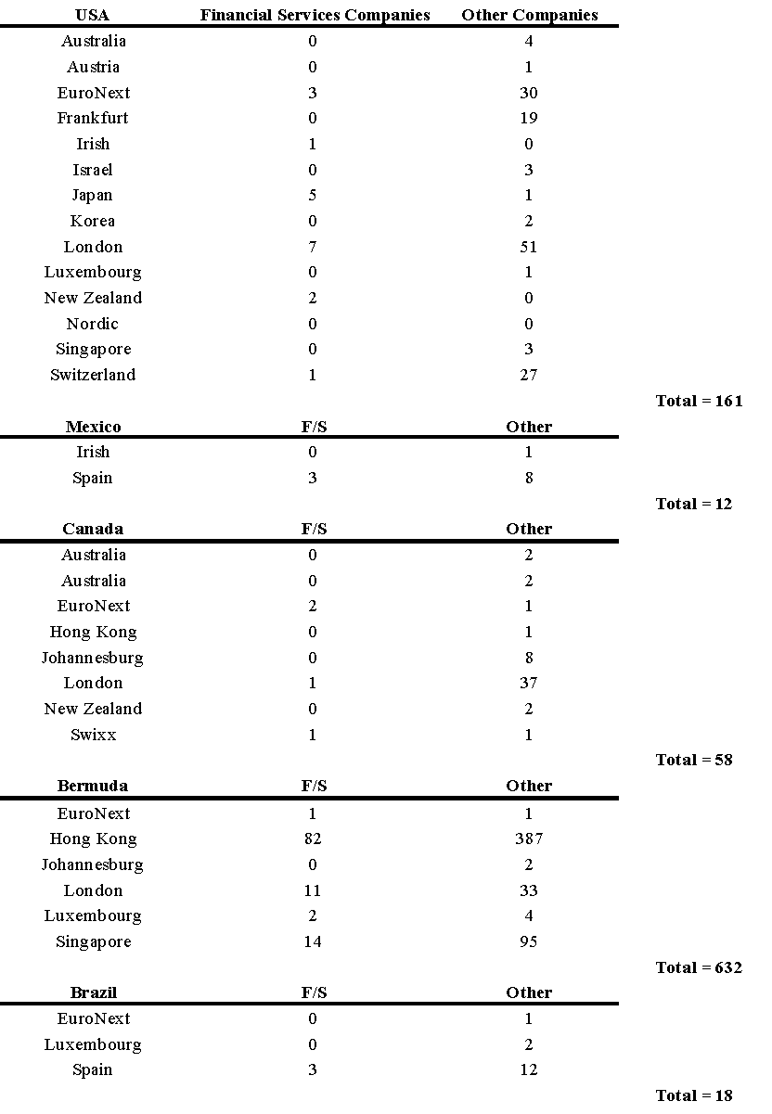

**Table XXV. Country Dispersion on American Exchanges**

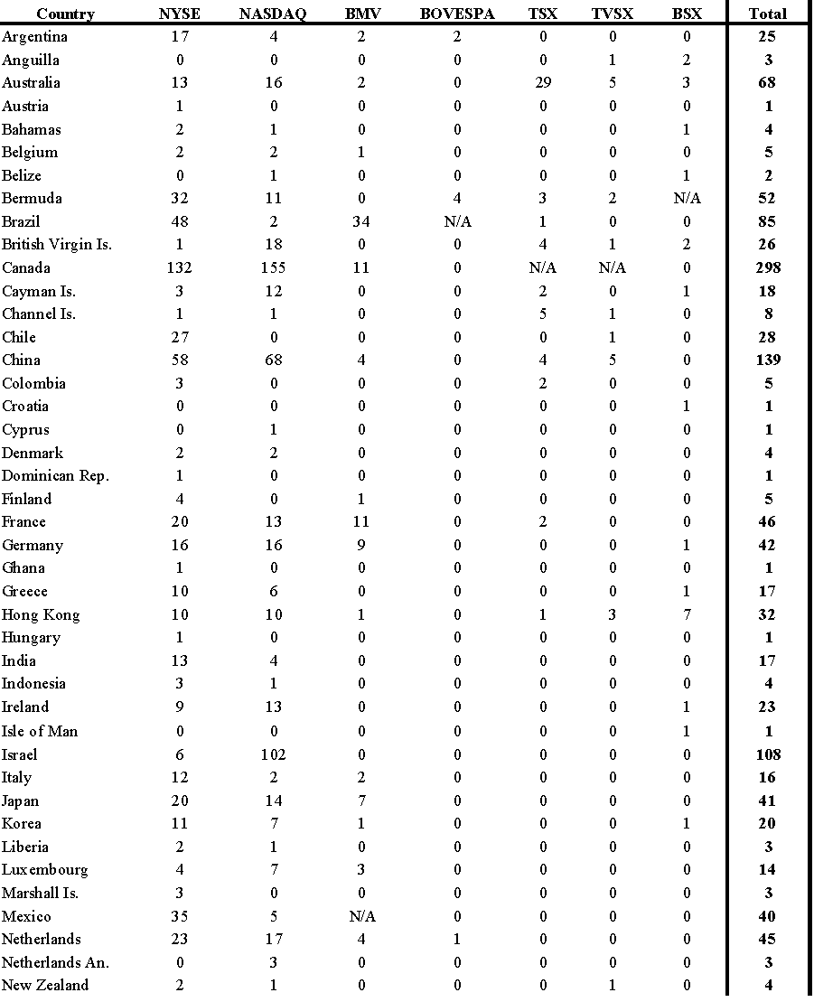

This table represents the home country distribution of firms listed on the dominant American exchanges. The distribution is accurate as of December 2008.

**Table XV. Country Dispersion on American Exchanges**

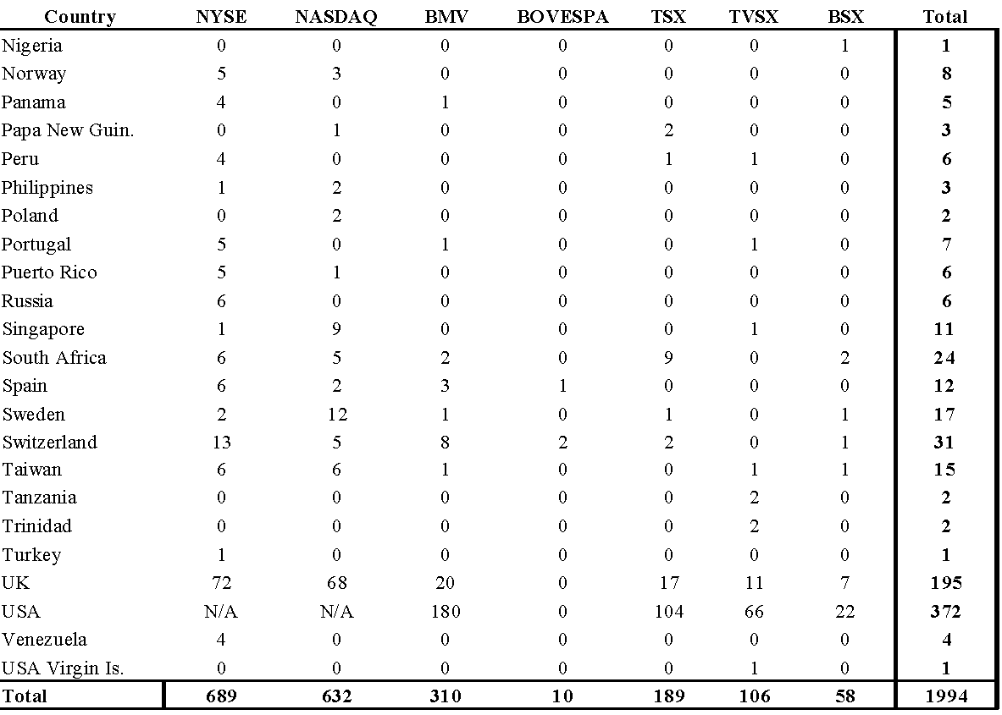

**IV. Asia-Pacific**

**1. Introduction**

The stock markets in the Pacific are among the largest in the world, and the most diverse. This region has a very eclectic variety of regimes, which has led to an incredible amount of diversity in their equity markets. For example, the two Indian exchanges boast upwards of 6,000 plus companies combined and ($600,000) each in market capitalisation, while the Tokyo Stock Exchange ($3,115,803) is the second most capitalised market in the world. The Shanghai ($1,425,354) and Shenzhen ($353,430) exchanges are steadily growing alongside their older brother in Hong Kong ($1,328,768), while Australia ($683,871) and New Zealand ($24,209) are home to several large and established exchanges as well. Korea's ($470,797) stock exchange rivals other established markets in terms of market capitalisation, while smaller economies like Singapore ($264,974) and Taiwan ($356,710) are carving out their own niche as well. Singapore is beginning to serve as the primary hub for cross-listing in the region by catering to an astonishing 312 cross-listed foreign firms, which is more than three times the next closest market of Australia, and Hong Kong.

It is not uncommon for countries to cater primarily to their own companies when utilising their capital markets, however, this region is definitively the least integrated of the three primary equity markets in the world, with Europe being one and the Americas being the other.[15] This is not always a bad thing however, as integration for the wrong reasons can lead to potentially devastating financial contagion. China and India not letting foreign firms list onto their markets is actually a very pragmatic approach, as it is much easier to initially let someone into your capital markets than to get rid of them once they have become tangled in your banking system. Though, as some degree of foreign compatibility is a prerequisite for global integration, which is where financial markets evolve towards as long as technology and standard of living keep rising, one has to believe that at some point admission of Australian and Japanese businesses to Chinese stock exchanges should benefit all three countries. The political differences may not be as distant as they at first appear, although the cultural barriers within all the different countries in the region seem likely to persist. This region has the potential to implement a revolutionary business model, and only allow regional companies onto their stock exchanges.

This study is organised into several sections as follows. Since the emphasis of the study is on how the Asia-Pacific region's corporate activity in the Americas may be affecting their capital market integration and currency union convergence, first the Asia-Pacific region's integration with the American markets is analysed. The Asia-Pacific region is characterised by its closed-door political and economic policies, and as such the efficacy of this type of system is discussed next, after which the current state of the Asia-Pacific markets is presented, and then empirical studies are performed. For the empirical studies, the corporate activity of the Asia-Pacific region's countries in the American stock markets is cross-sectionally analysed, and then the time series characteristics of the Asia-Pacific region's stock markets and economies are examined, all in an effort to deduce stock market and integration possibilities in the Asia-Pacific region, with an emphasis on how their corporate activity in the Americas may be affecting their welfare within the region. Then, more in depth background information on the Asia-Pacific region's major countries is presented in an effort to better understand how the results from the empirical studies may be best interpreted.

**1.1 American Influence**

Pacific corporate activity in the Americas is relevant to analyse, because as dominant as the American markets in the global economy, there are documented studies about the connections between these economies and the Americas, primarily the USA. To establish the relevance of the examination of the Pacific region's corporate activity in the Americas to their general integration processes, review of the studies analysing similarities and differences between these markets and the Americas provides a foundation for evaluation. The Asia-Pacific markets are relatively integrated with the American markets, both in terms of stock exchange factors and macroeconomic indicators.

In general the Asia-Pacific countries do exhibit significant integration with the American markets.

Australia, Japan, Korea, Malaysia, New Zealand and Singapore, America are neither perfectly integrated with foreign financial markets nor are they perfectly segmented, though American economic activity has a significant influence on Pacific-Basin stock markets in the long run, yet is less influential than domestic economic activity (Allen et. al., 2004). Phylaktis's (1995) study also showed that there has been an increase in capital market integration with both the USA and Japan during since the 1980s, and that Japan has not overtaken the USA in dominating the financial markets of these countries, except Malaysia, though Japan is the least integrated country with the United States. (Busetti and Manera, 2003) concur and also note that this integration with the Americas has even been increasing since the late 1990s. In regard to specific countries and the American markets, Indonesia is relatively independent of both the USA and Japan; Malaysia is more dependent on Japan rather than the USA; Thailand is relatively independent of the USA, though to some extent dependent on Japan; the Philippines is more affected by the USA than Japan; and the USA and Japan are both correlated with Singapore (Majid et. al., 2007). As far as Australia and the USA, Frino and Fabre (2004) determine that there is stronger commonality in liquidity in the USA than in Australia. There also has been no evidence of herding on the part of market participants in the USA, Hong Kong, and Japan, though in South Korea and Taiwan there is significant evidence of herding (Chang et. al., 1999).

More research can be done on this topic, as Faff and Mittoo (2000) found somewhat conflicting results with prior research, in that when analysing companies by size and industry it was shown that Australian regional stocks such as consumer and capital goods are priced in different markets than their Canadian and US counterparts, though for all samples the global stocks such as oil and mining, of which Australia has a lot of, are priced in a relatively integrated capital market (Faff and Mittoo, 2000). In terms of macroeconomic indicators, Change et. al., (1999) suggest that when comparing the American markets and the Asia-Pacific markets, macroeconomic indicators provide better information than firm-specific or stock exchange specific. When analysing inflation rates, observed declines in dispersion are usually associated with decreasing overall inflation levels, which indicates a positive relationship between mean inflation and overall inflation rate dispersion. Regional inflation rates show that dynamics are larger for Japanese prefectures than USA metropolitan areas (Beck and Weber, 2005).

**1.2 Capital Market Singularity**

A distinguishing aspect of the Pacific financial markets is their solitariness with respect to their economies. There are exceptions, such as Australia and New Zealand who are politically and culturally aligned with the West, and even countries like Hong Kong and Singapore. The Asian and Australian markets, however, are generally more nationalistic than the American or European markets. There is foreign activity in them, though not on nearly the same scale as the other two regions. The American markets are the primary corporate financing centre for the world, the European are the primary government financing centres for the world, and the Asian markets utilise both as well as their own. This suggests that the Pacific region should pass the American and European regions, as they have an operating efficiency advantage over the more crowded international markets in the Americas and Europe.

A capital market is at first completely solitary. As the country and others around it grow, the capital markets then develop the need for innovation, just as do others institutions. As such, there are distinct measures introduced, and distinct effects that they will have upon the previously solitary capital market. The structural differences between stock exchanges contribute to variations in observed measures of quality of markets, as these institutional and legal regulations are what determine the solitariness of the market. When discussing capital market solitariness, several issues arise, including: path to stock market development, governance, and eventual deregulation. It is important to note that as deregulation occurs, the stock market will begin to become more integrated with other markets, through several factors: foreign capital flows via both companies and investors, competition, and automation or technology.

It can be argued that there are two distinct paths to stock market development: an approach based on legal protections for investors, and an approach based on self-regulation of listed companies by stock exchanges (Liebman and Milhaupt, 2007). The first approach will involve more regulation by the government and thus more solitariness, or less willingness to allow foreign investors in, as then the government would have to ease its oversight so as to accommodate the foreigners who are used to more lax rules. The second approach advocates more openness, and thus more foreign involvement. A fundamental problem with the solitary exchanges lies with the issue of corporate governance, as when foreign corporations and their countries are allowed in, there will likely be less opportunity for corporations from the home government to gain undue influence, as there will be another check in place via the foreign companies. This does not mean that all foreign companies should be allowed into a market, though it does suggest that a healthy and appropriate amount of foreign entrants can help to balance some of the natural inclination to nefariously manipulate a market from the inside.

Another issue is that of non-tradable shares, though being a solitary exchange does not necessarily mean that there will be a significant amount of non-tradable shares. Traditionally, owners of non-tradable shares do not have a chance to realise the value of their shares in the market. As a result, many will abuse their executive power and participate in activities or awarding contracts that will lead their personal monetary gains (Yong and Fu, 2006). It must be noted, however, that non-tradable shares do have their advantages, as they also prevent excessive speculation and fraud of that type in the financial markets. As such, the best formula may well be to have non-tradable shares in some capacity, with some sort of limit as to when and how they can be sold. As such, if an exchange is completely solitary, then eventually measures will be introduced to encourage foreign capital, including deregulation in the banking sector and refinements in various financial markets, among many other options. Stock markets will by nature become integrated, no matter the policies, and as such the primary way they become integrated is through the cross-border capital flows, or with foreign companies or foreign investors entering the market.

Cross-border capital flows lead to integration, as does competition and the increasing automation and technology. Private capital flows has been linked to high stock market performance, as if there has been co-movement of net equity flows across markets, then, there will also be evidence of stock markets integration. Competition is also a major force influencing integration of stock markets. Three key psychological factors influence competition: greed, envy, and speculation, and the burst of the bubble to three contrasting factors: fear, lack of confidence, and disappointment (Yao and Luo, 2009).

Especially in an age of automation, automation could influence aspects of trading such as volume, volatility, liquidity, market efficiency, and bid-ask spreads, automation is associated with increases in volumes traded, return volatility and liquidity as defined by the ratio of volume to volatility, impact of automation and competition upon performance.

Information-based trading exists for all stocks, and there is an increased presence of informed trading in both liquid and illiquid stocks when markets are active. For the actively traded stocks, activities of informed traders deter uninformed investors from trading, thereby reducing market liquidity (Wong et. al., 2008). In an informational efficient market, the stock prices respond instantaneously, accurately, and in an unbiased manner. The informational content of dividend release has always played a significant role in strategizing the trading pattern of investors (Chander et. al., 2007). The concept of risk management in case of investment decision assumes paramount importance in modern day financial management, and though risk cannot be completely eliminated, it can be reduced by taking precautionary measures. systematic risk and unsystematic risk (Sarna and Sarnah, 2008).

Stock Exchanges commonly act as Self Regulatory Organizations (SROs), and the very nature of this function necessitates acting beyond their own monetary gains in order to secure good governance, with conflicts of interest are antithetical to the role of an SRO. Self-regulation should be understood broadly to include regulation of listed companies through quality standards, disclosure standards, and governance rules; regulation of broker-dealers; regulation of trading; and, perhaps most basic, regulation of the exchange's organizational structure. Internationally, competition and rapid technological changes have actuated Stock Exchanges to move from a mutual association model to a public limited company model through a process called demutualisation. Demutualisation has posed a new conflict of interest situation before these exchanges: Self Listing i.e. listing on their own circuits, carrying with it a huge potential for abuse (Jain and Jodhpur, 2007). Stock exchange conversion from mutual to publicly traded exchange is not only value enhancing for the exchange and its shareholders, yet it is also beneficial for the stock market as a whole, as with the ASX and India and Hong Kong (Otchere and Abou-Zied, 2007).

**2. The Pacific Markets Today**

Some may say that the American markets provide the primary corporate financing centre for the world, the European markets provide the primary government financing centre, and the Asian-Pacific markets utilise both. The Pacific markets, however, are characterised by their solidarity, rather than over-involvement in either the American or European markets. China and India are probably the two best known examples, as they do not allow foreign corporations onto their stock exchanges, though even on the Japanese market, there are only fifteen foreign corporations listed, and they have around 50 since inception, a much lower amount than the large country markets in Europe and the Americas. There is a movement towards integration in the Pacific, however, and though it is slow moving, this may be a good thing, as by moving slowly the Pacific countries are able to be restrained in their growth policies, and effectively minimise potential contagion consequences from irresponsible and poorly-directed international integration programmes.

The Asia-Pacific markets are less involved in the global markets than are the European or American, though they are still active on a global scale, as well as they exhibit substantial integration at the regional level. There are currency union characteristics and stock market integration prospects. Japan's stock markets are perhaps the most integrated with the rest of the world, though primarily due to Japan's economic strength, rather than their integration attitude. Australia and New Zealand are of course the most similar English speaking countries, India, China, and Russia are relevant, and the Asian crisis was important. There are significant linkages between the all the countries in the Pacific-Asia region, both economically and culturally, though politically there seems to still be significant differences. The South Asian markets which were known to be segmented mainly due to regulatory and institutional barriers in the early 1990s, have been gradually liberalised and opened up for the world economy, as the financial sector reforms have been successful in strengthening the interlinkages between the markets (Vats, 2008).

When discussing currency union possibilities in the Asia-Pacific region, one of the first grouping that comes to mind is Australia and New Zealand, because of their cultural, geographical, and political similarities. Haug et. al., (2005) discusses how there is substantial similarity of transmission mechanisms in New Zealand and Australia, primarily in regard to both GDP and the CPI in response to monetary stabilisation policy shocks. As a high degree of internal labour mobility is a desirable feature of currency unions, it is shown that shocks to relative per capita output have a significant and symmetrical impact on migration flows between Australia and New Zealand. Further separating the shocks to Australia and New Zealand shows that pull effects are more important than push effects, and it seems that the choice of New Zealand emigrants permanent migration responds intuitively to the state of the economy in Australia and New Zealand (Creighton, 2006). Regarding some of the other countries in the region, Vats (2008) suggests that even though formation of an East Asian monetary union may be to some extent feasible from an economic perspective, the region’s political situation does not appear favourable for the creation of one. When comparing the largest economies in the region, Japan and China, it seems that a currency union with China may generate higher average welfare gains for East Asian countries than a currency union with Japan. Shirono (2009) therefore concludes that Japan does not appear to be a dominant player in forming a currency union in East Asia, and this trend is likely to continue if China's relative presence continues to rise in the regional trade.

The majority of the countries in the region have major international stock exchanges which are listed on the World Federation of Exchanges, though there are three primary junior stock exchanges in East Asia with legitimate growth ambitions of becoming regional exchanges emerging corporations as well: the Tokyo Stock Exchange Mothers, Hong Kong Stock Exchange Growth Enterprise Market and the Singapore Exchange Catalist. As compared with the AIM section of the London Stock Exchange, one the most recognised growth exchanges in the world, the Catalist is more integrated with the AIM than the Mothers or the Enterprise, thereby suggesting the Singapore Catalist is more efficient than the Japanese Mothers or the Hong Kong Enterprise (Mizuno and Tabner, 2008). As far as the developed exchanges are concerned, Yu and Huang (2002) determined that the Taiwanese and Korean markets are the most two volatile markets in the Asia-Pacific region, yet the Taiwanese market is weaker than the Korean market in dissipating volatility.

To put in light the interaction between the countries in the region, Chang et. al., (2009) conducted a study analysing Japanese tourist activity via volatility estimates for the monthly growth in Japanese tourists to New Zealand and Taiwan. The results actually indicate that Japanese tourists to New Zealand are correlated with positive shocks, though there were no positive or negative effects for Taiwan. It may be expected for there to be little effect for Taiwan, since they are so close, though the positive effects for New Zealand suggest how close the many diverse members of the Asia-Pacific region really are.

In terms of cross-country integration, Mahmood and Dinniah (2007) determined that amongst Malaysia, Korea, Thailand, Hong Kong, Japan, and Australia, there is a long run equilibrium relationship between Japan, Korea, Hong Kong and Australia. As for short run relationship, all countries except for Hong Kong and Thailand show some interactions. Hong Kong shows relationship only between exchange rate and stock price while the Thailand reports significant interaction only between output and stock prices. Sanchez (2005) also suggests that the region's economies exhibit a high degree of cross-country supply diversity, though warns that there is little compelling evidence that shocks are highly correlated across the region. Kim and McKenzie (2008) find a significant evidence of a relationship between the presence of international investors and the level of stock market correlation in nine Asia-Pacific stock indices. In line with mainstream economic reasoning, private capital flows have been linked to high stock market performance in Asia-Pacific countries, suggesting stock market integration in this region due to the co-movement of net equity flows across markets. Specifically, it seems that these net equity capital flows have reduced the market segmentation in South Korea significantly, and linked Indonesia's stock market to regional stock markets after stock market liberalisation (Ameer, 2005). As for Russia and China, the Russian markets have substantially increased their integration with global stock markets recently, while both the Chinese A- and B-share markets continue to move largely independently from global movements, and only slightly in line with regional forces (Kozluk, 2008). As China is a growing force in the region, significant attention is given to China in the next section.

As Japan is the most developed market in the region, Japan's role and interaction with the other markets in the area is both highly informative when analysing the region as a whole, and important to be healthy in order for the region to compete with the other two major world regions of the Americas and Europe. Specifically, research has demonstrated that the equity markets of Australia, China, Hong Kong, Malaysia, New Zealand and Singapore are highly integrated with the stock market in Japan, and have become more integrated over time, especially since 1994. Soenen and Johnson (2002) also suggest that within the Asia-Pacific region, a higher import share as well as a greater differential in inflation rates, real interest rates and gross domestic product growth rates may have negative effects on stock market comovements between country pairs. They also noted an increased export share by Asian economies to Japan, as well as propose that greater foreign direct investment from Japan to other Asian economies can contribute to greater growth in the region. Further, considering the historical endogenous nature of many Asian markets, Japan will likely continue to be a lucrative destination for international investors to invest and diversify the portfolio risks (Seshaiah, 2006)

India is a rising economy, and as such research has shown that Asian Stock markets have a long term relationship with the Indian Stock Markets, whereas the Indian stock markets exhibit a short term relationship with the Japanese capital markets and developing markets in Asia and South America. Sariannidis et. al., (2009) also find that Indian, Singapore and Hong Kong, markets are highly integrated, with them reacting to information which influence not only the mean returns but their volatility as well. According to Raj and Dhal (2009), when analysing Bangladesh, India, Pakistan, and Sri Lank a it seems that stock markets indicators such as market capitalisation and trading value in the region following liberalisation measures do not seem to influence the real sector in South Asia, and the stock thus markets are still playing a minor role in their respective economies. As far as global reach in India, Husain and Qayyum (2006) have determined that the markets in India and Pakistan are affected by the major as well as by the regional markets in the long run though in the short-run are independent, though since 2003 the integration of India's stock market with the global markets, such as the USA and the UK, is much higher than with the regional markets. Also, due to the Indian market recent liberalisation, the Indian stock market may provide opportunity for higher return than global and regional markets.

Capital market integration in the Asia-Pacific is found to be greatest in Singapore, Hong Kong, Australia, and Taiwan, and weakest in mainland China and India. When Hsu (2009) analysed the daily returns of India, Indonesia, Korea, Malaysia, Singapore, Taiwan, and Thailand, it was shown that stock index and exchange returns are positively, yet weakly dependent on each other, with Singapore having the lowest dependence level and Indonesia having the highest. Yu and Huang's (2002) study found that the Tokyo and Singapore markets are very similar in fractal dimension and probability distribution, though different in their resistance to volatility, while Tokyo has a higher ability to dissipate volatility. Also, the Tokyo market is more efficient than the Singapore market, and the Hong Kong market is similar to the Singapore market in its ability to dissipate volatility. Analyst forecast revisions exhibit persistence in all countries in the region, though the profitability of trading strategies varies on earnings momentum, which is related to information dissemination mechanisms within a country. Earnings momentum yields significant profits in Australia and Hong Kong, though not in Malaysia, South Korea, Japan, Singapore, or Taiwan. Price momentum exists only in those countries where earnings momentum is profitable, and markets with high levels of corruption in the Asia-Pacific region exhibit weak momentum (Hong et. al., 2003). Another interesting fact about the cooperation between countries in this region is that the Singapore Exchange (SGX) and Taiwan Futures Exchange (TAIFEX) both offer future contracts based on the Taiwan stock market indice. Though there are structural differences between these two markets, such as the trading costs and speed of information transmissions, any significant developments in Taiwan will affect the Singapore market, such as higher trading taxes. As such, when taxes were reduced on the TAIFEX, implicit trading costs reduced significantly and the price execution efficiencies also improved significantly after the tax reduction (Chou and Lee, 2001).

The Asia Financial Crisis was an important event for the Asia-Pacific region. The Asian financial crisis of 1997, which started as an apparently limited shake-up in remote Thailand, became a crisis soon. Indonesia, the Republic of Korea, and Malaysia, which experienced little increase in capital risk before 1997. As for the development of the crisis, there was an over-identification of contagion for the early Thailand crisis phase but an under-identification of contagion during the late Hong Kong crisis phase during the two phases. There is little evidence of a significant change in the transmission mechanisms from Thailand to any other country, as most financial shocks are thus transmitted through non-crisis-contingent channels. Contrary to the Thailand finding, there is evidence of contagion from the Hong Kong stock market to most of the other Asian stock markets, contrary to most shocks are transmitted through crisis-contingent channels (Kleimeier et. al., 2003). Since the Asia crisis, interdependence of the stock markets in Hong Kong, Japan, Korea, Taiwan, Indonesia, Malaysia, Philippines, Singapore, Thailand, and Australia has not changed much (Vo and Daly, 2005). For countries involved in the crisis directly, it seems that correlations increased markedly between them during the crisis period (Hyde et. al., 2007). Trading strategy of international investors changed as a result of the Asian currency crisis evidence for the role of volatility in explaining autocorrelation is, though not substantially (Kim and McKenzie, 2008).

There was a long run relationship between the Malaysian and the Philippines stock markets before the 1997 Asian financial crisis, and a bi-directional relationship between Malaysia and the stock markets in Hong Kong and Thailand. Before the 1997 Asia financial crisis, the daily price movement of the Malaysian stock market led the daily price movement in Indonesia and China in the short-run, and the Philippines in the long run. The short-run causal relationship between the Malaysian stock market and the stock markets of its major trading partners started to weaken after the financial crisis, though Malaysia's imposition of capital controls in September 1998 in their attempt to curb speculative attacks has been relatively successful in shutting out negative foreign influences (Karim and Gee, 2006). As for dynamic capital mobility using deviations from uncovered interest parity in seven Asian countries-Hong Kong, Indonesia, the Republic of Korea, Malaysia, the Philippines, Singapore, and Thailand-capital mobility increased in six of the countries, and most in Thailand post crisis. Except in Singapore, the countries' currency (relative to the yen) was overvalued, largely because their interest rates differed from Japan's, while before the crisis, all seven countries' currencies were overvalued 30 to 40 percent against the yen. (Min, 1998). Another recent event in Asia was the Asia Flu crisis. During this time period, for Japan and Thailand exchange rates leads stock prices with positive correlation, while for Taiwan stock prices led exchange rates with negative correlation. Data from Indonesia, Korea, Malaysia, and the Philippines also indicate strong feedback relations (Granger et. al., 1998).

**3. Empirical Study**

Several African and inland Asian countries are also analysed, though the focus is on the Western Pacific region's main capital markets. For example, South Africa and Israel are perhaps as integrated into the Asian region as they are with the Americas or Europe, and so their characteristics are also briefly examined in this study. There are many variables, capital market related, firm-specific, and economy related, both theoretical and empirical in nature, that have direct effects on each other for capital market and currency union integration prospects.

**3.1 Hypotheses**

1. The Pacific region's corporate activity in the Americas is related to their degree of openness and thus integration within their own region, as the Americas is the preferred corporate financing destination in the world. Thus, we should expect that those Pacific countries with greater activity in the Americas to be more open themselves with capital markets, and with should have similarities in their economies.

The individual characteristics of the Asian region may help to explain their corporate activity in the Americas and thus integration in the Pacific.

**A.** Do certain Asian-Pacific countries exhibit more preference for the Americas than others, and if so, which American markets do their corporations prefer? How do these countries preferences differ according to region and cultural heritage?

**B.** Has there been a change in Asian-Pacific involvement in the Americas since the SOX act? If so, what is behaviour of the different regions and cultures, and what of the countries that could be integrated into common stock markets or a common currency?

**C.** Is there a discernable time series trend, in terms of unit roots and significant variables, in the stock markets and economies of the Asian-Pacific countries? If so, do these trends correlate to region, and do they mirror the affiliations we see today in their political and cultural heritages?

**Cross-Sectional Analyses**

Multiple Exchange Listings include: Australia, China, India, Indonesia, Israel, Japan, Korea, Liberia, New Zealand, Papa New Guinea, the Philippines, Singapore, South Africa, and Taiwan. Single Listings exchange listings include: Ghana, Marshall Islands, Russia, and Tanzania. Countries with no Listings from Asia include: Malaysia, North Korea, Pakistan, Azerbaijan, Bangladesh, Sri Lanka, Vietnam, Cambodia, Myanmar, and several other smaller Pacific island nations and inland Asian countries. There are only four African countries with listings: Ghana, Nigeria, South Africa, and Tanzania. There are 10 regional tests performed: Asia Pacific-Africa, Asia-Pacific, Asia, Oceania, Orient, Africa, South Asia, English Speaking, Dharmic Region, and Abrahamic Region.

Logistic regressions are performed an a sample of Asia-Pacific corporations cross-listed in the Americas, to determine their preferences as of their listing date. To do this, they first are regressed as USA exchanges against the other American exchanges, and then NYSE against the Nasdaq. Finally time-specific logistic regressions are run to determine if listing preferences have changed since SOX. This not only provides information about which markets certain types of Asian-Pacific firms prefer, it will also help explain what firms are locating in the Americas, which can then help us to understand better some of the dynamics occurring within the Asia-Pacific region in regards to their operating of their economies and stock markets.

**Time Series Analyses**

The stock market is affected by both economic and political factors. The political events of specific countries can have impacts on financial markets and economy performance both within and across countries. These stock exchanges are studied: Australian Stock Exchange, Bombay Stock Exchange, Bursa Malaysia, Colombo Stock Exchange, Hong Kong Stock Exchange, Jakarta Stock Exchange, Jasdaq, Johannesburg Stock Exchange, South Korea Stock Exchange, National Stock Exchange of India, New Zealand Stock Exchange, Osaka Stock Exchange, Shanghai Stock Exchange, Shenzhen Stock Exchange, Singapore Stock Exchange, Taiwan Stock Exchange, Tel Aviv Stock Exchange, Thailand Stock Exchange, and the Tokyo Stock Exchange. These countries' economies are tested: Australia, China, Hong Kong, India, Indonesia, Israel, Japan, Malaysia, New Zealand, Singapore, South Africa, South Korea, Sri Lanka, Taiwan, and Thailand.

**4. Sampling Distribution**

The sampling distribution details both the variables collected and the data sources used. The variables to be used were determined based on analysis of prior studies and after consideration of the current financial climate. Data sources utilised include both free-access databases and proprietary data obtained via correspondence.

**4.1 Variables**

Variables used include both the logistic cross-sectional, and the unit-root time series. There are 19 cross-sectional variables and 37 time series variables utilised. For the logistic cross-sectional study, there are: seven company specific variables, fourteen country specific variables, three industry specific variables, four market specific variables, and one time specific variable included. For the economy-specific series analysis there are 16 variables, which include: six income and productivity indicators, eight investment, savings, and government purchases variables, six monetary stabilisation policy variables, and one general indicator. The stock market-specific time series analysis utilises 21 variables: seven performance indicators, seven liquidity variables, and seven general identification factors. It has found that there are in fact dynamics relationships between stock prices and economic variables in the Asian-Pacific countries, and as such, time series analyses analysing the stock markets and economies of these countries and cross-sectional studies of their foreign corporate activity abroad may yield helpful information for studying stock market integration and currency union convergence in the region (Mahmood and Dinniah, 2007).

**4.1.1 Logistic Cross-Sectional**

The firm specific variables account for size (assets), liquidity (sales), profitability (net income), growth prospects or book-to-market ratio (BTM), market cap or market value of equity (MVE), and efficiency of operations or return on assets (ROA). There is also one firm-level indicator variables included, Big5 auditor used in year of listing, and one time period indicator variable included, the year 2002 and SOX. The firm’s total assets, total sales, net income, market value of common equity, and book-to-market ratios in year of listing are used to control for firm specific features. Market value of equity is defined as the corporation’s stock price multiplied by the number of basic common shares outstanding for the year of listing. Book-to-market ratio is calculated as the ratio of total shareholders’ equity to MVE in the year of listing. If shareholders’ equity is negative, BTM is assigned a value of zero. Return on assets is calculated as net income scaled by total assets in the year of listing. Another issue that will arise when a firm decides to cross-list on a new exchange is that modifications must be made to the firm’s accounting system; managers always have the opportunity to smooth income by selecting among accepted accounting methods or by applying given accounting methods in particular ways, and so an indicator variable equal to 1 if the firm employed a Big5 auditor in the year of listing is included. What is also helpful is using a cut-off date to analysis trends before and after, and for this reason, SOX passage in 2002 is used both as a midpoint, and to further examine its effect. Additionally, 2002 also happens to be shortly after Euro adoption, and so this can shed some light on those processes as well.

The country specific variables tested are: English speaking, emerging, common law, tax haven, and difference in trade to test for foreign dependence. The industry specific variables of energy, tech, or non/tech are added to control for preferences in industrial relocation. Type of home government can also affect the cross-listing decision of a foreign firm. For this reason a country-specific indicator variable of home government, equal to 1 for common law is included; indicator variables for tax English speaking and tax haven also flow from this same reasoning. The reason for including emerging country as an indicator is that emerging countries typically experience higher degrees of corruption and have less developed regulatory regimes; as such, firms from these countries should prefer markets with similar regulatory structures. As well, the country specific variable diff_trade is included to control for foreign market dependence, which is calculated by the difference in home and foreign government trade balance in the year of listing scaled by home country GDP. Indicator variables are included for industry type, as studies have shown that in matching companies from Australia, Canada, and the USA by size and industry, the degree of capital market integration varies across industries.

As market conditions have also been shown to impact a corporation’s listing decision, several explanatory exchange-specific variables are used: the difference in the turnover of domestic shares, the difference in index returns, the difference in share value, and the percentage change in total companies per exchange in year of listing. Domestic as opposed to total values are used for these values to provide a more consistent sample of corporations that typically list on the respective exchanges. Velocity, turnover, or liquidity is the ratio between the turnover of domestic shares and their market capitalisation for the year. Index return is measured as the percentage of the exchange’s index return for the year. Value of share trading refers to the total number of shares traded multiplied by their respective matching prices for the year of listing, and the percentage change of companies is measured as the change in total companies listed on the exchange for the 12 calendar months preceding the listing event.

**4.1.2 Two-Step Time Series**

As the primary focus of the paper is to add to the cross-listing literature by focusing on the stock-market attributes of foreign corporations in the Americas at their listing dates, there is less attention devoted to the time series variables used for the unit root and ARCH tests. They are, however, the traditional variables used for such analyses, and thus this type of analysis provides additional explanation of integration attitudes in the Americas. The economy-specific and stock market-specific tests employ 21 variables for a total of 37.

In the economy analysis, 16 variables are examined. There are five income and productivity indicators: gross domestic product (GDP) in USA dollars, % change in GDP, gross national income (GNI), GDP in terms of purchasing power parity (GDP-PPP), and GDP-PPP as a % of the world GDP. Investment, savings, and government purchases are represented with five indicators: investment, gross savings, gross external debt, current account balance (CAB), and CAB % of GDP. There are six indicators commonly used for monetary stabilisation policy analysis: short-term interest rates, long-term interest rates, exchange rates, inflation rate, unemployment rate, and poverty rate. The overall population level is also included as a general variable. The exchange rate is based on that of the USA. As poverty rate calculations can differ by country, it is calculated as the percentage of the people living under the poverty line for that country, as per the IMF website.

For the stock market study, 21 variables are used. These include seven performance indicators: index levels, equity market cap, bond market cap, PE ratio, gross dividend yield, total performance, index performance. Seven liquidity variables are regressed: value of share trading, value of bond trading, equity turnover, value of domestic equity trading, value of foreign equity trading, value of domestic bond trading, and value of foreign bond trading. Seven general identification factors are utilised, number of companies, stock market's importance in the national economy, gross capital formation, domestic equity capital raised, foreign equity capital raised, domestic bond capital raised, foreign bond capital raised. PE ratio is calculated by dividing the market capitalisation by the total market earnings of the stocks included in the main index of the stock exchange. Gross dividend yield is determined by dividing the total dividends distributed by the domestic companies composing the main index by their market capitalisation. Total performance is calculated by adding the annual stock price index performance and the gross dividend yield paid during a given year. Index performance is calculated as the percentage change in index level from the previous year. Turnover is calculated as value of share trading divided by equity market cap. Stock market's importance in the national economy is calculated as equity market cap divided by GDP. Capital raised is the exchange’s investment flows-capital raised divided by the national gross fixed capital formation (GFCF). Gross fixed capital formation is obtained from the IMF website, and is measured as the total value of a country's acquisitions less disposals of fixed assets for a given year.

**4.2 Data Sources**

Multiple data sources are used for both the cross-sectional and the time series collections. The cross-sectional data collection took substantially more time to complete, as many of the variables had to be cross-referenced and hand-collected from old listing prospectuses and annual financial information forms. The time series data collection was more straight-forward.

**4.2.1 Logistic Cross-Sectional**

A total of 19 variables are applied. Eight are indicator variables and 11 are numerical values. Of the 11 numerical values, four are exchange-specific variables, and six are firm-specific variables, with three being logs of the numerical values for better standardisation. Six indicator variables are used for geographic region or country, and two indicator variables are included for industry. Two more indicator variables are included for company specific characteristics, and diff_trade is the one country-specific quantitative variable. All variables are measured in terms of USA dollars. As described in Table XVI., there are a total of 247 (Nasdaq) + 163 (NYSE) + 45 (TSX) + 18 (TVSX) +18 (BMV) + 0 (BOVESPA) + 15 (BSX) corporations from each exchange for a sample total of 506 Asian-Pacific firms listed on American exchanges. Due to incomplete information: 1 firm is dropped from the NYSE, 5 from the Nasdaq, and 9 from the BSX. This drops the total sample to 491 Asia-Pacific firms listed on American exchanges for statistical regression analysis purposes.

The first items to be collected were the listings of the current foreign firms from the respective exchanges. The NYSE and NASDAQ provide this data directly on their websites. TSX responded to email inquiries and provided listings, and BMV, BOVESPA, and BSX provided the information on their websites as well. Second, the delisted firms were collected. For the USA exchanges, a Google search was used, as well as the SEC website. The BSX provides that data on their website, and the TSX provided a proprietary listing. Brazil has not had much turnover through the years, so no delisted firms are obtained for Brazil, even though if they were needed it is questionable whether they would have been able to be located. No delisted Mexican firms were able to be located after an exhaustive search online and multiple requests to the Mexican stock exchange, providing the only missing link in the study. ADR data from the Bank of New York and Citibank provided supplementary data for CUSIP, year of listing, and industry data for cross-checking purposes. After the lists of foreign companies were collected for each exchange, firm specific data was needed. The Compustat database was used to extract data on total assets, net income, sales, BTM, and MVE in the year of listing. For companies not available, such as many TSX, BMV, BOVESPA, and BSX firms, the SEDAR database, company websites, and Yahoo Finance provided the necessary data. Next all the corporations’ annual reports were searched through to identify which firms had employed a big 5 auditor in the year of listing. Some of this data had already been retrieved in an earlier step with SEDAR, though the remaining is collected via EDGAR, SEDAR again, and company websites. The logs of MVE, Assets, and Sales are used for better standardisation in the logistic model. If sales are zero or btm, then logsales is assigned a value of 0, and if shareholder's equity is negative, then BTM is assigned a value of 0.

Indicator variables were then assigned. Companies are assigned indicator variables equal to 1 if they are from an emerging country, as reported by the World Bank. Tax haven is an indicator variable included to control for how authoritative and strict the home tax regime is; firms will gravitate towards similar exchanges, with the USA being the most strict as a result of legislation such as SOX. A common law home government, English speaking country, and having a Big5 auditor in year of listing also result in a one for the indicator variable. Industry indicators are included for energy, tech, and non/tech[16]. The final country specific variable needed was diff_trade, which is defined as the difference between home and foreign government trade balance in the year of listing scaled by home country GDP.[17] The trade balances are obtained from the International Monetary Fund (IMF) website, with GDP data obtained from there as well. Similar to the exchange-specific indicators, the Canadian values are then subtracted from the USA values to arrive at the final value for difference in trade.[18] These could be different for each exchange, though there are infinite possibilities what vales can be assigned; as such, and due tot he time required to locate all the data, one set was finalised on with the USA acting as the primary, Canada acting as the primary when the USA was not part of the calculation, and England being used as a proxy in the Canadian and USA corporations cross-listed onto each other exchanges. Perhaps Mexico or Brazil could have been used here, however, the use of England offers a new distinguishing aspect to the study, and also represents a legitimate choice of cross-listing market, as London is one of the most desired foreign stock exchanges around the world.

The exchange specific variables presented the greatest challenge in collection. The preference would be to use the value in the month of listing, however, it is difficult to obtain month of listing values for some of the less transparent exchanges and more obscure variables for all years and months. For this reason, year of listing is used for all variables in order to standardise the data sets and tests. All exchange specific factors are calculated using the USA exchange data as the primary, where applicable, as with the diff_trade variable. For example, when calculating TSX’s index return differential, TSX data is subtracted from NYSE data. This creates diff_liquidity, diff_index return, diff_share differential, and diff_percentage of company turnover. Exchange specific variables were retrieved from the World Federation of Exchanges website, DataStream, and through direct correspondence with the individual exchanges. Additionally, the London Stock Exchange’s main index FTSE is used for the calculation of exchange level variables of Canadian firms on USA exchanges and USA firms on Canadian exchanges, in order to provide the next most realistic option for exchange level and difference in trade variable comparisons.

**4.2.2 Two-Step Times Series**

A total of 37 variables are applied in hypothesis two, and all are numerical values. For the economy study there are five income and productivity indicators; five investment, savings, and government purchases variables; six monetary stabilisation policy variables; and one general indicator. For the stock market study there are seven performance indicators, seven liquidity variables, and seven general identification factors. The majority of the variables for the economy time series analysis were obtained from the International Monetary Fund website. There were a few variables that were incomplete, such as: output gap, savings rates, investment rates, foreign direct investment rates, interest rates, poverty rates, unemployment rates, and exchange rates. Output gap had to be calculated for Mexico and Brazil. This was accomplished by using a methodology supplied by the International Monetary Fund that they used themselves to calculate the variables.[19] Savings, investment, and foreign direct investment data was partially supplied by the IMF, and was supplemented by the *Earthtrends* searchable database. Short and long term interest rates for all four countries were obtained from their central bank websites. Poverty and unemployment rates for Brazil and Mexico were obtained from their central banks as well and were confirmed with a Google search based on historical trends. The exchange rates are based on the USA dollar, which were obtained from Google searches. For the stock market data, the World Federation of Exchanges provided all of the information. Their website provides a wide array of stock market indicators for the major international stock exchanges, and this process was quite simple and straightforward.

**4.3 Limitations**

Several limitations presented themselves that made the data collection process more difficult. As much of the exchange information was obtained from the World Federation of Exchanges database, any data limitations from that database could be debilitating; as such, exchange info only goes back to 1996 on the World Federation of Exchanges database. In terms of classical assumptions fulfilment, several issues did present themselves. Of the three primary assumption issues; heteroscedasticty, autocorrelation, and model specification, the latter, model specification is the most pressing issue. Due to the large amount of variables used, it is difficult to say if all variables are truly needed in the final regression, or if all necessary explanatory variables have been culled from the error term. Another issue may be the standardisation of all variables. The size and scale variables were standardised using their logs, and the index variables were calculated using the same primary variables with the USA info serving as the model. The use of many dummy variables makes model creation more difficult as well, as dummy variable transformation can get rather mathematically involved.[20] One can conclude, however, that this sample reasonably represents the actual population of Asian-Pacific corporations listing on American exchanges, as there are very few companies left out. Although this is not a representative sample of all Asian-Pacific firms listing on all American markets from market inception, it does provide a fair sample for use in today’s economy.

**5. Results**

This study analyses whether corporations from the Asia-Pacific region prefer certain stock exchanges over others, and if so, what does that mean for stock market integration and currency union convergence within the region. As the Americas region is arguable the most influential in the world, understanding how one's corporations interact within that region can potentially provide useful information for numerous purposes relating to economics issues within the home region. Even though Israel is technically part of Asia, it is included in the Africa section. Two samples are used: USA exchanges (0) v. other American exchanges (1); NYSE (0) v. Nasdaq (1).

**5.1 Logistic Cross-Sectional**

Prob (NYSE =0) (1)

= α + β1*logMVE* + β2*logAst* + β3*logSales* + β4*ROA* + β5*NI*+ β6*BTM* + β7*Big5* + β8*SOX* + β9*English* + β10*Energy* + β11*Tech* + β12*Emerging* + β13*CommonLaw* + β14*TaxHaven* + β15*Diff_Trade* + β16*Diff_Liquidity* + β17*Diff_IndexReturn* + β18*Diff_NCompanies* + β19*Diff_ShareValue* + ε

***5.1.1. Regional Studies***

There are four regional studies presented, that of: Asia-Pacific-Africa, Asia-Pacific, Asia, and the Orient. Studies were also performed on Oceania, South Asia, and Africa, though the results were not significant for those three tests. As such, there were significant results obtained for the four studies presented, and substantial information can be obtained from them as to integration in the Asia-Pacific region. Asia includes firms from: China, Hong Kong, India, Japan, Korea, Russia, Taiwan, Indonesia, Philippines, and Singapore. Pacific (Oceania) includes firms from: Australia, Marshall Islands, New Zealand, and Papa New Guinea. Africa includes firms from: Ghana, Israel, Liberia, South Africa, and Tanzania. Orient includes firms from: China, Hong Kong, Japan, Korea, and Taiwan. The Dharmic sample includes firms from: China, Hong Kong, India, Japan, Korea, Taiwan and Singapore. The Abhramic sample includes firms from: Australia, Ghana, Indonesia, Israel, Liberia, Marshall Islands, New Zealand, Papa New Guinea, Philippines, Russia, and South Africa. Included in the English sample is firms from Australia, Hong Kong, Marshall Islands, New Zealand, Singapore, and South Africa. No individual countries from the Asia-Pacific region have significant results for cross-listings in the Americas.

**Table I. Asia-Pacific-Africa and Asia-Pacific**

*The Asia-Pacific-Africa sample includes 487 firms in the full sample (82% concordant with a chi-square of 365.99), and 404 firms in the USA only sample (57% concordant with a chi-square of 310.4) . The Asia-Pacific sample includes 352 firms in the full sample ( 82% concordant with a chi-square of 288.45), and 285 firms in the USA only sample (49% concordant with a chi-square of 149.6).* 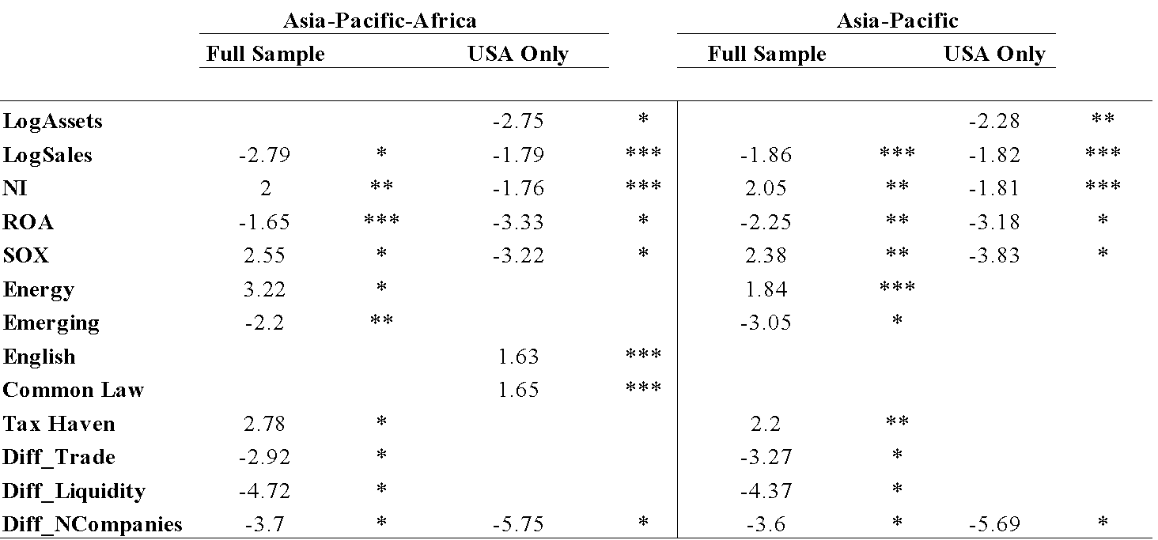

Asia includes firms from: China, Hong Kong, India, Japan, Korea, Russia, Taiwan, Indonesia, Philippines, and Singapore. Pacific (Oceania) includes firms from: Australia, Marshall Islands, New Zealand, and Papa New Guinea. Africa includes firms from: Ghana, Israel, Liberia, South Africa, and Tanzania. In the full Americas sample comprised of Asia, the Pacific, and Africa, firms with high sales, ROA, and those from emerging countries prefer the USA exchanges to others in the Americas. Energy firms, those with high NI, those from tax havens, and those listing since SOX prefer the other American exchanges to the USA. Trade balance is influential in listing with the USA, as are market liquidity differences and number of companies on the USA exchanges. In the Asia, Pacific, and Africa USA sample, firms with high amounts of assets, sales, NI, ROA, and those listing since SOX prefer the NYSE over the Nasdaq. Companies from English speaking and common law countries prefer the Nasdaq over the NYSE, while number of companies is a deciding factor for the NYSE. In the Asia and Pacific sample, or when Africa is dropped from the analysis, the same variables are significant for both the full sample and USA only sample. One difference is that firms from English speaking and common law countries are not significant when Africa is not included in the regression.

**Table II. Asia and the Orient**

The Asia sample includes 281 firms in the full sample (75% concordant with a chi-square of 146.4), and 250 firms in the USA only sample (51% concordant with a chi-square of 178.11). The Orient sample includes 240 firms in the full sample (75% concordant with a chi-square of 135.79) and 210 firms in the USA only sample (58% concordant with a chi-square of 169.58).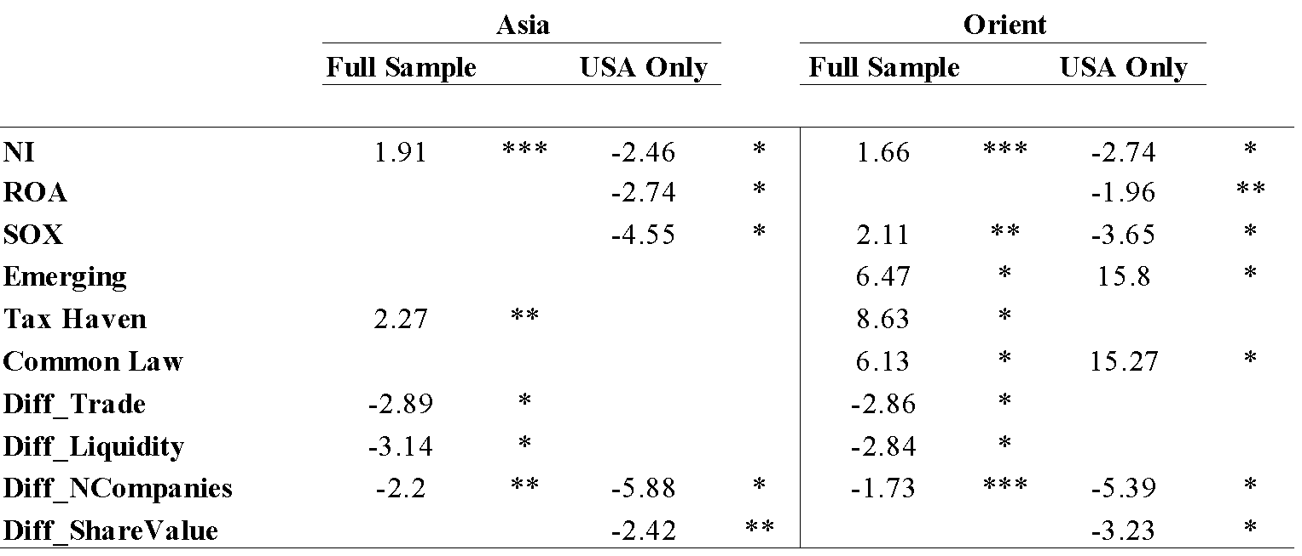

Asia includes firms from: China, Hong Kong, India, Japan, Korea, Russia, Taiwan, Indonesia, Philippines, and Singapore. Orient includes firms from: China, Hong Kong, Japan, Korea, and Taiwan. In the Asia full Americas sample, firms with high NI and those from tax havens prefer other American exchanges to the USA, while trade balance, market liquidity, and number of companies differences is more important when listing onto USA markets. In the USA only Asia sample, corporations with high NI, ROA, and those listing since SOX prefer the NYSE over the Nasdaq; number of companies and share value influence listing on the NYSE over the Nasdaq. In the Orient full Americas sample, companies with high NI, those listing since SOX, and those from emerging countries, tax havens, and common law countries prefer the other American exchanges to the USA. Trade balance, market liquidity, and number of companies listed is more important when listing onto the USA exchanges. In the USA only Orient sample, corporations with a high NI, ROA, and those listing since SOX prefer the NYSE, while companies from emerging and common law countries prefer the Nasdaq. Number of companies and share value is more relevant when listing onto the NYSE than the Nasdaq.

**Table III. Religious and Language Analysis**

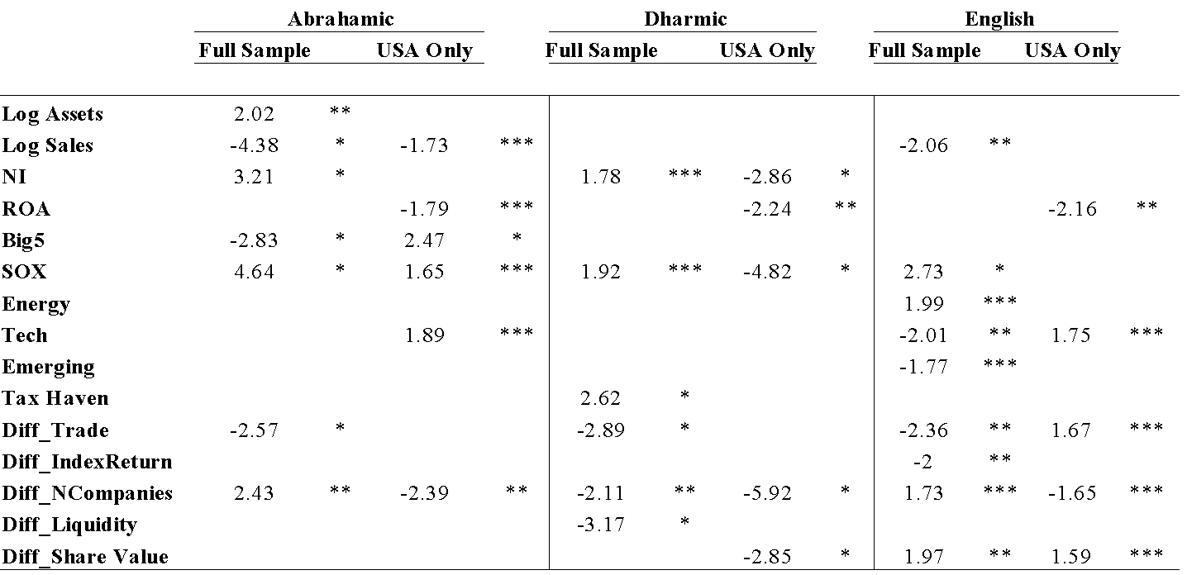

*The Abrahamic sample includes 219 firms in the full sample (68% concordant with a chi-square of 164.13), and 167 firms in the USA only sample (83% concordant with a chi-square of 152.03). The Dharmic sample includes 268 firms in the full sample(75% concordant with a chi-square of 143.14), and 237 firms in the USA only sample, and is (54% concordant with a chi-square of 177.42). The English speaking sample includes 132 firms in the full sample (84% concordant with a chi-square of 153.54), and 72 firms in the USA only sample (76% concordant with a chi-square of 75.24).*

The Abhramic sample includes firms from: Australia, Ghana, Indonesia, Israel, Liberia, Marshall Islands, New Zealand, Papa New Guinea, Philippines, Russia, and South Africa. The Dharmic sample includes firms from: China, Hong Kong, India, Japan, Korea, Taiwan and Singapore. Included in the English sample is firms from Australia, Hong Kong, Marshall Islands, New Zealand, Singapore, and South Africa. In the Abrahamic full Americas sample, companies with high amounts of assets, NI, and those listing since SOX prefer the other American exchanges over the USA, while those with high amounts of sales and employing a Big5 auditor prefer the USA exchanges. Trade differences are more important for USA listings, while the number of companies is more important for listings onto other American exchanges. In the USA only Abrahamic sample, companies with high amounts of sales and ROA prefer the NYSE over the Nasdaq, while those employing Big5 auditors in the year of listing, those listed since SOX, and technology firms prefer the Nasdaq over the NYSE; number of companies is more important for listing onto the NYSE than the Nasdaq. In the Dharmic full Americas sample, companies with high NI, those listing since SOX, and those from tax havens prefer the other American markets over the USA. Trade balance, number of companies, and market liquidity differences influences listings onto USA exchanges. In the Dharmic USA only sample, firms with a high NI, ROA, and those listing since SOX prefer the NYSE over the Nasdaq, while number of companies and share value also are reasons why companies may list on the NYSE over the Nasdaq. In the English full Americas sample, firms with high amounts of sales, those from emerging countries, and technology companies prefer the USA exchanges to the other American markets. Energy firms and those listing since SOX prefer the other American exchanges over the USA exchanges. Trade balance and index return are significant for firms listing onto the USA exchanges, while number of companies listed and share value are factors influencing listings onto other American exchanges. In the English USA sample, firms with a high ROA prefer the NYSE, while technology firms prefer the Nasdaq. Trade balance and share value influence listing onto the Nasdaq, while number of companies is important when listing onto the NYSE.

***5.1.2. Time Trends***

Prob (Pre-8/2002 =0; Post-8/2002 =1) (2)

= α + β1*logMVE* + β2*logAst* + β3*logSales* + β4*ROA* + β5*NI*+ β6*BTM* + β7*Big5* + β8*SOX* + β9*English* + β10*Energy* + β11*Tech* + β12*Emerging* + β13*CommonLaw* + β14*TaxHaven* + β15*Diff_Trade* + β16*Diff_Liquidity* + β17*Diff_IndexReturn* + β18*Diff_NCompanies* + β19*Diff_ShareValue* + ε

**Table IV. SOX Asia-Pacific-Africa, Asia-Pacific, and Asia**

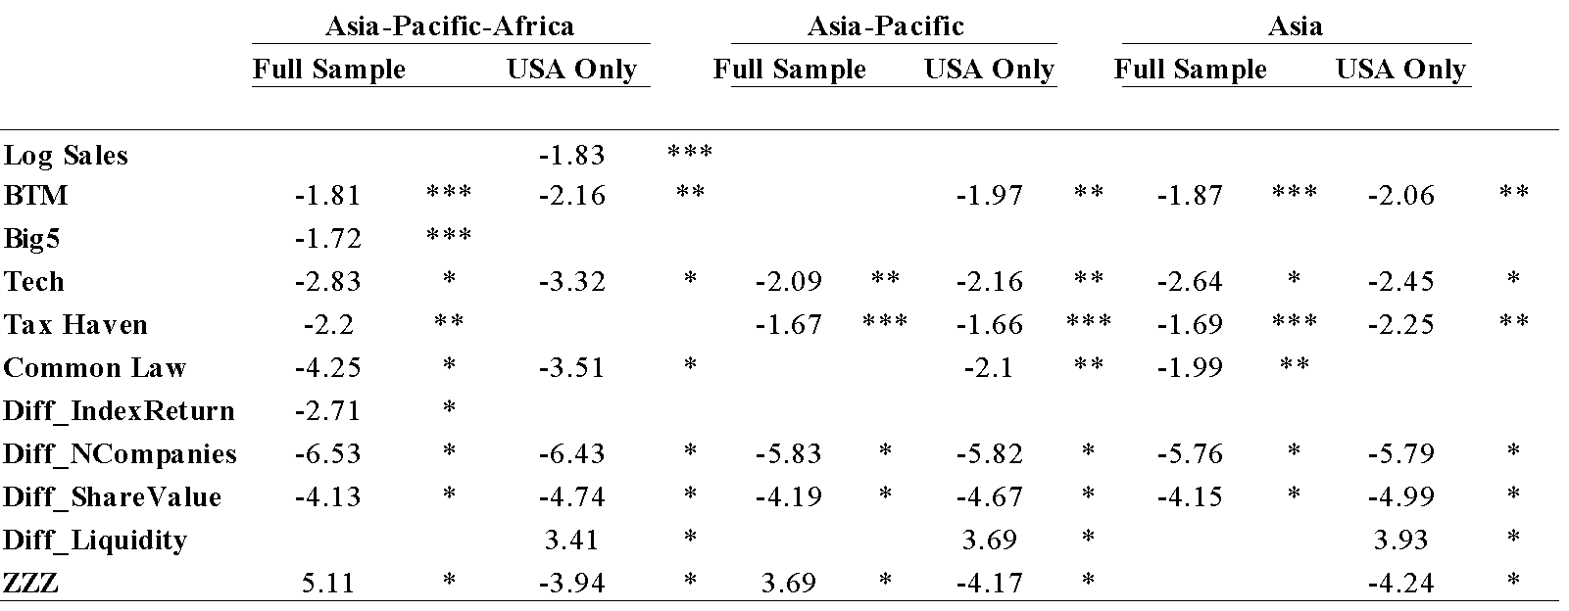

*The Asia-Pacific-Africa sample includes 487 firms in the full sample (36% concordant with a chi-square of 240.44), and 404 firms in the USA only sample (46% concordant with a chi-square of 250.75). The Asia-Pacific sample includes 352 firms in the full sample (36% concordant with a chi-square of 170), and 285 firms in the USA only sample (51% concordant with a chi-square of 201.76). The Asia sample includes 281 firms in the full sample (40% concordant with a chi-square of 150.64), and 250 firms in the USA only sample (57% concordant with a chi-square of 196).*

In the Asia, Pacific, and Africa full Americas sample, firms with a high BTM, Big5 auditors, technology firms, and those from tax havens and common law countries listed more before 2002. Number of companies and share value were more important factors in cross-listing decisions before SOX, and other American markets have been preferred to the USA exchanges since SOX. In the Asia, Pacific, and Africa USA only sample, firms with high sales, BTM, technology companies, and those from common law countries listed more before SOX. Number of companies and share value were more important before 2002, though since 2002 liquidity has been important in listing on USA exchanges; firms from these countries also have preferred the NYSE since SOX. The same factors are significant in all three samples.

**5.2 Time Series Analyses**

The time series analyses utilise a two-step time series stochastic process that employs unit roots to identify and remove nonstationary elements, and then regresses the significant factors in an ARCH model to identify the most important economy-specific and stock market-specific variables in the Asia-Pacific region.

***5.2.1. Currency Union Convergence***

Table V. Unit Roots

Table VI. ARCH

***5.2.2. Stock Market Integration***

Table VII. Unit Roots

Table VIII. ARCH Results

**6. Asia-Pacific Background Information**

What is beneficial to do now is to analyse in more depth some of the characteristics of the Asian-Pacific markets today, so as to attempt to understand what these results may mean for this region as completely as possible.

**6.1 China**

The Chinese stock markets appeared first in 1984, with the issuance of the stock of the Shanghai Feile Acoustics Company. Local leaders established the exchanges under their own control in 1990 and used them to maximise local investment and fiscal revenues, which resulted in deficient regulation and regular crisis. The China Securities Regulatory Commission (CSRC), the national-level regulator, was established in 1992, though initially was unable to effectively exercise control on behalf of the central government over the exchanges. In 1997, radical institutional change occurred, resulting in the empowerment of the CSRC and its effective take-over of the exchanges, which has led to a reduction in market instability and has oriented development towards the central government's priorities (Green, 2004). China's securities markets have opened further to foreign investors over the last few years into the WTO, as well as at their initial development stages, both the Shanghai and Shenzhen markets were inefficient, though the past decade clearly has seen a steady convergence of the two markets towards efficiency (Li, 2001). China also has over 1,000 companies and some three million investors that take part in an informal market in corporate equities organised in various locales outside the two stock exchanges in Shanghai and Shenzhen, and further this informal share market has appeared in a number of different guises since the establishment of the stock market in the late 1980s, partly as a result of the government's restrictions as to which type and what number of firms can publicly issue shares. Formal recognition by the government of these markets would provide a more secure basis for the Chinese financial system (Liu and Green, 2003). As of 2010, China’s main stock exchange is considering launching an international board that would allow foreign companies to sell shares denominated in Chinese currency for the first time. The Shanghai Stock Exchange is working on the board as part of efforts to promote the city as a regional financial centre, though details are yet to emerge. Since China's accession to the World Trade Organization, financial liberalisation has picked up considerable momentum. In 2002, the Chinese markets were opened to Qualified Foreign Institutional Investors (QFII).

***Chinese Integration***

There are two issues regarding integration of the Chinese markets, (i) integration amongst the mainland centres and the special political zones outside it, and (ii) their overall integration with the rest of the Pacific region and the world. The Chinese markets further have unique characteristics that will impact the integration of both the Chinese markets with each other, and the Chinese markets with the rest of the world. There are a few distinct characteristics of the Chinese stock markets, including A and B shares, and non-tradable shares.

One interesting facet of China's growth is that with the re-emergence of Shanghai, many people foresee the future demise of Hong Kong as the most important financial centre for the China mainland. Based on the concepts of comparative advantage and market segmentation, the extent to which Shanghai and Hong Kong can be considered complementary financial centres, as by using the listings of mainland China based companies on the stock exchange of each financial centre, it is shown that both cities do not only appear to have distinct hinterlands they also differ strongly in terms of sectoral specialisation (Karreman and Van der Knaap, 2009). The Shanghai and Shenzhen exchanges may go for a listing on the Hong Kong Stock Exchange, as the listing act will not only bring about better corporate governance to the Chinese exchanges (Yong and Fu, 2006). China’s stock market is fractionally cointegrated with the two markets, China’s stock market has stronger ties with its neighbouring Hong Kong market than with the US market (Yi et. al., 2010).

Since 2002, the Chinese A-Share market has demonstrated a long-term equilibrium relationship as measured by cointegration both with the other Chinese markets and with the USA markets. Tian (2007) discusses how the Shanghai A-share market has had a direct causality effect on the other regional Pacific markets since the Asian financial crisis and the A-share market and Hong Kong H-share market have had a significant feedback relationship since then, though no evidence there has been cointegrating relationship between the Shanghai B-share market and any other market since the B-share market inception. In terms of the time-varying nature of systematic risk in the Greater China equity markets, the Shanghai and Shenzhen markets both have a low average systematic risk when measured against the world market, and the short outbursts in systematic risk for these two markets seem to be directly related to policy shifts. The Hong Kong and Taiwan markets are more integrated with world markets and they show signs of large variations in systematic risk over time. Conditional betas in the Shanghai and Shenzhen markets are stationary, while the Hong Kong and Taiwan betas are integrated of order one. Long memory tests show that all four markets exhibit a long-run dependence in their conditional betas. While the two mainland China market betas are covariance stationary, the Hong Kong and Taiwan betas are not (Johansson, 2009).

China has established two stock exchanges, Shanghai and ShenZhen, with each exchange listing and trading both A shares (for domestic investment) and B shares (for overseas investment). The Shanghai markets and the ShenZhen markets are cointegrated, negating any effective diversification across the A share markets and across the B share markets of the two exchanges. Diversification across the HK market and the B share markets, however, would be effective. Overall, market efficiency is low, reflected by the findings that: the Shanghai A and B shares and the ShenZhen B share market returns could be forecasted by deviations from their long-run relationships; that the ShenZhen B share market returns could be forecasted by the Shanghai B share and ShenZhen A share market returns; and that the Shanghai B share market returns could be forecasted by the HK stock market returns (Wong, 1998). In terms of market segmentation and information asymmetry patterns, each of the six Chinese markets are not linked with other markets in the long run. Foreign investors in the Shanghai B-share market are better informed than Chinese domestic investors in the two A-share markets and foreign investors in Shenzhen and Hong Kong markets over time, thus suggesting that foreign investors could be more informed in emerging markets (Yang, 2003). According to causality tests between banks and the Shangahi Composite Index, stock markets in the greater China region are integrated and are strongly influenced by the psychological factors of investors, and a long-run stable equilibrium relationship between majority of the banking stock prices and the SSE Composite Index (Yao et. al., 2008).

In terms of Hong Kong and the mainland, the correlation between equity price and its fundamental value for H-shares is larger than the correlation for A-shares, as there have been big price gaps between A-shares and H-shares with exactly the same yields rights (Zhao et. al., 2005). There is also a price discovery process for cross-listing A- and H- shares, the Chinese stocks simultaneously listed in the Mainland China (MC) and the Hong Kong (HK) stock markets. Prices for cross-listing A- and H- shares in MC and HK stock markets are becoming more and more cointegrated, displaying an evolution of the emerging stock market in MC as the relative trading frequency or trading volume improves in HK relative to MC, though the MC market contributes to most of the price discovery. By combining the results of the econometrics method (IS and PT) with the decomposition of the bid-ask spread in market microstructure research, a significantly positive relationship between Mainland China’s relative shares of price discovery using both IS and PT methods and its relative Adverse Selection Component of the effective relative spread, indicating that the reason for MC dominating price discovery is the informational advantage of MC domestic investors (Ma et. al., 2009).

The evidence of lack of stationarity and ergodicity can be ascribed to two causes: (1) the initial interventions in these stock markets by the Chinese government by imposing various daily price change limits, and (2) the changing trading styles in the course of the development of these emerging stock markets, after the Chinese government left these equity markets to develop by themselves.

These stock markets were considerably more persistent before the deregulations, but that they now move much more efficiently. The Chinese stock markets are gradually and properly integrating into one Chinese stock market (Los and Yu, 2005).

**6.1.2 Hong Kong and Taiwan**

Hong Kong and Taiwan have distinct roles within the Chinese economy, both politically and economically. Hong Kong and Taiwan both enjoy special administrative region status with China. Taiwan sees a substantial amount of herding, while Hong Kong sees its volatility driven by a persistent component. The volatility of the benchmark Hang Seng Index is driven by a highly persistent component, punctuated by large jumps which are highly related to political events (Kim and Mei, 1994). Hong Kong instituted a three-year prelisting requirement on new issues led to no significant differences between before or after listing samples (Tse et. al., 2008). IPOs with high investor demand have large positive initial returns but negative longer-run excess returns, while IPOs with low investor demand have negative initial returns but positive longer-run excess returns. Investor demand for IPOs is largely driven by investor over-optimistic and over-pessimistic reaction to the information about the IPO's prospects prior to offerings (Agarwal et. al., 2005).

Taiwan opened its stock market fully on December 30, 2000, and after this openness, foreign investment volume increased and counted for more than one third of the market's value. Prior to the market's full financial liberalisation, market participants herded only when the market was on the downside. Since full openness, however, investors tend to herd when the market is on the up- or downside. Market returns tended to stabilise after the market was fully liberalised, though there is no clear evidence to support the conjecture that the industries favoured by foreign investors generate superior returns. While foreign investment comprises only one-third of the market value, considerable herding in the Taiwan Stock Exchange makes foreign investment dominate market movements. Foreign investment plays a stronger role when the market is at a downside, as when foreign investors are selling their holding shares, their behaviours would lead the market to a higher probability to switch from a bull market to a bear market regime (Hsu, 2008). Monetary policy has a real and quantitatively essential effect on the asymmetric conditional variance in equity returns in Taiwan (Chang, 2008).

As study of 18 leading country indexes reverse to the world trend with a speed of 18% per year, and the Hong Kong market converges to other markets with a speed of 22% per year or a half life of around three years (Balvers and Wu, 2002). According to studies of the 1997 Hong Kong crash, implied volatility of options is superior to volume and open interest of index options in forecasting future realised volatility (Fung, 2005). Data for the Hong Kong stock market, where individual investors' sentiment is likely to be influential, the publication of individual investors' sentiment temporarily affects stock prices regardless of the publication's incompetence in predicting stock returns. When the publication reports that more and more investors are optimistic, the return on the day just after the publication is higher and the return several days later is lower, the results are strongest for small stocks, and weakest for large stocks. Some individual investors buy (sell) stocks when others, as reported by the publication, are optimistic (pessimistic), and that the trading causes temporary buying (selling) pressure initially and price reversals afterwards (Chan and Fong, 2004).

When examining the Hong Kong stock market to determine the effects of removing short sales constraints on several trading characteristics of underlying stocks, the trading of underlying stocks become less active after the lift of short sales constraints; meanwhile the liquidity of underlying stocks is tightened and the information asymmetry among the investors aggravates, though there is no evidence indicating that the lift of short sales constraints seriously destabilizes the market (Cai et. al., 2006). During the Asian financial crisis, as Hong Kong illiquidity shocks, which results from volatility, have propagated to the other countries around the world (Chen and Poon, 2008). When pricing corporate credit risk for listed corporations in Hong Kong, both the equity value and the stock market index have significantly negative effects on credit spreads, while the implied volatility of the market index, which measures the economic risk, shows a significantly positive effect (Wong and Law, 2002).

The risk characteristics are more influential than the factor loading in the behaviours of stock returns. Either factor-based models or firm characteristics alone cannot fully explain the stock return behaviours in Taiwan Stock Exchange (Chen and Tu, 2000). The disposition effect, the tendency to sell investments are held for a profit at a faster rate than investments held for a loss, though Individuals, corporations, and dealers are reluctant to realise losses, while mutual funds and foreigners, who together account for less than five percent of all trades (by value), are not. Investors in Taiwan are about twice as likely to sell a stock if they are holding that stock for a gain rather than as loss, as eighty-four percent of all Taiwanese investors sell winners at a faster rate than losers (Barber et. al., 2006). Taiwan is a rapid growing financial markets are usually characterized by high volatility, relatively smaller capitalization, and less price efficiency, features which may hinder the effectiveness of those forecasting models developed for established markets (Chen et. al., 2001).

**6.1.2 Shanghai and Shenzhen**

The Chinese stock markets have a few defining characteristics. They have two class of shares, A and B, and there are distinct government regulations imposed on them. Psychological differences, different accounting standards for the B shares, varying returns for A and B shares, and ...

Chinese privatization initial public offerings (PIPOs) on the Shanghai and Shenzhen Stock Exchanges respectively see the average market-adjusted initial return is found to be 127.31%, and the initial returns on both stock exchanges are not significantly different from each other. The average market-adjusted buy and hold return over the three years after listing is 10.26%, with government ownership, the offering size, and the feature of belonging to a high-tech industry being the main determinants of the long-run performance. Corporations that perform better in the long-run tend to make more Seasoned Equity Offerings (SEOs), and the underpricing of IPOs is negatively related to their long-run performance (Chi and Padgett, 2002). On the Shanghai stock exchange, both individuals and institutions trade, buy, and sell more if past returns are high, and institutions tend to be contrarian traders. Trading of the individual investors is influenced more by trading of institutional investors, while trading of the institutional investors are mainly influenced by shocks from its past trading and shocks from market returns (Lee et. al., 2007).

Many companies on China's stock markets have separate, restricted classes of shares for domestic residents and foreigners. These shares are identical other than who can own them, though foreigners pay only about one-quarter the price paid by domestic residents. Plausible differences--about 4 percentage-points--in expected rates of return by foreign and domestic investors can account for the generally higher level and volatility of prices for domestic shares relative to foreign shares. Low Chinese expected returns to the limited alternative investments available in China. Various company characteristics can explain cross-company differences in the relative price paid by foreigners. Foreigners pay a lower relative price for companies with a higher proportion owned by the state--reflecting, surprisingly, a higher absolute price paid by both foreigners and domestic residents (Fernald and Rogers, 2000). The Chinese markets require that two sets of accounting information are to be prepared to list B-Shares. In terms of which one of these two competing sets of accounting information is more relatively with the stock's prices, Chinese-GAAP amounts are more highly associated with the stock's prices than IAS amounts, and the explanatory power of these earnings for stock's prices decreases over time (Hu, 2002).

Since the abolition of ownership restrictions in 2001 of the B-Share market, day-of-the-week effects are attenuated after the market entrance of Chinese individual investors who had previously not been allowed to trade in B-shares. Institutional rather than individual investors are a main driving force behind such anomalies, reduced index return auto-correlation and USA spillover effects in the post-liberalisation period (Siklos, 2008). In emerging markets, stock prices frequently deviate from their fundamental values resulting in high volatility caused, in part, by the growing influence of highly mobile foreign capital, despite possible segmentation, though B shares do not show significantly different volatility characteristics when compared to the volatility characteristics of A shares. Daily returns exhibit significant conditional volatility and non-linearity, though regulatory changes does not significantly change persistent volatility and non-linear characteristics. There is no presence of commonly reported day of the week effects for both Shanghai and Shenzhen A and B markets, with the sole exception of Shanghai B market, conditional volatility does not appear to influence the pricing of shares. B share markets are becoming progressively more correlated with the global markets, and volatility in B shares appears to be more affected by the developments in the domestic A share markets (Poshakwale, 2001)

In the Shanghai and Shenzhen markets, the prices of the A shares are relatively random in the short-term window (up to 10 days) after the price shock, those of the B shares carry on increasing significantly after both the positive and negative shocks. This trend is more pronounced for large shares with high liquidity, in contrast to the efficient market hypotheses expectations, which suggests that any abnormal performance should be arbitraged away sooner in a frictionless (in this case liquid) market. In the post-2001 period when the B shares are open to domestic investors, we find a significant drop in the post-shock abnormal returns in B shares, due to the high level of optimism of foreign investors (Lasfer et. al., 2007). The effect of price limits is asymmetric for the A shares in upward and downward price movements and different for bullish and bearish periods. During a bullish period price limits effectively reduce stock volatility for downward price movements, though not for upward price movements; while during a bearish period price limits effectively reduce stock volatility for upward price movements, though not for downward price movements. Price limits delay efficient price discovery for upward price movements, yet not for downward price movements, though there is no evidence to suggest that price limits harmfully interfere with the stock trading processes in the Chinese A share markets. Actively traded stocks hit their price limits more often and tend to hit the lower limit more frequently when overall market conditions are bearish. Stocks with high book-to-market values of equity hit their upper price limits more frequently, while stocks with a high ratio of tradable shares tend to hit their price limits less frequently (Chen et. al., 2005).

Only after Chinese companies become really commercialised and profitable and investors become rational can the stock markets become stable without extreme volatility as seen in the past. Government policies can play a role in soothing market volatility detrimental to shareholders and the wider economy, though investors should not depend on the government for making their own investment decisions (Yao and Luo, 2009). Stock markets in mainland China region are integrated and are strongly influenced by the psychological factors of investors, and the financial services institutions are highly integrated with the efficiency of the stock market (Yao et. al., 2008). From a cultural perspective, the Chinese see 8 as a lucky number, and 4 as unlucky, as price clustering is the tendency of prices to be observed more frequently at some numbers than others, and results from human bias and from haziness or imprecise beliefs about underlying value. Preference for 8 on both A-share exchanges was initially very strong, but has dissipated somewhat over time, about twice as likely. For the Shanghai A-shares the reduction in the cultural preference only occurred in the most recent period whereas for Shenzhen the reduction occurred considerably earlier. Overall, the cultural preference was widespread for both A-markets and was in fact stronger in opening, high and low relative to closing prices. The preference for 8 was much weaker for B-shares, largely held by foreigners, on both exchanges (Brown and Mitchell, 2004).

**6.2 India**

India currently has two major stock exchanges: The Bombay Stock Exchange and the National Stock Exchange. The stock markets in India have witnessed rapid growth, led by reforms, since the early 1990s and the surge in foreign portfolio capital flows. India's financial markets went from a situation in 1994 with one dominant market which used open outcry, to a situation with two competing electronic exchanges 1995. India, like China, has traditionally had closed doors when it relates to foreign investment; however, India's decades old policy of 'swadeshi,' or economic self-sufficiency, seems to be beginning to take a back seat to limited foreign trade. The process of Stock Exchange demutualization is going on in India and the Indian capital market regulator, the Securities and Exchange Board of India (SEBI) is searching for solutions concerning the issue of their listing, possibly cross-listing of stock exchanges, though cross listing cannot be the sole solution in the post-demutualisation phase and has to be in addition to self-listing along with measures to manage the potential (Jain and Jodhpur, 2007), similar to what is going on with the Hong Kong and Shanghai and Shenzhen markets.

The National Stock Exchange (NSE) is India's first fully demutualised stock exchange and the largest exchange in India in terms of volumes in both equity and derivatives segments. There are important differences in ownership structure, geographic reach, internal controls systems and institutionalised risk management facilities between the Bombay Stock Exchange and the National Stock Exchange, as well as different market performance characteristics on the two exchanges.

India's international integration has strengthened in the recent period beginning 2003. The integration of India's stock market with the global markets, such as the USA and the UK, is much higher than with the regional markets such as Singapore, Hong Kong, and Japan. Cointegration of the Indian stock market with the global and regional markets holds for stock prices measured in USA dollar rather than local currency, attributable to the role of international portfolio investors and capital flows (Raj and Dhal, 2009). Chittedi (2010) also found evidence of stock market integration between India and developed countries such as USA, UK, Japan, France and Australia. through analysis of stock indices. There may be integration between foreign exchange and stock markets in India during the liberalisation era, as there is a strong causal relationship in each financial year why the extent of market integration changes over time, and they suggest that this causal link especially may be increasing since the Asia crisis (Nath and Samanta, XXX). As for the two indices, both the stock indices return (Rsensex and Rnifty) are near normal whereas exchange rate return is not normal and more peak. The stock return and exchange rate return are positively related in India, which implies gains can be made by international investors (Mishra and Paul, 2008). Dicle et. al., (2009) also determined that the Indian markets are well integrated with the world markets, as the day-of-the-week effect seems to be a spillover from international markets. 86% of BSE and 91% of INE are Granger caused by at least one international market even after controlling for their liquidity and market returns. Apart from exhibiting a significant contemporaneous or same day inter-market relationship among India and most of the other foreign countries for price co-movements, there is also an increasing tendency in the degree of integration among the markets over a period of time (Mukherjee and Mishra, 2006).

Equity derivatives trading started on June 9, 2000 with introduction of stock index futures by Bombay Stock Exchange (BSE), and National Stock Exchange (NSE) also commenced its trading on 12 June, 2000 based on S&P Nifty, and included other products like stock futures on individual securities, index options and options on individual securities, with the S&P Nifty showing decline in volatility, and the BSE Sensex exhibiting a rise in volatility (Sah and Omkarnath, 2006). As for price integration between the two domestic stock markets in India, the Bombay Stock Exchange (BSE) and National Stock Exchange (NSE), there is a long-run equilibrium relationships between the variables. The long-run causal flows are unidirectional - running from NSE to BSE - and are found through the error correction mechanism, thus giving evidence for price integration between both the stock markets. Two measures of liquidity, aggregate trading volume and trading frequency at the security level, both have improved strongly for the BSE since the implementation of BOLT automation and the beginning of the NSE. The improvement in BSE trading frequency seems to be composed of a strongly positive effect of BOLT (automated trading) and a negative effect caused by competition with the NSE, with volatility increasing under BOLT (Shah and Thomas, 1996).

In terms of performance of value and growth strategies in India, stock returns in India increase with market capitalisation and price-to-earnings ratio (P/E), and decrease strongly with dividend yield (Sabharwal and Crack, 2009). Also, Indian investors' size factor has no higher influence on cross-sectional random stock returns, though the investors are influenced more by the value factor, as investors care less for the number of shares of a corporation that are traded on the floor of stock exchange, and more about the book value and market value of share (Mohamed, 2007). There are average abnormal returns around the dividend income announcement of corporations on the Bombay Stock Exchange, indicating over-expectation of investors regarding dividend announcements in the information leakage phase, which subsides considerably with new information disclosure (Chander et. al., 2007).

There are significant differences in liquidity and price volatility between the BSE and the NSE (Krishnamurti and Lim, 2001). There is little volatility present in the inter day returns in the stock of the two major national India’s Stock Exchanges, though there is volatility clustering and persistence of shock (Sinha, 2006). When measuring the impact of volatility from four parameters including closing, low, high quotes, and an average to find an entropy of volatility, there has been a relatively high impact from volatility computed on high-low-closing prices, though the lowest impact is found for volatility computed on high prices of the securities on the BSE (Bagchi, 2007). In analysing the volatility over the day, month, and year, for scrips on the BSE, stock returns do not follow normal distribution, and there is significant support for non-normality of stock returns of all the sample companies drawn from the Electrical, Electronics, Machinery, Mining, Non-Metalic, Power Plant, Diversified and Miscellaneous sectors (Padhi, 2006). Stocks on the NSE, following suspension, volatility, efficiency, and liquidity improved and the CARs were significant though not uniformly positive or negative. Less liquid stocks traded less in the auctions than other securities, especially at the opening, and they experienced the most gains following suspension (Camilleri and Green, 2005). As such, as less-liquid stock may not trade that well at auction in developing markets, this is a relevant concern for some of the Asia-Pacific countries.

By analysing the stability of beta for various stocks that formed a part of Bombay Stock Exchange Sensitivity Index (Sensex), Sarna and Sarnah (2008) suggest that BSE betas are unstable over time. The demand generated on the NSE for an issue during book building and the listing delay positively impact the first day under pricing, whereas the effect of money spent on the marketing of the IPO is insignificant. As usually is the case, the post IPO performance in one month after the listing for the firms under study is negative (Pande and Bangalore, 2009). Illiquidity that afflicts the stocks listed on the BSE is only a few of the more than 6000 listed stocks. Looking at the characteristics of firms leading to differential levels of trading frequency and also the resultant effect on average returns, there is evidence in favour of a liquidity premium for stocks on the BSE, with trading frequency being positively related to the number of shareholders and shares outstanding. The ownership structure also seems to matter, with concentration in the hands of insiders and government bodies having a deleterious effect on liquidity (Eleswarapu and Krishnamurti, 1994).

**6.3 Singapore and Malaysia**

The Singapore Stock Exchange automated fully in 1989. The Stock Exchange of Singapore Limited issued a set of guidelines on 7 June 1991 for the purpose of regulating share trading by directors of listed companies as well as associated companies, SES hopes to convince investors that the stock market provides a level playing field (Choong et. al., 1991). In terms of economic variables and integration, Singapore's real GDP and Singapore's stock market capitalisation in real terms have a positive relationship with inward foreign portfolio investment in Singapore, while USA interest rates are negatively related to foreign portfolio investment flows into Singapore. On balance, domestic (pull) and foreign (push) factors are equally important in determining the flow of foreign portfolio investment into Singapore (Lay and Wickramanayake, 2007). Parinduri and Thangavelu (2009) note that %, trade liberalisation and FTAs do increase the value of corporations, as the removal of the last obstacle to the free trade deal with the USA in January 2003 increases the value of firms in some industries by 2-5 in Singapore.

Improvements in market efficiency appear in reduced serial correlations of returns, though bid-ask spreads and their variability widen somewhat (Naidu and Rozeff, 1994). The level of annual report disclosures is positively related to the accuracy of earnings forecasts by analysts, provided there is no big earnings surprise, and is also positively related to analyst following, The level of corporate disclosure is negatively related to dispersion in analysts. earnings forecasts provided there is no big earnings surprise. More corporate disclosures by Singapore firms lead to more accuracy and less dispersion in the earnings forecasts among analysts, greater corporate disclosure can also lead to greater analyst interest in the firm (Eng and Teo, 2000). As trade linkages is one of the factors that increase the linkages of stock market movement between countries, there is a long run relationship between Malaysian and the Philippines stock markets as well as between Malaysian and the United States stock markets for period before the financial crisis. Before the 1997 financial crisis, the daily price movement of Malaysian stock market is found to lead the daily price movement in Indonesia, China in the short-run, and the Philippines in the long run. In addition, there is a bi-directional relationship between Malaysia and the stock markets in Hong Kong and Thailand. The short-run causal relationship between the Malaysian stock market and the stock markets of its major trading partners started to weaken after the financial crisis. Such finding is highly attributable to the fact that Malaysia's imposition of capital control in September 1998 in their attempt to curb speculative attacks had been relatively successful in shutting out foreign influences (Abd Karim and Gee, 2006).

**6.4 New Zealand**

The New Zealand Stock Exchange is the primary capital market in New Zealand. New Zealand has grown into a more open economy over time, as during the 1970s and 1980s, the stock market appears to have been inefficient with thin trading and non-linearity as leading causative agents, though the New Zealand stock market has become more efficient since 1990 (Rayhorn et. al., 2007). Good example of crisis management tactics utilized by New Zealand Stock Exchange, through CASE corporate communication strategies with its various stakeholders such as its market regulator, investors, students, issuers, members, and the media, and CASE future communication plans (Shahid, 2006). New Zealand and United States stock market is cointegrated, though the New Zealand stock market is not cointegrated with Australia or other G7 member stock markets (Narayan and Smyth, 2005). In terms of the financial statement impact of constructive lease capitalisation on the New Zealand Stock Exchange, constructive capitalisation has a material impact on reported liabilities and financial ratios, and relative to present value procedures of constructive lease capitalisation, heuristics used by analysts lead to the overstatement of lease liabilities and lease assets. The use of single cross-sectional parameters (e.g., discount rates, lease life) results in constructed lease assets and liabilities that are similar to more elaborate firm-specific procedures. Most countries like the USA require lease capitalisation (Bennett and Bradbury, 2003).

On the NZSE, privatisations have significantly increased market capitalisation, trading activity and liquidity, and privatised companies are generally larger in capitalisation and hence more liquid due to increasing investor interest, illustrated with a larger number of shareholders (Kerr and Rose, 2002). Changes in the board of directors is a statistically significant determinant of both writedown decision and the dollar amount of writedowns, changes in chief executive officer, corporate firm size as measured by total assets at balance date, and a firm's growth opportunities provide some support in explaining the dollar amount of writedowns (Ahmed and Roush, 2002). When analysing five economically-neutral psychology events, one of these events is associated with mean or median returns that are statistically different from those on non-event days, and several events offer returns that differ from those on non-event days in an economically significant manner. The variance of returns for event days is typically much greater than the variance for non-event days, and the market's propensity to react to economically-neutral events is largely independent of the mid-1980's market reforms (Boyle et. al., 2003).

In New Zealand, using value-weighted portfolios, in terms of price momentum profits, stock-specific factors dominate industry factors, and small stocks and winner stocks are better sources of momentum alpha than large stocks and loser stocks, respectively, and the gross momentum profits are more than fully consumed by transactions costs (Trethewey and Crack, 2009). A strong momentum effect, rather than a reversal effect, is present in this market. These strategies are most profitable when they are based on formation and holding periods of three-to-six months on the NZSE, though the profits generated by such investment strategies cannot be explained by either the small firm effect or the January effect (Kot, 2007). When determining why there are significant abnormal ex-date returns for stock dividends, even though the ex-date is known in advance and the distribution contains no new information, the higher transaction cost of selling odd-lot share parcels compared to round-lot share parcels is a key driver in the abnormal returns. Prior to October 1991 stock dividend ex-dates exhibit significantly positive returns, however, no significant ex-date return once the higher odd-lot transaction costs were removed. In terms of the New Zealand market imputation tax based argument of the ex-date price reaction, imputation tax credits have a value greater than zero (Anderson et. al., 2004).

**6.5 Australia**

The Australian Stock Exchange has long been the most dominant in Oceania, although there are several others in Australia, including the: Bendigo, National, and Australian. ASX is a self-listed stock, and consistently outperforms the stock index. Profitability ratios of the ASX have significantly improved in the five years following the demutualization and self-listing of the ASX, and these performance improvements remain significant even after controlling for growth in the Australian economy. Since 2002, bid-ask spreads of the stock market have narrowed, and small-cap corporations have become more liquid (Otchere and Abou-Zied, 2007). The Australian Stock Exchange (ASX), utilises a stock market monitoring program whereby when the ASX observes unusual share price or trading volume changes of a listed company, it sends a letter demanding an explanation. When asked, some companies do release new information to the market when asked, and share prices usually fluctuate accordingly based on the type of the information produced (Gong, 2007).

Speaking to integration prospects, there is even evidence of increased trading activity by foreign investors after ASX's demutualisation and self-listing. In terms of exchange rate risk in the Australian equities market, exchange rate exposure increases as the return intervals increase. The Australian dollar also seems to be more integrated with the USA dollar, as when the dollar and yen exchange rates are compared, the AUD/USD outperforms the AUD/JPY in Fama-French stock market tests (Di Iorio and Faff, 2002). When analysing the impact of currency shifts on the market value of major Australian banks and the value of the Australian dollar against other major currencies, a drop in the value of the banks' offshore assets in terms of USA dollars and Sterling Pounds lowers the stock price, though not for the New Zealand dollar.

In terms of whether or not current economic indicators, as reflected in interest rates and exchange rates, can explain stock market returns or vice versa. There is a negative relationship between the level of interest rates and the PB ratios in Australia indicating that the present value of future income streams is an important issue for investors investing in bank stocks (Chi et. al., 2007). There is no evidence that Australia's bank stock market returns form a cointegrating relationship with short- and long-term interest rates and exchange rates, though there are causality runs from bank stock returns to interest rates and exchange rates (Simpson and Evans, 2003). In terms of the relationship between unexpected changes in macroeconomic variables and Australian stock returns, stock returns are positively correlated with any surprise news in the current account deficit, the exchange rate and growth rate of real GDP, and negatively correlated with surprise news about the inflation rate and interest rates.

Stock returns are also positively correlated with the unexpected unemployment rate and negatively correlated to revisions in the expected unemployment rate, and market portfolios can detect the impact of common economic shocks better than the portfolios of the two main sub-sectors of the market (Sadeghi, 1992). As for whether the macroeconomic variables through Arbitrage Pricing Theory (APT) can explain the returns on the stock index in Australia, industry indices' returns can explain consumer discretionary, energy, financial, IT, and materials, price index returns, though cannot explain other index returns (Wang, 2008).

As for seasonality in the Australian market, all three forms, day-of-the-week, turn-of-the-month and month-of-the-year, with Tuesday, September and the second trading day of the month are the most significant, though there are parameter instability and structural breaks in these relationships, with day-of-the-week effects becoming less important in the post-1987 crash period (Worthington, 2008). Seasonal prices of assets such as bonds, stocks, currencies and commodities have also shown that asset prices approximately follow a martingale process on the ASX, though the distribution of asset returns tend to be fat-tailed. The extreme returns are found to belong to a range of extreme-valued family of distributions, while the distribution of the underlying returns generating process is conditional on the blocksizes used. Maximal and minimal returns have differing distributions, and are correlated, indicating a possible bivariate returns generating process, and extreme returns are found to be weakly correlated, implicating possible volatility clustering of the extreme returns (Jeyasreedharan et. al., 2009).

Environmentally speaking, both quantity of disclosure and quality of voluntary environmental and social responsibility disclosures in annual reports are highly correlated. Stakeholder power, strategic posture, and economic performance are significant in explaining the quantity and quality of environment disclosures in annuals reports, while the stakeholder power by shareholder, regulator and lobby groups are significant in explaining environmental disclosures. The strategic posture dimension by content of the mission statement and existence or otherwise of environmental or social responsibility committees are also significant. Economic performance is not supported by the results, though size is found to be a significant predictor of disclosure practices (Kent and Chan, 2003). The CGC of the ASX recommended that quantity and categories of environmental information disclosed in the corporate annual reports be good for shareholders, and an increasing number of companies are disclosing environmental information, with the relative volume of such information in annual reports is increasing across all categories (Gibson and O'Donovan, 2007).

In terms of the relationship between accounting variables and firm valuation, for firms which are above optimal leverage, earnings contain a greater level of transitory items, particularly when firm size is small, and cashflows provide higher incremental information. Investors perceiving earnings as progressively less informative as the probability of failure increases, and the likelihood of earnings manipulation for the purpose of reducing proximity to debt covenants increases (Stevenson-Clarke and Hodgson, 2000). On the ASX, there is a relationship between the extent of initial public offering (IPO) underpricing and market sentiment surrounding technology issues due to hype surrounding their issuances and the issue of cash burn, and thus going concern accountancy issues for these types of corporations. The extent of underpricing is systematically related to variables measuring the market sentiment surrounding the listing of an IPO, as underpricing is higher following high underpricing in similar recent issues, and there is higher underpricing for firms with higher media interest and in the period of the hot IPO market. Firms that experience a greater rate of cash burn also experience greater underpricing consistent with the conjecture that such firms are more likely to need additional financing shortly after they go public. The association between cash burn and underpricing is however reliant on several issues, including warnings in the prospectus regarding going concern issues, which can provide a valuable signal to mitigate uncertainty about the value of an offering, thereby reducing the subsequent level of underpricing achieved by that firm (Ho et. al., 2001).

Trade imbalance has a positive effect on the probability of price change, though \intra-day durations have a negative effect on price change, as forecasting analyses reveal that in 71% of the cases the system successfully predicts the direction of the subsequent price change (Parwada and Yang, 2008). In terms of corporate distress and the predictive power of accounting variables, investors in failed firms typically incur substantial negative stock returns leading up to failure announcements, though not on the day of announcement (Frino et. al., 2007). On the ASX, smaller companies seem to enjoy growth more than larger companies (Hotson et. al., 2007). On the ASX, in terms of energy and gold corporations, the market valuation of gold mining firms contain a premium for the option to close, and the difference between the present value of expected future cash flows and the market value of mining operations is accounted for by the options to close (R2 = 62.7%). The existence and magnitude of the option premium to close is dependent on other observable attributes of the mining firm, specifically the degree of moneyness of the firm's operations (Kelly, 2004). Using two 130/130 strategies, a returns and momentum based, the 130/30 portfolios have higher information ratios and earn higher risk-adjusted returns compared to their long only counterparts (Frino et. al., 2008).

Australian firms consider transaction costs and the effect of information asymmetries when determining debt maturity, as well as the correlation between earnings and interest rates when determining maturity, although it is likely that the emergence of interest rate derivatives has reversed the role played in this correlation. There is little support for the asset-matching principle, which is often cited as the most common determinant of maturity policy, though changes in maturity factors over a recent period of significant personal and corporate taxation changes, after the period of taxation changes, the role played by agency costs and asset maturity appear to increase in importance (Alcock et. al., 2008). Fund managers prefer large, liquid and low volatility stocks, though do not prefer to hold stocks that are past winners. In relation to derivatives, around half of the fund managers hold derivatives in the form of exchange traded options, and the level of exposure to stock price movements achieved by options is not significant relative to the total investment portfolio (Pinnuck, 2004).

Price, liquidity and volatility impact of underlying stocks after warrant issuance and find considerable differences to those found for option listings. There are significant negative abnormal returns on both the announcement and listing date of derivative warrants are reported, followed by a negative price drift. Relative trading volume and price volatility of underlying stocks are found to be significantly higher post-warrant listing. Warrant holders are unable to realize gains for the majority of trading days when they are alive, consistent with the view that banks trade profitability from their issue (Aitken and Segara, 2005). Australian options are European options traded on the ASX, and they have similar prices (Moreno and Navas, 2004). After controlling for the effects of information related trading halts on price discovery on the ASX, halts were found to be attributable to abnormally high trading activity, bid-ask spreads and excess volatility. Halts initiated by highly informative news releases are associated with the greatest amounts of abnormal volume, spreads and excess volatility, and lost trading volume and price adjustment was not contained to the reopening period. Abnormal levels of trading activity, spreads and volatility appeared to persist for up to two days following halts, and halts around informative news releases appears to hinder the price discovery process (Aitken et. al., 2008).

When quote returns are used instead of trade returns for block transactions, price continuations follow both purchases and sales, and the asymmetry in price behaviour following block trades is driven by bid-ask bounce (Frino et. al., 2003). In terms of price response to large block transactions made on the Australian Stock Exchange, there is asymmetry in the price reaction between buyer- and seller-initiated trades with respect to size and resiliency following the trade. Order book changes surrounding block trades and relating price effects to changes in book depth. Purchases are associated with persistent order book imbalance, while the sales imbalance is insignificant. Price resiliency following a trade is related to the speed at which limit orders arrive to replenish book depth (Anderson et. al., 2002).

**6.6 Tokyo**

Japan has one of the largest economies in the world, as well as one of the most active capital markets. The Tokyo Stock Exchange is the primary Japanese capital exchange, while the Osaka and Mothers exchanges are also often used. Overall, interest rate differentials between the financial centres of Japan and other regions do not follow a random walk, and hence are suggestive of market efficiency - in the sense that arbitrage opportunities did not persist. Integration in Japan is characterized by multiple stochastic elements with four long-run cointegrating relationships. Shocks occurring in a financial centre, such as the Kanto region in which Tokyo is located, were transmitted to outlying regions and had permanent yet small effects on their rates (Mitchener and Ohnuki, 2007).

As for these three exchanges in Japan, Bahng (2009) finds that the financial ratios of Tokyo, Osaka, and JASDAQ show converging behaviour over time, though differences in individual regression coefficients such as ROA and non-debt tax shield do exist between listed and delisted firms, and the overall regression coefficients about debt ratios seemed to be differently influenced by the states of the economy. Japan also has regional markets in Nagoya, Fukuoka and Sappora. Premia associated with size are dominant in valuation and cost of equity estimates for the international exchanges of Tokyo and Osaka, while liquidity is the dominant factor in the three regional markets. Costs of equity are very low in Tokyo and much higher in Osaka, reflecting the limited role of the equity market in the latter in contrast to its specialization in other financial products. Costs of equity are substantially higher in all three regional exchanges reflecting a high informational or liquidity premium. The Japanese regional exchanges have been able to reap significant economies of scale in achieving horizontal integration of their operations with a common clearing, settlements and payment systems largely through having a shared stable macroeconomic environment. While this enables their ability to compete with the lethargic regional banking sector it also facilitates the study of the informational premiums arising from the asymmetric information of focussing on SME financing (Hearn et. al., 2010).

One of the more distinguishing aspects of the TSE is price limits, which many claim are effective in curbing undesired fluctuations of stock prices and in protecting the market from crashes. Price limit advocates claim that price limits decrease stock price volatility, counter overreaction, and do not interfere with trading activity. Conversely, price limit critics claim that price limits cause higher volatility levels on subsequent days (volatility spillover hypothesis), prevent prices from efficiently reaching their equilibrium level (delayed price discovery hypothesis), and interfere with trading due to limitations imposed by price limits (trading interference hypothesis) (Kim and Rhee, 1997). Stocks that hit the upper limits tend to have smaller systematic risk, while stocks that hit the lower limit tend to have high systematic risk. Lower limit hits are mostly due to market driven downward movements, while upper limit hits are more likely related to company driven upward movements (AlShattarat et. al., 2009). An increase of price limit hits on Monday and Tuesday, for the day-of-the-week effect of stock returns in Japan. Such patterns of price limit hits are not all due to noise trading, though high limit hit occurrences are associated with high volatility and low limit hit occurrences are associated with low volatility (Nobanee et. al., 2009).

The Tokyo Stock Exchange runs like most other highly developed exchanges, and sees some of the same characteristics as they do. For example, as with most exchanges, regardless of tick and lot size, prices ending in zero and five are the most popular for price clustering. The TSE is purely electronic exchange, and so has no market makers or direct negotiation between traders; therefore, clustering is not explained by collusion or negotiation (Aşçıoğlu et. al., 2007). The TSE is also a pure order-driven market, which means executions are carried out by matching limit orders on the limit order book with incoming market orders. Analysing execution orders, Omura et. al., (2000) determined that execution probabilities of limit orders are low when the depth of the same side of the limit order book is thick, execution probabilities are high when the depth of the opposite side of the book is thick, execution probabilities are low when there are open ticks between the bid-ask spread, and execution probabilities are higher for limit orders submitted during earlier times of the day. On the TSE, stocks with higher turnover tend to have a lower expected return (Hu, 1997). Most TSE stock are more volatile at open than close. As such, daytime and overnight return covariances suggest that the volatility patterns are explained by the effect of implicit bid-ask spreads at the open and partial price adjustment at the close, both of which are related to the intensity of trading. Open-to-open returns are more volatile than close-to-close returns for stocks in general, and are consistent with the hypothesis that TSE price limit rules have a significant impact on the dynamics of security prices (George and Hwang, 1995).

Japan and the USA are two of the most developed economies in the world, though they do have differences. There are different accounting rules in Japan, as there are in many countries, which has led to differences in accounting estimates. As for stock exchange indicators, Bauwens (2005) found that for the usual stylised facts such as intra-daily seasonality clustering and overdispersion, the data is similar for the TSE and the NYSE. Further, as Japan is a developed market such as the USA, investors from less developed regimes can sometimes take advantage of corporate Japanese laws and profit on the domestic institutions and investors who have stricter rules to follow (Bae et. al., 2002). On the TSE, volatility dampens by more than 57% from the average level when there are greater sell trades by profit-taking investors, mostly by domestic investors, supplying liquidity while there are less momentum buy trades that demand liquidity (Bae et. al., 2006). Also similar in Japan and the developed markets in the Americas and Europe, it is the composition of shareholders, in terms of individual investor participation, rather than the total number of shareholders, that determines the effect of a change in MTU on share prices, as the greater is individual shareholder participation, the greater the return from MTU reduction (Ahn et. al., 2005).

Also on the TSE as for balance sheets and accounting aspects, large stocks offer little profits to score-based cash flow generating portfolio strategies, as most of the abnormal returns are concentrated on small firms with a market under reaction to the financial information released by smaller lightly researched firms (Nguyen, 2003). On the TSE, the accounting accruals and their components, in particular, the abnormal accruals, have significant explanatory power in explaining the future stock returns, even after adjusting for the systematic risk of the stocks. Hedging portfolio tests find that the accruals information helps investors earn abnormal returns, and the larger the abnormal accruals of the firms, the higher the subsequent downward revisions of analyst forecasts. The analysts fail to incorporate the full implications of accruals information in forming their forecasts, even though such an overestimation or underestimation eventually is corrected as the next year's earnings related information becomes publicly available (Kubota et. al., 2006). On the TSE, as is contrary though most common, turnover is higher for stocks with gains (winners) than for stocks with losses (losers), and the winner stocks of keiretsu firms tend to have high end-of-fiscal-year turnover, thus capital gains taxes have only a small impact on turnover volume in Japan. As with other exchanges as well, other non-tax-related motives, especially window dressing motivated trades appear to dominate investor behaviour, and this window dressing is concentrated in the stock of keiretsu firms (Bremer and Kato, 1996).

**6.7 South Korea**

The Korean Stock Exchange is one of the most growing exchanges in the world, including the Kosdaq. Korea is a growing market still, and as such is still not yet as open a market as the American or European, though is more so than many other Asian markets. Korea has been more aggressive than most other Asian markets in demutualising their markets, though they are still far away from full openness, which is not necessarily a bad thing. The Korean stock market began to demutualise in the early 1990s with other countries in East Asia, and is now one of the more developed countries in the world. In fact, in the early 1990s many Korean corporations found themselves in the position where they needed to issue convertible bonds overseas due to investment restrictions, though now are able to fully accommodate their domestic companies with the KSE, culminating in 1998 with the complete abolishment of foreign ownership restrictions, which has significantly improved the information role of foreign investors in the Korean stock market (Kim and Yi, 2008).

As far as Korea and the USA, lagged volatility spillovers from Korea to the USA do not exist in either the Korean or the USA stock markets, though when KOSPI returns measured in USA dollars are used, statistically significant lagged return spillovers exist from the USA to Korea, though not from Korea to the USA, the lagged return spillovers with returns measured in USA dollars may result from the way the Korean government has intervened in the KRW/USD foreign exchange market (Hahm, 2003). As for the Kosdaq and the KSE, Kosdaq firms tend to more actively manipulate earnings to avoid losses than KSE firms. KOSDAQ firms generally tend to increase reported earnings more aggressively than KSE firms when their operating cash flows are poor, and play down their reported earnings more when their operating cash flows are exceptionally good. More aggressive earnings management practices of KOSDAQ firms persist even when operating cash flows are controlled (Yoon, 2005).

**7. Summary on Asia-Pacific Integration**

After reviewing the results and developing an understanding of the characteristics of the Asian-Pacific markets today, it seems that though while these countries may act distant in a political sense from each other, they are actually all quite integrated with each other. The political issues, of course, usually take precedence over everything else, though it definitely seems as if these countries have a lot of similarities and thus integration prospects. The Asian-Pacific markets are integrated with the American markets, though whether this is affecting their prospects for continued growth at home is difficult to say.

As far as union possibilities in the Asia-Pacific region, Japan would be the first economy to consider, as they are the second largest in the world. Japan, however, has traditionally maintained relatively closed doors, much like the rest of the Asia-Pacific region. As such, currency union convergence and stock market integration may be more likely to occur in the Oceania region, likely something between Australia and New Zealand, if something were to merge. As for the Asian countries, although China and India have long maintained close doors themselves, perhaps these two countries, as their population begins to catch up with their economic progress, may take the lead in pushing some sort of currency unions and merged stock markets.

**Table IX. Asian-Pacific Stock Markets' Foreign Presence**

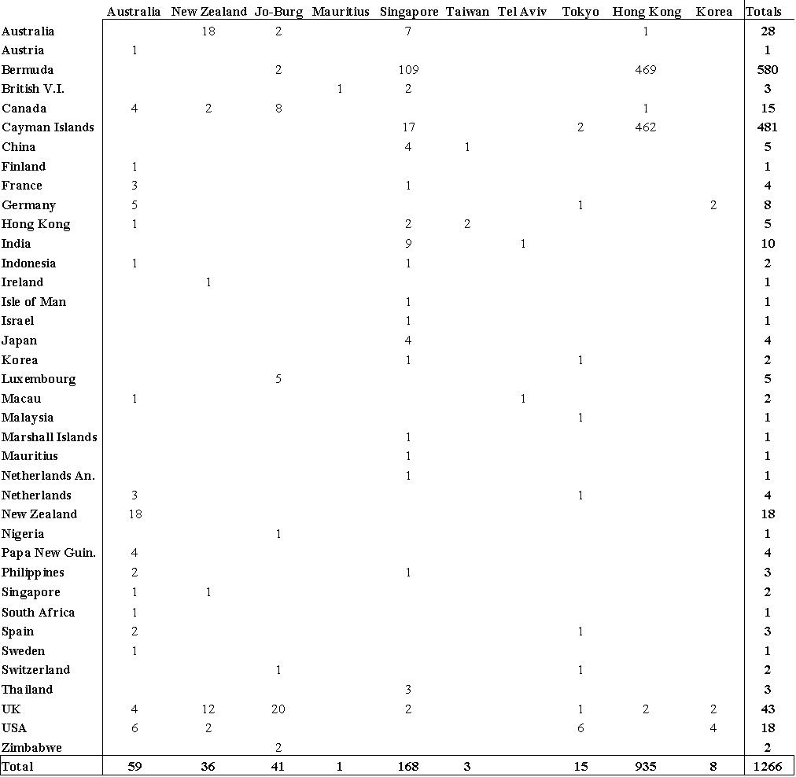

*Shows foreign corporations listed on Asian-Pacific stock exchanges as of January, 2010. Although this does not show all foreign corporations listed on Asian-Pacific stock exchanges since their inception, this does provide an example as to what foreign corporate activity on the Asian-Pacific stock exchanges typically looks like.*

**Table X. Annual Listings and Delistings of Foreign Corporations in Asia-Pacific**

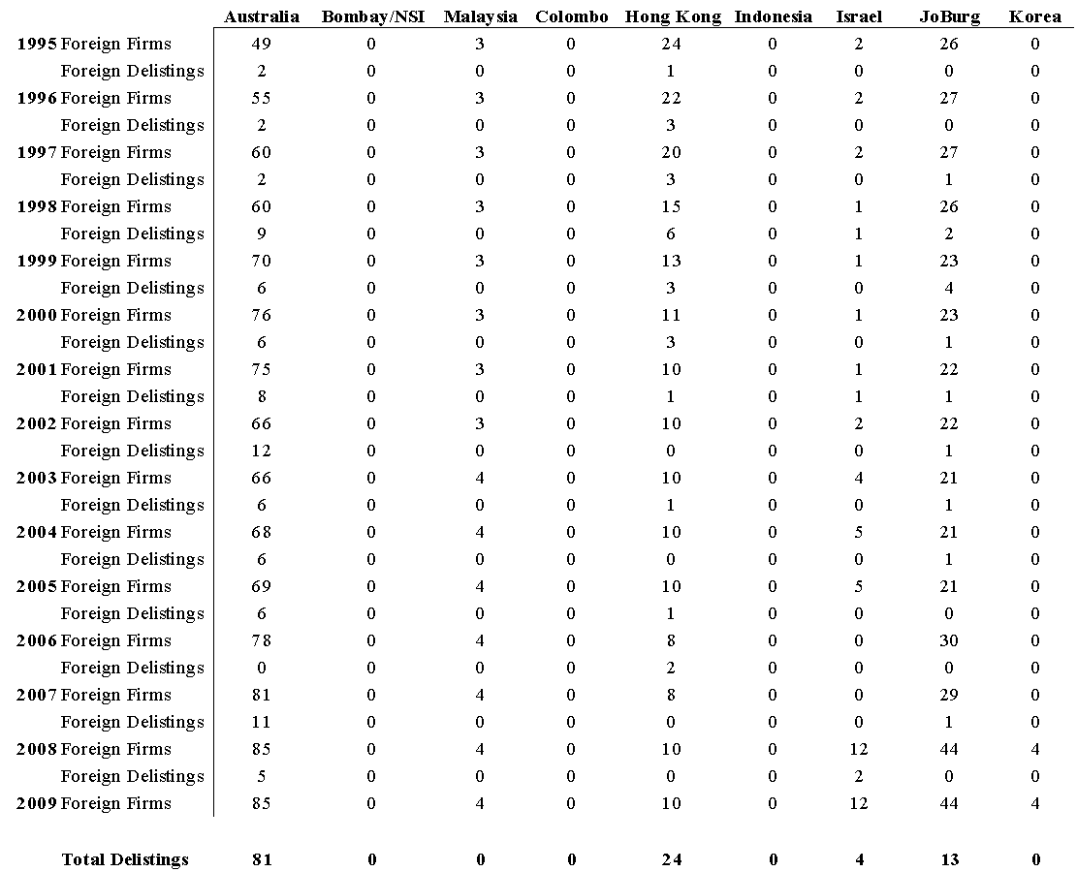

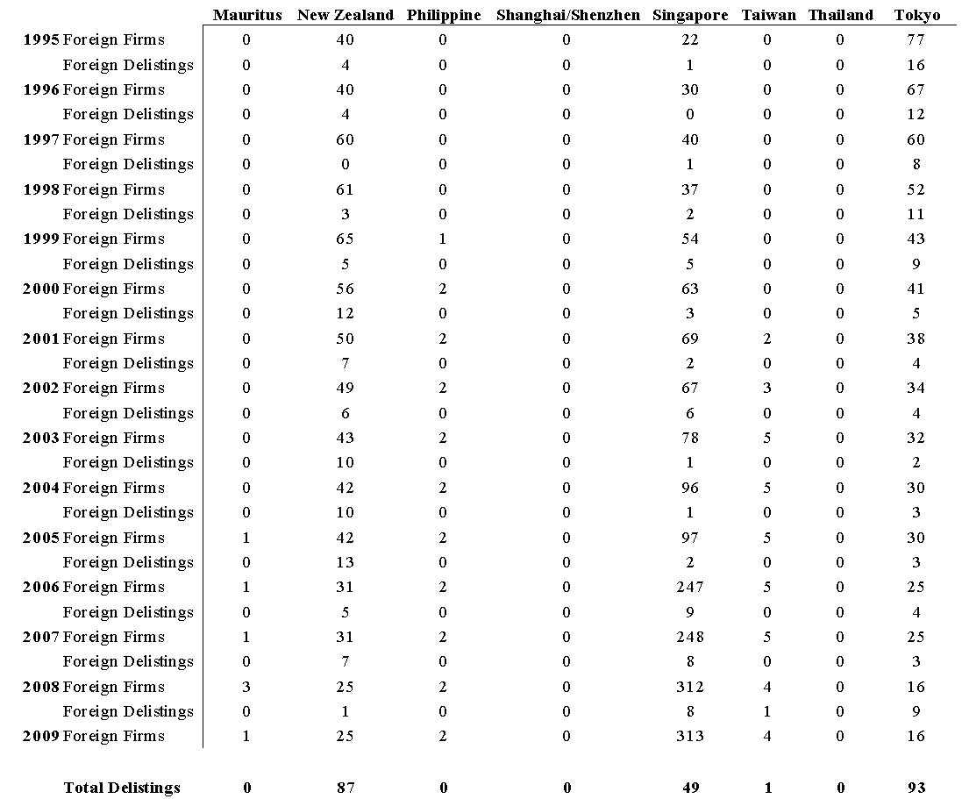

**Table X. Annual Listings and Delistings of Foreign Corporations in Asia-Pacific**

**Table XI. Asian-Pacific Governments' Listing Preferences**

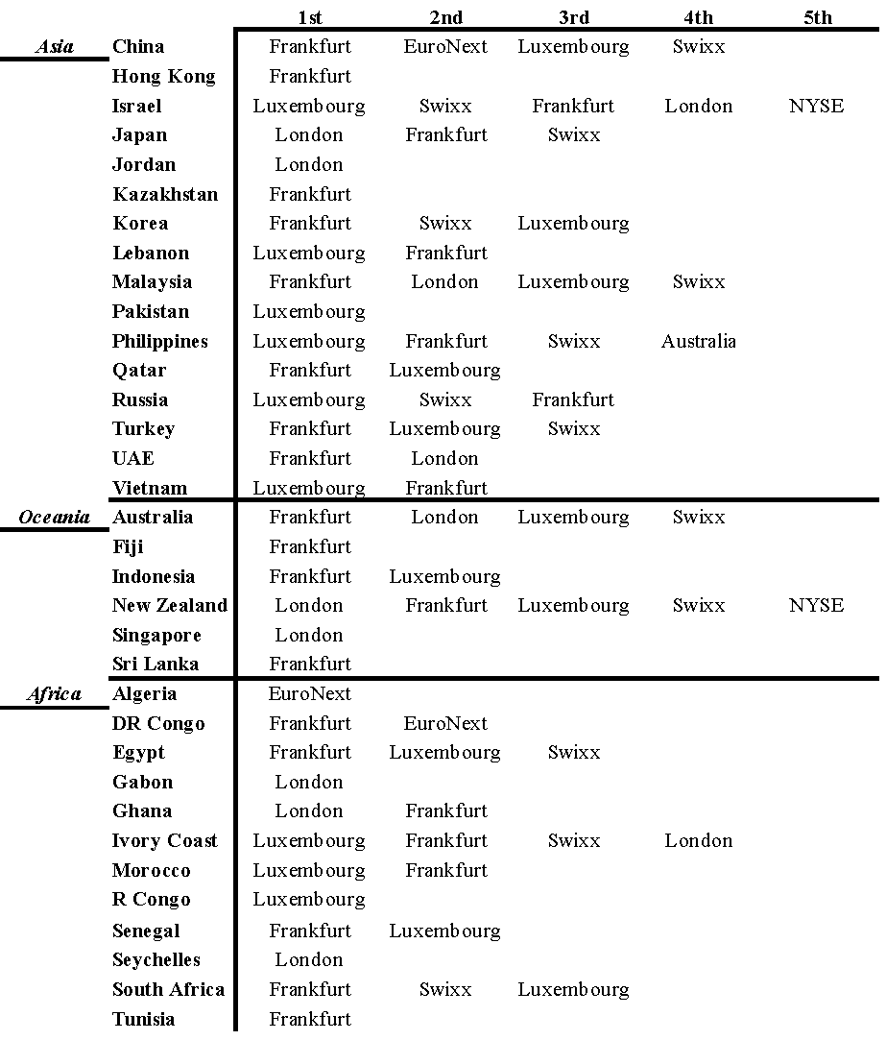

**Table XII. Asian-Pacific Governments' Proportional Utilisation of the Global Markets**

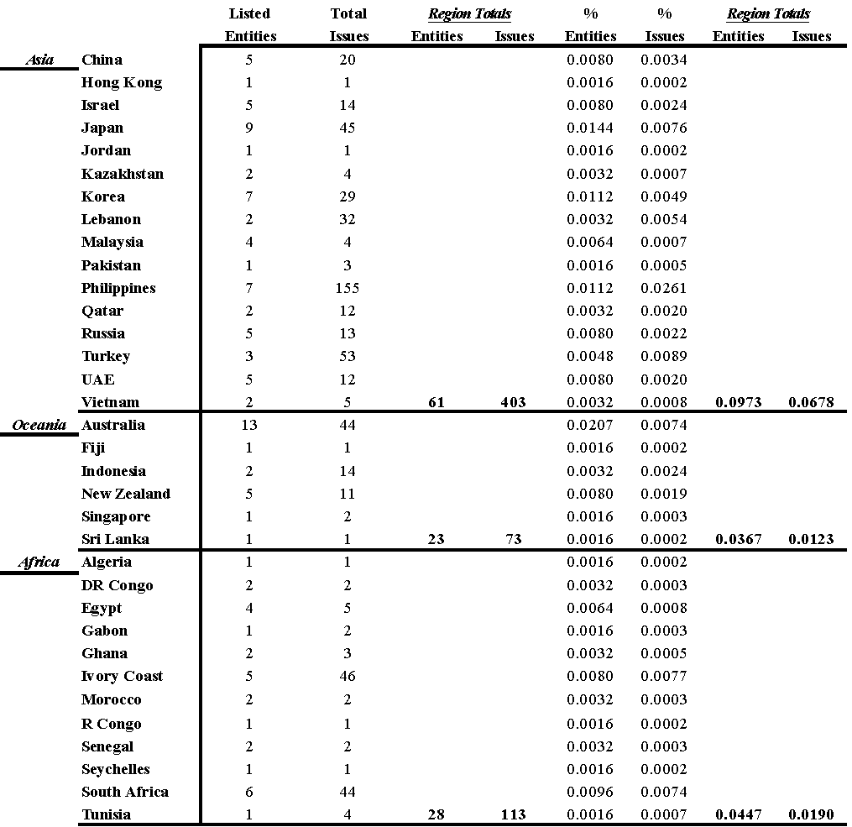

*The regional percentages are based on calculations from the entire population of foreign government listings on stock exchanges.*

Table XIII. Summary Statistics Asian--Pacific Corporations in the Americas

Table XIV. Summary Statistics Asian-Pacific Economies

**Table XV. Summary Statistics Asian-Pacific Stock Markets**

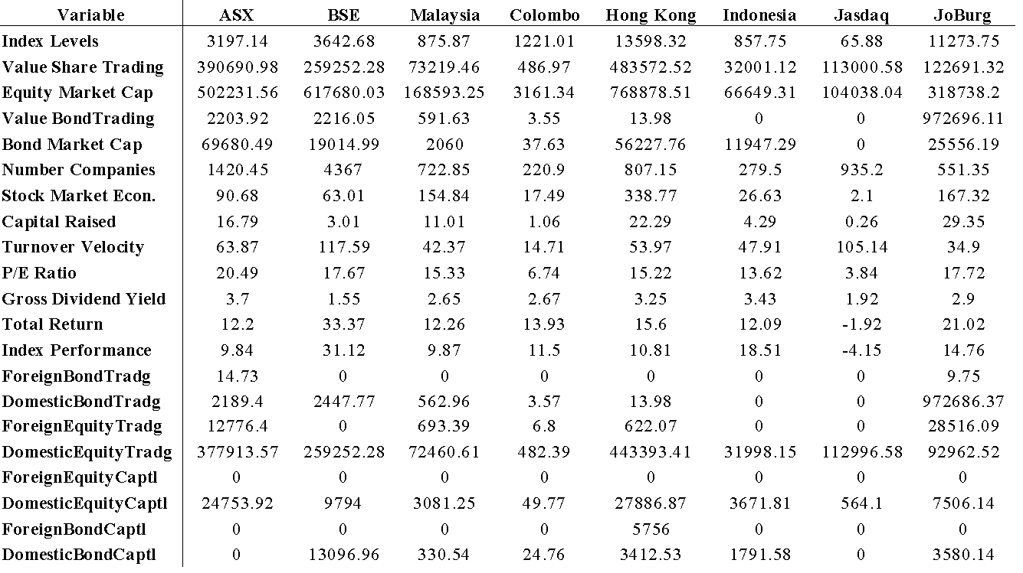

**Table XV. Summary Statistics Asian-Pacific Stock Markets**

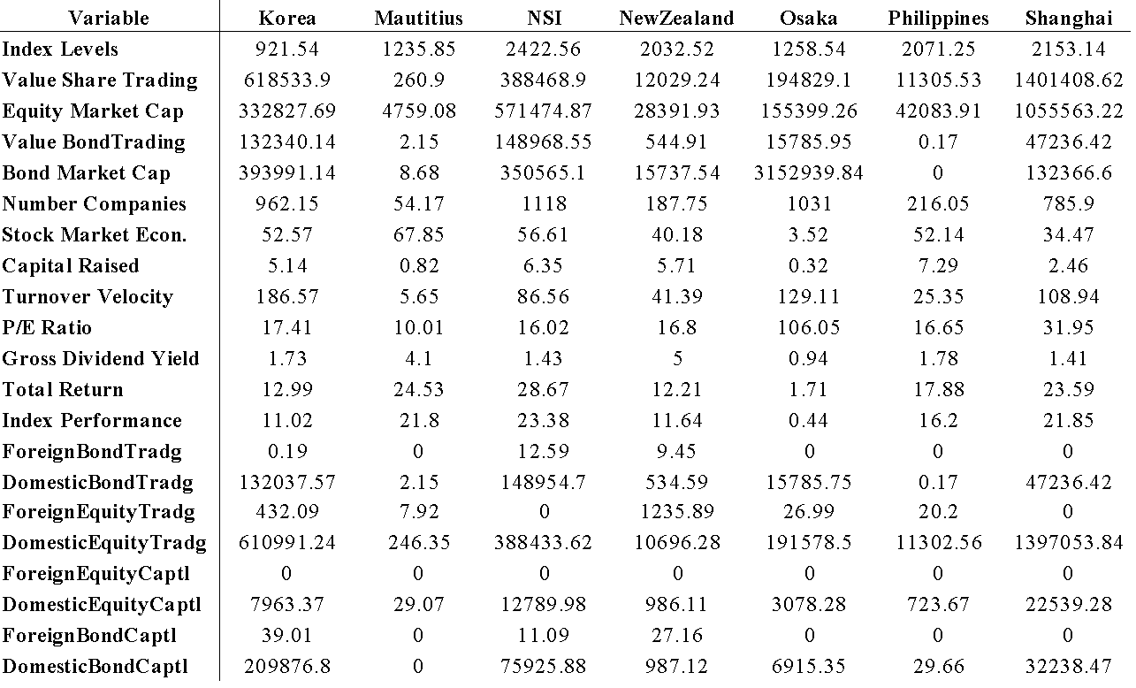

**Table XV. Summary Statistics Asian-Pacific Stock Markets**

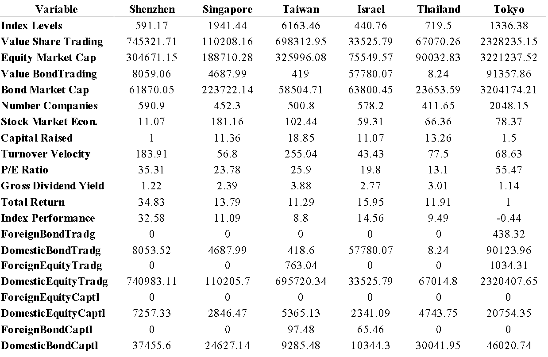

Table XVI. Asian-Pacific Corporations in the Americas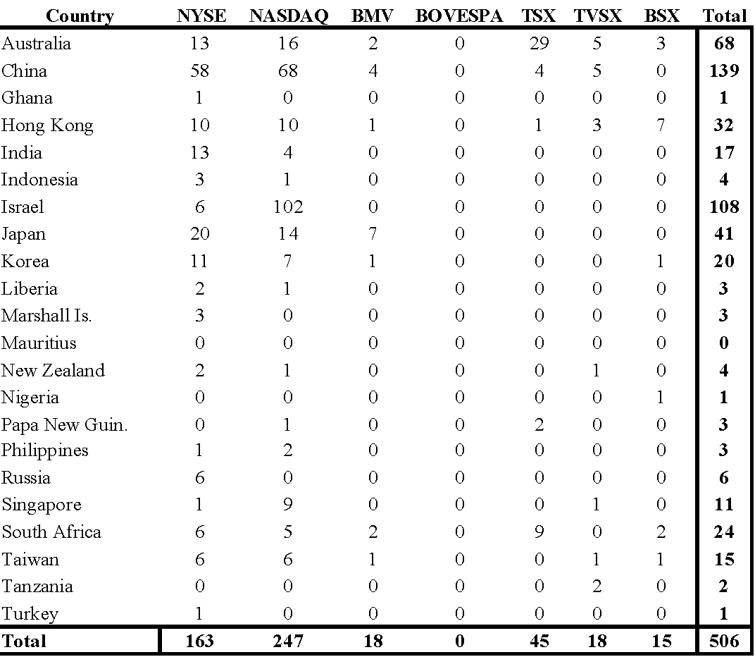

**V. Europe**

**1. Introduction**

The European financial markets are the most integrated in the world. There are many different countries in Europe, all with long histories, which has led to highly sophisticated development of their individual economies. Even though Europe is the most financially integrated region in the world, is still has discernable parts. The Euro area comprises most of mainland Europe, the European Union includes more countries, and then there are other countries still within the greater European community. Currency integration has of course begun on some level with the introduction of the Euro, though what is sometimes overlooked is that European capital markets are also the most integrated in the world. The EuroNext comprises Belgium, France, the Netherlands, and Portugal, while the Nordic includes Denmark, Finland, Iceland, and Sweden. As such, Europe is the most integrated region in the world, and in the following study the efficiency of the current state in Europe is examined, as well as possibilities for the future, all in consideration of European corporate involvement in the Americas. For example, the NYSE and the Nasdaq both own the two most integrated European stock exchanges, the EuroNext and the Nordic, which, due to the corporate nature of some stock exchanges today[21], is a clear example of corporate activity from the American region directly shaping the financial appearance of the European continent.

Integration involves a trade-off between welfare gains and contagion consequences. As such, it is not desirable to have complete integration where everyone uses the same currency and everyone's stock exchange is combined into the same entity. Even with the Nordic countries, it may be to their benefit for Norway to remain separate from the other Nordic exchanges, as well as for the countries to use their own currencies, yet it may be best for mainland Europe to have the same currency yet maintain distinct exchanges. These are decisions that have to be made by the participants, and are like most economic issues in that there is no right answer, while many political issues to cater to. Above the political concerns, however, the economic welfare of the working class is of the most important, and so these decisions should be made with the socialist aspect of the policies in regard. Contagion is usually defined as correlation between markets in excess of what would be implied by economic fundamentals, though there is considerable disagreement regarding the definitions of the fundamentals, how the fundamentals might differ across countries, and the mechanisms that link the fundamentals to asset returns (Bekaert et. al., 2002). And so, it becomes difficult to gauge how much welfare gain is acceptable to strive for while simultaneously recognising the contagion risk, and thus research into the integration literature almost becomes a continuously evolving field.

The two most distinguishing aspects of Europe are their currency union integration and capital market convergence. The theoretical rationales for these types of arrangements are presented, and then empirical analyses on the European currency arrangement and the European stock exchanges are examined in relation to European corporate involvement in the Americas. First, however, a review of some of the interdependencies between Europe and Americas is examined, so as to provide some clarity as to how exactly European corporate involvement in the Americas may be driving currency and capital market integration on the European continent. What is additionally fascinating about currency and capital market integration, is that often times they directly influence each other. Integration should accelerate the development of the most backward financial markets, and allow companies from these countries to access more sophisticated credit and security markets. Financial integration will usually have a 'growth dividend' in the region it is connecting, and this growth dividend can be quantified by analysing the relationship between financial market development and growth via the country, market, and firm characteristics, and then gauging how it will distribute itself across countries and sectors (Guiso, 2004).

In studies analysing the relative importance of country and industry effects in international stock returns within the three primary regions of Americas, Asia, and Europe, only in Europe has segmentation declined, while it has increased elsewhere, suggesting that Europe may be ripe for analysis. As well, Europe is also the only region where industry effects are now more important than country effects, and most of the variation explained by country effects is actually due to regional effects, though the region effects have fallen over time (Brooks and Del Negro, 2002). This suggests that looking at industry or corporate activity from a European perspective may be helpful in analysing financial and economic effects within Europe. Additionally, breaking the empirical studies into regional perspectives as well may also help shed light on currency union and capital market integration in Europe.

This study is organised into several sections as follows. As the emphasis of the study is on how the Europe region's corporate activity in the Americas may be affecting their capital market integration and currency union convergence, first the Europe region's integration with the American markets is analysed. The Europe region is characterised by its capital market integration and currency union convergence, and as such the efficacy of this type of system is discussed next, after which the current state of the Europe markets is presented, and then the empirical studies are performed. For the empirical studies, the corporate activity of the Europe region's countries in the American stock markets is cross-sectionally analysed, and then the time series characteristics of the Europe region's stock markets and economies are examined, all in an effort to deduce stock market and integration possibilities in the Europe region, with an emphasis on how their corporate activity in the Americas may be affecting their welfare within the region.

**1.1 Europe and the Americas**

The primary focus of this study is how European corporate involvement in the Americas influences capital markets and currency union integration in Europe. As such, a review of the literature on the state of the integration of the European and American capital markets and economies can shed light on the veracity of this study. In general, it would commonly be assumed that the USA likely has a greater corporate presence, or international corporate ownership, in other countries than other countries do in the USA. What is equally certain, is that the countries where the USA is most represented will likely have a similarly significant presence in the USA. As such, Wojcik (2002) notes that the level of foreign ownership in the major European countries is significant, though spread unevenly, with USA financial institutions controlling the majority of foreign stakes. The significance of USA corporations in Europe suggests that European corporations may be as represented in the Americas, may be dependent on each other to a degree, and thus the European corporations may be affecting financial integration in Europe in a direct or indirect manner similar to that the way the USA corporations in Europe do. This literature can be divided into three groups: that on currency effects, that on capital markets effects, and that where they both affect each other. The factors influencing currency union convergence are typically more macroeconomical in nature, whereas the factors influencing capital market convergence are usually more quantitatively financial in nature.

The factors influencing currency union convergence are typically more macroeconomical in nature, such as labour mobility, exchange rates, asset prices, and inflation rates. Inter-regional labour mobility appears to be a much more important adjustment mechanism in the United States, which has a more integrated labour market than the EU and thus better labour market adjustment (Bayoumi and Prasad, 1995). Eichengreen (1991) concurs, and suggests that labour mobility and the speed of labour market adjustment remain lower in Europe than in the United States, and thus, Europe remains further than the currency unions of North America from the ideal of an optimum currency area. He then compares European, USA, and Canadian real exchange rates, a standard measure of the extent of asymmetrical disturbances, remain considerably more variable in Europe than within the United States, while real securities prices, a measure of the incentive to reallocate productive capital across regions, appear considerably more variable between Paris and Dusseldorf than between Toronto and Montreal. Further, inflation rates across regions in the European Monetary Union are at least as large as they are across the North American markets of Canada and the USA, suggesting the same factors may be at work in both Europe and the Americas (Beck and Weber, 2005). It is important to remember that a country is essentially a currency union itself, through the different regions in the country, thus arguably making the USA the most efficient currency union in the world.

The factors influencing capital market convergence are usually more quantitatively financial in nature, such as time spreads in information transmission or volatility linkages in trading of financial products. Cerny's (2004) study determined that European markets react very quickly to the information revealed in the prices on other European and USA markets, and in all cases the reaction occurs as soon as within 1 hour. The USA markets seem to be an important source of information for the markets in London and Frankfurt, which react within 30 minutes, with the first reaction occurring within 5 minutes. Information transmission between the London market and any of the two continental markets in Paris or Frankfurt appears to be relatively unimportant compared to the information transmission between the two continental markets. The stock market in Paris seems to react to the information revealed at the stock market in Frankfurt with a delay of 40 minutes to 1 hour. The two relatively small Eastern European markets in Warsaw and Prague are found to react to the information revealed in the stock market prices in Frankfurt, with the market reaction in Prague (30 minutes) occurring 30 minutes faster than the market reaction in Warsaw (1 hour). In terms of volatility linkages between the American and European capital markets, there are identifiable country jumps in risk spillover during volatile periods in the European equity markets from the USA and European regional markets, though the USA contribution to the country variances is less than the contribution from the European regional markets. This implies that a USA investor does not gain much from diversification abroad in high volatility periods, though for European investors the relative benefit of the international diversification increases in the high volatility periods (Asgharian and Nossman, 2008). Thus, the stock exchanges in the USA and Europe seem to follow each other to some degree, and the mainland European markets may even react differently than the British Isles markets, which is why hypothesis XXX is included in the empirical section.

Considering the often times mutually dependent nature of currency union convergence and capital market integration, there will usually be correlations between currency union members and capital market convergence. On this note, there is a documented long-run convergence between USA, UK and major European stock markets, and while real short-run diversification gains may occur, they tend to be short-lived. USA and UK markets are relatively less bound to a common trend, which would imply that increased stock market merger activity, and any transition to the European common currency by the UK, may lead to relatively large capital market adjustments as markets adapt to these institutional changes (Fraser and Oyefeso, 2005). Thus, this data suggests that similar forces may be influencing European and American financial markets and may be present in European corporate involvement in the Americas, as well as information about UK capital markets suggests that they may not integrate well into a currency union with the Euro-Zone.

**2. Currency Union Theory**

The most distinguishing aspect of the European region is their currency union and capital market convergence. Currency union theory analyses more secondary data, which by nature means that theoretical assumptions will usually provide better explanations; this is in contrast to capital market convergence theory, which utilises primary data and focuses on country and market specific aspects. What we are seeing today, is that along with the globalisation of trade and finance and internationalisation of production and exchange has come a certain globalisation of money. Some countries have adopted currency unions and currency boards, while others increasingly use international currencies in place of national monies (Starr, 2006). As such, the global integration of these newfound currency markets reaches its apex with the creation of multiple international currency unions, such the Euro-Zone. Further, as perfect integration is not easily achieved, these regions must pursue the optimal regional and/or sectoral integration of financial systems (Fecht and Gruner, 2005). This optimal mix for each region can be determined by relating traditional currency union theory to the specific characteristics of that region, which is done so in this study for the European region. Some of the general concerns that arise when discussing currency unions are: general optimum currency area theory, effects of electronic transmission, and entering and exiting currency unions. Factors influencing currency union convergence and ways to measure it include: traditional macroeconomic monetary stabilisation policy indicators, and the factors of production of trade characteristics and labour issues. There are many ways to measure currency union convergence, such as with: GDP, interest rates, inflation rates, debt, or really any measure one hypothesis is relevant to that group of countries. The most cited world regions that currently function as currency unions comprising independent countries include: the Euro-Zone, Franc areas, Dollar areas, and Pound Sterling zones.

When discussing currency union theory, it is helpful to first delineate what is meant by a currency union, to which some people may refer to as an optimum currency area. Eichengreen (1991) defines an optimum currency area as an economic unit composed of regions symmetrically affected by disturbances, and between which labour and other factors of production flow freely. Consequently, the symmetrical nature of disturbances and the high degree of factor mobility make it optimal to forsake nominal exchange rate changes as an instrument of adjustment, and to reap the reduction in transactions costs associated with a common currency. Additionally, McCallum (1999) states that the optimal currency area concept is central to the economic analysis of currency unions, as it clearly identifies the relevant optimising tradeoff: that extension of the area over which a single currency is used enhances allocative efficiency, though at the same time reduces the possibility of tailoring monetary policy to the needs of different areas. Mongelli (2002) discusses this tradeoff, and suggests that optimum currency areas actually generate fewer costs in terms of the loss of autonomy of domestic macroeconomic policies, in relation to efficiency-benefits gained. As well, and similar to the dilemma faced by an independent country, once an optimal currency area has been established and its benefits deduced, the argument may then proceed about the best way to benefit from it, such as with attempting to specialise from certain a certain country's strengths, or to proceed with a more homogenous endogenous plan considering the interests equally of all countries; what equally is relevant is are all countries given equal consideration, is consideration based on population, or is consideration based on the economically dominant countries.

The emergence of electronic money may be likely to affect the optimal size of currency unions, just as technology affects most everything else in life. When electronic money supplants the existing publicly supported currency networks (including the national payments systems), there may be larger currency areas feasible, though when electronic payments systems free ride on the existing national payments systems, the size of unified currency areas is also likely to increase, though at a lower rate than with a pure electronic system replacement (Storti and Grauwe, 2002). This makes sense because electronic money is the same in any country or region, as pure mathematics-based technology knows no cultural or political differences, though traditional payment systems derived from centuries of face-to-face contact will take longer to naturally evolve to mirror the cultural and political characteristics of other regions and countries. Bandiera (2004) comments on this dilemma, and notes that if an increased use of electronic money substantially limits the demand for central bank reserves, then this limitation would require changes in the central bank operational target and a closer coordination of monetary and fiscal policies, and thus the optimal size of currency unions would be different. The current level of electronic money use does not seem to pose a threat to the stability of the financial system and thus, central banks can successfully implement the traditional objectives of monetary policy in a currency union with little alteration to current commonly accepted best-practise monetary stabilisation policies.

There will be reasons for joining a currency union and reasons for needing to leave one. Membership in a currency union reduces the likelihood of a currency crash for smaller countries by benefiting from stronger countries policies, as well it reduces transaction costs and raises overall efficiency, all reasons for which are discussed in the proceeding paragraphs. What is less transparent is why and how a country may leave a currency union. Rose (2007) comments on this issues, as he notes that during the post-WWII period, almost seventy distinct countries or territories have left a currency union, while over sixty have remained continuously in currency unions. The leavers tend to be larger, richer, and more democratic, and usually have higher inflation rates, though there are typically no sharp macroeconomic equilibrium movements before, during, or after exits. Nitsch (2004) concurs that historically dissolutions of currency unions are not unusual, and that departures from a currency union tend to occur when there is a large inflation differential between member countries, when the currency union involves a country which is closed to international trade and trade flows dry up, and when there is a change in the political status of a member, and as well that macroeconomic factors have only little predictive power for currency union dissolutions due to their small effects on general equilibrium.

Our attention now turns to the issue of properly defining characteristics of currency unions, and thus how they may be measured. Ways of measuring currency union integration are through analysis of traditional macroeconomic monetary stabilisation policy concerns, and non-monetary issues such as fiscal policy and the factors of production, i.e. trade and labour. After analysing these traditional aspects of currency unions, specific examples today such as the Euro-Zone can be explored in an appropriate light.

**2.1 Macroeconomic Concerns**

The traditional macroeconomic concerns which influence currency unions include: monetary stabilisation policy, fiscal policy, inflation rates, interest rates, and exchange rates. The monetary concerns are autonomy and consequently tradeoffs, while the non-monetary issues are those such as fiscal policy, labour market policy, and financial market policy. The primary policy tools of monetary stabilisation policy include inflation, interest rates, and exchange rates. Cooper (2000) suggests similarly that the success of a currency union depends on the commitment ability of the single central bank (monetary stabilisation policy), the policy flexibility of the national fiscal authorities (fiscal policy), and the central monetary authority and the cross country correlation of shocks (trade and labour). For example, if the central bank moves before the fiscal authorities, then a currency union will increase welfare as long as fiscal policy is sufficiently responsive to shocks, though if the fiscal authorities have a restricted set of tools and/or the monetary authority lacks the ability to commit to its policy, then a currency union may not be desirable.

***2.1.1 Monetary Stabilisation Policy***

The two primary monetary issues are arise in the formation of a currency union are that of the loss of autonomy, and of what tradeoffs may be expected in return. Autonomy is perhaps the most pressing issue in the creation of a currency union, which as a consequence results in the tradeoffs that countries will make and receive to sacrifice some of their control. Autonomy concerns whether the currency union will be effective at monetary stabilisation policy for the group as a whole, and tradeoffs concern how the individual participants will be affected. Issues relating to autonomy are: fiscal behaviour from the member countries, interaction between more and less developed economies within the union, and that of the ability of the central bank to effectively manage cross-border disputes and shocks. Tradeoffs may be both positive and negative in nature, with there being many influences on the degree of the tradeoff. The most relevant negative tradeoff is the loss of currency manipulation as a policy tool, while the greatest influence on the tradeoffs is that of currency commitment and home bias.

A currency union must by default lead to an autonomous central bank. There may be concerns over fiscal regimes of the independent countries, that of interaction between more and less developed countries within the union, and over that of the ability of the central bank to monitor disputes and shocks across and outside the union. This centralising of authority must lead to welfare gains, if the currency union is to be effective, which leads to concerns over the design and desirability of currency unions. Autonomy in this sense refers not only to there being one central bank, though also to the ability of that central bank to balance the fiscal policies of the member countries. The central bank in a currency union will attempt to maximise union-wide welfare with the fiscal authorities attempting to minimise comparable country-wide losses. The most welcome scenario is cooperation between all authorities and currency leadership, though collusive cooperation between fiscal authorities is harmful to both the whole union's and the other members' welfare. As such, Grimm and Ried (2007) determined welfare losses to be significantly larger in the heterogeneous union as compared to a homogenous, meaning the countries should all have similar political structures and fiscal policies. There could also be substantially different fiscal needs between industrialised and less-developed countries, and thus a prior reliance on seigniorage revenues may affect less developed countries performance within a currency union (Beetsma and Giuliodori, 2009). The monetary authority must also be able to handle disputes between the members and outside countries on non-monetary policy issues such as labour wages and trade tariffs, as well as shocks within and outside the union. Cooper and Kempf (2004) suggest that if shocks and policies across countries are sufficiently correlated, then delegating monetary policy to a single central bank is not very costly, and thus a currency union that is also equipped to mange outside pressures is feasible.

As a direct result of the concentration of autonomy into a centralised bank, there will be both positive and negative tradeoffs for the individual members, and possibly even for other economies. Further, the nature of the tradeoffs is dependent on a multitude of factors. Positive tradeoffs include: alleviating the scope for political pressure to influence monetary policy, eliminating harmful monetary stabilisation policy spill-overs and competitive devaluations, serving as a vehicle for beneficial institutional or structural changes, strengthening the commitment to price stability, and reducing transactions costs. The most glaring negative tradeoff would be the absolute loss of a strong policy instrument to combat the effects of country-specific shocks (Forlati, 2009). The nature of the tradeoff depends on: currency commitment and home bias, fiscal free-riding, co-movements of disturbances, distance, trading costs, and institutional arrangements such as the willingness of anchor countries to accommodate to the interests of other members (Alesina and Barro, 2000). In terms of outside effect to non-member countries, Pluemper and Troeger (2004) suggest that the introduction of a common currency may reduce monetary policy autonomy in non-members, as monetary autonomy of countries remaining outside a currency union declines with the establishment of the union. This is because governments in countries that did not join the currency union lose monetary policy autonomy if the establishment of a currency union increases the size of the key currency area, as governments in non-member countries have to pay a higher price if they seek to stimulate their domestic economy.

As just noted, perhaps the greatest influence on the nature of the tradeoffs is currency commitment and home bias. As monetary policy in a currency union is usually made by delegates from the member countries, strategic delegation may arise when countries may choose the types of delegates to influence outcomes in their favour. Thus, without a firm commitment to the prevailing monetary policy, strategic delegation may arise if: shocks affecting individual countries are not perfectly correlated, risk-sharing across countries is imperfect, or the Phillips curve is nonlinear, and inflation rates are inefficiently high (Chari et. al., 2004). Espinoza and Kwon (2009) concur, as they note that home bias is a major indicator of regional financial market integration, as a higher home bias for financial market preference signals a lower degree of integration. Thus, when there is a strong home bias, there may also be more of a likelihood for a currency commitment problem to arise. Although it is very difficult to control peoples' political preferences and motives, some ways of solving the commitment problem may include an emphasis on price stability and strong institutional arrangements.

***2.1.2 Fiscal Policy***

Fiscal policy must mirror on some level that of the central bank in order for there to be success, and that of the other countries, and specifically, how the debt obligations of each country in a currency union will be met becomes relevant to all members of the currency union. This tendency of fiscal behaviour in a currency union to mimic the monetary authority is not uncommon, as McCallum (1999) notes that the fiscal theory of price level determination suggests that the general price level (monetary authority) roughly follows the pattern of the government bond price (fiscal activity) rather than base money when their paths differ drastically. Additionally, it has been suggested that countries joining currency unions tend to accumulate less debt, and there has also been a free-rider effect noticed whereby the members tend to generate momentum with each other to maintain their debt at manageable levels.

In reality, when the individual countries lose their monetary autonomy, their fiscal policy becomes their primary stabilisation tool. Gali and Monacelli (2005) expound on this premise, as they note that the relinquishment of an independent monetary policy generates a stabilisation role for fiscal policy, and the stabilising role for fiscal policy is desirable not only from the viewpoint of each individual country, though also from that of the union as a whole. In turn, Cooper et. al., (2004) identify two distinct possibilities for a currency union in regard to fiscal policies (i) Ricardian, where the future obligations are met with taxation by a regional government (ii) Monetisation, where the central bank is induced to print money to finance the region's obligations. Thus, there is a commitment problem for the central bank, though in reality the most appropriate option is regional taxation, as seigniorage in a currency union will hurt the members who do not have fiscal shortfalls.

Following Cooper at. al.,'s theory, analysis of the distribution of the holdings of the regional debt can be helpful to examine the Ricardian and Monetisation options, though with interest bearing regional debt in a currency union, the circulation of this debt may have the same monetary implications as the printing of money by a central government, or the obligations of this debt simply backed by future taxation with no inflationary consequences (Cooper et. al., 2004).

Jahjah (2000) suggests that countries in a currency union tend to accumulate less debt, which reduces the need for fiscal criteria such as debt ceilings. In this situation, investors may begin rationing credit to the government more rapidly, resulting in an equilibrium with no inflation or default, though highly indebted countries may be likely to default once they join a currency union. Canova and Pappa (2007) note, however, that in currency unions, expansionary fiscal disturbances tend to produce positive price differentials, while contractionary fiscal shocks produce negative price differential responses, thus suggesting that the accumulation of a responsible amount of debt in a currency union may lead to positive welfare gains for the union. Chari and Kehoe (2004) elaborate on Jahjah's (2000) study as they suggest that the desirability of fiscal constraints in currency unions depends critically on whether the monetary authority can commit to follow its policies, as if it can commit then debt constraints can only impose costs, though if it cannot commit, fiscal policy has a free-rider problem and debt constraints may be desirable. When there is time inconsistency between monetary stabilisation and fiscal policy, which is reality, a free-rider problem may arise in the setting of nonmonetary policies, such as fiscal policy, labour market policy, and financial market policy, whereby the union's members may pursue lax nonmonetary policies that could induce high inflation and interest rates (Chari and Kehoe, 2002). This free-rider problem can be mitigated by imposing constraints on the nonmonetary policies, such as: debt constraints on members' fiscal policy, unionwide rules on labour market policy, and unionwide regulation of banks.

***2.1.3 Inflation, Interest, and Exchange Rates***

The traditional monetary stabilisation policy tools of inflation, interest, and exchange rates are also the tools that the monetary authority of a currency union will utilise. As with the case of an individual economy, these indicators continue to be difficult to measure in a currency union. In terms of trends, however, in a currency union inflation rates do tend to be lower and more stable due to greater fiscal restraint, interest rates do tend to be lower and more stable due to the reduction in transaction costs, and exchange rates do tend to be more stable due to the lower volatility in inflation and interest rates. One difference in the tools is that inflation and exchange rates must be stabilised at the union level, while interest rates are influenced at both the union and individual level, as well as the size of the different countries in the union may influence the movements of these rates. As well, these three indicators often affect and are affected by the factors of production, trade and labour, and is discussed in relation to them in the next two sections.

Inflation rates tend to be lower in currency unions because there is more reluctance to engage in seignioriage just to help one country at the expense of the rest of the members. Edwards and Magendzo (2003) identify this phenomena, as they note that common currency countries have lower inflation than countries with a domestic currency. Interest rates will usually be lower in a currency union, primarily because of reduction in transaction costs. McCauley and White (1997) suggested this even before the introduction of the Euro, as they said that a single currency would create a single private yield curve in the near term and could also lead to a more integrated government bond market in the long term. Exchange rates will typically be more stable in currency unions, because there is less ability to manipulate the exchange rate to help a single country's exports or purchasing power abroad. Parsley and Wei (2003) concur as they note that a currency board or a currency union generally provides a stimulus to goods market integration that reduces exchange rate volatility to zero. Additionally, these lower and more stable rates will tend to lead to higher and more stable growth. As Tenreyro and Barro (2003) discuss, sharing a common currency enhances trade and increases price co-movements. This is because a large part of the variation in real exchange rates is caused by fluctuations in nominal exchange rates, and a common currency decreases the co-movement of shocks to real GDP, thus being consistent with the view that currency unions lead to greater specialisation.

The fact that economies differ in size has important implications for international asset returns, as larger countries have lower real interest rates because their bonds provide insurance against shocks that affect a larger fraction of the world economy. Larger countries' bonds must therefore pay lower excess returns in equilibrium, and uncovered interest parity fails and stocks in the non-traded sector of larger countries also tend to pay lower excess returns. Therefore, in a currency union, there may be discrepancies between interest rates of the larger and smaller countries. If asset markets are segmented, the introduction of a currency union lowers real interest rates and expected returns on stocks in the non-traded sector of participating countries. A panel of OECD countries shows that they are strongly supported by the data, as investors earn lower excess returns on bonds and stocks in the non-traded sector of larger countries, and similarly, excess returns on EMU member countries' bonds and stocks in the non-traded sector fell after European currency integration (Hassan, 2009).

A currency union may also affect the inflation, interest, and exchange rates of countries outside the union. Pluemper and Troeger (2004) note that an increase in the size of the key currency area has external effects on countries remaining outside the currency union, as the exchange rate within the currency union becomes more stable, the value of goods exported from countries within the currency union increases because the countries inside the union have more synchronized business cycles. They also suggest that exchange-rate effects on changes in the real interest rate differential are larger if currency areas are less equal in size. Any given change in the real interest-rate differential may lead to an exchange-rate effect, which is larger the smaller the domestic currency area is relative to the key currency area. Outsider countries will also usually more closely follow the interest-rate policy of the currency union than they had previously followed the currency policy of the anchor currency.

**2.2 Trade and Current Account**

The two factors of production, trade and labour, are affected by currency unions. When discussing trade effects from currency unions, the general consensus is that currency unions increase trade, though other aspects such as customs unions will also be affected by joining a currency union. As far as labour, wages will tend to be more rigid in the short-term in a currency union, as well as there will be influences on the employment rate and to a lesser degree some of the other macroeconomic indicators. The macroeconomic factors are also influenced by the trade benefits, though the interaction between the primary indicators and labour rates is not as clear. For example, higher trade is more guaranteed and accepted to occur than wage benefits, as if the member countries have more flexible or more rigid wages, then adjustment will need to occur which can have contrasting effects on the currency union members to the employment rates, and to a lesser degree the inflation rates.

Espinoza and Kwon (2009) explain that common currencies affect trading costs and, thereby, the amounts of trade, output, and consumption. Further, analysis of current accounts and thus regional trade balances within the currency union, can shed light on if there are regional trade imbalances, can be interpreted as a lack of ways to finance current account deficits, which can also be referred to as a lack of regional financial integration. Therefore, within a currency union, we would expect to see countries that are integrated with each other, and thus their current accounts should be balanced within the union. Currency coordination also fosters the correlation of business cycles, which can help reduce trade imbalances due to shocks and seasonal adjustments (Flandreau and Maurel, 2001).

It widely assumed that joining a currency union will lead to higher trade, no matter who the entrants, though as Ritschl and Wolf (2003) note, currency unions usually are established precisely because trade among their members was already high. Frankel and Rose (2000) suggest that belonging to a currency union more than triples bilateral trade with the other members of the zone, and every one percent increase in trade (relative to GDP) raises income per capita by roughly 1/3 of a percent over twenty years. They continue to say that the beneficial effects of currency unions on economic performance come through the promotion of trade, rather than through a commitment to non-inflationary currency policy, or other macroeconomic influences. Yetman (2007) further finds that there is a correlation that trade within currency unions is much larger than outside of currency unions. Although there will be trade gains from joining a currency union, Albertin (2008) warns that the more economically dissimilar is an accession country, compared to the original members of a currency union, the smaller are the gains in trade that would follow the enlargement of a currency union. Glick and Rose (2001) also concur, and also note that countries will typically experience declines in bilateral trade when they leave the currency union.

For a dissenting perspective on the trade gains from joining a currency union, Pakko and Wall (2001) find that a common currency may lead to a small reduction in trade over a five-year period, and over ten- and twenty-year periods, trade volumes are more than halved by the adoption of a common currency. In terms of the link between currency areas and customs unions, the size of a bloc of countries practising some form of co-ordination of currency policy is limited by the incentive to free-ride that formation of the bloc creates, though when the threat of a trade war is introduced, the stable size of the bloc increases. This suggests that a large currency area is more likely to emerge where it combines with a customs union, and that the stability of both currency area and customs union are closely related, because the threat of tariff penalties can enforce co-operation (Kohler, 1998).

**2.3 Labour and Wages**

Currency unions affect labour and wages in two specific ways. Countries in a currency union will likely experience changes in wage rates, which then may have an effect on the employment rate.

Essentially, joining a currency union can either lower or raise the real wage rate. If wages are lowered, unemployment will decline, and if wages are raised, unemployment will rise. Whether the wages and consequently unemployment lowers or raises depends on the rigidity of wages, labour mobility, as well as other influences of other factors such as country-specific shocks, as the less correlated a country-specific shock is with the aggregate, the more bargaining power the union has (Leichtner, 1998). It has also been suggested that the wage bargaining process in a currency union can compensate to some degree for the loss of monetary autonomy, which will depend on the cooperation from both from countries and from the labour market to the union.

Whether there will be greater wage bargaining power for the labour market inside a currency union depends on three primary factors, including: wage rigidity and labour movement of the member countries, and the prevalence and effect of other factors such as country-specific and cross-country shocks. Dellas and Tavlas (2005) elaborate on this concept, as they note that countries with a high degree of nominal wage rigidity benefit from currency union, especially when they join other, similarly rigid countries, while countries with relatively more flexible wages tend to be worse off in unions with countries that have more rigid wages. Additionally, successful stabilisation of the asymmetric shocks in a currency union requires, either flexible wages and/or labour mobility, absent inter-regional fiscal transfer payments (Mann-Quirici, XXXX). Georgiou (2010) offers another perspective, and suggests that the relative real wage rigidity across countries is a result of the relative inflation across countries and the employment rate within countries, and thus in a perfect information currency union regime, unemployment declines, as workers may accept to work at a lower real wage instead of staying unemployed.

The labour issues can act to help compensate for the loss of monetary autonomy in a currency union, which in turn depends on the level of cooperation within the currency union. By treating wage formation as endogenous, the degree of real wage flexibility will depend upon the nature of the currency policy regime, which will theoretically mitigate some of the inevitable costs associated with losing autonomous currency policy. Therefore, wages may carry some of the economic burden of macroeconomic adjustment in lieu of independent currency policy and/or fiscal transfers. Cuciniello (2009) notes that whether cooperation in a currency union is welfare improving relies on wage setters’ perceptions about affecting monetary policy, as if wage setters perceive a tighter currency policy they will induce wage restraints. Incentives for cooperation are increased inside the currency union when governments and labour unions move simultaneously, and will be decreased when either the labour unions or the countries are powerful in the wage bargaining process (Tagkalakis, 2006). A currency union is found to elicit real wages that are broadly comparable to those obtained under currency autonomy.

Due to the potential differences in wage rigidity, labour mobility, and shocks between member countries, it is important to appropriately analyse the effects on employment rates from the labour wage rate consequences of joining a currency union. A currency union, like any currency regime, will affect the relative prices of tradables and non-tradables, as well as real wages and employment.

Cahuc and Kempf (XXXX) agree with this assessment, as they explain that unemployment in a currency union depends on the nature of externalities and dynamic strategic interactions between the currency Union's countries, namely on the labour mobility and rigidity of the currency union and the shocks across the countries. Rantala (2001) offers a few perspectives, as he notes that a switch from a floating exchange rate regime to a currency union improves employment, provided that the degree of central bank conservatism is sufficiently high, whereas with low degrees of conservatism employment falls. Inflation is higher in a currency union with all finite degrees of central bank conservatism. Thus, in spite of full price flexibility transmission of monetary policy operates via both aggregate demand and aggregate supply channels in a currency union, economic performance in a currency unions is also characterised by unemployment, inflation, real wages and competitiveness (Coricelli, 2001).

**2.4 European Monetary Union**

As the European Monetary Union is well established, its performance can be compared to the previously discussed theoretical aspects of a currency union, as well as offer empirical facts on important aspects of the EMU today. In terms of monetary stabilisation policy, the political aspects of the EMU will likely continue to important, and although the union has statistically performed quite well, there are areas which can be improved upon. Inflationary prices seem to have reduced in the EMU, interest rates have moved to convergence within the union, and exchange rates prior to EMU creation all converged relatively closely to the German Mark. Accordingly, results have also determined that these more stable rates have led to higher growth and investment in the EMU. Europe has a very diverse labour structure, which can be seen as an impediment to EMU efficiency, though studies have suggested that labour issues are not overly serious in the EMU. As far as trade, several questions that arise are whether the EMU has outperformed other countries, whether the EMU has done as well as other currency unions, and if there have been winners and losers within the EMU.

Going forward, as with any other currency agreement, in the EMU the political cooperation is the key condition for establishing and for maintaining the currency union, and political factors will be the central determinants of the future of EMU. In terms of the efficiency of the Euro-Zone, Artis, (2006) identifies that country premia within the EMU are very small, thereby offering a means for insurance against asymmetric shocks. Additionally, Mendizábal (XXXX) finds an upper bound for the savings associated with reductions of transaction costs derived from the EMU of approximately 0.6% of the Community GDP. Although the EMU has generally performed quite well since its inception, there are of course a few shortcomings that can identified and improved upon. Bordo and Jonung (1999) suggest a few, namely: the absence of a central lender of last resort function for EMU, the lack of a central authority supervising the financial systems of EMU, unclear and inconsistent policy guidelines for the European Central Bank, the absence of central co-ordination of fiscal policies within the EMU, unduly strict criteria for domestic debt and deficit rules, and in the face of asymmetric shocks the Euroland does not always function as an optimal currency area.

Inflation rates, interest rates, and exchange rates have all seen significant impact in the EMU. Inflation seems to have been mitigated by the drop in exchange rate volatility within the EMU, as the elimination of nominal exchange rate volatility has largely reduced the border effects in Europe, though distance and border still matter for intra-European relative price volatility (Beck and Weber, 2001). Essentially, prices are usually different among cities in different countries as compared to cities at the same distance in the same country, and what the EMU has effectively done is provide one area which all the cities can trade in. As for interest rates, Baele (2004) finds that the unsecured money market in the Euro area is fully integrated, while integration is reasonably high in the government and corporate bond market, as well as in the equity markets; the credit market is among the least integrated, especially in the short-term segment. As far as convergence, the co-movements of risk premiums among the EMU entrants before entrance displayed a tendency to convergence to the German mark's risk premium up to EMU implementation, and thus a clear pattern of asymmetry of the participating currencies in relation to the German mark (Gonzalez and Launonen, 2005), thus suggesting that the makeup of the EU is stable. As well, with more stable inflation, interest, and exchange rates, one would expect to see increases in investment and growth. After analysing inflation, interest, and exchange rate data, Foad (2005) determined that a multinational would prefer to invest within the EMU even if the UK market were three times the size of the EMU combined markets, as the UK's share of FDI inflows to the European Union has drastically declined since the introduction of the Euro in 1999.

Labour and wages has long been a contentious dispute in Europe, as many of the countries have decidedly different levels of labour mobility and rigidity, though statistical studies have found little problems arising from labour issues. For example, In France, Germany and the UK the welfare implications of currency arrangements depend more on the degree of wage asymmetry than on other types of asymmetries and that the higher wage flexibility in the UK would make its participation in EMU costly. The current pattern of relative wage rigidity and labour inertia in Europe thus can be viewed as a problematic factor in the successful functioning of the European common currency area. In terms of the current state in the EU, Sanchez (2009) found that more aggressive wage setting under currency union not been confirmed by the EMU experience, which has been characterised by wage moderation. Additionally, EMU membership results in lower prices of tradable goods and lower relative wages in the open sector, while opposite results hold for sheltered sector prices and wages

In terms of EMU trade performance, three relevant questions arise: (i) whether the EMU as a whole has prospered against the outside community, (ii) how the EMU performed compared to other currency unions, and (iii) whether there have been winners and losers within the union. Against the outside community, Stavrev and Decressin (2009) imply that divergences across euro-area countries are smaller and have not risen relative to those across other advanced economies with more flexible exchange rates, as well as the size of country-specific current account shocks in EMU countries is smaller and their persistence is greater than in the other advanced economies, though differences in current account dynamics do not appear related to different exchange rate dynamics. As far as being compared against other currency unions, Frankel (2008) found that whereas trade among members seems to increase by 100-200% in most currency unions, there has only been 10-20% during the first years of the Euro. He also notes that this is not necessarily wrong, as the Euro is still very young, and the European countries are much bigger on average than most of those who had formed currency unions in the past. It does see, however, that there have been winners and losers in the EMU. For Belgium/Luxembourg, Finland, Germany, Ireland, Italy the Netherlands, Portugal and Spain the bilateral trade of each EMU country by the EMU effect is positive, whereas in the cases of Austria, France and Greece, it is negative (Aristotelous, 2006). DeNardis et. al., (2008) elaborates further, as he notes that despite pro-trade effects in the majority of the EMU members, at the sectoral level there are some countries in which the impact of the Euro has been negative. These pro trade effects are mainly concentrated in scale intensive industries, and industrial specialisation and location of these industries, together with other factors such as factor endowments and product regulations, may have determined the winners and the losers in the currency integration process.

***2.4.1 Other World Currency Unions and Zones***

As the number of independent countries increases and their economies become more integrated, we would expect to observe more multi-country currency union, which we see with reasonably well-defined Euro and dollar areas. Two other well know zones include the British pound, and formerly the CFA Franc zone, which now follows the Euro. An important concept is that in the British and Franc Zones, there is often direct financial aid that is received from the country, as they used to be colonies. In the CFA Franc Zone and the East Caribbean Currency Area, are countries within international currency unions as integrated as regions within political unions.

There are two CFA zones, CEMAC and WAEMU. For the CEMAC, only about 15 percent of shocks to GDP are smoothed through the standard channels (that is capital market credit market and remittances). 44 percent of shocks are smoothed via foreign aid from France and 5 percent via central bank contributions while reserves pooling provides no shock smoothing. For the WAEMU, only 13 percent of shocks are smoothed through the standard channels while 63 percent are smoothed via foreign aid from France 7 percent via central bank contributions and no smoothing via reserves pooling. Thus, creating public venture capital at a regional level might help promote free capital flows within each zone and alleviate the apparently insufficient degree of risk-sharing observed through the standard channels (Yehoue, 2005).

**3. Capital Market Integration Rationale**

The most distinguishing aspect of the European region is their currency union and capital market convergence. The characteristics of currency union theory are more macroeconomical in nature, to which there is more pure theoretical analysis necessary. For capital market integration, the focus on the theory focuses more on the characteristics of the individual markets in each country. Macroeconomic indicators will usually be much harder to quantify. For example, it is difficult to measure inflation or trade directly, though measuring stock exchange results is a straightforward process utilising primary data, not secondary data like macroeconomical analysis. One caveat, however, is that even though international markets react quickly to news, they are volatile and difficult to predict and with a changing correlation structure of security returns among countries (D'Ecclesia and Costantini, 2004). When measuring integration, however, Pukthuanthong and Roll, 2009) warn that perfect integration implies that the same international factors explain 100% of the broad index returns in both countries, though if the countries differ in their sensitivities to these factors, they will not exhibit perfect correlation.

As such, capital market integration theory is essentially a business decision, with much less political overtones and concerns that a currency union. Yes, stock exchanges are symbols of national pride, and arguably should be more tightly controlled by the home country than they sometimes are; though, what is equally true is that stock exchanges are oftentimes publicly traded themselves, and so merging stock exchanges often amounts to little more than securing the financing required to complete the deal. There are many ways to measure capital market integration, such as with: market capitalisation, trading volume, capital raised, or really any aspect of the markets one supposes is relevant. Again, these are all primary sources of data. This primary aspect of the data is also what makes capital market integration much more straightforward than currency union convergence, which is based wholly on secondary data, as well as much more consequential political and security concerns. What is equally true, however, is that at the national scale, currency unions are much more common than capital market convergence, as evidence by the fact that capital markets had not converged until 2000, while currency unions have been active for the last 100 years. As Buettner and Hayo (2009) discuss, many of the factors which are very influential in currency union convergence, such as interest rate spreads and business cycle synchronisation, do not appear to play an important role in explaining equity market integration

In terms of the pure theory of, mergers and acquisitions between stock exchanges will first begin at the national level, with the local stock exchanges in a country accepting the merger between them in order to create a capital market significant at national level. The next step is integration at the national level, with the intent on becoming a relevant stock exchange on a global scale. A few of the more important aspects to consider when analysing capital market integration are: country ownership issues, foreign ownership, liberalisation and informational efficiency, data analysis, and overall economic growth.

Perhaps the most important argument to consider when analysing capital market integration is that of the wishes of the home government with regard to how their capital markets may be used. Some countries have very liberal capital controls and the national stock exchanges are free to merge with other nations, though in many the government has strict capital controls in place regarding the utilisation of their capital markets. Korajczyk (1996) suggested that market segmentation tends to be much larger for emerging markets than for developed markets, which makes sense considering the capital markets which have merged are all in developed countries. Closely related is the topic of foreign ownership of the capital markets, as there is a positive link between capital market integration and past portfolio inflows by foreign investors on the cross-section of local stocks (Konukoglu, 2010). This suggests that those stock exchanges that see more foreign activity in their day-to-day trading would be more likely to merge with other national exchanges. Nitschka (2009) elaborates further, and describes how relatively high past foreign stock market returns signal a currency depreciation, thus meaning that high currency risk premia are associated with relatively deep financial market integration and a high level of risk sharing, both of which are characteristics of capital market integration.

Arguably the most relevant reason as to why we are beginning to see more capital market integration is due to the global liberalisation of securities markets and the disappearance of technical barriers, which also directly affects the quality of information. These factors have decreased the importance of national stock exchanges as the only option to obtain funding, and thus have contributed to more consolidation and a destabilizing and fragmenting effect of competition on these markets (Nakajima and Bagheri, 2004). Closely related to the concept of liberalisation and reduction in barriers is that of information disclosure and efficiency. Measures for market integration and market efficiency both shows improvement over time and emerging markets are less integrated and less efficient as compared to their developed counterparts. There is a positive association between market integration and informational efficiency, even after controlling for standard determinants of price delay (Hooy and Lim, 2009). Zhang and Wu (2009) concur with this assessment, as they note that capital market integration has developed relatively slowly in emerging markets due to the hampering effects of their poor information environments.

As for statistical data on the capital markets and economies, stock markets are on average larger and more liquid than before, as returns are more volatile and more highly correlated with the world market return, dividend yields are lower, and credit ratings better (Bekaert, 1998). In terms of the impact of the trading system on prices and thus the integration of markets, futures and spot prices move together more closely when both instruments are screen traded (Korn and Kempf, 1996). Capital market integration has also been documented as raising growth in capital-importing countries to a higher degree than in capital-exporting countries. With integration, however, it is to be expected that capital flows will rise in both countries, due partly to the reduction in transaction costs. Using foreign direct investment (FDI) as a measure for capital flows, Egger et. al., (2005) finds that an increase in net capital inflows in response to capital market integration raises participation in higher education, and thereby fosters economic growth. Capital market integration also can drive up labour wages and taxes, as Arachi and D'Antoni (2003) describe how increased capital market integration can call for an increase in redistribution among workers, with a distortionary and insurance effect. This is because increased capital mobility makes labour income taxation more distortionary by increasing the variance of specific labour wage, though it also increases the scope for risk protection (insurance) through redistribution. The insurance effect of redistribution, however, can be stronger than the distortionary effect, so that the optimal tax rate on labour income can increase more so than the wages when capital markets become more integrated

As such, the world stock markets today are moving towards integration of local financial markets to international financial systems and institutions through cross borders transactions. The globalisation phenomenon may enhance welfare, or may increase contagion consequences, due to the fact that the irrational trading, instability or crises in one market or region may move to other markets and regions (Sabri, 2006). As the majority of international capital market integration has occurred in Europe, analysis of the European experience in this arena can shed light on what some of the driving forces may be.

**3.1 European Monetary Union**

The European Monetary Union has of course had substantial effects from the currency perspective, though it has also influenced the capital markets in the region. In the last few years, the existence of the single currency, euro, gave a huge potential to growth for the entire European capital market and opened the road for new integrations (mergers and/or acquisitions between stock exchanges) and thus between markets, which we have seen with the Euro-Next and Nordic exchanges (Stoica, 2002). Specifically, the efficiency of Euro area seems very sustainable, the Euro seems to have taken over from the dollar as the dominant currency in European stock markets, as well as many of the European stock markets have seen rises in productivity since the introduction of the Euro. As far as concerns go, areas for improvement in European financial market integration might focus on banking on the implications of the integration, on changing financial market structures, competition, and efficiency in Europe(Pichler et. al., 2008).

From an efficiency standpoint, the Euro has increased operating effectiveness of the European stock markets. Hardouvelis et. al., (2001) demonstrates that a single currency leads to an increase in capital market integration through a reduction in investment barriers, as the single currency group increases, restrictions on holding foreign assets become less binding, leading to higher market integration, which is what has happened in the EMU. Further, empirical analysis of Euro area stock markets diversification yields a balanced and stable allocation of wealth, free from the problem of corner solutions, suggesting that additional diversification among Euro area stock markets is still feasible and desirable (Morana, 2008).

The Euro also has taken over from the dollar as the dominant currency in the European stock markets. The integration in EU equity markets has been accelerated by the introduction of the euro, and the European stock markets have decreased their dependence on the dollar and increased their dependence on the Euro (Hernández, 2004). The Euro area market has gained considerably in importance in world financial markets and has taken over from the US as the dominant market in Europe, and this integration of European equity markets is in large part explained by the drive towards EMU, and in particular the elimination of exchange rate volatility and uncertainty in the process of currency unification (Fratzscher, 2001).

There has also been significant effect on the operations of the European stock markets from the Euro, though it is important to acknowledge that these markets all presented a high degree of integration and efficiency before the Euro. In a comprehensive study Yang et. al., (2002) arrive at several conclusions on this topic. Large EMU markets (Germany, France, Italy, Netherlands) are more integrated with each other after the establishment of the EMU, while Several small EMU markets are also more integrated with the large EMU markets while the three smallest EMU markets (Austria, Belgium and Ireland) are more isolated from other EMU markets after the EMU was launched. The EMU markets seem to be less integrated with the UK after establishment of the EMU, though the long-run linkages among these markets have generally been strengthened after the establishment of the EMU as equilibria are restored more quickly after system-wide shocks. On returns, the increase of the correlation after the Euro is noticed between the main stock exchanges: the German, French, Italian, Dutch and Spanish ones. Inside the European stock exchanges, the German one has become a leader market after the Euro (Hernández, 2004). Kearney and Poti (2003) arrive at a similar conclusion that correlations amongst market indices in Europe have risen, with a structural break related to the process of financial integration in the euro-zone. They also note that stock correlations are higher and have declined less in the Euro-Zone than in the United States over the 1990s, implying a lower benefit from diversification strategies within the Euro-Zone as compared to the USA.

There has been a significant trend toward more stock market integration in the Euro area, which is enhanced by the size of relative and absolute market capitalisation, though has been hindered by foreign exchange risk between old member states and the Euro area. Within the Euro area, market dependence increased after the introduction of the common currency only for large equity markets, such as in France, Germany, Italy, the Netherlands and Spain, while transaction costs remain important barriers to investment in and thus stronger co-movement of smaller markets. The increase in financial market dependence started around the beginning of 1998 when Euro membership was determined. The UK and Sweden, though not other countries outside the Euro area, are found to exhibit an increase in equity market co-movement, which is consistent with the interpretation that these countries may be expected to join the Euro in the future (Bartram et. al., 2005). In the Central European countries, EU accession has resulted in an increase in volatility spillovers between the Czech Republic, Hungary, and Poland and the UK (contagion) (Caporale and Spagnolo, 2010).

**3.2 Europe**

The EMU represents a major portion of Western Europe, though Europe as a whole boasts some 35 stock exchanges, although that number has been dropping as markets have and may continue to merge. These activities have been pursued in Europe for the better part of the last 40 years, and the fact that most of those efforts had failed or were abandoned first attests to the difficulties in achieving this goal (Licht, 1998). Nevertheless, integration of European stock markets has proceeded at a relatively slow pace when compared to the rapid convergence of money and bond markets, and as a result, benefits from geographical diversification of European stocks can still be gained (Violi, 2004). Perhaps the most distinguishing aspect of Europe is their deep variety in traditions and cultures, their diverse markets, as well as the historically strong economic and financial performance from their countries. Two specific European regions where there has been much activity lately is the emerging economies of the Balkans and Central and Eastern Europe, or the majority of the European countries which are not in the Euro-Zone. Understanding of the Balkan and Central and Eastern European countries is critical to understanding capital market convergence in Europe, as many of these stock exchanges are registered with the World Federation of Exchanges, which implies a high level of visibility, and further integration has already occurred in some with the merging of the Balkan countries into the Balkans-OMX.

Europe has always had a diverse financial, legal, and cultural environment, and as such all have an important influence on the efficacy of diversification. In a dynamic world, optimal organisational structure and corporate governance may be very different for corporations operating in emerging markets than it is for those operating in more developed and integrated countries. Thus, the value of corporate diversification is strongly related to the level of capital market development, integration, and legal systems. Further, among high-income countries, where capital markets are well developed and integrated, there will be a significant diversification discount, though for the lower income and more segmented countries, there will be either no diversification discount or a diversification premium. As such, for these poorer-counties, there will be benefits of diversification to offset the agency costs of diversification. In Europe, diversification discounts are largest among countries where the legal system is of English origin, and is smaller in countries where the legal system is of German, Scandinavian, or French origin (Fauver et. al., 2002). In terms of emerging countries, investors from all countries could expect statistically significant benefits from international diversification, though those gains are considerably larger for investors with smaller home markets (El Hedi, 2002). Panchenko (XXXX) further identifies that in emerging markets, there is an unambiguous and robust link between stock market integration and stock-bond return decoupling, explained with a decline in the segmentation risk premia in equities that leads to increased demand for stocks and unchanged demand for bonds. This suggests that some of the emerging Balkan and Central and Eastern European countries of more German and Scandinavian origin may see substantial benefits from continued integration on the European continent.

For a general overview of some of the observations of the European capital markets, Violi (2004) notes that there have been substantial improvements in the efficiency of the European markets for fixed income securities, especially the degree of government and corporate bond market integration have been achieved in the nineties, and these efficiency gains can be largely attributed to the successful unification of monetary policy in Europe. As far as tax reform is concerned, the granting of tax-exempt status to foreign investment has always been an important factor in fostering convergence in bond yields across Europe. Nowadays, however, tax wedges implicit in bond yields and spreads appear to be quantitatively very small, if present at all. In contrast to the unsecured segment of the money and bond market, integration of the collateralised segment (repo market) has progressed at a slower pace in Europe. Further, Europe still has some level of differential taxation, which tends to drives a non-negligible wedge across stock market returns and valuation. As taxation of income from capital is one of the most important factors affecting investment decision, differences will affect convergence of capital markets in a region. Taxes, trade and post-trade transaction and settlement costs, and regulatory constraints may hamper cross-border capital flows significantly, this suggesting that Europe could still improve their operating efficiency somewhat with more favourable taxation laws (Fauver etl al., 2002).

In Europe, general sector returns have converged across major European countries over time, though when capital market integration is tested within a capital-asset pricing model framework, the country effect remains strong (Oh, 2003). The rise in industry factors driving stock returns as opposed to sectoral issues implies a greater deal of overall integration amongst the sectors. Based on CAPM market betas of European countries' value and growth portfolio stock returns into cashflow and discount rate news driven components, there seems to be relatively well integrated stock markets among the core European countries. This is line with basic asset pricing theory, as one national discount factor should price any international asset, with the high average returns on value portfolios are associated with disproportionately high sensitivity to national cashflow news (Nitschka, 2007).

As for background information on a few of the Western European countries, there has been statistically significant exchange rate exposure in the post-Euro period for almost all the Finnish sector and industry portfolios, though in the pre-Euro period there is little evidence of excess exchange rate risk exposure associated with Finnish Markka (FIM)/Swedish krona (SEK) exchange rate shocks. The Finnish equity market was to a high degree homogeneous with respect to exchange rate shocks in the pre-Euro period, though for the post-Euro period the exposure is more sector and industry dependant (Gulati et. al., 2009). There has been an increasing degree of capital market integration in Germany, France, Netherlands, Ireland and UK, both at the aggregate level and also at the industry level, although some differences in the speed and degree of convergence exist among stock markets. There is an upswing of cross sectional dispersion for health care industry, which is more prone to regional shocks, while the average half-life of a shock to convergence changes at a range from 5.75 days for aggregate market to 10.25 days for consumer goods (Erdogan, 2009).

***3.2.1 Balkans***

The Balkans are unique in Europe because they have merged their national stock exchanges, similar to that of the Nordic and Euro-Next exchanges. Therefore, an understanding of the characteristics of the Balkan markets and their interactions with the rest of Europe can be helpful in understanding capital market integration in Europe.

In analysing the Balkan markets of Turkey, Romania, Bulgaria, Croatia, Serbia, FYROM, Albania and developed markets in Europe, there is a long-run cointegrating relationship among Balkan markets and between Balkan and developed markets (Samitas et. al., 2006). The Balkans markets display equilibrium relations with their mature counterparts, supporting the hypothesis that there are interdependencies between emerging and developed stock markets, which limit the potential for portfolio diversification by investing in different Balkans market, and an active strategy provides more potential to create exceptional returns than a passive strategy in the Balkans. When comparing the Balkan markets and the Nordic markets, there is little interdependence between the Nordic and Baltic stock indices. In the short run, the response of each market to a shock in another is insignificant, though in the longer term there is limited evidence of integration and only weak indication of convergence within the sample period. The stock markets seem no more integrated than they were at the outset of recent merger activity from 1996-2006, suggesting that the levels of cooperation between the Nordic and Baltic exchanges have not been deep enough to produce increased interdependence (Nielsson, XXXX).

***3.2.2 Central and Eastern Europe***

The economies of Central and Eastern Europe display the greatest upside of growth and integration in Europe. By most accounts, the best performers in the region are the Czech Republic, Poland, and Hungary, in addition to of course Russia. Convergence has been relatively slow with achievements in money markets and clear positive developments for the government bonds, and stock market integration has started, though is generally weak (Pungulescu, 2008). When considering the transition of emerging markets which have previously been strongly regulated into the global economy, an overdependence on the global economic sentiments may be expected, which would obviously cause a dangerous imbalance in the emerging market. When analysing share prices and income in the Czech Republic for this dependence, Belke et. al., (2009) found that there is an increasing dependence with integration for this emerging market, though it is relatively proportional to its market growth. Further, Wang and Moore (2008) find that capital market integration for the Czech Republic and Hungary seems to be a self-fuelling process, thereby implying a certain level of self-sufficiency for these markets. These findings, along with others, suggest that the Central and Eastern European countries are more than capable of safely integrating into the global economy. As such, Central and Eastern Europe is a very diverse region, as there are countries which are members of the EU, some that are not members, as well as Russia.

The Central and Eastern European countries' stock markets are actually quite integrated with the more developed European markets, and with the global markets. The Czech Republic, Hungary, Poland, Slovenia and Slovakia together with the German and the US stock markets have a significant common long-run component, while the Estonian and Romania markets are still slightly segmented (Syllignakis and Kouretas, 2006). Gilmore et. al., 2005) also identified an emerging long-term relationship between the German and UK markets and the Czech market, as well as cointegration within the group of Central European markets. Lucey and Birg's (2006) study also found similar results, in that Estonia, Hungary, Czech Republic, Lithuania, Poland are becoming increasingly integrated with both regional European and international equity markets, while Latvia, Slovakia, Slovenia have become increasingly integrated with the regional market, while growing segmented with the world market. Zalewska and Schotman (2005) concur as well, and note that the nature of integration of stock exchanges operating in the Czech Republic, Hungary, and Poland with the stock markets of Germany, UK and US in the period 1994-2004 is very dynamic, and the autocorrelation of returns on the main market indexes of the emerging markets have declined over time. These results are an encouraging indicator in that none of the countries have been growing segmented from the European equity markets since the EU accession, as well as it seems that the process of integration of the Central European countries into the EU is leading to a closer integration of their equity markets with those of major EU countries such as London or Frankfurt.

Russia is part of Europe, though of course has always maintained a safe distance from the traditional European leaders. What is certain, however, is that Russia occupies an important role in the European economy, and the performance of their markets is influential both in Europe and around the globe. Russia does seem to be growing more integrated into the European and global economy, partly due to their massive natural resource reserves, though what is equally certain is that as large as Russia is, any disruptances in their capital markets will surely felt amongst their European neighbours. In Russia, which is still in the process of opening its doors to the world, the international influence on Russian financial markets depends upon the degree of financial liberalisation, as the higher the degree of financial liberalisation, the stronger is the impact of USA stock returns on Russian financial markets. Banking reform and interest rate liberalisation efforts seem to dictate the globalisation of Russian stock markets, while it is the progress in liberalising securities markets and non-bank financial institutions that matters more for the globalisation of Russian bond markets(Hayo and Kutan, 2004).

As far as Russia's integration within the region, there is significant integration of markets of Russia with the Czech Republic, Hungary, Poland, and the UK. Fedorova and Vaihekoski (2009) also suggest that in terms of global and local sources of risk for Russia and its neighbours in Poland, the Czech Republic, Hungary, Bulgaria, Slovenia, most of these markets display considerable segmentation. Thus, the aggregate emerging market risk, as opposed to global market risk, is the significant driver for their stock market returns, meaning they are not yet fully integrated into the world. As big as Russia is, and as far of a reach as they have, any events in Russia will usually reverberate throughout the region. In Russia, oil prices and their border wars with former Soviet republics is usually in the news, though while energy news affects capital market returns, news from the war in Chechnya was not significant. Thus, market volatility does not appear to be sensitive to either type of news, though there is an upward effect of growth in oil prices on Russian stock returns (Hayo and Kutan, 2004). Oustide of Russia, since the Russian crisis of 1998, Russian market shows significantly more evidence of integration with the Central and Eastern European countries and with developed markets since, though the conditional relationship between the Russian market and the main developed markets is shifting (Lucey and Voronkova, 2004). As far as Russia's influence on the other markets, Syllignakis and Kouretas (2006) find that since the Russian crisis in 1998, the Central and Eastern European CEE stock markets have been stable, though they did exhibit substantial volatility during the crisis.

**4. European Markets Today**

Many would say that the European markets provide the primary government financing centre for the world, the American markets provide the primary corporate financing centre, and the Asian-Pacific markets utilise both. That said, the most distinguishing aspect of the European region is not their government financing activity, rather their well-documented currency union and capital market convergence. A distinguishing aspect of Europe is that there are discernable current attributes of both their capital markets and their currency markets. For example, an analysis of the Asia~Pacific or the American regions' current state would only be able to examine their capital markets, whereas in Europe the Euro currency is a distinguishing attribute of their markets as well.

The European markets today are essentially characterised quite well by the preceding two sections, specifically with their emphasis on the EMU and the characteristics of the European stock markets. As Guiso (2004) wrote, the diversity in the current degree of financial development across the EU can be a great opportunity at a time where this area is poised to become increasingly financially integrated. Europe is characterised by a diverse collection of cultures and a deep history, as well has a reputation for being a leader in cross-border market listing and integration.

As diverse as Europe is, it is important to acknowledge that the Euro-Zone is not the first currency union in Europe. Within any country, there will be a more to integrate the regional markets to a national market. In Italy, this occurred in 1862, though the prices of the Rendita Italiana 5% (Italian Consols) across regional stock exchanges did not fully converge until 1887, twenty five years after the creation of a currency union in the Italian peninsula (Conte et. al., 2003). As we still see happening today, even then the markets remained relatively fragmented for a period of time because local vested interests resisted the legal and regulatory changes needed to make arbitrage across individual stock exchanges efficient, and thus a single Italian financial market appeared only when the State imposed more uniform financial market legislation nationwide. As for cross-country currency unions, one early example is the Habsburg Monarchy, which was not only a customs union and a single market with well developed trade, capital, and service relations, it was also a currency union with a joint national bank and a joint currency policy (Nautz, 2000).

Europe has traditionally an area of political upheaval and regime change, which of course has occurred recently with the break up of the Soviet Union. For example, in 1993 Czechoslovakia experienced a two-step break-up on January 1, the country disintegrated as a political union, while preserving an economic and currency union then the Czech-Slovak currency union collapsed on February 8. This created a situation where the Czech and Slovak economies were vulnerable to asymmetric economic shocks, such as those induced by the economic transition, and the stability of Czechoslovakia was undermined by low correlation of permanent output shocks, low labour mobility and higher concentration of heavy and military industries in Slovakia (Fidrmuc et. al., 1999), though they both have done well to this day.

In Europe, it is quite common for companies to cross-list their stock onto other exchanges. For cross-listed European stocks, narrower spreads and more competitive liquidity provision during overlapping trading hours reflect a significant impact from the availability of more substitutes in addition to the enhanced information environment and liquidity externalities when home markets are open. (Moutlon and Wei, 2009). When studying the Paris stock exchange, Athanasios (2004) identified information spillover effects for cross-listed equities, and consequently that different regulatory environments have a significant impact on information spillovers. As such, volatility transmissions from a foreign listing in lax regulatory environments appear to be more important for spillovers to home equity cross-listings in the case of the French stock exchange.

The Euro-Zone and EMU may be perhaps the most distinguishable characteristic of the European markets today. The Euro has brought substantial growth to the area, though the challenge for EMU macropolicies lies in their potential to achieve full employment and low inflation in the Euro system (Arestis and Sawyer, 2002). The Euro has brought together countries of course, as well as speed up the process of capital market integration, though there are still certain capital markets which have not fully caught up, which would be expected, as the entire capital market will not all merge just integrate together perfectly at the same time. Some observations that have made going forward include: the German-dominated futures and the underlying cash market, the vulnerability of the cash markets' prices to free-riding and manipulation by large financial institutions, the possibility of joint bond issuance by Euro-area countries, the integration of clearing and settlement systems in the Euro-area bond market, and the participation of new accession countries' issuers to this market (Pagano and Von Thadden, 2004). Further, the enlargement of a currency union by, for example, extending the common interbank market might increase the benefits of also integrating retail banking markets through cross-border transactions or bank mergers (Fecht et al., 2007).

Euro countries were divided into two stable groups of financially more closely integrated countries in the pre-EMU period, and geographic proximity and country size might have played a role, though this situation has changed remarkably with the euro's introduction, though the introduction of the EMU has led to a shake-up both in the number and composition of groups. Financial integration can be seen to occur in stages, and as such there exist maximum similarity barriers in financial integration, and it takes extraordinary events, such as the EMU, to push the degree of financial integration beyond these barriers, and thus the substantial differences between the current and potentially new Euro states can be overcome (Kiehlborn and Mietzner, 2004). As well, the introduction of the Euro also highlighted the shortcomings of existing institutional structures, and identified areas where excessive focus on narrowly defined interests may stand in the way of realising the full potential benefits from the new environment. Diverging legal and institutional infrastructures and market practices can impede further financial market development and deepening; hence, the Euro has put a premium on cooperation between national authorities and institutions as a means of achieving a more harmonised financial environment (Galati and Tsatsaronis, 2001).

In addition to bringing together countries and political issues, the Euro has of course created significant capital market integration, though not in all areas. Lower barriers to cross-border financial transactions have also increased the contestability of the market for financial services, be it at the wholesale or the retail level, though the range of financial products available or terms attached thereto differ substantially across Euro area countries. Fecht and Gruner (2005) note that only interbank money markets display full integration. Vajanne (2007) agrees that the degree of integration varies greatly depending on market segment, as retail banking markets are generally seen to be much less integrated than other segments of financial markets, and most consumers still use domestic banks for their retail banking needs. Interest rate convergence is happening, though cross-border risk sharing amongst the financial institutions is still a concern, and Galati and Tsatsaronis (2001) also write that the impact of EMU on depth in foreign exchange markets has been less clear-cut, as volatility, spreads, trading volumes and liquidity appear not to have changed in a substantial way.

The markets for Euro-area sovereign and private-sector bonds have become increasingly integrated, as on the lender side, banks and investors in fixed income markets have become more focused on the characteristics of individual borrowers rather than the nationality of the issuer, while on the borrower side, the EMU has increased the attractiveness of market-based financing methods by allowing debt issuers to tap institutional portfolios across the Euro area (Galati and Tsatsaronis, 2001). Issuers and investors alike have come to regard the Euro-area bond market as a single one, and primary and secondary bond markets have become increasingly integrated on a pan-European scale, as well as issuance of corporate bonds has taken off on an unprecedented scale in continental Europe. Both investors and issuers have reaped the considerable benefits afforded by greater competition in the underwriting of private bonds and auctioning of public ones, and by the greater liquidity of secondary markets, as bond yields have converged dramatically in the transition to EMU. The persistence of small and variable yield differentials for sovereign debt under EMU, however, indicates that Euro-area bonds are still not perfect substitutes, although to a large extent this does not reflect persistent market segmentation but rather small differentials in fundamental risk. Further, liquidity differences play at most a minor role, and this role appears to arise partly from their interaction with fundamental risk.

The European stock exchanges are also among the most integrated in the world. In performing integration tests to measure European equity markets integration, Miloudi (2008) notes that European financial markets have been highly integrated over the last 5 years, though being a member of the EMU is not sufficient to be integrated to the European capital markets. In their study on the major European stock exchanges, Harnhardt and Ansotegui (2008) find a value premium is pervasive, existence of a size, and to a lesser extent, a momentum effect in the major European stock exchanges. Using an uncovered interest rate parity condition to measure financial integration, finds that European equity markets have become highly integrated only since 1996. The Euro area market has gained considerably in importance in world financial markets and has taken over from the US as the dominant market in Europe. The integration of European equity markets is in large part explained by the drive towards EMU, and in particular the elimination of exchange rate volatility and uncertainty in the process of currency unification (Fratzscher, 2001). Additionally, European equity markets seem to have been affected by the enhanced ability of investors to build strategies with a pan-European perspective as prices increasingly reflected risk factors specific to industrial sectors rather than individual countries since the introduction of the Euro.

**5. Empirical Methods**

There are two primary empirical hypotheses analysed in this study. One concerns the economic and stock market time series studies of the European economies, and the other discusses the European countries corporate involvement in the world financial markets. As there is more data transparent for the American region, analysis of the European countries' corporations involvement in the Americas is analysed, and discussed in relation to the capital market and currency union options in Europe.

**5.1 Hypotheses**

The focus of this part of the study is on the corporate involvement in the Americas; European corporate involvement in Europe and Asia can also be analysed, of course, though may be best suited to be performed by someone intimate with European institutional knowledge; this author is American, and as such he is not able to either effectively or efficiently read many European corporate financial data due to his linguistic shortcomings. A thorough analysis of European corporate activity in the American region, however, can still be very fruitful considering the important of the American financial markets, and in conjunction with the time series analysis.

**A.** Do certain European countries exhibit more preference for the Americas than others, and if so, which American markets do their corporations prefer? How do these countries preferences differ according to region, and according to whether or not they are in the Euro-Zone, Euro-Next, or Nordic, and what of the other countries that could join one of these three groups?

**B.** Has there been a change in European involvement in the Americas since the introduction of the Euro? If so, what is behaviour of the Euro-Zone countries, and what of the other countries that are either integrated into common stock markets, or could be integrated into common stock markets or a common currency?

**C.** Is there a discernable time series trend, in terms of unit roots and significant variables, in the stock markets and economies of the European countries? If so, do these trends correlate to region, and do they mirror the affiliations we see today in the Euro-Zone, Euro-Next, and Nordic exchanges.

**5.1.1 Cross-Sectional Analyses**

Two cross-sectional analyses are examined, a regional and an individual. The regional studies are: All of Europe, European Union, Euro Area, European Union, non Euro Area, Europe, Non Euro, Mainland Continent, British Isles, Scandinavia, British Isles and Scandinavia, Western Europe, Eastern Europe. These countries have major listings: Channel Islands, United Kingdom, Ireland, Germany, Greece, France, Italy, Luxembourg, Netherlands, Spain, Switzerland, Denmark, Finland, Norway, and Sweden. These countries have only singular listings: Austria, Belgium, Croatia, Cyprus, Hungary, Isle of Man, Poland, Portugal, Russia, Turkey, and Iceland. These countries are not represented on any exchanges: Czech Republic, Slovakia, Bosnia and Herzegovina, Romania, Bulgaria, Estonia, Latvia, Lithuania, Albania, Serbia and Montenegro, Ukraine, Belarus, and the FYROM.

Logistic regressions are performed an a sample of European corporations cross-listed in the Americas, to determine their preferences as of their listing date. To do this, they first are regressed as USA exchanges against the other American exchanges, and then NYSE against the Nasdaq. Finally time-specific logistic regressions are run to determine if listing preferences have changed since SOX. This not only provides information about which markets certain types of European firms prefer, it will also help explain what firms are locating in the Americas, which can then help us to understand better some of the dynamics occurring within the European region in regards to their operating of their economies and stock markets.

**5.1.2 Time Series Analyses**

What can be considered the home market in an era of integration is a common currency, as those countries using a common currency are affected equally by government currency stabilisation policy decisions. These stock exchanges are analysed: Athens, BME Spain, Italian, Budapest, Cyprus, German, Irish, Istanbul, Ljubljana, London, Malta, Nordic, EuroNext, Oslo Bors, Swixx, Warsaw, and Austrian. These countries' economies are studied: Greece, Spain, Italy, Hungary, Cyprus, Germany, Ireland, Turkey, Slovenia, UK, Malta, Iceland, Finland, Sweden, Denmark, France, Portugal, Belgium, the Netherlands, Norway, Switzerland, Poland, and Austria.

**6. Sampling Distribution**

The sampling distribution details both the variables collected and the data sources used. The variables to be used were determined based on analysis of prior studies and after consideration of the current financial climate. Data sources utilised include both free-access databases and proprietary data obtained via correspondence.

**6.1 Variables**

Variables used include both the logistic cross-sectional, and the unit-root time series. There are 19 cross-sectional variables and 37 time series variables utilised. For the logistic cross-sectional study, there are: seven company specific variables, fourteen country specific variables, three industry specific variables, four market specific variables, and one time specific variable included. For the economy-specific series analysis there are 16 variables, which include: six income and productivity indicators, eight investment, savings, and government purchases variables, six monetary stabilisation policy variables, and one general indicator. The stock market-specific time series analysis utilises 21 variables: seven performance indicators, seven liquidity variables, and seven general identification factors. Wojcik (2002) determined that in Europe countries' borders and economic characteristics and corporate governance in their capital markets are the main lines of discrimination between high and low levels of foreign corporate ownership influencing the intensity of cross-border links. Thus, there are in fact dynamics relationships between stock prices and economic variables in Europe, and so time series analysis of their economic and stock exchange characteristics and cross-sectional studies of their foreign corporate activity abroad can be informative about integration in Europe.

**6.1.1 Logistic Cross-Sectional**

The firm specific variables account for size (assets), liquidity (sales), profitability (net income), growth prospects or book-to-market ratio (BTM), market cap or market value of equity (MVE), and efficiency of operations or return on assets (ROA). There is also one firm-level indicator variables included, Big5 auditor used in year of listing, and one time period indicator variable included, the year 2002 and SOX. The firm’s total assets, total sales, net income, market value of common equity, and book-to-market ratios in year of listing are used to control for firm specific features. Market value of equity is defined as the corporation’s stock price multiplied by the number of basic common shares outstanding for the year of listing. Book-to-market ratio is calculated as the ratio of total shareholders’ equity to MVE in the year of listing. If shareholders’ equity is negative, BTM is assigned a value of zero. Return on assets is calculated as net income scaled by total assets in the year of listing. Another issue that will arise when a firm decides to cross-list on a new exchange is that modifications must be made to the firm’s accounting system; managers always have the opportunity to smooth income by selecting among accepted accounting methods or by applying given accounting methods in particular ways, and so an indicator variable equal to 1 if the firm employed a Big5 auditor in the year of listing is included. What is also helpful is using a cut-off date to analysis trends before and after, and for this reason, SOX passage in 2002 is used both as a midpoint, and to further examine its effect. Additionally, 2002 also happens to be shortly after Euro adoption, and so this can shed some light on those processes as well.

The country specific variables tested are: English speaking, emerging, common law, tax haven, and difference in trade to test for foreign dependence. The industry specific variables of energy, tech, or non/tech are added to control for preferences in industrial relocation. Type of home government can also affect the cross-listing decision of a foreign firm. For this reason a country-specific indicator variable of home government, equal to 1 for common law is included; indicator variables for tax English speaking and tax haven also flow from this same reasoning. The reason for including emerging country as an indicator is that emerging countries typically experience higher degrees of corruption and have less developed regulatory regimes; as such, firms from these countries should prefer markets with similar regulatory structures. As well, the country specific variable diff_trade is included to control for foreign market dependence, which is calculated by the difference in home and foreign government trade balance in the year of listing scaled by home country GDP. Indicator variables are included for industry type, as studies have shown that in matching companies from Australia, Canada, and the USA by size and industry, the degree of capital market integration varies across industries.

As market conditions have also been shown to impact a corporation’s listing decision, several explanatory exchange-specific variables are used: the difference in the turnover of domestic shares, the difference in index returns, the difference in share value, and the percentage change in total companies per exchange in year of listing. Domestic as opposed to total values are used for these values to provide a more consistent sample of corporations that typically list on the respective exchanges. Velocity, turnover, or liquidity is the ratio between the turnover of domestic shares and their market capitalisation for the year. Index return is measured as the percentage of the exchange’s index return for the year. Value of share trading refers to the total number of shares traded multiplied by their respective matching prices for the year of listing, and the percentage change of companies is measured as the change in total companies listed on the exchange for the 12 calendar months preceding the listing event.

**6.1.2 Two-Step Time Series**

As the primary focus of the paper is to add to the cross-listing literature by focusing on the stock-market attributes of foreign corporations in the Americas at their listing dates, there is less attention devoted to the time series variables used for the unit root and ARCH tests. They are, however, the traditional variables used for such analyses, and thus this type of analysis provides additional explanation of integration attitudes in the Americas. The economy-specific and stock market-specific tests employ 21 variables for a total of 37.

In the economy analysis, 16 variables are examined. There are five income and productivity indicators: gross domestic product (GDP) in USA dollars, % change in GDP, gross national income (GNI), GDP in terms of purchasing power parity (GDP-PPP), and GDP-PPP as a % of the world GDP. Investment, savings, and government purchases are represented with five indicators: investment, gross savings, gross external debt, current account balance (CAB), and CAB % of GDP. There are six indicators commonly used for monetary stabilisation policy analysis: short-term interest rates, long-term interest rates, exchange rates, inflation rate, unemployment rate, and poverty rate. The overall population level is also included as a general variable. The exchange rate is based on that of the USA. As poverty rate calculations can differ by country, it is calculated as the percentage of the people living under the poverty line for that country, as per the IMF website.

For the stock market study, 21 variables are used. These include seven performance indicators: index levels, equity market cap, bond market cap, PE ratio, gross dividend yield, total performance, index performance. Seven liquidity variables are regressed: value of share trading, value of bond trading, equity turnover, value of domestic equity trading, value of foreign equity trading, value of domestic bond trading, and value of foreign bond trading. Seven general identification factors are utilised, number of companies, stock market's importance in the national economy, gross capital formation, domestic equity capital raised, foreign equity capital raised, domestic bond capital raised, foreign bond capital raised. PE ratio is calculated by dividing the market capitalisation by the total market earnings of the stocks included in the main index of the stock exchange. Gross dividend yield is determined by dividing the total dividends distributed by the domestic companies composing the main index by their market capitalisation. Total performance is calculated by adding the annual stock price index performance and the gross dividend yield paid during a given year. Index performance is calculated as the percentage change in index level from the previous year. Turnover is calculated as value of share trading divided by equity market cap. Stock market's importance in the national economy is calculated as equity market cap divided by GDP. Capital raised is the exchange’s investment flows-capital raised divided by the national gross fixed capital formation (GFCF). Gross fixed capital formation is obtained from the IMF website, and is measured as the total value of a country's acquisitions less disposals of fixed assets for a given year.

**6.2 Data Sources**

Multiple data sources are used for both the cross-sectional and the time series collections. The cross-sectional data collection took substantially more time to complete, as many of the variables had to be cross-referenced and hand-collected from old listing prospectuses and annual financial information forms. The time series data collection was more straight-forward.

**6.2.1 Logistic Cross-Sectional**

A total of 19 variables are applied. Eight are indicator variables and 11 are numerical values. Of the 11 numerical values, four are exchange-specific variables, and six are firm-specific variables, with three being logs of the numerical values for better standardisation. Six indicator variables are used for geographic region or country, and two indicator variables are included for industry. Two more indicator variables are included for company specific characteristics, and diff_trade is the one country-specific quantitative variable. All variables are measured in terms of USA dollars.

As described in Table XVI., there are a total of 209 (NYSE) + 172 (Nasdaq) + 27 (TSX) + 13 (TVSX) +64 (BMV) + 4 (BOVESPA) + 14 (BSX) corporations from each exchange for a sample total of 503 Asian-Pacific firms listed on American exchanges. Due to incomplete information: 12 firms are dropped from the NYSE, 15 from the Nasdaq, and 7 from the BSX. This drops the total sample to 469 Asia-Pacific firms listed on American exchanges for statistical regression analysis purposes.

The first items to be collected were the listings of the current foreign firms from the respective exchanges. The NYSE and NASDAQ provide this data directly on their websites. TSX responded to email inquiries and provided listings, and BMV, BOVESPA, and BSX provided the information on their websites as well. Second, the delisted firms were collected. For the USA exchanges, a Google search was used, as well as the SEC website. The BSX provides that data on their website, and the TSX provided a proprietary listing. Brazil has not had much turnover through the years, so no delisted firms are obtained for Brazil, even though if they were needed it is questionable whether they would have been able to be located. No delisted Mexican firms were able to be located after an exhaustive search online and multiple requests to the Mexican stock exchange, providing the only missing link in the study. ADR data from the Bank of New York and Citibank provided supplementary data for CUSIP, year of listing, and industry data for cross-checking purposes. After the lists of foreign companies were collected for each exchange, firm specific data was needed. The Compustat database was used to extract data on total assets, net income, sales, BTM, and MVE in the year of listing. For companies not available, such as many TSX, BMV, BOVESPA, and BSX firms, the SEDAR database, company websites, and Yahoo Finance provided the necessary data. Next all the corporations’ annual reports were searched through to identify which firms had employed a big 5 auditor in the year of listing. Some of this data had already been retrieved in an earlier step with SEDAR, though the remaining is collected via EDGAR, SEDAR again, and company websites. The logs of MVE, Assets, and Sales are used for better standardisation in the logistic model. If sales are zero or btm, then logsales is assigned a value of 0, and if shareholder's equity is negative, then BTM is assigned a value of 0.

Indicator variables were then assigned. Companies are assigned indicator variables equal to 1 if they are from an emerging country, as reported by the World Bank. Tax haven is an indicator variable included to control for how authoritative and strict the home tax regime is; firms will gravitate towards similar exchanges, with the USA being the most strict as a result of legislation such as SOX. A common law home government, English speaking country, and having a Big5 auditor in year of listing also result in a one for the indicator variable. Industry indicators are included for energy, tech, and non/tech[22]. The final country specific variable needed was diff_trade, which is defined as the difference between home and foreign government trade balance in the year of listing scaled by home country GDP.[23] The trade balances are obtained from the International Monetary Fund (IMF) website, with GDP data obtained from there as well. Similar to the exchange-specific indicators, the Canadian values are then subtracted from the USA values to arrive at the final value for difference in trade.[24] These could be different for each exchange, though there are infinite possibilities what vales can be assigned; as such, and due tot he time required to locate all the data, one set was finalised on with the USA acting as the primary, Canada acting as the primary when the USA was not part of the calculation, and England being used as a proxy in the Canadian and USA corporations cross-listed onto each other exchanges. Perhaps Mexico or Brazil could have been used here, however, the use of England offers a new distinguishing aspect to the study, and also represents a legitimate choice of cross-listing market, as London is one of the most desired foreign stock exchanges around the world.

The exchange specific variables presented the greatest challenge in collection. The preference would be to use the value in the month of listing, however, it is difficult to obtain month of listing values for some of the less transparent exchanges and more obscure variables for all years and months. For this reason, year of listing is used for all variables in order to standardise the data sets and tests. All exchange specific factors are calculated using the USA exchange data as the primary, where applicable, as with the diff_trade variable. For example, when calculating TSX’s index return differential, TSX data is subtracted from NYSE data. This creates diff_liquidity, diff_index return, diff_share differential, and diff_percentage of company turnover. Exchange specific variables were retrieved from the World Federation of Exchanges website, DataStream, and through direct correspondence with the individual exchanges. Additionally, the London Stock Exchange’s main index FTSE is used for the calculation of exchange level variables of Canadian firms on USA exchanges and USA firms on Canadian exchanges, in order to provide the next most realistic option for exchange level and difference in trade variable comparisons.

**6.2.2 Two-Step Times Series**

A total of 37 variables are applied in hypothesis two, and all are numerical values. For the economy study there are five income and productivity indicators; five investment, savings, and government purchases variables; six monetary stabilisation policy variables; and one general indicator. For the stock market study there are seven performance indicators, seven liquidity variables, and seven general identification factors. The majority of the variables for the economy time series analysis were obtained from the International Monetary Fund website. There were a few variables that were incomplete, such as: output gap, savings rates, investment rates, foreign direct investment rates, interest rates, poverty rates, unemployment rates, and exchange rates. Output gap had to be calculated for Mexico and Brazil. This was accomplished by using a methodology supplied by the International Monetary Fund that they used themselves to calculate the variables.[25] Savings, investment, and foreign direct investment data was partially supplied by the IMF, and was supplemented by the *Earthtrends* searchable database. Short and long term interest rates for all four countries were obtained from their central bank websites. Poverty and unemployment rates for Brazil and Mexico were obtained from their central banks as well and were confirmed with a Google search based on historical trends. The exchange rates are based on the USA dollar, which were obtained from Google searches. For the stock market data, the World Federation of Exchanges provided all of the information. Their website provides a wide array of stock market indicators for the major international stock exchanges, and this process was quite simple and straightforward.

**6.3 Limitations**

Several limitations presented themselves that made the data collection process more difficult. As much of the exchange information was obtained from the World Federation of Exchanges database, any data limitations from that database could be debilitating; as such, exchange info only goes back to 1996 on the World Federation of Exchanges database. Of the three primary assumption issues; heteroscedasticty, autocorrelation, and model specification, the latter, model specification is the most pressing issue. Due to the large amount of variables used, it is difficult to say if all variables are truly needed in the final regression, or if all necessary explanatory variables have been culled from the error term. Another issue may be the standardisation of all variables. The size and scale variables were standardised using their logs, and the index variables were calculated using the same primary variables with the USA info serving as the model. The use of many dummy variables makes model creation more difficult as well, as dummy variable transformation can get rather mathematically involved.[26] One can conclude, however, that this sample reasonably represents the actual population of European corporations listing on American exchanges, as there are very few companies left out. Although this is not a representative sample of all European firms listing on all American markets from market inception, it does provide a fair sample for use in today’s economy.

**7. Results**

This study analyses whether corporations from the Asia-Pacific region prefer certain stock exchanges over others, and if so, what does that mean for stock market integration and currency union convergence within the region. As the Americas region is arguable the most influential in the world, understanding how one's corporations interact within that region can potentially provide useful information for numerous purposes relating to economics issues within the home region. Two samples are used: USA exchanges (0) v. other American exchanges (1); NYSE (0) v. Nasdaq (1).

**7.1 Logistic Cross-Sectional**

Prob (NYSE =0) (1)

= α + β1*logMVE* + β2*logAst* + β3*logSales* + β4*ROA* + β5*NI*+ β6*BTM* + β7*Big5* + β8*SOX* + β9*English* + β10*Energy* + β11*Tech* + β12*Emerging* + β13*CommonLaw* + β14*TaxHaven* + β15*Diff_Trade* + β16*Diff_Liquidity* + β17*Diff_IndexReturn* + β18*Diff_NCompanies* + β19*Diff_ShareValue* + ε

***7.1.1. Regional Studies***

Europe includes: Austria, Belgium, Channel Islands, Croatia, Cyprus, Denmark, Finland, France, Germany, Greece, Hungary, Ireland, Italy, Luxembourg, Netherlands, Norway, Poland, Portugal, Russia, Spain, Sweden, Switzerland, and the UK. European Union includes: Austria, Belgium, Cyprus, Denmark, Finland, France, Germany, Greece, Hungary, Ireland, Italy, Luxembourg, Netherlands, Poland, Portugal, Spain, Sweden, and the UK. Euro-Zone includes: Austria, Belgium, Cyprus, Finland, France, Germany, Greece, Ireland, Italy, Luxembourg, Netherlands, Portugal, and Spain. EU-NonEuro includes: Denmark, Hungary, Poland, Sweden, and the UK. Europe-NonEuro includes: Channel Islands, Croatia, Denmark, Hungary, Norway, Poland, Russia, Sweden, Switzerland, and the UK. Mainland includes: Austria, Belgium, Croatia, Denmark, Finland, France, Germany, Greece, Hungary, Italy, Luxembourg, Netherlands, Poland, Portugal, Russia, Spain, and Switzerland. British Isles includes: Channel Islands, Ireland, and the UK. Scandinavia includes: Denmark, Finland, Norway, and Sweden. Western includes: Austria, Belgium, Channel Islands, Cyprus, Denmark, Finland, France, Germany, Greece, Ireland, Italy, Luxembourg, Netherlands, Norway, Portugal, Spain, Sweden, Switzerland, and the UK. The UK is the only country from Europe that has significant results for cross-listings in the Americas.

**Table I. Europe and the UK**

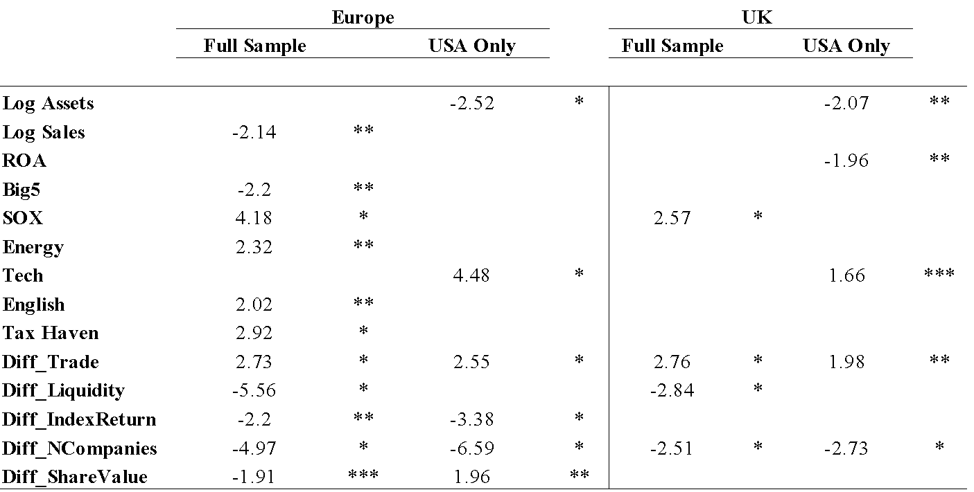

*The Europe sample includes 477 firms in the full sample (77% concordant with a chi-square of 406.3), and 362 firms in the USA only sample (65% concordant with a chi-square of 322.86). The UK sample includes 175 firms in the full sample (88% concordant with a chi-square of 186.16) and 64 firms in the USA only sample (75% concordant with a chi-square of 127.21).*

Europe includes: Austria, Belgium, Channel Islands, Croatia, Cyprus, Denmark, Finland, France, Germany, Greece, Hungary, Ireland, Italy, Luxembourg, Netherlands, Norway, Poland, Portugal, Russia, Spain, Sweden, Switzerland, and the UK. UK is the only country that had significant results on its own. In the Europe full Americas sample, companies with high sales and a employing a Big5 auditor prefer the USA exchanges, while those listing since SOX, energy firms, and those from tax havens and common law countries prefer the other American exchanges. Trade balance is important when listing onto other American exchanges, though market liquidity, index return, number of companies, and share value are influential when listing onto USA exchanges. In the Europe USA sample, high amounts of assets indicate a preference for the NYSE, while technology firms prefer the Nasdaq. Trade balance and share value are important when listing onto the Nasdaq, while index return and number of companies are influential for NYSE listings. For the UK full Americas sample, since SOX UK companies have listed more onto other American exchanges, and trade balance is also influential when listing onto other American exchanges; liquidity and number of companies are important when listing onto the NYSE for UK companies. In the UK USA sample, firms with high amounts of assets and ROA prefer the NYSE over the Nasdaq, while technology firms prefer the Nasdaq. Trade balance is important when listing onto the Nasdaq for UK firms, while number of listed companies is more relevant when listing onto the NYSE.

**Table II. The European Union and the Euro-Zone**

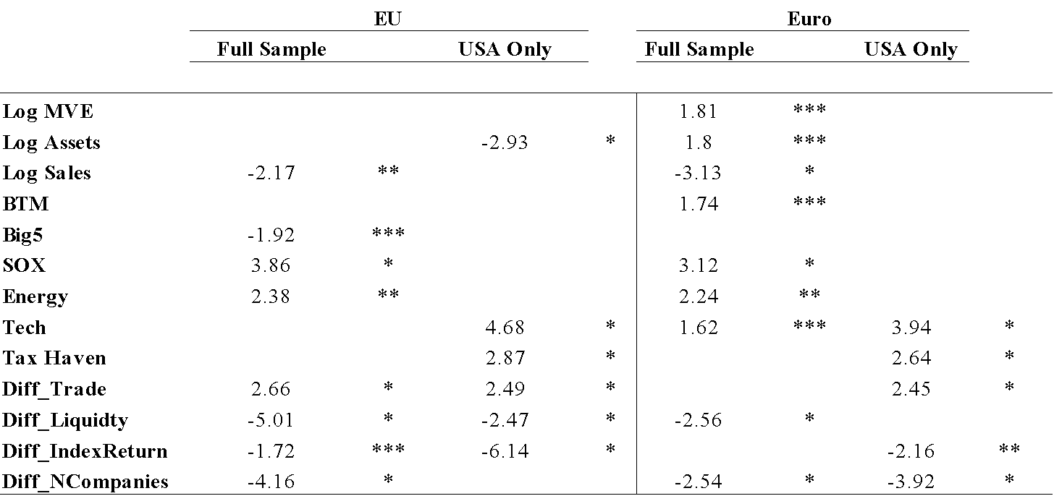

*The European Union sample includes 423 firms in the full sample (76% concordant with a chi-square of 344.29), and 362 firms in the USA only sample (66% concordant with a chi-square of 299.43). The Euro-Zone sample includes 226 firms in the full sample (82% concordant with a chi-square of 178.02) and 184 firms in the USA only sample (75% concordant with a chi-square of 188.01).*

European Union includes: Austria, Belgium, Cyprus, Denmark, Finland, France, Germany, Greece, Hungary, Ireland, Italy, Luxembourg, Netherlands, Poland, Portugal, Spain, Sweden, and the UK. Euro-Zone includes: Austria, Belgium, Cyprus, Finland, France, Germany, Greece, Ireland, Italy, Luxembourg, Netherlands, Portugal, and Spain. In the EU full Americas sample, firms with high sales and those employing a Big5 auditor prefer the USA exchanges, while those listing since 2002 and energy corporations prefer the other American exchanges. Trade balance is important when listing onto the other American exchanges, while market liquidity, index return, and number of listed companies influence listing on the USA exchanges. In the EU USA sample, firms high amounts of assets prefer the NYSE over the Nasdaq, while technology firms and those from tax havens prefer the Nasdaq. Trade balance is more important when listing on the Nasdaq, while liquidity and index return are influential when listing onto the NYSE. In the Euro full Americas sample, firms with high levels of MVE, assets, and BTM, and those listing since SOX and energy and technology firms prefer the other American exchanges over the USA exchanges. Firms with high amounts of sales prefer the USA exchanges, and market liquidity and number of companies are more important when listing onto the USA exchanges. In the Euro USA sample, technology firms and those from tax havens prefer the Nasdaq over the NYSE, while trade balance is influential in listing onto the Nasdaq, and index return and number of companies listed are more important when listing onto the NYSE.

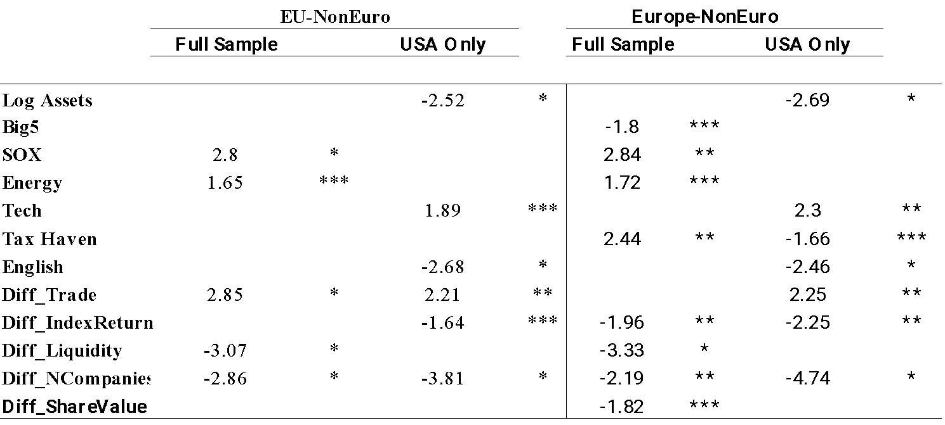

**Table III. NonEuro- European Union and Europe**

*The Non-Euro European Union sample includes 196 firms in the full sample (88% concordant with a chi-square of 204.04), and 362 firms in the USA only sample (68% concordant with a chi-square of 133.28). The Non-Euro Europe sample includes 250 firms in the full sample (88% concordant with a chi-square of 268.14) and 176 firms in the USA only sample (67% concordant with a chi-square of 163.76).*

EU-NonEuro includes: Denmark, Hungary, Poland, Sweden, and the UK. Europe-NonEuro includes: Channel Islands, Croatia, Denmark, Hungary, Norway, Poland, Russia, Sweden, Switzerland, and the UK. In the EU-NonEuro full Americas sample, energy corporations and those listing since SOX prefer the other American exchanges, and trade balance is important when listing onto the other American exchanges, while market liquidity and number of companies is relevant when listing onto the USA exchanges. In the EU-NonEuro USA sample, firms with high amounts of assets and those from English speaking countries prefer the NYSE, while technology firms prefer the Nasdaq; trade balance is important for firms listing onto the Nasdaq, while index return and number of listed companies are relevant when listing onto the NYSE. In the Europe-NonEuro full Americas sample, firms employing Big5 auditors prefer the USA exchanges, while energy firms, those from tax havens, and those listing since 2002 prefer the other American exchanges; index return, market liquidity, number of listed companies, and share value are all important when listing onto USA exchanges. For the Europe-NonEuro USA sample, corporations with high amounts of assets, and those from tax havens and English speaking countries prefer the NYSE, while technology firms prefer the Nasdaq over the NYSE. Trade balance is important when deciding to list onto the Nasdaq, while index return and number of listed companies are influential when listing onto the NYSE.

**Table IV. Mainland and Western Europe**

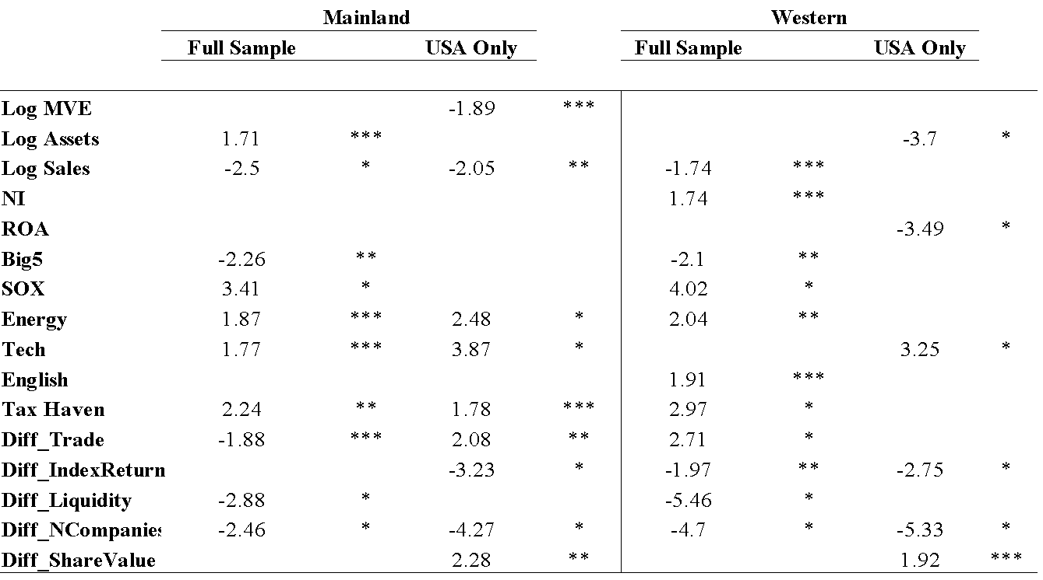

*The Mainland Europe sample includes 248 firms in the full sample (86% concordant with a chi-square of 218.55), and 193 firms in the USA only sample (75% concordant with a chi-square of 190.53). The Western Europe sample includes 467 firms in the full sample (78% concordant with a chi-square of 404.98) and 352 firms in the USA only sample (72% concordant with a chi-square of 349.88).*

Mainland includes: Austria, Belgium, Croatia, Denmark, Finland, France, Germany, Greece, Hungary, Italy, Luxembourg, Netherlands, Poland, Portugal, Russia, Spain, and Switzerland. Western includes: Austria, Belgium, Channel Islands, Cyprus, Denmark, Finland, France, Germany, Greece, Ireland, Italy, Luxembourg, Netherlands, Norway, Portugal, Spain, Sweden, Switzerland, and the UK. In the Mainland full Americas sample, firms with high amounts of assets, energy and technology firms, those listing since 2002, and those from tax havens prefer the other American exchanges, while those with high levels of sales and those employing Big5 auditors prefer the USA exchanges. Trade balance, market liquidity, and number of listed companies are all important when listing onto USA exchanges. For the Mainland USA sample, firms with high MVE and sales prefer the NYSE to the Nasdaq, while energy and technology firms and those from tax havens prefer the Nasdaq. Trade balance and share value are important considerations when listing onto the Nasdaq, as are index return and number of listed companies when listing onto the NYSE. In the Western full Americas sample, firms with high amounts of sales and those employing Big5 auditors prefer the USA exchanges, while those with a high NI, those listing since 2002, energy corporations, and those from English speaking countries and tax havens prefer the other American exchanges. Trade balance is important when listing onto other American exchanges, while index return, market liquidity, and number of companies listed are considerations when listing onto USA exchanges. For the Western USA sample, high amounts of assets and ROA indicate a preference for the NYSE over the Nasdaq, whereas technology firms prefer the Nasdaq. Index return and number of listed companies are considered when listing onto the NYSE, while share value is important when listing onto the Nasdaq.

**Table V. British Isles and Scandinavia**

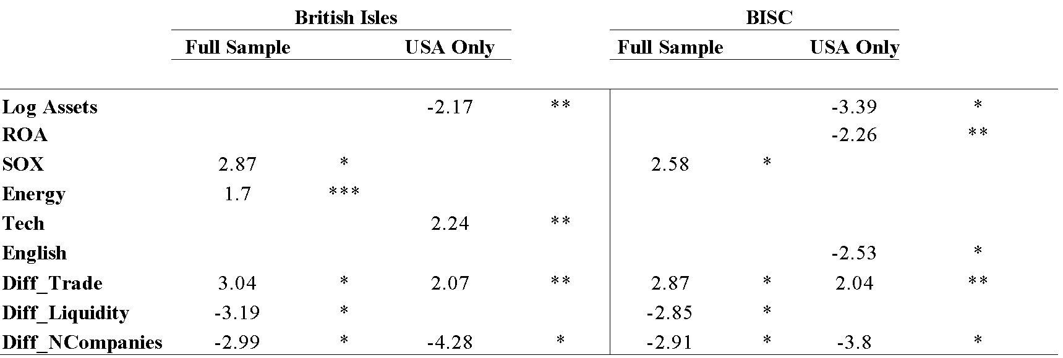

*The British Isles sample includes 208 firms in the full sample (89% concordant with a chi-square of 217.11), and 152 firms in the USA only sample (68% concordant with a chi-square of 138.82). The British Isles-Scandinavia sample includes 237 firms in the full sample (90% concordant with a chi-square of 244.66) and 175 firms in the USA only sample (74% concordant with a chi-square of 179.8).*

British Isles includes: Channel Islands, Ireland, and the UK. Scandinavia includes: Denmark, Finland, Norway, and Sweden. For the British Isles full Americas sample, energy firms and those listing since 2002 prefer the other American exchanges, trade balance is relevant when listing onto the other American exchanges, and market liquidity and number of listed companies are considered heavily when listing onto the USA exchanges. In the British Isles USA sample, firms with high levels of assets prefer the NYSE, technology firms prefer the Nasdaq over the NYSE, while trade

balance is important when listing onto the Nasdaq and number of listed companies is relevant to consider when listing onto the NYSE. When Scandinavia is included with the British Isles, the results are essentially the same, except that in the USA sample a high ROA and being from an English speaking country indicates a preference for the NYSE over the Nasdaq, and energy firms and technology firms now have no statistical preferences.

***7.1.2. Time Trends***

Prob (Pre-8/2002 =0; Post-8/2002 =1) (2)

= α + β1*logMVE* + β2*logAst* + β3*logSales* + β4*ROA* + β5*NI*+ β6*BTM* + β7*Big5* + β8*SOX* + β9*English* + β10*Energy* + β11*Tech* + β12*Emerging* + β13*CommonLaw* + β14*TaxHaven* + β15*Diff_Trade* + β16*Diff_Liquidity* + β17*Diff_IndexReturn* + β18*Diff_NCompanies* + β19*Diff_ShareValue* + ε

**Table VI. SOX- Europe, EU, and Euro-Zone**

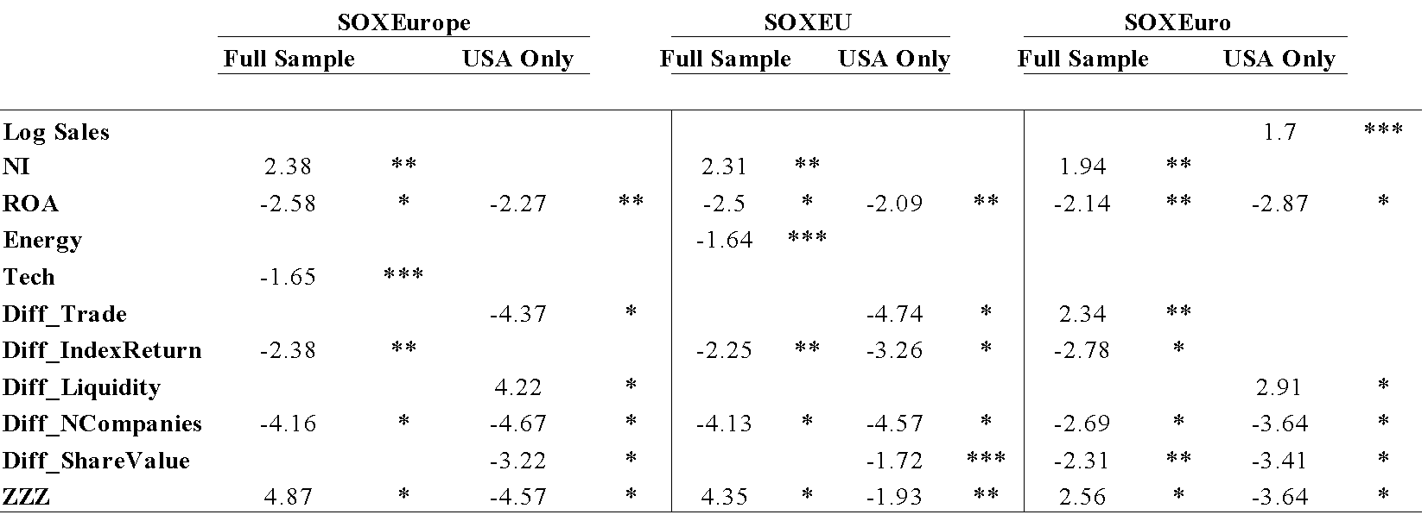

*The Europe sample includes 477 firms in the full sample (39% concordant with a chi-square of 232.54), and 362 firms in the USA only sample (37% concordant with a chi-square of 124.78). The European Union sample includes 423 firms in the full sample (38% concordant with a chi-square of 202.69), and 362 firms in the USA only sample (28% concordant with a chi-square of 89.52). The Euro-Zone sample includes 226 firms in the full sample (50% concordant with a chi-square of 142.42) and 184 firms in the USA only sample (41% concordant with a chi-square of 72.54).*

Europe includes: Austria, Belgium, Channel Islands, Croatia, Cyprus, Denmark, Finland, France, Germany, Greece, Hungary, Ireland, Italy, Luxembourg, Netherlands, Norway, Poland, Portugal, Russia, Spain, Sweden, Switzerland, and the UK. UK is the only country that had significant results on its own. European Union includes: Austria, Belgium, Cyprus, Denmark, Finland, France, Germany, Greece, Hungary, Ireland, Italy, Luxembourg, Netherlands, Poland, Portugal, Spain, Sweden, and the UK. Euro-Zone includes: Austria, Belgium, Cyprus, Finland, France, Germany, Greece, Ireland, Italy, Luxembourg, Netherlands, Portugal, and Spain. In the SOXEurope full Americas sample, firms with a high NI have listed more since 2002, though technology firms and those with a high ROA have listed less; index return and number of listed companies were more important considerations before 2002. In the SOXEurope USA sample the results are similar, except that trade balance and share value have become less important in the USA since 2002, and market liquidity has become more important. In the SOXEU sample the results are similar, except that energy firms have listed less since SOX, and index return has also become less important in the USA since 2002. For the SOXEuro sample, the results are again similar, though trade balance has become more important within all the American exchanges since 2002, and firms with high levels of sales have listed more since SOX. In all samples the other American markets have seen more activity than the USA since SOX, and within the USA the NYSE has been more active in cross-listing than the Nasdaq.

**7.2 Time Series Analyses**

The time series analyses utilise a two-step time series stochastic process that employs unit roots to identify and remove nonstationary elements, and then regresses the significant factors in an ARCH model to identify the most important economy-specific and stock market-specific variables in the Asia-Pacific region.

***7.2.1. Currency Union Convergence***

Table VII. Unit Roots

Table VIII. ARCH

***7.2.2. Stock Market Integration***

Table IX. Unit Roots

Table X. ARCH

**8. Summary**

An important aspect of capital market integration and common currency acceptance is the nature of the arrangements. In many Western countries, the stock exchanges are actually publicly traded entities, and therefore held by private citizens, though the printing press is the complete domain of the government. It thus, in theory, becomes much easier for stock market integration for to occur, as evidenced by the NYSE and Nasdaq branching into Europe. Many times there is still the government securities administration whom can block such deals however. Therefore joining the currency union is almost a national move to help the national welfare of the people, while stock market integration can be characterised as motivated more by business interests. This would suggest that stock market integration would be easier to occur, though not necessarily needed to occur before currency integration.

Stock markets are essential to the growth of a country. They are run by businessmen, and strictly regulated by the governments. In the island economy, the stock market will transfer funds between investors and businesses on a larger scale than deposit banking may, along with promises of a higher reward with higher risk. The government steps in to regulate, as they do with the banking system, and financial intermediation thus evolves to a capital debt and equity market level along with the money market banking system. Just as the government does not own the banks, they do not own the stock market auctioneer either, they make the laws to regulate them and allow their citizens to enter the business that suits them, whether it be financial intermediation or other pursuits. However, when the island economy engages in trade with other islands, the government faces a dilemma. The government wants to increase trade and take advantages of economies of scale and competitive advantages to raise welfare, yet it must also be careful to not let the foreigners dictate the terms of trade on a long-term basis for short-term benefits. This includes foreign corporations with domestic concerns that do not take control of markets, as well as ownership stakes in the country's present businesses. All businesses are of concern, though the financial intermediaries are of primary concern. The government must ensure the banks and stock market remain in home control to ensure the domestic citizens are being cared for not at the expense by the foreign citizens.

One only has to look at the Nasdaq OMX websites to see that the exchanges they have united in Europe offer much better products and service than they did previously. Nasdaq even offers competitive clearing facilities against the LSE from their London office. As the USA can attest to from their revolutionary experiences, however, when the exchanges become more advanced and developed, will they want Nasdaq's name attached to their national stock markets. The stock market is a very patriotic symbol, as evidenced by Norway's insistence on maintaining the Oslo Bors, while their Scandinavian neighbours have all combined onto one. In fact, the majority of stock exchanges in the world do not allow foreign firms from entering, and are owned by the government. Not the most capitalised, though the numerical majority nonetheless. This list includes some rather large economies and powerful nations as well, including: Russia, China, India, Brazil, and all the Muslim countries. One can not reasonable imagine there ever being a NYSE Moscow or a Nasdaq Shanghai. The stock exchange is national symbol, much like the nation's currency. Yet, integration of both of these instruments is necessary to economic unions for higher welfare for citizens. As such, some sort of compromise has to be reached before capital markets for financing needs and currency for currency policy issues can proceed. National pride is maintained with currency combinations through keeping national symbols on the currency, and through stock markets with the name and control. Currency will never be controlled by an outside region, though as we see with the NYSE and Nasdaq foreign regions can gain a footing in the capital markets. It is only reasonable to assume that national governments will want to maintain some symbolism, although

Nasdaq has branched out into several markets in Europe and the Middle East. They currently regulate the Nasdaq OMX, Nasdaq Baltic, and Nasdaq Dubai. This is a great example, as is the NYSE EuroNext, of integration of stock exchanges. There is also a Nasdaq OMX First North which is the growth exchange for the Nasdaq OMX, which serves Denmark, Finland, Sweden, and Iceland. Norway still maintains their own stock exchange, the Oslo Bors. The Nordic exchange has 26 foreign countries, all of which are from Norway. This is a conglomeration between Denmark, Sweden, Finland, and Iceland. However, only Finland uses the Euro for currency from this group. Denmark, Iceland, Sweden, and Norway all use a form of the Krone for their currencies. As such, there is clearly a trend emerging here, with possibilities for Norway to merge their Oslo Bors with the Nordic exchange, as well as for the countries to adopt a common Krone, or to adopt the euro. A similar trend has developed in Western Europe, though the countries first adopted a common currency, then some banded together stock exchanges, opposite to the Nordic countries not adopting a common currency, yet banding together their stock exchanges. In terms of the NYSE EuroNext, which is comprised of France, Belgium, the Netherlands, and Portugal, the primary benefit is most likely name recognition and security for foreign issuers, as they see the established American names and they feel better about the capital access they will receive from the EuroNext and Nordic exchanges. It is also very likely that the resources of the NYSE and Nasdaq helped to speed up an integration process between these countries. This is also seen in the Nasdaq's work in the Balkans, through the Nasdaq Balkan exchange. An issue that might arise as to how the EuroNext and Nordic exchanges would fit into a merger of sorts between the NYSE and Nasdaq. Would there be business issues that render their relationships with the American exchanges null, and what help are they really providing to the European exchanges anyways. Most likely, the European branches would continue, though affiliated through a corporate name rather than via a city name, just as Paris and Brussels still have their own exchanges within the EuroNext system.

Although there are other European countries clearly, the focus of this paper is on those with the most established and transparent stock exchanges, and the influences of the largest economies on financial integration in Europe. London has always occupied a unique role in the global financial network. They occupy a geographically decisive position, which allows them to be isolated from Europe while still being an integral part of the European economic society. Not only does this isolate them from physical contagions, it allows them to be more discerning in their financial relationships as well, although the close bond to the USA banks looks to have been quite regrettable. Germany has over time carved out a niche as the financial leader of the European mainland. Their low inflationary policies have helped to strengthen the EuroZone, as they also house the European Central Bank. Switzerland is the major European economy which has shown no interest to join the Euro. They maintain a strategic position in the middle of the European Union, acting as a sort of stabilising influence to the EuroZone surrounding them, much like their history of mutual independence suggests. Other countries that are influential include Iceland, who is a member of the Nordic and a developed economy themselves. Iceland is already a member of the Nordic exchange, though Breeden and Pétursson (2006) suggest that the Iceland's trade could increase by about 60% and that the trade-to-GDP ratio could rise by 12 percentage points should Iceland join the European Union and EMU. As such, the stock market merger and currency union possibilities in Europe are diverse, and likely can help create greater economic growth in Europe.

**Table XI. European Stock Markets' Foreign Presence**

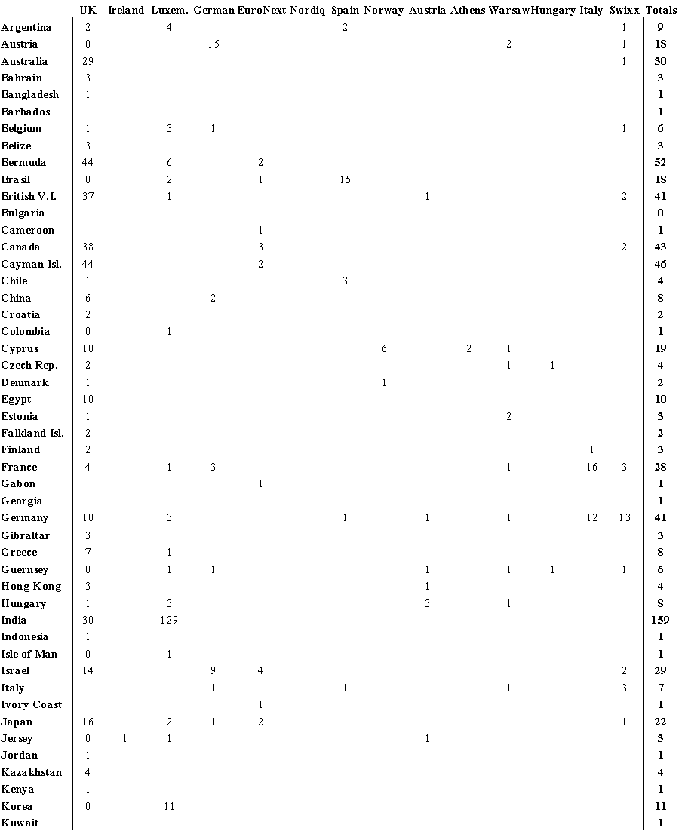

*Shows foreign corporations listed on European stock exchanges as of January, 2010. Although this does not show all foreign corporations listed on European stock exchanges since their inception, this does provide an example as to what foreign corporate activity on the European stock exchanges typically looks like.*

Table XI. European Stock Markets' Foreign Presence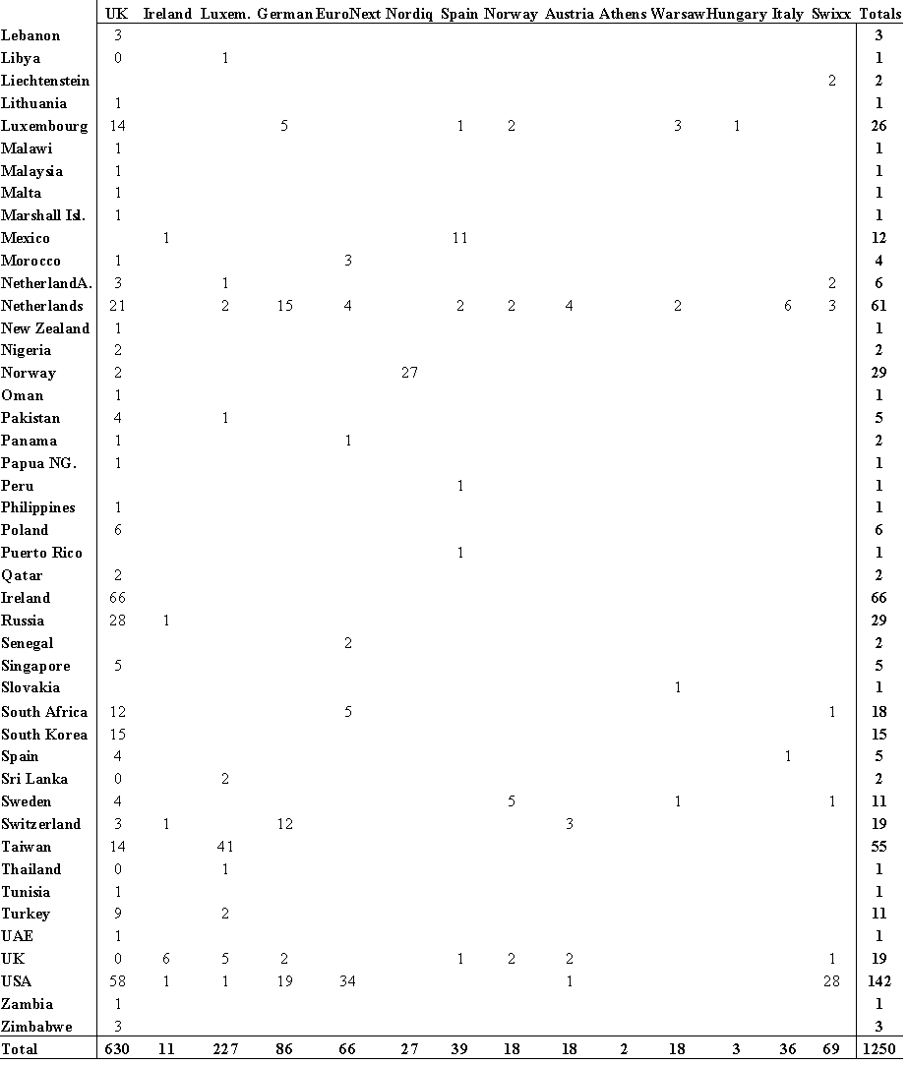

*Shows foreign corporations listed on European stock exchanges as of January, 2010. Although this does not show all foreign corporations listed on European stock exchanges since their inception, this does provide an example as to what foreign corporate activity on the European stock exchanges typically looks like.*

**Table XII. Annual Listings and Delistings of Foreign Corporations in Europe**

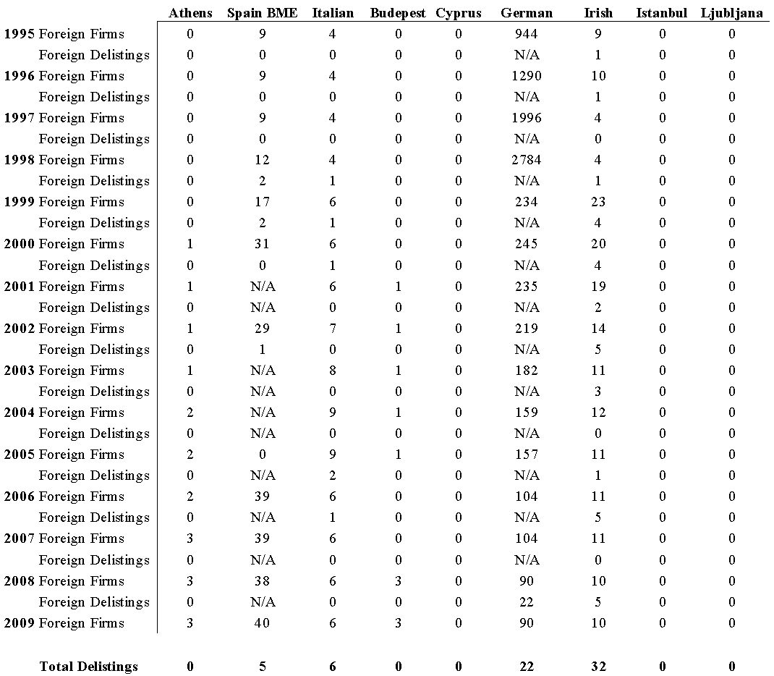

**Table XII. Annual Listings and Delistings of Foreign Corporations in Europe**

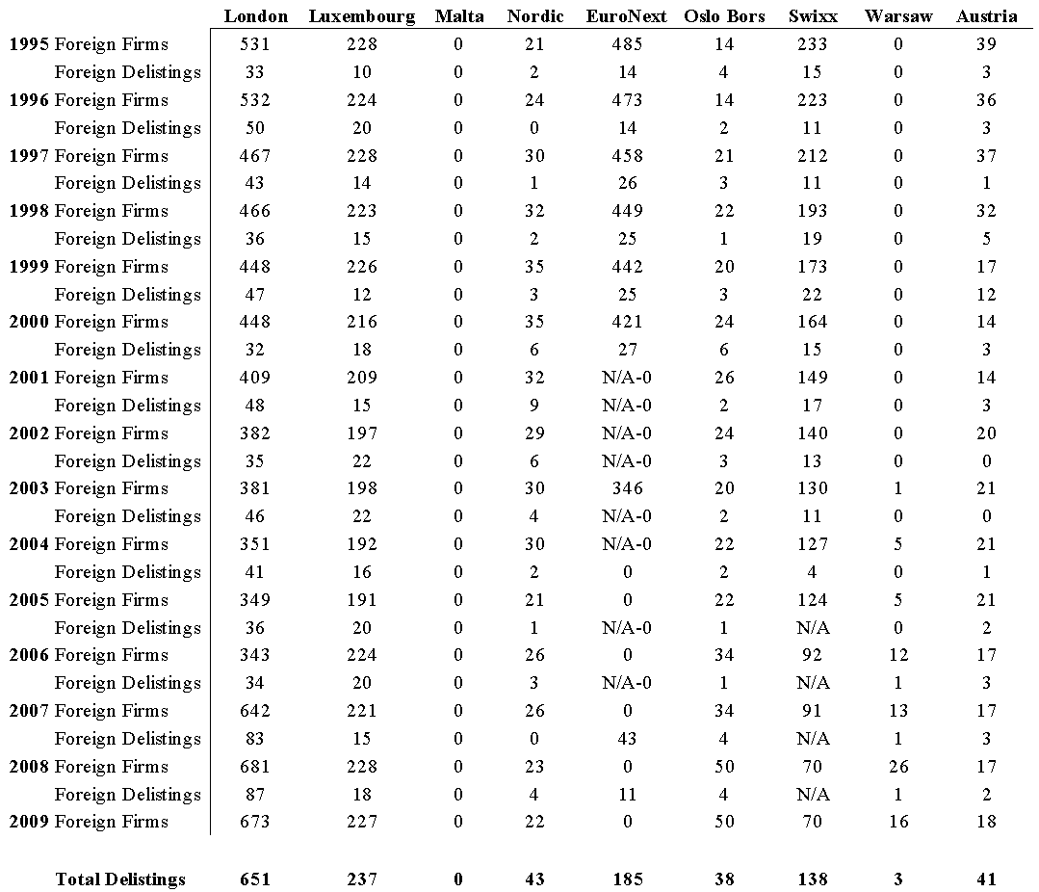

**Table XIII. European Governments' Listing Preferences**

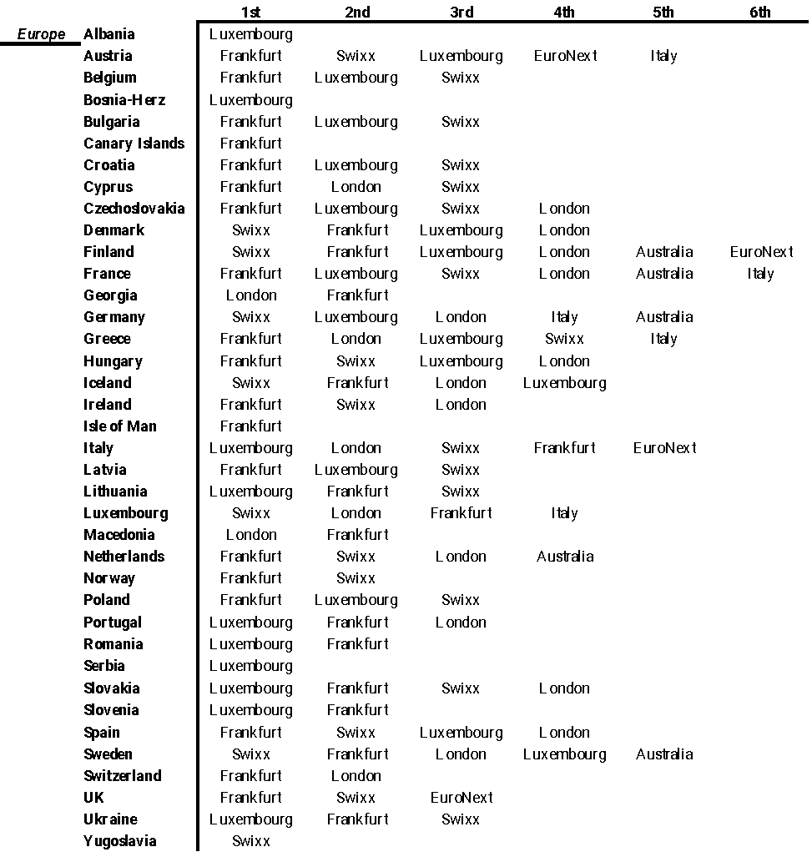

**Table XIV. European Governments' Proportional Utilisation of the Global Markets**

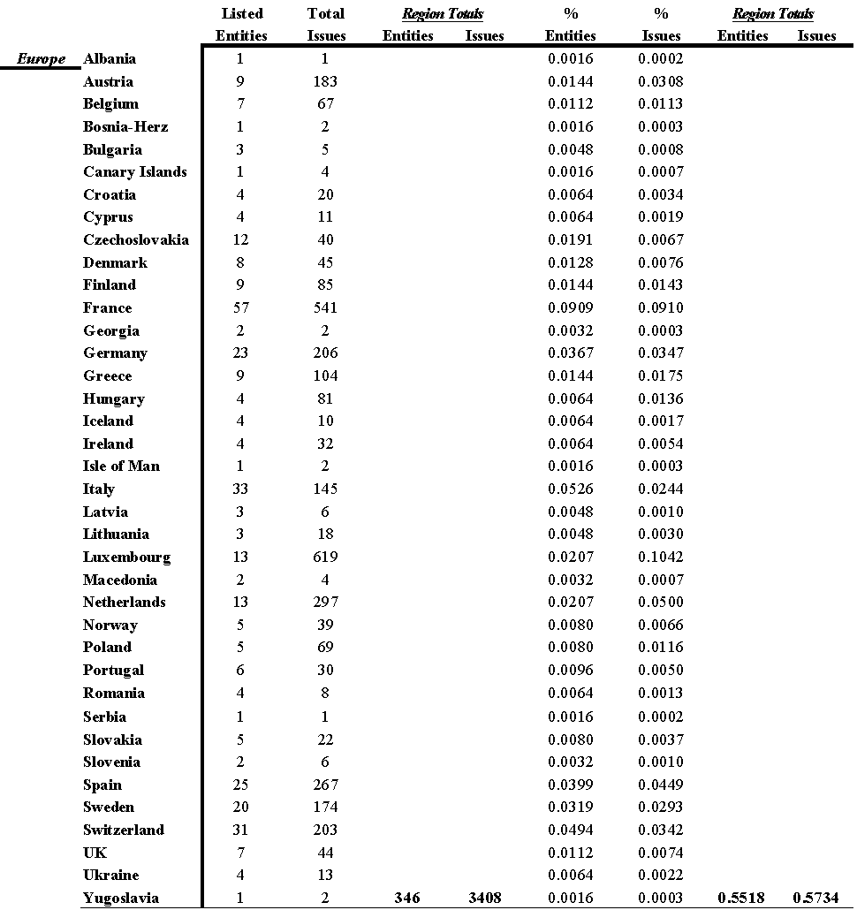

*The regional percentages are based on calculations from the entire population of foreign government listings on stock exchanges.*

Table XV. Summary Statistics European Corporations in the Americas

Table XVI. Summary Statistics European Economies

**Table XVII. Summary Statistics European Stock Markets**

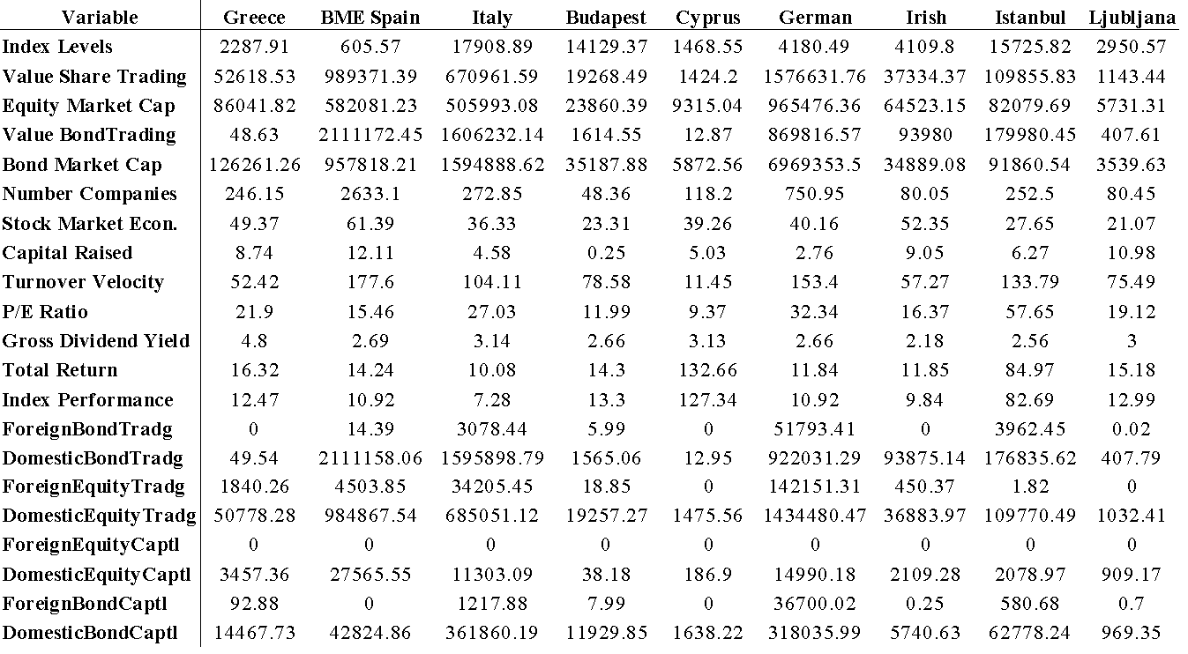

**Table XVII. Summary Statistics European Stock Markets**

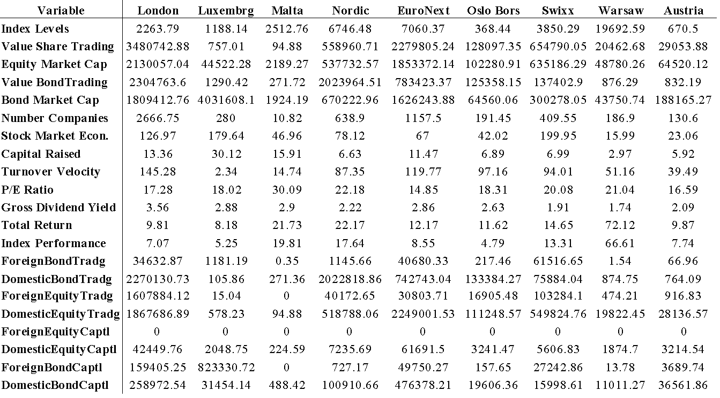

**Table XVIII. European Corporations in the Americas**

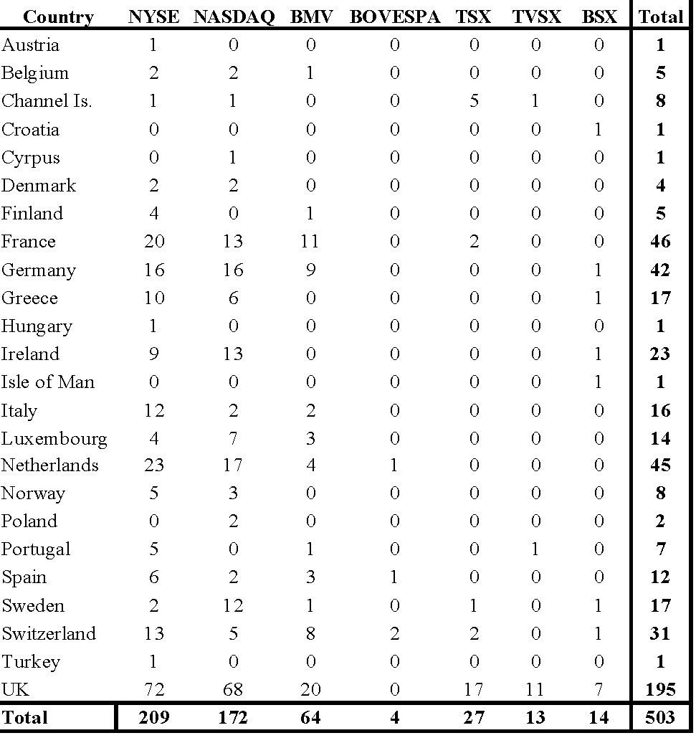

**VIII. Appendices**

**Appendix I. Governments in the Financial Markets**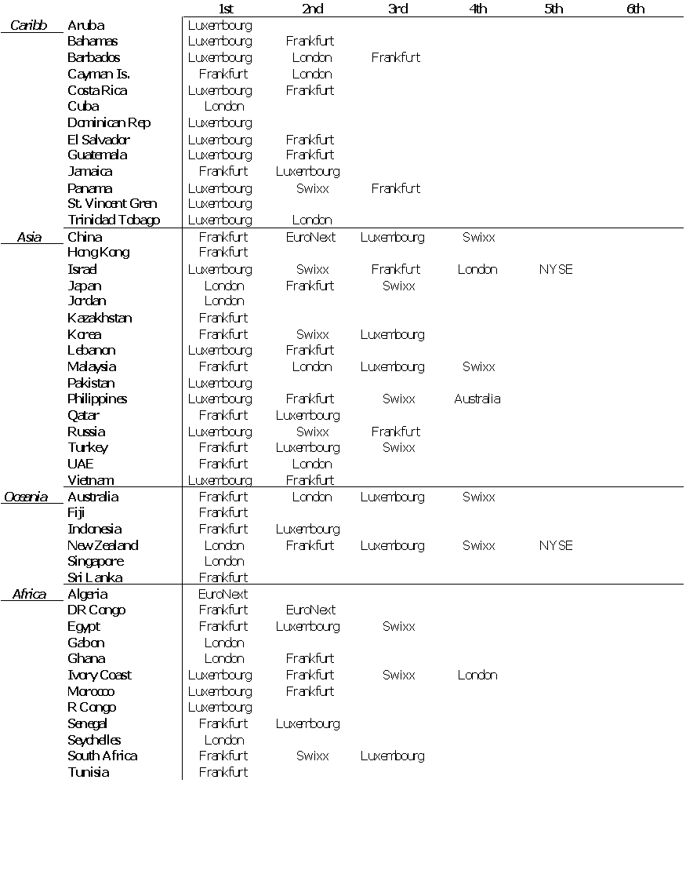

**Appendix I. Governments in the Financial Markets**

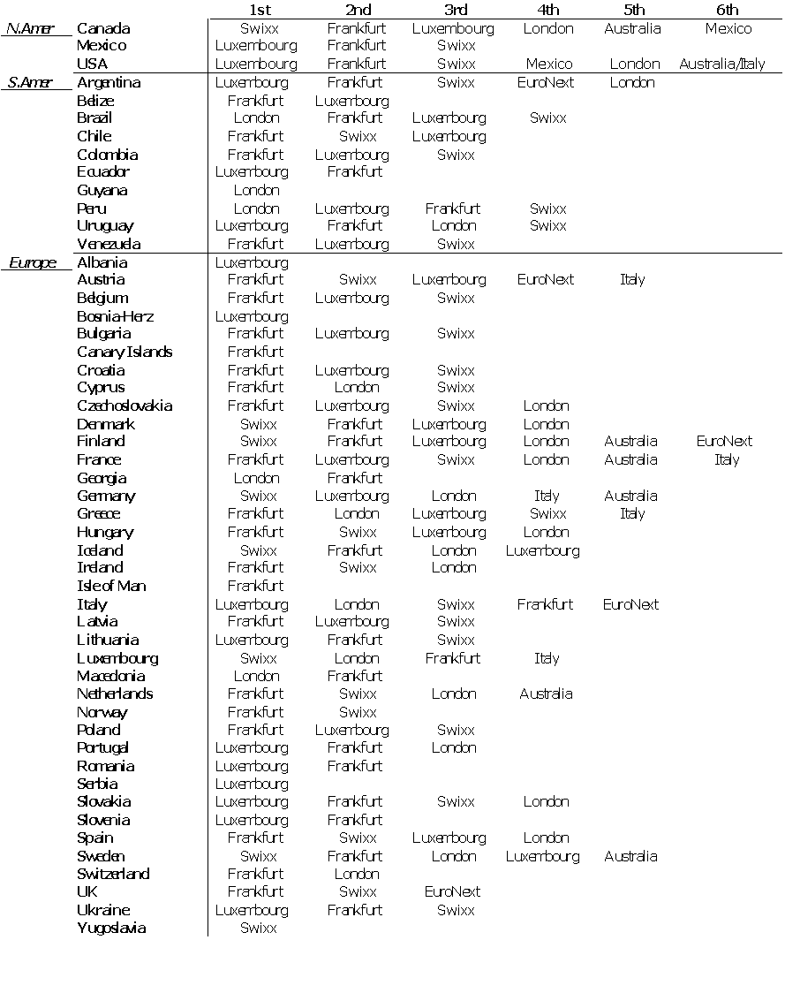

**Appendix I. Governments in the Financial Markets**

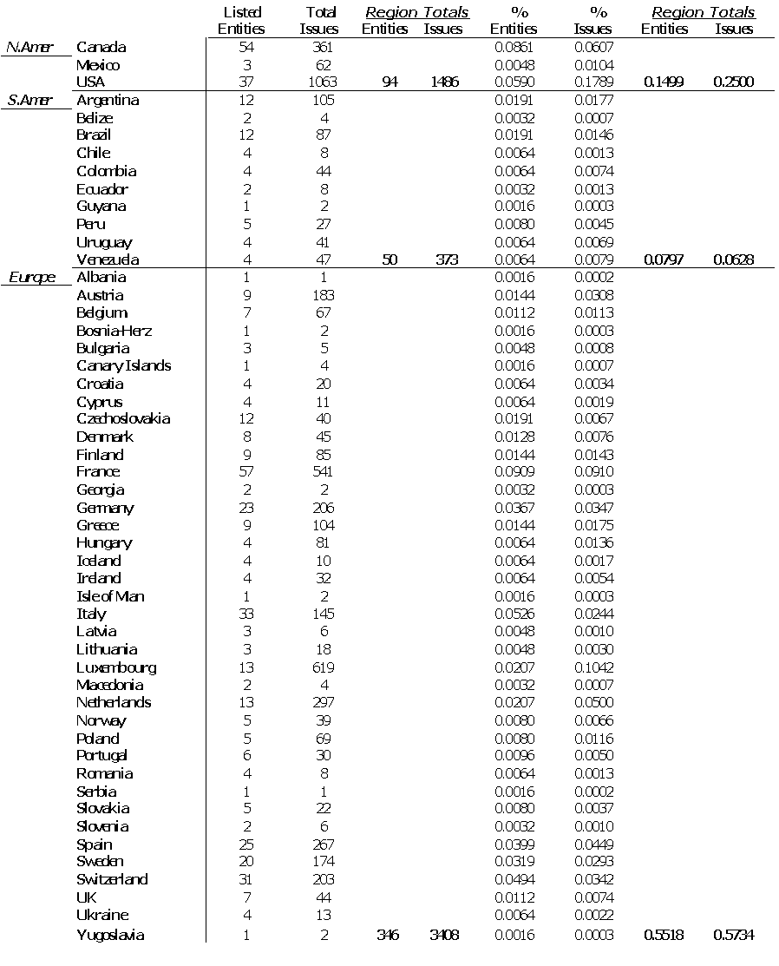

**Appendix I. Governments in the Financial Markets**

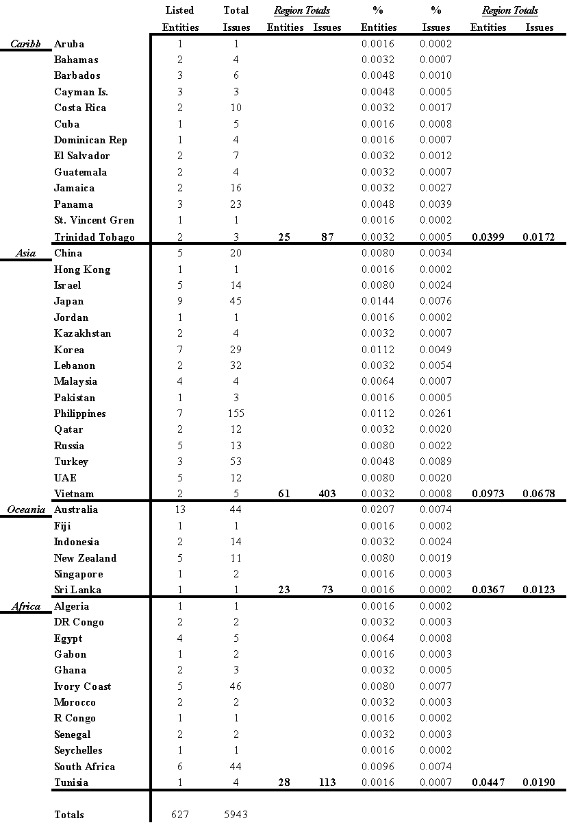

**Appendix I. Governments in the Financial Markets**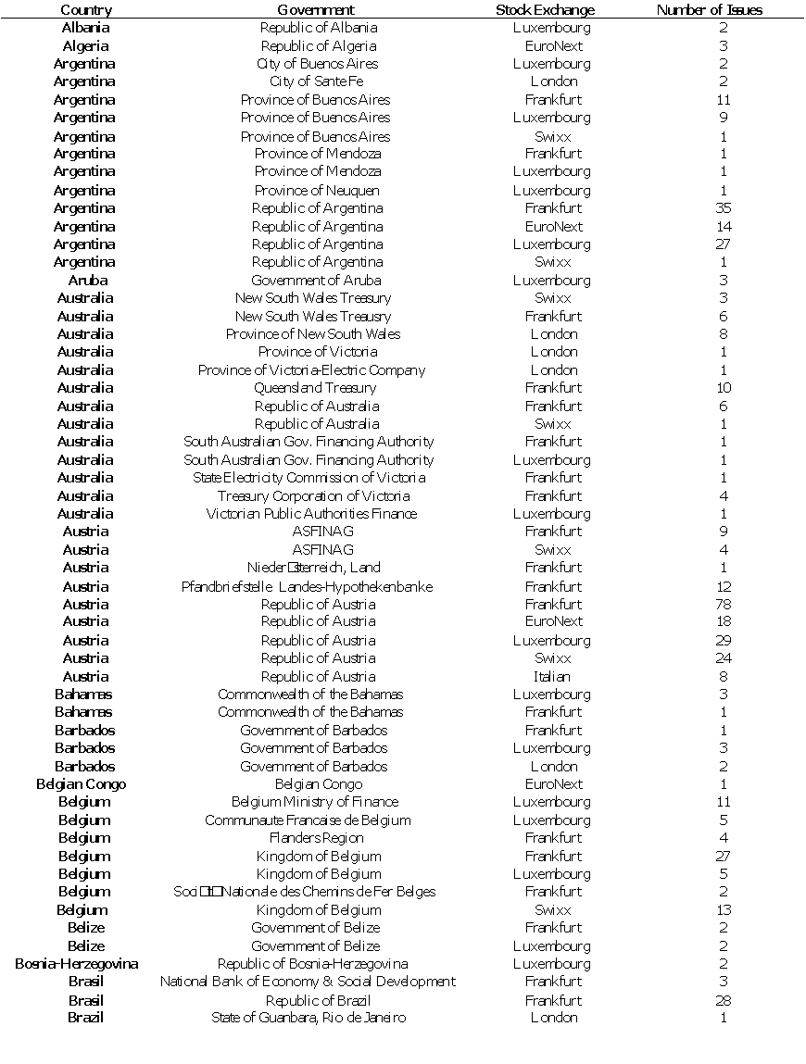

**Appendix I. Governments in the Financial Markets**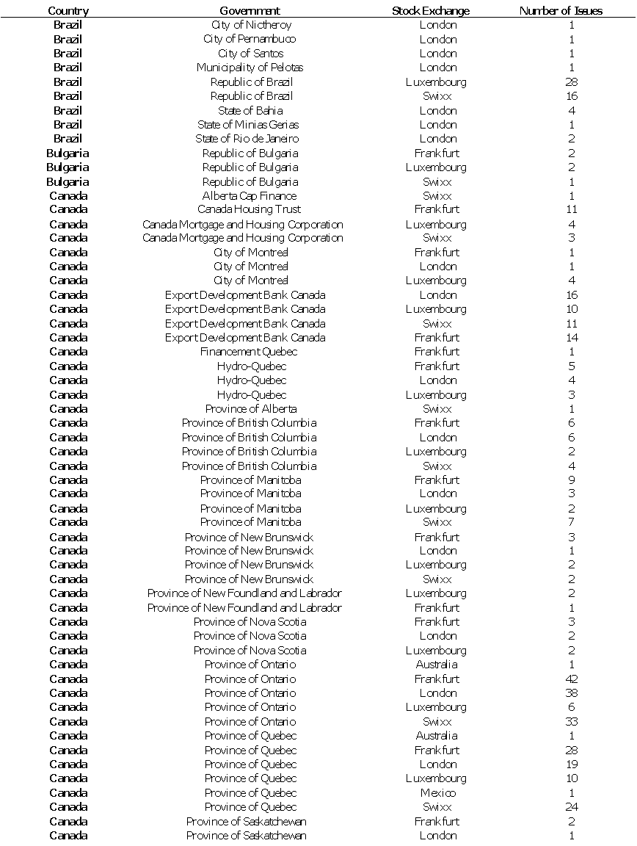

**Appendix I. Governments in the Financial Markets**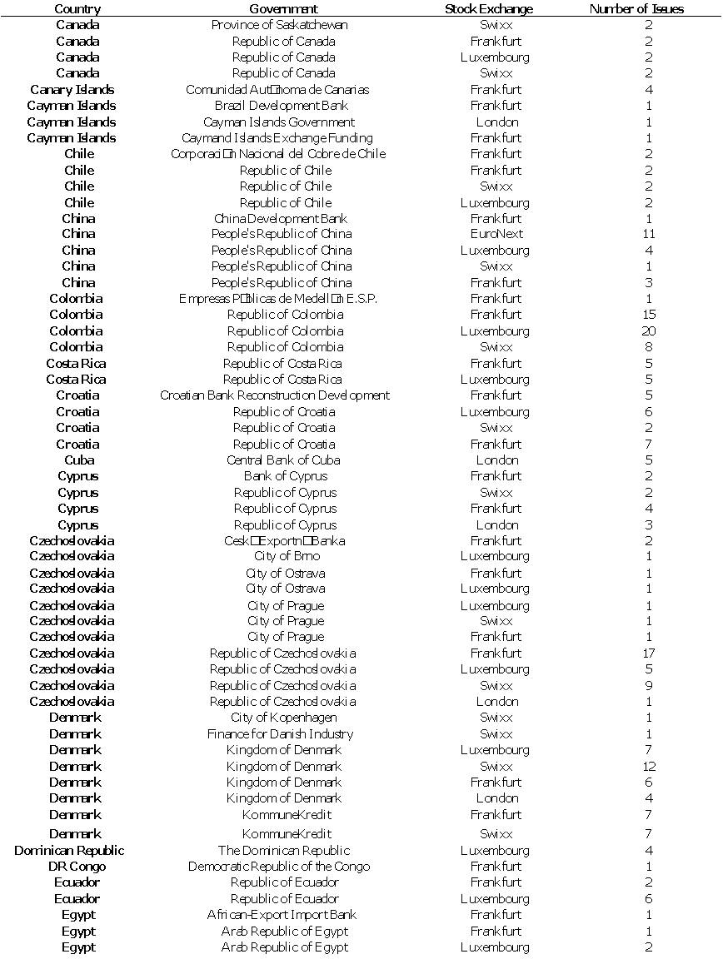

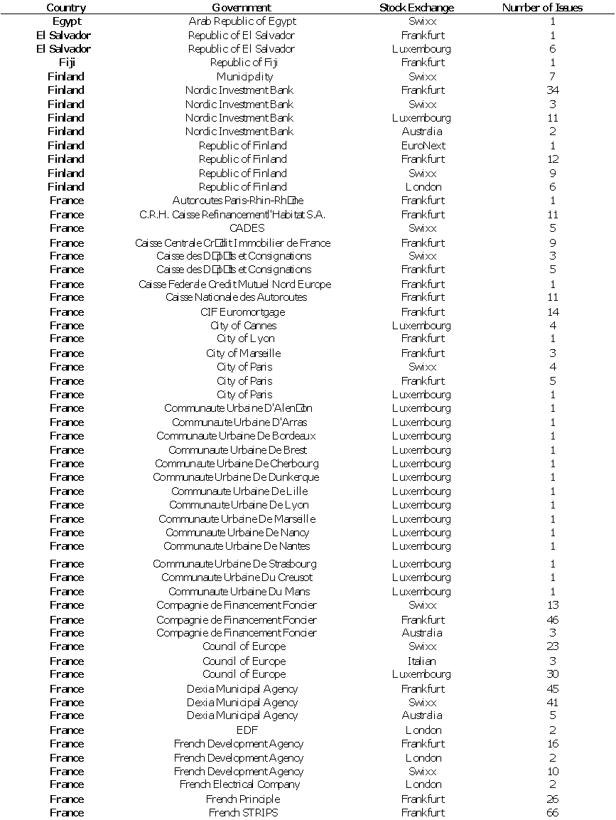

**Appendix I. Governments in the Financial Markets**

**Appendix I. Governments in the Financial Markets** 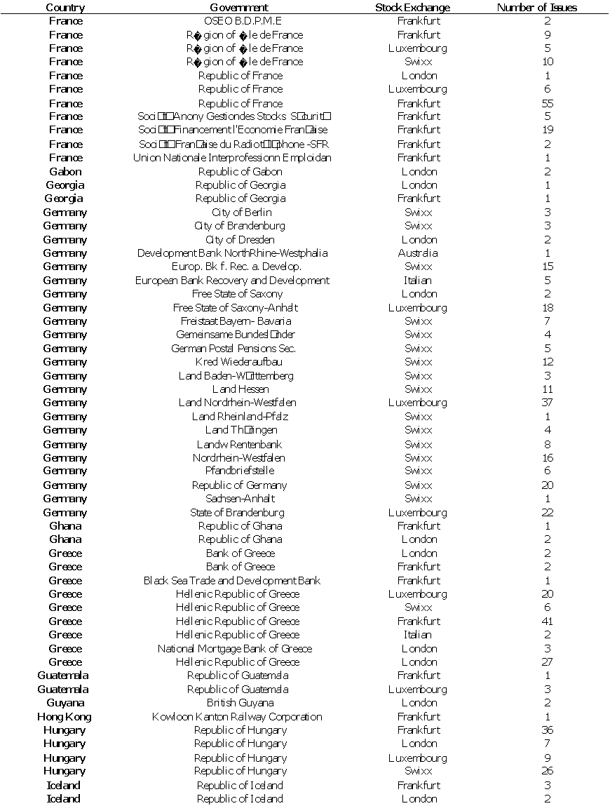

**Appendix I. Governments in the Financial Markets**

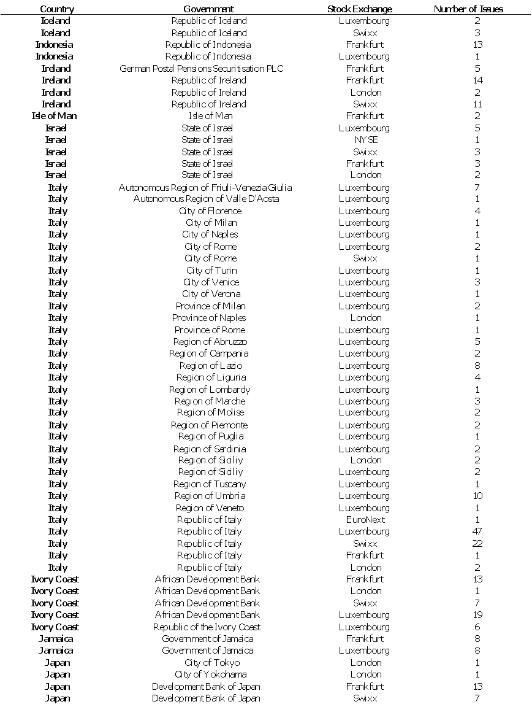

**Appendix I. Governments in the Financial Markets**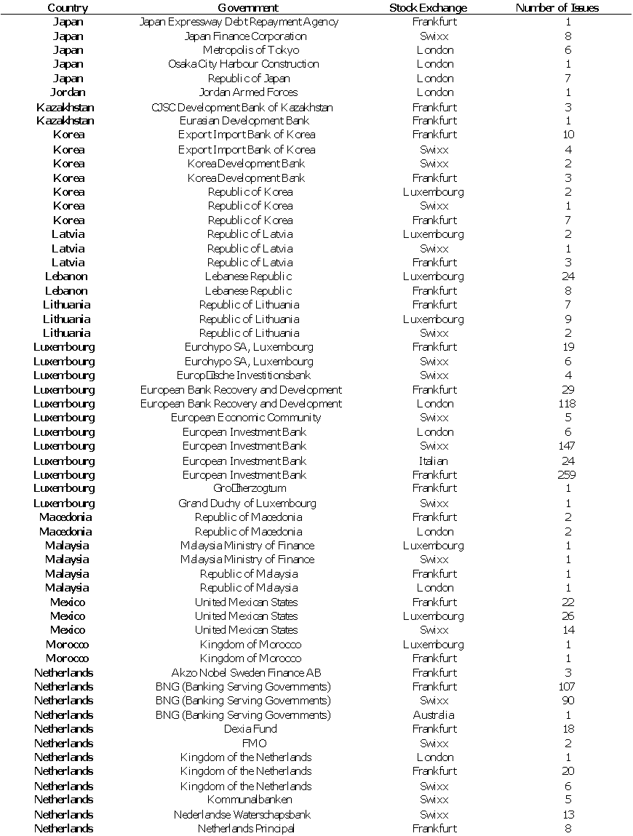

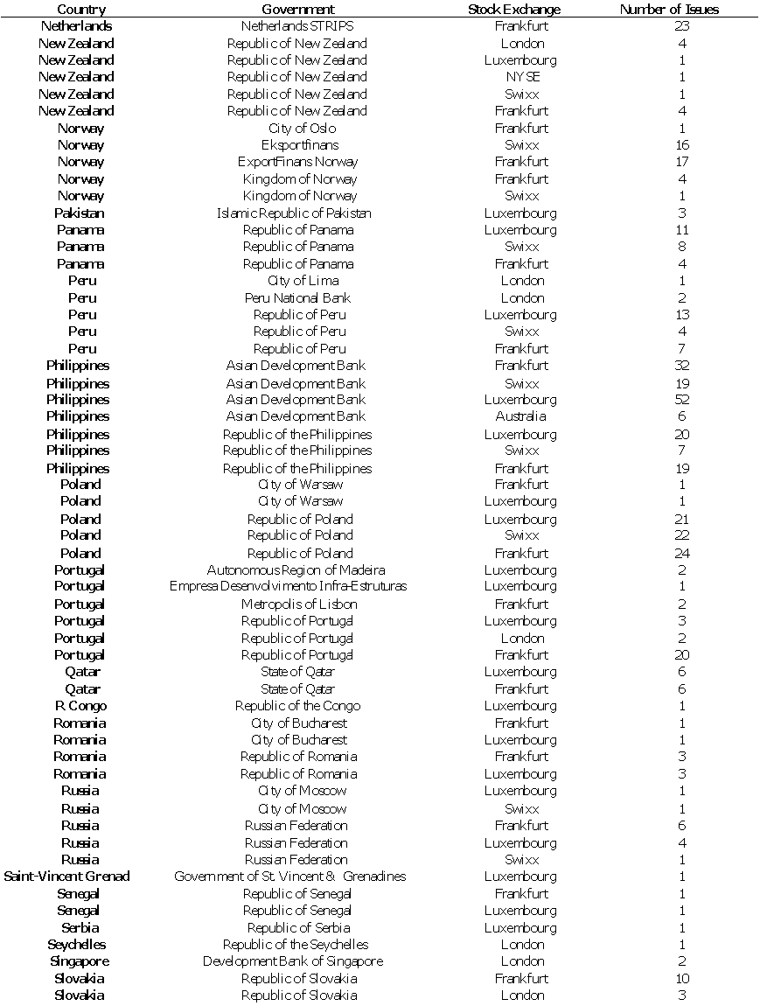

**Appendix I. Governments in the Financial Markets**

**Appendix I. Governments in the Financial Markets**

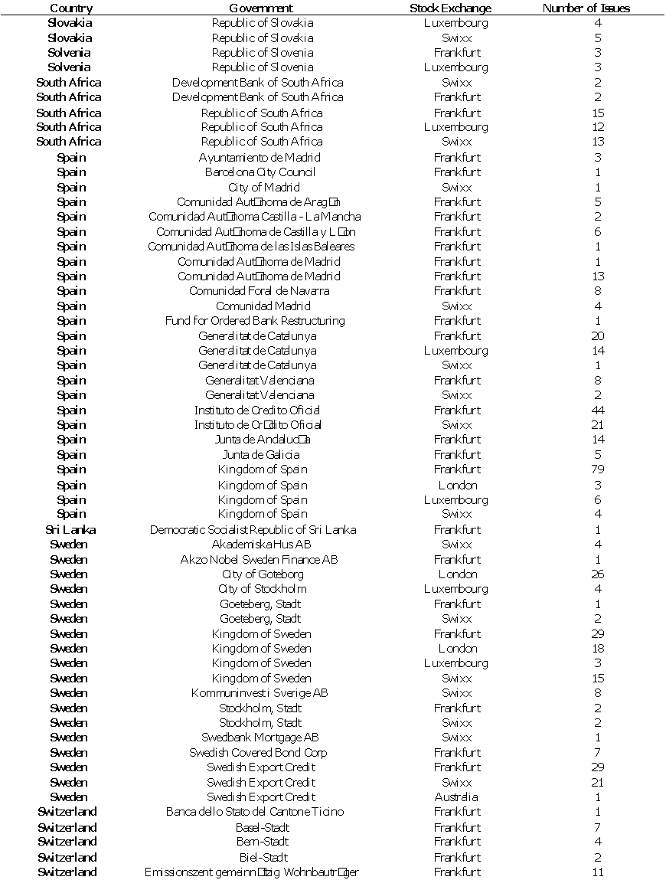

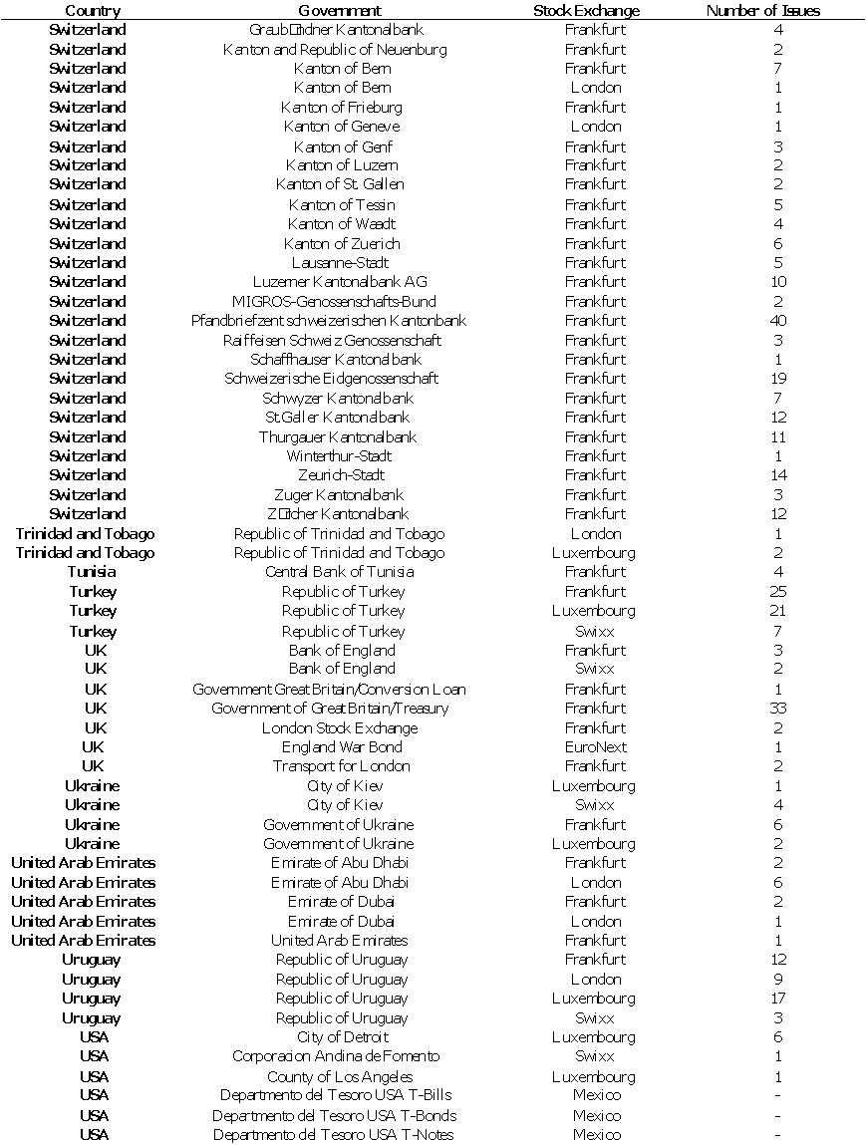

**Appendix I. Governments in the Financial Markets**

**Appendix I. Governments in the Financial Markets**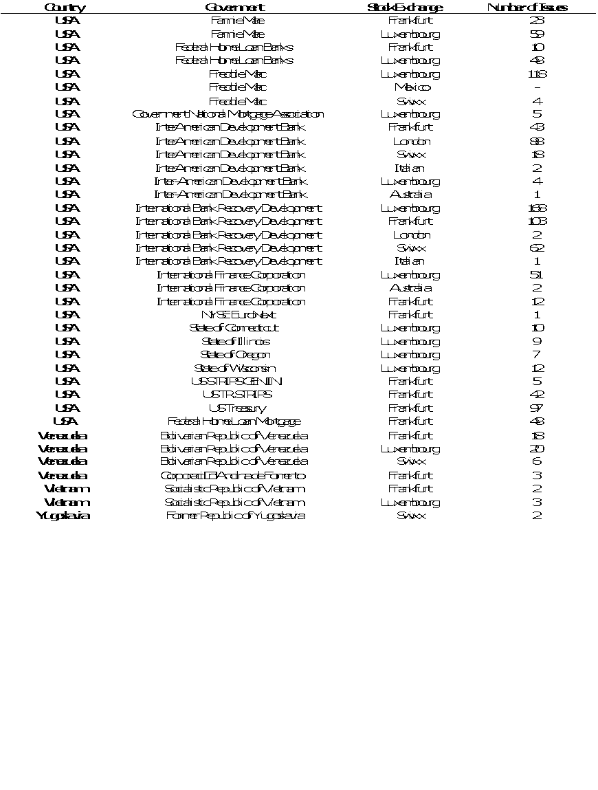

**Americas**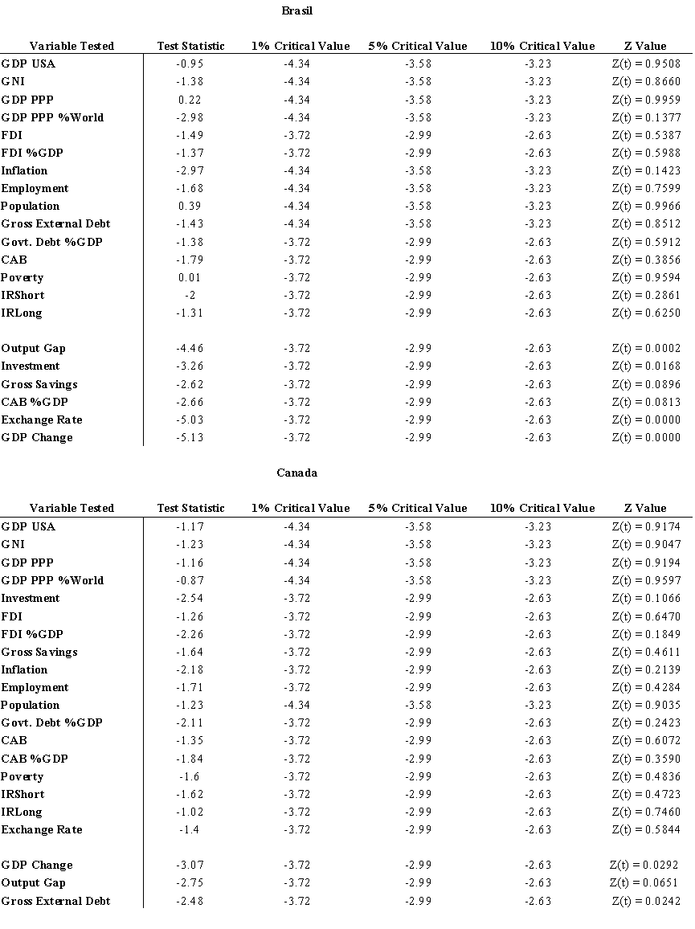

**Appendix II. Americas Economy Unit Roots**

**Appendix II. Americas Economy Unit Roots**

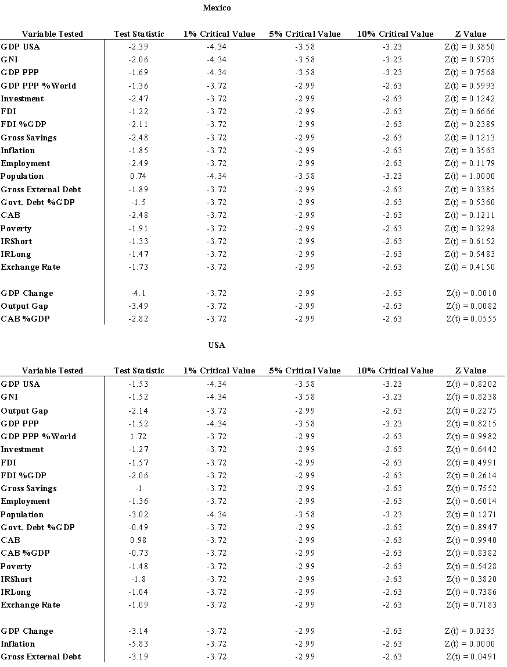

**Appendix III. Americas Economy ARCH Results**

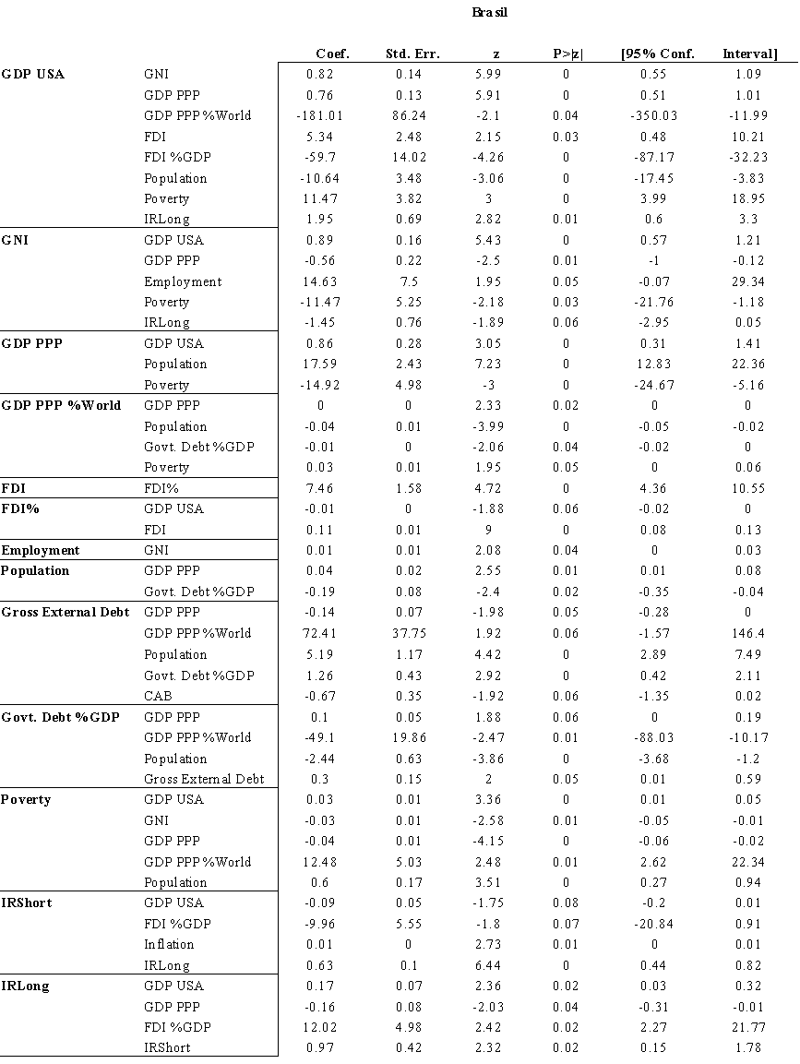

**Appendix III. Americas Economy ARCH Results**

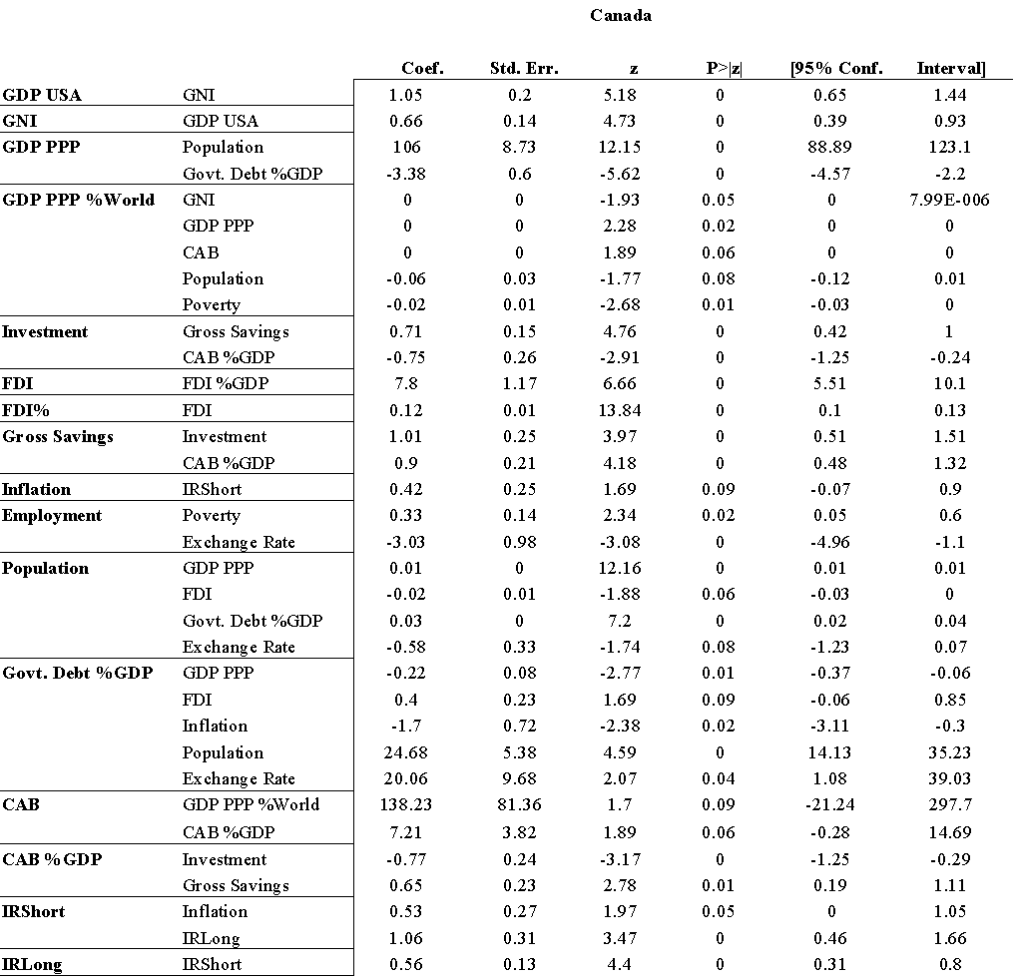

**Appendix III. Americas Economy ARCH Results**

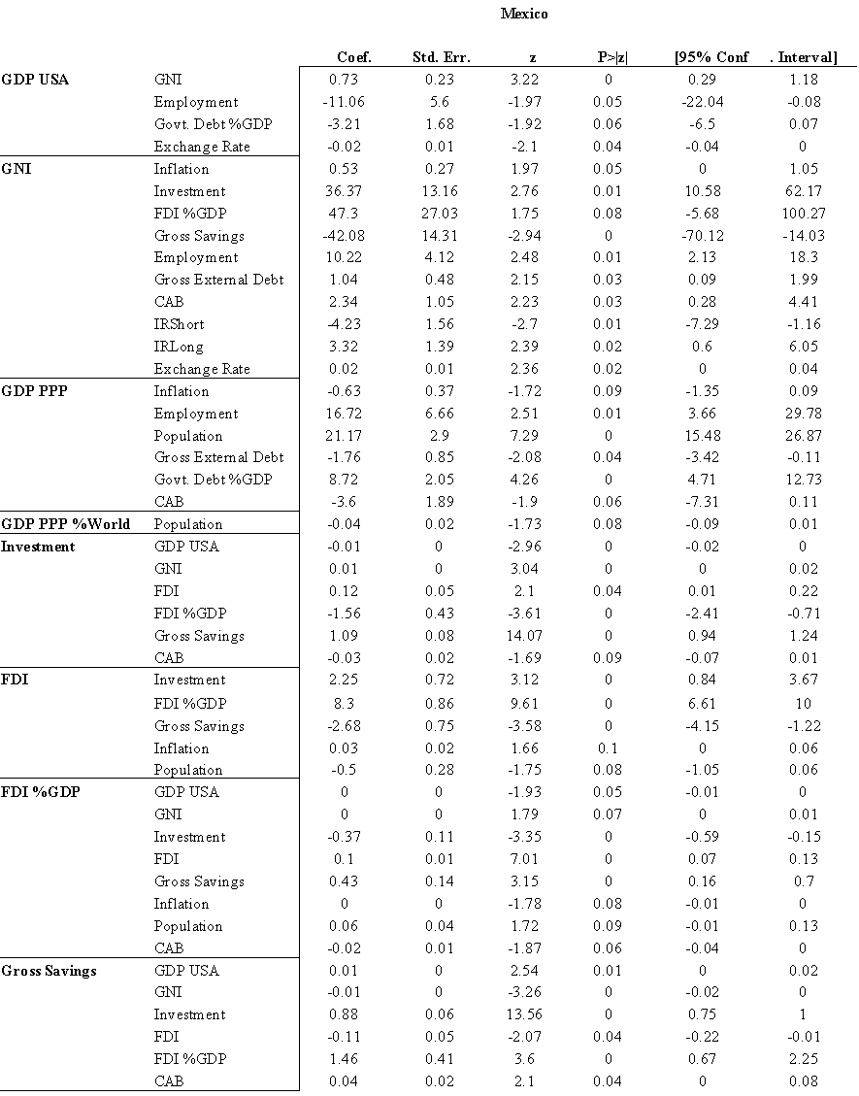

**Appendix III. Americas Economy ARCH Results**

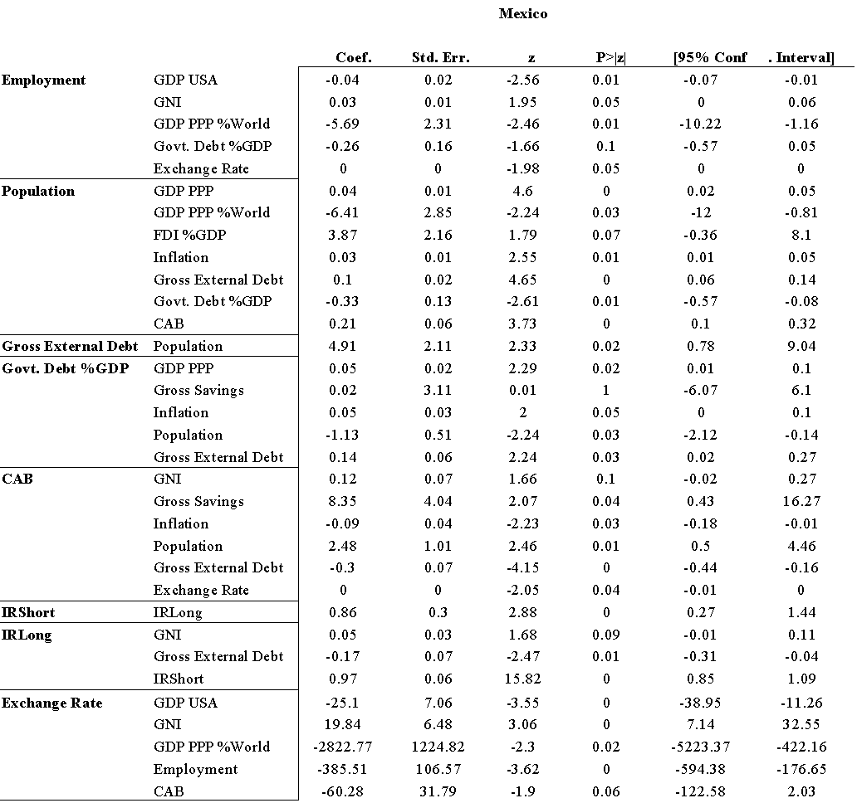

**Appendix III. Americas Economy ARCH Results**

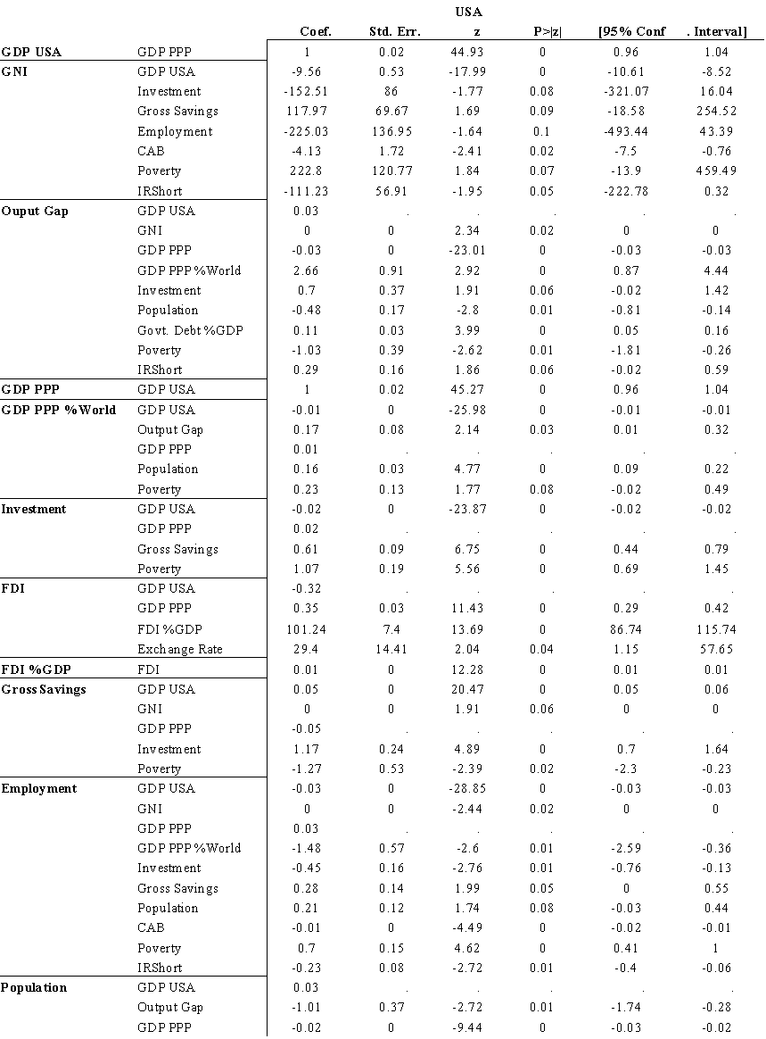

**Appendix III. Americas Economy ARCH Results**

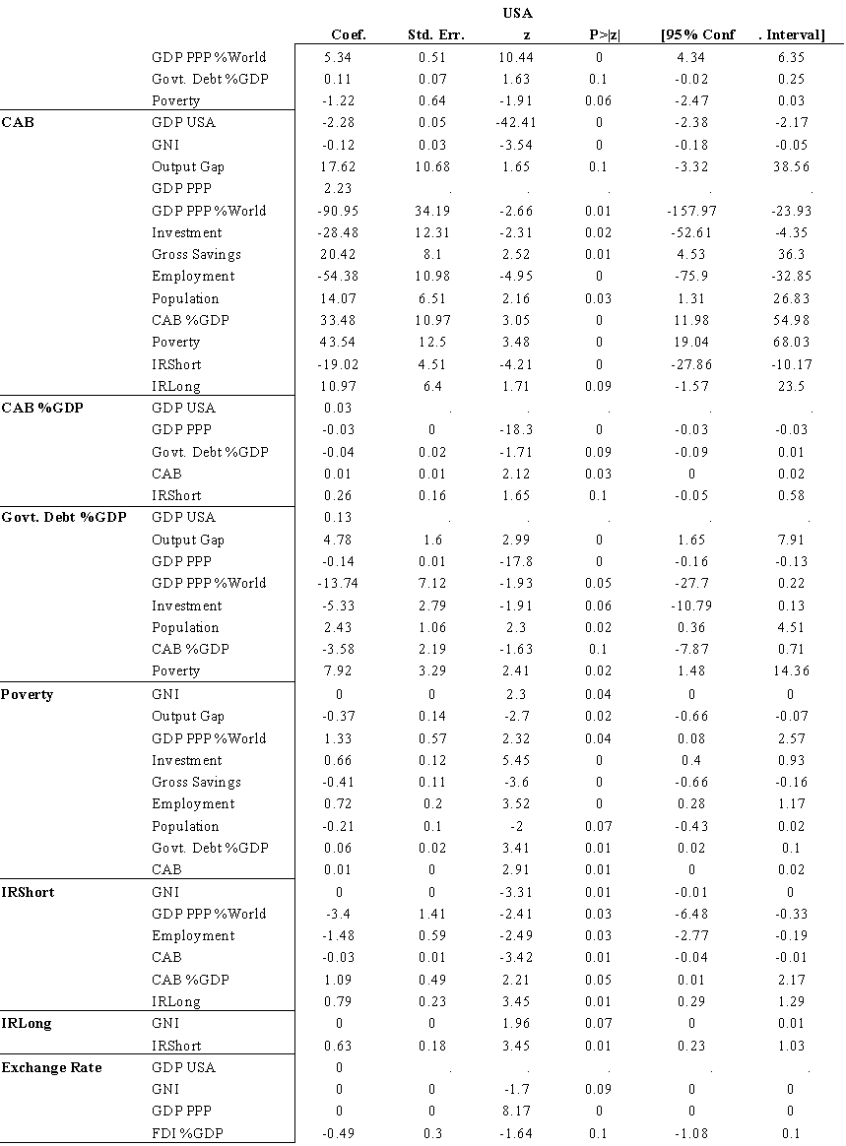

**Appendix IV. Americas Stock Exchange Unit Roots**

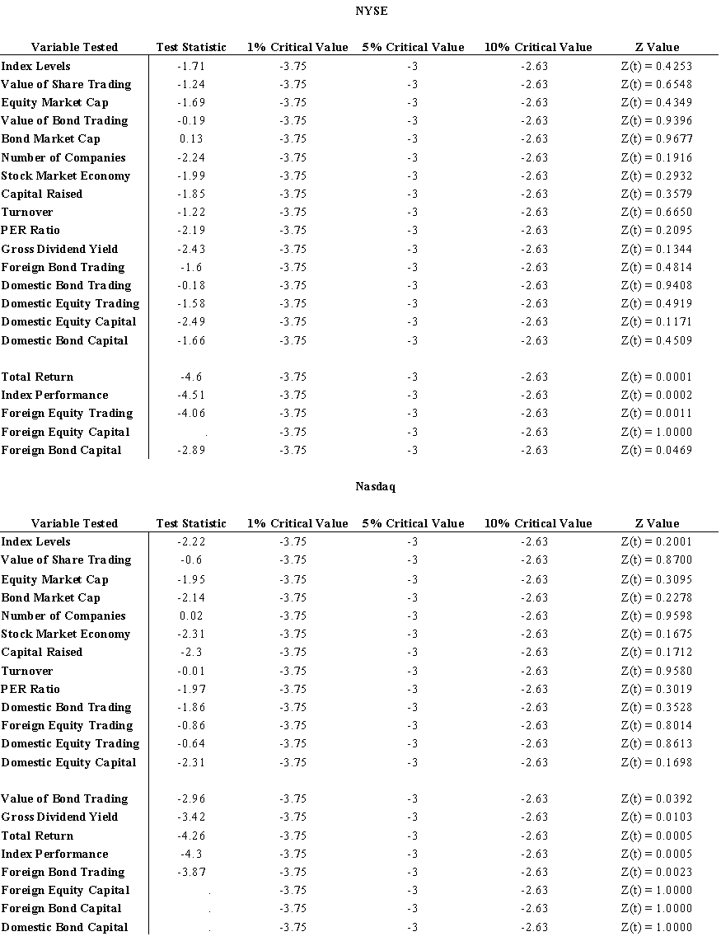

**Appendix IV. Americas Stock Exchange Unit Roots**

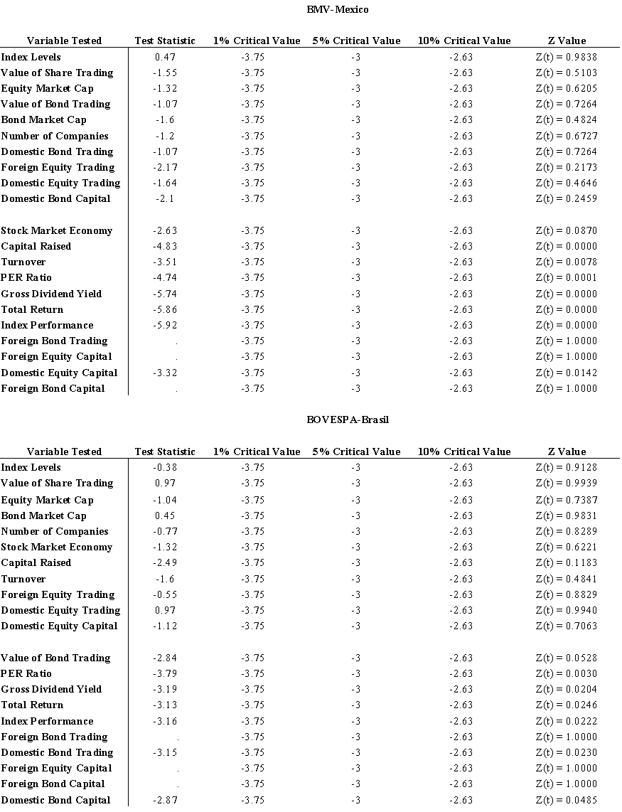

**Appendix IV. Americas Stock Exchange Unit Roots**

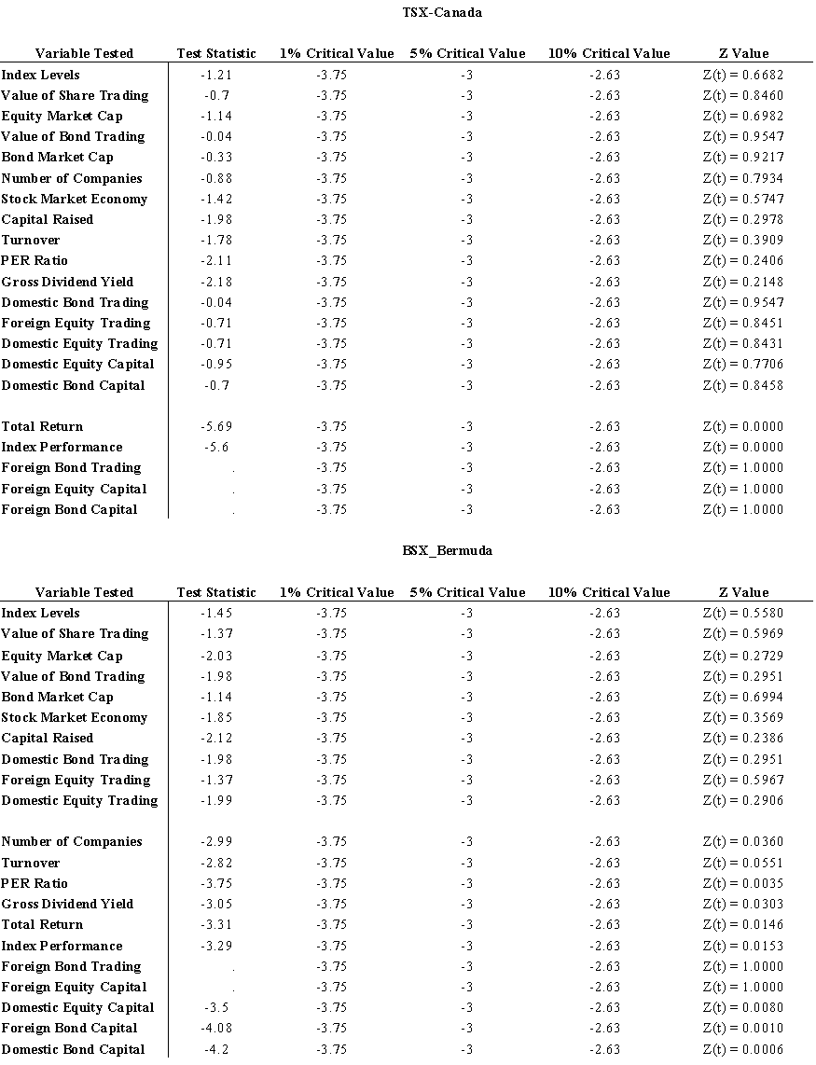

**Appendix V. Americas Stock Exchange ARCH Results**

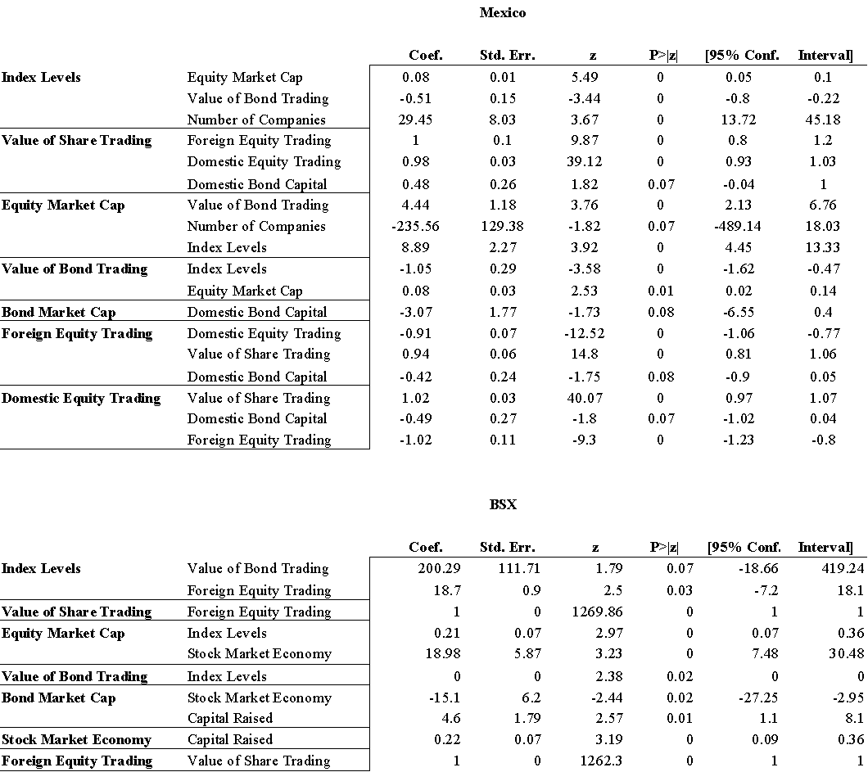

**Appendix V. Americas Stock Exchange ARCH Results**

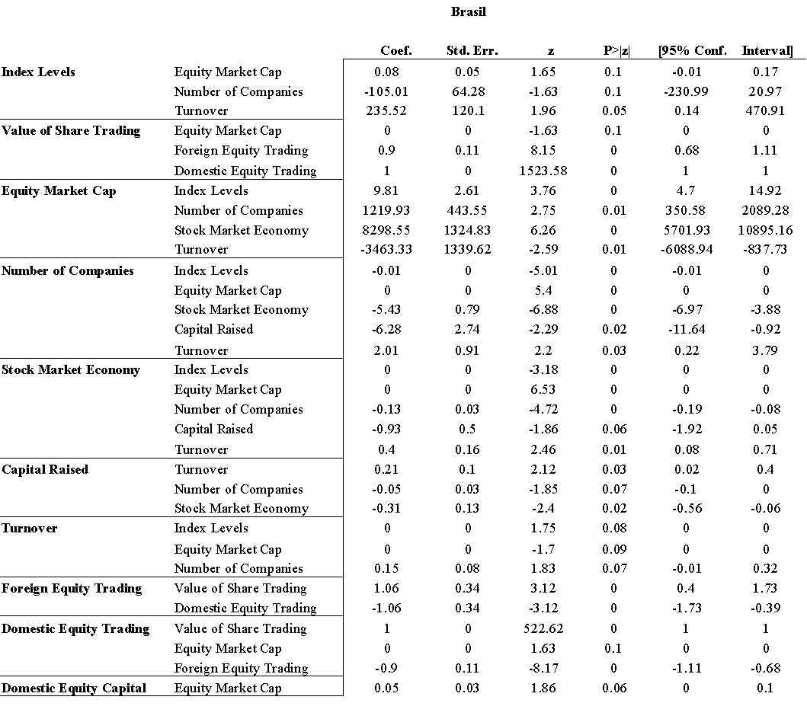

**Appendix V. Americas Stock Exchange ARCH Results**

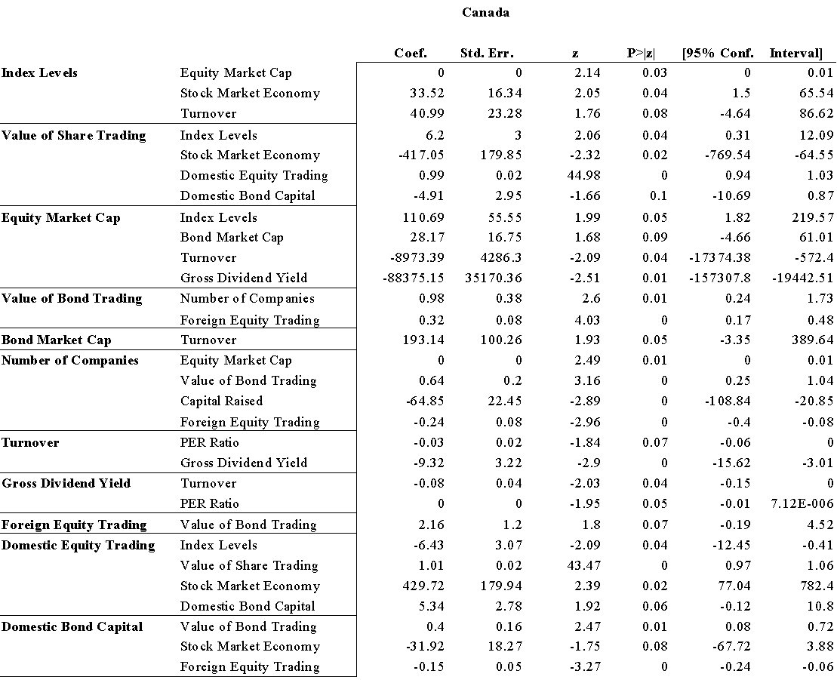

**Appendix V. Americas Stock Exchange ARCH Results**

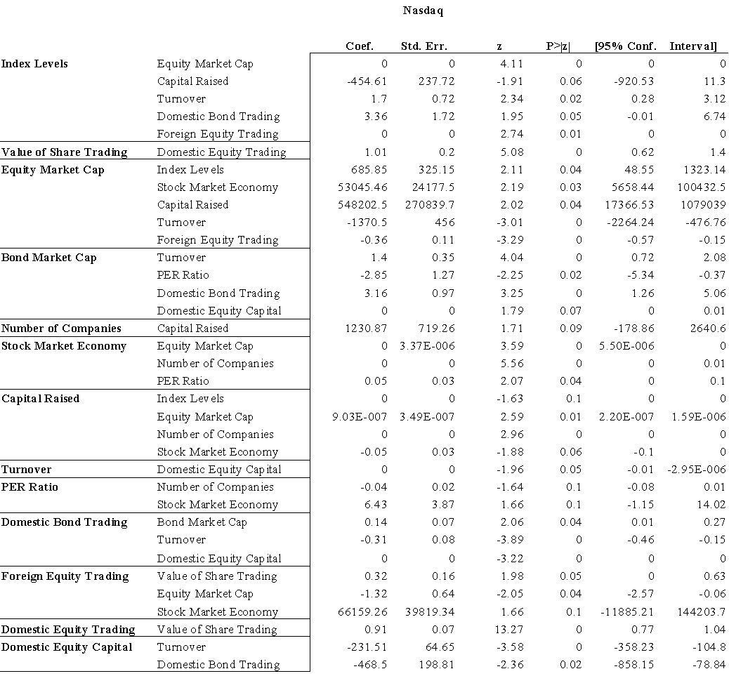

**Appendix V. Americas Stock Exchange ARCH Results**

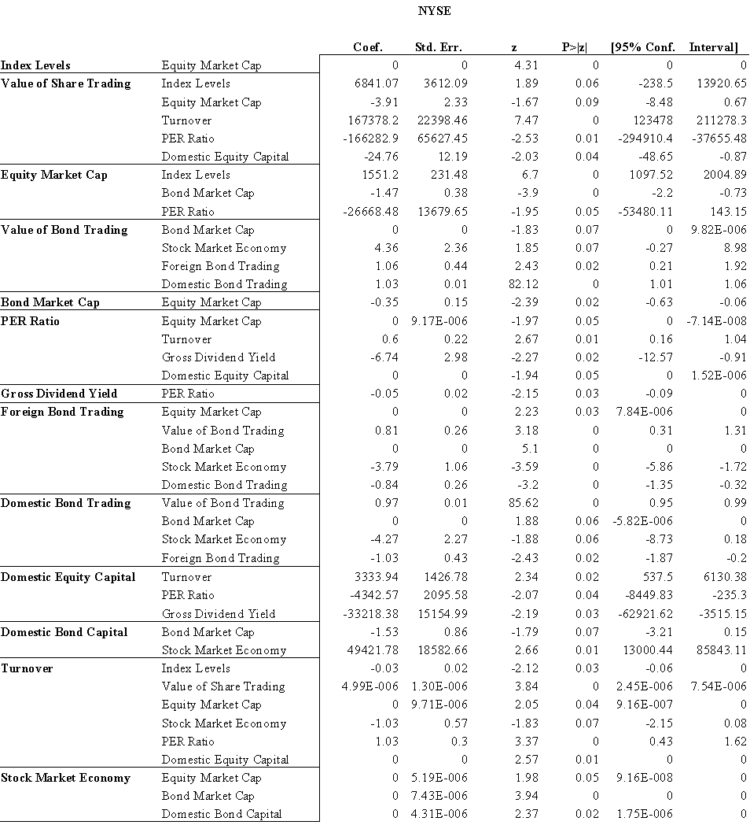

**IX. References**

Abd Karim, M. and Gee, C. (2006) Stock Market Integration between Malaysia and its Major Trading Partners (1994-2002), Applied Econometrics and International Development, Vol. 6, No. 3, 2006

Abd Majid, M., Meera, A., and Omar, M. (2007) Interdependence of ASEAN-5 Stock Markets from the US and Japan, 20th Australasian Finance & Banking Conference 2007 Paper

Adler, M. and Qi, R. (2003) The Integration of Mexico into the North American Capital Market, Emerging Markets Review 4 (2003) 91-120

Agarwal, S., Liu, C., and Rhee, S. (2005) Investor Demand for IPOs and Aftermarket Performance: Evidence from the Hong Kong Stock Market, Federal Reserve Bank of Chicago

Aggarwal, R. and Kyaw, N. (2004) Equity Market Integration in the NAFTA Region: Evidence from Unit Root and Cointegration Tests, University of Akron - Department of Finance

Ahmed, K. and Roush, M. (2002) The Effect of Board Changes on Writedowns of Non-current Assets: Evidence From New Zealand, Corporate Governance: An International Review, Vol. 10, pp. 278-287, 2002

Ahn, H.J., Cai, J., Hamao, Y., and Melvin, M. (2005) Little Guys, Liquidity, and the Informational Efficiency of Price: Evidence from the Tokyo Stock Exchange on the Effects of Small Investor Participation, SungKyunKwan University

Aitken, M. and Segara, R. (2005) Impact of Warrant Introductions on the Behaviour of Underlying Stocks: Australian Evidence. Accounting and Finance, Vol. 45, No. 1, pp. 127-144, March 2005

Aitken, M., Frino, A., and Winn, R. (2008) The Effect of Information Motivated Trading Halts on Price Discovery: Evidence from the Australian Stock Exchange, University of New South Wales - School of Banking and Finance

Akhigbe, A., Martin, A., and Newman, M. (2008) Risk shifts following Sarbanes-Oxley: Influences of disclosure and governance, The Financial Review 43, 383-401.

Albertin, G. (2008) Trade Effects of Currency Unions: Do Economic Dissimilarities Matter?, IMF Working Paper No. 08/249

Alcock, J., Finn, F., and Tan, J. (2008) Mismatched! An Empirical Examination of Traditional Debt Maturity Theories in Australian Firms. University of Queensland Business School

Alesina, A. and Barro, R. (2002) Currency Unions," The Quarterly Journal of Economics, MIT Press, vol. 117(2), pages 409-436.

Alexander, G., Eun, C., and Janakiramanan, S. (1988) International listings and stock returns: Some empirical evidence, Journal of Financial and Quantitative Analysis 23, 135 -152.

Allen, D., Lim, L., and Winduss, T. (2004) The Present Value of Pacific Basin Stock Markets: A Domestic and External Factor Model. Edith Cowan University

AlShattarat, W., Nobanee, H., and Haddad, A. (2009) Empirical Analysis of Price Limit Hits of Tokyo Stock Exchange

Ameer, R. (2005) Integration of the South and East Asian Stock Markets, Return and Volatility Spillovers from US, UK Singapore and Hong Kong using EGARCH Model, Universiti Teknologi MARA (UiTM)

Anderson, H., Cooper, S., and Prevost, A. (2002) Block Trade Price Asymmetry and Changes in Depth: Evidence from the Australian Stock Exchange, Massey University - Department of Finance, Banking and Property Studies

Anderson, H., Rose, L., and Cahan, S. (2004) Odd-lot Costs and Taxation Influences on Stock Dividend Ex-dates. Journal of Business Finance & Accounting, Vol. 31, No. 9-10, pp. 1419-1448, November 2004

Arachi, G. and D'Antoni, M. (2003) Redistribution as Social Insurance and Capital Market Integration, University of Siena Economics Working Paper No. 404

Arestis, P. and Sawyer, M. (2002) The 'Third Way' and the Challenges to Economic and Currency Union Macropolicies, Levy Economics Institute Working Paper No. 345

Aristotelous, K. (2006) Are there Differences across Countries Regarding the Effect of Currency Unions on Trade? Evidence from EMU, Journal of Common Market Studies, Vol. 44, No. 1, pp. 17-27, March 2006

Artis, M. (2006) What Do We Now Know About Currency Unions?, CEPR Discussion Paper No. 5677

Aşçıoğlu, A., Comerton-Forde, C., and McInish, T. (2007) Price Clustering on the Tokyo Stock Exchange. The Financial Review, Vol. 42, No. 2, pp. 289-301, May 2007

Asgharian, H. (2008) Risk Contagion Among International Stock Markets

Athanasios, K., Lyroudi, K., and Angelidis, D. (2004) The Impact of Foreign Cross-Listings on Symmetric Information Spillovers Between Markets: The Case of the Paris Stock Exchange, EFMA 2004 Basel Meetings Paper

Avgouleas, E., 2009. The Global Financial Crisis and the Disclosure Paradigm in European Financial Regulation: The Case for Reform. European Company and Financial Law Review, 6, 440-475.

Azad, A. and Bashar, O. (2010) Market Efficiency and Mean-Reversion in Developing Stock Markets: Evidence from South Asia, Deakin University - School of Accounting, Economics and Finance

Bae, K.H., Ito, K., and Yamada, T. (2002) How Do Foreigners Profit from Local Investors? Evidence from Trades in the Japanese Stock Market, York University - Schulich School of Business

Bae, K.H., Yamada, T., and Ito, K. (2006) Interaction of Investor Trades and Market Volatility: Evidence from the Tokyo Stock Exchange, York University

Bagachi, D. (2007) An Analysis of Relative Information Content of Volatility Measures of Stock Index in India, Icfai Journal of Derivatives Markets, Vol. 4, No. 4, pp. 35-43, October 2007

Bahng, J.S. (2009) Recent Evolutions of Capital Structure and Its Determinants: A Comparison of Major Stock Exchanges in Japan

Bailey, W., Chung, Y.P., and Kang, J.K. (1994) Investment Restrictions and the Pricing of Korean Convertible Eurobonds, Cornell University

Balvers, R. and Wu, Y. (2002) Stock Market Integration, Return Forecastability and Implications for Market Efficiency: A Panel Study, West Virginia University

Bandiera, L. (2004) Currency Policy, Currency Areas, and Financial Development with Electronic Money, IMF Working Paper No. WP/04/122

Bank for International Settlements, Financial Globalisation and Emerging Market Capital Flows (December 2008). BIS Paper No. 44, Available at SSRN: https://ssrn.com/abstract=1339922 or http://dx.doi.org/10.2139/ssrn.1339922

Barber, B., Lee, Y.T., Liu, Y.J., and Odean, T. (2006) Is the Aggregate Investor Reluctant to Realize Losses? Evidence from Taiwan, University of California at Davis

Bartlett, R. (2008) Going private but staying public: Re-examining the effect of Sarbanes-Oxley on firms' going-private decisions, working paper, University of Georgia Law School.

Bartram, S., Taylor, S., and Wang, Y. (2007) The Euro and European Financial Market Dependence, AFA 2007 Chicago Meetings Paper

Bauwens, L. (2005) Econometric Analysis of Intra-Daily Activity on Tokyo Stock Exchange, Catholic University of Louvain

Bayoumi, T. (1998) Deviations of Exchange Rates from Purchasing Power Parity: A Story Featuring Two Currency Unions, IMF Working Paper No. 98/69

Bayoumi, T. and Prasad, E. (1995) Currency Unions, Economic Fluctuations and Adjustment: Some Empirical Evidence, CEPR Discussion Paper No. 1172

Beale, L. (2003) Developments may lead SEC to ban certain tax services under Sarbanes-Oxley independence rules, Journal of Taxation of Financial Institutions 16, 5-15.

Beck, G. and Weber, A. (2001) How Wide Are European Borders? New Evidence on the Integration Effects of Currency Unions, University of Cologne - Department of Economics; Centre for Economic Policy Research (CEPR)

Beetsma, R. and Giuliodori, M. (2009) The Macroeconomic Costs and Benefits of the Emu and Other Currency Unions: An Overview of Recent Research, CEPR Discussion Paper No. DP7500

Bekaert, G., Harvey, C., and Lumsdaine, R. (1998) Dating the Integration of World Equity Markets, NBER Working Paper No. W6724

Bekaert, G., Harvey, R., and Ng, A. (2002) Market Integration and Contagion, EFA 2002 Berlin Meetings Presented Paper

Belke, A., Beckmann, J., and Kühl, M. (2009) Global Integration of Central and Eastern European Financial Markets: The Role of Economic Sentiments, DIW Berlin Discussion Paper No. 952

Bennett, B. and Bradbury, M. (2003) Capitalizing Non-Cancelable Operating Leases, Journal of International Financial Management & Accounting, Vol. 14, pp. 101-114, June 2003

Black, B. (2003) The Role of Self-Regulation in Supporting Korea's Securities Markets, Journal of Korean Law, Vol. 3, 2003

Bordo, M. and Jonung, L. (1999) The Future of Emu: What Does the History of Currency Unions Tell Us?, NBER Working Paper No. W7365

Bose, S. and Mukherjee, P. (XXXX) A Study of Interlingages Between the Indian Stock Market and Some Other Emerging and Developed Markets, Indian Institute of Capital Markets 9th Capital Markets Conference Paper

Boyle, G., Hagan, A., O'Connor, R., and Whitwell, N. (2003) Emotion, Fear and Superstition in the New Zealand Stockmarket. University of Canterbury - Department of Economics

Breedon, F. and Pétursson, T. (2006) Out in the Cold? Iceland's Trade Performance Outside the European Union and European Currency Union, Cambridge Journal of Economics, Vol. 30, Issue 5, pp. 723-736, 2006

Bremer, M. and Kato, K. (1996) Trading Volume for Winners and Losers on the Tokyo Stock Exchange J. OF FINANCIAL AND QUANTITATIVE ANALYSIS, March 1996

Bris, A., Cantale, S., and Nishiotis, G. (2007) A breakdown of the valuation effects of international cross-listing, European Financial Management 13, 498-530.

Brooks, R. and Del Negro, M. (2002) International Stock Returns and Market Integration: A Regional Perspective, FRB of Atlanta Working Paper No. 2002-20

Brown, P. and Mitchell, J. (2004) Culture and Stock Price Clustering: Evidence from The Peoples' Republic of China, University of New South Wales

Buettner, D. and Hayo, B. (2009) Determinants of European Stock Market Integration, MAGKS Working Paper No. 32-2009

Busetti, G. and Manera, M. (2003) STAR-GARCH Models for Stock Market Interactions in the Pacific Basin Region, Japan and US, FEEM Working Paper No. 43.2003

Cahuc, P. and Kempf, H. (XXX) Employment and Wage Bargaining in an Open Currency Union, Review of International Economics

Cai, J., Li, Y., and Xia, L. (2006) Liquidity, Information Asymmetry and Short Sales Constraints: Evidence from the Hong Kong Stock Market, Shenzhen Stock Exchange

Callaghan, J., Parkash, M., and Singhal, R. (2008) The impact of the multi-jurisdiction disclosure system on audit fees of cross-listed Canadian firms, The International Journal of Accounting 43, 99-113.

Camilleri, S. and Green, C. (2005) The Impact of the Suspension of Opening and Closing Call Auctions: Evidence from the National Stock Exchange of India, University of Malta

Campbell, J. and Hamao, Y. (1989) Predictable Stock Returns in the United States and Japan: A Study of Long-Term Capital Market Integration, NBER Working Paper No. W3191

Canarella, G., Miller, S., and Pollard, S. (2009) Dynamic Stock Market Interactions between the Canadian, Mexican, and the United States Markets: The NAFTA Experience, California State University, Los Angeles - Department of Economics & Statistics

Canova, F. and Pappa, E. (2007) Price Differentials in Currency Unions: The Role of Fiscal Shocks, Economic Journal, Vol. 117, No. 520, pp. 713-737, April 2007

Caporale, G. and Spangnola, N. (2010) Stock Market Integration between Three CEECs, Russia and the UK, CESifo Working Paper Series No. 2978

Cerny, A. (2004) Stock Market Integration and the Speed of Information Transmission, CERGE-EI Working Paper No. 242

Chan, K., Jacob, R., and Seow, P. (2008) The effects of Section 404 of Sarbanes-Oxley Act of 2002 on the audit fees of foreign firms listed on USA Exchanges, working paper, Pace University.

Chan, S.Y. and Fong, W.M. (2004) Individual Investors' Sentiment and Temporary Stock Price Pressure. Journal of Business Finance & Accounting, Vol. 31, No. 5-6, pp. 823-836, June 2004

Chander, R., Sharma, R., and Mehta, K. (2007) Dividend Announcement and Informational Efficiency: An Empirical Study of Indian Stock Market, The Icfai Journal of Applied Finance, Vol. 13, No. 10, pp. 29-42, October 2007

Chang, C.L., McAleer, M., and Lim, C. (2009) Modelling Short and Long Haul Volatility in Japanese Tourist Arrivals to New Zealand and Taiwan. National Chung Hsing University - Department of Applied Economics

Chang, E., Khorana, A., and Cheng, J. (1999) An Examination of Herd Behavior in Equity Markets: An International Perspective, University of Hong Kong

Chang, M.J. (2008) Monetary Policy and Asymmetric Volatility in Stock Returns: Evidence from Taiwan, National Dong Hwa University

Chari, V. and Kehoe, P. (2002) Time Consistency and Free-Riding in a Currency Union, NBER Working Paper No. W9370

Chari, V. and Kehoe, P. (2004) On the Desirability of Fiscal Constraints in a Currency Union, NBER Working Paper No. W10232

Chari, V., Jones, L., and Marimon, R. (2004) Strategic Delegation in Currency Unions, Manchester School, Vol. 72, No. S1, pp. 19-33, September 2004

Chen, A. and Tu, E. (2000) Factor Models Under Firm Characteristics in Emerging Markets: A Study of Taiwan Stock Returns, National Sun Yat-Sen University

Chen, A.S., Daouk, H., and Leung, M. (2001) Application of Neural Networks to an Emerging Financial Market: Forecasting and Trading the Taiwan Stock Index, National Chung Cheng University

Chen, G.M., Rui, O., and Wang, S. (2005) The Effectiveness of Price Limits and Stock Characteristics: Evidence from the Shanghai and Shenzhen Stock Exchanges, Hong Kong Polytechnic University

Chen, K.J. And Li, X. (2006) Is Technical Analysis Useful for Stock Traders in China? Evidence from the SZSE Component A-Share Index, Pacific Economic Review, Vol. 11, No. 4, pp. 477-488, December 2006

Chen, S. and Poon, S.H. (2008) International Stock Market Liquidity and Financial Crisis, Bocom Schroders Fund

Chey, H. (2009) A Political Economic Critique on the Theory of Optimum Currency Areas, and the Implications for East Asia, World Economy, Vol. 32, Issue 12, pp. 1685-1705, December 2009

Chi, J. and Padgett, C. (2002) The Performance and Long-Run Characteristics of the Chinese IPO Market, Massey University

Chi, J., Tripe, D., and Young, M. (2007) Do Exchange Rates Affect the Stock Performance of Australian Banks?, Massey University

Chittedi, K. (2010) Integration of Intenarional Stock Markets: With Special Refernce to India, GITAM Review Of International Business, Vol. 2, No. 1, January 2010

Choi, S. and Kim, K.S. (2002) Establishing a New Stock Market for Shareholder Value Oriented Firms in Korea, New York University - School of Law, Chicago Journal of International Law

Choong, T.C., JinHwee, T., and ChooEng, E.L. (1991) The Singapore Stock Exchange Guidelines on Directors' Dealings - A New Dimension in its Regulatory Role, Singapore Academy of Law Journal, Vol. 3, p. 285, 1991

Chou, R. and Lee, J.H. (2001) The Relative Efficiencies of Price Execution Between Singapore Exchange and Taiwan Futures Exchange, Journal of Futures Markets, Volume 22 Issue 2,Pages 173-196

Coffee, J. (2002) Racing towards the top?: The impact of cross-listings and stock market competition on international corporate governance, Columbia Law Review 102, 1757-1831.

Coles, J. (2008) Disclosure policy: A discussion of Leuz, Triantis and Wang (2008) on ‘‘going dark,’’Journal of Accounting and Economics 45, 209–220.

Collet, P. and Hrasky, S. (2005) Voluntary Disclosure of Corporate Governance Practices by Listed Australian Companies, Corporate Governance: An International Review, Vol. 13, No. 2, pp. 188-196, March 2005

Comerton-Forde, C., Frino, A., and Mollica, V. (2005) The Impact of Limit Order Anonymity on Liquidity: Evidence from Paris, Tokyo and Korea, University of Sydney - Faculty of Economics and Business

Conte, L., Toniolo, G., and Vecchi, G. (2003) Currency Union, Institutions and Financial Market Integration, Italy 1862-1905, CEPR Discussion Paper No. 3684

Cooper, R. (2000) Designing Stabilization Policy in a Currency Union, NBER Working Paper No. W7607

Cooper, R. and Kempf, H. (2004) Overturning Mundell: Fiscal Policy in a Currency Union, Review of Economic Studies, Vol. 71, No. 2, pp. 371-396, April 2004

Cooper, R., Kempf, H., and Peled, D. (2004) Is it is or is it Ain't my Obligation? Regional Debt in Currency Unions, University of Haifa - Department of Economics; National Bureau of Economic Research (NBER)

Coricelli, F., Cukierman, A., and Dalmazzo, A. (2001) Economic Performance and Stabilization Policy in a Currency Union with Imperfect Labour and Goods Markets, CEPR Discussion Paper No. 2745

Creighton, A. (2006) Labour Mobility and Trans-Tasman Currency Union, Australian Economic Papers, Vol. 45, No. 1, pp. 38-56, March 2006

Cuciniello, V. (2009) International Currency Policy Cooperation Revisited: Conservatism and Non-Atomistic Wage Setting, Center for Fiscal Policy, EPFL, Chair of International Finance (CFI) Working Paper No. 2009-05

D'Ecclesia, R. and Costantini, M. (2004) Comovements and Correlations in International Stock Markets, Dipartimento di Matematica, Statistica e Informatica Applicata Working Paper No. 26

De la Torre, A., Gozzi, J., and Schmukler, S. (2007) Capital Market Development: Whither Latin America?, World Bank Policy Research Working Paper No. 4156

De Nardis, S., De Santis, R., and Vicarelli, C. (2008) The Single Currency's Effects on Eurozone Sectoral Trade: Winners and Losers?, Economics-e-Journal Economics Discussion Paper No. 2008

Dehesa, M., Pineda, E., and Samuel, W. (2009) Optimal Reserves in the Eastern Caribbean Currency Union, IMF Working Paper No. 09/77

Dellas, H. and Tavlas, G. (2005) Wage Rigidity and Currency Union, Economic Journal, Vol. 115, No. 506, pp. 907-927, October 2005

DHaliwal, D. (1983) Exchange-listing effects on a firm's cost of equity capital, Journal of Business Research 11, 139-152.

Di Iorio, A. and Faff, R. (2002) Foreign Exchange Exposure and Pricing in the Australian Equities Market: A Fama and French Framework, RMIT University - School of Economics and Finance

Dicle, M., Beyhan, A., and Yao, L. (2009) Market Efficiency and International Diversification: Evidence from India, International Review of Economics and Finance

Dodd, R. and Mills, P. (2008) Outbreak: U.S. Subprime Contagion, International Monetary Fund, Finance and Development, June 2008, 14-18.

Doidge, C., Karolyi, G., and Stulz, R. (2008) Why do foreign firms leave USA equity markets? An analysis of deregistrations under SEC Exchange Act Rule 12h-6, working paper, University of Toronto.

Dunnea, P., Falkb, H., Forkera, J., and Powell, R. (2008) The market response to information quality shocks: the case of Enron. Applied Financial Economics 18, 1051–1066.

Dynan, K., Elmendorf, D., Sichel, D., 2005. Can Financial Innovation Help to Explain the Reduced Volatility of Economic Activity? Journal of Monetary Economics, 53, 123-150.

Edwards, S. (2006) Monetary Unions, External Shocks and Economic Performance: A Latin American Perspective, NBER Working Paper No. W12229

Edwards, S. and Magendzo, I. (2003) Strict Dollarization and Economic Performance: An Empirical Investigation, University of California, Los Angeles (UCLA) - Global Economics and Management (GEM) Area

Egger, H., Egger, P., Falkinger, J., and Grossman, V. (2005) International Capital Market Integration, Educational Choice and Economic Growth, CESifo Working Paper Series No. 1630

Eichengreen, B. (1991) Is Europe an Optimum Currency Area?, NBER Working Paper No. W3579

El Hedi, A. (2002) The Impact of Increasing Stock Market Integration on Expected Gains from International Portfolio Diversification: Evidence from a Multivariate Approach with Time Varying Risk, Universite Paris X Nanterre

Eleswarapu, V. and Krishnamurti, C. (1994) Liquidity, Stock Returns and Ownership Structure: An Empirical Study of the Bombay Stock Exchange, OppenheimerFunds, Inc.

Eng, L.L. And Teo, H.K. (2000) The Relation Between Annual Report Disclosures, Analysts? Earnings Forecasts and Analyst Following: Evidence From Singapore. Pacific Accounting Review Millennium Edition, Vol 11, No 2, December 1999/January 2000

Erdogan, B. (2009) How Does European Integration Affect the European Stock Markets?, DIW Berlin Discussion Paper No. 885

Faff, R. and Mittoo, U. (2000) Capital Market Integration and Industrial Structure: The Case of Australia, Canada and The United States, Monash University - Department of Accounting and Finance

Fan, W. (XXXX) An Empirical Study of Cointegration and Causality in the Asia-Pacific Stock Markets, Yale University - Department of Economics

Fauver, L., Houston, J., and Naranjo, A. (2002) Capital Market Development, Integration, Legal Systems, and the Value of Corporate Diversification: A Cross-Country Analysis, Tuck-JFQA Contemporary Corporate Governance Issues II Conference

Fedorova, E. and Vaihekoski, M. (2009) Global and Local Sources of Risk in Eastern European Emerging Stock Markets, Czech Journal of Economics and Finance, Vol. 59, No. 1, pp. 2-19, 2009

Fernald, J. and Rogers, J. (2000) Puzzles in the Chinese Stock Market, Federal Reserve Bank of San Francisco

Fidrmuc, J., Horvath, J., and Fidrmuc, J. (1999) The Stability of Currency Unions: Lessons from the Break-up of Czechoslovakia, Journal of Comparative Economics, Vol. 27, December 1999

Flandreau, M. and Maurel, M. (2001) Currency Union, Trade Integration, and Business Cycles in 19th Century Europe: Just Do It, CEPR Discussion Paper No. 3087

Foad, H. (2005) Currency Unions, Options, and Foreign Direct Investment, San Diego State University - Department of Economics

Foerster, S., and Karolyi, A. (1993) International listings of stocks: The case of Canada and the USA, Journal of International Business Studies 24, 763-785.

Forlati, C. (2009) On the Benefits of a Currency Union: Does it Pay to Be Bigger?, Center for Fiscal Policy, EPFL, Chair of International Finance (CFI) Working Paper No. 2009-03

Frankel, J. (2008) The Estimated Effects of the Euro on Trade: Why are They Below Historical Effects of Currency Unions Among Smaller Countries?, NBER Working Paper No. w14542

Frankel, J. and Rose, A. (2000) Estimating the Effect of Currency Unions on Trade and Output, NBER Working Paper No. w7857

Frankel, T., 2002. Regulation and Investors' Trust in the Securities Markets. Brooklyn Law Review, 68, 439-452.

Frankel, T., 2009. Regulating the Financial Markets by Examinations. Boston University School of Law, Working Paper, 09-08.

Fraser, P. and Oyefeso, O. (2005) US, UK and European Stock Market Integration, Journal of Business Finance & Accounting, Vol. 32, No. 1-2, pp. 161-181, January 2005

Fratzscher, M. (2001) Financial Market Integration in Europe: On the Effects of EMU on Stock Markets, ECB Working Paper No. 48

French, K. and Poterba, J. (1990) Are Japanes Stock Prices Too High? Dartmouth College

Friedman, J. and Shachmurove, Y. (2005) European Stock Market Dynamics Before and After the Introduction of the Euro, PIER Working Paper No. 05-028

Frino, A. and Fabre, J. (2004) Commonality in Liquidity: Evidence from the Australian Stock Exchange, Accounting and Finance, Vol. 44, pp. 357-368, November 2004

Frino, A., Jarnecic, E., and Das, A. (2008) The Performance of the 130/30 Strategy in the Australian Equities Market; University of Sydney

Frino, A., Jarnecic, E., and Lepone, A. (2003) Bid-ask Bounce and the Measurement of Price Behaviour Around Block Trades on the Australian Stock Exchange, University of Sydney

Frino, A., Jones, S., and Wong, J.B. (2007) Market Behaviour around Bankruptcy Announcements: Evidence from the Australian Stock Exchange, Accounting & Finance, Vol. 47, No. 4, pp. 713-730, December 2007

Fuchita, Y. (XXXX) US-Europe Capital Market Integration and its Implications for Japan. Nomura Capital Market Review Vol. 10, No. 3

Fung, J. (2005) The Information Content of Option Implied Volatility Surrounding the 1997 Hong Kong Stock Market Crash, Hong Kong Baptist University

Gali, J. and Monacelli, T. (2005) Optimal Currency and Fiscal Policy in a Currency Union, Department of Economics, Paolo Baffi Centre on Central Banking and Financial Regulation and IGIER, Bocconi University

George, T. and Hwang, C. (1995) Transitory Price Changes and Price-Limit Rules: Evidence from the Tokyo Stock Exchange, Journal of Financial and Quantitative Analysis (JFQA), Vol. 30, No. 2, June 1995

Georgieva, D., and Lee, W. (2007) Impact of Sarbanes-Oxley Act on cross-listing, working paper, University of Arkansas.

Georgiou, M. (2010) Testing the Viability of a Currency Union: A Panel Data Analysis for European Countries (1985-2002)

Ghosh, A. and Wolf, H. (1994) How Many Monies? A Genetic Approach to Finding Optimum Currency Areas, NBER Working Paper No. W4805

Gibson, K. and O'Donovan, G. (2007) Corporate Governance and Environmental Reporting: An Australian Study. Corporate Governance: An International Review, Vol. 15, No. 5, pp. 944-956

Gilmore, C., Lucey, B., and McManus, G. (2005) The Dynamics of Central European Equity Market Integration, St. Joseph's University - Haub School of Business

Glick, R. and Rose, A. (2001) Does a Currency Union Affect Trade? The Time Series Evidence, NBER Working Paper No. W8396

Gonçalves, C. (2003) Business Cycles, Trade and the Costs of Monetary Unions: Evidence for Latin America, Pesquisa E Planejamento Economico, Vol. 33, No. 2, August 2003

Gong, N. (2007) Effectiveness and Market Reaction to the Stock Exchange's Inquiry in Australia, Journal of Business Finance & Accounting, Vol. 34, No. 7-8, pp. 1141-1168, September/October 2007

González, F. and Launonen, S. (2005) Towards European Currency Integration: The Evolution of Currency Risk Premium as a Measure for Currency Convergence Prior to the Implementation of Currency Unions, ECB Working Paper No. 569

Granger, C., Huang, B.N., and Yang, C. (1998) A Bivariate Causality between Stock Prices and Exchange Rates: Evidence from Recent Asia Flu. University of California, San Diego

Green, S. (2004) Equity Politics and Market Institutions: The Development of Stock Market Policy and Regulation in China, 1984-2003, Standard Chartered Bank (Hong Kong) Limited

Grimm, O. and Ried, S. (2007) Macroeconomic Policy in a Heterogeneous Currency Union, CER-ETH - Center of Economic Research at ETH Zurich, Working Paper No. 07/67

Gulati, A., Knif, J., and Kolari, J. (2009) International Competition and Exchange Rate Shocks in Small Export-Oriented Economies: A Cross-Country Industry Analysis of Stock Returns in Finland and Sweden, Paris December 2009 Finance International Meeting AFFI - EUROFIDAI

Günter W. Beck & Axel A. Weber, 2005. "Inflation Rate Dispersion and Convergence in Monetary and Economic Unions: Lessons for the ECB," CFS Working Paper Series 2005/31, Center for Financial Studies.

Günter W. Beck & Axel A. Weber, 2005. "Inflation Rate Dispersion and Convergence in Monetary and Economic Unions: Lessons for the ECB," CFS Working Paper Series 2005/31, Center for Financial Studies.

Hahm, S.M. (2003) Transmission of Stock Returns and Volatility: the Case of Korea, KDI School of Public Policy and Management

Haleem, M.A., 1994. The Qur'an. Oxford University Press, New York.

Hamao, Y. and Hasbrouck, J. (1995) Securities Trading in the Absence of Dealers: Trades and Quotes on the Tokyo Stock Exchange, The Review of Financial Studies, Vol. 8 No. 3 1995; 849-878

Hamao, Y., Masulis, R., and Ng, V. (1990) Correlations in Price Changes and Volatility across International Stock Markets, Review of Financial Studies, Vol. 3, No. 2, pp. 281-307, 1990

Hamao, Y., Masulis, R., and Ng, V. (1991) The Effects of the 1987 Stock Crash on International Financial Integration, Japanese Financial Market Research, W. Ziemba, W. Bailey and Y. Hamao, editors, North Holland Publisher, 1991

Hansen, B., Pownall, G., and Wang, X. (2008) The robustness of the Sarbanes Oxley effect on the USA capital market, working paper, University of New Hampshire.

Hardouvelis, G., Malliaropulos, D., and Priestly, R. (2001) EMU and European Stock Market Integration, Norwegian School of Management (BI) - Department of Financial Economics

Hassan, T. (2009) Country Size, Currency Unions, and International Asset Returns.

Haug, A., Karagedikli, O., and Ranchhod, S. (2005) Monetary Policy Transmission Mechanisms and Currency Unions: A Vector Error Correction Approach to a Trans-Tasman Currency Union, Journal of Policy Modeling, Vol. 27

Hayo, B. and Kutan, A. (2004) The Impact of News, Oil Prices, and Global Market Developments on Russian Financial Markets, William Davidson Institute Working Paper No. 656

He, Z. and Su, D. (2009) Price Manipulation and Industry Momentum: Evidence from the Chinese Stock Market, Brock University

Heaney, R., Hooper, V., and Jaugietis, M. (2002) Regional Integration of Stock Markets in Latin America, Journal of Economic Integration, Vol. 17, No. 4, pp.745-760, 2002

Hearn, B., Lee, B., Strange, R., and Piesse, J. (2010) Liquidity and Stock Size Premia in Japanese Regional Financial Markets: An Industry Level Analysis, King's College London - Department of Management; University of Stellbosch

Hernández, M. (2004) The Euro Effect on the Integration of the European Stock Markets, EFMA 2004 Basel Meetings Paper

Hibbs, D., Acocella, N., and Di Bartolomeo, G. (2008) Labor Market Regimes and the Effects of Currency Policy, Journal of Macroeconomics, Vol. 30, pp. 134-156, 2008

Ho, B., Taher, M., Lee, R., and Fargher, N. (2001) Market Sentiment, Media Hype And The Underpricing Of Initial Public Offerings: The Case Of Australian Technology IPOs, University of New South Wales - School of Accounting

Hong, D., Lee, C., and Swaminathan, B. (2003) Earnings Momentum in International Markets, Singapore Management University

Hooy, C. and Lim, K. (2009) Is Higher Market Integration Associated with Improved Market Efficiency? Monash University - Department of Econometrics & Business Statistics

Hostak, P., Karaoglu, E., Lys, T., and Yang, Y. (2007) An examination of the impact of the Sarbanes-Oxley Act on the attractiveness of USA capital markets for foreign firms, working paper, Columbia University.

Hotson, L., Kaur, N., and Singh, H. (2007) The Information Content of Directors' Trades: Empirical Analysis of the Australian Market. Deakin University

Houston, C. and Jones, B. (2002) Canadian Manager Perceptions of the US Exchange Listings: Recent Evidence, Journal of International Financial Management and Accounting, Vol. 13, pp. 235-253, 2002

Hsu, C.P. (2008) State-Dependent Stock Market Reactions to Foreign Investment Behaviors, CUNY The Graduate Center

Hsu, C.P. (2009) Modeling the Dependence Between the Asian Stock Markets Returns and Currency Exchanges with Copula-EVT Based Semiparametric Approaches. CUNY The Graduate Center

Hu, D. (2002) The Usefulness of Financial Statements Under Chinese GAAP vs. IAS: Evidence from the Shanghai Stock Exchange in PRC, Kobe University

Hu, S.Y. (1997) Trading Turnover and Expected Stock Returns: The Trading Frequency Hypothesis and Evidence from the Tokyo Stock Exchange, National Taiwan University

Huberman, G. (1984) External financing and liquidity, The Journal of Finance 39, 895-908.

Hunter, D. (XXXX) The Evolution of Stock Market Integration in the Post-Liberalization Period - A Look at Latin America, Journal of International Money and Finance, Forthcoming

Husain, F. and Qayyum, A. (2006) Stock Market Liberalizations in the South Asian Region, PIDE Working Paper No. 2006:6

Hyde, S., Bredin, D., and Nguyen, N. (2007) Correlation Dynamics between Asia-Pacific, EU and US Stock Returns, Manchester Business School

Insup, L. (1991) The impact of overseas listings on shareholder wealth: The case of the London and Toronto stock exchanges, Journal of Business Finance & Accounting 18, 583-593.

Jahjah, S. (2000) Inflation, Debt, and Default in a Currency Union, IMF Working Paper No. 00/179

Jain, P., Jang-Chul, K., and Rezaee, Z. (2008) The Sarbanes-Oxley Act of 2002 and market liquidity, The Financial Review 43, 361-382.

Jain, T. and Sharma, R. (2007) Cross Listing of Stock Exchanges: Strengthening Self-Regulation, Company Law Journal (India), Vol. 3, p. 64, 2007

Jeyasreedharan, N., Alles, L., and Yatawara, N. (2009) The Asymptotics of Extreme Returns in the Australian Stock Market. University of Tasmania

Johansson, A. (2009) An Analysis of Dynamic Risk in the Greater China Equity Markets, Journal of Chinese Economic and Business Studies

Jordan, C. (2006) The Chameleon Effect: Beyond the Bonding Hypothesis for Cross-Listed Securities, Uni Melbourne

Kadlec, G., and McConnell, J. (1994) The effect of market segmentation and illiquidity on asset prices: Evidence from exchange listings, The Journal of Finance 49, 611-637.

Kakani, R. (2001) Ownership Distribution and Shareholder Value Creation in Indian Stock Markets: A Note, XLRI Jamshedpur, India

Karim, M. and Gee, C. (2006) Stock Market Integration between Malaysia and its Major Trading Partners (1994-2002), Applied Econometrics and International Development, Vol. 6, No. 3, 2006

Karreman, B. and Van der Knaap, B. (2009) The Financial Centres of Shanghai and Hong Kong: Competition or Complementarity?, Erasmus University Rotterdam (EUR)

Kearney, C. and Poti, V. (2003) Idiosyncratic Risk, Market Risk and Correlation Dynamics in European Equity Markets, Dublin City University

Kelly, S. (2004) The Market Premium for the Option to Close: Evidence from Australian Gold Mining Firms. Bond University-France

Kent, P. and Chan, C. (2003) Application of Stakeholder Theory to the Quantity and Quality of Australian Voluntary Corporate Environmental Disclosures, University of Queensland

Kerr, J. and Rose, L. (2002) Privatisation in the New Zealand Stock Market: An Empirical Analysis

Kim, H. and Mei, J. (1994) Political Risk and Stock Returns: The Case of Hong Kong

Kim, Hwa-Jin, and Kang, Woo. (2003) Cross-listing of Korean companies on foreign exchanges: Law and policy, working paper.

Kim, J.B. And Yi, C.H. (2008) Does Trading by Foreign Investors Contribute More to Stock Price Informativeness than Trading by Domestic Institutions in Emerging Markets? Korean Evidence, City University of Hong Kong

Kim, K. and Rhee, S. (1997) Price Limit Performance: Evidence from the Tokyo Stock Exchange, Journal of Finance

Kim, S. and McKenzie, M. (2008) Conditional Autocorrelation and Stock Market Integration in the Asia-Pacific, University of Sydney - Finance; University of Cambridge - Cambridge Endowment for Research in Finance (CERF)

Kim, S.J., Moshirian, F., and Wu, E. (2006) Evolution of International Stock and Bond Market Integration: Influence of the European Currency Union, Journal of Banking and Finance, Vol. 30, No. 5, pp. 1507-1534, 2006

King, M. and Segal, D. (2003) Corporate Governance, International Cross Listing and Home Bias, Canadian Investment Review, Vol. 16, No. 4, pp. 8-19, 2003

Kleimeier, S., Lehnert, T., and Verschoor, W. (2003) Contagion versus Interdependence: A Re-Examination of Asian-Crisis Stock Market Comovements, Maastricht University

Kohler, M. (1998) Optimal Currency Areas and Customs Unions: Are They Connected?, Bank of England Working Paper No. 89

Konukoglu, A. (2010) Foreign Ownership and World Market Integration, University of Toronto - Rotman School of Management

Korajczyk, R. (1996) A Measure of Stock Market Integration for Developed and Emerging Markets, World Bank Economic Review, Vol. 10, pp. 267-289, May 1996

Korczak, P., and Bohl, M. (2005) Empirical evidence on cross-listed stocks of Central and Eastern European companies, Emerging Markets Review 6, 121-137.

Korn, O. and Kempf, A. (1996) Trading System and Market Integration, University of Cologne - Department of Finance; University of Cologne - Centre for Financial Research (CFR)

Kot, H.W. (2007) Return-Based Investment Strategies in the New Zealand Stock Market: Momentum Wins. Pacific Accounting Review Year: 2007 Volume: 19 Issue: 2 Page: 108 - 124

Kozluk, T. (2008) Global and Regional Links between Stock Markets: The Case of Russia and China, BOFIT Discussion Paper No. 4/2008

Krishnamurti, C. and Lim, E. (2001) Competition, Liquidity and Volatility - A Comparative Study of Bombay Stock Exchange and National Stock Exchange. Nanyang Business School

Kubota, K., Suda, K., and Takehara, H. (2006) Pricing of Accounting Accruals Information and Revisions of Analyst Earnings Forecasts: Evidence from Tokyo Stock Exchange Firms, Graduate School of Strategic Management, Chuo University

Lang, M. (2008) Discussion of regulation and bonding: The Sarbanes-Oxley Act and the flow of international listings, Journal of Accounting Research 46, 427-433.

Lang, M., Linus, K., and Miller, D. (2002) ADRs, analysts, and accuracy: Does cross listing in the USA improve a firm's information environment and increase market value? , working paper, University of North Carolina at Chapel Hill.

Lasfer, M., Lin, S., and Muradoglu, Y. (2007) Market Behaviour of Foreign Versus Domestic Investors Following a Period of Stressful Circumstances, City University London

Lay, L. and Wickramanayake, J. (2007) Role of Inward Foreign Portfolio Investment in Transition of Singapore to a High Income Economy: First 25 Years, The Icfai Journal of International Business, Vol. 2, No. 4, pp. 7-23, November 2007

Lee, B.S., Li, W., and Wang, S. (2007) The Dynamics of Individual and Institutional Trading on the Shanghai Stock Exchange, Korea Advanced Institute of Science and Technology (KAIST)

Lee, J. and Wong, A. (2009) Impact of Financial Liberalisation on Stock Market Liquidity: Experience of China, Hong Kong Monetary Authority

Leichter, J. (1998) Optimal Wage Indexation for a Currency Union with Country Specific Shocks

Leon, G. (2006) Stigmata: The stain of Sarbanes-Oxley on USA capital markets, working paper, George Washington University Law School.

Leuz, C. (2002) Discussion of ADRs, analysts, and accuracy: Does cross listing in the USA improve a firm's information environment and increase market value?, working paper, University of Chicago.

Leuz, C., Triantis, A., and Wang, T. Y. (2008) Why do firms go dark? Causes and economic consequences of voluntary SEC deregistrations, Journal of Accounting and Economics 45, 181-208.

Li, X. (2001) China's Evolving Stock Market Efficiency Reconsidered: The Kalman Filter Analysis, Massey University

Li, X. (2002) International Stock Market Integration: Evidence from Nonlinear Cointegration Analysis

Li, X. (2006) A Revisit of International Stock Market Linkages: New Evidence from Rank Tests for Nonlinear Cointegration. Scottish Journal of Political Economy, Vol. 53, No. 2, pp. 174-197, May 2006

Li, X. aqnd Xu, J. (2001) A Note on New Zealand Stock Market Efficiency, Massey University

Li, Xi. (2007) The Sarbanes-Oxley Act and cross-listed foreign private issuers, working paper, Acadian Asset Management.

Liao, T. F. (1994) Interpreting probability models. London: Sage Publications.

Licht, A. (1998) Stock Market Integration in Europe, CAER II Discussion Paper No. 15

Liebman, B. and Milhaupt, C. (2007) Reputational Sanctions in China's Securities Market, Columbia University

Linsmeier, T., Thornton, D., Venkatachalam, M., and Welker, M. (2002) The effect of mandated market risk disclosures on trading volume sensitivity to interest rate, exchange rate, and commodity price movements, The Accounting Review 77, 343-377.

Litvak, K. (2007) The effect of the Sarbanes-Oxley Act on non-USA companies cross-listed in the USA, Journal of Corporate Finance 13, 195-228.

Liu, T. and Green, S. (2003) China's Informal Stock Market: How it Developed, how it Works and how it Might Grow, Shanghai Stock Exchange

Los, C. and Yu, B. (2008) Persistence Characteristics of the Chinese Stock Markets, International Review of Financial Analysis, Vol. 17, No. 1, pp. 64-82, 2008

Lothian, J. (2000) Capital Market Integration and Exchange-Rate Regimes in Historical Perspective, Research in Banking and Finance, Vol. 1, 2000

Lothian, J. and McCarthy, C. (2001) Currency Union and Real Exchange Rate Behavior, Momento Economico, 2001

Lucey, B. and Birg, G. (2006) Integration of Smaller European Equity Markets: A Time-Varying Integration Score Analysis, IIIS Discussion Paper No. 136

Lucey, B. and Voronkova, S. (2004) Linkages and Relationships between Emerging European and Developed Stock Markets before and after the Russian Crisis of 1997-1998, Centre for European Economic Research (ZEW)

Lucey, B. and Zhang, Q. (2007) Integration Analysis of Latin American Stock Markets 1993-2007, University of Dublin - Trinity College (Dublin)

Ma, J., Swan, P., and Song, F. (2009) Price Discovery and Information in an Emerging Market: Evidence from China, Tsinghua University

Mahmood, W. M. and Dinniah, N.M. (2007) Stock Returns and Macroeconomic Influences: Evidence from the Six Asian-Pacific Countries Universiti Teknologi MARA (UiTM)

Mann-Quirici, F. (XXXX) The Endogeneity of Optimum Currency Area Criteria - Lessons from History for European Currency Union (EMU), Oxford University; Nexus Associates

Massey University

McCallum, B. (1999) Theoretical Issues Pertaining to Currency Unions, NBER Working Paper No. W7393

McKenzie, M. (2007) International Evidence on the Determinants of the Decision to List, Australian Journal of Management 32, 1-29.

Mendizábal, H. (XXXX) Currency Unions and the Transaction Cost Savings of a Single Currency

Miles, W. (2006) One Continent, One Currency? Varieties of Common Currency Experience in Europe and Latin America, Kyklos, Vol. 59, No. 3, pp. 411-426, August 2006

Miller, D. (1998) Why do foreign firms list in the United States?: An empirical analysis of the depositary receipt market, working paper, Southern Methodist University.

Min, H. (1998) Dynamic Capital Mobility, Capital Market Risk, and Exchange Rate Misalignment: Evidence from Seven Asian Countries, World Bank Policy Research Working Paper No. 2025

Mishra, A. and Paul, M. (2008) Integration and Efficiency of Stock and Foreign Exchange Markets in India, University of Botswana

Mitchener, K. and Ohnuki, M. (2007) Capital Market Integration in Japan, Santa Clara University - Leavey School of Business - Economics Department; National Bureau of

Mizuno, M. and Tabner, I. (2008) Choice, Confusion and Competition in the Market for Markets: Aiming for Aim in Three Junior Asian Stock Exchanges. Pacific Economic Review, Vol. 13, Issue 5, pp. 575-603, December 2008

Mohamed, P. (2007) Validating the Cross-Sectional Determinants of Indian Stock Returns Under Fama-French Three Factor Model, Icfai Journal of Applied Finance, Vol. 13, No. 5, pp. 39-56, May 2007

Mohan, N. and Sauer, D. (1993) A note on the costs to go public internationally, Financial Management 22, 17-38.

Mongelli, F. (2002) 'New' Views on the Optimum Currency Area Theory: What is EMU Telling Us? ECB Working Paper No. 138

Morana, C. (2008) Realized Mean-Variance Efficient Portfolio Selection and Euro Area Stock

Market Integration, University of Piemonte Orientale; International Centre for Economic Research (ICER)

Moreira, M. and Mendoza, E. (2006) Regional Integration: What is in it for CARICOM?, Inter-American Development Bank (IADB)

Moreno, M. and Navas, J. (2004) Australian Options. University of Castilla

Moulton, P. and Wei, L. (2009) A Tale of Two Time Zones: The Impact of Substitutes on Cross-Listed Stock Liquidity, Journal of Financial Markets, Vol. 12, No. 4, 2009

Muir, D., 2009. Regulation of the Financial Services Industry: Whose Money is at Risk? Ross School of Business, Working Paper, 1126.

Mukherjee, K. (2004) Review of Stock Market Integration: An International Perspective, ICFAI Journal of Applied Economics, July 2004

Mukherjee, K. and Mishra, R. (2006) International Stock Market Integration and Its Economic Determinants: A Study of Indian and World Equity Markets, Institute of Public Enterprise (IPE)

Naidu, G. and Rozeff, M. (1994) Volume, Volatility, Liquidity and Efficiency of the Singapore Stock Exchange Before and After Automation. Pacific-Basin Finance Journal, Vol. 2, 1994

Nakajima, C. and Bagheri, M. (2004) Competition and Integration Among Stock Exchanges: The Dilemma of Conflicting Regulatory Objectives and Strategies, Oxford Journal of Legal Studies, Vol. 24, pp. 69-97, 2004

Narayan, P. and Smyth, R. (2005) Cointegration of Stock Markets between New Zealand, Australia and the G7 Economies: Searching for Co-Movement under Structural Change. Australian Economic Papers, Vol. 44, No. 3, pp. 231-247, September 2005

Nath, G. and Samanta, G. (XXXX) Relationship between Exchange Rate and Stock Prices in India - An Empirical Analysis, Reserve Bank of India

Nautz, J. (2000) Ethnic Conflicts and Currency Integration in Austria-Hungary, 1867-1914, University of Vienna; University of Kassel

Ndikumana, L., 2001. Financial Markets and Economic Development in Africa. Political Economy Research Institute, University of Massachusetts, Working Paper Series, 17.

Nguyen, P. (2003) Market Underreaction and Predictability in the Cross-Section of Japanese Stock Returns, University of New South Wales

Nielsson, U. (XXX) Interdependence of Nordic and Baltic Stock Markets, Baltic Journal of Economics, Vol. 6, No. 2

Nitsch, V. (2004) Have a Break, Have a ... National Currency: When Do Currency Unions Fall Apart?, CESifo Working Paper Series No. 1113

Nitschka, T. (2007) Cashflow News, the Value Premium and an Asset Pricing View on European Stock Market Integration, Swiss National Bank - Financial Stability

Nitschka, T. (2009) Momentum in Stock Market Returns, Risk Premia on Foreign Currencies and International Financial Integration, Swiss National Bank - Financial Stability

Nobanee, H., AlShattarat, W., Haddad, A., and Hajjar, M. (2009) Price Limits and Volatility: A New Approach and Some New Empirical Evidence from the Tokyo Stock Exchange, Hashemite University

Oh, Y. (2003) European Sector Returns and Capital Market Integration, Review of International Economics, Vol. 11, pp. 527-540, August 2003

Omura, K., Tanigawa, Y., and Uno, J. (2000) Execution Probability of Limit Orders on the Tokyo Stock Exchange, Waseda University

Oran, A. (1999) The Effects of Cross-Listing of Non-US Firms on the New York Stock Exchange, Middle East Technical University (METU)

Otchere, I. and Abou-Zied, K. (2007) Stock Exchange Demutualization, Self-Listing and Performance: The Case of the Australian Stock Exchange, Journal of Banking and Finance

Padhan, P. (2006) Price Integration in the Indian Stock Market: Evidence from BSE Sensex and S&P CNX Nifty, ICFAI Journal of Applied Finance, Vol. 12, No. 2, pp. 41-51, February 2006

Padhi, P. (2006) Non-Normal Stock Returns: Evidence from India, The ICFAI Journal of Applied Finance, Vol. 12, No. 8, pp. 32-43, August 2006

Pagano, M., Röell, A., and Zechner, J. (1999) The geography of equity listing: Why do European companies list abroad?, working paper, University of Naples.

Pakko, M. and Wall, H. (2001) Reconsidering the Trade-Creating Effects of a Currency Union, Federal Reserve Bank of St. Louis - Research Division

Panchenko, V., Wu, E., Yang, J., Min, I., and Li, Q. (2002) Time-Varying Market Integration and Stock and Bond Return Concordance in Emerging Markets, University of New South Wales

Pande, A. and Vaidyanathan, R. (2009) Determinants of IPO Underpricing in the National Stock Exchange of India, The Icfai Journal of Applied Finance, Vol. 15, No. 1, pp. 14-30, January 2009

Parinduri, R.A. And Thangavelu, S.M. (2009) Trade Liberalization and the Value of Firms: Stock Market Evidence from Singapore, Nottingham Univ. Business School Malaysia Campus Research Paper No. 2009-03

Parsley, D. and Wei, S. (2001) Limiting Currency Volatility to Stimulate Goods Market Integration: A Price-Based Approach, IMF Working Paper No. 01/197

Parsley, D. and Wei, S. (2003) How Big and Heterogeneous are the Effects of Currency Arrangements on Market Integration? A Price Based Approach, China Academy of Financial Research (CAFR)

Parwada, J. and Yang, J. (2008) Predicting Stock Price Movements: An Ordered Probit Analysis on the ASX, University of New South Wales

Patev, P. and Kanaryan, N. (2003) Stock Market Crises and Portfolio Diversification in Central and Eastern Europe, Tsenov Academy of Economics Department of Finance and Credit Working Paper No. 03-02

Penm, J. (2002) A Proposal for: 'A Common Financial Market for the Asia-Pacific', Australian National University - School of Finance and Applied Statistics, Faculty of Economics and Commerce

Perini, M. (2006) American corporate reform abroad: Sarbanes-Oxley and the foreign private issuer, working paper, St. John's University.

Phylaktis, K. (1995) Capital Market Integration in the Pacific Basin Region: An Analysis of Real Interest Rate Linkages, City University London - Sir John Cass Business School

Pichler, A., Steiner, K., Fink, G., and Haiss, P. (2008) Financial Integration in Europe: Effects on Markets and Economic Growth, Services Liberalisation in the Internal Market, F. Breuss, G. Fink, St. Griller, eds., Springer, Wien/New York, 2008

Pinnuck, M. (2004) Stock Preferences and Derivative Activities of Australian Fund Managers, Accounting and Finance, Vol. 44, pp. 97-120, March 2004

Piotroski, J., and Srinivasan, S. (2006) Regulation and bonding: The Sarbanes-Oxley Act and the flow of international listings, working paper St. Johns’s University.

Pluemper, T. and Troeger, V. (2004) External Effects of Currency Unions, WZB Markets and Political Economy Working Paper No. SP II 2004-06

Poshakwale, S. (2001) Foreign Investment, Market Segmentation and Volatility in the Emerging Chinese Stock Market, China Accounting & Finance Review, Vol. 3, No. 1, pp. 137-166, March 2001

Pozen, R. (2004) Can European companies escape USA Listings?, working paper, MFS Investment Management.

Prickett, S., Carroll, R., 1997. The Holy Bible: Authorized King James Version with Apocrypha. Oxford University Press, New York.

Pukthuanthong, K. and Roll. R. (2009) Global Market Integration: An Alternative Measure and its Application, AFA 2009 San Francisco Meetings Paper

Pungulescu, C. (2008) Measuring Financial Market Integration: An Application for the East-European New Member StatesT, oulouse Barcelona Business School - ESEC

Raj, J. and Dhal, S. (2009) Is India's Stock Market Integrated with Global and Major Regional Markets?, The Icfai Journal of Applied Finance, Vol. 15, No. 2, pp. 5-37, February 2009

Rantala, A. (2001) Does Currency Union Reduce Employment?, Bank of Finland Discussion Paper No. 7/2001

Rayhorn, C., Hassan, M., Yu, J.S., and Janson, K. (2007) Emerging Market Efficiencies: New Zealand's Maturation Experience in the Presence of Non-Linearity, Thin Trading and Asymmetric Information. International Review of Finance, Vol. 7, Issue 1-2, pp. 21-34, March/June 2007

Ritschl, A. and Wolf, N. (2003) Endogeneity of Currency Areas and Trade Blocs: Evidence from the Inter-War Period, London School of Economics - Centre for Economic Performance (CEP)

Rockoff, H. (2000) How Long Did It Take the United States to Become an Optimal Currency Area?, Newark College of Arts & Sciences - Department of Economics; National Bureau of Economic Research (NBER)

Rose, A. (2007) Checking Out: Exits from Currency Unions, University of California - Haas School of Business

Rose, A. and Engel, C. (2000) Currency Unions and International Integration, NBER Working Paper No. W7872

Sabharwal, S. and Crack, T. (2009) Growth Beats Value on the Bombay Stock Exchange, WESTPAC Institutional Bank

Sabherwal, S. and Eun, C. (2003) Price Discovery for Cross-Listed Stocks, Jourrnal Of Investment Management, Vol. 1, No. 4, Fourth Quarter 2003

Sabri, N. (2006) Globalization and Stock Market Stability, Birzeit University

Sabri, N. R. (2004) Stock Return Volatility and Market Crisis in Emerging Economies. Review of Accounting and Finance, Vol. 3, No. 3, 2004

Sadeghi, M. (1992) Stock Market Response to Unexpected Macroeconomic News: The Australian Evidence

Sah, A.N. And Omkarnath, G. (2006) Derivatives Trading and Volatility - A Study of the Indian Stock Markets, Hyderabad University

Samitas, A., Kenourgios, D., and Paltalidis, N. (2006) Short and Long Run Parametric Dynamics in the Balkans Stock Markets, International Journal of Business, Management and Economics, Vol. 2, No. 8, December 2006

Sanchez, M. (2005) Is Time Ripe for a Currency Union in Emerging East Asia? The Role of Monetary Stabilisation, ECB Working Paper No. 567

Sanchez, M. (2009) National Prices and Wage Setting in a Currency Union, ECB Working Paper No. 1058

Sariannidis, N., Drimbetas, E., and Konteos, G. (2009) Volatility Linkages among India, Hong Kong and Singapore Stock Markets, TEI of West Macedonia

Sarkissian, S., and Schill, M. (2004) The overseas listing decision: New evidence of proximity preference, The Review of Financial Studies 17, 769-809.

Sarma, J. and Sarmah, P. (2008) Stability of Beta: An Empirical Investigation into Indian Stock Market

Saudagaran, S. (1988) An empirical study selected factors influencing the decision, Journal of International Business Studies 19, 101-128.

Securities Industry Research Centre of Asia Pacific (SIRCA). The Icfai University Journal of Financial Risk Management, Vol. 5, No. 3, pp. 7-19, September 2008

Seshaiah, S. (2006) Indian Capital Market Integration with Select Developed and Developing Countries, 1997-2006, Applied Econometrics and International Development, Vol. 6, No. 2, 2006

Shah, A. and Thomas, S. (1996) How Competition and Automation Have Changed the Bombay Stock Exchange, Indira Gandhi Institute of Development Research (IGIDR)

Shahid, S. (2006) Importance of Corporate Communications to Stock Exchanges: The Example of Cairo & Alexandria Stock Exchanges. The Egyptian Exchange (EGX)

Sheikkoleslami, M. (1994) The impact of foreign stock exchange listing on income smoothing: Evidence from Japanese firms, International Journal of Management 11, 737-743.

Shirono, K. (2009) Yen Bloc or Yuan Bloc: An Analysis of Currency Arrangements in East Asia, IMF Working Paper No. 09/3

Siems, T., 1994. Financial Derivatives: Are New Regulations Warranted? Financial Industry Studies, August 1994, 1-13.

Siklos, P. (2008) Stock Return Seasonalities and Investor Structure: Evidence From China's B-Share Market, Wilfrid Laurier University

Simpson, J. and Evans, J. (2003) Banking Stock Returns and Their Relationship to Interest Rates and Exchange Rates: Australian Evidence, Curtin University of Technology

Sinha, B. (2006) Modeling Stock Market Volatility in Emerging Markets: Evidence from India. Institute of Chartered Financial Analysts of India (ICFAI)

Smith, G. (2008) What are the effects of Sarbanes-Oxley on cross-listed companies?, working paper, University of Illinois at Urbana-Champaign.

Soenen, L. and Johnson, R. (2002) Asian Economic Integration and Stock Market Comovement, Journal of Financial Research Volume 25 Issue 1,Pages141-157

Sosner, N. and Greenwood, R. (2002) Trade and the Comovement of Stock Returns: Evidence from Japan, Harvard University

Starr, M. (2006) One World, One Currency: Exploring the Issues, Contemporary Economic Policy, Vol. 24, Issue 4, pp. 618-633, 2006

Stavrev, E. and Decressin, J. (2009) Current Accounts in a Currency Union, IMF Working Paper No. 09/127

Stevenson-Clarke, P. and Hodgson, A. (2000) Accounting Variables and Stock Returns: The Impact of Leverage, Pacific Accounting Review, December 2000

Stoica, O. (2002) The Regional Stock Markets Integration and the Single European Market in Financial Services, Alexandru Ioan Cuza University - Faculty of Economics and Business Administration

Storti, C. and De Grauwe, P. (2002) Electronic Money and the Optimal Size of Currency Unions, CEPR Discussion Paper No. 3391

Subramanian, U. (2009) Cointegration of Stock Markets in East Asia in the Boom and Early Crisis Period, Addis Ababa University

Syllignakis, M. and Kouretas, G. (2006) Long and Short-Run Linkages in CEE Stock Markets: Implications for Portfolio Diversification and Stock Market Integration, William Davidson Institute Working Paper No. 832

Tagkalakis, A. (2006) Labour Market Reform in a Currency Union, Oxford Economic Papers, Vol. 58, Issue 4, pp. 655-680, 2006

Tan, L. (1999) The Legal & Regulatory Framework of Securities Markets in the PRC, Nanyang Technological University (NTU)

Tenreyro, S. and Barro, R. (2003) Economic Effects of Currency Unions, NBER Working Paper No. w9435

Tian, G. (2007) Are Chinese Stock Markets Increasing Integration With Other Markets in the Greater China Region and Other Major Markets?, Australian Economic Papers, Vol. 46, No. 3, pp. 240-253, September 2007

Trethewey, S. and Crack, T. F. (2009) Price Momentum in the New Zealand Stock Market: High Returns but Higher Transactions Costs. University of Otego.

Tse, Y.C., Cheng, W.Y., and Cheung, S. (2008) IPO Performance Under Different Regulatory Regimes: Evidence from Hong Kong. City University of Hong Kong (CityUHK)

Universitat Pompeu Fabra Economics working paper 291

Vartiainen, J. (2002) Relative Prices in Currency Union and Floating, Scandinavian Journal of Economics, Vol. 104, pp. 277-287, 2002

Vass, T., 2008. The American Innovation Economic Recovery Plan: How Much Government is Too Much Government? The Private Capital Market, Working Paper, 08-05-04.

Vats, A. (2008) Financial Market Integration in India: Conceptual and Empirical Issues, The Icfai University Journal of Applied Economics, Vol. VII, No. 4, pp. 52-72, July 2008

Violi, R. (2004) Tax Systems, Financial Integration and Efficiency of European Capital Markets, Ente per gli Studi Monetari, Bancari e Finanziari Luigi Einaudi

Vo, X. and Daly, K. (2005) International Financial Integration: An Empirical Investigation into Asian Equity Markets Pre-and Post-1997 Asian Financial Crisis, Asian Pacific Financial Markets in Comparative Perspective: Issues and Implications for the 21st Century, T. Fetherston, J. Batten, eds, Vol.86, pp. 75-100, Elsvier, 2005

Wang, G. (2008) Test of Macroeconomic Variables Through Arbitrage Pricing Theory in Different Industry Indices in the Australian Stock Market. Massey University

Wang, P. and Moore, T. (2008) Stock Market Integration for the Transition Economies: Time-Varying Conditional Correlation Approach, Manchester School, Vol. 76, Issue s1, pp. 116-133, September 2008

Weber, B. (1993) Information Technology in the Major International Financial Markets. NYU Working Paper No. 2451/14248, SSRN.

Wei, Y. (2005) The Development of the Securities Market and Regulation in China, Loyola of Los Angeles International and Comparative Law Review, Vol. 27, No. 3, pp. 479-514, 2005

White, L. (1999) The Role of Financial Regulation in a World of Deregulation and Market Forces. New York University, IMF Conference on Second Generation Reforms.

Woglom, G. (1991) Market-Based Fiscal Discipline in Monetary Unions: Evidence from the U.S. Municipal Bond Market, IMF Working Paper No. 91/89

Wojcik, D. (2002) Cross-border Corporate Ownership and Capital Market Integration in Europe: Evidence from Portfolio and Industrial Holdings, Journal of Economic Geography, Vol. 2, pp. 455-492, 2002

Wong, C. (1998) China's Emerging Stock Markets: An Investigation of the Market Linkages, City University of Hong Kong (CityUHK)

Wong, M. and Law, K. (2002) A Dynamic Model for Emerging Debt Markets: The Case of Hong Kong Corporate Credit Risk, City University of Hong Kong (CityUHK)

Wong, W., Tan, D., and Tian, Y. (2008) Informed Trading and Liquidity in the Shanghai Stock Exchange, International Review of Financial Analysis, Forthcoming

Worthington, A. (2008) The Decline of Calendar Seasonality in the Australian Stock Exchange, 1958-2005, Griffith University

Yang, J. (2003) Market Segmentation and Information Asymmetry in Chinese Stock Markets: A VAR AnalysisThe Financial Review, Volume (Year): 38 (2003) Issue (Month): 4 (November) Pages: 591-609

Yang, J., Kolari, J., Min, I., 2003. Stock Market Integration and Financial Crises: The Case of Asia. Applied Financial Economics, 13, 477-486.

Yao, S. and Luo, D. (2009) The Economic Psychology of Stock Market Bubbles in China, World Economy, Vol. 32, No. 5, pp. 667-691, May 2009

Yao, S., Morgan, S., and Luo, D. (2008) Shanghai Stock Exchange Composite Index and Bank Stock Prices in China: A Causality Analysis, University of Nottingham Research Paper No. 2008/25

Yehoue, E. (2005) International Risk Sharing and Currency Unions: The CFA Zones, IMF Working Paper No. 05/95

Yetman, J. (2007) Currency Unions, Trade Flows and Capital Flows, Pacific Economic Review, Vol. 12, No. 2, pp. 189-204, May 2007

Yi, Z., Chen, H., and Wong, W. (2010) China’s Stock Market Integration with a Leading Power and a Close Neighbor, Hong Kong Baptist University

Yong, K.P. And Fu, K. (2006) Introducing Demutualization and Listing as a Mean to Improve the Management of Chinese Stock Exchanges, University of Pennsylvania

Yoon, S. (2005) A Comparison of Earnings Management Between KSE Firms and KOSDAQ Firms, Journal of Business Finance & Accounting, Vol. 32, No. 7-8, pp. 1347-1372, September 2005

Yu, H.C. and Huang, M.C. (2002) Statistical Properties of Volatility in Fractal Dimension and Probability Distribution Among Six Stock Markets - USA, Japan, Taiwan, South Korea, Singapore, and Hong Kong. Chung Yuan Christian University

Zalewska, A. and Schotman, P. (2005) Non-Synchronous Trading and Testing for Market Integration in Central European Emerging Markets, Centre for Governance and Regulationa nd School of Management, University of Bath

Zaman, C., 2008. World Financial Crisis: Possible Impact on Developing Economies. Centre for Social and Economic Analyses (CASE), Working Paper.

Zhang, B. and Wu, E. (2009) Global Market Integration from Stock Analyst Forecasts, 22nd Australasian Finance and Banking Conference 2009

Zhao, Z., Ma, Y., and Liu, Y. (2005) Equity Valuation in Mainland China and Hong Kong: The Chinese A-H Share Premium, Hong Kong Monetary Authority

Zhu, Hong, and Small, K. (2007) Has Sarbanes-Oxley led to a chilling in the USA Cross-listing market?, The CPA Journal 77, 32-38.

**X. Index**

Introduction - Section I. page 3

Financial Market Theory 21st Century - Section II. page 7

Transition to InterEconomy Trade - Section III. page 20

Government's Role in the Financial Markets - Section IV. page 24

Americas - Section V. page 43

Asia-Australia - Section VI. page 95

Europe - Section VII. page 135

Appendices -Section VIII. page 180

References - Section XI. page 211

1. First primary undertaking.
2. Second primary undertaking.
3. The Pacific is assumed to include Asia and Oceania.
4. The Cayman Islands Stock Exchange caters primarily to debt, and is thus not a major part of the study.
5. Houston and Jones (2002)
6. See Appendices 1 and 2 for more descriptive statistics.
7. Non/tech is dropped from the regression to avoid the dummy trap.
8. For example, for a Chinese listed firm on the NYSE: the USA/China trade balance scaled by USA GDP in the year of listing, minus the Canada/China trade balance scaled by Canadian GDP in year of listing.
9. This is true for the Canadian and USA exchanges; for the other American exchanges, the respective country trade difference, i.e. Mexico, Brazil, or Bermuda, is subtracted from the Canadian trade difference. For USA and Canadian corporations cross-listed onto Canadian or USA exchanges, UK values are substituted appropriately, as a Canadian corporation cross-listing onto a USA exchange is usually not deciding between the USA or Canada.
10. De Masi, P. (1997) IMF Estimates of Potential Output: Theory and Practice, IMF Working Paper No. 97/177
11. Sweeny, R., and Ulveling, E. (1972) A transformation for simplifying the interpretation of coefficients of binary variables in regression analysis, *The American Statistician* **26,** 30-32.
12. 1995 is chosen as a cutoff point because exchange summary data is not available for diff_NCompanies and diff_ShareValue for pre 1995.
13. There is also a USA governmental agency listed on the Mexican exchange, Freddie Mac; this is a government agency, however, it seems to act as a corporation as well.
14. The absence of an established equity market in the Cayman Islands precludes the Caymans from inclusion in this stock exchange analysis. Their market consists primarily of hedge funds and debt offerings, rather than equity.
15. . Africa and the Middle East have lagged behind in integration due to various issues.
16. Non/tech is dropped from the regression to avoid the dummy trap.
17. For example, for a Chinese listed firm on the NYSE: the USA/China trade balance scaled by USA GDP in the year of listing, minus the Canada/China trade balance scaled by Canadian GDP in year of listing.
18. This is true for the Canadian and USA exchanges; for the other American exchanges, the respective country trade difference, i.e. Mexico, Brazil, or Bermuda, is subtracted from the Canadian trade difference. For USA and Canadian corporations cross-listed onto Canadian or USA exchanges, UK values are substituted appropriately, as a Canadian corporation cross-listing onto a USA exchange is usually not deciding between the USA or Canada.
19. De Masi, P. (1997) IMF Estimates of Potential Output: Theory and Practice, IMF Working Paper No. 97/177
20. Sweeny, R., and Ulveling, E. (1972) A transformation for simplifying the interpretation of coefficients of binary variables in regression analysis, *The American Statistician* **26,** 30-32.
21. Some countries maintain national control over the capital markets more firmly than others.
22. Non/tech is dropped from the regression to avoid the dummy trap.
23. For example, for a Chinese listed firm on the NYSE: the USA/China trade balance scaled by USA GDP in the year of listing, minus the Canada/China trade balance scaled by Canadian GDP in year of listing.
24. This is true for the Canadian and USA exchanges; for the other American exchanges, the respective country trade difference, i.e. Mexico, Brazil, or Bermuda, is subtracted from the Canadian trade difference. For USA and Canadian corporations cross-listed onto Canadian or USA exchanges, UK values are substituted appropriately, as a Canadian corporation cross-listing onto a USA exchange is usually not deciding between the USA or Canada.
25. De Masi, P. (1997) IMF Estimates of Potential Output: Theory and Practice, IMF Working Paper No. 97/177
26. Sweeny, R., and Ulveling, E. (1972) A transformation for simplifying the interpretation of coefficients of binary variables in regression analysis, *The American Statistician* **26,** 30-32.