UNC Arrest Warrant, Hinton James Black
So I have been suspended from college three times, and it ruined my life every time, twice being made a homeless college student. I was also homeless on a Navy ship. I believe the term is homeless veteran, because the critique of capitalism is that being fired can make you homeless, when your money is cut off, and unemployment counseling is not offered.

I was suspended from the dorms at UNC Chapel Hill in September 2001, then suspended from Florida Atlantic University on December 2, 2008, for performance, before finals, and then suspended from Durham Tech for redecorating the UNC Campus Y, January 2021, after my NC Insurance License was denied for history. We are not in the business of denying business licenses to tax paying citizens, and I am fine with purchasing an officer commission in the Navy, if that is the protocol for that military clearance too. How much, dear leader.

So, I had to leave Durham, some people broke into my house, I was working for the Durham Bulls selling concessions, and considering moving to Raleigh for Wake Tech, but I had to quit the job, and moved back to Fayetteville instead. If there is one suspect event in my life that I do not hold a grudge about, it is Durham, because after I was suspended by Durham Tech, I enrolled at Post Online in Accounting, and passed the CPA Exam at FTCC, where I received 2 Associate’s Degrees. At Durham Tech, a black lady contacted me on Facebook during the semester, and I cursed out the Spanish Professor. So, Durham was a learning experience.

As for Florida Atlantic, let me share the author quote from my latest paper, on electricity capacity markets, published to SSRN, and as Dr. Gleason told me, you can still publish in business, and as I say, and defend your dissertation in open court, where the prosecutor told me he read my paper on the theoretical role of the government in the financial markets, then sent me to prison. There was a silver lining at the end of Florida, as I was committed to Florida State Hospital out of prison, and there my social security benefits were turned on, but I should have been put on military benefits, and FAU should have paid me the 1 year contract upon severance, and I could have moved on, and I did pass the CPA Exam on the second attempt at Fayetteville Tech. The government was a day late and a dollar short with my FAU doctoral defense.

The author, Kevin Sleem, received the PhD degree in finance from Florida Atlantic University in 2010, and is currently an undergraduate electrical engineering student at Arizona State University, ksleem@asu.edu, and recently graduated from the electrical systems technology program at Fayetteville Technical Community College, sleemk5779@student.faytechcc.edu. This paper was written using the online library databases at Post University and Arizona State University. He would like to acknowledge his PhD advisor, Jeff Madura, and Florida Atlantic University, for providing review and guidance on this paper.

So this gripe brings me to what can I use my life experiences for, as learning experiences, both for myself, and to contribute to social welfare. I think that what I can contribute is case law on the 4th amendment to the U.S. constitution, which concerns unreasonable search and seizure. The Fourth Amendment protects individuals against unreasonable government searches and seizures of their persons, houses, papers, and effects. It requires that warrants be issued only upon probable cause, specifically describing the place and items involved. Violations can result in evidence being excluded from trial.

I believe that this violation of the 4th amendment is a civil rights violation, and there is no statute of limitations for civil rights violations.

Statement of the Case
At UNC, in September 2001, I was smoking marijuana in my friend’s dorm room, where I stayed that semester after being evicted, and my absentee parents said I was trying to get a dorm refund to buy drugs, my friend Jeff Privette stopped by and said that the police were at my dorm. Me and my roommate, Han Hwang, both were startled, and we eventually agreed that I would claim ownership of the tobacco gravity bong smoking device, which was confiscated when the police entered the room. Apparently, the black RA in my quad, who told me after eviction when I went back to take a shower, and magically appeared and met me in the hallway, told me that I was not allowed to be there, he must have called the police on me and said that he smelled marijuana smoke. A gravity bond does not produce much marijuana smoke, and even if he did smell marijuana from my dorm room, the smell would have dissipated by the time the campus police arrived, and thus there was no reasonable suspicion to enter the dorm room, without me or my roommate’s consent.

UNC’s Actions
UNC scheduled a meeting, and I met with a black lady. I told her I was appealing the decision, and she scheduled a hearing. I forgot about the hearing because I was smoking marijuana in my new dorm, but you cannot prove that of course, so I missed the meeting. UNC then illegally used that missing hearing as grounds for eviction, and as the final record. If the glove does not fit, you must acquit, if a significant person is not at the meeting, you must reschedule. So not only according to the UNC illegal drugs policy should I have only been assigned probation for a first marijuana offense, they never found any marijuana, because I had it on me, and the parties never effected the consent to judicial proceedings by attending the court hearing, or meeting, or appeal. UNC could have met me at class to reschedule the meeting. They certainly knew my class schedule.

Then 20 years later, I emailed UNC about this, and they lied to me, and said they had no records, including the arrest warrant, the search warrant, or the name of the black RA who called the police on me. Do I need to inspect more offices on the UNC campus, dear judge. And I admit, I confiscated many documents that nite at the UNC Campus Y, and I have been given 2 flash drives from UNC, but there is case law here to discuss on the 4th Amendment.

And I also did not appreciate Willie the Rasta traveling from Fayetteville in the Chinese lady’s car to steal from me. He needs to let go of high school. Poor black people have no business traveling across county lines to a rich college to steal from young students. That would be 4 computers I have donated to the Black Panthers, whatever that buys me, 2 at Chapel Hill, which I used the student insurance to get new ones, and 2 in Durham.

Case Law for Dorm Room Searches on College Campuses
- Eileen Gu, Dorm Room Robbery
https://www.kron4.com/sports/italy-olympics/controversial-olympian-eileen-gu-says-she-was-assaulted-and-robbed-at-stanford-report/

- Columbia University, Need a warrant to access the student housing.
https://www.nytimes.com/2026/02/26/nyregion/columbia-university-ice-student.html

- Michele Guarino, Hot Mamma
https://www.yahoo.com/news/articles/mom-2-taken-off-life-001838219.html

- Amelia Statue, Canada, persecution for exposing the truth
https://www.yahoo.com/news/articles/she-thought-finding-stolen-amelia-120000960.html

Exhibits
- UNC Illegal Drugs Policy
- UNC Email Chain 20 Years Later
- Attorney James Arrasmith, 4th Amendment for College Dorms
- Biltmore Estate Unemployment Counseling Policy
- NC Insurance License Denial

Exhibit 1. UNC Illegal Drugs Policy
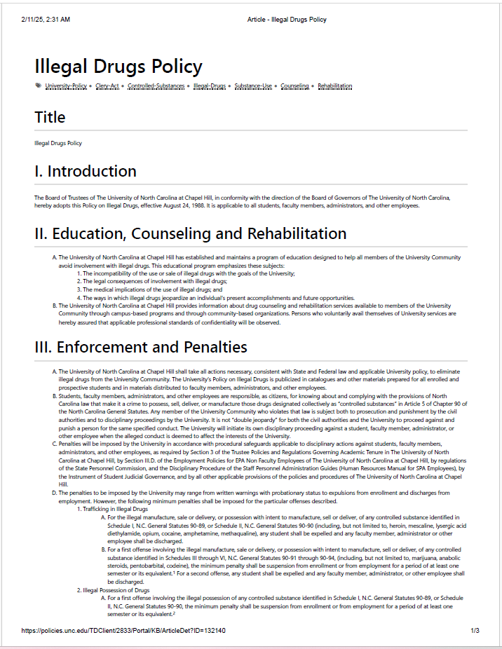

Exhibit 1. UNC Illegal Drugs Policy
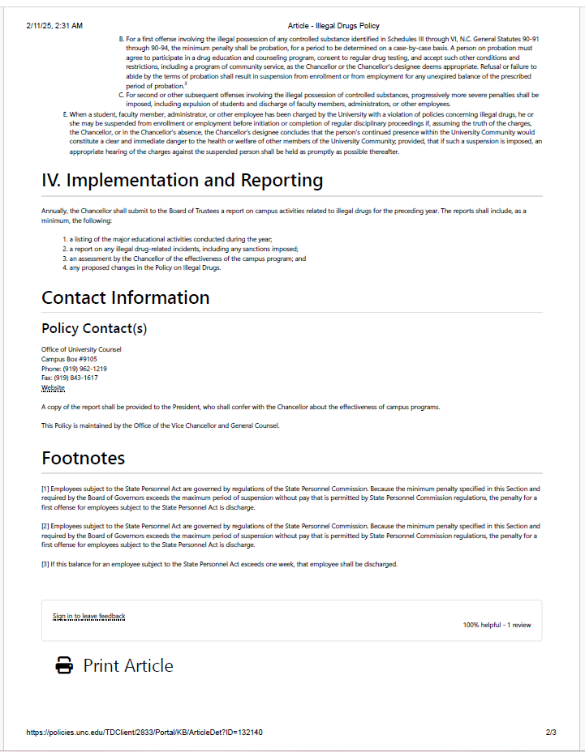

Exhibit 2. UNC Email Chain 20 Years Later
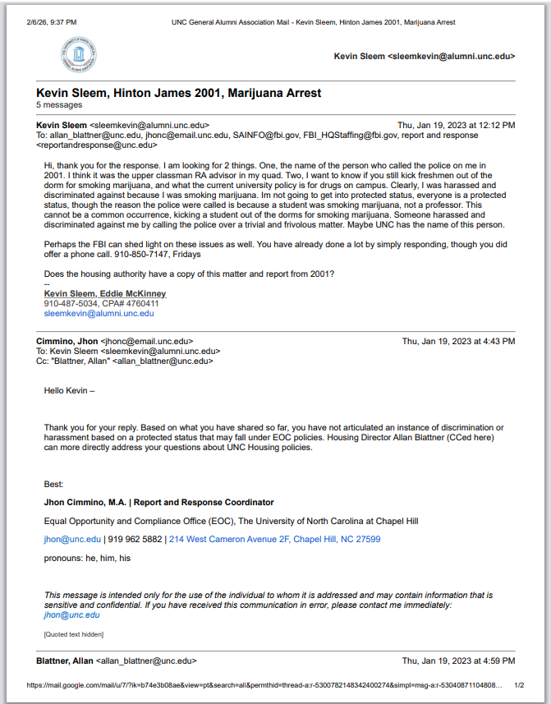

Exhibit 2. UNC Email Chain 20 Years Later

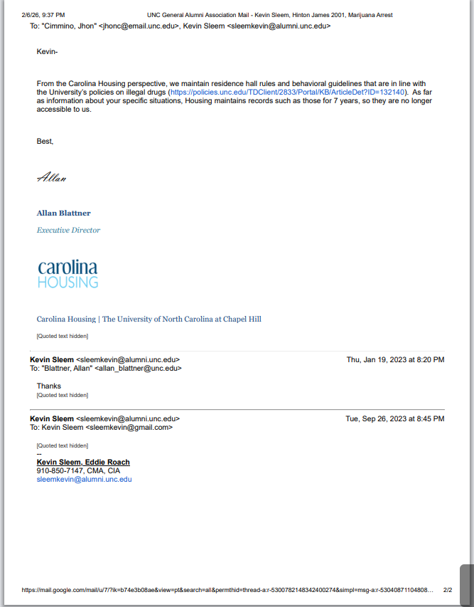

Exhibit 2. UNC Email Chain 20 Years Later
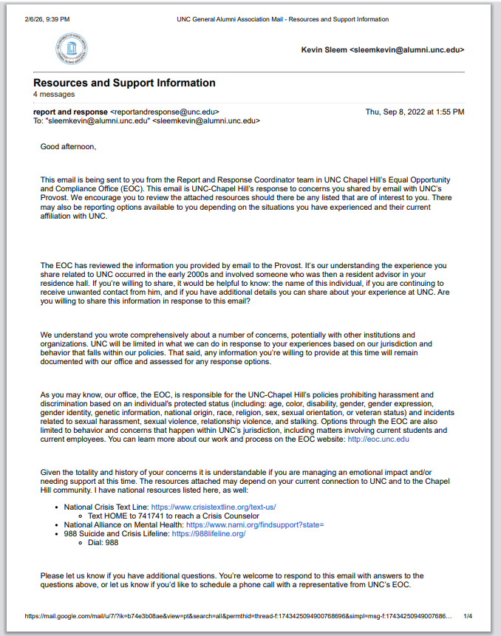

Exhibit 2. UNC Email Chain 20 Years Later
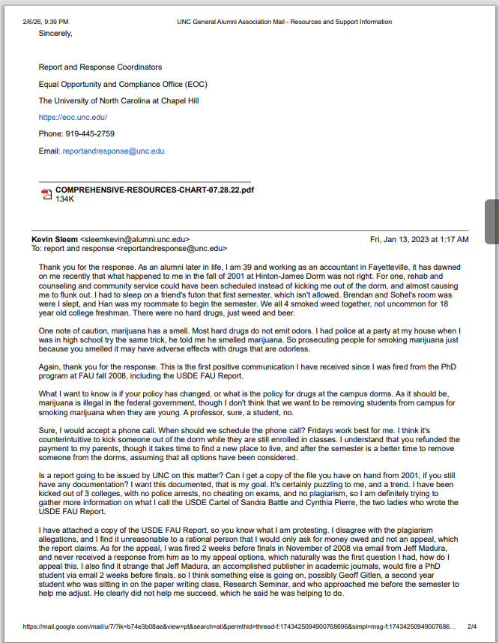

Exhibit 2. UNC Email Chain 20 Years Later
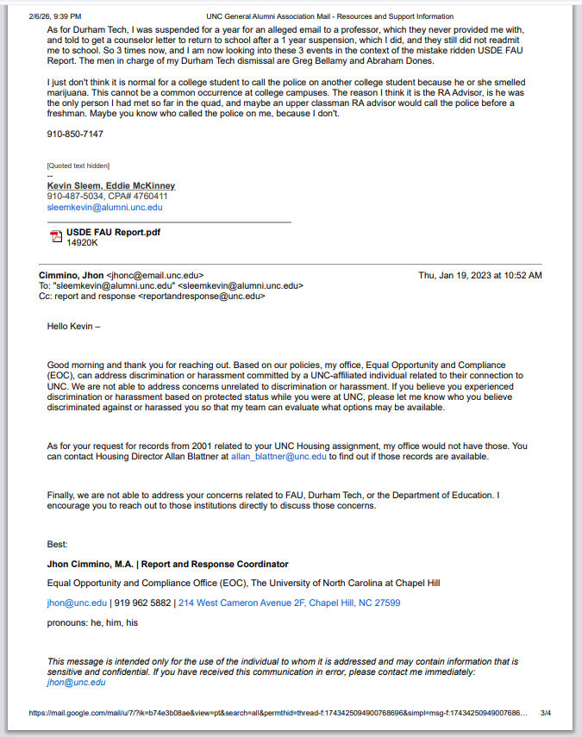

Exhibit 2. UNC Email Chain 20 Years Later
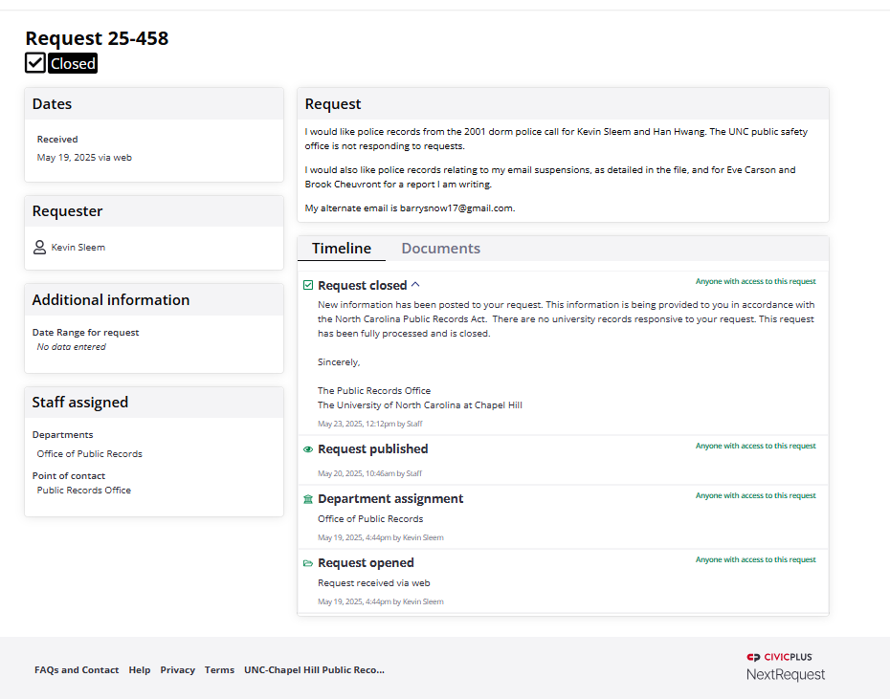

Exhibit 3. Attorney James Arrasmith, 4th Amendment for College Dorms
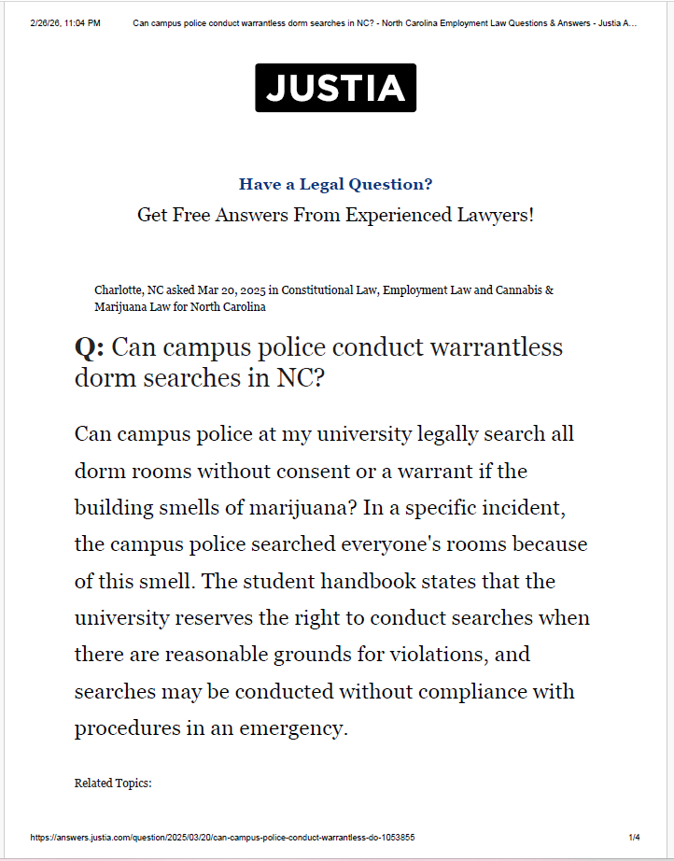

Exhibit 3. Attorney James Arrasmith, 4th Amendment for College Dorms
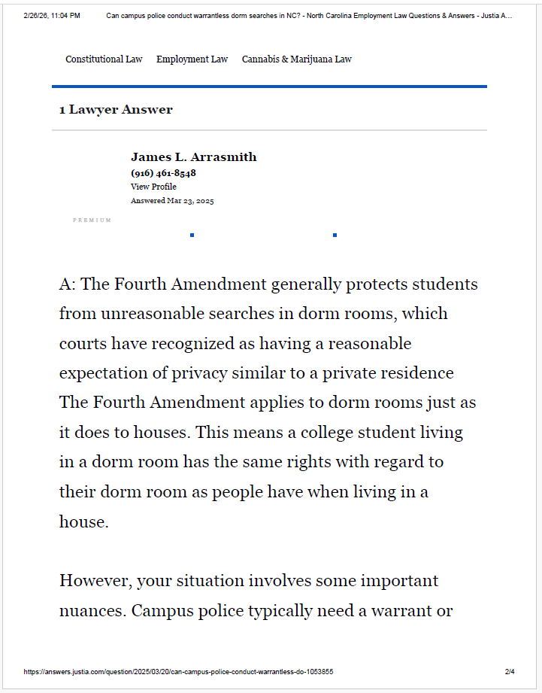

Exhibit 3. Attorney James Arrasmith, 4th Amendment for College Dorms
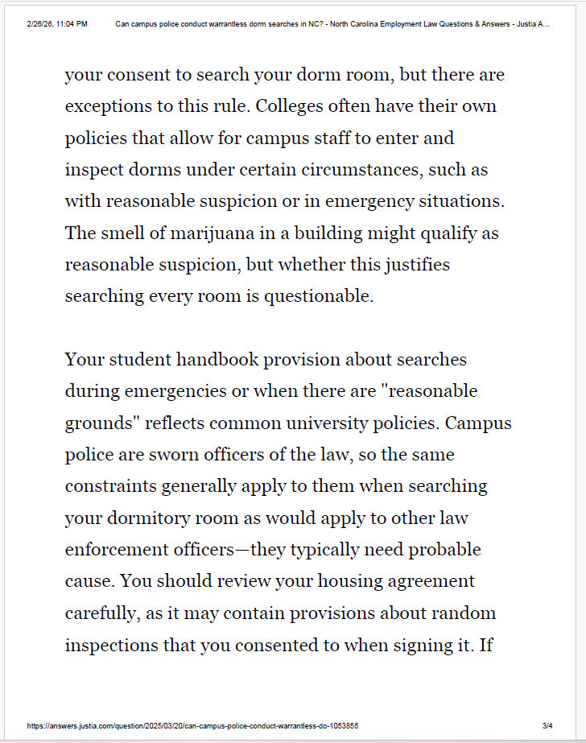

Exhibit 3. Attorney James Arrasmith, 4th Amendment for College Dorms
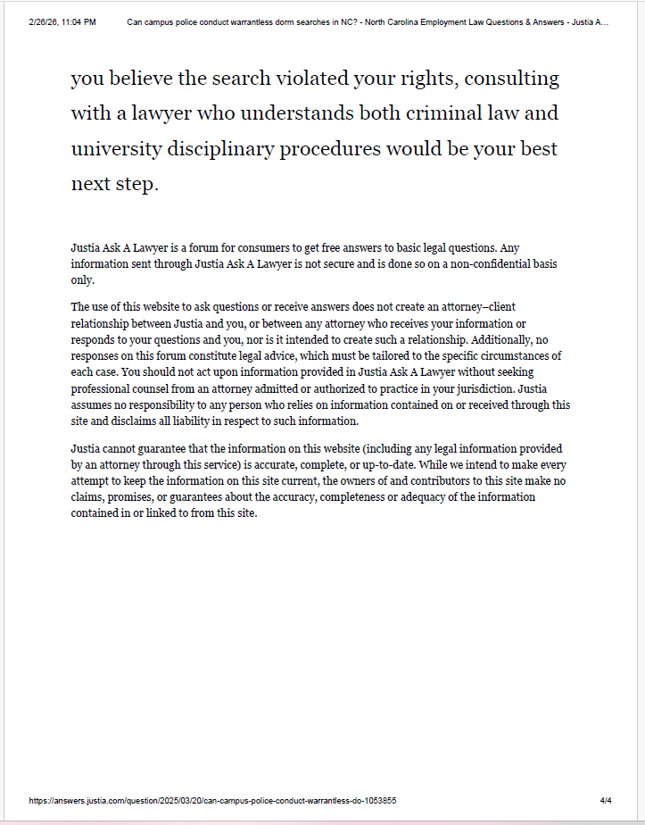

Exhibit 4. Biltmore Estate Unemployment Counseling Policy
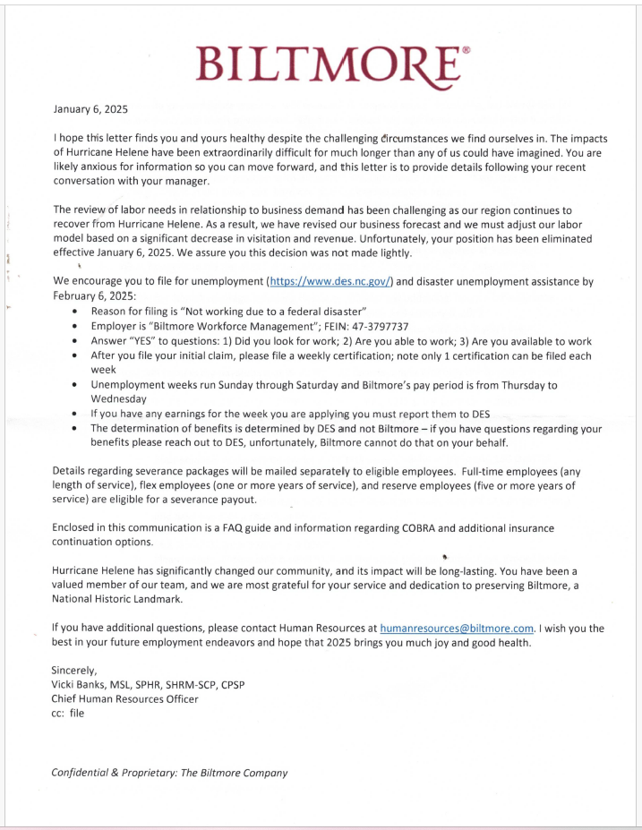

Exhibit 4. Biltmore Estate Unemployment Counseling Policy
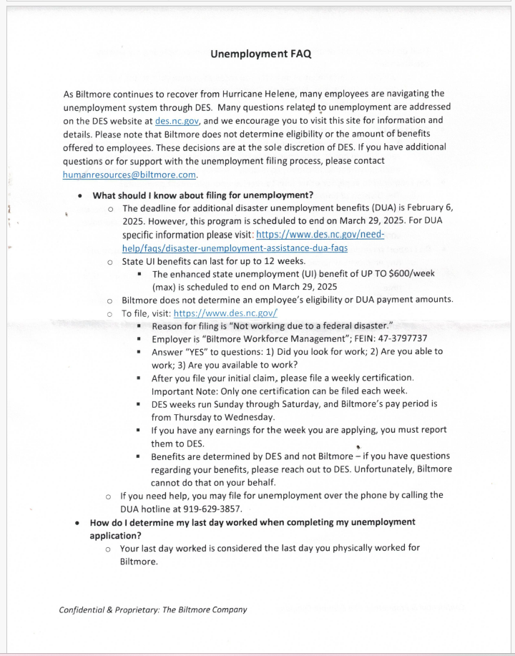

Exhibit 4. Biltmore Estate Unemployment Counseling Policy
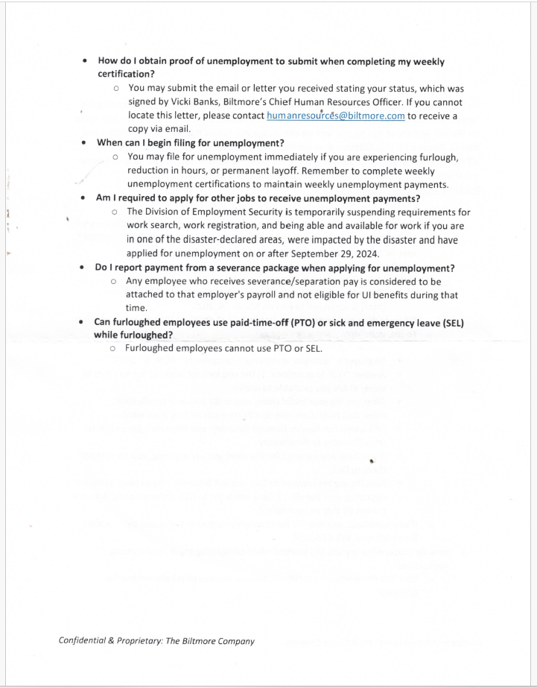

Exhibit 5. NC Insurance License Denial
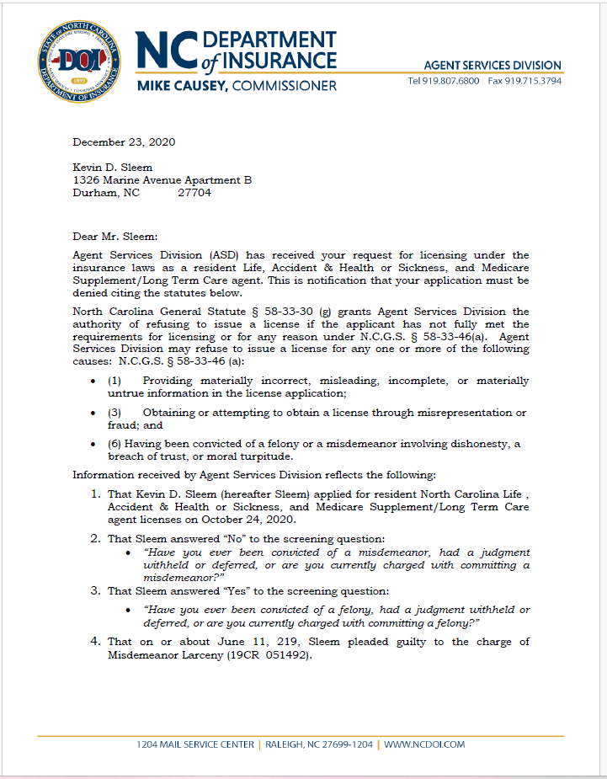

Exhibit 5. NC Insurance License Denial
