**Hydrogen Power, Vehicle Fuel Cells and Industrial Furnaces**

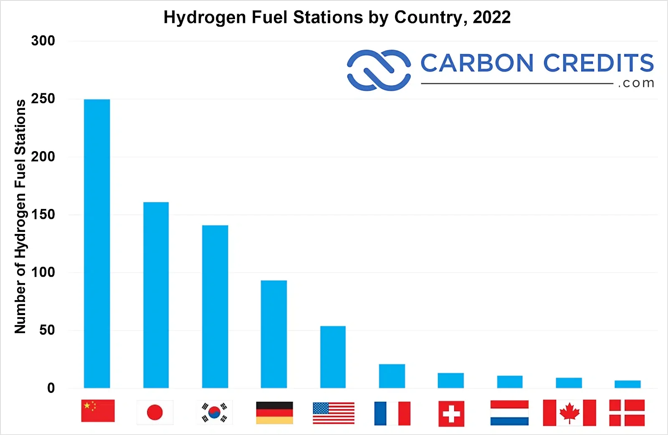

**SoHyCal Green Hydrogen Plant**

The SoHyCal plant, the largest in North America, has a green hydrogen production capacity of up to three tonnes per day, with an objective of providing green hydrogen to the California mobility sector. The SoHyCal hydrogen plant is run by H2B2 Electrolysis Technologies, which focuses on green hydrogen energy solutions, and is located in Fresno, California. The 100 percent renewable hydrogen production plant with proton exchange membrane electrolysis (PEM) technology has a nameplate capacity of up to three tonnes per day, and uses renewable energy from a photovoltaic plant. In phase 1 the plant utilizes renewable energy and electrolysis technology to produce up to one tonne per day of green hydrogen fueled by biogas. In phase 2, it will shift to solar energy, with a total capacity of three tonnes per day of green hydrogen driven by photovoltaics by Q2 2024. Three tonnes of hydrogen can power up to 210,000 automobiles or 30,000 city buses each year. The project will also encompass the storage of hydrogen in compressed gas, dispensing into tube-trailers up to 520 bar, and capability of injection of hydrogen blended with natural gas (Malayil, 2023).

Hydrogen, by means of electrolysis, provides a sustainable solution for energy storage, transportation fuel and industrial applications. Electrolysis-produced hydrogen could aid in the storage of renewable energy sources, making renewable energy sources more dispatchable and allowing for long-duration energy storage. For transportation, hydrogen fuel cell technology provides an alternative to gas or electric that offers zero emissions, while maintaining the range and refueling time comparable to gas-powered vehicles. Hydrogen energy generation can provide cost-effective on-site production for industrial uses (Malayil, 2023).

Malayil, Jijo (2023) Interesting Engineering. North America's largest green hydrogen plant now operational. Retrieved November 5, 2023. <https://interestingengineering.com/innovation/north-americas-largest-green-hydrogen-plant-now-operational>

**Hydrogen Fuel**

China has the most hydrogen fueling stations at 250, followed by the USA at 50, mostly in California. Currently, battery-electric heavy-duty trucks can travel around 300 miles and take hours to recharge. Some truckers report getting just over 150 miles between charges. In contrast, hydrogen trucks boast a range of up to 500 miles and refuel in about 30 minutes. They are also lighter than battery-electric rigs, enabling heavier loads (Carbon Credits, 2023).

Carbon Credits (2023) Truck Companies Are Shifting to Hydrogen Fuel for Long-Haul Trips. Retrieved November 29, 2023. <https://carboncredits.com/truck-companies-are-shifting-to-hydrogen-fuel-for-long-haul-trips/>

Foley, EV (2025) PV Magazine, Solar discovery could transform hydrogen production,

<https://www.pv-magazine.com/2025/01/10/solar-discovery-could-transform-hydrogen-production/?utm_source=Global+%7C+Newsletter&utm_campaign=700a3a74c3-dailynl_gl&utm_medium=email&utm_term=0_6916ce32b6-700a3a74c3-160603208>

Krishnan, G., O’Donnell, S., Broughton, R., et al. (2024) Chemical and Valence Electron Structure of the Core and Shell of Sn(II)-Perovskite Oxide Nanoshells, Journal of Physical Chemistry C, pages 17387–17398, Volume 128, Issue 41, 10.1021/acs.jpcc.4c04169

Nanoscale chemistry could be used to develop sustainable and efficient generation of hydrogen from water using solar power. An international research team has discovered a new class of kinetically stable ‘core and shell Sn(II)-perovskite’ oxide solar material, which in the future, could be a potential catalyst for the critical oxygen evolution reaction in producing pollution-free hydrogen energy. Combined with a catalyst for water splitting, developed by US-based Baylor University Department of Chemistry and Biochemistry Professor Paul Maggard, the study paves the way toward carbon-free green hydrogen technologies using non-greenhouse-gas-emitting forms of power with high-performing, affordable electrolysis. The research outlines how the use of tin and oxygen compounds are already used in a variety of applications, including catalysis, diagnostic imaging and therapeutic drugs, saying however, that Sn(II) compounds are reactive with water and dioxygen, which can limit their technological applications. Global solar photovoltaic research is focusing on developing cost-effective, high performance perovskite generation systems as an alternative to conventional existing silicon and other panels. Low-emission hydrogen can be produced from water through electrolysis (when an electric current splits water into hydrogen and oxygen) or thermochemical water splitting, a process which also can be powered by concentrated solar power or waste heat from nuclear power reactors. Solar-driven processes use light as an agent for hydrogen production and is a potential alternative for generating industrial-scale hydrogen (Krishnan et al., 2024; Foley, 2025).

**Solar Energy for Water Electrolysis Hydrogen Production**

Hydrogen is an alternative to fossil fuels, and is known as a sustainable energy vector. Grey and Blue hydrogen are produced through the methane steam reforming, a fossil fuel-based process that releases carbon dioxide (CO2) as a by-product, and are classified as “grey” (when CO2 is released into the atmosphere) or “blue” (when CO2 undergoes capture and geological storage). Green hydrogen depends on the energy efficiency of the setup (the electrolyzer) that splits water molecules into hydrogen and oxygen (Istituto Italiano, 2024). In 2022, global consumption of hydrogen was around 95 million tons, and was used to improve various fuel products, and especially to produce ammonia, which is needed for manufacturing agricultural fertilizers. Hydrogen production using gray hydrogen, made from natural gas or methane, and black hydrogen, made from coal, is responsible for around 2.5% of the annual global carbon dioxide emissions into the atmosphere. Green hydrogen is produced through electrolysis, which is the electrochemical decomposition of water into oxygen and hydrogen using energy from renewable sources such as wind and sun. Green hydrogen produced through electrolysis still is too expensive, including the need for expensive membranes, gaskets, and sealing components to separate the cathodic and anodic compartments (Technion-Israel, 2024). As of 2024, the world produces just 180 kilotonnes of electrolysis-based hydrogen per year, but could reach more than 14,000 kilotonnes by 2030 if all projects currently under construction become operational (Olano, 2024).

**Alkaline Electrolyzer (Service, 2024)**

-works a bit like a battery

1. Two electrodes are dropped in a chamber containing water and a liquid electrolyte that encourages the movement of ions
2. Applying an electric current to the negatively charged cathode splits the water into hydrogen molecules and negatively charged hydroxide ions
3. The hydroxide ions diffuse through the liquid to the positively charged anode, where they react to form oxygen and a smaller amount of water
4. The setup relies on a membrane between the two electrodes. It allows hydroxide ions to travel from the cathode to anode, but prevents the commingling of hydrogen and oxygen, which can combine explosively

**Costs of Hydrogen Electrolysis (Service, 2024)**

1. Renewable electricity that drives the process
2. Electrolyzer—and the membrane is one of its most expensive components, because it typically contains many specialized layers to house and protect the molecular filters

**PUB Net-zero Emissions by 2045 Approach**

1. Replacing fossil fuels with renewable solar energy
2. Investing in research and development to reduce the energy required in water-treatment processes
3. Capturing and removing carbon released into the atmosphere

In 2024, UCLA partnered with Singapore’s national water agency to build the world’s largest ocean-based carbon dioxide removal plant capable of removing 3,650 metric tons (8,046,873 lb) of the greenhouse gas per year while producing 105 metric tons (231,000 lb) of carbon-negative hydrogen. Agencies included in the project include: Singapore’s national water agency, the Public Utilities Board (PUB), Singapore’s National Research Foundation (NRF), and UCLA’s Institute for Carbon Management (ICM). The World Bank suggests that average global carbon dioxide (CO2) emissions in 2020 were 4.3 metric tons (9,500 lb) per capita (McClure, 2024).

The project will be called Equatic-1 and uses electrolysis to produce hydrogen, passing an electrical current through seawater from adjacent desalination plants. Water is broken into its constituents, hydrogen and oxygen, through electrolysis chemical reactions, while atmospheric CO2 is dissolved and stored as solid calcium and magnesium-based materials for at least 10,000 years. The ocean has natural CO2-storing ability, and this process allows dissolved CO2 to be removed from the ocean while enabling it to absorb more of the greenhouse gas. Equatic-1’s modular design will use selective anodes to produce oxygen while eliminating the unwanted chlorine byproduct created during seawater electrolysis. This opens both removes carbon dioxide at the gigaton scale and produces hydrogen. Equatic-1 will be built in two phases. Beginning in March, the first phase is designed to remove one metric ton (approximately 2,205 lb) of CO2 per day by late 2024. In early 2025, installing nine additional modules will complete phase two. With 10 modules in operation, it’s expected that Equatic-1 will be able to remove 10 metric tons of CO2 per day from seawater and the atmosphere. The Singapore pilot plant was deemed successful after removing 0.1 metric ton (220 lb) of CO2 per day; Equatic-1 could remove 100 times more. The technology could also simultaneously produce nearly 300 kg (660 lb) of carbon-negative hydrogen daily (McClure, 2024).

Japanese researchers at the University of Tsukuba researchers have developed highly durable electrodes without precious minerals for green energy electrolysis hydrogen production from seawater, in a paper titled, “Durable high-entropy non-noble metal anodes for neutral seawater electrolysis” in the Chemical Engineering Journal. They used a multi-elemental alloy electrode composed of nine non-noble metal elements, and conducted an accelerated degradation test, consisting of turning the power supply on and off, which mainly caused degradation during the operation of the water electrolysis system, suggests sustained anode performances for over a decade when powered by solar energy. This multi-element anode alloy requires higher voltages than that of the precious metal, such as iridium oxide to offer direct seawater electrolysis without using fresh water (Westenhaus, 2024D).

Renewable energy sources can be used to perform water electrolysis as a clean method for hydrogen production. Since the water electrolysis method for hydrogen production relies on freshwater, thereby limiting the regions available with water resources required for water electrolysis, a new technology for water electrolysis that can directly harness the abundant supply of seawater is needed. Seawater electrolysis utilizes an anode reaction to generate oxygen from water, chlorine gas, and hypochlorous acid from chloride ions. The anode electrodes are precious metal electrodes, such as platinum oxide, ruthenium oxide, and iridium oxide, which are unaffected by chlorine. However, precious metals as electrodes for seawater electrolysis technology have a high cost, although non-noble metals, which are highly reactive with chloride ions, cannot be employed for durable anodes (Westenhaus, 2024D).

Italian researchers have developed a method utilizing small ruthenium particles, a new family of electrocatalysts, in conjunction with a solar-powered electrolysis system for water electrolysis to produce green hydrogen more efficiently and cheaply. They found a greater efficiency than other methods in the conversion of electrical energy (the energy bias exploited to split water molecules) into the chemical energy stored in the hydrogen molecules that are produced. Using nanoparticles of ruthenium, a noble metal that is similar to platinum in its chemical behavior but far cheaper, the ruthenium nanoparticles serve as the active phase of the electrolyzer’s cathode, leading to an increased efficiency of the overall electrolyzer (Istituto Italiano, 2024).

1. Theoretical simulations to understand the catalytic behavior of ruthenium nanoparticles at the molecular level; the mechanism of water splitting on their surfaces
2. Electro-chemical analyses and tests under industrially-significant conditions to assess the catalytic activity of materials

Using a precious metal such as ruthenium results in an initial investment that is slightly greater than what would be needed for a standard electrolyzer, to improve the efficiency of ruthenium-based cathodes for alkaline electrolyzers. Ruthenium is a precious metal that is obtained as a by-product of platinum extraction (30 tonnes per year, as compared to the annual production of 200 tonnes of platinum) but at a lower cost (18.5 dollars per gram as opposed to 30 dollars for platinum). The Italian researchers used 40 mg of ruthenium per kilowatt, in stark contrast with the extensive use of platinum (up to 1 gram per kilowatt) and iridium (between 1 and 2.5 grams per kilowatt, with iridium price being around 150 dollars per gram) that characterize proton-exchange membrane electrolyzers (Istituto Italiano, 2024).

**2019 E-TAC Electrolysis**

E-TAC electrolysis, developed by Israeli Technion researchers, doesn’t require a membrane and sealing to separate the two parts of the cell, since the hydrogen and the oxygen are produced at different stages of the process, unlike in regular electrolysis where they are created simultaneously (Technion-Israel, 2024). This model does away with the membrane by “decoupling” the electrolysis and separating the hydrogen and oxygen production in space or time. They charged a nickel-based electrode like a battery during the hydrogen production step, and when they moved that electrode to a second chamber, it produced oxygen as it discharged (Service, 2024).

***Challenges 2019 Design***

1. Moving the electrode between steps means the reactor can’t operate continuously, likely making it expensive to scale up.
2. The electrolyte used in the oxygen generation step must be hot to speed the reaction, requiring the use of expensive materials and insulation to prevent heat loss.

**2024 Technion Electrolysis**

Unlike the E-TAC process where hydrogen and oxygen are produced in the same cell but at different stages, this is a new process whereby hydrogen and oxygen are produced simultaneously in two separate cells in a continuous process without any temperature changes. The solid electrode where the oxygen is produced in the E-TAC technique is replaced with NaBr aqueous electrolyte in water. This NaBr replacement allows for a continuous process, as opposed to a batch process with E-TAC, and removes the need to swing cold and hot electrolytes alternately through the cell. The bromide anions in the electrolyte are oxidized to bromate while producing hydrogen in a cathode, and they then flow with the aqueous electrolyte to a different cell, where they are turned back into their original state while at the same time producing oxygen. Moreover, the oxygen is produced in the aqueous electrolyte and not in the solid electrode as in E-TAC, and it is therefore not dependent on the rate and capacity limitations typical of those types of electrodes, such as chargeable batteries (Technion-Israel, 2024). In the 2024 Design, the decoupled electrolyzer was designed so that hydrogen production didn’t charge the anode, but instead altered molecules in the liquid electrolyte. During hydrogen production at the anode, bromide ions in the electrolyte are converted to bromate, and that bromate-containing electrolyte is pumped into a second chamber, which has a catalyst that causes the bromate to decompose back into bromide and oxygen in a reaction that works at room temperatures (Service, 2024).

***Challenges to 2024 Design***

1. The efficiency wasn’t as high as a typical alkaline electrolyzer, though they were able to keep the hydrogen and oxygen separate without a membrane, which could reduce the cost of large-scale hydrogen production.
2. To prevent bromate from reacting at the anode before it can be pumped to the second chamber, the team had to coat the anode with a material that allows hydrogen to escape but blocks bromate from reaching the anode. And that coating required adding hexavalent chromium, a powerful carcinogen, to the solution, raising concerns about toxic leaks.
3. The electrodes in the device use either platinum or ruthenium, which are expensive and rare metals.

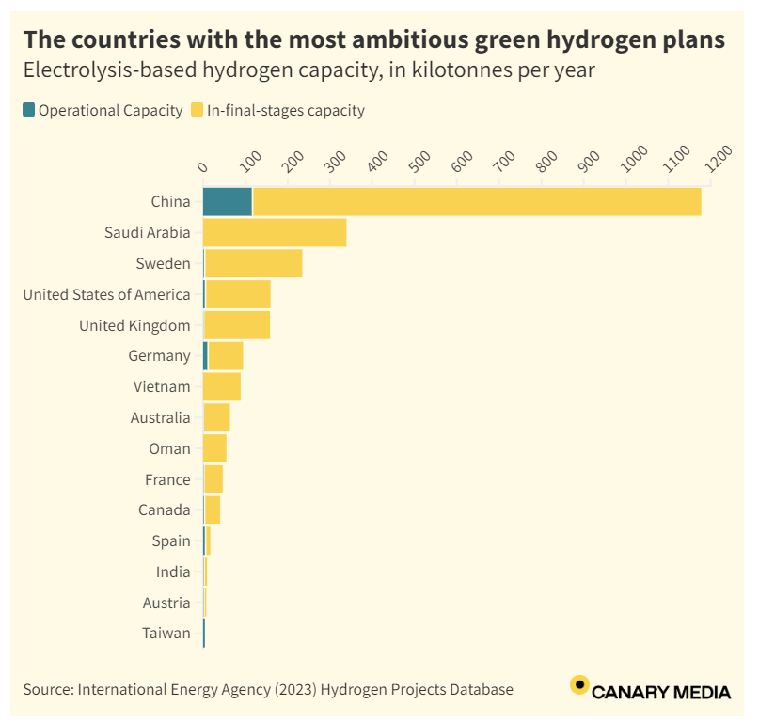

Source: Olano, Maria (2024) Canary Media. Chart: Which countries are leading the green hydrogen race? <https://www.canarymedia.com/articles/hydrogen/chart-which-countries-are-leading-the-green-hydrogen-race>

**Hydrogen Energy, Liquified and Gaseous**

Two atom dihydrogen (H2) can be used in vehicles and electric power plants. Hydrogen is an energy carrier that can be used to store, move, and deliver energy produced from other sources.[1] Hydrogen is a clean fuel that produces water and heat when consumed in a fuel cell. Hydrogen, by means of electrolysis, provides a sustainable solution for energy storage, transportation fuel and industrial applications. Electrolysis-produced hydrogen could aid in the storage of renewable energy sources, making renewable energy sources more dispatchable and allowing for long-duration energy storage. For transportation, hydrogen fuel cell technology provides an alternative to gas or electric that offers zero emissions, while maintaining the range and refueling time comparable to gas-powered vehicles. Hydrogen energy generation can provide cost-effective on-site production for industrial uses (Malayil, 2023).

Liquid hydrogen is the key to fuel cell efficiency. I envisage a future where green hydrogen powers our vehicles, industrial applications, and energy storage needs. Existing gas and oil pipelines could be repurposed to carry hydrogen, and our gas stations could be refitted for hydrogen fuel over gasoline. I think that hydrogen fuel is more promising than electric vehicles, because of refueling and recharging times. It takes too long to charge an electric vehicle, and unless you have a garage you cannot charge at home. A major challenge and the topic of this thesis is how do we create enough renewable power to power the green hydrogen creation process. We can use solar panels, wind turbines, and nuclear energy to power our power plants, and also for industrial applications including green hydrogen production. Solar collectors for industrial power sources have potential to power industry and factories, and we can also use green hydrogen to create ammonia for fertilizer, with nitrogen taken from the air.

**Manganese Catalyst with Lower Iridium for Hydrogen Electrolysis**

Hydrogen electrolysis production in a proton exchange membrane (PEM) electrolyzer requires a catalyst to break the bonds of water and free the hydrogen, and the most widely used catalyst is iridium. However, iridium is a rare earth transition metal, very expensive to find and mine, and consequently scaling up global hydrogen production to the terawatt scale is estimated to require 40 years’ worth of iridium, according to Shuang Kong of Japan RIKEN. Japanese RIKEN researchers have been experimenting with replacing 95% of iridium with manganese oxide as the catalyst, a common earth metal. The Japanese researchers spread individual iridium atoms on a piece of manganese oxide, preventing them from clumping together (McFadden, 2024).

The manganese catalyst allowed hydrogen production continuously for over 3000 hours (about four months) at 82% efficiency without any degradation. Ailong Li suggests that the unexpected interaction between manganese oxide and iridium was critical, with the iridium resulting from this interaction being in the rare and highly active +6 oxidation state. To achieve sustainable green hydrogen production, we must complement the rare metals currently used with common metal-based electrolyzers (McFadden, 2024).

**Solid Oxide Electrolysis Cell (SOEC)**

In Korea, researchers at the Korea Institute of Energy Research (KIER) developed an 8 kW solid oxide electrolysis cell (SOEC) that can reportedly produce 5.7 kg of hydrogen per day to provide stable operation for 2,500 h. The SOEC stack was constructed by layering ceramic cells, separator plates, and sealing materials. The separator plate was created using a press forming method that reduces production costs and time. Channels were created using this SOEC technique that enables a proper flow of hydrogen and oxygen in the system. The group maximized the contact area between the cell and the separator plate, which allows for more uniform performance, and sealed the stacked components via brazing technology, which ensures that the stack can minimize hydrogen leakage even in the face of thermal shock or rapid temperature changes, thus maintaining stable performance (Bellini, 2024A).

This a solid oxide electrolysis cell stack that uses a special kind of separator plate to ensure proper flow of hydrogen and oxygen after water splitting. In a SOEC system, a solid oxide, or ceramic, is used to produce hydrogen and oxygen. Water supplied at the cathode is used to separate hydrogen from water in an external separation unit, with the hydroxide ions flowing through an aqueous electrolyte to the anode to generate oxygen. The Korean researchers said that, “The SOEC technology, which electrolyzes high-temperature steam into hydrogen and oxygen, is considered a high-efficiency hydrogen production technology that can reduce electricity consumption by more than 25% compared to other electrolysis methods when applied to places with a large demand for hydrogen and/or a large steam supply, such as nuclear power plants, steel mills, petrochemical plants, and ammonia manufacturing plants.” (Bellini, 2024A)

**Hydrogen storage options**

1. Gaseous, leaks and is combustible
2. Liquid, low temperatures
3. Hydrogen boride sheets, low conversion rates

**Stages of hydrogen conversion**

1. Geologic hydrogen rocks
2. Fossil fuel hydrogen
3. Green hydrogen electrolysis
4. Gold hydrogen deposits

**Energy Storage Options**

1. Electrochemical Batteries, Lithium and Sodium
2. Thermal Batteries, Heated Water
3. Mechanical Storage, Hydroelectric Dams
4. Chemical Storage, Ethanol and Hydrogen
5. Hydrogen engines are less efficient than electric vehicles and lose more energy in the conversion process.
6. Hydrogen fuel is more combustible than gasoline.

**Processes to Produce Hydrogen Fuel**

1. Natural gas reforming, steam-methane reforming; Thermal process- Steam reforming is a high-temperature thermal process for hydrogen production in which steam reacts with a hydrocarbon fuel to produce hydrogen. Hydrocarbon fuels which can be reformed to produce hydrogen include: natural gas, diesel, renewable liquid fuels, gasified coal, or gasified biomass. As of 2023, about 95% of all hydrogen is produced from steam reforming of natural gas.
2. Electrolysis- Electrolysis is a process in which water is separated into oxygen and hydrogen. An electrolyzer, which mirrors a fuel cell in reverse, is where electrolysis processes take place. In the electrolyzer, hydrogen is created from water molecules, instead of using the energy of a hydrogen molecule, like a fuel cell does.
3. Solar-driven, photolytic process- Light is used as the agent for hydrogen production in solar-driven processes. Solar-driven processes include: photobiological, photoelectrochemical, and solar thermochemical. In photobiological processes, the natural photosynthetic activity of bacteria and green algae is used to produce hydrogen. In photoelectrochemical processes, specialized semiconductors are used to separate water into hydrogen and oxygen. In solar thermochemical hydrogen production, concentrated solar power is used to drive water splitting reactions often along with other species such as metal oxides.
4. Biological processes- Microbes such as bacteria and microalgae are used to produce hydrogen through biological reactions in biological processes. Microbial biomass conversion is a process in which the microbes break down organic matter like biomass or wastewater to produce hydrogen, while photobiological processes for the energy source the microbes use sunlight.
5. Thermochemical processes- Convert biomass into gas or liquids and separate the hydrogen

**Hydrogen Storage Options**

1. Gas- Storage of hydrogen as a gas typically requires high-pressure tanks (350–700 bar [5,000–10,000 psi] tank pressure).
2. Liquid- Storage of hydrogen as a liquid requires cryogenic temperatures because the boiling point of hydrogen at one atmosphere pressure is −252.8°C.
3. Adsorption- on the surfaces of solids
4. Absorption- within solids

According to the U.S. Department of Energy, hydrogen has the highest energy per mass of any fuel; however, its low ambient temperature density results in a low energy per unit volume, therefore requiring the development of advanced storage methods that have potential for higher energy density. On a mass basis, hydrogen has nearly three times the energy content of gasoline—120 MJ/kg for hydrogen versus 44 MJ/kg for gasoline. On a volume basis, however, the situation is reversed; liquid hydrogen has a density of 8 MJ/L whereas gasoline has a density of 32 MJ/L, as shown in the figure comparing energy densities of fuels based on lower heating values. Onboard hydrogen storage capacities of 5–13 kg hydrogen will be required to meet the driving range for the full range of light-duty vehicle platforms.

To overcome these challenges Hydrogen and Fuel Cell Technologies Office (HFTO) is pursuing two strategic pathways, targeting both near-term and long-term solutions. The near-term pathway focuses on compressed gas storage, using advanced pressure vessels made of fiber reinforced composites that are capable of reaching 700 bar pressure, with a major emphasis on system cost reduction. The long-term pathway focuses on both (1) cold or cryo-compressed hydrogen storage, where increased hydrogen density and insulated pressure vessels may allow for DOE targets to be met and (2) materials-based hydrogen storage technologies, including sorbents, chemical hydrogen storage materials, and metal hydrides, with properties having potential to meet DOE hydrogen storage targets.

**Hydrogen Embrittlement**

Hydrogen embrittlement is a major obstacle to the transition to a global hydrogen economy, and to develop large-scale transport and storage solutions for the hydrogen age, to be able to effectively produce, transport, store and use hydrogen on a large-scale, we need to determine why stored hydrogen causes steels to become brittle and crack. When hydrogen embrittlement occurs, hydrogen causes high strength materials like steel to become brittle and crack, which prevents hydrogen from being effectively stored and transported at high pressures. As the smallest atom and molecule, hydrogen is insidious, and it seeps into materials, then cracks and breaks them. Deloitte estimates the clean hydrogen market could reach USD$1.4 trillion by 2050 (U Sydney, 2024).

Ceramic carbides are added to steels to increase their durability and strength, and in this experiment, molybdenum was added to the steel, combined with other elements to form the carbide. By adding the chemical element molybdenum to steel reinforced with metal carbides, its ability to trap hydrogen was greatly increased, according to the Australian researchers. An advanced microscopy technique developed at the University of Sydney, known as cryogenic atom probe tomography, was used to allow for direct observation of hydrogen distribution in materials, in which the researchers saw the trapped hydrogen atoms were at the core of the carbide sites, suggesting the addition of molybdenum helps trap hydrogen. Conversely, a benchmark titanium carbide steel did not show the same hydrogen trapping mechanism. The addition of molybdenum, only 0.2% of the total steel, helped boost the presence of carbon vacancies, a defect in carbides that can effectively capture hydrogen. The researchers also believe niobium and vanadium may also have a similar effect as molybdenum on steels (U Sydney, 2024).

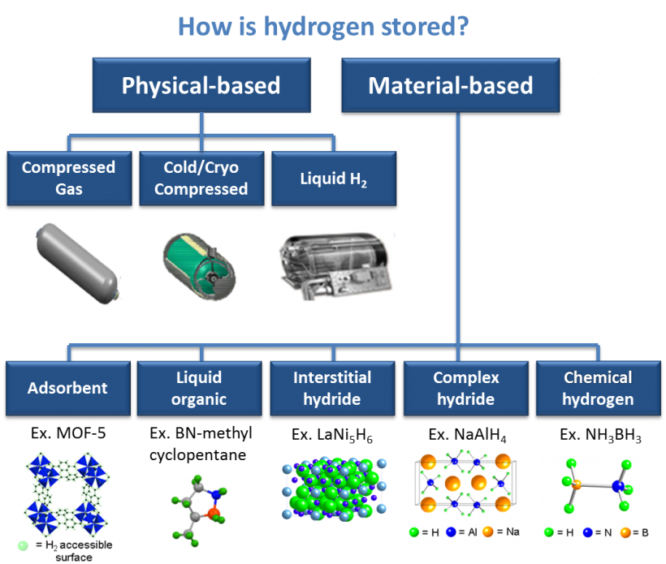

Source: US Department of Energy, Office of Energy Efficiency and Renewable Energy, Hydrogen and Fuel Cells Technologies Office, Hydrogen Storage. <https://www.energy.gov/eere/fuelcells/hydrogen-storage#:~:text=Hydrogen%20can%20be%20stored%20physically,pressure%20is%20%E2%88%92252.8%C2%B0C>

Japanese scientists developed a method to release hydrogen from hydrogen boride sheets electrochemically using an electrical current, a safe and lightweight hydrogen carrier with low energy consumption. which is more efficient than traditional methods requiring high temperatures or UV light. They demonstrated that dispersing these sheets in an organic solvent and applying a small voltage is enough to release all the stored hydrogen efficiently. The Faradaic efficiency of this process, which measures how much electrical energy is converted into chemical energy, was over 90%. Traditionally, getting the hydrogen out of the sheets is the difficult part, as heating at high temperatures or strong ultraviolet (UV) illumination is required to release H2 from HB sheets. But both approaches have inherent disadvantages, such as high energy consumption or incomplete H2 release. The Japanese researchers used electrochemical release to separate the hydrogen from the boride sheets. In consideration of the mechanism of UV-induced H2 release from HB sheets, the team speculated that electron injection from a cathode electrode into HB nanosheets by an electric power supply could be a superior way to release H2 compared to UV irradiation or heating. Based on this theory, the researchers dispersed HB sheets into acetonitrile – an organic solvent – and applied a controlled voltage to the dispersion. The experiments revealed that nearly all of the electrons injected into the electrochemical system were used to convert H+ ions from the HB sheets into H2 molecules (Westenhaus, 2024C).

Researchers in the United States are looking at ways to produce geologic hydrogen, by exploring a suite of natural catalysts to help produce hydrogen gas from iron-rich rocks without emitting carbon dioxide. A $1.7 million grant from the Department of Energy was issued to the UT Austin and the University of Wyoming to explore the feasibility of this process on different rock types across the United States. Catalyst-enhanced production of hydrogen from iron-rich rocks has the potential to significantly increase hydrogen production globally. A natural geologic process known as “serpentinization” is the catalyst, where iron-rich rocks release hydrogen as a byproduct of chemical reactions, as serpentinization usually occurs at high temperatures. The team is using natural catalysts including nickel and other platinum group elements, to stimulate hydrogen production at lower temperatures and at depths easily accessible by today’s technology where iron-rich rocks are found throughout the world. The goal is to generate larger volumes of hydrogen from these iron-rich rocks by driving reactions that would take several million years to happen in nature. The team will investigate using the catalysts on basalts from the Midcontinent Rift in Iowa, banded iron formations in Wyoming and ultramafic rocks in the Midwest (UT Austin, 2024).

**Hydrogen Fuel Cells[2]**

1. Proton exchange membrane- Polymer electrolyte membrane (PEM) fuel cells, or proton exchange membrane fuel cells, use for an electrolyte a proton-conducting polymer membrane, with hydrogen as the fuel. PEM cells can quickly vary their output to meet changing power demands, and operate at low temperatures. PEM fuel cells are used for automobiles, but they can also be used for stationary power production. Due to their low operating temperature, however, PEMs cannot directly use hydrocarbon fuels, such as natural gas, liquefied natural gas, or ethanol, so these fuels must be converted to hydrogen in a fuel reformer to be able to be used by a PEM fuel cell.
2. Alkaline membrane- Alkaline electrolytes such as potassium hydroxide or alkaline membranes that conduct hydroxide ions rather than protons are used in alkaline fuel cells. These fuel cells have been used by NASA for space missions, and for portable power.
3. Direct methanol fuel cells- Both the direct-methanol fuel cell (DMFC) and the PEM cell use a proton conducting polymer membrane as an electrolyte. DMFCs eliminate the need for a fuel reformer, however, by using methanol directly on the anode. Laptop computers and battery rechargers, portable electronic devices, can be powered with DMFCs, because methanol provides a higher energy density than hydrogen. .
4. Phosphoric acid fuel cells- Phosphoric acid fuel cells operate at about 200°C in a porous matrix holding a phosphoric acid electrolyte that conducts protons. They can be used in modules of 400 kW or greater and are being used for stationary power production in hotels, hospitals, grocery stores, and office buildings, where waste heat can also be used. By being immobilized in polymer membranes, phosphoric acid fuel cells membranes can be used for stationary power applications.
5. Molten carbonate fuel cells- Molten carbonate fuel cells utilize a porous matrix with a molten carbonate salt that conducts carbonate ions as their electrolyte, and are used in medium-to-large-scale stationary applications, where their high efficiency produces net energy savings. Their high-temperature operation, approximately 600°C, enables them to internally reform fuels such as natural gas and biogas.
6. Solid oxide fuel cells- Solid oxide fuel cells use as a solid electrolyte a thin layer of ceramic that conducts oxide ions, and can be used in stationary power applications, as well as in auxiliary power devices for heavy-duty trucks. Operating at 700°C–1,000°C with zirconia-based electrolytes, and as low as 500°C with ceria-based electrolytes, these fuel cells can internally reform natural gas and biogas, and can be combined with a gas turbine to produce electrical efficiencies as high as 75%.
7. Combined heat and power fuel cells- Fuel cells produce heat in addition to electricity. . Combined heat and power fuel cells are of interest for powering houses and buildings, including hot water and space heating, where total efficiency as high as 90% is achievable.
8. Regenerative or reversible fuel cells- This fuel cell produces electricity from hydrogen and oxygen, but can also be reversed and powered with electricity to produce hydrogen and oxygen. This fuel cell could provide storage of excess energy produced by intermittent renewable energy sources, such as wind and solar power stations.

AVL Racetech, an Austrian motorsport engineering firm, has developed the H2-ICE engine, a hydrogen powertrain that combines the characteristics of ICE and EV technologies. It is a 2.0-liter turbocharged engine that produces 410 horsepower (hp) and reaches peak power at 6,5000 rpm. With its use of water injections, it infiltrates more water with the intake air. This advanced technology creates optimal performance and is a great step forward in creating cleaner internal combustion engines (The Moment KB, 2024).

***Catalysts[3]***

Key to improving the operating abilities of hydrogen fuel cells is isolating and optimizing the catalysts and polymer electrolytes. Catalyst research focuses on developing and optimizing advanced electrocatalysts and new synthesis methods, including extended-surface catalysts with reduced precious-metal loading and improved performance, durability, and activity compared to standard catalytic materials. Fuel cells and electrolyzer catalysts act differently under acidic and alkaline conditions. The focus of this research is on thrifting platinum, iridium, and their alloys in acidic-based systems, and thrifting silver, cobalt, nickel, and their oxides/alloys in alkaline-based systems.

***Polymer Electrolytes***

Perfluorinated alkaline membranes can be analyzed in terms of new chemistries to enable higher-temperature and higher-current-density operation. Alkaline membrane fuel cells enable the use of non-precious-metal catalysts. However, alkaline membranes are vulnerable to ambient carbon dioxide conditions, although this vulnerability decreases at higher operating temperatures. Proton exchange membranes with tethered heteropolyacid functionality can allow higher-temperature, lower-humidity operation. The stability of covalently tetherable cations in proton exchange membranes is also being researched.

**Fuel Cell Electric Vehicles (FCEL)[4]**

Hydrogen fuel cells generate electricity through an electrochemical reaction instead of combustion. FCEVs produce electricity using a fuel cell powered by hydrogen, rather than drawing electricity from only a battery, like conventional electric vehicles. The power of the vehicle is determined by the size of the electric motor(s) that receives electric power from the appropriately sized fuel cell and battery combination. FCEVs use a propulsion system where energy stored as hydrogen is converted to electricity by the fuel cell, which is similar to that of electric vehicles. These vehicles also produce no harmful tailpipe emissions, like electric vehicles, and unlike internal combustion engine vehicles; they only emit water vapor and warm air. FCEVs utilize a tank on the vehicle which is fueled with pure hydrogen gas or liquified hydrogen. These hydrogen vehicles are similar to conventional internal combustion engine vehicles, in that they have a driving range of more than 300 miles and can fuel in about 5 minutes. FCEVs are equipped with regenerative braking systems that capture the energy lost during braking and store it in a battery. This braking energy recapture technology provides extra power during short acceleration events, and smooths out the power delivered from the fuel cell with the option to idle or turn off the fuel cell during low power needs. In hydrogen vehicles, the amount of energy stored onboard is determined by the size of the hydrogen fuel tank. Conversely, in all-electric vehicles, the amount of power and energy available are both closely related to the battery's size. Hydrogen is considered an alternative fuel under the Energy Policy Act of 1992 and qualifies for alternative fuel vehicle tax credits.

The polymer electrolyte membrane (PEM) fuel cell is the most common type of fuel cell for hydrogen vehicle applications. In a PEM fuel cell, the electrolyte membrane is located between the positive electrode (cathode) and the negative electrode (anode). There are bipolar plates on either side of the cell that serve as current collectors and help distribute gasses. The hydrogen conversion process begins when hydrogen fuel is introduced to the anode, and oxygen from the air is introduced to the cathode. This means that an oxidation occurs at the anode, while a reduction occurs at the cathode, with the two reactions connected by a charged species that migrates through the electrolyte and electrons that flow through the external circuit. Next, an electrochemical reaction in the fuel cell, a catalyst, breaks the hydrogen molecules apart into protons and electrons, where the protons travel in different paths to the cathode through the membrane. Traveling through an external circuit, the electrons perform work, creating a flow of electricity, including providing power to the electric car, and then recombine with the protons on the cathode side where the protons, electrons, and oxygen molecules combine to form wastewater and heat.

Different types of fuel cells use different electrolytes and serve different application needs, with the charged species traveling through the electrolyte and the fuel being different, though the basic functions remain the same. A fuel cell stack may contain anywhere from a few to hundreds of individual fuel cells layered together, with this scalability making hydrogen fuel cells ideal for a wide variety of applications, such as stationary power stations, portable devices, and transportation. Fuel cells work like batteries, and they produce electricity and heat as long as fuel is supplied, but they do not run down or need recharging like a battery does.

***Liquid Hydrogen, LH2[5]***

GENH2 writes that creating systems that produce, liquefy, store, and use hydrogen is critical to the renewable energy economy. This view may be debated, as to the overall need for the hydrogen economy, but what is true is that hydrogen has potential for use as a fuel source. Hydrogen can be used as an energy carrier, and this includes hydrogen fuel cells. Hydrogen fuel cells can be used for providing power, including transportation, industrial/commercial/ residential buildings, and long-term energy storage.

Liquid hydrogen (LH2) is a higher purity for the hydrogen fuel, which allows the fuel cells to operate at higher efficiency and can convert the chemical energy in the hydrogen directly to electrical energy with efficiencies capable of exceeding 60%, according to GENH2. The liquefaction of the hydrogen as the energy carrier supply used for fuel cells maximizes the amount of fuel that can be stored, by increasing the energy density and purity of hydrogen. Machines powered by hydrogen fuel cells can achieve longer operational periods between refueling due to the increased density and storage process of liquified hydrogen.

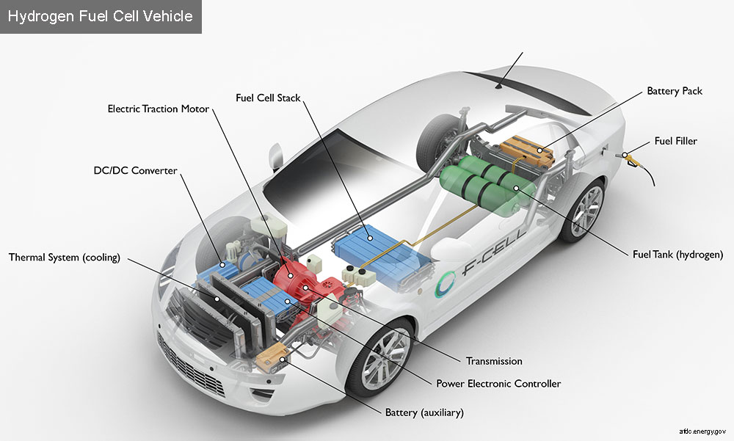

*Image:* U.S. Department of Energy, Alternative Fuels Data Center, <https://afdc.energy.gov/vehicles/how-do-fuel-cell-electric-cars-work>

**Electric Battery Power Train Components**

-There are also sensors and computerized controls and the like, but very few moving parts and very little that requires much maintenance (Barnard, 2024).

1. Batteries
2. Electricity charging system with no moving parts except the flap over the plug
3. Power management unit to move electricity across wires to the motor
4. Motor

**Hydrogen Fuel Cell Vehicle, Battery Hydrogen Hybrid Vehicle**

-A heavy duty fuel cell vehicle like a freight truck or transit bus is a battery electric vehicle with added fuel cell drive train components (Barnard, 2024).

1. Adds a 700 atmosphere hydrogen tank or an even more sophisticated liquid hydrogen tank with pressure sensor and relief systems
2. Hydrogen fuel movement system which has to deal with very large pressure changes in the case of the pressurized tanks or very large volume and hence pressure changes as liquid hydrogen is warmed to gaseous form
3. Very large thermal management challenges and hence thermal management sensors, actuators and components in both cases
4. Expensive and life-limited fuel cell which requires pure hydrogen and and clean air
5. Air intake and filtering system as a result and an exhaust system for moving the resultant water from the fuel cell out of the vehicle without freezing hence a heating solution

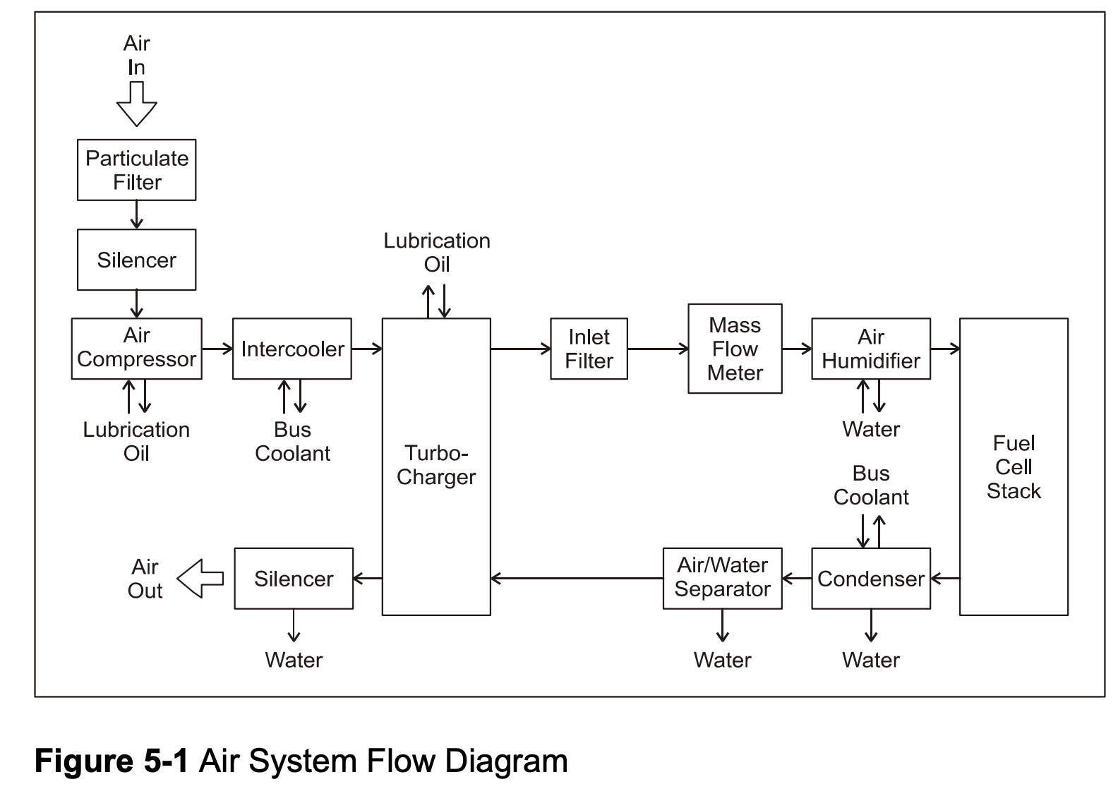

Schematic of just air management system for fuel cell vehicle courtesy US DOE

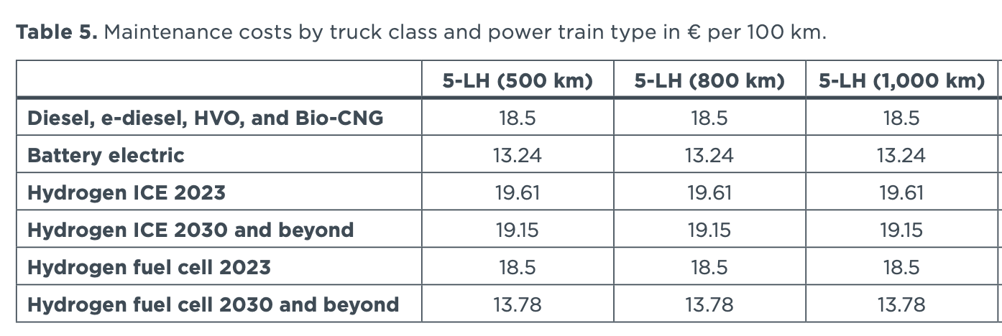

Table of maintenance costs for heavy trucks from ICCT total cost of ownership report

**Pros of Hydrogen Fuel Cell Vehicles (Ross, 2024)**

1. Energy efficiency’
2. Long driving range
3. Reduced dependency on fossil fuels
4. Quick refueling process
5. Zero emissions
6. Quiet operation
7. Lifecycle emissions- Hydrogen cars have life-cycle emissions that are at least as low as that of EVs. One study found that a hydrogen car emits around 120g/km of CO2 over its lifetime. This number can be reduced to 60g/km if the hydrogen used is produced using renewable energy.

**Cons of Hydrogen Fuel Cell Vehicles (Ross, 2024)**

1. Infrastructure challenges- A) storage and transportation B) hydrogen refueling stations
2. High production costs
3. Energy-intensive production
4. Limited model availability

EVs are powered through electricity stored in a lithium-ion battery, but the electricity used to power hydrogen cars is created via a chemical reaction between hydrogen and oxygen in a fuel cell stack (Ross, 2024).

1. Step 1: Hydrogen is extracted from a range of resources, which includes fossil fuels, biomass, and water electrolysis with electricity. Most hydrogen used in the U.S. is produced at large industrial sites and transported via pipelines, high-pressure tube trailers, or liquefied hydrogen tankers.
2. Step 2: Hydrogen is compressed and stored onboard in carbon-fiber-reinforced high-pressure tanks.
3. Step 3: Compressed hydrogen is fed into an onboard fuel cell stack, where it is combined with oxygen to generate electricity. The fuel cell functions similarly to a battery. The hydrogen enters the anode where its exposure to oxygen causes the hydrogen atoms to separate into an electron and a proton.
4. Step 4: The electrons are fed, via a conductive current collector, to the vehicle’s high-voltage circuitry, to power the car’s electric motors that turn its wheels.
5. Step 5: Water vapor — the only by-product of the chemical reaction between hydrogen and oxygen — is released via the car’s exhaust.

**Hydrogen Pyrolysis for Catalyst Production**

U.S. researchers have added hydrogen to iron-nitrogen-carbon catalyst fabricating process that approaches the performance of platinum and could significantly lower the costs of climate-friendly fuel cells. Finding cost-effective alternatives to platinum and other high-priced metals for use in fuel cells have focused on exploring various combinations of three readily available and less expensive materials: iron, nitrogen, and carbon. The challenge in this process is in achieving a balance between durability and efficiency in these iron-nitrogen-carbon catalysts, as while they have been successful in making the catalyst either long-lasting or high-performing, accomplishing both attributes simultaneously remains a challenge (U Buffalo, 2024).

The researchers used a fabricating process called pyrolysis to overcome this challenge, which involves using extremely hot temperatures to combine materials. During pyrolysis, four nitrogen atoms are bonded to the iron in a high-temperature chamber, and this material is then embedded into a few layers of graphene, which is a tough, light, and flexible form of carbon. Pyrolysis usually occurs within a chamber featuring an inert gas, such as argon, though the researchers fed hydrogen into the chamber to create a mixture of 90% argon and 10% percent hydrogen. Hydrogen pyrolysis allowed the researchers to more precisely control the makeup of the catalyst, as they were able to place two different iron-nitrogen-carbon compounds (one contained 10 carbon atoms, the other contained 12 carbon atoms) in positions that support durability and efficiency (U Buffalo, 2024).

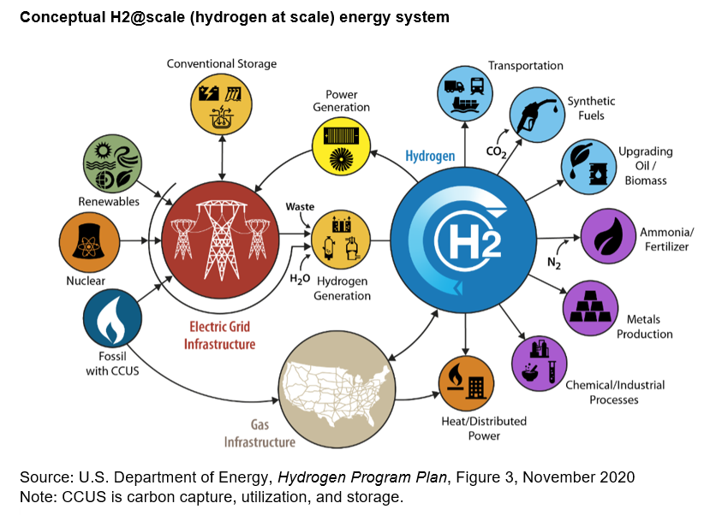

U.S. Energy Information Administration. <https://www.eia.gov/energyexplained/hydrogen/production-of-hydrogen.php>

**Hydrogen Combustion in Power Plants**

Burning hydrogen is an option for carbon-free power at times when the sun isn’t shining, the wind is slack, and your batteries have discharged their stores. Hydrogen combustion can be achieved by mixing small amounts into the fossil-gas supply at existing plants, which produces very marginal greenhouse gas reductions at considerable cost. With the cost of hydrogen being really high in 2024, hydrogen could be used in a peaking application where the demand and price for power is really high (Spector, 2024).

**Options for Carbon-free Power Plants**

1. Long-duration batteries
2. Advanced geothermal
3. Gas plants with effective carbon capture
4. Small modular nuclear
5. Big old-school nuclear
6. Clean hydrogen combustion, tucked away in salt caverns for the big peak hours of the year when other clean power plants can’t produce enough.
7. 5% hydrogen blend

The theoretical capacity to one day burn hydrogen is one way to manufacture gas turbines. Today’s fleet of gas turbines in the U.S. can burn hydrogen, but both practical and legal reasons limit the amount. GE and Siemens Energy have both pledged to make all their new turbines capable of burning 100% hydrogen by 2030. Hydrogen is much less energy-dense than natural gas methane, so you need to burn more of it to get the same amount of energy output. Consequently, bigger valves, pipes and nozzles are needed to deliver higher volumes of hydrogen gas. Hydrogen also burns hotter than methane, which produces more NOx, a regulated air pollutant that needs to be mitigated. Technical and regulatory constraints currently prevent large power plants from burning more than a low-level blend of hydrogen with natural gas. However, the turbine industry is working to make standard turbine models ready to support higher levels of hydrogen. Finding hydrogen supply is the next major barrier to hydrogen combustion in power plants. For cost comparisons, in 2024 renewable hydrogen selling for $3 to $4 per kilogram equates to about $20 per million Btu. Natural gas goes for around $3 per MMBtu in 2024 (Spector, 2024).

Spector, Julian (2024) Canary Media. Should power plants burn clean hydrogen to make electricity? <https://www.canarymedia.com/articles/hydrogen/should-power-plants-burn-clean-hydrogen-to-make-electricity>

U.S. Energy Information Administration. <https://www.eia.gov/energyexplained/hydrogen/production-of-hydrogen.php>

Ross, Laura (2024) Thomas Net. Hydrogen Cars Pros and Cons. <https://www.thomasnet.com/insights/hydrogen-cars-pros-and-cons/>

U Buffalo (2024) Sci Tech Daily. Toward a Green Future: Scientists Identify Key Ingredient for Affordable Fuel Cell Catalysts. <https://scitechdaily.com/toward-a-green-future-scientists-identify-key-ingredient-for-affordable-fuel-cell-catalysts/>

U.S. Department of Energy, Alternative Fuels Data Center, <https://afdc.energy.gov/vehicles/how-do-fuel-cell-electric-cars-work>

Barnard, Michael (2024) Clean Technica. Hydrogen Fleets Are Much More Expensive To Maintain Than Battery & Even Diesel. <https://cleantechnica.com/2024/01/26/hydrogen-fleets-are-much-more-expensive-to-maintain-than-battery-even-diesel/>

GENH2, LIQUID HYDROGEN IS THE KEY TO FUEL CELL EFFICIENCY, <https://genh2hydrogen.com/blog/liquid-hydrogen-the-key-to-fuel-cell/#:~:text=Fuel%20cell%20systems%20are%20a,fuel%20cell%20is%20higher%20purity>

The Moment KB (2024) The Moment. New hydrogen fuel cell heat engine: unprecedented power and a detail that no one understands. <https://www.riazor.org/news/hydrogen-fuel-engine/173/>

NREL, National Renewable Energy Laboratory, <https://www.nrel.gov/hydrogen/fuel-cells.html>

Bellini, Emiliano (2024A) PV Magazine. Korean researchers build 8 kW solid oxide electrolysis cell that can produce 5.7 kg of hydrogen per day. <https://www.pv-magazine.com/2024/04/26/korean-researchers-build-8-kw-solid-oxide-electrolysis-cell-that-can-produce-5-7-kg-of-hydrogen-per-day/>

McFadden, Christopher (2024) Interesting Engineering. Scientists unlock key to cheap hydrogen fuel with 95% less iridium. <https://interestingengineering.com/energy/cheap-hydrogen-fuel-with-less-iridium>

US Department of Energy, Office of Energy Efficiency and Renewable Energy, Hydrogen and Fuel Cells Technologies Office, Hydrogen Storage. <https://www.energy.gov/eere/fuelcells/hydrogen-storage#:~:text=Hydrogen%20can%20be%20stored%20physically,pressure%20is%20%E2%88%92252.8%C2%B0C>

UT Austin (2024) Sci Tech Daily. Turning Rocks Into Renewable Energy With Hydrogen Breakthrough. <https://scitechdaily.com/turning-rocks-into-renewable-energy-with-hydrogen-breakthrough/>

U.S. Department of Energy, Office of Energy Efficiency and Renewable Energy, Hydrogen and Fuel Cell Technologies Office, Fuel Cell Basics, <https://www.energy.gov/eere/fuelcells/fuel-cell-basics#:~:text=Polymer%20electrolyte%20membrane%20(PEM)%20fuel,to%20meet%20shifting%20power%20demands>

Westtenhaus, Brain (2024C) Oil Price. Tokyo Tech Scientists Crack Hydrogen Storage Conundrum. <https://oilprice.com/Energy/Energy-General/Tokyo-Tech-Scientists-Crack-Hydrogen-Storage-Conundrum.html>

U Sydney (2024) Phys Org. Researchers closer to understanding hydrogen's greatest challenge: Embrittlement. <https://phys.org/news/2024-02-closer-hydrogen-greatest-embrittlement.html>

U.S. Department of Energy, Office of Energy Efficiency and Renewable Energy, Hydrogen and Fuel Cell Technologies Office, Hydrogen Fuel Basics, <https://www.energy.gov/eere/fuelcells/hydrogen-fuel-basics>

Olano, Maria (2024) Canary Media. Chart: Which countries are leading the green hydrogen race? <https://www.canarymedia.com/articles/hydrogen/chart-which-countries-are-leading-the-green-hydrogen-race>

Service, Robert (2024) Science. New type of water splitter could make green hydrogen cheaper. <https://www.science.org/content/article/new-type-water-splitter-could-make-green-hydrogen-cheaper>

Technion-Israel Institute of Technology (2024) Sci Tech Daily. Electrolysis Reimagined: Turning Renewable Energy Into Green Hydrogen. <https://scitechdaily.com/electrolysis-reimagined-turning-renewable-energy-into-green-hydrogen/>

Istituto Italiano di Tecnologia (2024) Sci Tech Daily. Italian Scientists Develop New System for Producing Green Hydrogen Cheaply and Efficiently. <https://scitechdaily.com/italian-scientists-develop-new-system-for-producing-green-hydrogen-cheaply-and-efficiently/>

Westenhaus, Brian (2024D) Oil Price. New Electrode Revolutionizes Hydrogen Production from Seawater. <https://oilprice.com/Energy/Energy-General/New-Electrode-Revolutionizes-Hydrogen-Production-from-Seawater.html>

McClure, Paul (2024) New Atlas. Seawater plant will capture 10 tons of CO2 and make 300 kg of H2 per day. <https://newatlas.com/energy/equatic-ocean-based-co2-removal-plant-singapore/>

Matalucci, Sergio (2024A) PV Magazine, The Hydrogen Stream: Optimal PV-to-electrolyzer ratio in Italy is 1.8-2.1,

<https://www.pv-magazine.com/2024/12/10/the-hydrogen-stream-optimal-pv-to-electrolyzer-ratio-in-italy-is-1-8-2-1/?utm_source=Global+%7C+Newsletter&utm_campaign=0900ac023d-dailynl_gl&utm_medium=email&utm_term=0_6916ce32b6-0900ac023d-160603208>

Ademollo, A., Calabrese, M., and Carcasci, C. (2025) An up-to-date perspective of levelized cost of hydrogen for PV-based grid-connected power-to-hydrogen plants across all Italy, Applied Energy, Volume 379, 124958, <https://doi.org/10.1016/j.apenergy.2024.124958>.

Hydrogen storage may offer more supply-side flexibility than batteries, according to Italian researchers. According to Ademollo et al. (2025), the optimal PV-to-electrolyzer ratio ranges from 1.8 in southern Italy to 2.1 in the north. Another interesting fact from their study is that grid dependence increases by 60% when considering the aging of PV systems, electrolyzers, and batteries, raising the levelized cost of hydrogen (LCOH) by 7%. The researchers used hourly data and the Multi Energy System Simulator (MESS) for optimal sizing, aiming to minimize LCOH while complying with green hydrogen incentives, and they concluded that stricter temporal requirements for certification raise green hydrogen by 22% while only slightly increasing LCOH (Ademollo et al., 2025; Matalucci, 2024A).

Enkhardt, Sandra (2024) PV Magazine, Fraunhofer IEG building new sector coupling test facility to increase electrolyzer, heat pump efficiencies,

<https://www.pv-magazine.com/2024/07/26/fraunhofer-ieg-building-new-sector-coupling-test-facility-to-increase-electrolyzer-heat-pump-efficiencies/?utm_source=Global+%7C+Newsletter&utm_campaign=7005630397-dailynl_gl&utm_medium=email&utm_term=0_6916ce32b6-7005630397-160603208>

The aim is to develop cost-effective electrolyzers for the production of green hydrogen, in which the by-products oxygen and heat can be optimally used. PEM stands for proton exchange membranes or polymer electrolyte membranes. PEM electrolyzers have good partial load capacity and high efficiencies. They are also considered insensitive to load changes. They are therefore well suited for the production of green hydrogen from volatile renewable sources such as photovoltaics and wind power.

Matalucci, Sergio (2024B) PV Magazine, The Hydrogen Stream: Equatic making anodes to produce H2 from seawater,

<https://www.pv-magazine.com/2024/09/20/the-hydrogen-stream-equatic-making-anodes-to-produce-h2-from-seawater/?utm_source=Global+%7C+Newsletter&utm_campaign=2e36662961-dailynl_gl&utm_medium=email&utm_term=0_6916ce32b6-2e36662961-160603208>

To produce hydrogen, Equatic has developed electrodes, oxygen-selective anodes, with finely architectured catalysts that do not react with the salt in seawater, which means that the chlorine in the salt remains stable and safe, while hydrogen gas is generated and captured to be used as clean energy. This new technology enhances the lifespan of anodes and improves their recyclability, the anodes require only a new coating of catalysts made from inexpensive, abundant elements every three years, allowing them to be restored to like-new condition and extend their usability for decades. The proprietary electrolyzer separates seawater into two liquids – an acid and a base stream – and two gases, hydrogen and oxygen. The acid stream is neutralized with crushed rock to prevent ocean acidification, while the base stream interacts with the atmosphere to capture carbon dioxide from the air. The company said its clean hydrogen production will help reduce carbon removal costs to below $100 per metric ton by 2030 (Matalucci, 2024B).

Kahana, Lior (2024A) PV Magazine, New method to calculate levelized cost of hydrogen,

<https://www.pv-magazine.com/2024/08/09/new-method-to-calculate-levelized-cost-of-hydrogen/?utm_source=Global+%7C+Newsletter&utm_campaign=410eab76aa-dailynl_gl&utm_medium=email&utm_term=0_6916ce32b6-410eab76aa-160603208>

Rezaei, M., Akimov, A., and Gray, E.M. (2025) Levelised cost of dynamic green hydrogen production: A case study for Australia's hydrogen hubs, Applied Energy, Volume 370, 123645, <https://doi.org/10.1016/j.apenergy.2024.123645>.

One method to calculate the levelized cost of hydrogen is to incorporate overload capacity and power-dependent efficiency of the electrolyser in a novel techno-economic model, which can be used to ascertain the impact of internalizing environmental costs on the cost-competitiveness of green hydrogen compared to grey hydrogen. The Australian researchers used this method because failure to include the variability in electrolyzer efficiency, as is often observed in green hydrogen studies, results in a substantial overestimation of hydrogen production costs. This new methodology considers the electrolyzer's input power, the occasional electrolyzer operation under overload conditions, and the actual operating characteristics based on the electrolyzer type. It includes the electrolyzer system's calendar life and the stacks' usage life in operational hours, as well as the learning rate to predict the routine end-of-life electrolyzer stack replacement cost, and includes economies of scale and the cost of desalinated water and required land (Rezaei et al., 2025; Kahana, 2024A).

Matalucci, Sergio (2024C) PV Magazine, The Hydrogen Stream: BNEF forecasts sharper green H2 price drop by 2050,

<https://www.pv-magazine.com/2024/12/27/the-hydrogen-stream-bnef-forecasts-sharper-green-h2-price-drop-by-2050/?utm_source=Global+%7C+Newsletter&utm_campaign=3c5e3c9128-dailynl_gl&utm_medium=email&utm_term=0_6916ce32b6-3c5e3c9128-160603208>

BloombergNEF has analyzes the projected cost of hydrogen in 2050, and has determined that due to higher-than-expected future costs for electrolyzers, that green hydrogen will fall from its current price range of $3.74/kg to $11.70/kg to between $1.60/kg and $5.09/kg by 2050. BNEF projects in 2024 that green hydrogen will remain far more expensive than earlier projections for decades, and that only China and India are likely to see green hydrogen become cost-competitive with gray hydrogen by 2040 (Matalucci, 2024C).

Bellini, Emiliano (2024A) PV Magazine, How to combine off-grid agrivoltaics with large-scale hydrogen production,

<https://www.pv-magazine.com/2024/12/05/how-to-combine-off-grid-agrivoltaics-with-large-scale-hydrogen-production/?utm_source=Global+%7C+Newsletter&utm_campaign=f1f040ae5a-dailynl_gl&utm_medium=email&utm_term=0_6916ce32b6-f1f040ae5a-160603208>

Baker, J., Guler, M., Medonna, A., Li, Z., and Ghosh, A. (2025) Analysis of large-scale (1GW) off-grid agrivoltaic solar farm for hydrogen-powered fuel cell electric vehicle (HFCEV) charging station, Energy Conversion and Management, Volume 323, Part A, 119184, <https://doi.org/10.1016/j.enconman.2024.119184>.

U.K. scientists have simulated how a 1 GW off-grid agrivoltaic facility may be used to fuel hydrogen fuel electric cell vehicles across Australia, California, China, Nigeria, and Spain. Their techno-economic analysis showed that the proposed combination of producing hydrogen with agrivoltaics could provide a levelized cost of hydrogen ranging from $3.90/kg to $8.13/kg (Baker et al., 2025; Bellini, 2024A).

Matalucci, Sergio (2024D) PV Magazine, The Hydrogen Stream: PV-hydrogen polygeneration system for humid climates,

<https://www.pv-magazine.com/2024/12/31/the-hydrogen-stream-pv-hydrogen-polygeneration-system-for-humid-climates/?utm_source=Global+%7C+Newsletter&utm_campaign=dc2482b916-dailynl_gl&utm_medium=email&utm_term=0_6916ce32b6-dc2482b916-160603208>

Sezer, N., Bayhan, S., Che Wanik, M.Z., and Ozdemir, M.B. (2025) Atmospheric polygeneration with hydrogen storage, International Journal of Hydrogen Energy, <https://doi.org/10.1016/j.ijhydene.2024.12.290>.

An international research team has proposed an atmospheric polygeneration system for hot, humid climates that integrates solar photovoltaics, vapor compression refrigeration, electrodeionization, PEM water electrolysis, hydrogen storage, and fuel cells. The system generates water, cooling, and hydrogen, producing 5 kW of electricity, 8.2 tons of cooling, 28.36 L/h of atmospheric water, and 17 kg of hydrogen during daytime operations, and at night, the system uses stored hydrogen to maintain water and cooling production (Sezer et al., 2025; Matalucci, 2024D).

Mataluccid, Sergio (2024E) PV Magazine, The Hydrogen Stream: new model and repository for accurate pre-feasibility studies,

<https://www.pv-magazine.com/2024/11/29/the-hydrogen-stream-h2-costs-often-underestimated-in-prefeasibility-studies/?utm_source=Global+%7C+Newsletter&utm_campaign=65618d02c0-dailynl_gl&utm_medium=email&utm_term=0_6916ce32b6-65618d02c0-160603208>

Campion, N., Montanari, G., Guzzini, A., et al. (2025) Green hydrogen techno-economic assessments from simulated and measured solar photovoltaic power profiles, Renewable and Sustainable Energy Reviews, Volume 209, 115044, <https://doi.org/10.1016/j.rser.2024.115044>.

Hydrogen production costs from solar PV power are often underestimated in prefeasibility studies, as European researchers have concluded that relying on simulated data instead of measured data can underestimate hydrogen production costs by 36% for users requiring a constant supply, with average underestimations of around 20% being most severe in cloudy climates, because of difficulties estimating solar PV power production when there is cloud cover, and due to the lower time resolution of satellite reanalysis dataset but also due to inherent errors coming from inaccurate cloud modeling in these data sets. Campion et al. (2025) developed an optimization techno-economic model that estimates e-fuel production costs by factoring in optimal investment and hourly system operations, in an effort to enhance green hydrogen assessments by addressing discrepancies between simulated and measured solar power profiles. The optimization techno-economic model in addition to open-source collaborative repositories to share measured renewable power profiles and provide tools for time series analysis and green hydrogen techno-economic assessments will enhance prefeasibility studies and location screening (Campion et al., 2025; Matalucci, 2024E).

Bellini, Emiliano (2024B) PV Magazine, Italian startup offers green hydrogen generation, storage system for homes,

<https://www.pv-magazine-india.com/2024/11/08/italian-startup-offers-green-hydrogen-generation-storage-system-for-homes/?utm_source=Global+%7C+Newsletter&utm_campaign=510e99f867-dailynl_gl&utm_medium=email&utm_term=0_6916ce32b6-510e99f867-160603208>

Hydrogen production and storage systems can be used for long-term storage of surplus residential and commercial solar power, in a system that includes an indoor main unit with an electrolyzer and fuel cell, as well as an indoor/outdoor storage unit with 3 kg of hydrogen capacity and 100 kWh of energy capacity. This Italian system uses excess solar power from rooftop PV installations to produce hydrogen via an electrolyzer, with the hydrogen stored into a storage unit consisting of a metal hydrik tank. The hydrogen can be converted back into electricity via a fuel cell or supplied to the user in gaseous form for different purposes when the household needs more power. The main unit hosts a DC/DC converter, a DC/AC inverter, a water demineralizer, an electrolyzer, a hydrogen dryer, a buffer lithium battery, and a fuel cell. According to the company, the electrolyzer uses anion exchange membrane (AEM) technology, while the fuel cell utilizes polymer electrolyte membrane (PEM) technology (Bellini, 2024B).

Kahana, Lior (2024B) PV Magazine, Panasonic powers UK factory with solar-driven hydrogen fuel cell generators,

<https://www.pv-magazine.com/2024/12/04/panasonic-powers-uk-factory-with-solar-driven-hydrogen-fuel-cell-generators/?utm_source=Global+%7C+Newsletter&utm_campaign=84fee40efa-dailynl_gl&utm_medium=email&utm_term=0_6916ce32b6-84fee40efa-160603208>

One hydrogen for factories, developed by Panasonic for a U.K. factory, integrates hydrogen fuel cell generators, PV generators, and storage batteries, and an energy management system (EMS) to monitor electricity demand and weather fluctuations. The hydrogen fuel cell generators use the heat generated during electricity production to provide heating and hot water, aiming for an energy efficiency of 95% (Kahana, 2024B).

Kahana, Lior (2024C) PV Magazine, Hydrogen detection system for safety, quality control,

<https://www.pv-magazine.com/2024/11/07/hydrogen-detection-system-for-safety-quality-control/?utm_source=Global+%7C+Newsletter&utm_campaign=21c7ddc8fd-dailynl_gl&utm_medium=email&utm_term=0_6916ce32b6-21c7ddc8fd-160603208>

Xiafukaiti, A., Lagrosas, N., Ogita, M. et al. (2025) Optimization for hydrogen gas quantitative measurement using tunable diode laser absorption spectroscopy, Optics & Laser Technology, Volume 180, 111587, <https://doi.org/10.1016/j.optlastec.2024.111587>.

Tunable diode laser absorption spectroscopy (TDLAS) has traditionally been employed for gas analysis, but has had difficulties quantifying low concentrations of hydrogen due to its lower absorption compared to other gases in the near-infrared (NIR) region. Japanese researchers have developed a new TDLAS system for hydrogen measuring at different pressures and in a high-pressure gas cell, which could be used for measures including detecting hydrogen leakages in fuel cell vehicles. In TDLAS methods, a laser is passed through a Herriott multipass cell (HMPC) containing the target gas. The laser's wavelength is modulated around the gas's target absorption line to remove any environmental noise, while the cell pressure can be tuned to influence the absorption line (Xiafukaiti et al., 2025; Kahana, 2024C).

Matalucci, Sergio (2024F) PV Magazine, The Hydrogen Stream: UK scientists call for strict rules for H2 leakage,

<https://www.pv-magazine-india.com/2024/11/27/the-hydrogen-stream-uk-scientists-call-for-strict-rules-for-h2-leakage/?utm_source=Global+%7C+Newsletter&utm_campaign=ae0a1301e0-dailynl_gl&utm_medium=email&utm_term=0_6916ce32b6-ae0a1301e0-160603208>

Addressing hydrogen leakage across the supply chain is crucial to making hydrogen a sustainable energy vector and enhancing its effectiveness as a sustainable energy solution. Methods to reduce leakage of hydrogen include use of containment materials and real-time monitoring systems, in addition to the implementation of stringent regulatory standards and economic incentives for low-leakage technologies across production, storage, and distribution. The Oxford Institute for Energy Studies (OIES) said that, “As hydrogen reacts with hydroxyl radicals, it extends the atmospheric lifetime of methane, a potent greenhouse gas. Additionally, hydrogen leakage contributes to changes in tropospheric and stratospheric ozone, with possible repercussions for both human health and ecosystem stability,” said the energy research institute. “These indirect effects underline the need for comprehensive leakage mitigation to preserve hydrogen’s environmental benefits” (Matalucci, 2024F).

In order to create an effective hydrogen network, existing gas pipelines must be repurposed and new hydrogen lines constructed, connecting production, import sites, and industrial hubs.

Matalucci, Sergio (2024G) PV Magazine, The Hydrogen Stream: US government offers $62 million for hydrogen tech,

<https://www.pv-magazine.com/2024/09/03/the-hydrogen-stream-us-government-offers-62-million-for-hydrogen-tech/?utm_source=Global+%7C+Newsletter&utm_campaign=c814edb6a0-dailynl_gl&utm_medium=email&utm_term=0_6916ce32b6-c814edb6a0-160603208>

Guzzini, A., Pellegrini, M., Saccani, C. et al. (2024) Hydrogen in natural gas grids: prospects and recommendations about gas flow meters, International Journal of Hydrogen Energy, Volume 86, Pages 343-362, <https://doi.org/10.1016/j.ijhydene.2024.08.344>.

Guzzini et al. (2024) discuss how hydrogen injection into existing natural gas infrastructure could affect the 115 million gas meters in the EU distribution network. Critical to this debate is the impact of hydrogen and natural gas (H2NG) mixtures on the performance of state-of-the-art fiscal measuring devices, which are essential for accurate billing. Identifying and addressing any potential degradation in their metrological performance due to H2NG is critical for decision-making (Guzzini et al., 2024; Matalucci, 2024G).

Matalucci, Sergio (2024H) PV Magazine, The Hydrogen Stream: MIT shows hydrogen can be made from aluminum, caffeine,

<https://www.pv-magazine.com/2024/08/16/the-hydrogen-stream-mit-shows-hydrogen-can-be-made-from-aluminum-caffeine/?utm_source=Global+%7C+Newsletter&utm_campaign=1a6ba955b3-dailynl_gl&utm_medium=email&utm_term=0_6916ce32b6-1a6ba955b3-160603208>

Kombargi, A., Ellis, E., Godart, P., and Hart, D.P. (2024) Enhanced recovery of activation metals for accelerated hydrogen generation from aluminum and seawater, Cell Reports Physical Science, Volume 5, Issue 8, 102121, <https://doi.org/10.1016/j.xcrp.2024.102121>.

Can hydrogen be produced from recycled aluminum cans in seawater by combining them with gallium-indium and caffeine? U.S. researchers think so, and they have developed a process to recycle gallium and indium during the aluminum-water reaction (AWR). Apparently, adding a low concentration of imidazole (0.02 M) to seawater speeds up the AWR reaction, in 10 minutes, producing hydrogen at a higher rate and yield by enabling the retrieval and reuse of over 90% of the relatively costly gallium-indium eutectic and producing 99% of the anticipated hydrogen output based on the aluminum’s mass. Without the added stimulant imidazole, the reaction would take two hours. The researchers think that they can develop a small reactor for use on marine vessels, where aluminum pellets pre-treated with the rare-metal alloy would react with filtered seawater and coffee grounds to produce hydrogen to power the ship (Kombargi et al., (2024; Matalucci, 2024H).

Matalucci, Sergio (2024I) PV Magazine, The Hydrogen Stream: Clean ammonia supplies set to soar, says BNEF,

<https://www.pv-magazine.com/2024/08/09/the-hydrogen-stream-clean-ammonia-supplies-set-to-soar-says-bnef/?utm_source=Global+%7C+Newsletter&utm_campaign=410eab76aa-dailynl_gl&utm_medium=email&utm_term=0_6916ce32b6-410eab76aa-160603208>

According to BloombergNEF, clean ammonia supplies could grow by 30 times this decade to 32 million tons of capacity by 2030, and clean ammonia could account for 13% of the global ammonia supply by 2030 (Matalucci, 2024I).

Molina, Pilar Sánchez (2024) PV Magazine, Spanish researchers develop materials to obtain hydrogen from water via microwave radiation,

<https://www.pv-magazine.com/2024/07/26/spanish-researchers-develop-materials-to-obtain-hydrogen-from-water-via-microwave-radiation/?utm_source=Global+%7C+Newsletter&utm_campaign=7005630397-dailynl_gl&utm_medium=email&utm_term=0_6916ce32b6-7005630397-160603208>

Research areas in hydrogen production technologies include steam electrolysis and solar-powered thermochemical cycles using reducible solid oxides, however, due to high operating temperatures they face challenges to commercialization.

Spanish researchers have developed a process that allows green hydrogen to be obtained from renewable electrical energy using materials that have redox properties and that respond to microwave radiation. In green hydrogen production through redox cycles, the material takes up and releases oxygen from water, and stably separates it from oxygen. In a redox chemical cycle, electrons are transferred between atoms of different elements in the presence of the induced electromagnetic field, which allows the electrification of the process. This method of a microwave-driven redox chemical loop enables direct, contactless electrification of the process, while reducing operating temperature and complexity. Microwaves can effectively drive water reduction/splitting cycles using Gd-doped ceria at low temperatures (<250 C), but the doped ceria needs to be screened to enhance microwave hydrogen production (Molina, 2024).

1. U.S. Department of Energy, Office of Energy Efficiency and Renewable Energy, Hydrogen and Fuel Cell Technologies Office, Hydrogen Fuel Basics, <https://www.energy.gov/eere/fuelcells/hydrogen-fuel-basics>
2. U.S. Department of Energy, Office of Energy Efficiency and Renewable Energy, Hydrogen and Fuel Cell Technologies Office, Fuel Cell Basics, <https://www.energy.gov/eere/fuelcells/fuel-cell-basics#:~:text=Polymer%20electrolyte%20membrane%20(PEM)%20fuel,to%20meet%20shifting%20power%20demands>.
3. NREL, National Renewable Energy Laboratory, <https://www.nrel.gov/hydrogen/fuel-cells.html>
4. U.S. Department of Energy, Alternative Fuels Data Center, https://afdc.energy.gov/vehicles/how-do-fuel-cell-electric-cars-work
5. GENH2, LIQUID HYDROGEN IS THE KEY TO FUEL CELL EFFICIENCY, <https://genh2hydrogen.com/blog/liquid-hydrogen-the-key-to-fuel-cell/#:~:text=Fuel%20cell%20systems%20are%20a,fuel%20cell%20is%20higher%20purity>.