**2025 PhD Application, Electrical Engineering**

Kevin Sleem, Fayetteville, North Carolina

NC State: Deadline, January 9

UNLV: Deadline, February 1

FAU: Deadline, February 1

North Dakota State: Online Bachelors Degree

Hello

I am going to take online undergraduate electrical engineering classes with North Dakota State University, but I am also eligible to apprentice as accountant and electrician.

The reason I want to complete engineering grad school instead of an economics PhD program is I think I would learn more in engineering. A lot of economics you can read on your own on the internet, though I do want to become an expert in taxes.

The reason I am not transferring to NC State to complete the undergraduate classes is because of money. I want to get off welfare and government housing. I recently passed the CPA Exam on the second attempt, and need 1 year of experience for the CPA License, which I could work part time while taking classes.

I understand that undergraduate classes are typically not covered by PhD programs, but I have made improvements to my application, including a research proposal and job market paper, and wanted to gauge interest. I understand that I may need to work for a few years first then save money to enroll in the undergraduate classes.

I am only applying to NC State and UNLV. My FAU PhD references were John MacArthur and John Adams from UNF. When I asked Dr. MacArthur for a reference to NC State, he asked me, why do I think I could complete a PhD if I failed the first time? Also, I refused a conditional offer from the Imperial College London in 2008 for finance when they asked me to resend references for financial aid. I have asked a friend from the Mormon Church for a reference, and an employee at my father’s business. I have sued FAU over references. So, I think I have jumped through enough hoops for references, when what is more important is prerequisite classes. My favorite professors at FTCC are Dr. Lonnie Mott, who I had for 2 semesters in physics, and Professor Jonathon Griffin, who I had for 3 semesters of calculus. The University of Cape Town does not require references, only communication with a professor.

Duke has a notice on the PhD application that they do not accept second PhDs. I think that is generally a good idea. I was in 1 semester of a finance PhD program at FAU, before I was fired and dismissed, 2 separate things, for missing classes in November in a math class I was failing. So I have written economics theses on global stock markets and health insurance, 4 papers published to SSRN, but no journal publications and hence no conference presentations, though I think I have 1 paper in me. I want to attempt a natural science PhD before I fall back on a social science.

I want to learn more about power systems engineering and renewable energy sources and hydrogen cars and sodium batteries, including working at nuclear power plants. Maybe even take a couple physics classes in electricity and magnetism, though I wonder how high I can go in math. I got As in calculus, but I know it gets harder. I probably would have had a 25 in physics if we didn’t have Chegg.

I have previously applied to NC State and UNLV for the PhD program in electrical engineering, and wanted to update my application history. I have completed prerequisites at FTCC, including 3 semesters of calculus, linear algebra, differential equations, 2 semesters of physics, and 1 semester of chemistry. However, I may still need 2 years of undergraduate classes in electrical engineering.

***FAU Finance PhD Programme, Thesis Only***

I have published 4 papers from my doctoral thesis in finance to SSRN, and have written job market papers in capacity markets, solar energy, and electric field. The problem at FAU was I spent my first semester writing my dissertation proposal, and blew off Statistics, which I was in danger of failing before I was fired via email 2 weeks before finals by Jeff Madura, for missing the last 2 classes in November. I had a doctor’s note from the student clinic for heartburn which I showed to Gleason, but did not tell DInev I was missing class because I was sick. I could have approached the situation differently, and still taken finals, and the reason Madura and I were not communicating was because I arrived early and finished my teaching notes for Finance 101 before the semester, and then it was radio silence until December 2, 2008. I also strongly asked to take 4 classes the first semester, so I could finish in 3 years, like England. I was conditionally admitted to the Imperial College London who asked me to resubmit references for financial aid, which I refused. Jeff Madura has 100 publications; I’m looking for my first.

***College Progression***

I have 5 degrees and 1 incomplete degree, and have also been suspended from school or housing at 3 schools: UNC, FAU, Durham Tech. I have been readmitted to all 3 schools. I regret tearing down the banners at UNLV and Duke, there was no need for that. I regret my DUI. And I regret some of the language I used at UNC that compromised the investigation. College is a journey, and I have had a few bumps and accomplishments. I am glad I was not admitted to Purdue Global Law School. I would have been overwhelmed being enrolled in 2 schools at once.

What I have learned about writing dissertations is that you start early, and get a big data collection so the experiment stands out over your writing. Also, go over your discussion boards a few times. I was cited once for plagiarism on a discussion board at Post Online.

Kevin Sleem

UNC BA 2005, US Navy 2005-2007, UNF MBA 2008

Describe why you would succeed in a PhD program. What life experiences will you draw upon that show you can persist and succeed finishing a major goal like a PhD?

I think I would succeed in a PhD program because I know that the most important thing is writing the dissertation and completing the experiment and publishing a paper. Classes are good, especially in math and science, but it is important to get a jump on the experiment. I have started on my electrical engineering thesis, which includes capacity markets, solar energy, and salt batteries. I hope to get a paper in all 3 subjects. I would succeed in a PhD program because I show up for work, only miss classes when I am stressed out at the end of the semester sometimes, and think that 50k is an appropriate salary. I earned 21k a year at FAU, and I think that Harvard recently awarded all PhD students 50k stipends. Also, Harvard and Yale have unionized their graduate students, so that is a thing now.

As for life experiences, I call upon my first PhD program at FAU. I finished the experiment and wrote the dissertation from my parents’ house in Myrtle Beach. For economics, all you need is a computer and internet to write a book. My time at FTCC was enjoyable, and really I learned the most at FTCC than all my other colleges. I took a lot of science and math prerequisites at FTCC, and financed myself with student loans and welfare. I want a salary that I don’t need to worry about welfare and student loans. Harvard published an article that encouraged their graduate students to get on food stamps, but this might not be accurate, because there is a financial limit for food stamps, about 1200 dollars per month. I also understand that a PhD program might be the best financial fit for me, and if not, I will work as an accountant first then maybe computer programmer. Computer programming has gotten easier with AI.

Why do want to come to NCSU?

I want to go to NC State because I have North Carolina residency, and I might even be able to transfer government housing. I would keep government housing, but I want to get off social security and welfare. I would like to go to UNLV because they have a lot of music in Las Vegas. I would like to go to either UCT or Melbourne for international schools, but it is hard to move overseas. I have tried several times, and I never had enough money. Now, I have a house in Fayetteville, NC, where I store my books and papers. I want to go to a school that has a power systems research department, like renewable energy power plants or electric cars.

What do you want to work on and with whom?

**NC State Professors**

1. Iqbal Husain- The primary application of Dr. Husain’s work is in the transportation, automotive, and aerospace industries.
2. Srdjan Lukic- [Demonstration of Portable Solar Carport with Integrated EV Charger](https://ece.ncsu.edu/grant/2585-demonstration-of-portable-solar-carport-with-integrated-ev-charger/)
3. N. Moorthy Muthukrishnan- He coordinated the design and installation of 100 KWp solar PV power plant at GNITS.
4. Zeljko Pantic- Dr. Pantic’s primary areas of interests are electrified transportation, personal mobility, charging systems for electric vehicles.
5. Wenyuan Tang- His research interests include electricity markets, data analytics and machine learning, and optimization for power systems.

**UNLV Professors**

1. Yahia Baghzouz- Electrical power conversion, renewable source grid interconnection, power efficiency, and fuel cell integration.
2. Brendan Morris- Computer Vision, Intelligent Systems, Pattern Recognition, Machine Learning, Intelligent Transportation Systems, Intelligent Vehicles.
3. Ke-Xun (Kevin) Sun- Radiation hardened electronics, optics, and imaging systems. High Energy Density Physics diagnostics. Space flight instrumentation. Laser spectroscopy.

What are your biggest professional accomplishments to date? Please list peer reviewed publications here.

I published 4 papers from my finance thesis to SSRN. My Americas region paper was peer reviewed by the Review of Finance, and they provided helpful information. I am currently preparing a book proposal for the LSE Press. I think the experiment was good enough to publish, just maybe my technical writing is not tight enough, but maybe in a book. I have also written a paper on capacity markets in electrical engineering, which is also posted to my website. I have prepared a 50 page research prospectus on electrical engineering, and every week I review articles from PV Magazine on batteries, including lithium and sodium, and photovoltaic cells, including perovskite-silicon tandem cells. My goal is to publish a paper and teach a class one day. I recently passed the CPA Exam on the second attempt, and need 1 year experience under a CPA to qualify for CPA. I also hold the CIA and CMA accounting designations.

If we called your faculty mentors, what would they say your strengths are?

My faculty mentors would say my strengths are research over teaching, and perseverance. When I left FAU after 1 year due to debt, and started working, I continued to write my dissertation in Myrtle Beach and had it reviewed by the Review of Finance. I want to publish 5 books in the next 10 years, including on health insurance, monetary policy, global financial markets, capacity markets, sodium batteries and perovskite-silicon tandem cells, and free speech and graduate student unions on college campuses. I also prefer research over teaching, though I think I could teach a class in accounting.

**Research Proposal, Salt Batteries**

1. Perovskite-Silicon Tandem Panels
2. Diffuse Solar Radiation
3. Grid Enhancing Technologies
4. Salt Batteries for Energy Storage
5. Thermal Batteries
6. Electrostatic Capacitors
7. Long Duration Energy Storage Systems
8. Waste Disposal of Solar Panels
9. Biofuels
10. Domicile Wireless Electricity
11. Solar Energy for Desalination
12. Solar Energy for Water Electrolysis Hydrogen Production
13. Hydrogen Energy, Liquified and Gaseous

**Introduction**

There are four main types of low-carbon energy: solar, wind, hydro, and nuclear. These are our four options for producing electricity and power in the near future, when we run out of fossil fuels. Like China, I don’t believe that global warming and climate change is a big deal, and believe that the world temperature is rising and the arctic ice melting because of normal changes in the Earth’s climate as has happened over millions of years. That said, maybe we should not be pursuing the US Democratic Green New Deal so much, but we still need to be spending money researching new power technologies for the time when fossil fuels run out. Plus, it is healthier for the environment to use renewable energy sources or nuclear, it is just not healthy for the economy to rush to change so quickly before the technology is sound. In the US, government taxpayer subsidies constitute a portion of the costs of wind and solar technologies. This is not sustainable, using taxpayer subsidies to pay for electricity.

Two primary issues arise when discussing renewable or intermittent power sources. One, their construction and design, or how do we create renewable energy sources that can produce enough electricity to power our society. Related to this issue, is that of battery storage, and how do we create more powerful batteries to store the renewable energy from the sun and the wind to power our society at nite and on cloudy days? Two, is the pricing of renewable energy sources in the electricity market, as they have low marginal cost. This low marginal cost leads to what is known as the merit order effect of renewable energy sources, whereby conventional fossil fuel energy sources are priced lower. Renewable energy sources have low marginal costs because they have zero fuel costs and only price operations and maintenance into their marginal cost.

One area of research for solar panels is how do we increase the amount of diffuse solar radiation which is utilized by solar panels. Diffuse solar radiation is the solar radiation that is absorbed, scattered, and reflected by: air molecules, water vapor, clouds, dust, pollutants, forest fires, and volcanoes. The solar radiation that reaches the Earth's surface without being diffused is called direct beam solar radiation. The sum of the diffuse and direct solar radiation is called global solar radiation. Atmospheric conditions can reduce direct beam radiation by 10% on clear, dry days and by 100% during thick, cloudy days.[1]

Another area of research for low-carbon systems is the battery design that stores the intermittent energy sources before they are dispatched by power plants for energy to households and businesses. Related to battery design is how do we increase the life of the solar panels. A third area of research is in waste disposal of solar panels and dealing with the dangerous chemicals and minerals that are used to construct solar panels.

In order to move away from nuclear energy in the future, which still relies on rare earth elements to service energy demands, we have to figure out ways to still draw solar energy when the clouds are out, and ways to still harness wind energy when the wind is not blowing. Of these two options, becoming more efficient at utilizing diffuse solar radiation is more feasible than procuring wind when the wind is not blowing. Diffuse radiation is still there, unlike wind power, and we only need to figure out how to harness diffuse solar radiation.

What electricity experiments is your lab working on? I’ve just done 4 years of school at FTCC and Post Online, so I might even want to start with the salt battery experiment. I could start out in accounting as a junior accountant, and 50k would be a premium for the school.

**NC State Professors**

1. Iqbal Husain- The primary application of Dr. Husain’s work is in the transportation, automotive, and aerospace industries.
2. Srdjan Lukic- [Demonstration of Portable Solar Carport with Integrated EV Charger](https://ece.ncsu.edu/grant/2585-demonstration-of-portable-solar-carport-with-integrated-ev-charger/)
3. N. Moorthy Muthukrishnan- He coordinated the design and installation of 100 KWp solar PV power plant at GNITS.
4. Zeljko Pantic- Dr. Pantic’s primary areas of interests are electrified transportation, personal mobility, charging systems for electric vehicles.
5. Wenyuan Tang- His research interests include electricity markets, data analytics and machine learning, and optimization for power systems.

**UNLV Professors**

1. Yahia Baghzouz- Electrical power conversion, renewable source grid interconnection, power efficiency, and fuel cell integration.
2. Brendan Morris- Computer Vision, Intelligent Systems, Pattern Recognition, Machine Learning, Intelligent Transportation Systems, Intelligent Vehicles.
3. Ke-Xun (Kevin) Sun- Radiation hardened electronics, optics, and imaging systems. High Energy Density Physics diagnostics. Space flight instrumentation. Laser spectroscopy.

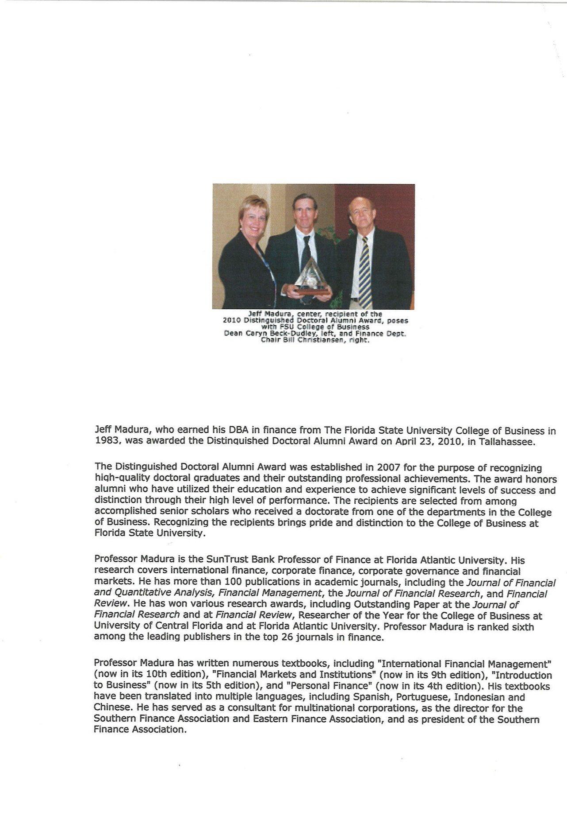

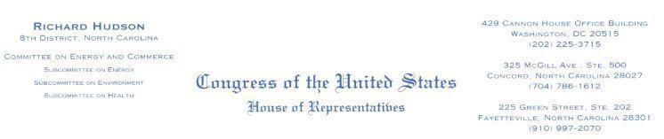

March 15, 2019

Mr. Kevin Sleem

3528 Turnberry Cir

Fayetteville, NC 28303-4664

Dear Mr. Sleem:

Thank you for contacting me regarding H.R. 227, the *Multinational Species Conservation Funds Reauthorization Act* . We completely agree on the need to protect and preserve our wildlife populations, particularly our endangered species. This is why I have supported numerous bills to protect our environment to ensure these species have thriving habitats.

As someone who loves and appreciates animals, I understand the importance of taking care of our most vulnerable wildlife. Additionally, as a lifelong outdoorsman who grew up right here in North Carolina, I know that caring for the environment is our duty and we must preserve our lands now and for future ge nerations. I believe it is extremely important to be good stewards of the environment and I am committed to fighting for the responsible management of our wildlife.

As you may know, H.R. 227 was introduced in the 115 th Congress by Representative Don Young (R-AK) on January 3, 2017. While this legislation has not been reintroduced in the 116th Congress, please know I will keep your thoughts in mind should I have the opportunity to consider this or similar legislation this Congress.

Again, thank you for taking the time to share your views. Your opinions are important, so please continue to write, call, or email me with any concerns you may have in the future. For more information on issues impacting North Carolinians, please visit our website at [http://hudson.house.gov](http://hudson.house.gov/) and sign up for our weekly newsletter.

Sincerely,



Richard Hudson

Member of Congress

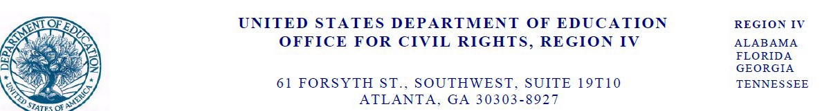

August 29, 2023

Via email only: sleemkevin@gmail.com

Mr. Kevin Sleem

3528 Turnberry Circle

Fayetteville, North Carolina 28303

Re: OCR Complaint #04-23-2022

Dear Mr. Sleem:

The U.S. Department of Education, Office for Civil Rights (OCR), has completed its investigation of your complaint against Florida Atlantic University (University) received on November 1, 2022 alleging discrimination based on national origin. Where appropriate this letter will refer to you as the Complainant.

OCR enforces Title VI of the Civil Rights Act of 1964 (Title VI), 42 U.S.C. §§ 2000d et seq., and its implementing regulation, 34 C.F.R. Part 100, which prohibit discrimination on the basis of race, color, or national origin by recipients of Federal financial assistance from the Department of Education. As a recipient of Federal financial assistance from the Department of Education, the University is subject to Title VI and to OCR’s jurisdiction.

You told OCR that you first enrolled in the PhD program at the University’s Business School in fall 2008. You stated that you were dismissed from the program in November 2008 because of your grade point average. You stated that you applied for enrollment at another university that requires references from previous instructors. You stated that you emailed a professor from the College of Business on September 29, 2022 to request a reference but did not receive a response. You alleged that you did not receive a response to your request because you have U.S. and Jamaican citizenship.

OCR enforces Title VI of the Civil Rights Act of 1964 (Title VI), 42 U.S.C. §§ 2000d et seq., and its implementing regulation, 34 C.F.R. Part 100, which prohibit discrimination on the basis of race, color, or national origin by recipients of Federal financial assistance from the Department of Education. As a recipient of Federal financial assistance from the Department of Education, the University is subject to Title VI and to OCR’s jurisdiction.

OCR investigated whether the University discriminated against the Complainant on the basis of national origin, in violation of Title VI and its implementing regulation at 34 C.F.R. §100.3.

OCR interviewed the Complainant and the Graduate College Program Assistant who was responsible for responding to email inquiries directed to the Graduate College. We also

Page 2 – Complaint #04-23-2022

reviewed documents provided by the Complainant and the University including email correspondence between the Complainant and the University employees.

**Legal standards**

The regulation implementing Title VI at 34 C.F.R. Section 100.3(a), (b)(1)(i)-(iii) and (2) provides that no person shall, on the ground of race, color or national origin, be excluded from participation in, be denied the benefits of, or be otherwise subjected to discrimination under any program to which the regulation applies. A recipient may not, on the ground of race, color or national origin, subject an individual to segregation or separate treatment in any matter related to his receipt of any service, financial aid, or other benefit under the program. Further, a recipient may not, on the ground of race, color, or national origin, deny an individual any service or other benefit, provide any service in a different manner from that provided to others, or subject an individual to segregation or separate treatment under the program.

When investigating an allegation of different treatment, OCR first determines whether there is sufficient evidence to establish an initial, or prima facie, case of discrimination. Specifically, OCR determines whether a school treated an individual less favorably than similarly situated individuals of a different national origin. If so, OCR then determines whether the school had a legitimate, nondiscriminatory reason for the different treatment. Finally, OCR determines whether the reason given by the school is a pretext, or excuse, for unlawful discrimination.

**Factual findings**

The Complainant, a former University student, was last enrolled at the University during the fall 2008 semester; during that term he was in the Ph.D. program in Finance in the University’s College of Business.

The Complainant told OCR that on September 29, 2022, he emailed a former professor in the College of Business to request that a professor provide a reference to North Carolina State University (School), but he did not receive a response. He asserted that he did not receive a response to his request because of his national origin.

According to the University’s Civil Rights Investigator, the University conducted an email search and did not locate the email that the Complainant described, but did locate a request for recommendations submitted by the School. The University’s Civil Rights Investigator reported that auto-generated emails were sent to the University Graduate College’s general email account, and not to a particular University employee’s email account. The request was addressed: “Dear [the former professor whom the Complainant identified].” The University advised OCR that the Complainant’s former professor retired and is no longer employed by the University.

On December 1, 2022, the Graduate College Program Assistant, who monitors the Graduate College’s email account, responded to the request, stating that “the Graduate College does not provide letters of recommendation as we do not know the student on a personal basis.”1 In an

1 The University received similar letters of recommendation requests on behalf of the Complainant from three universities.

Page 3 – Complaint #04-23-2022

interview with OCR, the Graduate College Program Assistant stated that she did not know the Complainant, and likewise was unaware of his national origin.

According to information provided by the University’s representative in response to OCR’s request for information, the University’s College of Business does not request or require that faculty write letters of recommendation on behalf of students and does not maintain records regarding issuance of such letters

**Analysis**

The evidence does not substantiate that the University received from the Complainant a request for a letter of recommendation from the professor to support the Complainant’s application to the School. When the University received a request from the School through the Graduate College email account, the Graduate College Program Assistant, who had no knowledge of the Complainant, replied that the College does not provide recommendations for students. In light of the representative’s statement that the University does not request or require that faculty provide letters of recommendation, the response to the School’s request does not indicate any different treatment of the Complainant. Nor is there other evidence of possible national origin-based different treatment since the Graduate College Program Assistant did not know the Complainant’s national origin. The evidence therefore does not support that the University discriminated against the Complainant on the basis of national origin, as alleged.

**Conclusion**

Accordingly, OCR found insufficient evidence to support a finding of a violation of the applicable regulation.

This concludes OCR’ s investigation of the complaint. This letter should not be interpreted to address the University’s compliance with any other regulatory provision or to address any issues other than those addressed in this letter.

This letter sets forth OCR’ s determination in an individual OCR case. This letter is not a formal statement of OCR policy and should not be relied upon, cited, or construed as such. OCR’ s formal policy statements are approved by a duly authorized OCR official and made available to the public. The Complainant may have a right to file a lawsuit in federal court whether or not OCR finds a violation.

Please be advised that the University must not harass, coerce, intimidate, discriminate, or otherwise retaliate against an individual because that individual asserts a right or privilege under a law enforced by OCR or files a complaint, testifies, assists, or participates in a proceeding under a law enforced by OCR. If this happens, the individual may file a retaliation complaint with OCR.

Under the Freedom of Information Act, it may be necessary to release this document and related correspondence and records upon request. If OCR receives such a request, we will seek to protect, to the extent provided by law, personally identifiable information, that, if released, could reasonably be expected to constitute an unwarranted invasion of personal privacy.

Page 4 – Complaint #04-23-2022

If you have any questions regarding this letter, please contact Philip Weltner, Senior Attorney, at (202) 987-1891or me, at (404) 974-9356.

Sincerely,

Wendy Gatlin

Compliance Team Leader

1. Solar Radiation Basics, Department of Energy. Retrieved October 6, 2023. <https://www.energy.gov/eere/solar/solar-radiation-basics>