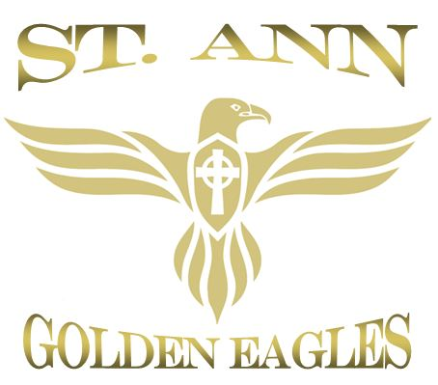
St. Ann Cheerleading
24500 Navajo Drive
Channahon, IL 60410
2018 Application & Activity Waiver

Player Information
Player’s Name: __________________________________________ Birth Date: ___ /____ /____
School: __________________ Parish: ___________________ Sibling Playing Football: Yes No
Medical Conditions / Allergies: _______________________________ Which Level: JV Varsity
_________________________________________________________ *See Below Cheer Information
Parental Information
Father’s Name __________________________________ Dad’s Cell (______)_______________________ eMail_________________________________________
Mother’s Name_________________________________ Mom’s Cell (______)_______________________ eMail____________________________________________
One of the strengths of our program has been our volunteers. Please consider sharing your talent with us.
Head Coach Assistant Coach
Name: ______________________________
I have attended Protecting God’s Children
Date / Parish: ________________________

Family Address (Street) ______________________________ City/State/Zip______________________________________
Other Phone (_____)____________________________

In Case of an Emergency
Contact Name: ______________________________ Relationship : ____________________________
Home Phone: (____)__________________________ Cell Phone: (____)_________________________
St. Ann Cheer Waiver and Release
I, parent of__________________________________________________, do hereby grant permission for my child, a minor, to participate in the St. Ann Cheer program. I hereby release the schools, the parishes, and all other participating schools and their agents, coaches, managers, all league officials and board members from any liabilities which may arise out of or caused by any injury to my child while playing, practicing, or otherwise participating in any game during the 2017 season. I do also agree to indemnify St. Raphael Football, St. Ann Football, St. Ann Catholic Church, St. Mary’s Catholic Church, Holy Family Catholic church, schools, and parishes, the Channahon Park District, and all other schools and churches and all coaches, managers, officials and board members for any and all sums paid, as a result of prosecution of my child. I agree that it is my responsibility to provide my child with primary hospital and medical insurance and the schools, parishes, or the football league are not responsible for doing so.
Parent signature________________________________________________________ Date__________________________
Office Use Only:
Paid in Full: Y / N Amount Paid:
Pre-paid Raffle: Y / N Amount Paid:
Team:
Insurance Information:
Policyholder: _________________________
Insurance Co: _________________________
Policy No: _________________________
Primary Phys: _________________________

