FIVE DATES PROPOSAL

COPYRIGHT STATEMENT
Films 4 Flyovers respects the rights of all screenwriters, filmmakers, artists and copyright holders. Consequently, all works that appear in this proposal do so with the consent of the screenwriter/s, filmmaker/s, artist/s or the copyright holder/s with the exception of released poster images which have been used for thematic reference only.
No image or information displayed in this proposal may be reproduced, transmitted or copied, stored in a retrieval system, or transmitted in any form or by any means – electronic, mechanical, photocopy, recording, or scanning (other than for purposes of obtaining investment for this particular project) without the express written permission of Films 4 Flyovers. Contravention is an infringement of the Copyright Act and its amendments and may be subject to legal action.

Copyright © 2021 Film 4 Flyovers All rights reserved
www.Films4Flyovers.com

Film Investment Disclosure
www.Films4Flyovers.com

Motion Picture Investing involves risk.
Past performance is not a guarantee or indicative of future returns. The value of your investment will fluctuate, and you may gain or lose money.
Investors are urged to read and carefully consider in determining whether such an agreement is suitable for their individual facts and circumstances.
All charts, figures, and graphs are for illustrative purposes only. There can be no assurance that a hypothetical, or actual performance shown, will lead to the
expected results shown or perform in any predictable manner.
The tax consequences of the tax-rebate activities that Films 4 Flyovers may pursue are complex and uncertain and may be challenged by the IRS. The information with regard to this activity was not prepared to be used, and it cannot be used, by any Client to avoid penalties or interest. Clients should confer with their personal tax advisors regarding the tax incentives/consequences of investing in Motion Pictures based on their particular circumstances. Clients and their personal tax advisors are responsible for how the transactions conducted in an account are reported to the IRS or any other taxing authority on the Client’s personal tax returns. Films 4 Flyovers assumes no responsibility for the tax consequences to any Client of any transaction. We are not tax professionals. Clients should consult qualified legal or tax professionals, such as tax attorneys or CPAs, regarding their specific situation.
Although the material contained in this proposal was prepared based on information from public and private sources that Films 4 Flyovers believes to be reliable, no representation, warranty or undertaking, stated or implied, is given as to the accuracy of the information contained herein. Films 4 Flyovers Expressly disclaims any liability for the accuracy and completeness of information contained in this proposal.
All investment strategies and investments involve risk of loss. Nothing contained in this proposal should be construed as investment advice. Any reference to an investment’s past or potential performance is not, and should not be construed as, a recommendation or as a guarantee of any specific outcome or profit.
Any ideas or strategies discussed herein should not be undertaken by any individual without prior consultation with a financial professional for the purpose of assessing whether the ideas or strategies that are discussed are suitable to you based on your own personal financial objectives, needs and risk tolerance. Films 4 Flyovers expressly disclaims any liability or loss incurred by any person who acts on the information, ideas or strategies discussed herein.

- INTRODUCTION Page 6
INDEX:
SEPARATE DOCUMENTS:
- FILM PROJECT SYNOPSIS Page 9
- INVESTMENT STRUCTURE Page 11
- TAX CREDIT & DEDUCTION Page 13
- TRADE REPORT BRIEFS Page 47
- AWARDS Page 48
A) Five Dates, LLC Investment Agreement
- PROJECTS IN
DEVELOPMENT Page 49

- FATHOM EVENTS MARKETING Page 18
-MAKE LEMONADE -MRS J
-FINDING CHRISTMAS -EXIT STRATEGY
16) CONTACT Page 57
- DIGITAL AUDIENCE ANALYSIS Page 20
- PRODUCTION TEAM Page 32
- OUR LEAD Page 42
- SCHEDULE Page 43
- POST PRODUCTION Page 44
- DISTRIBUTION Page 45
- COMPARISON MARKETS Page 46

FILMS 4 FLYOVERS are seeking an investment of USD $500,000 to complete the feature film ‘FIVE DATES’.
- Key risk mitigants protecting the investment are its cost-effective budget, an experienced production team, strong family / faith friendly messages, proven underserved market and own distribution company as part of production company.
- This film will be targeting the high-demand and low-saturation market of the 'family / faith-friendly film industry' with past proven ROI.
JAMES WALCHLE
(404) 409 - 5145
jim@films4flyovers.com
www.Films4Flyovers.com

Thank you for taking the time to read the FILMS 4 FLYOVERS’ investment proposal for the FIVE DATES feature film. Investing in this film is an exciting opportunity, not just as a business venture, but also an opportunity to be part of something both entertaining and life changing. We believe that films are the most powerful influential mediums around today.
Films have been, and are still key drivers of influence in all areas of politics, faith, popular culture and social behaviors today. For the last 100 years films have been used to present a message, so if you find you are not content with the current message out there, an opportunity lies before you, to help change it and make a difference.
There has never been a more exciting time within the history of cinema with the rise of the ‘Family / Faith-friendly’ markets. This has created a niche market with a large demand and a small supply. Investment into a film within the ‘Family / Faith-friendly’ market has a previously proven market that reaches into both the church-based audiences and mainstream audiences. Movieguide recently reported that films with a G or PG rating have an average ROI (Return On Investment) of 80% - 141%, however R-rated films' ROI average is just 16% - 3%.
Family / Faith-friendly films don't need big budgets or even big names, yet they make more money than many Oscar nominated films every year.

FIVE DATES
Logline:
There’s always a frog pond en route to the castle
Hattie, a happily single children’s author
receives a subscription to an online dating
service for her birthday resulting in a series of hilarious mismatches until she meets Henry, who insists that you need Five Dates to find out if you're compatible.
Screenplay by Donna Douglas Walchle
Posters are placeholders only and are not final print images.

Films similar to FIVE DATES...

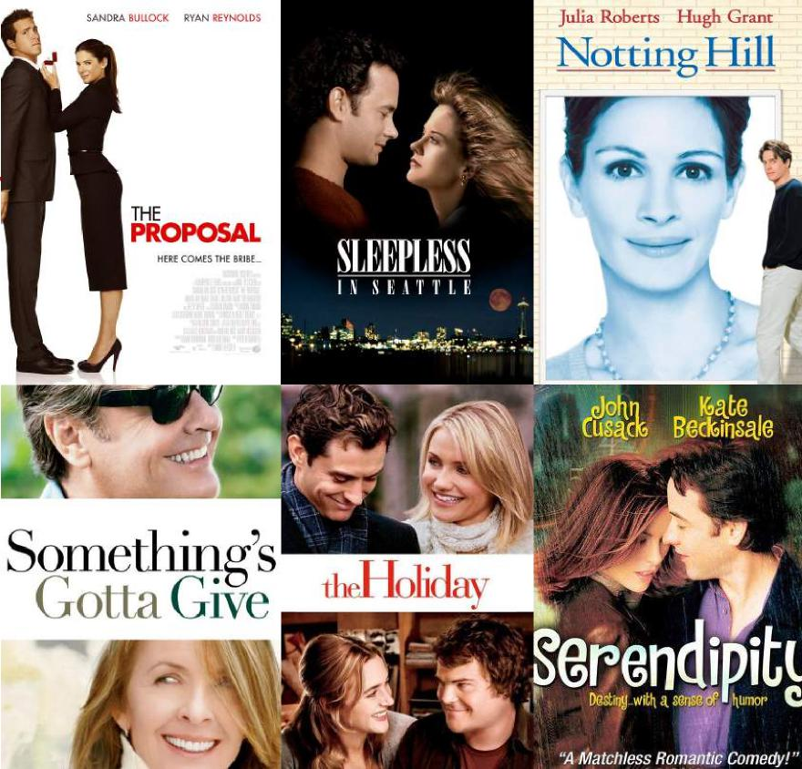
PROPOSED RELEASE DATE:
“VALENTINE’S DAY”

FIVE DATES: SYNOPSIS
It’s happily single, children’s author, Hattie Fisher’s birthday and her lifelong besties, Jill and Maggie, both married, have decided it’s time for her single status to be transformed into marital bliss. Their birthday gift to her is a subscription to an online dating service. Reluctantly, Hattie cautiously embraces the idea and is immediately contacted by three guys for a first date: a dentist who invites her to a comedy club, but fails to tell her that he is one of the performers and that he’s incorporated their first date into his act; a minister who asks her to meet him at his church where he’ s wrapping up a funeral and invites her to the bereavement luncheon; and an attorney who takes business calls all during dinner and addresses her by the wrong name each time he attempts to resume the conversation. Hattie’s more convinced than ever that she’s meant to be single.
Written by Donna Douglas Walchle

However, shortly after that declaration while walking her dog, Utah, Hattie meets Henry and his dog, Canaan as he mows her neighbor’s lawn. Henry’s handsome, well-spoken, kind and seems like a really decent guy, but Jill and Maggie don’t think he’s good enough, after all, he mows lawns! However, this author has learned not to judge a book by its cover and decides to take Henry up on his good- humored proposal that they commit to having FIVE DATES. He explains that anything short of that doesn’t give a fair assessment of potential compatibility.
The challenge will be pulling off this plan without the interference of Hattie’s well-intended friends. However, Henry is very resourceful and thinks he may have an idea to squelch the resistance. Invite them to come along! Jill has five children under nine and Maggie is eight months pregnant. If nothing else, let’s add fearless to Henry’s list of accolades! Hattie has no idea what the end of this story will be, but she loves the premise and acknowledges that Henry has checked one of her “must have” boxes - he makes her laugh.

FIVE DATES - OVERVIEW
- LOCAL PRODUCTION: Utilizing local cast and crew, businesses, churches and community groups.
- PROFESSIONAL TEAM: Decades of experience, multiple feature films completed and distributed, experts at this budget size and scale of production.

- 181 FEDERAL TAX CREDIT: States that investment in a motion picture shot in the US is 100% tax deductible for the investor in the same year invested. Under Section 181 an investor may deduct the money which is invested in a film or television production from his or her passive income earned in the same year.
- 501c3 Deduction:.We have aligned with From the Heart, a not for profit organization for anyone wanting to make a tax deductible donation to them, earmarked for any of our films. From the Heart has been established for over 30 years raising over 30M to help filmmakers make their films.
- GEORGIA TAX INCENTIVES: Up to 30% (20% for productions of $500,000 or more plus 10% for using the Georgia logo in the credits and on the movie website.)
- MITIGATED BUDGET: Lower cost productions with higher quality end results.

- STRONG GROWING MARKET: High demand and low saturation.
365 days a year.
- POWERFUL MINISTRY TOOL: The medium of film reaches across the globe 24/7,

INVESTMENT STRUCTURE
Investment opportunity into FIVE DATES. STANDARD FILM INVESTMENT STRUCTURE:
- Investor can purchase SHARES which are made up of the entire budget ($500,000).
- 100% = $500,000
- 50% = $250,000
- 25% = $125,000
- 10% = $50,000
- 5% = $25,000
- Once the initial ‘Investment’ is paid back (full 100% of entire investment budget -PLUS 20%) the ‘PROFIT’ will then be divided up 50/50 – these are the SHARES and will be paid out to both the investors and production team (production team divides SHARES out to cast and crew in order to offset initial film budget and keep it low).

INVESTMENT STRUCTURE GRAPH
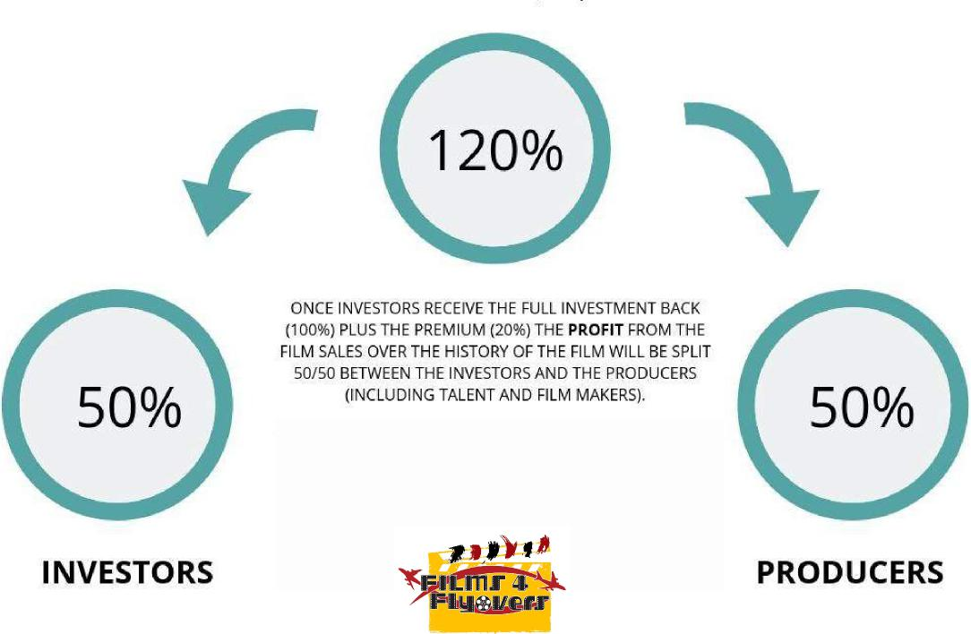

#1 FEDERAL TAX CREDIT (181)
If you are an individual Investor, Private Equity Firm, Hedge Fund, HNW Investor, Asset Manager, Fund Of Fund, or Regional Company and are looking for a high-yield,
absolute-return alternative investment that also can generate substantial Federal and State Tax Incentives, Credits, Cash Rebates, while at the same time be part of a structured film finance opportunity that can offer a potential return of up to 50-100% on capital before revenues, offer long-term multiple exit strategies, and liquidity options, then continue reading.
SECTION 181: states that investment in a motion picture shot in the US is 100% tax deductible for the investor in the same year invested. Under Section 181 an investor may deduct the money which is invested in a film or television production from his or her passive income earned in the same year.
If the investor is actively involved in the operation of the production, he or she may deduct the amount of investment from all active income earned in the same year. Productions with budgets below $15,000,000 (up to $20,000,000) which have at least seventy-five percent 75% of its production completed within the United States qualify under Section 181. Investors can be either individuals or businesses.
WHAT IT MEANS FOR INVESTORS:
Tax rebates and incentives for money spent on film or television production within a particular state combined with the benefits of Section 181 allow an investor (working with cooperative film producers) to greatly minimize his or her risk on what would ordinarily be considered a risky investment. For example, if a taxpayer is in the thirty-five percent (35%) tax bracket and a qualifying film is shot in a US state (see below) offering thirty percent (30%), an investor will be eligible to recapture conceptually sixty five percent (65%) of their investment in a qualifying production.

(cont’d)

Investor broad strokes for the 181 Tax Deduction:
-100% of the motion picture costs are deductible in year of investment.
- 75% of the motion picture must be shot in the U.S. to qualify.
- There is a 15 to 20 million dollar budget cap.
- There is no minimum film production budget cost.
- TV pilots, TV episodes, short films, music videos and feature films qualify.
- Section 181 can be applied to active income or passive income.
- Investors can be either individuals or businesses.
- Deduction can be claimed regardless of film's completion/distribution.
- The motion picture’s corporation issues Schedule K-1’s to the investors.
- 181 applies to the purchase of unreleased motion picture content.

# 2 TAX DEDUCTION THROUGH A CHARITABLE CONTRIBUTION
As an innovative Movie and Television Production Company, Films4Flyovers, Inc. wants to provide options for our investors. Our partnership with Impact Foundation makes it easy for investors to put their charitable capital to work for social, spiritual, and economic transformation.  Now you have a choice: invest as usual or use tax-advantaged dollars from any donor advised fund or your private foundation. Or make a new gift and get a full tax deduction. | 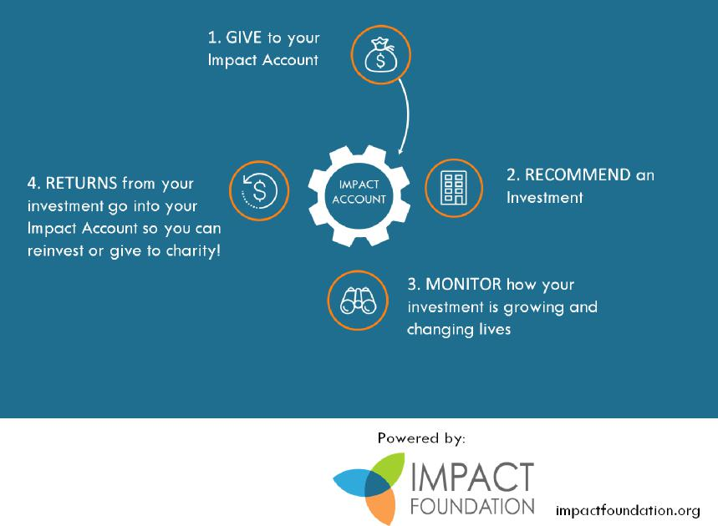

#3 GEORGIA STATE TAX CREDIT

Film, television and digital entertainment tax credits of up to 30 percent create significant cost savings for companies producing feature films, television series, music videos and commercials, as well as interactive games and animation.
Georgia's Entertainment Industry Investment Act provides up to 30 percent tax credit for companies that spend $500,000 or more on production and post-production in Georgia, either in a single production or on multiple projects.
(which is 20% for productions of 500,000 or more plus 10% for using the Georgia logo in the credits and on the movie website.)

Example of EXPECTED RETURN
TIMELINE ‘FIVE DATES’:

- PHASE ONE:
- 181 TAX CREDIT
- STATE TAX REBATE
- 501c3 deduction
-
- PHASE TWO:
+ THEATRICAL:+Fathom Events - Owned by AMC and Regal
Theaters, Fathom Events are in theaters everywhere as special one- time exhibitions, i.e. a new movie, a concert, a Broadway play, a ballet. They begin with presales for tickets and expand the event according to those sales and attendance.
- PHASE THREE:
+ DOMESTIC Home Entertainment Returns :
+ DOMESTIC VOD / CABLE / TV
- PHASE FOUR:
+ Ancillary Rights
+ FOREIGN Theatrical
+ FOREIGN Home Entertainment
+ FOREIGN VOD / Cable /TV
+
- PHASE FIVE +
+ Ancillary Rights to New Platforms and Libraries
+ Continued Revenue from Ongoing Domestic and Foreign
VOD / Cable / TV
+ Film’s Lifespan 7-10 years+

FATHOM EVENTS MARKETING PLAN
Marketing budget $100,000
FIVE DATES aka Five Date Rule
Five Date Rule, a faith-friendly romantic comedy with a multicultural cast that will make you laugh a little, cry a little and leave feeling better than when you came in. People are looking for and longing for this genre film and released as a Valentine’s Day Fathom Event is the perfect time to bring it to the world!
Five Date Rule is about Hattie Fisher, a children’s author, happily single, who is given by her two besties a three- month subscription to an online dating service for her birthday. Reluctantly, she tries it out only to find herself feeling like she’s in perpetual episodes of Punk’d. Until she meets Henry.
- We are seeking and in talks with several major corporations interested in this sponsorship opportunity.
- Andy Stanley, who pastors the second largest church in the country, does cameo appearances in three scenes teaching his dating series, The New Rules of Love, Sex and Dating. (Influencer to churches) Andy also has a 30- minute program called, Your Move that airs in 50 cities after Saturday Night Live and The Late Night Show with a 67-74% retention rate. When available, we’d like Fathom to give us a list of the cities and theaters where Five Date Rule will exhibit and we will target market churches and leadership we have direct contact and relationships with, send an electronic promo to the leadership and as well, do the same on all social media outlets. We will couple that effort with the secular community who watch Andy’s program Your Move. Andy’s dad, Dr. Charles Stanley has a presence all over the world through his broadcast, In Touch. Although recently retired, In Touch is still in play. I wrote the Christmas Television Special for his dad’s church in 2020 and Babbie and I were filmed introducing a song we wrote that the choir sang in the special. I’m certain we can tap into the support of First Baptist Atlanta and In Touch, broadcast around the globe.
- Janelle Arthur plays the lead. Janelle came in 5th on American Idol, has just released her first country single, a duet with Dolly Parton, (and BTW Dolly has known her since she was eight and loves her. Pretty sure Dolly will let her fans know about Five Dates Rule. Also, Vicki Hampton, African American and has been one of Dolly’s background singers for decades, sings one of the songs I co-wrote on the soundtrack.) Janelle has had two feature stories in People Magazine and has acted on stage and starred in the movie, Chasing Your Roots. Her record company has a publicist who will blitz all activity related to Five Date Rule and will be a great help in getting the word out. Janelle is also mentored by Vince Gill. Vince and Amy Grant have a big social media following and can talk it up. Janelle can also tap into the American Idol Audience and her own social media following.
Click the link or paste into your browser to see Janelle: https://www.youtube.com/watch?v=rVYET9Bwfc8

FATHOM EVENTS MARKETING PLAN CONT'D
- Babbie Mason, known around the globe for her Top 5 radio hits, singing at churches, live performances at Carnegie Hall, Radio City Music Hall, Billy Graham Crusades, for Presidents and hosting her own television series, Babbie’s House is performing a piece of a gospel song before Andy teaches. We will engage much of the same outreach as mentioned for Our Petition. Babbie has an enormous social media footprint. Here’s a sample of Babbie performing: https:// www.youtube.com/watch?v=Ek1lLdl55qc
- Jeff Rose will direct Five Dates. Jeff has acted in 98 movies and is also a producer and casting agent. He has the ability to get the word out in a big way.
- We are talks to add three more surprise cameos. Hattie’s mom and dad and the host of the comedy club scene. Don’t like to speculate. However, if we can pull off what is looking like we will, these cameos come with millions of fans they can be alerted to come see Five Date Rule.
- Most of the songs for the soundtrack are co-written by me (Donna Douglas Walchle). (I’m a multi-platinum award winning songwriter.) They will be produced by the four women team of Mama Jan Smith (Grammy nominated producer/vocal coach: Justin Bieber, Usher, The Rock, Jill Scott, Shania Twain and so many more) Babbie Mason (award winning singer/songwriter/producer) Cheryl Rogers (Grammy award winning writer/producer) and myself. Jan Smith has 700,000 Twitter followers as well as a big footprint in other social media. Her clients love her and I know she’ll talk up Five Date Rule. I’m thinking so will her elevated clientele.
- And, we’d like to model the same opportunity as for Our Petition to allow ticket purchasers to choose from a vetted list of 5-10 not for profits to give to. Out of our portion of revenue we will set aside 10 % to be given away. This is a powerful way to get the word out. As an example, let’s take Samaritan’s Purse. Franklin Graham knows Babbie well. Babbie is in Five Date Rule and Our Petition. If Franklin puts the word out to his supporters that they can raise money for Samaritans Purse by buying a ticket to see Five Date Rule and/or Our Petition. It’s a win/win. We get the word out, pack the theaters, and do some good in real life. What’s better than that?
- The CEO of the Visitors and Convention Bureau for City of Alpharetta where we begin filming May 9th-26th, has rolled out the red carpet to us. She is unleashing her PR team to cover our every move. They will be doing posts and soliciting coverage from local news outlets. We have engaged many local businesses in the way of sponsorship to provide, catering, locations, wardrobe, etc. The city will put out flags on flag poles indicating a film is being shot.
- Creating an online contest in the cities where we will be exhibited to solicit students and adults alike to create a movie poster. The winner will be determined by votes from people who qualify when they purchase the presale tickets.
- We can create the opportunity for people dating or wanting better relationships to watch Andy’s dating series in its entirety before coming to the movie.
- Partnering with publishers as sponsors for cross-promotional ads, i.e. Gary Chapman’s book, Love Languages, Shaunti Feldhaun’s books For Men Only, For Women Only, etc.

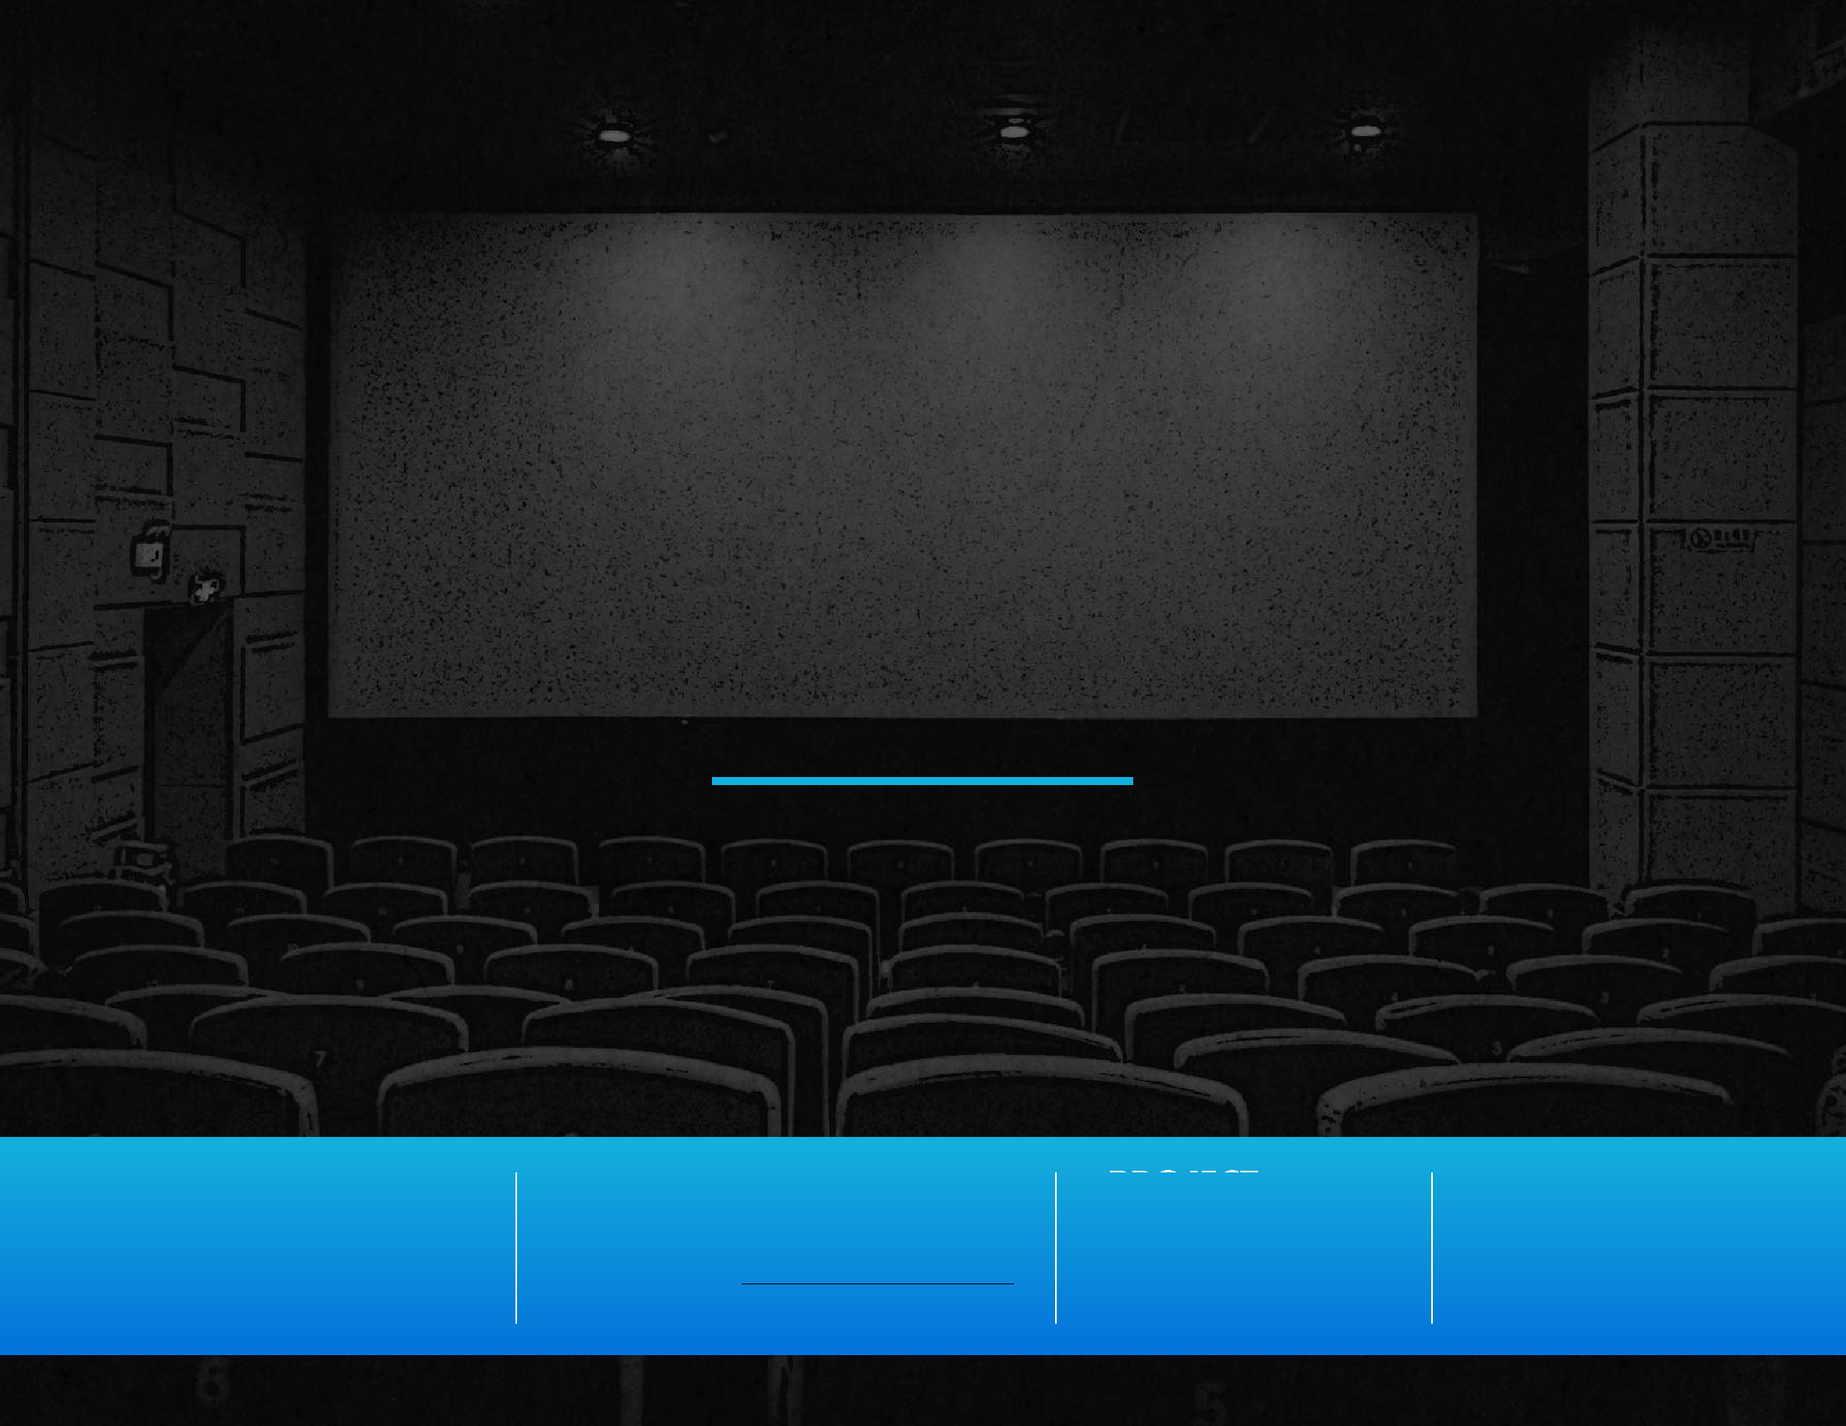
FIVE DATES
Digital Audience Analysis
 | CONTACT: | PROJECT: | 2/3/22
COMPANY:  Five Dates, LLC | James Walchle / Films4Flyovers, LLC  404 409 5145 / Jim@films4flyovers.com | Five Dates

DATE CREATED:

FIVE DATES | Digital Audience Analysis
“3D” AUDIENCE ANALYSIS
During the Digital Audience Analysis process our team seeks to identify the potential reachable audience for a film, determine current interest, and gain unique insights about the audience that can inform the film’s development and release strategy. The 3D Audience Analysis below is a summary of our Audience and Interest findings for Five Dates. The Facebook Audience section on the left shows the number of Facebook users likely to be interested in this film that can be targeted and reached with organic and paid content. The Google Interest Section to the right is a measurement of Google Keyword Volume and is helpful in illustrating the level of interest that currently exists in the marketplace for thematically similar films or television shows. Our hope is that the data found
in this 3D Analysis, as well as the insights on the following pages, will serve as a valuable resource through both the development and release of Five Dates.
AUDIENCE
FACEBOOK GOOGLE
17.3
MILLION
INTEREST
1.7
MILLION
Potential Reachable Audience
Avg Monthly Keyword Volume
We researched and analyzed the Facebook audiences (18+ in the US) of over 30 films, genres, and interests that are similar or related to Five Dates. We sorted our data into 3 audience subgroups (explained in more detail on the next three pages): Comp
Movies, Faith Based Films, and Romantic Comedies. We arrived at the Potential
Facebook Audience number of 17.3 million by combining all 3 audience groups and then
removing any overlapping segments.
Our team analyzed common keywords (1-2 word phrases people use when searching the internet) associated with the films used in our research. The numbers listed below are the average monthly Google search volume for each film over the last 12 months. The number above is the sum of those searches. On the lowest end, monthly searches totaled 381k. On the highest end, monthly searches totaled 3.81 million. This average monthly keyword volume, 1.7 million, can be used as an informal measurement of the interest that currently exists for properties similar to Five Dates.
Comp Movies
Comp Movies & TV (381k - 3.81M)
- Old Fashioned
- Fireproof
- The Proposal
- You’ve Got Mail
- Sleepless in Seattle
- My Best Friend’s Wedding
- Serendipity
2M
- 50 First Dates
- The Vow
- 27 Dresses
- How to Lose a Guy in 10 Days
- Notting Hill
- Serendipity - avg. 55k
- The Vow - avg. 55k
- 27 Dresses - avg. 55k
- Notting Hill - avg. 55k
- Old Fashioned - avg. 6k
- 50 First Dates - avg. 550k
- How to Lose a Guy in 10 Days - avg. 550k
- The Proposal - avg. 550k
- Fireproof - avg. 55k
21.7M
14.5M
- You’ve Got Mail - avg. 55k
- Sleepless in Seattle - avg. 55k
- My Best Friend’s Wedding - avg. 55k
Faith Based Films
Romantic Comedies
2

FIVE DATES | Digital Audience Analysis
COMP MOVIES AUDIENCE SIZE
Facebook Audience Insights 2 Million

AUDIENCE ANALYSIS
GENDER/AGE DEMOGRAPHICS
This audience was built using movies and films that are similar in theme and genre to Five Dates. In particular, we looked for films that:
82% Women 18% Men
54% All Facebook 46% All Facebook
* were romantic comedies, especially with a clever plot hook

* featured both romance and faith elements

Movies and television shows such as 50 First Dates, Old Fashioned, and The Proposal bore strong similarities to Five Dates and were used to build the segment.
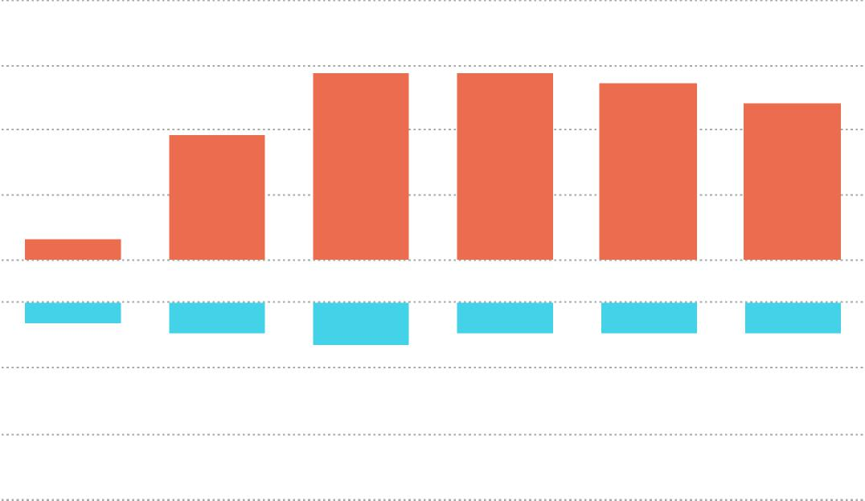
3% 3% 3% 3%
4%
18% 18% 17%
2%
12%
15%
18-24 25-34 35-44 45-54 55-64 65+
2%
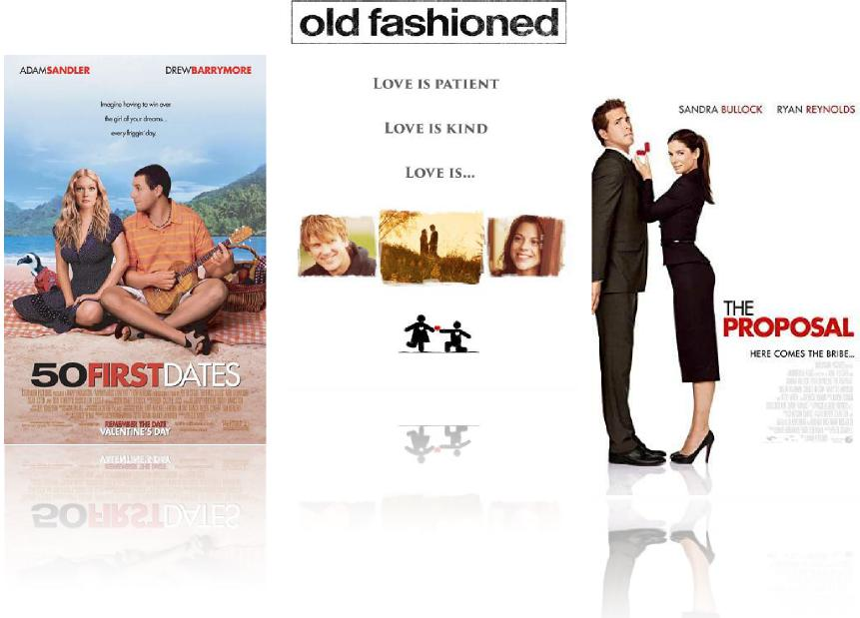

This audience is comprised of the combined audiences of Old Fashioned, Fireproof, The Proposal, You’ve Got Mail, Sleepless in Seattle, My Best Friend’s Wedding, Serendipity, 50 First
3
*
Dates, The Vow, 27 Dresses, How to Lose a Guy in 10 Days, Notting Hill

FIVE DATES | Digital Audience Analysis
FAITH BASED FILMS AUDIENCE SIZE
Facebook Audience Insights 14.5 Million

AUDIENCE ANALYSIS
GENDER/AGE DEMOGRAPHICS
Since one of the primary, if not THE primary, draw of Five Dates is its strong faith elements, we built an audience off of the most visible and successful Christian and faith-based films of the last two decades.
77% Women 23% Men
54% All Facebook 46% All Facebook

Films such as Facing the Giants, War Room, and I Can Only Imagine have firmly established the massive potential box office success that this genre can command. Without a doubt, emphasizing the positive faith elements of Five Dates will be absolutely crucial to the potential success of the film.
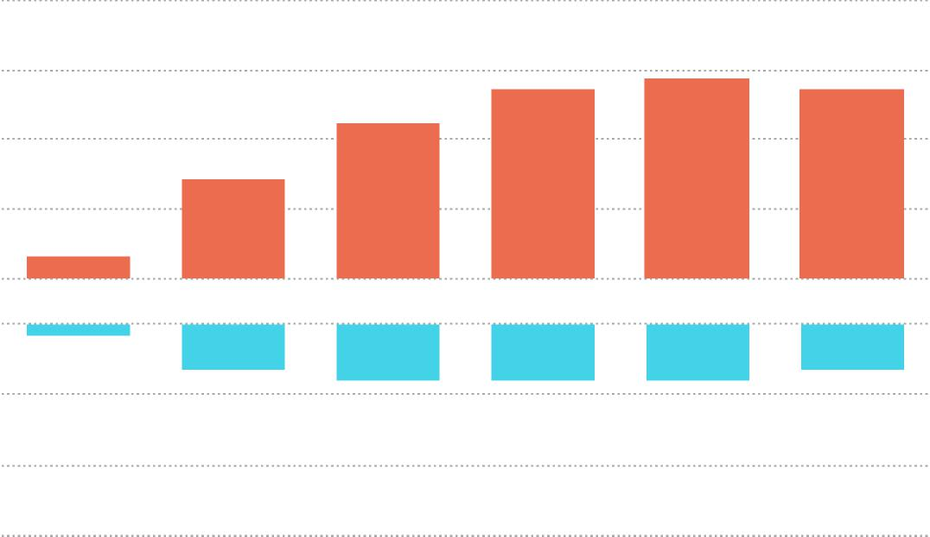
1%
14%
9%
2%
18%
17% 17%
18-24 25-34 35-44 45-54 55-64 65+
4% 4%
5% 5% 5%
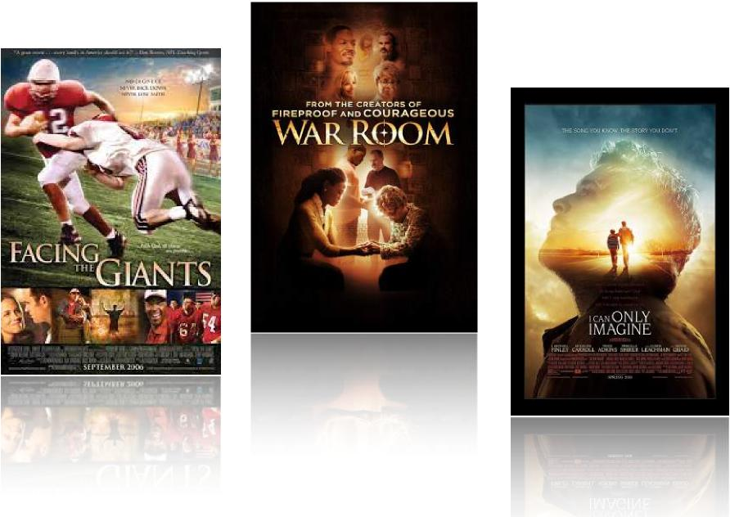

4

FIVE DATES | Digital Audience Analysis
ROMANTIC COMEDIES AUDIENCE SIZE
Facebook Audience Insights 21.7 Million

AUDIENCE ANALYSIS
GENDER/AGE DEMOGRAPHICS
This was the largest audience segment we built using a wide range of romantic comedies, from lighter PG fare such as 13 Going on 30 to more raunchy R-rated comedies like There’s Something About Mary.
79% Women 21% Men
54% All Facebook 46% All Facebook
Because this segment is so broad, highlighting the core romantic comedy tropes present in Five Dates will be the key to reaching this audience. They need to be convinced that this film contains all of the hallmarks of their favorite rom-coms, from the quirky “dare” to the meddling friends to the inevitable heart break to the final kiss.
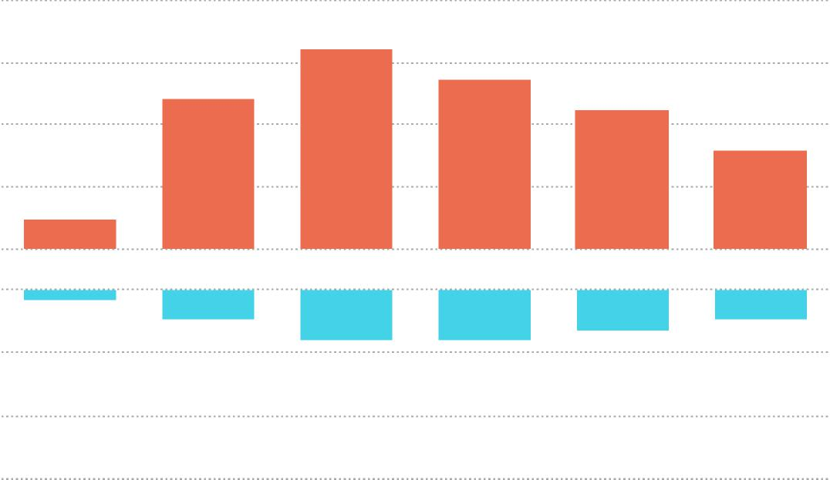
18-24 25-34 35-44 45-54 55-64 65+
1%
3% 3%
5% 4%
5%
20%
3%
15%
17%
14%
10%
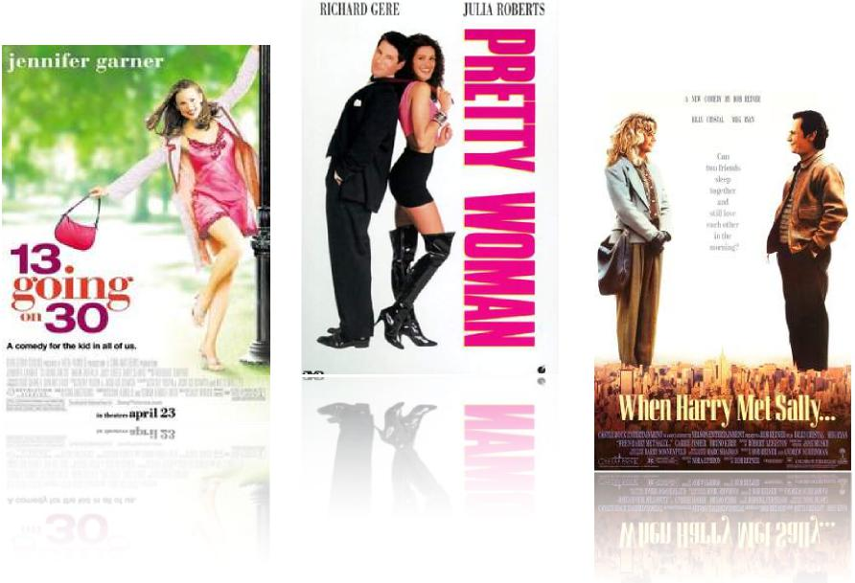

5

FIVE DATES Digital Audience Analysis

COMPARABLE FILM
BREAKDOWNS

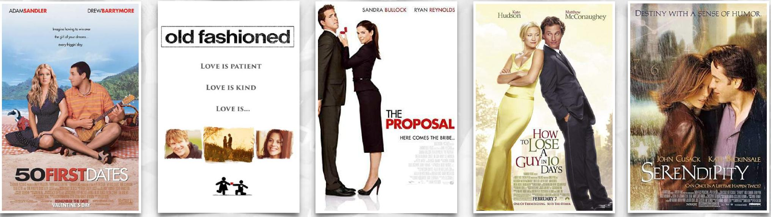
ADAMSANDLER
DREWBAR RYMO RE
hnoOna hcni.g
'he airldyas drawn, . ⁰.7f⁶t0^{,4}*
old fashioned
LOVE IS PATIENT
LOVE IS KIND
LOVE IS...
SANDRA BULLOCK RYAN REYNOLDS
THE
PROPOSAL
HE RE COMES THE BRIBE...
Matthew
McConaughey
Hudsit
How

A
GUYINID
DAYS
.021.::
.r11.1 1.V. ICIne.ME Entallfin
Mrall.%111EZVEI1111151117, D41.111 911.11VAINF •21111111X1111
TIFFICr =MT= Mtn :11/111 .irwrimatkosikerm:ilimaki
—gruicnkudoill.Mai
7,1: FEBRUARY 7 7. AP
(3.013.2a [SLUNG. So 1511.[I1im

6

50 FIRST DATES (2004)

FIVE DATES | Digital Audience Analysis *Comps are organized in order of relevancy.
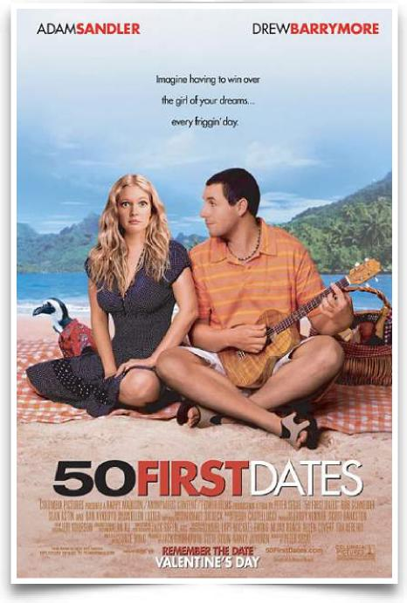
Rating: PG-13 6.8/10 IMDB Rating 45% Tomatometer 65% Audience Score
The Numbers
$75M

February
3,612
Max
Theater
Count

$39.8M | $11k | $120.9M | 3x
Opening  Weekend  Gross | Opening  Weekend  PSA | Total  Domestic  Gross | Multiplier

Release
Window
Budget

Facebook Audience Insights 338k - 398k  Potential Audience Size | Google Trends: Interest Over Time  Avg. Monthly Searches: 100k - 1M

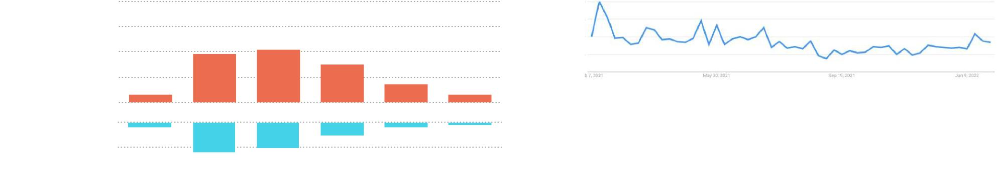
68% Women
54% All Facebook
32% Men
46% All Facebook
January
2022
February
2021
12%
10%
21%
19%
15%
3%
2%
18-24 25-34 35-44 45-54 55-64 65+
2% 1%
5%
7%
3%

7

OLD FASHIONED (2014)

FIVE DATES | Digital Audience Analysis
*Comps are organized in order of relevancy.
Rating: PG-13 5.2/10 IMDB Rating 17% Tomatometer 84% Audience Score
The Numbers
$600k

February
Release
Window
298
Max
Theater
Count
$4.5k
1.9x
$1.9M
$1M
Total
Domestic
Gross
Multiplier
Opening
Weekend
PSA
Opening
Weekend
Gross
Budget

Facebook Audience Insights | Google Trends: Interest Over Time  Avg. Monthly Searches: 1k - 10k

The audience for Old Fashioned is too small for statistically significant Facebook insights. | 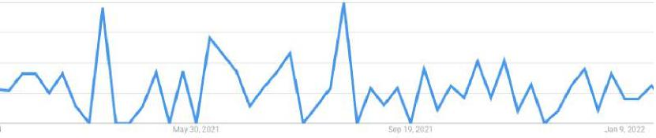

8
February  2021 | January  2022

FIVE DATES | Digital Audience Analysis *Comps are organized in order of relevancy.

THE PROPOSAL (2009)

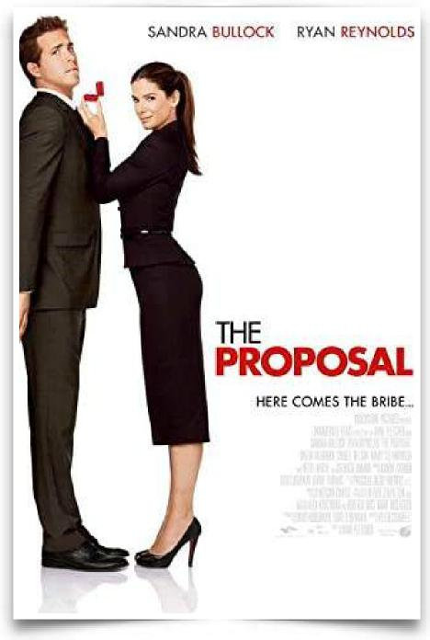
Rating: PG-13 6.7/10 IMDB Rating 45% Tomatometer 67% Audience Score
The Numbers
$40M

June
3,158
Max
Theater
Count
$11k
4.9x
$163.9M
$33.6M
Total
Domestic
Gross
Multiplier
Opening
Weekend
PSA
Opening
Weekend
Gross
Release
Window
Budget

Facebook Audience Insights 479k - 564k Google Trends: Interest Over Time

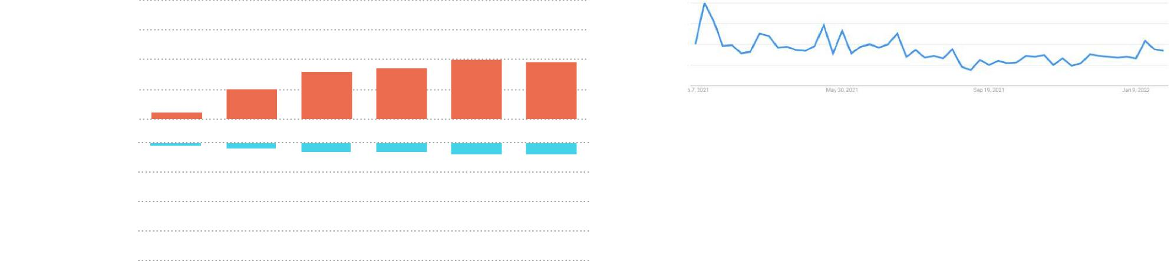
January
2022
February
2021
84% Women
54% All Facebook
16% Men
46% All Facebook
10%
2%
1% 2% 3% 3% 4% 4%
18-24 25-34 35-44 45-54 55-64 65+
20% 19%
16% 17%
Potential Audience Size Avg. Monthly Searches: 100k - 1M

9

HOW TO LOSE A GUY IN 10 DAYS (2003)

FIVE DATES | Digital Audience Analysis *Comps are organized in order of relevancy.
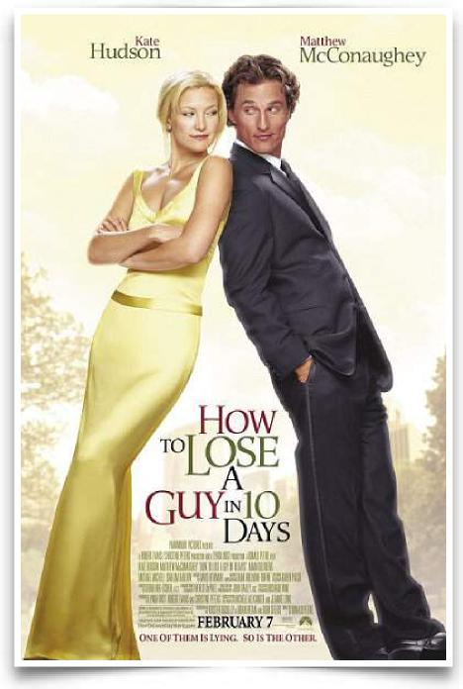
The Numbers

Rating: PG-13 6.4/10 IMDB Rating 42% Tomatometer 77% Audience Score
February
Release
Window
2,923
Max
Theater
Count
$8.1k
4.5x
$105.8M
$23.7M
Total
Domestic
Gross
Multiplier
Opening
Weekend
PSA
Opening
Weekend
Gross
$50M
Budget

Facebook Audience Insights 14k - 16k

January
2022
February
2021
92% Women
54% All Facebook
8% Men
46% All Facebook
30%
29%
17%
3%
0% 0%
2% 3% 2% 1%
18-24 25-34 35-44 45-54 55-64 65+
8%
4%
Potential Audience Size
Google Trends: Interest Over Time
Avg. Monthly Searches: 100k - 1M

10

FIVE DATES | Digital Audience Analysis *Comps are organized in order of relevancy.

SERENDIPITY (2001)

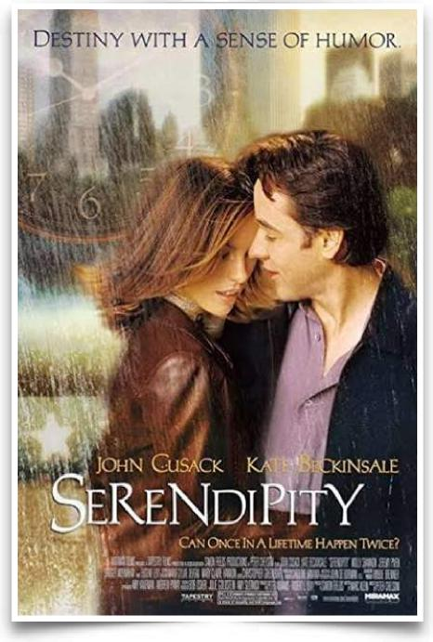
Rating: PG-13 6.9/10 IMDB Rating 59% Tomatometer 79% Audience Score
The Numbers
$28M

October
2,610
Max
Theater
Count
$5.1K
3.7x
$50.2M
$13.3M
Total
Domestic
Gross
Multiplier
Opening
Weekend
PSA
Opening
Weekend
Gross
Release
Window
Budget

Facebook Audience Insights Google Trends: Interest Over Time
Avg. Monthly Searches: 10k - 100k

The audience for Serendipity is too small for statistically significant Facebook insights. | 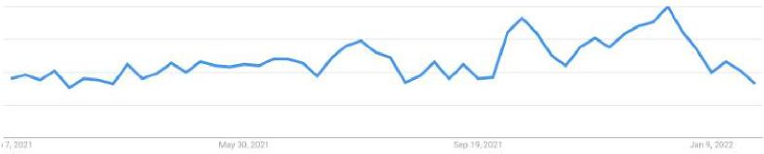

February January
11
2021 2022

Digital Audience Analysis
THE END.

DIRECTOR / PRODUCER / CASTING AGENT / ACTOR
Jeff Rose
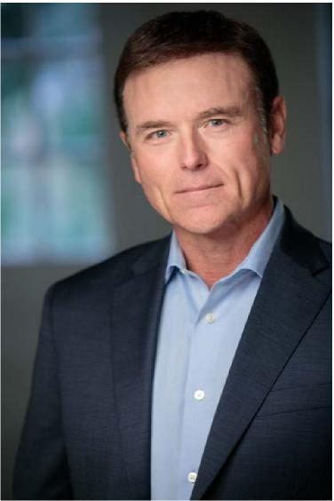
Actor, producer, casting agent and director, Jeff Rose has done it all. Inspired by an emotional re-run episode of "The Rifleman" at the age of seven, Jeff Rose set his sights on becoming a professional actor and filmmaker. Born and raised in Marietta, Georgia, for ten long years, Jeff could only dream about his goals until registering for beginning acting classes during his freshman year of college at Kennesaw State University.
After honing his skills in professional theatre in the southeast and around the world, Jeff soon found himself cast in a major supporting role in an episode of the hit television series 'In the Heat of the Night" alongside two acting legends, Carroll O'Connor and Howard Rollins.
A few film and TV credits later, thanks to Warner Brothers casting legend, Marion Dougherty, and his Orlando talent agent, Helen Gittens, Jeff found himself under consideration for the role of Robin in Tim Burton's Batman sequel, "Batman Returns". At one point he was competing with Michael J. Fox and Shawn Wayans for the role.
Though the character of Robin was ultimately not introduced in that film, the experience opened up enough doors for Jeff to relocate to Los Angeles, where he continued to grow as an artist and accumulate credits.
Jeff decided to move back to Atlanta a decade later when his mother suffered a massive stroke. A two year self-imposed hiatus during that traumatic period proved to be the catalyst Jeff needed to jump back into acting with a renewed passion. At one point shortly thereafter, Jeff was recurring on four television shows simultaneously -- Army Wives, Drop Dead Diva, Teen Wolf, and Devious Maids.
Jeff has casted produced and directed many projects including several short films, five episodes of the Sid Roth, “It’s Supernatural” television series and recently, directed a family-friendly feature film titled, Game Changer.
Jeff is the proud father of two child actors, Brody Rose, the star of the Erwin Brothers hit feature film, 'I Can Only Imagine', and Kayla Rose, and is the proud stepfather to another child actor, Riley Bundick, and her brother, Evan.

DIRECTOR OF PHOTOGRAPHY

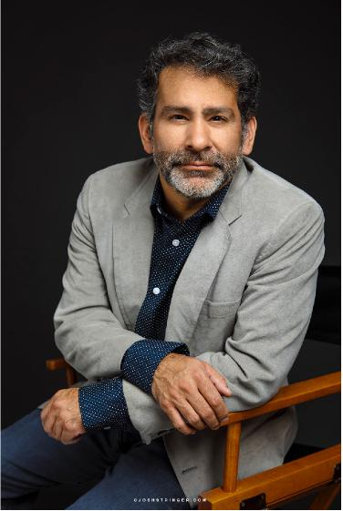 | Marco Gutierrez  MARCO GUTIERREZ, SOC studied Cinematography at the University of Southern California. For over 20 years Marco has honed his craft which has taken him storm chasing with the Discovery Channel to making international commercials for large companies like Red Bull and Microsoft.  His influences include painters from Edward Hopper to Rembrandt, photographers like George Hurrell, Helmut Newton and Peter Lindbergh. Marco’s own work as a photographer has taken him to New York where he was a Fashion Week photographer and has won several awards for his narrative style in his photographs.  Marco is known for his work on television series and feature films like, 'Iron Chef Gauntlet,' 'Billion Dollar Buyer,' 'Going Rogue,' 'Tyson’s Run,' 'The Replaceables, ' 'A Unicorn for Christmas' and 'Game Changer.'  Finally, Marco’s faith has been a deep part of his life. When it comes to being a Director of Photography, his skill comes from 20 years of filming a diverse portfolio of work. Marco believes that cinematography should be transparent and not distract from the film, but instead add an additional dimension to film that immerses the audience in the story and characters.

CINEMATOGRAPHER / EDITOR / DIRECTOR OF PHOTOGRAPHY

Derek Arwood
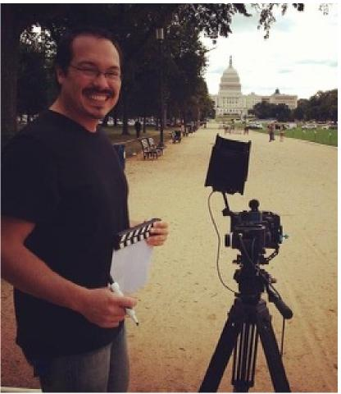
DEREK ARWOOD brings to the table over twenty years’ experience in television, film and commercial production. He has worked on numerous corporate projects including Delta Airlines, Home Depot, Chick-fil-a, Coca Cola, UPS, Bellsouth and Burger King.
Derek has served as a producer, director and editor on several nationally syndicated television series, like Swift Justice with Nancy Grace on Fox, Real Moms, Real Stories, Real Savvy for PBS and later bought by Disney, 54 Holes to Sunday for the Golf Channel, Wild About Animals for the Animal Channel and Urban Reporters for the Black Family Channel.
Derek served as the Executive Producer, Colorist and Cameraman for the children’s feature film, Crimes and Mr. Meanors, as well as a 2nd AC and colorist for, The Solomon Bunch.
Derek’s production company, Crevo Visual Media, Inc. was the first to own a drone camera in Georgia. Amidst multiple drone camera shoots to his credit, he was responsible for all the drone footage for Our Petition (calling believers to unity) that won both the ICVM Gold Crown Award for The Best Television Program and the ICVM Silver Crown Award for the Best Worship Musical.
Derek resides in a suburb of Atlanta, Georgia with his wife and daughter.

EXECUTIVE PRODUCER
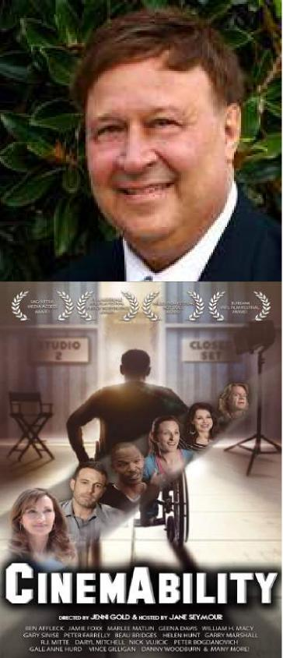
James A. Walchle
From an early age, the entrepreneurial skill of Mr. JAMES WALCHLE was apparent. From booking bands, to overseeing the advertising and promotions, to the ticket sales, he successfully celebrated his debut as a concert promoter at his very publicly attended sixteenth birthday party. Following, he scheduled the first outdoor concert series in his area and booked bands in the Hullabaloo Nightclub circuit.
At twenty years old, he formed his first staffing company, Summit Employment and in 1972, expanded his outreach by developing Association of Permanent Placement Staffing agencies. Mr. Walchle became a franchise owner of three offices for Norrell, one of the largest staffing company in the country, where he served on the Board of Directors of the Franchise Division until 1981. At twenty-seven he expanded his base and became a commercial contractor when he won the bid to build an office building for Prudential Insurance Company.
Further diversifying, Mr. Walchle started a transportation company that became the largest private transportation company in Northeast Indiana, providing public and contract services for the handicapped and Conrail and N&W Railways. He formed and built another staffing company, Blue Jean Jobs, Inc. for the express purpose of selling it, which he successfully accomplished.
In 1999, he formed Labor Staffing, Inc. with his son, Jon. Labor Staffing, Inc. has grown to become the second largest provider of temporary labor for one of the world’s largest hotel chains. Always interested in the movie industry, in 2010, Mr. Walchle, (IMDB known as Jim Walchle,) was one of the executive producers on a star-studded documentary, titled, Cinemability with Gold Pictures. The project was released in 2014.
Currently, and due to his concern that the film distribution model is broken, he is passionate about restructuring the model so that investors are able to recoup their investment making it potentially more attractive for more films to be made. He is also concerned that with the possibility of the tax incentives in Georgia going away at some point, that putting together a film fund through a municipal bond offering is a viable solution.
Mr. Walchle is married, has three grown children, eleven grandchildren, is an active member of Northpoint Community Church and
resides in the greater Atlanta area with his wife, Donna Douglas Walchle.
jim@films4flyovers.com www.Films4Flyovers.com

PRODUCER/WRITER

Donna Douglas Walchle
Creative, energetic, and a visionary. These are just a few of the adjectives describing the multi- faceted talent of producer, writer, author and speaker, DONNA DOUGLAS WALCHLE. Ms. Douglas Walchle has written and produced two television series, Two Lane Traveller, nationally syndicated in 84 million homes on PBS and Direct TV, and Real Moms, Real Stories, Real Savvy, that aired on PBS and was later bought by Disney. She has written five screenplays, Make Lemonade, Mrs. J, Exit Strategy, Five Dates and Finding Christmas, as well as all of the songs for the soundtracks. In 2020, she wrote the script for All is Well, First Baptist Atlanta’s Christmas Music Television Special. (Dr. Charles Stanley.)
Ms. Douglas Walchle’s reputation as a songwriter now spans the globe, with more than two hundred recorded songs to her credit, including several compositions that have charted to Top 5 on CCM and Adult Contemporary radio. Ms. Douglas penned “The Hard Way,” which landed on multi-platinum country artist, Faith Hill’s CD, “Faith,” for which Ms. Douglas has received seven platinum albums commemorating seven million copies sold. R&B/ Pop sensation, Usher, debuted her composition, "King Jesus Is His Name" on a nationally syndicated Christmas Special after touring with the song throughout Africa and Europe.
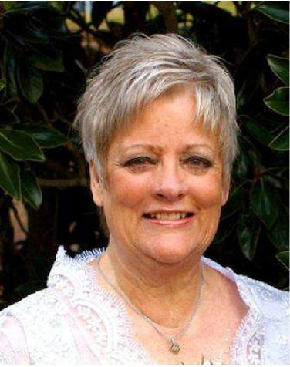
Some of the other artists to record her songs include Larnelle Harris, Babbie Mason, Margaret Becker, Susan Ashton, The Christ Church Choir, Michael English, 4-Him and The Brooklyn Tabernacle Choir. Some of her songs include “He’ll Find a Way,” “In All of His Glory,” “ Pray On” “What Can Separate,” The First Thing I’ll See, “ Somebody Say Amen,” “King Jesus is His Name,” “Life Goes On,” “No Other,” “The Only Hope,” and “All In Favor.” Many of her compositions have been heard on The Billy Graham Crusades, In Touch, The Bill Gaither Music Videos and Hour of Power, as well as other international television broadcasts and are now performed in twenty-one different languages throughout the world. Her composition,” In All of His Glory” was performed at Carnegie Hall.
As a record and music video producer, Ms. Douglas Walchle has produced numerous projects, which have received national attention. Several songs she's produced have resulted in Top 5 radio hits. Her youth musical, "Who Me?” that was co-written with Andy Stanley, has been performed by thousands of teens all over the country. Ms. Douglas Walchle owns her own publishing company, Did My Music.
Ms. Douglas Walchle has served on the Board of Governor’s for NARAS, Atlanta, (The National Academy of Recording Arts and Sciences.) She has taught songwriting classes at Atlanta Christian College, Lee College, Kennesaw State University, The Christian Artist Music Seminar, American Society of Composers, Artists and Publishers, The Babbie Mason Music Seminar and The Inner Circle.
Ms. Douglas Walchle’s book, God Stories (They’re So Amazing Only God Could Make Them Happen) (Starburst Publishers), was named Book of the Month at an Atlanta Barnes and Noble. The paperback version is titled, “Winks from God.” Her fiction novel, “Make Lemonade,” her children’s book and sing-along song, “There’s an Owl in the Closet,” Finding Christmas (an unexpected love story) available in hard copy or ebook and “Kickin’ Cancer’s Butt AGAIN!” an ebook or audio book can all be found on Amazon. She is a frequently sought after speaker at women’s events, singles conferences, corporate gatherings and churches.
Ms. Douglas Walchle cohosts an internet radio show with Babbie Mason, titled Cantaloupe Café that airs on www.babbiemasonradio.com from 2:00-2:15 pm Eastern every Saturday and can be heard in 90 countries.
Although for most of her life she was married to her career, on October 27, 2012, she married James Walchle and became a wife, mom to three adult children and Grammy to eleven, all without labor pains!

donnadhere@gmail.com www.donnadhere.com

AWARD-WINNING PRODUCER ! SONGWRITER ! VOCAL COACH

"Mama Jan" Smith
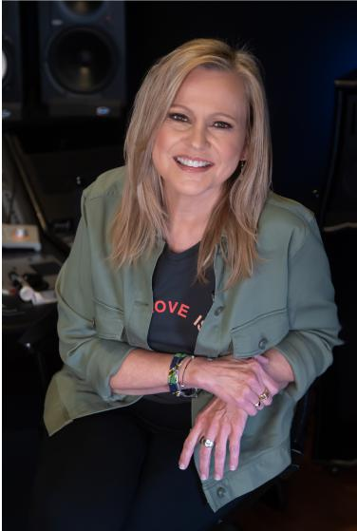
A nationally recognized singer/songwriter/musician, JAN SMITH is also a Grammy nominated producer, GA Music Hall of Fame inductee, and a multi-platinum certified vocal coach/vocal producer who has tended to some of the most distinctive voices in the business. Owner of Jan Smith Studios in Atlanta, a state-of-the-art vocal coaching, artist development, and production facility offering services nationwide to record companies, artists, producers and motion pictures. Clients include Usher, Rob Thomas/ Matchbox Twenty, Janet Jackson, Shania Twain, Justin Bieber, The Band Perry, Jill Scott, India Arie, David Crowder, Tasha Cobbs-Leonard, Sugarland, Drake, Mastodon, Nicki Minaj, FLA/GA Line, Jesus Culture, etc. (www.jansmith.com). Vocal consultation and production credits also include Tyler Perry Productions, Warner Bros Pictures, Universal Pictures, Paramount, Disney, New Line Cinema, Fox Television, as well as work with award winning actors Liam Neeson, Dwayne “The Rock” Johnson, Christina Applegate, Ed Helms, Jamie Chung, Terrence Howard, Christian Serratos, the girl group STAR on Fox, and White House Correspondent John Roberts.
A frequent media guest and sought-after speaker, Smith has been featured with Usher on MTV’s hit reality show Duets, with Ciara on BET’s Behind the Scenes, on UPN’s RUtheGirl? with Chilli and T-Boz of TLC, on Bravo’s popular Housewives of Atlanta, with Justin Bieber in Paramount’s documentary of Never Say Never, on Nightline’s vocal reporting on singer Adele, on E!’s The Wanted Life (a Ryan Seacrest & Scooter Braun production), and on multiple network news and cable programs. She has been a keynote speaker for such events as the Vineyard SE Arts Conference, TAG Digital Media Summit, the Women of Worth Conference, Grammy in the Schools, the “Project Light” Arts Conference, and most recently was a featured speaker at LeaderCast Women’s inaugural event and the National Prayer Breakfast in Washington, DC. Additionally, Mama Jan was asked to consult the Chinese Audio-Visual Association on the creation of awards categories for their prestigious Golden Disc Awards and continues her work with pop artists from Beijing and Korea.
Smith has served as President of the Atlanta Chapter of the Recording Academy for two terms, as a National Trustee for several multi-year terms, and continues to participate on national committees as a voting member of the Grammys in good standing. She continues to see clients worldwide, produces records in her Atlanta Homegirl Entertainment studios, and develops aspiring artists under Mama Jan Music. Jan Smith Studios has created employment opportunities for many others and hosts the largest roster of charting artists of any vocal coaching and artist development facility in America.
Instagram FaceBook Twitter YouTube @MamaJanMusic www.jansmith.com

GRAMMY / EMMY AWARD WINNING PRODUCER / SONGWRITER

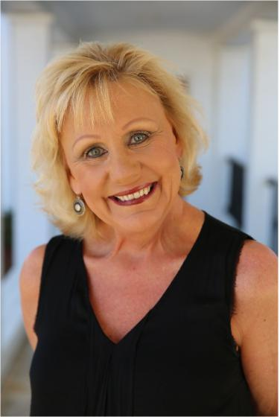 | Cheryl Rogers  CHERYL ROGERS is a composer, producer, arranger, singer and keyboardist who has been working in the commercial and contemporary Christian music industry for over 30 years. She is a five-time Dove award nominee and a producer on the Grammy-award winning Andrae Crouch “Tribute” project. Her music has been played all over the world on radio, television and the web.  She is also a four-time Emmy award winner. Her commercial client list includes Atlanta Falcons, WSB-TV, Georgia Lottery Corporation, Tennis Channel, Discovery Channel, TNT, TBS, Cartoon Network, Coca Cola, Georgia Aquarium and many others. She is proud to have co-written and produced 2 Christmas songs for former Celtic Woman, Lisa Kelly, as well as being Music Director for Lisa’s live shows. She recently scored the critically acclaimed documentary, “Olympic Pride, American Prejudice” produced by Deborah Riley Draper and Blair Underwood.

AWARD-WINNING SINGER ! SONGWRITER ! SINGER

Babbie Mason
BABBIE MASON is a two-time Dove Award winning, Grammy, Emmy and Stellar nominated Gospel recording artist, songwriter, author and women’s conference speaker. Inducted into the Christian Music Hall of Fame in 2010, Babbie has been a favored guest at churches, conferences and conventions worldwide, including Billy Graham Crusades, Bishop T. D. Jakes Potter’s House, Bill Gaither Homecoming Events, Carnegie Hall, the United Nations, and the Brooklyn Tabernacle. Her timeless singing and songwriting gifts have been featured on her twenty-six recordings, in concerts, on radio and television for over three decades. Her original compositions appear in countless worship anthems, musicals and hymnals in over twenty languages. She has graced the stage with American presidents Carter, Ford and Bush.
A sought women’s conference speaker and author, Babbie builds up the hearts of her audience in her brand new book Fully Qualified. In this encouraging and life-giving message, Babbie reminds readers that they possess an abundance of gifts, talents and abilities that are yet untapped. She cheers them on to nurture those gifts and celebrate their unique and distinct purpose. She is the author of seven other books and two Bible Studies for women, including Embraced By God and This I Know For Sure. Babbie also mentors the next generation of independent singers and songwriters through her weekend music conferences called The Inner Circle and provides a platform where their music and life stories and be in the spotlight on her internet radio station at www.babbiemasonradio.com.
Babbie Mason and her husband Charles live on a farm in west Georgia.

KEY WARDROBE
Margaret Flock
Margaret Flock A native of Atlanta, Margaret Flock has been working with clothes her whole life and her passion is creating characters. She has worked on numerous television series as well as feature films. Some of her recent credits include, Lovecraft Country, Doom Patrol, Underground Railroad, Long Slow Exhale, American Soul, Lovestruck, Ciper and The Walking Dead.
When she is not working, she enjoys spending time outdoors. Margaret's goal is to spread love through film and wishes peace and love to all!

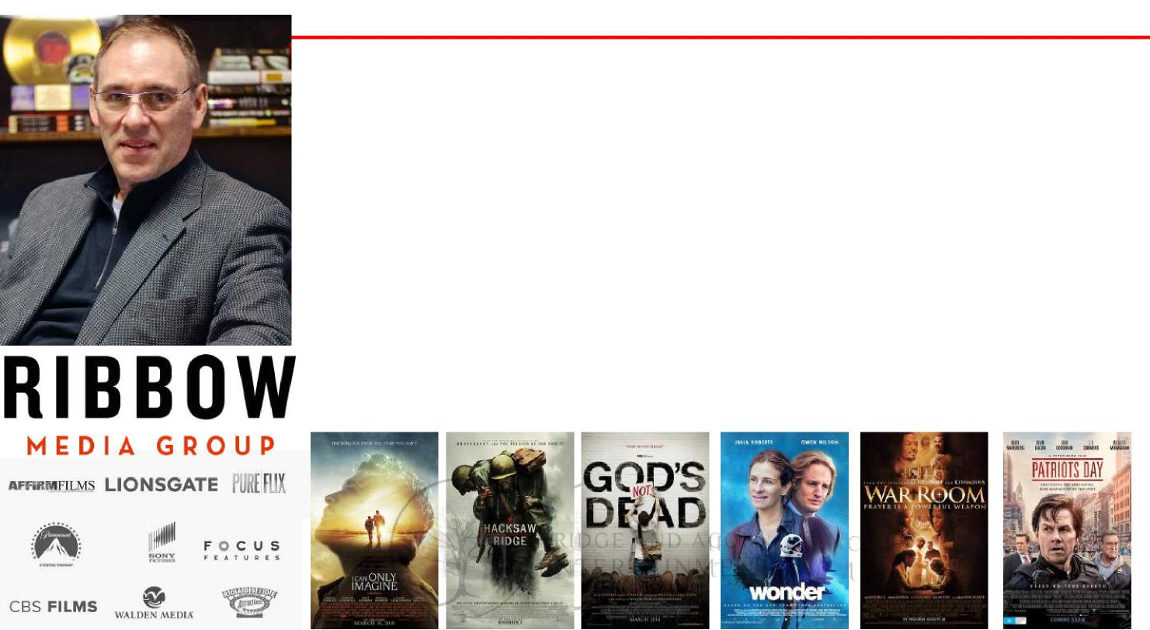
MARKETING
Barry Landis
BARRY LANDIS is the Chairman and Co-Founder of the Ribbow Media Group in Nashville, TN, a digital marketing firm which has been the marketing agency on movies such as I Still Believe (Lionsgate/Kingdom Films), Paul, Apostle of Christ (Sony AFFIRM), I Can Only Imagine (Roadside Attractions), The Shack (Lionsgate), Hacksaw Ridge (Summit Entertainment), God’s Not Dead (Pure Flix), War Room (Sony TriStar), Woodlawn (Pure Flix), Risen (Sony AFFIRM), Do You Believe (Pure Flix) and more than 100 others. Before Ribbow, he was a partner in The Working Title Agency and led the marketing campaign for the theatrical launch of the first Pure Flix movie, God’s Not Dead, which earned more than $60 million at the box office.
A Warner Bros. Records employee for 20 years, he was President of Word/Curb Records where he launched POD and Plus One to multiple platinum albums and led the company in a remarkable financial turnaround by reestablishing one of the world’s leading country music artists, Randy Travis, back to prominence with the Country Music Song of The Year in 2003,Three Wooden Crosses.
During his career, his strategies have been responsible for the sale of more than $100,000,000 worth of music, home videos, books and theatrical ticket sales
He is the founder of the Faith in Film Breakfast Club, a networking gathering of more than 4000 people that meet monthly in Nashville, Atlanta, Los Angeles and New York and he is the Executive Director of The Briner Institute, a Tennessee 501c3 entertainment industry think tank. He is on the faculty of Belmont University in Nashville where he teaches courses on Motion Pictures Marketing & Distribution as well as Record Company Operations.
He served on the board of the Nashville Chapter of NARAS (Grammys) for nine years and is the author of the book, “Get Wisdom” (May 2019) http://brinerinstitute.org/getwisdom. He
has been executive producer on countless music projects and he has more than 20 Gold or Platinum sales awards from artists with whom he has worked.
https://www.allmusic.com/artist/barry-landis-mn0001339065
He has been honored by two of the three universities where he holds degrees: In 2002 he was given the Outstanding Alumnus Award by Western Kentucky University where he received
his Master’s Degree and he also was presented the Alumni Award from Mt Vernon Nazarene University in 2005 for his Outstanding Achievement in the field of Entertainment.

PLAYING THE LEAD ROLE OF HATTIE - JANELLE ARTHUR
NEW SINGLE “WHAT WOULD DOLLY DO?” LISTEN HERE
JANELLE ARTHUR

“HAND ME DOWNS” (feat. DOLLY PARTON)
LISTEN HERE WATCH HERE
BLACK SHEEP RECORDING ARTIST TOP 5 AMERICAN IDOL FINALIST
APPEARANCES ON: Grand Ole Opry The Today Show The Tonight Show Access Hollywood The American Idol Tour
Over 7,500+ CAREER PERFORMANCES
LEAD ACTRESS in the feature film RUNNIN’ FROM MY ROOTS nominated for:
Best Lead Actress
Best Musical Score - WINNER Best Picture
(2019 International Film and Christian Music Festival)
6 WEEK NUMBER 1 VIDEO “Runnin’ From My Roots” on CMT’s 12 pack
5 ORIGINAL SONGS featured on the motion picture soundtrack,
Runnin’ From My Roots

READ J A N E L L E ’ S FULL B I O HERE

Stephanie Gastley Susan Hobbs Vanessa Davis
Joshua Tree Entertainment Group Black Sheep Label Group Splash! PR / Publicity
JoshuaTreeEnt@comcast.net susan@blacksheeprecords.net vanessadavis@splashpublicity.com

SCHEDULE

(any dates indicated below are examples only until schedule confirmed and dates locked in)
- DEVELOPMENT: 6 MONTHS
- PRE-PRODUCTION: 4 MONTHS
3) PRODUCTION: 18 DAYS (May 9th-26th 2022)
- EDITING AND POST PRODUCTION: 5 MONTHS
- MARKETING AND DISTRIBUTION: 6-12 MONTHS

Posters are placeholders only and are not final images.

POST PRODUCTIONION
Interested parties can make a tax deductible contribution to Kappa Studios through their Christian Film Finishing Fund (a part of NCF) for the purpose of post production completion.
kappastudios
TV+ FILM POST
December 13, 2021
Dear lames,

Kappa Studios has a commitment to faith anc fe niy 'Mr n⁻ia.:ini; and we are committed to helping
filmmakers like you whose projects convey messages acid lope.
We are excited about your film slate and wish you all the best on the production of your show. Consider us a part of your team for post-production arid we look forward to delivering the kind of quality that we've provided to shows like The Chosen, Run The Race, Unplanned, and God's Not Dead.
Here's information about our studio and our Christian Film Finishing Fund for you to share with your team.
Kappa Studio's story: | Irttps://www.lcapgrastudios.combau— start,

Christian Film Finishing Fund: ht⁻tps://www-kappastudios.com/information-for-donors
CFFF Adopt-A-Filmmaker Program: http://www.kaopastudios.com/adoptafilmmaker-program

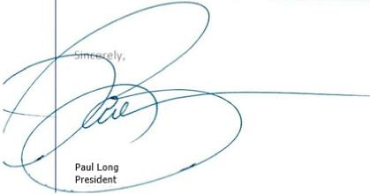
Kappa Studios
paulig] kappastudios.com
0: 818-843-3400

DISTRIBUTION

- Theatrical – Fathom Event
- Cable - we have contacted numerous cable channels for licensing deals once the film is completed.
- Film festivals - to increase the buzz, we will enter a select number of festivals to generate interest and support of Five Dates.
- Online streaming and VOD – we will pursue all options
- Foreign Markets - we have access to foreign distributors who have successfully negotiated foreign sales
- DVD sales
- College markets and airplane exhibition

COMPARISON MARKET REVENUES

"Low-budget' Family/Faith movies that have been incredibly successful, making up to 70X at the box-office

These include:
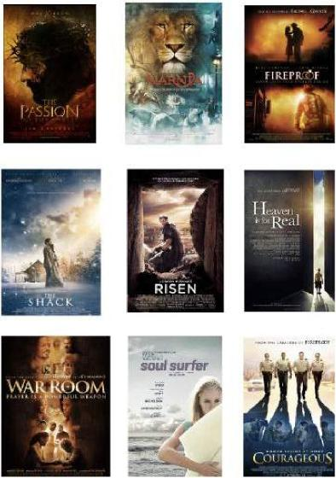
⁻⁻¹•1•=¹11
2,17
sauf sur⁻far
(⁻471 ..I.::
'Fireproof: cost $500K
'Courageous': cost $2M
`God's Not Dead': cost $2M
The War Room': cost $3M
`God's Not Dead 2': cost $3M
`Heaven is for Real': cost $12M
'Son of God' . cost $12M
The Shack" cost $ 12M
Soul Surfer': cost $18M
'Risen': cost $20M
'Passion of the Christ: cost $30M
'Chronicles of Namia: cost $180M
made $35M made $34M made $62M made $80M made $60M made $101M made $67M made $53M made $47M made $46M made $612M made $745M
ROI
7,000 % 1,700 % 3,100 % 2,667 % 2,000 % 842 % 558 % 442 % 261 % 230 % 2,040 % 414 %

TRADE REPORTS ON MARKET GROWTH
Faith Market is a growth market
For feature films, the demand for faith content is growing every year with strong theatrical returns to lucrative distribution platforms all wanting content.
Click on the Bussiness Insider, Bloomberg and Forbes Link for a review on this growing market
Bloomberg

BUSINESS
INSIDER
Forbes

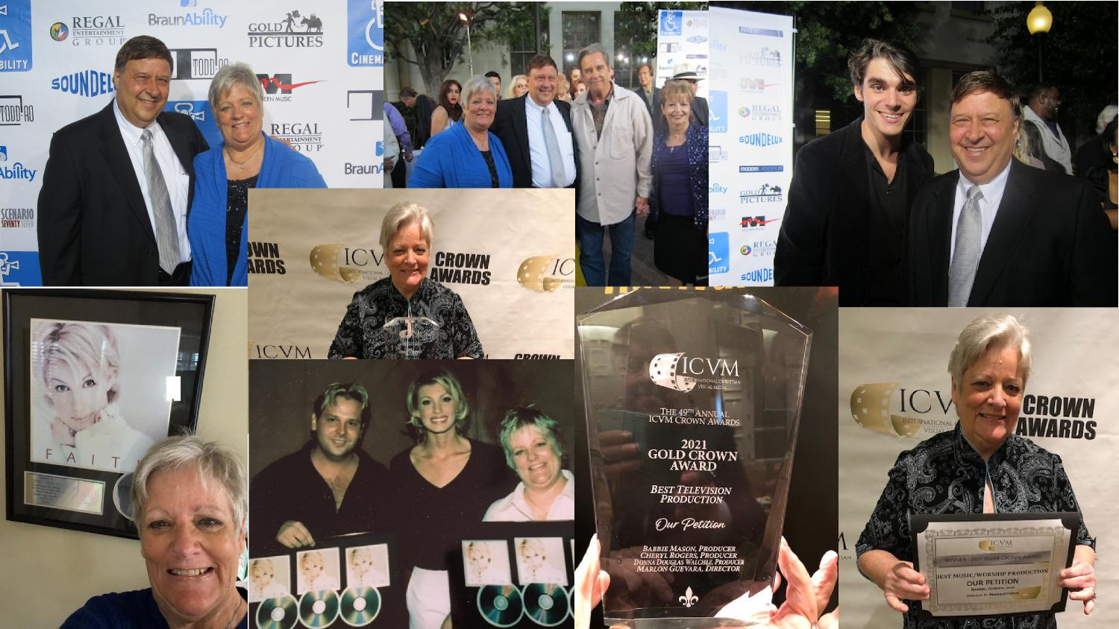
AWARDS

PROJECTS IN DEVELOPMENT
Posters are placeholders only and are not final print images.
A driven, successful record company executive has it all, or so she thought. It takes being ousted from the company that she built and 200 community service hours at a children’s home, to reveal what was missing in her life.
Screenplay by Donna Douglas Walchle
When life gives you lemons...
MAKE
LEMONADE
Logline:

PROJECTS IN DEVELOPMENT
Written by Donna Douglas Walchle

MAKE LEMONADE: SYNOPSIS
Casey Alliston, mid-thirties, is the attractive, driven, successful owner of an internationally renowned record company, Hit Maker Music and she’s obsessed with climbing corporate and social ladders. To further her claim of being ‘self-made’, she’s resistant to all things ‘God’.
One night, en route to a $1,000 a plate gala, in her honor, she is pulled over for several traffic violations, after smart-mouthing the officer, she is arrested in front of the hotel where she is being esteemed. With charges pending, Casey is forced to temporarily step down from the company she built for reasons of moral turpitude.
Casey’s day in court arrives and she is fined and sentenced to serve two hundred community service hours at a church-affiliated home for orphans, foster children and senior citizens. There’s no chance of reinstatement until her service hours are completed. To make matters worse, she learns that her best friend and attorney, Winnie Jenkins, is dating the arresting officer. As hard as she has worked for everything she has achieved, Casey has no use for children or old people, and has no tolerance for handouts or for charities that don’t personally benefit her corporate and social status. Initially, Casey meets her orders with the harshest of opposition, and would prefer wearing an orange suit and pick up trash on the roadside or serve a stint at Leavenworth, to this...
However, over time, Casey’s armor begins to crack. Although this strong-willed, woman-in-charge has every intention of being the teacher in this class, in the end, it is Casey who learns some invaluable lessons about love, life, giving back, God and the biggest shock of all, having her heart captured by 3 of the children. When life gives you lemons, making lemonade is the best thing to do, and for Casey, it is a tall, cool, thirst-quenching glass, indeed.

PROJECTS IN DEVELOPMENT
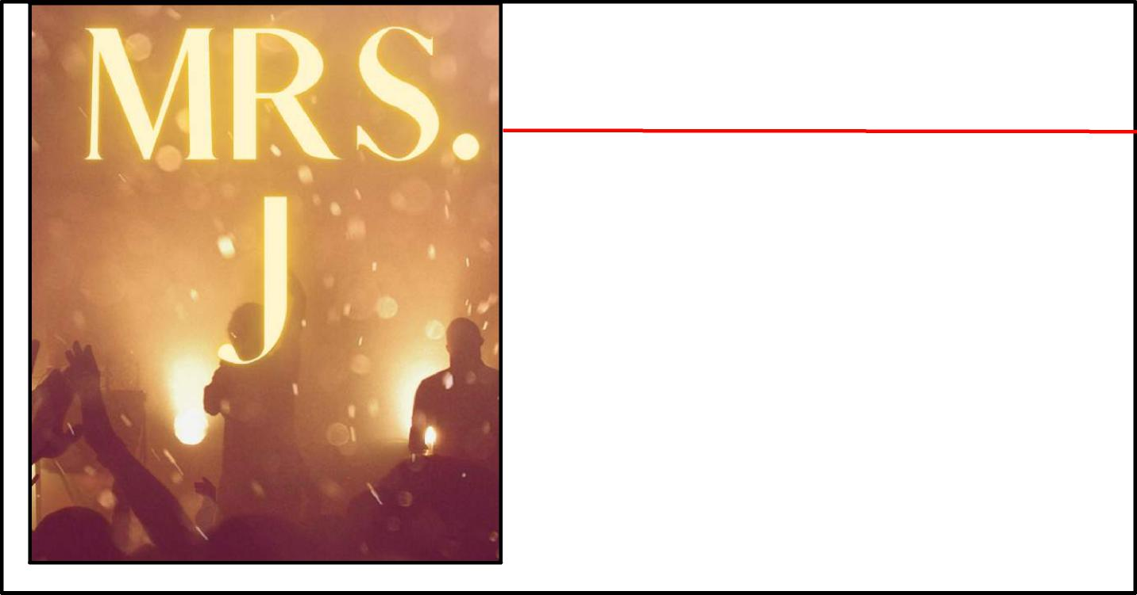
Posters are placeholders only and are not final print images.
An introverted sixteen-year-old actor/singer, befriends an elderly, forgotten film star, leading to an unexpected friendship and an end of the year summer performance at an Arts Center that all in attendance will never forget.
Screenplay by Donna Douglas Walchle
MRS. J
Logline:

PROJECTS IN DEVELOPMENT
MRS. J : SYNOPSIS
In her late seventies, Maxie Johnson, affectionately called, Mrs. J, is a spry, eccentric woman who has been a customer of Goldberg’s Deli for many years.
Connor Hampton, a shy, pensive, sixteen-year-old, whose interests include acting, singing, songwriting and collecting classic movies, has joined his actor father, Vito Hampton, who is working on location in Atlanta for the summer. His mom recently passed away and his dad has become emotionally unavailable. Connor takes classes at the Arts Center and has a part-time job at Goldberg’s Deli. At the close of his first day of work he is introduced to Mrs. J. Something about her rings familiar. He goes home and puts his favorite classic film, A SUMMER’S EDGE, in the DVD player. There, his suspicions are further raised. The star of this classic is named, Maxie Johnson.
When he musters up the courage to approach her, she thinks that he is making fun of her. Soon after realizing she has misjudged him, she confesses her identity and over time explains how and why she disappeared after only one film. Connor also learns that she’s been evicted from her home and is living in her car. He talks his Dad into allowing her to move into their palatial rental mansion in exchange for chauffeuring Connor to work and art center classes. Connor outs her to the head of the Arts Center and she graciously agrees to co-teach an acting class to Connor’s peers and assist with production ideas for their end of the summer production, she also gets a small part in Vito’s film playing his mother.
As the summer ends, Maxie’s heart’s desire is to be on stage one last time, she wonders what will become of her once Vito and Connor head back to the coast. However, undisclosed to her, Connor and Vito have a plan, and the legacy left by this almost forgotten treasure, teaches all who have the good pleasure of crossing her path that to “live in the moment” is much more than just an acting technique.
Written by Donna Douglas Walchle

PROJECTS IN DEVELOPMENT
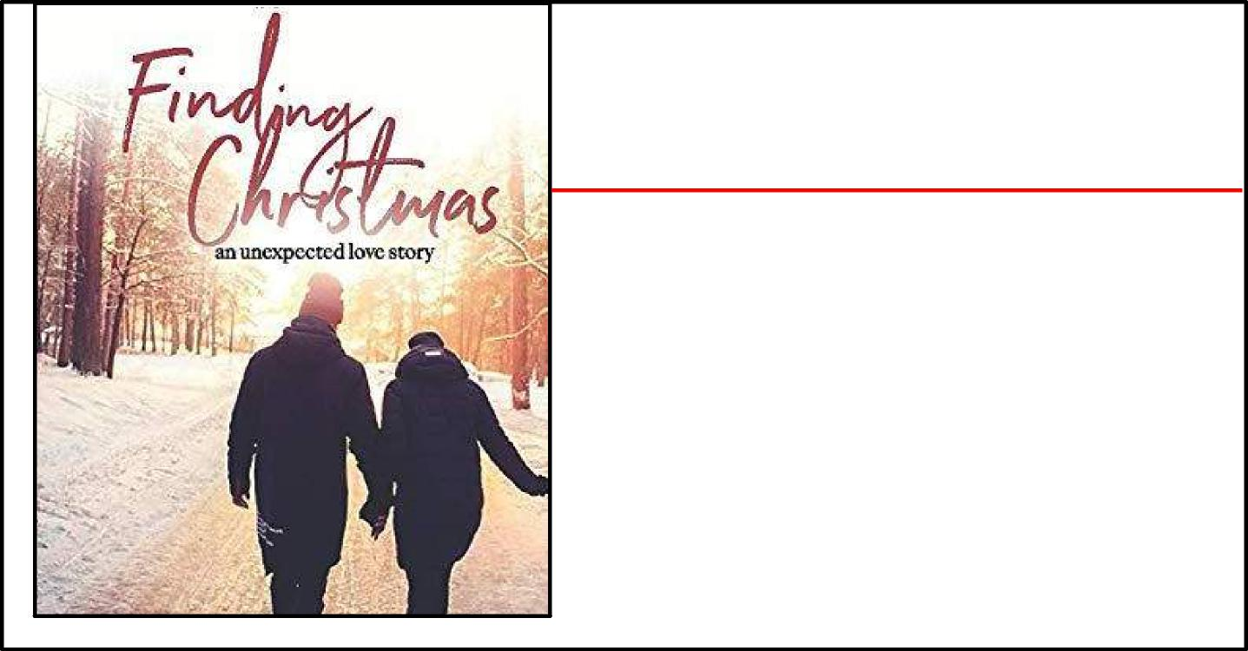
Posters are placeholders only and are not final print images.
Convinced that his life is over, Sam Waters, a reclusive billionaire widower, has an unusual encounter with a mild-mannered stranger who seems to know every detail of his existence, past, present and future. The kind stranger gently assures him that not only is his life not over, but the best is yet to come, a principle that for any one with an open heart, changes everything.
Screenplay by Donna Douglas Walchle
FINDING
CHRISTMAS
Logline:

PROJECTS IN DEVELOPMENT
FINDING CHRISTMAS: SYNOPSIS
Several years after his wife Becca’s death, Sam Waters, a youthful- looking, mid-fifties, billionaire, finds that he’s lost his drive for business, his interest in life and any desire to celebrate Christmas. Early one morning while visiting Becca’s grave, Sam is startled when a man wearing warm winter clothing and a hat with the initials, SSV, approaches him and introduces himself as the ‘Still Small Voice’. Sam resists with unrestrained skepticism and unloads his displeasure in large explosive doses. However, after SSV easily overviews the highlights of Sam’s entire life so far, along with a few hints of what the future may hold if Sam doesn’t make some adjustments, Sam elects to hear him out.
Amongst other areas of interest, SSV points out that Sam has completely lost touch with his adult children and grandchildren. His son, Robert, is married with two children and living off of a generous trust fund rather than hard work. His daughter, Callie was dismissed by Sam when she married a pastor whose earning potential didn’t meet up to his expectations for his treasured princess. Callie and Pastor Jack have a spunky little five- year- old disabled daughter named Megan that Sam has never met. Marianna, Sam’s personal assistant, was Becca’s best friend since they were nine years old. Marianna has never married and although open to it, says that so far no one has ridden up on a white horse and swept her off of her feet. For the first time since Becca’s passing, Sam allows his home to be decorated for Christmas and Marianna coaxes Sam into helping her decorate the big tree in the family room, a tradition that she and Becca enjoyed. Spending this personal time together causes Sam to see her in a way that he never has before.
When the church has the annual Christmas play that Becca always dragged Sam to every year, Sam not only goes willingly but his reunited family occupies an entire pew. At the conclusion of the service, an answer to the prayers of many walks through the back door of the church. It’s nothing short of a Christmas miracle! Sam rediscovers the things that comprise life at its best and most meaningful. He understands firsthand that being rich in life has little to do with money or social status. Although his generosity changes a lot of lives the life most changed is his. It all began with finding Christmas: a principle that for any open heart, changes everything.
Written by Donna Douglas Walchle

PROJECTS IN DEVELOPMENT
Posters are placeholders only and are not final print images.
After suffering several highly publicized blows to her own personal life causing her stellar career to become a punchline, a disgraced internationally renowned Life Strategist, intentionally pursues exposing herself to a series of dangerous scenarios, but becomes further frustrated when each incident backfires and she's repeatedly hailed a hero.
Sometimes winning requires losing everything
Screenplay by Donna Douglas Walchle
EXIT
STRATEGY
Logline:

PROJECTS IN DEVELOPMENT
EXIT STRATEGY: SYNOPSIS
Gabby Cardoni, a successful, internationally known Life Strategist, finds that the eight-step plan she customarily offers others, isn’t enough to get over her own hurdles. She receives extensive negative press coverage resulting in the termination of her television contract, all of her books are pulled from the bookstore shelves and her literary agent receives a plethora of cancellations for future speaking engagements.
Gabby’s investments and savings are quickly depleted, and out of desperation she's forced to move in with her neighbor who is raising her seven-year-old grandson.
Gabby wishes she were dead but would never consider damaging her reputation with such an act, and so her mission transforms as she begins to put herself in risky situations hoping someone else will do the deed. However, every effort backfires and she comes out the hero rather than the victim.
Gabby draws more positive press coverage than ever before, becoming an ever-present feature on the nightly news. Although undisclosed to her, everyone from agents, to book publishers to film producers are taking note. Over time, Gabby comes to the realization that her life’s purpose goes well beyond television ratings and book sales. She capitulates to an unknown and vastly redefined future as a resident of this place called surrender. There, she rediscovers the love, laughter and passion for a completely different life that she'd almost left behind as she embraces an invaluable life-lesson, that sometimes winning requires losing everything.
Written by Donna Douglas Walchle

(404) 409 - 5145
CONTACT JAMES WALCHLE
jim@films4flyovers.com
www.Films4Flyovers.com

