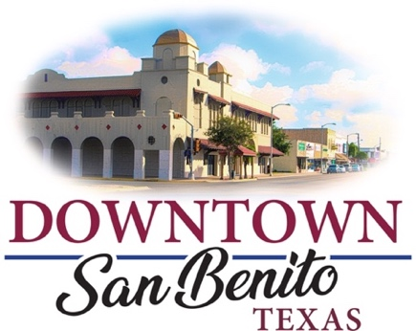


2022 Downtown San Benito Art Murals Application

- Complete the 2022 Downtown San Benito Art Murals program application.
- In a single PDF or Microsoft Work document include the following items:
- A one-page resume or short biography.
- JPG images of a color rendering of proposed mural.
- JPG images of the site and physical surrounding.
- Up to 6 JPG images of artist’s past work, if more than one artist submits 6 JPG images per artist.
- Mural Project Timeline.
- Mural Project’s budget including the artist’s fee, estimated materials costs.
- Contact information for 2 references from past mural clients.
- Letter of commitment from building/property owner to include commitment to keep the mural in place as approved for a minimum of 3 years.

Artist Information
Lead Artist’s Full Name: ________________________________________
Street Address: _______________________________________________
Website: ____________________________________________________
Main phone: _________________________________________________
Email: ______________________________________________________
Describe the artist’s past experience creating murals.
________________________________________________________________________________________________________________________________________________________________________________________________________________________________________________

Mural Location
Building Name: _______________________________________________
Business(es) Located in Building: _________________________________
Street Address: _______________________________________________
City, State, Zip: _______________________________________________
Property Owner Name: _________________________________________
Property Owner Contact Info: ____________________________________
Cell phone: __________________________________________________
Business phone:______________________________________________
Email: ______________________________________________________

Mural Proposal and Materials
Describe the concept, composition, and purpose of the proposed mural:
________________________________________________________________________________________________________________________________________________________________________________________________________________________________________________________________

Describe mural’s relevance to its location and the community that will be impacted by it.
________________________________________________________________________________________________________________________________________________________________________________________________________________________________________________________________

From what intersections/viewpoints can pedestrians and vehicle see the mural?
________________________________________________________________________________________________________________________________________________________________________________________________________________________________________________________________

What is the composition and condition of the wall the mural is to be on and how will you prepare the wall appropriately?
________________________________________________________________________________________________________________________________________________________________________________________________________________________________________________________________

What’s the mural’s proposed dimensions?
________________________________________________________________________________________________________________________________________________________________________________________________________________________________________________________________

What painting materials do you plan to use?
________________________________________________________________________________________________________________________________________________________________________________________________________________________________________________________________

Describe your commitment to repair the mural surface as necessary before painting & a plan for mitigating graffiti through design and/or graffiti coating.
________________________________________________________________________________________________________________________________________________________________________________________________________________________________________________________________

Expenses
Artist fees: __________________________________
Assistance fees (if applicable): __________________
Permit fees: _________________________________
Supplies/Materials: ____________________________
Installation fees: ______________________________
Insurance: __________________________________
Wall Preparation: _____________________________
Scaffolding/Ladders/Lifts: _______________________
Other Expected Expenses: ______________________

