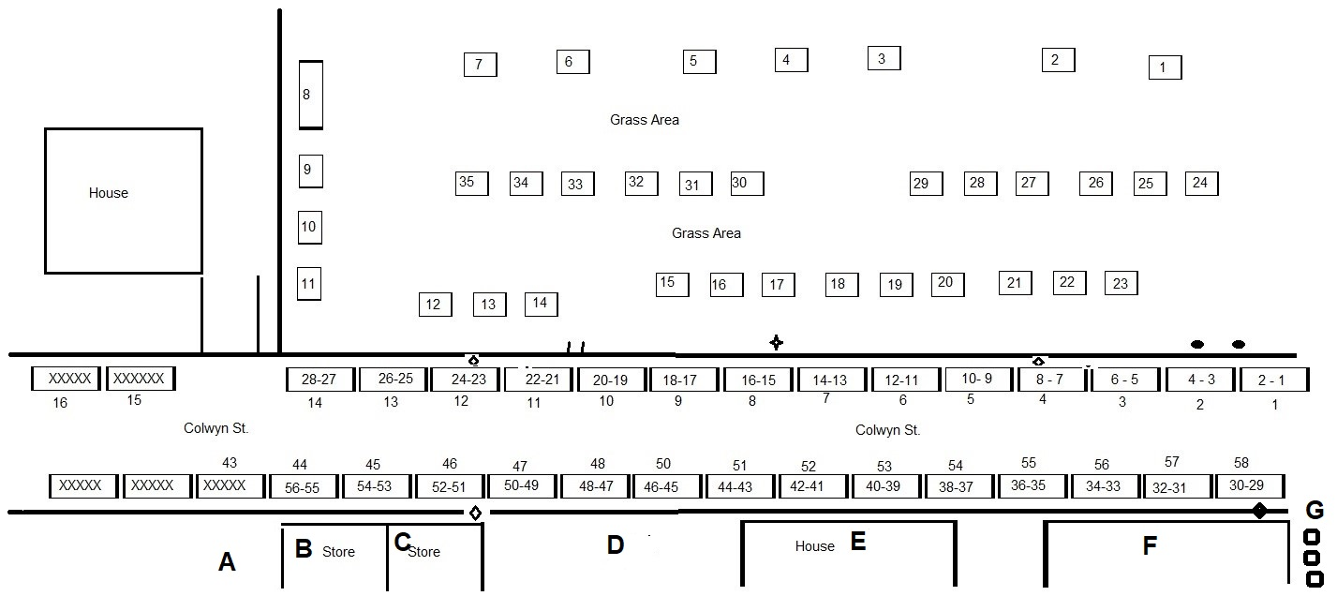
Last update 8/26/2019
Colwyn St.
Genealogical, Historical, Surname, Food and Living History located on Colwyn St. The numbers on the outside of rectangles are parking spots. Numbers on the inside of rectangles are vendors.

1 Claiborne Co. History & Genealogy Society
2 Union Co. Tennessee Cemetery Association
3 Matthew Aaron Clark Living History
4 Brett Compton East Ave. Rare Books local History and Genealogy.
5 U.S. Census Bureau
6 National Society Descendants of Early Farmers NSDAF
7 Davis Creek Primitive Baptist Church Membership Book 1797
8 Nickie Mozingo, Domestic Violence Advocate and Community Outreach for Cease, Inc.
9 Meigs Museum Decatur, TN
10 xxxxxxxxx
11 RK Smoking pig BBG
12 RK Smoking pig BBG
13 xxxxxxxxx
14 xxxxxxxxx
15 xxxxxxxxx
16 xxxxxxxxx
17 xxxxxxxxx
18 xxxxxxxxx
19 xxxxxxxxx
20 XXXX Steps
21 XXXX Steps
22 xxxxxxxxx
23 xxxxxxxxx
24 xxxxxxxxx
25 xxxxxxxxx
26 xxxxxxxxx
27 xxxxxxxxx
28 xxxxxxxxx
29 Bell County Historical Society
30 Surname Tent Massengill Nelson
31 Surname Tent Massengill Nelson
32 Surname Tent Massengill Nelson
33 Surname Tent Massengill Nelson
34 Martin Station Chapter SAR Donald Campbell
35 Help with starting your family tree with Dora
36 Cumberland Gap Tennessee Genealogy & History Group (CGTGHG) and Genealogy Jamboree and Pioneer Days
37 Dick Gault Talking 1 on 1 Civil War History & more
38 d&p Designs Birdhouses
39 xxxxxxxxx
40 xxxxxxxxx
41 xxxxxxxxx
42 xxxxxxxxx
43 xxxxxxxxx
44 xxxxxxxxx
45 xxxxxxxxx
46 xxxxxxxxx
47 xxxxxxxxx
48 xxxxxxxxx
49 xxxxxxxxx
50 xxxxxxxxx
51 xxxxxxxxx
52 xxxxxxxxx
53 xxxxxxxxx
54 xxxxxxxxx
55 xxxxxxxxx
56 xxxxxxxxx

A Festival Park
B Cumberland Gap Artists' Co-Op
C Olde Drug Store Closed
D Living History Demonstration Smelting
E Victorian house Living History front yard
F Cumberland Gap Park General Store Closed
G Porta Pots

Grass Area
Living History, Crafters and Food vendors in the Grass Area. Numbers on the inside the squares are vendors location.
1 Lester & Judy Wilson (Basket & Caning)
2 Leather by Gary Prater **
3 Blacksmithing by Kelvin Ryder**
4
5 Over Mountain Victory Trail Association
6 Tennessee Sons of the Revolution
7 xxxxxxxxx
8 xxxxxxxxx
9 xxxxxxxxx
10 Living History demon Charcoal making
11 Living History demon Charcoal making
12 Living History demon Charcoal making
13 Living History demon Charcoal making
14 Living History demon Charcoal making
15 xxxxxxxxx
16 xxxxxxxxx
17 xxxxxxxxx
18
19
20
21 Father & Son Paul Douglas(son) antiques, heirloom seeds, hand carved things such as walking stick.
22 Clinch Valley Beekeeper Association
23 Tom Kitzmiller Woodwork & Antiques**
24 Gap Creek Apothecary, natural way of living.
25 Healing Stone Handmade Jewelry by Angela
26
27
28
29
30 xxxxxxxxx
31 xxxxxxxxx
32 xxxxxxxxx
33 xxxxxxxxx
34 xxxxxxxxx
35 xxxxxxxxx

