HOW ARE POLES MADE!
Selecting the right size pole should be the first decision made by a coach and the athlete.
If the pole does not fit the athlete and their ability, the coach will face an unnecessary hurdle in helping the athlete achieve his or her potential.
So many skip this phase which should be listed right in there with beginning vaulting!
First one should have some understanding about poles and how they are built.
1. A vaulting pole is made up of fiberglass and it is rolled on a mandrel. The first wrap or wraps is the hoop wraps. The provide strength to the frame of the pole and contributes to the HOOP strength of the pole. Alignment of the mandrel’s soft side, how the mold sags and a marked starting place for every pole made on that mandrel is very important for calculating the soft side and pre-curve of the pole! One may use a bi-direction weave of glass or us a longitudinal weave cut side ways and applied to provide strength around the pole.
2. A carbon wrap can be applied at this point after the Hoop Wrap to further stiffen the pole with CARBON for a little more costs, yet much less weight than standard glass! A spiral works the best as this provides a ratio of strength to hoop and to the stiffness of the pole!
3. The next set is usually the body wrap or stiffeners to the body of the pole.
It is a rectangle piece of glass that usually requires a wrapping of 3 wraps to form the body of the pole. If one is using Carbon, less wraps of this material can be applied. It is crucial that the starting place be determined to reduce an event called twisting. On poles the starting point s exactly the other side of the mandrel from where we started the first piece. This allows RIB of the overlap to be positioned on each side of the pole. The Accelerator pole company designed its poles with the use of carbon as a strip to provide the RIB. Yet they had many twisters due to miscalculations of the layup of the glass! Using some of this concept we allow the GUFF or end of the glass to roll on top of itself at the end of the wrap to provide that one side one extra layer than the rest of the pole has. With the first wrap and second wrap using this concept the pole has a layer of glass extra on both sides of the pole . This extra strength is in an important position to provide a stronger side to reduce Blow out of hoop failure. It also makes the outside of the pole oval and not round and the pole can only bend in one direction, alas no twisters!
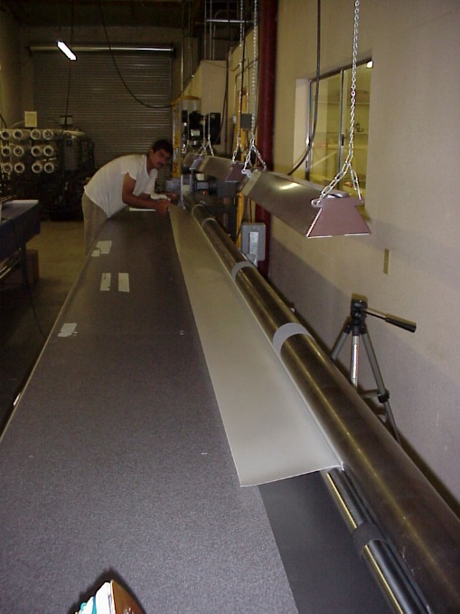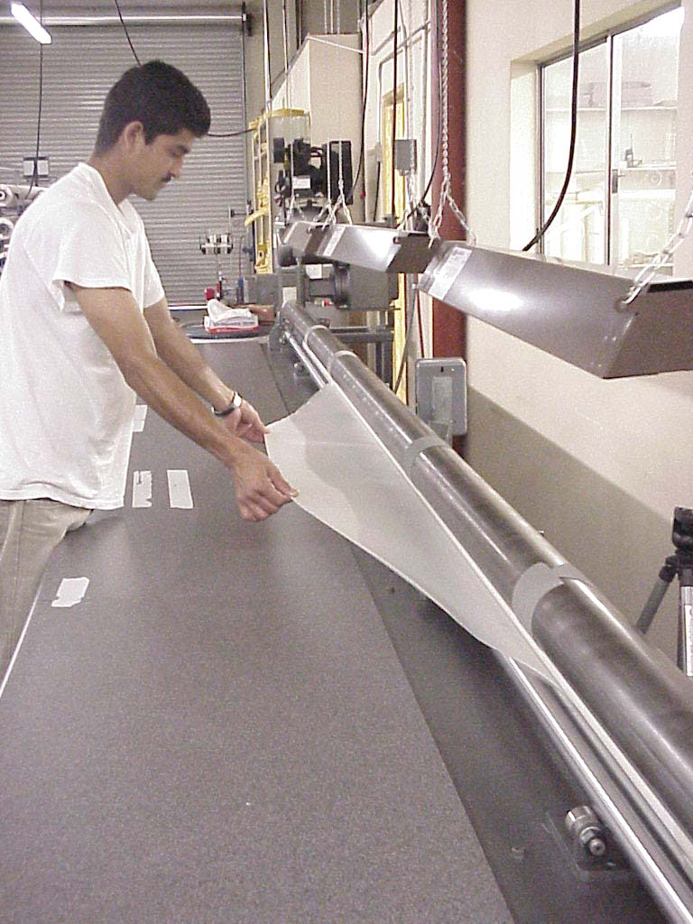
3. A spiral of glass or carbon will be used depending on the stiffness or brand or type pole being built. The angle of the spiral determines how much stiffness contributes to the stiffness of the pole. Or one can use a straight strip of carbon wrapping it around the pole providing 100% of the Carbon strength used in the stiffness of the pole. This will make the pole come back much faster that when used to add to a properly built non carbon will result in a carbon pole that will return to vertical too fast for the vaulter’s timing. Incorrect use of this lay-up will result in pole that will throw you really high in the air but reduce your depth of penetration on top of the bar. For years one company made fast returning poles only to result in vaulters clearing the bar by 1-2 feet but having to volz or touch the bar to keep the crossbar away so they will not land on it. Many vaulters cleared their highest bar only to bring the bar down with lack of penetration on top of the jump! Making a pole lighter as well as a pole that will time with the vaulters jump is a very difficult challenge that has most certainly met. The sacrifice in most cases is we are not as light of a pole as those who have crossed that line!
4. Then a sail wrap that is shaped to provide additional properties at critical points in the structure of the pole that the other layers do not contribute. This sail will vary from each manufacturer and for each type of pole being built. To keep the poles consistent through out the whole line and allow a smooth transition, one must keep the length of the sail D and the length of A and B the same for that mandrel size and pole length.
These variables are the to be the same for the mandrel used for that length and a mathematical calculated adjustment is made when moving to a longer pole by the pole maker! Other pole makers widen the length of A and B to get a stiffer pole, however this distorts the reaction of how the pole receives energy and expels it back to the vault! On All poles Earl Bell had a request to keep the length of E plus A and B to be equal to half the length of the pole. This one move to establish a better rolling pole has been crucial in the line. Thanks to Earl Bell and his years of experience in Coaching and seeing the athletes needs!
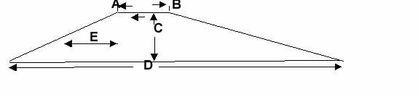
5. A butt or reinforced area is applied to the pole to support the pole as it is removed from the box or to add strength at the butt for planting the pole. Some put very little importance on this wrap. The use carbon to get the strongest wrap with the least amount of weight, crucial at the very end of the pole. One manufacture builds the glass up in order to fit their pole tip line. With this method you may need a little grip tape to secure the pole tip but the end of the pole is attractively light!
In a perfect pole design process we measure the sail wrap as all other properties stay relatively the same in perspective to the vaulter needs. Using a design method that changes the sail, and the body to get the stiffness required throws the vaulter off in his timing when moving from one pole to another.
The pole is at this point ready to be placed into an oven and heated by various methods such as high pressure steam to heat and cure the pole and or heated oil which is more efficient and controllable.
Since this article was written technology used by the new pole maker of the Altius poles shared a cellophane wrap to provide a better solution and it works both with oil and steam. We were experiencing a high cost of replacing bags with the use of 25 poles per rubber bag. The cellophane method introduced by Altius reduces any moisture to the pole, improves bag pressure, and yields 150 poles to rubber diaphragm bag. Further research found a special shrink wrap to further eliminate air voids in the pole, by increasing the pressure on the pole.
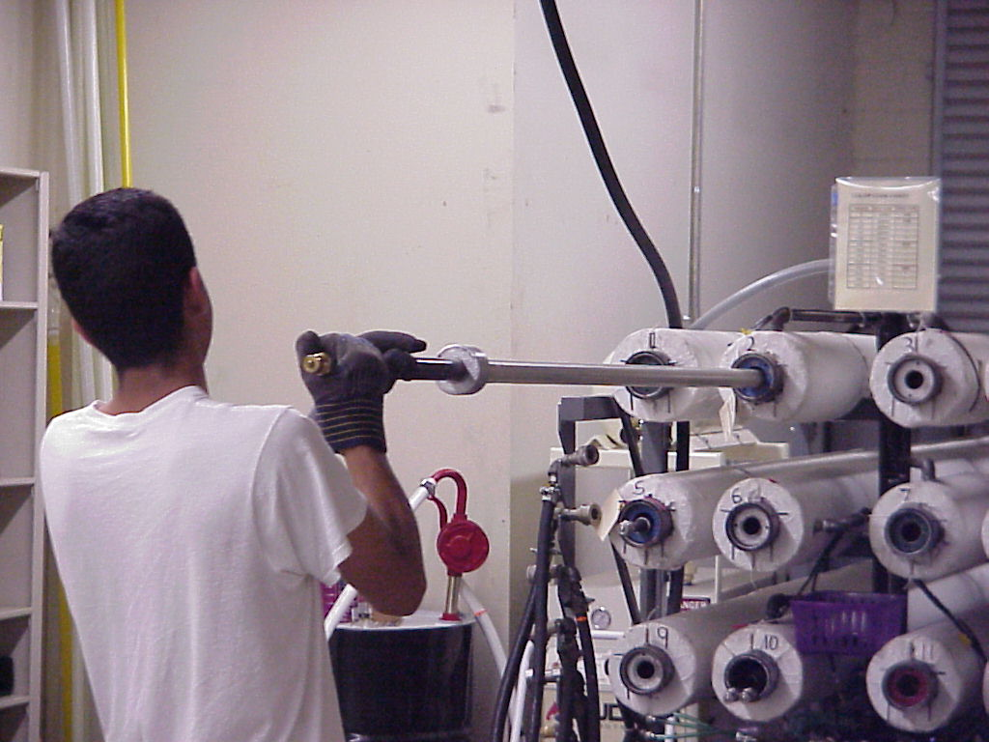
Once the pole is constructed with its pattern, the end result is a pattern unique to each pole and specific glass properties unique to each brand. It is tested to insure the pole is built properly and sound. Our method is 100% inclusive and we maintain a record of each test.
All poles are tested farther than they bend in use.
Once the pole has past this test it is then measured on a butt sail de-flex machine for relative stiffness. A flex number is a very general, non-scientific way of comparing the stiffness of a pole to all the other poles without regard pattern and glass properties.
A flex number is derived by using the universal flex system invented by Herb Jenks of Sky pole. This system was shared with Cata-pole, then with Pacer/Skypole, and, has been finally, adopted by UCS/Spirit.
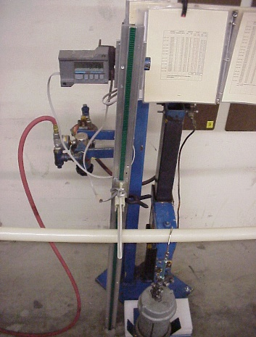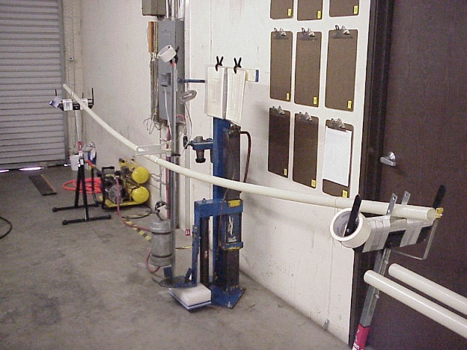
A frictionless support on both sides of the pole with a method of measuring the deflection load of a 50 lbs weight suspended in the middle of the pole.
Each length of pole has a specific span that the end supports are set to depending on the brand and length. Each span will produce a reading based on the relative stiffness of the pole in relationship to its structure and the 50 lb weight.
The flex spans of the system were changed by Pacer/Skypole in 1996 to reflect a more precise measurement. Which when working with flex number one should never rely on this number being an exact. Many conditions alter the results such as altitude where the measurement is being made, the friction if any on the supports, humidity in the testing area, and many other little things to alter the number found by at least .2! Some methods use 6 inches from the butt for a measure point, Earl Bell and Tye Harvey flex systems use 12 inches from each side as a measure. Many forget that the method of measure is measuring the sail wrap only not the whole pole. Measuring the whole pole provide a reading of stiffness in the grip area contributed to flex number an area vaulters do not bend the pole. So this type of reading maybe considered more accurate it will be very much different by .4 than a butt sail measurement. Both methods do provide a relative stiffness if you are measuring the pole on the same machine.
Flex numbers from brand to brand will vary due to the following inconstancies;
- The span to support the pole is different with each manufacturer!
- Some use a weight in Lbs and other sin KGs.
- Some measure from 6” from the butt of the pole and others from 12”.
- Some have a wider span that others measuring more of the poles stiffness not relative to the stiffness of the pole.
- Many have had their number out in the market place for years and to change or adjust at this point in time would be devastating to matching future poles to what you are using. It would be just Chaos to all pole makers!
When you are moving from one pole to the next you expect it to be only stiffer but to react the same. One manufacturer uses so many changes to the pattern it is very necessary that they have a more precise system to measure the butt flex number.
Each brand has a marking that tells you the load at which the pattern of the pole will hold the load; this is called the pole rating. All brands used are differential by only 2.2 lbs between brands. Far too many athletes rely on the flex number as the basis for evaluating a pole and depend on the flex number as a magic number. Let me help you throw that myth out the door with this statement.
The flex number of a 12’ 2” PVC plastic tube is the same as 12’-125 lbs test pole but you could not vault with it could you?
A flex number is only a relative stiffness number and can only compare stiffness. It will not allow comparison of flexural ability, hoop strength, elasticity properties, or even the load the pole will hold. All these properties and the load it will hold is determined by the pole pattern and the type of glass used. So flex numbers are a guide and cannot be related or used to calculate the load a pole holds. They are only a relative stiffness of one pole brand to the same pole brand and within that same length only, all things being equal. One brand pole may be made a different way, may have a longer sail or shorter sail, and it may have more or less wraps of the body wrap. A method of flexing the pole to measure more of the pole is not going to derive the same or a relative flex number of a system that measures only the sail of the pole.
So as a result I strongly recommend you forget about flex numbers until you are building a series of poles or until you have 4 to 6 poles in your series.
So this brings us to how many poles should you have?
To be really into the pole vault one should have a minimum of three to four poles depending upon experience.
- The everyday pole, the Blue one that is soft and will work in head wind or on rainy days. This is usually the pole you work out with and can start in any meet with.
- The Money Pole, the Green one when you have it all together, a pole that always works when conditions are just right.
- The adrenaline Pole, the red one that is ready for you when you move the grip up 1 fist or when you are going for that Personal Record.
- The next pole in the line. It may be longer it may also be stiffer in weight rating.
In the beginning you may only have the budget for one pole. This one should be no longer than 1 foot over what you are trying to jump, and must it be able to handle 4.4 lbs (2 kilos) above your weight. As you progress, your first pole if kept in good condition can be your “blue pole”, and the new one can fill the role of being your “green pole” as described in items 1. and 2. Above.. Then as you progress, you will develop the confidence to throw everything at the bar with a “red pole” when you feel that surge of adrenalin and assurance that the goal can be yours.
To explain this process, we convert imperial to a Metric number such as 2.2 lbs equals 1 kilo. Kilo divided by 2.2= lbs. Always round up when using this method converting back to imperial!
Having the poles 4.4 lbs or 2 kilos apart is the best until you get to the end of the season then 2.2 lbs or 1 kilo works may be more appropriate as you go higher in smaller increments. As you get to pole over 200lbs one must realize that a system of measure that is suppose to be perfect and uniform will have its flex numbers worth more stiffness as the measure becomes less of a measurement.
Other words as the number gets smaller 2 flex numbers will be much more stiffness than flex number in the middle of the scale. So if you are working beyond 200 lbs on a pole select your poles closer together more like 2.2 or even by flex numbers of .2 if you can afford more poles.
This concept complies with National Federation High School rules and works best when the vaulter selects a pole that is rated over their weight. Another requirement is that the vaulter must be holding in the grip area, no higher than 6" from the top of any pole or no lower than 18" from the top of the pole. This is very important for developing proper technique and efficient timing on the pole. Keeping the hand grip closer to the height that the vaulter jumps is important in the development stages for good technique. Most pole manufacturers are producing their poles with 5 lb. increments (light to heavy models with varying flex numbers). You, as the athlete or coach probably do not know what those numbers mean or where they fall in the light, medium, or heavy ranges of the 5 lbs. increment. Once you get a variety of poles then the flex number will be apparent to you within the same lengths.
SOLUTION using LOGIC to move from one pole to another: A method using the standard metric measurement of 1-2 kilograms or 2.2 - 4.4 lbs. increments between poles to assure exact measurement and labeling in 10’s works the best. There is no overlapping of crucial stiffness ratios, no rounding up or down. (Example: a 54 kilo pole is not 120 but actually 118.8 lbs. Some manufacturers round it off and say it is a 120 lbs test pole). Use the Kilo number as a POWER number to move from one size to another. This system will eliminate the complication of actual pole size to allow the coach and vaulter to work on the important aspects of the vault - TECHNIQUE!

HOW TO SELECT A POLE
It is always better to select a more powerful and stiffer pole to keep the lift of the vault than to move to a longer pole and have to move the weight rating down to accomplish penetration. Obtaining good penetration with a stiffer pole will yield faster and more lift to the hips.
This is demonstrated and very apparent by the Jan Johnson relative stiffness chart located on the net at
The biggest mistake in ordering poles is to raise the handgrip more than 1-4 inches or one fist at a time. Moving to a longer pole and moving the handgrip up more than a fist can alter the timing of the vault thereby required the vaulter to complete readjust their vault to again get the timing down. Only change one thing at a practice not multiple things, it must be a controlled situation.www.fibersportpoles.com
Www.fibersportpoles.com
FiberSport Poles - Pole Vaulting Poles, Pole Vaulting
Vault Safe / Have Fun!

