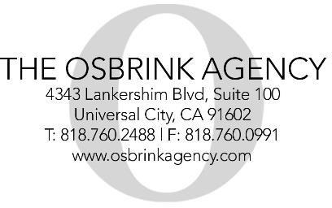

Londyn Regimbal 10/28/2013
Brown / Hazel

LONDYN REGIMBAL
Updated 11/11/2018

Agent: The Osbrink Agency 818.760.2488

DOB: 10/28/2013
Height: 45.5”
Weight: 47 lbs Ethnicity: Caucasian
Hair: Brown Eyes: Hazel Clothing Size: 5T Shoe Size: 12/13

COMMERCIAL
POP-IQ |Principal |National, Web, Cable | Ashley Avis
Vylla | Principal |National, Web | Ryan Knight
Amazon | Funrise Toys | Wonder Park

TELEVISION
Timeless |Co-Star (Flynn) | Director: Eric Kripke and Shawn Ryan
Life In Pieces | Co-Star (Larks Friend) | Jason Adler
Artista Obscura |Co-Star (Young Da) | Ryhan Schwartz

FILM
CHILD | co-Star (Neshemia) | Talia Zucker

PRINT
Tiny Trucker | Kaylee Taylor
Fellimi Couture | Jenni Fellimi
Educational Insights | Liesl Kadile

STAGE
“It’s A Spring thing” Lead

SKILLS/TRAINING/ATTRIBUTES
Diving, Gymnastics, Swimming, Taekwondo, Running, Scooter Riding, Trampoline, Snowboarding, Bike Riding.
Very good student, great learner, fantastic memory, listens well and follows directions.
Very sweet, quirky, friendly, loves to perform, dance and sing.

