
206 Old Rd. Eliot ME 03903 207.956.0565 info@pinetreeinstitute.org

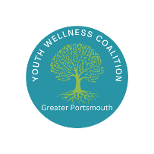

Greater Portsmouth Youth Wellness Coalition
December 17, 2025

Attendees:
Amy Michaels, Meghan Stewart, Larry McCullough, Lisa Jacobus, Mary Calhoun, Gina Abood, Ashley Murphy, Tristan Anderson, JoAnne Coles, Kelly Hartnett

Agenda:
- Welcome, introductions, and opening activity
- Corinne Shea with Institute for Behavior and Health One Choice Prevention
- Coalition updates

Discussion:
- Welcome, introductions and opening activity
- One Choice Prevention – slides attached
  - Highlighting prevention as a public health message and norming non-use for youth
  - We need more parenting support groups (Upper Room has virtual Parent Café meetings open to anyone but it would be great to have local options)
  - Seeing a lot of young people locally who may feel THC/marijuana is less stigmatized than mental health medication and using it in place of MH medication
  - Also seeing an uptick in THC/marijuana-induced psychosis in NH

Next Meeting: Wednesday, January 21st 9:00am-10:30am at Community Campus, Activity Room 4

