
206 Old Rd. Eliot ME 03903 207.956.0565 info@pinetreeinstitute.org

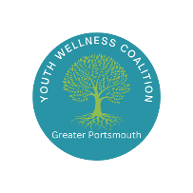

Greater Portsmouth Youth Wellness Coalition
February 18, 2026

Attendees:
Amy Michaels, Meghan Stewart, Ashley Murphy, Brady Barre, Larry McCullough, Brooke Cochran, Lisa Jacobus, Mary Calhoun, Whitney Brown, Kelly Hartnett, Sam Thamsen, Lisa Rappaport, Becky, Alana, JoAnn Coles, Rich Blaloc, Gary Bleddyn, Rochelle Jones, Danielle Heaton, Jennifer Del Deo Barry

Agenda:
- Welcome, introductions, and opening activity
- Coalition updates
- Gary Bleddyn with Granite United Way
- Yoga in Action with Rochelle Jones
- Coalition member updates

Discussion:
- Welcome, introductions and opening activity
- Coalition updates
  - More discussion on unregulated intoxicants in Greater Portsmouth – have people been seeing things like kratom, whippets, THC products for sale at convenience stores?
    - Keep an eye out so we can decide as a group how we want to address this if it is becoming a growing problem
    - New Futures has taken this on as a priority for this legislative season: https://new-futures.org/issues/regulation-of-addictive-products
- Gary Bleddyn with Granite United Way
- Yoga in Action with Rochelle Jones

Next Meeting: Wednesday, March 18th 9:00am-10:30am at Community Campus, Activity Room 4

