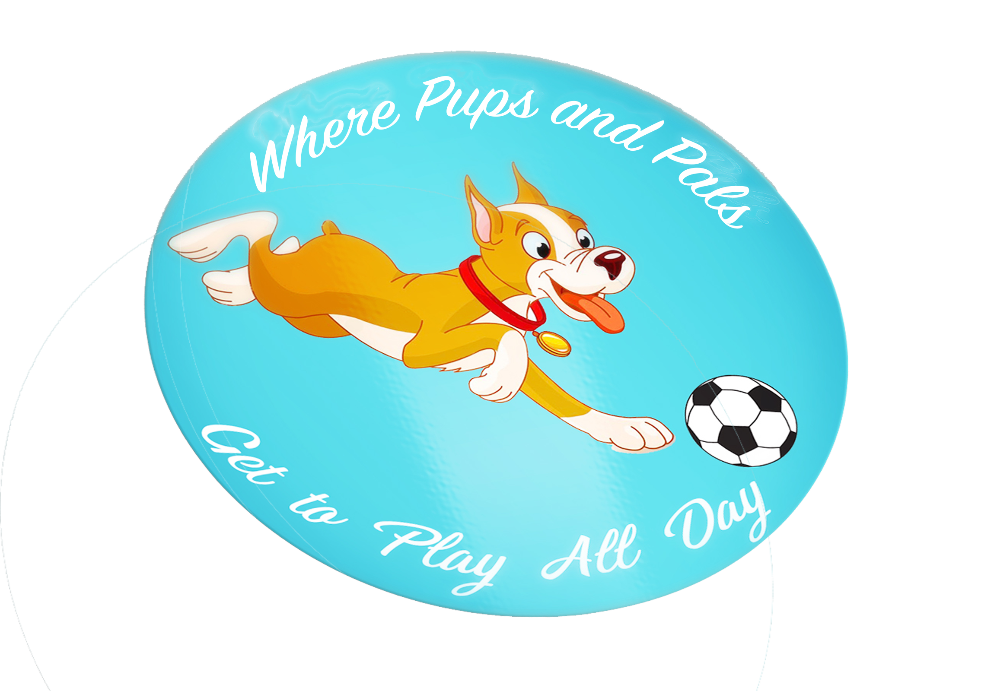

Total K9 Doggie Daycare Agreement

Doggie Daycare is designed for social dogs to play and have fun. Safety is our primary goal; therefore, **daycare is not for every dog**. It is not a place for aggressive or fearful dogs to learn how to be social. To be accepted into our daycare program, each potential daycare guest must:

1. Complete this Agreement

2. Provide us with a copy of your dog(s) shot records

3. Be spayed or neutered (except puppies under 6 months)

**CLIENT INFORMATION:**

Owner’s Name___________________________________________________________

Address_________________________________________________________________

City______________________________State___________________Zip____________

Home (___)________________Work (___)_______________Cell (___)_____________

Email ____________________________________________

**EMERGENCY CONTACT(S):**

Name_________________________Phone__________________Relationship_________

Name_________________________Phone__________________Relationship_________

Others authorized to pick-up my pet___________________________________________

Veterinary Clinic _________________________________________________

Phone________________

**PET INFORMATION:**

Pet ’s Name_________________________________

Primary Breed_________________________________Color______________________

Sex:  Male  Female  Spayed  Neutered Approximate Weight ____________

Birth Date: ___________________ How long have you had this pet?__________________

This pet is from:  Rescue  Store  Breeder  Stray  Other_________________

**MEDICAL INFORMATION:**

Does your pet have any injuries/health concerns that require special attention?

□ Yes □ No

If yes, please explain _________________________________________________________

Does your dog have hip dysplasia? □ Yes □ No

If yes, are there any restrictions on your dog’s activities or movements: ___________________

___________________________________________________________________________

If there are previous injuries, I understand that daycare may cause a flare up of that injury and hereby waive any fault to Total K9

____________ Initials

Is your pet taking any medications? □ Yes □ No

If yes, please specify medication(s) and the condition being treated:

_______________________

____________________________________________________________________________

**BEHAVIORAL INFORMATION:**

Does your pet engage in any unusual or repetitive behaviors?  Yes  No

If yes, please explain:______________________________________________________

Has your pet ever bitten a person?  Yes  No

Has your pet ever bitten another dog?  Yes  No

Additional information you should know about my pet: _________________________________

**DAYCARE TERMS AND CONDITIONS:**

To ensure the health and safety of your dog and all other guests, we require that all of our clients agree and comply with the following terms and conditions:

**Please initial each line**

________ I specifically represent to Total K9 that I am the legal owner of my dog. In addition, my dog is healthy, my dog meets Total K9 vaccination standards, my dog has not harmed or shown aggression or threatening behavior towards any person(s) or other dog(s) and has not been exposed to any known communicable disease within the 30 day period immediately prior to admission to daycare. I further represent that each time my dog is brought to Total K9, I will be recertifying that my dog is in good health and has not had any communicable illness of any kind for 30 days prior to admission. I further agree to inform Total K9 of any changes in my dog’s condition and/or behavior prior to any daycare visit.

_________ I understand that my dog must be spayed or neutered prior to attending daycare (if 6 months of age or older). In addition, I am not permitted to bring personal items to daycare.

___________ I understand daycare is offered between _7___ A.M. – _6___ P.M. Dogs not picked up by closing time (__6__P.M.) will be charged $10.00 for every 15 minutes after _6:15__ P.M.

___________ I understand that daycare is by appointment only. If you have certains days you want your dog to come regularly on, please confirm weekly.

____________ All dogs must be dropped off by Noon for daycare. No dogs will be accepted after that time, for safety reasons.

___________ **NO CALL/NO SHOWS WILL NOT BE TOLERATED** If you can not bring your dog that day, you must call/text us to let us know. No call/no shows will result in your dog not being allowed to come to daycare

___________ Payment is due by Sunday evening of each week. Invoices can be issued or you are welcome to pay by PayPal or Venmo as well as at the time of pick up.

___________ I understand that my dog is required to be fully vaccinated (including distemper, parvo, rabies and bordetella) and I will provide Total K9 with proof thereof from my veterinarian. I agree to provide Total K9 with annual updates of my dog’s vaccination records. I acknowledge that it is my responsibility to ensure that my dog continues to be fully vaccinated and that Total K9 reserves the right to remove my dog from the facility if they are not fully vaccinated.

_____________ I understand that my dog must have flea protection in the form of a topical liquid such as K9 Advantix, Advantage or Frontline. I acknowledge that flea collars are not acceptable. I understand that my dog will be inspected for fleas when entering Total K9 and will be refused entrance if fleas are found. I further acknowledge that Total K9 shall not be held responsible if my dog contracts fleas while at Total K9 because proper flea protection is my responsibility.

_____________ I understand that Total K9 may use any type of training tool deemed necessary to properly walk your dog to the potty area to prevent slippage or aggravation to the trachea caused by pulling or to prevent excessive barking.

___________ I understand that the leash-free environment at Total K9 provides dogs the opportunity to play in close physical contact, including with their teeth and paws. I acknowledge that no amount of supervision or personalized care by Total K9, its agents or employees, can prevent the possibility of injury or illness to my dog.

____________ I understand that daycare play at Total K9 is a cage-free service. I accept the risks involved and agree that I am solely responsible for any damages that result from injuries caused by my dog while at Total K9. I agree to indemnify Total K9 from all claims, liabilities, costs and expenses, including court costs and attorney fees, arising out of any harm or injury caused by my dog to other dogs or people. I authorize Total K9 to do whatever is deemed necessary for the safety, health and well-being of my dog and I agree to assume full financial responsibility for any and all medical expenses incurred. I expressly waive and relinquish any and all claims against Total K9, its employees, agents, and representatives for any injury, illness, or harm to my dog including death. Under no circumstances will Total K9 be liable for consequential damages or death of my dog.

__________ I understand that while play time is cage free, Total K9 is not 100% cage free. If my dog is here for more than 4 hours, my dog will nap as needed. If my dog is not playing nice or humping constantly, I understand that my dog may be caged or a training tool of our choice will be used until the issue is alleviated. Tools may include a touch stick, water bottle or vibration collar

__________ I understand Total K9 reserves the right to refuse admittance to any dog that displays signs of untreated or potentially contagious conditions, demonstrates aggressive behavior, or who fails our standard health and temperament policies. I further understand and agree that any problems that develop with my dog will be treated as deemed appropriate by the staff of Total K9, in their sole discretion.

___________ Photographs and videos: I agree that Total K9 can take photos and/or videos and post them to social media sites such as Instagram, FB or other social resources at any given time.

__________ In the event any provision of this agreement is declared by a court of competent jurisdiction to be unenforceable, the remaining provisions shall remain in full force and effect.

I certify that I have read, understand and agree to be bound by the terms and conditions as set forth herein.

_______________________________________ Date: _________________________

Signature of Owner

Print Name

How did you find Total K9?

___________________________________________