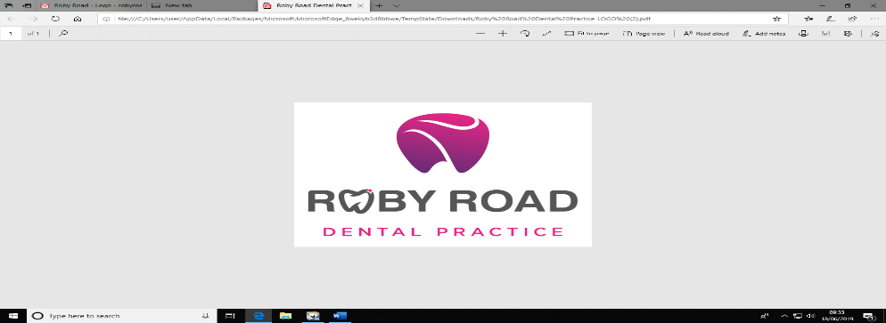

**Roby Road Dental Practice**

**Cancellation Policy**

**Failure to attend and cancellation of appointments**

At Roby Road Dental Practice, we follow this policy in order to be able to meet the high demand of patient care and also to avoid lengthy appointment waiting times for our patients.

If a patient:

* Cancels **(3)** appointments with us in a single 12-month period
* Late cancels **(2)** appointments with us in a single 12-month period
* Fails to attend **(2)** appointments in a single 12-month period
* Combination of **(2)** fails to attends or late cancels in a single 12-month period

You will no longer be offered an appointment at the practice.

In this circumstance, if you are an NHS patient you will be offered the opportunity to register with us as a private patient. This is in discretion of your dentist and their decision is final.

* A **Late cancellation** is an appointment that is cancelled without 24 hours’ notice or cancelled on the same day.
* For a **private patient** a charge of **£10.00 per 10 minutes** will be added and the charge will need to be paid before any further appointments are scheduled.

**Arriving late for a scheduled appointment**

Please be aware that if you arrive more than halfway through your appointment time depending on the type of appointment/treatment that was planned for that day. It is at the dentist’s discretion if they will see you or not.