APPLICATION 940 SOUTH EASTMAN ROAD
FOR EMPLOYMENT Kingsport, TN 37660
423-349-4261
We consider applications for all positions without regard to race, color, religion, creed, gender, national origin, age, disability, sexual orientation, citizenship status, genetic information or any other legally protected status.
(PLEASE PRINT)
Position(s) Applied For |  |  |  |  |  | Date of Application
How Did You Learn About Us?  Advertisement   Employment Agency |  | Relative   Friend |  | Inquiry Other
Last Name |  |  | First Name |  | Middle Name
Address Number | Street |  |  | City | State Zip Code
Telephone Number(s) |  |  |  |  | Social Security |  | Number (Voluntary)
Best time to contact you at home is: 
If you are under 18 years of age, can you provide required proof of your eligibility to work? - Yes - No
Have you ever filed an application with us before? ....................... Yes Z No
. If Yes, give date
Have you ever been employed with us before? ............................. . -Z Yes No
If Yes, give date
Do any of your friends or relatives, other than spouse, work here? Yes No
Are you currently employed? Yes No
May we contact your present employer? . Yes No
Are you prevented from lawfully becoming employed in this country because of Visa or Immigration Status?
Proof of citizenship or immigration status will be required upon employment. ..... ..... Yes No
Date available for work  What is your desired salary range?
Are you available to work: Pullnme (please indicate 1 2 3 shift)
(please indicate Mornings Afternoon Evenings)
t] Temporaw (please indicate dates available
Are you currently on "lay-off' status and subject to recall? . Yes No
Can you travel if a job requires it? ..... ..... ..... ........... . Yes No
WE ARE AN EQUAL OPPORTUNITY EMPLOYER

EDUCATION

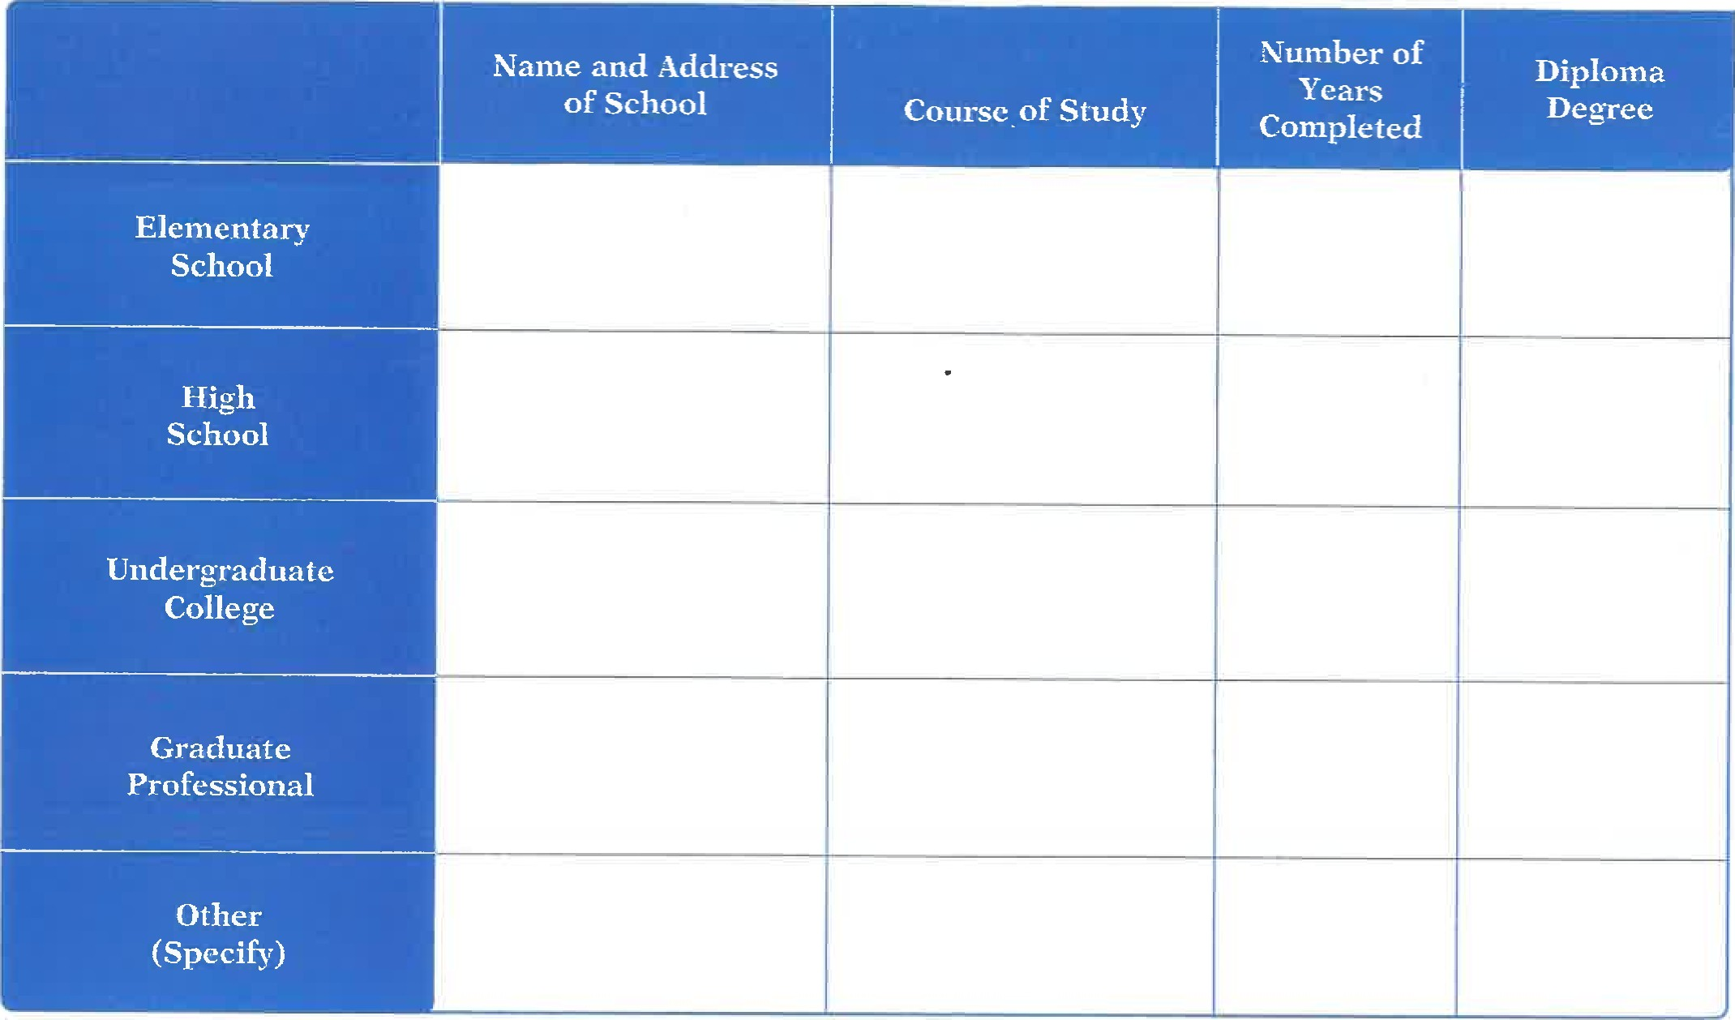
Describe
anv specialized training, apprenticeship, skills and extra-curricular activities.
Describe any job-related training received in the United States military.

EMPLOYMENT EXPERIENCE

Employer |  | Dates Employed | From | To
Address |  | Work Performed
Telephone Number(s)
Job Title | Supervisor
Reason for Leaving
Employer |  | Dates Employed | From | To
Address |  | Work Performed
Telephone Number(s)
Job Title | Supervisor
Reason for Leaving
Employer |  | Dates Employed | From | To
Addres.s |  | Work Performed
Telephone Number(s)
Job Title | Supervisor
Reason for Leaving
Employer |  | Dates Employed | From | To
Address |  | Work Performed
Telephone Number(s)
Job Title | Supervisor
Reason for Leaving
1 .
4.
If you need additional space, please continue on a separate sheet of paper.
List professional, trade, business or civic activities and offices held.
You may exclude membership which would reveal gender, race, religion, national origin, age, ancestry, disability or other protected status:

APPLICANT'S STATEMENT

I certify that answers given herein are true and complete.
I authorize investigation of all statements contained in this application for employment as may be necessary in arriving at an employment decision.
This application for employment shall be considered active for a period of time not to exceed 45 days. Any applicant wishing to be considered for employment beyond this time period should inquire as to whether or not applications are being accepted at that time.
I hereby understand and acknowledge that, unless otherwise defined by applicable law, any employment relationship with this organization is of an "at will" nature, which means that the Employee may resign at any time and the Employer may discharge Employee at any time with or without cause.
In the event of employment, I understand that false or misleading information given in my application or interview(s) may result in discharge. I understand, also, that I am required to abide by all rules and regulations of the employer.
Signature of Applicant Date

Arrange Interview a Yes O No
Remarks
INTERVIEWER DATE
Employed Yes No Date of Employment
Hourl Rate/
Job Title Salary Department
By
NAME AND TITLE DATE
This Application For Employment is sold for general use throughout the United States. Amsterdam Printing assumes no responsibility for the use of said form or any questions which, when asked by the employer of the job applicant, may violate State and/or Federal Law.

Rev 7 Re-order Foml #23960 (23962 imprinted) Ocopyright 2018 Amsterdam Printing, Amsterdam, N.Y. 12010 Rmsterdam'
Toll Free 1-866-466-1438 or online wuw.amsterdamforms.com

ADDITIONAL INFORMATION
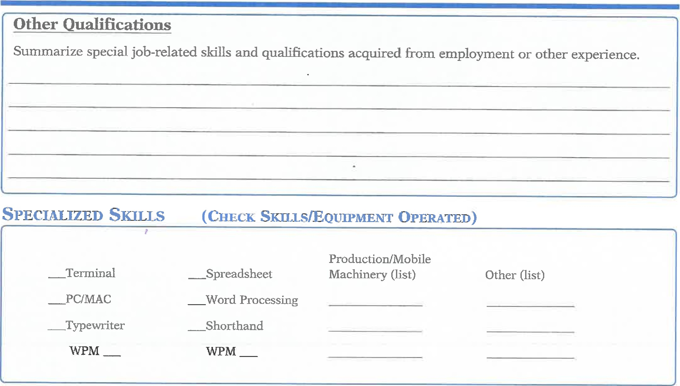
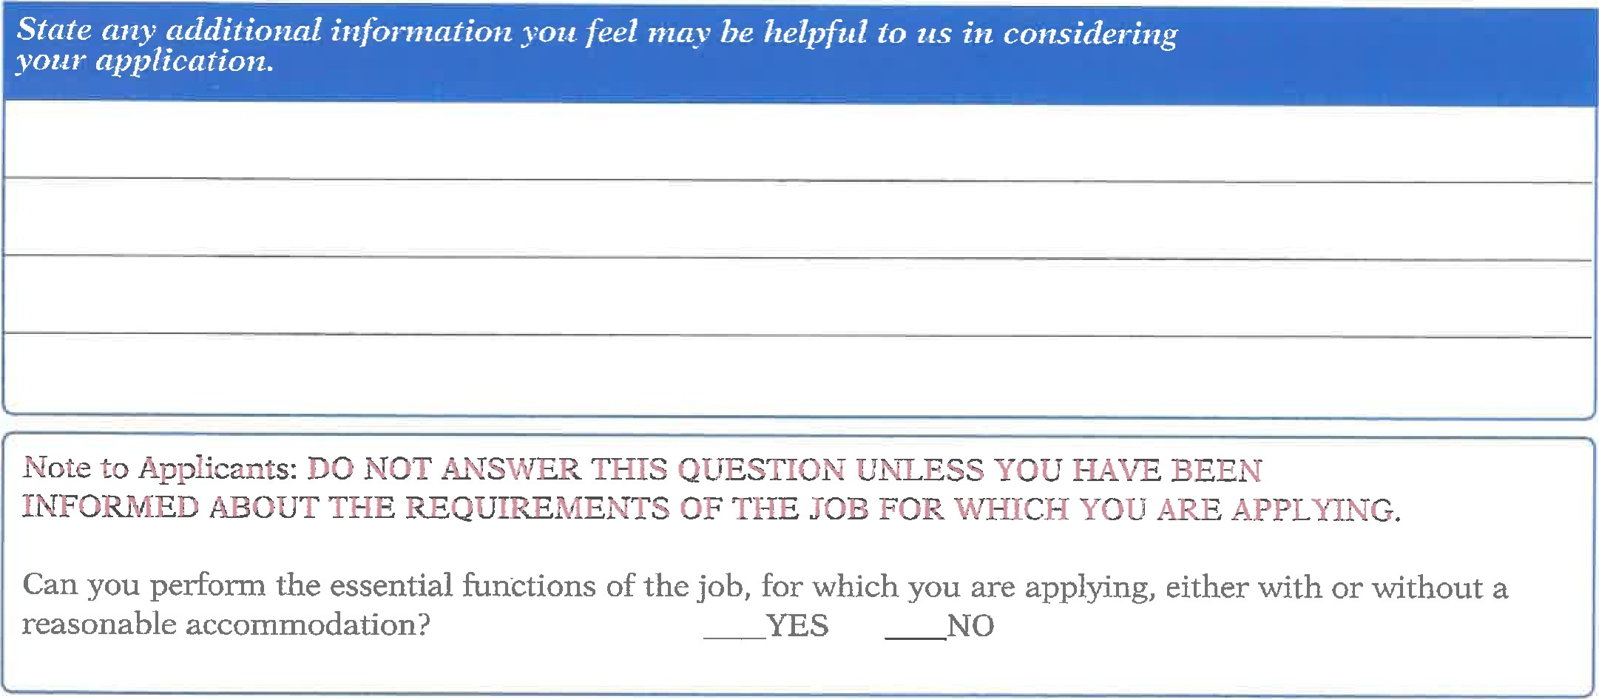
REFERENCES
(Name) Phone #
(Address) 2.
Phone
(Address)
(Name) Phone #
(Address)
FOR PERSONNEL DEPARTMENT USE ONLY
Position(s) Applied For Is Open: [3 Yes No
Position(s) Considered For:
Date

