Arthritis Center
3440 DePaul Lane Suite 113 Bridgeton, MO 63044
Phone: 314-942-6464 Fax: 314-492-4636 Email : Info@drbaak.com

Dear Patient,

Welcome. We look forward to caring for you at the Arthritis Center. Our goal is to ensure you are treated with dignity and compassion during your visit. Your mission is simply to heal. You do this by attending your scheduled appointments, taking the medications and therapies we recommend and by providing us with your medical information.

Arthritis problems can be tiring and confusing. If at any time you do not understand what you have been told, please ask questions. We want to be aware of your concerns, so we can address and resolve them together as we create the best treatment plan that allows you to regain your strength and ability to function at your peak.
Getting Ready for Your Visit:
-Allow 2-3 hours for your first appointment
-Please arrive 15 minutes before your appointments to register and bring:
-The completed patient forms attached to this letter
-A list of all medications you are currently taking (including vitamins/herbals)
-Your insurance card, photo ID, and copay

Please Contact:
Your Primary Care Physician can fax us at 314-492-4636:
- A copy of your most recent labs and office notes
- A referral if your insurance requires one to see a specialist

Our Location:
The office is located at 3440 DePaul Lane, Suite 113 Bridgeton, Missouri 63044. We are on the DePaul Hospital Campus in a free standing, two story building across from the emergency room. There is an “Arthritis Center” sign on our building. The Arthritis Center is located on the ground floor with parking directly adjacent to our entrance.
New Patient Rescheduling Policy:
The office works with you to get you in ASAP for your first appointment, we understand if you need to reschedule, however it will delay the appointment 4+ weeks for the first reschedule. Due to high volume in New Patient request, we unfortunately will not be able to reschedule a New Patient appointment for a second time.
Follow Up Appointments and Visits:
Please make your follow-up appointment before you leave. If you need to change your appointment or make an urgent appointment, call the office at 314-942-6464. We require a 24-hour notice for appointment changes to avoid the $50.00 no show fee. For more information about our practice, please visit our website at www.drbaak.com.

We look forward to caring for you,

Steven Baak, MD
Rheumatologist-Medical Director

RHEUMATOLOGY Patient History Form

Date: ______________________
Name: _________________________________________________ Birthdate: __________________________
Address: ___________________________________________________________________________________
Email:______________________________________________________________________________________
Cell Phone: _______________________Pharmacy:_________________ Pharmacy Phone_________________
Whom do we thank for referring you here?
Name of your Primary Care Physician:
Describe briefly your present symptoms: |  |  |  |  |  | 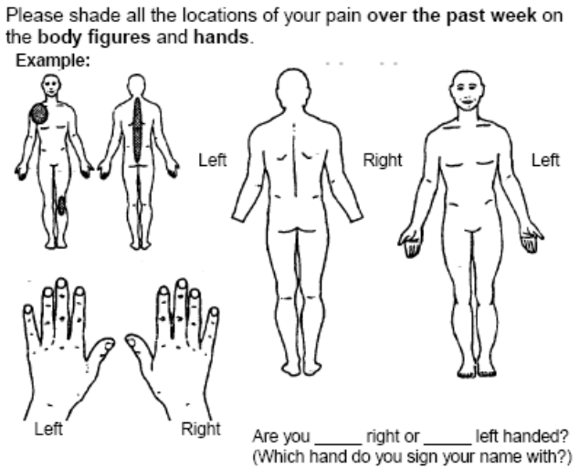
When did your symptoms start?
What diagnosis have you been given, if any?
Names of other Physicians that are caring for you that we should consult:
Previous treatment for this problem (include physical therapy, surgery, and injections)

RHEUMATOLOGIC (ARTHRITIS) HISTORY
At any time have you or a blood relative had any of the following? (check if “yes”)
 | Yourself | Relative | → | Relationship
Arthritis (type unknown) | ❑ | ❑ | →
Osteoarthritis | ❑ | ❑ | →
Rheumatoid arthritis | ❑ | ❑ | →
Gout | ❑ | ❑ | →
Lupus or “SLE” | ❑ | ❑ | →
Ankylosing spondylitis | ❑ | ❑ | →
Childhood arthritis | ❑ | ❑ | →
Sjogren’s syndrome | ❑ | ❑ | →
Osteoporosis | ❑ | ❑ | →
Psoriasis/psoriatic arthritis | ❑ | ❑ | →

Past medical history
Do you now or have you ever had: (check if “yes”)
❑ Diabetes |  | ❑ Heart murmur |  |  |  |  |  |  |  | ❑ Crohn’s disease
❑ High blood pressure |  | ❑ Pneumonia |  |  |  |  |  |  |  | ❑ Colitis
❑ High cholesterol |  | ❑ Pulmonary embolism |  |  |  |  |  |  |  | ❑ Anemia
❑ Hypothyroidism |  | ❑ Asthma |  |  |  |  |  |  |  | ❑ Jaundice
❑ Goiter |  | ❑ Emphysema |  |  |  |  |  |  |  | ❑ Hepatitis
❑ Cancer (type) _________________ |  | ❑ Stroke |  |  |  |  |  |  |  | ❑ Stomach or peptic ulcer
❑ Leukemia |  | ❑ Epilepsy (seizures) |  |  |  |  |  |  |  | ❑ Rheumatic fever
❑ Psoriasis |  | ❑ Cataracts |  |  |  |  |  |  |  | ❑ Tuberculosis
❑ Angina |  | ❑ Kidney disease |  |  |  |  |  |  |  | ❑ HIV/AIDS
❑ Heart problems |  | ❑ Kidney stones
Other significant illnesses (please list):
Previous Operations
Type |  |  |  |  | Year |  |  |  | Reason
1.
2.
3.
4.
5.
6.
7.
Any previous fractures?  No  Yes Describe
Any other serious injuries?  No  Yes Describe
Do you smoke?  Yes  No  In the past - How long ago? ________
Do you drink alcohol?  No  Yes: Usual drink: _________ How much: _____________________
Has anyone ever told you to cut down on your drinking?  Yes  No
Do you use drugs for reasons that are not medical?  No  Yes If yes, please list: ________________
Do you get enough sleep at night?  Yes  No
Do you wake up feeling rested?  Yes  No

MEDICATIONS
Drug allergies:  No  Yes To what?
Please list any medications that you are now taking. Include non-prescription medications, such as aspirin, vitamins, glucosamine, laxatives, calcium, etc.
Name of drug |  |  |  |  |  | Dose (include strength and number of pills per day)
1.
2.
3.
4.
5.
6.
7.
8.
9.
10.
11.
12.
PERSONAL HISTORY
What is your highest educational level? | ❑ High school  Some college courses  College graduate
What is your current or past occupation?
Are you currently working?  Yes  No |  |  | If yes, hours/week ______ |  |  |  |  | If not, are you  retired  disabled  sick leave?
Do you receive disability or SSI?  Yes  No |  |  |  | If yes, for what disability?____________________________________
What date did this disability begin? ____________
With whom do you currently live?
How much exercise do you get each week? |  |  |  |  |  |  |  |  | What kind of exercise?

FAMILY HISTORY
If living |  |  |  | If deceased
 | Age | Health |  | Age at death | Cause
Father
Mother
Number of siblings: _______ Number living ________
Number of children _______ Number living ________ List ages of each ______________________
Health of children:

Systems Review
Date of last eye exam ________ |  |  |  |  | Date of last chest x-ray ________
Date of last bone density test ____________
Result of last TB (PPD) test:  Never done  Negative  Positive |  |  |  |  |  | Date test performed: ___________
General |  |  |  | THROAT |  |  | BLOOD
❑ Recent weight gain; how much____ |  |  |  | ❑ Frequent sore throats |  |  | ❑ Anemia
❑ Recent weight loss: how much____ |  |  |  | ❑ Hoarseness |  |  | ❑ Bleeding tendency
❑ Fatigue |  |  |  | ❑ Difficulty in swallowing
❑ Weakness |  |  |  | ❑ Pain in jaw while chewing |  |  | SKIN
❑ Fever |  |  |  |  |  |  | ❑ Easy bruising
❑ Night sweats |  |  |  | NECK |  |  | ❑ Redness
 |  |  |  | ❑ Swollen glands |  |  | ❑ Rash
Muscle/Joints/Bones |  |  |  | ❑ Tender glands |  |  | ❑ Hives
❑ Morning stiffness |  |  |  |  |  |  | ❑ Sun sensitive
Lasting how long |  | Minutes |  | HEART AND LUNGS |  |  | ❑ Skin tightness
 |  | Hours |  | ❑ Pain in chest |  |  | ❑ Nodules/bumps
❑ Joint pain |  |  |  | ❑ Irregular heart beat |  |  | ❑ Hair loss
❑ Muscle weakness |  |  |  | ❑ Sudden changes in heart beat |  |  | ❑ Color changes of
❑ Joint swelling |  |  |  | ❑ Shortness of breath |  |  |  | hands or feet in the
List joints affected in the last 6 months |  |  |  | ❑ Difficulty in breathing at night |  |  |  | cold (Raynaud’s)
 |  |  |  | ❑ Swollen legs or feet
 |  |  |  | ❑ Cough |  |  | NERVOUS SYSTEM
 |  |  |  | ❑ Coughing of blood |  |  | ❑ Headaches
 |  |  |  | ❑ Wheezing |  |  | ❑ Dizziness
 |  |  |  |  |  |  | ❑ Fainting or loss of consciousness
 |  |  |  | STOMACH AND INTESTINES |  |  | ❑ Numbness or tingling in hands/feet
EARS |  |  |  | ❑ Nausea |  |  | ❑ Memory loss
❑ Ringing in ears |  |  |  | ❑ Heartburn |  |  | ❑ Muscle weakness
❑ Loss of hearing |  |  |  | ❑ Stomach pain relieved by food
 |  |  |  | ❑ Vomiting of blood |  |  | PSYCHIATRIC
EYES |  |  |  | ❑ Yellow jaundice |  |  | ❑ Depression
❑ Pain |  |  |  | ❑ Increasing constipation |  |  | ❑ Excessive worries
❑ Redness |  |  |  | ❑ Persistent diarrhea |  |  | ❑ Difficulty falling asleep
❑ Loss of vision |  |  |  | ❑ Blood in stools |  |  | ❑ Difficulty staying asleep
❑ Double or blurred vision |  |  |  | ❑ Black stools
❑ Dryness
❑ Feels like something in eye |  |  |  | KIDNEY/URINE/BLADDER |  |  | For women only:
 |  |  |  | ❑ Difficult urination |  |  | Age when periods began: ___________
MOUTH |  |  |  | ❑ Pain or burning on urination |  |  | Number of pregnancies: ____________
❑ Sore tongue |  |  |  | ❑ Blood in urine |  |  | Number of miscarriages: ____________
❑ Bleeding gums |  |  |  | ❑ Cloudy, “smoky” urine |  |  | Have you reached menopause?
❑ Sores in mouth |  |  |  | ❑ Pus in urine |  |  | ❑ No  Yes If yes, at what age: ____
Loss of taste |  |  |  | ❑ Discharge from penis/vagina |  |  | Date of last Pap smear: ____________
❑ Dryness |  |  |  | ❑ Frequent urination |  |  | Date of last mammogram: ___________
❑ Recent increase in tooth cavities |  |  |  | ❑ Getting up at night to pass urine
 |  |  |  | ❑ Vaginal dryness |  |  | If you are still having periods:
NOSE |  |  |  | ❑ Rash/ulcers |  |  | Are they regular?  Yes  No
❑ Nosebleeds |  |  |  | ❑ Sexual difficulties |  |  | How many days apart? _________
❑ Loss of smell |  |  |  | ❑ Prostate trouble

Name: Date of Birth: Appt time:

Email: Have you had your flu shot within the last year? Y or N
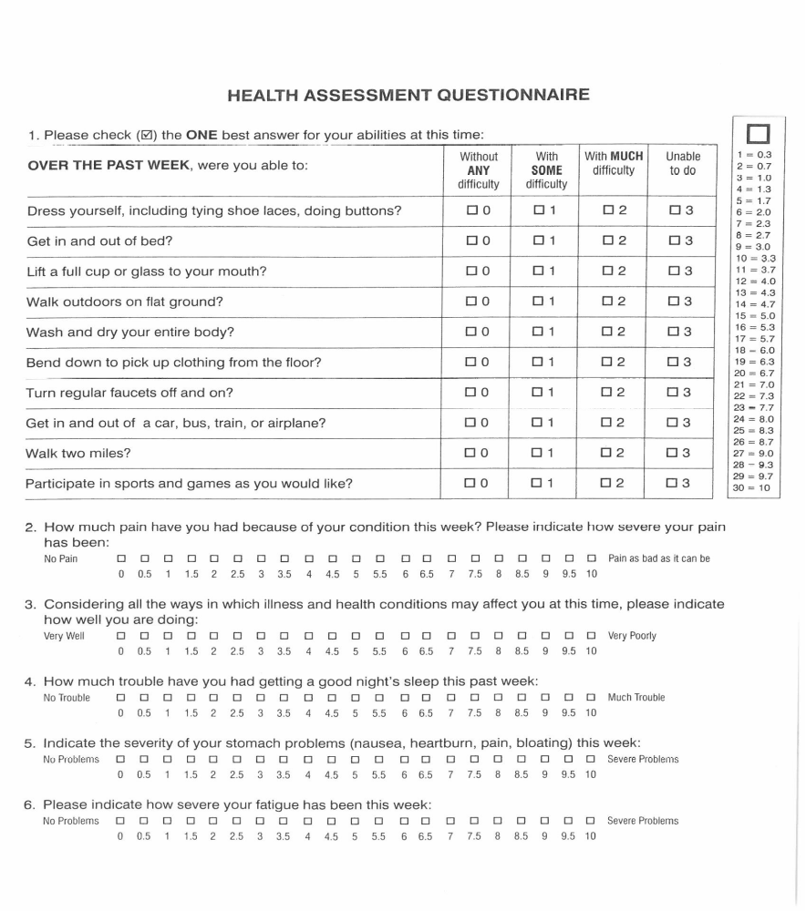
Notice of Privacy Practices Acknowledgement

Arthritis Center will only obtain my written authorization to release information about me if it is not permitted or required by law to disclose this information without authorization.

Patient Full Name: __________________________________________________________________ Date of Birth_______________

Patient Address |  | City | State |  | Zip
E-mail address

Home Ph: | Cell Ph: |  |  | Work Ph:

Record of Disclosure
HIPAA privacy rules give individual the right to request restriction on disclosure of their protected health information (PHI). Individuals are also provided the right to request confidential communication of PHI be given or prohibited by alternative means such as sending correspondence, the individual’s office or cell phone instead of the individual’s home telephone.

Please check all methods of phone communications that you are permitting communication of PHI:
Home Phone # ___ Leave Message with Detailed Information ___Leave Message with call back number only
Cell Phone # ___ Leave Message with Detailed Information ___Leave Message with call back number only
Work Phone # ___ Leave Message with Detailed Information ___Leave Message with call back number only
Written Communication: Note address(es) that we have permission to mail Protected Health Information (PHI)

Address | City | State | Zip

I give consent to Arthritis Center to discuss or release detail of my medical care, including test results, medications, appointment and other information to persons below:

Name | Phone Number | Relationship
Name | Phone Number | Relationship

Emergency Contact – Person to call in case of emergency.
Name | Phone Number | Relationship

Authorization to Release Medical Information and Pay Benefits consent for Treatment/Privacy Notice Acknowledgement
I hereby authorize the release of any medical information necessary to bill my insurer and process claims, and I authorize payment of medical benefits be made to Arthritis Center.
I hereby consent to medical treatments rendered by Steven Baak, MD, Kristy Moore, NP, and Amanda Agee, NP

Signature of Patient/ Parent or Legal Guardian: _________________________________ Date:_____________

Notice of Financial Acknowledgement

Declaration made this date________________________

I, Patient/Guardian, the undersigned patient/responsible party have been informed of the treatment considered necessary for _______________________________and any extension of this treatment or procedure, whether or not currently anticipated, that the attending physician may consider necessary during the course of such in order to correct an immediate medical problem, and that such treatment and procedures (i.e. Labs, Vaccinations) will be performed by physicians who are staff members of Arthritis Center. The undersigned herby consents and grants authorization for such treatment and procedures and certifies that no guarantee or assurance has been made as to the results may be obtained. The undersigned agrees to pay for the service rendered by Arthritis Center on the release of the patient.

I do herby assign any hospital benefits of a liability of and payable by any third party for the herein-named patient to Arthritis Center unless I pay the amount in full on the release of the patient. I do authorize Health Information Services of Arthritis Center to release any information requested by my insurance company(s) or other third-party payers in connection with this assignment. I do herby appoint the Financial Manager of Arthritis Center as my lawful attorney to endorse for me any checks payable to me for debts or claims collected under this assignment and to apply any credit balance to any other debt I may owe to Arthritis Center.

Statement of Financial Responsibility

All services rendered are the payment responsibility of the patient. As a courtesy, we will bill your insurance carrier. The patient is responsible for all fees, regardless of insurance coverage or the usual and customary fees provided by your insurance company. It is customary to pay for the services when rendered unless other arrangements have been made in advance. If my account reaches collection status, the system will be unable to process my prescriptions and/or schedule appointments. I understand that I will be responsible for any cost incurred as a result of my account having to be turned over to a collections agency or attorney.

As of January1st 2017, there is a $50.00 no show policy that requires a 24-hour cancellation notice. All late fees must be paid in full before your next office visit.

Consent for Appeal:
I, with my signature, authorize (Arthritis Center), and any employee working under the direction of the physician to appeal any insurance claims/ prior authorizations that are denied on my (the patient’s) behalf regarding medication, medical devices, and/or medical procedures prescribed by the physician.

I understand the full importance of this declaration.

______________________________________ Date:_______________
Patient Signature

______________________________________ Date:_______________
Witness Signature

