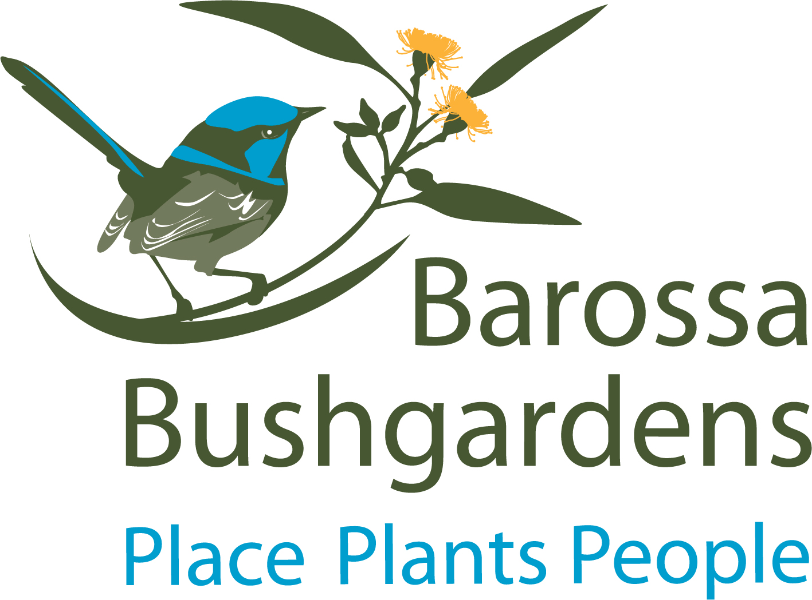

We invite you to support the BBG by making a financial contribution. This could be a one-off donation/sponsorship or funding support of a key element within the master plan. Additional information is available if you require specific details.

For any contribution received, we would promote your company logo on all media and communication in connection with the projects and display it on our sponsor ship board at the Community Centre. If you wish to support the BBG, please contact the Natural Resource Centre for more detailed information.

The ongoing contribution and support that the BBG makes to the community is made possible through the generosity of our partners. Corporate financial supporters assist us in continuing to display, promote and supply regional native plant species as well as information about sustainable natural resource management to local businesses, residents and tourists.

The BBG team is excited to be able to showcase the natural diversity of the Barossa Valley and we thank you for your support.

Yours faithfully,

Doreen von Linde
Barossa Bushgardens Natural Resource Centre Co-ordinator

Invitation to Morning Tea
You are welcome to join the Volunteer Team and staff at the
Barossa Bushgardens
Community Centre
WHERE: 653 Research Road, Nuriootpa
WHEN: Tuesdays or Thursdays 10.30am
RSVP to Doreen in the office (08) 8563 8331

Sponsorship and Donations

Key elements of the Master Plan:

- Parking
The volunteers and visitors of the gardens have experienced difficulty finding vehicle parking spaces, especially during the wetter months of the year. Soil compaction, eliminating microbial life during dry weather and inundation during wet weather, has led to the planning of a permanent car parking site, which will include disabled parking spaces, next to the Community Nursery.
- Community Centre building
Expansion of the building, which includes the Natural Resource Centre, volunteer space and room for nursery works. Our team would like to be able to better accommodate for functions, such as morning and afternoon teas, presentations and workshops, a craft corner for some of our creative volunteers and room for nursery related activities, including a designated seed drying and cleaning area.

Or support one of our new projects:

- Disability Friendly Vegetable Garden
We would like to install three, wheelchair accessible and two standing sized raised garden beds for people with health issues or disabilities, as gardening can have many health benefits and can provide a source of exercise, friendship, stimulation and relaxation.
- Disability Friendly Vertical Sensory Garden
The Barossa Bushgardens contain a Sensory Garden, where people can feel different plant textures and crushing up leaves, enjoy different smells. We would like to expand this experience to include a vertical sensory experience for people in wheelchairs. This vertical sensory would showcase not only plants, but different stones, sourced from the Barossa, woods and structures built by children and volunteers, made out of natural materials.

Or make a Donation:

100 AUD – buy tools for our volunteers
200 AUD – help source materials for workshops
500 AUD – will pay for petrol and parts to service our tractor and lawn mowers
………………………AUD – choose your own amount

Account details: or Please enclose a cheque and mail to:
Friends of Barossa Bushgardens Fund Barossa Bushgardens
ACC: 045 929 140 The Barossa Council
BSB: 105 055 PO Box 867
Nuriootpa SA 5355

