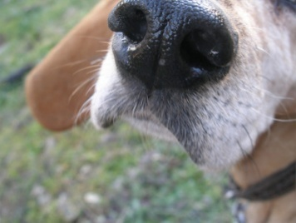
This Photo by Unknown Author is licensed under CC BY-NC-ND

A Weekend with Judith Guthrie
of Nose Dogs Detection Services
April 17 – 19, 2026
Butler Dog Training Association
1017 Evans City Rd., Renfrew, PA 16053

Judith Guthrie is an educator specializing in the development of detection dogs, handlers, and high-functioning teams in both professional detection and competitive scent and nose work. She serves as a judge for multiple organizations, including NACSW, AKC, and USCSS, and competes actively across venues. She founded and operates Nose Dogs Detection Services, a program dedicated to developing detection dogs, advancing handler skill, and strengthening working teams.
She approaches team development by defining what belongs to the dog, what belongs to the handler, and how those responsibilities integrate during the search. By separating intrinsic working traits, handler skill sets, and team-level interaction, she identifies breakdowns at their source and corrects the appropriate component. The result is cohesive teams: dogs and handlers who understand their responsibilities and function as an integrated working unit

Registration Form

Working Spots $80 for each 4-hr. topic Auditing spots $40 for each 4-hr. topic
Friday – April 17th Please circle one
Handler mechanics and handling decisions 8:00 AM-Noon Working / Auditor
Odor commitment and source identification 1:00 PM-5:00 PM Working / Auditor

Saturday – April 18th Please circle one
Problem solving exercises 8:00 AM – Noon Working / Auditor
Competition preparation 1:00 PM-5:00 PM Working / Auditor

Sunday – April 19th Private Lessons:
30 minutes - $85 ______________
45 minutes - $120 _______________
60 minutes - $150 ________________

Handler’s Name ___________________________________
Phone # / email ____________________________________________________________________
Dog’s Name / Breed / Age ___________________________________________________________
Dog’s level of experience/training issues? ________________________________________________________________________________________________________________________________________________________________________
Total workshop fee enclosed: $____________MAKE CHECKS PAYABLE TO: BDTA
Mail registration with payment to:
Nancy Kieffer 457 ½ Whitestown Rd. Butler, PA 16001 (724-482-6017)
Please read the following page….

This workshop is open to all levels of Nose Work experience…the only requirement is that your dog has been working on Birch, Clove, Anise, and Cypress.

There are limited working spots and auditing spots available each day. These will be filled as the registrations are received by mail.

Cancellations will be refunded up through April 10th for working spots and auditing spots.

Only dogs with working spots may attend. All dogs must be crated. They may be crated at your chair.as long as they can remain quiet during the workshop.

Bring your own lunch. There are fast food options nearby. Snacks and bottled water will be provided throughout the day.

Feel free to bring your own chair (there are chairs available.) Floor covering under your crate is optional but would be appreciated.
