
How much does it cost to be in the TPS and what do I get?
Each year the employee contribution rates to the TPS change in line with any pay award. In April 2026 this meant that contributions rose 3.8% to those in the table below, depending on your current annual salary.
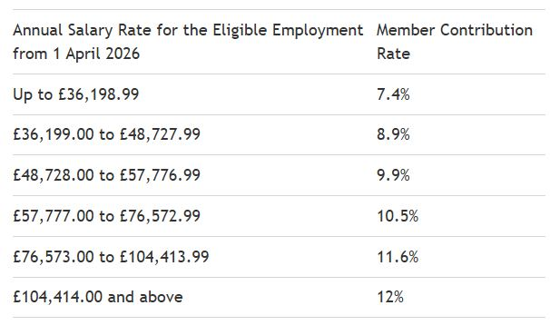

Remember your employer currently pays 28.68% as their contribution, so it is a more expensive pension scheme than average to be in, but one that brings great benefits.

What are the benefits?
In the career average scheme, which everyone is on now, you build up 1/57th of your earnings for each year you are in the scheme. For example, if you earnt £40k in the year, you will build up a yearly pension when you retire of 40/57 = £702. This is £702 paid every year from retirement until death. If you earnt £45k the next year, that would be 45/57 = £789 built up, and added to the £702 from the previous year. This means after 2 years you would have built up a yearly pension of £1491. You can imagine how this can grow if you are a teacher after 20, 30, or even 40 years.

In simple terms, if you earnt a decent teacher salary of £50k for 30 years, this would be 50/57x30, = over £26k a year in today’s money in retirement. And it isn’t this simple. Every year, the benefits already earnt are revalued by the rate of inflation plus 1.6%. So over time, the pension actually grows above the rate of inflation, meaning you build up even more benefit.

There are many other benefits like death in service payouts, and dependent pensions too. And you can take a lump sum at retirement too. Seek advice as to whether this is the right thing to do.
You can increase these benefits, by buying faster accrual, buying out some years from your normal pension age, or by buying additional pension. See my guides about each of these ways to increase your pension further. The Teachers’ Pension website also has many useful calculators you can use.

So, the employee rates are in the table, and the benefits are great.

This article is for information only and is not personal financial, investing, or tax advice.



