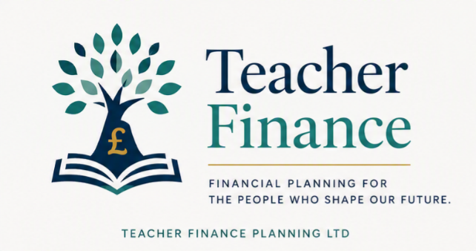
Should I opt out of the TPS?
If you've looked at your payslip recently and wondered whether opting out of the Teachers' Pension Scheme (TPS) would give you a welcome pay rise, you're not alone. It's a question many teachers ask, particularly when household bills are rising in the current cost of living crisis.
For the vast majority of teachers, however, my answer is simple:
No. I don't think you should opt out of the Teachers' Pension Scheme.
In fact, I think it's one of the biggest financial mistakes you could probably make as a teacher.

Why do teachers consider opting out?
The main reason is straightforward. Pension contributions reduce your take-home pay, and if money is tight, opting out gives you a little more in your monthly salary.
Teacher contributions currently range from around 7.4% to 12%, depending on your salary. That can feel like a significant deduction, especially early in your career. So it is understandable to wonder whether that money would be better spent elsewhere.
However, when you opt out, you don't just stop paying your own contributions. You also lose your employer's contribution. At the time of writing, employers contribute around 28% of your pensionable salary into the scheme. Now as you know from reading my TPS guide, this 28% isn’t really real, it doesn’t build up a pot of money, like in a Defined Contribution (DC) pension. However, it does show the cost of building up the benefit that you get from the TPS.
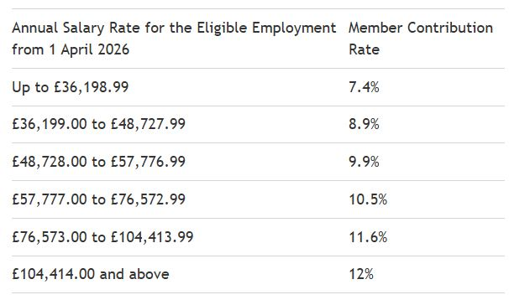

"But I could invest the money myself..."
This is another common argument. I'm a big believer in investing. I've been investing for many years and regularly write about ISAs, index funds and long-term investing. But this isn't an either/or decision, you can always do both.

The Teachers' Pension is one of the biggest perks of the job
Teaching is not always the highest-paid profession and there are easier jobs that pay more.
One of the reasons many teachers stay in the profession is because the overall package is attractive, and the Teachers' Pension is a huge part of that package.
If you remove the pension, you're giving up one of the biggest financial advantages of being a teacher.

When might opting out make sense?
I can think of very few situations where I'd say opting out is the right decision.
One example might be if you're facing genuine financial hardship.
Perhaps you're:
- about to lose your home,
- struggling to afford food or essential bills,
- or facing another short-term financial emergency.
In those situations, increasing your immediate income may be necessary while you get back on your feet.
Even then, I'd view opting out as a very temporary measure rather than a long-term plan.
If your circumstances improve, I'd strongly consider rejoining the scheme as soon as possible.

What should you do instead?
If you're finding your pension contributions difficult to afford, there may be better options than opting out.
For example, you could:
- review your household budget,
- check whether you're paying unnecessary subscriptions,
- refinance expensive debt if appropriate,
- or look for ways to increase your income.
These aren't always easy solutions, but in most cases I'd explore them before giving up such a valuable pension.

My view
Having worked in both state and independent schools, I've seen how valuable the Teachers' Pension Scheme is, and how much teachers have had to fight for it in some independent schools. Many independent schools have left the scheme because the employer contributions became too expensive to sustain.
Schools are making difficult financial decisions because the pension is costly to provide. As a teacher, you're receiving the benefit of that investment.
Personally, I think most teachers underestimate just how valuable their pension really is.
Yes, it reduces your take-home pay today.
But in return, you're building a secure, inflation-linked income for life, backed by one of the strongest pension schemes available in the UK.
Read the Teacher Pension guide on Teacher Finance to find out more about how the pension builds up over time.

To conclude:
For almost every teacher, I believe staying in the Teachers' Pension Scheme is the right decision.
Unless you're facing severe financial hardship and genuinely need every pound just to get through the next few months, I'd think very carefully before opting out.
The extra money in your monthly payslip may feel helpful now, but giving up one of the best pension schemes in the country is a price that most teachers are likely to regret later.

This article is for information only and is not personal financial, investment, or tax advice

