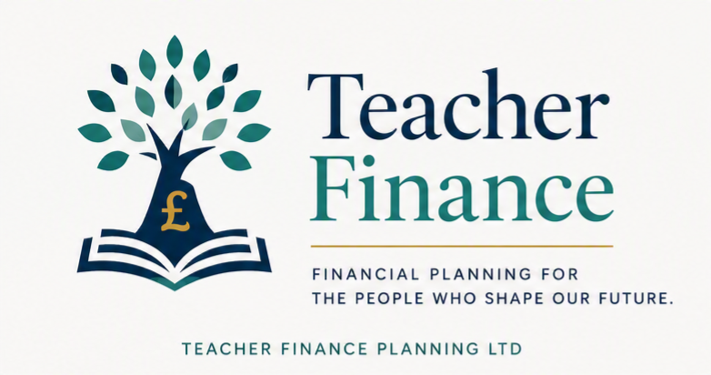

Introduction to the Teachers' Pension Scheme (UK)
Everything to get you started learning about the Teacher’s Pension Scheme (TPS)

Contents:
What is the Teachers' Pension Scheme?
Why is the Teachers' Pension Scheme so valuable?
How does the Teachers' Pension Scheme work?
Who can join?
Can I opt out?
How much do teachers contribute?
What type of pension is it?
Career Average vs Final Salary
When can I retire?
Is the pension guaranteed?
What happens if I leave teaching?
What happens if I die?
Is the Teachers' Pension Scheme worth it?
Frequently Asked Questions
Disclaimer

What is the Teachers' Pension Scheme?
The Teachers' Pension Scheme (TPS) is the workplace pension available to eligible teachers in England and Wales.
It is a defined benefit pension, which means your retirement income is based on scheme rules rather than the performance of the stock market.
Unlike a personal pension, where you build up a pot of money, the Teachers' Pension Scheme provides a guaranteed income for life from retirement, together with valuable benefits such as survivor pensions and ill-health protection.
For many teachers, it is one of the most valuable employment benefits they will ever receive.

Why is the Teachers' Pension Scheme so valuable?
The Teachers' Pension Scheme offers benefits that are increasingly rare in the private sector.
These include:
✅ Guaranteed income for life
✅ Inflation protection
✅ Employer contributions
✅ Tax-efficient pension saving
✅ Survivor benefits
✅ Ill-health retirement protection
✅ No investment decisions required
For many teachers, replacing these benefits privately would require a pension fund worth hundreds of thousands of pounds.

How does the Teachers' Pension Scheme work?
Every month:
- You contribute a percentage of your salary.
- Your employer also contributes.
- You build up pension benefits.
- Those benefits are protected under the scheme rules.
Unlike a defined contribution pension, your retirement income is not directly linked to investment performance.
Instead, the scheme calculates your pension according to the benefits you've built up over your teaching career.

Who can join?
You will usually be eligible if you are employed as a teacher by:
- Local authority schools
- Academies
- Free schools
- Many further education colleges
- Some independent schools (if they participate)
- Other eligible educational organisations
Not every independent school participates in the scheme.

Can I opt out?
Yes.
Membership is generally automatic if your employer participates in the scheme, but you can choose to opt out.
However, opting out means giving up valuable benefits, including:
- Employer pension contributions
- Future pension accrual
- Death benefits
- Ill-health retirement cover
Because the implications vary from person to person, it's important to understand the consequences before making this decision.

How much do teachers contribute?
Teachers contribute a percentage of their pensionable salary.
The percentage depends on how much you earn.
Higher earners pay a higher contribution rate.
Your employer also contributes significantly towards your pension.
See our Teacher Pension Contribution Rates Guide for the latest contribution bands.

What type of pension is it?
Since April 2015, most teachers build pension under the Career Average Revalued Earnings (CARE) scheme.
Teachers who built up pension before 2015 may also have benefits in the older Final Salary scheme.
Many teachers therefore have benefits in both schemes.

Career Average vs Final Salary
Career Average | Final Salary
Based on earnings throughout your career | Based on salary near retirement
Current scheme | Closed to new accrual for most members
Revalued each year | Protected benefits remain
We'll explain both schemes in detail in separate guides.

When can I retire?
Your normal pension age depends on:
- Which section of the scheme you're in
- When you joined
- Your State Pension Age (for CARE benefits)
You may also be able to:
- Retire early
- Take phased retirement
- Retire due to ill health
- Continue working after drawing some pension benefits (subject to scheme rules)

Is the pension guaranteed?
One of the biggest advantages of the Teachers' Pension Scheme is that it provides a guaranteed pension under the scheme rules.
Unlike investments, the amount you receive is not directly affected by stock market rises and falls.
This makes it a valuable foundation for many teachers' retirement planning.

What happens if I leave teaching?
If you leave pensionable employment before retirement:
- Your existing benefits are normally preserved within the scheme.
- In most cases, they continue to be revalued in line with scheme rules until you retire or transfer them.
- If you later return to eligible teaching, you may begin building up further benefits, depending on the scheme rules in force at the time.
The exact outcome depends on factors such as when you leave, how long you've been a member, and any future employment.

What happens if I die?
The Teachers' Pension Scheme includes valuable protection for your family.
Depending on your circumstances, this may include:
- A lump-sum death grant.
- A pension for an eligible spouse, civil partner or qualifying partner.
- Children's pensions where the scheme rules allow.
The benefits available depend on your membership status and personal circumstances.

Is the Teachers' Pension Scheme worth it?
For many teachers, it represents one of the strongest workplace pension arrangements available in the UK.
It combines:
- Guaranteed retirement income.
- Employer contributions.
- Inflation protection.
- Valuable family benefits.
- Tax-efficient saving.
Whether it's the right choice for you depends on your own circumstances, but it's important to understand everything the scheme offers before deciding whether to remain a member or opt out.

Frequently Asked Questions
Is the Teachers' Pension Scheme compulsory?
No. If you're eligible, you'll usually be enrolled automatically, but you can choose to opt out (But I wouldn’t without careful thought).
Can supply teachers join?
Many supply teachers can join if they are employed in pensionable service by a participating employer. Eligibility depends on the nature of the employment.
Can I transfer another pension into the Teachers' Pension Scheme?
Transfers may be possible in some circumstances and are subject to scheme rules and time limits.
Can I continue working after taking my pension?
In some cases, yes. This depends on the type of retirement and the scheme rules that apply to your benefits.
Is my Teachers' Pension taxable?
Pension income is generally taxable in the same way as other forms of retirement income, although the amount of tax you pay depends on your overall circumstances.

Related Guides
- Teacher Pension Contribution Rates
- Career Average (CARE) Pension Explained
- Final Salary Benefits Explained
- Early Retirement Guide
- Phased Retirement Explained
- Additional Pension Guide
- McCloud Remedy Explained
- Teacher Pension Calculators
- Teachers' Pension FAQs

Disclaimer
The information on this page is provided for general educational purposes only and does not constitute regulated financial advice or a personal recommendation. Pension rules can change, and their application depends on your individual circumstances. If you need advice tailored to your situation, please seek professional financial advice.

