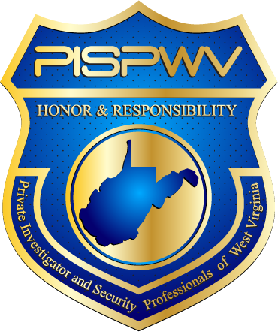 | Private Investigator and Security Professionals of WV
Year End 2015 | Volume 1, Number 2
In This Issue  - Training Summary by Quarter  - Legislative Update  - Tips for the Year  Leadership  Robert Fluharty  President  Larry Peters  VP of Investigators  Benjamin Moore  VP of Security  Michael Mounts  VP of Training  Diane Lewis  Treasurer  Lisa Turley  Secretary  Links  www.pispwv.org  Check out the website for other members; events and news.  www.nciss.org  For national issues check out National Council of Investigation and Security Services  www.wvsos.com  To learn more about licensing from the West Virginia Secretary of State  www.wvago.gov  For questions about bond certificates | Training Summary by Quarter  The first quarter training in Charleston, members learned about GIS Mapping. Other states are more advanced in this process but in learning the topography of land in rural surveillance, this can be a helpful tool in identifying the location of a subject and what and more importantly whom the neighbors are before proceeding with the project. Reference www.digitalcourthouse.com  The second quarter training was focused on legislative issues. Discussion was made regarding taking a proactive approach to WVSOS’s introduction of SB 575 which would move our profession to the WVSP. Future meetings and representatives will be assigned to take a hands-on approach if needed.  The third quarter training was a roundtable discussion about issues affecting investigators and security professionals.  The fourth quarter training focused on new business question roundtable discussion. WV Sales Tax and Municipal Tax requirements along with W-9 exclusions to tax were discussed. Basics for getting started with a PI Business were addressed.  Legislative Summary Update  In the 2012 West Virginia Legislative Session, HB 4512 was proposed but died (was it even introduced?) At that time, PISPWV had secured the paid support of lobbyist Chris Marr along with the security interest (?) to introduce and move the bill through both House and Senate. This bill would create a separate entity for licensure of our profession. Due to the lack of support of this bill and/or consensus of direction moving forward, PISPWV efforts ceased. In the 2015 WVLS, SB 575 was introduced by the WVSOS and fortunately died but this bill would have moved our profession to the WVSP. As the 2016 WVLS quickly approaches, members are asked to be prepared for the possibility of bill introduction by WVSOS. Both HB 4512 and SB 575 are posted under resources for members at the PISPWV.org website. Please let leadership know of your availability should the need arise to contact, meet, email, etc. with your local and or state representatives to best meet the needs of our profession.  Training Highlights for the Year  - Complying with audio/video rules – use an rc cable to kill the audio portion if a smartphone is the only option to get the video footage needed  PISPWV  Post Office Box 11236  Charleston, West Virginia 25339

