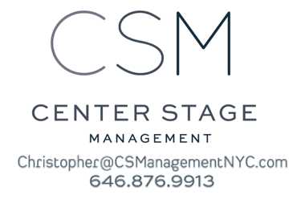
Hollis McCarthy
SAG - AFTRA, AEA

Television
Bull Recurring Guest Star CBS
Blue Bloods Co-Star (Irish President) CBS
The Good Wife Co-Star CBS
House of Cards Co-star (Senator) Netflix
Think Tank Co-Star A&E Digital
Across Five Aprils Lead Family Channel
Dead Before Dawn Supporting ABC
Stalking Laura Supporting CBS
Unsolved Mysteries Co-Star NBC

Film
Jenny's Wedding Supporting Dir. Mary Agnes Donoghue
Road To Perdition Supporting Dir.Sam Mendes
Last Call Lead Dir. Matt Irvine
More Than Puppy Love Lead Dir. Tom Whitus
Garage Sale Lead Dir. Mark Stock
Behind the Waterfall Lead Dir. Scott Murphy

Theatre
Eternal Equinox Vanessa Bell 59E59th Theaters
Shatter Jenny Maclean Urban Stages
Gabriel Jeanne (u/s) Atlantic Theatre
Everything is Wonderful Esther Contemp. Amer. Thtr. Fest
Byhalia, Mississippi Celeste Contemp. Amer. Thtr. Fest
Macbeth Rosse Northern Stage
Julius Caesar Cassius Swine Palace
Good People Margaret Shadowland Theater
Betrayal Emma Capital Repertory
Cornelia Marie Wallace The Old Globe
Richard III Elizabeth Alabama Shakespeare Fest
Tartuffe Elmire Two River Theater
Much Ado About Nothing Beatrice Colorado Shakespeare Fest
Hamlet Gertrude Colorado Shakespeare Fest
Love's Labours Lost Maria Chicago Shakespeare
Taming of the Shrew Katharina Notre Dame Shakespeare

Training
MFA, Acting, University of Missouri-KC, BFA, Acting, University of Toledo
Shakespeare Training with Derek Clarke, of Nat’l Theatre GB; Jane Whittenshaw, of RSC.
Special Skills
Dialects, stage combat, audiobook narration, vo, ear prompter, sing mezzo, softball, cycling

