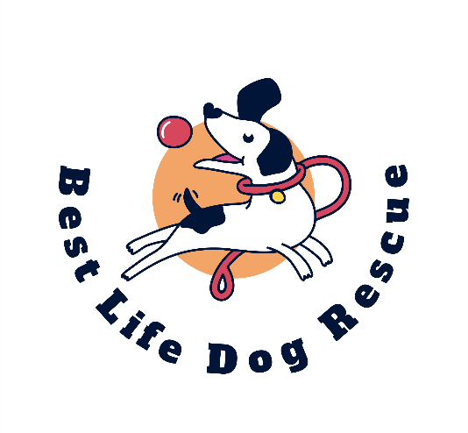
BEST LIFE DOG RESCUE
PRE-ADOPTION FORM

YOUR NAME:
YOUR ADDRESS (INC POST CODE):
YOUR EMAIL:
TEL NO’S:
APPLICANTS AGES:
NUMBER OF RESIDENTS IN HOME:
NUMBER OF CHILDREN IN HOME (INCL AGES) AND ARE THEY USED TO DOGS?
ANY VISITING CHILDREN (INCL AGES) AND ARE THEY USED TO DOGS?

NAME OF DOG YOU WISH TO ADOPT:
DO YOU HAVE ANY CATS?
DO YOU HAVE ANY OTHER DOGS?
IF SO WHAT BREEDS AND AGE, AND ARE THEY NEUTERED?
HOW WOULD YOU DESCRIBE YOUR HOME ENVIRONMENT? – QUIET/ BUSY/A BIT OF BOTH (DELETE AS APPROPRIATE)
WHAT TYPE OF PROPERTY DO YOU LIVE IN? – HOUSE/FLAT/BUNGALOW/OTHER (DELETE AS APPROPRIATE)
IF RENTED, DO YOU HAVE PERMISSION TO KEEP A DOG? (PROOF REQUIRED)
DO YOU HAVE A GARDEN?
HOW SECURE IS IT? (I.E FENCING/HEDGEROW OR GATES AND HOW HIGH)
HOW MUCH EXERCISE CAN YOU OFFER A DOG – HOW OFTEN AND HOW LONG?
WHERE WILL YOU EXERCISE THE DOG?
WHAT ARE YOUR (INCL PARTNER) WORKING HOURS?
HOW LONG WOULD THE DOG BE LEFT DURNG THE DAY AND HOW OFTEN?
WHERE WILL DOG SLEEP AT NIGHT OR WHEN LEFT ALONE?.
ARE YOU GOING ON HOLIDAY IN THE NEXT 4 WEEKS?
IF SO WHAT ARRANGEMENTS WOULD BE MADE FOR THE DOG?
WILL THE DOG BE LEFT OUTSIDE ALONE FOR ANY LENGTH OF TIME?
IF YOU HAVE EVER OWNED DOGS IN THE PAST PLEASE TELL US WHAT HAPPENED TO THEM:
PETS CAN BE EXPENSIVE – HAVE YOU CONSIDERED HOW YOU WILL PAY FOR VET BILLS THAT MAY ARISE?
IF YOU ALREADY HAVE A VET, PLEASE PROVIDE DETAILS AND PERMISSION TO CONTACT THEM.

WOULD YOU CONSIDER USING THE SERVICES OF A DOG BEHAVIOURIST IF THE NEED EVER ARISED FOR THE DOG YOU ADPOT?
WHAT ARE YOUR REASONS FOR WANTING TO ADD A DOG TO THE FAMILY?
IS EVERYONE IN THE HOUSEHOLD HAPPY FOR A DOG TO JOIN THE FAMILY?
DOES ANYONE IN THE HOUSE HAVE ANY ILLNESSES OR ALLERGIES INCLUDING MENTAL ILLNESSES OR DISABILITLES? (THIS WILL NOT AFFECT YOUR ABILITY TO ADOPT, JUST GIVE US THE RIGHT INFO TO BE ABLE TO MATCH THE RIGHT DOG TO YOUR CIRCUMSATANCES.)
If YOU ARE NOT SUCCESSFUL REHOMING THE DOG YOU HAVE APPLIED FOR, WOULD YOU BE INTERESTED IN HEARING FROM US WITH ANOTHER DOG WE THINK MAY BE SUITABLE FOR YOU?
DO YOU HAVE ANY PLANS THAT MAY EFFECT THE DATE YOU WOULD BE READY TO ADOPT?
CAN YOU CONFIRM THAT YOU UNDERSTAND THE RESPONSIBILITY AND ISSUES YOU MAY FACE WHEN ADOPTING A RESCUE DOG AND AGREE TO GIVE THE DOG TIME TO SETTLE AND ADJUST.

