Muskingum County Regional Coordinated Public Transit-Human Services

Transportation Plan

September 2018 Coordination Lead Agencies: South East Area Transit and Ohio Mid-Eastern Governments Association.

For more information about this plan, please contact Howard Stewart, SEAT Transit Director, Zanesville Ohio

Table of Contents

Executive Summary 3

Geographic Area, Demographic, and Socio -Economic Conditions 6

Population Demographics 7

Individuals with Disabilities 8

Household Income 9

Language 10

Race Breakdown 10

Household Vehicles 12

Assessment of Available Services 13

Inventory of Transportation Providers 13

Additional Provider Information: 22

Assessment of Community Support for Transit 27

Safety 27

Vehicles 28

Assessment of Transportation Needs and Gaps 31

Local Demographic and Socio-Economic Data 31

Older Adult Population 31

Individuals with Disabilities 32

General Public and Stakeholder Meetings/Focus Groups 32

Surveys 33

Challenges to Coordinated Transportation 33

Summary of Unmet Mobility Needs 34

Developing Strategies to Address Gaps and Needs in Muskingum County 35

Goal #1: Increase the amount of funds available for coordinated public-agency transportation in the county while working cooperatively to control costs 35

Goal #2: Establish Active Transportation Projects -bike and walking routes, safe routes to schools, improvements to roads and sidewalks 36

Goal #3: Improve the level of service provided in the county, thereby increasing availability of services. 37

Goal #4: Obtain the necessary capital assistance, including vehicles and related equipment and new technology to improve mobility options 38

Goal #5: Create a transportation structure that promotes more efficient use of resources. 39

Goal #6: Increase funding opportunities for transit. 39

Plan Adoption 41

Appendix A: List of Planning Committee Participants 42

Agency Representation 42

Appendix B: List of Annual Reviews and Plan Amendments 43

Annual Review 2019 43

Appendix C: Definitions 44

## Executive Summary

This plan is the Public Transit-Human Services Coordination Transportation Plan for Muskingum County Ohio. This regional plan was finalized in September 2018 and will be reviewed and updated annually. This plan fulfills the requirements of the Federal Transit Administration (FTA) under the Fixing America’s Surface Transportation (FAST) Act, signed into law as a reauthorization of surface transportation programs through Fiscal Year 2020. According to requirements of the FAST Act, locally developed coordinated public transit-human services transportation plans must be updated to reflect the changes established by the FAST Act legislation. The FAST Act applies new programs and rules for all Fiscal Year 2016 funds and authorizes transit programs for five (5) years.

Transportation is a critical component of the communities in Muskingum County. Transportation provides access to jobs, education, health care, human services and allows all community members, including older adults and people with disabilities, to live independently and engage in community life. It is the purpose of this plan for local stakeholders to work collaboratively to complete the following activities:

1. Identify all community resources including:

* Southeast Area Transit (SEAT)
* Carr Center
* Muskingum County Center for Seniors
* Muskingum County Developmental Disabilities
* Zanesville – Muskingum Behavior Health
* Creative Options
* Genesis
* Starlight
* Muskingum County Job and Family Services
* Goodwill
* Muskingum County ESC
* Muskingum County Housing
* Mid-Ohio Mobility Solutions

1. Identify and Prioritize community transportation needs. A series of five public and stakeholder meetings were held in between January and May 2108, to gain insight to unmet needs for the county. In addition to the five public meetings, surveys were distributed throughout the county. The results of the public meetings and surveys revealed the following unmet transportation needs:

**County Transportation Needs:**

**First Priority**

* Sustainable funding for transportation service – capital and operating
* Educate the public to Increase awareness and education of transportation services throughout the counties and region
* Out of county service for any trip purpose at an affordable rate
* Increased same day transportation options
* Increase accessible vehicle fleets
* Extended hours and days of operation
* Shared scheduling software among providers to increase coordination opportunity

**Second Priority**

* Coordinate with the county in the development of Complete Streets and Active Transportation plans – bike and walking paths, sidewalk improvements, road improvements, curb cuts, safe routes to school, etc.

1. Establish a clear plan for achieving shared goals

The coordination partners have worked together to develop through the coordination planning effort to identify six (6) goals county specific goals. Along with sustainable funding, one of the fundamental strategies to attaining the goals established for the county is securing a Regional Mobility Manager, who will have a presence in Muskingum County and the other counties in the Ohio Department of Transportation Coordination Region. The Regional Mobility Manager will a building block in achieving the other goals identified through this planning process. The Regional Mobility Manager will be the liaison for regional transportation needs, encouraging memorandum of understandings among partners, and increased community education.

Detailed goals including strategies to achieve the goals along with achievement timeframes as well as identification of responsible individuals to lead the effort to achieve the goals are provided in the Goals and Strategies Section of this plan.

Fundamental to the Coordinated Transportation Plan process is the active and meaningful involvement of stakeholders. For projects selected for funding under the Section 5310 and Section 5311 programs, participation in planning activities must include participation and/or representation of the following, at minimum:

* Seniors;
* Individuals with disabilities;
* People with low incomes;
* Public, private and non-profit transportation providers;
* Human services providers, and;
* The general public.

In order to ensure participation from the above groups the following stakeholder involvement activities were performed:

* The Leading Agencies invited potential stakeholders to five (5) public meetings
* The Leading Agencies posted a public notice of the meetings
* Email notifications were sent to identified stakeholders and stakeholders were encouraged to share the public meeting information.
* Public meetings were held in accessible facilities that were well known in the community and had adequate public parking spaces.
* Individuals were provided the opportunity to submit comments outside of the public meetings and survey process via telephone or email.

This plan was developed and adopted by a planning committee. More information about the planning committee can be found in Appendix A.

## Geographic Area, Demographic, and Socio -Economic Conditions

Muskingum County is located east of Columbus, Ohio, Muskingum County contains a land area of 673 square miles, with Zanesville as its county seat. The population was listed at 84,884 in the 2010 census. The following map depicts the major trip generators for Muskingum County.

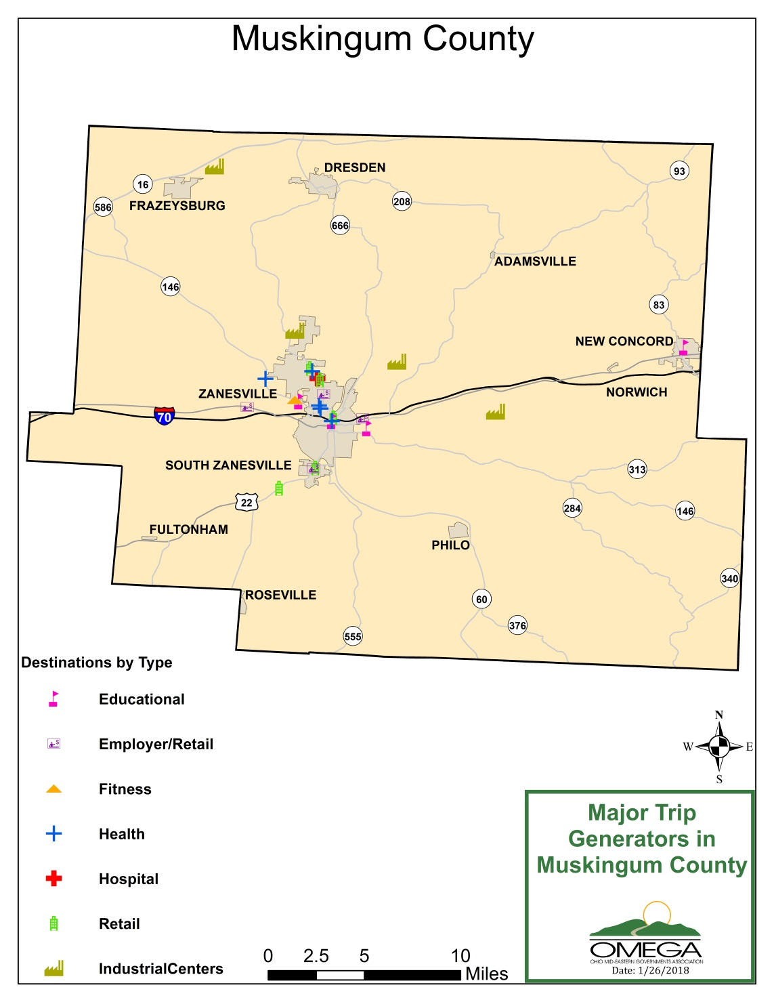

## Population Demographics

As of the 2010 census 86,074 people, 34,271 households, and 23,125 families reside in the county. The population density was 129.5 inhabitants per square mile (50.0/km2). There were 38,074 housing units at an average density of 57.3 per square mile (22.1/km2). The racial makeup of the county was 93.0% white, 3.8% black or African American, 0.3% Asian, 0.2% American Indian, 0.2% from other races, and 2.5% from two or more races.

The exhibit below shows the distribution of the older adult population per square mile for Muskingum County.



## Individuals with Disabilities

Disability data was collected using the 2016 U.S. Census. The following exhibits show the number of persons in Muskingum County with disabilities and the percentage of each age group with a disability.

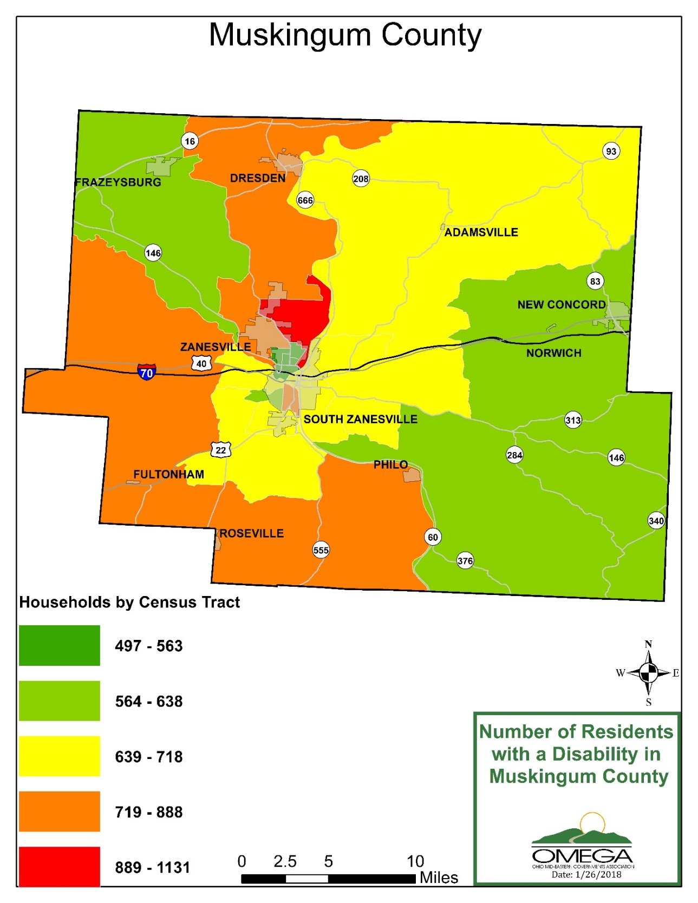

## 

## Household Income

The median income for a household in Muskingum county was $39,538 and the median income for a family was $48,425. Males had a median income of $40,183 versus $28,668 for females. The per capita income for the county was $20,561. About 13.0% of families and 16.6% of the population were below the poverty line, including 24.6% of those under age 18 and 9.3% of those age 65 or over.

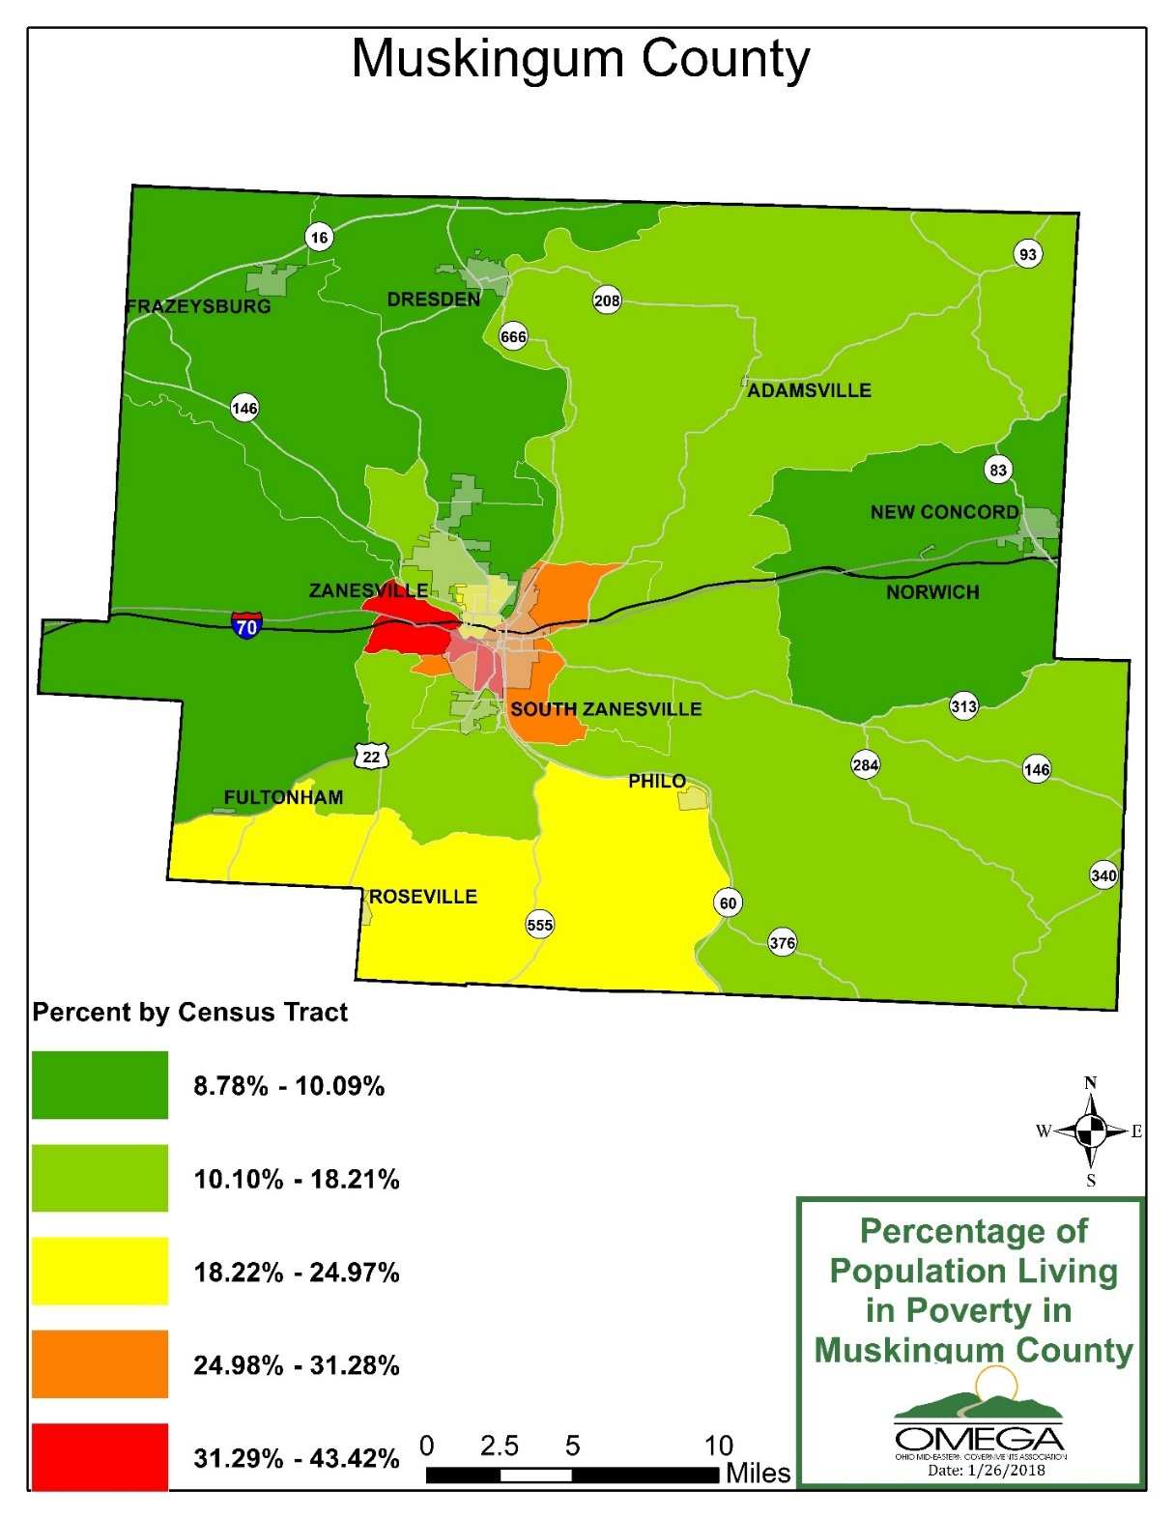

## Language

According to the 2016 US Census Data, 99.28 percent of the individuals in Muskingum County speak “English Very Well” while .72% individuals “Speak English Less than Very Well”. The exhibit depicts the breakdown of English Proficiency for Muskingum County.

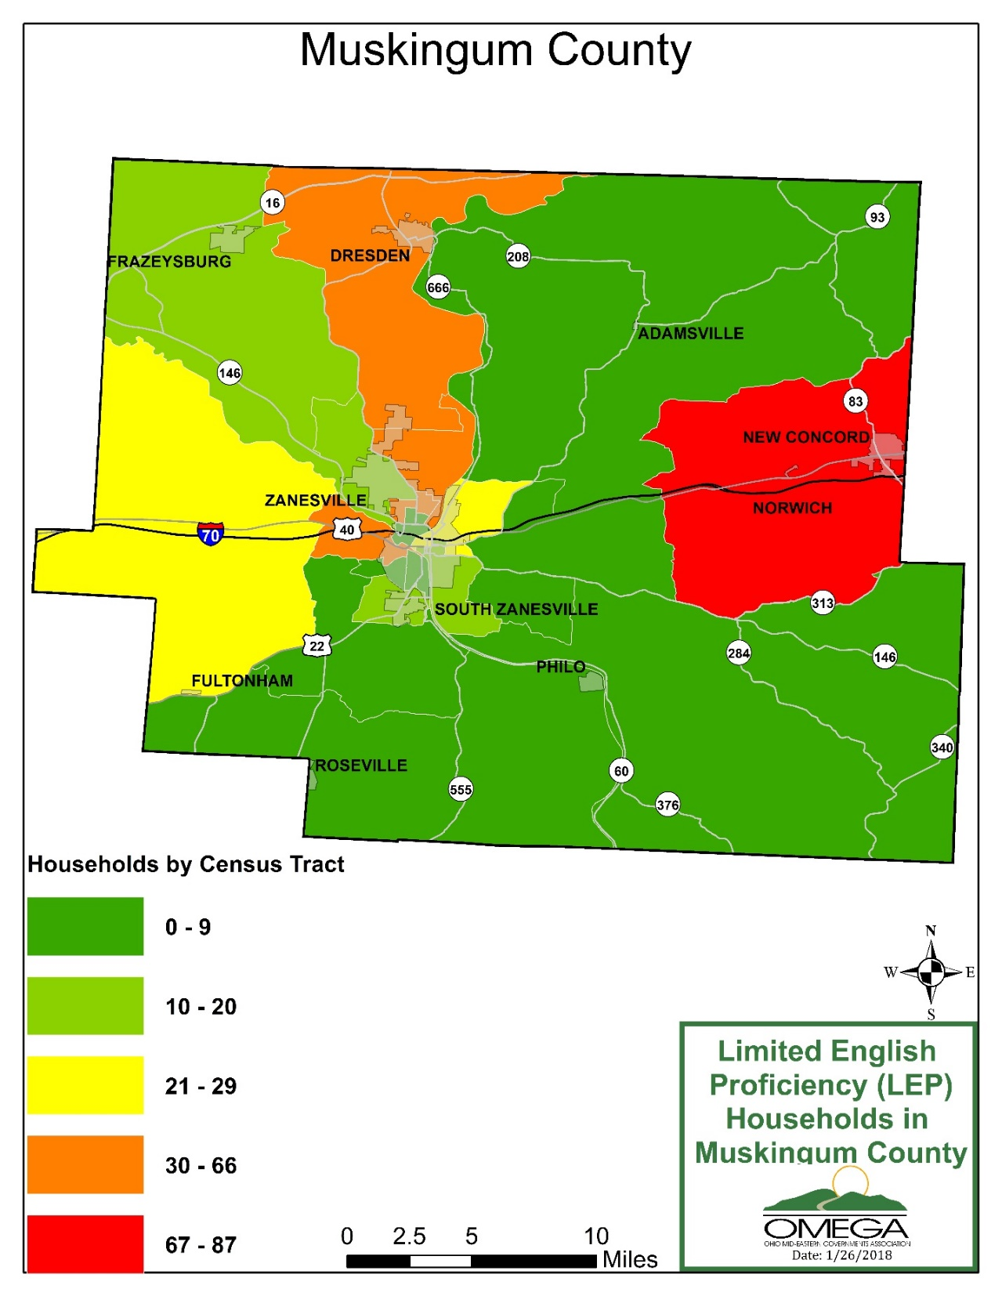

## Race Breakdown

The following exhibit depicts the population race breakdown of Muskingum County.

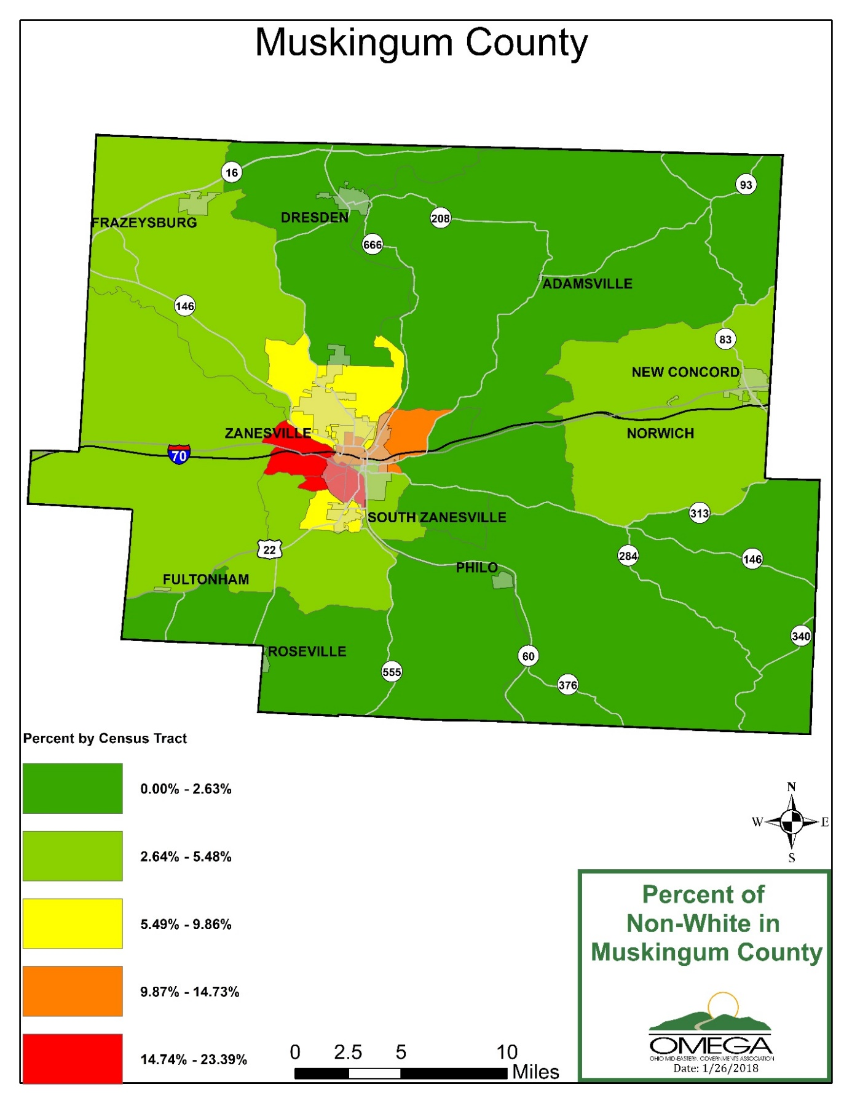

## Household Vehicles

The following map depicts the breakdown of zero vehicle households in Muskingum County.

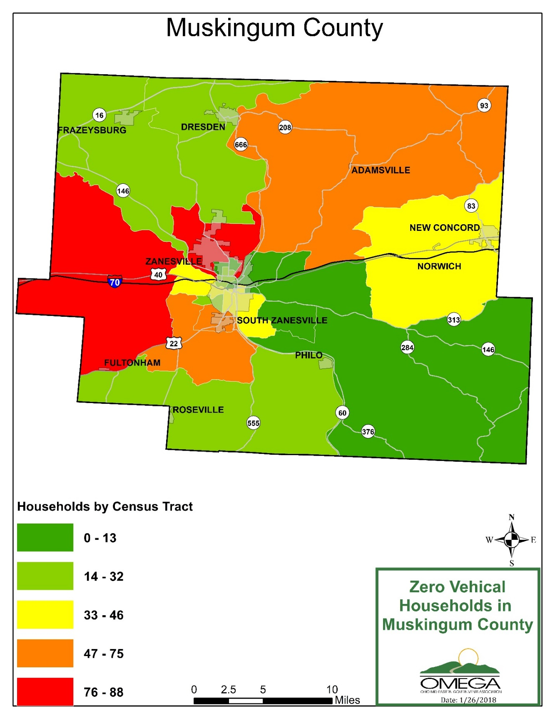

## Assessment of Available Services

Conducting an evaluation of service provider capabilities and analyzing the existing gaps and duplications of services for transportation resources in each community, provides transportation planners with the information needed to implement changes that will improve the network of transportation resources and services in Muskingum County.

The lead agencies identified stakeholders to participate in the assessment of available services. These stakeholders included those who were represented in the current and past planning committees, as well as others who the planning committee identified as being appropriate stakeholders.

Surveys to gain information were distributed to each identified stakeholder. Interviews were conducted to secure additional information. It is noted some of the identified stakeholders were only able to provide limited information as they were not the direct provider of transportation service. Some stakeholders represented transit disadvantaged individuals with individual care plans whereby the individual selects and secures a transportation provider of their choice.

The purpose of the interview was to offer the stakeholders an opportunity to discuss the specific transportation services, gaps, needs, and priorities for their respective service areas or communities.

When applicable, information reported in the previous coordinated plan was used to supplement information gathered during this planning effort.

## Inventory of Transportation Providers

The participating organizations provide a wide range of transportation including demand response transportation. All of the participating organizations provide services on weekdays. Some operate transportation on Saturdays and on Sundays as needed. Evening services after 6pm are operated by a few organizations. The following table depicts the transportation service characteristics by agency.

**Transportation Service Characteristics**

|  |  |  |  |  |  |  |
| --- | --- | --- | --- | --- | --- | --- |
| Agency Name | Mode of Service | Service Days/Times | Provides Medicaid-Eligible Trips (Y/N) | Level of Passenger Assistance Provided | Training Courses Required for Drivers | Driver Training Instructors and/or Resources |
| Quality Care Partners | Refer passengers to providers | M –F; 8am –4:30pm | N; only refers | N/A | N/A | N/A |
| Mid-Ohio  Mobility  Solutions | Refer passengers to providers | M_F  9am-3pm | N | N/A | N/A | N/A |
| SEAT | Human Services Agency fixed route (fixed path, schedule, stops)/Demand response (one-time & standing order appointments & group trips for agency consumers attending program activities) | Monday – Friday 6am-6pm; contractual services operate on weekends & holidays for Medicaid recipients | Y | Curb-to-Curb; Door-to-Door; Passengers are permitted to travel with their own personal care attendant or escort | All FTA & ODOT mandated training, background checks, drug and alcohol pre/post/random testing | FTA, ODOT, OTRP, individual SEAT course training |
| The Carr Center | Human service agency fixed route (fixed path, fixed schedule, designated stops) | Monday – Friday 7am-5pm | Y | Door-to-Door | Ohio DRIVE, Defensive Driving | Ohio Area Agency on Aging |
| Muskingum County Board of DD – Starlight | Does not provide direct support transportation but do authorize the cost for individuals to access transportation through other resources. Service Coordinators will provide some occasional 1:1 transportation for individuals to appointments. | Service Coordinators are on duty from 8:30am-4pm | N; only refers & authorizes | Coordinated | Good driving record; Defensive driving course | Through Muskingum County |
| Muskingum County Job & Family Services | Do not directly operate transportation but they do buy bus passes or purchase transportation on behalf of our consumers. Provide Muskingum County residents with services through programs such as SNAP, OWF, TANF, Medicaid & WIOA | Office hours are Monday-Friday 7am-5pm, but the transportation need is based on scheduled Doctor appointments | N; provides Muskingum County Residents with services through programs like Medicaid | Curb-to-Curb; Passengers are permitted to travel with their own personal care attendant or escort | None; refer all customers to SEAT to arrange their own | Trained internally on policy of who would qualify. Must be Medicaid eligible |
| Muskingum County Center for Seniors | Demand response (includes one-time and standing order appointments and group trips for agency consumers attending program activities) | Monday - Friday 8AM to 4PM | N/A | Door-to-door; Passengers are permitted to travel with their own personal care attendant or escort. | Drive Training and Defensive Driving, Sensitivity to Aging, First Aid and CPR | Area Agency on Aging, CORSA, Mid East Adult Education |
| Zanesville-Muskingum County Health Department | We do not directly operate transportation but we do buy bus passes or purchase transportation on behalf of our consumers. | 8-4:00 M-F are our regular business hours | N/A | N/A | NA – we do require employees to complete an online safe driving course every 2 years | Online through our liability provider |
| Zanesville Civic League | N/A | M –Th; 10am –7pm; Friday 10am – 5pm | N/A | N/A | Proof of insurance, valid driver’s license, age must be 25+ to drive company vehicle | N/A |
| Genesis HealthCare System | We do not directly operate transportation but we do buy bus passes or purchase transportation on behalf of our consumers. | 24/7 | Y | N/A | N/A | N/A |
| Allwell Behavioral Health Services | Demand response (includes one-time and standing order appointments and group trips for agency consumers attending program activities) – Yes; | Monday through Friday, 8:00 am to 5:00 pm | N/A | Curb-to-curb- Yes | Safety training and driving instruction with Maintenance Director, First Aid/CPT, DART (workplace violence training), orientation and annual online training (customer service, culture awareness, fire safety, Bloodborne Pathogens, Safety in the Community, Transportation and Service Delivery, etc.) | The Maintenance Director, hired certified CPR/First Aid instructor and online portal (myLearningPointe) |

The following table depicts the ridership characteristics for participating organizations. Some organizations may have eligibility requirements that are typically based on funding sources or the agency’s mission (i.e., transportation service is only available to older adults, individuals with disabilities, people with low incomes, registered consumers, etc.). Other agencies provide public transportation that is open to everyone or open to anyone in the public that has a disability, and/or meets age and/or income requirements. Still other agencies provide a combination of transportation for agency clients and older adults or people with disabilities who are not agency clients. It is important to explain each agency’s policy for passenger eligibility because it demonstrates the level of service availability for various geographic and demographic areas.

**Ridership Characteristics**

|  |  |  |  |  |
| --- | --- | --- | --- | --- |
| Agency Name | What are the Eligibility Requirements to use Transportation Services (eg. age, income) | Are Vehicles Only Available for Human Service Agency Clients (Y/N)* | Number of Annual One-Way Passenger Trips | Average Number Trip Denials per Week |
| Quality Care Partners | N/A | N/A | N/A | N/A |
| Mid-Ohio Mobility Solutions | N/A | N/A | N/A | N/A |
| SEAT | None | N | Street Route 91,171; Elderly/Disabled 19,636; Demand Response GP 550; Demand Response ED 1,913; JFS Medical 15,916; Other Contracts 4,030; JFS Contract Drivers 5,209;  TOTAL – 152,767 trips; 133,131 (total SEAT ridership) | N/A |
| The Carr Center | All transportation is provided for Carr Center Clients Only | Y | 0 | N/A |
| Muskingum County Board of DD – Starlight | Riders must be eligible for their services; support individuals with developmental disabilities, their families, and providers | Y | N/A | N/A |
| Muskingum County Job & Family Services | Yes. Individuals must be a Medicaid recipient, attending a Medicaid covered service & meet requirements of the NET Plan. | N/A | Between 12,000-15,000 (Contract Drivers 3,062 trips; In Town Bus 8,296 trips; Bus passes 48 trips) | N/A |
| Muskingum County Center for Seniors | Must be over the age of 60 and live within Muskingum County. | N/A | All billing is one way (?)8122 trips for 188 clients | N/A |
| Zanesville-Muskingum County Health Department | Clients of our services who need transportation for related services | N/A | We don’t track this | N/A |
| Zanesville Civic League | Yes, students have to be enrolled in our after school program. | N/A | N/A | N/A |
| Genesis HealthCare System | For the Genesis Providence Fund:   1. will assist anyone whose needs have been made known through Genesis and who has not been able to obtain immediate funds or services from any other sources 2. A maximum of $300 for each applicant may be allocated from the Providence Fund each calendar year. Assistance can be provided only one time per year per applicant and is intended to be short-term needs. Amounts greater than $300 and requests for additional assistance within the same year must be approved by the Director of Mission in consultation with the Vice President of Human Development. 3. Give 2- $5.00 card if the destination is within Zanesville city limits. • Give 3 - $5.00 cards if destination is outside of Zanesville City limits, but within or less than 30 miles (1/2 hour drive). • Give 4 - $5.00 cards if destination is more than 30 miles and up to 60 miles (1-hour drive).   Genesis Service Recovery (Genesis Patient Experience) oversees the distribution of assistance for rides on an as-needed basis, once other options have been considered. | N/A | N/A | N/A |
| *Allwell Behavioral Health Services* | Transportation is only available to clients of Allwell participating in either Mental Health Day Treatment groups or Case Management Services (aka – CPST, TBS/PSR) | *Y* | Reporting Muskingum only:  Mental Health Day Treatment = estimated 3,200 trips  Case Management = estimated 27,600 trips | *N/A* |

* “Yes” indicates that the agency is closed door. An example of an agency that is closed door is a sheltered workshop that only provides transportation to individuals who are enrolled in the sheltered workshops programs. Answering “no” indicates that the agency is open door. This means the service is open to the public or a segment of the general public defined by age, disability, or low income. For example, if anyone in the community regardless of enrollment in agency programs, can request transportation services are considered open door.

Transportation-related expenses and revenues also differ by organization. Grants and contract are common revenue sources for transportation operators in Muskingum County. The table below provides a summary of expenses and revenues for public and non-profit transportation programs.

**Table : Transportation-Related Expenses and Revenues**

|  |  |  |  |  |  |  |
| --- | --- | --- | --- | --- | --- | --- |
| Agency Name | Fare Structure | Donations Accepted (Y/N) | Number of Full-Time & Part-Time Drivers | Number of Full-Time & Part-Time Schedulers/ Dispatchers | Revenue Sources (most recent Fiscal Year) | Total Annual Transportation Expenses |
| *Quality Care*  *Partners* | *N/A* | *N/A* | *N/A* | *N/A* | *N/A* | *N/A* |
| *Mid-Ohio Mobility*  *Solutions* | *N/A* | *Yes* | N/A | *2 Part time* | *5310 Grant* | N/A |
| *SEAT* | *Destination location ($0.50 - $16.00 range)* | *No* | *N/A* | *N/A* | *$3,069,631 operating revenues – vehicles, lighting in maintenance garage, CTS Software, tire alignment machine, cameras* | *$252, 124 capital expenses* |
| *The Carr Center* | *$1.75/loaded mile or fee reimbursable rates as provided by agencies served* | *No* | *N/A* | *N/A* | *Fundraising and gifts* | *N/A* |
| *Muskingum County Board of DD –*  *Starlight* | *N/A* | *No* | *N/A* | *N/A* | *N/A* | *N/A* |
| *Muskingum County Job & Family Services* | *No charge or fee for providing transportation* | *No* | *N/A* | *N/A* | *N/A* | *Total of Contract Drivers + In town bus + Bus passes = $692,317.13* |
| *Muskingum County Center for Seniors* | *No, N/A* | *Y, suggested donation of $3 ea trip EXCEPT for Title III Passport Clients* | *N/A* | *N/A* | *Annual Operating Revenue $84,077.42; no other source* | *$112,832.00* |
| *Zanesville-*  *Muskingum County Health Department* | *No, N/A* | *No, N/A* | *N/A* | *N/A* | *0, none* | *We assist with transportation costs for our employees to perform their job. We don’t track these expenses separately in the categories you are requesting.* |
| *Zanesville Civic League* | *No, N/A* | *N/A* | *N/A* | *N/A* | *None* | *Gas & Maintenance only* |
| *Genesis HealthCare System* | *N/A* | *No* | *N/A* | *N/A* | *N/A* | *N/A* |
| *Allwell Behavioral Health Services* | *N/A* | *No* | *N/A* | *N/A* | *N/A* | *According to the FY2018 Budget, companywide expenses (across all six counties):*  *Vehicle Licensing: $1,967*  *Insurance: $34,434*  *Gas: $50,000*  *Vehicle Maintenance: $27,060*  *Vehicle Lease (4 leased vehicles were returned in March, expenses not anticipated in next fiscal year): $16,774*  *Employee Travel Reimbursement: $250,000 (case management staff allocation only)* |

The following table provides basic information about transportation options other than the traditional public and human services transportation. Transportation options might include bike share, ride share, intercity, or taxi services, and more.

**Table : Transportation Options**

|  |  |  |  |  |
| --- | --- | --- | --- | --- |
| Transportation Option | Availability | Cost | Usage | Service Area |
| *Quality Care Partners* | *N/A* | *N/A* | *N/A* | *Southeast Ohio* |
| *Mid-Ohio Mobility*  *Solutions* | *M-F 9am-3pm* | N/A | N/A | *OMEGA Region &*  *Morgan,Noble & Perry* |
| *SEAT* | *N/A* | *N/A* | *N/A* | *Muskingum & Guernsey County & 150mi Med Appt Radius* |
| *The Carr Center* | *N/A* | *N/A* | *N/A* | *Muskingum & Guernsey Counties* |
| *Muskingum County Board of DD – Starlight* | *N/A* | *N/A* | *N/A* | *Muskingum County Only* |
| *Muskingum County Job & Family Services* | *N/A* | *N/A* | *N/A* | *Muskingum County Residents Only* |
| *Muskingum County*  *Center for Seniors* | *N/A* | *N/A* | *N/A* | *Muskingum County Only* |
| *Zanesville-Muskingum County Health*  *Department* | *N/A* | *N/A* | *N/A* | *Muskingum County Only* |
| *Zanesville Civic League* | *N/A* | *N/A* | *N/A* | *N/A* |
| *Genesis HealthCare*  *System* | *N/A* | *N/A* | *N/A* | *N/A* |
| *Allwell Behavioral Health Services* | *N/A* | *N/A* | *N/A* | *Muskingum* |

The following table provides basic information about local travel training program options.

**Table : Transportation Resources**

|  |  |  |  |  |
| --- | --- | --- | --- | --- |
| Transportation Resource | Availability | Cost | Usage | Service Area |
| *Quality Care Partners* | *N/A* | *N/A* | *N/A* | *Southeast Ohio* |
| *Mid-Ohio Mobility*  *Solutions* | *M-F 9am-3pm* | N/A | N/A | *OMEGA Region &*  *Morgan,Noble & Perry* |
| *SEAT* | *N/A* | *N/A* | *N/A* | *Muskingum & Guernsey County & 150mi Med Appt Radius* |
| *The Carr Center* | *N/A* | *N/A* | *N/A* | *Muskingum & Guernsey Counties* |
| *Muskingum County Board of DD – Starlight* | *N/A* | *N/A* | *N/A* | *Muskingum County Only* |
| *Muskingum County Job & Family Services* | *N/A* | *N/A* | *N/A* | *Muskingum County Residents Only* |
| *Muskingum County*  *Center for Seniors* | *N/A* | *N/A* | *N/A* | *Muskingum County Only* |
| *Zanesville-Muskingum County Health*  *Department* | *N/A* | *N/A* | *N/A* | *Muskingum County Only* |
| *Zanesville Civic League* | *N/A* | *N/A* | *N/A* | *N/A* |
| *Genesis HealthCare*  *System* | *N/A* | *N/A* | *N/A* | *N/A* |
| *Allwell Behavioral Health Services* | *N/A* | *N/A* | *N/A* | *Muskingum* |

The following table illustrates the technology used by each transportation provider for scheduling, dispatching, and/or GPS tracking vehicles. (SEE NEXT PAGE)

**Table : Technology**

|  |  |  |  |  |
| --- | --- | --- | --- | --- |
| Agency Name | Name of Scheduling Software | Do you have an App for Transportation (Y/N)? | Name of Dispatching Software | AVL System/ GPS (Y/N) |
| *Quality Care*  *Partners* | *N/A* | *N/A* | *N/A* | *N/A* |
| *Mid-Ohio Mobility Solutions* | *CTS* | *N/A* | *CTS* | *Y* |
| *SEAT* | *CTS* | *N/A* | *CTS* | *Y* |
| *The Carr Center* | *N/A* | *N/A* | *N/A* | *N/A* |
| *Muskingum County Board of DD – Starlight* | *N/A* | *N/A* | *N/A* | *N/A* |
| *Muskingum County Job & Family Services* | *N/A* | *N/A* | *N/A* | *N/A* |
| *Muskingum County Center for Seniors* | *N/A* | *N/A* | *N/A* | *N/A* |
| *Zanesville-*  *Muskingum County Health*  *Department* | *N/A* | *N/A* | *N/A* | *N/A* |
| *Zanesville Civic League* | *N/A* | *N/A* | *N/A* | *N/A* |
| *Genesis HealthCare*  *System* | *N/A* | *N/A* | *N/A* | *N/A* |
| *Allwell Behavioral Health Services* | *N/A* | *N/A* | *N/A* | *N/A* |

## Additional Provider Information:

Providers were also asked to answer a series of questions about specific to their organization about gaps in service and transportation and coordination opportunities. The responses to those questions follow below.

***Agency: Quality Care Partners***

**Future of Coordinated Public & Human Service Agency transportation**: Increased access to transportation for our region including same day service, door to door, and door through door services.

**Positive Momentum & Interest:** Yes, the increased need for transportation has been identified and groups have been collaborating on identifying ways to achieve additional resources.

**Availability Efficiency:** There has been some improvement in the transportation, but I think that the lack of publicity of available services is probably intensifying the problem.

**Unmet Needs or Gaps:** Same day service, door to door, and door through door, weekend

**Needs & Gaps Strategies:** Improved communication, more availability and flexibility

**Challenges to Implementation:** Cost and availability

***Agency: Mid-Ohio Mobility Solutions***

**Future of Coordinated Public & Human Service Agency transportation**: Increased access to transportation options in our region including same day service, door to door, and door through door services.

**Positive Momentum & Interest:** Yes, the increased need for transportation has been identified and groups have been collaborating on identifying ways to achieve additional resources.

**Availability Efficiency:** Since starting this service the amount of clients helped has been increased in not only Muskingum County but all counties in OMEGA Region

**Unmet Needs or Gaps:** Service after 6 pm for non-Medicaid clients, weekend service & affordable out of the county transportation.

**Needs & Gaps Strategies:** work with regional providers to coordinate more trip

**Challenges to Implementation:** Cost and availability

***Agency: South East Area Transit (SEAT)***

**Future of Coordinated Public & Human Service Agency transportation**: Alignment of services between local agencies and providers

**Positive Momentum & Interest:** Yes, there is a strong need in the area and interest continues to grow.

**Availability Efficiency:** First stages show good information and a good plan is in place.

**Unmet Needs or Gaps:** Nights and weekends

**Needs & Gaps Strategies:** Working together and partnering with other community providers.

**Challenges to Implementation:** Financial backing to pay for the transportation costs.

***Agency: The Carr Center***

**Future of Coordinated Public & Human Service Agency transportation**: N/A

**Positive Momentum & Interest:** Yes

**Availability Efficiency:** Improvement for past previous years

**Unmet Needs or Gaps:** N/A

**Needs & Gaps Strategies:** Coordination between providers to unify the service and eliminate inefficiencies in duplication of services

**Challenges to Implementation:** Funding

***Agency: Muskingum County Board of DD – Starlight***

**Future of Coordinated Public & Human Service Agency transportation**: More county-wide transportation and extended hours but understand to offer these services they must be utilized.

**Positive Momentum & Interest:** It makes sense. Muskingum County is a large area and coordinating transportation among agencies could possibly save money.

**Availability Efficiency:** Unsure

**Unmet Needs or Gaps:** The after-hours availability.

**Needs & Gaps Strategies:** Unsure – need more information.

**Challenges to Implementation:** Unsure – need more information.

***Agency: Muskingum County Job & Family Services***

**Future of Coordinated Public & Human Service Agency transportation**: A common contact person

**Positive Momentum & Interest:** Yes, aware of community groups trying to do this very thing. There is always an interest with growing population.

**Availability Efficiency:** SEAT work well with our agency on concerns regarding client issues/concerns.

**Unmet Needs or Gaps:** Rural areas outside of bus line and consumers not being aware of services available.

**Needs & Gaps Strategies:** Public awareness and one-person contact

**Challenges to Implementation:** Ownership & cooperation of multiple entities

***Agency: Muskingum County Center for Seniors***

**Future of Coordinated Public & Human Service Agency transportation**: The ability to serve more seniors with extended service. Also, possible purchasing vehicles at a lower cost.

**Positive Momentum & Interest:** I believe there will be once the community understands the plan.

**Availability Efficiency:** We are moving in the right direction.

**Unmet Needs or Gaps:** Transportation outside the county and evening and weekend services.

**Needs & Gaps Strategies:** Coordination with other providers.

**Challenges to Implementation:** Pulling all providers together and communicating with the public the availability of services.

***Agency: Zanesville Civic League***

**Future of Coordinated Public & Human Service Agency transportation**: We would like to see more outreach and collaboration in our community.

**Positive Momentum & Interest:** Yes. We believe coordinated transportation is a benefit that our community can use to better our client’s lifestyle.

**Availability Efficiency:** N/A

**Unmet Needs or Gaps:** Availability

**Needs & Gaps Strategies:** We believe that availability and dependability needs would be resourceful to our targeted audience.

**Challenges to Implementation:** N/A

***Agency: Zanesville-Muskingum County Health Department***

**Future of Coordinated Public & Human Service Agency transportation**: Improved access for the underserved and those with no personal transportation.

**Positive Momentum & Interest:** Yes.

**Availability Efficiency:** We are working to make medical transportation improvements but there are still gaps for seniors and low-income families.

**Unmet Needs or Gaps:** Unplanned needs with inability to request assistance in advance including medical, social, and daily needs (ie grocery, beauty shop, etc)

**Needs & Gaps Strategies:** Work together to better communicate and utilize the transportation available. And, we need more flexible funding to help us provide transportation to those that don’t have a need which fits into a funded service.

**Challenges to Implementation:** It’s everybody’s responsibility and nobody’s direct responsibility. Agencies are all doing more work with fewer people and communication among agencies takes time. We don’t know what we don’t know so it creates silos where we can only focus on what we know.

***Agency: Genesis Healthcare System***

**Future of Coordinated Public & Human Service Agency transportation**: At times Genesis pays for cab service when no other transportation is available but this comes from Providence Funding, so I'm not sure if this is an actual "Genesis" payment. I do not have the $$ amounts of what is spent from Providence Funding on transportation for the hospital or for the Cancer Center. Providence fund also provides $5 gas vouchers, these are provided to patients in a last resort scenario or in the event of a wasted trip by patient to Cancer Center (example if radiation equipment down or a wrong appointment was provided to patient) This funding is utilized but I do not have any way to retrieve this information, it goes through Customer Service.

**Positive Momentum & Interest:** I am not aware of any programs that anyone is looking into transportation issues. Often working with the Senior Center can be challenging, Z-Bus tries their best but can fill up and only covers Muskingum County. Coshocton transit is extremely difficult, Morgan County doesn't have anything, Perry County has a transit but people would rather walk than use it.

**Availability Efficiency:** Transportation is only available to those on Medicaid or who live in county and fall under the Senior Center's criteria to utilize their services. If you do not fall into these categories, or live in Coshocton for example, patients are on their own to find a ride.

**Unmet Needs or Gaps:** Transportation is not available for everyone, the transportation entities that do exist fill up quickly.

**Needs & Gaps Strategies:** For our area, public transportation conjures up negative attitudes. The public attitude would need changed to be able to get more people to utilize public transportation. Even the separate Medicaid managed care plans have a transportation company that Medicaid patients can use, but people would "rather not" and prefer to receive cash assistance instead. This drains the funding in other areas for those who cannot receive "free" transportation through Medicaid. The local Cab Service allows smoking in their vehicle by the driver. I've had a case where patients will refuse to use the cab service for this reason but we have no competition in this area. An increase in availability would help but isn't practical, transportation companies have to prepare the next day's route for drivers and any last-minute add-on's or changes could cause delays for previously scheduled patients. Transportation runs thin, so there are long wait times for return rides home. So of course, in a small community where most places can be reached in less than 15 minutes a long wait is not accepted. These situations make it hard to change the negative attitude towards public transportation.

**Challenges to Implementation:** Transit provider were asked a series of questions to identify unmet needs realized within their organization. The information below details the responses by each organization.

***Agency: Allwell Behavioral Health Services***

**Future of Coordinated Public & Human Service Agency transportation**: Transportation options for evenings and weekends

**Positive Momentum & Interest:** Yes.

**Availability Efficiency:** Transportation is only available to clients of Allwell participating in either Mental Health Day Treatment groups or Case Management Services (aka – CPST, TBS/PSR)

**Unmet Needs or Gaps:** Evening and weekend services

**Needs & Gaps Strategies:** Better coordination of transportation between and among health care providers and employers

**Challenges to Implementation:** No coordinated plan.

## 

## Assessment of Community Support for Transit

Community support for transportation was apparent at the stakeholder and public meetings. All meetings were well attended. Stakeholders voiced ongoing commitment toward advancing the goals and strategies identified in this coordination plan. While local government official’s participation was limited, representatives did attend the first meeting and voiced support for the project.

The SEAT Board meets on a regular basis and SEAT is very active in the community. SEAT seeks agency and public comment on SEAT services on at least an annual basis.

## Safety

This plan includes goals for Complete Streets and Active Transportation Plans that will improve the safety of pedestrians, bicyclers, and those operating vehicles. Improvements and or development to walking and biking paths in addition to sidewalk improvements will greatly increase the safety of pedestrians and bicyclers by providing dedicated paths without the congestion of vehicle traffic. Road improvements, curb cuts, strategically timed stop lights, street lights, etc. will improve the safety of not only transit vehicles but all traffic traveling throughout the counties.

## Vehicles

A complete vehicle inventory was also conducted during this plan development. Vehicle inventories are detailed below. Currently, there have been no reports that agencies have turned away individuals requiring a wheelchair accessible vehicle. As vehicles age, they require additional maintenance, may break down more often, and become costlier to operate. Vehicle replacement, based on age and condition, is vital to the overall cost effectiveness of the transportation services provided.

**Vehicle Utilization Table**

| **Veh #** | **Make** | **Vin #** | **Capacity** | **Service Days** | **Vehicle**  **Condition** | **Program to which Vehicle is Assigned (if applicable)** | | **Service Area** | |
| --- | --- | --- | --- | --- | --- | --- | --- | --- | --- |
| **Year** | **Model** | **WC Capacity** | **Service Hours** |
| **South East Area Transit** | | | | | | | | | |
| 273 | Ford | [1FDXE45S67DB21129](http://ohdot.blackcatgrants.com/extensions/organizations/controls/InventoryDisplay.aspx?type=1&organizationId=3639&recordId=474) | 12 | M-F | Good | 5311 | | Muskingum | |
| 2007 | LTV | 2 | 6A-6P |
| 281 | Ford | [1FD4E45S58DB51386](http://ohdot.blackcatgrants.com/extensions/organizations/controls/InventoryDisplay.aspx?type=1&organizationId=3639&recordId=475) | 12 | M-F | Good | 5311 | | Muskingum | |
| 2008 | LTV | 2 | 6A-6P |
| 1034 | Dodge | [2D4RN4DE4AR133098](http://ohdot.blackcatgrants.com/extensions/organizations/controls/InventoryDisplay.aspx?type=1&organizationId=3639&recordId=482) | 4 | M-F | Good | 5311 | | Muskingum | |
| 2010 | MV | 1 | 6A-6P |
| 1041 | Ford | [1F1E4FS0ADA48874](http://ohdot.blackcatgrants.com/extensions/organizations/controls/InventoryDisplay.aspx?type=1&organizationId=3639&recordId=485) | 12 | M-F | Good | 5311 | | Muskingum | |
| 2010 | LTV | 2 | 6A-6P |
| 1042 | Ford | [1F1E4FS2ADA48875](http://ohdot.blackcatgrants.com/extensions/organizations/controls/InventoryDisplay.aspx?type=1&organizationId=3639&recordId=486) | 12 | M-F | Good | 5311 | | Muskingum | |
| 2010 | LTV | 2 | 6A-6P |
| 1043 | Ford | [1F1E4FS4ADA48876](http://ohdot.blackcatgrants.com/extensions/organizations/controls/InventoryDisplay.aspx?type=1&organizationId=3639&recordId=487) | 12 | M-F | Good | 5311 | | Muskingum | |
| 2010 | LTV | 2 | 6A-6P |
| 1044 | Ford | [1F1E45SX9DA92359](http://ohdot.blackcatgrants.com/extensions/organizations/controls/InventoryDisplay.aspx?type=1&organizationId=3639&recordId=488) | 16 | M-F | Good | 5311 | | Muskingum | |
| 2009 | LTV | 2 | 6A-6P |
| 1046 | Ford | [1F1E4FS8ADA55507](http://ohdot.blackcatgrants.com/extensions/organizations/controls/InventoryDisplay.aspx?type=1&organizationId=3639&recordId=490) | 16 | M-F | Good | 5311 | | Muskingum | |
| 2010 | LTV | 2 | 6A-6P |
| 1201 | Ford | 1FDE4FS5CDA32513 | 16 | M-F | Good | 5311 | | Muskingum | |
| 2012 | LTV | 2 | 6A-6P |
| 1301 | Ford | [1F1E4FS3DDA59565](http://ohdot.blackcatgrants.com/extensions/organizations/controls/InventoryDisplay.aspx?type=1&organizationId=3639&recordId=3968) | 16 | M-F | Good | 5311 | | Muskingum | |
| 2013 | LTV | 2 | 6A-6P |
| 1401 | Ford | [1FTDS3EL1EDA48848](http://ohdot.blackcatgrants.com/extensions/organizations/controls/InventoryDisplay.aspx?type=1&organizationId=3639&recordId=4360) | 6 | M-F | Good | 5311 | | Muskingum | |
| 2014 | LTV | 1 | 6A-6P |
| 1402 | Ford | [1F1E4FS1EDA41079](http://ohdot.blackcatgrants.com/extensions/organizations/controls/InventoryDisplay.aspx?type=1&organizationId=3639&recordId=4361) | 16 | M-F | Good | 5311 | | Muskingum | |
| 2014 | LTV | 2 | 6A-6P |
| 1403 | Ford | [1F1E4FS8EDA83619](http://ohdot.blackcatgrants.com/extensions/organizations/controls/InventoryDisplay.aspx?type=1&organizationId=3639&recordId=4458) | 16 | M-F | Good | 5311 | | Muskingum | |
| 2014 | LTV | 2 | 6A-6P |
| 1404 | Ford | [1F1E4FS7EDB10857](http://ohdot.blackcatgrants.com/extensions/organizations/controls/InventoryDisplay.aspx?type=1&organizationId=3639&recordId=4500) | 16 | M-F | Good | 5311 | | Muskingum | |
| 2014 | LTV | 2 | 6A-6P |
| 1501 | Ford | [1F1E4FS2GDC10965](http://ohdot.blackcatgrants.com/extensions/organizations/controls/InventoryDisplay.aspx?type=1&organizationId=3639&recordId=4871) | 16 | M-F | Good | 5311 | | Muskingum | |
| 2016 | LTV | 2 | 6A-6P |
| 1502 | Ford | [1FDEE3FL2GDC12374](http://ohdot.blackcatgrants.com/extensions/organizations/controls/InventoryDisplay.aspx?type=1&organizationId=3639&recordId=4878) | 12 | M-F | Good | 5311 | | Muskingum | |
| 2016 | LTV | 2 | 6A-6P |
| 1601 | Ford | [1F1E4FS0GDC41129](http://ohdot.blackcatgrants.com/extensions/organizations/controls/InventoryDisplay.aspx?type=1&organizationId=3639&recordId=5388) | 16 | M-F | Good | 5311 | | Muskingum | |
| 2016 | LTV | 2 | 6A-6P |
| 1602 | Ford | [1F1E4FS9GDC53456](http://ohdot.blackcatgrants.com/extensions/organizations/controls/InventoryDisplay.aspx?type=1&organizationId=3639&recordId=5487) | 16 | M-F | Good | 5311 | | Muskingum | |
| 2016 | LTV | 2 | 6A-6P |
| 1701 | Ford | [1F1E4FS8HDC37802](http://ohdot.blackcatgrants.com/extensions/organizations/controls/InventoryDisplay.aspx?type=1&organizationId=3639&recordId=9149) | 16 | M-F | Good | 5311 | | Muskingum | |
| 2017 | LTV | 2 | 6A-6P |
| 1702 | Ford | [1F1E4FS1HDC37804](http://ohdot.blackcatgrants.com/extensions/organizations/controls/InventoryDisplay.aspx?type=1&organizationId=3639&recordId=9150) | 16 | M-F | Good | 5311 | | Muskingum | |
| 2017 | LTV | 2 | 6A-6P |
| 1703 | Ford | [1FTYR2CM4HKB54455](http://ohdot.blackcatgrants.com/extensions/organizations/controls/InventoryDisplay.aspx?type=1&organizationId=3639&recordId=9249) | 4 | M-F | Good | 5311 | | Muskingum | |
| 2017 | Transit | 1 | 6A-6P |
| 1801 | Ford | 1FDFE4FS2JDC20869 | 16 | M-F | Good | 5311 | | Muskingum | |
| 2018 | LTV | 2 | 6A-6P |
| 1802 | Ford | 1FDFE4FS8JDC20875 | 16 | M-F | Good | 5311 | | Muskingum | |
| 2018 | LTV | 2 | 6A-6P |
| 1803 | Ford | 1FTYR2CM6JKB21950 | 4 | M-F | Good | 5311 | | Muskingum | |
| 2018 | Transit | 1 | 6A-6P |
|  |  |  |  |  |  |  | |  | |
|  |  |  |  |
| **Zanesville Civic League** | | | | | | | | | |
| 1 | GMC | 1GJHG39R321179061 | 11 | M-TH | Good | N/A | | Muskingum | |
| 2002 | Van | 0 | 8 hrs |
| 2 | GMC | 1GJHG39R6W1097802 | 15 | M-TH | Good | N/A | | Muskingum | |
| 1998 | Van | 0 | 8 hrs |
| 3 | Chevy | 1GNDU03E94D102495 | 8 | M-TH | Good | N/A | | Muskingum | |
| 2001 | Van | 0 | 8 hrs |
| **Muskingum County Center for Seniors** | | | | | | | | | | |
| 677YJX | Ford | 1FBSS31L05HA98697 | 4 Inc. driver | As Needed | Fair | Senior Trans. | | Muskingum | |
| 2005 | Van | 1 |  |
| 656YEN | Dodge | 2C4RDGBG6GR335200 | 6 Inc. driver | 5 days | Good | Senior Trans. | | Muskingum | |
| 2016 | Van | 0 | 7 hrs/day |
| OF2423 | Dodge | 2C4RDGBG3GR335199 | 6 Inc. driver | 5 days | Good | Senior Trans. | | Muskingum | |
| 2016 | Van | 0 | 7 hrs/day |  | |
| 164YSF | Ford | 1FBNE3BL6DDA76888 | 10 inc driver | 5 days | Good | Congregate Trans. | | Muskingum | |
| 2013 | Van | 0 | 4 hrs/day |
| OF8815 | Ford | 1FBNE31L78DA73487 | 10 inc driver | 5 days | Good | Congregate Trans. | | Muskingum | |
| 2008 | Van 350 | 0 | 4 hrs/day |
| OD6415 | Ford | 1FBNE31L76DA43824 | 10 inc driver | As Needed | Fair | Congregate Trans. | | Muskingum | |
| 2006 | Van | 0 |  |
| **The Carr Center** | | | | | | | | | |
| 2 | Ford | 1FMNE1BW1ADA10475 | 4 | M-F | Good | N/A | In and out of county | | |
| 2010 | E-150 | 1 | 6:00am-6:00pm |
| 1 | Ford | 1FDFE4FL8DDA50806 | 12 | M-F | Good | N/A | In and out of county | | |
| 2013 | F-450 | 2 | 6:00am-6:00pm |
| 3 | Dodge | 2D4GP44LX6R16392 | 4 | M-F | Good | N/A | In and out of county | | |
| 2006 | Grand Caravan | 1 | 6:00am-6:00pm |
| **Allwell Behavioral Health** | | | | | | | | | |
| 5 | Ford | 1FTNS24L49DA24971 | 12 | M-F | Good | Day Treatment | Musk | |
| 2009 | E-250 | 0 | 8-5 |
| 10 | Dodge | 1D4GP25BX5B436532 | 8 | M-F | Good | CPST | Musk | |
| 2005 | Van | 0 | 8-5 |
| 11 | Ford | 1FBSS3BL9ADA25442 | 12 | M-F | Good | Day Treatment | Musk | |
| 2010 | E-350 | 0 | 8-5 |
| 16 | Ford | 1FBNE3BLXDDA52562 | 8-15 | Intermittent | Good | Day Treatment | All | |
| 2013 | Van | 0 | 8-5 |

## Assessment of Transportation Needs and Gaps

In an effort to better understand the needs of Muskingum County the planning committee examined research and data, as well as solicited input from the community in an effort to gather information about needs and gaps in transportation services.

The demographic and socio-economic conditions of the study area are discussed in the Demographics Chapter of this plan. The following overview is an evaluation of the gaps in service based upon geographic data as well as from the perspective of the targeted populations, transportation providers, and the general public.

A variety of stakeholders in the area worked together in an attempt to solicit input and request participation from any organization that could potentially be impacted by the coordinated transportation planning process. More information on how the lead agency engaged stakeholder and the general public is available upon request.

The following methods were used to assess transportation needs and gaps

* Assessment of data and demographics
* Survey data of individuals who currently use public transportation
* Information gathering at public meetings
* Community and agency surveys
* Stakeholder input

## Local Demographic and Socio-Economic Data

Data for each target population group were aggregated by Census Block Group for transportation analysis. The demographic and socio-economic data is valuable because a comparison of where the highest and lowest densities individuals who are most likely to need transportation live. This information can then be compared to the locations of (1) major trip generators, and (2) available transportation services. Demographic and Socio – Economic specific details were provided earlier in this plan in the demographic and socio-economic data section.

### Older Adult Population

Older adults are most likely to use transportation services when they are unable to drive themselves or choose not to drive. Older adults also tend to be on a limited retirement income and, therefore, transportation services are a more economical option to owning a vehicle. For these reasons, the population of older adults in an area is an indicator of potential transit demand.

There is a trend occurring in the United States relating to the aging of the population. The two age cohorts with the largest percentage of growth over the last decade were the 50-54-year-old cohort and the 45-49-year-old cohort. People in these two age groups were primarily born during the post-WWII “baby boom,” era defined by the Census Bureau as persons born from 1946 through 1964. These baby boomers are now reaching the age of 65 and are becoming more likely to use transportation services if they are available.

Further, the Administration on Aging (U.S. Department of Health and Human Services) reports that, based on a comprehensive survey of older adults, longevity is increasing and younger seniors are healthier than in all previously measured time in our history. Quality of life issues and an individual’s desire to live independently will put increasing pressure on existing transit services to provide mobility to this population. As older adults live longer and remain independent, the potential need to provide public transit is greatly increased.

The exhibits above of population density for individuals 65 and over illustrate the population density of persons over 65 years of age by block group. The concentrations of this age group mimic the densities of the overall population for the region.

### Individuals with Disabilities

Enumeration of the population with disabilities in any community presents challenges. First, there is a complex and lengthy definition of a person with a disability in the Americans with Disabilities Act implementing regulations, which is found in 49 CFR Part 37.3. This definition, when applied to transportation services applications, is designed to permit a functional approach to disability determination rather than a strict categorical definition. In a functional approach, the mere presence of a condition that is typically thought to be disabling gives way to consideration of an individual’s abilities to perform various life functions. In short, an individual’s capabilities, rather than the mere presence of a medical condition, determine transportation disability.

The U.S. Census offers no method of identifying individuals as having a transportation related disability.

## General Public and Stakeholder Meetings/Focus Groups

A total of five (5) local meetings and focus groups to discuss the unmet transportation needs and gaps in mobility and transportation. 60 total people participated in the meetings. Of those 60, several self- identified as older adults and at least one individual 4 self-identified as being a person with a disability. More information about the meetings, meeting participants, and meeting content is provided as an appendix to this plan.

During the meetings, highlights of historical coordinated transportation in Muskingum County.

Following the initial presentation, the stakeholders were asked to review the gaps in transportation services and needs from the previous plan/or update and identify any gaps that were no longer valid and any new needs/gaps, which the facilitator deleted/added to/from a list. The focus of the discussion was transportation for older adults, individuals with disabilities, and people with low incomes. However, several topics discussed also impact mobility options for the general public.

At the second meeting the changes to the needs/gaps list were presented and new needs/gaps were added, each participant was asked to rank the needs/gaps using colored dots representing a high, medium, or low priority or that the remaining gap/need should be deleted.

The additional three (3) meetings held focused on potential solutions to the unmet needs identified and to share results of the community survey.

Participants discussed more than 46 mobility issues to achieve, preserve, avoid, or eliminate through coordination during the meetings. Coordinated transportation stakeholders will consider these unmet needs when developing transportation goals and strategies, and grant applications. The exhibit at the end of this section provides a summary of the unmet mobility needs discussed during the meeting as well as the needs identified by the survey results.

The final public meeting was held to review goals and strategies and establish priorities. The final meeting provided consensus of the established goals and strategies. The agreed upon goals and strategies are presented in the Goals and Strategies section of this plan.

## 

## Surveys

Community surveys were conducted during the planning process. 183 surveys from the general public were received. Surveys were received from individuals that use current transportation resources. All survey responses and unmet needs identified were considered in the development of the goals and strategies.

## Challenges to Coordinated Transportation

In addition to identifying needs, the planning committee gathered information from stakeholders and used their own professional experience to identify challenges to providing coordinated transportation services. These challenges include the following:

* Insurance rates for sharing vehicles.
  + When discussing the option of coordinating the use of vehicles across organizations, many stakeholders brought to the attention of the group the logistical problem when it comes to insurance on the vehicles. It becomes a liability problem for multiple organizations to use the same vehicle.
* Deciding where the funding comes from when coordinating services.
  + It was discussed that some counties may have a difficult time convincing elected officials to allow resources that were purchased from one county to be used for another county.
* A lack of software that communicates with various organizations.
  + While discussing the coordination between counties and organizations to eliminate trips that arrived at the same location, it became apparent that not every organization currently has the appropriate software that would allow the various organizations to easily coordinate trips.
* Causing an inconvenience for the riders.
  + While coordinated efforts are achievable and important, there is an obvious concern of causing a longer wait time for the individuals using the transportation. One example that was made was if two individuals both had to go to the same hospital, but one rider finishes up their trip in one hour while the other individual will need two hours, there is an obvious inconvenience for the first rider. Stakeholders were concerned that if this occurred, less people would use the transportation services.
* Billing Issues.
  + Another concern that was discussed was that the current software of some organizations did not bill correctly when having multiple passengers in the same trip for their organization alone. Concerns about adding multiple organizations, multiple funding programs, or other coordinated efforts could lead to a complicated billing system.

## Summary of Unmet Mobility Needs

The following tables describe the identified unmet transportation needs that were identified and the method used to identify and prioritize each need for each county within the region. Needs are listed in order of their rank in highest to lowest priority.

**Exhibit [IV.10]: Unmet Mobility Needs**

|  |  |  |
| --- | --- | --- |
| Rank | Unmet Need Description | Method Used to Identify and Rank Need |
| *1* | A Lack of Funding Available | Stakeholders determined that without proper funding, other unmet needs can’t be addressed. |
| *2* | Educating the public. | If the public doesn’t know the options available to it, it’s hard to meet the unmet needs. |
| *3* | Out-of-County trips including trips to Columbus and other Cities | Surveys and Mid-Ohio Mobility Solutions data indicates that the public would like more options outside of the county |
| *4* | Funding for clients over 60 who are low income but do not qualify for Medicaid but need affordable transportation | Mid-Ohio Mobility Solutions data indicates that the 60 and older clients who are low income but do not qualify for Medicaid need affordable transportation. |
| *5* | Transportation services earlier and later (before 6 AM and after 6 PM) especially for Jobs and Medical appointments and weekend service | Surveys and Mid-Ohio Mobility Solutions data indicates the public acknowledged a need for transportation options outside of the current service hours, such as for jobs and medical appointments. |
| *6* | Same-Day Transportation Options | Currently, most trips require a reservation in advance. If a transportation need arises on the same day, it’s hard to find options. |
| *7* | Complete Streets and Bike Trails | Mobility is not limited to transportation using vehicles. It’s important to add sidewalks and other options for biking, walking, or running in the major cities. |

## Developing Strategies to Address Gaps and Needs in Muskingum County

Strategies for improving transportation for the region should address the service gaps and user needs identified in this plan, if they are to be effective. As described, the gaps and unmet needs were based on information obtained from geographic analysis, the attendees participating in the meetings, and responses to the public survey.

Based on information gathered throughout the planning process, RLS and Associates facilitated the development of the following strategies to address the gaps and unmet transportation needs. Priority levels are assigned by considering the primary funding sources that could be available to support plan implementation compared to the importance of meeting this unmet need expressed by the public and stakeholders. Not all strategies are activities specifically eligible for funding under the existing programs, nor is it guaranteed that sufficient funding will be available to achieve every strategy identified. In addition, the local stakeholders will need to provide support and commit to pursuing the strategies if they are to be accomplished. Nonetheless, these strategies have been tailored to seven of the identified primary gaps and needs.

Below is an outline describing the prioritized strategies to address each of the identified unmet transportation needs and gaps in service.

**Regional Goals and Strategies:**

### **Goal #1: Increase the amount of funds available for coordinated public-agency transportation in the county while working cooperatively to control costs**

Need(s) Being Addressed: Sustainable funding to maintain and grow transportation service within the county and controlling costs.

#### Strategy and Action Steps 1.1:

Mid-Ohio Mobility Solutions to generate additional revenue and also help meet the unmet needs identified in the community.

#### Strategy and Action Steps 1.2:

Transportation providers meet with respective local elected officials, businesses, economic development, and others to explain the benefits of local transportation program, increase buy-in, and seek more significant financial support

Enter into MOU agreements for purchase of service agreements among agencies

#### Strategy and Action Steps 1.3:

Transportation providers and agencies from Muskingum and neighboring counties working through a Transportation Advisory Committee(TAC) for shared service agreements.

Develop an allocated cost model. All providers would complete the model to determine the cost of service. The TAC would review the cost model tool and agree to rates on an annual basis.

#### Strategy and Action Steps 1.4:

Submit collaborative grant applications for coordinated service. National, local, state, and Federal applications. Explore opportunities for joint grant applications, purchasing of vehicle parts, drug testing, driver training, bloodborne pathogen training, vehicle maintenance and other services to lower expenses.

#### Strategy and Action Steps 1.5:

Solicit funding from all levels of local government, local businesses, foundations, and community organizations.

#### Strategy and Action Steps 1.6:

Establish a planned giving campaign with an annual solicitation and bequeath opportunities.

#### Strategy and Action Steps 1.7:

Use vehicles as a revenue source by selling advertising and offering company sponsorships.

**Timeline for Implementation:** Long-Term Goal with some strategies implemented sooner than 4 years and on-going.

**Responsible for Leading Implementation:** TAC, Mobility Manager, Transit providers, and stakeholders.

**Potential Cost Range:** $0.00 to $25,000.00

**Potential Funding Sources:** 5310 Grant,5311 Grant, 5339 Grant and local funding sources.

**Performance Measures/Targets:**

1. Mid-Ohio Mobility Solutions program by December 2018
2. Increase funding by December 31, 2019
3. Increase public and private support for Transportation by July 31, 2019
4. Funding solicitation presentation developed by March 2019
5. Sign MOUs with organizations and submit joint funding applications by January of 2019.
6. Establish planned giving plan by December 2021

### **Goal #2: Establish Active Transportation Projects -bike and walking routes, safe routes to schools, improvements to roads and sidewalks**

Need(s) Being Addressed: Improved alternative transportation options in the community and improved road conditions for traditional transportation modes.

#### Strategy and Action Steps 2.1:

Work with economic development and planning to draft plan and participate in Active Transportation Projects.

#### Strategy and Action Steps 2.2:

Support county funding applications and submit grant funding applications.

#### Strategy and Action Steps 2.3:

Develop community involvement process to support and educate the community on active transportation.

**Timeline for Implementation:** Long Term Goal. Up to 4 years.

**Parties Responsible for Leading Implementation:** Economic development and county government with support of transportation providers.

**Potential Cost Range:** $00 to $10,000 for grant writing services.

**Potential Funding Sources:** Grants and local funding

**Performance Measures/Targets:**

1. Discussion with economic development and local leaders occur – July 2019
2. Community participation meetings occur – July 2020
3. Grants submitted to support Active Transportation – December 2020.

### **Goal #3: Improve the level of service provided in the county, thereby increasing availability of services.**

Need(s) Being Addressed: Need for additional services in county and out of county and later evening and early morning service.

#### Strategy and Action Steps 3.1:

Mid-Ohio Mobility Solutions will be able to meet need for trips outside of the SEAT regular service area and hours. Mid-Ohio Mobility Solutions will also be able to provide services such as charter service and special trips that SEAT is prohibited from providing.

It is noted that this strategy is well underway as Mid-Ohio Mobility Solutions will be able to assist the

community with many unmet needs.

#### Strategy and Action Steps 3.2:

Expand Transit to provide, extended hours and days of operation.

#### Strategy and Action Steps 3.3:

Hire regional mobility manager to serve Muskingum County. Establish MOUs and shared scheduling software capabilities.

It is noted that this strategy is well underway as a mobility manager has been assigned and is making regular visits to Muskingum County and SEAT’s scheduling software is being shared with five other provider and transit consumer institutions.

#### Strategy and Action Steps 3.4:

Coordinate trips with Morgan County

It is noted conversations are already taking place between SEAT and Morgan County Transit to establish service connections points.

#### Strategy and Action Steps 3.5:

Expand same day service scheduling options. Use scheduling software to increase same day scheduling options

It is noted that SEAT has increased the level of same day service drastically since implementation of the new scheduling and dispatch software.

**Timeline for Implementation:** Mid-Term Goal. Approximately 2 years and ongoing

**Performance Measures/Targets**

1. Mid-Ohio Mobility Solutions – December 2018
2. Coordination with Morgan County service established – March 2019
3. Mobility Manager secured – January 2019
4. Same day scheduling of trips increases – September 2018
5. Joint use of scheduling software – September 2018

**Parties responsible for Leading Implementation:** Providers, Mobility Manager, and TAC

**Potential Cost Range:** $20,000 to $200,000 for local match money and shared scheduling software licenses.

**Potential Funding Sources:** Grants, purchase of service contracts, and advertising sales.

### **Goal #4: Obtain the necessary capital assistance, including vehicles and related equipment and new technology to improve mobility options**

Need(s) Being Addressed: New accessible vehicles, communications and other equipment to sustain and expand services.

#### Strategy and Action Steps 4.1:

Generate local funding support for new technology and new/replacement vehicles.

#### Strategy and Action Steps 4.2:

Coordinate purchase of capital equipment and secure ongoing funding for capital equipment maintenance.

It is noted SEAT has a maintenance facility and is able to provide maintenance for other organizations.

#### Strategy and Action Steps 4.3:

Joint purchasing of services, drug testing, training, maintenance, other services.

**Timeline for Implementation:** Short Term Goal and ongoing

**Performance Measures/Targets**

1. Funding presentation for local funding sources – June 2019
2. Meetings with economic development, planning and local leaders occur – August 2019
3. Agreements among providers for coordinated/joint purchase of equipment and maintenance – March 2019
4. Funding applications submitted – December 2019

**Parties responsible for Leading Implementation:** Mobility Manager, providers, TAC, business partners, economic development, planning commission, and community leaders

**Potential Cost Range:** $500,000 to $3M or more depending on the scale of the projects

**Potential Funding Sources:** Grants, In-kind donations, national and community foundations, fund raisers.

### **Goal #5: Create a transportation structure that promotes more efficient use of resources.**

Need(s) Being Addressed: Increased mobility options for the community.

#### Strategy and Action Steps 5.1:

Develop Regional TAC and meet on a regular basis. Hold county TAC meetings on at least a quarterly basis

#### Strategy and Action Steps 5.2:

Develop contracts and MOUs among partners. MOU will express commitment to work together and promote coordination of service.

#### Strategy and Action Steps 5.3:

Coordination of service – shared ride and use of shared scheduling software.

It is noted that several Muskingum County providers are using shared scheduling software.

Mid-Ohio Mobility Solutions is coordinating trips within the OMEGA Region

It is noted that providers in the OMEGA Region have the option of using CTS Software for coordination of trips

**Timeline for Implementation:** Short-Term and ongoing

**Performance Measures/Targets**

1. Local TAC meetings reconvened – January 2019
2. Regional TAC meeting established – March 2019
3. Shared scheduling software – September 2018
4. MOUs signed – March 2019

**Parties responsible for Leading Implementation**: Mobility Manager, TAC, providers and coordination partners.

**Potential Cost Range:** $ 5,000 to $10,000

**Potential Funding Sources:** Grants, In-kind donations, national and community foundations.

### **Goal #6: Increase funding opportunities for transit.**

Need(s) Being Addressed: Funding shortfall to meet the mobility needs of the community.

#### Strategy and Action Steps 6.1:

Conduct presentations on public and coordinated transportation at meetings for local elected officials, businesses, and other entities.

#### Strategy and Action Steps 6.2:

Secure operating and capital grants, including vehicle maintenance grants.

#### Strategy and Action Steps 6.3:

Maintain and expand contract revenue

**Timeline for Implementation:** Short-Term and ongoing

**Performance Measures/Targets**

1. Local presentations to the community and local funders developed – March 2019
2. Funding presentations conducted – June 2019
3. Funding applications submitted – December 2019

**Parties responsible for Leading Implementation**: Providers, Mobility Manager, TAC, providers and coordination partners.

**Potential Cost Range:** $ 5,000 to $10,000

**Potential Funding Sources:** Grants, national and community foundations.

## Plan Adoption

The development of this regional coordination plan was inclusive of extensive community involvement including a total of 5 stakeholder and public meetings, email communications, public announcements in local papers and community postings. Stakeholder and public meetings included representation from older adults and individuals with disabilities as well as organizations representing seniors and individuals with disabilities.

Final plan goals and strategies were presented during the final stakeholder and public meetings during the week of June 18, 2018 The goals and strategies for the region and each county were reviewed, revised, and approved by all in attendance at the meetings. Additionally, the revised goals presentation was distributed to all who had attended prior meetings for review and comment. The draft final plan was then developed and distributed to stakeholders for comment and approval. Upon receipt of comments and revisions to the plan the final plan was presented to the stakeholders and governing boards for adoption. Signatures of adoption are included in the appendix of this plan.

## Appendix A: List of Planning Committee Participants

The planning committee consists of representation from local agencies as well as participation of individuals with disabilities, older adults, and members of the general public. More information about the planning committee is available upon request by contacting Howard Stewart at (740) 454-8574.

## Agency Representation (see attached appendix a)

In addition to participants listed above, the planning committee also included representation of older adults, people with disabilities, and members of the general public. In addition to hosting a planning committee, SEAT and other planning committee members also conducted a wide variety of activities designed to increase involvement of community stakeholders in identifying community resources, addressing community needs, and setting goals and priorities. More information about the efforts that occurred is available upon request. To request additional information please contact:

Howard Stewart

Southeast Area Transit

## Appendix B: List of Annual Reviews and Plan Amendments

It is required that this plan be reviewed by the planning committee annually. For more information on when the next annual review will occur, how to be involved in the annual review process or to request information on how to make changes or corrections to this plan between annual reviews, please contact:

Howard Stewart, Transit Director, South East Area Transit, 375 Fairbanks Street, Zanesville, OH

## Annual Review 2019

The Planning Committee with the help of RLS and Associates drafted the plan in September 2018. There will be a review yearly. If you would like to participate in the 2019 review of the Coordination Plan, please contact:

Howard Stewart, Transit Director, South East Area Transit, 375 Fairbanks Street, Zanesville, OH

The 2019 yearly plan review was held October 31, 2019. The Planning Committee was given all the information from surveys conducted, stakeholder’s meetings and data collected. The Planning Committee updated the gaps in service and unmet needs ranking and the priorities in the plan. Included in the plan is a spreadsheet of the current status of the goals and strategies.

## Appendix C: Definitions

There are several terms used throughout the plan that may be unique to transportation providers or human service agencies. The terms are defined here for reference.

**Coordination** – Collaborative efforts toward understanding and meeting the mobility needs in the most appropriate, cost effective, and responsive manner.

**FAST Act** – Congress established the funding for Federal Transit Administration programs through authorizing legislation that amends Chapter 53 of Title 49 of the U.S. Code. On December 4, 2015, President Obama signed the Fixing America’s Surface Transportation (FAST) Act, reauthorizing surface transportation programs through Fiscal Year 2020.

**Gaps in Service** – A break in the continuity of available transportation resources such as a break between hours of operation or a break between two or more geographic areas.

**Lead Agency** – The organization responsible for facilitating outreach; composing a plan that meets the requirements of current Federal and State legislation; maintaining documentation from the planning process and making it available upon request; and leading stakeholders through annual reviews, amendments, and updates of the plan. The Lead Agency also is responsible for submitting the adopted Coordinated Plan and all amendments or updates to participating stakeholders and ODOT.

**Planning Committee** – (indicate if the planning committee has another formal name) The Planning Committee is composed of key community stakeholders. The Planning Committee members agree to actively participate in the planning process and act as the plan advisory and adopting entity.

**Ridership** – The total number of passengers who boarded transportation vehicles are counted each time they board a vehicle.

**Section 5310 Program** – Enhanced Mobility of Seniors & Individuals with Disabilities (49 U.S.C. 5310) provides Federal formula funding for the purpose of assisting private nonprofit groups in meeting the transportation needs of older adults and people with disabilities when the transportation service provided is unavailable, insufficient, or inappropriate to meeting these needs. The program aims to improve mobility for seniors and individuals with disabilities by removing barriers to transportation service and expanding transportation mobility options.

**Section 5311 Program** – The Formula Grants for Rural Areas program provides capital, planning, and operating assistance to states to support public transportation in rural areas with populations of less than 50,000 where many residents often rely on public transit to reach their destinations. The program also provides funding for state and national training and technical assistance through the Rural Transportation Assistance Program. Subrecipients may include state or local government authorities, nonprofit organizations, and operators of public transportation or intercity bus service.

**Section 5307 Program** – The Urbanized Area Formula Grants program (49 U.S.C. 5307) makes federal resources available to urbanized areas and to governors for transit capital and operating assistance in urbanized areas and for transportation-related planning. An urbanized area is an incorporated area with a population of 50,000 or more.

**Transportation** – Transportation is broadly defined to include traditional transit, human service agency services, on-demand (taxi-like) services, bicycle and pedestrian programs and amenities.

**Unmet Transportation Needs** – Transportation that is wanted or desired but is not currently available

Muskingum County Coordinated Plan Goals and Strategies

|  |  |  |  |  |
| --- | --- | --- | --- | --- |
| **Goal #1: Increase the Amount of Funds Available For Coordinated Public-Agency Transportation in the County While Working Cooperatively To Control Costs** | **Completed** | **Not Completed** | **Ongoing** | **Comments** |
| 1.1 SEAT to develop a non-profit transportation agency to generate additional revenue and also help meet the unmet needs identified in the community. |  |  | X | Mid-Ohio Mobility Solution opened it doors on July 1, 2019. |
| 1.2.1 Transportation providers meet with respective local elected officials, businesses, economic development, and others to explain the benefits of local transportation program, increase buy-in, and seek more significant financial support. |  |  | X | SEAT on the Muskingum County Workforce Advisory board as of October. SEAT meets with COZ City Council, Muskingum County Commissioners, City of Cambridge Mayor, Guernsey County Commissioners and Noble County Commissioners |
| 1.2.2 Enter into MOU agreements for purchase of service agreements among agencies |  |  | X | Working with agencies on purchase of service for NEMT |
| 1.3.1Transportation providers and agencies from Muskingum and neighboring counties working through a Transportation Advisory Committee (TAC) for shared service agreements. |  | X |  |  |
| 1.3.2 Develop an allocated cost model. All providers would complete the model to determine the cost of service. The TAC would review the cost model tool and agree to rates on an annual basis. |  | X |  |  |
| 1.4 Submit collaborative grant applications for coordinated service. National, local, state, and Federal applications. Explore opportunities for joint grant applications, purchasing of vehicle parts, drug testing, driver training, blood borne pathogen training, vehicle maintenance and other services to lower expenses |  |  | X |  |
| 1.5 Solicit funding from all levels of local government, local businesses, foundations, and community organizations. |  |  | X |  |
| 1.6 Establish a planned giving campaign with an annual solicitation and bequeath opportunities. |  | X |  |  |

|  |  |  |  |  |
| --- | --- | --- | --- | --- |
| **Goal #2: Establish Active Transportation Projects – Bike and Walking Routes, Safe Routes to Schools, Improvements to Roads and Sidewalks** | **Completed** | **Not Completed** | **Ongoing** | **Comments** |
| 2.1 Work with economic development and planning to draft plan and participate in Active Transportation Projects. |  |  | X | SEAT was part of the City of Zanesville Comprehensive Plan Transportation Element |
| 2.2 Support county funding applications and submit grant funding applications. |  |  |  |  |
| 2.3 Develop community involvement process to support and educate the community on active transportation. | x |  |  | On-The Go Travel Trainer, SEAT Staff, 2020 Mobility Manger and Mid-Ohio Mobility Solutions |
| **Goal #3: Improve the level of service provided in the county, thereby increasing availability of services.** | **Completed** | **Not Completed** | **Ongoing** | **Comments** |
| 3.1 SEAT nonprofit transit service will be able to meet need for trips outside of the SEAT regular service area and hours. The nonprofit will also be able to provide services such as charter service and special trips that SEAT is prohibited from providing.  It is noted that this strategy is well underway as SEAT is establishing a nonprofit transit agency that will be able to assist the community with many unmet needs. |  |  | X | NEMT inside and outside the counties they serve. |
| 3.2 Expand Transit to provide, extended hours and days of operation. |  |  | X | Independent Contracted  Vendors NEMT only 24-hour operating service |
| 3.3 Hire regional mobility manager to serve Muskingum County. Establish MOUs and shared scheduling software capabilities.  It is noted that this strategy is well underway as a mobility manager has been assigned and is making regular visits to Muskingum County and SEAT’s scheduling software is being shared with five other provider and transit consumer institutions. |  | X |  | Mobility Manager will be hired by 01-01-2020.  OMEGA pilot, MOMS |
|  |  |  |  |  |
| 3.4 Coordinate trips with Morgan County.  It is noted conversations are already taking place between SEAT and Morgan County Transit to establish service connection points. |  |  | X | Morgan County Transit is transporting to Seat Transit Center on Fridays. SEAT and Morgan County Transit is also meeting at the county line. MCT has CTS and will be included in coordination in the pilot. |
| 3.5 Expand same day service scheduling options. Use scheduling software to increase same day scheduling options.  It is noted that SEAT has increased the level of same day service drastically since implementation of the new scheduling and dispatch software. |  |  | X | SEAT’s scheduling software has helped to increase same day service on average of 200 trips per month. |

|  |  |  |  |  |  |
| --- | --- | --- | --- | --- | --- |
| **Goal #4: Obtain the necessary capital assistance, including vehicles and related equipment and new technology to improve mobility options.** | **Completed** | **Not Completed** | **Ongoing** | **Comments** | |
| 4.1 Generate local funding support for new technology and new/replacement vehicles |  |  | X |  | |
| 4.2 Coordinate purchase of capital equipment and secure ongoing funding for capital equipment maintenance.  It is noted that SEAT has a maintenance facility and is able to provide maintenance for other organizations. |  |  | X | SEAT is servicing and providing preventive maintenance on Senior Centers vehicles, Public Transit vehicles, private and public Non-Profit vehicles, Church vehicles, Fire and EMS vehicles | |
| 4.3 Joint purchasing of services, drug testing, maintenance, and other services. |  | X |  |  | |
| **Goals #5: Create a Transportation Structure that Promotes More Efficient Use of Resources** | **Completed** | **Not Completed** | **Ongoing** | | **Comments** |
| 5.1 Develop Regional TAC and meet on a regular basis. Hold county TAC meetings on at least a quarterly basis. |  |  | X | |  |
| 5.2 Develop contracts and MOUs among partners. MOU will express commitment to work together and promote coordination of service. |  |  | X | |  |
| 5.3 Coordination of service – shared ride and use of shared scheduling software.  It is noted that several Muskingum County providers are using shared scheduling software. |  |  | X | | Several agencies are using the scheduling software to schedule transportation for client through the software portal |

|  |  |  |  |  |
| --- | --- | --- | --- | --- |
| **Goals #6: Increase Funding Opportunities for Transit** | **Completed** | **Not Completed** | **Ongoing** | **Comments** |
| 6.1 Conduct presentations on public and coordinated transportation at meetings for local elected officials, businesses, and other entities. |  |  | X |  |
| 6.2 Secure operating and capital grants, including vehicle maintenance grants. | X |  |  | Completed for 2020 |
| 6.3 Maintain and expand contract revenue | X |  | X | SEAT has maintained NEMT contracts with MCJFS, GCJFS, NCJFS, CCMEP with MCJFS and GCJFS. SEAT has contracts and is developing contracts with medical facilities and agencies, social service agencies, schools and after school programs. |