Clan Labhran Insignia
During The MacLaren’s most recent visit to Australia in October 2019 I had the honour and pleasure of acting as the Chief’s Banner Bearer during the ACT /NSW leg of his journey.
At a couple of events I was asked by members about the Heraldry of the MacLaren. In response to those conversations and The MacLaren clearly indicating that we should, where practical, adhere to the appropriate conventions. I have undertaken some research into the subject and I hope, in this short article, to clarify some common misunderstandings and outline the appropriate protocols associated with the Clan’s identifiers and their uses.
Scotland has a unique system which differs from the rest of the UK and the rest of the world. For those of you who are interested in further reading I found the websites of The Lord Lyon Court https://www.courtofthelordlyon.scot/ and http://www.lyon-court.org/lordlyon/CCC_FirstPage.jsp are particularly useful in providing concise explanations of Flags and Crest entitlements and uses. The Scottish Society of Armigers http://www.scotarmigers.net/ and The Heraldry Society of Scotland http://www.heraldry-scotland.co.uk/ are also useful.
There is an interesting article on the subject which includes further information on dress and weaponry at:
https://www.scotclans.com/tracing-your-scottish-ancestry/ancestral-lands/clan-heraldry-what-you-can-and-cant-wear-and-display/
The MacLaren’s Arms.
Margaret MacLaren of MacLaren, the Chief’s mother, wrote a comprehensive explanation of the Heraldry of Clan Labhran (ch. XI) in her book The MacLarens, A History of Clan Labhran. It is worth reading if you are lucky enough to have access to a copy.
Donald MacLaren of MacLaren and Achleskine by authority of the Lord Lyon is entitled to:
Coat of Arms Standard Arms
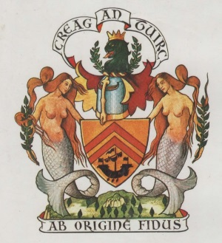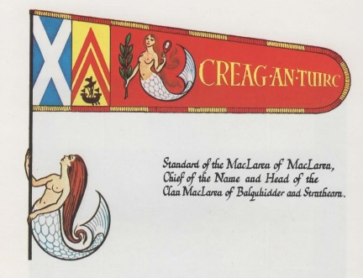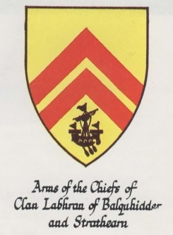
The Arms in rectangular form is also used as a Banner to indicate the Chief’s presence as used during his visit to Australia.
These are the sole property of the Chief of the name and are for his use only. We as Clan members are not entitled to any claim or use of these insignia.
The Chief’s Pincel
[insert pic]
This is used on various occasions, by delegated authority of the Chief when he is not present. Our (CMSA) pinsel is in the care of Linda McLaren in her position as Chairperson of the Clan MacLaren Society of Australia (CMSA).
The Chief’s Badge
This is often erroneously referred to as the Clan Crest. The crest is the part of the Coat of Arms above the helmet and below the motto Creag an Tuirc.
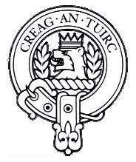
We, as members of Clan Labhran are entitled to wear this badge as a sign of acknowledgement and allegiance to The MacLaren as Chief of the name.
There are rules and conventions regarding Badges and the use or displaying of them. Briefly – the illustration below is the only acceptable form a badge can take. The artistic interpretation of such a badge is governed by the rules of Heraldry.
As members of the Clan, whether we are members of clan societies or not, we are entitled to wear the Chief’s badge with pride. It should take the form of a Strap and Buckle surrounding the Chief’s Crest with his motto inscribed.
The Chief’s badge is most usually a circlet (no buckle) surrounding his crest and he is entitled to wear three (3) feathers either cast as part of his badge and/or eagle feathers worn behind his badge while outdoors.
The wearing of feathers is regulated by the Lord Lyon and despite pretentious practice by some in our Scottish communities can only be worn by those people who have been granted arms by the Lord Lyon i.e. Chiefs of Clans, Chieftains and Armigers.
Clan Carrying Flags
We often and mistakenly refer to these flags as ‘banners’. These are the Flags we rally too and carry onto the field at gatherings and marches or are displayed at our Clan tents and in our homes. They can be in the form of a flag hanging from the left or from the top as use dictates. They are often colourful affairs and embellished with the clan’s name and the Chief’s motto’s - Creag an Tuirc (Scottish Gaelic - the Rock of the Boar).
In conversation with The MacLaren I propose that we all (as far possible) adopt and adapt our flags to the “correct” form regarding the Chief’s carrying flag. That is:
Materials – there are no set rules regarding the materials to be used. Choose according to application and situation. Use whatever suits your needs for indoor and/or outdoor use.
Size – again there are no hard and fast rules. Application will dictate the size you need. A general guide is a ratio of 5 (On the hoist – closest to the pole or the left side): 4 (on the Fly – length of the flag) or 3:2.
The Lord Lyon indicates 110cm (hoist) x 85cm (fly) is correct for a Chief's carrying flag.
Fringes – no rules. Considered as decoration but if added the suggestion is to use colours of the Arms i.e. Gold and Red alternating along the edge.
Background colour – there are no rules regarding background colours except a recommendation that the background highlights the Badge. We often use a swatch of tartan (which is whole other subject to be discussed in another article) as backing which is ok but may draw attention away from the badge so a plain background may be better. As stated there is no rule regarding background colour but the use of either the gold or red from the Arms may be a better option. Our Scottish kin use a red background on their Clan Flag. Some of our North American kin use a white background.
The main focal point is the badge.
Positioning – the Lion faces (respects) the flagpole or to the left on a hanging flag. If the flag is sewn through so that the lion still faces the pole on the reverse side the motto needs to be reversed. If the flag is double sided the lion still faces the pole or left of the flag when viewed from the front.
If the badge is in colour it needs to conform to the heraldic requirements of the Chief’s Crest.
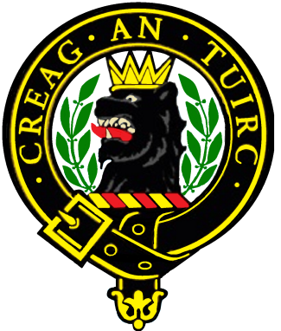
Belt and Buckle can be any colour except a Blue belt with Gold outline (which signifies the Order of The Garter and is strictly controlled).
The Chief’s crest, as illustrated, is composed of the Lion’s head Sable (black) erased (ragged along the bottom edge) on a Wreath of the Chief’s colours Gold (or yellow) and Red (6 twists alternating) bearing a gold (or yellow) antique crown of 6 points - 4 points argent (showing) surrounded by a Laurel branch (plant badge) proper (natural colour).

Most importantly there should be nothing else on this flag. NO name. NO motto(s). No war cry.
So how will we identify ourselves in the crowd?
Those who know will know.
Those who don’t will ask why the clan name is not on the flag and give you the opportunity to talk to them about heraldic protocol, Clan Labhran and our Chief.
Carry a separate placard with the Clan name and/or war cry - Creag an Tuirc (the Boar’s Rock) on it.
The White Cockade and the Laurel

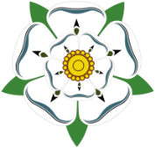
The Scottish White Rose, Jacobite Rose or the White Cockade Rose is the symbol of the Jacobites, the supporters of the Stewart Kings of Scotland and followers of Bonnie Prince Charlie. The MacLarens were a strong Jacobite Clan and were out in support of the Stewarts in all of the rebellions. This ended with that terrible day of defeat on Culloden Moor but on that day the Appin Stewarts and MacLarens were on the part of the Jacobite lines that actually broke through the Hanoverian lines and then fought their way back through the government forces to their own line. The white cockade is worn with pride by descendants of these brave rebels who paid a terrible price for their loyalty to the Stewarts, “their own true kings.”

Hanoverian loyalists wear the black cockade and if you buy a Scottish hat, Balmoral or Glengarry, it will come with a black cockade already on it. If you are a MacLaren, you may choose to wear a white cockade on your hat to show you are from a Jacobite Clan, the MacLarens.

Make a simple cockade from 2 pieces of white ribbon folded and pinned together to form a St Andrew’s cross.
Pin your clan cap badge over it, in the centre.
Women may pin the cockades on their blouse or dress and can pin it on with the clan badge or just pin it from underneath.
(Acknowledgement to CMSNA)

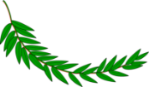
The Suaicheantas or plant badge of Clan Labhran is Labhrail or Buaidh croabh (the victory tree) true laurel (Laurus Nobilis). Some argue that the plant badge is actually spurge laurel (Daphne Laureola). Neither is native to Scotland and was not introduced before the mid 16thC. Margaret MacLaren suggests that rather than an ancient totemistic pagan origin for adoption of the plant as a clan identifier that “In the case of Clan Labhran it is clear that the badge was adopted because of the punning reference to the name Labhran or Laurence”. She also writes that the tradition holds that plant badges were used as a means of identifying clansmen in battle “necessitated by the Highlander’s custom of discarding his plaid … and fighting in his shirt” (4th Ed, 2014, pp135).

If you come upon a sprig of Laurel put that in the cockade as well since the Laurel is the plant badge of the MacLarens. Since most of the Scottish Clansmen warriors were not in uniform they were identified by the plant worn in the their bonnets as to what Clan they were from and as to which side they were on by the colour of the cockade, white for Jacobite, black for Hanoverian.

“I don’t find any disposition in my neighbours… to give up their arms… The people of Balquihidder not only keep their arms but wear their white cockades”.
Campbell of Glenorchy, May, 1746

Wear both laurel and white cockade with pride MacLarens!

(Acknowledgement to CMSNA)
Creag an Tuirc
Bill Law
Deputy Chair, CMSA, October 2019

