MacLaren and MacLaurin Tartans
At last count, during my research on tartans associated with the Clan Labhran, I have identified a number of different tartans named as MacLaren and one named as MacLaurin. The Scottish Government’s “Tartan Register”, established in November 2008 as the official Scottish register of tartans provided most of the information for this article.
https://www.tartanregister.gov.uk/aboutUs
Tartans in this register are numbered for identification and tartans produced before the advent of this register use Scottish Tartan Authority (STA) or Scottish World Tartan Register (SWTR) numbers.
The Tartan Register lists six MacLaren tartans (3 Clan 2 fashion i.e. Dress or Dance and 1 ‘other’). A further search reveals that there are a number of variations of those and other tartans. Tartan weavers such as D.C. Dalgliesh and Lochcarron list a number of further variations mostly related to the types of materials and the dyes used in the fabric.
The terms modern, ancient, antique, muted and weathered and reproduction (faded) are often misleading in that they are generally descriptors used by weavers to differentiate a particular sett (weave) relating to its dye type and colours. Note that MacLaren does not have a hunting tartan. https://www.houseoftartan.co.uk/house/tfinder.htm
The art of tartan design and weaving is too complex a subject to discuss here.
MacLaren Tartans
From our perspective our choice to wear tartan in some form as an identifier of Clan association is personal. Ancient and Modern tartans are the most popular, and as a result are the tartans most often seen at Clan events.

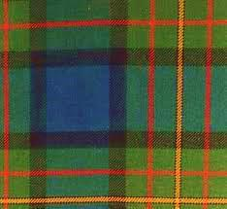 #342 Ancient 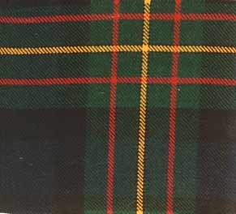 #342 Modern
Weathered and MacLaurin of Broich tartans have a smaller following, while the Dress tartan is favoured for formal ladies wear.

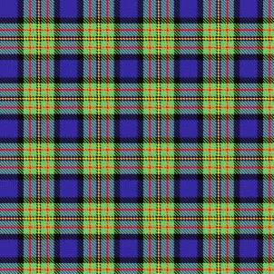
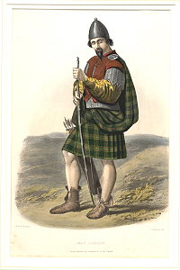
STA / STWR ref: 342 Clan
Available in Ancient, Modern and Weathered dyes.
Date: 01/01/1819
This sett was adopted by the MacLaren’s at the time of the levee (1822). The MacLaren differs from The Ferguson only in having a yellow line where the latter has a white. They share the unusual feature of an unbroken band of blue. The present tartan appears under this name in Mclan's plate for Clan MacLauran. Wilsons of Bannockburn were producing it before 1820 - but only under the name of 'Regent'. The Regency ended when George IV succeeded to the throne in that year, the name of the tartan then becoming outdated, but production of the sett continued. Clans Originaux (1880) shows this sett (Brian Wilton June 2004). House of Edgar produces what they call Maclaren (Ancient) Variant which is this sett but with different proportions and the blue changed to dark red/purple. This tartan is specifically mentioned by Telford Dunbar in his 1962 'History of Highland Dress' (Page 149) when he included it in a list of in a list of Wilson of Bannockburn tartans that were most popular in 1822. The tartan has been adopted by the Small Arms School Corps with permission of the Clan Chief.
https://www.tartanregister.gov.uk/tartanDetails?ref=2594

STA / STWR ref: 343 Clan
Wilsons of Bannockburn a weaving firm founded c1770 near Stirling were weaving this sett which appears to be a colour variation of #342 prior to 1820.

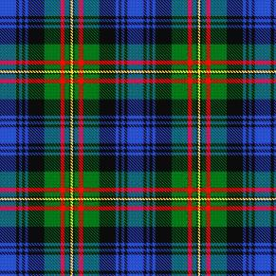
STA / STWR Ref: 310
Listed as “other”
The sample is labelled MacLaren in a collection from Wilson's of Bannockburn, but it is believed to be a naming error. It is normally known as Hunting Grant. Wilson's Hunting Grant is a marriage between Black Watch and the Regent sett, later known as MacLaren.

Dress/Dance
STA / STWR ref: 1770
Designer: Lyn MacLaren of Duns
A fashion tartan produced by D.C. Dalgliesh as a country dancing tartan.

Albino (Dance)
STA ref: 5687
Designer: Bob Martin
Tartan date: 01/01/1974. Made for Billy Forsyth in 1974 for a Highland dancing competition.

STA / STWR ref: 649 Clan
Designed 1981 by L.G. Campbell MacLaren and approved by the Chief and accepted by the A.G.M. of the Clan MacLaren Society as Dress MacLaren in 1981. The sett has been designed by changing the blue ground of the usual MacLaren sett to white and then centring a blue stripe on the white ground.

MacLaurin of Broich
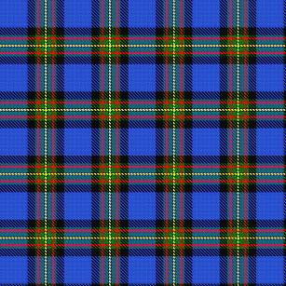
STA /STWR ref: 344 Clan
Dated : 1856
Described in David Macgregor Peter's The Baronage of Angus and Mearns (1856).
Broich is an area near Crieff in Scotland farmed for centuries by a MacLaren family.

Choose your sett, choose your colours and wear with pride.

