Falls Meat Service  Locally Raised Beef and Pork  Black Angus Beef: $3.49/lb  Available ¼, ½, or Whole  Pork: $2.39/lb  Available ½, or Whole  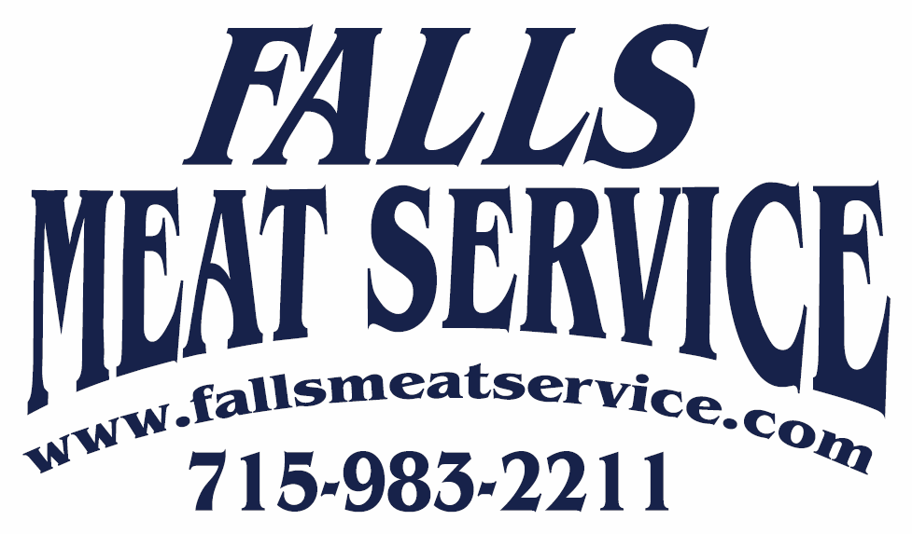 |  | 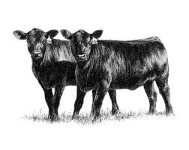  Black Angus Beef $3.49/lb  (Hanging weight)  Average ¼ weighs 200lbs and includes approximately:  - 8 Roasts (3# Each)  - 7-8 Ribeye Steaks  - 4 T-Bone Steaks  - 4 Porterhouse Steaks  - 6 Sirloin Steaks  - 3-4 Tenderloin Steaks  - Soup Bone, Short Ribs, and other cuts upon request.  - 60-70# Ground Beef  - Sausage Products and Hamburger Patties also available at an additional cost.  Typical ¼ costs $700.00 |  |  | - 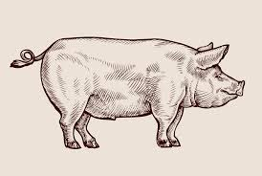  - Pork $2.39/lb  - (Hanging weight-curing, smoking and sausage extra)  - Average ½ Hog weighs 90-100lbs and includes approximately:  - 3 Pork Roasts (3# Each)  - 8-10 Pork Steaks or Butt Bacon  - 25-30 Pork Chops  - 10-12# Smoked Bacon or Fresh Sidepork  - 16-18# Ham (Fresh, Smoked, or Pulled Pork)  - Shanks, Spare Ribs, and other cuts available.  - 10-12# Trim (Ground Pork, Seasoned. Italian, Brats, or Links)  Typical ½ with extras cost $300.00

