Develop Ticket Queue Management Distribution/Assignment procedure

**Table Of Contents**

**1.** **INTRODUCTION** 3

**2.** **SCOPE** 3

**3.** **TICKET TYPES** 3

**4.** **TICKET SOURCE** 3

**5.** **TICKET SEVERITY** 3

**6.** **TICKET STATUS** 3

**7.** **TICKET QUEUES** 4

**8.** **TICKET SOURCE AND QUEUES** 4

8.1 Sample Ticket Holding Process 4

8.2 Workflow Process 5

8.3 Ticket Priority Process Rating 5

**9** **CREATING THE UCC ORGANIZATION FOR TICKET MANAGEMENT** 5

**10** **CREATING UCC USER ACCOUNTS** 5

**11** **CREATING USER POLICIES** 6

**12** **ALIGNING USER POLICIES WITH USER ACCOUNT}** 6

**13** **CREATING TICKET QUEUES** 6

**14** **TICKET QUEUE MANAGEMENT** 6

**15** **CREATING ESCALATION POLICIES** 6

**16** **TICKET QUEUE ASSIGNMENTS** 6

**17** **CREATING UCC ASSIGNMENT RULES** 7

**18** **SHARING RULES** 7

**19** **IT SERVICE CENTER** 7

**20** **HR SERVICE CENTER** 7

# **INTRODUCTION**

{This document describes the process for creating Ticket Queues for Incident Management responses}

# **SCOPE**

{The focus of this document is to provide a step-by-step process for establishing an incident response ticket process}

# **TICKET TYPES**

|  |  |
| --- | --- |
| **Type** | **Description** |
| Request. | A minor change or request for information. |
| Incident. | A service interruption or degradation. |
| Event. | An alert or notification created by a monitoring tool. |
| Project. | A temporary endeavor undertaken to meet unique goals and objectives. |
| Emergency. | An incident that impacts more than one customer. |
| Other. | . Any item not classified as one of the types listed above. |

# **TICKET SOURCE**

|  |  |
| --- | --- |
| **Source** | **Description** |
| Email | Email ticket created by a customer and received by NOC staff. |
| Portal | Ticket created by a customer through the portal. |
| Phone | Telephone call from customer to NOC staff. NOC staff creates a ticket and assigns the ticket to an engineering queue for resolution. |
| Event | Event created by an automated management system. NOC staff creates a ticket and assigns the ticket to an Engineering queue for resolution. |
| Other | Any ticket opened not because of one of the sources listed above. An example might be a ticket opened by an internal employee of Super Service Provider suggesting an improvement. |

# **TICKET SEVERITY**

|  |  |
| --- | --- |
| **Type** | **Description** |
| Critical | A service outage that requires an immediate response. |
| Major | A service degradation or imminent service outage that requires a response within one hour. |
| Minor | A minor change or request for information that requires a response within four hours. |
| Notice | A minor change or request for information that requires a response within one day. |
| Healthy | A minor change or request for information that requires a response within three days. |

# **TICKET STATUS**

|  |  |
| --- | --- |
| **Type** | **Description** |
| Open | The ticket has been created. |
| Pending | Someone acknowledged the ticket and is awaiting the next action. |
| Working | Someone is working on the ticket. |
| Resolved | The issue has been resolved. |

# **TICKET QUEUES**

|  |  |
| --- | --- |
| **Type** | **Description** |
| Triage | All new tickets from customer emails or customer access to the portal are assigned to this queue. The NOC staff manages this queue |
| Network Engineering | Tickets are assigned to this queue if someone from the Network Engineering team must work on and resolve the ticket. Only employees of Super Service Provider can assign tickets to this queue. |
| Windows Engineering | Tickets are assigned to this queue if someone from the Windows Engineering team must work on and resolve the ticket. Only employees of Super Service Provider can assign tickets to this queue. |
| Linux Engineering | Tickets are assigned to this queue if someone from the Linux Engineering team must work on and resolve the ticket. Only employees of Super Service Provider can assign tickets to this queue |
| Follow-up | Tickets are assigned to this queue after the request or repair has been completed, but the NOC staff or Engineering staff are waiting for customer confirmation or approval before setting the status of the tickets to Resolved. |

# **TICKET SOURCE AND QUEUES**

{The Following sample is a holding area for tickets that need approval before they are assigned the status Resolved}

## 8.1 Sample Ticket Holding Process

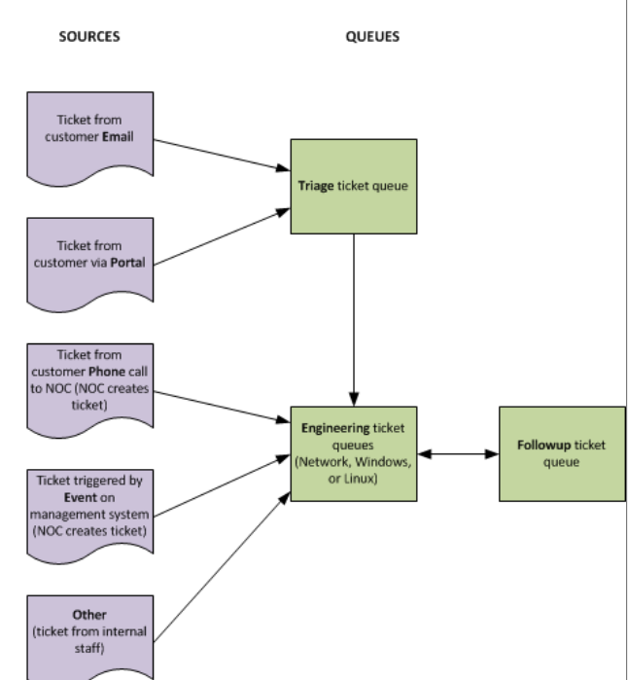

## 8.2 Workflow Process

{This section shows how a customer-generated ticket moves through the ticket workflow}

## 8.3 Ticket Priority Process Rating

|  |  |
| --- | --- |
| **Type** | **Process Timeline** |
| Critical | Tickets with a severity of Critical must be updated within 35 minutes of assignment. To update the ticket, the assigned user can assign the ticket to someone else, change the status of the ticket to Working, or add a note to the ticket. |
| Major | Tickets with a severity of Major must be updated within one hour of assignment. To update the ticket, the assigned user can assign the ticket to someone else, change the status of the ticket to Working, or add a note to the ticket. |
| Minor | Tickets with a severity of Minor must be updated within four hours of assignment. To update the ticket, the assigned user can assign the ticket to someone else, change the status of the ticket to Working, or add a note to the ticket. |
| Notice | Tickets with a severity of Notice must be updated within one day of assignment. To update the ticket, the assigned user can assign the ticket to someone else, change the status of the ticket to Working, or add a note to the ticket. |
| Healthy | Tickets with a severity of Healthy must be updated within three days of assignment. To update the ticket, the assigned user can assign the ticket to someone else, change the status of the ticket to Working, or add a note to the ticket |

# **CREATING THE UCC ORGANIZATION FOR TICKET MANAGEMENT**

{Follow ________ ITS process for creating organizations}

# **CREATING UCC USER ACCOUNTS**

{Follow ________ ITS process for creating User Accounts}

# **CREATING USER POLICIES**

{Follow ________ ITS process for creating User Policies}

# **ALIGNING USER POLICIES WITH USER ACCOUNT}**

{Follow ________ ITS process for Aligning user policies with User Accounts}

# **CREATING TICKET QUEUES**

{Follow ________ ITS process for creating Ticket Queues} Sample queues:

|  |  |
| --- | --- |
| **Type** | **Description** |
| Triage | All new tickets from customer emails or customer access to the portal are assigned to this queue. The NOC staff manages this queue |
| Network Engineering | Tickets are assigned to this queue if someone from the Network Engineering team must work on and resolve the ticket. Only employees of Super Service Provider can assign tickets to this queue. |
| Windows Engineering | Tickets are assigned to this queue if someone from the Windows Engineering team must work on and resolve the ticket. Only employees of Super Service Provider can assign tickets to this queue. |
| Linux Engineering | Tickets are assigned to this queue if someone from the Linux Engineering team must work on and resolve the ticket. Only employees of Super Service Provider can assign tickets to this queue |
| Follow-up | Tickets are assigned to this queue after the request or repair has been completed, but the NOC staff or Engineering staff are waiting for customer confirmation or approval before setting the status of the tickets to Resolved. |

# **TICKET QUEUE MANAGEMENT**

{Follow ________ ITS process for Ticket Queue Management} sample

1. Assign Priority on a First-Come Basis.
2. Set and Monitor All Ticket Statuses.
3. Use a Digital Adoption Platform for Better User Training and Support.
4. Give Biggest Clients Support Priority.
5. Automate Workflows Wherever Possible.
6. Create a Ticket-Tiering System
7. Continuously Train and Develop Support Staff
8. Leave detailed Ticket Description Notes
9. Integrate Customer Relationship and Support Technologies
10. Identify Root cause of support tickets
11. Assign a Triage Team
12. Gather Customer Feedback

# **CREATING ESCALATION POLICIES**

{Follow ________ ITS process for creating Escalation Policies to include Service Level Agreements, if applicable}

# **TICKET QUEUE ASSIGNMENTS**

{Follow the ________ ITS process for creating Ticket Queue Assignments}

# **CREATING UCC ASSIGNMENT RULES**

{Follow ________ ITS process for creating Assignment Rules to ensure that all new tickets are assigned to a queue}

# **SHARING RULES**

{Follow ________ ITS process for Sharing Rules to give group user access to tickets they don’t own}

# **IT SERVICE CENTER**

{Follow ________ ITS process for connecting to the ITS Service Center so users can troubleshoot and resolve issues faster and in real time}

# **HR SERVICE CENTER**

{Follow ________ ITS process for connecting to the HR Service Center so users can troubleshoot and resolve issues in a hybrid environment}