Emergency Blue Light Phones
(Checks, Maintenance, Repairs)
(Shared with UC&C)

Document History
Version Number | Implemented By | Revision Date | Approved By | Approval Date | Description of Change

TABLE OF CONTENTS
1. INTRODUCTION 4
2. SCOPE 4
3. RESPONSIBILITY 4
3.1 Office of Public Safety: 4
3.2 Unified Communications and Collaboration 4
4. EMERGENCY BLUE PHONE OPERATING PROCEDURES 4
4.1 Operating Cadence 4
4.2 General Failure Points 5
5. PROBLEM REPORTING STATEMENT 5
6. MAINTENANCE SCHEDULE 5
6.1 Maintenance Process 5
6.2 Maintenance Schedule 5
6.2.1 Daily or Weekly Schedule 5
6.2.2 Monthly or Quarterly 6
6.2.3 Biannual Maintenance 6
6.2.4 Annual Maintenance 7
7. BREAKDOWNS / REPAIRS 7
8. APPENDIX A: ________BLUE LIGHT PHONE LOCATIONS 8
9. APPENDIX B: ________EMREGENCY PHONE NUMBERS 9

INTRODUCTION
{This document introduces the maintenance and repair procedures for the Blue Light Emergency Phones}

SCOPE
{This procedure applies to Blue Light phones that are connected to the ________Department of Public Safety's 24-hour communications center}

RESPONSIBILITY

3.1 Office of Public Safety:
Is the governing body for Blue Light Phone Services. Their role may include, but not limited to the following}:
- Maintain database of incident reports
- Provide Security Awareness Training
- Provide Workplace violence training

3.2 Unified Communications and Collaboration
Manages the communications and collaboration experience for faculty, staff, and students for all aspects of collaboration technology including, but not limited to::
- Web Conferencing
- Unified Messaging
- Mobile Phone Integration
- Desktop Video Conferencing
- Telecommuter Solutions
- In-house Audio Conferencing
- VoIP Solution
- PC based phones
- Location Base Services
- Corporate Instant Messenger
- Voice over WI=FI
- Speech Recognition applications
- Conference Solutions
- Voice Communications
- ZOOM E911 Blue Phone Installation, Maintenance, Service Communications

EMERGENCY BLUE PHONE OPERATING PROCEDURES
{This section is to identify the Emergency Blue Phone operating cadence and problem issues}

4.1 Operating Cadence
- All designated emergency campus blue phones will dial directly to the University Police Emergency Communications Center.
- All designated emergency campus blue phones will have a unique phone number that can be traced to the specific location of that phone.
- All free-standing emergency campus blue phones will be equipped with a strobing blue light. Wall-mounted assemblies may also have blue lights but are not required by this operating cadence.
- The Global Positioning System (GPS) coordinates of all designated emergency campus blue phones will be maintained by University Police.
- Checks of all designated emergency phones will be performed quarterly by Fire Protection to make sure the phone lines and any equipped blue lights are operating properly.
- Communications Technologies, or Vendor will install and maintain all designated emergency phones and ensure system functionality.
- Police response to calls for emergency service or other services made via designated emergency campus blue phones will be in accordance with University Police Standard Operating Procedures.
- Emergency Blue Light Phone are connected to the ________Department of Public Safety’ 24 hour Communications Center and identify the phone locations f the caller is unable to talk.

General Failure Points
{General issues with campus blue Light phones involve the following:}
- Mechanical or electronic failure
- Malfunction due to installation
- Intentional false activation by a person
- Blue Strobe light not working
- Speaker System not working

PROBLEM REPORTING STATEMENT
{To report a problem with a blue light device, follow the below steps:}
- Contact the Facilities Customer Service Center by phone at ______________, or Campus Security at: _______________. . Be sure to note the blue light number located at the top of the blue light device}
- Contact Unified Communications Director, or Staff to notify them of a problem so they can connect with other organizations for a rapid solution. UC&C phone number:_________.

MAINTENANCE SCHEDULE
{Maintenance, and repair of equipment is managed and facilitated by Facilities, Operations & Maintenance}.

6.1 Maintenance Process
- Campus Emergency Blue phones are maintained via an application which monitors and checks the phones for dial tones, and speaker volume daily.
- All inoperable phones are repaired by the end of the day. If not repaired within 24 hours the phone is covered with a bag and marked inoperable, or ‘out of service’.

6.2 Maintenance Schedule
{Create regular maintenance schedule for operability} Sample

6.2.1 Daily or Weekly Schedule
Perform functional communications check:
- Action: Press emergency phone button
- Strobe light activates
- Red LED “Call Placed” to police, or campus security
- Light turns on
- Message plays
- Call connects, green LED “Call Received”
- Light turns on
- Confirm conversation clarity with dispatch

6.2.2 Monthly or Quarterly
- Visually check lighting functions:
- Faceplate light
- Beacon
- Strobe
- Visually inspect unit for damage to:
- Faceplate
- Piezo button
- Microphone (pest infestation, damage or obstructions)
- Speaker (pest infestation, damage or obstructions)
- Check batteries
- Functioning with full charge
- Recharging fully, including NightCharge/Solar units
(NOTE: recommend mid- to late afternoon inspection)

6.2.3 Biannual Maintenance
- Remove access door and faceplate assembly to inspect the following:
- Ensure all electrical connections are secure
- Check all phone connections for corrosion (If corroded, clean and coat with dielectric gel or replace)
- Ensure all battery connections are tight and clean
- Verify no stains exist around gasket areas (Stains indicate leaking and gasket should be replaced)
- Verify moisture weep hole on cabinet bottom is open and unobstructed
- Verify bottom of bollards are at least 1/2 inch above footing and free of obstructions.
- Apply automotive paint sealant to unit exterior for protecting finish against environmental pollutants (Suggested products include Black Magic Wet Shine Liquid Wax, Nu Finish NFP-80, and 5 Star Shine)
- Clean and coat exterior stainless-steel cabinets with cleaner/polish (Suggested products include Chase Products' Champion Sprayon Stainless Steel Cleaner to help protect finish against environmental pollutants)
- Visually confirm line-of-sight is still clear to base station (i.e., confirm that new tree growth, new building construction or other obstructions are not blocking view of base station

6.2.4 Annual Maintenance
- Replace batteries used with NightCharge, cellular or RF systems (Replace with batteries recommended by the communication manufacturer to ensure optimal performance

BREAKDOWNS / REPAIRS
{In case of breakdown, discontinue use and contact the following for repairs}
- Campus Facilities at: ______________,
- Campus Security at _______________
- Unified Communications and Collaboration Staff
- Vendor (per contract agreement)

APPENDIX A: ________BLUE LIGHT PHONE LOCATIONS
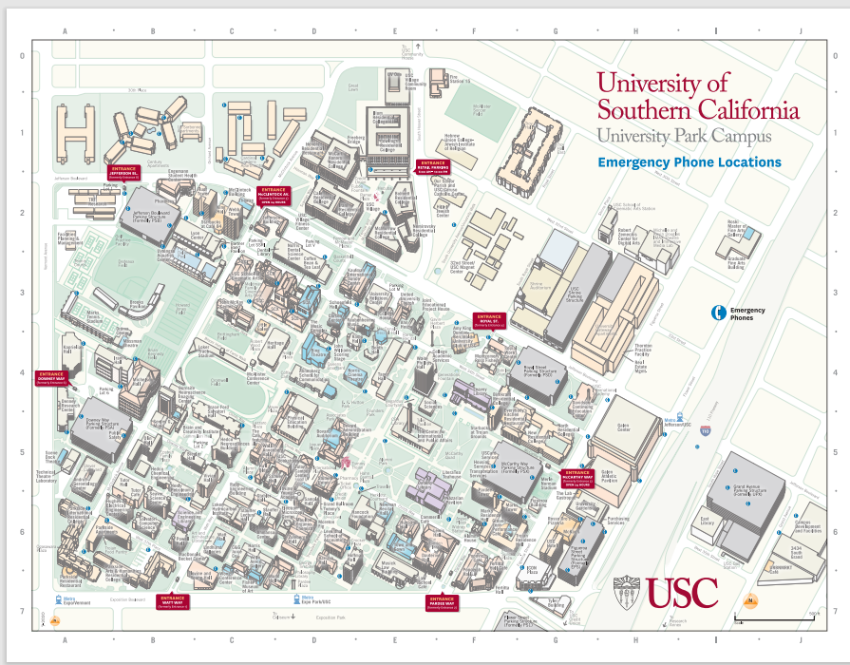

APPENDIX B: ________EMREGENCY PHONE NUMBERS
Agency | Number | Non-Emergency
Public Safety | 213-740-4321
University Park Campus | 213-740-4321 | 213-740-6000.
Campus Security |  | 213-740-6000
________Village | 213-740-4321 | 213-740-6000
Sub Station | 213-821-6677.
________Emergency | 9-1-1
________Health | 213-740-9355
Unified Communications and Collaboration

- APPENDIX C: USER FAQ
Question | Answer
How do Blue Phone Emergency Work?
When to use a Blue Phone?
What do Blue Phones Do?
Why Can’t I just use a cell phone for help
Where are the phones located?
Other

