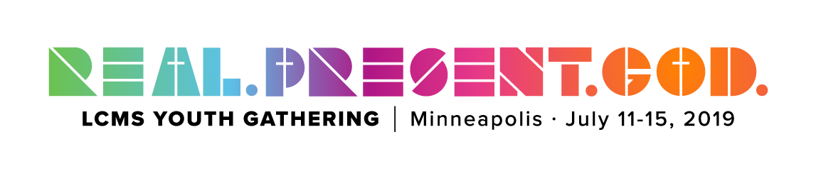

2019 Youth Gathering

What is the Youth Gathering?

“Held every 3 years since 1980, the LCMS Youth Gathering (Gathering) provides thousands of youth and adults the opportunity to come together as a community of God’s people to learn more about Jesus Christ...During the five days of the Gathering, youth spend time together in God’s word, worship, service and fellowship.” -lcmsgathering.com
Date and Location
July 11-15, 2019 in Minneapolis, Minnesota at the Convention Center and U.S. Bank Stadium

Travel Itinerary
July 9, 2019 Leave for Minneapolis Morning/Afternoon Flight
July 10-11, 2019 Get acclimated and explore Minneapolis
July 11-15, 2019 Attend Gathering Activities
July 15, 2019 Fly Home in the Afternoon/Evening
Cost (initial estimate)
$ 365 Registration- $150 Non- Refundable Deposit Due October 14
February - $115
April- $100
If you have to cancel before May 30 you can receive all but your $150 deposit back. After May 30 the gathering office does not give refunds. Also remember we will have to purchase airfare tickets that won’t get refunded
Covers: Gathering program & Administration Costs, Backpack, Bible, Memory Book, Post Gathering DVD amd 2nd insurance.

Estimated Costs:
Airfare $500
Hotel $400
Food $250- $25/ traveling days- $40/day other days
Fun Activity $100
Gathering T-shirt $20
Shuttle $50
Total Cost $1685
Need to raise/person $1320

Fundraisers:
Pumpkin Patch October 2018
Christmas Wreaths October 2018
Thanksgiving Dinner/Servant Auction November 4, 2018
Fat Tuesday Pancake Dinner February 5, 2019
Yard Sale May 3 & May 4, 2018
Sponsor a Mile June 2018
Extra Fundraisers as needed- Trivia Night, Restaurant Fundraisers, Baby sitting
For more information
Talk to Bonnie
Bonniehicks@ctknp.com
Church: 805-498-2217
Visit the website! lcmsgathering.com

