**Standing Orders**

* 1. **Article 1.0. Title:** National Copperheads
  2. **Official Emblem:**

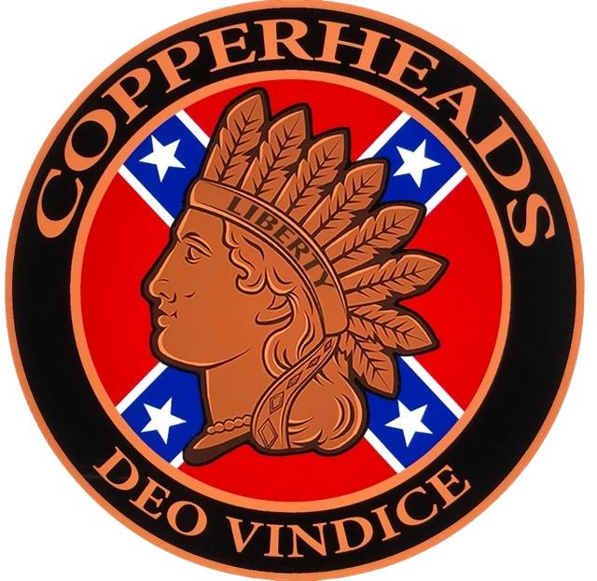

* 1. **Organization:** The Copperheads are a band of brothers who defend the memory of the Confederate soldier of 1861.  Founded in 2019 by two members of Sons of Confederate Veterans organization, they saw the need for an 501(c)(3) tax exempt organization where membership is not based on having a relative who fought for the Confederacy during the war but anyone who supports its original vision for limited central government and the people’s right for self-determination. Its members are an association of individuals who love America.  We believe in the ideals and principles expressed by the Founding fathers and the American Constitution.  We seek to preserve and advocate those principles for future generations. We desire to see the true history of America, our ancestors, the South, and the War of 1861 preserved for future generations by supporting preservation efforts to prevent the destruction and relocation of current historical monuments, the creation of new privately owned memorial parks across the United States and continuing educational programs at the local level. And lastly, we expect the laws designed to protect and preserve monuments in the public domain to be respected and followed by the people’s representatives at the county, city, State, and national levels, regardless of personal ideology. Our organization’s name is derived from a vocal faction of the Democratic party in the Northern United States of the Union who opposed the War of 1861.  Republicans likened them to venomous snakes known as “copperheads” but just as our ancestor’s opposed violence, our organization supports all peaceful measures to accomplish our goals, today. One of the ways we show our support for the memory of the Confederate Soldier of 1861 is to enjoy the freedom of the road on the back of our “iron horses” or motorcycles across the interstates and county roads of America.

**Article 2.0. Nature & Purpose**

**2.1. Motorcycle Enthusiast.** The National Copperheadsare motorcycle enthusiasts who share the same historical devotion to the confederate soldier and preserving the history of the South during the Civil War.

**2.2.** The National Copperheads shall be an organization that carries on the Stephen Dill Lee’s Charge.

**2.3.** The National Copperheads shall be a strictly patriotic, historical, educational, fraternal, benevolent, non-political, and non-sectarian organization.

**2.4.** The National Copperheads are a 501(c)(3) corporation defined as a historical preservation organization.

**2.5** Copperhead members are not permitted to wear any other organization or club back patch that belongs to any other organization of any kind.

**2.6** Copperhead members are not permitted to wear any support patches of any kind. Only Exception (Ladies of Liberty)

**Article 3.0 Membership & Definitions**

**3.1.** Members must show enthusiasm and willingness to participate. After a $200 one-time fee the recruit needs to complete three Copperhead events to earn their bottom rocker, top rocker and the center patch. A new recruit is sworn in at the 3rd event with the center patch. This is over 3 months, not less than 90 days before a recruit can become a brother. Officers of the state are allowed to extend or stop this process at any time. The patch and emblems of the National Copperheads is on loan as long as the member is in good standing.

**3.2. Conduct.** Members shall always conduct themselves as gentlemen, so as to bring credit and respect upon The National Copperheads and upon the memory of our confederate forebearers.

**Article 4.0 Copperhead Membership Overseas**

**4.1.** Individuals living overseas, in any free and democratic country abroad, can apply for application to the National Copperheads. Due to their physical distance from Headquarters, new overseas members will be required to demonstrate their fidelity and commitment to the mission and cause of the National Copperheads prior to being sworn in as members.

**4.2. Required Demonstrations**. There are any number of activities and/or projects that new overseas prospects can perform to meet requirements for joining the Copperheads. Overseas prospects must work closely in coordination with the Headquarters Staff on their demonstrations and projects that will qualify them for membership in the Copperheads.

**4.3. Examples of Demonstrations/Projects for Qualification**. The following list of projects are simply examples as to what can be done but this list is not all inclusive.

**4.3.1.** Attend a public meeting or affair at a motorcycle shop or other place of business with high traffic where the prospective member can set up a display table of patches and other information on the Copperheads. During such an event, the prospect can educate visitors as to the history of the Copperheads, its mission and charge, and requirements to join our organization from an overseas location. Photos should be taken to document these events and forwarded to Headquarters for review and approval.

**4.3.2**. Schedule a public event at a school, retirement home, scout meeting, or a hospital to discuss the history of the American Civil War and the current day role of the Copperheads. Encourage those attending the event to do their own research and consider joining the Copperheads. Take photos and send them to Headquarters as stated above.

**4.3.3.** Perform some type of restoration and/or clean-up of a soldier(s) marker or gravesite. An attempt should be made to involve some other voluntary or charitable group to accomplish this task. Again, photos should be forwarded to Headquarters.

**4.4. Acceptance for Membership**. Once Headquarters has been satisfied that the overseas prospect is sincere in his desire to join the Copperheads and make his contribution to the organization’s mission, the prospect will be approved for induction. Swearing in ceremonies can be done via Zoom software and new overseas members will be mailed their patches.

**Article 5.0 Headquarters /States financial reporting**

**5.1. Headquarters reporting.** National will publish and present financial statements each fiscal year. Headquarters will also audit each state financial books every fiscal year.

**5.3. States reporting.** States Will be responsible for their own finances and reporting to headquarters each fiscal year.

**5.4 Nonprofit.** Once a state has a membership of over 30 members, they need to raise funds and file to become a 501(c)(3) tax exempt, non-profit corporation. When States make an application to their Secretary of State to incorporate, their proposed Articles of Incorporation will first be forwarded to Headquarters for review and approval. After receiving their approved Articles of Incorporation by the Secretary of State, IRS Form 1023EZ will be prepared to request 501(c)(3) tax exempt status. Prior to filing Form 1023EZ, this documentation will be forwarded to Headquarters for review and approval. Only States and Headquarters will file Articles of Incorporation and requests for tax exempt status.

**Article 6.0 Discipline**

**6.1. Headquarters.** The General and headquarters staff will oversee disciplinary actions for all State Captains and Officers of any State based upon duly filed complaints of the State Captains. Before filing WRITTEN charges on any person, the State Captain will brief his Officers and receive concurrence of a majority of those Officer to confer charges to Headquarters. State Captains will maintain written records of the investigation into charges and the results of all votes taken in writing by the other Officers in the State. Headquarters will respond to the complaint within 30 days by email. After review and investigation, if disciplinary action is deemed warranted, the General will take the complaint, gather evidence, and make his recommendation to the Corporate Board of Directors. The Corporate Board of Directors will review the recommendation of the General, formulate a Board response, and vote on any disciplinary action to be taken. Disciplinary action taken by the General and Corporate Board of Directors is FINAL.

**6.2. States.** StateCaptains will oversee disciplinary actions on all enlisted personnel for their State. Once a member is brought up on charges, he will have 30 days to respond to the allegations in writing. Once received, the Captain will reconsider all the evidence and response from the charged member. If the Captain still feels that formal charges are warranted, the Captain will make his recommendation for disciplinary action to his Officers. A written vote will be taken by the Officers and a majority vote will determine the disciplinary action to be taken. **For enlisted personnel, there is no appeal process beyond the State Captain and the State Officers.** State Captains are authorized to appoint Officers and Non-Commissioned Officers under their command. As such, Officers and Non-Commissioned Officers serve “at the pleasure” of the State Captain and may be demoted at any time at the sole discretion of the State Captain. **No vote or approval from Headquarters is required for a State Captain to demote an Officer or Non-Commissioned Officer under his command**.

**6.3. Expulsion.** Expulsion of any member of any rank from the National Copperheads is the most severe disciplinary action that can be administered. At the State level, any enlisted member or Officer can be expelled following the procedures outlined in paragraph 6.2 above. However, expulsion will require a super majority vote of at least 75% of all the State’s Officers and Captain. All votes taken will be done in writing and maintained in the State’s official files. Election results will also be forwarded to Headquarters. Expulsion of all Officers and enlisted personnel in any State does NOT require the approval of Headquarters.

**6.4 Disciplinary Action on State Captains**. **Only Headquarters** has the authority to remove a State Captain from office. Nonetheless, the Officers of a State can confer charges on the State Captain only if 75% or more of the Officers recommend charges. Said Charges will be communicated to the Captain and to Headquarters in writing. The Officers of a State may recommend disciplinary action to Headquarters but they may not be acted upon. This is the sole decision of Headquarters. Likewise, Headquarters on its own initiative can take disciplinary action against any State Captain but only with concurrence with 75% or more of the State’s Officers.

**Article 7.0. Elections.**

**7.1. Elections.** Every four (4) years from the date of their appointment, an election will be conducted at the State level for the position of Captain. Elections will be held in writing. There will be at least three (3) witnesses to any counting of votes. Results of Captain elections will first be reported to Headquarters for review and approval. Once the vote is approved by the General, the election results for State Captain will be promulgated throughout the State.

**7.2. Officers.** Captains will appoint all Officers and Non-Commissioned Officer (NCO) positions.

**7.3. Recount.** A member running for State Captain can request a recount if the results are within 5 votes.

**7.4. Replacement of Headquarters Staff**. When required, Headquarters staff will be replaced by the Headquarters personnel themselves by election and/or affirmation.

**8.0. Purchase of property:** States are encouraged to purchase real property and other assets. When at all possible, assets should be titled to and/or owned by the organization. Any property that will be owned by an individual will first be authorized by Headquarters. Organization assets owned by an individual will be discouraged by Headquarters.

**8.1. Use of Assets.** State Captains and their state organizations must have the ability to accept statues / monuments that help preserve the history of the confederate soldier. Such monuments and other historical items may be used and displayed as they see fit.

**9.0. Supporting Organization:** Ladies of Liberty

**9.1. The name of the organization:** Ladies of Liberty

**9.2. Official Emblem:** TBD

**9.3. Organization:** Ladies of Liberty is a women’s only organization that

supports The Copperheads who defend the memory of the Confederate

soldier of 1861.

**9.4. Nature & Purpose.** The Ladies of Liberty are motorcycle enthusiasts who share the same historical devotion to the confederate soldier and preserving the history of the South during the Civil War. The Ladies of Liberty shall be a strictly a woman only, patriotic, historical, educational, sorority, non-political, and non-sectarian organization that preserves he history of the South during the Civil war.

**9.5. Fundraising**. All individual members, State organizations, and headquarters must work to raise funds for the Copperheads to help support the perseveration of the confederate soldier and southern history.

**9.6. Structure**. The Captain of each State will appoint one member of the Ladies of Liberty to run, accept membership applications and organize fundraising efforts.

**9.7. Reporting**. The appointed representative of the Ladies of Liberty in each State will report Membership numbers, applications, and fundraising efforts to the State Captain. The Captain will then report these numbers to the Chief of Staff at Headquarters.

**9.8. Membership & Definitions of the Ladies of Liberty**. Each member of the Ladies of Liberty must have a Copperhead sponsor. After they fill out an application and submit it for approval to the state representative, they are required to pay a one-time fee of $100 for the future “Ladies of Liberty” to earn their back patch.

**9.9. Sponsors**. All members of the Ladies of Liberty must have a sponsor who will be a current Brother of The National Copperheads and the prospective member needs to be the significant other of the sponsor.

**9.10. Conduct**. Members of the Ladies of Liberty shall always conduct themselves as Ladies, to bring credit and respect upon The National Copperheads and upon the memory of our confederate forebearers.

**9.11. Dismissal**. Membership in the Ladies of Liberty will be revoked if the member is no longer the significant other of their sponsoring Copperhead or their sponsor is no longer a Copperhead. The Backpatch must be returned to the Captain of the State that issued the membership. There will be no refund for the purchase of the patch.