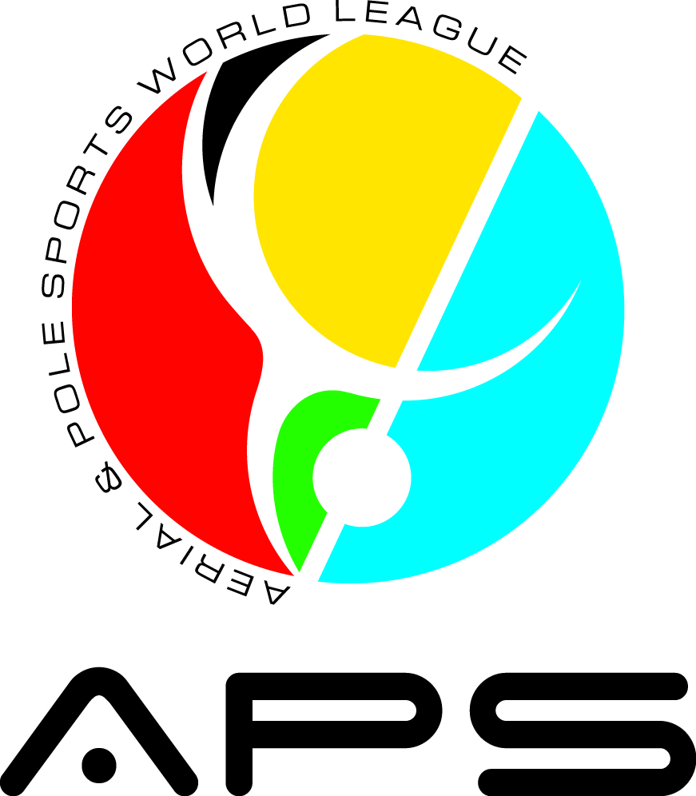 | ARTISTIC DISCIPLINES
 | Pole Art / Aerial Pole Artistic / Artistic Hoop / Artistic Silks
 | Athlete’s Name:
Event Name:
Country: |  |  | Artistic discipline:
Division: |  |  | Category:
Description and/or presentation of the athlete's routine:
Please describe what your routine is about. Remember all routines must be kids friendly.

List accessories, props, and human props that will be used in the routine

Athlete’s Name: |  | ** Signed - Coach/Responsible Adult’s Name:
*To be filled out by the Judge. **Only if applicable.

