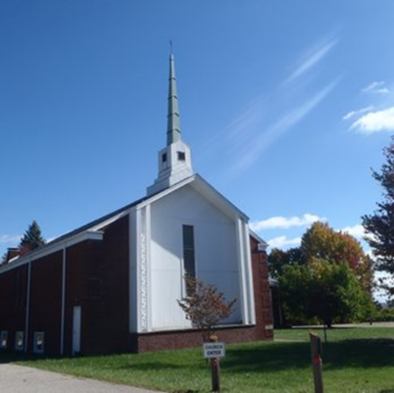
The Beacon
October 2025
Bethlehem United Presbyterian Church
(304) 242-4407
45 Chapel Road
Wheeling, WV 26003
secretary@bupcwheeling.org
bupcwheeling@comcast.net
Website: bupcwheelingwv.org
Weekly Worship
Bethlehem United Presbyterian Church
Sundays at 10:45 am.

October 5 Agnes Brady
October 12 Mike Taylor
October 19 Spencer Curry
October 26 Mike Taylor
 | 
Oct13 Alyssa Mengeu  Oct 28 Craig Garvin | Oct 1 Dan & Alice Burns  Oct 17 Cliff & Nancy Elliott  Oct 20 Brian & Lisa Mengeu
In Our Hearts and Prayers
“remembering before our God and Father your work of faith and labor of love and steadfastness of hope in our Lord Jesus Christ.”
I Thessalonians 1:3
General, Long-term, and Special Health Concerns
John Adams, health concerns Joellen McNeil, health concerns
Sherry Conrad, health concerns Anita Marvin, health concerns
Kathy Butler, health concerns Nancy K. Mumley, health concerns
Nancy Elliott, health concerns Kitty Patrick, health concerns
Eydie Garvin, health concerns Stacy Stewart, health concerns
Jerry Hinton, health concerns Jon Sykes, health concerns
Nancy Hostutler, health concerns Bob Mengeu, health concerns
David Waites, health concerns Simon Morris, health concerns
Michael Kuthy, health concerns Tiffany


Sophia
NURSING HOME & RETIREMENT HOME

Peggy Foster, Good Shepherd Nursing Home, 159 Edington Lane, Wheeling, WV 2600
Craig Garvin, Peterson Healthcare & Rehab Center, 20 Homestead Avenue, Wheeling, WV 26003
Tom Hostutler, Moundsville Healthcare Center, Room 404, 2200 Floral Avenue, Moundsville, WV

Come join Friendship Diners
for a relaxing time of
food and fellowship!
Tuesday, October 7th
at 5 pm

Undo’s West, 51130 National Road E, St, Clairsville, Ohio
Please let Becky Habak know if you are coming.





Scripture Readers |  | Coffee Hour Host(s)
October 5th | Jan Pysh | October 5th | Birthdays & Anniversaries: Jackie, Pam, & Raenel
October 12th | Jan Pysh | October 12th | Jan & Wayne Pysh
October 19th | Bill Syphers | October 19th | Volunteer needed!
October 26th | Tony Werner | October 26th | Jackie and Jody


Tuesdays
1:30 pm
in the library

Studying Zechariah
- Bible Project
- https://bibleproject.com/videos/zechariah/
- Spoken Gospel
  - https://www.youtube.com/@SpokenGospel
  - Chapters 1 and 2 https://youtu.be/Oan2dlvv4cQ?si=P1RRPcxee0PInoGF
  - Chapters 3 and 4 https://youtu.be/PwzsmjwFUmg?si=QdcBrIeCOnx4WJNV

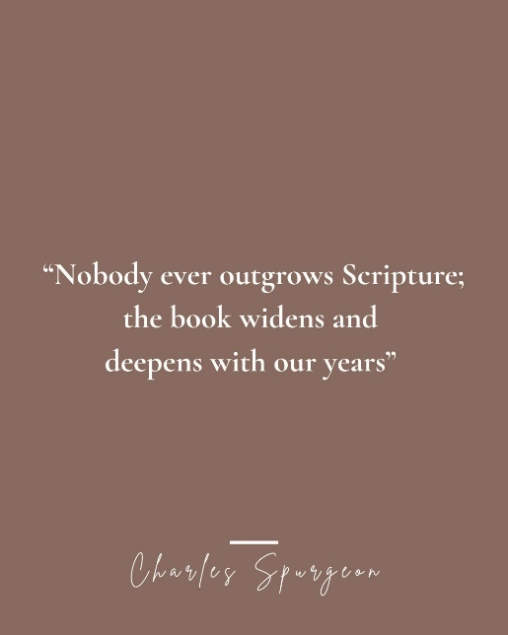



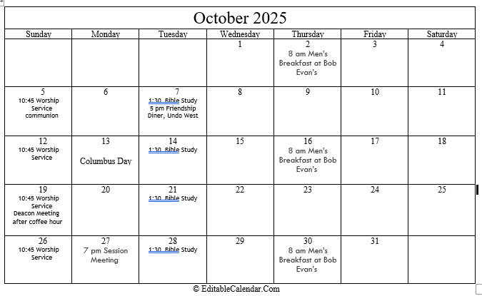

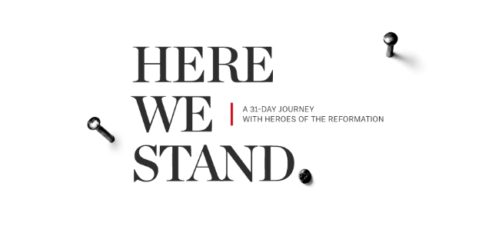
October Devotion: Sign up to take this 31-day journey, travel back through the faith-stirring stories of courageous men and women.
Here We Stand | Desiring God

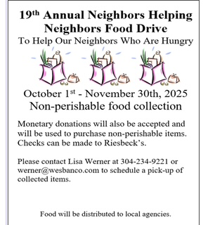

Isaiah 58:7
Is it not to share your food with the hungry…

Bethlehem United Presbyterian Church
45 Chapel Road
Wheeling, WV 26003

“Trust in the Lord with all your heart and
lean not on your own understanding;
in all your ways submit to Him, and
He will make your paths straight.” – Proverbs 3:5-6

