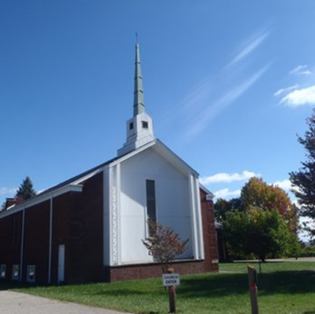
The Beacon
Summer Edition
Bethlehem United Presbyterian Church
(304) 242-4407
45 Chapel Road
Wheeling, WV 26003
secretary@bupcwheeling.org
bupcwheeling@comcast.net
Website: bupcwheelingwv.org
Weekly Worship
Bethlehem United Presbyterian Church
Sundays at 10:45 am.

June 1st Bill McCoy
June 8th Mike Taylor
June 15th Bill McCoy
June 22nd Mike Taylor
June 29th Spencer Curry
July 6th Mike Taylor
July 13th Matt Cummins
July 20th
July 27th Agnes Brady
August 3rd Mike Taylor
August 10th
August 17th Mike Taylor
August 24th
August 31st Mike Taylor
 |  | 
June 7 Jody Werner  June 8 Sue Lane Johnson  June 9 Raenel Edge | July 4 Brian Mengeu  July 4 Kathy Syphers | August 7 Bob Mengeu  August 9 Ira Werner  August 13 Lisa Mengeu  August 14 Cligg Elliott  August 31 Eydie Garvin


June 6 Craig and Eydie Garvin
June 14 Bill and Kathy Syphers
June 16 Wayne and Janell Pysh
June 19 Scott and Amy Kiene
August 6 Bob and Pattie Mengeu
August 8 John and Becky Habak

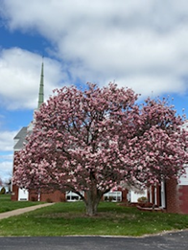
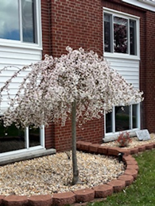
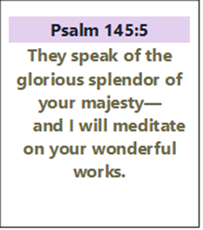

In Our Hearts and Prayers
“remembering before our God and Father your work of faith and labor of love and steadfastness of hope in our Lord Jesus Christ.”
I Thessalonians 1:3
General, Long-term, and Special Health Concerns
John Adams, health concerns Joellen McNeil, health concerns
Camden Brown, eye/health concerns Anita Marvin, health concerns
Kathy Butler, health concerns Nancy K. Mumley, health concerns
Nancy Elliott, health concerns Kitty and Ron Patrick, health concerns
Eydie Garvin, health concerns Stacy Stewart, health concerns
Jerry Hinton, health concerns Jon Sykes, health concerns
Nancy Hostutler, health concerns Bob Mengeu, health concerns
Michael Kuthy, health concerns Tiffany

David Waites, health concerns Sophia


NURSING HOME & RETIREMENT HOME

Peggy Foster, Good Shepherd Nursing Home, 159 Edington Lane, Wheeling, WV 2600
Craig Garvin, Peterson Healthcare & Rehab Center, 20 Homestead Avenue, Wheeling, WV 26003
Tom Hostutler, Moundsville Healthcare Center, Room 404, 2200 Floral Avenue, Moundsville, WV


Come join Friendship Diners
Join us for a
Father’s Day Celebration
during coffee hour,
Sunday June 15th
Parish Life is hosting this event.
for a relaxing time of food and fellowship!
Tuesday, July 1st at 5 pm
Tuesday, August 5th at 5 pm

The restaurant will be shared in church. Please let Becky Habak know if you are coming.

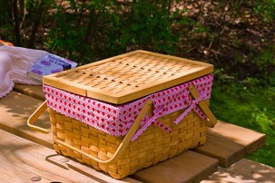
Church Picnic
Sunday, August 3rd
Hotdogs, hamburgers, condiments, and drinks will be provided.
Please bring a covered dish or dessert!

Scripture Readers |  | Coffee Hour Host(s)
June 1st | Bill Syphers | June 1st | Birthdays & Anniversaries
June 8th | Sue Johnson | June 8th | Kathy & Bill Syphers
June 15th | Nancy McBee | June 15th | Father’s Day Celebration
June 22nd | Jan Pysh | June 22nd | Jan & Wayne Pysh
June 29th | Bob Young | June 29th | Nancy McBee
July 6th | Jan Pysh | July 6th | Birthdays & Anniversaries
July 13th | Kathy Syphers | July 13th
July 20th |  | July 20th
July 27th |  | July 27th
August 3rd |  | August 3rd | Church Picnic
August 10th |  | August 10th | Birthdays & Anniversaries
August 17th |  | August 17th
August 24th |  | August 24th
August 31st |  | August 31st

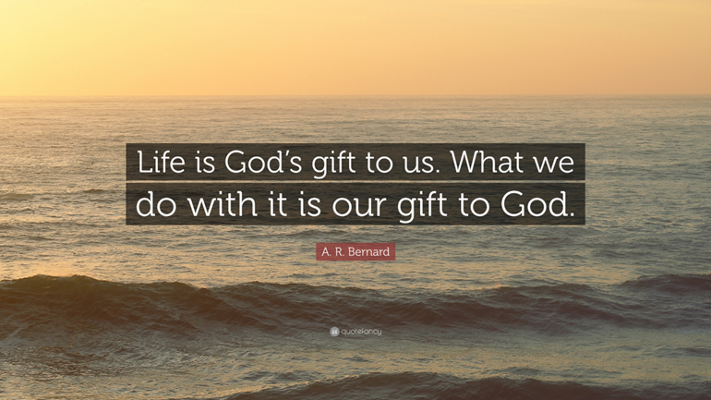


Tuesdays
1:30 pm in the library

June 3rd-Obadiah  June 10th-Jonah  June 17th-Micah  June 24th-Nahum | July 1st-Habakkuk  July 8th-Zephaniah  July 15th-Haggai  July 22nd-Zechariah  July 29th-Malachi

Have you turned yours in?
Updated Church Directory
Coming Soon!

Please provide the church secretary with updated information
- Name
______________________________________________________
- Address
______________________________________________________
- Phone numbers
  - Home ___________________________________________
  - Cell _____________________________________________
- Email address
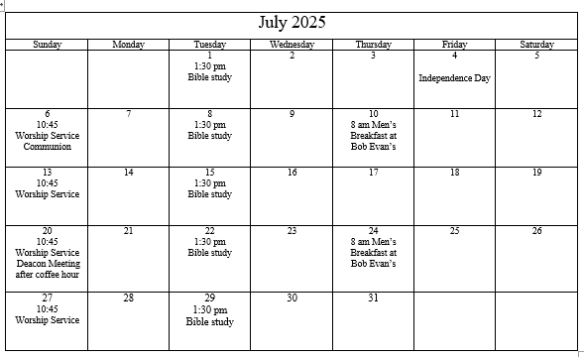
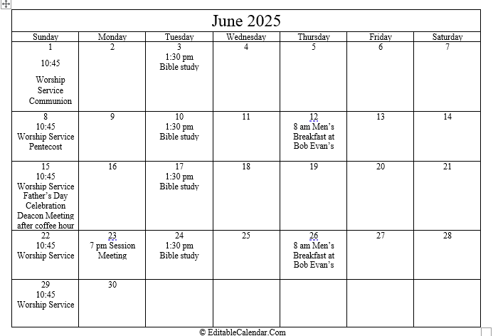
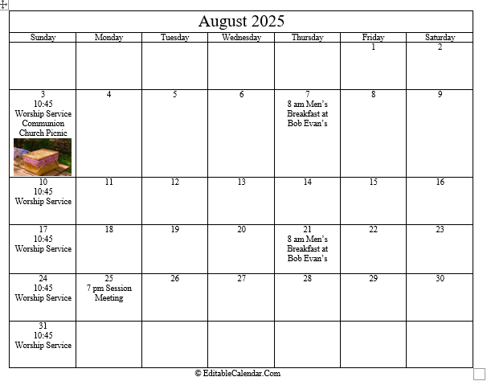

Psalm 91
14For here is what the Lord has spoken to me:

“Because you loved me, delighted in me, and have been loyal to my name,
^{I will greatly protect you.}
15I will answer your cry for help every time you pray,
^{and you will feel my presence}
^{in your time of trouble.}
I will deliver you and bring you honor.
16I will satisfy you with a full life and with all that I do for you.
For you will enjoy the fullness of my salvation!”

Top Five Questions Guaranteed to Make You Smile!”
This Photo by Unknown Author is licensed under CC BY-NC
Posted by Michael Peck
www.michael peck.org

Thanks for stopping by today. You have a lot to do so I won’t keep you very long. I have some questions for you today that are just for fun and hopefully will bring a smile or two along your way. They concern the words we use all the time and think nothing of them. Consider with me these questions.

1. Why is it in America that we park our cars on our driveway and we drive our cars on parkways?
2. If money doesn’t grow on trees, why do banks have branches?
3. Since bread is square, why is sandwich meat round?
4. What did “cured” ham have before it came to us?
5. Why is it that people say “I slept like a baby” when many babies wake up every two hours?

These questions are only meant to amuse us. But before you leave, let me ask you a serious question. How will you use your words today? The Bible says “The mouth of the righteous is a well of life, but violence covers the mouth of the wicked. The lips of the righteous know what is acceptable, but the mouth of the wicked what is perverse” (Proverbs 10:11, 32). As King David prayed I too want to pray today. “Let the words of my mouth and the meditation of my heart be acceptable in Your sight, O LORD, my strength and my Redeemer” (Psalm 19:14). Watch your words because they convey the condition of your heart!

www.michael peck.org

Bethlehem United Presbyterian Church
45 Chapel Road
Wheeling, WV 26003

