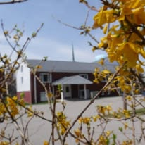
The Beacon
November 2025
Bethlehem United Presbyterian Church
(304) 242-4407
45 Chapel Road
Wheeling, WV 26003
secretary@bupcwheeling.org
bupcwheeling@comcast.net
Website: bupcwheelingwv.org
Weekly Worship
Bethlehem United Presbyterian Church
Sundays at 10:45 am.

November 2 Peter Jessen
November 9 Mike Taylor
November 16 Bill McCoy
November 23 Mike Taylor
November 30 Spencer Curry


The annual Congregation meeting will be held after worship on Sunday, November 9th. The purpose of the meeting is to elect officers for 2026 and to review the proposed 2026 Church budget.

In Our Hearts and Prayers

Do not fear, for I am with you, do not be afraid, for I am your God;
I will strengthen you, I will help you, I will uphold you with my victorious right hand. Isaiah 41:10(NSRV)
General, Long-term, and Special Health Concerns
John Adams, health concerns Joellen McNeil, health concerns
Sherry Conrad, health concerns Anita Marvin, health concerns
Kathy Butler, health concerns Nancy K. Mumley, health concerns
Nancy Elliott, health concerns Kitty Patrick, health concerns
Eydie Garvin, health concerns Stacy Stewart, health concerns
Jerry Hinton, health concerns Jon Sykes, health concerns
Nancy Hostutler, health concerns Bob Mengeu, health concerns
David Waites, health concerns Simon Morris, health concerns
Michael Kuthy, health concerns Tiffany

Becky Habak, health concerns Sophia Lexi

NURSING HOME & RETIREMENT HOME
Peggy Foster, Good Shepherd Nursing Home, 159 Edington Lane, Wheeling, WV 26003
Craig Garvin, Peterson Healthcare & Rehab Center, 20 Homestead Avenue, Wheeling, WV 26003
Tom Hostutler, Moundsville Healthcare Center, Room 404, 2200 Floral Avenue, Moundsville, WV 26041
Carol Schul, Good Shepherd Nursing Home, 159 Edington Lane, Wheeling, WV 26003

Come join Friendship Diners
for a relaxing time of
food and fellowship!
Tuesday, November 4th
at 5 pm
(Location to be announced during church)

Please let Becky Habak know if you are coming.




Scripture Readers |  | Coffee Hour Host(s)
November 2nd | Nancy McBee | November 2nd | Birthdays & Anniversaries
November 9th | Bob Young | November 9th | Amy Kiene’s and Habak’s
November 16th | Jan Pysh | November 16th | Kathy and Bill
November 23rd | Sue Lane Johnson | November 23rd | Nancy
November 30th | Bill Syphers | November 30th | Sue


November 25
Nancy Young McBee


Bible Study ?????
Your input is needed to continue.

What type of groups: Combined, Men’s, Women’s
Time: Morning, Afternoon, Evening
Day: Monday, Tuesday, Wednesday, Thursday, Friday
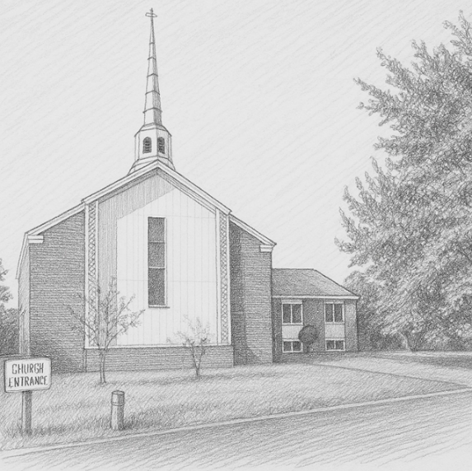

BUPC 2025 Church Directory
Available at the church
Corrections:
Mike Moore’s email address should be
mmoore59@comcast.net


First Sunday of
Advent is
November 30th

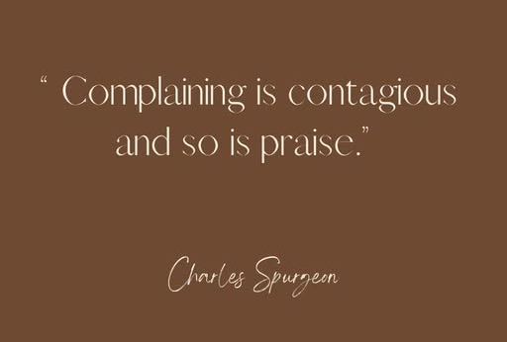
30 DAYS OF PRAISE & THANKSGIVING
with Wendy Speake on our
Facebook page



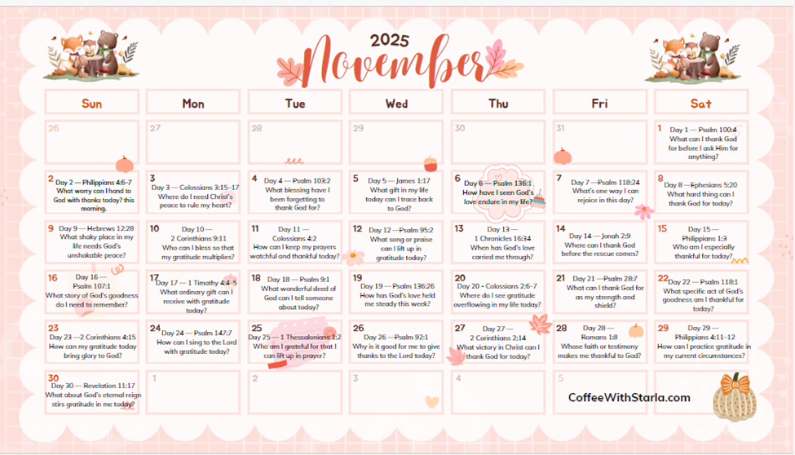

CoffeeWithStarla.com
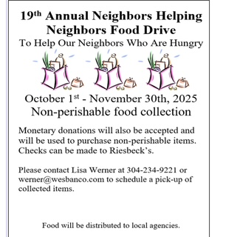

Isaiah 58:7
Is it not to share your food with the hungry…


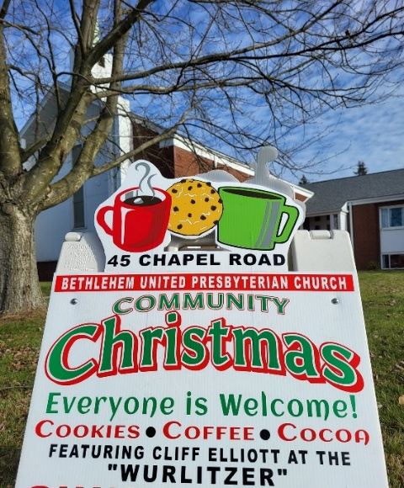

Carols & Cocoa
Sunday, December 7th!!!!

Cookies are needed!! If you would like to bake and donate 3 dozen cookies, please let Kathy or Jody know. Thank you.

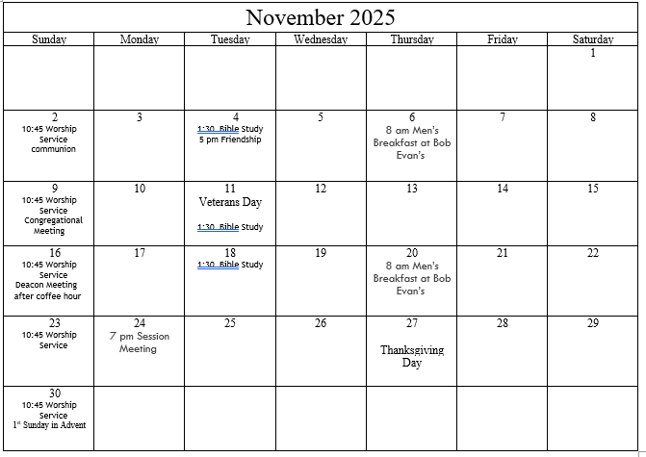
Bethlehem United Presbyterian Church
45 Chapel Road
Wheeling, WV 26003

"Give thanks to the LORD,
for He is good;
His love endures forever"
Psalm 107:1

