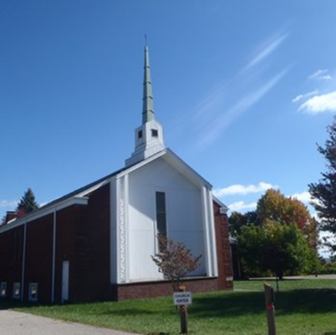
The Beacon
Bethlehem United Presbyterian Church
(304) 242-4407
45 Chapel Road
Wheeling, WV 26003
secretary@bupcwheeling.org
Website: bupcwheelingwv.org
Weekly Worship
Bethlehem United Presbyterian Church
Sundays at 10:45 am.

April 6th Rev. Agnes Brady with communion
April 13th Palm Sunday, Rev. Mike Taylor
April 17th Maundy Thursday Worship Service with
communion 7 pm
April 20th Easter Sunday, Elders and Deacons
April 27th Rev. Mike Taylor
May 4th Matt Cummings

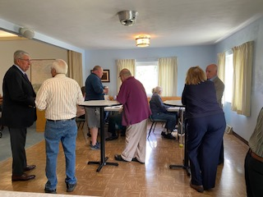

Easter Sunday Coffee Hour
9:30 am

There will be a special coffee hour on Easter Sunday before the worship service. The Parish Life Committee will be serving coffee, juice, water, donuts, colored eggs, omelets, breakfast casserole, and fruit. Be sure to arrive early to enjoy breakfast and the fellowship of your friends in Christ.

April 19 Dan Burns

One Great Hour of Sharing

The Session has designated Palm Sunday, April 13, as “One Great Hour of Sharing” Sunday. We encourage you to bring your jars of loose change (please note that fish are not available) and place them in the designated receptacle. Alternatively, you can put loose currency or a check into one of the pew envelopes or directly into the collection plate. All loose currency and change will be contributed to “One Great Hour of Sharing.”


To the Deacons and congregation,
Thank you so much for the donation in memory of Dorothy Werbecki. She was the heart and soul of “Ladies’ Day Out.” She had many talents and was always willing to help anyone.
Thank you for purchasing some of the kitchen towels.
I have purchased some yarn and fleece for blankets for WIC. Our mission for “Ladies’ Day Out” was to help an organization in need. WIC has been so appreciative of anything I make and give to them.
Thanks again. Your kindness is a blessing and so are you.” Clarinda
In Our Hearts and Prayers
General, Long-term, and Special Health Concerns
John Adams, health concerns
Camden Brown, eye/health concerns

Kathy Butler, health concerns
Nancy Elliott, health concerns
Eydie Garvin, health concerns
Jerry Hinton, health concerns
Nancy Hostutler, health concerns
Michael Kuthy, health concerns

Anita Marvin, health concerns
Joellen McNeil, health concerns
Nancy K. Mumley, health concerns
Kitty and Ron Patrick, health concerns Stacy Stewart, health concerns
Jon Sykes, health concerns David Waites, health concerns
Tiffany Sophia

NURSING HOME & RETIREMENT HOME
Peggy Foster, Good Shepherd Nursing Home, 159 Edington Lane, Wheeling, WV 2600
Craig Garvin, Peterson Healthcare & Rehab Center, 20 Homestead Avenue, Wheeling, WV 26003
Tom Hostutler, Moundsville Healthcare Center, Room 404, 2200 Floral Avenue, Moundsville, WV

 | Easter Lilies orders are due BEFORE Friday, April 11th, 2025.  The cost is $10.00 per plant.  You can email the church secretary@BUPCWheeling.org or place order form in offering plate.  Please include the following information.  - in Memory/Honor of  - Include the person(s) name  - Number of lilies order  - Given by name  The lilies will be placed on the Chancel, Easter Sunday, April 20

Lent Bible Study
Tuesday, 1:30p.m.

He Chose the Nails sessions

April 1st: Lesson 4 He Chose to Love Us Forever
April 8th: Lesson 5 He Chose to Give Us Victory
April 15th: Lesson 6 He Chose to Give Us
Confidence

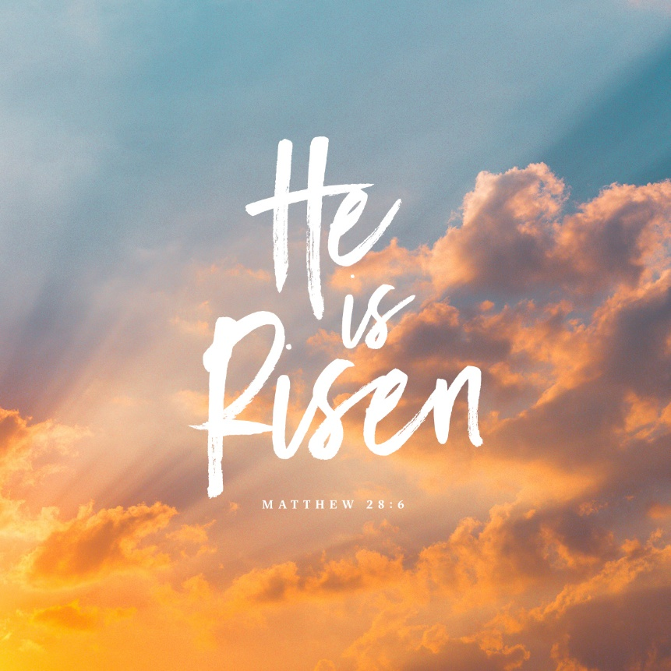
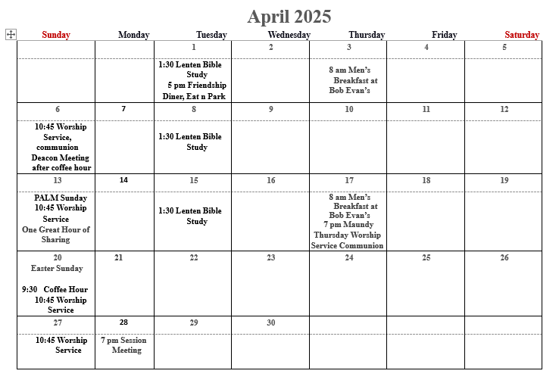

In loving memory…
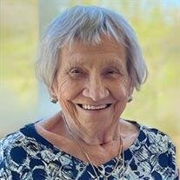
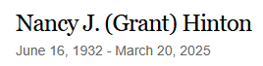

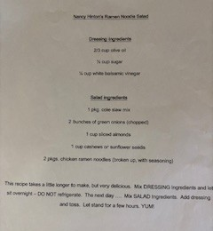

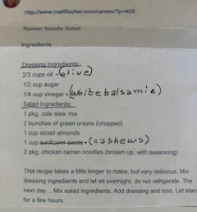



For WPHS Student Michael Kuthy


https://www.zeffy.com/ticketing/mikeys-support-squad-gift-card-raffle

There are $5, $10, and $20 ticket options. There will be a total of 3 winners! Each Gift Card Bundle is valued well over $500 in winnings! 🙂

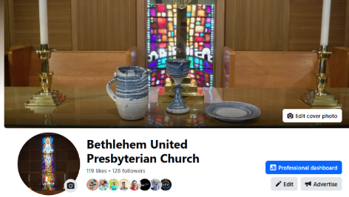
 FACEBOOK
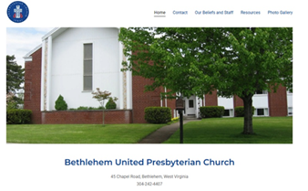
https://bupcwheelingwv.org/

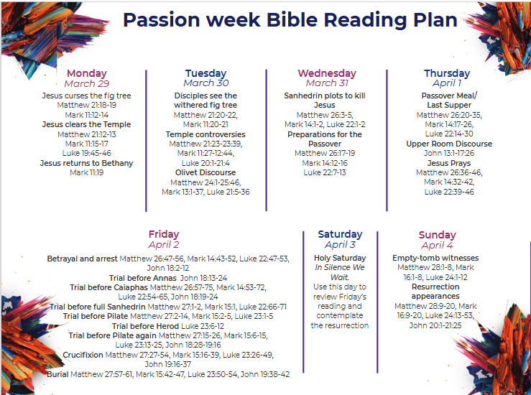
https://www.hpministry.com/hp_wordpress/wp-content/uploads/2021/03/Passion-Week-Reading-Plan-Printable-FINAL.pdf




How would you like your copy of The Beacon to be delivered?
- Email (send your email address to secretary@bupcwheeling.org)
- US Postal Service
Thank you to all that signed up for email delivery.

Bethlehem United Presbyterian Church
45 Chapel Road
Wheeling, WV 26003

