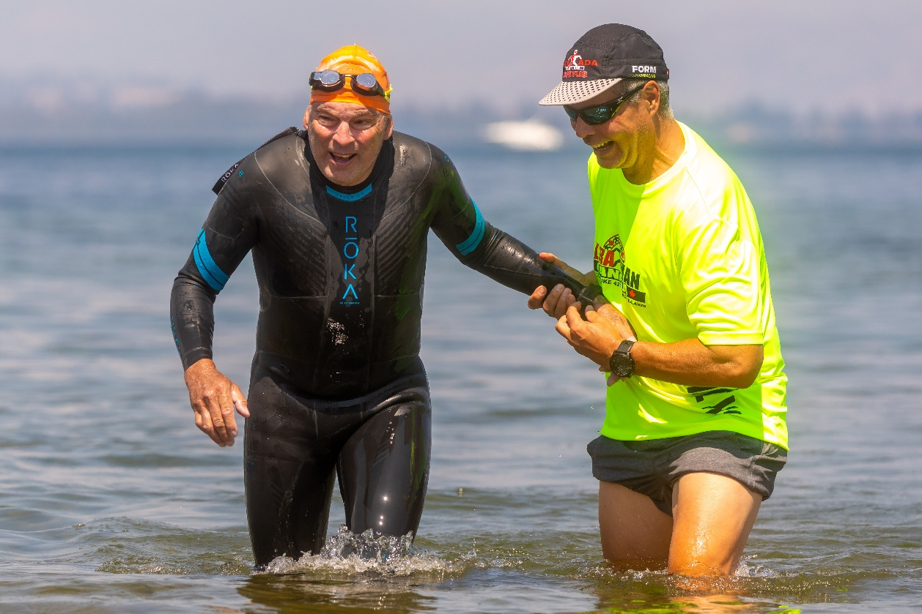

UM Canada

Race & Crew Manual
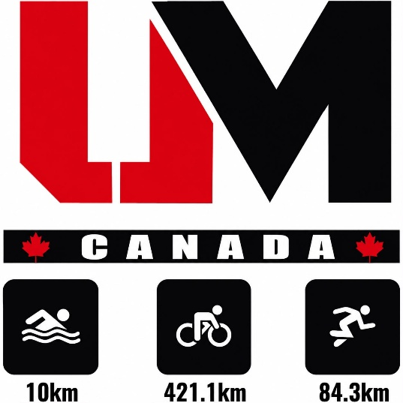

This manual covers some of the official rules/guidelines (again, refer to the Rules/Guidelines manual for full clarification), but also how the race works in general and how you and your crew can ensure a successful event for you.
Each day, someone from the crew must checkin the athlete so that we know you are present and ready to race. Please keep an eye out at the start location (Surf Club day 1, Lions park Day 2/3) for a member of the UM Team doing checkin.
Contents

The Swim 3
Water safety 3
Paddler option and preparation 3
Nutrition 4
Hints and tips for the Swimmer 5
Hints and tips for the Paddler 5
Goal of the Paddler and the Athlete 5
Speed 6
Direction 6
Responsibilities (in order of importance) 7
The Ride 9
Operational check of bike(s) at registration (Thursday) 9
Helmets 9
Road Rules 9
Additional bike information 10
Spare parts that may be useful 10
The Run 11
Navigation 11
Nutrition 11
Pacers 11
Finish 11
The Crew 12
Introduction 12
The Crew Meeting 12
Expenses 13
Registration 13
Pre-Race Briefing 13
Shopping for supplies 14
Car setup 14
Crew roles 14
During the race 15
Day 1 – Swim/Bike 15
Tip – caution times/areas 16
End of the day 16
Day 2 – Bike 17
Day 3 – Run 17
No Crew Zones/Caution zones 17
Day 1 17
Day 2 18
Day 3 18

The Swim

Water safety
Rescue Boat(s) (IRBs) will be on course manned by Surf Lifesaving staff and have access to emergency rescue equipment. They are in place to support athletes and paddlers for the duration of the swim.

Paddler option and preparation
The UM team works with the Noosa Surf club and volunteers to have paddlers available to athletes for race day. You will be asked by race organizers if you need this service in the months leading up to the race.

- Even if you are using a hoodoo paddler, you need to do open water swim training with a paddler to get used to swimming this way and using a paddler/craft for sighting.
- You will be put in touch with your paddler in the days leading up to the race, it if good to make contact with them and try to meet them prior to race morning.
- Your decision on using a friend/family member as opposed a surf club volunteer is yours. Do what you think you are most comfortable with. A surf club volunteer knows the conditions and local area, your friends will know you. It is a balance.

- If you choose to use your own paddler, ensure they are fit and prepared for the task. Either bring your own craft, or make sure you have one organized locally to borrow/hire(we recommend Noosa Beach Hire for hiring craft – 0402 841 338)

Nutrition
Nutrition is initially the responsibility of the swimmer. Organize your calories ahead of time, planning on being in the water for 5 hours (it’s always better to carry extra). Discuss your expectations and the timing of your nutrition breaks with your paddler.
Mesh bags are a good option for storing nutrition and supplies.

Hints and tips for the Swimmer
- Be prepared for a long swim, which means anywhere from 2 hours 30 minutes to 5hours 30 minutes. Even if you just make the swim cut-off, you’ll still have plenty of time to ride the 145 km and make the cut-off for Day 1.
- You can’t win Ultraman in the swim, but you can lose it.
- Your Ultraman experience is dependent on many people. The most important person in getting your event off to a good start is your paddler.
- Ultraman is a 3 day event. Things you do on Day 1 will ultimately affect you on Day 3. Maintain your calorie and fluid intake, even during the swim.
- Don’t do anything that you haven’t already done many times in training.

Hints and tips for the Paddler
- Be prepared for a long trip, which means anywhere from 2.5 to 5.5 hours. Even the fastest swimmer doesn't go very fast compared to a surf craft, so you'll find your stroke rate is about 10 strokes per minute.
- Arrive at the beach early as you will not only have to rig and launch, register with the organizers and get your numbers, but you'll need to meet your swimmer and get his/her nutrition and hydration supplies.
- Ensure that you are ready for the paddle and that you have your own nutrition and hydration needs.
- Make yourself familiar with the swim map and the approximate land marks so that you can let your swimmer know where they are.
- Carry your mobile phone in a plastic bag for emergency purposes.
- Attend the pre-race swim briefing.

Goal of the Paddler and the Athlete
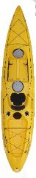
Your paddler is the most important link between you and a successful swim. The paddler can provide the athlete with their nutrition needs, but the MOST IMPORTANT role of the paddler is to paddle at the proper “speed” in a line that is as straight as possible. Your role as the swimmer then, is to swim and sight off your paddler.

Try to swim with your paddler directly to your right approximately 10 feet (3 metres) away. Every time you breathe to your right side, sight your paddler and adjust your line to mimic theirs. If you prefer, the paddler can be to your left.
Direction of travel

3 m (10 ft)

Speed
Speed is the responsibility of the paddler. It is adjusted based on the speed of the swimmer: paddle so that your craft speed matches your swimmer’s speed.
*Perfect speed control
Swimmer stays within the fore and aft shadow of the boat

Too fast Way too fast
Swimmer might start to feel pressure to swim faster Swimmer might feel they are chasing the boat
Too slow Way too slow
Swimmer might start to feel pressure to swim slower Control is in jeopardy: who’s leading who? Or to start to sight for themselves

Direction

THE PADDLER IS IN CONTROL AND MUST NEVER RELINQUISH CONTROL.
The paddler is in charge of the direction that both the boat and swimmer travel.

Scenario One: The paddler maintains directional control for the entire swim.

Typical case
The swimmer sights off the paddler; swims off line slightly (paddler retains control)
and adjusts back to the paddler.

Swimmer must adjust (and does)
Paddler retains control

Best case
The swimmer sights off the paddler; and swims straight.
Result: Shortest possible straight swim.
Result: Swim is a little longer.


Scenario Two: The paddler relinquishes directional control (NOT good).


Bad case
The swimmer sights for him/herself initially and then gives in to reason.
Worst case
The swimmer sights for him/herself for the entire swim.












Swimmer is back on line with the buoy
Swimmer is in
control

Paddler in control

Swimmer does adjust (finally)

Paddler tries to regain control

Swimmer now thinks that everything is ok and on line

Paddler gives up control

Paddler is following

Result: A long swim
Result: The swimmer risks missing the cut-off!

Responsibilities (in order of importance)

Swimmer | Paddler
Swim | Paddle in as straight a line as possible.
TRUST that your paddler knows where to go | TRUST that your swimmer will follow you
Swim in a direction that keeps you close to your paddler | Paddle at the proper speed*
Ingest nutrition/calories | Carry nutrition/calories
Relax and enjoy the swim | Relax and enjoy the swim

The Ride

Operational check of bike(s) at registration (Thursday)
- You will need to bring your bike(s) and helmet with you to registration on Thursday of raceweek. An Aus Triathlon Technical Official will check that your bike's brakes operate, the seat post and handle bars are in good condition and that your helmet is legal. This is a basic operational check and is not a full mechanical inspection. Make sure you have your bike checked and service thoroughly BEFORE you come to Noosa, and/or allow extra time to have this checked once you get to Penticton.
- If you are traveling with a spare bike during the race, please bring your spare bike also to be checked.

Helmets
- Athletes MUST wear an Canadian Standard bike helmet, which must be labelled as such (see below). Note that UM Canada does not close roads, therefore rules that may apply to other events with road closures do not apply here. This rule may affect international athletes in particular. HELMETS WITHOUT Canadian STANDARDS STICKER WILL NOT BE PASSED AT BIKE INSPECTION
- Canadian helmet rules can be found at https://www2.gov.bc.ca/gov/content/transportation/driving-and-cycling/cycling/cycling-regulations-restrictions-rules Road Rules
- British Columbia road rules apply to vehicles and bicycles. PLEASE familiarise yourself with these rules.
- Rules relating to bicycles specifically are https://www.peopleslawschool.ca/cyclist-rules-of-the-road/?gad_source=1&gad_campaignid=14002153386&gbraid=0AAAAADHZbzIBP8O6ub9rbEOq4crPBGdxA&gclid=Cj0KCQjwp9vTBhCWARIsANaUrjsi9pDF6mQKkDKm67EeHVsonM9QnF_HTfvcnL6otbvEfZlMty0qIBUaAo0dEALw_wcB
- General road rules and https://rcmp.ca/en/bc/safety-tips/road-safety/road-safety-legislation
- Rules for motorists passing cyclists https://news.gov.bc.ca/releases/2024MOTI0046-000476

Additional bike information
Bike checks and spare parts Items which should be checked by your mechanic.
Ensure that you’ve had a thorough service carried out on the bike before getting to the race.
- Gear cables - Ensure all your cables have been checked and are in good condition. You don't want to be without gears out on the bike course.
- Brake cables - As above - brakes are definitely needed! If in doubt, get these replaced.
- Electronic gears - Make sure everything is checked, charger is packed and maybe even a spare battery if your mechanic recommends it
- Derailleurs - These should be checked before AND after you travel. The rear derailleur hanger in particular can be damaged easily during transit, make sure it's checked thoroughly.
- Chain - Don't skimp, get a new chain fitted a few rides before the event, or at the very least make sure it has been checked and serviced well.
- Frame - modern carbon fibre bike frames need to be checked for damage/cracks which can be hard to find. Good bike mechanics can ensure the frame/forks are in good condition.

Spare parts that may be useful
- Tyres and tubes - make sure you know what you need to repair these. Are you running 'clinchers' or 'singles'/'Tubular' tyres? Can you change these yourself? Will you carry spare wheels to save time?
- Tubes and extensions - make sure your spare suit your bike/wheels. for example, some wheels will require extensions to the standard tube/tyre. Be familiar with this and/or make sure one of your crew is.
- CO2/pump - bring your inflator and/or pump that you and your crew are familiar with using.
- Derailleur hanger - Not to scare you, but especially if you are flying, it might be a good idea to bring a spare derailleur hanger with you. Talk to your bike mechanic about this.
- Chain/breaker - If you are super paranoid and/or keen, a spare chain and chain breaking tool might get used. This is pretty specialised so make sure you or your crew know how to do this

The Run

Navigation
- There are several spots on the run course where the crew car takes a different route to the athlete and pacer- check the maps, take the drive, know where you will leave the athlete and where you will meet back up with them. The first approx. 5km of the run is unsupported. Make sure your team works out where they will meet up with the athlete on Leslie Drive. Athletes will be led out from the start by an official on bicycle.

Nutrition
- Be prepared for anything on run day. The addition of pacing and pacers also adds a further element to this day and may of them run many many kms also – for some they run the whole thing, for others they might unexpectedly clock up their first marathon.
- Water - You will go through a lot, for the crew and for your athlete, it can get really hot out there.
- Ice - The holy grail of run day. Make sure to have enough and then some more

Pacers
- Pacers can jump in from the 5km mark at the school and can then join for the rest of the race. We do require people to have their pacers for the last 10km of the run, athletes are tired, there are some road crossings and the pacer is more important than ever for safety. (We will cover this in the briefing).
- Pacers will be provided with a ‘Pacer’ bib, and each athlete can have 1 person run with them at a time. We suggest taking a race belt for the pacer bib so you can swap easily if changing pacers. Pacers need to ensure they also have enough of their own nutrition needs sorted – a big one for today is that history tells us that a lot of people cover a lot more kms then they intended to- so be prepared.

Finish
- As you may have seen in many photos, we encourage all crew and pacers to run the beach with athletes and cross the line together. It’s really important to make sure your athlete has what they need before you leave them to give enough time to find a park and hit the sand together.

The Crew

Introduction
UM Canada is one of the most grueling triathlon challenges that an athlete can ever attempt and complete. The staggering distance will take an athlete to mental, physical and spiritual places that they have never been before. The toll placed on the human body is tested to the extreme. Athletes who challenge this event have the ability to train and focus longer and harder than anyone can possibly imagine. After all the training and discipline, fundraising, pre-race races, travel and costs, they could be left on the side of the road if they do not have a crew that knows what they are doing.
The job of the crew is to look after everything - communication, navigation, daily supplies, vehicle reliability and maintenance, minor first-aid, road safety, mental encouragement for the athlete, and comic relief! The crew is the athlete’s lifeline, ensuring the athlete has the correct amount of water, electrolytes, salt, protein, and caloric intake to successfully complete the event.

The Crew Meeting
The athlete will usually arrive in town a few days prior to the event to acclimatize and check out the course. It is the responsibility of the Team Captain to handle the administrative duties of the crew. If you have members on the crew you have not personally met, make sure to connect with them prior to arriving in British Columbia, and plan on a meeting time and place. Don’t forget to include your paddler in the meeting especially if it is someone local and this is your first time to meet your paddler.
Your agenda should include the following items and issues:
  - Assign Crew Tasks
  - Review General Guidelines and Rules
  - Review the Planning Lists document
  - Understand the Leap Frog Method of Support and Support Stop Protocol
  - Course Maps
  - Swim to Bike Transition set-up and Crew Duties
  - Athlete Nutrition & Hydration
  - Crew Nutrition & Hydration
  - Meeting times and places
  - Crew Finances and Expenses
  - Schedule of Events – starting times each day

Expenses
It is understood that the athlete is responsible for all expenses – especially when the crew is volunteering. The expenses need to be laid out to determine what the athlete is paying for, and what they are not paying for. Accommodation should have already been discussed and looked after before the athlete arrives. Athletes will not have time for discussions about expenses or going through receipts during the event (fuel costs, food costs, general supplies etc), so arrangements will need to be in place.

Registration
The Team Captain should organise all crew members to attend the registration on Thursday. Each crew member will need to sign a waiver(if they haven’t done so online beforehand) and provide other information during the registration process. The Captain and athlete will need to provide the following items in order to complete the registration process:
  - Crew Vehicle Details
  - Contact numbers during the event.
Race organizers will distribute a complete contact list to the Team Captains to be kept with the team vehicle. This will include emergency numbers, the numbers of all officials, and the numbers of every crew member.
At registration you will receive the following items:
  - Crew Shirts & Wristbands
  - Sponsor Products
  - Hi Vis Vests x 2 (you are borrowing these vests and will need to return them after the event).
  - Race Numbers and placement instruction
  - Athlete bag with merchandise
During registration, you will also meet race commentator, who will extract as much information about you and every person on your crew as he possibly can during
individual interviews.

Pre-Race Briefing
All team members must attend the pre-race briefing (Thursday). Be prepared to take notes (either manually or electronically). The briefing is informative and is your final opportunity to ask questions and be clear on everything related to race including navigation, rules etc. The briefing and breakfast beforehand also allow crews and athletes the opportunity to meet, bond, exchange ideas and generally get to know each other. Crews helping crews, and athletes helping athletes are all a part of the UltraTribe experience.

Shopping for supplies
Try to break down what you will need daily. Each athlete will have different requirements. You should have already discussed at the crew meeting what your athlete likes to eat.
During the first trip to the store, buy enough to last throughout the three days. If you need fresh ingredients you may need to shop each day.
Remember, the athlete’s body is being taken to the edge. They need to trust what their training has taught them - new spices or day old wraps should not be on the menu unless they ask for it. Remember that both salty and sweet items are often appreciated by the athlete.
Make sure that you buy food and drinks for the crew as well. The days can be long, and there are no opportunities to stop for lunch along the course. You always need to remember that you are the lifeline to your athlete and you need to be there at all times.
We will provide more information about places to shop, and also about pit stops on the bike and run courses, closer to the event.

Tip: You will need a cooler or two in the car however Styrofoam coolers are at local stores like Walmart and Canadian tire.

Car setup
You should set up the car the night before each day. This includes clearing out rubbish, restocking supplies, including any spare equipment and tools (e.g. spare wheels) needed for the next day. Doing this the night before each day of racing means on race morning you’re good to get up and go.

Crew roles
It’s important that the crew attend athlete registration (Thursday) – they are the ones who most need to understand the course so they can manage and prepare the athlete and this is their opportunity to ask questions and clarify all details. Once you’ve been to the check-in and briefings, you should have a good idea of what the crew members need to do each day. Think about assigning particular jobs to each crew member. They will be responsible for ensuring that job gets done each day, including preparation and out on the course. This includes:
  - Driver
  - Navigator
  - Nutrition tracker
  - Chief motivator
  - Person responsible for dress-ups

During the race

Day 1 – Swim/Bike
When you arrive at the swim start, your athlete will need to check in, or a crew member can do it on their behalf.
Arrive at your pre-determined meeting spot on time and meet with your paddler. Your athlete can discuss final points including eating/drinking times, waves, currents and communication signals etc. with the paddler.
Once the opening ceremonies are over, the swim commences. The crew will have between 2½ hours and 5½ hours to wait for their athlete. This is an opportunity to do any last minute checks that need to be done before the bike portion begins (e.g. get more ice, put fuel in the vehicle).
The transition area will need to be set up for your athlete and it is recommended that you do this about an hour prior to when your athlete thought they may come out of the water. Make sure that the transition area has everything laid out for easy access, including a foot wash to get the sand off their feet. There are public facilities and outdoor showers at the Noosa Surf Lifesaving club.
Familiarize yourself with the first section of the bike course and ensure the bike is in the correct gear. Helmet, gloves, glasses, shoes and socks and any riding clothes that the athlete will be wearing should be free of entanglements and neatly placed on a towel next to the bike. You should also include a drink and some food.
Crew members should think about who will do what for the athlete when they enter transition (eg one crew member responsible for getting the bike off the rack, another crew member for helping the athlete get changed, one to put sunscreen on). The space is relatively small and you don’t want to get in the way and slow things down.
Once the athlete is out of the water, allow them to have a few words of appreciation with their paddler, and move toward their transition area at their own pace. A crew member should meet their athlete coming out of the water to assist them if needed and give them a drink of fresh water or something to eat. At the transition area, the crew should be close in case the athlete needs assistance and to play their part in getting the athlete ready for the ride.
When the athlete starts out on the bike, the technical part of crewing begins. The crew will need to:
  - Clean up the transition area (wetsuit, goggles, and other goodies)
  - Prepare nutrition for first stop
  - Have your course notes out and ready for navigation
  - Re-set your vehicle odometer to ‘0’ – remember to do this at the beginning of Day 2 and 3 as well
  - Start Leap Frog Method of support – head to first planned support stop

You need to be sure everyone knows how the Leap Frog Method of support works and what their duties are at the support stops. Depending on the athlete, you can hand off food or water bottles at their discretion - just make sure that you try to do it on uphills, or just before the crest of the hill, as they are moving incredibly fast on the downhills, which makes handoff difficult and dangerous.
Remember to park your vehicle in a safe spot, with the hazard lights on.
For the rest of day be careful and stay in touch with your athlete. Always be aware of the turns and be a step ahead in the manual. Know what’s coming next!

Tip – caution times/areas
As the day wears on, the athlete is doing fine and the crew has become proficient with handoffs and making sure they were at all the corners. Coming towards the end of the day, and the finish line, everyone is looking forward to some celebration. However, the last 15 kms can be taxing as it becomes the area attention levels go down because the athlete is looking forward to the finish line and the crew is anxious to give a few high fives and call it a day. Things can happen in this time such as missed turns, accidents and any number of other possible pitfalls. It is imperative that the crew be on top of their game throughout this time.
Even at the finish line accidents can happen and cause injury to athletes, crew and volunteers. Once the athlete is heading toward the finish line make sure they have a clear path for stopping and that no-one is standing around where they could be hit. The crew is responsible until the athlete is over the line and the bike has come to a complete stop. It is then that the crew can go for hugs, high fives and pictures. Just be sure you are clear of the finish line for the next crew coming in.
Parking at the end of the day near the finish line is difficult and you might not find a parking space easily. Do not park illegally or in dangerous places. If you can’t find a spot near the finish line, drop the rest of the crew off and park safely.

End of the day
Get your athlete to the medical check in as soon as you can, as you may learn something about their condition and if any special care is to be administered.
After the medical check-in the athlete should go to massage. Be sure to have lots of cold liquids and some food available so they can start to rebuild the glycogen stores for the next day. The athlete will probably want to eat and go to bed.
The crew needs to restock on ice and shop for stores for the following day. You will need to re-pack the vehicle and clear out the stuff you will no longer need; wetsuit and assorted swim stuff, empty bottles, garbage etc.

Day 2 – Bike
The big difference to Day 1 is that everyone starts together. DO NOT DRIVE SLOWLY BESIDE YOUR ATHLETE. Immediately adopt the leap frog method, and be mindful of the other athletes and teams.
The first approximately 50 km of Day 2 bike is a no crew zone. Make sure your athlete has enough food and drink with them to keep them fuelled before you meet up with them a few hours later. As the first part is a no feed zone, there is less pressure on the crew to quickly get ice and coffee before heading out to the course.
The first 100 km’s on Day 2 is on some of the same roads that were biked on Day 1. Your athlete should be pretty familiar with the corners, intersections and hand off areas. Have the course map close at hand and be very aware of the turns and corners upcoming, and the NO CREW ZONES. These will be discussed at the Pre Race Briefing. Make sure you arrive at the turns before the athlete so you can get out of the car and direct the athlete around safely.

Day 3 – Run
Today will be a much slower pace for the crew, however, this is the day that being prepared and thinking ahead will pay the biggest dividends. The day starts at race precinct in Lions Park. Once the athlete has begun their run and completed the first 5km, begin Leap Frog Method of support.
While a slower day, it is generally the day your athlete needs the most support. It can get hot during the day, so make sure you have ice and cool drinks ready for the athlete. Make sure that they’re getting their nutrition in and think about having a few options available in case of digestive distress.
Don’t forget about the crew needs during the run. Crew pacers will also need to ensure they have water and nutrition available throughout the day.

No Crew Zones/Caution zones

Day 1
  - Ensure your athlete knows how to get out of Noosa and to the top of ‘Noosa hill’ (km 13.3). Exercise caution leading up to this point and at no time stop on Noosa hill (overtaking lanes).
  - From km39 to km115 (Pomona-Turn-Pomona) please exercise caution and be careful where you pull off to service your athlete. There are many narrow parts and blind corners, do not stop in these places. Use quiet spots to service your athlete and look after them off the road, even in the back of your car so you minimise any risk.

Day 2
  - Day 2 starts where da1 finishes behind Belocks grocery .
  - Crews will wait south of the junction of maple street and why 97 south

****ANY CREW CARS FOUND IN THE AREA km.3 to km21.1 (including but not limited to Maple Street ) WILL RESULT IN THE DISQUALIFICATION OF THEIR ATHLETE. CREW CARS MUST LEAVE THE START AREA 15MIN PRIOR TO THE START AND WILL PROCEED TO THE JUNCTION ON MAPLE AND 97

Day 3
  - Coming soon

