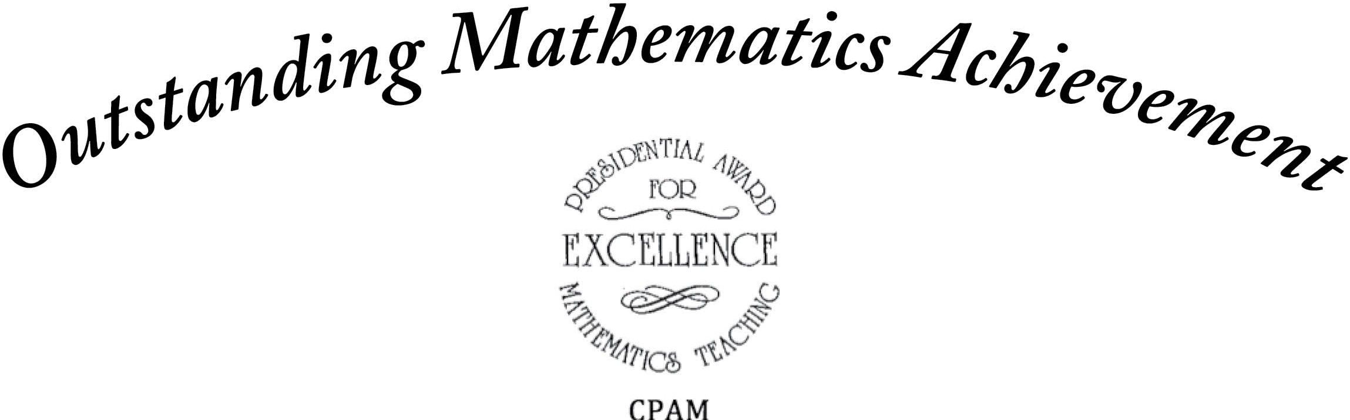

The Council of Presidential Awardees in Mathematics recognizes

***for******outstanding achievement in mathematics.***

Member, Council of Presidential Awardees in Mathematics

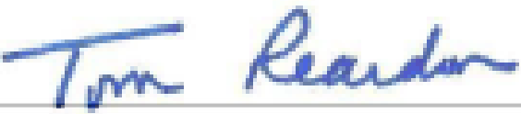

President, Council of Presidential Awardees in Mathematics