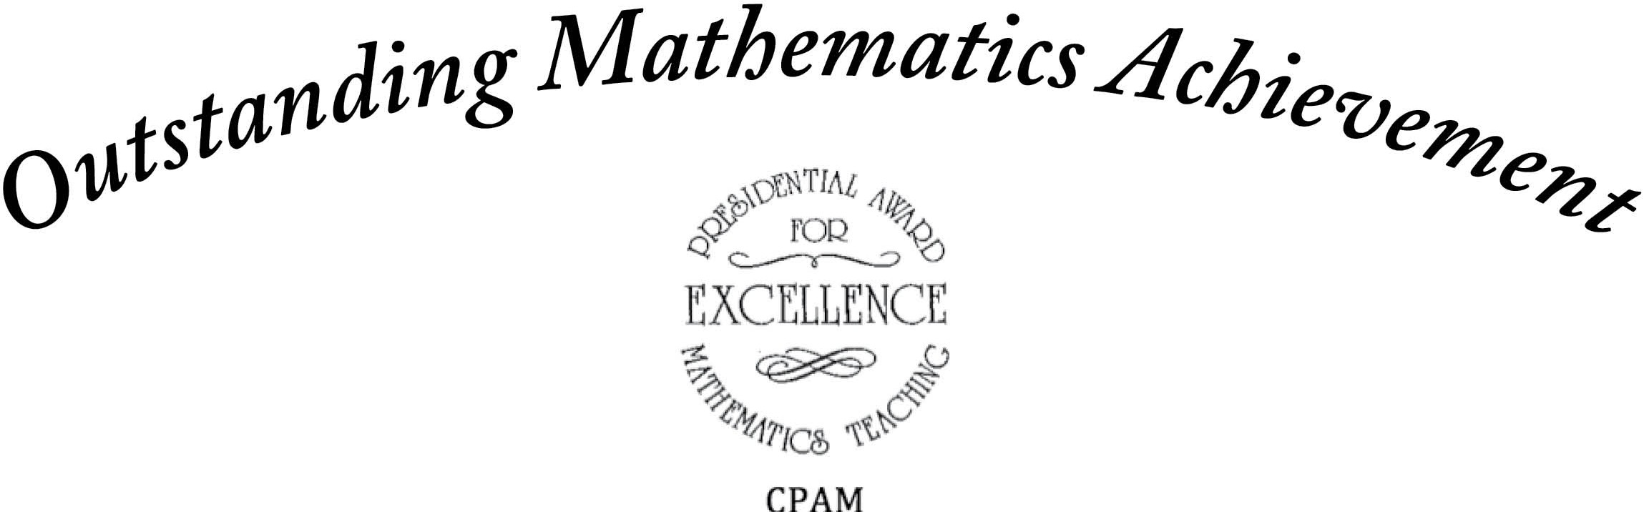

The Council of Presidential Awardees in Mathematics recognizes

for outstanding achievement in mathematics.

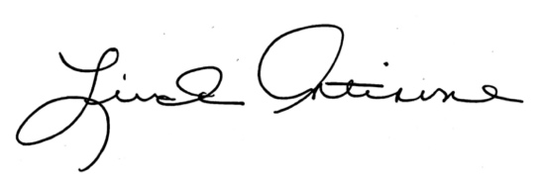

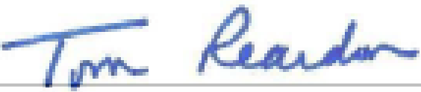
Member, Council of Presidential Awardees in Mathematics
President, Council of Presidential Awardees in Mathematics

