Louisiana State Florist Association invites you to…

“Bloom”

March 14th-15th, 2020

Evangeline Downs Racetrack & Casino, Opelousas

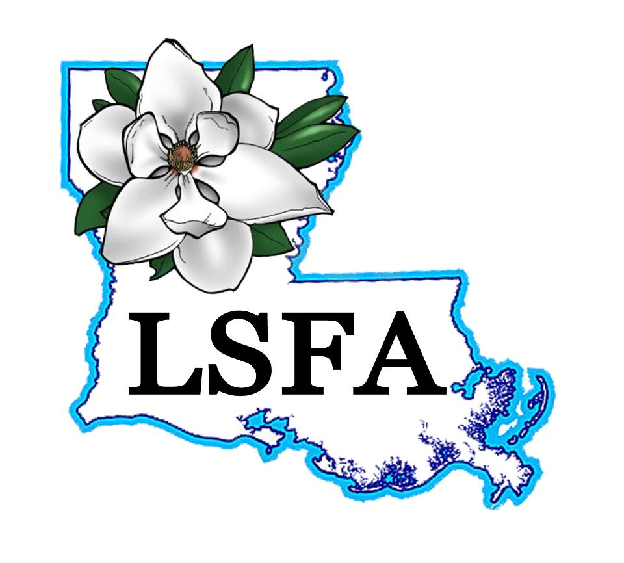

PLEASE fill out one form per person.

NAME: ______________________________________________________________________________

E-Mail address: ____________________________________________________________________

(you will be emailed important notices and events, etc.)

Company Name: ____________________________________________________________________

Mailing Address: ____________________________________________________________________

City, State, Zip: ______________________________________________________________________

Annual Membership Dues: $25.00

(If you register for a Full Registration, you will receive Complimentary Membership) _______

Registration fees are per person (see below to register as a shop)

*FULL REGISTRATION: FOR SATURDAY & SUNDAY*

*Please note that registration for Saturday gives you access to* ***ALL HANDS ON WORKSHOPS and COMPLIMENTARY MEMBERSHIP***

_______**Members**---------------------------------------------------------$250 _________

**\*Shop Registrant**-------------------------------------------------------$200 _________  
***\*Shop registrants PLEASE fill out a form per person, make sure to put shop name and circle shop registrant. Must have 4 or more attending from 1 shop for full registration (attending both Sat. and Sun.) with at least 2 being LSFA members. All forms must be turned in together with payment before convention to qualify for shop discount.***

ONE DAY REGISTRATION: FOR SATURDAY **REGISTRATION DAY OF CONVENTION WILL BE $25 MORE**

_______**Members**-----------This includes **all hands on** classes---------------$125 ___________

_______**Non-Members-------------------------------------**----------- $150 ___________  
ONE DAY REGISTRATION: FOR SUNDAY **REGISTRATION DAY OF CONVENTION WILL BE $25 MORE**

_______**Members------------------------------------**-----------------------$125 ___________

_______**Non-members**----------------------------------------------------$150 ___________

_______**Shop Ad in Program (BUSINESS CARD SIZE)** -------$20 **___________ (Due by 2/29/20)**

_______**DESIGNER OF THE YEAR COMPETITION-----------------$60 _________________**

**BRING YOUR OWN DESIGN CONTEST---------------------------------------------------- FREE !!!**

Bring your best take on a garden inspired centerpiece, any style, color or theme that inspires you!

**TOTAL---------------------------------------------------------------------------------------$ _________**

**Louisiana State Florists Association Designer of the Year Competition!**

You will be given flowers, supplies, instructions, and a time limit. You must bring your own tools. All designs are judged by number not by name. Winners will be announced at the convention!

1st place winner will receive $500 towards entry and travel to represent the great state of Louisiana at the Mid America Cup Invitational Competition, held in August 2021. Designer of the Year competition fee is $60.00 and will be held on Sunday March 15th at the Evangeline Downs Casino & Racetrack

**Bring a design contest is FREE!**  
Supply Limit -$75 wholesale. **Must provide a list of goods and cost!**

Have some fun with it & challenge another shop! Winner gets free registration to Convention 2021.

**Make and Take Classes**

Classes fill fast and are on a first come first served basis. These classes are extremely educational and informative. Flowers are supplied; please bring your own tools. You take home what you make!

COMPLETED FORMS AND PAYMENTS SHOULD BE MAILED TO:

**LSFA C/O ANNIE TAYLOR P O BOX 637, SCOTT, LA 70583.**

CREDIT CARDS CAN ALSO BE USED.

CARD NAME: _________________________

CARD NUMBER: _________________________

EXP: _________________CVV: _______________

CARD ZIP CODE_____________________

PHONE NUMBER____________________________

**NON-REFUNDABLE**

Any questions call Annie @ Leona Sue’s Florist (337) 234-1421

**Saturdays ALL NEW ALL HANDSON CLASS DAY**

**This year we are changing things up and including more hands on classes for all one price! We have structured the schedule so that the entire day on Saturday will be jam packed with classes and shopping!**

**Saturday HANDSON Schedule**

|  |  |  |  |
| --- | --- | --- | --- |
| Time | Group A | Time | Group B |
| 8-10am | Modern Corsages with Lucinda Peltier AIFD | 8-9am | Certified Florist Program with Bridget Joslin AIFD |
|  |  | 9-10am | Enhancing Social Media Skills |
| 10-10:30 | Break & Shopping | 10-10:30 | Break & Shopping |
| 10:30-11:30 | Certified Florist Program with Bridget Joslin AIFD | 10:30-12:30 | Modern Corsages with Lucinda Peltier AIFD |
| 11:30-12:30 | Enhancing Social Media Skills |  |  |
| 12:30-1:30 | Lunch & Shopping | 12:30-1:30 | Lunch & Shopping |
| 1:30-3:30 | Creative Caskets with Annie Venable AIFD | 1:30-2:30 | Competing Competitively with Samantha Bates AIFD |
|  |  | 2:30-3:30 | Cost Effective Creations with Amy Jo Spence |
| 3:30-4 | Break & Shopping | 3:30-4 | Break & Shopping |
| 4:00-5 | Competing Competitively with Samantha Bates AIFD | 4:00-6 | Creative Casket with Annie Venable AIFD |
| 5:00-6 | Cost Effective Creations with Amy Jo Spence |  |  |
| 6:00-7:30 | Break & Dinner | 6:00-7:30 | Break & Dinner |
| 7:30-til | Social Hour in Main Area | 7:30-til | Social Hour in Main Area |

**Sunday Schedule**

|  |  |
| --- | --- |
| 8:00 | Registration Desk Opens |
| 8:00-9:30am | Designer of the Year Competition |
| 8:00-9:30 | Shopping |
| 10-11:30am | Main Stage Program |
|  | Teleflora Education Specialist Gerald Toh AIFD, CFD, CCF |
| 11:30-Noon | Announcement of Lifetime Achievement Award |
| Noon-1pm | Lunch & Shopping |
| 1-3:30 | Main Stage Program |
|  | Abel Gonzales CFD, TMF |
|  | 2019 Louisiana State Designer of the Year |
| 3:30-3:45 | Announcement of 2020 Designer of the Year Award |
| 3:45-4:30 | Closing and Auction |
| 4:30 | Board Member Meeting |

**We will be having an AWESOME social mixer Saturday night at the Main Stage area at 7:30pm. Here we will have a Whimsical Wearables Contest!**

**When booking your hotel room, be sure to mention that you are a part of LSFA Convention to receive special rates!**

