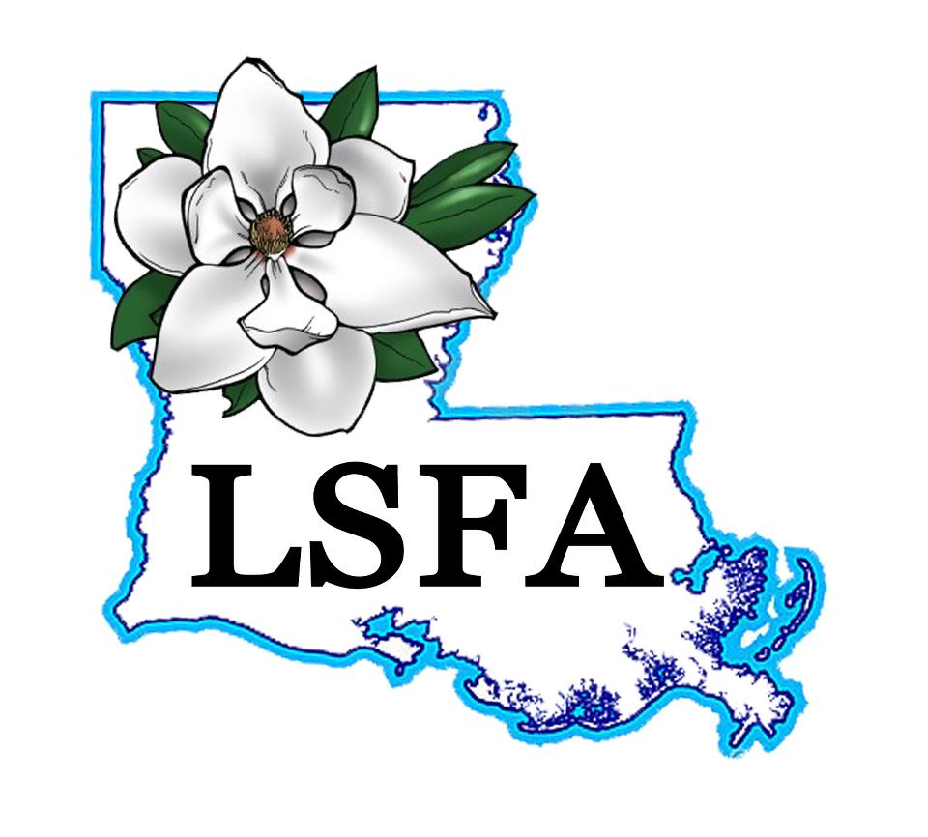
LOUISIANA STATE FLORISTS’ ASSOCIATION
2020 STATE CONVENTION
“Bloom”
March 14th & March 15th
Exhibitor/Vendor Application--- Please fill out completely
COMPANY___________________________________________________
ADDRESS___________________________________________________
CITY, STATE & ZIP CODE_______________________________________
PHONE_______________________CELL__________________________
PERSONS WORKING IN BOOTH________________________________ (NO ONE WILL BE ALLOWED IN WITHOUT A NAME TAG. PLEASE LIST ALL NAMES, can use back of paper if needed)
NUMBER OF BOOTHS NEEDED
_______1@$250.00 ______Extra Tables
_______2@$425.00 ______Extra Chairs
_______3@$500.00 ______Sat. Meal _____ Sun Meal
ADS
_______$200.00 Inside Front Cover, Inside Back Cover, OR Outside cover
_______$175.00 Center Page ______$250.00 Both center pages
_______$150.00 Full page ______$100.00 1/2 page
_______$ 75.00 1/4 page ______$ 40.00 Business card

PAYMENTS MUST ACCOMPANY THIS FORM IN ORDER TO RESERVE YOUR BOOTH/AD SPACE.
MAKE CHECKS PAYABLE TO
LSFA, c/o Annie Taylor; P O Box 637, Scott, LA 70583
CREDIT CARD: VISA MASTERCARD DISCOVER
CCV Code______________
Card Number._________________________________ Exp. Date ________________ Signature.____________________________________ Phone # _________________
Address for Card________________________________________________________

Book your hotel room with our group code 3417728 for special rate!!

