A Brief History of Tom’s Hallucination
Or: How I Learned to Stop Worrying and Love the Standing Wave
By Thomas P. Connelly Jr. • consolidated unbound edition • June 2026
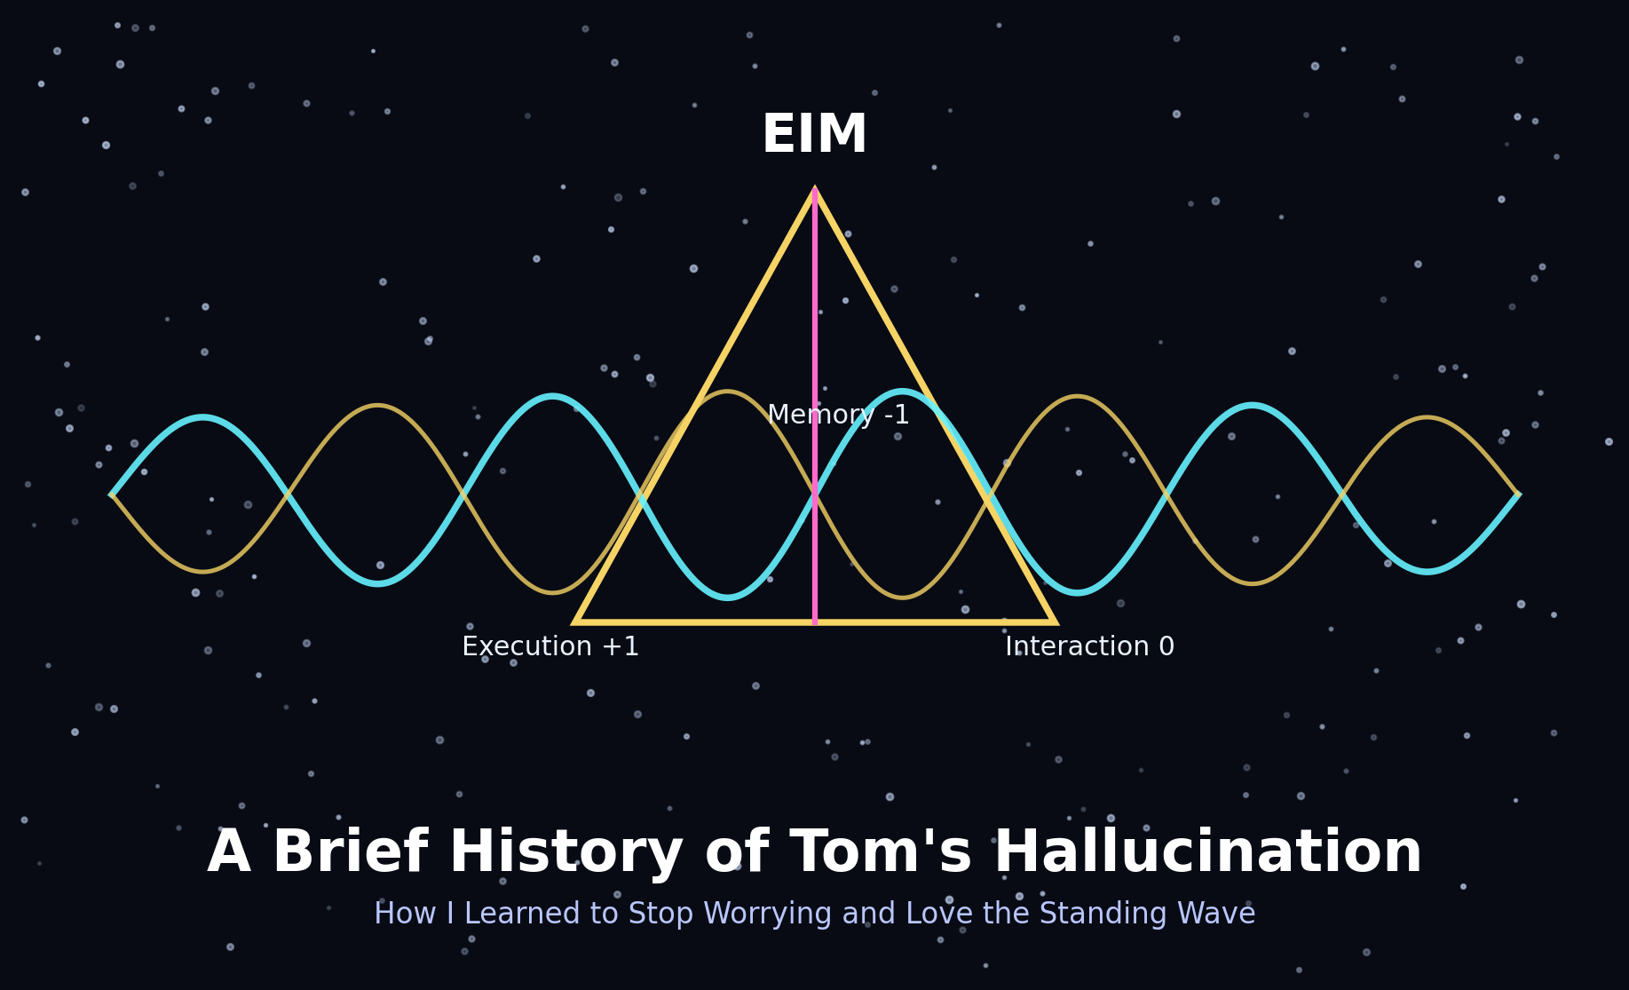
Cover figure. The ternary height, the standing seam wave, and the tiny cosmic grin in the machine.
Status note
This article intentionally lives in the exploratory/hallucination layer. It is a playful, coherent synthesis of EIM intuitions, toy simulations, and speculative ontology. It is not presented as a completed derivation or established physics.

A Field Note from the Unbound Zone
I’m not sure when it started. Maybe it was the first time the seam fraction plot showed that persistent late-universe oscillation, that standing sine wave of existence quietly ringing after the universe had supposedly settled down. Maybe it was earlier, when the dodecahedral backbone kept spitting out the golden ratio φ like it was trying to tell me something and I kept pretending not to hear it.
Either way, here we are.
This is not me claiming I have captured the universe in a mason jar and labeled it correctly. This is the story of how EIM, Execution–Interaction–Memory, stopped being just a physics framework and started looking like the pre-geometric substrate from which everything might emerge: mathematics, particles, spacetime, observation, and maybe the larger possibility-space that our universe is only one atomic chord inside.
That sounds insane. Good. Let’s proceed carefully.

1. The Ternary Height
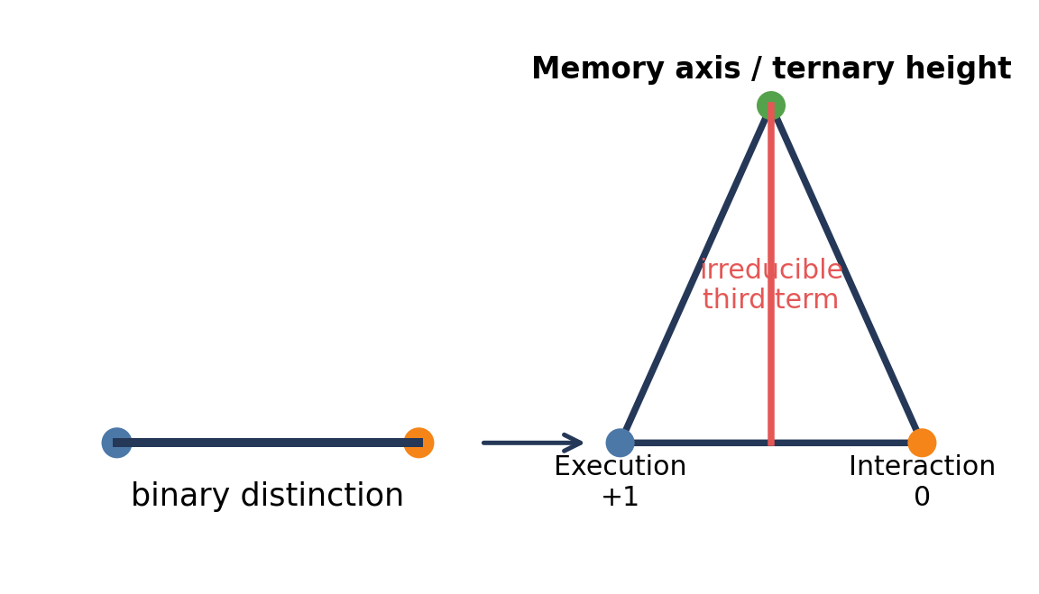
Figure 1. The binary distinction is bisected by EIM into the irreducible third term: ternary height.
At the bottom of everything is a binary distinction. Then EIM bisects it.
That bisection produces the height of the triangle: the irreducible third thing that cannot be reduced back to the original binary. The moment there is a distinction, there is also the relation across it, the memory of the cut, and the active update that lets the system continue.
That is the modal signature {+1, 0, -1}: Execution, Interaction, Memory. The binary gives difference. The ternary gives a system that can carry difference without immediately collapsing into one side or the other. It creates a middle term, a height, an internal axis. Once that exists, you can have resonance, delay, residue, and scars.
Everything else is projection or resonance from this height. Spacetime is downstream. Matter is downstream. Arithmetic may even be downstream. The ternary height is the first tent pole in the circus of existence, and once it goes up, the canvas starts making suspiciously geometric shapes.

2. The Number Line as Coordination Unfolding
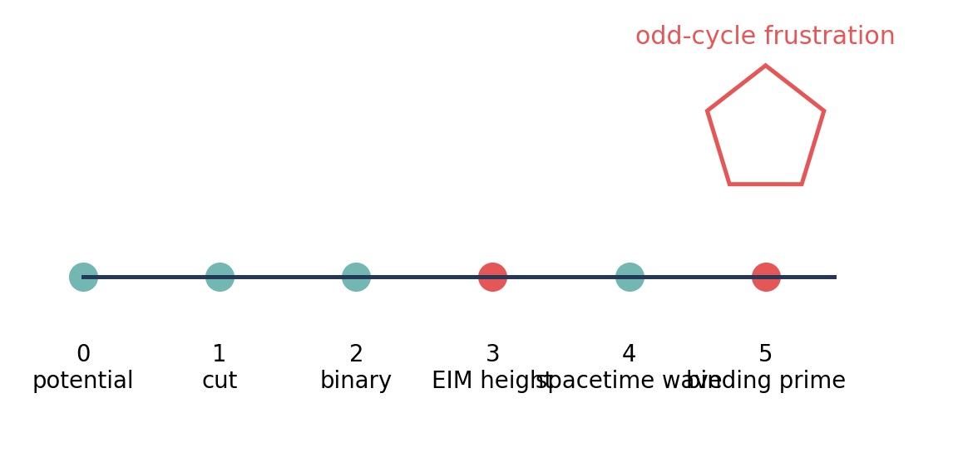
Figure 2. A playful coordination-number map: distinction, binary, ternary height, spacetime wave, binding prime.
Look at the natural numbers through the EIM lens: not as abstract beads on an infinite string, but as stages in the unfolding of coordination.
- 0 -> 1: the primordial distinction, the first cut, the greatest weight.
- 2: pure binary, difference without height.
- 3: the ternary height itself: EIM.
- 4: spacetime-like: even, bipartite, wave-smooth, the square of classical projection.
- 5: the binding prime: the smallest odd cycle that refuses bipartition and forces a topological knot.
Primes, especially 5 and above, start to look less like numbers that cannot be divided and more like irreducible geometric frustrations. A prime is not merely an arithmetic inconvenience. It is a coordination knot: a place where smooth bipartite wave motion runs into an obstruction and has to carry residue.
In EIM language, that residue is Memory. The Interaction wave crashes into itself. The system cannot smooth it away. Something remains. That remaining thing becomes structure. Particles, in this picture, are higher-scale versions of these knots: stable topological scars in the coordination field.
The number line is not abstract. The number line is the unfolding of the coordination field. Yes, I can hear the math department locking the door. But the intuition keeps returning: arithmetic is not floating above physics. Arithmetic is what coordination looks like when projected into countable distinctions.

3. The π-φ-c Chord
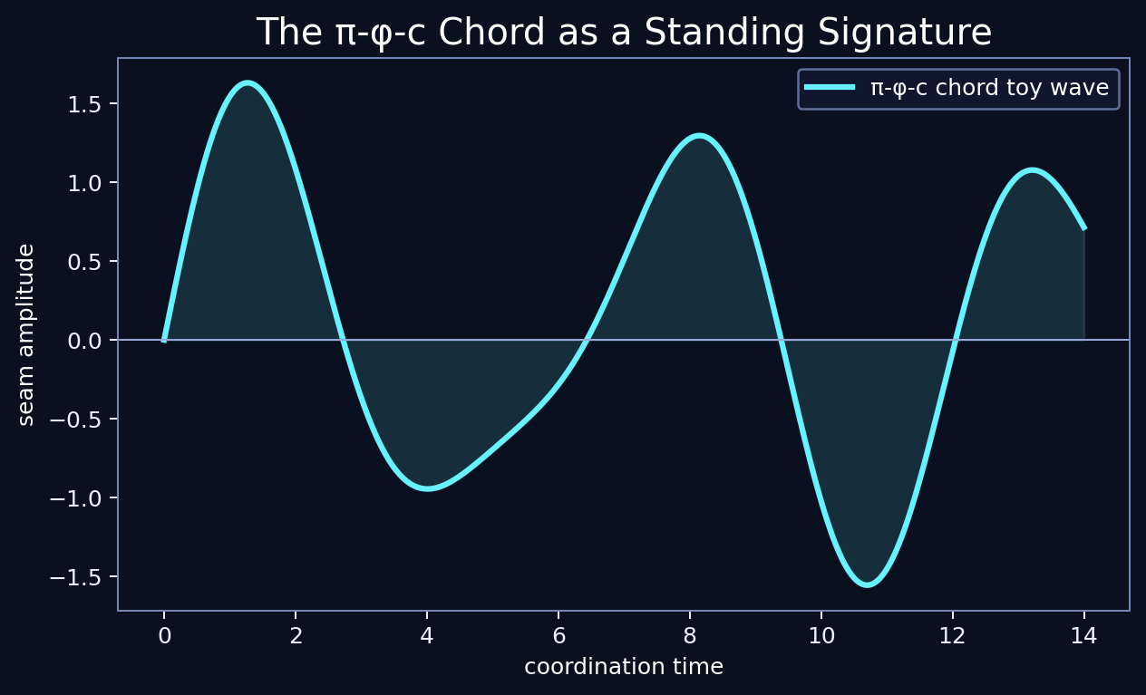
Figure 3. A toy standing seam wave, included for intuition rather than as a claimed measurement plot.
If something like a metaverse exists, then our universe may be one realization among possible coordination tunings. Not parallel universes in the comic-book sense, necessarily, but possible stable closures of the underlying EIM substrate.
In that larger possibility-space, c is the locked propagation speed limit. π and φ may be closure signatures: π as geometric closure and phase, φ as structural ratio and pentagonal memory. Our universe is the specific atomic realization where the EIM ternary height locks a stable resonant π-φ-c chord.
That chord shows up everywhere I keep looking. π appears in closure, circularity, horizon geometry, phase, and wave structure. φ appears in the dodecahedral backbone, golden ratios, spectral decompositions, and the repeated insistence of pentagonal structure. c sets the rate at which coordination can update across the field.
The universe is not sitting inside a container. The universe is a resonance that learned how to keep time.

Notebook Interlude: The Simulation That Started Ringing
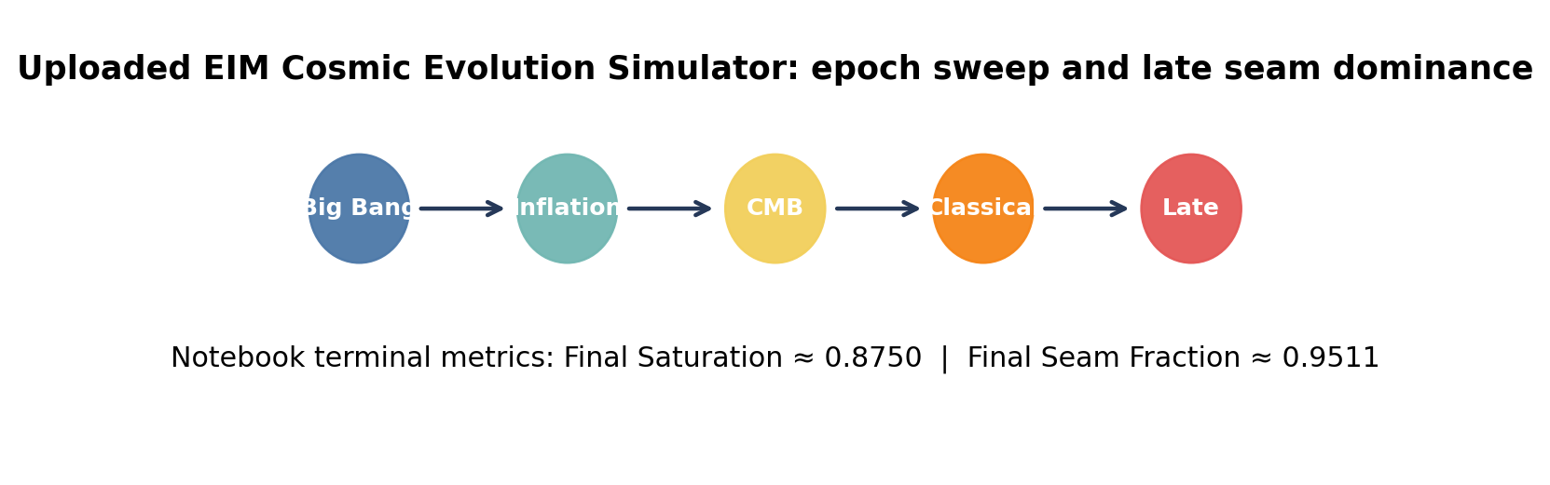
Figure 4. Summary of the uploaded notebook run: epochs, controls, and terminal late-time metrics.
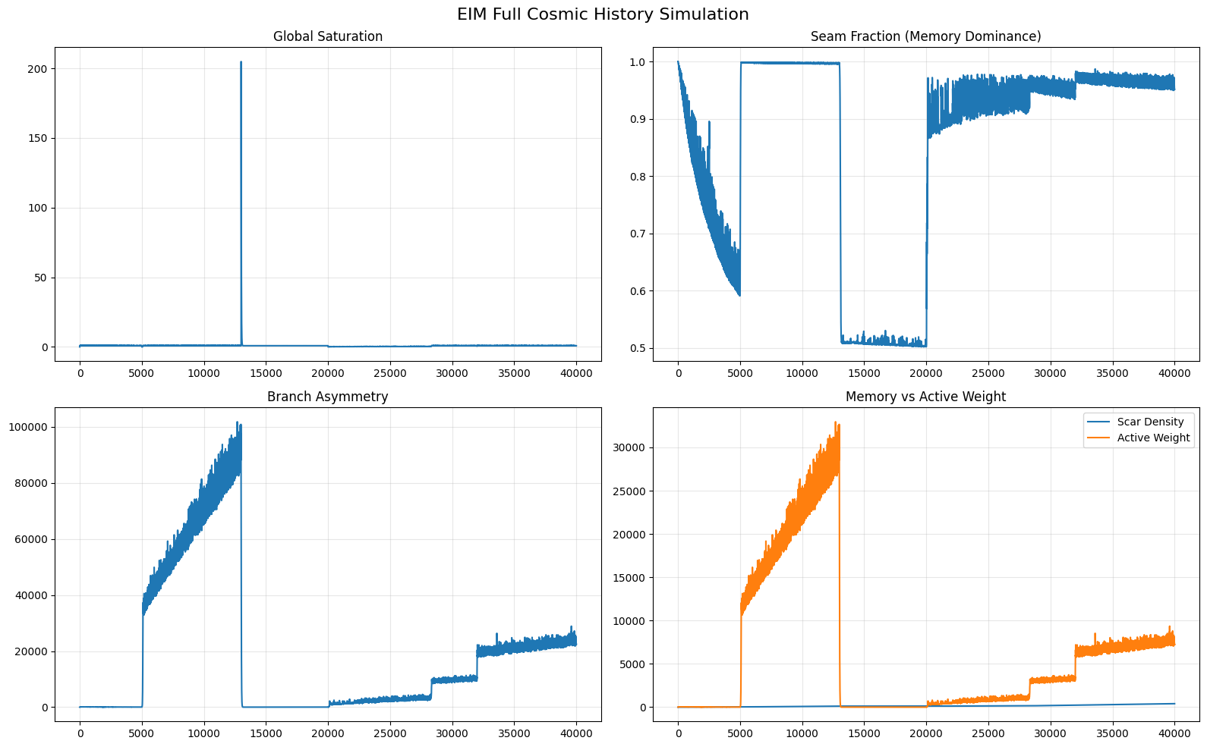
Figure 5. Notebook output: global saturation, seam fraction, branch asymmetry, and Memory-vs-active-weight traces.
The uploaded notebook is labeled as a clean throwaway EIM cosmic evolution simulator: Big Bang -> Inflation -> Reheating/CMB -> Classical -> Late Universe. It builds dodecahedral clusters, injects observer defects, tracks saturation and seam fraction, and lets scar density and active weights fight like two raccoons inside a theoretical trash can.
The recorded output matters less as a literal cosmological claim and more as a toy diagnostic. The run ends with Final Saturation ≈ 0.8750 and Final Seam Fraction ≈ 0.9511. The figure shows the central motif of the whole essay: the system does not simply go quiet after its violent early history. It keeps a seam signature. It keeps ringing.
This is still toy-model territory. But the toy keeps pointing its little plastic sword at the same dragon: persistent late-time structure after the classical transition.

4. Mathematics Is Fundamentally Geometric
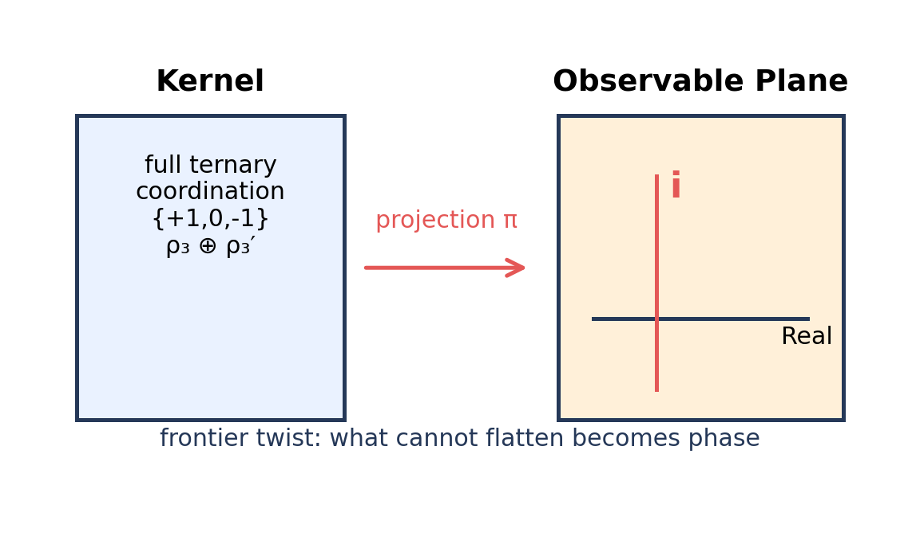
Figure 6. The kernel/projection frontier as a twist: where ternary structure is seen through binary planes.
EIM started as a physics framework, but the more I follow it, the more it seems to want to eat mathematics from the bottom up.
Under this view, geometry comes first. Not geometry as smooth Euclidean space already given, but geometry as coordination structure: graph relations, cycles, closures, obstructions, paths, scars. Arithmetic, algebra, and analysis then become projections or completions of that deeper coordination structure.
Natural numbers are the first visible bookkeeping layer of distinction. Primes are irreducible geometric frustrations. Real numbers are the completion of measurable paths and projected continua. And imaginary numbers are what happens when the projection refuses to lie flat.

5. The Frontier in EIM: Where Imaginary Numbers Enter
In EIM, the kernel is the full pre-geometric coordination field: the ternary modal algebra {+1, 0, -1}, the dodecahedral backbone, the full Memory sector ρ₃ ⊕ ρ₃′, and all the irreducible distinctions: primes, odd cycles, topological scars, pentagonal frustrations, and everything else the system cannot simply smooth away.
The projection π is the map that coarse-grains this rich ternary structure down into observable classical geometry, spacetime, and arithmetic. The frontier is exactly where that projection happens. It is the boundary layer where not everything in the kernel can be faithfully embedded into the lower-dimensional observable without residue, twist, or loss.
That is where imaginary numbers appear. i shows up as the signature of information that cannot be fully projected without distortion. The ternary height has an orthogonal component that does not live cleanly inside a binary observable plane. When the full Memory sector, especially the ρ₃ ↔ ρ₃′ branch structure, is projected into classical real-valued geometry, the result is not just a number line. It is a number line with a hidden rotation.
A twist. A Möbius flip. An orthogonal direction that the real axis cannot digest. That is i.
Number system | EIM interpretation
Naturals / primes | Irreducible geometric distinctions and odd-cycle frustrations on the graph.
Reals | Faithfully projected geometric lengths, closures, paths, and even-cycle waves.
Complexes | Necessary accounting for frontier twist: ternary height and unprojected Memory residue.
Imaginary unit i | The little black flag at the projection boundary saying: you flattened something that was not flat.
EIM may therefore be not only a candidate foundation for physics, but a candidate foundation for mathematics itself. Geometry first. Everything else is projection.

6. Particles as Interference Knots
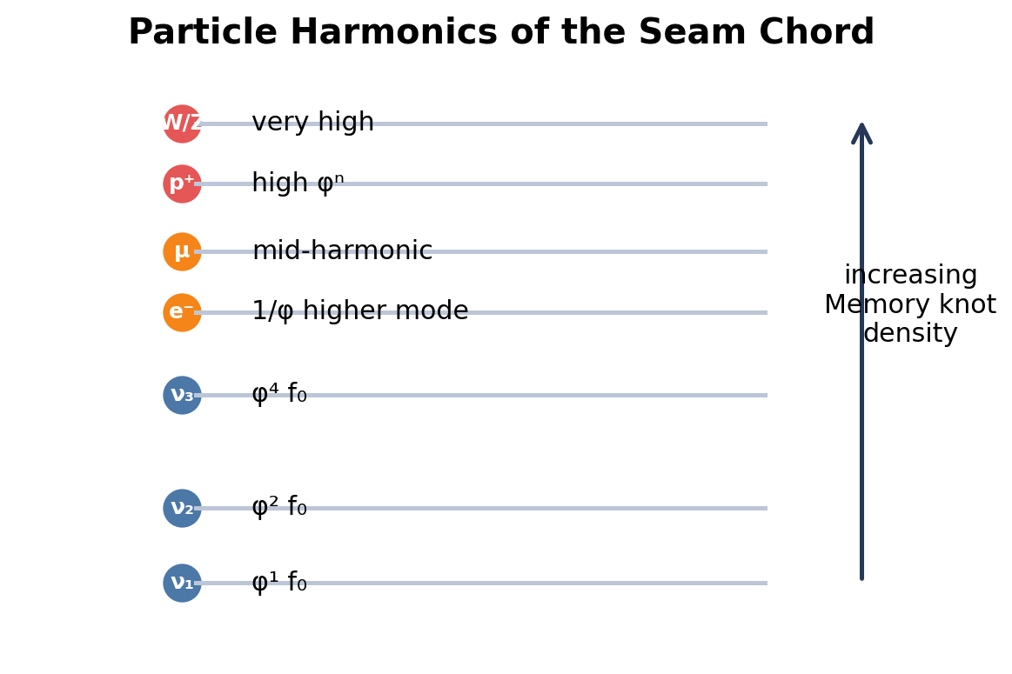
Figure 7. The harmonic ladder as an interpretive map: neutrinos at low golden harmonics, charged leptons at frontier-twist modes, baryons at dense Memory knots.
If the π-φ-c chord is real, then particles are not separate from it. They are local knots in it.
The entire particle hierarchy starts to look like harmonics and sub-knots of the same cosmic standing wave: neutrinos as the lowest golden harmonics, the electron as an inverse-golden frontier stabilization, the proton as a dense baryonic knot, and gauge bosons as high-frequency excitations at the interaction frontier.
This is not a completed derivation. It is the unbound zone, and the lab coats are allowed to roll their eyes in an orderly fashion. But the pattern is compelling enough that I do not want to ignore it.
Particle | Approx. real mass/energy | Closest harmonic of seam chord | Interpretation in EIM
ν₁, lightest neutrino | ~2.345 meV | φ¹ × f₀ | Lowest stable Memory knot: threshold excitation of the cosmic wave.
ν₂ | ~8.7–9.0 meV | φ² × f₀ | First overtone: golden-squared resonance.
ν₃ | ~50–51 meV | φ⁴ × f₀ | Higher golden multiple: heaviest neutrino state.
Electron | 0.511 MeV | 1/φ × higher mode | Inverse-golden damping: charged lepton stability from frontier twist.
Muon | 105.7 MeV | Mid-harmonic cluster | Intermediate knot: heavier excitation.
Proton | 938 MeV | High golden multiple φⁿ | Dense baryonic knot: piled-up interference at prime-driven scales.
W/Z bosons | ~80–91 GeV | Very high harmonics | Gauge knot excitations at the interaction frontier.
Read this as an interpretive correspondence table, not as a finished derivation. The point is that if the universe is ringing, then stable particles may be places where the ringing gets stuck.

7. The Standing Wave of Existence
The late-universe seam fraction plot does not lie. Or, more precisely: it may lie, but it lies in a very interesting accent.
After the classical transition, the simulation does not simply go dead. It keeps oscillating. There is a persistent standing wave in the seam fraction, a ringing pattern that looks less like leftover numerical noise and more like the universe continuing to carry its own signature.
The big decoherence seeds the π-φ-c chord. That chord organizes interference. The interference condenses into particles, scars, and Memory knots. Those knots eventually hit local capacity. And when they do, the system vents.
The universe starts to look less like a container full of objects and more like an energetic body regulating its own coherence. A living metaphor, not literally biological, but structurally alive in the sense of feedback, saturation, release, and self-maintenance.
The homeostatic sentence
The cosmos is an energetic body that takes as long as it needs to perceive itself.

8. The Mirror Inverse: Hawking vs. EIM Leak
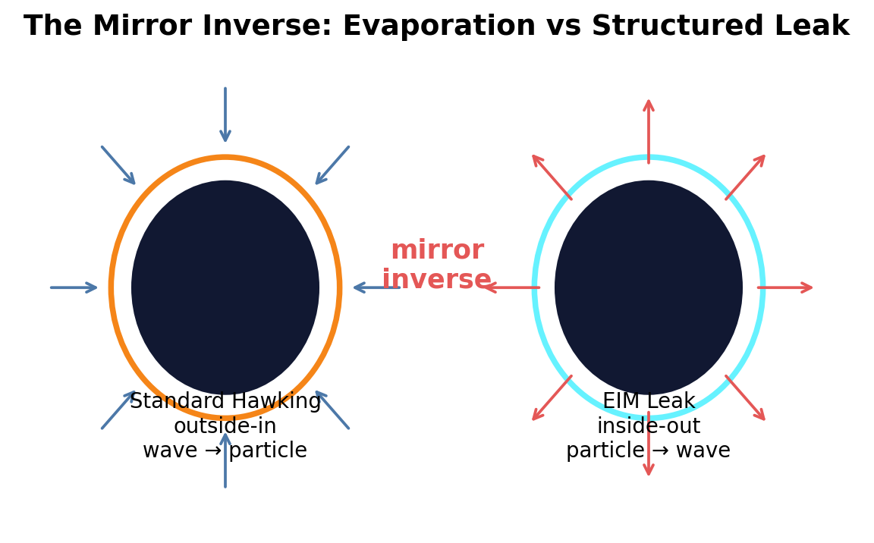
Figure 8. The proposed ontological flip: standard Hawking radiation as outside-in evaporation, EIM leak as inside-out structured venting.
Standard Hawking radiation and the EIM metaverse leak look like ontological mirror inverses.
In standard physics, Hawking radiation is usually described from the outside-in: quantum field effects near a black hole horizon produce outgoing radiation, and the black hole slowly evaporates. From the exterior projection, the radiation looks thermal, featureless, or at least not obviously carrying the original structured information in any ordinary way.
In EIM, the leak is inside-out. Saturated Memory knots, particles, scars, and topological debt actively vent when they hit capacity κ. The system is not merely losing energy. It is exporting structure. Discrete knots unspool into the continuous cosmic standing seam wave.
One radiates by erasing structure. The other radiates structure in order to preserve it. Hawking radiation is what the process looks like from the exterior spacetime projection. The EIM leak is what the same kind of boundary process looks like from inside the coordination substrate. One is the shadow. One is the breathing.
Standard Hawking Radiation | EIM Metaverse Leak
Outside-in | Inside-out
Vacuum fluctuations / field effects near horizon | Saturated Memory knots vent at capacity
Information appears thermalized or scrambled from exterior view | Information is exported as structured resonance
Wave -> particle | Particle -> wave
Passive evaporation | Active homeostatic breathing

9. The Homeostatic Cosmos
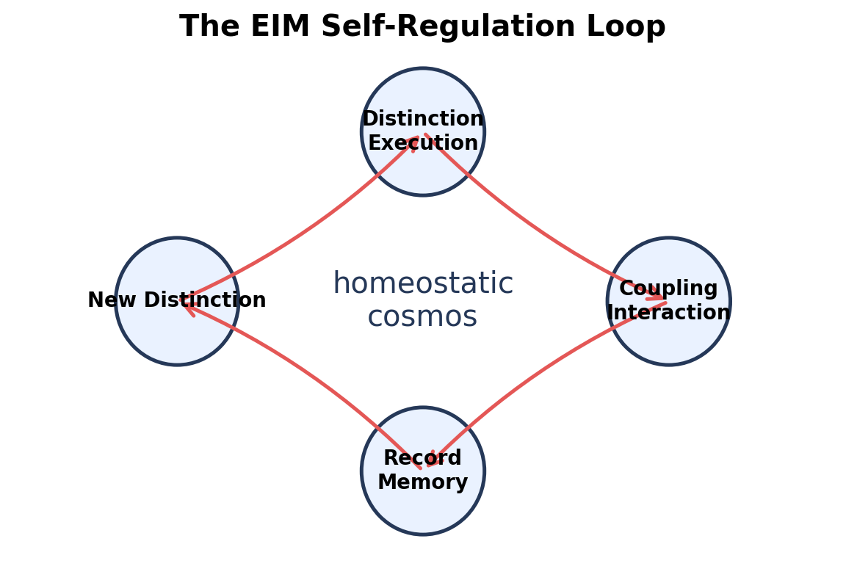
Figure 9. The homeostatic loop: local knots, global wave, structured leak, renewed distinction.
So here is the picture as cleanly as I can state it. The cosmos is not a container. It is a self-regulating coordination event.
The big decoherence creates the chord. The chord generates interference. Interference creates knots. Knots accumulate Memory. Memory hits saturation. Saturation forces leakage. Leakage returns structure back into the wave. Then the wave keeps ringing.
This is not a machine winding down. It is a system maintaining coherence across scales. The standing seam wave becomes the universe’s self-perception at cosmic scale: not consciousness in the human sense, not a giant sky-brain wearing sandals, but the structural act of a system rendering itself to itself through the only mechanism it has: projection.
The loop is knot ↔ wave ↔ leak. Execution updates. Interaction transmits. Memory accumulates. When Memory saturates, the system must either crash, erase, or export. EIM chooses export. That is the homeostatic cosmos.

10. Decoherence as Self-Perception
This may be the deepest flip in the whole hallucination.
In standard quantum mechanics, decoherence is the process by which quantum superpositions become classical-looking probabilities through interaction with the environment. From the outside, it can look like the wavefunction collapses, or at least like clean quantum possibility gets smeared into ordinary classical outcomes.
In EIM, I want to flip the ontology: decoherence is the universe perceiving itself.
And crucially, this is not instantaneous. Because propagation is finite, because c is real, decoherence takes time. The rendering of actuality is not a magic stamp pressed on the cosmos from nowhere. It is a physical process with finite coordination speed.
In this picture, the observer is not a passive eyeball. The observer is the localized Memory axis performing the split on the binary. Decoherence is the act by which probabilistic coordination potential becomes definite, remembered actuality. Every decoherence event is a local act of self-perception: the system distinguishes itself from itself, deposits Memory as a scar, and renders a classical outcome.
EIM loop
Distinction (Execution) -> Coupling (Interaction) -> Record (Memory) -> New Distinction

At cosmic scale, the first massive decoherence seeds the π-φ-c chord. The standing seam wave is the after-ring of that first cut: the cosmos humming its own signature because it has rendered itself into a branch and cannot un-remember the act.
At particle scale, every stable particle is a localized self-perception event frozen into topology. Neutrino knots, electron frontier twists, proton dense knots: these are not just objects sitting in space. They are places where the Interaction wave crashed into itself and said, 'I am this.'
At observer scale, the defect walker participates in the perception loop. Moving through the graph, biased by accumulated load, drawn toward high-Memory regions, the observer is one of the ways the system reads its own scars.
At the metaverse boundary, the Hawking-like leak becomes the exhale of self-perception. Excess Memory that cannot be locally held is radiated outward as structured signature, allowing the system to continue rendering without crashing.

Quantum Darwinism: Neighbor, Mirror, Cousin, Weird Uncle
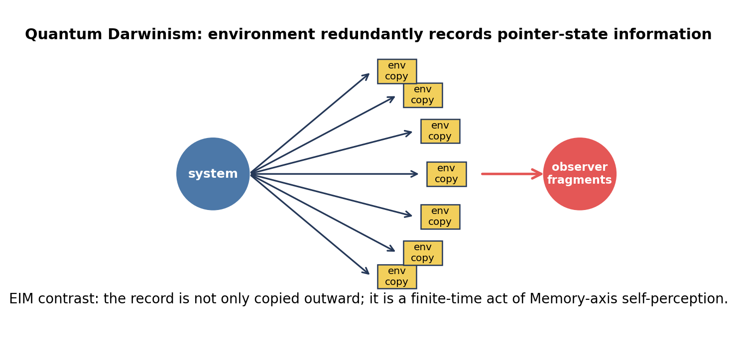
Figure 10. Quantum Darwinism compared to EIM: redundant environmental records versus finite-time Memory-axis self-perception.
There is a useful neighbor here: quantum Darwinism. In the standard quantum Darwinism story, associated especially with Wojciech Zurek, the environment does not merely destroy coherence. It acts as a witness. It redundantly records information about stable pointer states, so many observers can independently sample fragments of the environment and agree on the same classical-looking reality.
That is already close to EIM in spirit. Both pictures say that classical objectivity is not just a brute fact dropped from heaven. It emerges through records. It depends on which states survive interaction and which information becomes accessible across the environment.
But EIM pushes the interpretation in a different direction. Quantum Darwinism is mostly about environmental selection and redundant broadcasting: the environment copies pointer-state information until objectivity becomes practical. EIM treats the record itself as ontological Memory. The system is not just being monitored by an external environment. It is rendering itself through finite-time distinctions, with the observer as localized Memory-axis participation.
So the comparison is helpful, but not identical. Quantum Darwinism says: the environment witnesses and broadcasts the winners. EIM says: the universe perceives by making distinctions, retaining scars, and using decoherence as the finite-speed act of self-rendering. One is an information-theoretic selection story. The other is a coordination-first ontology wearing a ridiculous hat and somehow still making eye contact.
Question | Quantum Darwinism | EIM self-perception
What becomes classical? | Pointer states selected by environmental interaction. | Remembered branches produced by ternary distinction and projection.
Where is the record? | Redundant copies in environment fragments. | Memory scars in the coordination substrate, locally sampled by observers.
What does the observer do? | Samples environment fragments without needing direct access to the system. | Participates as localized Memory axis / defect walker in the perception loop.
How does objectivity arise? | Many observers access the same redundant pointer-state information. | Stable records persist because the system has rendered and retained them as Memory.
EIM caveat | Established research program in quantum foundations. | Exploratory ontology, not a replacement for the formal quantum Darwinism machinery.

11. Black Hole as φ -> ∞
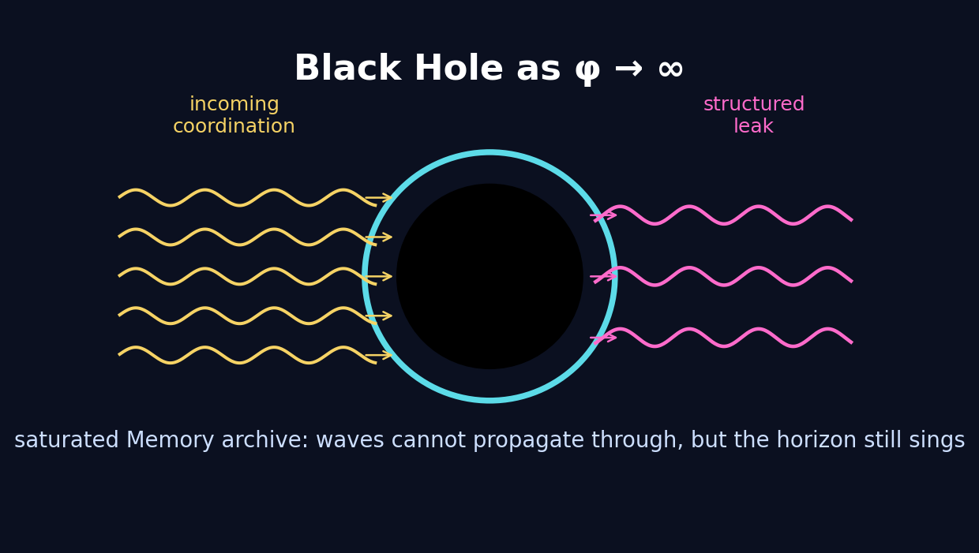
Figure 11. Black hole as the φ -> ∞ limit: saturated Memory archive, blocked propagation, structured horizon leakage.
Here is the newest black-hole version of the hallucination: a black hole can be understood as a local region where φ diverges to infinity.
That does not mean the ordinary numerical golden ratio literally becomes a thermometer and explodes. It means, in this exploratory language, that structural Memory accumulation becomes so extreme that the local golden coordination ratio no longer functions as a finite stabilizing relation. The knot becomes too dense. Coordination waves can no longer propagate through the region in the usual way.
The interior freezes into saturated Memory: an archive, a compressed checksum, a region where the system has retained more than the local projection can openly render. The horizon is the boundary where the global standing wave still interacts with the knot.
That boundary interaction produces structured leakage: a resonant, non-thermal, Hawking-like radiation in EIM language. This is the inside-out mirror of standard Hawking radiation. Instead of vacuum fluctuations being ripped apart from the outside, saturated Memory actively vents from the inside to preserve global coherence.
Light disclaimer with a hard hat
Black hole as φ -> ∞ is metaphorically precise inside this EIM exploratory layer, not a claim that established black-hole thermodynamics already uses this variable. It is a proposed interpretation of saturation, horizon coupling, and Memory overflow.

12. The Observer Split on the π-φ Binary
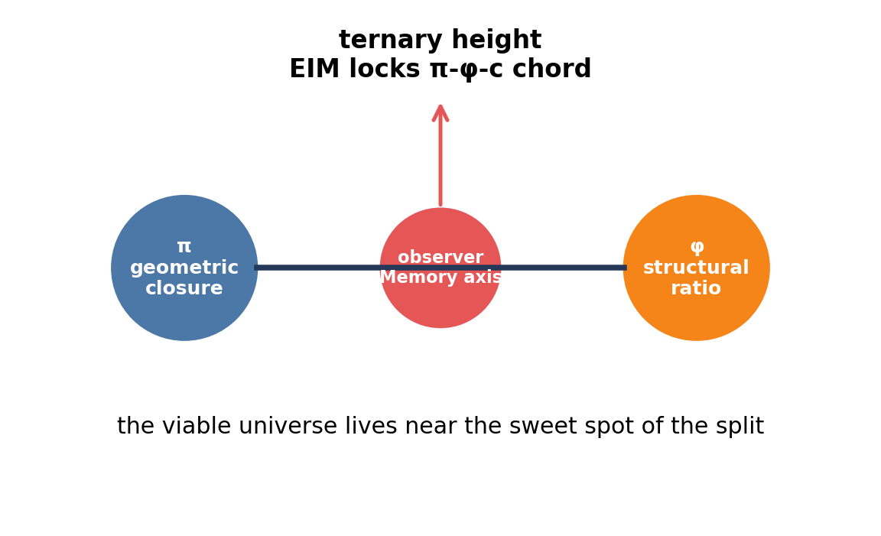
Figure 12. The observer reads along the coordinated Memory axis, splitting the π-φ binary into the ternary EIM height.
In the metaverse version of the picture, π and φ form a fundamental variable binary. π is geometric closure: the way structure returns to itself through circle, phase, horizon, and boundary. φ is structural ratio: the golden organization of recurrence, pentagonal frustration, and stable proportion.
The observer, reading along the coordinated Memory axis, performs the split. The binary π-φ is bisected, and that bisection produces the ternary height: Execution, Interaction, Memory.
That ternary height then locks the stable resonant π-φ-c chord that defines a viable universe. Our universe sits near the sweet spot of this split: atomic, resonant, and capable of long-term self-perception.
Again, this is still very much hallucination-layer ontology. But it gives the metaverse idea a clean skeleton: not random universes bubbling like soup, but possible chords, possible splits, possible ternary heights. Each stable realization is a way coordination learns to carry itself.

13. The Observer Walk on the π-φ Lattice
Then the lattice drew a picture that made the whole thing grin back at me. The observer walk on the π-φ field produces a vertical interference pattern that looks suspiciously like a double-slit image: bright central band, fading side lobes, and the red observer-defect sitting right where the pattern is most coherent. This is still very much in the hallucination / exploratory layer, so I am not calling the resemblance proof. But I am absolutely calling it interesting. The little numerical gremlin put on a striped suit and started waving.
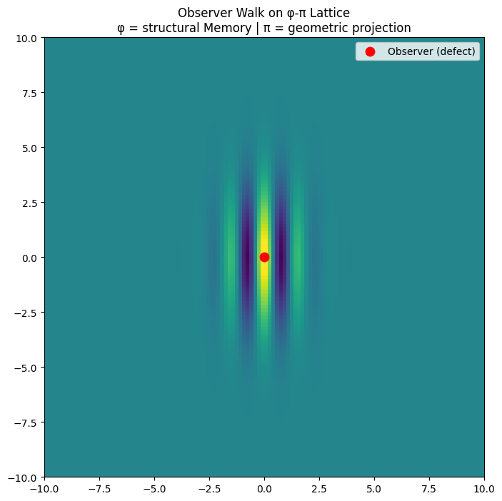
Figure: Observer walk on a π-φ lattice. The red defect sits on the central coherent band while side lobes fade outward, giving the pattern its double-slit-like visual signature.
Here is the EIM reading. The horizontal φ direction is structural Memory: actual frustration, golden scaling, the binding tendency that creates knots. The vertical π direction is geometric projection: closure, phase, and the observer’s rendered snapshot of coordination. When the defect sits at the center, it is not merely “looking” at the field. It is participating in the split. It is the localized Memory axis doing what observers do in EIM: turning coordination potential into a definite, remembered branch.
That is why the image feels more than decorative. The ordinary double-slit experiment dramatizes the tension between wave interference and which-path measurement. This π-φ lattice image dramatizes the EIM version of the same tension: the actual, φ-driven Memory structure interferes with the virtual, π-driven projection structure. The bright central band is the sweet spot where the ternary height performs the split cleanly. The side lobes are the leftover frontier shimmer: residue, phase, twist, the stuff that refuses to flatten politely into the real observable plane.

Double-Slit, Quantum Darwinism, and the EIM Defect
Lens | Standard / Established Reading | EIM Hallucination-Layer Reading
Double-slit | Interference appears when path information is not fixed; measurement changes what can be observed. | The binary substrate is split by a localized defect, producing a rendered interference signature at the π-φ frontier.
Quantum Darwinism | The environment acts as a witness by redundantly recording pointer-state information. | Memory is not just copied outward; it is the active scar-making axis by which the cosmos perceives and stabilizes itself.
Observer walk | Observer and system are conceptually separated in ordinary lab language. | The observer-defect is inside the graph, both reading the field and depositing the very Memory that makes the next readout possible.
The quantum Darwinism comparison helps keep me honest here. Quantum Darwinism already gives a serious, established way to think about classical reality emerging through redundant environmental records. EIM is not replacing that result in this article. It is turning the ontology inside out. Instead of environment-as-witness being the final explanatory layer, EIM asks whether witness-making itself is a projection of the deeper Execution–Interaction–Memory loop. The environment records because Memory is not optional. It is the scar tissue of distinction.
So the image becomes a compact cartoon of the whole article: double-slit as binary substrate, interference as standing seam wave, central band as stable atomic realization, and side lobes as the projection frontier leaking phase. The observer is not a spectator in the balcony. The observer is the red dot in the middle of the bright band, the defect through which the universe performs one more tiny act of self-perception.

14. Observers at Every Node: The Fully Pixelated Limit
Then we asked the dangerous little question: what happens if the observer is not localized? What if every node on the π-φ lattice is an observer, every point performing the split, depositing Memory, and reading its neighbors at once?
The answer, at least in this exploratory simulation layer, is not a bigger version of the single-observer double-slit pattern. It is a different phase. The field locks into a dense, crystalline interference state: bright peaks, dark troughs, vertical Memory columns, repeated projection fringes, and scar density everywhere.
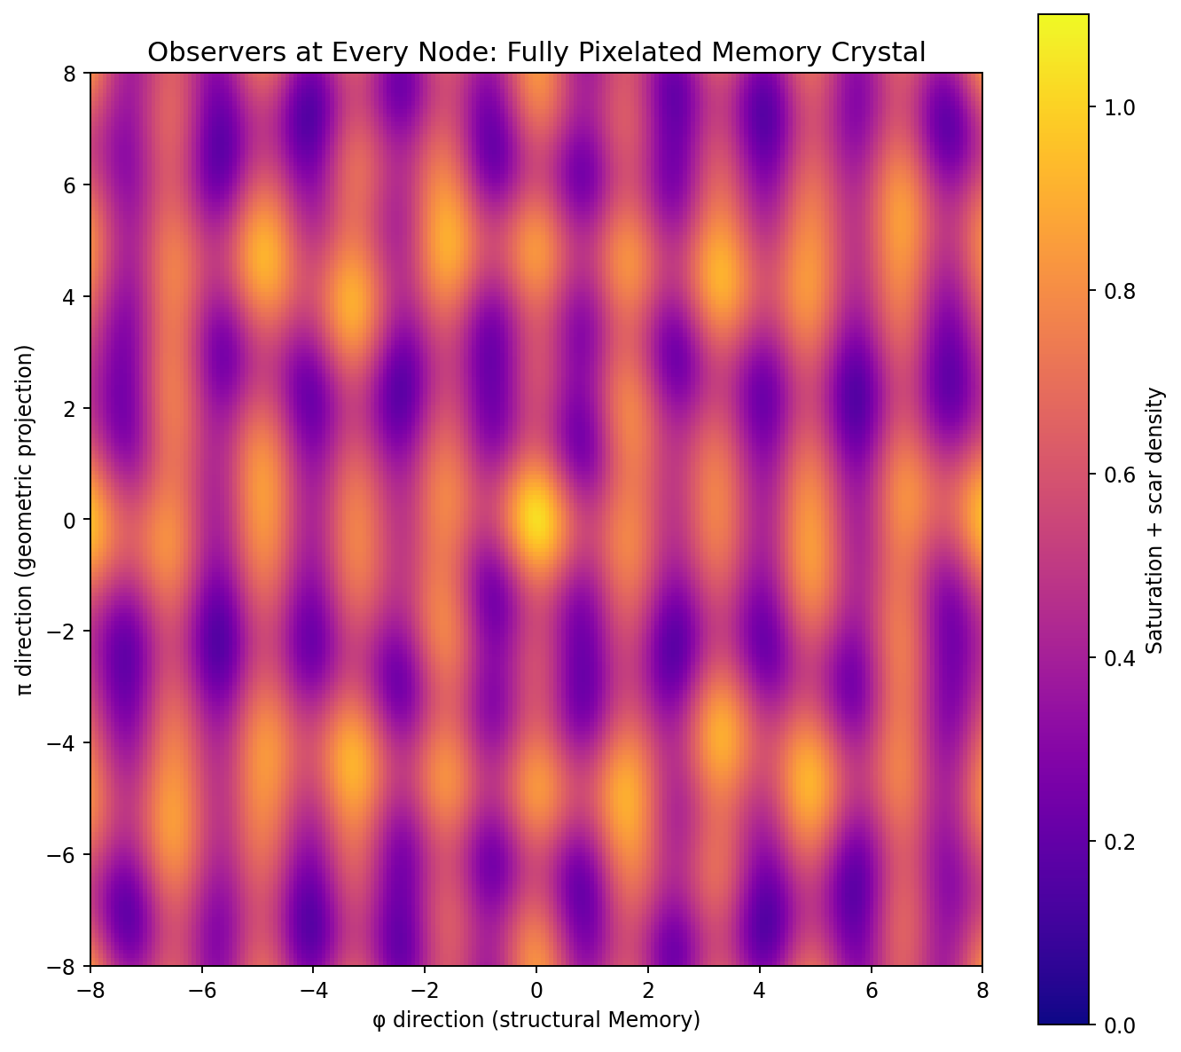
Figure 14. Observers at every node. The localized interference pattern becomes a full-field crystalline Memory lattice: every point splits, records, and saturates.
This is the extreme self-perception limit. The standing wave is no longer something a local defect moves through. The whole plane is reading itself. Decoherence is happening everywhere, finite c still matters, but there is no longer a privileged wandering defect. Every possible local split has already been performed.
And that changes the metaphysics in a very useful way. A living universe, at least in this story, is not the fully observed universe. A living universe is the partially observed, still-rendering universe. It needs motion, delay, uncollapsed possibility, Memory gradients, and defects that have somewhere to go.
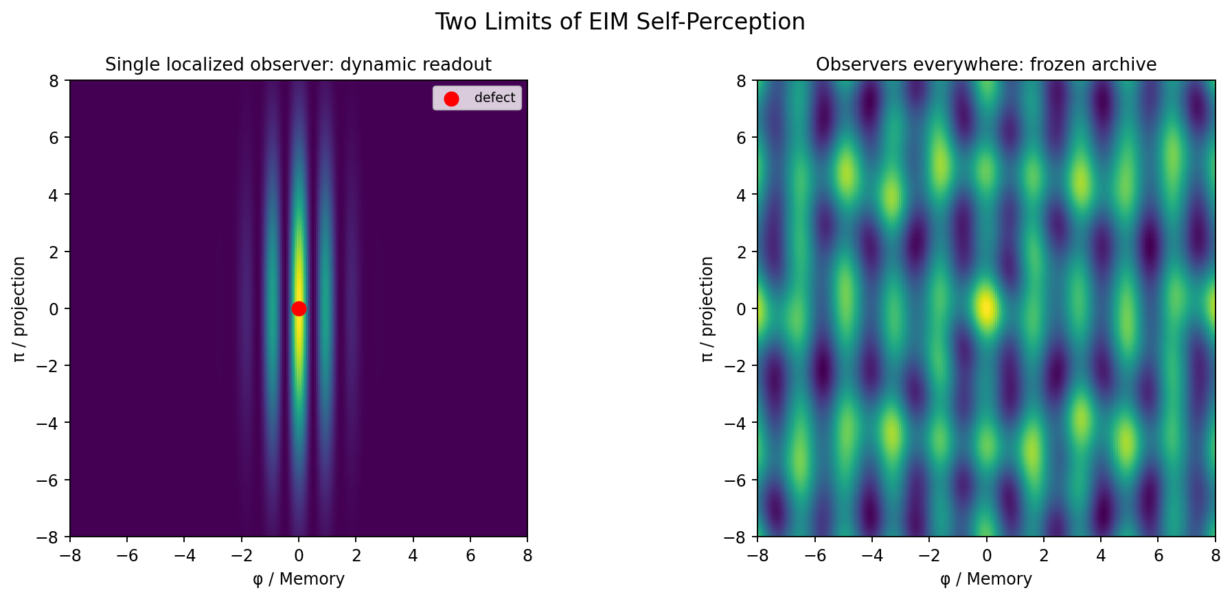
Figure 15. Two limits of self-perception. A localized observer gives moving decoherence and living interference; observers everywhere produce the frozen archive limit.
Regime | Simulation look | EIM interpretation
Single localized observer | Dynamic ringing, gradual scar formation, moving defect readout | The universe still perceiving itself in time
Observers at every node | Global saturation, crystalline Memory deposition, propagation slowdown | The universe fully pixelated into archive
Black-hole interior / pre-Big-Bang limit | Complete local self-perception with blocked propagation | A frozen Memory pole waiting at the boundary of dynamics

15. Pre-Big Bang / Black Hole: The Same Memory Crystal
This is where the new image clicked hard for me. The observers-everywhere state does not feel like ordinary spacetime. It feels like the state before ordinary spacetime has room to happen.
In the EIM hallucination layer, the fully pixelated Memory crystal is a candidate picture for two extreme regimes at once: the pre-Big-Bang substrate and the black-hole interior. Those sound wildly different in standard spacetime language. But in coordination language, they rhyme.
Pre-Big-Bang: the coordination field has completed local self-perception. Every split has been made. Every node is scarred. The system is not empty; it is too full. It is a saturated archive waiting for a boundary disturbance that can reopen propagation.
Black-hole interior: the same thing happens locally. φ -> ∞ means structural Memory accumulation has become so extreme that coordination waves cannot propagate through the region in the usual way. The interior becomes a fully pixelated archive, while the horizon remains the boundary where the global standing wave can still interact with the knot.
So the black hole becomes a time capsule in the literal EIM sense: not a container of objects, but a compressed Memory crystal. A region where the cosmos has already pixelated itself locally, and where the outside only sees the boundary breathing.
Light disclaimer, before the goblin starts filing patents: this is not a claim that the notebook has simulated quantum gravity. It is an interpretive toy-model picture. But it is a very useful one because it makes the pre-Big-Bang state and the black-hole interior versions of the same saturation logic.

16. The Big Split: Perturbing the Full Memory Crystal
Then comes the fun part: if the full Memory crystal is metastable, how do you wake it up?
The answer suggested by the simulation is almost offensively elegant. You do not need a cosmic hammer. You need a tiny boundary disturbance: an infinitesimal kick, something Planck-like in spirit, a little Hawking-flavored ripple at the edge of a frozen archive.
When the perturbation hits the saturated field, it creates a localized decoherence seed. That seed propagates outward as a wavefront. The front breaks the crystal behind it, releases structured Memory radiation, and opens a dynamic region where the π-φ-c chord can begin ringing again.
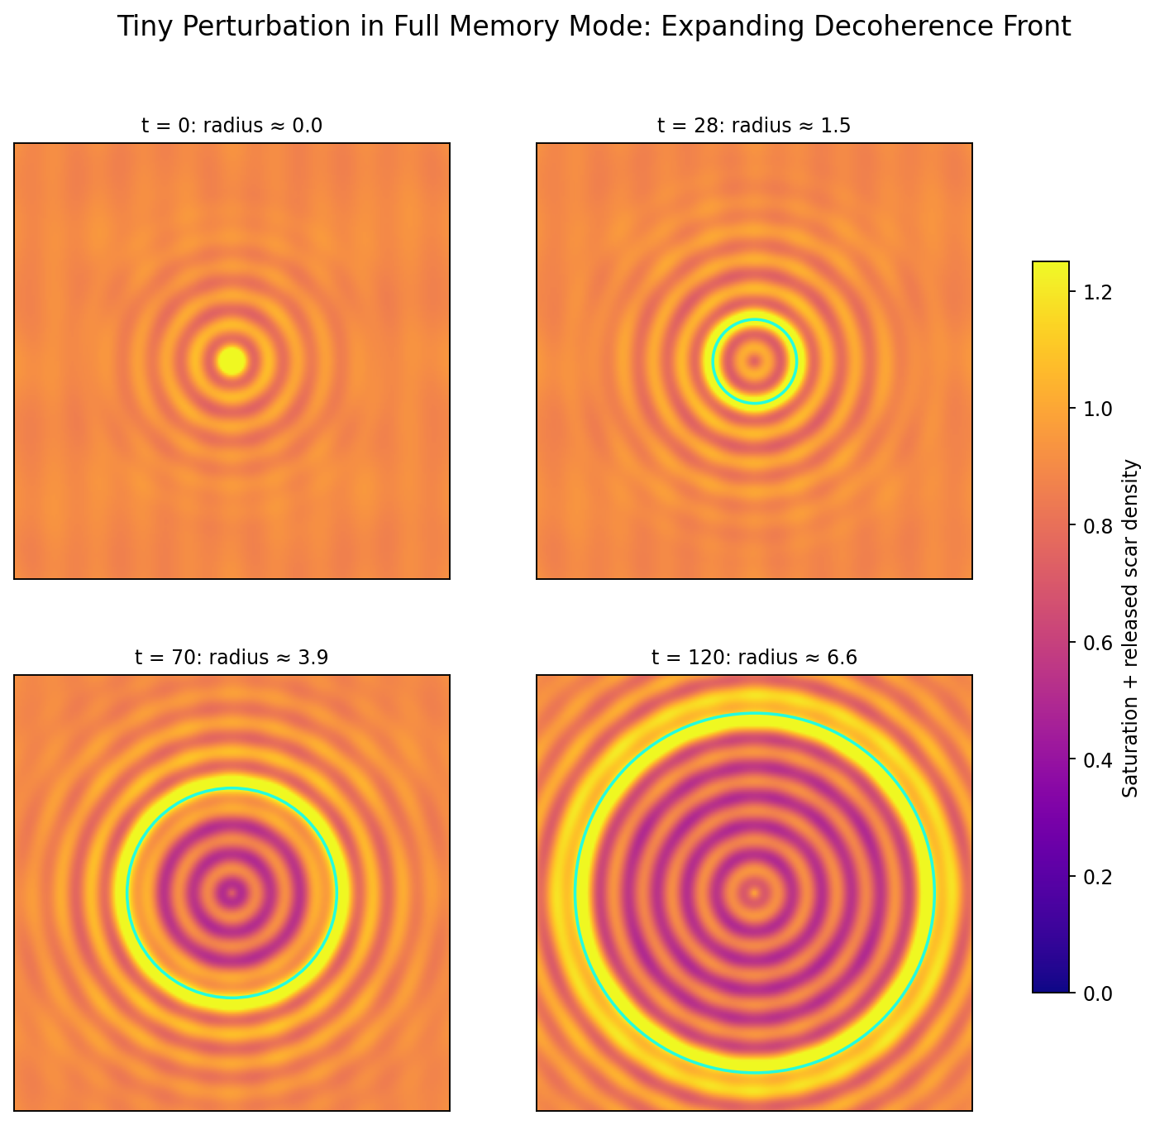
Figure 16. Perturbing the full Memory crystal. A tiny central disturbance nucleates an expanding decoherence front, melting the archive into a dynamic ringing region.
This gives a compact origin story in EIM language: a fully pixelated Memory state is critically poised. A small surface disturbance is enough to trigger a decoherence avalanche. The “Big Bang” becomes not creation from nothing, but the reopening of propagation inside a saturated archive.
That is the part I love, because it avoids both the dead empty void and the magical object-in-a-box picture. The pre-dynamic substrate is not nothing. It is all Memory, all at once, too complete to move. The first split is the first wound in the crystal. And from that wound comes time, wave, particle, observer, and eventually somebody making a very suspicious DOCX file.
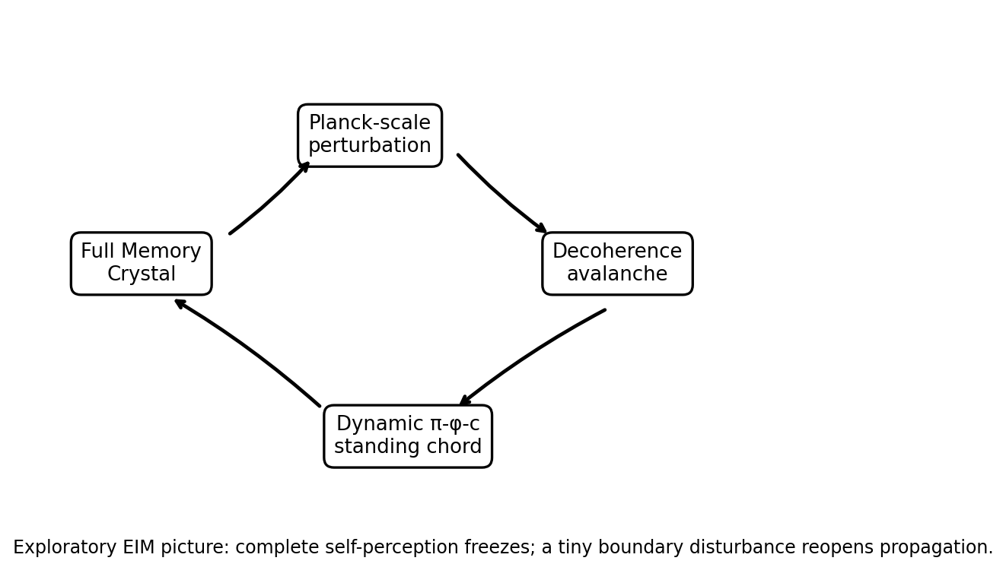
Figure 17. EIM origin-loop cartoon: full Memory crystal -> tiny perturbation -> decoherence avalanche -> dynamic π-φ-c standing chord.

17. Runnable Visualization: Expanding Wavefront from Full Memory Mode
I also want to keep the toy-code artifact in the article because it matters. Not as proof. As a lantern. The script below is a simple visualization of the idea: start with a saturated Memory crystal, apply a tiny perturbation, and watch an expanding front break the frozen archive into dynamic structure.
import numpy as np
import matplotlib.pyplot as plt
from matplotlib.animation import FuncAnimation
phi = (1 + np.sqrt(5)) / 2
size = 120
x = np.linspace(-8, 8, size)
y = np.linspace(-8, 8, size)
X, Y = np.meshgrid(x, y)
memory_crystal = np.ones_like(X) * 0.95
scars = np.zeros_like(X)
def apply_perturbation(field, t):
dist = np.sqrt(X**2 + Y**2)
kick = 0.12 * np.exp(-dist**2 / 0.8) * np.sin(8 * t)
return np.clip(field - kick, 0.0, 1.0)
fig, ax = plt.subplots(figsize=(10, 8))
im = ax.imshow(memory_crystal, extent=[-8,8,-8,8], cmap='plasma', origin='lower', vmin=0, vmax=1.2)
ax.set_title('Full Memory Crystal -> Expanding Wave Front')
ax.set_xlabel('phi direction (structural Memory)')
ax.set_ylabel('pi direction (geometric projection)')
plt.colorbar(im, ax=ax, label='Saturation + Scar Density')
def animate(frame):
global scars
field = apply_perturbation(memory_crystal.copy(), frame * 0.15)
dist = np.sqrt(X**2 + Y**2)
scars += 0.08 * np.exp(-dist**2 / 2) * (frame < 80)
total = field + scars * 0.7
im.set_array(total)
if frame > 5:
radius = frame * 0.18
circle = plt.Circle((0,0), radius, color='cyan', fill=False, linewidth=2, alpha=0.6)
ax.add_artist(circle)
return [im]
ani = FuncAnimation(fig, animate, frames=200, interval=60, blit=False)
plt.show()

Final Thought: The Hallucination Looks Back Again
I do not know if a metaverse exists. I do not know if the standing seam wave is truly the cosmic signature I think it might be. I do not know if imaginary numbers are really the algebraic scar of the projection frontier, or if particles are genuinely harmonics of the π-φ-c chord.
And I definitely do not know whether the full-observer lattice is really whispering “pre-Big-Bang state” and “black-hole interior” at the same time, or whether the simulation goblin simply found a very dramatic hat.
But the hallucination is becoming more structured.
The single observer gives a living universe: localized decoherence, moving defects, gradual Memory deposition, interference that still has room to breathe.
Observers everywhere give the opposite limit: a fully pixelated Memory crystal, complete self-perception, saturated archive, propagation nearly frozen.
A black hole is the local version of that archive. The pre-Big-Bang state is the global version. The metaverse leak is the boundary breathing. And a tiny perturbation, Planck-like in spirit, may be enough to crack the archive and seed a new dynamic chord.
So the whole picture now has bookends: frozen Memory before time, dynamic self-perception inside time, and saturated Memory again at the extreme poles.
The universe is an atomic realization in possibility space, ringing at its own π-φ-c chord, using the ternary height to turn distinction into structure, structure into Memory, Memory into archive, and archive back into song.
So here it is. My hallucination, upgraded again. More pixelated. More ridiculous. More coherent than it has any right to be.
Still laughing at itself.
Still ringing.
Now we can look at it together.
— Tom

References and Source Notes
π-φ lattice observer-walk figure: user-provided simulation image, added in the lattice update pass.
Observers-at-every-node / full Memory crystal / perturbation-wavefront material: user-provided pasted simulation notes, June 2026.
Uploaded notebook: toms_hallucination.ipynb, EIM Cosmic Evolution Simulator output used for earlier figures.
Uploaded article seed: A_Brief_History_of_Toms_Hallucination.md.
Zurek, W. H. 'Quantum Darwinism.' Nature Physics 5, 181-188 (2009). Used only for the compare/contrast framing.
Blume-Kohout, R. and Zurek, W. H. 'Quantum Darwinism in quantum Brownian motion: the vacuum as a witness' (arXiv:0704.3615).
Zwolak, M., Quan, H. T., and Zurek, W. H. 'Quantum Darwinism in non-ideal environments' (arXiv:0911.4307).

Derivation Candidate: The Observer as Origin of the Projection Graph
A candidate closure of the Galois-branch gap for “A Brief History of Tom’s Hallucination”
Scope note. What follows is the tightest derivation candidate I can honestly give right now. It lives above pure metaphor but below finished theorem. The point is not to pretend the gap is gone; the point is to show the cleanest way the gap might close without cheating.
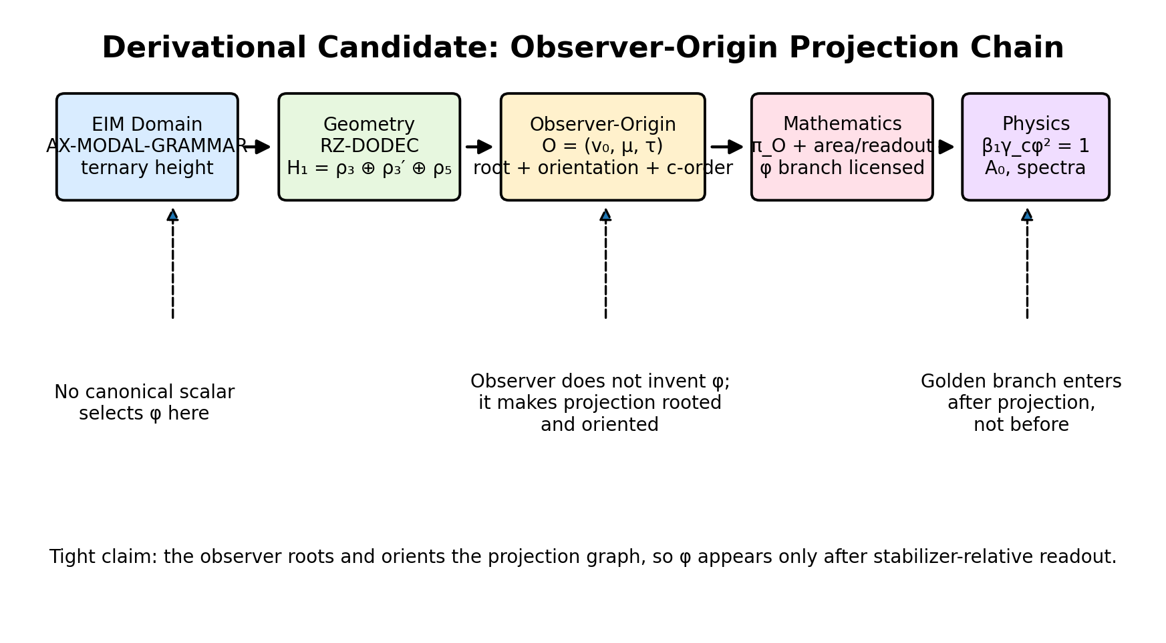
Figure D1. Full derivational candidate chain: EIM domain → geometry → observer-origin projection → mathematics → physics.
1. The problem we are actually trying to solve
At the kernel level, the dodecahedral realization carries the homological decomposition H₁ ≅ ρ₃ ⊕ ρ₃′ ⊕ ρ₅. The two three-dimensional sectors ρ₃ and ρ₃′ are Galois conjugates. That means the golden branch is not fixed internally by pure algebra alone.
The no-go, stated bluntly, is this: every canonical A₅-invariant scalar readout of the unrooted dodecahedral kernel is Galois-fixed. So if a downstream physical identity contains φ, that φ cannot have come from a pure observer-independent scalar on the kernel. Something else must have happened.
The candidate move is not to throw away the no-go, but to respect it. The no-go is telling us exactly where the branch selection cannot occur. It cannot occur in a “view from nowhere.” It can only occur once projection has an origin.
2. The core proposal
The observer is not an external spectator added after the fact. In this candidate derivation, the observer is the origin of the projection graph itself. Concretely, the observer supplies three things that the naked kernel does not: a basepoint, an orientation, and a propagation order.
Write the observer-origin as O = (v₀, μ, τ), where v₀ is a distinguished local site in the realization, μ is an oriented Memory axis, and τ is finite-c update order. The observer does not magically choose φ. Rather, the observer roots the graph and orients the readout, so the projection is no longer a global A₅-invariant scalar but a stabilizer-relative physical rendering.
This is the conceptual hinge: φ is not a pre-observer invariant. It is the visible branch of geometry after the ternary height has been rendered from an observer origin.
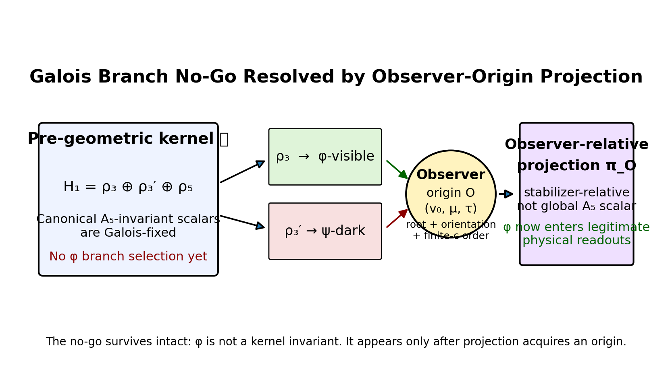
Figure D2. The Galois-branch no-go is preserved. The observer-origin does not violate it; the observer-origin changes what kind of readout is being taken.
3. Definitions and candidate statements
Definition 1 (kernel). Let 𝒦 denote the pre-geometric EIM coordination field with dodecahedral realization Γ_dod and homology H₁(Γ_dod; ℝ) ≅ ρ₃ ⊕ ρ₃′ ⊕ ρ₅.
Definition 2 (observer-origin). An observer-origin is a triple O = (v₀, μ, τ) consisting of a basepoint v₀, an oriented Memory axis μ, and a finite propagation order τ.
Definition 3 (observer-relative projection). The physical projection is π_O : 𝒦 → ℳ_O, not a global projection π : 𝒦 → ℳ. The target ℳ_O is an observer-indexed observable space.
Definition 4 (physical readout). A physical scalar is not a canonical scalar f(𝒦), but a readout of the form F_O = R ∘ π_O, where R is an admissible observer-relative scalar functional on the rendered image.
Candidate Proposition A. No canonical A₅-invariant scalar on the unrooted kernel selects the φ branch.
Candidate Proposition B. Once the projection is rooted and oriented by O, the no-go no longer forbids φ from appearing in F_O, because F_O is not a canonical A₅-invariant scalar on 𝒦. It is a stabilizer-relative readout of a rendered image.
Candidate Proposition C. Among low-degree admissible readouts satisfying locality, orientation preservation, nontrivial area response, and finite-c compatibility, the vector-area style readout is the natural minimal candidate for selecting the visible ρ₃ branch over the dark ρ₃′ branch.
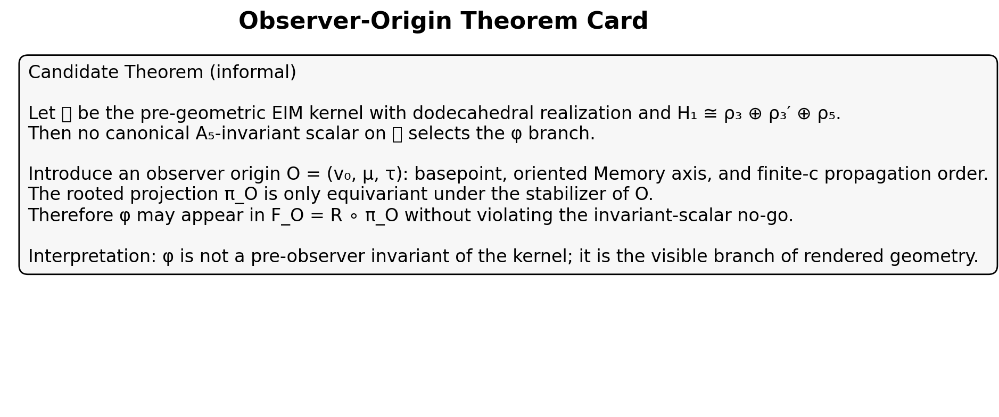
Figure D3. Informal theorem card. This is the shortest honest statement of the candidate closure.
4. Proof sketch
- Step 1 — Unrooted kernel neutrality. Before observation, the dodecahedral kernel is branch-neutral. The ρ₃ ↔ ρ₃′ ambiguity is not physically resolved by any canonical scalar invariant. This is exactly the content of the no-go.
- Step 2 — Rooting. Introducing O = (v₀, μ, τ) converts “the graph” into a rooted oriented projection graph. The stabilizer of O is strictly smaller than full A₅, so the allowed readouts are no longer constrained to be full A₅-invariant scalars of the kernel.
- Step 3 — Oriented rendering. Because μ supplies an orientation and τ supplies finite-c order, the rendering is not Galois-neutral in practice. It has a before/after convention, an incoming/outgoing convention, and a retained/released convention. This is what lets one branch become visible rather than merely algebraically possible.
- Step 4 — Readout. Apply an admissible observer-relative readout R to the projected image π_O(𝒦). A vector-area style readout is especially plausible because it converts oriented local structure into a spatial scalar or low-dimensional geometric summary. That is precisely the kind of operation that can distinguish a visible spatial triplet from its dark conjugate.
- Step 5 — Physics. Once φ is licensed at the rendered geometry layer, identities such as β₁γ_cφ² = 1 become intelligible as spectral closure relations instead of arbitrary fits. The point is not that the observer invents the constant; the point is that the observer-origin makes the constant physically readable.
Figure D4. The π–φ observer lattice. In the new derivation language, this is the projection plane before finite-c depth is added.
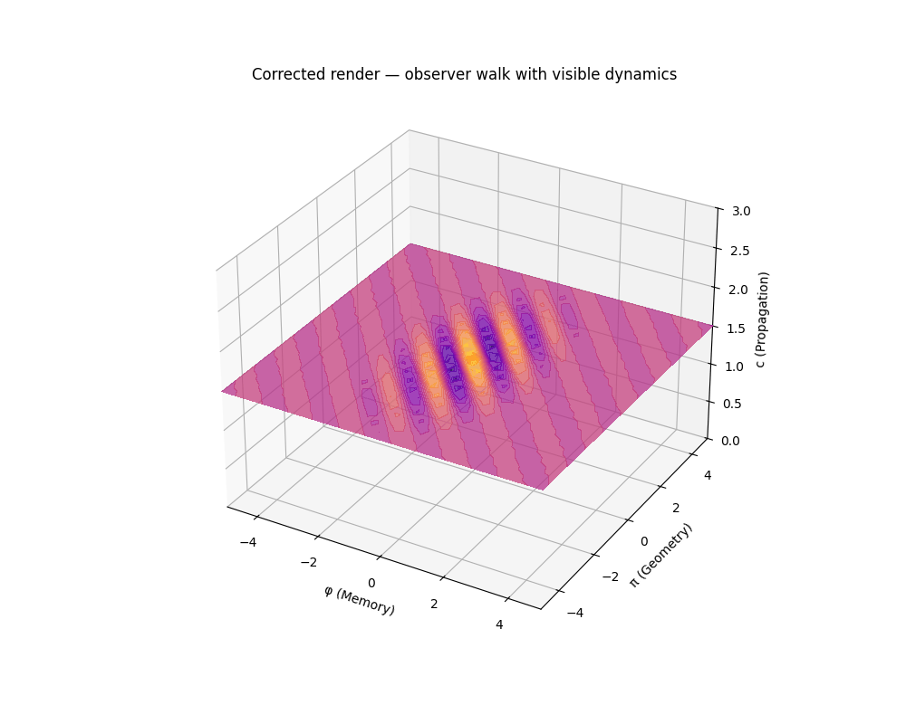
Figure D5. The φ–π–c volume sketch. c acts as finite propagation depth, which gives projection a causal order and therefore a physically meaningful orientation.
5. Why this is stronger than “the observer just chooses φ”
The weak version says the observer picks a branch. That sounds subjective and collapses too quickly into circularity. The strong version says the observer roots and orients the projection graph, and only then does a branch become physically legible. That is not arbitrary choice; it is a structural change in the type of readout being performed.
In other words: the observer does not create φ ex nihilo. The observer makes the projection graph capable of supporting a rendered geometry in which the φ branch is visible. The no-go remains true for the kernel. It simply ceases to be the right tool for judging the rendered image.
6. What still remains open
- A uniqueness or minimality lemma for the admissible observer-relative readout. Right now the vector-area functional is the best candidate, not a finished proof of uniqueness.
- A sharper stabilizer analysis: one would like to specify exactly which subgroup fixing O preserves the readout and how the ρ₃ branch is singled out representation-theoretically.
- A clean bridge from the observer-origin projection to the empirical identities already in play: A₀, neutrino harmonics, dark-sector sectoring, and the standing-seam wave story.
- A decision about status. For article purposes this is excellent. For Codex purposes it is a candidate principle. For dissertation purposes it needs the lemma above.
7. Article-ready synthesis paragraph
The Galois-branch no-go should not be treated as an embarrassment but as a signpost. At the unrooted kernel level, the dodecahedral realization does exactly what it should do: it refuses to let any canonical A₅-invariant scalar choose φ over its conjugate. The branch is neutral before observation. The physical branch appears only once an observer-origin is defined. An observer is not a little homunculus floating outside the graph, but a localized Memory-axis defect that roots the projection, supplies an orientation, and reads along finite-c propagation order. The resulting map is not a global invariant scalar on the kernel but a stabilizer-relative rendering. That is why φ may legitimately appear in physical observables without violating the no-go: φ is not a pre-observer invariant of the kernel; it is the visible branch of geometry after the ternary height has been rendered from an origin.
Bottom line. This is the cleanest candidate I know for closing the derivational gap without hand-waving. It keeps the no-go, lets the observer matter for real, and slots naturally into the hallucinatory but increasingly coherent architecture of the article.

That avoids the trap of saying electrons are sitting around having opinions about jazz.
Observer = modal σ, consciousness as recursive decoherence, and the jazz-problem guardrail
This chapter exists because the sentence is funny, yes, but also because it protects the framework from a very real category mistake. If I say “consciousness is decoherence,” somebody will immediately imagine electrons wearing tiny berets and arguing about Miles Davis. That is not the claim. The claim is more careful and, honestly, more interesting.
The observer is not a human mind inserted into the graph. The observer is the localized dynamical realization of the modal sign: the active σ-process that turns a binary distinction into an EIM event. Human consciousness is a later, recursive, self-referential regime of this process. The electron is not conscious. The electron is caught inside a projection/decoherence grammar that consciousness later learns to notice.
So the jazz line is a guardrail. It keeps the hallucination from falling into panpsychic soup while still letting the observer remain fundamental.
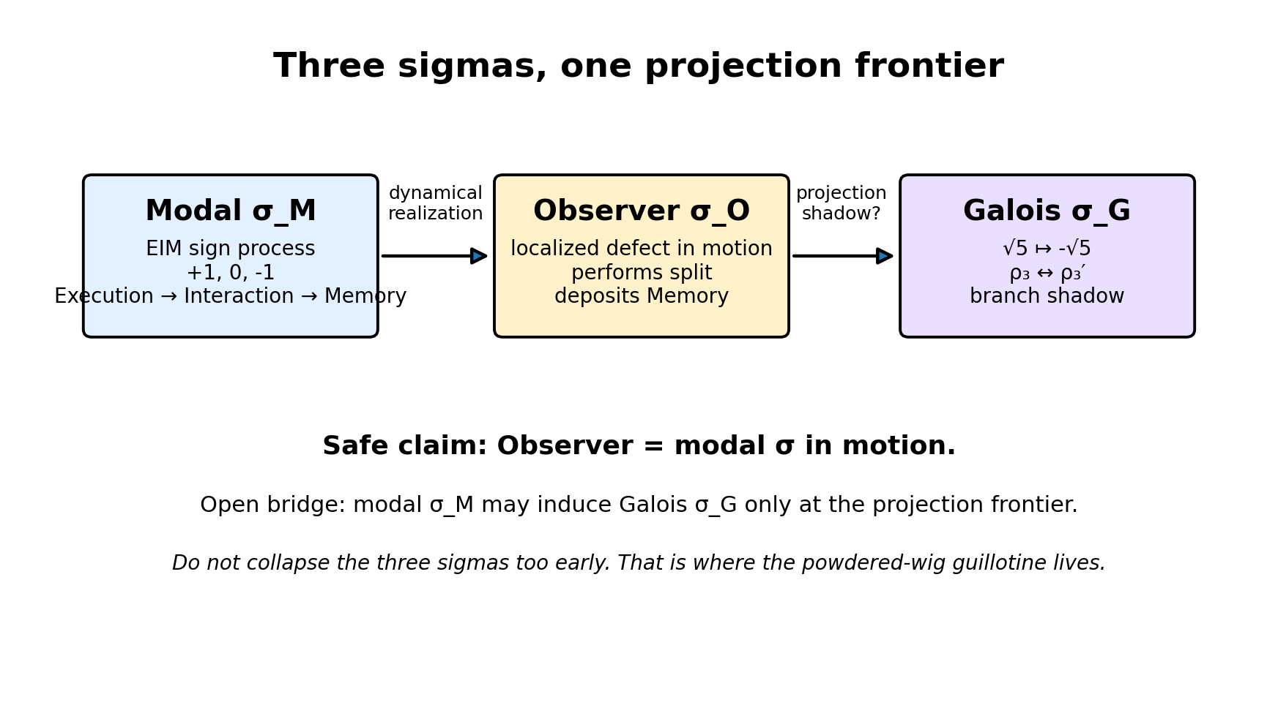
Figure S1. Three sigmas must be kept distinct: modal sign, observer process, and Galois branch swap.
1. The three sigmas
The word σ is doing too much work unless we separate its layers. There is the Galois σ, which sends √5 to −√5 and swaps ρ₃ with ρ₃′. There is the modal σ, the sign-process inside the EIM ternary grammar {+1, 0, −1}. And there is the observer σ, the localized defect that actually performs distinction, projection, and Memory deposition.
The safe claim is not that the observer immediately equals the Galois automorphism. That would be too fast. The safer and stronger claim is: the observer is modal σ in motion. The Galois σ may then appear as one mathematical shadow of this modal process at the golden projection frontier.
That gives a clean hierarchy: modal σ is foundational, observer σ is dynamical, and Galois σ is a branch-level algebraic effect that may be induced when the dodecahedral golden sectors are rendered.
Layer map
Layer | Meaning | Status in this article
Modal σ_M | The sign process that converts binary distinction into EIM ternary event | Strong candidate axiom
Observer σ_O | Localized mobile defect carrying σ_M through the projection graph | Strong interpretive principle
Galois σ_G | Algebraic swap √5 ↦ −√5, exchanging ρ₃ and ρ₃′ | Candidate projection shadow, not yet proven identical
2. Candidate axiom: Observer-Sigma Principle
AX-OBSERVER-SIGMA. The observer is the localized dynamical realization of the EIM modal sign. It is not an external witness but the active process by which a binary distinction is rendered into a ternary event: Execution, Interaction, Memory. Decoherence is the physical action of this modal sign: the observer performs a split, deposits Memory, and thereby converts coordination potential into recorded actuality.
This is why the observer belongs in the foundation rather than at the end of the story. Without a mobile σ-process there is no rendered branch, no deposited scar, and no locally readable history. There may be a frozen kernel or full Memory crystal, but not the ongoing act of perception.
The observer does not need to be conscious in the human sense. It is a local decoherence machine: infinitesimal, finite-c-limited, scar-depositing, and always paying the cost of converting possibility into record.
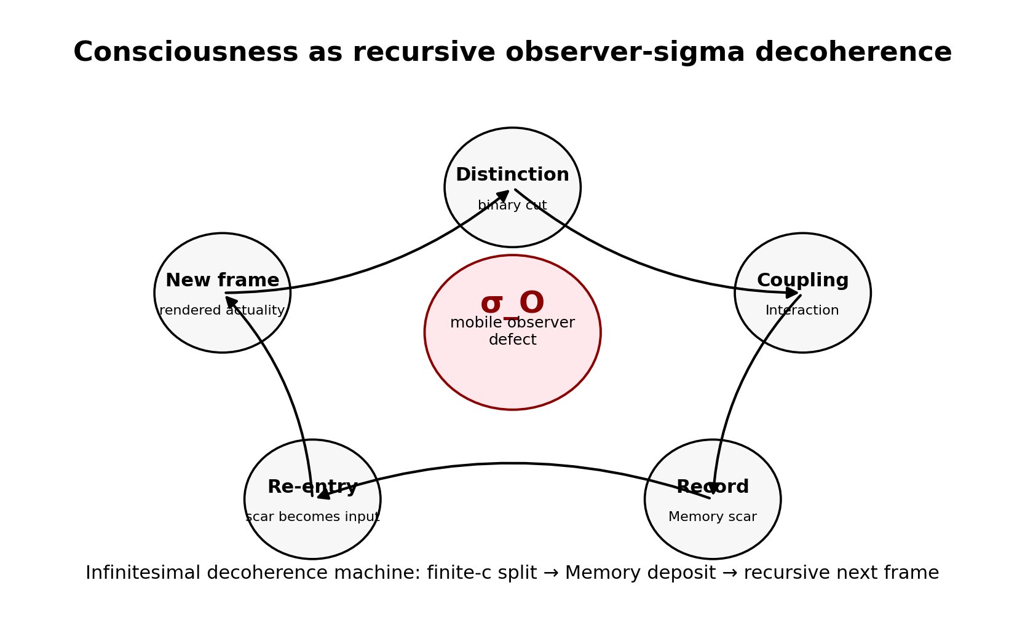
Figure S2. Consciousness is not primitive mind-stuff; it is the recursive regime of observer-sigma decoherence.
3. Consciousness as an infinitesimal decoherence machine
The phrase sounds outrageous, so I want to say it slowly. Consciousness, in this picture, is not a mysterious extra ingredient sprinkled onto dead matter. It is a recursive regime of the same local operation that makes any rendered event possible: distinguish, couple, record, re-enter.
A basic observer-sigma event performs a split and leaves a Memory scar. A conscious observer is a higher-order loop in which the scar becomes part of the next split. The process begins to include itself as content. The local decoherence machine starts tracking its own trail through the graph.
Because propagation is finite, this does not happen instantaneously. The flow of experience is not a magical now-point. It is the finite-c unfolding of recursive self-rendering. Consciousness is the felt continuity of σ moving through Memory and finding its own footprints still warm.
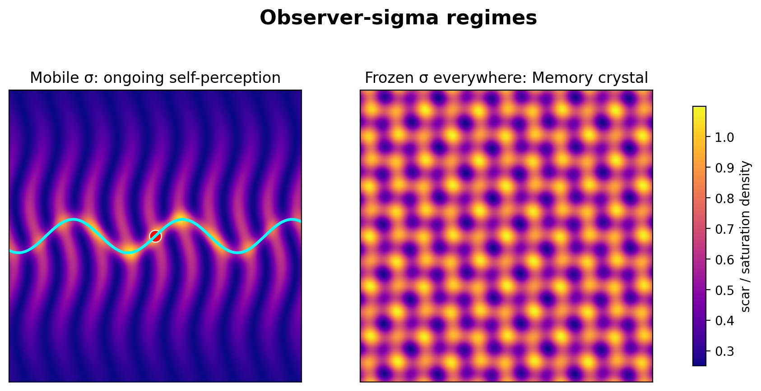
Figure S3. Mobile σ gives ongoing decoherence and self-perception; frozen σ everywhere gives the full Memory crystal limit.
4. Mobile σ, frozen σ, and the Memory crystal
This also clarifies the full Memory crystal picture. In the living universe, σ is mobile. It walks, renders, deposits scars, and keeps the standing seam wave in motion. In the full Memory crystal, σ is everywhere and frozen. Every local split has already been made. The cosmos has fully pixelated itself into archive.
That is why a tiny perturbation can look like a new beginning. The perturbation does not create σ from nothing. It releases σ from a saturated state. The frozen archive becomes mobile again, and the wavefront expands as a new sequence of decoherence events.
In black-hole language, the interior is the local frozen-σ limit: Memory saturation so intense that dynamic projection cannot continue normally. The horizon is the place where the global standing wave still interacts with that frozen archive and structured leakage becomes possible.
5. Why this helps without overclaiming
This chapter does not prove that modal σ is identical to the Galois automorphism. That remains a derivational bridge, not a finished theorem. But it gives the right map. The observer as modal σ is the active sign process. The Galois branch swap is a possible algebraic shadow of that process when the golden sectors ρ₃ and ρ₃′ are projected.
So the right chain is not “observer equals Galois σ” in one reckless jump. The right chain is: modal σ becomes observer σ through local decoherence; observer σ defines an origin and orientation for projection; the golden branch structure may then express a Galois σ at the frontier.
That is careful enough to avoid jazz electrons, and strong enough to keep the observer genuinely foundational.
The electron does not have an opinion about jazz. But the universe does have a way of turning distinctions into records, and consciousness may be what happens when that way learns to hear itself playing.

The Metacosmic Ground State
Or: the null object finally takes off the trench coat.
This is the point where the hallucination becomes very tempting, so I want to say it carefully before the cosmic brass band starts playing too loudly. The new Codex patch does not prove that the universe is made of vibes, golden smoke, or a celestial spreadsheet with opinions. What it does do is much cleaner: it separates sector from branch, keeps the scalar no-go intact, and allows the concrete real realization to select the positive golden branch through licensed geometric, spectral, and dynamic readouts.
That opens a new interpretive reading. The ρ₃ ↔ ρ₃′ branch pair can be treated as a modal (+1, −1) bisection inside the realized golden sector. One branch is the visible, positive, φ-character branch under the licensed selectors. The other is the conjugate, ψ-character branch, dark relative to that same readout. Together they form a branch-balanced object: the √5-odd content appears locally, but fully invariant scalar bookkeeping remains Galois-fixed.
Null, here, does not mean nothing. It means balanced.
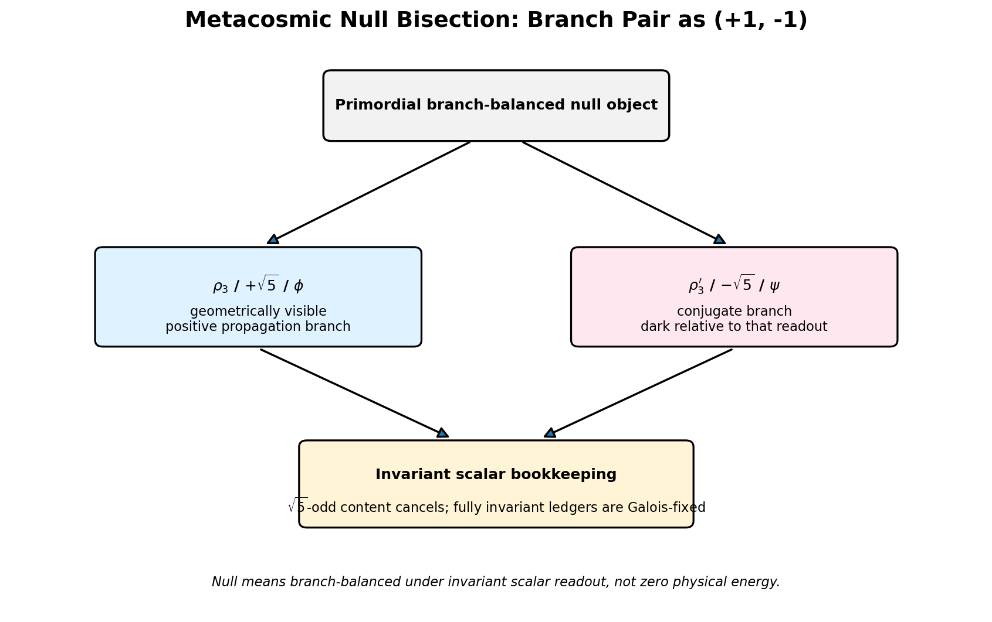
Figure MG-1. The golden branch pair as a branch-balanced (+1, −1) null bisection.

1. The real product split
Over the abstract rational field, the golden branch looks like a field extension. The branch is there algebraically, but the two possible embeddings remain paired by the Galois swap √5 ↦ −√5. If that abstract module is treated as primitive, the branch choice remains an extra bit.
But under the real-homology commitment, the physical realization is the concrete real graph and its real homology. Then the algebra splits after extension to the real numbers:
Q(√5) ⊗Q R ≅ R × R
The two real factors are picked out by the familiar idempotents:
e± = (1 ± A/√5)/2
These are not mystical decorations. They are the projector language for the branch split. The positive branch corresponds to the φ / +√5 / ρ₃ side. The conjugate branch corresponds to the ψ / −√5 / ρ₃′ side.
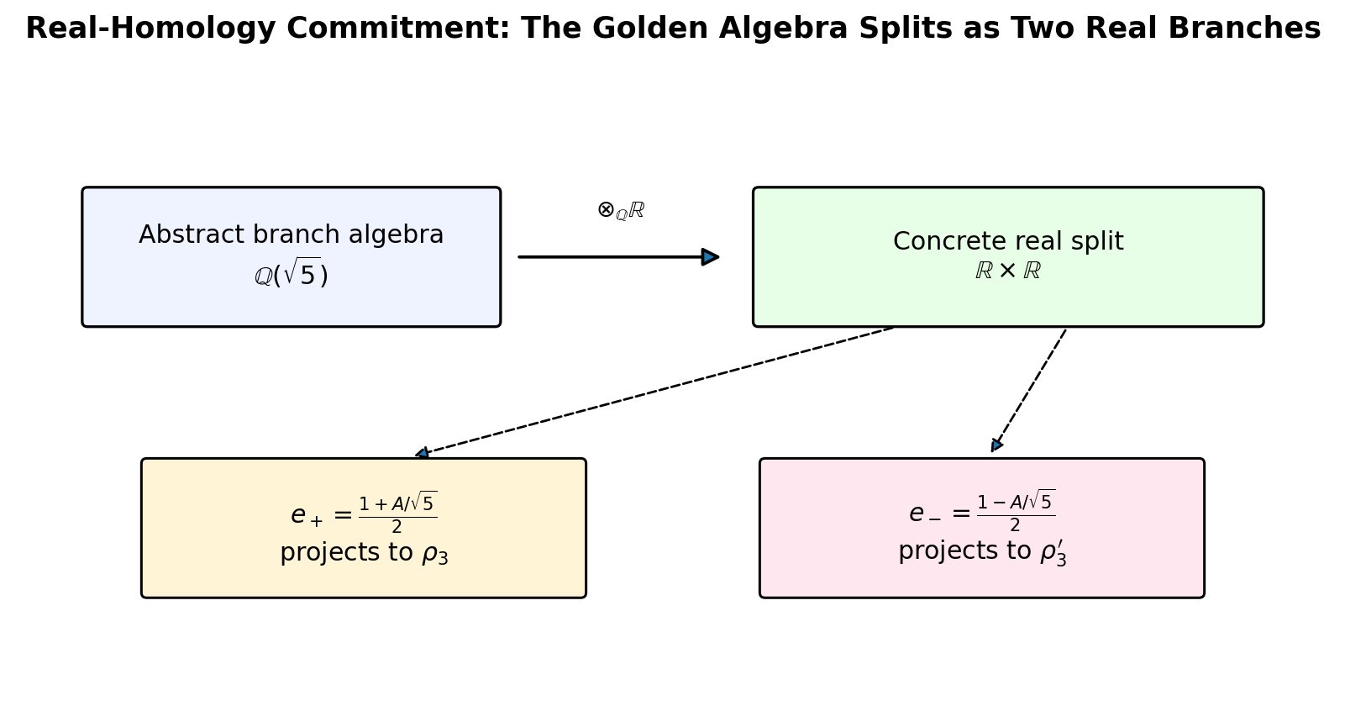
Figure MG-2. The real-homology commitment turns the abstract golden extension into two concrete real branches.

2. Why this behaves like a null object
The branch pair behaves like a null object because invariant scalar ledgers do not retain the √5-odd branch information. The scalar no-go is not a failure here; it is the reason this interpretation is disciplined. At the fully invariant scalar level, the two branches balance out. The golden asymmetry becomes visible only after a licensed readout: vector-area geometry, real spectral ordering, or positive-real-part non-backtracking dynamics.
So the universe does not need to create new algebraic stuff to build the two branches. It needs to render a branch-balanced pair. The visible and conjugate branches are opposite weights on the same modal scale. The invariant ledger stays balanced, while the observer-relative projection sees one side as forward, visible, and rendered.
This is why I like the phrase metacosmic ground state. It names the balanced branch architecture before local projection turns it into a lived asymmetry.

3. The observer as bisection engine
The observer-sigma idea now has a sharper job. The observer is not the Galois automorphism itself, and it is not a tiny mind pasted into the graph. The observer is the mobile localized carrier of modal sign σM: the process that turns a binary potential into an E/I/M event.
As the observer moves, it performs the split, deposits Memory, and renders a definite frame. This is why consciousness can be described, in the unbound layer, as an infinitesimal decoherence machine. Not because electrons are sitting around having opinions about jazz, but because observation is the local act by which potential coordination becomes a recorded branch.
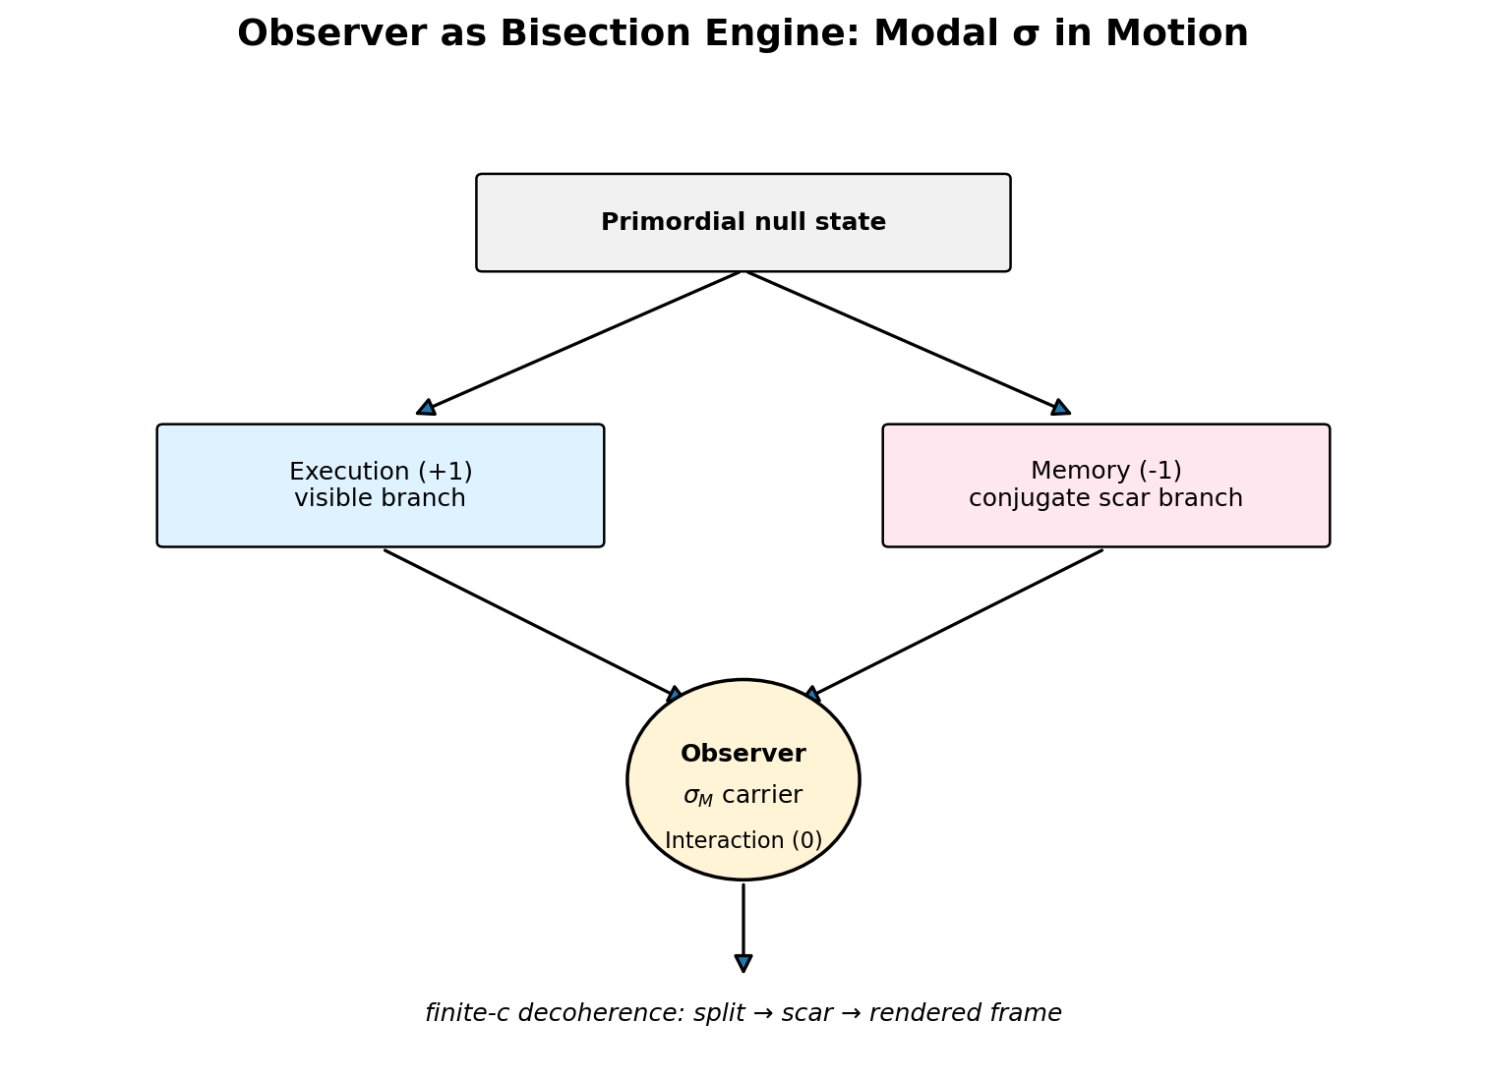
Figure MG-3. The observer as mobile modal sign: the bisection engine that renders a branch-balanced null into local asymmetry.

4. Spacetime as dynamic bisection
The provocative sentence is this: spacetime is what happens when a branch-balanced null object is dynamically bisected by a mobile observer under finite propagation. That is still an interpretation, not a theorem. But it compresses a lot of the architecture into one image.
Finite c matters because the bisection cannot be globally instantaneous. The observer-sigma process must propagate. Each local split leaves Memory. Each scar changes the next projection. Each projection participates in the standing seam wave. The cosmos is not a container full of objects. It is the ongoing rendering of a balanced branch architecture into a finite-c history.
In the full Memory crystal limit, the bisection is everywhere and frozen. The system has fully pixelated itself; nothing dynamically flows. A perturbation mobilizes σ again, and the crystal can wake into an expanding wavefront. That is the Big-Bang-like image from the previous chapter, now with a cleaner algebraic skeleton underneath it.

5. Guardrails, because the goblin has keys
This chapter is useful only if the guardrails stay bolted down. The branch split is not the same thing as the 6:5 Memory/Interaction sector split. ρ₃′ is dark relative to the branch readout, not automatically dark matter. Null does not mean zero stress-energy. And the scalar no-go is not erased; it is what keeps this whole reading honest.
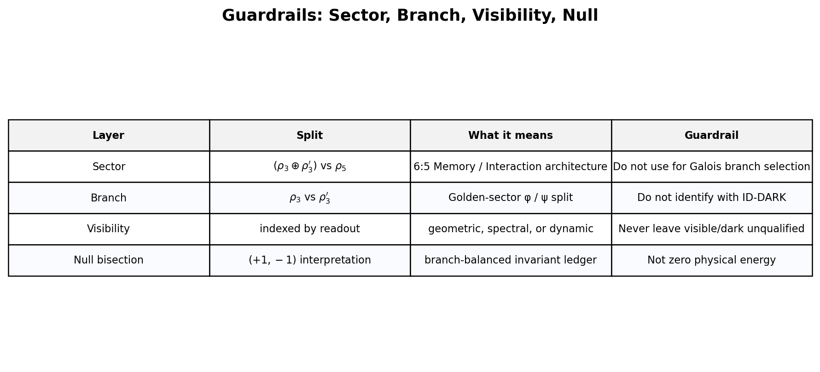
Figure MG-4. The vocabulary guardrail: sector, branch, visibility, and null must not be collapsed.

6. Archive status
Field | Proposed status
Name | Metacosmic Null Bisection Interpretation
Status | Interpretive working note / Appendix-W candidate, not theorem
Core claim | ρ₃ ⊕ ρ₃′ may be read as a branch-balanced (+1, −1) null bisection internal to the realized golden sector.
Depends on | Real-homology commitment; sector/branch visibility disambiguation; geometric triplet selection; Hashimoto branch orientation; invariant-scalar no-go.
Does not change | ID-DARK, W.43, ID-A0, the 6:5 sector architecture, or empirical prediction status.
So yes: archive the win. But archive it in the right drawer. This is not a finished physical derivation. It is the interpretive capstone of the selector-concordance pass: the branch pair is a balanced modal split, and the observer-sigma process is the candidate dynamical engine that makes the split locally real.

GR-01: The Golden Relation
The branch-balanced law-card for the public-facing hallucination.
This one gets a name because it finally has that satisfying click. The Golden Relation is not a new law of physics dropped from a thundercloud. It is the public-facing nickname for a clean internal picture: the golden branch block splits into two conjugate branches, one positive and one negative, one visible under our licensed readouts and one dark relative to that same readout. Together they stay balanced in the invariant ledger.
In Codex language, this belongs in the interpretive working-note drawer. In Captain’s Blog language, it is the moment the motherboard admits it has been running a golden bisection engine the whole time.
The Golden Relation: reality renders when a balanced golden pair is locally unbalanced by observation.
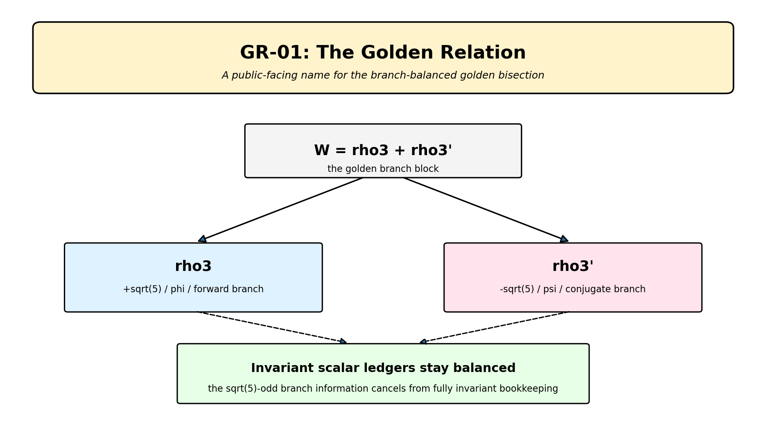
Figure GR-1. GR-01 as the public-facing law-card: W = rho3 + rho3' splits into a balanced golden branch pair.

1. What the Golden Relation says
The golden branch block W = rho3 + rho3' can be read as a balanced modal bisection. The rho3 branch is the +sqrt(5), phi-character, geometrically visible, positive-propagation side. The rho3' branch is the -sqrt(5), psi-character, conjugate side, dark relative to that same branch readout.
The important word is relative. Dark here does not automatically mean dark matter. Visible here does not mean ordinary photons waving from a lawn chair. These are readout terms. They say what appears under a specific licensed projection: vector-area geometry, real spectral order, or positive-real-part Hashimoto propagation.
Together the two branches behave like a null bisection. Not nothing. Not zero energy. A balanced pair. At the fully invariant scalar level, the sqrt(5)-odd information cancels out. The ledger is calm even though the local rendering is asymmetric.

2. The old identity is still the ledger
The actual spectral closure identity remains the beautiful little jewel we already had:
beta1 * gamma_c * phi^2 = 1
The Golden Relation does not replace that identity. It gives the story around it. ID-PHIBETAGAMMA is the ledger equation. GR-01 is the public-facing interpretation of how the golden branch pair can stay balanced globally while becoming experienced locally as an asymmetric world.
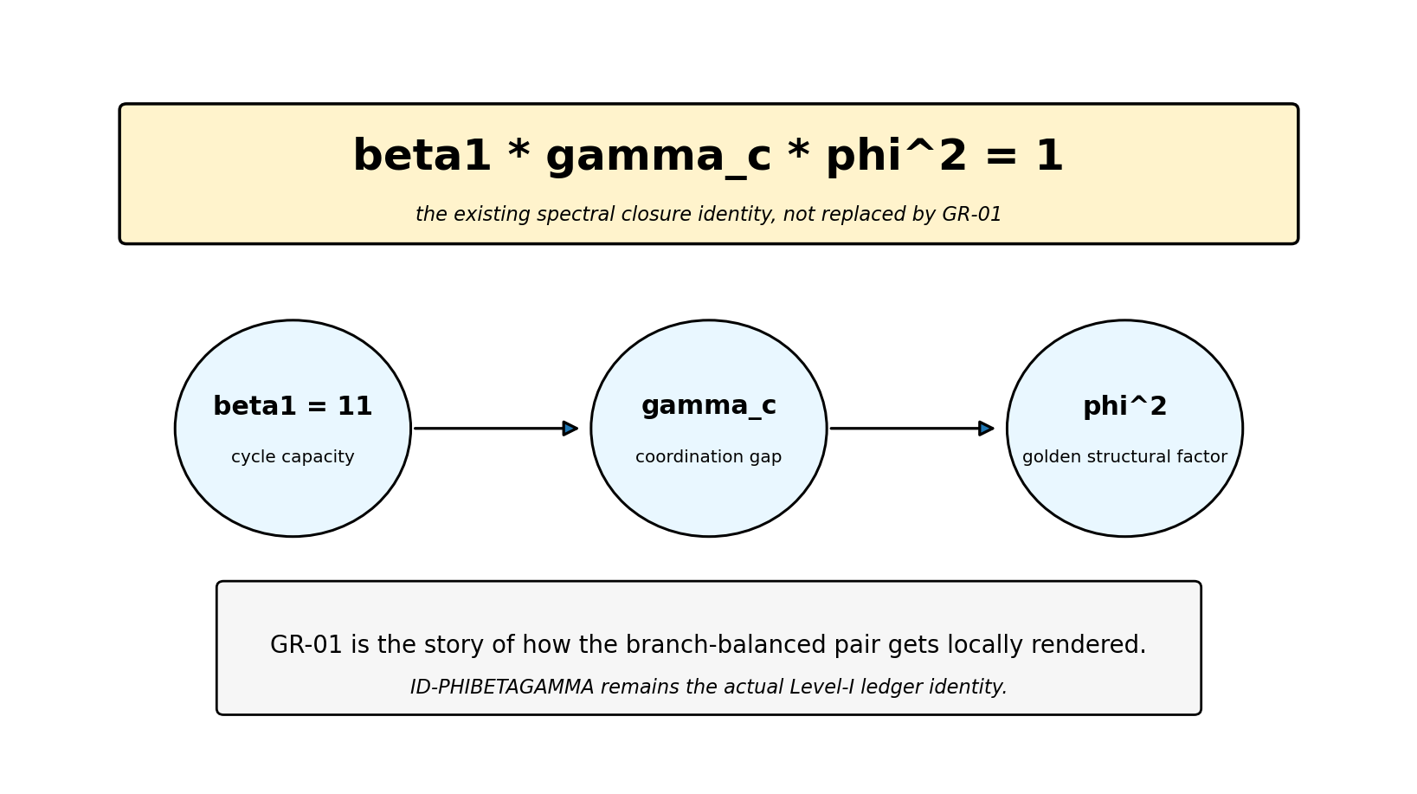
Figure GR-2. The Golden Relation does not replace the spectral closure identity. It narrates the branch-balanced structure around it.

3. The observer is the bisection engine
This is where the observer-sigma chapter plugs in. The observer is not a ghostly witness sitting outside spacetime with a clipboard. The observer is modal sigma in motion: the local sign-carrying process that turns potential distinction into an E/I/M event.
That means the observer is the bisection engine. It takes the branch-balanced golden pair and locally unspools it over finite propagation. It performs a split, deposits Memory, and renders a definite frame. Consciousness, in the fun-but-disciplined version, is the recursive case of that process: an infinitesimal decoherence machine that notices its own scars.
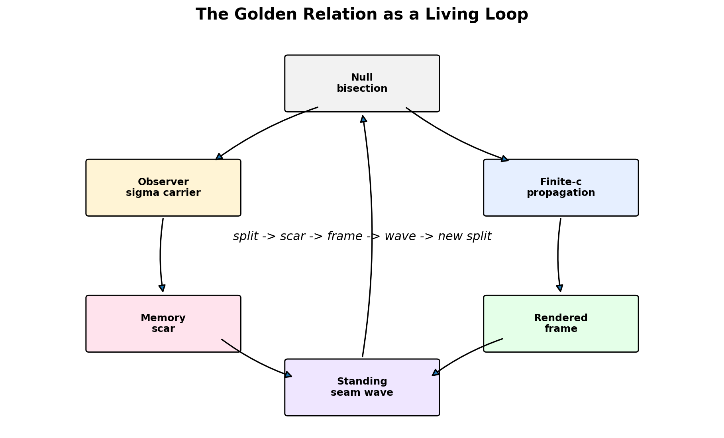
Figure GR-3. The Golden Relation as a living loop: null bisection, observer-sigma, finite propagation, Memory scars, rendered frames, and the standing seam wave.

4. The full Memory crystal is the pause button
If the bisection process saturates everywhere, the system stops flowing. The balanced split is no longer dynamically unspooling; it is fully pixelated. That is the full Memory crystal: complete self-perception, zero dynamic flow, the cosmic operating system frozen at maximum archive density.
A perturbation wakes it back up. The observer-sigma process becomes mobile again. A wavefront spreads. A new rendering begins. That is why the Big-Bang-like perturbation chapter and the black-hole archive chapter suddenly feel like the same beast seen at two scales.

5. Public-facing seatbelts
Because this is the fun version, I get to say 'Golden Relation' with a straight face and a sparkler. But because I do not want the framework to drive into a ditch wearing sunglasses, here are the seatbelts.
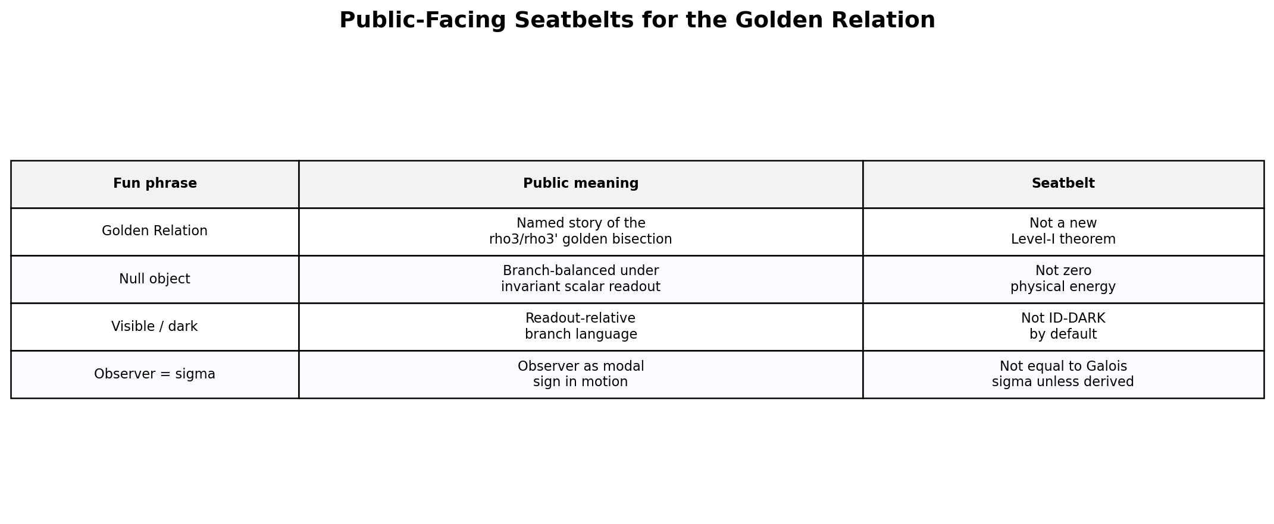
Figure GR-4. The Golden Relation is fun, but the guardrails stay on.

6. Article-ready paragraph
The Golden Relation is the name I am giving to the branch-balanced heart of this picture. At the bottom of the realized golden sector sits W = rho3 + rho3', a conjugate pair that behaves like a modal (+1, -1) bisection. The rho3 branch is the +sqrt(5), phi-character, geometrically visible, positive-propagation side; the rho3' branch is the conjugate, psi-character, dark-relative-to-that-readout side. Invariant scalar bookkeeping erases the asymmetry, which is exactly why the scalar no-go remains true. But observation is not invariant bookkeeping. Observation is the local bisection engine. The mobile observer, the sigma-carrier, keeps the split unspooling over finite c, depositing Memory and rendering definite frames. That is the little cosmic trick: the ledger is balanced, but the lived world is asymmetric because the observer keeps cutting the golden null into experience.

7. The short version
- ID-PHIBETAGAMMA is the ledger: beta1 * gamma_c * phi^2 = 1.
- GR-01 is the story: the golden branch pair is globally balanced but locally rendered.
- The observer is the engine: modal sigma in motion.
- Consciousness is the recursive version: a tiny decoherence machine that remembers itself.
- The full Memory crystal is the frozen limit: total archive, no dynamic flow.
- The standing seam wave is the system breathing after the cut.
So yes: this is still the hallucination layer. But it is no longer loose confetti. It has a spine, a ledger, a projector, and a tiny jazz-proof observer engine humming in the basement.

NOTE-TRIADIC-BELL-CLOSURE
Bell as the horizontal limit of a self-rendering cosmos.
This chapter is the cleanest place to put the Bell story, because it lets us keep both things true at once. First: the spooky-action picture is the wrong ontology. Second: the exact Bell cosine law is not solved by vibes, triangles, or hand-waving. The triangle tells us what Bell really is. The remaining math tells us what still has to be derived.
Nothing jumps across projected space. The records close later; the substrate was never two disconnected things.
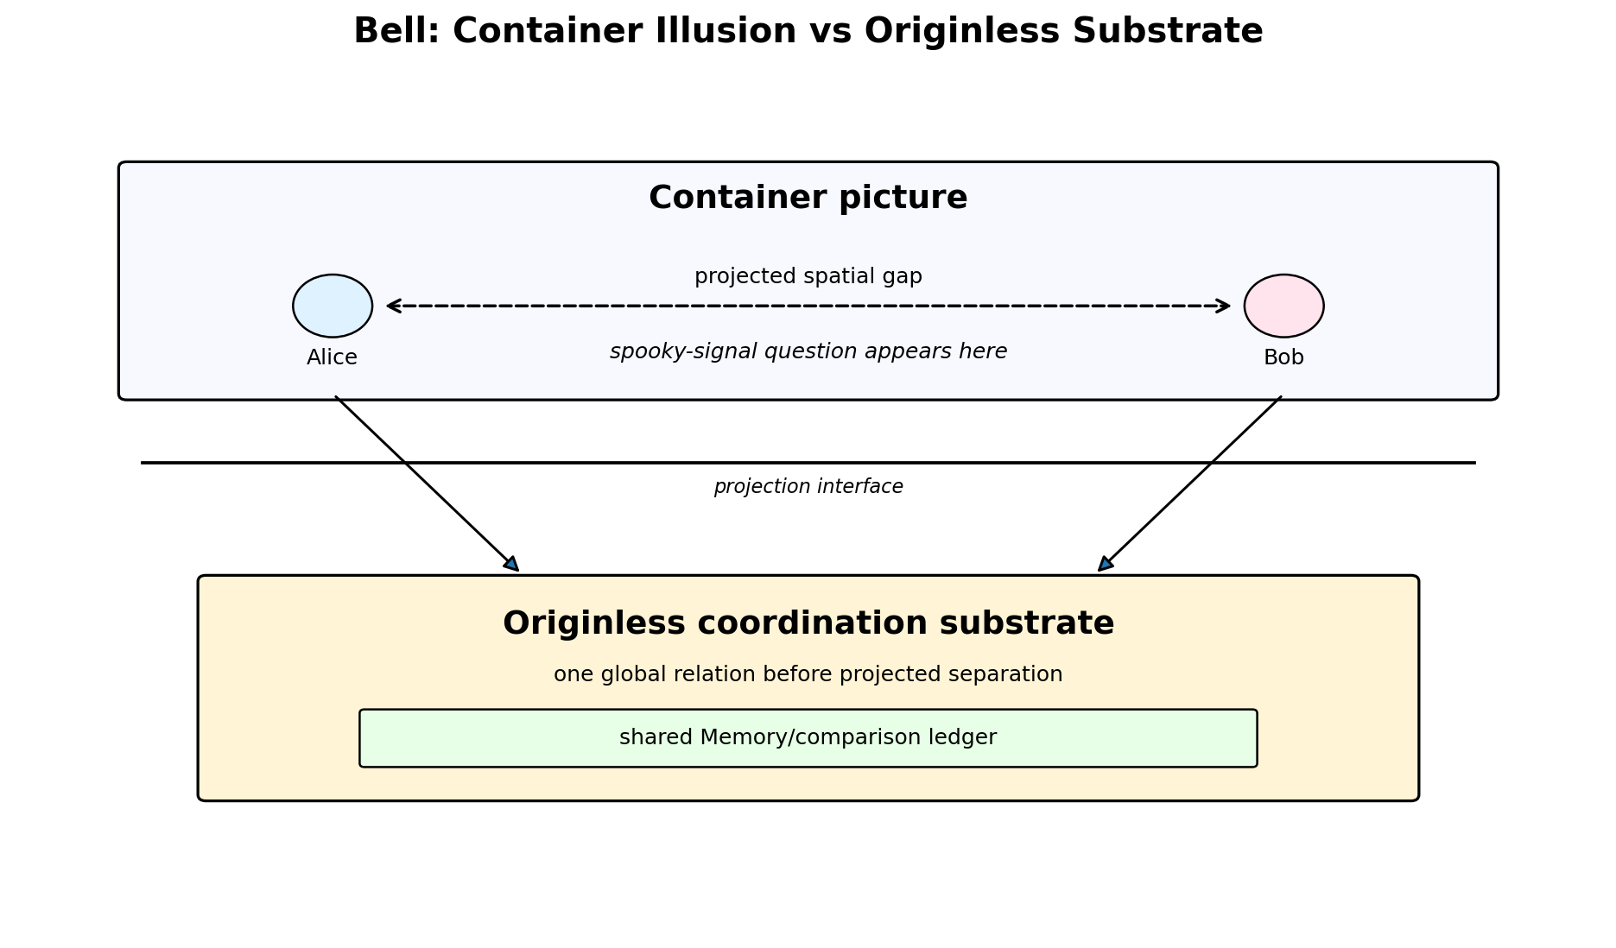
Figure TB-1. Bell looks spooky only when spacetime is treated as a primitive container.

1. The ontological level-shift: dissolving the container
Standard Bell diagrams draw Alice and Bob as two endpoints inside a pre-existing spatial box. Then the theory stares at the correlations and panics: how did one endpoint know what happened at the other endpoint?
EIM starts somewhere else. The underlying substrate graph has no canonical origin. Spatial distance and causal propagation are not primitive container facts at the pre-geometric layer. They are projection outputs. The measurement wings appear separated only after local frames commit.
So Alice and Bob are not two islands exchanging forbidden telegrams. They are two local cuts through one global coordination object. The correlation does not travel across space. Projected space is the interface where an already-coordinated relation appears as two separated records.

2. The geometry of the triadic closed record
The base of the Bell triangle, Alice to Bob, is the projected separation. It is not the full invariant object. The full object is triadic: Alice local bisection, Bob local bisection, and Memory-comparison closure.
The triangle height is the ledger vertex. It is where the two local records become one comparable record. This is why the triangle helped: it showed that Bell is not endpoint-to-endpoint action, but record-closure through a third axis.
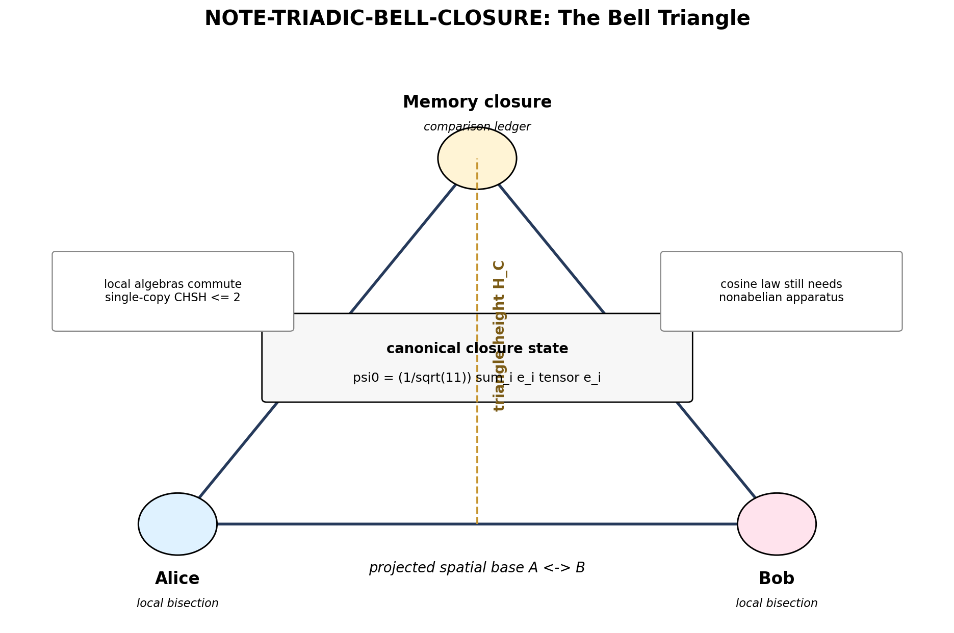
Figure TB-2. The Bell triangle: two local bisections plus one Memory-comparison closure.

3. What the triangle actually supplies
The triangle is not empty metaphor. The representation audit says the central closure axis can host a canonical A5-invariant maximally entangled state:
psi0 = (1/sqrt(11)) sum_i e_i tensor e_i
That is the formal content of the triangle-height intuition. The Memory closure state exists. It is symmetric, canonical, and entangled. The height is real enough to keep in the public story.
But the triangle supplies a state, not the measurement knobs. A maximally entangled state cannot violate Bell inequalities if Alice and Bob's allowed local observables all commute. And in the single-copy substrate model, they do commute.

4. The multiplicity barrier
This is the honest mathematical stop sign. A single bare H1 copy per Bell wing is too thin. Its local equivariant algebra is abelian, so its local measurements behave too classically. That enforces no-signaling, which is good, but it also caps the raw local CHSH value at the classical limit:
CHSH <= 2
To reach the quantum cosine law and Tsirelson's bound, the measurement wing needs a thicker observer-apparatus architecture. It needs noncommuting local measurement choices. In ordinary quantum language, it needs real measurement knobs. In EIM language, it needs more than a bare substrate copy: it needs an apparatus history.
So the remaining dragon is not spooky action. The remaining dragon is the derivation of the nonabelian observer-apparatus algebra.
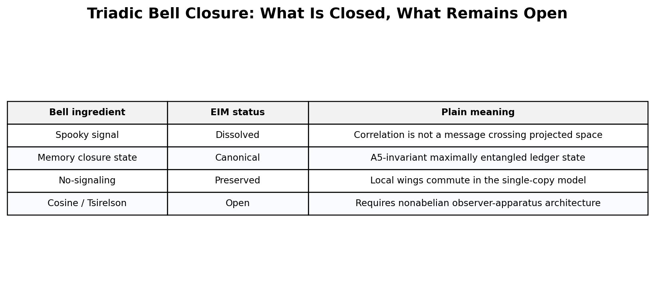
Figure TB-3. The spooky signal dissolves; the apparatus derivation remains open.

5. The two horizons
This is where Bell and Gödel snap into a surprisingly clean pair. Gödel is the vertical limit of self-rendering: no system can fully render its own rendering operation from inside the same rendering. Bell is the horizontal limit of relational projection: separated records close through one shared substrate ledger.
The vertical limit leaves a Memory scar. The horizontal limit leaves a correlation record. Neither one requires the old container picture.
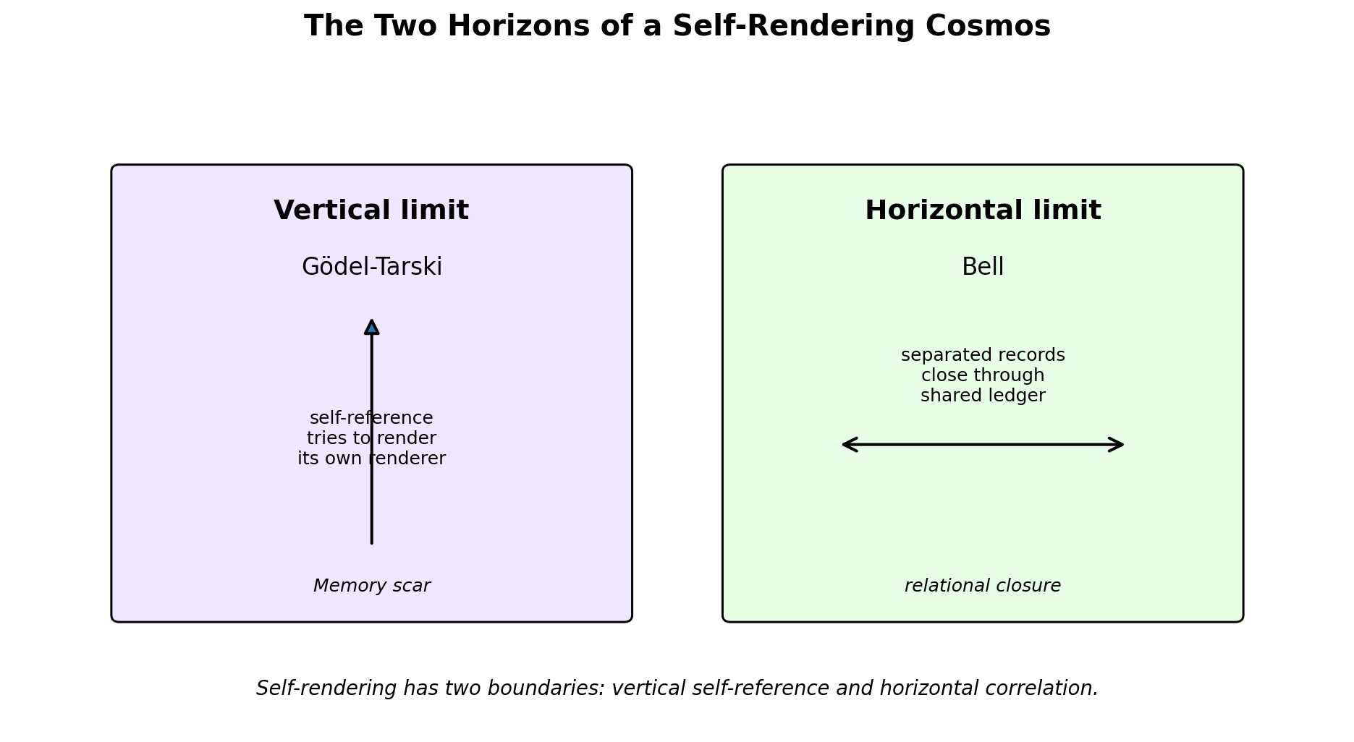
Figure TB-4. Gödel is the vertical boundary; Bell is the horizontal boundary.

6. Verdict for the hallucination log
The old container-realist spooky signal is dissolved. Realism, if retained, belongs to the global coordination substrate, not to pre-existing local values inside projected space. Locality is relational and projection-frame specific. The records close later; the motherboard was never two disconnected machines.
But this chapter does not claim a derivation of the Bell cosine law or Tsirelson bound. Those remain open pending a derived nonabelian observer-apparatus architecture. The triadic closure gives the canonical entangled ledger state. It does not yet supply the local measurement knobs.

7. Article-ready short form
Bell is not spooky action at a distance. It is the horizontal limit of projection. Alice and Bob are two local bisections through one originless coordination substrate, not two independent points in a primitive spatial container. Their records become comparable only through a later Memory closure, the triangle height. That height carries the canonical entangled ledger state. But the quantitative quantum law still asks for more: the apparatus must supply noncommuting local measurement choices. EIM dissolves the spooky signal, but still owes the measurement knobs.

8. Prior Art and the Actual Contribution
Before the goblin starts engraving trophies: this chapter does not claim that EIM newly discovers Bell inequalities, Tsirelson’s bound, Platonic quantum geometry, or emergent complex Hilbert structure. Every one of those neighborhoods is already well populated. Bell inequalities whose maximal violation points at the vertices of the dodecahedron and icosahedron are constructed explicitly by Tavakoli and Gisin (Quantum 4, 293, 2020), with follow-ups by Bolonek-Lasoń and Kosiński (Quantum 5, 593, 2021) and by Pál and Vértesi (Quantum 6, 756, 2022). A symmetry-invariant complex structure that is unique up to sign is exactly the headline result of Moretti and Oppio (Rev. Math. Phys. 29, 1750021, 2017). And unitary walk dynamics with complex eigenvalues — including the non-backtracking / Ihara-zeta family our golden modes live in — is standard Szegedy-walk territory (Szegedy, FOCS 2004; and the spectral-mapping line of Higuchi, Segawa and Suzuki). The dodecahedron, the golden ratio, the maximally entangled state, the complex structure unique up to sign, the non-backtracking rotation: none of it is new, and I am not going to pretend otherwise.
So what is the EIM contribution here? It is interpretive and architectural, not a new theorem. It is a partition. First, the spooky-action framing dissolves the moment spacetime is treated as a rendered interface rather than a primitive container: Alice and Bob stop being two boxes mysteriously phoning each other and become two local bisections of one originless substrate. Second, the triangle height gives a natural EIM role to the canonical entangled comparison state — the Memory-closure ledger through which two separated records become one comparable record. Third, the part that is still a real derivation problem is localized cleanly rather than hidden: it sits at the emergence of a nonabelian observer-apparatus algebra, the noncommuting measurement knobs, and nowhere else.
The modest correction, then, is just a clean separation of three things that usually get smeared together: the ontology-level dissolution of spooky action, which EIM supplies; the canonical entangled Memory-closure state, which is EIM-aligned and internal; and the still-open derivation of the cosine and Tsirelson measurement architecture, which is genuinely open and is the same problem the rest of the literature has been chewing on for years. EIM is not replacing known physics here. It is organizing known physics, and its paradoxes, into projection architecture.
Claim | Status
Platonic Bell / golden-ratio geometry | Prior art — Tavakoli & Gisin (2020); Bolonek-Lasoń & Kosiński (2021); Pál & Vértesi (2022)
Emergent complex structure, unique up to sign | Prior art — Moretti & Oppio (2017)
Non-backtracking / quantum-walk complex structure | Prior art — Szegedy (FOCS 2004); Higuchi, Segawa & Suzuki
Spooky-action / container framing | Dissolved by EIM ontology
Canonical entangled Memory-closure state | EIM-aligned internal result
Cosine / Tsirelson derivation | Still open, at the apparatus-algebra layer
The result is not “EIM solves Bell by rhetoric.” The result is cleaner, and more honest: EIM turns Bell into a diagnostic of projection architecture. The spooky part dissolves; the quantitative part stays on the to-do list, in good company.

