A Projection-First Case Study of Bell Correlations on the Dodecahedral Non-Backtracking Sector
Emergent qubit structure, triadic closure, and the localization of the residual quantitative freedom
Thomas P. Connelly Jr.
GCAS College Dublin
ORCID: 0009-0006-8267-1378
Abstract
It is already known that the Platonic solids host maximal Bell violations (Tavakoli & Gisin 2020; Bolonek-Lasoń & Kosiński 2021), and that a complex structure — the “imaginary unit” of quantum theory — can emerge, unique up to sign, from the symmetry or dynamics of an underlying real structure (Moretti & Oppio 2017; Aste 2019; and, in discrete form, from the unitarity of graph quantum walks). This paper does not claim to derive the Tsirelson bound, nor to discover a new prediction. Its contribution is interpretive and structural, anchored to one fully explicit finite model: the golden sector of the non-backtracking (Hashimoto) operator of the regular dodecahedron, on which a genuine A₅×ℤ₂-equivariant qubit and a CHSH value of 2√2 are realized. Against that worked example we make three claims. (1) A projection-first reading, in which spatial separation and the causal limit are outputs of a substrate projection rather than primitives, can here be stated as a mathematically defined operation rather than a metaphor — at the cost, openly admitted, of dissolving a non-paradox rather than a paradox. (2) A triadic closure classification (two local bisections plus one comparison closure) maps cleanly onto the Bell scenario and separates, in representation-theoretic terms, the parts of the correlation the substrate symmetry fixes from the part it does not. (3) The model permits a precise relocation of the open quantitative question: the cosine law and the value 2√2 are not symmetry-derivable (they live in a multiplicity space on which A₅ acts trivially); a dynamical operator and a unitarity (quantum-walk) metric premise select the complex structure canonically up to a single chirality bit; what remains genuinely unforced is exactly the measurement-circle freedom of any Bell test, plus the metric premise. The residual freedom is thereby reduced to a named one-bit object tied to the Galois structure of the golden field ℚ(√5).
Keywords. Bell inequalities; Tsirelson bound; emergent complex structure; non-backtracking operator; quantum walks; Platonic solids; quantum foundations; representation theory.

1 Prior art, stated plainly
We begin by conceding the landscape, because the contributions below are meaningful only relative to it.
1.1 Platonic Bell inequalities are known. Tavakoli and Gisin [1] constructed bipartite, two-outcome Bell inequalities whose maximal quantum violation is attained by projective measurements pointing toward the vertices of the Platonic solids, including the icosahedron–dodecahedron dual compound, with quantum values expressed through the golden ratio φ=(1+√5)/2 and confirmed optimal by the NPA hierarchy. Pál and Vértesi [2] extended the construction to all dimensions, and Bolonek-Lasoń and Kosiński [3] showed that these inequalities and their bounds follow from the fact that the solids are orbits of group representations. The statement “the dodecahedron / A₅ realizes a maximal, golden-ratio-flavored Bell violation with a maximally entangled state” is therefore not new. In [1] the qubit is supplied by hand (a spin-½ Bloch sphere) and the solid’s geometry is used only to choose measurement directions.
1.2 The emergence of the imaginary unit is known. Solèr’s theorem confines quantum theory to real, complex, or quaternionic Hilbert spaces; Stückelberg gave physical reasons against the real case. Moretti and Oppio [4] proved that an elementary relativistic system carries a natural, symmetry-invariant complex structure, unique up to sign, commuting with the entire observable algebra, which yields the standard complex formulation; Aste [5] reached a similar conclusion from the linear dynamics of real quantum theory. In the discrete setting, a Szegedy or non-backtracking quantum walk is unitary by construction, its non-trivial spectrum lies on a circle of fixed modulus, and its rotational action is a complex structure on the relevant invariant subspace [6,7]. Hence “a symmetry/dynamics-invariant complex structure, unique up to sign” and “a complex structure from a graph walk” are also not new.
1.3 The golden field, A₅, and qubits are already linked. The icosian construction identifies A₅ with the unit quaternions over the golden field ℚ(√5), realized as single-qubit gates in PU(2) (Parzanchevski & Sarnak [8]; Blackman & Stier [9]); icosahedral (A₅) symmetry with golden-ratio structure also appears in flavor physics (Everett & Stuart [10]). The algebraic backbone we use — A₅, ℚ(√5), qubits — is established territory.
1.4 What this paper is not. We do not derive 2√2 (the Tsirelson bound is a theorem of quantum mechanics [11], saturated by any anticommuting ±1 qubit pair on a maximally entangled state via the Khalfin–Tsirelson–Landau identity [12]). We claim no new measurable prediction. We also distinguish our use of a graph — a concrete physical lattice whose spectral dynamics carries the qubit — from the Cabello–Severini–Winter program [13], in which the graph is the abstract exclusivity graph of events and the quantum bound is its Lovász number. These are different objects; we do not contribute to that program.
Given all of this, the honest question is not whether the dodecahedron can produce a maximal Bell violation (it can; this is [1]) but: does treating the violation as emerging intrinsically from the substrate’s own dynamics, rather than from imposed Bloch-sphere measurements, buy any interpretive or structural clarity? We argue it buys three specific things.

2 The model
We fix notation and recall the verified facts of the worked example. All numerical claims below were checked computationally (exact representation theory; floating-point residuals ≤ 10⁻¹⁴); none is new mathematics, and this section should be read as a realization, in the sense of §1.2, not a discovery.
2.1 Substrate. Let Γ be the regular dodecahedron as a 3-regular graph: |V|=20, |E|=30, first Betti number β₁=11, automorphism group Aut(Γ)=A₅×ℤ₂ of order 120. Let B be the non-backtracking (Hashimoto) operator on the 2|E|=60 directed edges (arcs): B maps arc (u→v) to (v→w) iff w≠u. B commutes with the Aut(Γ) action on arcs (verified).
2.2 Golden sector. For a 3-regular Ramanujan graph the non-trivial Hashimoto eigenvalues have modulus √2. The eigenvalues arising from the adjacency eigenvalues λ=±√5 (each of multiplicity 3, carrying the two three-dimensional irreps ρ₃, ρ₃′ of A₅) are μ=(±√5±i√3)/2, the roots of the golden quartic μ⁴−μ²+4=0 (Figure 1). Define the golden sector
W = ker(B⁴ − B² + 4I),
the real Aut(Γ)-invariant subspace they span. Then dim W = 12 and, as an A₅-representation, W ≅ 2ρ₃ ⊕ 2ρ₃′ (verified by the character formula dim End_{Aut}(W) = (1/|G|) Σ |χ_{W}(g)|² = 8).
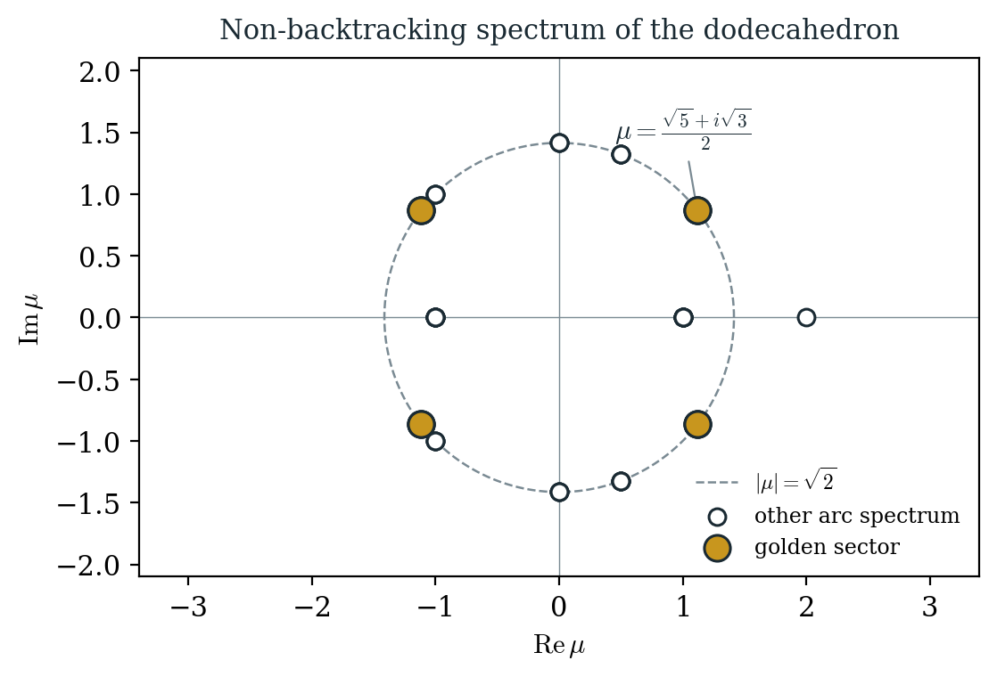
Figure 1. The non-backtracking (Hashimoto) spectrum of the dodecahedron in the complex plane. All non-trivial eigenvalues lie on the circle |μ|=√2. The four highlighted points (each of multiplicity 3) are the golden sector μ=(±√5±i√3)/2, roots of μ⁴−μ²+4=0; they span the 12-dimensional subspace W.
2.3 Nonabelian commutant — the engine. Because ρ₃ and ρ₃′ each occur with multiplicity two, the equivariant commutant is End_{Aut}(W) = M₂(ℝ) ⊕ M₂(ℝ) (dimension 8, nonabelian). This is the decisive contrast with the first homology H₁(Γ;ℝ) = ρ₃ ⊕ ρ₃′ ⊕ ρ₅, in which every irrep is multiplicity-free, so End_{Aut}(H₁) = ℝ³ is abelian: there, all equivariant observables commute, no anticommuting ±1 pair exists, and CHSH is capped at the classical bound 2. The golden sector supplies the nonabelian structure that H₁ lacks.
2.4 Emergent complex structure. The closed form
J₀ = (1 / 2√3) (B + B³) |_{W}
satisfies J₀² = −I, is Aut(Γ)-equivariant, and is manifestly a polynomial in the dynamical operator B; it is therefore canonical given B. It is the discrete analogue of the Moretti–Oppio complex structure: invariant, unique up to sign — here the sign being a chirality ℤ₂, J₀ versus −J₀.
2.5 Unitarity (quantum-walk) metric. B is not normal in the bare arc inner product, so J₀ is not antisymmetric there. There exists an equivariant positive metric G (unique up to a per-block scale) in which J₀ is antisymmetric — equivalently the metric making B/√2 unitary on W, i.e. the standard Hilbert-space structure of the non-backtracking quantum walk. This metric is a premise beyond the bare graph, though a principled one: it is the choice that makes the discrete walk a unitary evolution.
2.6 Equivariant qubit and CHSH. In that metric there exist self-adjoint, anticommuting, Aut(Γ)-equivariant involutions X, Z with Z = X J₀, {X,Z} = 0, and X Z = J₀. The qubit’s complex structure is the emergent imaginary unit J₀. With observables A(a) = cos a · X + sin a · Z and the canonical A₅-invariant maximally entangled state ψ₀ = (1/√2·… ) on WA ⊗ W, one obtains E(a,b) = −cos(a−b) and max-over-settings CHSH = 2√2, with no-signaling holding because party-local observables act on distinct tensor factors. The maximally-entangled bipartition that forces commuting locals on H₁ does not bind here, precisely because the party-local algebra is the nonabelian M₂(ℝ) ⊕ M₂(ℝ).
We stress again: §2.6 is the standard qubit Tsirelson construction realized on W; the content of this paper is what §§3–5 make of it.

3 Contribution 1 — the projection-first reading, made concrete
3.1 Statement. In the projection-first reading, the entities a container-realist treats as primitive — the spatial separation d between the two wings and the causal limit c that forbids superluminal signaling — are treated as outputs of a projection from a substrate that has no preferred origin. A Bell correlation is then not a relation across pre-existing space but a property of how two local records close into one comparison record. On this reading the “spooky action” picture never arises: there is no pre-existing spatial channel for an influence to traverse.
3.2 What is, and is not, new here. The interpretive stance itself is not new: emergent-spacetime programs, relational quantum mechanics, and ordinary no-signaling readings all dissolve the same pseudo-problem, and we concede openly that superluminal signaling was already forbidden in textbook quantum mechanics, so this reading dissolves a non-paradox, not a paradox. The contribution is narrower and concrete: in the present model “projection” is a defined operation. The arc space carries the dynamics (B); the vertex/length data and the effective light-cone structure are read off projections of that arc-level object; and the two “locations” of a Bell test are images of one substrate under a chosen projection rather than addresses in a pre-given manifold. Where most projection-first rhetoric is metaphorical, here one can point to the operator whose spectral projection (ker(B⁴−B²+4I)) defines the register, and ask precise questions of it. This is a modest but genuine gain in explicitness, and we claim no more.
3.3 Honest limitation. Because the reading dissolves a non-paradox and reproduces standard no-signaling, it makes no new prediction and cannot be tested against the container-realist reading by experiment. Its value is the value of a perspicuous model, not of a discriminating one.

4 Contribution 2 — triadic closure classification
4.1 The triad on the Bell scenario. The framework organizes any multi-observer record around an Execution–Interaction–Memory triad. Mapped onto CHSH this gives a three-part decomposition we call triadic closure (Figure 2): two wings (local bisections), whose canonical single-cell equivariant algebras are multiplicity-free, hence abelian, hence commute — enforcing no-signaling and capping the local readout at CHSH ≤ 2; a central height (the comparison/Memory ledger), which canonically distinguishes a maximally entangled A₅-invariant state ψ₀ (distinguished, not forced); and a base, the projected spatial separation A↔B, which §3 demotes to a projection output.
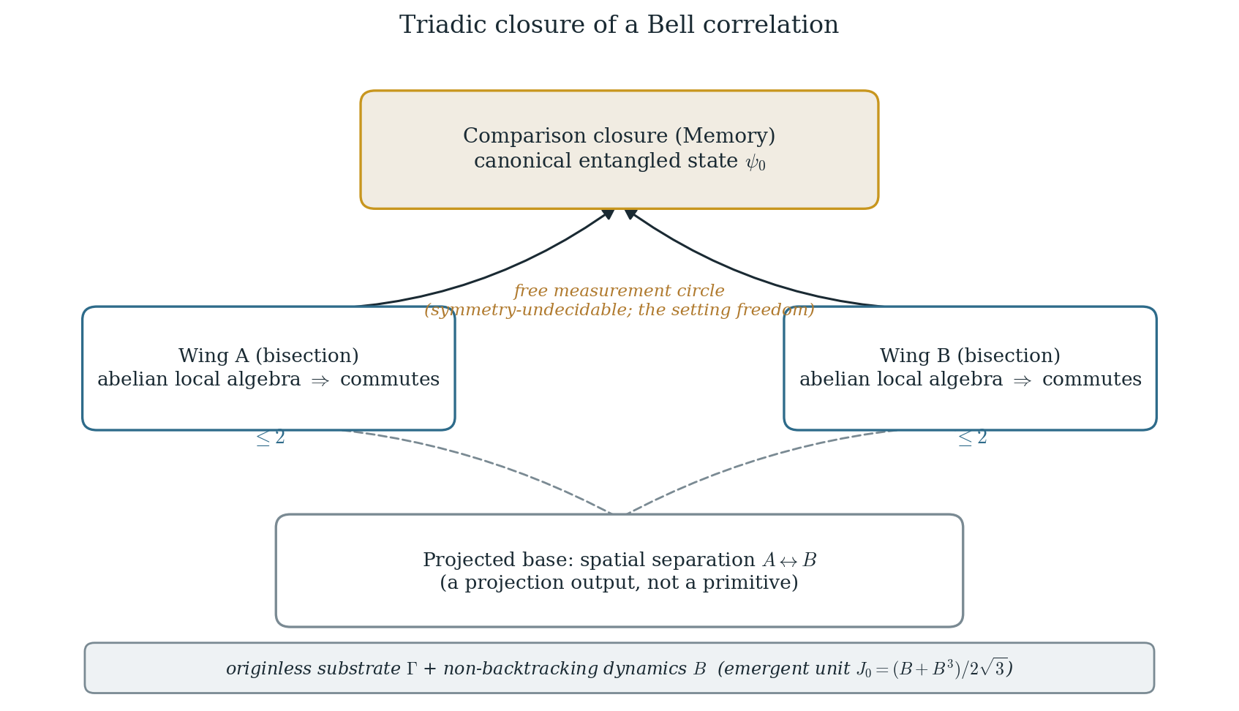
Figure 2. Triadic closure of a Bell correlation. The two wings carry abelian party-local algebras (CHSH ≤ 2 individually); the comparison closure supplies the canonical entangled state ψ₀; the projected spatial base is a derived, not primitive, datum. The measurement circle that fixes the quantitative value is symmetry-undecidable (§5) — the free setting choice of any Bell test.
4.2 What the classification does. Read this way, the Bell structure factorizes into the part fixed by the substrate symmetry (the abelian wings ⇒ ≤2; the distinguished closure state ψ₀) and the part it does not fix (the measurement circle; §5). The triadic decomposition is, we concede, a reorganization in the framework’s vocabulary of the standard tensor/locality structure — its content is explanatory, not a new theorem. Its payoff is that it makes the symmetry-fixed / symmetry-free split visible before any computation.
4.3 Two horizons. We offer, as an organizing map and not as an identification, a distinction between two epistemic limits: the vertical limit of self-reference (Gödel–Tarski: no system fully renders its own rendering from within) and the horizontal limit of relational closure (Bell: two local histories cut into one originless substrate and later close into one record). These are distinct — different theorems, different methods (diagonalization versus joint distributions) — and we do not claim either reduces to the other. The map’s only role is to place the present model on the horizontal axis and to discourage the common conflation of the two.

5 Contribution 3 — precise relocation of the open quantitative gap
This is the technical heart, and the place where the explicit model does real work.
5.1 Three regimes. The model exhibits a sharp representation-theoretic trichotomy for the maximal CHSH attainable with canonical (equivariant) observables on a maximally entangled invariant state (Figure 3):
- H₁ (multiplicity-free): End_{Aut}=ℝ³ abelian ⇒ no anticommuting ±1 pair ⇒ CHSH ≤ 2. Tsirelson-incapable.
- Golden sector W (multiplicity two): End_{Aut}=M₂(ℝ) ⊕ M₂(ℝ) nonabelian ⇒ anticommuting equivariant involutions exist ⇒ CHSH reaches 2√2. Tsirelson-capable.
- The cosine circle itself: the family of measurement axes A(a)=cos a·X + sin a·Z lives in the multiplicity space, on which A₅ acts trivially.
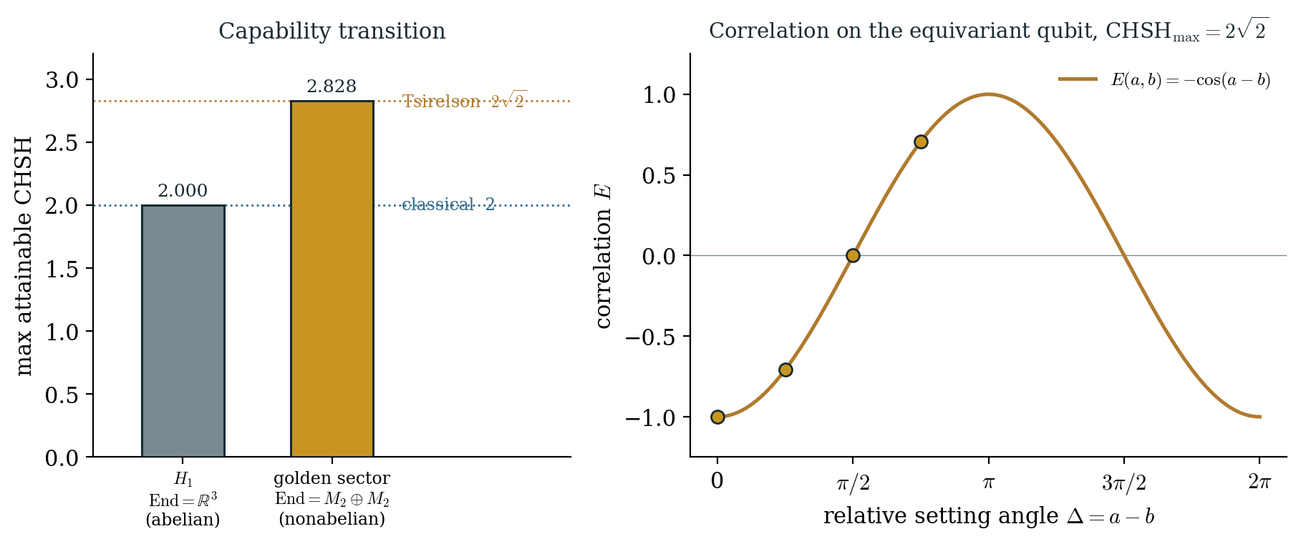
Figure 3. Left: the maximal attainable CHSH jumps from the classical bound 2 on the abelian commutant of H₁ to the Tsirelson bound 2√2 on the nonabelian commutant of the golden sector. Right: on the equivariant qubit the correlation is E(a,b)=−cos(a−b); the value in [2, 2√2] is set entirely by the relative setting angle, which the substrate symmetry does not fix.
5.2 The relocation. Regime 3 is the crux. The value of CHSH in [2, 2√2] is fixed by the angle pair (a,b), and the angles live where the symmetry is silent. Hence the substrate’s discrete symmetry A₅×ℤ₂ neither forces nor forbids any particular value in [2, 2√2]: the quantitative content of Bell is symmetry-undecidable. This is not a failure; it is a localization. What the symmetry does fix (the ≤2 wings, the capability transition H₁ → W, the distinguished state) is cleanly separated from what it does not (the circle). The model then shows how much of the remainder is recovered without symmetry: the dynamical operator B selects the complex structure J₀=(B+B³)/(2√3), canonical up to the chirality ℤ₂; the unitarity (quantum-walk) metric of §2.5 makes J₀ a genuine imaginary unit and is the one substantive premise beyond the bare graph; and what then remains irreducibly free is exactly the measurement circle — the two settings of a Bell test — which must be free, since a Bell experiment with a single fixed measurement axis per party could not exist.
5.3 The residue is one bit. After B and the quantum-walk metric, the only substrate-level datum not fixed by either symmetry or dynamics is the orientation J₀ versus −J₀. This chirality ℤ₂ is Bell-inert (the CHSH value is invariant under J₀ ↦ −J₀). Structurally it coincides with an orientation of the golden field: the endomorphism algebra of the relevant A₅-module over ℚ is the field ℚ(√5), on which the Galois swap √5 ↦ −√5 is an outer automorphism — not realizable by any inner (symmetry or dynamical) operation. The residual one bit is therefore not an oversight to be removed but a Galois-theoretic invariant of the substrate. (The claim that no canonical inner datum fixes this bit is, in the present model, a verified structural statement; its elevation to a general principle is a conjecture of the broader framework and is flagged as such.)
5.4 Net statement. The open quantitative question is thus relocated from the already-answered, standard-QM question “why 2√2?” to the sharper pair: “what, beyond a dynamical operator and a unitarity metric, could canonically select the measurement circle?” — to which the model’s honest answer is nothing internal does, and nothing should — and “is the unitarity metric itself forced?”, which we leave open. This is the contribution: not closing the gap, but giving it coordinates.

6 Discussion: what would turn a case study into physics
We are explicit about the boundary. The construction reproduces standard qubit quantum content (the cosine law and the Tsirelson ceiling); it introduces no new number; it rests on a metric premise; and its interpretive payoff dissolves a non-paradox. Relative to [1] it differs in mechanism (an intrinsic qubit emergent from the non-backtracking spectrum, versus vertices imposed as Bloch vectors) but not in result. For the case study to become physics rather than a perspicuous re-encoding, at least one of the following would have to be exhibited, and none is claimed here:
- A graph family. A structural reason the dodecahedron is distinguished among graphs whose non-backtracking golden sector is Tsirelson-capable — a classification of which G yield M₂(ℝ) ⊕ M₂(ℝ) on a golden sector, and whether A₅ / ℚ(√5) is forced.
- A robustness or resource edge. A respect in which the non-backtracking realization outperforms the vertex construction (noise tolerance, self-testing, device-independence), making the mechanism operationally, not just conceptually, distinct.
- A consequence of the metric premise. A falsifiable corollary of taking the quantum-walk metric as physical, rather than as a modeling choice.
Absent these, the appropriate home for the result is as a worked consistency lemma within a larger program, and the appropriate claim for this paper is the interpretive/structural one made in §§3–5.

7 Conclusion
On the golden sector of the dodecahedron’s non-backtracking operator, an A₅×ℤ₂-equivariant qubit and a maximal CHSH violation are realized, with the imaginary unit emerging in closed form from the graph dynamics. None of these ingredients is individually new: Platonic Bell violations, emergent complex structures unique up to sign, and the A₅ / ℚ(√5) / qubit link are all established. What the explicit model adds is interpretive and structural: a projection-first reading made mathematically concrete (§3); a triadic closure classification that separates the symmetry-fixed from the symmetry-free content of a Bell correlation (§4); and a precise relocation of the open quantitative question, reducing the irreducible substrate freedom to a single Bell-inert chirality bit with a Galois-theoretic identity, while naming the unitarity metric as the one outstanding premise (§5). We make no claim to new physics; we claim a sharper map of where, in a fully explicit substrate, the quantitative content of quantum nonlocality is and is not determined.

Methods and disclosure
The representation-theoretic and numerical statements of §2 were obtained and verified computationally: exact character computation for the commutant dimension, and explicit construction of B, the golden sector, J₀, the tempered metric, the equivariant qubit, and the CHSH value, with floating-point residuals at or below 10⁻¹⁴. Computational tooling and drafting assistance were used in preparing this manuscript and are disclosed here in accordance with the target journal’s authorship and AI-use policy; the author is responsible for all claims.

References
[1] A. Tavakoli and N. Gisin, “The Platonic solids and fundamental tests of quantum mechanics,” Quantum 4, 293 (2020).
[2] K. F. Pál and T. Vértesi, “Platonic Bell inequalities for all dimensions,” Quantum 6, 756 (2022).
[3] K. Bolonek-Lasoń and P. Kosiński, “Groups, Platonic solids and Bell inequalities,” Quantum 5, 593 (2021).
[4] V. Moretti and M. Oppio, “Quantum theory in real Hilbert space: how the complex Hilbert space structure emerges from Poincaré symmetry,” Rev. Math. Phys. 29, 1750021 (2017); arXiv:1611.09029.
[5] A. W. Aste, “Origin of the complex structure of quantum mechanics,” arXiv:1905.12894 (2019).
[6] M. Szegedy, “Quantum speed-up of Markov chain based algorithms,” Proc. 45th IEEE FOCS, 32–41 (2004).
[7] K. Hashimoto, “Zeta functions of finite graphs and representations of p-adic groups,” in Automorphic Forms and Geometry of Arithmetic Varieties, Adv. Stud. Pure Math. 15, 211–280 (1989).
[8] O. Parzanchevski and P. Sarnak, “Super-Golden-Gates for PU(2),” Adv. Math. 327, 869–901 (2018).
[9] T. R. Blackman and Z. Stier, “Fast navigation with icosahedral golden gates,” arXiv:2205.03007 (2022).
[10] L. L. Everett and A. J. Stuart, “Icosahedral (A₅) family symmetry and the golden ratio prediction for solar neutrino mixing,” Phys. Rev. D 79, 085005 (2009).
[11] B. S. Cirel’son (Tsirelson), “Quantum generalizations of Bell’s inequality,” Lett. Math. Phys. 4, 93–100 (1980).
[12] L. J. Landau, “On the violation of Bell’s inequality in quantum theory,” Phys. Lett. A 120, 54–56 (1987).
[13] A. Cabello, S. Severini and A. Winter, “Graph-theoretic approach to quantum correlations,” Phys. Rev. Lett. 112, 040401 (2014).
[14] J. S. Bell, “On the Einstein Podolsky Rosen paradox,” Physics 1, 195–200 (1964).
[15] J. F. Clauser, M. A. Horne, A. Shimony and R. A. Holt, “Proposed experiment to test local hidden-variable theories,” Phys. Rev. Lett. 23, 880–884 (1969).

