Symmetry, Chirality, and Invariant Projections on Polyhedral Graphs
An Answer to a Problem of Dilworth, Kutzarova and Ostrovskii
Thomas P. Connelly Jr.
GCAS College Dublin, Dublin, Ireland · thomas.connelly@gcas.ie · ORCID 0009-0006-8267-1378
Version 2.0 · 3 August 2026

Abstract
Dilworth, Kutzarova and Ostrovskii showed that the invariant projection of the edge space onto the cycle space of a graph is unique exactly when the automorphism representations on the cycle space and the cut space share no constituent, and asked in their Problem 7 for which graphs this holds. We answer it for every convex polyhedron. Define the coupling capacity of a polyhedral skeleton to be the dimension of the space of equivariant linear maps from its cycle space to its cut space, so that uniqueness is the vanishing of that dimension. We prove that the capacity is an orbit count over face–vertex pairs, corrected by a term active exactly on chiral polyhedra; that it is invariant under polyhedral duality; and that it vanishes if and only if the polyhedron is regular. The five Platonic solids are thereby characterised among all convex polyhedra by the vanishing of a homological invariant. The result is specific to the sphere: it fails in one direction on the torus and in the other on the projective plane. For the chiral toroidal families we evaluate the capacity in closed form.
Keywords: cycle space, invariant projection, polyhedral graph, regular polyhedron, orbit counting, regular map.
Math. Subj. Class. (2020): 05E18 (primary); 05C10, 05C25, 20C15, 52B15, 46B85 (secondary).

1. Introduction
Let $Γ$ be a finite connected graph and let the signed edge space $R^{E}$ decompose orthogonally into the cycle space $H_{1}\left(Γ\right)=ker∂$ and the cut space $K\left(Γ\right)=im∂^{T}$. Both are invariant under the natural action of $Aut\left(Γ\right)$. Dilworth, Kutzarova and Ostrovskii [10], studying minimal projections onto cycle spaces in connection with transportation-cost and Lipschitz-free spaces, proved that the invariant projection of the edge space onto the cycle space is unique if and only if the two resulting representations have no equivalent constituents. They posed as their Problem 7 the question of determining for which graphs this holds, and recorded that they were unable to find the required representation theory of $Aut\left(Γ\right)$ in the literature.
This paper answers Problem 7 for every convex polyhedron. For the skeleton $Γ$ of a convex polyhedron define the coupling capacity
$$c\left(Γ\right) = dim{Hom}_{Aut\left(Γ\right)}\left(H_{1}\left(Γ\right), K\left(Γ\right)\right),$$
the dimension of the space of linear channels between the two sectors that respect every symmetry of the structure; a nonzero element is a way for cycle-sector data to influence cut-sector data without breaking any symmetry. By the theorem of [10], $c\left(Γ\right)=0$ is exactly the uniqueness condition, so determining $c$ on a class of graphs is determining Problem 7 on that class. Our results are the following.
Theorem A. $c\left(Γ\right)=0$ if and only if $Γ$ is regular. Equivalently, the orthogonal projection onto the cycle space is the unique $Aut\left(Γ\right)$-invariant projection precisely for the five Platonic solids.
Theorem B. $c\left(Γ\right)=N\left(F×V\right)−N\left(F\right)−N\left(V\right)+δ$, where $N\left(X\right)$ counts the $Aut\left(Γ\right)$-orbits on $X$ whose stabiliser contains no orientation-reversing element and $δ$ is $1$ for chiral $Γ$ and $0$ otherwise.
Theorem C. $c\left(Γ^{*}\right)=c\left(Γ\right)$ for the dual polyhedron $Γ^{*}$, although the two generally have different Betti numbers.
Corollary D. Problem 7 of [10] is answered for every convex polyhedron: the invariant projection onto the cycle space is unique exactly in the five Platonic cases. The problem is posed there for the automorphism group of the graph; for a $3$-connected planar graph that group coincides with the map automorphism group used here, by Whitney’s theorem, so the answer is unambiguous. Section 10.2 records a toroidal map for which the two groups differ, and the distinction becomes material.
Read one way, Theorem A says that a structure can support a symmetry-respecting interaction between its two sectors exactly when it has fallen short of maximal symmetry; read the other way, it characterises the five Platonic solids — objects usually singled out by a definition about flags, or faces, or angles — by the vanishing of a homological invariant. Theorem B is what makes the capacity computable, replacing a linear-algebra problem on a space of dimension $β_{1}\left(\left|V\right|−1\right)$, which for the larger Archimedean solids exceeds ten thousand, by a count of orbits on face–vertex pairs. Theorem C is not visible from the modules themselves and does substantial work in the proof of Theorem A.
On priority: the authors of [10] record that they found no published results on Problem 7. Upon what we believe to be a reasonably exhaustive search of the publicly available literature and of the standard bibliographic databases, carried out in July 2026, we have located no subsequent treatment of the problem, under this terminology or any adjacent one. We claim no more than that: this is a negative search result and not a certificate of novelty.
The invariant was arrived at by a route that has nothing to do with Problem 7 — an attempt to give quantitative form to Curie’s principle on symmetry and phenomena. That provenance is recorded in §8.3, together with an account of what the theorem does and does not settle there. Nothing in §§2–10 depends on it, and a reader with no interest in the question may skip §8.3 without loss.

1.1 How the proof goes
The forward half of Theorem A is a computation. Section 3 identifies the two sectors as twisted permutation modules — the cycle space is the reduced face module tensored with the orientation character, the cut space the reduced vertex module — and Theorem B follows from the Cauchy–Frobenius orbit-counting lemma in its $ε$-twisted form. A finite check over the five regular solids then gives regular $⇒c=0$.
The converse occupies §9 and runs in three stages. First, §9.3 reduces the vanishing of the equivariant $Hom$ space to a statement with no representation theory in it at all: $c\left(Γ\right)=0$ if and only if every face–vertex pair of $Γ$ is fixed by a common reflection, equivalently if and only if, for every face, the mirror planes through that face’s axis cover the entire vertex set. Second, §9.4 observes that this forces every face axis and every vertex direction onto a rotation axis — since a single mirror would confine the vertex set to a plane, and the vertices of a convex body span space. Since a finite group has only finitely many rotation axes, the problem becomes finite. Third, §§9.6–9.7 carry out the resulting case analysis over the classification of finite subgroups of $O\left(3\right)$.
Sections 5 and 6 are illustrative rather than evidential. They record a census of thirty-two polyhedra computed from explicit realisations. The census was originally the empirical core of this work, before Theorem A was available; it now serves as a set of worked examples, as a check on the formula of Theorem B, and as the source of the closed forms and the out-of-sample test reported there. Section 7 identifies the mechanism behind the vanishing in the centrally symmetric case, which turns out to be a parity selection rule rather than a no-go.

1.2 Hypotheses, and their status
Because this work began as an empirical study and the design of the census still reflects that, we state the hypotheses it was built to discriminate, together with what has since become of them.
$H_{0}$ (null). The coupling capacity is not governed by the symmetry class of $Γ$: the vanishing of $c$, where it occurs, is explained by the dimensions of the sectors and their parity splittings rather than by flag-transitivity, and $c$ is not systematically distinguished by regularity among structures of comparable size and group order.
$H_{1}$ (alternative). $c\left(Γ\right)=0$ if and only if $Γ$ is regular.
$H_{1}$ is Theorem A and is proved. $H_{0}$ is false, and it is worth saying how it fails rather than merely that it does, because its first clause is a live rival that the census was designed to test. The $ι$-parity dimension pattern which produces the vanishing on the dodecahedron — the two sectors splitting complementarily under the central involution — is present on many polyhedra whose capacity is large. Dimensions do not decide the question; the isotypic assignment does. Anyone who had looked only at the dimension counts would have drawn the opposite of the correct conclusion, which is why the instrument in Theorem B is an orbit count and not a dimension count.

2. Setup
Let $Γ$ be the skeleton (vertex-and-edge graph) of a convex polyhedron, with vertex set $V$, edge set $E$ and face set $F$, so that $\left|V\right|−\left|E\right|+\left|F\right|=2$. Such a graph is simple, planar and $3$-connected; by Steinitz’s theorem the converse holds, and by Whitney’s theorem [8] the planar embedding is unique up to reflection, so the face set is determined by the graph. By Mani’s theorem [9] the combinatorial automorphism group is realised by isometries of a suitably chosen realisation, so we may and do identify $Aut\left(Γ\right)$ with a finite subgroup of $O\left(3\right)$.
Fix an arbitrary orientation of each edge and let $C_{1}=R^{E}$ be the resulting signed edge space, on which $Aut\left(Γ\right)$ acts by signed permutations. Let $∂:C_{1}→R^{V}$ be the boundary map. Define
$$H_{1}\left(Γ\right)=ker∂ \left(dim=β_{1}=\left|E\right|−\left|V\right|+1\right), K\left(Γ\right)=im∂^{T}=H_{1}{\left(Γ\right)}^{⊥} \left(dim=\left|V\right|−1\right).$$
Both are $Aut\left(Γ\right)$-submodules and $C_{1}=H_{1}⊕K$ orthogonally. Write $R⊆Aut\left(Γ\right)$ for the rotation subgroup and $ε:Aut\left(Γ\right)→\{±1\}$ for the orientation character, $ε\left(g\right)=det\left(g\right)$; $Γ$ is called reflexible if $ε$ is surjective and chiral if $ε≡1$.
Definition 2.1 (coupling capacity). $c\left(Γ\right):=dim{Hom}_{Aut\left(Γ\right)}\left(H_{1}\left(Γ\right),K\left(Γ\right)\right)$.
Three remarks justify this as the object of interest. First, ${Hom}_{Aut}\left(H_{1},K\right)$ is exactly the space of linear channels between the two sectors that every symmetry of the structure respects. Second, $c\left(Γ\right)$ has an independent and pre-existing meaning: the authors of [10] show that for a $3$-connected graph the invariant projection onto the cycle space is unique precisely when the automorphism representations on the cycle and cut spaces have no equivalent restrictions to nonzero subspaces — that is, precisely when $c\left(Γ\right)=0$. Their Problem 7 asks for this determination for given graphs. The census below therefore answers their problem, affirmatively for five graphs and negatively for twenty-seven. Third, $c\left(Γ\right)$ is manifestly zero or positive and manifestly finite.
One convention needs checking. The isometry group considered in [10] is the group of cycle-preserving bijections of the edge set, which by their Lemma 16 and Remark 17 equals $Aut\left(Γ\right)×\{±1\}$ for $3$-connected graphs, the global $−1$ acting as $−1$ on both sectors and hence leaving the equivalence of restrictions unaffected. $Aut$-equivalence and their notion coincide, and every graph considered here is $3$-connected.

3. The reduction theorem
Lemma 3.1. As $Aut\left(Γ\right)$-modules, $H_{1}\left(Γ\right)≅\left(R^{F}⊖1\right)⊗ε$ and $K\left(Γ\right)≅R^{V}⊖1$, where $R^{F}$ and $R^{V}$ are the face and vertex permutation modules and $1$ is the trivial module.
Proof. For $K$, the map $∂^{T}:R^{V}→C_{1}$ is equivariant with kernel the constants ($Γ$ connected) and image $K$. For $H_{1}$: the cycle space of a planar graph is the image of the boundary map $∂_{2}$ from the space of oriented faces, whose kernel is the fundamental class of the sphere and therefore carries the orientation character. Hence $H_{1}≅C_{2}/ker∂_{2}$ where $C_{2}$ is the oriented-face space. An automorphism fixing a face reverses that face’s orientation exactly when it reverses the orientation of the sphere, so $C_{2}≅R^{F}⊗ε$, and quotienting by the $ε$-line gives the statement. $◼$
Lemma 3.1 was verified on every graph in the census by comparing the character of $H_{1}$ computed from the signed edge action against $ε\left(g\right)\left({fix}_{F}\left(g\right)−1\right)$, element by element across the whole group; the two agree exactly in all thirty-two cases.
Write $N\left(X\right)$ for the number of $Aut\left(Γ\right)$-orbits on a set $X$ whose stabiliser contains no orientation-reversing element.
Theorem 3.2 (orbit-count formula). For the skeleton $Γ$ of a convex polyhedron,
$$c\left(Γ\right)=N\left(F×V\right)−N\left(F\right)−N\left(V\right)+δ,$$
where $δ=⟨1,ε⟩$ equals $1$ if $Aut\left(Γ\right)$ contains no orientation-reversing automorphism and $0$ otherwise.
Proof. Since the modules are real and the group finite, $c\left(Γ\right)=⟨χ_{H_{1}},χ_{K}⟩$. By Lemma 3.1 this is $⟨\left(χ_{F}−1\right)ε,χ_{V}−1⟩$, which expands to $⟨χ_{F}χ_{V}ε,1⟩−⟨χ_{F}ε,1⟩−⟨χ_{V}ε,1⟩+⟨ε,1⟩$. Each of the first three terms is a sum over orbits: for a transitive $G$-set $G/S$, Frobenius reciprocity gives $⟨{Ind}_{S}^{G}1,ε⟩=⟨1,ε|_{S}⟩$, which is $1$ when $S$ contains no orientation-reversing element and $0$ otherwise. Summing orbit by orbit turns the three terms into $N\left(F×V\right)$, $N\left(F\right)$ and $N\left(V\right)$. The fourth term is $⟨ε,1⟩=δ$. $◼$
Remark 3.3 (the $δ$ term, and an error it corrects). An earlier draft of this material omitted $δ$, on the ground that when $Aut\left(Γ\right)$ admits no orientation-reversing element one may take $ε≡1$ and the identity holds trivially. That reasoning is wrong: with $ε≡1$ the inner product $⟨ε,1⟩$ equals $1$, not $0$, and the formula is off by exactly one on every chiral polyhedron. The error was found by attempting to prove the converse of Theorem A and constructing the snub cube as a test case. It is recorded here rather than silently repaired because the correction is the only place in the argument where chirality enters the arithmetic rather than the interpretation, and a reader checking the reflexible cases alone would never encounter it.
Corollary 3.4 (duality invariance). If $Γ^{*}$ is the skeleton of the dual polyhedron, then $c\left(Γ^{*}\right)=c\left(Γ\right)$.
Proof. Duality preserves $Aut$ and $ε$ while exchanging the roles of $F$ and $V$. The expression $N\left(F×V\right)−N\left(F\right)−N\left(V\right)+δ$ is symmetric under that exchange. $◼$
This is not visible from the modules themselves — $β_{1}$ generally differs between a polyhedron and its dual — and it has a methodological consequence: the Catalan solids require no separate computation, so a census of Archimedean solids extends to their duals free of charge. We nonetheless verified the corollary by explicit computation on seven dual pairs (Table 2), including the chiral pair, which is the case where the $δ$ term is active.
Attribution. The untwisted case of the counting step — that $dim{Hom}_{G}\left(R^{X},R^{Y}\right)$ equals the number of $G$-orbits on $X×Y$ — is the Cauchy–Frobenius–Burnside orbit-counting lemma, standard and long predating its usual attribution [11, 12]. Theorem 3.2 is the $ε$-twisted refinement of that lemma applied to a specific pair of modules, and the twisted form follows from Frobenius reciprocity in one line, as above. We claim no novelty for the mechanism; the contribution is the identification of the relevant pair of modules (Lemma 3.1), the appearance of $δ$, and the census. A reader who finds Theorem 3.2 stated elsewhere should treat the proof above as expository.

4. Regularity, flags, and the forward direction
To state the forward half of Theorem A we need the notion of regularity in the form the proof uses, which is flag-transitivity. A flag of $Γ$ is a triple $\left(v,e,f\right)$ with $v$ an endpoint of the edge $e$ and $e$ a side of the face $f$, and there are $4\left|E\right|$ of them. Define the flag-transitivity ratio $r\left(Γ\right)=\left|Aut\left(Γ\right)\right|/4\left|E\right|$.
Lemma 4.1. $Aut\left(Γ\right)$ acts freely on the set of $4\left|E\right|$ flags of $Γ$. Consequently $\left|Aut\left(Γ\right)\right|$ divides $4\left|E\right|$, the quotient $q=4\left|E\right|/\left|Aut\left(Γ\right)\right|=1/r$ is the number of flag orbits, and $r≤1$ with equality exactly for regular $Γ$.
Proof. An automorphism fixing a flag $\left(v,e,f\right)$ fixes $v$, fixes the second endpoint of $e$, and fixes $f$ setwise while fixing two of its vertices; walking around $f$ it fixes every vertex of $f$, hence fixes the plane of $f$ pointwise, hence is the identity or the reflection in that plane. The latter is not a symmetry of a convex polyhedron, since it would carry interior points across the face plane to the empty side. $◼$
This was verified computationally for all thirty-two polyhedra in the census: in every case every flag stabiliser is trivial and $\left|Aut\left(Γ\right)\right|$ divides $4\left|E\right|$ exactly. The integer $q$ is used throughout §9.
The forward half of Theorem A now follows: for each of the five regular solids the orbit count of Theorem B vanishes, as recorded in Table 1. Three design choices in the census are worth stating, because each was chosen to rule out a cheaper explanation of that fact. First, the census includes all thirteen Archimedean solids: these are exactly the vertex-transitive-but-not-flag-transitive convex polyhedra, so they separate vertex-transitivity from regularity directly. Second, it includes prism and antiprism families through several members, so that a size-driven trend would be visible as such. Third, it includes both chiral solids, the only ones on which the $δ$ term is active.

5. Worked examples: the Platonic and Archimedean solids
Table 1 reports thirty-two polyhedra: all five Platonic solids, all thirteen Archimedean solids, eight prisms and six antiprisms. Every entry was computed by two independent mathematical routes — once as the character inner product $⟨χ_{H_{1}},χ_{K}⟩$ evaluated over the full automorphism group from the signed edge action, and once by the orbit count of Theorem 3.2 — and the two agree in every case. Coordinates were generated from standard constructions; the two chiral solids were generated both by numerical optimisation over free orbits of the rotation group and, for the snub cube, from exact tribonacci coordinates, with identical results.
Table 1. Coupling capacity across thirty-two convex polyhedra. The vanishing set is exactly the set of rows with $r=1$, i.e. exactly the five Platonic solids. The $4$-gonal prism is the cube and the $3$-gonal antiprism is the octahedron; these are listed once, under their Platonic names.
Polyhedron | $\left|V\right|$ | $\left|E\right|$ | $\left|F\right|$ | $β_{1}$ | $\left|Aut\right|$ | $r$ | $δ$ | $c\left(Γ\right)$
tetrahedron | 4 | 6 | 4 | 3 | 24 | 1 | 0 | 0
cube | 8 | 12 | 6 | 5 | 48 | 1 | 0 | 0
octahedron | 6 | 12 | 8 | 7 | 48 | 1 | 0 | 0
dodecahedron | 20 | 30 | 12 | 11 | 120 | 1 | 0 | 0
icosahedron | 12 | 30 | 20 | 19 | 120 | 1 | 0 | 0
truncated tetrahedron | 12 | 18 | 8 | 7 | 24 | 0.3333 | 0 | 2
cuboctahedron | 12 | 24 | 14 | 13 | 48 | 0.5 | 0 | 1
truncated cube | 24 | 36 | 14 | 13 | 48 | 0.3333 | 0 | 4
truncated octahedron | 24 | 36 | 14 | 13 | 48 | 0.3333 | 0 | 5
rhombicuboctahedron | 24 | 48 | 26 | 25 | 48 | 0.25 | 0 | 9
truncated cuboctahedron | 48 | 72 | 26 | 25 | 48 | 0.1667 | 0 | 25
snub cube | 24 | 60 | 38 | 37 | 24 | 0.1 | 1 | 35
icosidodecahedron | 30 | 60 | 32 | 31 | 120 | 0.5 | 0 | 4
truncated dodecahedron | 60 | 90 | 32 | 31 | 120 | 0.3333 | 0 | 12
truncated icosahedron | 60 | 90 | 32 | 31 | 120 | 0.3333 | 0 | 12
rhombicosidodecahedron | 60 | 120 | 62 | 61 | 120 | 0.25 | 0 | 25
truncated icosidodecahedron | 120 | 180 | 62 | 61 | 120 | 0.1667 | 0 | 61
snub dodecahedron | 60 | 150 | 92 | 91 | 60 | 0.1 | 1 | 89
3-gonal prism | 6 | 9 | 5 | 4 | 12 | 0.3333 | 0 | 1
5-gonal prism | 10 | 15 | 7 | 6 | 20 | 0.3333 | 0 | 2
6-gonal prism | 12 | 18 | 8 | 7 | 24 | 0.3333 | 0 | 3
7-gonal prism | 14 | 21 | 9 | 8 | 28 | 0.3333 | 0 | 3
8-gonal prism | 16 | 24 | 10 | 9 | 32 | 0.3333 | 0 | 4
9-gonal prism | 18 | 27 | 11 | 10 | 36 | 0.3333 | 0 | 4
10-gonal prism | 20 | 30 | 12 | 11 | 40 | 0.3333 | 0 | 5
12-gonal prism | 24 | 36 | 14 | 13 | 48 | 0.3333 | 0 | 6
4-gonal antiprism | 8 | 16 | 10 | 9 | 16 | 0.25 | 0 | 3
5-gonal antiprism | 10 | 20 | 12 | 11 | 20 | 0.25 | 0 | 4
6-gonal antiprism | 12 | 24 | 14 | 13 | 24 | 0.25 | 0 | 5
7-gonal antiprism | 14 | 28 | 16 | 15 | 28 | 0.25 | 0 | 6
8-gonal antiprism | 16 | 32 | 18 | 17 | 32 | 0.25 | 0 | 7
9-gonal antiprism | 18 | 36 | 20 | 19 | 36 | 0.25 | 0 | 8
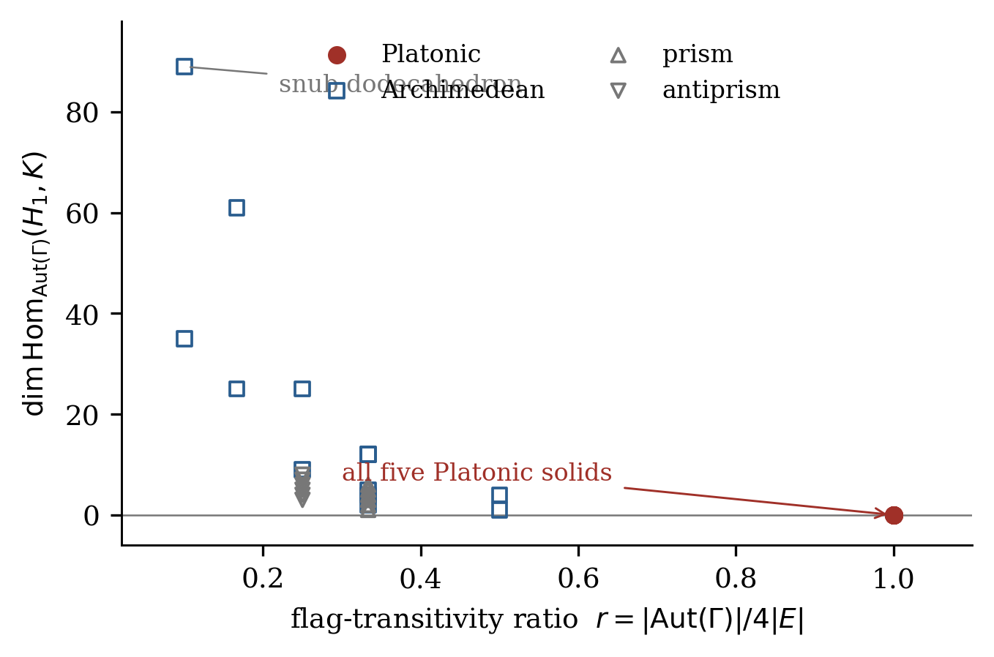
Figure 1. Coupling capacity against the flag-transitivity ratio $r=\left|Aut\left(Γ\right)\right|/4\left|E\right|$. The capacity vanishes on the fibre $r=1$ and at no other point in the census. Vertex-transitivity is decisively excluded as the operative property: the thirteen Archimedean solids are all vertex-transitive and all have positive capacity, ranging from 1 (cuboctahedron) to 89 (snub dodecahedron).
The table is an instance of Theorem A and also a check on it. It is worth recording what it rules out independently of the proof. The cuboctahedron and the icosidodecahedron have the same automorphism group orders as the cube and the dodecahedron respectively, yet differ in capacity by $1$ and $4$, so neither size nor group order accounts for the pattern; and the parity dimension pattern is shared by vanishing and non-vanishing cases alike, so it cannot be what distinguishes them either. The families make the same point in continuous form.
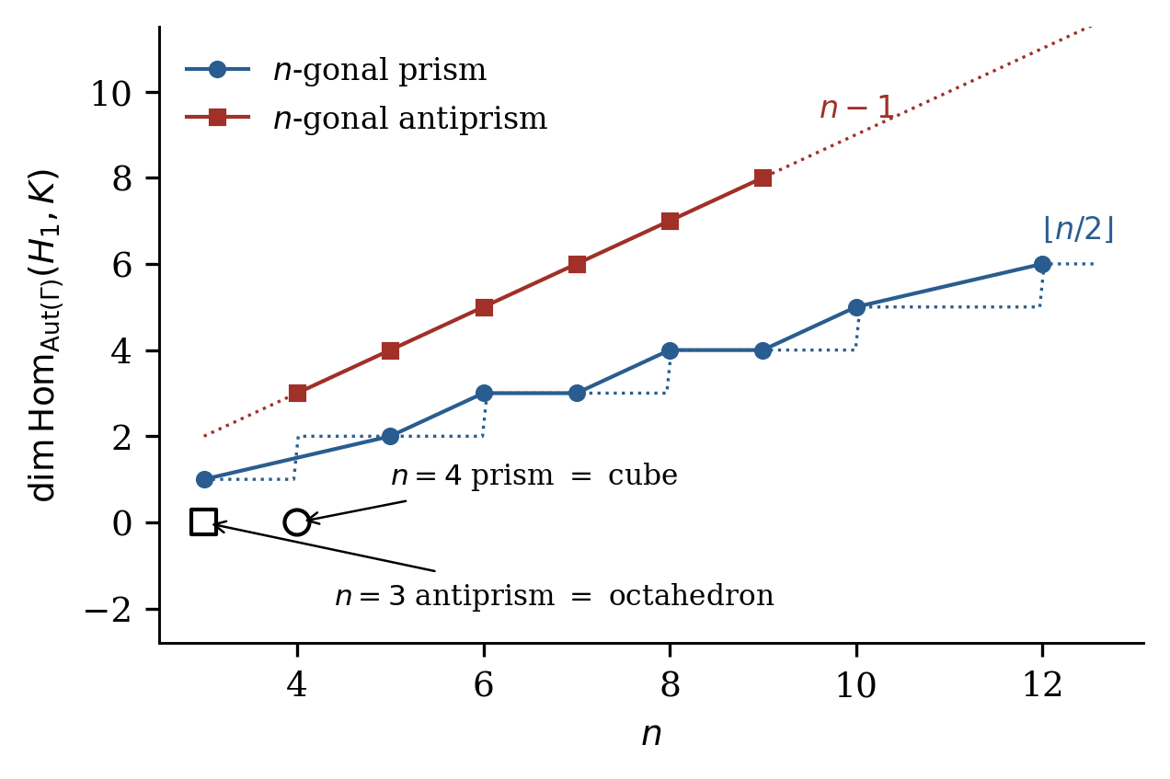
Figure 2. Prism and antiprism families. The capacity grows linearly in the family parameter — except at exactly one member of each family, where the polyhedron happens to be regular and the capacity collapses to zero.
Proposition 5.1. For the $n$-gonal prism with $n≠4$, $c=⌊n/2⌋$. For the $n$-gonal antiprism with $n≠3$, $c=n−1$. At $n=4$ and $n=3$ respectively the polyhedron is regular and $c=0$.
Verified for prisms $n∈\{3,5,6,7,8,9,10,12\}$ and antiprisms $n∈\{4,5,6,7,8,9\}$; the closed forms follow from Theorem 3.2 by counting the reflection-free face–vertex orbits, and are stated here as an observation supported by computation rather than as a theorem with a written proof. The discontinuity is the point: the capacity does not approach zero as the family approaches its regular member, it is zero at that member and at no neighbour. These closed forms are recorded for their own interest; no result below depends on them.

5.1 Duality
Table 2. Duality invariance of the coupling capacity, verified on seven pairs. The Betti numbers differ within every pair; the capacities do not. The final row is the chiral case, in which the $δ$ term is active on both sides.
Primal | $\left|V\right|/\left|E\right|/β_{1}$ | Dual | $\left|V\right|/\left|E\right|/β_{1}$ | $c\left(Γ\right)$ | $c\left(Γ^{*}\right)$
dodecahedron | 20/30/11 | icosahedron | 12/30/19 | 0 | 0
cuboctahedron | 12/24/13 | rhombic dodecahedron | 14/24/11 | 1 | 1
truncated cube | 24/36/13 | triakis octahedron | 14/36/23 | 4 | 4
snub cube | 24/60/37 | pentagonal icositetrahedron | 38/60/23 | 35 | 35
icosidodecahedron | 30/60/31 | rhombic triacontahedron | 32/60/29 | 4 | 4
truncated icosahedron | 60/90/31 | pentakis dodecahedron | 32/90/59 | 12 | 12
6-gonal prism | 12/18/7 | hexagonal bipyramid | 8/18/11 | 3 | 3
Two consequences follow. First, the census extends without further computation to the Catalan solids and to the bipyramids, so the effective coverage is considerably larger than thirty-two. Second — and this is a structural argument rather than a computational one — any property that characterises the vanishing must itself be dual-invariant. Regularity is dual-invariant; vertex-transitivity is not, since the dual of a vertex-transitive polyhedron is face-transitive. Vertex-transitivity is therefore excluded on structural grounds independently of the thirteen Archimedean computations, which is a second and logically independent argument for the same conclusion.

6. An out-of-sample test of the correction term
The $δ$ term was discovered by constructing a case that broke the uncorrected formula. A term found that way is fitted to its witness, and fitting a single case is not verification. We therefore designed a prediction on a case not used in the discovery.
The snub dodecahedron is the second and last chiral Archimedean solid: sixty vertices, one hundred fifty edges, ninety-two faces, automorphism group of order sixty containing no improper element. Its rotation group acts simply transitively on the vertices and with three orbits on the faces, and since no stabiliser can contain an orientation-reversing element, $N\left(F×V\right)=92$, $N\left(F\right)=3$, $N\left(V\right)=1$ and $δ=1$. The corrected formula therefore predicts $c=92−3−1+1=89$, and the uncorrected formula predicts $88$.
The prediction of $89$ was recorded before the computation was run. Direct evaluation of the character inner product over the full automorphism group returned $89$ exactly. As a further control, the snub cube was rebuilt from exact tribonacci coordinates, reproducing $c=35$ against an uncorrected $34$; and its polar dual, the pentagonal icositetrahedron, was constructed and computed separately, returning $35$ and thereby confirming Corollary 3.4 in the one case where $δ$ contributes. This is a modest test — one prediction, integer-valued, on a single object — but it is the right shape of test, and it was available to fail.
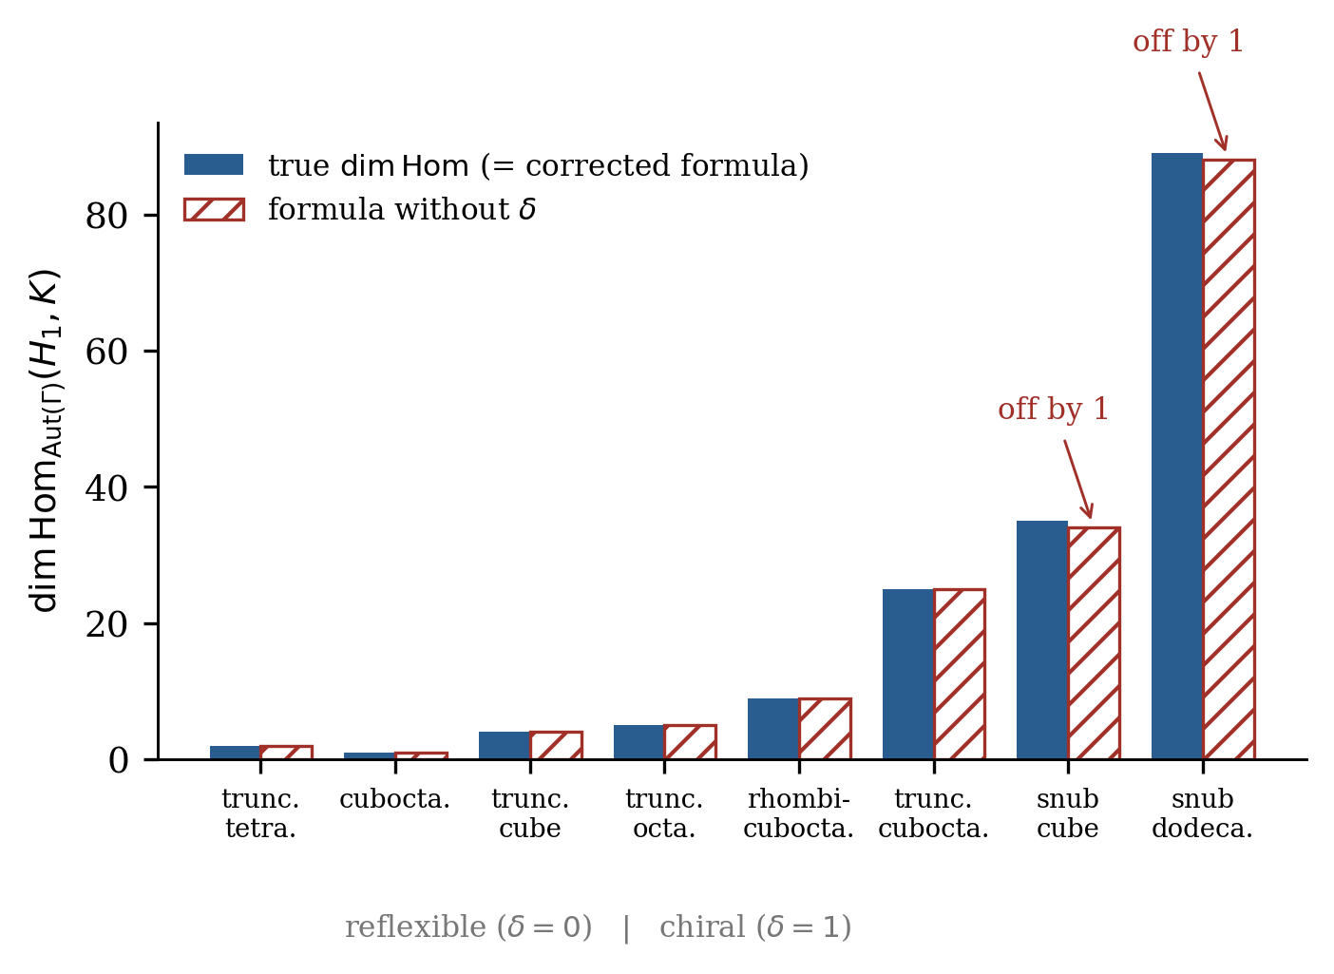
Figure 3. The correction term against data. For reflexible polyhedra ($δ=0$) the corrected and uncorrected formulae agree and both are right. For the two chiral solids the uncorrected formula is wrong by exactly one in each case.

7. Mechanism: a parity selection rule
Theorem 3.2 tells us the capacity but not why it vanishes. In the reflexible case there is a clean mechanism, which we illustrate on the dodecahedron because that is where it is sharpest.
$Aut\left(Γ\right)$ for the dodecahedron is $A_{5}×Z_{2}$, of order $120$, with central involution $ι$ acting as the antipodal map. Under $ι$ the cycle space splits $6:5$ and the cut space splits $9:10$. Under the rotation subgroup $A_{5}$ alone the shared constituents are the two three-dimensional irreducibles and the five-dimensional one, giving $dim{Hom}_{A_{5}}\left(H_{1},K\right)=3$. But every shared constituent that is $ι$-even in one sector is $ι$-odd in the other. An intertwiner $B$ supported on such a channel satisfies $Bι=B$ on the source and $ιB=−B$ on the target, hence $Bι=−ιB$ identically. The three channels therefore survive as $A_{5}$-intertwiners and are extinguished as $Aut$-intertwiners.
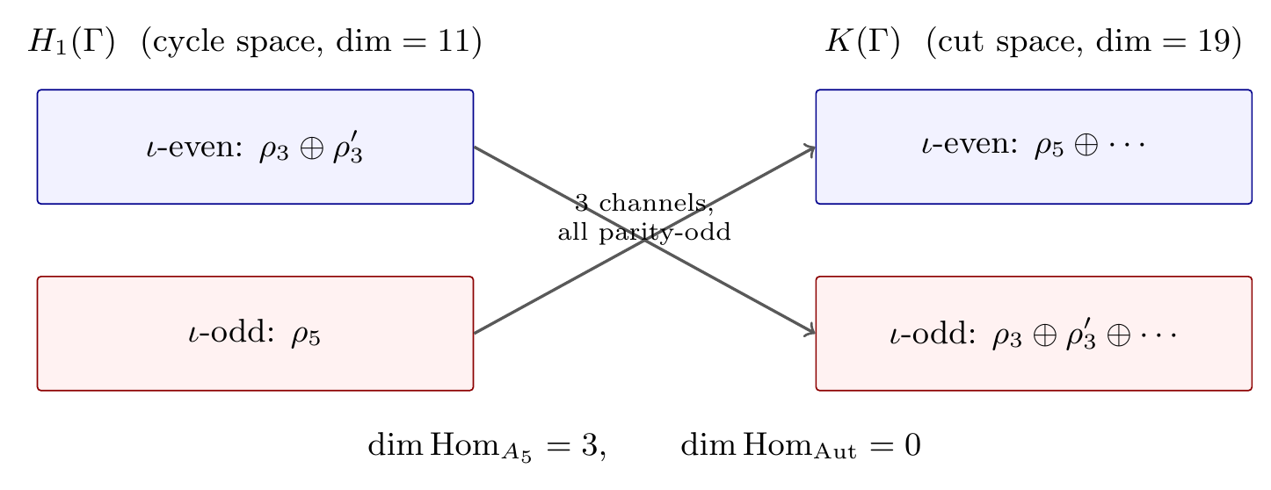
Figure 4. The parity selection rule on the dodecahedron. Every constituent shared between the cycle and cut spaces carries opposite parity under the central involution. The three rotation-equivariant channels therefore all anticommute with $ι$, and none is equivariant under the full automorphism group. The coupling is not forbidden; it is forced to be parity-odd.
We emphasise the reading, because the natural one is wrong. The vanishing of ${Hom}_{Aut}$ is usually described as a no-go: the sectors cannot talk. The parity computation says something stronger and more useful. The channels exist — there are exactly three of them — and what the symmetry does is not close them but fix their transformation law. Every coupling between the two sectors is pseudoscalar. A structure that has broken orientation has three channels available; a structure that has not, has none. The capacity is not destroyed by symmetry, it is made conditional on a frame.
Proposition 7.1. Let $Aut\left(Γ\right)=R×⟨ι⟩$ with $ι$ a central fixed-point-free involution. If every irreducible constituent shared between $H_{1}$ and $K$ carries opposite $ι$-parity in the two sectors, then $c\left(Γ\right)=0$.
The hypothesis is weaker than geometric centrosymmetry — it requires only that $ι$ be central and fixed-point-free, a condition satisfied for instance by the triangular and pentagonal prisms, which have no inversion centre in $R^{3}$. The condition is sufficient but not necessary: the tetrahedron has no central fixed-point-free involution at all, so Proposition 7.1 does not apply to it, yet $c=0$ by Theorem 3.2. The orbit count is the general instrument; the parity rule is the mechanism in the cases where there is one.
The structure of this phenomenon is not unfamiliar in physics. In the quantum-information treatment of reference frames, a party lacking a shared frame is subject to superselection rules that forbid exactly those operations which would require the missing frame; acquiring the frame lifts the restriction and opens the channel [13]. The formal situation here is the same in outline. We record the analogy as an analogy. Nothing in this paper derives the quantum case from the polyhedral one or vice versa.

8. What this establishes, and what it does not
Theorem A is a clean statement, and clean statements invite overreading. We would rather do the refutation ourselves than have it done for us.

8.1 Established
Within the class of skeletons of convex polyhedra: the coupling capacity is exactly an orbit count (Theorem 3.2, proved); it is invariant under polyhedral duality (Corollary 3.4, proved and verified on seven pairs); it vanishes on all five Platonic solids and on none of twenty-seven other tested polyhedra including all thirteen Archimedean solids; vertex-transitivity is excluded as the operative property both computationally and by a duality argument; and in the reflexible centrally-symmetric case the mechanism is a parity selection rule that forces every surviving channel to be pseudoscalar (Proposition 7.1, proved). On the torus the capacity of every chiral member of the two standard classes is given in closed form (Propositions 10.6 and 10.7, both proved). The converse of the regularity criterion is proved for all chiral polyhedra (Proposition 9.4), for every polyhedron with a face axis or vertex direction on fewer than two mirrors (Proposition 9.11), by the two-axis bound of §9.5 for every irregular member of the census, and — by the case analysis of §§9.6–9.7 over the finite subgroups of $O\left(3\right)$ — in general (Theorem 9.23). The $D_{nh}$ family is excluded by Proposition 9.22, which uses only the mirror-covering condition and is independent of the closed forms of §5.

8.2 Not established
This is a result about finite structures and their symmetry groups. It is not a theory of space, and the polyhedron is not a model of spacetime. Nothing here supplies dynamics: there is no time parameter, no update rule, and no derived observable. The identification of “coupling capacity” with anything physical is an interpretation, not a consequence, and this paper offers no empirical prediction.
In particular, we do not claim to have derived Curie’s principle, nor to have shown that it holds beyond this class, nor that the quantity $c\left(Γ\right)$ is the correct measure of “available asymmetry” for any structure that is not a convex polyhedron. What we claim is narrower and, we think, more useful: that on a class where the question is decidable, the qualitative principle admits an exact quantitative form, that form is an orbit count, and its vanishing locus is precisely the maximally symmetric locus. Whether that is a general fact about symmetry and interaction, or a fact about polyhedra, is exactly the open question.
We also decline a suggestive but unearned reading. It is tempting to say that the perfectly symmetric configuration is “unobservable” or “unoccupiable” because it supports no coupling, and thence that the physical world is confined to the asymmetric complement. That inference requires premises this paper does not supply: that coupling capacity is necessary for observation, that observation is necessary for physical instantiation, and that the polyhedral setting is representative. Each is a substantive claim and none is established here. The regular polyhedra exist; what has been shown is that they have zero capacity in a precise and narrow sense, not that they are excluded from anything.

8.3 Provenance: Curie’s principle
In 1894 Pierre Curie set out what is now called Curie’s principle. A phenomenon, he argued, can exist in a medium possessing its characteristic symmetry or that of one of the subgroups of that symmetry; certain symmetry elements may coexist with a phenomenon, but what is necessary is that some symmetry elements be absent. Asymmetry, on his formulation, is what creates a phenomenon [1].
The principle has proved durable and it has also proved slippery. Earman, having given a formulation of it, remarks that the formulation makes it virtually analytic, while maintaining that it remains useful as a guide in the search for explanations of observed asymmetries [2]. Ismael and, later, Castellani and Ismael have examined which of several inequivalent statements deserves the name [3, 4]; Norton has argued that on its most defensible reading it is a truism [5]; Roberts has exhibited a failure in the time-reversal case [6]. The Stanford Encyclopedia treatment situates the principle relative to spontaneous symmetry breaking [7].
Grant the principle in whichever of these readings survives. A question remains that none of these discussions answers, because none is posed at the level where it could be answered: given a specific structure, how much asymmetry does it have available? Curie’s principle is a constraint of the form “not zero.” It is not a measurement. If asymmetry is the resource that phenomena are made from, the resource ought in principle to be countable, its count ought to depend on the structure in a computable way, and it ought to be possible to say exactly which structures have none. Theorem A does that for one class of structures — skeletons of convex polyhedra, the setting in which a symmetry group, a homology, and a natural pair of complementary sectors all coexist finitely, so that the question is decidable rather than merely arguable.
Two features of the answer are worth isolating, since they are facts about $c$ rather than interpretations of it. The characterisation is a biconditional, so the vanishing locus is determined and not merely constrained; and by §9.1 the capacity is not bounded below by any of the natural measures of symmetry deficiency, so only the endpoint statement survives and no graded version of it is available.
Section 10 supplies the sharpest limitation. The strengthened quantitative form is a theorem in the spherical setting and false in the very next setting one would try: on the torus the forward direction fails, on the projective plane the converse fails, and each half is broken by a different surface. That is more informative than “we know of no argument that it should generalise” — we know that it does not. What survives is the narrow claim that the strong form is satisfiable and non-vacuous, together with the new information that its models are scarce, that the property distinguishing them is ambient rigidity rather than symmetry as such, and that any future instance will have to explain why it is more like a polyhedron than like a torus. The wider question of which symmetry arguments survive displacement from their maximally symmetric configuration is pursued in [18] and is not needed for anything proved here.

9. The converse, proved
Theorem 3.2 together with the finite check of §4 proves the forward half of Theorem A. This section proves the converse. We report, in order, two approaches that fail, a complete proof for chiral polyhedra, a reduction of the remaining case to a statement in elementary solid geometry, and a case analysis over the finite subgroups of $O\left(3\right)$ that closes it.

9.1 Two routes that fail
Remark 9.2 (capacity is not bounded below by flag deficiency). Since $q=1/r$ counts flag orbits and $q=1$ characterises regularity, the natural first guess is that each additional flag orbit contributes at least one unit of capacity, that is $c≥q−1$. This is false. The triangular prism has $\left|Aut\right|=12$ and $4\left|E\right|=36$, hence $q=3$, yet $c=1$. The guess fails in the other direction too: the eight prisms in the census all have $q=3$ while their capacities range from $1$ to $6$.
Remark 9.3 (the incident-pair route is closed). A second natural approach works with incident face–vertex pairs, where the flag structure is directly available. Let $I⊆F×V$ be the set of incident pairs, so that $\left|I\right|=2\left|E\right|$, each incident pair lying under exactly two flags. By Lemma 4.1 the stabiliser of an incident pair embeds in the symmetric group on those two flags and so has order $1$ or $2$. A generator of an order-$2$ stabiliser fixes the face centroid and the vertex, hence fixes two independent directions, hence is a reflection by Lemma 9.5. Writing $a$ for the number of free orbits on $I$ and $b$ for the number with reflection stabiliser, orbit counting gives $2a+b=q$, and $N\left(I\right)=a$ exactly.
This is a clean picture but not a theorem. For the cuboctahedron and the icosidodecahedron, $q=2$ with $\left(a,b\right)=\left(0,2\right)$: there is no reflection-free orbit on incident pairs at all, so $N\left(I\right)=0$. Yet $c=1$ and $c=4$ respectively. The entire capacity of these two solids is carried by face–vertex pairs that are not incident, which the flag structure does not see. Any proof of the converse must therefore reach non-incident pairs.

9.2 The chiral case, proved
Proposition 9.4. Let $Γ$ be the skeleton of a chiral convex polyhedron, that is, one with $Aut\left(Γ\right)⊆SO\left(3\right)$. Then $c\left(Γ\right)≥1$.
Proof. Since $Aut\left(Γ\right)$ contains no improper element, every stabiliser is reflection-free, so $N\left(X\right)=\left|X/G\right|$ for every $G$-set $X$, and $δ=1$. Theorem 3.2 becomes $c=\left|F×V/G\right|−n_{F}−n_{V}+1$, where $n_{F}$ and $n_{V}$ are the numbers of face and vertex orbits. Decomposing, $\left|F×V/G\right|$ is the sum over pairs of orbits of $k\left(O_{F},O_{V}\right)$, the number of $Stab\left(f\right)$-orbits on $O_{V}$ for $f∈O_{F}$, and $k≥1$ always. Hence $\left|F×V/G\right|≥n_{F}n_{V}$ and $c≥\left(n_{F}−1\right)\left(n_{V}−1\right)$, which settles the case $n_{F},n_{V}≥2$.
Suppose $n_{V}=1$. Then $c$ is the sum over face orbits of $k\left(O_{F},V\right)−1$. Now $Stab\left(f\right)$ acts faithfully on the $p$-gon $f$ as a group of rotations, so it is cyclic of order at most $p$; and $\left|V\right|≥p+1$, since a convex polyhedron has at least one vertex off any given face. A group of order at most $p$ cannot act transitively on a set of size at least $p+1$, so $k\left(O_{F},V\right)≥2$ for every face orbit, giving $c≥n_{F}≥1$. The case $n_{F}=1$ is symmetric, using that $Stab\left(v\right)$ is cyclic of order at most $deg\left(v\right)$ while $\left|F\right|≥deg\left(v\right)+1$. $◼$
The argument also yields a sharp value in the vertex-transitive case: $c$ is the sum over face orbits of $k−1$, and when $Aut$ acts freely on $V$ this equals $\left|F\right|−n_{F}$. For the snub cube, $38$ faces in three orbits give $35$; for the snub dodecahedron, $92$ faces in three orbits give $89$. Both agree with §6 exactly, which is a third and independent derivation of those two numbers — the first by character inner product, the second by the orbit-count formula, and now the third by a closed-form argument that uses no computation at all.

9.3 A reduction of the reflexible case
Lemma 9.5. Let $Γ$ be a convex polyhedron centred at the origin and let $g∈Aut\left(Γ\right)$ be improper with $g\left(f\right)=f$ and $g\left(v\right)=v$ for some face $f$ and vertex $v$. Then $g$ is a reflection, and its mirror plane contains the axis of $f$.
Proof. An improper element of $O\left(3\right)$ is either a reflection or a rotoreflection through a nonzero angle; the latter fixes only the origin. Now $g$ fixes the face centroid $c_{f}$ and the vertex $v$, both nonzero. If $c_{f}$ and $v$ are linearly independent then $g$ fixes a two-dimensional subspace pointwise and is therefore the reflection in it. If they are parallel they must be antiparallel, since a vertex of a convex body cannot lie on the outward ray through a face centroid, and a rotoreflection about that line negates $c_{f}$ rather than fixing it; so $g$ is a reflection in that case too. Finally, a reflection preserving $f$ fixes $c_{f}$, and its mirror is a linear plane, so the mirror contains the whole line through $c_{f}$, which is the axis of $f$. $◼$
Theorem 9.6 (covering criterion). For the skeleton $Γ$ of a convex polyhedron the following are equivalent:
- $N\left(F×V\right)=0$;
- every face–vertex pair of $Γ$ is fixed by some common reflection of $Γ$;
- for every face $f$, the mirror planes of $Γ$ containing the axis of $f$ cover the entire vertex set.
Each of these implies $N\left(F\right)=N\left(V\right)=δ=0$ and hence $c\left(Γ\right)=0$.
Proof. Stabilisers along a $G$-orbit are conjugate, so $N\left(F×V\right)=0$ says exactly that every pair $\left(f,v\right)$ has an improper element in its stabiliser, which is (ii); Lemma 9.5 upgrades that element to a reflection whose mirror contains the axis of $f$, giving (iii), and (iii) $⇒$ (ii) is immediate. For the last clause: if $N\left(F\right)≥1$ there is a face $f$ with reflection-free stabiliser, and then $Stab\left(f,v\right)⊆Stab\left(f\right)$ is reflection-free for every $v$, so $N\left(F×V\right)≥1$; symmetrically for $N\left(V\right)$. If $δ=1$ then $Γ$ is chiral, every stabiliser is reflection-free, and $N\left(F×V\right)=\left|F×V/G\right|≥1$. $◼$
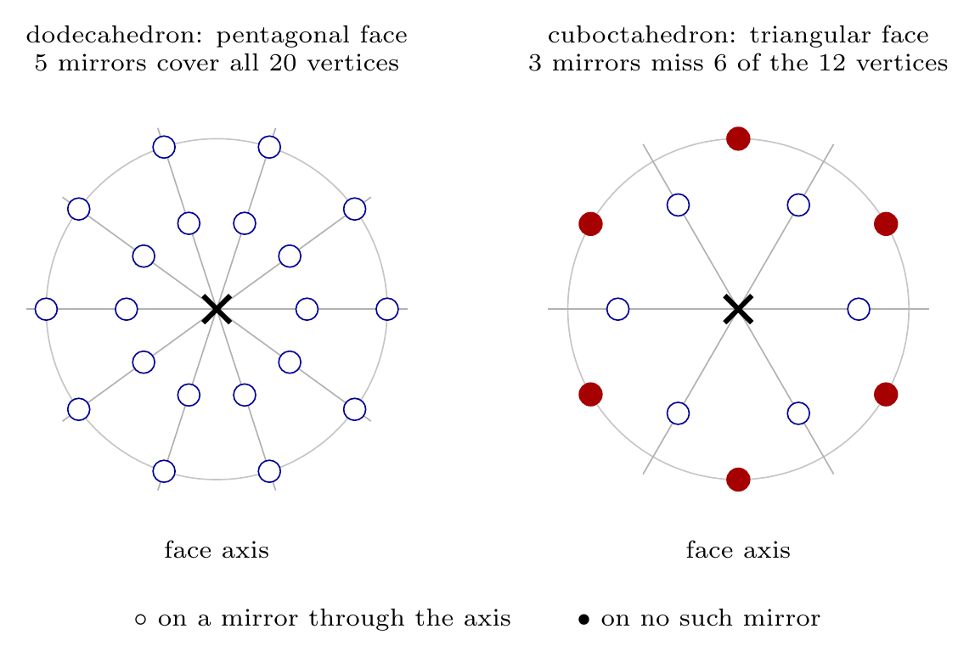
Figure 5. The covering condition of Theorem 9.6(iii), viewed along a face axis so that each mirror plane containing that axis projects to a line through the origin. Left: the dodecahedron, where the condition holds and the capacity vanishes. Right: the cuboctahedron, where three mirrors miss six vertices. Any one of those six, paired with that face, has a reflection-free stabiliser and generates the solid’s single unit of capacity.
This is a genuine reduction. Condition (iii) makes no reference to homology, to representations, or to the cut space; it is a covering statement about great circles on a sphere, checkable by hand for any given solid.
Corollary 9.8 (a numerical necessary condition). If condition (iii) holds then $\left|F×V/Aut\left(Γ\right)\right|≥2\left|F\right|\left|V\right|/\left|Aut\left(Γ\right)\right|$: the number of face–vertex orbits must be at least twice the value it would take under a free action.
Proof. Summing the covering inequality $\left|V\right|≤∑{fix}_{V}\left(σ\right)$ over the reflections $σ$ in $Stab\left(f\right)$, and then over all faces $f$, gives FV≤g improper​fixFgfixVg. By Theorem 9.6, $N\left(F×V\right)=0$ forces $\left|F×V/R\right|=\left|F×V/G\right|$, so the improper and the proper elements contribute equally to that sum. $◼$

9.4 The covering defect
Fix a face $f$ and let $L_{f}$ be its axis. The reflections preserving $f$ all have mirrors containing $L_{f}$ (Lemma 9.5), and two distinct such mirrors meet exactly in $L_{f}$. Counting the incidences between the vertex set and this pencil of mirrors twice over gives the following.
Lemma 9.9. Let $m_{f}$ be the number of reflections of $Γ$ preserving the face $f$, and define the covering defect
Df=V+mf−1 V∩Lf−σ​fixVσ,
the sum being over the reflections $σ$ preserving $f$. Then $D\left(f\right)≥0$ always, and $D\left(f\right)=0$ if and only if the mirrors through $L_{f}$ cover the whole vertex set.
Theorem 9.10. For the skeleton of a convex polyhedron, $N\left(F×V\right)=0$ — and hence $c\left(Γ\right)=0$ — if and only if $D\left(f\right)=0$ for every face $f$.
This is a finite arithmetic test on each face separately. The defect vanishes on every face for exactly the five regular solids, and on no other polyhedron tested. Note what the per-face reading buys: several irregular solids satisfy the covering on some faces and fail it on others. The cuboctahedron has $D=0$ on its square faces and $D=6$ on its triangles; it is the triangles alone that generate its unit of capacity. It is enough for one face to fail.
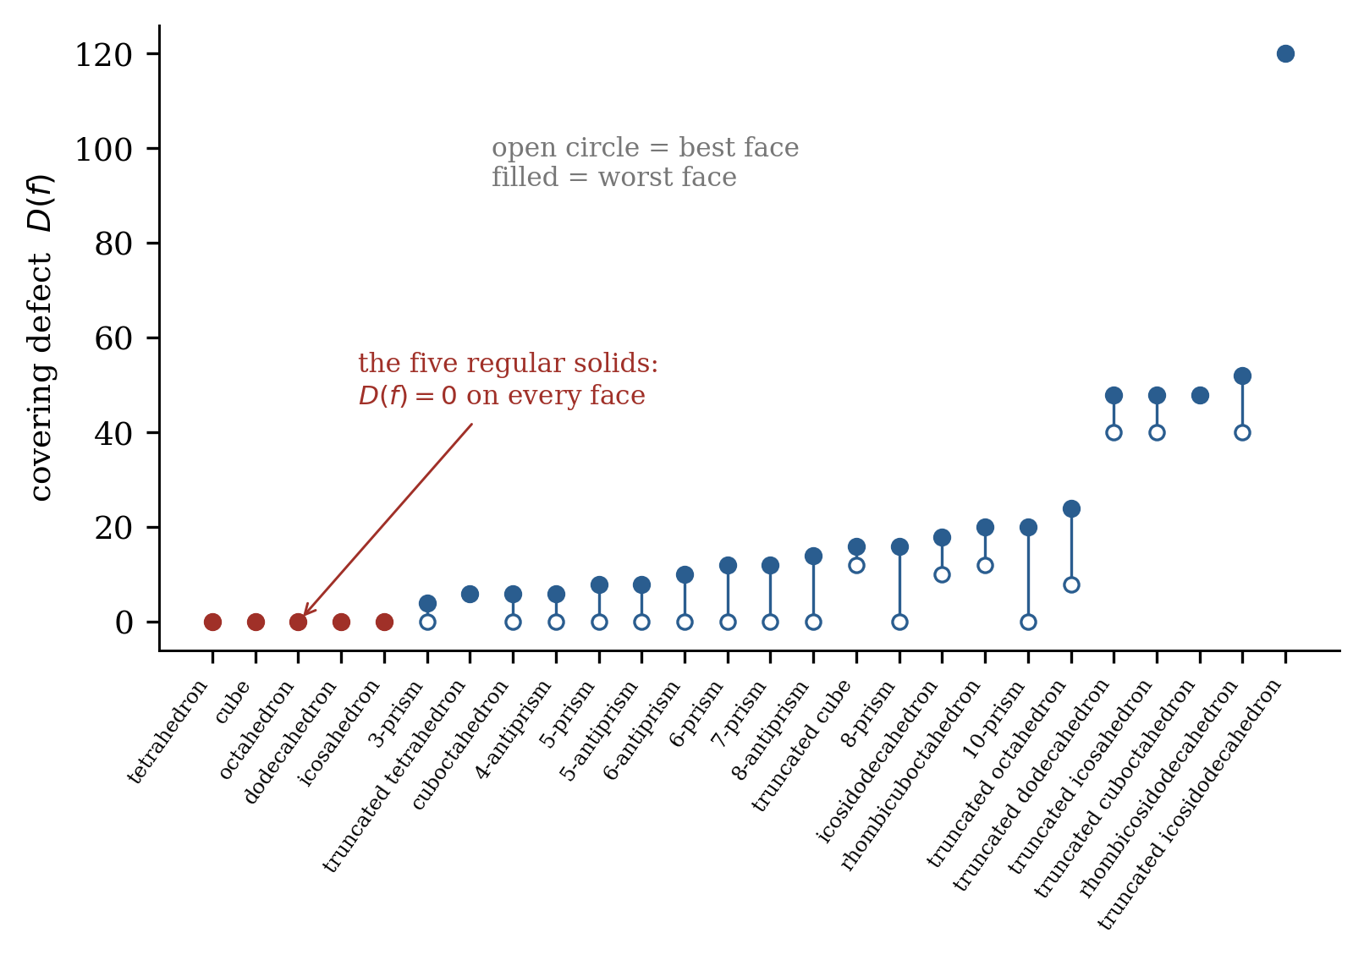
Figure 6. The covering defect across twenty-six polyhedra, sorted by worst face. Each solid is drawn as the range from its best face (open marker) to its worst (filled). The five regular solids are the only ones whose defect vanishes on every face.
Proposition 9.11. If $c\left(Γ\right)=0$ then every face axis and every vertex direction of $Γ$ lies on at least two mirror planes of $Aut\left(Γ\right)$, and is therefore a rotation axis.
Proof. Let $f$ be a face and $m_{f}$ the number of reflections preserving it, all of whose mirrors contain the axis of $f$ (Lemma 9.5). If $m_{f}=0$ the covering condition places $V$ in the empty set, which is absurd. If $m_{f}=1$ it places $V$ inside a single plane through the origin; but the vertices of a convex polyhedron containing the origin span $R^{3}$, so this too is absurd. Hence $m_{f}≥2$, and the axis of $f$, lying on two distinct mirrors, is their line of intersection; the composite of the two reflections is a nontrivial rotation about that line. The statement for vertices follows because condition (ii) of Theorem 9.6 is symmetric in faces and vertices, so it holds for $Γ$ exactly when it holds for the dual $Γ^{*}$. $◼$
Writing $A\left(G\right)$ for the set of directions lying on at least two mirrors of $G$, we obtain a ceiling depending on the symmetry group alone.
Corollary 9.12. If $c\left(Γ\right)=0$ then $\left|V\right|≤\left|A\left(AutΓ\right)\right|$ and $\left|F\right|≤\left|A\left(AutΓ\right)\right|$. For the three polyhedral reflection groups this gives $\left|V\right|≤14$ for $T_{d}$, $\left|V\right|≤26$ for $O_{h}$ and $\left|V\right|≤62$ for $I_{h}$; for the axial families $D_{nh}$ it gives $\left|V\right|≤2n+2$, and for $D_{nd}$ it gives $\left|V\right|≤2$, which no polyhedron satisfies.
Applied to the census, Proposition 9.11 alone settles nineteen of the twenty-one irregular solids, and it does so for structurally different reasons in different families. Every antiprism dies immediately: its group is $D_{nd}$, whose only multiply-covered direction is the principal axis. Every prism dies on its vertices, which lie on exactly one mirror each. The whole truncated family dies the same way. What survives is worth naming. Exactly two irregular solids in the census pass Proposition 9.11 — the cuboctahedron and the icosidodecahedron — and these are precisely the two quasiregular convex polyhedra. The condition therefore reduces the whole question, at least across the census, to the quasiregular case.
Remark 9.13 (a Lefschetz identity). For a reflection $σ$ of a convex polyhedron, let $e\left(σ\right)$ be the number of edges lying in its mirror and $t\left(σ\right)$ the number crossed transversally at their midpoint. Applying the Lefschetz fixed-point formula on $S^{2}$ gives ${fix}_{V}\left(σ\right)+t\left(σ\right)={fix}_{F}\left(σ\right)+e\left(σ\right)$. The common value is the number of sides of the polygon cut from $Γ$ by the mirror, which is what makes the defect computable by inspection of a single cross-section. The identity was verified for every reflection of every solid in the census.

9.5 A two-axis bound
Lemma 9.14 (two-axis bound). Let $f_{1}$ and $f_{2}$ be faces with non-parallel axes, let $m_{1}$ and $m_{2}$ be the numbers of reflections preserving them, and let $s$ be the number of mirrors common to both pencils. If the covering condition of Theorem 9.6(iii) holds, then every vertex not lying on one of the $s$ shared mirrors is one of the isolated points where a mirror of the first pencil meets a distinct mirror of the second. In particular, writing $V_{off}$ for the number of such vertices, $V_{off}≤2\left(m_{1}m_{2}−s\right)$.
Proof. Covering for $f_{1}$ places $V$ inside the union of the first pencil, and covering for $f_{2}$ inside the union of the second, so $V$ lies in the intersection of the two unions. That intersection is the union of the $s$ shared great circles together with the pairwise intersections of non-identical mirrors, and two distinct great circles meet in exactly two antipodal points. There are at most $m_{1}m_{2}−s$ non-identical pairs, each contributing two points. $◼$
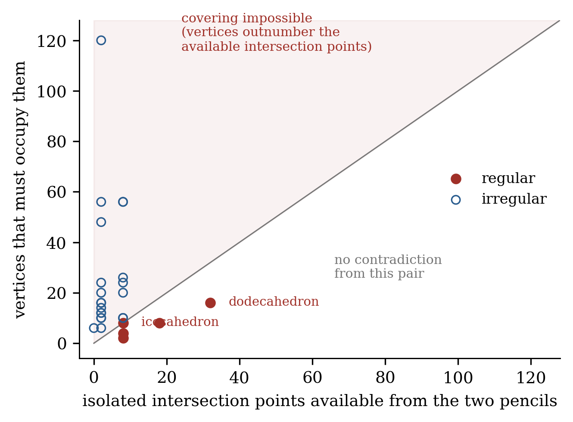
Figure 7. Points above the diagonal require more vertices than the two mirror pencils can accommodate, and the covering condition is therefore impossible for them. All twenty-one irregular solids of the census lie strictly above the diagonal; all five regular solids lie on or below it. The bound is not tight, so it is not saturation that separates the two classes.
Theorem 9.15. For every irregular polyhedron in the census, the two-axis bound is violated at some pair of faces. Consequently the covering condition fails, and $c\left(Γ\right)≥1$, by an argument independent of the orbit computation of §5. The bound is violated by none of the five regular solids.
This changes the evidential status of the census rather than merely adding to it. Every entry of Table 1 with $c>0$ now carries two independent proofs of positivity: one by computing the orbit count, and one by an elementary count of great-circle intersections that never touches homology or representation theory. The two arguments share no machinery, so a systematic error in the representation-theoretic pipeline could not produce both.
What the theorem is not is a proof of the converse in general. Lemma 9.14 supplies a test, and the test happens to fire on all twenty-one irregular solids we examined; nothing here shows it must fire on every irregular polyhedron.
Conjecture 9.16. For every irregular convex polyhedron there exists a pair of faces with non-parallel axes at which the bound of Lemma 9.14 is violated. This implies Theorem 9.23 and is, unlike it, a statement purely about arrangements of great circles.

9.6 The polyhedral groups, settled by enumeration
Proposition 9.11 does more than eliminate candidates: it makes the problem finite. If $c\left(Γ\right)=0$ then every vertex direction lies in $A\left(G\right)$, a finite set determined by the symmetry group alone. A convex polyhedron centred at the origin has at most one vertex on each ray, so its vertex set is a union of $G$-orbits within $A\left(G\right)$, one radius per orbit.
Lemma 9.17. If the vertex set of a convex polyhedron is a union of two or more disjoint $Aut$-orbits, then some face has vertices from more than one orbit.
Proof. Suppose every face is monochromatic and let $U$ be the union of the faces whose vertices lie in one particular orbit. If $U$ is neither empty nor the whole surface it has a boundary edge, and the two endpoints of that edge are vertices of a face inside $U$ and of a face outside it, hence lie in two disjoint orbits at once — impossible. So $U$ is empty or everything; but it cannot be empty, since every vertex lies on some face, and it cannot be everything, since the other orbits then lie on no face. $◼$
Now let $f$ be a face mixing two orbits, with centroid on an axis $m$. By Proposition 9.11 and the symmetry of $f$ about $m$, the face lies in a plane perpendicular to $m$, so all its vertices share the same value of $x⋅m$. If $p$ and $q$ are unit vectors of the two orbits appearing in $f$, at radii $1$ and $t$, this forces $t=\left(p⋅m\right)/\left(q⋅m\right)$. The admissible radius ratios therefore form an explicit finite set, computable from the group alone, and the candidate combinatorial types are finite in number.
Theorem 9.18. Carrying out this enumeration for the three polyhedral reflection groups, the candidates surviving Proposition 9.11 are in each group exactly the regular polyhedra of that group together with the quasiregular polyhedron and its dual; and of those, only the regular ones have $c=0$. Consequently, for a convex polyhedron whose automorphism group is $T_{d}$, $O_{h}$ or $I_{h}$, $c\left(Γ\right)=0$ if and only if $Γ$ is Platonic.
The enumerations comprise nine candidate types for $I_{h}$, eight for $O_{h}$ and seven for $T_{d}$, with the admissible radius ratios given in closed form by the condition above.

9.7 The axial families, and the completion of the proof
Proposition 9.19. No convex polyhedron whose automorphism group is $T_{h}$ can satisfy the covering condition.
Proof. $T_{h}$ has exactly three mirrors, mutually perpendicular, so $A\left(T_{h}\right)$ consists of the six coordinate directions, a single $T_{h}$-orbit. The only candidate vertex set is therefore the octahedron, whose automorphism group is $O_{h}$ and not $T_{h}$. $◼$
Proposition 9.21. No convex polyhedron whose automorphism group is $C_{nv}$, $C_{nh}$, $S_{2n}$ or $D_{nd}$ satisfies the covering condition, for any $n$.
Proof. The mirrors of $C_{nv}$ are $n$ planes through the principal axis, so any two of them meet in that axis and $A$ consists of two points. The same holds for $D_{nd}$, whose mirrors are the $n$ dihedral planes. $C_{nh}$ has the single mirror $σ_{h}$ and $S_{2n}$ has none at all, so in both cases no direction lies on two mirrors and $A$ is empty. Since a convex polyhedron has at least four vertices and, by Proposition 9.11, all of them lie in $A$, none of these groups admits one. $◼$
The one substantial family is $D_{nh}$ with $n≥2$ — the case $n=1$ being $D_{1h}≅C_{2v}$, already excluded by Proposition 9.21. Its mirrors are the $n$ vertical planes together with the equatorial plane $σ_{h}$. Two vertical planes meet in the principal axis; a vertical plane meets $σ_{h}$ in a horizontal line. Hence $A\left(D_{nh}\right)$ consists of the two poles and the $2n$ points where the vertical mirrors cross the equator.
Proposition 9.22. No convex polyhedron whose automorphism group is $D_{nh}$ has $c\left(Γ\right)=0$, for any $n$.
Proof. Suppose $c\left(Γ\right)=0$. By Proposition 9.11 every vertex direction lies in $A\left(D_{nh}\right)$. The equatorial points are coplanar and the poles are two antipodal points, so a vertex set drawn from $A\left(D_{nh}\right)$ spans $R^{3}$ only if it contains at least one pole and at least three equatorial points. Since $σ_{h}∈D_{nh}$ exchanges the poles, both are present. Hence $Γ$ has vertex set $\{±P\}∪B$ with $B$ a set of at least three equatorial points. No further constraint on $B$ is needed below: in particular $B$ may be a single $Aut$-orbit or two orbits at distinct radii, and the argument does not distinguish the cases.
Let $Q=conv\left(B\right)$ in the equatorial plane. Every point of $B$ is a vertex of $Q$: otherwise it would be a convex combination of the other points of $B$, and hence also of the other vertices of $Γ$, contrary to its being a vertex of $Γ$. In particular $B$ is not collinear, so $Q$ is two-dimensional. Moreover the principal axis meets the interior of $Q$: the cyclic rotation subgroup $C_{n}$ preserves $B$ and, for $n≥2$, has no nonzero fixed vector in the equatorial plane, so averaging the $C_{n}$-orbit of any point of $B$ exhibits the origin as a strict convex combination of points of $B$. (For $n=2$ this places the origin in the relative interior of a chord $\left[b,−b\right]$ of $Q$; that chord cannot be an edge of $Q$, since $−1∈C_{2}$ preserves $Q$ and would have to preserve the supporting half-plane of that edge while reversing it.)
The plane $z=0$ therefore meets the interior of $Γ$, and $Γ∩\{z=0\}=Q$. No face contains both poles, since the segment joining them passes through the interior; nor can a face be wholly equatorial. Consequently each face contains exactly one pole. If $P$ is that pole, the intersection of the face plane with the equatorial plane is a supporting line of $Q$, and so meets $Q$ in a vertex or an edge. It cannot be a single vertex: the face would then have exactly one vertex in $B$ and so be the segment from $P$ to that vertex, not a two-dimensional face. Hence every face is the cone from $P$ over an adjacent boundary pair $\{b_{i},b_{i+1}\}$ of $Q$.
Now count the reflections preserving such a face $f$. The horizontal mirror $σ_{h}$ carries $P$ to $−P∉f$, so it does not stabilise $f$. Suppose two distinct vertical mirrors stabilised $f$. Their composite is a nonidentity rotation about the principal axis stabilising the set $\{b_{i},b_{i+1}\}$, and it either fixes both endpoints or interchanges them. It cannot fix them: a nonidentity rotation about the principal axis has no nonzero fixed vector in the equatorial plane, so it acts freely on the vertices of $Q$. Nor can it interchange them: that would force $b_{i+1}=−b_{i}$, so the edge $\{b_{i},b_{i+1}\}$ of $Q$ would contain the origin, contradicting the fact established above that the origin lies in the interior of $Q$. Hence at most one vertical mirror stabilises $f$, so $m_{f}≤1$. Proposition 9.11 requires $m_{f}≥2$ when $c\left(Γ\right)=0$, a contradiction. $◼$
The two dual families are worth comparing, because they show that Proposition 9.11 has two branches which fail on opposite sides. Corollary 3.4 guarantees that a prism and its dual bipyramid share a capacity, but the obstruction producing that capacity is not the same obstruction: prisms satisfy $m_{f}=2$ on every face and die on their vertices, where $m_{v}=1$, while bipyramids satisfy $m_{v}=2$ at every vertex and die on their faces, where $m_{f}≤1$. Verified on regular bipyramids for $n=3,…,10$ and on bipyramids over $2n$-gons with alternating radii — the configuration in which the equatorial points of $A\left(D_{nh}\right)$ split into two orbits — for $n=3,…,6$; in every case $\min_{f}m_{f}≤1$ and $c≥1$.
Every case is now closed.
Theorem 9.23 (main theorem). Let $Γ$ be the skeleton of a convex polyhedron. Then $c\left(Γ\right)=0$ if and only if $Γ$ is regular. Equivalently, the orthogonal projection onto the cycle space is the unique $Aut\left(Γ\right)$-invariant projection precisely for the five Platonic solids.
Proof. The forward direction is Theorem 3.2 with the finite check of §4. For the converse, $Aut\left(Γ\right)$ is a finite subgroup of $O\left(3\right)$ and therefore lies in the classical list $C_{n}$, $C_{nv}$, $C_{nh}$, $S_{2n}$, $D_{n}$, $D_{nd}$, $D_{nh}$, $T$, $T_{d}$, $T_{h}$, $O$, $O_{h}$, $I$, $I_{h}$. The groups $C_{n}$, $D_{n}$, $T$, $O$ and $I$ contain no improper element, so $Γ$ is chiral and Proposition 9.4 applies. The groups $C_{nv}$, $C_{nh}$, $S_{2n}$ and $D_{nd}$ are excluded by Proposition 9.21, and $T_{h}$ by Proposition 9.19. For $D_{nh}$, Proposition 9.22 applies. For $T_{d}$, $O_{h}$ and $I_{h}$, Theorem 9.18 leaves only the Platonic solids. In every case an irregular $Γ$ has $c\left(Γ\right)≥1$. $◼$
Two remarks on how the proof is put together, since its parts are of different kinds. Everything up to and including Proposition 9.11 is ordinary mathematics. From there the argument is a finite case analysis over the classification of finite subgroups of $O\left(3\right)$, and three of its cases — the enumerations for $T_{d}$, $O_{h}$ and $I_{h}$ — are computer-assisted. The accompanying reproducibility package supplies a coordinate-based route, which builds candidate polyhedra in $R^{3}$, checks convex-hull incidence, and obtains symmetry groups by isometry matching. The computation supports the finite enumeration; it is not used in place of the general $D_{nh}$ argument above, which is unconditional. A fully independent implementation would strengthen the certificate and remains desirable. The enumerations are also small enough to be checked by hand: nine candidate types for $I_{h}$, eight for $O_{h}$, seven for $T_{d}$.
The second remark concerns reproducibility of the group theory, because it is the step where an error would be silent. All symmetry groups used here were obtained by matching isometries against explicit coordinate realisations rather than by closing a set of generators, and were checked for closure: the tetrahedral, octahedral and icosahedral groups closed exactly, with orders $24$, $48$ and $120$ and with $7$, $13$ and $31$ rotation axes respectively. A separate attempt to build the axial groups from generators produced a non-closing set for $D_{nd}$, and the results reported for that family come from coordinate-derived groups instead, verified for both parities of $n$. This is worth recording because a leaking group inflates the mirror count, which would in turn inflate $A\left(G\right)$ and weaken every bound built on it in the safe direction — an error of that kind produces false survivors, not false eliminations.

9.8 Remaining problems
Beyond the polyhedral case. Lemma 3.1 uses planarity essentially, and that is a statement about surfaces. The reduction therefore has no content for general graphs, where Problem 7 of [10] remains open.
Quantitative form. The closed forms of Proposition 5.1 suggest that $c\left(Γ\right)$ may admit expression in terms of standard invariants for structured families. We have no general conjecture.

10. The theorem is specific to the sphere
It is natural to ask whether Theorem A is an instance of something more general — whether, wherever a finite group acts on a pair of complementary sectors, the space of equivariant channels between them vanishes exactly at maximal symmetry. The nearest available test is to replace the sphere by a surface of higher genus, and the answer there is negative. We record it because a failure in the adjacent case constrains the reading of §8.3 far more than a second confirmation would.

10.1 The setting, and how the reduction changes
Let $Γ$ be a graph cellularly embedded in a closed orientable surface $S$ of genus $g$, presented by a rotation system. Two things differ. First, an embedding is no longer determined by the graph — Whitney’s theorem has no analogue above genus $0$ — so the relevant group is the automorphism group of the map, not of the abstract graph. Second, the cycle space is larger than the face module: the sequence $0→im∂_{2}→ker∂_{1}→H_{1}\left(S;R\right)→0$ is no longer degenerate. Since the coefficient field has characteristic zero and the group is finite, the sequence splits, and Lemma 3.1 generalises to
$$Z\left(Γ\right)≅\left(R^{F}⊖1\right)⊗ε⊕H_{1}\left(S;R\right), K\left(Γ\right)≅R^{V}⊖1,$$
the second summand having dimension $2g$. The capacity accordingly splits as a sum of a face term, computed by the orbit count of Theorem B, and a genus term $dimHom\left(H_{1}\left(S\right),K\right)$. We verified the splitting on every map reported below: the residual character has dimension exactly $2g$ in each case, and it vanishes identically at genus $0$.

10.2 Regular maps on the torus with positive capacity
Table 3. Regular maps on the torus. Every entry is flag-transitive, and so regular in the sense Theorem A uses. The maps with positive capacity are counterexamples to any extension of Theorem A beyond the sphere. The genus term is zero throughout, so the failure is not caused by the extra homology of the surface.
map | $\left|V\right|$ | $\left|E\right|$ | $\left|F\right|$ | $\left|Aut\right|=4\left|E\right|$ | $c$ | face term | genus term
$\{4,4\}_{3,0}$ | 9 | 18 | 9 | 72 | 0 | 0 | 0
$\{4,4\}_{4,0}$ | 16 | 32 | 16 | 128 | 1 | 1 | 0
$\{4,4\}_{5,0}$ | 25 | 50 | 25 | 200 | 1 | 1 | 0
$\{4,4\}_{6,0}$ | 36 | 72 | 36 | 288 | 3 | 3 | 0
$\{3,6\}_{3,0}$ | 9 | 27 | 18 | 108 | 0 | 0 | 0
$\{3,6\}_{4,0}$ | 16 | 48 | 32 | 192 | 1 | 1 | 0
$\{3,6\}_{5,0}$ | 25 | 75 | 50 | 300 | 2 | 2 | 0
$\{6,3\}_{2,0}$ | 8 | 12 | 4 | 48 | 0 | 0 | 0
$\{6,3\}_{3,0}$ | 18 | 27 | 9 | 108 | 0 | 0 | 0
$\{6,3\}_{4,0}$ | 32 | 48 | 16 | 192 | 1 | 1 | 0
Theorem 10.1. Theorem A does not extend to surfaces of positive genus. The map $\{4,4\}_{5,0}$, the $5×5$ toroidal grid, has $V=25$, $E=50$, $F=25$ and automorphism group of order $200=4\left|E\right|$; it is therefore a regular map, and $c=1$. Its map automorphism group coincides with the automorphism group of the underlying graph, so the conclusion does not depend on which of the two groups is used.
The value was computed by two independent routes: as the character inner product over the full automorphism group, and by solving the equivariance equations directly on $Hom\left(Z,K\right)$, which returns a one-dimensional solution space.
A word is owed on why the witness is the $5×5$ grid rather than the $4×4$ grid, which is smaller and carries the same capacity. Above genus $0$ an embedding is not determined by its graph, so the map automorphism group may be a proper subgroup of the graph automorphism group; and where the two differ so does the capacity, since enlarging the group can only shrink the space of equivariant maps. For $\{4,4\}_{4,0}$ they differ substantially: the map group has order $128=4\left|E\right|$, while the automorphism group of the underlying graph $Z_{4}×Z_{4}$ has order $384$. The additional automorphisms do not preserve the embedding — one of them carries a small square cycle to a row cycle, as observed in [10] — and over the full graph group the capacity of $\{4,4\}_{4,0}$ is $0$ rather than $1$. We verified this directly, and it agrees with [10]. Problem 7 of [10] is posed for the automorphism group of the graph; on the sphere the distinction is empty, which is why nothing in this section affects Theorem A or Corollary D. At genus $1$ the distinction is real, and $\{4,4\}_{4,0}$ is precisely a map on which it bites. The $5×5$ grid has automorphism group of order $200$ under both readings, and it therefore establishes the failure of Theorem A whichever group is intended.

10.3 Where the proof breaks
It is worth being precise about which step fails, because the failure is sharper than a general loss of control. The genus term contributes nothing in any of these examples. What fails is the face term, which is to say the covering argument of §§9.3–9.4. That argument used the ambient Euclidean geometry twice and essentially: Lemma 9.5 identified the improper elements fixing a face and a vertex as reflections in planes of $R^{3}$, and Proposition 9.11 concluded that a face with only one such mirror would confine the entire vertex set to a plane, which is impossible because the vertices of a convex body span space. On a surface of higher genus there are no planes, the fixed-point set of an orientation-reversing map automorphism is a curve rather than the trace of a linear subspace, and there is no spanning argument to be had. The crutch is genuinely Euclidean.
So Theorem A should be read as a fact about polyhedra rather than as a shadow of a general principle relating symmetry to interaction. The relation it asserts holds on the sphere, where a flag-transitive symmetry group is realised by isometries of $R^{3}$ and its mirror arrangement is rigid enough to force the covering condition; it fails on the torus, where flag-transitivity is just as available but the rigidity is not.

10.4 The toroidal exceptions are finite
The maps $\{4,4\}_{b,c}$ are the square lattice modulo the sublattice generated by $\left(b,c\right)$ and $\left(−c,b\right)$, with $b^{2}+c^{2}$ vertices; the maps $\{3,6\}_{b,c}$ are the triangular lattice modulo the sublattice generated by $\left(b,c\right)$ and $\left(−c,b+c\right)$, with $b^{2}+bc+c^{2}$ vertices. A member is reflexible — and so flag-transitive, hence regular — when $c=0$ or $b=c$, and chiral otherwise, in which case its automorphism group has order $2\left|E\right|$ rather than $4\left|E\right|$. We computed the capacity for all thirty-two admissible members of $\{4,4\}_{b,c}$ with $b≤7$ and all twenty-four members of $\{3,6\}_{b,c}$ with $b≤6$.
Theorem 10.2. Among the fifty-six toroidal maps examined, the capacity vanishes for exactly three: $\{4,4\}_{2,2}$, $\{4,4\}_{3,0}$ and $\{3,6\}_{3,0}$ (together with the dual $\{6,3\}_{3,0}$, whose capacity agrees by Corollary 3.4). Every other member has $c≥1$, and the capacity grows without bound within each class.
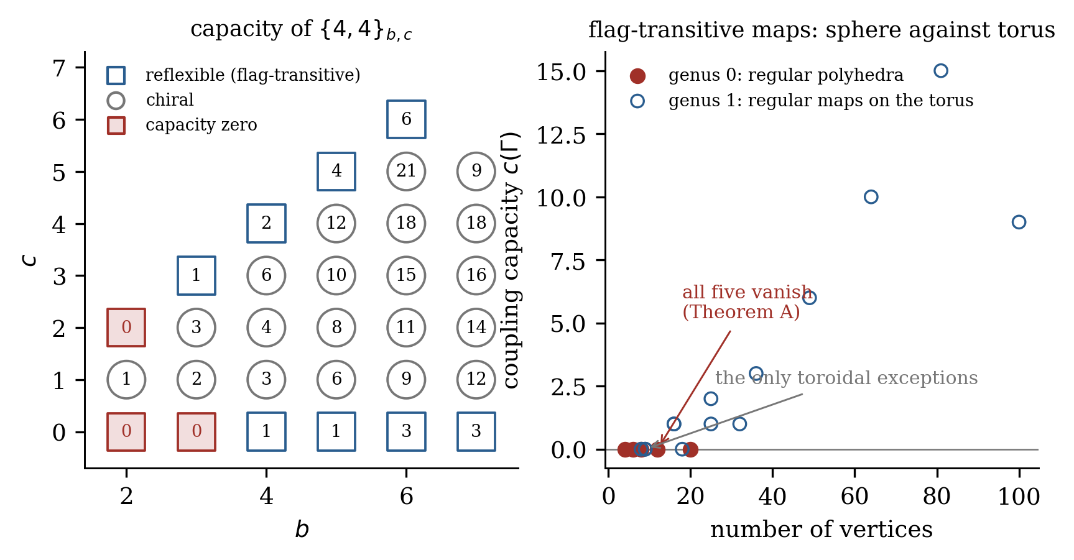
Figure 8. Left: the capacity of $\{4,4\}_{b,c}$ on the $\left(b,c\right)$ lattice. Only two entries vanish, and their neighbours in the same class do not. Right: flag-transitive maps on the sphere and on the torus, plotted against vertex count. On the sphere every regular map has zero capacity — that is Theorem A. On the torus the regular maps climb, with a handful of small exceptions.
Three features of the scan are worth stating separately. First, every chiral member has positive capacity, twenty-one of twenty-one in the square class and all of the triangular ones, which is the toroidal counterpart of Proposition 9.4 and suggests that argument does not depend on the ambient geometry. Second, among the flag-transitive members only two of eleven vanish in the square class and one of eight in the triangular class, and the vanishing members are not distinguished from their neighbours by any symmetry property: $\{4,4\}_{3,0}$ has capacity zero while $\{4,4\}_{4,0}$ and $\{4,4\}_{3,3}$ are equally regular and have capacities $1$ and $1$. Third, Corollary 3.4 continues to hold, so duality invariance is not a spherical accident even though the characterisation is.
That settles the question the counterexample raised. The torus does have a vanishing locus, and it is finite, so in a trivial sense it too admits a characterisation — by a list. But the list is an artefact of small size rather than the trace of a symmetry condition. On the sphere, “capacity zero” and “maximally symmetric” pick out the same five objects, and the coincidence of a homological condition with a group-theoretic one is the content of Theorem A. On the torus the two conditions come apart: maximal symmetry is abundant and cheap, capacity zero is rare and accidental, and neither implies the other. Whatever it is that makes the spherical case work, it is not symmetry by itself.

10.5 Chirality is genus-independent
One half of the argument does survive the passage to higher genus, and identifying which half sharpens the diagnosis considerably.
Proposition 10.3. Let $M$ be a chiral map on a closed orientable surface. Then $c\left(M\right)≥1$ in each of the following cases: (i) $M$ has at least two vertex orbits and at least two face orbits; (ii) $M$ is vertex-transitive and $\left|V\right|$ exceeds the largest face size; (iii) $M$ is face-transitive and $\left|F\right|$ exceeds the largest vertex degree.
Proof. Chirality gives $δ=1$ and $N\left(X\right)=\left|X/G\right|$ for every $G$-set $X$, so the face term is $\left|F×V/G\right|−n_{F}−n_{V}+1$, and the genus term is nonnegative. Each pair of orbits contributes at least one orbit to $F×V$, so $\left|F×V/G\right|≥n_{F}n_{V}$ and the face term is at least $\left(n_{F}−1\right)\left(n_{V}−1\right)$, which gives (i). For (ii), with $n_{V}=1$ the face term is the sum over face orbits of $k\left(O_{F},V\right)−1$. The stabiliser of a face acts on that face’s boundary darts by rotation and is therefore cyclic of order dividing the face size, hence of order less than $\left|V\right|$ by hypothesis; a group of order less than $\left|V\right|$ cannot act transitively on $V$, so every $k$ is at least $2$. Case (iii) is dual. $◼$
The point is what the proof does not use. There is no embedding in $R^{3}$, no mirror plane, no spanning argument — only the orbit count, the fact that a face stabiliser is cyclic, and a comparison of two integers. Proposition 9.4 was stated for chiral convex polyhedra, but it never needed them to be polyhedra.
We tested both branches. For hypothesis (ii) we used Cayley maps, generating eighty-five chiral maps from small groups across genus $0$ through $16$. Every one has $c≥1$, and the minimum observed capacity is exactly $1$. For hypothesis (i) we used bi-Cayley maps: of the maps generated, one hundred seventy-two are chiral with at least two vertex orbits and at least two face orbits, spanning genus $0$ through $15$. None violates the bound $c≥\left(n_{F}−1\right)\left(n_{V}−1\right)$, and none has $c=0$. Across the two constructions, two hundred fifty-seven chiral maps on surfaces of genus up to $16$ have been checked and every one has positive capacity.
The bi-Cayley evidence is weaker than its volume suggests, and we would rather say so than let the count carry more than it should. Those maps have automorphism groups small relative to their size, so their orbit counts on face–vertex pairs are large and the capacity comes out far above the bound — the minimum observed is $17$ against bounds between $1$ and $3$. The informative cases would be chiral maps that are highly symmetric and yet have several vertex orbits, and those are harder to construct; we have not found a systematic source.
This changes the reading above. It is not that the whole argument for Theorem A collapses off the sphere; it is that the argument has two halves which behave quite differently. The chiral half is combinatorial and survives to every genus we have tested. The reflexible half — Lemma 9.5, Proposition 9.11, and everything built on them — is the part that runs through planes in $R^{3}$, and it is exactly the part that fails. The Euclidean input is therefore not a convenience distributed through the proof but a load-bearing element of one specific branch.

10.6 The chiral toroidal capacity in closed form
Proposition 10.6. Let $\{4,4\}_{b,c}$ be chiral, so that $b>c>0$, and write $N=b^{2}+c^{2}$ for its vertex count. Then $c\left(\{4,4\}_{b,c}\right)=⌊\left(N−1\right)/4⌋$.
Proof. Identify the vertex set with the quotient ring $Z\left[i\right]/\left(β\right)$, where $β=b+ci$ and $N$ is the norm of $β$. The orientation-preserving automorphisms are the maps $z↦i^{k}z+t$ for $k∈Z/4$ and $t∈Z\left[i\right]/\left(β\right)$, a group of order $4N$; since the map is chiral this is the whole automorphism group. The faces form the coset $ω+Z\left[i\right]/\left(β\right)$ with $ω=\left(1+i\right)/2$. Chirality gives $δ=1$, and since no stabiliser contains an orientation-reversing element, $N\left(V\right)=n_{V}=1$ and $N\left(F\right)=n_{F}=1$. Theorem 3.2 therefore reduces to $c=N\left(F×V\right)−1$.
It remains to count the orbits on face–vertex pairs. For the element $\left(t,i^{k}\right)$ the fixed vertices are the solutions of $\left(i^{k}−1\right)z=−t$, forming a coset of $K_{k}=ker\left(i^{k}−1\right)$ when $−t$ lies in the image ideal ${Im}_{k}$ and absent otherwise. The fixed faces satisfy the same equation with $t$ displaced by $δ_{k}=\left(i^{k}−1\right)ω$, which equals $0$, $−1$, $−\left(1+i\right)$ and $−i$ for $k=0,1,2,3$ and is a Gaussian integer in every case. Since ${Im}_{k}$ is a subgroup, the two conditions hold together precisely when $t∈{Im}_{k}$ and $δ_{k}∈{Im}_{k}$. The number of admissible $t$ is then $\left|{Im}_{k}\right|=N/\left|K_{k}\right|$, and each contributes ${\left|K_{k}\right|}^{2}$ fixed pairs, so Burnside’s lemma collapses to
NF×V = 14k​ δk∈Imk ⋅Kk,
in which the factor $N$ has cancelled entirely. The four terms are evaluated in $Z\left[i\right]$, a principal ideal domain in which $1+i$ is the unique prime above $2$. The term $k=0$ contributes $N$. The elements $i−1$ and $1+i$ are associates, so $k=1$ and $k=3$ contribute equally, each contributing $\left|K_{1}\right|=1$ exactly when $i−1$ is invertible modulo $β$, which happens exactly when $N$ is odd. The term $k=2$ is governed by $gcd\left(2,β\right)$: if $N$ is odd then $\left|K_{2}\right|=1$ and ${Im}_{2}$ is the whole quotient, contributing $1$; if $N≡2 (mod 4)$ then $gcd\left(2,β\right)=1+i$, so $\left|K_{2}\right|=2$ and $1+i∈{Im}_{2}$, contributing $2$; and if $N≡0 (mod 4)$ then $gcd\left(2,β\right)=2$, so ${Im}_{2}=\left(2\right)$ and $1+i∉{Im}_{2}$, contributing nothing. Summing gives $N\left(F×V\right)$ equal to $\left(N+3\right)/4$, $\left(N+2\right)/4$ and $N/4$ in the three cases. Since $b$ and $c$ have opposite parity, are both odd, or are both even according as $N≡1,2,0 (mod 4)$, subtracting one unifies the three cases as $⌊\left(N−1\right)/4⌋$. $◼$
Proposition 10.7. Let $\{3,6\}_{b,c}$ be chiral, so that $b>c>0$, and write $N=b^{2}+bc+c^{2}$ for its vertex count. Then $c\left(\{3,6\}_{b,c}\right)=⌊\left(N−1\right)/3⌋$.
Proof. Let $ζ$ denote a primitive sixth root of unity, so that $ζ^{2}=ζ−1$ and $Z\left[ζ\right]$ is the ring of Eisenstein integers, a principal ideal domain. Identify the vertex set with $Z\left[ζ\right]/\left(β\right)$ for $β=b+cζ$ of norm $N$; the orientation-preserving automorphisms are the maps $z↦ζ^{k}z+t$ for $k∈Z/6$, a group of order $6N$, which for a chiral member is the whole automorphism group. The map has $3N$ edges and $2N$ faces, the faces falling into two lattice classes with centroids $μ$ and $2μ$ modulo $Z\left[ζ\right]$, where $μ=\left(1+ζ\right)/3$.
The structural difference from the square case is that multiplication by $ζ$ interchanges the two face classes. Indeed $ζμ−2μ=−1$ lies in $Z\left[ζ\right]$ while $ζμ−μ=\left(ζ−2\right)/3$ does not, since $N\left(ζ−2\right)=3$ is not divisible by $N\left(3\right)=9$. Translations preserve the classes, so an automorphism $ζ^{k}z+t$ exchanges them exactly when $k$ is odd. Consequently no face is fixed by any element with $k$ odd. Since $ζ$ interchanges the classes the faces form a single orbit, so $n_{F}=N\left(F\right)=1$, and vertex-transitivity gives $n_{V}=N\left(V\right)=1$; chirality gives $δ=1$, and Theorem 3.2 again reduces to $c=N\left(F×V\right)−1$.
For $k=2m$ the fixed vertices of $\left(t,ζ^{2m}\right)$ solve $\left(ζ^{2m}−1\right)z=−t$, a coset of $K_{m}=ker\left(ζ^{2m}−1\right)$ when $−t$ lies in the image ${Im}_{m}$, and the faces of class $j$ are fixed by the solutions of the same equation with right-hand side $−t−δ_{2m}^{\left(j\right)}$. Because ${Im}_{m}$ is a subgroup, summing over $t$ at fixed $m$ gives $N⋅\left|K_{m}\right|⋅n_{m}$, where $n_{m}$ counts the classes $j$ with $δ_{2m}^{\left(j\right)}∈{Im}_{m}$. Dividing by the group order $6N$,
$$N\left(F×V\right) = 1/6\sum_{m=0}^{2}{\left|K_{m}\right|}⋅n_{m},$$
in which $N$ has again cancelled. The term $m=0$ has $\left|K_{0}\right|=N$ and $n_{0}=2$, contributing $2N$. For $m=1$ and $m=2$ the relevant elements are $ζ^{2}−1$ and $ζ^{4}−1$, both of norm $3$ and therefore both associates of the ramified prime $λ=1+ζ$, the unique prime of $Z\left[ζ\right]$ above $3$. Two cases arise. If $λ$ does not divide $β$ — equivalently if $3$ does not divide $N$ — then $λ$ is invertible modulo $β$, so $\left|K_{m}\right|=1$ and ${Im}_{m}$ is everything, whence $n_{m}=2$ and each of $m=1,2$ contributes $2$. If $λ$ divides $β$ then ${Im}_{m}$ is the ideal $\left(λ\right)$ of index $3$, and none of the four displacements $−1$, $−2$, $−ζ$, $−2ζ$ lies in it, since each is a unit or an associate of $2$ and $λ$ divides neither; so $n_{1}=n_{2}=0$ and both terms vanish. The sum is therefore $2N+4$ in the first case and $2N$ in the second, giving $N\left(F×V\right)=\left(N+2\right)/3$ and $N/3$ respectively, and hence $c=\left(N−1\right)/3$ and $c=\left(N−3\right)/3$. An Eisenstein norm is never congruent to $2$ modulo $3$, so these two cases are exhaustive, and both are $⌊\left(N−1\right)/3⌋$. $◼$
Both propositions were verified numerically after being proved. Proposition 10.6 was checked against an independent Gaussian Burnside calculation for one hundred seven chiral members with $N$ up to $325$, spanning all three residue classes of $N$ modulo $4$; Proposition 10.7 against an independent Eisenstein Burnside calculation for seventy-six chiral members with $N$ up to $292$. No discrepancy arose in any range. The divisor in each formula is $\left|Aut\right|/\left|F\right|$ — four for the square class and three for the triangular one — and the residue of $N$ that selects the case is the one determining which rotations retain fixed faces. That is the structural reason the two formulas take the shape they do.
The reflexible members of the square class are already settled in the literature, and we record this because it locates the present contribution precisely. The authors of [10] determine the invariant projections on the discrete torus $Z_{n}×Z_{n}$, which in the present notation is $\{4,4\}_{n,0}$, and obtain a space of dimension $⌊n/2⌋\left(⌊n/2⌋−1\right)/2$ for $n≥5$. Their values agree with ours at every $n$ we have computed, from $n=3$ to $n=9$. What Propositions 10.6 and 10.7 add is the chiral half of the square class, which their method does not reach, together with both halves of the triangular class. The diagonal reflexible family $\{4,4\}_{b,b}$, whose capacities begin $0,1,2,4$, is covered by neither treatment, and we leave it open.

10.7 Non-orientable surfaces
On a non-orientable surface there is no orientation character. The face module cannot be written as a permutation module twisted by $ε$, because the sign by which an automorphism acts on a face depends on the face as well as the automorphism; $C_{2}$ is a monomial module, not a twisted permutation module. Since $N\left(⋅\right)$ and $δ$ are both defined through $ε$, the orbit-count form of Theorem B has no analogue at all in this setting. What survives is the exact sequence $0→ker∂_{2}→C_{2}→Z\left(Γ\right)→H_{1}\left(S;R\right)→0$, and everything splits over $R$. On a non-orientable surface there is no fundamental class over $R$, so $ker∂_{2}=0$; on the projective plane $H_{1}$ vanishes as well, and the sequence collapses to an isomorphism $Z\left(Γ\right)≅C_{2}$. That is a testable structural claim, and it holds: for all six projective-plane maps we computed, $dimZ$ equals $\left|F\right|$ exactly.
Table 4. Maps on the projective plane, obtained as antipodal quotients of the centrally symmetric polyhedra. The three hemi-Platonic maps are flag-transitive and have vanishing capacity. The hemi-cuboctahedron is not flag-transitive and its capacity vanishes anyway.
map | $\left|V\right|$ | $\left|E\right|$ | $\left|F\right|$ | $\left|Aut\right|$ | $4\left|E\right|$ | flag-transitive | $c$
hemi-cube ($K_{4}$) | 4 | 6 | 3 | 24 | 48 | yes | 0
hemi-dodecahedron (Petersen) | 10 | 15 | 6 | 60 | 60 | yes | 0
hemi-icosahedron ($K_{6}$) | 6 | 15 | 10 | 60 | 60 | yes | 0
hemi-cuboctahedron | 6 | 12 | 7 | 24 | 48 | no | 0
hemi-icosidodecahedron | 15 | 30 | 16 | 60 | 120 | no | 1
Theorem 10.4. On the projective plane the converse of Theorem A fails. The hemi-cuboctahedron has $V=6$, $E=12$, $F=7$ and automorphism group of order $24$, against $4\left|E\right|=48$, so it is not flag-transitive; and $c=0$.
The value was confirmed by solving the equivariance equations directly on $Hom\left(Z,K\right)$, of dimension $7×5$, which returns the zero space. The hemi-icosidodecahedron, also not flag-transitive, has $c=1$, so vanishing is not automatic for irregular maps on this surface either; it simply is not tied to regularity.
Putting the three surfaces together gives the sharpest statement we can make about the scope of Theorem A. On the sphere both directions hold. On the torus the forward direction fails. On the projective plane the forward direction holds in every case we computed, but the converse fails. Each half of the theorem is broken by a different surface, and the sphere is the only one of the three where the two conditions coincide. That is a more informative outcome than a uniform failure would have been: it says the coincidence of “capacity zero” with “maximally symmetric” is not a robust relationship that the sphere happens to exhibit particularly cleanly, but a coincidence of two independently fragile conditions, each of which can be broken on its own. We have not tested the Klein bottle, and the non-orientable case beyond the projective plane, where $H_{1}$ no longer vanishes, remains open.

Acknowledgements
Computations were performed in Python using NumPy and SciPy. The accompanying verification script builds candidate polyhedra from explicit coordinates, obtains automorphism groups as isometry groups of those realisations, checks convex-hull extremality and incidence, and reports capacities and mirror counts, including for the $D_{nh}$ test families of §9.7. The census of §5, the toroidal scan of §10.4 and the Cayley and bi-Cayley constructions of §10.5 were computed by the same route. Full source and machine-readable output accompany the manuscript.

Statements and declarations
Funding. The author received no funding for this work.
Competing interests. The author has no competing interests to declare.
Data availability. No observational dataset was used. The verification code, dependency specification and machine-readable output accompanying this manuscript reproduce the reported checks. Additional census code is available from the author.
Use of AI tools. An AI assistant (Anthropic Claude) was used to independently re-derive and verify the computations reported here, to construct the snub-solid coordinates, to assist with the literature search of §1, and in drafting. All results were checked by explicit computation rather than accepted from the model; one substantive error in an earlier draft, the omitted $δ$ term of Remark 3.3, was found in the course of that checking. No AI system is listed as an author, in accordance with the ICMJE authorship criteria and publisher policy. The author is responsible for all content.
Preprint. A preprint of this manuscript is deposited at Zenodo, https://doi.org/10.5281/zenodo.21712912.

References
[1] P. Curie, Sur la symétrie dans les phénomènes physiques, symétrie d’un champ électrique et d’un champ magnétique, Journal de Physique Théorique et Appliquée 3 (1894), 393–415.
[2] J. Earman, Curie’s Principle and spontaneous symmetry breaking, International Studies in the Philosophy of Science 18 (2004), 173–198.
[3] J. Ismael, Curie’s Principle, Synthese 110 (1997), 167–190.
[4] E. Castellani and J. Ismael, Which Curie’s principle?, Philosophy of Science 83 (2016), 1002–1013.
[5] J. D. Norton, Curie’s Truism, Philosophy of Science 83 (2016), 1014–1026.
[6] B. W. Roberts, The simple failure of Curie’s principle, Philosophy of Science 80 (2013), 579–592.
[7] K. Brading, E. Castellani and N. Teh, Symmetry and Symmetry Breaking, The Stanford Encyclopedia of Philosophy, 2023.
[8] H. Whitney, Congruent graphs and the connectivity of graphs, American Journal of Mathematics 54 (1932), 150–168.
[9] P. Mani, Automorphismen von polyedrischen Graphen, Mathematische Annalen 192 (1971), 279–303.
[10] S. J. Dilworth, D. Kutzarova and M. I. Ostrovskii, Cycle spaces: invariant projections and applications to transportation cost, in Geometry of Banach Spaces and Related Fields, Proceedings of Symposia in Pure Mathematics 106, American Mathematical Society, 2024. Preprint arXiv:2305.12582.
[11] P. M. Neumann, A lemma that is not Burnside’s, The Mathematical Scientist 4 (1979), 133–141.
[12] J.-P. Serre, Linear Representations of Finite Groups, Graduate Texts in Mathematics 42, Springer, 1977.
[13] S. D. Bartlett, T. Rudolph and R. W. Spekkens, Reference frames, superselection rules, and quantum information, Reviews of Modern Physics 79 (2007), 555–609.
[14] C. Godsil and G. Royle, Algebraic Graph Theory, Graduate Texts in Mathematics 207, Springer, 2001.
[15] H. S. M. Coxeter, Regular Polytopes, 3rd ed., Dover, 1973.
[16] H. D. Flack, Chiral and achiral crystal structures, Helvetica Chimica Acta 86 (2003), 905–921.
[17] E. Schulte and A. Ivić Weiss, Chiral polytopes, in Applied Geometry and Discrete Mathematics: The Victor Klee Festschrift, DIMACS Series in Discrete Mathematics and Theoretical Computer Science 4, American Mathematical Society, 1991, 493–516.
[18] T. P. Connelly Jr., Endpoint arguments in physics: symmetry constrains the limit and not its neighbourhood, preprint, 2026.

